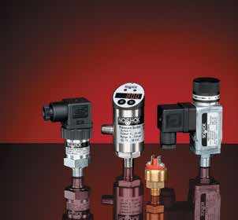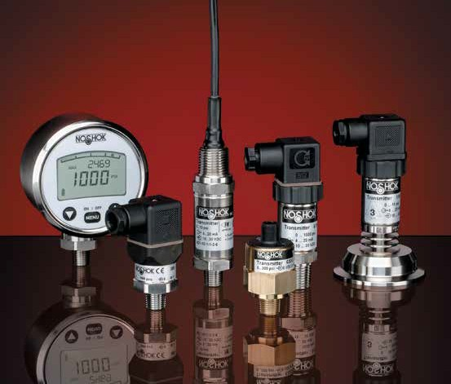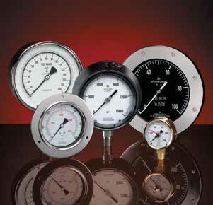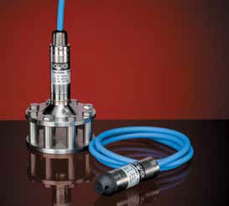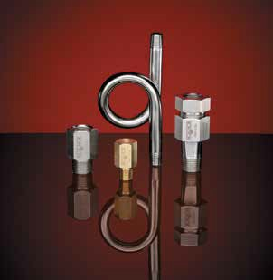Pressure & Level Measurement Solutions

Pressure Gauges Dial Indicating Differential Sanitary Digital

Pressure & Level Transducers & Transmitters
Industrial OEM
Hazardous Location Sanitary
Pressure Switches Options & Accessories

t NOSHOK, we pride ourselves on being innovators in the industry by continually offering the latest technology and measurement solutions, and providing the best customer support in the marketplace.
A
Established in 1967, NOSHOK was one of the first companies to offer liquid filled pressure gauges. We also took a bold step by backing our quality gauges with an extended 3-year warranty. That unwavering standard of quality has endured for
over 50 years, and as we have expanded our product offering we continue to provide industry-leading warranties. NOSHOK also leads the industry as one of the first companies to offer corrosion-resistant zinc nickel plating standard on our carbon steel valves.
We have the capacity to put together special requirements which are so often hard to find. If you do not find what you need in this catalog, chances are we can still put a solution together.
NOSHOK is committed to providing excellence on every level. Thank you for choosing NOSHOK products.

Jeff N. Scott President

NOSHOK Corporate Headquarters

Your Single Source Instrumentation Company

NOSHOK is a member and actively supports:
NOSHOK is an ISO 9001:2015 registered company.

WARRANTY INFORMATION
NOSHOK’s Five Year Warranty applies to our 1000 and 1100 Series differential gauges.
Our Three Year Warranty applies to our 300, 500, 502, 660, 760, and 900 Series liquid filled gauges; 10 Series liquid filled
sanitary gauges; 1000 Series digital gauge; 100, 200, 300, 612, 613, 615/616, 621/622, 623/624, 625/626, 627, 640, 650, 660 and 800 Series transmitters & transducers; 11 Series sanitary transmitters, and 500, 800 Series electronic switch products.
Our One Year Warranty applies to our 100, 200, 400, 402, 640, 740, and 800 Series dry gauges; 10 Series dry sanitary gauges; 100, 200, 300 and 400 Series mechanical switch products, and 628 Series intrinsically safe hammer union transmitter.
NOSHOK guarantees all products to be free from defects in material and workmanship, to remain within catalogued accuracy specifications, and to operate within the catalogued performance specifications. These products must be operated within the catalogued environmental and application parameters. Determination of failure will be made by NOSHOK, Inc.’s equipment and personnel or a certified test facility specializing in this type of evaluation. Instrument failures determined to be caused by over-range, incompatibility with environment or product media and abuse will not be considered under this warranty. NOSHOK, Inc. will, at its discretion, repair or replace the instrument without cost to the customer.
Limitations which apply are: Bourdon tube pressure gauges must be used within their calibrated maximum range to prevent damage. Pressure gauges must be operated within the following working pressure limits: Dynamic pressure application, 60% of the dial range; Static pressure applications, where no sharp fluctuations occur, 90% of the dial range. The gauges must be operated within specified ambient temperature ranges.

CAUTION:
Operating conditions including, but not limited to, system pressure, media compatibility and ambient conditions must be considered when selecting gauges and accessories, improper selections and use of gauges could possibly cause gauge failure and lead to possible property damage or personal injury. Refer to the American National Standard ASME B40.1 for the correct selection and use of dial indicating gauges.

T A B L E O F C O N T E N T S

DIAL INDICATING PRESSURE GAUGES

ABS & Steel Case, Dry:
100 SERIES 6-9

Low Pressure Diaphragm:
200 SERIES 10-13

Brass Case, Liquid Filled:
300 SERIES 14-17

All Stainless Steel, Dry & Liquid Filled:
400/500 SERIES 18-21

All Stainless Steel, Dry & Liquid Filled, Extreme High Pressure:
402/502 SERIES 22-25

Process:
600/700 SERIES 26-27

Precision Test:
800 SERIES 28-29

ABS & Stainless Steel Case, Liquid Filled:
900 SERIES 30-33

In keeping with and for purpose of product and/or manufacturing process improvements, NOSHOK, Inc. reserves the right to make design changes without prior notice. 3

T A B L E O F C O N T E N T S

DIFFERENTIAL PRESSURE GAUGES
Piston Type:
1000 SERIES 34-37
Diaphragm Type:
1100 SERIES 38-41
Dial Layouts:
1000 & 1100 SERIES 42-43
SANITARY PRESSURE GAUGES
Fractional:
10 SERIES 44-45
Heavy-Duty:
10 SERIES 46-47
DIAL INDICATING PRESSURE GAUGE OPTIONS & ACCESSORIES
Panel Mounting Flanges, Cases & Cover Rings, Lenses, Maximum Indicating Pointer, Set Pointers, Rubber Case Protectors, Recalibrators & Adjustable Pointers, Overpressure Protection, Ammonia Refrigeration Gauges, Liquid Filling Options, Special Connections, Reid Vapor Test Gauges, Metric Dials & Customized Special Dials, Certified
Calibration, Magnetic Spring Contact Switch 48-52
Options & Accessories by Gauge Series 53-54
Gauge Fill Options 55
Accuracy/Standard Dial Configurations 56-61
DIGITAL PRESSURE GAUGE
Digital Gauge:
1000 SERIES 62-63
INDUSTRIAL PRESSURE & LEVEL TRANSMITTERS & TRANSDUCERS
Current Output:
100 SERIES 64-65
Voltage Output:
200 SERIES 66-67
Submersible Level:
612 SERIES 68-69
Cage-Protected Submersible Level:
613 SERIES 70-71
High Accuracy:
615/616 SERIES 72-73
Precision:
640 SERIES 74-75
Micro-sized:
660 SERIES 76-77
Electronic Indicating Pressure Transmitter/Switch:
800 SERIES 78-79

4

T A B L E O F C O N T E N T S

OEM TRANSMITTERS & TRANSDUCERS
Compact:
300 SERIES 80-81

High Volume:
650 SERIES 82-83

HAZARDOUS LOCATION PRESSURE & LEVEL TRANSMITTERS

Explosion-Proof:
621/622 SERIES 84-85

Non-Incendive:
623/624 SERIES 86-87

Intrinsically Safe:
625/626 SERIES 88-89

Intrinsically Safe Submersible Level:
627 SERIES 90-91

Intrinsically Safe Hammer Union:
628 SERIES 92-93

SANITARY PRESSURE TRANSMITTERS

ASME-BPE Sanitary Clamp:
11 SERIES 94-95

PRESSURE SWITCHES

Mechanical Miniature Low Pressure:
100 SERIES 96-97

Mechanical Compact SPDT:
200 SERIES 98-99

Mechanical Compact SPDT with Adjustable Hysteresis:
300 SERIES 100-101

Mechanical Heavy-Duty:
400 SERIES 102-103

Electronic Mag-Switch:
500 SERIES 104-105

Electronic Indicating Pressure Transmitter/Switch:
800 SERIES 106-107

ALL PRESSURE MEASUREMENT INSTRUMENTATION OPTIONS & ACCESSORIES
Piston-Type Snubbers, Sintered Snubbers, Pigtail Steam Syphons, Swivel Adaptors 108-111
Reference Information 112-123
Frequently Asked Questions 124-126

Canadian Registration Numbers 127

5

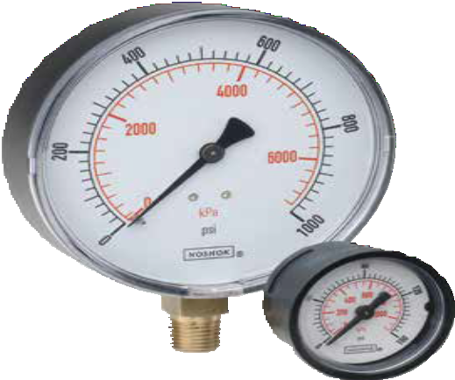

OPERATING SPECIFICATIONS
- Working Pressure Limitations
  - Dynamic Pressure
The working pressure should be limited to 60% of the dial range.
  - Static Pressure
The working pressure, where no sharp fluctuations occur, should be limited to 90% of the dial range

APPLICATIONS
- Hydraulics & pneumatics
- Medical
- Pumps & compressors
- Refrigeration controls
- Utilities
- Water management

100 SERIES

General purpose non-fillable dry gauge
- Vacuum and compound ranges through 0 psi to 15,000 psi
- 1-1/2", 2", 2-1/2" and 4" gauge sizes
- Standard impact-resistant ABS & Steel case
- Copper alloy and Brass wetted parts

 | SERIES SPECIFICATIONS
Pressure ranges | 100 Series (all) | Vacuum and compound ranges through 0 psi to 15,000 psi
Accuracy | 15-100, 15-110, 15-120, 20-100, 20-110,  20-120, 20-148, 25-100, 25-110, 25-120 | ±2.5% full scale
 | 40-100 | ±1.6% full scale
Temperature ranges* | 100 Series (all) | Media -4 °F to 140 °F (-20 °C to 60 °C)  Ambient -40 °F to 140 °F (-40 °C to 60 °C)
Measuring element | 100 Series (all) | Copper alloy Bourdon tube
Connection | 15-100, 15-110, 15-120, 20-100, 20-110 | 1/8″ NPT, Brass
 | 20-148 | 1/8″ NPT/10-32 Female, Brass
 | 20-100, 20-110, 20-120, 25-100, 25-110,  25-120, 40-100 | 1/4″ NPT Brass  SAE J1926-3:7/16-20
Case | 15-100, 15-110, 20-100, 20-110, 20-148,  25-100, 40-100 | ABS (Acryl Nitril Butadien Styrol)
 | 15-120, 20-120, 25-120 | Black painted Steel with chrome triangular bezel and U-clamp
Bezel | 15-110, 20-110, 25-110 | Built-in bezel, molded as an integral part of the case for ease of panel mounting.
 | 15-120, 20-120, 25-120 | Chrome-plated Steel triangular bezel
Lens | 100 Series (all) | Acrylic
Pointer | 100 Series (all) | Molded plastic
Dial | 100 Series (all) | White background with black primary scale & red secondary scale. UV resistant.
Movement | 100 Series (all) | Brass & nylon, or all-Brass with highly polished bearing surfaces
- For every 18 °F (10 °C) shift in temperature from which the gauge is calibrated, the user can experience up to ±0.4% additional error.

Dial Indicating Pressure Gauges
ABS & Steel Case, Dry

For details on accuracy/standard dial configuration
and dial layouts, see pages 56-61.

WARNING: This product can expose you to chemicals including Lead, which is known to the State of California to cause cancer and birth defects or other reproductive harm. For more information go to www.P65Warnings.ca.gov
6

ORDERING INFORMATION
GAUGE SIZES | 15 | 1-1/2″ | 20 | 2″ | 25 | 2-1/2″ 40 | 4″
CASE TYPES | 100 | ABS, bottom connection | 120 | Steel case panel mount
 | 110 | ABS, back connection | 148 | Square ABS, panel mount (2″ only)
PRESSURE | 30vac | -30 inHg vacuum to 0 psi | 30/300 | -30 inHg to 0 to 300 psi | 200 | 0 psi to 200 psi 2000 | 0 psi to 2,000 psi
RANGES | 30/15 | -30 inHg to 0 to 15 psi | 15 | 0 psi to 15 psi | 300 | 0 psi to 300 psi 3000 | 0 psi to 3,000 psi
 | 30/30 | -30 inHg to 0 to 30 psi | 30 | 0 psi to 30 psi | 400 | 0 psi to 400 psi 5000 | 0 psi to 5,000 psi
 | 30/60 | -30 inHg to 0 to 60 psi | 60 | 0 psi to 60 psi | 600 | 0 psi to 600 psi 6000 | 0 psi to 6,000 psi
 | 30/100 | -30 inHg to 0 to 100 psi | 100 | 0 psi to 100 psi | 1000 | 0 psi to 1,000 psi 10000 | 0 psi to 10,000 psi
 | 30/160 | -30 inHg to 0 to 160 psi | 160 | 0 psi to 160 psi | 1500 | 0 psi to 1,500 psi 15000 | 0 psi to 15,000 psi
 | 30/200 | -30 inHg to 0 to 200 psi
 |  |  |  | Other ranges available on request
SCALE OPTIONS*** | psi | psi single scale | psi/kPa | psi/kPa dual scale | psi/kg/cm2 | psi/kg/cm2 dual scale psi/bar | psi/bar dual scale
CONNECTION SIZES | 1/8 | 1/8″ NPT | SST | SAE J1926-3:7/16-20 Adjustable | 1/4 | 1/4″ NPT
OPTIONS | PMC SSB  BLRF | Panel Mount Clamp  Polished Stainless Steel Bezel Black Rear Flange | SSC CRC  FAC | Stainless Steel Case Chrome Case  Flat Sided ABS Case | LL GL  SG | Polycarbonate Lens ST  Glass Lens* CPO  Safety Glass Lens* BP1 | Stainless Steel Tagging  Brass Sintered Orifice 20 Micron Brass Press Fit Orifice 0.1 mm
 | BLFF | Black Front Flange – ABS Case | BCR | Black Cover Ring** | HL | Homalite Lens* BP3 | Brass Press Fit Orifice 0.3 mm
 | CFF | Chrome Front Flange – ABS Case | SSCR | Stainless Steel Cover Ring** | SP | Red Set Pointer** BP8 | Brass Press Fit Orifice 0.8 mm
 | SBFF | Black Front Flange – Steel Case | CCR | Chrome Cover Ring** | MIP | Maximum Indicating Pointer
 | SCFF | Chrome Front Flange – Steel Case | PCCR | Polished Chrome Cover Ring** | SDM | Silicone Dampened Movement
 | BSC | Black Steel Case | CAR | Chrome Adapter Ring* | LM | Laser Marking
Please consult your local NOSHOK Distributor or NOSHOK, Inc. for availability and delivery information.
NOTE: Refer to 100 Series options & accessories chart on page 50 for availability by part number.
* A Steel, Stainless or chrome case & cover ring must be additionally ordered when lenses other than acrylic are utilized on all 100 Series.
** Only 110 Series require a Steel, Stainless or chrome case & cover ring to be additionally ordered when utilizing a set pointer or cover ring.
Please consult factory when a set pointer is to be utilized on a 120 Series.
*** Other scales available on request

EXAMPLE 20 – 110 – 100 – psi – 1/4 – BSC

Gauge size 2"
Case type ABS, back connection
Pressure range & scale option psi to 100 psi
Connection size 1/4" NPT
Option Black Steel Case

15-100 20-100 25-100
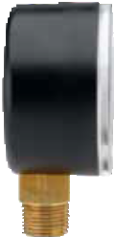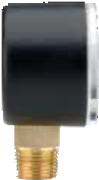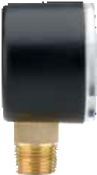 1.08" (27.5 mm)
1.08"
(27.5 mm)

1.93"
(49 mm)
1.77"
(45 mm)

0.55"
(14 mm)
0.39"
(10 mm)
1.02"
(26 mm)
1.54"
(39 mm)
1.42"
(36 mm)
0.55"
(14 mm)
0.38"
(9.6 mm)

2.11"
2.44"
(62 mm)

(53.5 mm)
100 SERIES INFORMATION
ORDERING
DIMENSIONS
0.55"
(14 mm)
0.37"
(9.5 mm) 7

40-100 15-110
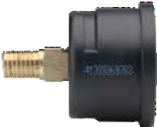 1.59" (40.5 mm)
1.20" (30.5 mm)
3.94"
(100 mm)
3.29"
(83.5 mm)

0.87"
(22 mm)
0.45" (11.5 mm)
0.18" (4.5 mm)

1.57"
(40 mm)
0.55"
(14 mm)

1.77"
(45 mm)

1.04" (26.5 mm)

20-110 20-148

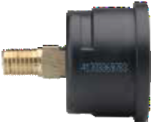 1.67"
(42.5 mm)
0.18" (4.5 mm)
1.57" (40 mm) 0.39" (10 mm)
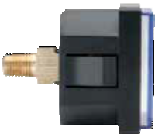0.16" (4 mm)

1.95"
(49.5 mm)
0.55"
(14 mm)

1.04" (26.5 mm)

2.13"
(54 mm)
1.77"
(45 mm)
0.55"
(14 mm)

1.06"
(27 mm)
1.90"
(48.5 mm)

25-110
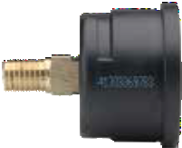1.67"
(42.5 mm)
0.22" (5.5 mm)

2.48"
(63 mm)
0.55"
(14 mm)
2.68"
(68 mm)

Dial Indicating Pressure Gauges
Dimensions
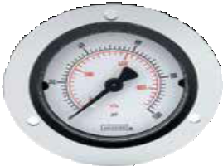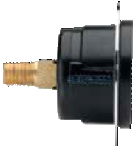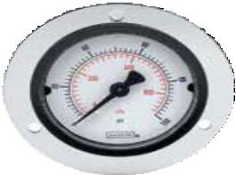 1.40" (35.5 mm)
2.80" (71 mm)
1.59" (40.5 mm)
0.18"
(4.5 mm)
2.36" (60 mm)
1.67" (42.5 mm)
0.18"
(4.5 mm)
0.14"
(3.6 mm)
1.57"
(
40 mm)
1.95"
(49.5 mm)
0.55"
(14 mm)
0.14"
(3.6 mm)

0.55"
(14 mm)

8
120°
1.04" (26.5 mm)
120°
1.04" (26.5 mm)
20-110 Front Flange
15-110 Front Flange
2.40" (61 mm)
2.00" (51 mm)

25-110 Front Flange
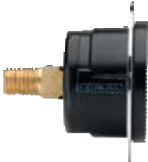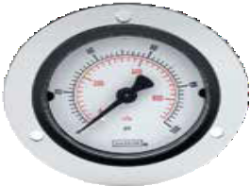 3.35" (85 mm)
1.67" (42.5 mm)
0.22"
(5.5 mm)
2.48"
(63 mm)
0.55"
(14 mm)
1.40" (35.5 mm)
2.95" (75 mm)

0.14"
(3.6 mm)

120°
25-100 Rear Flange 40-100 Rear Flange

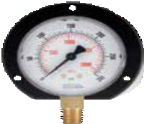0.20"
3.35" (85 mm)
2.95" (75 mm)
(5 mm)
1.28" (32.5 mm)

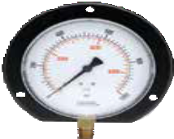0.20"
5.20" (132 mm)
4.57" (116 mm)
(5 mm)
1.40"
(35.5 mm)

0.14"
(3.6 mm)

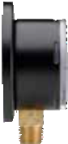120°
2.11"
(53.5 mm)

2.44"
(62 mm)

0.55"
(14 mm)

0.14"
(3.6 mm)

120°

3.94"
(100 mm)
3.29"
(83.5 mm)
0.55"
(14 mm)

15-120 Chrome Bezel With U-Clamp 20-120 Chrome Bezel With U-Clamp 25-120 Chrome Bezel With U-Clamp

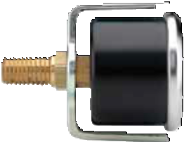 1.84" (46.7 mm)

0.18"
1.98" (50.3 mm)
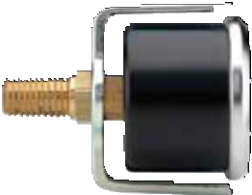
2.07" (52.6 mm)
0.19" 0.20"

(4.5 mm)
(4.9 mm)
(5 mm)

1.54"
(39 mm)
0.55"
(14 mm)
1.69"
(42.8 mm)
1.97"
(50 mm)
1.95"
(50 mm)
0.55"
(14 mm)
2.12"
(53.8 mm)
2.40"
(61 mm)
2.44"
(62 mm)
0.55"
(14 mm)
2.64" 3.58"
(67 mm) (91 mm)

1.12" (28.5 mm)
1.15" (29.3 mm)
1.25" (31.8 mm)

100 SERIES DIMENSIONS
15-110 Panel Mount Clamp 20-110 Panel Mount Clamp 25-110 Panel Mount Clamp

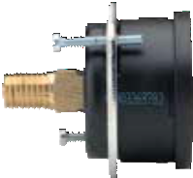m)
1.77" (45 mm)
0.18"
(4.5 mm)
1.57"
(40 mm)
1.77"
(45 mm)
0.55"
(14 mm)
1.04" (26.5 mm)
1.85" (47 mm)
0.18"
(4.5 m
1.95"
(49.5 mm)
2.13"
(54 mm)
0.55"
(14 mm)
1.04" (26.5 mm)
1.87" (47.5 mm)
0.20"
(5 mm)
2.44"
(62 mm)
2.68"
(68 mm)
0.55"
(14 mm)
1.38"
(35 mm)

9

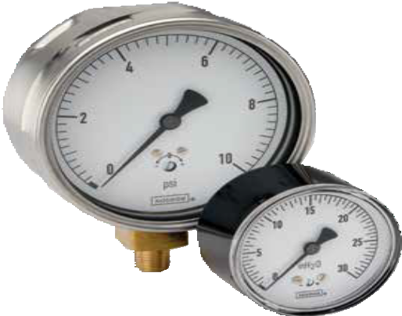

OPERATING SPECIFICATIONS
- Working Pressure Limitations

Dynamic Pressure
The working pressure should be limited to 60% of the dial range.
  - Static Pressure
The working pressure, where no sharp fluctuations occur, should be limited to 90% of the dial range

APPLICATIONS
  - Filter monitoring
  - Gas distribution
  - HVAC
  - Leak detection
  - Level indication
  - Medical

SERIES

- Sensitive capsule-type, non-fillable dry gauge
200
- Vacuum ranges through 0 psi to 10 psi
- 2-1/2" and 4" gauge sizes
- Black painted Steel, Stainless Steel and impact-resistant ABS case
- Copper alloy and Brass wetted parts

 | SERIES SPECIFICATIONS
Pressure ranges | 200 Series (all) | Extreme low pressure vacuum ranges through 0 psi to 10 psi
Accuracy | 25-200, 25-210, 25-224 | ±1.6% full scale
 | 25-206, 25-216 | ±2.5% full scale
 | 40-200 | ±1.6% full scale; optional ±1% full scale
Temperature ranges* | 200 Series (all) | Media -4 °F to 176 °F (-20 °C to 80 °C)  Ambient -4 °F to 140 °F (-20 °C to 60 °C)
Measuring element | 25-200, 25-210, 25-224, 40-200 | Copper alloy diaphragm capsule
Connection | 200 Series (all) | 1/4″ NPT, Brass
Case | 25-200, 25-210 | Black painted Steel
 | 25-206, 25-216, 25-224 | Black ABS (Acryl Nitril Butadien Styrol) with 25-224 includes zinc-plated Steel panel mount clamp
 | 40-200 | 304 Stainless Steel
Bezel | 40-200 | 304 Stainless Steel
Lens | 25-200, 25-206, 25-210, 25-216, 25-224 | Acrylic
 | 40-200 | Instrument glass
Pointer | 200 Series (all) | Black finished Aluminum
Dial | 200 Series (all) | Aluminum, white background with black scale. UV resistant.
Movement | 25-200, 25-210, 25-224, 40-200 | Brass and Nickel-silver with highly polished bearing surfaces
 | 25-206, 25-216 | Cu-Alloy
- For every 18 °F (10 °C) shift in temperature from which the gauge is calibrated, the user can experience up to ±0.4% additional error.

Dial Indicating Pressure Gauges
Low Pressure Diaphragm

For details on accuracy/standard dial configuration
and dial layouts, see pages 56-61.

WARNING: This product can expose you to chemicals including Lead, which is known to the State of California to
10 cause cancer and birth defects or other reproductive harm. For more information go to www.P65Warnings.ca.gov

ORDERING INFORMATION
GAUGE SIZES | 25 | 2-1/2″ 40 4″
CASE TYPES | 200  206  210 | Steel, bottom connection (304SS for 4″) ABS, bottom connection  Steel, back connection | 216  224  234 | ABS, back connection ABS, panel mount  Gas pressure test kit**
PRESSURE RANGES | 15 inH2O Vac  30 inH2O Vac  60 inH2O Vac  100 inH2O Vac  10 inH2O  15 inH2O  30 inH2O  60 inH2O | -15 inH2O to 0 inH2O 100 inH2O 0 inH2O to 100 inH2O  -30 inH2O to 0 inH2O 160 inH2O 0 inH2O to 160 inH2O  -60 inH2O to 0 inH2O 200 inH2O 0 inH2O to 200 inH2O  -100 inH2O to 0 inH2O 10 oz/in2 0 oz/in2 to 10 oz/in2  0 inH2O to 10 inH2O 15 oz/in2 0 oz/in2 to 15 oz/in2  0 inH2O to 15 inH2O 30 oz/in2 0 oz/in2 to 30 oz/in2  0 inH2O to 30 inH2O 35 oz/in2 0 oz/in2 to 35 oz/in2  0 inH2O to 60 inH2O 60 oz/in2 0 oz/in2 to 60 oz/in2 | 100 oz/in2  160 oz/in2  20 oz/ in2/inH2O  32 oz/ in2/inH2O  3 psi  5 psi  10 psi  40 mbar | 0 oz/in2 to 100 oz/in2  0 oz/in2 to 160 oz/in2  0 oz/in2/inH2O to 20 oz/in2/inH2O  0 oz/in2/inH2O to 32 oz/in2/inH2O  0 psi to 3 psi  0 psi to 5 psi  0 psi to 10 psi  0 mbar to 40 mbar | 60 mbar  100 mbar  160 mbar  250 mbar  400 mbar  600 mbar | 0 mbar to 60 mbar  0 mbar to 100 mbar  0 mbar to 160 mbar  0 mbar to 250 mbar  0 mbar to 400 mbar  0 mbar to 600 mbar
CONNECTIONSIZE | 1/4 | 1/4″ NPT
OPTIONS | BLRF SSRF BLFF SSFF CFF  SSC | Black Rear Flange GL Glass Lens*  304SS Rear Flange SG Safety Glass Lens*  Black Front Flange*** PL Acrylic Lens  304SS Front Flange RL Recalibrator Lens Chrome Front Flange*** SP Red Set Pointer  Stainless Steel Case MIP Maximum Indicating Pointer | OP SSBU BBU BCR SSCR | Over Pressure Protection Stainless Steel Bezel & U-Clamp Black Bezel & U-Clamp Black Cover Ring  Stainless Steel Cover Ring | CCR LM ST BP3 BT3 | Chrome Cover Ring Laser Marking Stainless Steel Tagging  Brass Press Fit Orifice 0.3 mm Brass Threaded Orifice 0.3 mm
Please consult your local NOSHOK Distributor or NOSHOK, Inc. for availability and delivery information.
NOTE: Refer to 200 Series Options & Accessories chart on page 51 for availability by part number.
- A Steel, Stainless or chrome cover ring must be additionally ordered when lenses other than acrylic are utilized on all 200 Series
** Only available in 2-1/2" size, 20 oz/35 inH2O
*** Not available on 25-200 model

EXAMPLE

Gauge size .. 2-1/2"
Case type Steel, bottom connection
Pressure range & scale option 0 inH20 to 30 inH20
Connection size 1/4" NPT
Option Brass Press Fit Orifice 0.3 mm
25 – 200 – 30 – inH20 – 1/4 – BP3

200 SERIES INFORMATION
ORDERING
DIMENSIONS

25-200 25-206 40-200 25-210

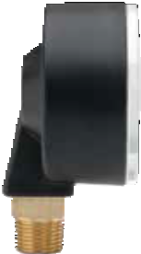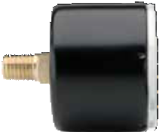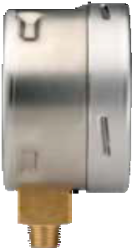)
1.57" (40 mm)
2.48"
(63 mm
2.05"
2 mm)

0.55"
(14 mm)
0.37"
(9.5 mm)
1.36" (34.5 mm)
1.16" (29.5 mm)
0.94"
(24 mm)

2.44"
(62 mm)
1.89"
(48 mm)

0.55"
(14 mm)
1.00" (25.5 mm)
2.19" (55.5 mm)
2.48"
(63 mm)
0.55"
(14 mm)
1.44" (36.5 mm)
1.94" (49.3 mm)
3.98"
(101 mm)
3.35"
(85 mm)
0.87"
(22 mm)

0.61"
(15.5 mm)

(5

11

25-216 25-210 Front Flange
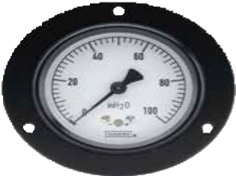
3.35" (85 mm)
2.95" (75 mm)
0.14" (3.6 mm)
120°

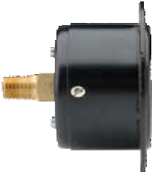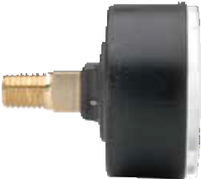 25-200 Rear Flange
2.03" (51.5 mm)

0.16"
(4 mm)
2.48"
(63 mm)
0.55"
(14 mm)
1.44" (36.5 mm)
2.03" (51.5 mm)
2.44"
(62 mm)
0.55"
(14 mm)
0.94"
(24 mm)

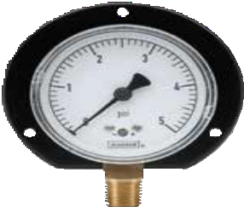 1.77" (45 mm)
3.35" (85 mm)

2.95" (75 mm)
0.20"
(5 mm)

2.48"
(63 mm)

0.14" (3.6 mm)
2.05"
(52 mm)

Dial Indicating Pressure Gauges
Dimensions
0.55"
(14 mm)

120°

40-200 Rear Flange

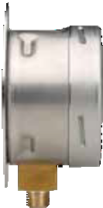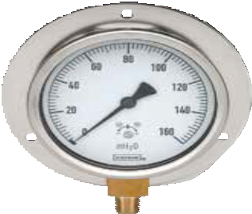0.14"
0.12"
(3 mm)
1.95" (49.6 mm)
3.98"
(101 mm)
3.35"
(85 mm)
0.87"
(22 mm)
5.20" (132 mm)

4.57" (116 mm)
(3.6 mm)

120°

12

200 SERIES DIMENSIONS

25-210 Triangular Bezel w/U-Clamp

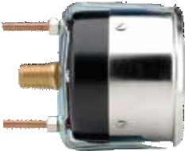
2.37" (60.2 mm)
0.16"
(4 mm)
2.49"
(63.2 mm)
2.70"
(68.5 mm)
0.55"
(14 mm)
1.55" (39.4 mm)

25-224 with Panel Mount Clamp

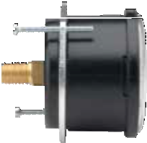1.58" (40.2 mm)
2.03" (51.6 mm)
0.28"
(7 mm)
2.59"
(65.9 mm)
2.84"
(72.2 mm)
0.55"
(14 mm)

25-234

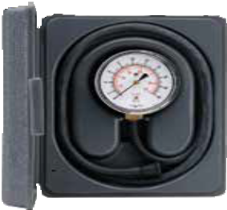
7.50"
(190.5 mm)
5.75" (146.1 mm)

2.06" (52.3 mm)

13

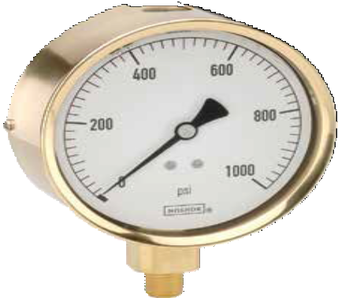SERIES
300

  - High quality, heavy-duty liquid filled gauge
  - Vacuum and compound ranges through 0 psi to 15,000 psi
  - 2-1/2" and 4" gauge sizes
  - Die cast Brass case with natural Brass finish
  - Copper alloy or 316 Stainless Steel and Brass wetted parts

OPERATING SPECIFICATIONS
- Working Pressure Limitations
  - Dynamic Pressure
The working pressure should be limited to 60% of the dial range.
  - Static Pressure
The working pressure, where no sharp fluctuations occur, should be limited to 90% of the dial range.

APPLICATIONS
- Automotive
- Construction
- Hydraulics & pneumatics
- Mining
- Stamping & forming presses
- Transportation

- For every 18 °F (10 °C) shift in temperature from which the gauge is calibrated, the user can experience up to ±0.4% additional error.
 | SERIES SPECIFICATIONS
Pressure ranges | 300 Series (all) | Vacuum and compound ranges through 0 psi to 15,000 psi
Accuracy | 25-300, 25-310 | ±1.6% full scale
 | 40-300, 40-310 | ± 1% full scale
Temperature ranges* | 300 Series (all) | Media -4 °F to 140 °F (-20 °C to 60 °C)  Ambient 0 °F to 160 °F (-18 °C to 71 °C) Optional temperature ratings available from  -40 °F to 212 °F (-40 °C to 100 °C)
Measuring element | 25-300, 25-310  (≤ 600 psi) | Copper alloy “C” tube
 | 25-300, 25-310  (800 psi to 6,000 psi) | Copper alloy coiled safety tube
 | 25-300, 25-310  (7,500 psi to 15,000 psi) | 316 Stainless Steel coiled safety tube
 | 40-300, 40-310  (≤ 1,000 psi) | Copper alloy “C” tube
 | 40-300, 40-310  (15,000 psi) | 316 Stainless Steel coiled safety tube
Connection | 25-300, 25-310 | 1/4″ NPT die-cast Brass with the case. 7/16″ – 20 SAE adjustable type straight thread with FKM O-ring is also available as a stock option on many ranges (-4 SAE).
 | 40-300, 40-310 | 1/4″ NPT die-cast Brass with the case. 1/2″ NPT is available on certain 40-300 ranges as a stock option, and on all other 40-300 and 40-310’s as a non-stock option.
Case | 300 Series (all) | Die cast Brass (natural Brass finish) with safety relief plug
Cover ring | 300 Series (all) | Polished Brass
Lens | 300 Series (all) | Acrylic with o-ring seal
Pointer | 300 Series (all) | Balanced Aluminum, black finish
Dial | 300 Series (all) | Aluminum, white background with black scale. UV resistant.
Movement | 300 Series (all) | Brass and Nickel-silver with highly polished bearing surfaces
Fill liquid** | 300 Series (all) | Glycerin

**See page 51 for gauge fill options.

Dial Indicating Pressure Gauges
Brass Case, Liquid Filled

For details on accuracy/standard dial configuration
and dial layouts, see pages 56-61.

WARNING: This product can expose you to chemicals including Lead, which is known to the State of California to
14 cause cancer and birth defects or other reproductive harm. For more information go to www.P65Warnings.ca.gov

ORDERING INFORMATION
GAUGE SIZES | 25 | 2-1/2″ | 40 | 4″
CASE TYPES | 300 | Brass, bottom connection | 310 | Brass, back connection
PRESSURE RANGES | 30vac 30/15  30/30  30/60  30/100  30/160  30/200 | -30 inHg to 0 psi  -30 inHg to 0 to 15 psi  -30 inHg to 0 to 30 psi  -30 inHg to 0 to 60 psi  -30 inHg to 0 to 100 psi  -30 inHg to 0 to 160 psi  -30 inHg to 0 to 200 psi | 30/300  15  30  60  100  160  200 | -30 inHg to 0 to 300 psi  0 psi to 15 psi  0 psi to 30 psi  0 psi to 60 psi  0 psi to 100 psi  0 psi to 160 psi  0 psi to 200 psi | 300  400  600  800  1000  1500  2000 | 0 psi to 300 psi  0 psi to 400 psi  0 psi to 600 psi  0 psi to 800 psi  0 psi to 1,000 psi  0 psi to 1,500 psi  0 psi to 2,000 psi | 3000  5000  6000  7500  10000  15000 | 0 psi to 3,000 psi  0 psi to 5,000 psi  0 psi to 6,000 psi  0 psi to 7,500 psi  0 psi to 10,000 psi  0 psi to 15,000 psi
SCALE OPTIONS | psi | psi single scale | psi/kPa | psi/kPa dual scale | psi/kg/cm2 | psi/kg/cm2 dual scale | psi/bar | psi/bar dual scale
CONNECTION SIZES 1/4 1/4″ NPT 1/2 1/2″ NPT SST SAE J1926-3:7/16-20 Adjustable
OPTIONS | CFF CFFN BFF BLFF  SSRF | Chrome Front Flange  Chrome Front Flange w/o holes Brass Front Flange  Black Front Flange  304SS Rear Flange | RF CCR CBU MIP  LL | Rear Flange Chrome Cover Ring  Chrome Bezel & U-Clamp  Maximum Indicating Pointer  Polycarbonate Lens | GLO SGO AR LM | Glass Lens Overlay Safety Glass Overlay Adapter Ring  Laser Marking | ST BT3 BT4 BT8 | Stainless Steel Tagging  Brass Threaded Orifice 0.3 mm Brass Threaded Orifice 0.4 mm Brass Threaded Orifice 0.8 mm
Please consult your local NOSHOK Distributor or NOSHOK, Inc. for availability and delivery information.
NOTE: Refer to 300 Series Options & Accessories chart on page 51 for availability by part number.

EXAMPLE 40 – 300 – 3000 – psi – 1/4 – BT3

Gauge size 4"
Case type Brass, bottom connection
Pressure range & scale option psi to 3,000 psi
Connection size 1/4" NPT
Option Brass Press Fit Orifice 0.3 mm

25-300 40-300 25-310

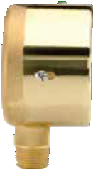 1.77"
1.34"
(34 mm)
2.48"
(63 mm)
2.13"
(54 mm)

0.55"
(14 mm)
0.43"
(11 mm)
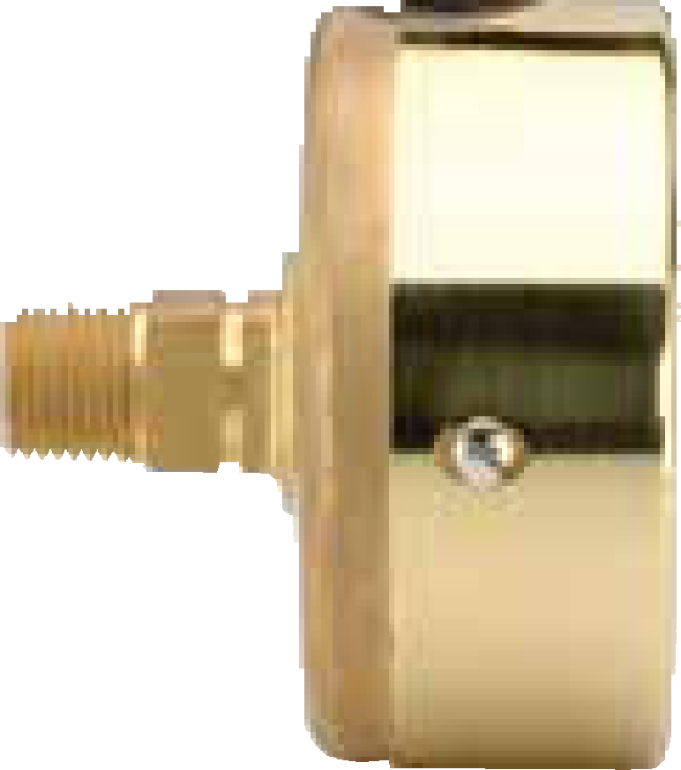(45 mm)
2.36" (60 mm)
2.48"
(63 mm)
0.55"
(14 mm)
1.34"
(34 mm)

3.94"
(100 mm)

3.46"
(88 mm)

0.87"
(22 mm)
0.53"
(13.5 mm)

15
300 SERIES INFORMATION
ORDERING
DIMENSIONS

40-310 25-300 Front Flange

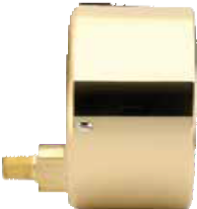 3.46" (88 mm)
3.35" (85 mm)
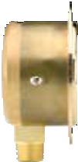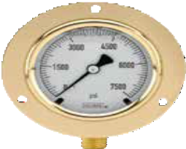 2.95" (75 mm)
1.38"
(35 mm)
0.08"
(2 mm)
2.48"
(63 mm)
2.09"
(53 mm)
0.55"
(14 mm)
0.43"
(11 mm)

1.18"
(30 mm)
3.94"
(100 mm)

0.14"
(3.6 mm)

0.87"
(22 mm)

1.77" (45 mm)
120°

40-300 Front Flange 25-310 Front Flange

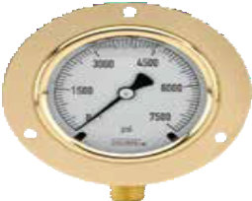1.79"
5.20" (132 mm)

4.53" (115 mm)
"
120°
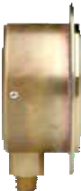(45.5 mm)
0.14"
(3.5 mm)
3.35" (85 mm)
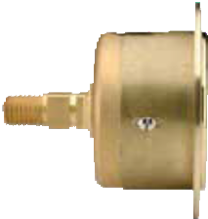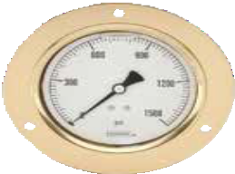 2.95" (75 mm)
2.48" (63 mm)

0.08"
(2 mm
2.48"
(63 mm)
0.55"
(14 mm)
1.46"
(37 mm)
)

0.20
(5 mm)
3.98"
(101 mm)

3.15"
(80 mm)

0.14"
(3.6 mm)

0.87"
(22 mm)
120°

40-310 Front Flange 25-300 Rear Flange
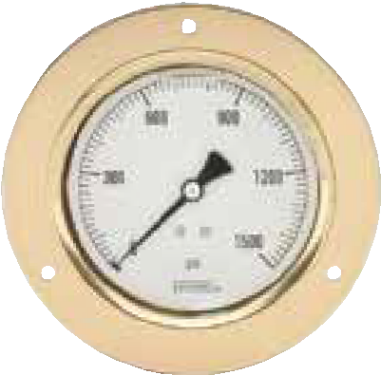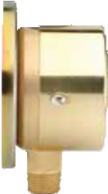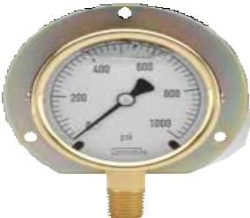 5.20" (132 mm)
0.08"
(2 mm)
1.46"
(37 mm)

2.48"
(63 mm)
2.09"
(53 mm)
0.55"
(14 mm)
3.35" (85 mm)
2.95" (75 mm)
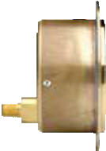 4.53" (115 mm)
2.78" (70.5 mm)
0.14"
(3.5 m
3.94"
(100 mm)
1.93"
(49 mm)

m)

0.20"
(5 mm)

0.14"
(3.6 mm)

120°
0.87"
(22 mm)

Dial Indicating Pressure Gauges
Dimensions
120°

16

40-300 Rear Flange 25-310 Rear Flange

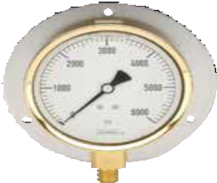0.08"
5.20" (132 mm)
4.57" (116 mm)
0.20"
5 mm)
(2 mm)
1.85"
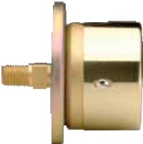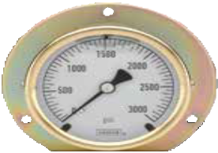(47 mm)
0.20"
(5 mm)
1.54"
(39 mm)
2.36" (60 mm)
3.35" (85 mm)
2.95" (75 mm)

3.94"
(100 mm)

( 3.46"
(88 mm)

0.14"
(3.5 mm) 0.55"
(14 mm)
2.48"
(63 mm)

0.87"
300 SERIES DIMENSIONS
(22 mm)
120° 120°

40-310 Rear Flange
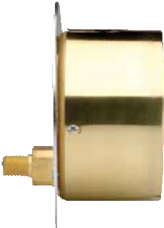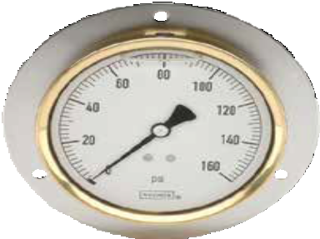 5.20" (132 mm)
1.85" (47 mm)
0.08"
(2 mm)
3.94"
(100 mm)
1.18"
(30 mm)
0.87"
(22 mm)
3.46" (88 mm)
4.57" (116 mm)

0.20"
(5 mm)

120°

25-310 Chrome Triangular Bezel with U-Clamp 40-310 Chrome Triangular Bezel with U-Clamp
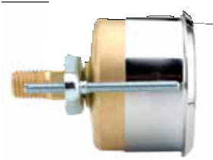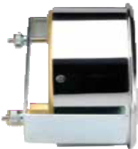
2.36" (60 mm)
0.16"
(4 mm)
2.48"
(63 mm)
2.68"
(68 mm)
0.55"
(14 mm)
1.26"
(32 mm)
3.46" (88 mm)
0.16"
(4 mm)
3.94"
(100 mm)

1.18"
(30 mm)
4.21"
(107 mm)
0.87"
(
22 mm)
1.93"
(49 mm)

17

Dial Indicating Pressure Gauges
All Stainless Steel, Dry & Liquid Filled

OPERATING SPECIFICATIONS
- Working Pressure Limitations

Dynamic Pressure
The working pressure should be limited to 60% of the dial range.
  - Static Pressure
The working pressure, where no sharp fluctuations occur, should be limited to 90% of the dial range

APPLICATIONS
- Chemical processing
- Oil field & offshore
- Paper mills
- Agriculture plants
- Marine
- Water & wastewater
- For every 18 °F (10 °C) shift in temperature from which the gauge is calibrated, the user can experience up to ±0.4% additional error.
** See page 51 for gauge fill options.

For details on accuracy/standard dial configuration
and dial layouts, see pages 56-61.

18
SERIES
- 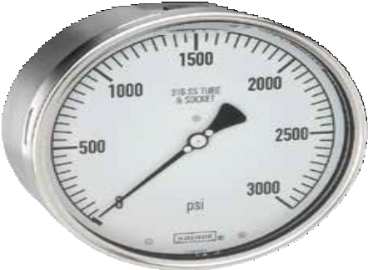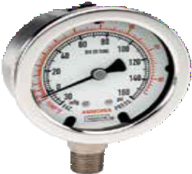Corrosion-resistant fillable dry or liquid-filled gauge
400/500
- Vacuum and compound ranges through 0 psi to 20,000 psi
- 1-1/2", 2-1/2", 4 and 6" gauge sizes
- Stainless Steel case
- 316 Stainless Steel wetted parts
- ECE-R110 Certification for CNG/LNG Pressure Gauge Component
(Part number 25-410-300-psi/bar only)

 | SERIES SPECIFICATIONS
Pressure ranges | 400/500 Series (all) | Vacuum and compound ranges through 0 psi to 20,000 psi
Accuracy | 15-401, 15-411 | ±2.5% full scale
 | 25-400, 25-410, 25-500, 25-510 | ±1.6% full scale
 | 40-400, 40-410, 40-500, 40-510, 60-400,  60-410, 60-500, 60-510 | ±1% full scale
Temperature ranges* | 15-401, 15-411 | Media -40 °F to 212 °F (-40 °C to 100 °C)  Ambient -40 °F to 140 °F (-40 °C to 60 °C)
 | 25-400, 25-410, 40-400, 40-410, 60-400,  60-410 | Media -40 °F to 392 °F (-40 °C to 200 °C)  Ambient -40 °F to 140 °F (-40 °C to 60 °C)
 | 500 Series (all) | Media -4 °F to 212 °F (-20 °C to 100 °C) Glycerin fill  -40 °F to 212 °F (-40 °C to 100 °C) Special fill  Ambient -4 °F to 140 °F (-20 °C to 60 °C) Glycerin fill  -40 °F to 140 °F (-40 °C to 60 °C) Special fill
Measuring element | 15-401, 15-411, 25-400, 25-410, 25-500, 25-510,  40-400, 40-410, 40-500, 40-510, 60-400, 60-410,  60-500, 60-510 (up to 600 psi) | 316 Stainless Steel C-Type Bourdon tube
 | 25-400, 25-410, 25-500, 25-510, 40-400, 40-  410, 40-500, 40-510, 60-400, 60-410, 60-500,  60-510 (greater than 600 psi) | Coiled safety tube
Connection | 15-401, 15-411 | 1/8″ NPT, 316 Stainless Steel
 | 25-400, 25-410, 25-500, 25-510 | 1/4″ NPT, 316 Stainless Steel
 | 40-400, 40-410, 40-500, 40-510, 60-400,  60-410, 60-500, 60-510 | 1/2″ NPT, 316 Stainless Steel. 9/16″ – 18 high pres- sure  connections are standard on 0 - 30,000 psi and higher
Case | 15-401, 15-411, 40-400, 40-410, 60-400,  60-410, 60-500, 60-510 | 304 Stainless Steel (Optional 316 Stainless Steel) with safety relief plug
 | 25-400, 25-410, 25-500, 25-510, 40-500, 40-510 | Polished 304 Stainless Steel with safety relief plug
Cover ring | 15-401, 15-411, 25-400, 25-410, 25-500, 25-510,  40-400, 40-410, 40-500, 40-510 | Polished 304 Stainless Steel
 | 60-400, 60-410, 60-500, 60-510 | Polished 304 Stainless Steel bayonet ring
Lens | 15-401, 15-411, 40-400, 40-410, 40-500, 40-510 | Instrument glass
 | 25-400, 25-410, 25-500, 25-510 | Trogamide
 | 60-400, 60-410, 60-500, 60-510 | Laminated safety glass
Pointer | 115-401, 15-411 | Black finished Aluminum
 | 25-400, 25-410, 25-500, 25-510, 40-400,  40-410, 40-500, 40-510 | Balanced Aluminum, black finish
 | 60-400, 60-410, 60-500, 60.510 | Balanced micro-adjustable Aluminum, black finish
Dial | 15-401, 15-411 | Aluminum, white background with black scale. Single scale psi. UV resistant
 | 25-400, 25-410, 25-500, 25-510, 40-400, 40-410,  40-500, 40-510, 60-400, 60-410, 60-500, 60-510 | Aluminum, white background with black scale. UV resistant.
Movement | 15-401, 15-411, 25-400, 25-410, 25-500,  25-510 | Stainless Steel with highly polished bearing surfaces
 | 40-400, 40-410, 40-500, 40-510 | All Stainless Steel with internal zero stop and highly polished bearing surfaces
 | 60-400, 60-410, 60-500, 60-510 | Stainless Steel with highly polished bearing surfaces An internal zero stop is standard
Fill liquid** | 25-500, 25-510, 40-500, 40-510, 60-500, 60-510 | Glycerin
WARNING: This product can expose you to chemicals including Chromium (VI) and Nickel, which are known to the State of
California to cause cancer and birth defects or other reproductive harm. For more information go to www.P65Warnings.ca.gov

ORDERING INFORMATION
GAUGE SIZE | 15 | 1-1/2″ | 25 | 2-1/2″ 40 4″ * |  | 60 6″ *
CASE TYPES | 400  401 | All SS, dry/fillable, bottom connection  All SS, dry, bottom connection | 410  411 | All SS, dry/fillable, back connection  All SS, dry, back connection | 502 | SS case, solid front, liquid filled, bottom  connection
 | 402 | SS case, solid front, dry, bottom connection | 500 | SS case, liquid filled, bottom connection | 510 | SS case, liquid filled, back connection
PRESSURE | 30vac | -30 inHg to 0 psi *** | 30 | 0 psi to 30 psi | 1000 | 0 psi to 1,000 psi
RANGES | 30/15 | -30 inHg to 0 psi to 15 psi *** | 60 | 0 psi to 60 psi | 1500 | 0 psi to 1,500 psi
 | 30/30 | -30 inHg to 0 psi to 30 psi *** | 100 | 0 psi to 100 psi | 2000 | 0 psi to 2,000 psi
 | 30/60 | -30 inHg to 0 psi to 60 psi *** | 160 | 0 psi to 160 psi | 3000 | 0 psi to 3,000 psi
 | 30/100 | -30 inHg to 0 psi to 100 psi *** | 200 | 0 psi to 200 psi | 5000 | 0 psi to 5,000 psi
 | 30/160 | -30 inHg to 0 psi to 160 psi *** | 300 | 0 psi to 300 psi | 6000 | 0 psi to 6,000 psi
 | 30/200 | -30 inHg to 0 psi to 200 psi *** | 400 | 0 psi to 400 psi | 10000 | 0 psi to 10,000 psi
 | 30/300 | -30 inHg to 0 psi to 300 psi *** | 600 | 0 psi to 600 psi | 15000 | 0 psi to 15,000 psi
 | 15 | 0 psi to 15 psi | 800 | 0 psi to 800 psi | 20000 | 0 psi to 20,000 psi **
SCALE OPTIONS | psi  psi/kPa | psi single scale  psi/kPa dual scale | psi/kg/cm2  psi/bar | psi/kg/cm2 dual scale  psi/bar dual scale
CONNECTION SIZES | 1/8 | 1/8″ NPT | 1/2 | 1/2″ NPT | SST | SAE J1926-3:7/16-20 Adjustable
 | 1/4 | 1/4″ NPT | 9/16-18 | 9/16″-18 UNF 2B high pressure cone
OPTIONS | SSFF SSRF SSBU  SPMC | 304SS Front Flange 304SS Rear Flange  Stainless Steel Bezel & U-Clamp  304SS Panel Mount Clamp | SSFR AP SG  MIP | 304SS Flange Ring Adjustable Pointer Safety Glass Lens  Maximum Indicating Pointer | LM ST ST5  ST8 | Laser Marking Stainless Steel Tagging  Stainless Steel Threaded Orifice 0.5 mm  Stainless Steel Threaded Orifice 0.8 mm
 | PMC | Steel Panel Mount Clamp | SP | Red Set Pointer
Please consult your local NOSHOK Distributor or NOSHOK, Inc. for availability and delivery information.
NOTE: Refer to 400/500 Series options & Accessories chart on page 52 for availability by part number.
* On 40-400, 40-410, 40-500, 40-510, 60-400, 60-410, 60-500, and 60-510 models with 20,000 psi, the accuracy is ±1.5% or 1.6%
** 4" model only available with solid front case types
*** Ammonia gauges are available in these ranges. To order, add " – AMMONIA" at the end of the part number.

EXAMPLE 40 – 500 – 600 – psi – 1/2 – MIP

Gauge size 4"
Case type SS case, liquid filled, bottom connection
Pressure range & scale option psi to 600 psi
Connection size 1/2" NPT
Option Maximum Indicating Pointer

15-401 | 25-400/500 | 40-400/500
 |  | 2.13"
 | 1.26" | (54 mm)
0.98" | (32 mm)
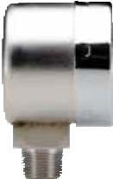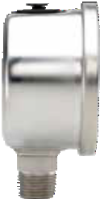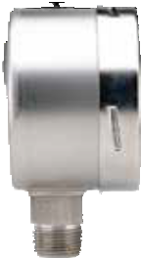(25 mm)

2.68"
(68 mm)
2.13"
(54 mm)

0.55"
(14 mm)
0.51"
(13 mm)

1.57"
(40 mm)
3.98"
(101 mm)

1.54"
(39 mm)
0.55"
3.43"
(87 mm)

0.87"

(14 mm)
0.35"
(9 mm)
(22 mm)

0.70" (17.7 mm)

19
400/500 SERIES INFORMATION
ORDERING
DIMENSIONS

60-400/500 15-411 25-410/510 40-410/510

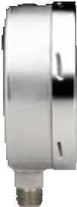 *1.95"
* ≥ 1,500 psi increase by 0.67" (17 mm)

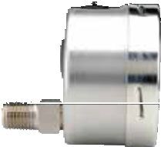(49.5 mm)
1.61" (40.9 mm) 1.97" (50 mm ) 0.20"
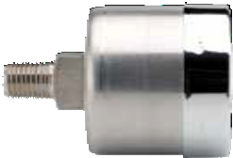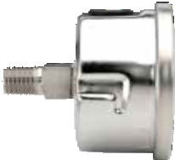(5 mm)
3.37" (85.5 mm)

4.65"
(118 mm)

6.34"
(161 mm)

0.55"

1.57"
(40 mm)

2.44"
(62 mm)

0.55"

2.68"
(68 mm)

1.18"
(30 mm)

3.98"
(101 mm)

(14 mm)
0.87"
(22 mm)
0.61" (15.5 mm)

1.06" (27 mm)
(14 mm)

1.26"
(32 mm)

0.87"
(22 mm) 2.13"
(54 mm)

60-410/510 40-400/500 Front Flange 60-400/500 Front Flange

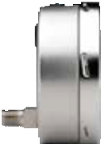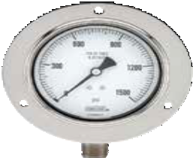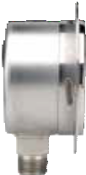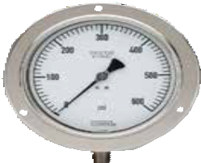

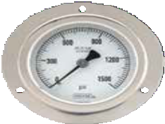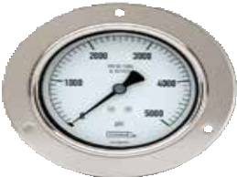
3.35" (85 mm)
2.95" (75 mm)
5.20" (132 mm)
4.57" (116 mm)

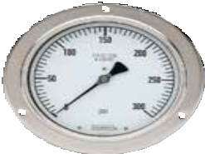 *2.95"
7.72" (196 mm)
7.01" (178 mm)
(75 mm)

0.31"
(8 mm)

5.20" (132 mm)
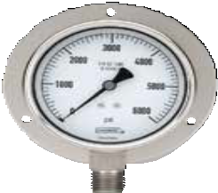4.57" (116 mm)

0.08"
(2 mm)
2.20"
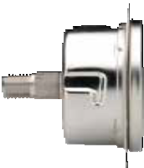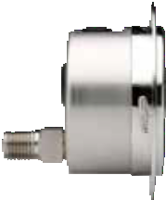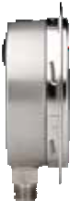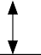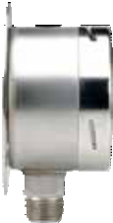(56 mm)
*3.27"
(83 mm)
5.20" (132 mm)
4.57" (116 mm)
1.81"
(46 mm)
0.24"
(6 mm)
7.72" (196 mm)
7.01" (178 mm)
*1.63" (41.5 mm)

0.31"
(8 mm)
0.19"
( )
4.8 mm
(13.97"
01 mm)
6.34"
(161 mm)
1.97"
(50 mm)
6.34"
(161 mm)
0.20"
(5 mm)
0.87"
(22 mm)
3.43"
(87 mm)
*1.95" (49.5 mm)
* ≥ 1,500 psi increase
by 0.67" (17 mm)

120°

0.87"
(22 mm)
0.70"
(17.7 mm)
4.65"
(118 mm)
120°
0.61"
(15.5 mm)
0.87"
(22 mm)
1.97" (50 mm)
0.20"
(5 mm)
3.13" (79.5 mm)
0.24"
(6 mm)
0.14" (3.6 mm)
2.68"
(68 mm)
3.97"
(101 mm)
0.55"
(14 mm)
0.19" (4.8 mm)
1.18"
(30 mm)
1.26"
(32 mm)
0.87"
(22 mm)
120°
2.13"
(54 mm)
40-400/500 Rear Flange
60-410/510 Front Flange
40-410/510 Front Flange
25-410/510 Front Flange

0.20"
(5 mm)

1.97"
(50 mm)

6.34"
(161 mm)

0.20"
(5 mm)

3.43"

3.97"
(101 mm)

0.87"
(22 mm)
(87 mm)
0.87"

20 120°

Dial Indicating Pressure Gauges
Dimensions
1.95"
(49.5* mm)
- ≥ 1,500 psi increase
by 0.67" (17 mm)

120°

0.70" (17.7 mm)
(22 mm)

60-400/500 Rear Flange 40-410/510 Rear Flange

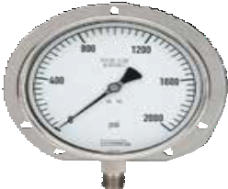0.11"
7.72" (196 mm)
7.01" (178 mm)
*1.91" (48.5 mm)

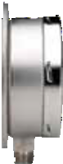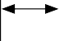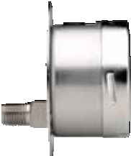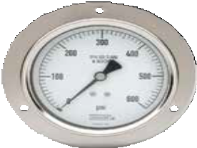 5.20" (132 mm)

0.11"
2.07" (52.5 mm)
(3 mm)
1.18"
(30 mm)
3.98"
(101 mm)
0.87"
(22 mm)
3.27"
(83 mm)

(3 mm)
4.57" (116 mm)

0.23"
(5.8 mm)

120°

4.65"
(118 mm)

0.61"
(15.5 mm)
6.34"
(161 mm)

0.87"
(22 mm)

0.20"
(5 mm)

120°

60-410/510 Rear Flange 25-410/510 Flange Ring
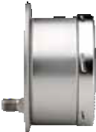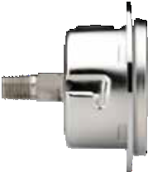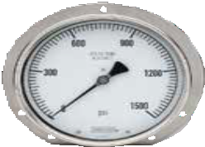*1.95" (49.5 mm)
1.26"
(32 mm)
0.55"
(14 mm)
2.44"
(62 mm)
2.68"
(68 mm)
1.89"
(48 mm)
0.20"
(5 mm)
7.72" (196 mm)
7.01" (178 mm)
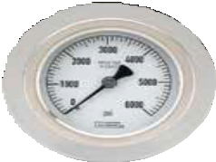0.11"
3.35" (85mm)
(3 mm)

0.23"
(5.8 mm)

120°

1.97"
(50 mm)

0.87"
(22 mm)
6.34"
(161 mm)

*3.27"
(83 mm)

120°

25-410/510 Panel Mount Clamp 40-410/510 SS Narrow Bezel w/U-Clamp 60-410/510 SS Narrow Bezel w/U-Clamp

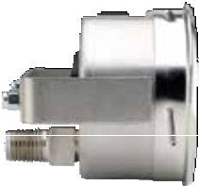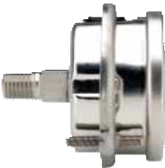)
3.21" (81.5 mm)

(4 mm
0.16"
3.98"
(101 mm)
1.18"
(30 mm)
4.21"
(107 mm)
0.87"
(22 mm)
2.13"
(54 mm)
2.17" (55 mm) 0.20"
(5 mm)
2.44"
(62 mm)
2.68"
(68 mm)
0.55"
(14 mm)
1.26"
(32 mm)

6.34"
(161 mm)
1.97"
(50 mm)
3.07" (78 mm)
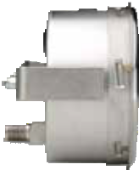 0.20"
(5 mm)

6.85"
(174 mm)

0.87"
(22 mm)
*1.95" (49.5 mm)

400/500 SERIES DIMENSIONS

* Dimension will be 0.67" (17 mm) for pressure ranges above 1,500 psi.
21

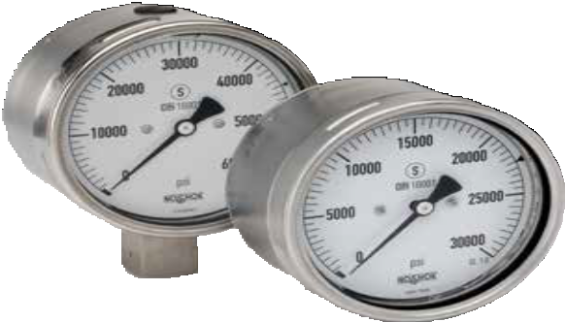

OPERATING SPECIFICATIONS
- Working Pressure Limitations
  - Dynamic Pressure
The working pressure should be limited to 65% of the dial range.
  - Static Pressure
The working pressure, where no sharp fluctuations occur, should be limited to 75% of the dial range

APPLICATIONS
  - Pumps & compressors
  - High pressure processing
  - Test equipment & systems
  - Water jet cutting

For details on accuracy/standard dial configuration
and dial layouts, see pages 56-61.

SERIES
- Corrosion-resistant dry or liquid-filled gauge for high pressure applications
402/502
- Ranges from 0 psi to 30,000 psi through 0 psi to 85,000 psi
- 4" and 6" gauge sizes
- Solid front design with a blow out back in accordance to EN 837, S3 Safety Pattern
- Stainless Steel case
- NiFe alloy/316L Stainless Steel wetted parts
- DIN 16001 compliant

SERIES SPECIFICATIONS

Pressure ranges | 402, 412 & 500 Series | 0 psi to 30,000 psi through 0 psi to 85,000 psi
Accuracy | ≤40,000 psi | ±1.6% full scale (optional 1% increased accuracy)
 | ≥50,000 psi | ±1% full scale (85,000 psi is ±1.6% accuracy)
Temperature ranges* | 402 & 412 Series | Media -40 °F to 392 °F (-40 °C to 200 °C)  Ambient -40 °F to 140 °F (-40 °C to 60 °C)
 | 502 Series | Media -4 °F to 212 °F (-20 °C to 100 °C) Glycerin fill  Ambient -4 °F to 140 °F (-20 °C to 60 °C) Glycerin fill
Measuring element | 402/502 Series (all) | NiFe alloy
Connection | 402/502 Series (all) | 316L Stainless Steel
Case | 402/502 Series (all) | Stainless Steel, solid front with blowout back
Cover ring | 402/502 Series (all) | Stainless Steel bayonet ring
Lens | 402/502 Series (all) | Laminated safety glass
Pointer | 402/502 Series (all) | Black finished Aluminum
Dial | 402/502 Series (all) | Aluminum, white background with black scale. UV resistant.
Movement | 402/502 Series (all) | Stainless Steel with highly polished bearing surfaces
Fill liquids | 502 Series  (Bottom connected only) | Glycerin
- For every 68 °F (20 °C) shift in temperature from which the gauge is calibrated, the user can experience up to ±0.4% additional error.

WARNING: This product can expose you to chemicals including Chromium (VI) and Nickel, which are known to the State of
California to cause cancer and birth defects or other reproductive harm. For more information go to www.P65Warnings.ca.gov

Dial Indicating Pressure Gauges
All Stainless Steel, Dry & Liquid Filled, Extreme High Pressure

22

ORDERING INFORMATION
GAUGE SIZE | 40 | 4″ | 60 | 6″ *
CASE TYPES | 402 | Dry, bottom connection | 412 | Dry, lower back connection | 502 | Liquid filled, bottom connection
PRESSURE RANGES | 30000  40000 | 0 psi to 30,000 psi  0 psi to 40,000 psi | 50000  60000 | 0 psi to 50,000 psi  0 psi to 60,000 psi | 75000  85000 | 0 psi to 75,000 psi  0 psi to 85,000 psi **
SCALE OPTIONS | psi  psi/kPa | psi single scale  psi/kPa dual scale | psi/kg/cm2  psi/bar | psi/kg/cm2 dual scale  psi/bar dual scale
CONNECTION SIZES *** | 9/16-18 | 9/16″-18 UNF 2B high pressure cone - Female | 9/16-HPM | 9/16″-18 UNF 2A left hand thread - Male
OPTIONS | BRSP LM  MIP | Bayonet Ring Adjustable Set Pointer Laser Marking  Maximum Indicating Pointer | SL SP  SSFF | Silicone Fill Red Set Pointer  304SS Front Flange | ST IA | Stainless Steel Tagging  Increased Accuracy

* Bottom connection only.
Please consult your local NOSHOK Distributor or NOSHOK, Inc. for availability and delivery information.

** Only available on 60-402 and 60-502 models, with ±1.6% accuracy.
402/502 SERIES INFORMATION
ORDERING
DIMENSIONS
*** Additional process connection sizes available, consult factory.

EXAMPLE 40 – 402 – 30000 – psi – 9/16-18 – BRSP

Gauge size 4"
Case type Dry, bottom connection
Pressure range & scale option psi to 30,000 psi
Connection size 9/16″-18 UNF 2B high pressure cone
Option Bayonet Ring Adjustable Set Pointer

9/16″-18 UNF 2B High Pressure Cone Connection

Female Male

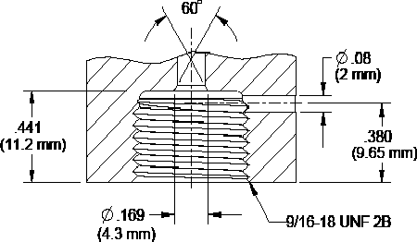
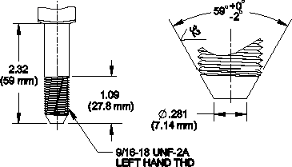

23

40-402/502 40-412

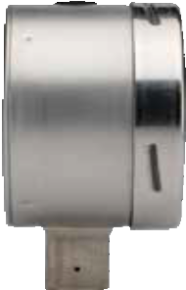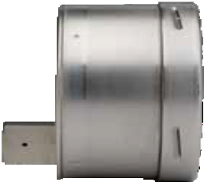2.34"
2.32"
(59 mm)
0.67"
(17 mm)
3.90"
(99 mm)
3.98"
(101 mm)
3.43"
(87 mm)
0.87" sq
(22 mm)
0.98"
(25 mm)
(59.5 mm)

0.67"
(17 mm)

3.90"
(99 mm)

1.18"
(30 mm)

3.98"
(101 mm)

0.87" sq
(22 mm)

3.66"
(93 mm)

60-402/502 40-402/502 Front Flange

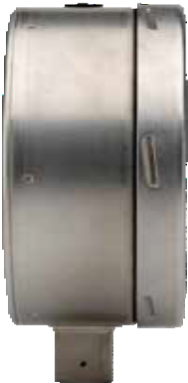 2.56"
(65 mm)

0.69"
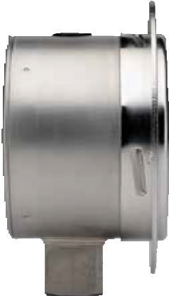 (17.5 mm)
2.32"
(59 mm)

0.24"
(6 mm)
3.90"
(99 mm)
5.20"
(132 mm)
3.98"
(101 mm)
3.43"
(87 mm)
0.87" sq (22 mm)
0.98"
(25 mm)

6.26"
(159 mm)

6.34"
(161 mm)

4.65"
(118 mm)

1.06"
(27 mm)
0.87" sq
(22 mm)

Dial Indicating Pressure Gauges
Dimensions

24

40-412 Front Flange

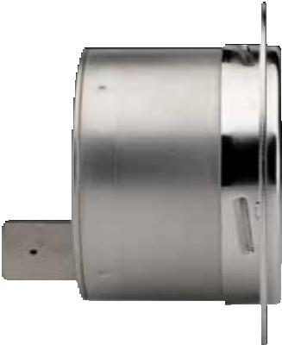
2.34"
(59.5 mm)
0.24"
(6 mm)
3.90"
(

99 mm)
3.98"
(101 mm)
5.20"
(132 mm)
1.18"
(30 mm)
0.87" sq
(22 mm)
3.43"
(87 mm)

60-402/502 Front Flange

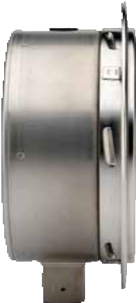 2.56"
(65 mm)

0.31"
(8 mm)

6.26"
(159 mm)

6.34"
(161 mm)
7.72"
(196 mm)

4.65"
(118 mm)

1.06"
(27 mm)

  - " sq
(22 mm)

402/502 SERIES DIMENSIONS
25

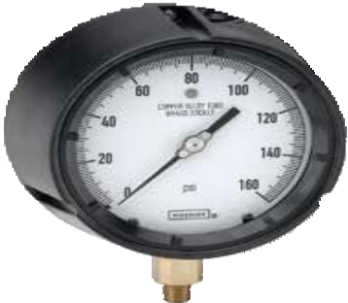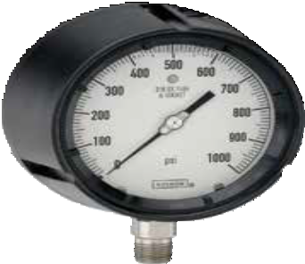SERIES
600/700

    - Turret style dry or liquid-filled gauge
    - Vacuum and compound ranges through 0 psi to 15,000 psi
    - 4-1/2" gauge sizes
    - Black phenolic safety case with solid front and blow-out back PBT
    - Phosphor bronze, 316 Stainless Steel and Brass wetted parts

OPERATING SPECIFICATIONS
 | SERIES SPECIFICATIONS
Pressure ranges | 600/700 Series (all) | Vacuum and compound ranges through 0 psi to 15,000 psi
Accuracy | 600/700 Series (all) | ±0.5% full scale
Temperature ranges* | 45-640 | Media -4 °F to 150 °F (-20 °C to 65 °C)  Ambient -40 °F to 150 °F (-40 °C to 65 °C)
 | 45-740 | Media -40 °F to 212 °F (-40 °C to 100 °C)  500 °F (260 °C) Maximum for short term/intermittent Ambient -40 °F to 150 °F (-40 °C to 65 °C)
 | 45-660 | Media -4 °F to 150 °F (-20 °C to 65 °C) Glycerin fill  -40 °F to 150 °F (-40 °C to 65 °C) Special fill  Ambient -4 °F to 150 °F (-20 °C to 65 °C) Glycerin fill  -40 °F to 150 °F (-40 °C to 65 °C) Special fill
 | 45-760 | Media -4 °F to 212 °F (-20 °C to 100 °C) Glycerin fill  -40 °F to 212 °F (-40 °C to 100 °C) Special fill  250 °F (130 °C) Maximum for short term/intermittent  Ambient -4 °F to 150 °F (-20 °C to 65 °C) Glycerin fill  -40 °F to 150 °F (-40 °C to 65 °C) Special fill
Case | 600/700 Series (all) | Turret style black phenolic case.  Solid front, safety case with blow-out back PBT.
Bayonet ring | 600/700 Series (all) | Threaded black PBT
Lens | 600/700 Series (all) | Acrylic
Measuring Element | 45-640, 45-660 (≤ 600 psi) | Copper alloy C-Type Bourdon tube
 | 45-740, 45-760 (≤ 600 psi) | 316 Stainless Steel C-Type Bourdon tube
 | 600/700 Series (all) (>600 psi) | 316 Stainless Steel coiled safety Bourdon tube
Connection | 45-640, 45-660 | 1/4″ NPT, Brass
 | 45-740, 45-760 | 1/4″ NPT or 1/2″ NPT, 316 Stainless Steel
Movement | 45-640, 45-660 | Brass and Nickel-silver with highly polished bear- ing surfaces. An internal zero stop is standard.
 | 45-740, 45-760 | Stainless Steel with highly polished bearing surfaces. An internal zero stop is standard.
Pointer | 600/700 Series (all) | Balanced micro-adjustable Aluminum, black finish
Dial | 600/700 Series (all) | Aluminum, white background with black scale. UV resistant.
Fill liquid ** | 45-660, 45-760 | Glycerin

- Working Pressure Limitations
  - Dynamic Pressure
The working pressure should be limited to 60% of the dial range.
  - Static Pressure
The working pressure, where no sharp fluctuations occur, should be limited to 90% of the dial range

APPLICATIONS
  - Injection molding machines
  - Laboratory & test equipment
  - Power generation
  - Oil field & offshore
  - Utilities
  - Water & wastewater

* For every 18 °F (10 °C) shift in temperature from which the gauge is calibrated, the user can experience up to ±0.4% additional error.

Dial Indicating Pressure Gauges
Process
** See page 51 for gauge fill options.

For details on accuracy/standard dial configuration
and dial layouts, see pages 56-61.

26

NOSHOK 600 Series Gauges:
WARNING: This product can expose you to chemicals including Lead, which is known to the State of California to cause cancer and birth defects or other reproductive harm. For more information go to www.P65Warnings.ca.gov

NOSHOK 700 Series Gauges:
WARNING: This product can expose you to chemicals including Chromium (VI) and Nickel, which are known to the State of
California to cause cancer and birth defects or other reproductive harm. For more information go to www.P65Warnings.ca.gov

ORDERING INFORMATION
GAUGE SIZES 45 4-1/2″
CASE TYPES | 640 | Brass, dry, bottom connection | 660 | Brass, liquid filled, bottom connection
 | 740 | SS, dry, bottom connection | 760 | SS, liquid filled, bottom connection
PRESSURE | 30vac | -30 inHg to 0 psi | 30/300 | -30 inHg to 0 to 300 psi | 300 | 0 psi to 300 psi | 3000 | 0 psi to 3,000 psi
RANGES | 30/15 | -30 inHg to 0 to 15 psi | 15 | 0 psi to 15 psi | 400 | 0 psi to 400 psi | 5000 | 0 psi to 5,000 psi
 | 30/30 | -30 inHg to 0 to 30 psi | 30 | 0 psi to 30 psi | 600 | 0 psi to 600 psi | 6000 | 0 psi to 6,000 psi
 | 30/60 | -30 inHg to 0 to 60 psi | 60 | 0 psi to 60 psi | 800 | 0 psi to 800 psi | 10000 | 0 psi to 10,000 psi
 | 30/100 | -30 inHg to 0 to 100 psi | 100 | 0 psi to 100 psi | 1000 | 0 psi to 1,000 psi | 15000 | 0 psi to 15,000 psi
 | 30/160 | -30 inHg to 0 to 160 psi | 160 | 0 psi to 160 psi | 1500 | 0 psi to 1,500 psi
 | 30/200 | -30 inHg to 0 to 200 psi | 200 | 0 psi to 200 psi | 2000 | 0 psi to 2,000 psi
SCALE OPTIONS | psi | psi single scale | psi/kg/cm2 | psi/kg/cm2 dual scale | psi/bar | psi/bar dual scale
CONNECTION SIZES | 1/4 | 1/4″ NPT | 1/2 | 1/2″ NPT
OPTIONS | SG GL MIP  BPMR | Safety Glass Lens Glass Lens  Maximum Indicating Pointer  Uninstalled Black Panel Mount Ring | CPMR OS LM  ST | Uninstalled Chrome Panel Mount Ring Overload Stop  Laser Marking  Stainless Steel Tagging | BP3 BT3 ST8 | Brass Press Fit Orifice 0.3 mm Brass Threaded Orifice 0.3 mm 316SS Threaded Orifice 0.8 mm
Please consult your local NOSHOK Distributor or NOSHOK, Inc. for availability and delivery information.
NOTE: Refer to 600/700 Series Options & Accessories chart on page 52 for availability by part number.

EXAMPLE 45 – 740 – 100 – psi – 1/2 – ST8

Gauge size .. 4-1/2"
Case type SS internals, dry, bottom connection
Pressure range & scale option psi to 100 psi
Connection size 1/2" NPT
Option 316SS Threaded Orifice 0.8 mm

45-640/660 & 45-740/760
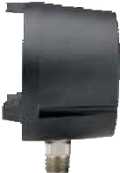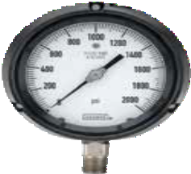 3.39"
5.83" 5.39"
(148 mm) (137 mm)
0.43"
(11 mm)
0.24"
(6 mm)
0.87"
(22 mm)
(86 mm)

3.82"
5.08"
(129 mm)

1.06" (27 mm)
1.69" (43 mm)
(97 mm)

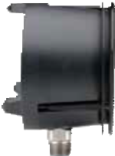 45-640/660 & 45-740/760 Panel Mount Ring
600/700 SERIES INFORMATION
ORDERING
DIMENSIONS
3.46"
(88 mm)
5.83" 5.39"
(148 mm) (137 mm)
5.98"
(152 mm)
3.82"
(97 mm)
0.87"
(22 mm)
1.69" (43 mm)
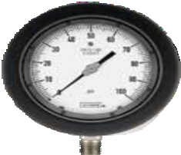
27

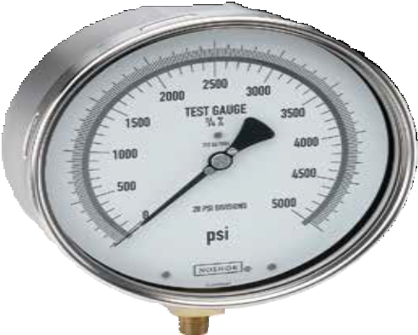

OPERATING SPECIFICATIONS
- Working Pressure Limitations
  - Static Pressure
The working pressure, where no sharp fluctuations occur, should be limited to 100% of the dial range. NOTE: 800 Series Precision Test gauges are not intended for dynamic applications.

APPLICATIONS
  - Aerospace equipment
  - Gauge repair facilities
  - Laboratory & test equipment
  - Precision measurement

SERIES

- Highly accurate dry gauge
800
- Vacuum and compound ranges through 0 psi to 6,000 psi
- 6" gauge size
- Stainless Steel case
- Beryllium copper, 316 Stainless Steel, and Brass wetted parts

 | SERIES SPECIFICATIONS
Pressure ranges | 60-800 | Vacuum and compound ranges through 0 psi to 6,000 psi
Accuracy | 60-800 | ±0.25% full scale
Temperature ranges* | 60-800 | Media -40 °F to 180 °F (-40 °C to 80 °C)  Ambient -40 °F to 140 °F (-40 °C to 60 °C)
Measuring element | 60-800 | Beryllium copper Bourdon tube to 1,000 psi 316 SS Bourdon tube 1,500 psi to 6,000 psi
Connection | 60-800 | 1/4″ NPT bottom connection, Brass
Case | 60-800 | 304 Stainless Steel
Cover ring | 60-800 | 304 Stainless Steel
Lens | 60-800 | Instrument glass
Pointer | 60-800 | Adjustable knife-edge pointer
Dial | 60-800 | Aluminum, white mirrored background with black scale.
Movement | 60-800 | Brass with jeweled bearings Nickel-silver pinion gear and shafts
- For every 18 °F (10 °C) shift in temperature from which the gauge is calibrated, the user can experience up to ±0.4% additional error.

Dial Indicating Pressure Gauges
Precision Test

For details on accuracy/standard dial configuration
and dial layouts, see pages 56-61.

WARNING: This product can expose you to chemicals including Lead, which is known to the State of California to
28 cause cancer and birth defects or other reproductive harm. For more information go to www.P65Warnings.ca.gov

ORDERING INFORMATION
GAUGE SIZE 60 6″
CASE TYPE | 800 | SS Case, bottom connection
PRESSURE | 30vac | -30 inHg to 0 psi | 30/300 | -30 inHg to 0 to 300 psi | 300 | 0 psi to 300 psi | 5000 | 0 psi to 5,000 psi
RANGES | 30/15 | -30 inHg to 0 to 15 psi | 15 | 0 psi to 15 psi | 400 | 0 psi to 400 psi | 6000 | 0 psi to 6,000 psi
 | 30/30 | -30 inHg to 0 to 30 psi | 30 | 0 psi to 30 psi | 600 | 0 psi to 600 psi
 | 30/60 | -30 inHg to 0 to 60 psi | 60 | 0 psi to 60 psi | 1000 | 0 psi to 1,000 psi
 | 30/100 | -30 inHg to 0 to 100 psi | 100 | 0 psi to 100 psi | 1500 | 0 psi to 1,500 psi
 | 30/160 | -30 inHg to 0 to 160 psi | 160 | 0 psi to 160 psi | 2000 | 0 psi to 2,000 psi
 | 30/200 | -30 inHg to 0 to 200 psi | 200 | 0 psi to 200 psi | 3000 | 0 psi to 3,000 psi
SCALE OPTION | psi | psi single scale
CONNECTION SIZES |  | 1/4 1/4″ NPT | 1/2 1/2″ NPT |  | SST SAE J1926-3: 7/16-20 Adjustable
OPTIONS | SSFF SSRF GC  LM | 304SS Front Flange 304SS Rear Flange Gauge Carrying Case  Laser Marking | ST BP3 BT8 | Stainless Steel Tagging  Brass Press Fit Orifice 0.3 mm Brass Threaded Orifice 0.8 mm
Please consult your local NOSHOK Distributor or NOSHOK, Inc. for availability and delivery information.
NOTE: Refer to 800 Series Options & Accessories chart on page 52 for availability by part number.

EXAMPLE 60 – 800 – 100 – psi – 1/4 – GC

Gauge size 6"
Case type SS case, bottom connection
Pressure range & scale option psi to 100 psi
Connection size 1/4" NPT
Option Gauge Carrying Case

60-800* 60-800 Front Flange 60-800 Rear Flange

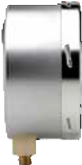*1.95" (49.5 mm)
7.72" (196 mm)
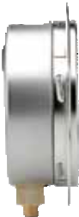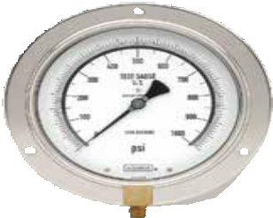7.01" (178 mm)
0.12"
(3 mm)
*2.07" (52.5 mm)
6.34"
(161 mm)

4.61"
(117 mm)

0.87"
(22 mm)
*1.63" (41.5 mm)
0.31"
(8 mm)
6.34"
(161 mm)

4.61"
(117 mm)
0.87 "
(22 mm)

4.61"
(117 mm)

6.34"
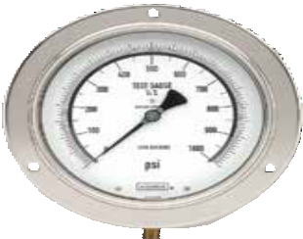(161 m
7.72" (196 mm)
7.01" (178 mm)
m)
0.23"
(58 mm)

0.61" (15.5 mm)
0.87"
(22 mm)

120°

0.61" (15.5 mm)

120°

0.61" (15.5 mm)

*For ranges ≤60 psi and ≥1,500 psi,
800 SERIES INFORMATION
ORDERING
DIMENSIONS
increase by 0.63" (16 mm)

29

Dial Indicating Pressure Gauges
ABS & Stainless Steel Case, Liquid Filled

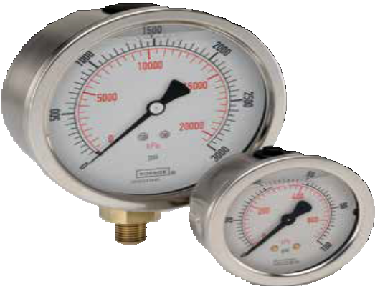

OPERATING SPECIFICATIONS
- Working Pressure Limitations

Dynamic Pressure
The working pressure should be limited to 60% of the dial range.
  - Static Pressure
The working pressure, where no sharp fluctuations occur, should be limited to 90% of the dial range

APPLICATIONS
  - Automotive
  - Construction
  - Hydraulics & pneumatics
  - Power generation
  - Transportation
  - Water management

For details on accuracy/standard dial configuration
and dial layouts, see pages 56-61.

30

SERIES

- High quality liquid filled gauge
900
- Vacuum and compound ranges through 0 psi to 15,000 psi
- 1-1/2", 2", 2-1/2" and 4" gauge sizes
- Impact-resistant ABS and Stainless Steel case
- Copper alloy and Brass wetted parts

 | SERIES SPECIFICATIONS
Pressure ranges | 900 Series (all) | Vacuum and compound ranges through 0 psi to 15,000 psi
Accuracy | 15-910 | ±2.5% full scale
 | 25-900, 25-910, 25-901, 25-911 | ±1.6% full scale
 | 40-901, 40-911 | ±1% full scale
Temperature ranges* | 900 Series (all) | Media -4 °F to 140 °F (-20 °C to 60 °C) Glycerin fill  -40 °F to 140 °F (-40 °C to 60 °C) Special fill  Ambient -4 °F to 140 °F (-20 °C to 60 °C) Glycerin fill  -40 °F to 140 °F (-40 °C to 60 °C) Special fill
Measuring element | 900 Series (up to 600 psi) | Copper alloy C-Type Bourdon tube
 | 900 Series (> 600 psi) | Coiled safety tube
Connection | 15-910 | 1/8″ NPT, Brass
 | 25-900, 25-910, 25-901, 25-911 | 1/4″ NPT or 7/16”-20 adjustable, Brass
 | 40-901, 40-911 | 1/4″ NPT, Brass 1/2″ NPT, Brass
Case | 15-910, 25-900, 25-910 | ABS with safety relief plug
 | 25-901, 25-911, 40-901, 40-911 | 304 Stainless Steel
Bezel | 25-901, 25-911, 40-901, 40-911 | 304 Stainless Steel
Lens | 15-910, 25-900, 25-910 | Acrylic; ultrasonically welded to the case
 | 25-901, 25-911, 40-901 | Polycarbonate
Pointer | 15-910, 25-900, 25-910, 25-901, 25-911 | Molded plastic
 | 40-901, 40-911 | Balanced Aluminum, black finish
Dial | 15-910, 25-900, 25-910, 25-901,  25-911 | Molded plastic, white background with black primary scale & red secondary scale.  UV resistant
 | 40-901, 40-911 | Aluminum, white background with black primary scale & red secondary scale. UV resistant.
Movement | 15-910, 25-900, 25-910, 25-901, 25-911 | Brass and nylon with highly polished bearing surfaces
Fill liquid** | 15-910 | 86.5/13.5 Glycerin:H2O
- For every 18 °F (10 °C) shift in temperature from which the gauge is calibrated, the user can experience up to ±0.4% additional error.
**See page 51 for gauge fill options.

WARNING: This product can expose you to chemicals including Lead, which is known to the State of California to cause cancer and birth defects or other reproductive harm. For more information go to www.P65Warnings.ca.gov

900 SERIES INFORMATION
ORDERING
DIMENSIONS

ORDERING INFORMATION
GAUGE SIZES | 15 | 1-1/2″ | 20 | 2″ | 25 | 2-1/2″ 40 | 4″
CASE TYPES | 900  901 | ABS Case, bottom connection  SS Case, bottom connection |  |  | 910  911 | ABS Case, back connection  SS Case, back connection
PRESSURE | 30vac | -30 inHg to 0 psi | 100 | 0 psi to 100 psi | 5000 | 0 psi to 5,000 psi 10 | 0 bar to 10 bar
RANGES | 30/15 | -30 inHg to 0 to 15 psi | 160 | 0 psi to 160 psi | 6000 | 0 psi to 6,000 psi 16 | 0 bar to 16 bar
 | 30/30 | -30 inHg to 0 to 30 psi | 200 | 0 psi to 200 psi | 7500 | 0 psi to 7,500 psi 25 | 0 bar to 25 bar
 | 30/60 | -30 inHg to 0 to 60 psi | 300 | 0 psi to 300 psi | 10000 | 0 psi to 10,000 psi 40 | 0 bar to 40 bar
 | 30/100 | -30 inHg to 0 to 100 psi | 400 | 0 psi to 400 psi | 15000 | 0 psi to 15,000 psi 60 | 0 bar to 60 bar
 | 30/160 | -30 inHg to 0 to 160 psi | 600 | 0 psi to 600 psi | −1 | −1 bar to 0 bar 100 | 0 bar to 100 bar
 | 30/200 | -30 inHg to 0 to 200 psi | 800 | 0 psi to 800 psi | 1 | 0 bar to 1 bar 160 | 0 bar to 160 bar
 | 30/300 | -30 inHg to 0 to 300 psi | 1000 | 0 psi to 1,000 psi | 1.6 | 0 bar to 1.6 bar 250 | 0 bar to 250 bar
 | 15 | 0 psi to 15 psi | 1500 | 0 psi to 1,500 psi | 2.5 | 0 bar to 2.5 bar 400 | 0 bar to 400 bar
 | 30 | 0 psi to 30 psi | 2000 | 0 psi to 2,000 psi | 4 | 0 bar to 4 bar 600 | 0 bar to 600 bar
 | 60 | 0 psi to 60 psi | 3000 | 0 psi to 3,000 psi | 6 | 0 bar to 6 bar 1000 | 0 bar to 1,000 bar
SCALE OPTIONS | psi  psi/bar | psi single scale  psi/bar dual scale | psi/kg/cm2 | psi/kg/cm2 dual scale | bar/psi | bar/psi dual scale psi/kPa | psi/kPa dual scale
CONNECTION SIZES | 1/8 | 1/8″ NPT | 1/4 | 1/4″ NPT | 1/2 | 1/2″ NPT SST | SAE J1926-3:7/16-20 Adjustable *
OPTIONS | PMC SPMC SSBU  SSB | Steel Panel Mount Clamp 304SS Panel Mount Clamp Stainless Steel Bezel & U-clamp  Stainless Steel Bezel | AP MIP SP  SG | Adjustable Pointer Maximum Indicating Pointer Red Set Pointer  Safety Glass Lens | SSFF SSRF LM  ST | 304SS Front Flange BP3  304SS Rear Flange BT5  Laser Marking BT8  Stainless Steel Tagging | Brass Press Fit Orifice 0.3 mm Brass Threaded Orifice 0.5 mm Brass Threaded Orifice 0.8 mm
 | SSCR | 304SS Cover Ring | BLFF | Black Front Flange
Please consult your local NOSHOK Distributor or NOSHOK, Inc. for availability and delivery information.
NOTE: Refer to 900 Series Options & Accessories chart on page 53 for availability by series number.
* Includes FKM o-ring

EXAMPLE 25 – 910 – 1000 – psi /kPa – 1/4 – PMC

Gauge size .. 2-1/2"
Case type ABS case, liquid filled, back connection
Pressure range & scale option 0 psi to 1,000 psi/kPa
Connection size 1/4" NPT
Option Panel Mount Clamp

25-900 25-901
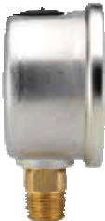 1.26"
2.13"
(54 mm)
2.83"
(72 mm)
2.13"
(54 mm)

0.55"
(14 mm)
0.45" (11.5 mm)
(32 mm)

2.68"
(68 mm)

2.13"
(54 mm)

0.55"
(14 mm)
0.51" (13 mm)

31

15-910 25-910 25-911

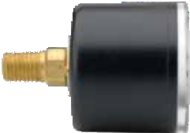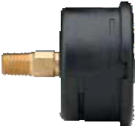 1.89"
1.67" (42.5 mm)
1.61"
(41 mm)
0.47"
(12 mm)
1.04" (26.5 mm)
(48 mm)

0.24" (6 mm)
1.85"
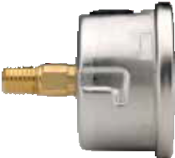(47 mm)

0.20" (5 mm)

2.48"
(63 mm)
0.55"

2.68"
(68 mm)
2.45"
(62.2 mm)
0.55"
2.68"
(68 mm)

(14 mm)
(14 mm)

1.14"
(29 mm)
1.26"
(32 mm)

40-901 40-911

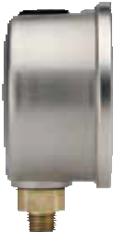 1.85"
(47 mm)

* 2.58"
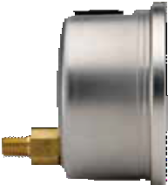(65.5 mm) 0.30"
(7.5 mm)

3.94"
(100 mm)

* 3.15"
(80 mm)

4.21"
(107 mm)

3.94"
(100 mm) 1.18"
(30 mm)

4.21"
(107 mm)

- 1/4" NPT shown
Add 6 mm for 1/2" NPT

0.61"
(15.5 mm)
0.87"
(22 mm)

0.87"
(22 mm)

1.85"
(47 mm)

25-910 Front Flange 25-911 Front Flange

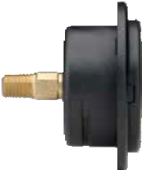 1.73"
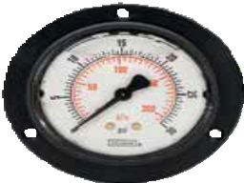(44 mm)
3.35" (85 mm)
2.95" (75 mm)

0.39" (10 mm)

1.77"
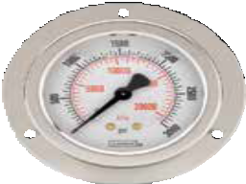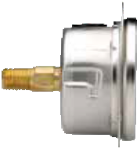(45 mm) 0.28" (7 mm)
2.95" (75 mm)
3.35" (85 mm)

0.14" (3.6 mm)

0.55"
(14 mm)

2.48"
(63 mm)

0.14"
(3.6 mm)

0.55"
(14 mm)
2.45"
(62.2 mm)

Dial Indicating Pressure Gauges
Dimensions

120°

32

1.14"
(29 mm)

120°

1.26"
(32 mm)

40-911 Front Flange 40-901 Rear Flange

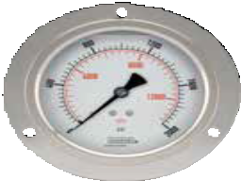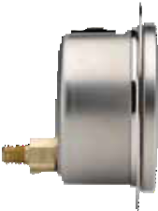2.53" (64.2 mm)
5.20" (132 mm)
4.57" (116 mm)

0.35"
(8.8 mm)
5.20" (132 mm)
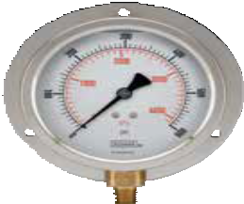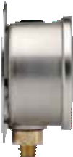4.57" (116 mm)
0.08"
(2 mm)
1.93"
(49 mm)
4.21"
(107 mm)
3.15"
(80 mm)

0.69"
0.87"
(22 mm)

0.19"
(4.8 mm)

1.18"
(30 mm)
4.21"
(107 mm)
0.14 " (3.6 mm)

120°
0.87"
(22 mm)

1.85"
(47 mm)

120°

(17.5 mm)

40-911 Rear Flange 25-911 Flange Ring

0.14" (3.6 mm)

0.08"
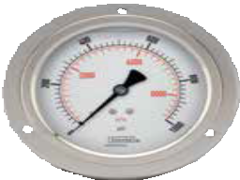(2 mm)
5.20" (132 mm)
4.57" (116 mm)

1.18"
(30 mm)
1.93"
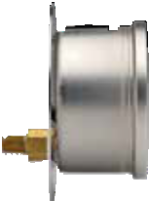(49 mm)

4.21"
(107 mm)

2.45"
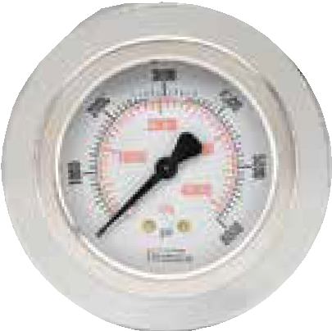(62.2 mm)
3.35" (85 mm)

2.05"
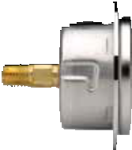(52 mm)

0.55"
(14 mm)

0.98" 0.28"

120°
2.87"
(73 mm)
(25 mm)
(7 mm)

25-910 Panel Mount Clamp 25-911 Panel Mount Clamp

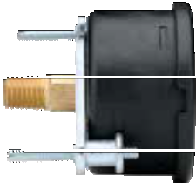 1.89"
(48 mm) 0.24" (6 mm)

1.85"
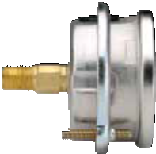(47 mm) 0.20" (5 mm)

2.45"
(62.2 mm)
2.68"
(68 mm)

2.45"
(62.2 mm)
2.68"
(68 mm)

900 SERIES DIMENSIONS
1.14"
(29 mm)

1.26"
(32 mm)

33

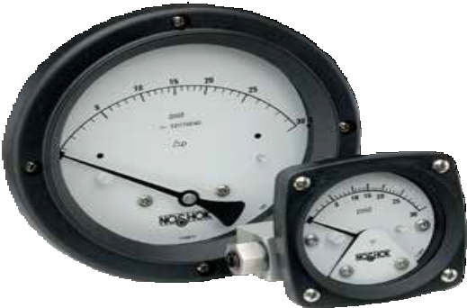
1000 SERIES

Simple, rugged, compact differential pressure gauge
  - Ranges from 0 psid to 5 psid through 0 psid to 110 psid
  - 2-1/2", 4-1/2" and 6" gauge sizes
  - Engineered plastic gauge case
  - Clear anodized Aluminum and 316 Stainless Steel wetted parts

SPECIFICATIONS

Pressure ranges 0 psid to 5 psid through 0 psid to 110 psid
Max. working static pressure Aluminum 3,000 psig; Stainless Steel 6,000 psig

Accuracy ±3/2/3% of full scale on rising pressure

APPLICATIONS

Heat exchangers
  - Filter monitoring
Temperature ranges (Including switch option)

Temperature ranges
(4-20 mA transmitter option)
Media -40 °F to 200 °F (-40 °C to 93 °C)
Ambient -40 °F to 200 °F (-40 °C to 93 °C)
Storage -40 °F to 200 °F (-40 °C to 93 °C)
Ambient -20 °F to 150 °F (-29 °C to 66 °C)

Flow indication
  - Level indication
Measuring element 316 Stainless Steel and ceramic piston/magnet

O-ring & diaphragm material NBR

Connection 1/4” NPT female, back connection

Sensor housing material Clear anodized Aluminum

Case Engineered plastic

Bezel Engineered plastic

Lens Shatter-resistant acrylic

Pointer Balanced Aluminum, black finish

Dial Aluminum, white background with black scale

Movement Magnetic

SPDT, 3W, 0.25 Amp, 125 Vac/Vdc (standard) (switch adjustable range of 15-95%). Other options available, consult factory.
Optional switch rating

Differential Pressure Gauges
Piston Type

WARNING: This product can expose you to chemicals including Chromium (VI) and Nickel, which are known to the State of
34 California to cause cancer and birth defects or other reproductive harm. For more information go to www.P65Warnings.ca.gov

1000 SERIES INFORMATION
ORDERING
DIMENSIONS

ORDERING INFORMATION
GAUGE SIZES & SERIES | 25 - 10 | 2-1/2″ | 45 - 10 | 4-1/2″ | 60 - 10 | 6″
CONNECTION LOCATIONS | 0 | Bottom | 1 | Back | 2 | Side
CONNECTION SIZE | 2 | 1/4″ NPT female | 9 | 7/16-20 female (Back only)
PRESSURE RANGES * | P5  P10 P15 | 0 psid to 5 psid  0 psid to 10 psid  0 psid to 15 psid | P20  P25 P30 | 0 psid to 20 psid  0 psid to 25 psid  0 psid to 30 psid | P50  P60 P75 | 0 psid to 50 psid  0 psid to 60 psid  0 psid to 75 psid | P100 P110 | 0 psid to 100 psid  0 psid to 110 psid
SENSOR HOUSING MATERIALS | A | Aluminum (3,000 max working pressure) |  |  | S | 316L Stainless Steel (6,000 max working pressure)
O-RING & DIAPHRAGM | 1 | PTFE | 3 | NBR
MATERIALS | 2 | FKM | 4 | EPDM
CASE MATERIALS | A | Aluminum (4-1/2" only) | P | Engineered plastic
LENSES | 1 | Shatter-resistant acrylic | 2 | Safety glass ** | 3 | Maximum indicating pointer (MIP) ***
FILL FLUID (optional) | GY | Glycerin | SL | Silicone †
SWITCH OR TRANSMITTER TYPE | 1 | Single switch, flying leads with grommet wire seal |  |  | 5 | Single switch with Hirschman electrical connection
& HOUSING | 2 | Dual switch, flying leads with grommet wire seal |  |  | 6 | Dual switch with Hirschman electrical connection
 | 3 | Single switch, flying leads with 1/4" female NPT, NEMA 4X |  |  | 7 | 4-20 mA transmitter in NEMA 4x IP65 plastic enclosure with terminal
 | 4 | Dual switch, flying leads with 1/4" female NPT, NEMA 4X |  |  |  | strip (1/2" female NPT conduit connection)
OPTIONS | MH MK5-CS  MK5-SS | (2) 1/4-20 Mounting Holes Pipe Mounting Kit, Steel  Pipe Mounting Kit, Stainless Steel |  |  | RP ST  WMK | Reversed Ports Stainless Steel Tagging  Wall Mounting Kit
Please consult your local NOSHOK Distributor or NOSHOK, Inc. for availability and delivery information.
- Other ranges and scales available on request.
** Only available with dry, 4-1/2" gauge size with Aluminum case.
*** Available with dry gauge only, 2-1/2" and 4-1/2" gauge sizes only.
† Optional Silicone filling available with 2-1/2" and 6" gauge case sizes, and 4-1/2" gauge case size with Aluminum case and standard shatter-resistant acrylic lens only.

EXAMPLE 25-10 1 2 – P5 – A 2 P – 1

Gauge size & series .. 2-1/2" 1000 Series

Connection location Back
Connection size 1/4" NPT female
Pressure range 0 psid to 5 psid
Sensor housing material Aluminum, clear

O-ring material FKM
Case material Engineered plastic
Lens Shatter-resistant acrylic

35

2-1/2" Gauge

1.42"
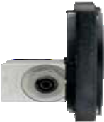(36.0 mm)

0.12" (3.1 mm)

3.39"
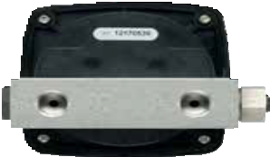(86.0 mm)

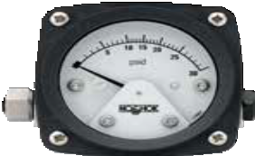1.00"
3.29"
(83.5 mm)
3.29" (83.5 mm)
(25.4 mm)

Ø3.00" (76.1 mm)

1.25"
(31.8 mm)

2.00"
(50.7 mm)

2.12"
(53.8 mm)

4.0"
(102 mm)
0.50"
(12.7 mm)

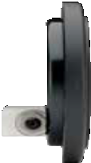 4-1/2" Gauge

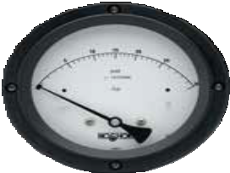Ø6.30" (Ø160.0 mm)

1.25" (31.8 mm)

0.14" (3.6 mm)

1.00" (25.4 mm)

Ø5.22" (132.5 mm)

1.47"
(37.3 mm)

1.72" (43.6 mm)
2.43"
(61.7 mm)
2.12"
(53.8 mm)

3.39" (86.0 mm)

4.0" (102 mm)

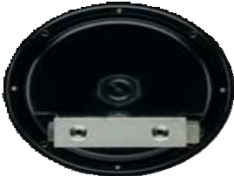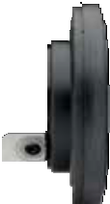 6" Gauge

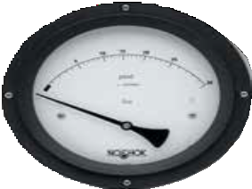Ø8.18" (Ø207.6 mm)

1.25" (31.8 mm)
0.15" (3.8 mm)

1.00"
(25.4 mm)

Ø6.95" (176.4 mm)

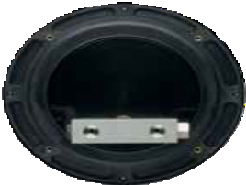1.55"

2.12" (53.8 mm)

3.39" (86.0 mm)

4.0" (102 mm)
(39.4 mm)

2.04" (51.7 mm)

Differential Pressure Gauges
Dimensions

36

2.98"
(75.8 mm)

1000 SERIES

Single switch, flying leads with grommet wire seal Dual switch, flying leads with grommet wire seal

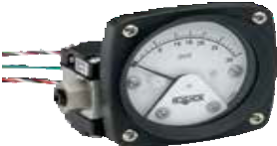
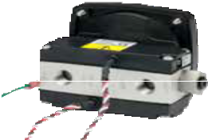
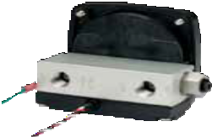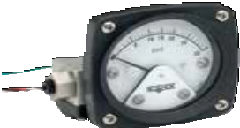

Single switch, flying leads with 1/4" female NPT, NEMA 4X Dual switch, flying leads with 1/4" female NPT, NEMA 4X

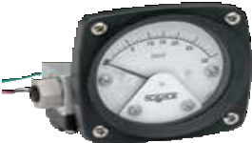
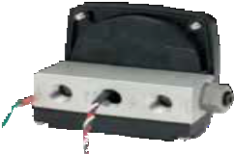
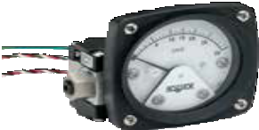
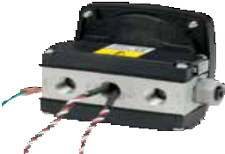

Single switch with Hirschman electrical connection Dual switch with Hirschman electrical connection
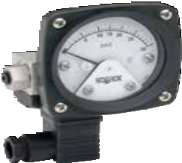
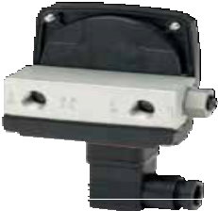
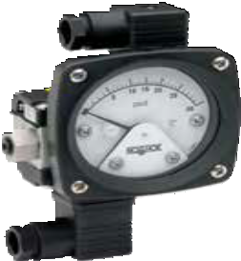
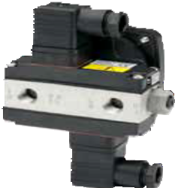

4-20 mA transmitter in NEMA 4x IP65 plastic enclosure with terminal strip (1/2" female NPT conduit connection)

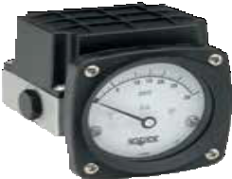
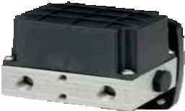

37

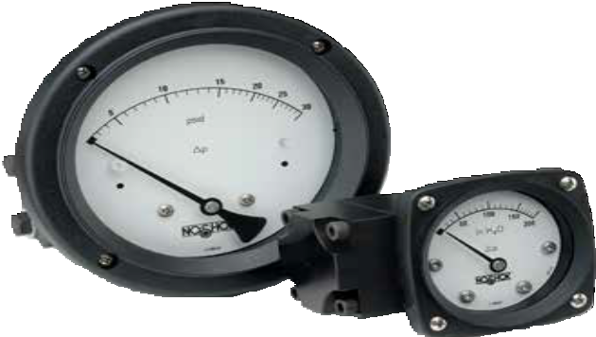
1100 SERIES

Simple, rugged, compact differential pressure gauge
  - Ranges from 0 inH2O to 20 inH2O through 0 psid to 100 psid
  - 2-1/2", 4-1/2" and 6" gauge sizes
  - Engineered plastic gauge case
  - Black anodized Aluminum and 316 Stainless Steel wetted parts

SPECIFICATIONS

Pressure ranges 0 inH2O to 20 inH2O through 0 psid to 100 psid

Max. working static pressure Aluminum & Stainless Steel 3,000 psig; Brass 1,500 psig

Accuracy ±3/2/3% of full scale on rising pressure

APPLICATIONS

Heat exchangers
Temperature ranges (Including switch option)

Temperature ranges
Media -40 °F to 200 °F (-40 °C to 93 °C)
Ambient -40 °F to 200 °F (-40 °C to 93 °C)
Storage -40 °F to 200 °F (-40 °C to 93 °C)
Ambient -20 °F to 150 °F (-29 °C to 66 °C)

Filter monitoring
  - Flow indication
  - Level indication
(4-20 mA transmitter option) Measuring element 316 Stainless Steel and ceramic magnet
O-ring & diaphragm material NBR

Connection 1/4” NPT female, back connection

Sensor housing material Black anodized Aluminum

Case Engineered plastic

Bezel Engineered plastic

Lens Shatter-resistant acrylic

Pointer Balanced Aluminum, black finish

Dial Aluminum, white background with black scale

Movement Magnetic

SPDT, 3W, 0.25 Amp, 125 Vac/Vdc (standard) (switch adjustable range of 15-95%). Other options available, consult factory.
Optional switch rating

Differential Pressure Gauges
Diaphragm Type

WARNING: This product can expose you to chemicals including Chromium (VI) and Nickel, which are known to the State of
38 California to cause cancer and birth defects or other reproductive harm. For more information go to www.P65Warnings.ca.gov

1100 SERIES INFORMATION
ORDERING
DIMENSIONS

ORDERING INFORMATION
GAUGE SIZES & SERIES | 25 - 11 | 2-1/2″ | 45 - 11 | 4-1/2″ | 60 - 11 | 6″
CONNECTION LOCATIONS | 0 | Dual top & bottom *** | 1 | Back | 2 | Side | 3 | Bottom
CONNECTION SIZE | 2 | 1/4″ NPT female | 9 | 7/16-20 female (Back or side only)
PRESSURE RANGES* | W20 | 0 inH2O to 20 inH2O | W75 | 0 inH2O to 75 inH2O | W400 | 0 inH2O to 400 inH2O | P30 | 0 psid to 30 psid
 | W25 | 0 inH2O to 25 inH2O | W100 | 0 inH2O to 100 inH2O | P5 | 0 psid to 5 psid | P50 | 0 psid to 50 psid
 | W30 | 0 inH2O to 30 inH2O | W135 | 0 inH2O to 135 inH2O | P10 | 0 psid to 10 psid | P60 | 0 psid to 60 psid
 | W40 | 0 inH2O to 40 inH2O | W150 | 0 inH2O to 150 inH2O | P15 | 0 psid to 15 psid | P75 | 0 psid to 75 psid
 | W50 | 0 inH2O to 50 inH2O | W200 | 0 inH2O to 200 inH2O | P20 | 0 psid to 20 psid | P100 | 0 psid to 100 psid
 | W60 | 0 inH2O to 60 inH2O | W300 | 0 inH2O to 300 inH2O | P25 | 0 psid to 25 psid
SENSOR HOUSING MATERIALS | A | Aluminum, black | B | Brass | S | 316L Stainless Steel
O-RING & DIAPHRAGM MATERIALS | 2 | FKM | 3 | NBR | 4 | EPDM
CASE MATERIAL | A | Aluminum (4-1/2" only) | P | Engineered plastic
LENSES | 1 | Shatter-resistant acrylic | 2 | Safety glass** | 3 | Maximum indicating pointer (MIP) †
FILL FLUIDS (optional) | GY | Glycerin | SL | Silicone † †
SWITCH OR TRANSMITTER TYPE & HOUSING (OPTIONAL) | 3  4 | Single switch, NEMA 4X  Dual switch, NEMA 4X |  |  | 7 | 4-20 mA transmitter in NEMA 4x IP65 plastic enclosure with  terminal strip (1/2" female NPT conduit connection).
OPTIONS | MH MK5-CS  MK5-SS | (2) 1/4-20 Mounting Holes Pipe Mounting Kit, Steel  Pipe Mounting Kit, Stainless Steel |  | RP ST  WMK |  | Reversed Ports Stainless Steel Tagging  Wall Mounting Kit
Please consult your local NOSHOK Distributor or NOSHOK, Inc. for availability and delivery information.
* Other ranges and scales available on request.
** Only available with dry, 4-1/2" gauge size with Aluminum case.
*** Not available with switch or transmitter option.
† Available with dry gauge only, 2-1/2" and 4-1/2" gauge sizes only.
† † Optional Silicone filling available with 2-1/2" and 6" gauge case sizes, and 4-1/2" gauge case size with Aluminum case and standard shatter-resistant acrylic lens only.

EXAMPLE 25-11 1 2 – P75 – A 2 P – 1

Gauge size & series .. 2-1/2" 1100 Series

Connection location Back
Connection size 1/4" NPT female
Pressure range 0 psid to 75 psid
Sensor housing material Aluminum, black

O-ring material FKM
Case material Engineered plastic
Lens Shatter-resistant acrylic

39

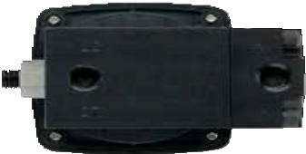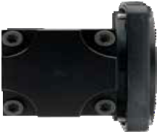 2-1/2" Gauge (<25 psid)
1.30"
(71.1 mm)
3.85"
(97.8 mm)
4.4"
(112 mm)
2.00" 0.12" (50.8 mm) (3.1 mm)
2.00"
(50.8 mm)
Ø3.00" (76.1 mm)
2.19"
(55.7 mm)
2.78"
(70.7 mm)
(33.0 mm)
2.80"

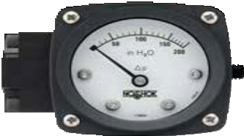 0.04"
3.29"
(83.5 mm)
3.29" (83.5 mm)
(1.1 mm)

4-1/2" Gauge (<25 psid)

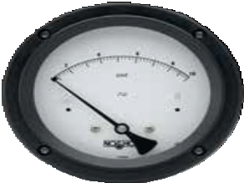Ø6.30" (Ø160.0 mm)

2.00 (50.8 mm)

0.14" (3.6 mm)

1.30" (33.0 mm)

2.00" (50.8 mm)
Ø5.22" (132.5 mm)

1.02"
(25.8 mm)

2.47"
(62.7 mm)
3.20"
(81.3 mm)
2.80"
(71.1 mm)
3.85" (97.8 mm)

4.4" (112 mm)

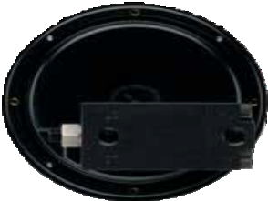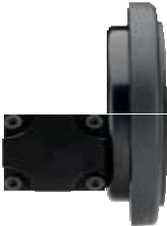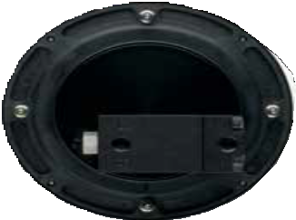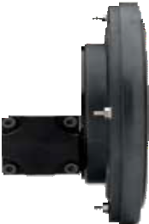 6" Gauge (<25 psid)
1.30" (33.0 mm)
2.80"
(71.1 mm)
3.85" (97.8 mm)

4.4" (112 mm)

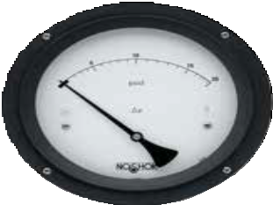Ø8.18" (Ø207.6 mm)

2.00 (50.8 mm)
0.15" (3.8 mm)

2.00" (50.8 mm)
Ø6.95" (176.4 mm)

1.10"
(27.9 mm)

Differential Pressure Gauges
Dimensions

2.79"
(70.9 mm)

3.74"
40 (94.9 mm)

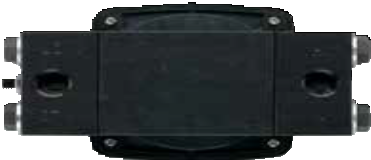 2-1/2" Gauge (≥25 psid)
3.80"
(96.5 mm)
4.70"
(119.4 mm)
5.27"
(133.8 mm)

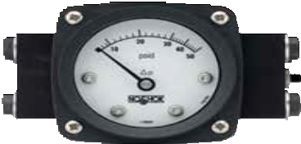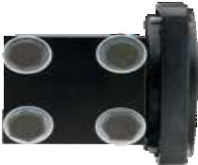
3.29"
(83.5 mm)
3.29" (83.5 mm)
2.00"
(50.8 mm)
0.12"
(3.1 mm)
2.00"
(50.8 mm)
Ø3.00" (76.1 mm)
2.19"
(55.7 mm)
2.72"
(69.1 mm)

0.04"
(1.1 mm)

4-1/2" Gauge (≥25 psid)

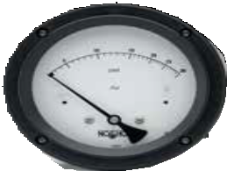Ø6.30" (Ø160.0 mm)

2.00 (50.8 mm) 0.14" (3.6 mm)

2.00" (50.8 mm)
Ø5.22" (132.5 mm)
1.02"
(25.8 mm)

2.47"
(62.7 mm)
3.20"
(81.3 mm)
3.80"
(96.5 mm)
4.70" (119.4 mm)
5.27" (133.8 mm)

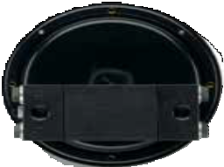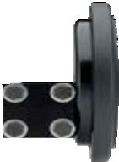 6" Gauge (≥25 psid)

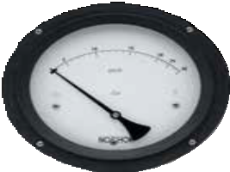Ø8.18" (Ø207.6 mm)

2.00 (50.8 mm)

2.00" (50.8 mm)
0.15" (3.8 mm)

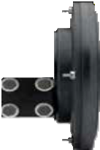Ø6.95" (176.4 mm)

1.10"
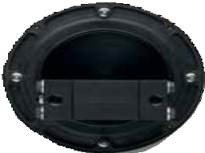(27.9 mm)

3.80"
(96.5 mm)
4.70" (119.4 mm)
5.27" (133.8 mm)

2.79"
(70.9 mm)
3.74"
(94.9 mm)

4-20 mA Transmitter in NEMA 4x Enclosure
1100 SERIES DIMENSIONS

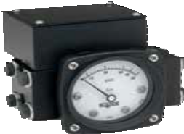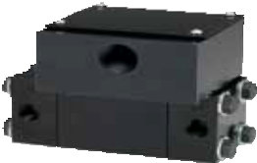
Single Switch in NEMA 4x Enclosure

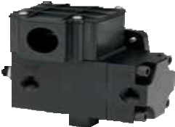
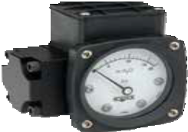
41

Differential Pressure Gauges
Dial Layouts

1000 Series 2-1/2"

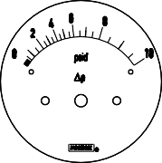
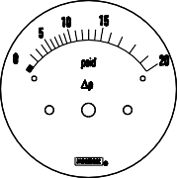
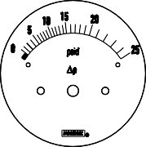
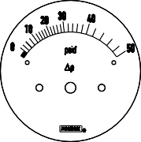
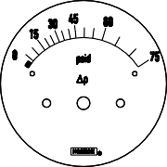
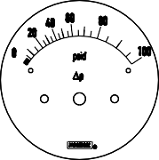

1000 Series 4-1/2"

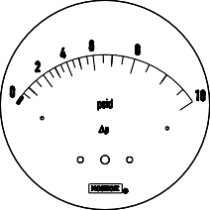
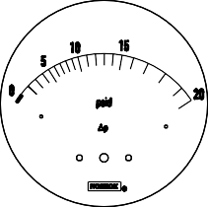
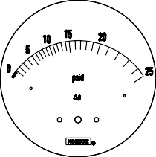
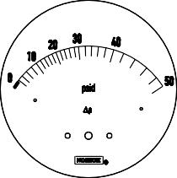
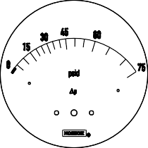
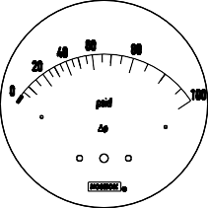

1100 Series 2-1/2"

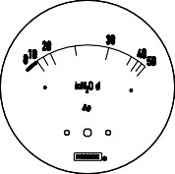
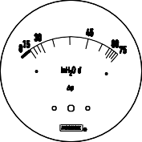
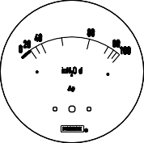
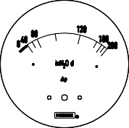
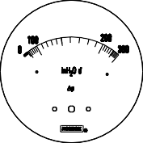
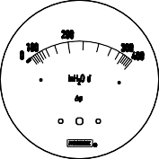
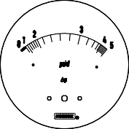

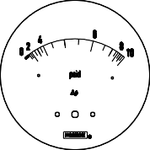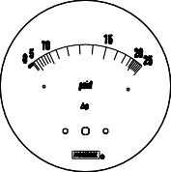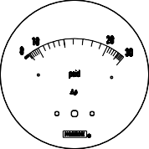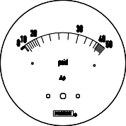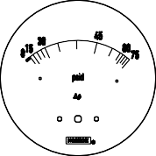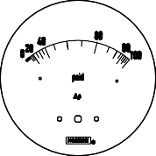

42

1100 Series 4-1/2"

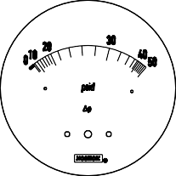
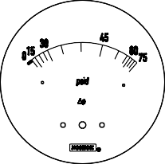
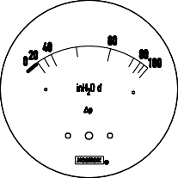
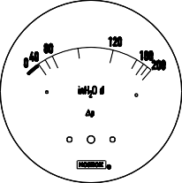
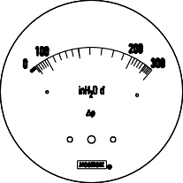
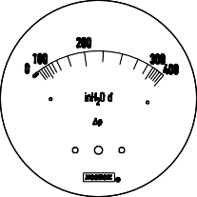
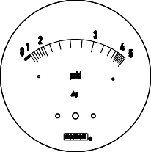

1100 Series 4-1/2"

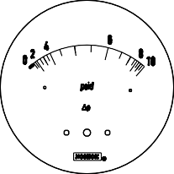
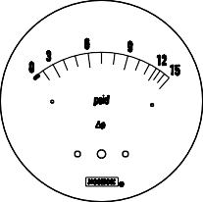
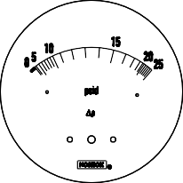
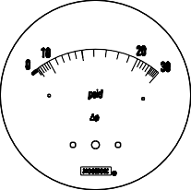

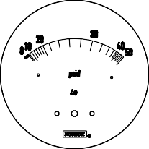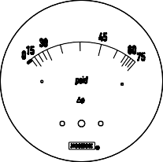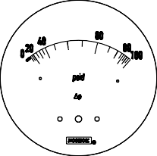

43

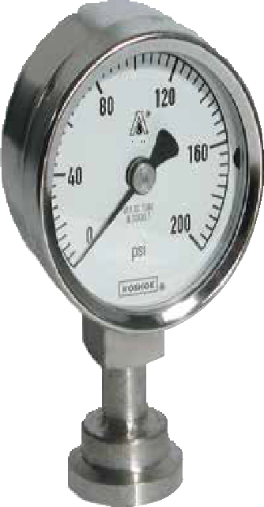

APPLICATIONS
- Food & beverage processing
- Pasteurization systems
- Pharmaceutical
- Medical

10 SERIES

3/4" clamp, dry gauge
- Ranges from 0 psig to 30 psig through 0 psig to 600 psig
- 2" gauge size
- Electropolished Stainless Steel case
- 316 Stainless Steel wetted parts
- Meets current standards for 3A and ASME BPE-2009
- C.I.P, S.I.P and Autoclave (only dry gauges are recommended for
Autoclave)

SPECIFICATIONS

Pressure ranges 0 psig to 30 psig through 0 psig to 600 psig

Accuracy ±2.5% full scale

Temperature ranges Media -40 °F to 300 °F (-40 °C to 150 °C)
Ambient 25 °F to 140 °F (-4 °C to 60 °C)
Storage 25 °F to 140 °F (-4 °C to 60 °C)

Measuring element 316 Stainless Steel Bourdon tube
Connection 3/4" ASME-BPE Sanitary Clamp, 316L Stainless Steel
Diaphragm 316L Stainless Steel, electropolished to 32 μin Ra or better

Case 2" Electropolished 304 Stainless Steel
Cover ring Electropolished 304 Stainless Steel

Lens* Polycarbonate
Pointer Balanced Aluminum, black finish

Dial Aluminum, white background, black print

Movement Stainless Steel

Fill liquid Glycerin, USP Grade

*Note: Autoclave requires the addition of optional laminated safety glass lens
Diaphragm seal must be installed facing downward or in a vertical position for drainability. Do not install diaphragm seal facing in an upward position.

Sanitary Pressure Gauges
Fractional

WARNING: This product can expose you to chemicals including Chromium (VI) and Nickel, which are known to the State of
44 California to cause cancer and birth defects or other reproductive harm. For more information go to www.P65Warnings.ca.gov

10 SERIES INFORMATION
ORDERING
DIMENSIONS

ORDERING INFORMATION
SERIES | 100 | 10 Series fractional
CLAMP SIZE | 06 | 3/4″
FILL LIQUID | 1 | Glycerin | Other food grade quality fill fluids available – please consult factory
GAUGE SIZE | 20 | 2″
PRESSURE RANGES | 43 | 0 psig to 30 psig | 55 | 0 psig to 160 psig 64 0 psig to 400 psig
 | 46 | 0 psig to 60 psig | 58 | 0 psig to 200 psig 70 0 psig to 600 psig
 | 49 | 0 psig to 100 psig | 61 | 0 psig to 300 psig
OPTIONS | 0 | None | 3 | Safety Glass Lens (Required for Autoclave applications)
Please consult your local NOSHOK Distributor or NOSHOK, Inc. for availability and delivery information.

EXAMPLE 100 – 06 – 1 – 20 – 43 – 3

Series 10 Series fractional
Clamp size 3/4" ASME-BPE Sanitary
Fill liquid Glycerin (USP food grade)

Gauge size 2"
Pressure range 0 psig to 30 psig
Option Safety Glass Lens

2" Gauge with 3/4" ASME-BPE Sanitary Clamp Connection

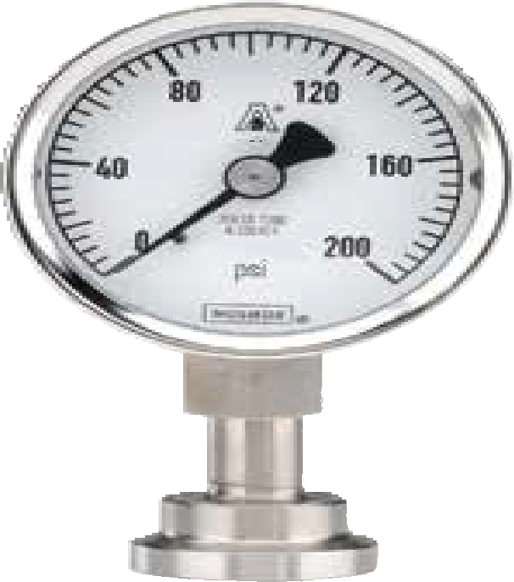0.158"
0.378"
(9.6 mm)
1.043"
(26.5 mm)
1.969"
(50 mm)
2.067"
(52.5 mm)
0.551"
(14 mm)
Square
(4 mm)

0.394"
(10 mm)

0.551"
(14 mm)
0.984"
(25 mm)

45

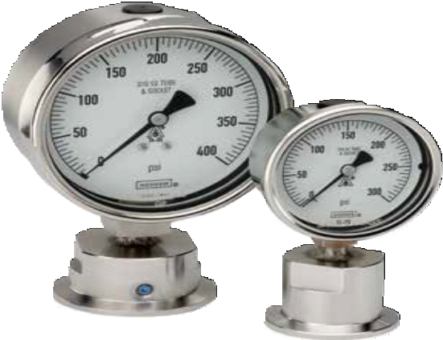

APPLICATIONS

Food & beverage processing
- Pasteurization systems
- Pharmaceutical
- Medical

10 SERIES

1-1/2" and 2" clamp, fillable dry or liquid-filled gauge
- Ranges from -30 inHg to 0 psig through 0 psig to 600 psig
- 2-1/2" and 4" gauge sizes
- Electropolished Stainless Steel case
- 316 Stainless Steel wetted parts
- Meets current standards for 3A and ASME BPE-2009
- C.I.P, S.I.P and Autoclave (only dry gauges are recommended for
Autoclave)

SPECIFICATIONS

Pressure ranges -30 inHg to 0 psig through 0 to 600 psig

Accuracy 2-1/2" gauge ±1.6% full scale 4" gauge ±1.0% full scale

Temperature ranges Media -40 °F to 300 °F (-40 °C to 150 °C)
Ambient 25 °F to 140 °F (-4 °C to 60 °C)
Storage 25 °F to 140 °F (-4 °C to 60 °C)

Measuring element 316 Stainless Steel “C” tube

Connection 1-1/2" or 2" ASME-BPE Sanitary Clamp, 316L Stainless Steel
Diaphragm 316L Stainless Steel, electropolished to 32 μin Ra or better

Case Electropolished 304 Stainless Steel

Bayonet ring Electropolished 304 Stainless Steel

Lens Safety glass
Pointer Balanced Aluminum, black finish

Dial Aluminum, white background, black print

Movement Stainless Steel

Fill liquid Glycerin, USP Grade

*Note: Autoclave requires the addition of optional laminated safety glass lens
Diaphragm seal must be installed facing downward or in a vertical position for drainability. Do not install diaphragm seal facing in an upward position.

Sanitary Pressure Gauges
Heavy-Duty

WARNING: This product can expose you to chemicals including Chromium (VI) and Nickel, which are known to the State of
46 California to cause cancer and birth defects or other reproductive harm. For more information go to www.P65Warnings.ca.gov

ORDERING INFORMATION
SERIES | 100 | 10 Series heavy-duty, bottom connected 101 10 Series heavy-duty, back connected
CLAMP SIZES | 12 | 1-1/2″ 16 2″
FILL LIQUID | 1 | Glycerin Other food grade quality fill fluids available – please consult factory
GAUGE SIZES | 25 | 2-1/2″ 40 4″
PRESSURE RANGES | 01 | -30 inHg to 0 psig * 16 -30 inHg to 160 psig 46 0 psig to 60 psig 64 0 psig to 400 psig
 | 04 | -30 inHg to 15 psig 19 -30 inHg to 200 psig 49 0 psig to 100 psig 70 0 psig to 600 psig
 | 07 | -30 inHg to 30 psig 22 -30 inHg to 300 psig 55 0 psig to 160 psig
 | 10 | -30 inHg to 60 psig 40 0 psig to 15 psig * 58 0 psig to 200 psig
 | 13 | -30 inHg to 100 psig 43 0 psig to 30 psig 61 0 psig to 300 psig
GAUGE FILLS | 0 | None 1 Glycerin 2 Silicone 3 Mineral oil  (All food grade quality fill fluids)
GAUGE OPTIONS | 0 | None 1 Max. Indicating Pointer 2 Adjustable Pointer **
Please consult your local NOSHOK Distributor or NOSHOK, Inc. for availability and delivery information.
* Not available on 4″ gauge and 1-1/2″ ASME-BPE Sanitary Clamp
** Not available on 2-12" gauge

EXAMPLE 100 – 12 – 1 – 25 – 55 – 1 – 1

Series 10 Series heavy-duty
Clamp size ..1-1/2" ASME-BPE Sanitary
Fill liquid Glycerin (USP food grade)
Gauge size .. 2-1/2"
Pressure range 0 psig to 160 psig
Gauge fill Glycerin
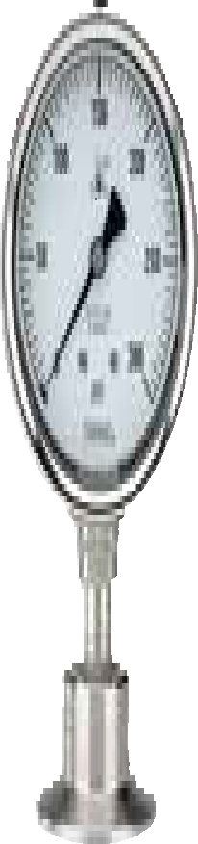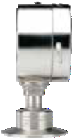Option Maximum Indicating Pointer
0.866"
(22 mm)
Square
0.112"
(2.85 mm)

1.90"
(48 mm)
1.125"
( 29 mm)
2.516"
(64 mm)
1.97" (50 mm)
4.01"
(102 mm)
0.680"
(17.3 mm)
4.61"
(117 mm)

0.866"
(22 mm)
Square
6"
mm)

1.40"
(36 mm)
1.375"
( 35 mm)
1.984"
(50 mm)

4" Gauge with 2" ASME-BPE Sanitary Clamp Connection 4" Gauge with 1-1/2" ASME-BPE Sanitary Clamp Connection

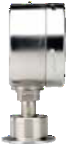0.11
1.97" (50 mm)
4.01"
(102 mm)
0.680"
(17.3 mm)
4.61"
(117 mm)
(2.95

2-1/2" Gauge with 2" ASME-BPE Sanitary Clamp Connection 2-1/2" Gauge with 1-1/2” ASME-BPE Sanitary Clamp Connection

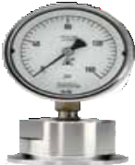1.303"
(33 mm)
1.303"
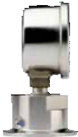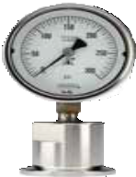(33 mm)
2.504"
(63.6 mm)
3.189"
(81 mm)

0.55
(140
Squa
0.116"
(2.95 mm)

1.375"
(35 mm)

1.40"
( )

36 mm
1.969"
(50 mm)
1.984"
(50 mm)

0.112"

0.551"
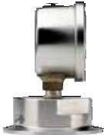(140 mm)
Square

2.504"
(63.6 mm)
1"
mm)
re

(2.85 mm)

1.90"
(48 mm)
2.516"
(64 mm)
1.125"
(29 mm)
0.374"
(9.5 mm)

3.189"
(81 mm)

0.374"
(9.5 mm)

47
10 SERIES INFORMATION
ORDERING
DIMENSIONS

PANEL MOUNTING FLANGES
- Many panel mounting options are available and can be installed in the field
- Options include:
  - Brass Front Flanges (BFF)
  - Black Painted Steel Front Flanges (BLFF)
  - Chrome Front Flanges (CFF)
  - Stainless Steel Front Flanges (SSFF)
  - Chrome Triangular Bezel with U-Clamp (CBU)
  - Black Painted Steel Triangular Bezels with U-Clamp (BBU-Clamp)
  - Stainless Steel Narrow Bezel Front Flanges (SSBU)
  - Panel Mount Clamps (PMC)
- Chrome-plated Steel Adapter Rings (AR) are available in conjunction with several
of these flanges to adapt to oversized panel cut outs, including:
  - Stainless Steel Flange Rings (SSFR)
  - Chrome-Plated Steel Flange Rings (CFR)
  - Black or Chrome Panel Mount Rings (BPMR & CPMR)
- Rear Flanges (RF) for front of panel mounting are also available as a factory installed option on some series

CASES & COVER RINGS
- The following cases and cover rings are available on many NOSHOK gauges as production options:
  - Black painted Steel (BCR)
  - Chrome-plated Steel (CCR)
  - 304 Stainless Steel (SSCR)
- Some NOSHOK gauges are also available with a solid front, safety case

LENSES
- A variety of lens options are available on many NOSHOK gauges as a production option:
  - Instrument glass lenses
  - Laminated safety glass lenses
  - Acrylic lenses
  - Homalite lenses (resistant to many industrial solvents)
  - A Steel or Stainless case and cover ring may be required when other than
acrylic lenses are utilized

MAXIMUM INDICATING POINTERS (MIP)
- An invaluable tool for identifying pressure spikes in a system
- Extremely helpful during system start up and troubleshooting
- MIPs add an additional ±1% error to the gauge because of the increased load on the
Bourdon tube
- On ranges of 60 psi and lower, MIPs may double the allowed error of the gauge

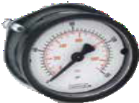
Panel Mount Clamp 20-110 PMC

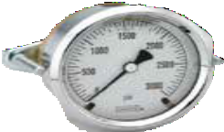
Chrome Triangular Bezel with U-Clamp

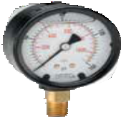
Cases and Cover Rings
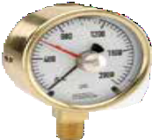
Maximum Indicating Pointer

Dial Indicating Gauge Options & Accessories

See the Gauges Accessories & Options Charts on pgs. 50-53 for availability on specific gauges
48

SET POINTERS (SP)
  - Used to identify an operating minimum or maximum pressure or vacuum value
  - Set pointers are available on many NOSHOK gauges

RUBBER CASE PROTECTORS (RCP)
  - Ideal for gauges that are subjected to direct physical shock
  - 2-1/2" covers are blue and 4" covers are black

ORIFICES
  - Press-fit or threaded orifices in Brass or 316 Stainless Steel are available on
all NOSHOK pressure gauges
  - Available with I.D.’s from 0.004” to 0.032” depending on the specific NOSHOK gauge
  - Used in a gauge to restrict the flow of rapidly increasing and decreasing
pressures, reducing the immediate effect of pulsations and pressure spikes
  - Recommended for all dynamic applications

RECALIBRATORS & ADJUSTABLE POINTERS
  - This option gives the user the capability of resetting the pointer by an adjustment screw accessible through the dial, or by a gear located on the pointer

OVERPRESSURE PROTECTION
  - Overpressure protection of 3 times up to 10 times of the dial range is available on some NOSHOK gauges as a production option

AMMONIA REFRIGERATION GAUGES
  - Ammonia and refrigeration gauges with dials reading in both pressure and temperature are available in 400/500 Series 2-1/2” and 4" sizes
  - Refrigeration gauges with dials reading in pressure and temperature are available in 300, 400 and 500 Series for R-12 and R-22

LIQUID FILLING OPTIONS
  - Many NOSHOK gauges are available with liquid filling options
  - Standard fill is Glycerin
  - Optional fill liquids include Dow Corning 200® Silicone and Halocarbon®

SPECIAL CONNECTIONS
  - Available on most NOSHOK gauges
  - Some examples include:
    - Metric threads
    - Female threads
    - Straight threads (flare or swivel type)
    - Special o-ring connections
  - Please contact us with your requirements for prices, availability and minimum quantities

REID VAPOR TEST GAUGES
  - Configuration includes a handle, special dial and special pressure port
  - Available in 600/700 Series gauges with pressure ranges of 0 to 5 psi, 0 to 15 psi and 0 to 30 psi

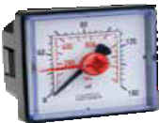
Set Pointers
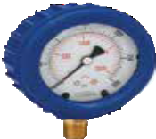
Rubber Case Protectors

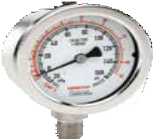
Ammonia Gauges

See the Gauges Accessories & Options Charts on pgs. 50-53 for availability on specific gauges
49

Dial Indicating Gauge Options & Accessories

METRIC DIALS & CUSTOMIZED SPECIAL DIALS
- Dual scale metric dials in psi/bar, psi/kPa and psi/kg/cm2 are available on many NOSHOK gauges
- Other scales are available for specific sizes and ranges, such as single scale bar and kPa,
refrigerant scales and altitude scales
- Please consult the factory for availability
- Customized special dials such as non-standard metric scale, tons of ram, lbs. of force, etc.
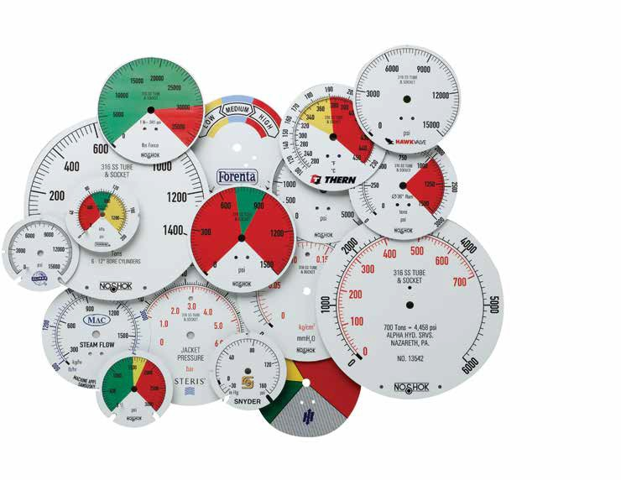
are available in small quantities (as few as one piece) on some NOSHOK gauges

Metric Dials and Customized Special Dials

CERTIFIED CALIBRATION
- Available on all NOSHOK gauges
- Certified calibration provides the user with a serial numbered gauge along with a calibration sheet
against a primary pressure standard
- Traceable to the National Institute of Standards and Technology

50

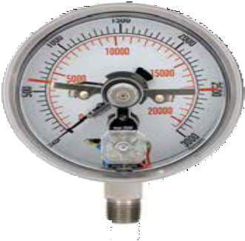
MAGNETIC SPRING CONTACT SWITCH (MSCS)
  - An excellent choice when an accurate pressure switch is required in addition to a reliable
pressure gauge
  - Fully adjustable by the user
  - These switches are actuated by the pressure gauge pointer to provide accurate field adjustment
  - A removable adjustment key makes them tamper-proof
  - They operate with an extremely broad power supply, AC or DC up to 250V max. (30W 50 VA), allowing them to be used virtually anywhere in the world in addition to very remote applications with only DC battery pack power available
  - Standard units consist of (2) two magnetic spring switches; either one or both switches may be used:
    - Switch (1) one is normally closed
    - Switch (2) two is normally open with operation referenced on clockwise pointer motion
  - Magnetic spring contact switches are available as a factory installed option on 40-400 Series and 40-410 Series
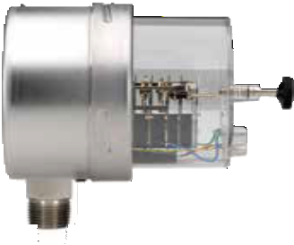
  - The lowest full scale pressure range this switch may be used on is 0 psi to 60 psi because of the increased load on the pointer and Bourdon tube
  - A mating 4-pin connector with 5' of 4-wire and color coded shielded cable is standard

APPLICATIONS
SPECIFICATIONS

Type of power A.C. or D.C. 24 to 250V max

Maximum amps 1.0 A

- Air compressors
- Gas compressors
Maximum switching capacity
30 W/50 VA

- Hydraulic and pneumatic circuitry
- Die-cast machinery
Gauge accuracy Add an additional ±2%
Minimum magnet 1g
holding force

- Plastic injection molding machinery
Contact pin material Silver Tungsten
40-400 Series Gauge with

Ambient temperature limitation
Minimum full scale pressure range
0 °F to 140 °F (-18 °C to 61 °C)

  - psi
Magnetic Spring Contact Switch

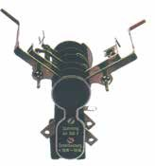WIRING AND TERMINAL LOCATION
2
4
1
3
CONTACT NO. 2
Normally open, Closes on Rising Pressure
CONTACT NO. 1
Normally closed, Opens on Rising Pressure
G
    - Contact Switch No. 1; Red or Black
    - Contact Switch No. 2; Blue
    - Power; Green or Brown
    - Ground; Yellow/Green Stripe

51

100 SERIES ABS & Steel CASE, DRY PRESSURE GAUGE ACCESSORIES
— = Option/accessory is available C = Consult factory for availability STD = Standard stock series specification

MODEL NO. | 15-100 | 15-110 | 15-120 | 20-100 | 20-110 | 20-120 | 20-148 | 25-100 | 25-110 | 25-120 | 40-100
CONNECTION
Black Steel Case (BSC) | C |  | STD | C | C | STD | — |  |  | STD
Chrome Case (CRC) | C |  | — | C | C | — | — |  |  | — | —
Flat Sided ABS Case (FAC) | — |  | — | — |  | — | — | — |  | — | —
Stainless Steel Case (SSC) | C |  | — | C | C | — | — |  |  | — | —
Silicone Dampened Movement (SDM) | C | C | C | C | C | C | C | C | C | C | C
Glass Lens (GL)* | C | N/C |  | C | N/C |  | — | N/C | N/C |  | N/C
Homalite Lens (HL)* | — | — |  | — | — |  | — | — | — |  | —
Polycarbonate Lens (LL)* | — | — | — | — | — | — | — |  |  | — | —
Maximum Indicating Pointer (MIP) | — | — | — | — | — | — | — | C | C | — | —
Red Set Pointer (SP)** |  | C | C | C |  | C |  |  |  | C | —
Safety Glass Lens (SG)* | — | — | — | — | — | — | — |  |  | —
Black Front Flange (BLFF) ABS Case | — |  | — | — |  | — | — | — |  | — | —
Chrome Front Flange (CFF) ABS Case | — |  | — | — |  | — | — | — |  | — | —
Chrome Front Flange (SCFF) Steel Case | C | C | — | C | C | — | — |  |  | —
Black Front Flange (SBFF) Steel Case | C | C | — | C | C | — | — |  |  | —
Black Rear Flange (BLRF) | — | — | — | — | — | — | — |  | — | —
Black Cover Ring (BCR)** | C |  | — | C | C | — | — |  |  | —
Stainless Steel Cover Ring (SSCR)** | C |  | — | C | C | — | — |  |  | — | —
Chrome Cover Ring (CCR)** | C |  | — | C | C | — | — |  |  | —
Polished Stainless Steel Bezel (SSB) | — |  | STD | — |  | STD | — | — |  | STD | —
Chrome Adaptor Ring (AR) | — |  |  | — |  |  | — | — |  |  | —
Panel Mount Clamp (PMC) | — |  | STD | — |  | STD | — | — |  | STD | —
Rubber Case Protectors (RCP) | — | — | — | — | — | — | — |  |  | —
10-32-UNF-2B (10-32)
Orifice - Brass Press Fit Sintered,
20 Micron (CPO)
Orifice - Brass Press Fit 0.1mm (BP1)
Orifice - Brass Press Fit 0.3mm (BP3)
Orifice - Brass Press Fit 0.8mm (BP8)
Laser Marking (LM)
Stainless Steel Tagging (ST)
STANDARD ORIFICE FOR 100 SERIES GAUGE IS 0.3 MM PRESS FIT, UNLESS OTHERWISE SPECIFIED.

* A Steel, Stainless or chrome case & cover ring must be additionally ordered when lenses other than acrylic are utilized on all 100 Series.
** Only 110 Series require a Steel, Stainless or chrome case & cover ring to be additionally ordered when utilizing a set pointer or cover ring. Please consult factory when a set pointer is to be utilized on a 120 Series.

Consult factory for additional non-stock and special accessory availability.

Options & Accessories by Gauge Series
52

200 SERIES LOW PRESSURE DIAPHRAGM GAUGE ACCESSORIES
300 SERIES Brass CASE LIQUID-FILLED GAUGE ACCESSORIES

— = Option/accessory is available C = Consult factory for availability
STD = Standard stock series specification

MODEL NO. | 25-200 | 25-210 | 25-224 | 40-200
CONNECTION
Stainless Steel Case (SSC) |  |  | — | STD
Glass Lens (GL)* |  |  | — | STD
Safety Glass Lens (SG)* |  |  | —
Plexiglass Lens (PL) |  |  | —
Recalibrator Lens (RL) |  |  | — | —
Red Set Pointer (SP)
Maximum Indicating Pointer (MIP) |  |  |  | C
Black Front Flange (BLFF) | — |  | —
304SS Front Flange (SSFF) | — | — | —
Chrome Front Flange (CFF) | — |  | — | —
Black Rear Flange (BLRF) |  | — | — | —
304SS Rear Flange (SSRF) | — | — | —
Black Cover Ring (BCR) |  |  | — | —
Stainless Steel Cover Ring (SSCR) |  |  | — | STD
Chrome Cover Ring (CCR) |  |  | — | —
Black Bezel w/U-Clamp (BBU) | — |  | — | —
SS Bezel w/U-Clamp (SSBU) | — |  | — | —
Rubber Case Protectors (RCP) |  |  | —
10-32-UNF-2B (10-32)
Orifice - Brass Press Fit  0.3mm (BP3) | —
Orifice - Brass Threaded
0.3mm (BT3)
Laser Marking (LM)
Stainless Steel Tagging (ST)

STANDARD ORIFICE FOR 200 SERIES GAUGE IS 0.3 MM PRESS FIT, UNLESS OTHERWISE SPECIFIED.
* A Steel, Stainless or chrome cover ring must be additionally ordered when lenses other than acrylic are utilized on all 2-1/2" 200 Series.
Consult factory for additional non-stock and special accessory availability.

— = Option/accessory is available

MODEL NO. | 25-300 | 25-310 | 40-300 | 40-310
CONNECTION
Maximum Indicating Pointer (MIP) |  |  | — | —
Polycarbonate Lens (LL) | — | —
Glass Lens Overlay (GLO) |  |  | — | —
Safety Glass Overlay (SGO) |  |  | — | —
Safety Glass (SG) | — | —
Chrome Front Flange (CFF)
Chrome Front Flange w/o Holes (CFFN)
Brass Front Flange (BFF)
Black Front Flange (BLFF) | — | —
304SS Rear Flange (SSRF) | — | —
Rear Flange (RF) |  |  | — | —
Chrome Cover Ring (CCR) |  |  |  | —
Chrome Bezel w/U-Clamp (CBU) | — |  | —
Adaptor Ring (AR) | — |  | — | —
Increased Accuracy from 1.5% to 1.0% (IA) |  |  | — | —
Increased Accuracy from 1.0% to 0.5% (IA) | — | —
SAE J1926-3:7/16-20 Adjustable Connection (SST)*
10-32-UNF-2B (10-32)
Orifice - Brass Threaded 0.3mm
(BT3)
Orifice - Brass Threaded 0.4mm
(BT4)
Orifice - Brass Threaded 0.8mm
(BT8)
Rubber Case Protectors (RCP)
Laser Marking (LM)
Stainless Steel Tagging (ST)
STANDARD ORIFICE FOR 300 SERIES GAUGE IS 0.8 MM THREADED, UNLESS OTHERWISE SPECIFIED.
- Includes FKM o-ring. Consult factory for availability.
Consult factory for additional non-stock and special accessory availability.

53

400/500 SERIES ALL Stainless Steel PRESSURE GAUGES DRY, LIQUID & AMMONIA GAUGE ACCESSORIES
— = Option/accessory is available C = Consult factory for availability STD = Standard stock series specification

MODEL NO.  CONNECTION | 15-401 | 15-411 | 25-400 | 25-410 | 40-400 | 40-410 | 60-400 | 60-410
 |  |  | 25-500 | 25-510 | 40-500 | 40-510 | 60-500 | 60-510
Adjustable Pointer (AP) | — | — | — | — |  |  | STD | STD
Safety Glass Lens (SG) | — | — |  |  |  |  | STD | STD
Maximum Indicating Pointer (MIP) | — | —
Red Set Pointer (SP) | — | —
Magnetic Spring Contact, 4" 400 & 410 (MSCS) | — | — | — | — |  |  | — | —
304 SS Front Flange (SSFF) | — | — | —
304 SS Rear Flange (SSRF) | — | — | C | C
SS Bezel w/U-Clamp (SSBU) | — | — | — | — | — |  | —
Flange Ring 304SS (SSFR) | — | — | — |  | — | — | — | —
304SS Panel Mount Clamp (SPMC) | — | — | — |  | — | — | — | —
Steel Panel Mount Clamp (PMC) | — | — | — |  | — | — | — | —
Increased Accuracy from 1.5% to 1.0% (IA) | — | —
Increased Accuracy from 1.0% to 0.5% (IA) | — | —
10-32-UNF-2B (10-32)
Orifice - 316SS Threaded 0.8mm (ST8)
Orifice - 316SS Threaded 0.5mm (ST5)
Rubber Case Protectors (RCP) | — | — |  |  |  | — | — | —
Laser Marking (LM)
Stainless Steel Tagging (ST)
STANDARD ORIFICE FOR 400/500 SERIES GAUGE IS 0.8 MM THREADED, UNLESS OTHERWISE SPECIFIED.
Consult factory for additional non-stock and special accessory availability.

600/700 SERIES PROCESS GAUGE ACCESSORIES

Options & Accessories by Gauge Series
— = Option/accessory is available
MODEL NO. 45-640 45-740 45-660 45-760
CONNECTION
Safety Glass Lens (SG)
Glass Lens (GL)
Maximum Indicating Pointer (MIP)
Overload Stop (OS)
10-32-UNF-2B (10-32)
Orifice - Brass Press Fit 0.3mm (BP3) |  | — |  | —
Orifice - Brass Threaded 0.8mm (BT8) |  | — |  | —
Orifice - 316SS Threaded 0.8mm (ST8) | — |  | —
Laser Marking (LM)
Stainless Steel Tagging (ST)
STANDARD ORIFICE FOR 600/700 SERIES GAUGE IS 0.8 MM THREADED, UNLESS OTHERWISE SPECIFIED.
Consult factory for additional non-stock and special accessory availability.
54
800 SERIES PRECISION TEST GAUGE ACCESSORIES
— = Option/accessory is available

MODEL NO. 60-800
CONNECTION
304 SS Front Flange (SSFF)
304 SS Rear Flange (SSRF)
10-32-UNF-2B (10-32)
Orifice - Brass Press Fit 0.3mm (BP3)
Orifice - Brass Threaded 0.8mm (BT8)
Laser Marking (LM)
Stainless Steel Tagging (ST)
Carrying Case (GC)
STANDARD ORIFICE FOR 800 SERIES GAUGE IS 0.8 MM THREADED, UNLESS OTHERWISE SPECIFIED.
Consult factory for additional non-stock and special accessory availability.

900 SERIES ABS & Stainless Steel LIQUID FILLED PRESSURE GAUGE ACCESSORIES

— = Option/accessory is available C = Consult factory for availability STD = Standard stock series specification

MODEL NO. | 15-910 | 25-900 | 25-910 | 25-901 | 25-911 | 40-901 | 40-911
CONNECTION
Adjustable Pointer (AP) | — | — | — | — | —
Maximum Indicating Pointer (MIP) | — | — | —
Red Set Pointer (SP) | — | — | —
Safety Glass Lens (SG) | — | — | —
Magnetic Spring Contact Switch 4" 901 & 911 Dry (MSCS) | — | — | — | — | —
Black Front Flange (BLFF) | — | — |  | — | — | — | —
304 SS Front Flange (SSFF) | — | — | — | —
304 SS Rear Flange (SSRF) | — | — | — | — | —
304 SS Polished Flange Ring (SSFR) | — | — | — | — |  | — | —
SS Bezel w/U-Clamp (SSBU) | — | — | — | — | — | —
304SS Panel Mount Clamp (SPMC) | — | — | — | — |  | — | —
Steel Panel Mount Clamp (PMC) | — | — |  | — |  | — | —
Increased Accuracy from 1.5% to 1.0% (IA) | — | — | — |  |  | — | —
Increased Accuracy from 1.0% to 0.5% (IA) | — | — | — | — | —
SAE J1926-3:7/16-20 Adjustable Connection (SST)* † | —
1/4" NPT x G1/4 Adaptor (1/4-NPT-MXG1/4-F-BR)
G1/4 Sealing Washer (G1/4-SEALING-WASHER)
10-32-UNF-2B (10-32)
Orifice - Brass Press Fit 0.3mm (BP3)
Orifice - Brass Threaded 0.5mm (BT5) |  |  |  |  |  | — | —
Orifice - Brass Threaded 0.8mm (BT8) | — | — | — | — | —
Rubber Case Protectors (RCP) | — | — | —
Dry Out Charge (DRY) | — | — | —
Laser Marking (LM)
Stainless Steel Tagging (ST)

STANDARD ORIFICE FOR 900 SERIES GAUGE IS 0.3 MM PRESS FIT, UNLESS OTHERWISE SPECIFIED.
- Includes FKM o-ring. Consult factory for
availability.
** For ranges 60 psi and above.
Consult factory for additional non-stock and special accessory availability.

GAUGE FILL OPTIONS

55
SERIES NO. | VOLUME SILICONE HALOCARBON® -40° SERVICE MINERAL OIL
300 SERIES | OZ | D.C. 200 | 4.2 OIL | 86.5 : 13.5  GLYCERIN: H2O (d) | LIGHT  VISCOSITY
25-300/25-310 | 2.0 | — | — | — | —
40-300/40-310 | 6.5 | — | — | — | —
500 SERIES
25-500/25-510 | 2.0 | — | — | — | —
40-500/40-510 | 8.5 | — | — | — | —
60-500/60-510 | 31.0 | — | — | — | —
600/700 SERIES
45-660/45-760 | 14.0 | — | — | — | —
900 SERIES
25-900/25-910 | 2.0 | C | C | — | C
25-901/25-911 | 2.0 | C | C | — | C
40-901/40-011 | 8.5 | — | — | — | —

Dial Indicating Gauge Accuracy/Standard Dial Configuration

Applies to:
300 Series Gauges: 4″ 400/500 Series Gauges: 4″ and 6″ 900 Series Gauges: 4″

ACCURACY: ±1.0% full scale
Primary Scale |  |  | Secondary Scales
Dial Range | Figure | Graduation | kPa | Figure | Graduation | kg/cm2 | Figure | Graduation | bar | Figure | Graduation
-30 inHg to  0 psi | -5 inHg | -0.5 inHg | -100 kPa to  0 kPa | -20 kPa | -2 kPa | -1.02 kg/cm2  to 0 kg/cm2 | -0.2 kg/cm2 | -0.02 kg/cm2 | -1 bar to  0 bar | -0.2 bar | -0.02 bar
-30 inHg to  15 psi | -10 inHg  5 psi | -1 inHg  0.5 psi | -100 kPa to  100 kPa | -50 kPa  50 kPa | -5 kPa  5 kPa | -1 kg/cm2 to  1.05 kg/cm2 | -0.5 kg/cm2  0.5 kg/cm2 | -0.05 kg/cm2  0.05 kg/cm2 | -1 bar to  1 bar | -0.5 bar  0.5 bar | -0.05 bar  0.05 bar
-30 inHg to  30 psi | -10 inHg  5 psi | -1 inHg  0.5 psi | -100 kPa to  205 kPa | -50 kPa  50 kPa | -5 kPa  5 kPa | -1 kg/cm2 to  2.10 kg/cm2 | -1 kg/cm2  0.5 kg/cm2 | -0.1 kg/cm2  0.05 kg/cm2 | -1 bar to  2.05 bar | -0.5 bar  0.5 bar | -0.05 bar  0.05 bar
-30 inHg to  60 psi | -30 inHg  10 psi | -2 inHg  1 psi | -100 kPa to  410 kPa | -100 kPa  100 kPa | -10 kPa  10 kPa | -1 kg/cm2 to  4.2 kg/cm2 | -1 kg/cm2  1 kg/cm2 | -0.1 kg/cm2  0.1 kg/cm2 | -1 bar to  4.1 bar | -1 bar  1 bar | .01 bar  .1 bar
-30 inHg to  100 psi | -30 inHg  20 psi | -5 inHg  2 psi | -100 kPa to  680 kPa | -100 kPa  200 kPa | -20 kPa  20 kPa | -1 kg/cm2 to  7 kg/cm2 | -1 kg/cm2  2 kg/cm2 | -0.2 kg/cm2  0.2 kg/cm2 | -1 bar to  6.8 bar | -1 bar  2 bar | -0.2 bar  0.2 bar
-30 inHg to  160 psi | -30 inHg  20 psi | -5 inHg  2 psi | -100 kPa to  1,100 kPa | -100 kPa  200 kPa | -20 kPa  20 kPa | -1 kg/cm2 to  11.2 kg/cm2 | -1 kg/cm2  2 kg/cm2 | -0.2 kg/cm2  0.2 kg/cm2 | -1 bar to  11 bar | -1 bar  2 bar | -0.2 bar  0.2 bar
-30 inHg to  200 psi | -30 inHg  40 psi | -5 inHg  4 psi | -100 kPa to  1,360 kPa | -100 kPa  400 kPa | -20 kPa  40 kPa | -1 kg/cm2 to  14 kg/cm2 | -1 kg/cm2  4 kg/cm2 | -0.2 kg/cm2  0.4 kg/cm2 | -1 bar to  13.6 bar | -1 bar  4 bar | -0.2 bar  0.4 bar
-30 inHg to  300 psi | -30 inHg  50 psi | -10 inHg  5 psi | -100 kPa to  2,050 kPa | -100 kPa  500 kPa | -50 kPa  50 kPa | -1 kg/cm2 to  21 kg/cm2 | -1 kg/cm2  5 kg/cm2 | -0.5 kg/cm2  0.5 kg/cm2 | -1 bar to  20.5 bar | -1 bar  5 bar | -0.5 bar  0.5 bar
0 psi to  15 psi | 3 psi | 0.2 psi | 0 kPa to  102 kPa | 30 kPa | 2 kPa | 0 kg/cm2 to  1.04 kg/cm2 | 0.3 kg/cm2 | 0.04 kg/cm2 | 0 bar to  1.02 bar | 0.3 bar | 0.02 bar
0 psi to  30 psi | 5 psi | 0.5 psi | 0 kPa to  205 kPa | 50 kPa | 5 kPa | 0 kg/cm2 to  2.1 kg/cm2 | 0.5 kg/cm2 | 0.1 kg/cm2 | 0 bar to  2.05 bar | 0.5 bar | 0.05 bar
0 psi to  60 psi | 10 psi | 1 psi | 0 kPa to  410 kPa | 100 kPa | 10 kPa | 0 kg/cm2 to  4.2 kg/cm2 | 1 kg/cm2 | 0.1 kg/cm2 | 0 bar to  4.1 bar | 1 bar | 0.1 bar
0 psi to  100 psi | 20 psi | 2 psi | 0 kPa to  680 kPa | 200 kPa | 20 kPa | 0 kg/cm2 to  7 kg/cm2 | 2 kg/cm2 | 0.2 kg/cm2 | 0 bar to  6.8 bar | 2 bar | 0.2 bar
0 psi to  160 psi | 20 psi | 2 psi | 0 kPa to  1,100 kPa | 200 kPa | 20 kPa | 0 kg/cm2 to  11.2 kg/cm2 | 2 kg/cm2 | 0.2 kg/cm2 | 0 bar to  11 bar | 2 bar | 0.2 bar
0 psi to  200 psi | 40 psi | 4 psi | 0 kPa to  1,360 kPa | 400 kPa | 40 kPa | 0 kg/cm2 to  14 kg/cm2 | 4 kg/cm2 | 0.4 kg/cm2 | 0 bar to  13.6 bar | 4 bar | 0.4 bar
0 psi to  300 psi | 50 psi | 5 psi | 0 kPa to  2,050 kPa | 500 kPa | 50 kPa | 0 kg/cm2 to  21 kg/cm2 | 5 kg/cm2 | 0.5 kg/cm2 | 0 bar to  20.5 bar | 5 bar | 0.5 bar
0 psi to  400 psi | 50 psi | 5 psi | 0 kPa to  2,750 kPa | 500 kPa | 50 kPa | 0 kg/cm2 to  28 kg/cm2 | 5 kg/cm2 | 0.5 kg/cm2 | 0 bar to  27.5 bar | 5 bar | 0.5 bar
0 psi to  600 psi | 100 psi | 10 psi | 0 kPa to  4,100 kPa | 1,000 kPa | 100 kPa | 0 kg/cm2 to  42 kg/cm2 | 10 kg/cm2 | 1 kg/cm2 | 0 bar to  41 bar | 10 bar | 1 bar
0 psi to  1,000 psi | 200 psi | 20 psi | 0 kPa to  6,800 kPa | 2,000 kPa | 200 kPa | 0 kg/cm2 to  70 kg/cm2 | 20 kg/cm2 | 2 kg/cm2 | 0 bar to  68 bar | 20 bar | 2 bar
0 psi to  1,500 psi | 300 psi | 20 psi | 0 kPa to  10,200 kPa | 3,000 kPa | 200 kPa | 0 kg/cm2 to  104 kg/cm2 | 30 kg/cm2 | 2 kg/cm2 | 0 bar to  102 bar | 30 bar | 2 bar
0 psi to  2,000 psi | 400 psi | 40 psi | 0 kPa to  13,600 kPa | 4,000 kPa | 400 kPa | 0 kg/cm2 to  140 kg/cm2 | 40 kg/cm2 | 4 kg/cm2 | 0 bar to  136 bar | 40 bar | 4 bar
0 psi to  3,000 psi | 500 psi | 50 psi | 0 kPa to  20,500 kPa | 5,000 kPa | 500 kPa | 0 kg/cm2 to  210 kg/cm2 | 50 kg/cm2 | 5 kg/cm2 | 0 bar to  205 bar | 50 bar | 5 bar
0 psi to  5,000 psi | 1,000 psi | 100 psi | 0 kPa to  34,000 kPa | 10,000 kPa | 1,000 kPa | 0 kg/cm2 to  350 kg/cm2 | 100 kg/cm2 | 10 kg/cm2 | 0 bar to  340 bar | 100 bar | 10 bar
0 psi to  6,000 psi | 1,000 psi | 100 psi | 0 kPa to  41,000 kPa | 10,000 kPa | 1,000 kPa | 0 kg/cm2 to  420 kg/cm2 | 100 kg/cm2 | 10 kg/cm2 | 0 bar to  410 bar | 100 bar | 10 bar
0 psi to  7,500 psi | 1,500 psi | 100 psi | 0 kPa to  51,000 kPa | 10,000 kPa | 1,000 kPa | 0 kg/cm2 to  520 kg/cm2 | 100 kg/cm2 | 10 kg/cm2 | 0 bar to  510 bar | 100 bar | 10 bar
0 psi to  10,000 psi | 2,000 psi | 200 psi | 0 kPa to  68,000 kPa | 20,000 kPa | 2,000 kPa | 0 kg/cm2 to  700 kg/cm2 | 200 kg/cm2 | 20 kg/cm2 | 0 bar to  680 bar | 200 bar | 20 bar
0 psi to  15,000 psi | 3,000 psi | 200 psi | 0 kPa to  102,000 kPa | 30,000 kPa | 2,000 kPa | 0 kg/cm2 to  1,040 kg/cm2 | 300 kg/cm2 | 20 kg/cm2 | 0 bar to  1,030 bar | 300 bar | 20 bar
0 psi to  20,000 psi | 4,000 psi | 400 psi | 0 kPa to  136,000 kPa | 40,000 kPa | 4,000 kPa | 0 kg/cm2 to  1,400 kg/cm2 | 400 kg/cm2 | 40 kg/cm2 | 0 bar to  1,360 bar | 400 bar | 40 bar
0 psi to  30,000 psi | 5,000 psi | 500 psi | 0 kPa to  205,000 kPa | 50,000 kPa | 5,000 kPa | 0 kg/cm2 to  2,100 kg/cm2 | 500 kg/cm2 | 50 kg/cm2 | 0 bar to  2,050 bar | 500 bar | 50 bar
0 psi to  40,000 psi | 5,000 psi | 500 psi | 0 kPa to  275,000 kPa | 50,000 kPa | 5,000 kPa | 0 kg/cm2 to  2,800 kg/cm2 | 500 kg/cm2 | 50 kg/cm2 | 0 bar to  2,750 bar | 500 bar | 50 bar
0 psi to  50,000 psi | 10,000  psi | 1000 psi | 0 kPa to  340,000 kPa | 100,000 kPa | 10,000 kPa | 0 kg/cm2 to  3,500 kg/cm2 | 1,000 kg/cm2 | 100 kg/cm2 | 0 bar to  3,400 bar | 1,000 bar | 100 bar
0 psi to  60,000 psi | 10,000  psi | 1000 psi | 0 kPa to  410,000 kPa | 100,000 kPa | 10,000 kPa | 0 kg/cm2 to  4,200 kg/cm2 | 1,000 kg/cm2 | 100 kg/cm2 | 0 bar to  4,100 bar | 1,000 bar | 100 bar
0 psi to  75,000 psi | 15,000  psi | 1000 psi | 0 kPa to  510,000 kPa | 100,000 kPa | 10,000 kPa | 0 kg/cm2 to  5,200 kg/cm2 | 1,000 kg/cm2 | 100 kg/cm2 | 0 bar to  5,100 bar | 1,000 bar | 100 bar
0 psi to  100,000 psi | 20,000  psi | 2000 psi | 0 kPa to  680,000 kPa | 200,000 kPa | 20,000 kPa | 0 kg/cm2 to  7,000 kg/cm2 | 2,000 kg/cm2 | 200 kg/cm2 | 0 bar to  6,800 bar | 2,000 bar | 200 bar
56

Dial Indicating Gauge Accuracy/Standard Dial Configuration

Applies to:
200 Series Gauges: 2-1/2″ and 4″ 700 Series Gauges (Low Pressure): 4-1/2″

ACCURACY: ±1.0% full scale
Standard Dial Configurations
Dial Range | Figure Interval | Graduation Intervals | Dial Range | Figure Interval | Graduation Intervals
-15 inH2O to 0 inH2O | -3 inH2O | -0.2 inH2O | 0 oz/in2 to 10 oz/in2 | 2 oz/in2 | 0.2 oz/in2
-30 inH2O to 0 inH2O | -5 inH2O | -0.5 inH2O | 0 oz/in2 to 15 oz/in2 | 3 oz/in2 | 0.2 oz/in2
-60 inH2O to 0 inH2O | -10 inH2O | -1 inH2O | 0 oz/in2 to 30 oz/in2 | 5 oz/in2 | 0.5 oz/in2
-100 inH2O to 0 inH2O | -20 inH2O | -2 inH2O | 0 oz/in2 to 35 oz/in2 | 5 oz/in2 | 0.5 oz/in2
-60 inH2O to 60 inH2O | -10 inH2O | 10 inH2O | -1 inH2O | 1 inH2O | 0 oz/in2 to 60 oz/in2 | 10 oz/in2 | 1 oz/in2
0 inH2O to 10 inH2O | 2 inH2O | 0.2 inH2O | 0 oz/in2 to 100 oz/in2 | 20 oz/in2 | 2 oz/in2
0 inH2O to 15 inH2O | 3 inH2O | 0.2 inH2O | 0 oz/in2 to 160 oz/in2** | 40 oz/in2 | 4 oz/in2
0 inH2O to 30 inH2O | 5 inH2O | 0.5 inH2O | 0 oz/in2 inH2O to 20 oz/in2 inH2O | 4 oz/in2 - 10 inH2O | 0.4 oz/in2 - 1 inH2O
0 inH2O to 60 inH2O | 10 inH2O | 1 inH2O | 0 oz/in2 inH2O to 32 oz/in2 inH2O | 4 oz/in2 - 10 inH2O | 0.5 oz/in2 - 1 inH2O
0 inH2O to 100 inH2O | 20 inH2O | 2 inH2O | 0 psi to 3 psi | 0.5 psi | 0.05 psi
*  0 inH2O to 160 inH2O | 40 inH2O | 4 inH2O | 0 psi to 5 psi | 1 psi | 0.1 psi
0 inH2O to 200 inH2O | 40 inH2O | 4 inH2O | 0 psi to 10 psi | 2 psi | 0.2 psi
* The values in the table are for 2-1/2". On 4" & 4-1/2" 0 inH20 to 160 inH20 gauges, the Figure is 20 inH20, and the Graduation is 2 inH20.
** The values in the table are for 2-1/2". On 4" & 4-1/2" 0 oz/in2 to 160 oz/in2 gauges, the Figure is 20 oz/in2, and the Graduation is 2 oz/in2.

57

Dial Indicating Gauge Accuracy/Standard Dial Configuration

Applies to:
100 Series Gauges: 4″ 300 Series Gauges: 2-1/2″ 400/500 Series Gauges: 2-1/2″ 900 Series Gauges: 2-1/2″

ACCURACY: ±1.6% full scale
Primary Scale |  |  | Secondary Scales
Dial Range | Figure | Graduation | kPa | Figure | Graduation | kg/cm2 | Figure | Graduation | bar | Figure | Graduation
-30 inHg to  0 psi | -5 inHg | -0.5 inHg | -100 kPa to  0 kPa | -20 kPa | -2 kPa | -1.02 kg/cm2  to 0 kg/cm2 | -0.2 kg/cm2 | -0.02 kg/cm2 | -1 bar to  0 bar | -0.2 bar | -0.02 bar
-30 inHg to  15 psi | -10 inHg  5 psi | -1 inHg  0.5 psi | -100 kPa to  100 kPa | -50 kPa  50 kPa | -5 kPa  5 kPa | -1 kg/cm2 to  1.05 kg/cm2 | -0.5 kg/cm2  0.5 kg/cm2 | -0.05 kg/cm2  0.05 kg/cm2 | -1 bar to  1 bar | -0.5 bar  0.5 bar | -0.05 bar  0.05 bar
-30 inHg to  30 psi | -30 inHg  10 psi | -2 inHg  1 psi | -100 kPa to  205 kPa | -100 kPa  100 kPa | -10 kPa  10 kPa | -1 kg/cm2 to  2.10 kg/cm2 | -1 kg/cm2  1 kg/cm2 | -0.1 kg/cm2  0.1 kg/cm2 | -1 bar to  2 bar | -1 bar  1 bar | -0.1 bar  0.1 bar
-30 inHg to  60 psi | -30 inHg  20 psi | -5 inHg  2 psi | -100 kPa to  400 kPa | -100 kPa  200 kPa | -20 kPa  20 kPa | -1 kg/cm2 to  4.2 kg/cm2 | -1 kg/cm2  2 kg/cm2 | -2 kg/cm2  0.2 kg/cm2 | -1 bar to  4 bar | -1 bar  2 bar | -0.2 bar  0.2 bar
-30 inHg to  100 psi | -30 inHg  20 psi | -5 inHg  2 psi | -100 kPa to  680 kPa | -100 kPa  200 kPa | -20 kPa  20 kPa | -1 kg/cm2 to  7 kg/cm2 | -1 kg/cm2  2 kg/cm2 | -0.2 kg/cm2  0.2 kg/cm2 | -1 bar to  6.8 bar | -1 bar  2 bar | -0.2 bar  0.2 bar
-30 inHg to  160 psi | -30 inHg  40 psi | -10 inHg  4 psi | -100 kPa to  1,080 kPa | -100 kPa  400 kPa | -50 kPa  40 kPa | -1 kg/cm2 to  11.2 kg/cm2 | -1 kg/cm2  4 kg/cm2 | -0.5 kg/cm2  0.4 kg/cm2 | -1 bar to  11 bar | -1 bar  4 bar | -0.5 bar  0.4 bar
-30 inHg to  200 psi | -30 inHg  40 psi | -10 inHg  4 psi | -100 kPa to  1,360 kPa | -100 kPa  400 kPa | -50 kPa  40 kPa | -1 kg/cm2 to  14 kg/cm2 | -1 kg/cm2  4 kg/cm2 | -0.5 kg/cm2  0.4 kg/cm2 | -1 bar to  13.6 bar | -1 bar  4 bar | -0.5 bar  0.4 bar
-30 inHg to  300 psi | -30 inHg  50 psi | -10 inHg  5 psi | -100 kPa to  2,050 kPa | -100 kPa  500 kPa | -50 kPa  50 kPa | -1 kg/cm2 to  21 kg/cm2 | -1 kg/cm2  5 kg/cm2 | -0.5 kg/cm2  0.5 kg/cm2 | -1 bar to  20.5 bar | -1 bar  5 bar | -0.5 bar  0.5 bar
0 psi to  15 psi | 3 psi | 0.2 psi | 0 kPa to  102 kPa | 30 kPa | 2 kPa | 0 kg/cm2 to  1.04 kg/cm2 | 0.3 kg/cm2 | 0.02 kg/cm2 | 0 bar to  1.02 bar | 0.3 bar | 0.02 bar
0 psi to  30 psi | 5 psi | 0.5 psi | 0 kPa to  205 kPa | 50 kPa | 5 kPa | 0 kg/cm2 to  2.1 kg/cm2 | 0.5 kg/cm2 | 0.05 kg/cm2 | 0 bar to  2.05 bar | 0.5 bar | 0.05 bar
0 psi to  60 psi | 10 psi | 1 psi | 0 kPa to  410 kPa | 100 kPa | 10 kPa | 0 kg/cm2 to  4.2 kg/cm2 | 1 kg/cm2 | 0.1 kg/cm2 | 0 bar to  4.10 bar | 1 bar | 0.1 bar
0 psi to  100 psi | 20 psi | 2 psi | 0 kPa to  680 kPa | 200 kPa | 20 kPa | 0 kg/cm2 to  7 kg/cm2 | 2 kg/cm2 | 0.2 kg/cm2 | 0 bar to  6.8 bar | 2 bar | 0.2 bar
0 psi to  160 psi | 40 psi | 4 psi | 0 kPa to  1,080 kPa | 400 kPa | 40 kPa | 0 kg/cm2 to  11.2 kg/cm2 | 4 kg/cm2 | 0.4 kg/cm2 | 0 bar to  11 bar | 4 bar | 0.4 bar
0 psi to  200 psi | 40 psi | 4 psi | 0 kPa to  1,360 kPa | 400 kPa | 40 kPa | 0 kg/cm2 to  14 kg/cm2 | 4 kg/cm2 | 0.4 kg/cm2 | 0 bar to  13.6 bar | 4 bar | 0.4 bar
0 psi to  300 psi | 50 psi | 5 psi | 0 kPa to  2,050 kPa | 500 kPa | 50 kPa | 0 kg/cm2 to  21 kg/cm2 | 5 kg/cm2 | 0.5 kg/cm2 | 0 bar to  20.5 bar | 5 bar | 0.5 bar
0 psi to  400 psi | 100 psi | 10 psi | 0 kPa to  2,700 kPa | 1,000 kPa | 100 kPa | 0 kg/cm2 to  28 kg/cm2 | 10 kg/cm2 | 1 kg/cm2 | 0 bar to  27 bar | 10 bar | 1 bar
0 psi to  600 psi | 100 psi | 10 psi | 0 kPa to  4,100 kPa | 1,000 kPa | 100 kPa | 0 kg/cm2 to  42 kg/cm2 | 10 kg/cm2 | 1 kg/cm2 | 0 bar to  41 bar | 10 bar | 1 bar
0 psi to  1,000 psi | 200 psi | 20 psi | 0 kPa to  6,800 kPa | 2,000 kPa | 200 kPa | 0 kg/cm2 to  70 kg/cm2 | 20 kg/cm2 | 2 kg/cm2 | 0 bar to  68 bar | 20 bar | 2 bar
0 psi to  1,500 psi | 300 psi | 20 psi | 0 kPa to  10,200 kPa | 3,000 kPa | 200 kPa | 0 kg/cm2 to  104 kg/cm2 | 30 kg/cm2 | 2 kg/cm2 | 0 bar to  102 bar | 30 bar | 2 bar
0 psi to  2,000 psi | 400 psi | 40 psi | 0 kPa to  13,600 kPa | 4,000 kPa | 400 kPa | 0 kg/cm2 to  140 kg/cm2 | 40 kg/cm2 | 4 kg/cm2 | 0 bar to  136 bar | 40 bar | 4 bar
0 psi to  3,000 psi | 500 psi | 50 psi | 0 kPa to  20,500 kPa | 5,000 kPa | 500 kPa | 0 kg/cm2 to  210 kg/cm2 | 50 kg/cm2 | 5 kg/cm2 | 0 bar to  205 bar | 50 bar | 5 bar
0 psi to  5,000 psi | 1,000 psi | 100 psi | 0 kPa to  34,000 kPa | 10,000 kPa | 1,000 kPa | 0 kg/cm2 to  350 kg/cm2 | 100 kg/cm2 | 10 kg/cm2 | 0 bar to  340 bar | 100 bar | 10 bar
0 psi to  6,000 psi | 1,000 psi | 100 psi | 0 kPa to  41,000 kPa | 10,000 kPa | 1,000 kPa | 0 kg/cm2 to  420 kg/cm2 | 100 kg/cm2 | 10 kg/cm2 | 0 bar to  410 bar | 100 bar | 10 bar
0 psi to  7,500 psi | 1,500 psi | 100 psi | 0 kPa to  51,000 kPa | 10,000 kPa | 1,000 kPa | 0 kg/cm2 to  520 kg/cm2 | 100 kg/cm2 | 10 kg/cm2 | 0 bar to  510 bar | 100 bar | 10 bar
0 psi to  10,000 psi | 2,000 psi | 200 psi | 0 kPa to  68,000 kPa | 20,000 kPa | 2,000 kPa | 0 kg/cm2 to  700 kg/cm2 | 200 kg/cm2 | 20 kg/cm2 | 0 bar to  680 bar | 200 bar | 20 bar
0 psi to  15,000 psi | 3,000 psi | 200 psi | 0 kPa to  102,000 kPa | 30,000 kPa | 2,000 kPa | 0 kg/cm2 to  1,040 kg/cm2 | 300 kg/cm2 | 20 kg/cm2 | 0 bar to  1,020 bar | 300 bar | 20 bar

58

Dial Indicating Gauge Accuracy/Standard Dial Configuration

Applies to:
600/700 Series Gauges: 4-1/2″

ACCURACY: ±0.5% full scale
Primary Scale |  |  | Secondary Scales
Dial Range | Figure | Graduation | kPa | Figure | Graduation | kg/cm2 | Figure | Graduation | bar | Figure | Graduation
-30 inHg to  0 psi | -5 inHg | -0.2 inHg | -101 kPa to  0 kPa | -20 kPa | -1 kPa | -1.03 kg/cm2 to  0 kg/cm2 | -0.2 kg/cm2 | -0.01 kg/cm2 | -1.01 bar to  0 bar | -0.2 bar | -0.01 bar
-30 inHg to  15 psi | -5 inHg  3 psi | -0.5 inHg  0.2 psi | -100 kPa to  102 kPa | -20 kPa  20 kPa | -2 kPa  2 kPa | -1 kg/cm2 to  1.04 kg/cm2 | -0.2 kg/cm2  0.2 kg/cm2 | -0.02 kg/cm2  0.02 kg/cm2 | -1 bar to  1.02 bar | -0.2 bar  0.2 bar | -0.02 bar  0.02 bar
-30 inHg to  30 psi | -10 inHg  5 psi | -1 inHg  0.5 psi | -100 kPa to  205 kPa | -50 kPa  50 kPa | -5 kPa  5 kPa | -1 kg/cm2 to  2.10 kg/cm2 | -0.5 kg/cm2  0.5 kg/cm2 | -0.05 kg/cm2  0.05 kg/cm2 | -1 bar to  2.05 bar | -0.5 bar  0.5 bar | -0.05 bar  0.05 bar
-30 inHg to  60 psi | -10 inHg  10 psi | -1 inHg  0.4 psi | -100 kPa to  412 kPa | -50 kPa  100 kPa | -5 kPa  4 kPa | -1 kg/cm2 to  4.2 kg/cm2 | -0.5 kg/cm2  1 kg/cm2 | -0.01 kg/cm2  0.04 kg/cm2 | -1 bar to  4.12 bar | -0.5 bar  1 bar | -0.01 bar  0.04 bar
-30 inHg to  100 psi | -30 inHg  10 psi | -2 inHg  1 psi | -100 kPa to  680 kPa | -100 kPa  100 kPa | -10 kPa  10 kPa | -1 kg/cm2 to  7 kg/cm2 | -1 kg/cm2  1 kg/cm2 | -0.1 kg/cm2  0.1 kg/cm2 | -1 bar to  6.8 bar | -1 bar  1 bar | -0.1 bar  0.1 bar
-30 inHg to  160 psi | -30 inHg  20 psi | -5 inHg  2 psi | -100 kPa to  1,100 kPa | -100 kPa  200 kPa | -20 kPa  20 kPa | -1 kg/cm2 to  11.2 kg/cm2 | -1 kg/cm2  2 kg/cm2 | -0.2 kg/cm2  0.2 kg/cm2 | -1 bar to  11 bar | -1 bar  2 bar | -0.2 bar  0.2 bar
-30 inHg to  200 psi | -30 inHg  20 psi | -5 inHg  2 psi | -100 kPa to  1,360 kPa | -100 kPa  200 kPa | -20 kPa  20 kPa | -1 kg/cm2 to  14 kg/cm2 | -1 kg/cm2  2 kg/cm2 | -0.2 kg/cm2  0.2 kg/cm2 | -1 bar to  13.6 bar | -1 bar  2 bar | -0.2 bar  0.2 bar
0 psi to  15 psi | 3 psi | 0.1 psi | 0 kPa to  103 kPa | 30 kPa | 1 kPa | 0 kg/cm2 to  1.05 kg/cm2 | 0.3 kg/cm2 | 0.01 kg/cm2 | 0 bar to  1.03 bar | 0.3 bar | 0.01 bar
0 psi to  30 psi | 5 psi | 0.2 psi | 0 kPa to  206 kPa | 50 kPa | 2 kPa | 0 kg/cm2 to  2.1 kg/cm2 | 0.5 kg/cm2 | 0.02 kg/cm2 | 0 bar to  2.06 bar | 0.5 bar | 0.02 bar
0 psi to  60 psi | 10 psi | 0.4 psi | 0 kPa to  412 kPa | 100 kPa | 4 kPa | 0 kg/cm2 to  4.2 kg/cm2 | 1 kg/cm2 | 0.04 kg/cm2 | 0 bar to  4.12 bar | 1 bar | 0.04 bar
0 psi to  100 psi | 10 psi | 1 psi | 0 kPa to  680 kPa | 100 kPa | 10 kPa | 0 kg/cm2 to  7 kg/cm2 | 1 kg/cm2 | 0.1 kg/cm2 | 0 bar to  6.8 bar | 1 bar | 0.1 bar
0 psi to  160 psi | 20 psi | 1 psi | 0 kPa to  1,100 kPa | 200 kPa | 10 kPa | 0 kg/cm2 to  11.2 kg/cm2 | 2 kg/cm2 | 0.1 kg/cm2 | 0 bar to  11 bar | 2 bar | 0.1 bar
0 psi to  200 psi | 20 psi | 2 psi | 0 kPa to  1,360 kPa | 200 kPa | 20 kPa | 0 kg/cm2 to  14 kg/cm2 | 2 kg/cm2 | 0.2 kg/cm2 | 0 bar to  13.6 bar | 2 bar | 0.2 bar
0 psi to  300 psi | 50 psi | 2 psi | 0 kPa to  2,060 kPa | 500 kPa | 20 kPa | 0 kg/cm2 to  21 kg/cm2 | 5 kg/cm2 | 0.2 kg/cm2 | 0 bar to  20.6 bar | 5 bar | 0.2 bar
0 psi to  400 psi | 40 psi | 4 psi | 0 kPa to  2,720 kPa | 400 kPa | 40 kPa | 0 kg/cm2 to  28 kg/cm2 | 4 kg/cm2 | 0.4 kg/cm2 | 0 bar to  27.2 bar | 4 bar | 0.4 bar
0 psi to  600 psi | 100 psi | 4 psi | 0 kPa to  4,120 kPa | 1,000 kPa | 40 kPa | 0 kg/cm2 to  42 kg/cm2 | 10 kg/cm2 | 0.4 kg/cm2 | 0 bar to  41.2 bar | 10 bar | 0.4 bar
0 psi to  1,000 psi | 100 psi | 10 psi | 0 kPa to  6,800 kPa | 1,000 kPa | 100 kPa | 0 kg/cm2 to  70 kg/cm2 | 10 kg/cm2 | 1 kg/cm2 | 0 bar to  68 bar | 10 bar | 1 bar
0 psi to  1,500 psi | 300 psi | 10 psi | 0 kPa to  10,300 kPa | 3,000 kPa | 100 kPa | 0 kg/cm2 to  105 kg/cm2 | 30 kg/cm2 | 1 kg/cm2 | 0 bar to  103 bar | 30 bar | 1 bar
0 psi to  2,000 psi | 200 psi | 20 psi | 0 kPa to  13,600 kPa | 2,000 kPa | 200 kPa | 0 kg/cm2 to  140 kg/cm2 | 20 kg/cm2 | 2 kg/cm2 | 0 bar to  136 bar | 20 bar | 2 bar
0 psi to  3,000 psi | 500 psi | 20 psi | 0 kPa to  20,600 kPa | 5,000 kPa | 200 kPa | 0 kg/cm2 to  210 kg/cm2 | 50 kg/cm2 | 2 kg/cm2 | 0 bar to  206 bar | 50 bar | 2 bar
0 psi to  5,000 psi | 500 psi | 50 psi | 0 kPa to  34,000 kPa | 5,000 kPa | 500 kPa | 0 kg/cm2 to  350 kg/cm2 | 50 kg/cm2 | 5 kg/cm2 | 0 bar to  340 bar | 50 bar | 5 bar
0 psi to  6,000 psi | 1,000 psi | 40 psi | 0 kPa to  41,200 kPa | 10,000 kPa | 400 kPa | 0 kg/cm2 to  420 kg/cm2 | 100 kg/cm2 | 4 kg/cm2 | 0 bar to  412 bar | 100 bar | 4 bar
0 psi to  10,000 psi | 1,000 psi | 100 psi | 0 kPa to  68,000 kPa | 10,000 kPa | 1,000 kPa | 0 kg/cm2 to  700 kg/cm2 | 100 kg/cm2 | 10 kg/cm2 | 0 bar to  680 bar | 100 bar | 10 bar
0 psi to  15,000 psi | 3,000 psi | 100 psi | 0 kPa to  103,000 kPa | 30,000 kPa | 1,000 kPa | 0 kg/cm2 to  1,050 kg/cm2 | 300 kg/cm2 | 10 kg/cm2 | 0 bar to  1,030 bar | 300 bar | 10 bar
0 psi to  20,000 psi | 2,000 psi | 200 psi | 0 kPa to  136,000 kPa | 20,000 kPa | 2,000 kPa | 0 kg/cm2 to  1,400 kg/cm2 | 200 kg/cm2 | 20 kg/cm2 | 0 bar to  1,360 bar | 200 bar | 20 bar
0 psi to  30,000 psi | 5,000 psi | 200 psi | 0 kPa to  206,000 kPa | 50,000 kPa | 2,000 kPa | 0 kg/cm2 to  2,100 kg/cm2 | 500 kg/cm2 | 20 kg/cm2 | 0 bar to  2,060 bar | 500 bar | 20 bar
0 psi to  40,000 psi | 4,000 psi | 400 psi | 0 kPa to  272,000 kPa | 40,000 kPa | 4,000 kPa | 0 kg/cm2 to  2,800 kg/cm2 | 400 kg/cm2 | 40 kg/cm2 | 0 bar to  2,720 bar | 400 bar | 40 bar
0 psi to  50,000 psi | 5,000 psi | 500 psi | 0 kPa to  340,000 kPa | 50,000 kPa | 5,000 kPa | 0 kg/cm2 to  3,500 kg/cm2 | 500 kg/cm2 | 50 kg/cm2 | 0 bar to  3,400 bar | 500 bar | 50 bar
0 psi to  60,000 psi | 10,000  psi | 400 psi | 0 kPa to  412,000 kPa | 100,000 kPa | 4,000 kPa | 0 kg/cm2 to  4,200 kg/cm2 | 1,000 kg/cm2 | 40 kg/cm2 | 0 bar to  4,120 bar | 1,000 bar | 40 bar

59

Dial Indicating Gauge Accuracy/Standard Dial Configuration

Applies to:
100 Series Gauges: 1-1/2″, 2″ and 2-1/2″ 400 Series Gauges: 1-1/2″ 900 Series Gauges: 1-1/2″ and 2″

ACCURACY: ±2.5% full scale
Primary Scale |  |  | Secondary Scales
Dial Range | Figure | Graduation | kPa | Figure | Graduation | kg/cm2 | Figure | Graduation | bar | Figure | Graduation
-30 inHg to  0 psi | -5 inHg | -0.5 inHg | -100 kPa to  0 kPa | -20 kPa | -5 kPa | -1 kg/cm2 to  0 kg/cm2 | -0.2 kg/cm2 | -0.05 kg/cm2 | -1 bar to  0 bar | -0.2 bar | -0.05 bar
-30 inHg to  15 psi | -10 inHg  5 psi | -1 inHg  0.5 psi | -100 kPa to  100 kPa | -50 kPa  50 kPa | -5 kPa  5 kPa | -1 kg/cm2 to  1.05 kg/cm2 | -0.5 kg/cm2  0.5 kg/cm2 | -0.05 kg/cm2  0.05 kg/cm2 | -1 bar to  1 bar | -0.5 bar  0.5 bar | -0.05 bar  0.05 bar
-30 inHg to  30 psi | -30 inHg  10 psi | -2 inHg  1 psi | -100 kPa to  200 kPa | -100 kPa  100 kPa | -10 kPa  10 kPa | -1 kg/cm2 to  2.10 kg/cm2 | -1 kg/cm2  1 kg/cm2 | -0.1 kg/cm2  0.1 kg/cm2 | -1 bar to  2 bar | -1 bar  1 bar | -0.1 bar  0.1 bar
-30 inHg to  60 psi | -30 inHg  20 psi | -5 inHg  2 psi | -100 kPa to  400 kPa | -100 kPa  200 kPa | -20 kPa  20 kPa | -1 kg/cm2 to  4.2 kg/cm2 | -1 kg/cm2  2 kg/cm2 | -0.2 kg/cm2  0.2 kg/cm2 | -1 bar to  4 bar | -1 bar  2 bar | -0.2 bar  0.2 bar
-30 inHg to  100 psi | -30 inHg  20 psi | -10 inHg  5 psi | -100 kPa to  680 kPa | -100 kPa  200 kPa | -50 kPa  50 kPa | -1 kg/cm2 to  7 kg/cm2 | -1 kg/cm2  2 kg/cm2 | -0.5 kg/cm2  0.5 kg/cm2 | -1 bar to  6.8 bar | -1 bar  2 bar | -0.5 bar  0.5 bar
-30 inHg to  160 psi | -30 inHg  40 psi | -10 inHg  4 psi | -100 kPa to  1,100 kPa | -100 kPa  400 kPa | -50 kPa  40 kPa | -1 kg/cm2 to  11.2 kg/cm2 | -1 kg/cm2  4 kg/cm2 | -0.5 kg/cm2  0.4 kg/cm2 | -1 bar to  11 bar | -1 bar  4 bar | -0.5 bar  0.4 bar
-30 inHg to  200 psi | -30 inHg  40 psi | -10 inHg  4 psi | -100 kPa to  1,360 kPa | -100 kPa  400 kPa | -50 kPa  40 kPa | -1 kg/cm2 to  14 kg/cm2 | -1 kg/cm2  4 kg/cm2 | -0.5 kg/cm2  0.4 kg/cm2 | -1 bar to  13.6 bar | -1 bar  4 bar | -0.5 bar  0.4 bar
-30 inHg to  300 psi | -30 inHg  100 psi | -30 inHg  10 psi | -100 kPa to  2,050 kPa | -100 kPa  1,000 kPa | -100 kPa  100 kPa | -1 kg/cm2 to  21 kg/cm2 | -1 kg/cm2  10 kg/cm2 | -1 kg/cm2  1 kg/cm2 | -1 bar to  20.5 bar | -1 bar  10 bar | -1 bar  1 bar
0 psi to  15 psi | 3 psi | 0.5 psi | 0 kPa to  100 kPa | 30 kPa | 5 kPa | 0 kg/cm2 to  1.05 kg/cm2 | 0.3 kg/cm2 | 0.05 kg/cm2 | - bar to  - bar | 0.3 bar | 0.05 bar
0 psi to  30 psi | 5 psi | 0.5 psi | 0 kPa to  205 kPa | 50 kPa | 5 kPa | 0 kg/cm2 to  2.1 kg/cm2 | 0.5 kg/cm2 | 0.05 kg/cm2 | 0 bar to  2.05 bar | 0.5 bar | 0.05 bar
0 psi to  60 psi | 10 psi | 1 psi | 0 kPa to  410 kPa | 100 kPa | 10 kPa | 0 kg/cm2 to  4.2 kg/cm2 | 1 kg/cm2 | 0.1 kg/cm2 | 0 bar to  4.1 bar | 1 bar | 0.1 bar
0 psi to  100 psi | 20 psi | 2 psi | 0 kPa to  680 kPa | 200 kPa | 20 kPa | 0 kg/cm2 to  7 kg/cm2 | 2 kg/cm2 | 0.2 kg/cm2 | 0 bar to  6.8 bar | 2 bar | 0.2 bar
0 psi to  160 psi | 40 psi | 4 psi | 0 kPa to  1,100 kPa | 400 kPa | 40 kPa | 0 kg/cm2 to  11.2 kg/cm2 | 4 kg/cm2 | 0.4 kg/cm2 | 0 bar to  11 bar | 4 bar | 0.4 bar
0 psi to  200 psi | 40 psi | 4 psi | 0 kPa to  1,360 kPa | 400 kPa | 40 kPa | 0 kg/cm2 to  14 kg/cm2 | 4 kg/cm2 | 0.4 kg/cm2 | 0 bar to  13.6 bar | 4 bar | 0.4 bar
0 psi to  300 psi | 50 psi | 5 psi | 0 kPa to  2,050 kPa | 500 kPa | 50 kPa | 0 kg/cm2 to  21 kg/cm2 | 5 kg/cm2 | 0.5 kg/cm2 | 0 bar to  20.5 bar | 5 bar | 0.5 bar
0 psi to  400 psi | 100 psi | 10 psi | 0 kPa to  2,700 kPa | 1,000 kPa | 100 kPa | 0 kg/cm2 to  28 kg/cm2 | 10 kg/cm2 | 1 kg/cm2 | 0 bar to  27 bar | 10 bar | 1 bar
0 psi to  600 psi | 100 psi | 10 psi | 0 kPa to  4,100 kPa | 1,000 kPa | 100 kPa | 0 kg/cm2 to  42 kg/cm2 | 10 kg/cm2 | 1 kg/cm2 | 0 bar to  41 bar | 10 bar | 1 bar
0 psi to  1,000 psi | 200 psi | 20 psi | 0 kPa to  6,800 kPa | 2,000 kPa | 200 kPa | 0 kg/cm2 to  70 kg/cm2 | 20 kg/cm2 | 2 kg/cm2 | 0 bar to  68 bar | 20 bar | 2 bar
0 psi to  1,500 psi | 300 psi | 50 psi | 0 kPa to  10,000 kPa | 3,000 kPa | 500 kPa | 0 kg/cm2 to  105 kg/cm2 | 30 kg/cm2 | 5 kg/cm2 | 0 bar to  100 bar | 30 bar | 5 bar
0 psi to  2,000 psi | 400 psi | 40 psi | 0 kPa to  13,600 kPa | 4,000 kPa | 400 kPa | 0 kg/cm2 to  140 kg/cm2 | 40 kg/cm2 | 4 kg/cm2 | 0 bar to  136 bar | 40 bar | 4 bar
0 psi to  3,000 psi | 500 psi | 50 psi | 0 kPa to  20,500 kPa | 5,000 kPa | 500 kPa | 0 kg/cm2 to  210 kg/cm2 | 50 kg/cm2 | 5 kg/cm2 | 0 bar to  205 bar | 50 bar | 5 bar
0 psi to  5,000 psi | 1000 psi | 100 psi | 0 kPa to  34,000 kPa | 10,000 kPa | 1,000 kPa | 0 kg/cm2 to  350 kg/cm2 | 100 kg/cm2 | 10 kg/cm2 | 0 bar to  340 bar | 100 bar | 10 bar
0 psi to  6,000 psi | 1000 psi | 100 psi | 0 kPa to  41,000 kPa | 10,000 kPa | 1,000 kPa | 0 kg/cm2 to  420 kg/cm2 | 100 kg/cm2 | 10 kg/cm2 | 0 bar to  410 bar | 100 bar | 10 bar

60

Dial Indicating Gauge Accuracy/Standard Dial Configuration

Applies to: 800 Series Gauges

ACCURACY: ±0.25% full scale
Primary Scale |  |  | Primary Scale
Dial Range | Figure | Graduation | Dial Range | Figure | Graduation
0 psi to 30 psi | 2 psi | 0.1 psi | 0 psi to 1,500 psi | 100 psi | 5 psi
0 psi to 60 psi | 5 psi | 0.2 psi | 0 psi to 2,000 psi | 200 psi | 10 psi
0 psi to 100 psi | 10 psi | 0.5 psi | 0 psi to 3,000 psi | 250 psi | 10 psi
0 psi to 160 psi | 20 psi | 0.8 psi | 0 psi to 5,000 psi | 500 psi | 20 psi
0 psi to 200 psi | 20 psi | 1 psi | 0 psi to 6,000 psi | 500 psi | 20 psi
0 psi to 300 psi | 25 psi | 1 psi
0 psi to 400 psi | 50 psi | 2 psi
0 psi to 600 psi | 50 psi | 2 psi
0 psi to 1,000 psi | 100 psi | 5 psi

PRESSURE & VACUUM CONVERSIONS
Pounds per Square Inch | bar | Kilopascals | Kilograms per Square Centimeter | Ounces per Square Inch | Inches of Mercury | Millimeters of Mercury | Inches of Water
psi | bar | kPa | kg/cm2 | oz-in2 | inHg | mmHg* | inH2O
1 | .0689476 | 6.89476 | .0703069 | 16 | 2.03602 | 51.71485 | 27.6807
14.5038 | 1 | 100 | 1.019716 | 232.0608 | 29.530 | 750.0626 | 401.8596
.145038 | .01 | 1 | .0101972 | 2.320608 | .295299 | 7.500610 | 401.8596
14.2233 | .9806649 | 98.06649 | 1 | 227.5739 | 28.95901 | 735.5588 | 393.7118
.0625 | .0043092 | .4309223 | .0043942 | 1 | .1272513 | 3.23218 | 1.73004
.4911542 | .0338639 | 3.386389 | .0345316 | 7.85847 | 1 | 25.4 | 13.59548
.0193368 | .0013332 | .1333225 | .0013595 | .3093888 | .0393701 | 1 | .535255
.0361263 | .0024908 | .2490819 | .0025422 | .578020 | .0735539 | 1.868268 | 1

* 1 kPa = 1 kN/m2, 1 mmHg = 1 Torr, 1Kg/cm2 = 1 kp/cm2 (Conversions of: H2O are at 39.2 °F (4 °C): Hg are at 32 °F (0 °C)

Fill Fluid Temperature Table**

CONVERSIONS FOR HYDRAULIC RAM CAPACITY

psi x AREA = (LBS.) FORCE | TONS = psi x .7854 x D2 | psi = | TONS
 | 2000 |  | D2 x .0003927

For further assistance with conversions please consult the factory.
Fill Fluid | Temperature Range (°F)
Glycerin* | 30 – 300
Silicone 200-10 | -35 – 450
Silicone 710 | 30 – 650
Silicone 550 | -40 – 600
Silicone 510 | -60 – 400
Fluorolube FS-5 | -40 – 500
Silicone 200-350 | 0 – 300
Halocarbon® Oil 6.3 | -40 – 400
Ethylene Glycol | -30 – 300
Propylene Glycol | -50 – 200
Syltherm 800 | -40 – 450
Neobee M-20 | -40 – 320

- Not recommended for use on vacuum applications
** Temperatures in this table are fluid limits only. Refer to the 61
specific gauge series for gauge temperature limits.

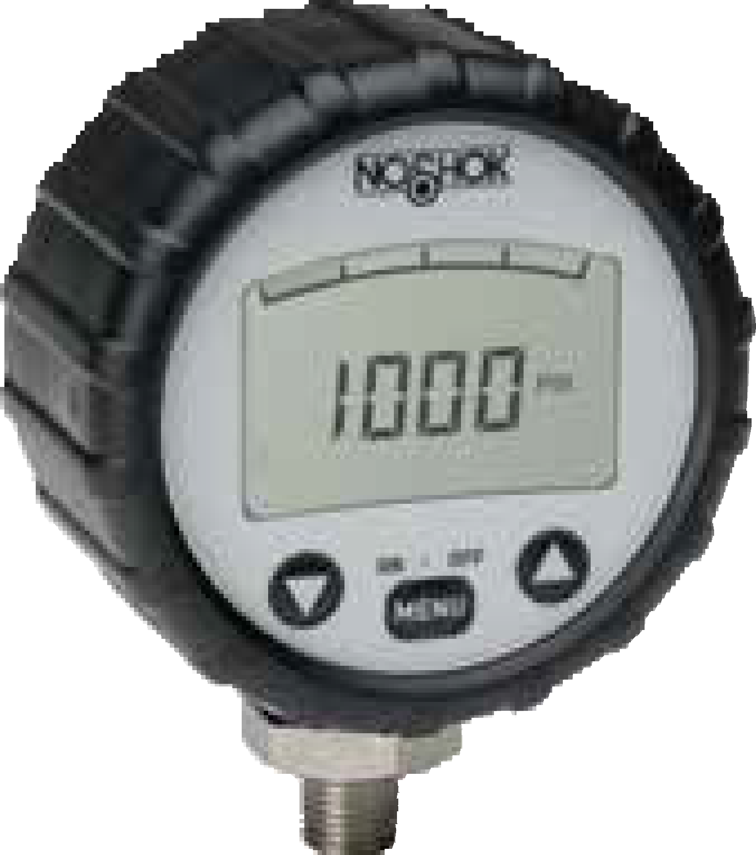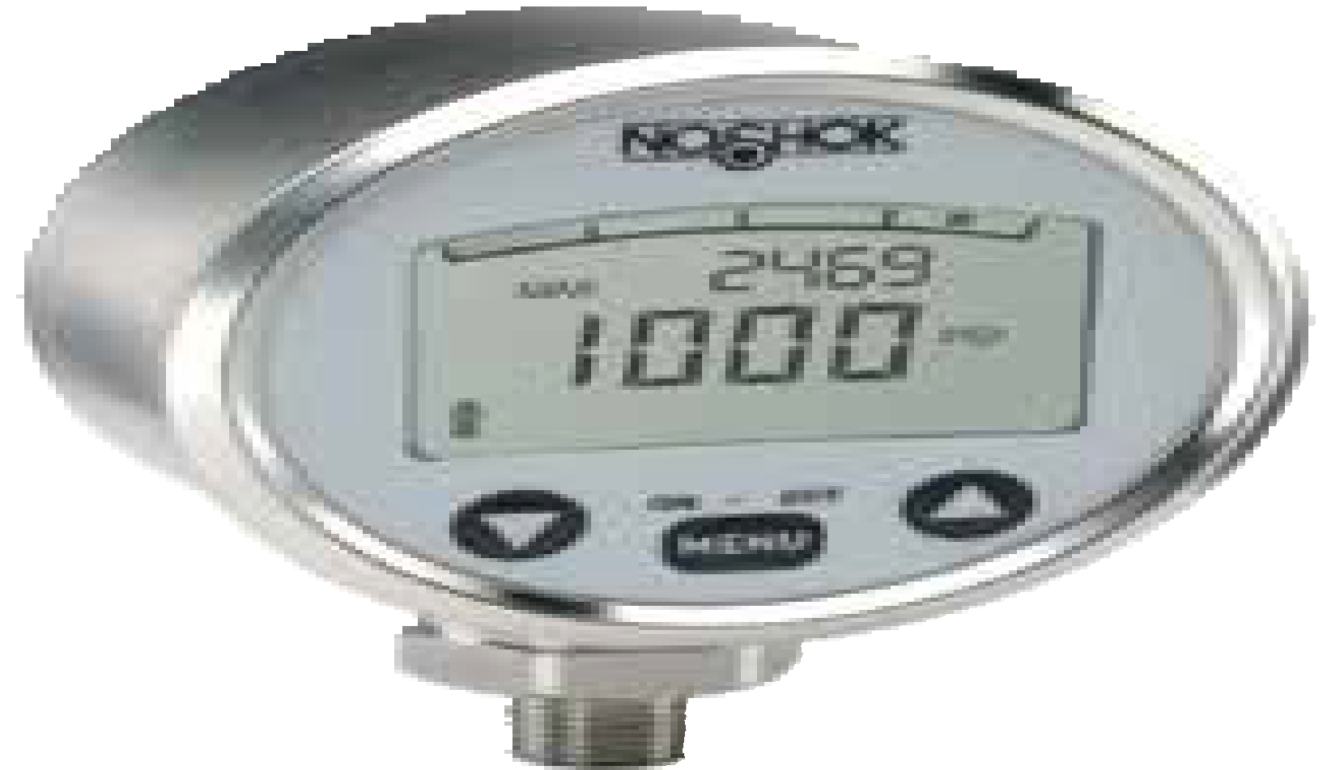1000 SERIES

Rugged, electronic gauge
  - Compound and standard ranges through 0 psig to 10,000 psig
  - 3.31" gauge size
  - Stainless Steel case
  - Stainless Steel wetted parts
  - CE compliant to suppress RFI, EMI and ESD

APPLICATIONS

Shown with enhanced software.
SPECIFICATIONS

Pressure ranges 0 psig to 72 psig through 0 psig to 10,000 psig
Compound ranges available
Accuracy ±0.25% full scale (BFSL); ±0.5% terminal point ±1 digit

Temperature ranges Compensated 32 °F to 140 °F (0 °C to 60 °C)
Effect ±0.15% per 10K at zero and span Span effect is ±0.005% full scale/ °F Media -22 °F to 185 °F (-30 °C to 85 °C)
Ambient 14 °F to 140 °F (-10 °C to 60 °C)
Storage -4 °F to 158 °F (-20 °C to 70 °C)

  - Hydraulics & pneumatics
  - Laboratory & test equipment
  - Leak detection
  - Power generation
  - Water management

Measuring element Stainless Steel, thin-film measuring element

Connection 1/4" NPT Male, 316 Stainless Steel

Case Stainless Steel

Bezel Stainless Steel triangular

Display Liquid Crystal Display with 0.43" digits
4 digits up to 9999 with bar graph

Power requirement* 2 x 1.5V “AA” battery
4,000 hrs (“AA” 2000 mAh)

Response time 200 ms

Proof pressure 2 times full scale range, maximum 15,000 psi

OPTIONAL ENHANCED SOFTWARE FEATURES
Programmable functions Measuring units
Peak memory
Adjustable through front key pad bar, psi, MPa
min/max, display, hold

  - Tare function
  - Password protection
  - Min./max. memory
  - Internal lighting
  - 300° rotatable base

Environmental rating IP65

Electromagnetic rating CE compliant to EMC norm EN 61326:1997/A1:1998
RFI, EMI and ESD protection

Weight 0.88 lb.

* Unregulated

Digital Pressure Gauge
Digital Gauge

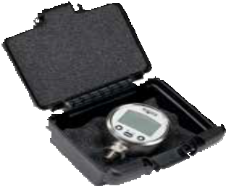
Optional Gauge Carrying Case

WARNING: This product can expose you to chemicals including Chromium (VI) and Nickel, which are known to the State of
62 California to cause cancer and birth defects or other reproductive harm. For more information go to www.P65Warnings.ca.gov

ORDERING INFORMATION
SERIES 1000
PRESSURE RANGES | 30/72  30/145  72 | -30 inHg to 0 to 72 psig  -30 inHg to 0 to 145 psig  0 psig to 72 psig  psig = gauge pressure | 145 0 psig to 145 psig  300 0 psig to 300 psig  750 0 psig to 750 psig  Other ranges available on request |  | 1450  2300  3625 | 0 psig to 1,450 psig  0 psig to 2,300 psig  0 psig to 3,625 psig | 6000  8500  10000 | 0 psig to 6,000 psig  0 psig to 8,500 psig  0 psig to 10,000 psig *
PROCESS CONNECTION 2 1/4″ NPT male
OPTIONS | 1 | Peak memory - standard | GC | Gauge Carrying Case | RCP | Rubber Case Protector
 | 6 | Enhanced software | ST8 | Threaded Orifice
Please consult your local NOSHOK Distributor or NOSHOK, Inc. for availability and delivery information.
* Standard model will only display 9999 psig.

EXAMPLE 1000 – 1450 – 2 – 1 – GC

Series 1000 Series
Pressure range 0 psig to 1,450 psig
Process connection 1/4" NPT Male
Options Peak memory
Options Gauge Carrying Case

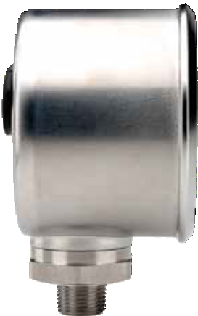1.80"
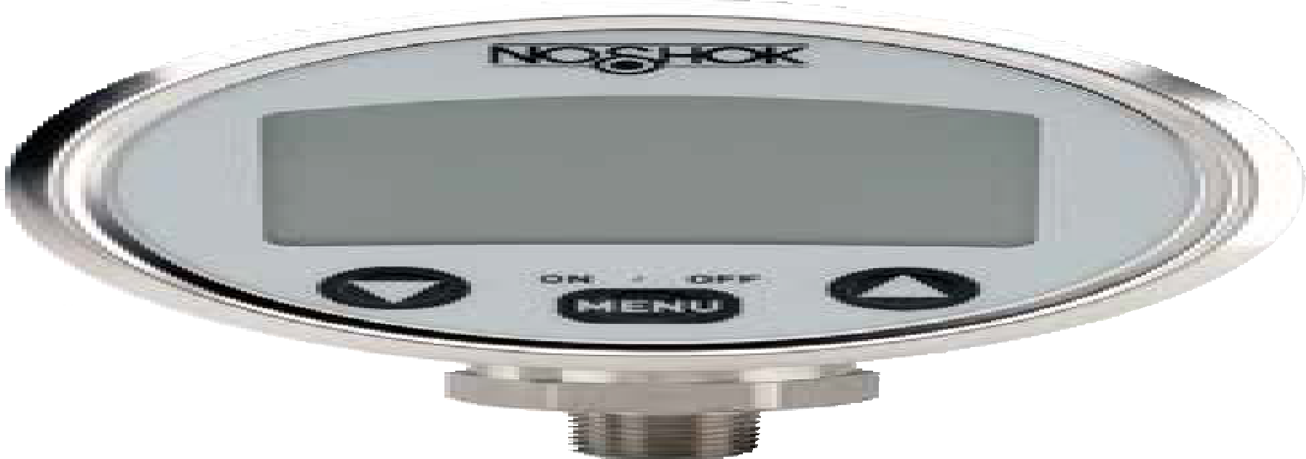(45.7 mm)
3.31"
(84 mm)

2.17"
(55 mm)
1.06" NPT
(27 mm)
1/4" NPT
0.51"
(13 mm)

0.18"
(4.6 mm)

1000 SERIES INFORMATION
ORDERING
DIMENSIONS

3.15" (80 mm)

0.62"
(15.8 mm)

63

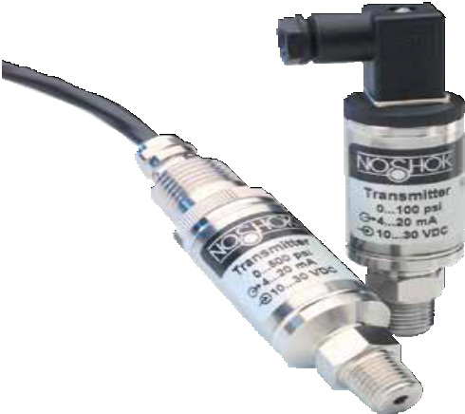

APPLICATIONS

HVAC
  - Hydraulics & pneumatics
  - Injection molding machines
  - Railroad equipment
  - Stamping & forming presses

100 SERIES

Vacuum and compound ranges through 0 psig to 15,000 psig

Current output
- 316 and 17-4PH Stainless Steel wetted parts
- CE compliant to suppress RFI, EMI and ESD

SPECIFICATIONS

Output signal 4 mA to 20 mA, 2-wire

Pressure ranges Vacuum through 0 psig to 15,000 psig
Absolute from 0 psia to 15 psia through 0 psia to 300 psia

Accuracy ±0.5% full scale (BFSL); optional ±0.25% full scale (BFSL);
(Includes the effects of non-linearity, hysteresis, non-repeatability, zero point
and full scale errors)

Stability ≤ ±0.2% full scale for 1 year, non-accumulating

Adjustment ≤ ±10% full scale for zero and span

Response time ≤ 1 ms (between 10% and 90% full scale)

Service life > 100,000,000 load cycles

Temperature ranges Compensated 32 °F to 176 °F (0 °C to 80 °C)
Effect ±0.017% full scale/ °F for zero and span Media -22 °F to 212 °F (-30 °C to 100 °C)
Ambient -40 °F to 185 °F (-40 °C to 85 °C)
Storage -40 °F to 212 °F (-40 °C to 100 °C)

Power requirement* 10 Vdc to 30 Vdc (4 mA to 20 mA, 2-wire)

Load limitations ≤ (Vpower supply -10)/.020 Amp

Proof pressure 3 times full scale for ranges 0 psi to 5 psi through 0 psi to 200 psi
1.75 times full scale for ranges 0 psi to 300 psi through 0 psi to 10,000 psi
1.5 times full scale for 0 to 15,000 psi

Burst pressure 3.8 times full scale for ranges 0 psi to 5 psi through 0 psi to 200 psi
4 times full scale for ranges 0 psi to 300 psi through 0 psi to 10,000 psi 3 times full scale for 0 psi to 15,000 psi

Measuring element 316 Stainless Steel for vacuum through 300 psi;
17-4PH Stainless Steel for ≥500 psi

Connection 316 Stainless Steel

Housing material 316 Stainless Steel

Environmental rating IP65

Electromagnetic rating CE compliant to EMC norm EN 61326:1997/A1:1998
RFI, EMI and ESD protection

Electrical protection Reverse polarity, over-voltage and short circuit protection

Shock 1000 g’s according to IEC 60068-2-27

Vibration 20 g’s according to IEC 60068-2-6

Weight Approximately 3.5 oz.

* Unregulated

Industrial Pressure T ransmitters & T ransducers
Current Output

WARNING: This product can expose you to chemicals including Chromium (VI) and Nickel, which are known to the State of
64 California to cause cancer and birth defects or other reproductive harm. For more information go to www.P65Warnings.ca.gov

ORDERING INFORMATION
SERIES 100
PRESSURE RANGES | 30vac 30/15  30/30  30/45  30/100  30/150  30/200  30/300 | -30 inHg to 0 psig 5  -30 inHg to 15 psig 10  -30 inHg to 30 psig 15  -30 inHg to 45 psig 25  -30 inHg to 100 psig 30  -30 inHg to 150 psig 60  -30 inHg to 200 psig 100  -30 inHg to 300 psig 150 | 0 psig to 5 psig  0 psig to 10 psig  0 psig to 15 psig  0 psig to 25 psig  0 psig to 30 psig  0 psig to 60 psig  0 psig to 100 psig  0 psig to 150 psig  psig = gauge pressure | 200 0 psig to 200 psig 3000 0 psig to 3,000 psig  300 0 psig to 300 psig 4000 0 psig to 4,000 psig  500 0 psig to 500 psig 5000 0 psig to 5,000 psig 600 0 psig to 600 psig 6000 0 psig to 6,000 psig 750 0 psig to 750 psig 7500 0 psig to 7,500 psig 1000 0 psig to 1,000 psig 10000 0 psig to 10,000 psig 1500 0 psig to 1,500 psig 15000 0 psig to 15,000 psig 2000 0 psig to 2,000 psig  psia = absolute pressure Other ranges available on request | 15A  30A  60A  100A  150A  200A  300A | 0 psia to 15 psia  0 psia to 30 psia  0 psia to 60 psia  0 psia to 100 psia  0 psia to 150 psia  0 psia to 200 psia  0 psia to 300 psia
ACCURACIES | 1 | ±0.5% full scale (BFSL) |  | 2 ±0.25% full scale (BFSL)
OUTPUT SIGNAL | 1 | 4 mA to 20 mA, 2-wire
PROCESS 1 1/8″ NPT male 3 SAE J1926-3:7/16-20 Adjustable 9 SAE J1926-1:7/16-20
CONNECTIONS 2 1/4″ NPT male 4 1/8″ NPT female 10 G1/4 male
ELECTRICAL CONNECTIONS | 1  2  3 | 36″ cable (connected to option 7) 4-pin Bendix  6-pin Bendix |  | - 1/2″ NPT conduit ( with 36″ cable)  - Mini-Hirschmann (DIN EN 175301-803 Form C) | 25  36 | M12 x 1 (4-pin)  Integral cable 36″
OPTION | ST8 | Threaded Orifice
Please consult your local NOSHOK Distributor or NOSHOK, Inc. for availability and delivery information.

EXAMPLE

Series 100 Series
Pressure range 0 psig to 500 psig
Accuracy ±0.5% full scale (BFSL)
Output signal 4 mA to 20 mA, 2-wire
Process connection 1/4" NPT Male
Electrical connection Mini-Hirschmann
Option Threaded Orifice

100 – 500 – 1 – 1 – 2 – 7 – ST8

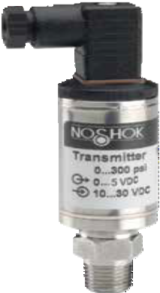1.38"
Load Limitations
4 mA to 20 mA output
Vmin | = | 10V + (.020 x RL)
RL | = | Loop resistance (Ω)  RL = RS + RW
RS | = | Sensor resistance (Ω)
RW |  | Wire resistance (Ω)

(35 mm)

  - " sq
(15.8 mm)

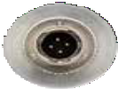
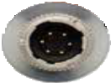
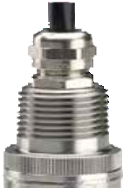0.71"
1.61"
(41 mm)
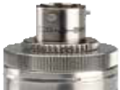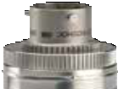(18.1 mm)

0.72"
(18.2 mm)

0.72"
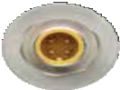
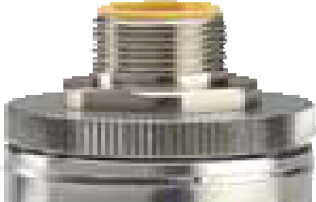(18.2 mm)
1.28"
(32.5 mm)

1/2" NPT conduit with 36" jacketed cable

* 6 pin Bendix * 4 pin Bendix * M12 x 1 (4-pin)

2.30"
(58.5 mm)

* Note: Mate supplied separately or customer supplied.
WIRING
Wire | Bendix  4-pin or 6-pin | Mini- Hirschmann | Cable | M12 x 1
+ Supply | pin A | pin 1 | Red | pin 1
+ Output | pin B | pin 2 | Black | pin 3

  - " HEX
(17 mm)
14" NPT
1.06"
(27 mm)

Mini-Hirschmann

0.51"
(13 mm)

100 SERIES INFORMATION
ORDERING
DIMENSIONS

65

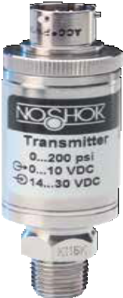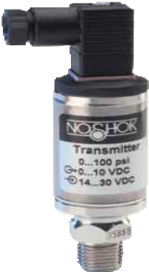SERIES
200

    - Ranges from vacuum to 0 psig to 15,000 psig; absolute ranges from 0 psia to 15 psia through 0 psia to 300 psia

Voltage output
    - 316 and 17-4PH Stainless Steel wetted parts
    - CE compliant to suppress RFI, EMI and ESD

APPLICATIONS

HVAC
    - Hydraulics & pneumatics
    - Injection molding machines
    - Railroad equipment
    - Stamping & forming presses

SPECIFICATIONS

Output signals 0 Vdc to 5 Vdc, 3-wire; 0 Vdc to 10 Vdc, 3-wire; 1 Vdc to 5 Vdc, 3-wire; 1 Vdc to 6 Vdc, 3-wire; 1 Vdc to 11 Vdc, 3-wire

Pressure ranges Vacuum through 0 psig to 15,000 psig
Absolute from 0 psia to 15 psia through 0 psia to 300 psia

Accuracy ±0.5% full scale (BFSL); optional ±0.25% full scale (BFSL);
(Includes the effects of non-linearity, hysteresis, non-repeatability, zero point and
full scale errors)

Stability ≤ ±0.2% full scale per year, non-accumulating

Adjustment ±10% full scale for zero and span Response time ≤ 1 ms (between 10% and 90% full scale) Service life > 100,000,000 load cycles
Temperature ranges Compensated 32 °F to 176 °F (0 °C to 80 °C)
Effect ±0.017% full scale/ °F for zero and span Media -22 °F to 212 °F (-30 °C to 100 °C)
Ambient -40 °F to 185 °F (-40 °C to 85 °C)
Storage -40 °F to 212 °F (-40 °C to 100 °C)

Power requirement* 10 Vdc to 30 Vdc (0 Vdc to 5 Vdc, 3-wire, 1 Vdc to 5 Vdc, 3-wire,
- Vdc to 6 Vdc, 3-wire)
14 Vdc to 30 Vdc (0 Vdc to 10 Vdc, 3-wire, 1 Vdc to 11 Vdc, 3-wire)

Load limitations ≥ 5,000 Ω for 0 Vdc to 5 Vdc, 1 Vdc to 5 Vdc, and 1 Vdc to 6 Vdc outputs;
≥10,000 Ω for 0 Vdc to 10 Vdc and 1 Vdc to 11 Vdc outputs. Current consumption 8 mA

Proof pressure 3 times full scale for ranges 0 psi to 5 psi through 0 psi to 200 psi
1.75 times full scale for ranges 0 psi to 300 psi through 0 psi to 10,000 psi
1.5 times full scale for 0 psi to 15,000 psi

Burst pressure 3.8 times full scale for ranges 0 psi to 5 psi through 0 psi to 200 psi
4 times full scale for ranges 0 psi to 300 psi through 0 psi to 10,000 psi 3 times full scale for 0 psi to 15,000 psi

Measuring element 316 Stainless Steel for vacuum through 300 psi;
17-4PH Stainless Steel for ≥500 psi

Connection 316 Stainless Steel

Housing material 316 Stainless Steel

Environmental rating IP65

Electromagnetic rating CE compliant to EMC norm EN 61326:1997/A1:1998
RFI, EMI and ESD protection

Electrical protection Reverse polarity, over-voltage and short circuit protection

Shock 1,000 g’s according to IEC 60068-2-27

Vibration 20 g’s according to IEC 60068-2-6

Weight Approximately 3.5 oz.

Industrial Pressure T ransmitters & T ransducers
Voltage Output

* Unregulated

WARNING: This product can expose you to chemicals including Chromium (VI) and Nickel, which are known to the State of
66 California to cause cancer and birth defects or other reproductive harm. For more information go to www.P65Warnings.ca.gov

ORDERING INFORMATION
SERIES 200
PRESSURE | 30vac | -30 inHg to 0 psig | 30/300 | -30 inHg to 300 psig | 200 0 psig to 200 psig 3000 0 psig to 3,000 psig | 15A | 0 psia to 15 psia
RANGES | 30/15 | -30 inHg to 15 psig | 5 | 0 psig to 5 psig | 300 0 psig to 300 psig 4000 0 psig to 4,000 psig | 30A | 0 psia to 30 psia
 | 30/30 | -30 inHg to 30 psig | 10 | 0 psig to 10 psig | 500 0 psig to 500 psig 5000 0 psig to 5,000 psig | 60A | 0 psia to 60 psia
 | 30/45 | -30 inHg to 45 psig | 15 | 0 psig to 15 psig | 600 0 psig to 600 psig 6000 0 psig to 6,000 psig | 100A | 0 psia to 100 psia
 | 30/60 | -30 inHg to 60 psig | 30 | 0 psig to 30 psig | 750 0 psig to 750 psig 7500 0 psig to 7,500 psig | 150A | 0 psia to 150 psia
 | 30/100 | -30 inHg to 100 psig | 60 | 0 psig to 60 psig | 1000 0 psig to 1,000 psig 10000 0 psig to 10,000 psig | 200A | 0 psia to 200 psia
 | 30/150 | -30 inHg to 150 psig | 100 | 0 psig to 100 psig | 1500 0 psig to 1,500 psig 15000 0 psig to 15,000 psig | 300A | 0 psia to 300 psia
 | 30/200 | -30 inHg to 200 psig | 150 | 0 psig to 150 psig | 2000 0 psig to 2,000 psig
 |  |  |  | psig = gauge pressure | psia = absolute pressure Other ranges available on request
ACCURACIES | 1 | ±0.5% full scale (BFSL) |  | 2 ±0.25% full scale (BFSL)
OUTPUT SIGNALS | 2 | 0 Vdc to 5 Vdc, 3-wire | 3 | 1 Vdc to 5 Vdc, 3-wire | 4 1 Vdc to 6 Vdc, 3-wire 5 0 Vdc to 10 Vdc, 3-wire | 6 | 1 Vdc to 11 Vdc, 3-wire
PROCESS | 1 | 1/8″ NPT male | 3 | SAE J1926-3:7/16-20 adjustable 9 SAE J1926-1:7/16-20
CONNECTIONS | 2 | 1/4″ NPT male | 4 | 1/8″ NPT female 10 G1/4 male
ELECTRICAL CONNECTION | 1  2  3 | 36″ cable (connected to option 7) 6 1/2″ NPT conduit ( with 36″ cable) 25  4-pin Bendix 7 Mini-Hirschmann (DIN EN 175301-803 form C) 36  6-pin Bendix  NOTE: 0 Vdc to 5 Vdc and 0 Vdc to 10 Vdc outputs are also available in 4-wire configurations for use with other electrical systems. |  |  |  |  | M12 x 1 (4-pin)  Integral cable 36"
OPTION | ST8 | Threaded Orifice
Please consult your local NOSHOK Distributor or NOSHOK, Inc. for availability and delivery information.

EXAMPLE 200 – 500 – 1 – 2 – 2 – 7 – ST8

Series 200 Series
Pressure range 0 psig to 500 psig
Accuracy ±0.5% full scale (BFSL)
Output signal 0 Vdc to 5 Vdc, 3-wire
Process connection 1/4" NPT Male
Electrical connection Mini-Hirschmann
Option Threaded Orifice

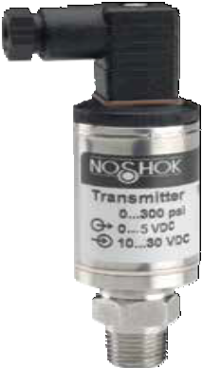1.38"
(35 mm)

  - " sq.
(15.8 mm)

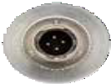
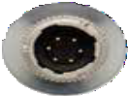
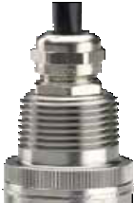0.71"
1.61"
(41 mm)
(18.1 mm)

0.72"
(18.2 mm)

0.72"
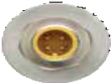
(18.2 mm)
1.28"
(32.5 mm)

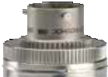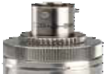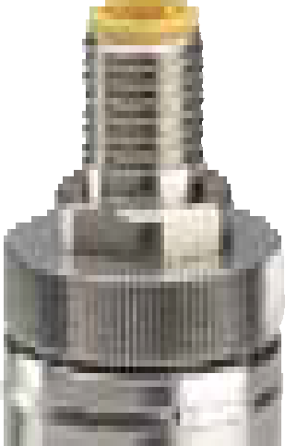

1/2" NPT Conduit with 36" jacketed cable
* 6 pin Bendix * 4 pin Bendix * M12 x 1 (4-pin)
2.30"
(58.5 mm)

* Note: mate supplied separately or customer supplied
WIRING
Wire | Bendix  4-pin or 6-pin | Mini- Hirschmann | Cable | M12 x 1
+ Supply | pin A | pin 1 | Red | pin 1
Common | pin B | pin 2 | Black | pin 3
+ Output | pin C | pin 3 | White | pin 4

0.69" HEX
(17 mm) 1/4" NPT
1.06"
(27 mm)

Mini-Hirschmann

0.51"
(13 mm)

200 SERIES INFORMATION
ORDERING
DIMENSIONS

67

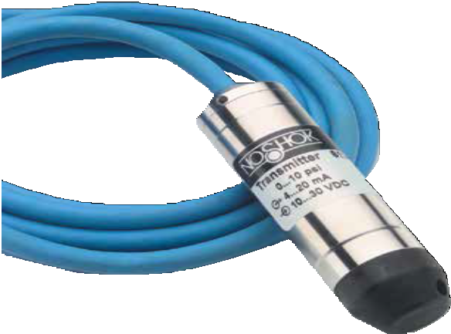

APPLICATIONS

Irrigation
    - Tank monitoring
    - Water & wastewater
    - Well head measurement

612 SERIES

Ranges from 0 inH2O to 50 inH2O through 0 psig to 1,000 psig
- Current and voltage outputs available
- 316 Stainless Steel, polyamide and polyurethane wetted parts
- CE compliant to suppress RFI, EMI and ESD

SPECIFICATIONS

Output signals 4 mA to 20 mA, 2-wire; 0 Vdc to 5 Vdc and 0 Vdc to 10 Vdc, 3-wire;
0.5 Vdc to 2.5 Vdc, 3-wire

Pressure ranges 0 inH2O to 50 inH2O through 0 psig to 1,000 psig

Accuracy ± 0.25% full scale (BFSL); optional ± 0.125% full scale (BFSL);
(includes the effects of non-linearity, hysteresis, non-repeatability, zero point and full scale errors)

Stability ≤ ± 0.2% full scale for 1 year, non-accumulating

Response time ≤ 1 ms (between 10% and 90% full scale)

Service life > 100,000,000 load cycles
Temperature ranges Compensated 32 °F to 122 °F/0 °C to 50 °C
Effect ± 0.01%/ °F for zero and span Media 14 °F to 122 °F / -10 °C to 50 °C Storage -22 °F to 175 °F/-30 °C to 80 °C

Power requirement* 10 Vdc to 30 Vdc (4 mA to 20 mA, 2-wire, 0 Vdc to 5 Vdc, 3-wire)
5 Vdc to 30 Vdc (0.5 Vdc to 2.5 Vdc, 3-wire)
14 Vdc to 30 Vdc (0 Vdc to 10 Vdc, 3-wire)

Load limitations ≤ (VPower-10)/0.020 Amp for 4 mA to 20 mA
≥ 10,000 Ω for 0 Vdc to 10 Vdc, 3-wire
≥ 5,000 Ω for 0 Vdc to 5 Vdc, 3-wire

Proof pressure 2 times range

Burst pressure 4 times range

Measuring element Cap: Polyamide, 316 Stainless Steel with weighted nosecone
Cable: Polyurethane, optional FEP or PVC with double water block

Connection 316 Stainless Steel

Housing material 316 Stainless Steel

Environmental rating IP68

Electromagnetic rating CE compliant to EMC norm EN 61326:1997/A1:1998
RFI, EMI and ESD protection

Electrical protection Reverse polarity protection, short circuit and optional lightning protection per EN 6100-4-5; 1.5J

Shock 100 g’s according to IEC 60068-2-27

Vibration 15 g’s according to IEC 60068-2-6

Weight Approximately 7 oz. with standard nosecone - cable extra

Industrial Level T ransmitters & T ransducers
Submersible

* Unregulated

WARNING: This product can expose you to chemicals including Chromium (VI) and Nickel, which are known to the State of
68 California to cause cancer and birth defects or other reproductive harm. For more information go to www.P65Warnings.ca.gov

ORDERING INFORMATION
SERIES 612
PRESSURE RANGES | 50 inH2O 0 inH2O to 50 inH2O 2 0 psig to 2 psig (4.6 ftH2O)  100 inH2O 0 inH2O to 100 inH2O 3 0 psig to 3 psig (6.9 ftH2O)  150 inH2O 0 inH2O to 150 inH2O 5 0 psig to 5 psig (11.5 ftH2O)  200 inH2O 0 inH2O to 200 inH2O 10 0 psig to 10 psig (23.1 ftH2O)  400 inH2O 0 inH2O to 400 inH2O 15 0 psig to 15 psig (34.6 ftH2O)  psig = gauge pressure Other ranges available on request |  | 20  25 | 0 psig to 20 psig (46.2 ftH2O)  0 psig to 25 psig (57.7 ftH2O) | 200  300 | 0 psig to 200 psig (461.3 ftH2O)  0 psig to 300 psig (692.5 ftH2O)  0 psig to 350 psig (807.9 ftH2O)  0 psig to 500 psig (1154.2 ftH2O)  0 psig to 750 psig (1733.3 ftH2O)  0 psig to 1,000 psig (2311.0 ftH2O)
 |  |  | 30 | 0 psig to 30 psig (69.2 ftH2O) | 350
 |  |  | 60 | 0 psig to 60 psig (138.5 ftH2O) | 500
 |  |  | 100 | 0 psig to 100 psig (230.8 ftH2O) | 750
 |  |  | 150 | 0 psig to 150 psig (346.3 ftH2O) | 1000
ACCURACIES | 1 | ±0.25% full scale (BFSL) | 2 | ±0.125% full scale (BFSL)
OUTPUT SIGNALS | 1 | 4 mA to 20 mA, 2-wire | 5 | 0 Vdc to 10 Vdc, 3-wire
 | 2 | 0 Vdc to 5 Vdc, 3-wire | 11 | 0.5 Vdc to 2.5 Vdc, 3-wire
PROCESS CONNECTIONS | N  T | Nosecone  G 1/2 B x 1/2″ NPT male with 1/4″ NPT female | W | Nosecone w/added weight (1.1 lb.)
ELECTRICAL CONNECTIONS | XX 22-XX | Standard polyurethane (PUR) cable  Optional water-blocked PVC cable (200+ psi only)  NOTE: XX = length of cable in feet. | 38-XX | Optional FEP cable
OPTIONS | PT1  DC | PT100 RTD * CBC Cable Clamp  Desiccant Cartridge LP Lightning Protection * | FE  JB | Filter Element  Cable Junction Box

* Not available for PVC cable
Please consult your local NOSHOK Distributor or NOSHOK, Inc. for availability and delivery information.

EXAMPLE 612 – 5 – 1 – 1 – N – 50

Series 612 Series
Pressure range 0 psig to 5 psig
Accuracy ±0.25% full scale (BFSL)
Output signal 4 mA to 20 mA, 2-wire
Process connection Nosecone
Electrical connection 50' of submersible polyurethane cable

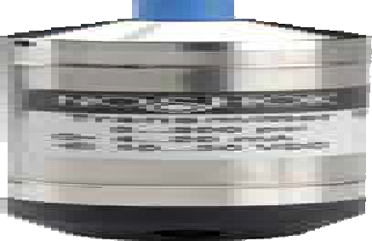1.06″
(27 mm)

  - ″ Dia (5 mm)

G1/2

Weighted nosecone NPT adapter
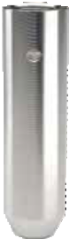1.06″
(27 mm)
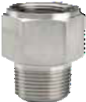 FKM o-ring 1.06″ HEX
(27 mm)

3.90″
(99 mm)

5.12″ (130 mm)

1.81″
(46 mm)

0.73″ (18.5 mm)

0.20″
(5 mm)

1/2″ NPT
Male 1/4″ NPT
Female

612 SERIES INFORMATION
ORDERING
DIMENSIONS
    - WIRE WIRING 3-WIRE WIRING
Wiring | Cable
+ Supply | Red
+ Output | Black

Wiring | Cable
+ Supply | Red
Common | Black
+ Output | White

69

Industrial Level T ransmitters & T ransducers
Cage-Protected Submersible

613 SERIES

Ranges from 0 psi to 5 psi through 0 psi to 300 psi
      - Current & voltage outputs available
      - 316 Stainless Steel and polyurethane wetted parts
      - CE compliant to suppress RFI, EMI and ESD

APPLICATIONS

Lift stations
  - Sewage
  - Slurry tanks
  - Storm canals
  - Water & wastewater
  - Wet wells

SPECIFICATIONS

Output signals 4 mA to 20 mA, 2-wire; 0 Vdc to 5 Vdc and 0 Vdc to 10 Vdc, 3-wire;
0.5 Vdc to 2.5 Vdc, 3-wire

Pressure ranges 0 psi to 5 psi through 0 psi to 300 psi

Accuracy ± 0.25% full scale (BFSL); optional ± 0.125% full scale (BFSL);
(includes the effects of non-linearity, hysteresis, non-repeatability, zero point and full scale errors)

Stability ≤ ± 0.2% full scale for 1 year, non-accumulating

Response time ≤ 1 ms (between 10% and 90% full scale)

Service life > 100,000,000 full scale cycles
Temperature measurement Optional PT100, 4-wire per IEC 60751

Temperature ranges Compensated 32 °F to 122 °F/0 °C to 50 °C
Effect ± 0.01%/ °F for zero and span Media 14 °F to 122 °F / -10 °C to 50 °C
Storage -22 °F to 175 °F/ -30 °C to 80 °C
Power requirement* 10 Vdc to 30 Vdc (4 mA to 20 mA, 2-wire, 0 Vdc to 5 Vdc, 3-wire)
5 Vdc to 30 Vdc (0.5 Vdc to 2.5 Vdc, 3-wire)
14 Vdc to 30 Vdc (0 Vdc to 10 Vdc, 3-wire)

Load limitations ≤ (VPower-10)/0.020 Amp for 4 mA to 20 mA
≥ 10,000 Ω for 0 Vdc to 10 Vdc, 3-wire
≥ 5,000 Ω for 0 Vdc to 5 Vdc, 3-wire

Proof pressure 2 times range

Burst pressure 4 times range

Measuring element Cage seal: All 316 Stainless Steel
Cable: Polyurethane, optional FEP

Connection 316 Stainless Steel

Housing material 316 Stainless Steel

Environmental rating IP68

Electromagnetic rating CE compliant to EMC norm EN 61326:1997/A1:1998
RFI, EMI and ESD protection

Electrical protection Reverse polarity protection, short circuit and optional lightning protection per EN 6100-4-5; 1.5J

Shock 100 g’s according to IEC 60068-2-27

Vibration 15 g’s according to IEC 60068-2-6

Weight Approximately 3.2 lb. - cable extra

* Unregulated

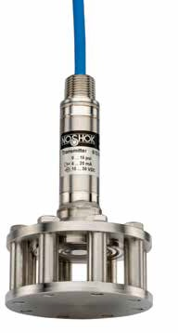

WARNING: This product can expose you to chemicals including Chromium (VI) and Nickel, which are known to the State of
70 California to cause cancer and birth defects or other reproductive harm. For more information go to www.P65Warnings.ca.gov

ORDERING INFORMATION
SERIES 613
PRESSURE RANGES | 5  10  15 | 0 psi to 5 psi (11.55 ft/H2O)  0 psi to 10 psi (23.10 ft/H2O)  0 psi to 15 psi (34.65 ft/H2O) | 20  30  50 | 0 psi to 20 psi (46.20 ft/H2O)  0 psi to 30 psi (69.30 ft/H2O)  0 psi to 50 psi (115.50 ft/H2O) | 75  100  150 | 0 psi to 75 psi (173.25 ft/H2O)  0 psi to 100 psi (231.00 ft/H2O)  0 psi to 150 psi (346.50 ft/H2O) | 300 | 0 psi to 300 psi (693 ft/H2O)
ACCURACIES | 1 | ±0.25% full scale (BFSL) |  |  | 2 | ±0.125% full scale (BFSL)
OUTPUT SIGNALS | 1  2 | 4 mA to 20 mA, 2-wire  0 Vdc to 5 Vdc, 3-wire |  |  | 5  11 | 0 Vdc to 10 Vdc, 3-wire  0.5 Vdc to 2.5 Vdc, 3-wire
ELECTRICAL CONNECTIONS | XX | Standard polyurethane (PUR) cable  NOTE: XX = length of cable in feet. |  |  | 38-XX | Optional FEP cable
OPTIONS | CBC  DC | Cable Clamp  Desiccant Cartridge | FE  JB | Filter Element  Cable Junction Box | LP  LR | Lightning Protection *  Lifting Ring | PT1 | PT100 RTD *
Please consult your local NOSHOK Distributor or NOSHOK, Inc. for availability and delivery information.
- Only available with PUR cable

EXAMPLE 613 – 5 – 1 – 1 – 50' – LR

Series 613 Series
Pressure range psi to 5 psi
Accuracy ±0.25% full scale (BFSL)
Output signal 4 mA to 20 mA, 2-wire
Electrical connection 50' of submersible polyurethane cable
Option Lifting Ring

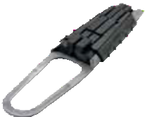
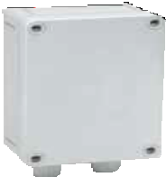
Optional Cable Clamp
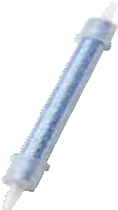
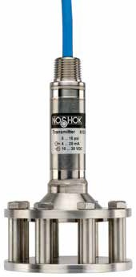Optional Cable Junction Box
1/2″ NPT
Ø 1.06″
(27 mm)
4.44″ (113 mm)
1.75″ 1.25″
(44 mm) (32 mm) (27 mm)
1.06″
0.25″
(6 mm)
2.14″
(54 mm) Active area
Ø 3.75″
(95 mm)

Optional Desiccant Cartridge

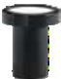

Optional Filter Element

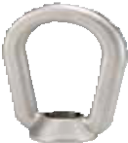

Optional Lifting Ring

613 SERIES INFORMATION
ORDERING
DIMENSIONS

71
WARNING: This product can expose you to chemicals including Chromium (VI) and Nickel, which are known to the State of
California to cause cancer and birth defects or other reproductive harm. For more information go to www.P65Warnings.ca.gov

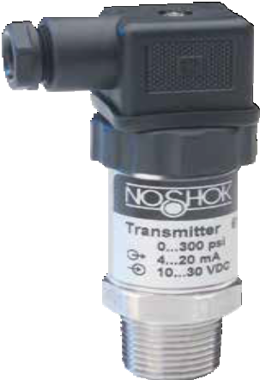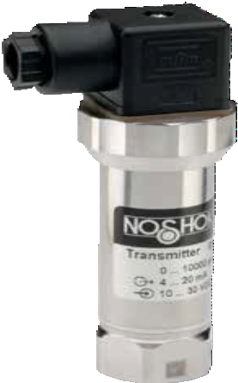615/616 SERIES

Vacuum ranges through 0 psig to 145,000 psig; absolute ranges from 0 psia to 15 psia through 0 psia to 300 psia
  - Current and voltage outputs available
  - 316 and 17-4PH Stainless Steel wetted parts
  - CE compliant to suppress RFI, EMI and ESD

APPLICATIONS

Construction
  - Hydraulics & pneumatics
  - Laboratory & test equipment
  - Power generation
  - Stamping & forming presses
  - Transportation

Also available with our 1800 Series
Attachable Loop Indicator.
Visit www.noshok.com for more

High pressure model
SPECIFICATIONS

Output signals 4 mA to 20 mA, 2-wire;
0 Vdc to 5 Vdc, 0 Vdc to 10 Vdc, 1 Vdc to 5 Vdc,3-wire

Pressure ranges Vacuum through 0 psig to 145,000 psig
Absolute from 0 psia to 15 psia through 0 psia to 300 psia

Accuracy ± 0.25% full scale (BFSL); optional ± 0.125% full scale (BFSL); (includes the effects of non-linearity, hysteresis, non-repeatability, zero point and full scale errors)

Stability ≤ ±0.2% full scale for 1 year, non-accumulating

Adjustment ± 10% full scale for zero and span

Response time Less than 1 ms (between 10% and 90% full scale)

Service life >100,000,000 load cycles

Temperature ranges Compensated 32 °F to 175 °F (0 °C to 80 °C)
Effect ± 0.01%/ °F for zero and span Media -20 °F to 212 °F (-30 °C to 100 °C)
Ambient -15 °F to 175 °F (-10 °C to 80 °C)
Storage -40 °F to 212 °F (-40 °C to 100 °C)

Power requirement* 10 Vdc to 30 Vdc (4 mA to 20 mA, 2-wire, 1 Vdc to 5 Vdc, 3-wire, 1 Vdc to 6 Vdc, 3-wire, 0 Vdc to 5 Vdc, 3-wire)
14 Vdc to 30 Vdc (0 Vdc to 10 Vdc, 3-wire, 1 Vdc to 11 Vdc, 3-wire)

Load limitations ≤ (VPower-10)/0.020 Amp for 4 mA to 20 mA
≥ 10,000 Ω for 0 Vdc to 10 Vdc, 3-wire
≥ 5,000 Ω for 0 Vdc to 5 Vdc, 3-wire

Proof pressure 3 times full scale for ranges 0 psi to 2 psi through 0 psi to 200 psi
1.75 times full scale for ranges 0 psi to 300 psi through 0 psi to 10,000 psi
1.5 times full scale for 0 psi to 15,000 psi
1.2 times full scale for ranges 0 psi to 20,000 psi through 0 psi to 145,000 psi

Burst pressure 3.8 times full scale for ranges 0 psi to 2 psi through 0 psi to 200 psi
4 times full scale for ranges 0 psi to 300 psi through 0 psi to 10,000 psi 3 times full scale for 0 psi to 15,000 psi
1.5 times full scale for ranges 0 psi to 20,000 psi through 0 psi to 145,000 psi

Measuring element 316 Stainless Steel for vacuum through 300 psi;
17-4PH Stainless Steel for ≥500 psi

Connection 316 Stainless Steel

Housing material 316 Stainless Steel

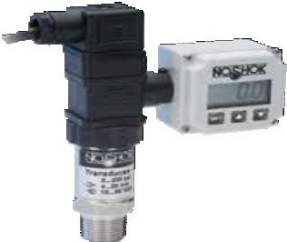
Environmental rating IP65

Electromagnetic rating CE compliant to EMC norm EN 61326:1997/A1:1998
RFI, EMI and ESD protection

Electrical protection Reverse polarity, overvoltage and short circuit protection

Shock 1,000 g’s according to IEC 60068-2-27

Vibration 15 g’s according to IEC 60068-2-6

Weight Approximately 7.2 oz.

information. * Unregulated

Industrial Pressure T ransmitters & T ransducers
High Accuracy Heavy-Duty

WARNING: This product can expose you to chemicals including Chromium (VI) and Nickel, which are known to the State of
72 California to cause cancer and birth defects or other reproductive harm. For more information go to www.P65Warnings.ca.gov

ORDERING INFORMATION
SERIES | 615 | (Internal diaphragm) 616 | (Front flush diaphragm)
PRESSURE | 30vac | -30 inHg to 0 psig 2 0 psig to 2 psig 150  -30 inHg to 15 psig 3 0 psig to 3 psig 200  -30 inHg to 30 psig 5 0 psig to 5 psig 300  -30 inHg to 60 psig 10 0 psig to 10 psig 500  -30 inHg to 100 psig 15 0 psig to 15 psig 600  -30 inHg to 150 psig 30 0 psig to 30 psig 750  -30 inHg to 200 psig 60 0 psig to 60 psig 1000  -30 inHg to 300 psig 100 0 psig to 100 psig 1500  psig = gauge pressure psia = absolute pressure | 0 psig to 150 psig 2000 0 psig to 2,000 psig 20000 0 psig to 20,000 psig * 145000 0 psig to 145,000 psig
RANGES | 30/15 |  | 0 psig to 200 psig 3000 0 psig to 3,000 psig 30000 0 psig to 30,000 psig 15A 0 psia to 15 psia
 | 30/30 |  | 0 psig to 300 psig 4000 0 psig to 4,000 psig 36000 0 psig to 36,000 psig 30A 0 psia to 30 psia
 | 30/60 |  | 0 psig to 500 psig 5000 0 psig to 5,000 psig 58000 0 psig to 58,000 psig 60A 0 psia to 60 psia
 | 30/100 |  | 0 psig to 600 psig 6000 0 psig to 6,000 psig 72000 0 psig to 72,000 psig 100A 0 psia to 100 psia
 | 30/150 |  | 0 psig to 750 psig 7500 0 psig to 7,500 psig 87000 0 psig to 87,000 psig 150A 0 psia to 150 psia
 | 30/200 |  | 0 psig to 1,000 psig 10000 0 psig to 10,000 psig 100000 0 psig to 100,000 psig 200A 0 psia to 200 psia
 | 30/300 |  | 0 psig to 1,500 psig 15000 0 psig to 15,000 psig 115000 0 psig to 115,000 psig 300A 0 psia to 300 psia
 |  |  | Other ranges available on request Note: 616 Series is available for pressure ranges up to 0 psig to 8,000 psig
ACCURACIES | 1 | ±0.25% full scale (BFSL) 2 | ±0.125% full scale (BFSL)
OUTPUT SIGNALS | 1 | 4 mA to 20 mA, 2-wire 3 | 1 Vdc to 5 Vdc, 3-wire NOTE: 0 Vdc to 5 Vdc and 0 Vdc to 10 Vdc outputs are also available in 4-wire configurations for use with other electrical systems.  0 Vdc to 10 Vdc, 3-wire
 | 2 | 0 Vdc to 5 Vdc, 3-wire 5
PROCESS 615: | 2 | 1/4″ NPT male 6 | 9/16″ -18 UNF 2B high pressure cone ** 8 1/2″ NPT male
CONNECTIONS |  |  | (Standard on 30,000 to 120,000 psig)
616: | 11 | G 1/2 B (Pressure ranges ≥ 0 psig to 30 psig) 13 | G 1 B (Pressure ranges ≤ 0 psig to 30 psig) Other connections available upon request
ELECTRICAL CONNECTIONS | 1  3 | 36″ cable (connected to option 8) 8  6-pin Bendix 14 | Hirschmann (DIN EN 175301-803 Form A) 25 M12 x 1 (4-pin)  Hirschmann type with 1/2″ NPT female conduit 36 Integral 36″ cable
 | 6 | 1/2″ NPT conduit w/ 36″ cable
OPTIONS | ST8 | SS Threaded Orifice G1 | G 1 Weld-on adapter (616 only) G½ G 1/2 Weld-on adapter (616 only)
Please consult your local NOSHOK Distributor or NOSHOK, Inc. for availability and delivery information.
* Not available with 1/4" NPT
** Equivalent to F250C Parker Autoclave
EXAMPLE 615 – 500 – 1 – 1 – 8 – 1 – ST8

Series 615 Series
Pressure range 0 psig to 500 psig
Accuracy ±0.25% full scale (BFSL)
Output signal 4 mA to 20 mA, 2-wire
Process connection 1/2" NPT Male
Electrical connection 36" cable
Option Threaded Orifice

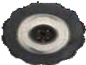
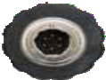 1.36″ (34.5 mm)

1.89"
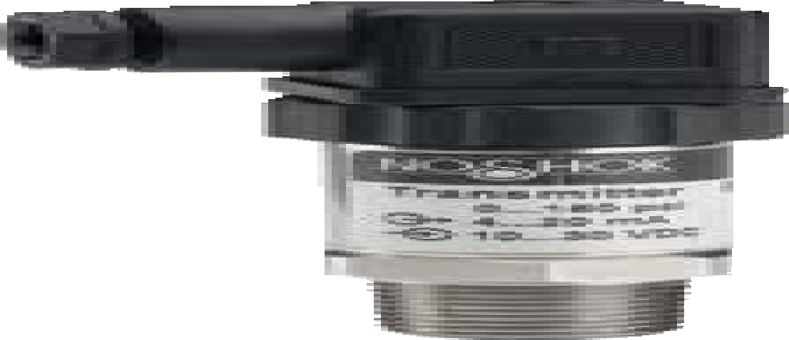(48 mm) 1.06" sq.
(27 mm)

1.10"
(28 mm)

1/2″ NPT Conduit with 36″ jacketed cable

0.68"
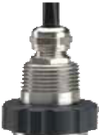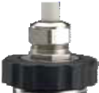(17.3 mm)

1.48"
(37.5 mm)

Integral 36″ cable

*6 pin Bendix

0.51"
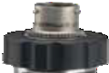(13 mm)

0.54"
(13.8 mm)

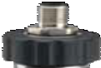
*M12 x 1 (4-pin)

1.65"
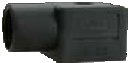(42 mm)

Hirschmann with
1/2″ NPT Female

1.06" sq.
(27 mm)

  - " HEX
(27 mm) 1/2" NPT
1.06"
(27 mm)

2.16"
(55 mm)

0.75"
(19 mm)

2-WIRE WIRING
*Note: mate supplied
separately or customer supplied

    - WIRE WIRING
ISO 4400 conduit
Hirschmann

615/616 SERIES INFORMATION
ORDERING
DIMENSIONS

73
NOTE
See 621/622 Series for G1/2B and G1B Front Flush Process
Connection Dimensions pg. 85
 | Hirschmann | Cable | M12 | Bendix
+ Supply | 1 | Red | 1 | A
Common | 2 | Black | 3 | B
+ Output | 3 | White | 4 | C

 | Hirschmann | Cable | M12 | Bendix
+ Supply | 1 | Red | 1 | A
+ Output | 2 | Black | 3 | B

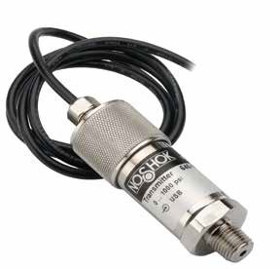

APPLICATIONS
    - Aerospace equipment
    - Laboratory & test equipment
    - Precision measurement

SERIES

- Vacuum ranges through 0 psig to 15,000 psig; absolute ranges from 0 psia to 15 psia through 0 psia to 300 psia
640
- Standard 4 mA to 20 mA output
- 316 and 17-4PH Stainless Steel wetted parts
- CE compliant to suppress RFI, EMI and ESD

SPECIFICATIONS

Output signals 4 mA to 20 mA, 2-wire; 0 Vdc to 5 Vdc and 0 Vdc to 10 Vdc, 3-wire

Pressure ranges Vacuum through 0 psig to 15,000 psig
Absolute from 0 to 15 psia through 0 psia to 300 psia

Accuracy ±0.05% full scale (BFSL); optional ±0.025% full scale (BFSL); (includes the ef- fects of non-linearity, hysteresis, non-repeatability, zero point and full scale errors)

Stability ≤ ±0.1% full scale; 5 psi ±0.2% full scale per year Response time < 300 ms (between 10% to 90% full scale) Service life > 100,000,000 load cycles
Temperature ranges Compensated 32 °F to 160 °F (0 °C to 70 °C)
Effect: ±0.005% °F (32 °F to 50 °F) to zero point and pressure range no effect (50 °F to 104 °F) for zero and span
±0.005%/ °F (104 °F to 158 °F) to zero point and pressure range Media - 5 °F to 160 °F (-20 °C to 70 °C)
Ambient 32 °F to 160 °F (0 °C to 70 °C)
Storage -5 °F to 160 °F (-20 °C to 70 °C)

Power requirement* 9 Vdc to 30 Vdc (4 mA to 20 mA, 2-wire, 0 Vdc to 5 Vdc, 3-wire)
14 Vdc to 30 Vdc (0 Vdc to 10 Vdc, 3-wire) Voltage supply via RS232 interface (RS232)

Load limitations ≤ (VPower-10)/0.020 Amp for 4 mA to 20 mA
≥ 10,000 Ω for 0 Vdc to 10 Vdc, 3-wire
≥ 5,000 Ω for 0 Vdc to 5 Vdc, 3-wire

Proof pressure 3 times full scale for ranges 0 psi to 5 psi through 0 psi to 200 psi
2 times full scale for ranges 0 psi to 300 psi through 0 psi to 10,000 psi
1.5 times full scale for 0 psi to 15,000 psi

Burst pressure 4 times full scale for ranges 0 psi to 5 psi through 0 psi to 200 psi
4 times full scale for ranges 0 psi to 300 psi through 0 psi to 10,000 psi 3 times full scale for 0 psi to 15,000 psi

Measuring element 316 Stainless Steel for vacuum through 300 psi;
17-4PH Stainless Steel for ≥500 psi

Connection 316 Stainless Steel

Housing material 316 Stainless Steel

Environmental rating IP65

Electromagnetic rating CE compliant to EMC norm EN 61326:1997/A1:1998
RFI, EMI and ESD protection

Electrical protection Reverse polarity, overvoltage and short circuit protection

Shock 100 g’s according to IEC 60068-2-27

Vibration 15 g’s according to IEC 60068-2-6

Weight Approximately 11 oz.

- Unregulated

Industrial Pressure T ransmitters & T ransducers
Precision Heavy-Duty

WARNING: This product can expose you to chemicals including Chromium (VI) and Nickel, which are known to the State of
74 California to cause cancer and birth defects or other reproductive harm. For more information go to www.P65Warnings.ca.gov

ORDERING INFORMATION
SERIES 640
PRESSURE RANGES | 30vac  30/15 | -30 inHg to 0 psig 30/300 -30 inHg to 300 psig 150  -30 inHg to 15 psig 5 0 psig to 5 psig 200  -30 inHg to 30 psig 10 0 psig to 10 psig 300  -30 inHg to 60 psig 15 0 psig to 15 psig 500  -30 inHg to 100 psig 30 0 psig to 30 psig 750  -30 inHg to 150 psig 60 0 psig to 60 psig 1000  -30 inHg to 200 psig 100 0 psig to 100 psig 2000  psig = gauge pressure psia = absolute pressure |  | 0 psig to 150 psig 3000 0 psig to 3,000 psig  0 psig to 200 psig 5000 0 psig to 5,000 psig  0 psig to 300 psig 6000 0 psig to 6,000 psig  0 psig to 500 psig 7500 0 psia to 7,500 psig  0 psig to 750 psig 10000 0 psia to 10,000 psig  0 psig to 1,000 psig 15000 0 psia to 15,000 psig  0 psig to 2,000 psig 15A 0 psia to 15 psia  Other ranges available on request | 30A  60A | 0 psia to 30 psia  0 psia to 60 psia
 | 30/30 |  |  |  | 100A | 0 psia to 100 psia
 | 30/60 |  |  |  | 150A | 0 psia to 150 psia
 | 30/100 |  |  |  | 200A | 0 psia to 200 psia
 | 30/150 |  |  |  | 300A | 0 psia to 300 psia
 | 30/200
ACCURACIES | 1 | ±0.05% full scale (BFSL) | 2 | ±0.025% full scale (BFSL)
OUTPUT SIGNALS | 1 | 4 mA to 20 mA, 2-wire analog | 5 | 0 Vdc to 10 Vdc, 3-wire analog
 | 2 | 0 Vdc to 5 Vdc, 3-wire analog
PROCESS CONNECTIONS | 2 | 1/4″ NPT male | 8 | 1/2″ NPT male; other connections available upon request
ELECTRICAL CONNECTIONS | 1 | 54″ Integral cable | 25 | M12 x 1 (4-pin)
OPTION | ST8 | Threaded Orifice
Please consult your local NOSHOK Distributor or NOSHOK, Inc. for availability and delivery information.

EXAMPLE 640 – 3000 – 1 – 1 – 8 – 25 – ST8

Series 640 Series
Pressure range 0 psig to 3,000 psig
Accuracy ±0.05% full scale (BFSL)
Output signal 4 mA to 20 mA, 2-wire analog
Process connection 1/2" NPT Male
Electrical connection M12 x 1 (4-pin)
Option Threaded Orifice

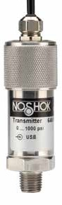0.71" (18 mm)

2.95"
(75 mm)

1.06" HEX
(27 mm)

0.51" (13 mm)

1/4" NPT

2-WIRE WIRING

1.06"
(27 mm)

- WIRE WIRING
Wiring | M12 | Cable
+ Supply | 1 | Brown
Common | 3 | Blue
+ Output | 4 | Black

640 SERIES INFORMATION
ORDERING
DIMENSIONS
Wiring | M12 | Cable
+ Supply | 1 | Brown
+ Output | 3 | Blue

75

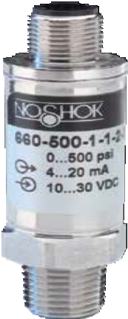

APPLICATIONS
  - Hydraulics & pneumatics
  - Mobile hydraulics
  - Power generation
  - Pumps & compressors
  - Refrigeration controls

SERIES

- Ranges from 0 psig to 200 through 0 psig to 15,000 psig
660
- Current & voltage outputs available
- Stainless Steel wetted parts
- 1.0 mm standard orifice size for improved performance in dynamic
applications
- CE compliant to suppress RFI, EMI and ESD

SPECIFICATIONS

Output signals 4 mA to 20 mA 2-wire, 1 Vdc to 5 Vdc 3-wire; 0.1 Vdc to 10 Vdc, 3-wire

Pressure ranges 0 psig to 200 psig through 0 psig to 15,000 psig

Accuracy ±0.25% full scale (BFSL); (Includes the effects of non-linearity, hysteresis,
non-repeatability, zero point and full scale errors)

Stability ≤ ±2% full scale for 1 year, non-accumulating Response time <2 ms (between 10% and 90% full scale) Service life > 100,000,000 load cycles
Temperature ranges Compensated -4 °F to 185 °F (-20 °C to 85 °C)
Zero effect ±0.01% full scale/ °F Span effect ±0.01% full scale/ °F
Media -13 °F to 185 °F (-40 °C to 100 °C); -40 °F to 257 °F (-40 °C to 125 °C)
available on request
Ambient -4 °F to 185 °F (-25 °C to 85 °C)
Storage -40 °F to 212 °F (-40 °C to 100 °C)

Power requirement* 10 Vdc to 36 Vdc (4 mA to 20 mA, 2-wire)
8 Vdc to 36 Vdc (1 Vdc to 5 Vdc, 3-wire)
14 Vdc to 36 Vdc (0.1 Vdc to 10 Vdc, 3-wire)

Load limitations ≤ (VPower-10)/0.020 Amp for 4 mA to 20 mA
≥ 10,000 Ω for 1 Vdc to 10 Vdc, 3-wire
≥ 5,000 Ω for 1 Vdc to 5 Vdc, 3-wire

Proof pressure 2 times full scale for ranges 0 psi to 200 psi through 0 psi to 10,000 psi
1.5 times full scale for 0 psi to 15,000 psi range

Burst pressure 9 times full scale for 0 psi to 200 psi through 0 psi to 1,000 psi
3 times full scale for ranges 0 to 3,000 psi through 0 psi to 15,000 psi

Measuring element 17-4PH Stainless Steel

Connection 316 Stainless Steel

Housing material 316 Stainless Steel

Environmental rating IP65; IP67 M12x1 electrical connection for pressure ranges 0 psig to 1,500 psig
or higher

Electromagnetic rating CE compliant to EMC norm EN 61326:1997/A1:1998
RFI, EMI and ESD protection

Electrical protection Reverse polarity, over-voltage and short circuit protection

Shock 1,000 g’s according to IEC 60068-2-27

Vibration 20 g’s according to IEC 60068-2-6

Weight Approximately 1.75 oz.

Industrial Pressure T ransmitters & T ransducers
Micro-Size

* Unregulated

WARNING: This product can expose you to chemicals including Chromium (VI) and Nickel, which are known to the State of
76 California to cause cancer and birth defects or other reproductive harm. For more information go to www.P65Warnings.ca.gov

ORDERING INFORMATION
SERIES 660
PRESSURE RANGES | 200  300 | 0 psig to 200 psig 500 0 psig to 500 psig 3000 0 psig to 3,000 psig  0 psig to 300 psig 1000 0 psig to 1,000 psig 5000 0 psig to 5,000 psig  psig = gauge pressure Other ranges available on request | 10000  15000 | 0 psig to 10,000 psig  0 psig to 15,000 psig
ACCURACY | 1 | ±0.25% full scale (BFSL)
OUTPUT SIGNALS | 1 | 4 mA to 20 mA, 2-wire 3 1 Vdc to 5 Vdc, 3-wire 27 0.1 Vdc to 10 Vdc, 3-wire
PROCESS CONNECTIONS | 2 | 1/4″ NPT male
ELECTRICAL CONNECTIONS | 1 | 36″ cable (connected to option 7) 7 Mini-Hirschmann (DIN EN 175301-803 Form C) | 25 | M12 x 1 (4-pin)
Please consult your local NOSHOK Distributor or NOSHOK, Inc. for availability and delivery information.

EXAMPLE 660 – 500 – 1 – 1 – 2 – 25

Series 660 Series
Pressure range 0 psig to 500 psig
Accuracy ±0.25% full scale (BFSL)
Output signal 4 mA to 20 mA, 2-wire
Process connection 1/4" NPT Male
Electrical connection M12 x 1 (4-pin)

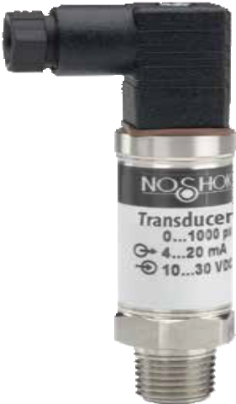1.40"
(35.5 mm)

0.63" sq
(15.8 mm)

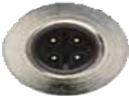
0.44"
(11 mm)

1.06"
(26.8 mm)

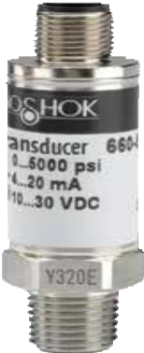0.78”
1.73"
(44 mm)
(19.8 mm)

1.83"
(46.5 mm)

0.75" HEX
(19 mm)

1/4" NPT

0.75"
(19 mm) 0.51"
(13 mm)

M12 x 1 (4-pin)

2-WIRE WIRING
Mini-Hirschmann

3-WIRE WIRING

660 SERIES INFORMATION
ORDERING
DIMENSIONS

77
Wiring | M12 | Mini-Hirschmann | Cable
+ Supply | 1 | 1 | Red
Common | 3 | 2 | Black
+ Output | 4 | 3 | White

Wiring | M12 | Mini-Hirschmann | Cable
+ Supply | 1 | 1 | Red
+ Output | 3 | 2 | Black

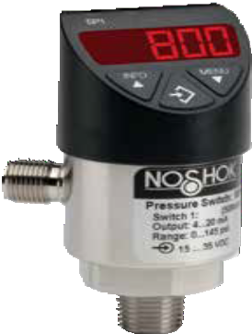

APPLICATIONS
  - Hydraulics & pneumatics
  - Power generation
  - Pumps & compressors
  - Stamping & forming presses
  - Water & wastewater

SERIES

- Compound and standard ranges from 0 psig to 10 psig through 0 psig to 7,500 psig
800
- 316L Stainless steel wetted parts
- Current and voltage outputs available
- 7 different output configurations available
- Display and electrical connection can be rotated independently
- CE compliant to suppress RFI, EMI and ESD
- RoHS compliant

SPECIFICATIONS

Compound and standard ranges from 0 psig to 10 psig through
Pressure ranges
0 psig to 7,500 psig
Switching parameters Individually adjustable via external control keys
Number 1 or 2 (PNP or NPN)
Function N.O., N.C., window, hysteresis (freely adjustable)
Contact rating 250 mA max.
Response time ≤5 ms
Accuracy ≤ 0.5 % of span
Switch point .25 to 100% of full scale
Hysteresis Fully adjustable

Transmitter parameters
Output signal 4 mA to 20 mA or 0 Vdc to 10 Vdc; programmable and freely adjustable Accuracy ≤±0.5% of span including non-linearity, hysteresis, zero offset and end value
deviation (corresponds to measured error per IEC 61298-2)
Non-repeatability < 0.1% of span (IEC 61298-2)
Adjustment Freely scalable within the range of 5:1

Service life 100,000,000 load cycles

Temperature ranges Compensated 32 °F to 176 °F (0 °C to 80 °C)
Media -4 °F to 185 °F (-20 °C to 185 °C)
Ambient -4 °F to 176 °F (-20 °C to 80 °C)
Storage -4 °F to 158 °F (-20 °C to 70 °C)
Display 14 segment-LED, red 4-digit, height 0.35”

Power requirement* 15 - 35 Vdc

Max. 45 mA for versions without 4-20 mA output signal,

Current consumption Max. 70 mA for versions with 4-20 mA output signal,

Industrial Pressure T ransmitters & T ransducers
Electronic Indicating Transmitter/Switch
Total consumtpion max. 600 mA including switching current
Proof pressure 2 times full scale

Measuring element <150 psi: 316L Stainless steel
≥150 psi: 316L, PH grade Stainless steel
Housing material 304 Stainless steel

Connection 316 stainless steel

Environmental rating IP65 and IP67 per IEC 60529

Electromagnetic rating CE compliant to EMC norm EN 61326:1997/A1:1998
RFI, EMI and ESD protection
Electrical protection Protected against reverse polarity, over-voltage and short circuit

Shock > 50 g’s according to IEC 60068-2-27

Vibration > 20 g’s according to IEC 60068-2-6

Weight Approx 0.49 lb.

* Unregulated

WARNING: This product can expose you to chemicals including Chromium (VI) and Nickel, which are known to the State of
78 California to cause cancer and birth defects or other reproductive harm. For more information go to www.P65Warnings.ca.gov

ORDERING INFORMATION
SERIES | 800 | 304 Stainless steel housing
SWITCH FUNCTIONS | 1  2  3  4 | 2 N.O. or N.C. (PNP or NPN)  1 N.O. or N.C. (PNP or NPN) with 4 mA to 20 mA 3-wire analog output  - N.O. or N.C. (PNP or NPN) with 0 Vdc to 10 Vdc 3-wire output  - N.O. or N.C. (PNP or NPN) with 4 mA to 20 mA analog output* | 5  6  7 | 2 N.O. or N.C. switch (PNP/NPN) with 0 Vdc to 10 Vdc 3-wire output *  - N.O. or N.C. switch (PNP/NPN) with 4 mA to 20 mA/0 Vdc to 10 Vdc 3-wire output 2 **  - N.O. or N.C. switch (PNP/NPN) with 4 mA to 20 mA/0 Vdc to 10 Vdc 3-wire output *, **
PROCESS CONNECTIONS | 2  8 | 1/4″ NPT male 10 G 1/4 B male  1/2″ NPT male 11 G 1/2 B male | 45 | SAE J514 FIG B (Non-Adjustable)
ADJUSTABLE RANGES  (Max. working pressure) | 14.5vac 14.5/15  14.5/30  14.5/50  14.5/100  14.5/160  14.5/200  14.5/300  10 | -14.5 psig to 0 psig 15 0 psig to 15 psig  -14.5 psig to 15 psig 25 0 psig to 25 psig  -14.5 psig to 30 psig 30 0 psig to 30 psig  -14.5 psig to 50 psig 50 0 psig to 50 psig  -14.5 psig to 100 psig 100 0 psig to 100 psig  -14.5 psig to 160 psig 160 0 psig to 160 psig  -14.5 psig to 200 psig 200 0 psig to 200 psig  -14.5 psig to 300 psig 300 0 psig to 300 psig  0 psig to 10 psig 500 0 psig to 500 psig | 1000  1500  2000  3000  5000  7500  10A  15A  25A | 0 psig to 1,000 psig 30A 0 psia to 30 psia  0 psig to 1,500 psig 50A 0 psia to 50 psia  0 psig to 2,000 psig 100A 0 psia to 100 psia  0 psig to 3,000 psig 160A 0 psia to 160 psia  0 psig to 5,000 psig 200A 0 psia to 200 psia  0 psig to 7,500 psig 300A 0 psia to 300 psia  0 psia to 10 psia  0 psia to 15 psia  0 psia to 25 psia
ELECTRICAL CONNECTIONS 2 M12 x 1 (4-pin) 3 M12 x 1 (5-pin), 2 switch and analog output
OPTIONS | ST8 | Threaded Orifice
Please consult your local NOSHOK Distributor or NOSHOK, Inc. for availability and delivery information.
* Available only with a M12 x 1 (5-pin) connector
** Can switch between 4 mA to 20 mA / 0 Vdc to 10 Vdc

EXAMPLE 800 – 1 – 2 – 160 – 2 – ST8

Series 800 Series
Switch function 2 N.O. or N.C. (PNP or NPN)
Process connection 1/4" NPT Male
Adjustable range 0 psig to 160 psig
Electrical connection M12 x 1 (4-pin)
Option Threaded Orifice

1 switching output (M12x1) with 4 mA to 20 mA signal† p-switching

1 switching output (M12x1) with 4 mA to 20 mA signal† n-switching

≈Ø1.50"
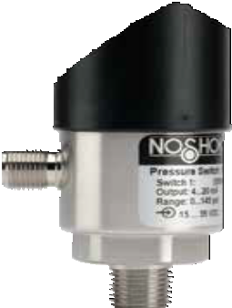(38 mm)
x 1
1.06" HEX
(27 mm)

1.16"
(29.5 mm)
1/4" NPT

Display rotates >300°

2 switching output (M12x1)
1.42"
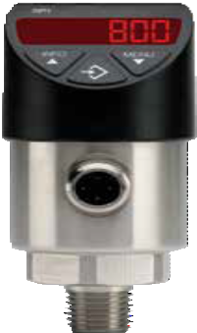(36 mm)
4 3
power supply
sig. output
1 2
S1 output
4 3
power supply
sig. output
1 2
S1 output

2 switching output (M12x1)

M12

p-switching
power supply
4 3
S2 output
1 2
S1 output
power supply
4 3
S2 output
1 2
S1 output

2 switching output (M12x1) with 4 mA to 20 mA signal†
p-switching
4 3
power supply
5
S2 output
1 2
S1 output
sig. output
n-switching

- switching output (M12x1) with 4 mA to 20 mA signal† n-switching
2.83"
(72 mm)

1.02"
(26 mm)

.51"
(13 mm)
power supply
4
S2 output
1
S1 output
sig. output
2
5
3

Ø1.38"
(35 mm)

Electrical Connection rotates >300°

800 SERIES INFORMATION
ORDERING
DIMENSIONS

† Also applies to 0 Vdc to 10 Vdc output 79

OEM Pressure T ransmitters & T ransducers
Compact

SERIES
300

Ranges from 0 psig to 15 through 0 psig to 10,000 psig; absolute ranges from 0 psia to 15 psia through 0 psia to 300 psia
- Current and voltage outputs available
- 316 and 13-8PH Stainless Steel wetted parts
- RoHS compliant
- CE compliant to suppress RFI, EMI and ESD

APPLICATIONS

HVAC
- Hydraulics & pneumatics
- Injection molding machines
- Railroad equipment
- Stamping & forming presses

SPECIFICATIONS

Output signals 4 mA to 20 mA, 2-wire; 0 Vdc to 5 Vdc, 3-wire; 1 Vdc to 5 Vdc, 3-wire; 0 Vdc to 10 Vdc, 3-wire; 0.5 Vdc to 4.5 Vdc ratiometric, 3-wire

Pressure ranges 0 psig to 15 psig through 0 psig to 10,000 psig
Absolute from 0 psia to 15 psia through 0 psia to 300 psia

Accuracy ±0.5% full scale (BFSL); optional ±0.25% full scale (BFSL); (includes the effects of non-linearity, hysteresis, non-repeatability, zero point and full scale errors)

Stability ≤ ±0.2% full scale per year, non-accumulating Response time ≤ 4 ms (between 10% and 90% full scale) Service life > 100,000,000 load cycles
Temperature ranges Compensated 32 °F to 176 °F (0 °C to 80 °C)
Media 32 °F to 176 °F (0 °C to 80 °C)
Ambient 32 °F to 176 °F (0 °C to 80 °C)
Storage -4 °F to 176 °F (0 °C to 80 °C)

Power requirement* 8 Vdc to 30 Vdc (4 mA to 20 mA, 2-wire, 0 Vdc to 5 Vdc, 3-wire, 1 Vdc to 5 Vdc, 3-wire, 0.5 Vdc to 4.5 Vdc, 3-wire)
14 Vdc to 30 Vdc (0 Vdc to 10 Vdc, 3-wire)
5 Vdc ± 10% (0.5 Vdc to 4.5 Vdc ratiometric, 3-wire)

Load limitations ≤ (VPower−10)/0.020 Amp for 4 mA to 20 mA output
≤ 5,000 Ω for 1 Vdc to 5 Vdc output
≤ 10,000 Ω for 0 Vdc to 10 Vdc output
≤ 4,500 Ω for 0.5 Vdc to 4.5 Vdc output

Proof pressure 2 times full scale

Burst pressure 6 times full scale

Measuring element 316 Stainless Steel for absolute through 150 psi
13-8PH Stainless Steel for ≥150 psi

Connection 316 Stainless Steel

Housing material 316 Stainless Steel

Environmental rating IP65 to IP67 depending on electrical connection

Electromagnetic rating CE compliant to EMC norm EN 61326:1997/A1:1998
RFI, EMI and ESD protection

Electrical protection Reverse polarity, over-voltage and short circuit protection

Shock 500 g’s according to IEC 60068-2-27

Vibration 10 g’s according to IEC 60068-2-6

Weight Approximately 2.8 oz.

* Unregulated

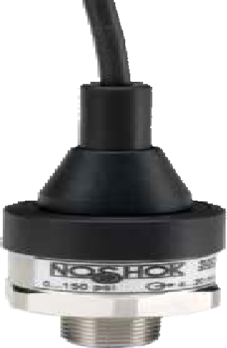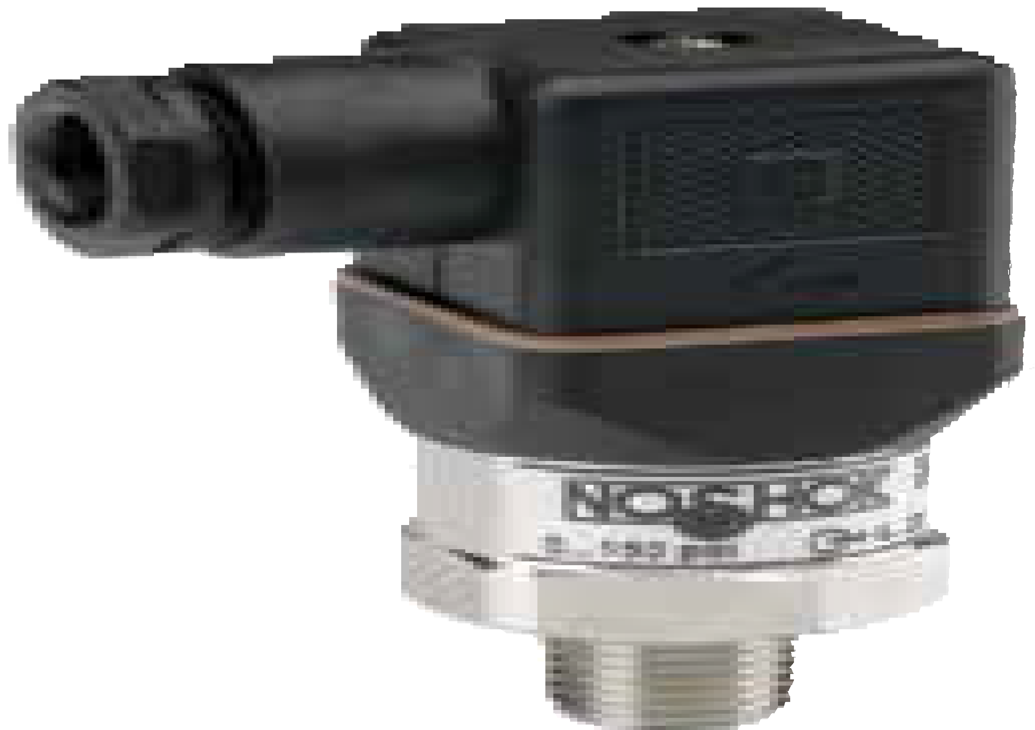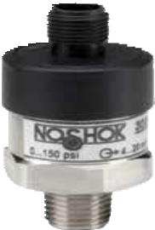

WARNING: This product can expose you to chemicals including Chromium (VI) and Nickel, which are known to the State of
80 California to cause cancer and birth defects or other reproductive harm. For more information go to www.P65Warnings.ca.gov

ORDERING INFORMATION
SERIES 300
PRESSURE RANGES | 15 0 psig to 15 psig 300 0 psig to 300 psig 3000  30 0 psig to 30 psig 500 0 psig to 500 psig 5000 |  | 0 psig to 3,000 psig  0 psig to 5,000 psig | 30A  60A | 0 psia to 30 psia  0 psia to 60 psia
 | 60 0 psig to 60 psig 750 0 psig to 750 psig 6000 |  | 0 psig to 6,000 psig | 100A | 0 psia to 100 psia
 | 100 0 psig to 100 psig 1000 0 psig to 1,000 psig 7500 |  | 0 psig to 7,500 psig | 150A | 0 psia to 150 psia
 | 150 0 psig to 150 psig 1500 0 psig to 1,500 psig 10000 |  | 0 psig to 10,000 psig | 200A | 0 psia to 200 psia
 | 200 0 psig to 200 psig 2000 0 psig to 2,000 psig 15A |  | 0 psia to 15 psia | 300A | 0 psia to 300 psia
 | psig = gauge pressure psia = absolute pressure Other ranges available upon request.
ACCURACIES | 1 ±0.5% full scale (BFSL) 2 ±0.25% full scale (BFSL)
OUTPUT SIGNALS | - 4 mA to 20 mA, 2-wire 3  - 0 Vdc to 5 Vdc, 3-wire 5 | 1 Vdc to 5 Vdc, 3-wire 13  0 Vdc to 10 Vdc, 3-wire | 0.5 Vdc to 4.5 Vdc, 3-wire (ratiometric)
PROCESS CONNECTIONS | 2 1/4″ NPT male 10 G 1/4 B 45  8 1/2″ NPT male 11 G 1/2 B |  | SAE J514 FIG B (Non-Adjustable)
ELECTRICAL CONNECTIONS | 1 36″ cable (connected to option 8) 8 |  | Hirschmann (DIN EN 175301- | 25 | M12 x 1 (4-pin)
 |  |  | 803 form A)
 | 7 Mini-Hirschmann (DIN EN 175301-803 form C) 14 |  | Hirschmann type with 1/2″ | 36 | 6' Integral cable
 |  |  | NPT female conduit
OPTION | ST8 Threaded Orifice (0.3 mm)
Please consult your local NOSHOK Distributor or NOSHOK, Inc. for availability and delivery information.

EXAMPLE 300 – 500 – 1 – 1 – 2 – 8 – ST8

Series 300 Series
Pressure range 0 psig to 500 psig
Accuracy ±0.50% full scale (BFSL)
Output signal 4 mA to 20 mA, 2-wire
Process connection 1/4" NPT Male
Electrical connection Hirschmann
Option Threaded Orifice

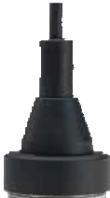0.51″
(13 mm)

1.14″

1.85″
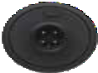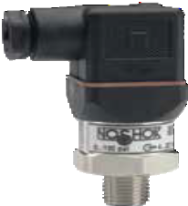(47 mm)

  - ″ sq

0.36″
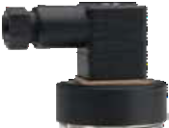(9 mm)

0.80″

1.40″
(35.5 mm) 0.63″ sq
(15.8 mm)
(29 mm)
(27 mm)

(20.3 mm)
0.47″ sq
1.10″
(27.8 mm)

0.78″
(19.7 mm)
1.06″
(26.8 mm)
(12 mm)

1.12″ sq
(28.5 mm)

1.29″
(32.8 mm)

Integral cable Mini-Hirschmann

*M12 x 1 (4-pin)

* Note: (mate supplied separately)
1.06″ HEX
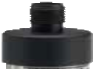(27 mm)

1/4″ NPT

Hirschmann
0.51″
(13 mm)

300 SERIES INFORMATION
ORDERING
DIMENSIONS
3-WIRE WIRING
2-WIRE WIRING
Wiring | M12 | Hirschmann | Cable
+ Supply | 1 | 1 | Brown
Common | 3 | 2 | Blue
+ Output | 4 | 3 | White

Wiring | M12 | Hirschmann | Cable
+ Supply | 1 | 1 | Brown
+ Output | 3 | 2 | Blue
81

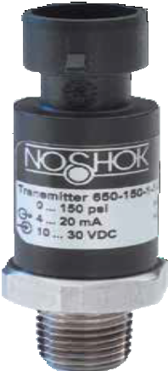

APPLICATIONS
    - Hydraulics & pneumatics
    - Mobile hydraulics
    - Pumps & compressors
    - Refrigeration controls
    - Transportation

SERIES

- Ranges from 0 psig to 100 psig through 0 psig to 8,000 psig
650
- Current and voltage outputs available
- Stainless Steel wetted parts
- CE compliant to suppress RFI, EMI and ESD

SPECIFICATIONS

Output signals 4 mA to 20 mA 2-wire, or 1 Vdc to 5 Vdc 3-wire

Pressure ranges 0 psig to 100 psig through 0 psig to 8,000 psig

Accuracy ±0.50% full scale (BFSL) (Includes the effects of non-linearity, hysteresis,
non-repeatability, zero point and full scale errors)

Stability ±0.2% full scale for 1 year, non-accumulating

Response time < 5 ms (between 10% and 90% full scale); restrictor port I.D. to
dampen pulsations

Service life > 100,000,000 load cycles

Temperature ranges Compensated 32 °F to 176 °F (0 °C to 80 °C)
Zero effect ±0.008% full scale/ °F Span effect ±0.008% full scale/ °F
Media -40 °F to 257 °F (-40 °C to 125 °C)
Ambient -40 °F to 212 °F (-40 °C to 100 °C)
Storage -40 °F to 248 °F (-40 °C to 120 °C)

Power requirement* 8 Vdc to 36 Vdc (4 mA to 20 mA, 2-wire, 0 Vdc to 5 Vdc, 3-wire, 1 Vdc to 5 Vdc, 3-wire, 0.5 Vdc to 4.5 Vdc, 3-wire)
14 Vdc to 36 Vdc (0 Vdc to 10 Vdc, 3-wire)
5 Vdc ± 10% (0.5 Vdc to 4.5 Vdc ratiometric, 3-wire)

Load limitations ≤ (VPower−10)/0.020 amp for 4 mA to 20 mA output
≤ 5,000 Ω for 1 Vdc to 5 Vdc output
≤ 10,000 Ω for 0 Vdc to 10 Vdc output
≤ 4,500 Ω for 0.5 Vdc to 4.5 Vdc output

Proof pressure 2 times full scale

Burst pressure 8 times full scale for ranges 0 psi to 100 psi through 0 psi to 1,500 psi
4 times full scale for ranges 0 psi to 2,000 psi through 0 psi to 8,000 psi

Measuring element 17-4PH Stainless Steel Connection 316 Stainless Steel Housing material PBT - fiber reinforced plastic
Environmental rating IP67 for M12x1 (4-pin) electrical connection and Metri-Pack connection; IP69K (steam jet cleaning) for cable connection

Electromagnetic rating CE compliant to EMC norm EN 61326:1997/A1:1998
RFI, EMI and ESD protection

Electrical protection Reverse polarity, over-voltage and short circuit protection

Shock 500 g’s according to IEC 60068-2-27

Vibration 20 g’s according to IEC 60068-2-6

Weight Approximately 2.5 oz.

OEM Pressure T ransmitters & T ransducers
High Volume

* Unregulated

WARNING: This product can expose you to chemicals including Chromium (VI) and Nickel, which are known to the State of
82 California to cause cancer and birth defects or other reproductive harm. For more information go to www.P65Warnings.ca.gov

ORDERING INFORMATION
SERIES 650
PRESSURE RANGES | 100  150 | 0 psig to 100 psig  0 psig to 150 psig | 300 0 psig to 300 psig  400 0 psig to 400 psig  500 0 psig to 500 psig  Other ranges available on request |  | 600  750 | 0 psig to 600 psig  0 psig to 750 psig | 1500  2000 | 0 psig to 1,500 psig  0 psig to 2,000 psig | 5000  8000 | 0 psig to 5,000 psig  0 psig to 8,000 psig
 | 200 | 0 psig to 200 psig |  |  | 1000 | 0 psig to 1,000 psig | 3000 | 0 psig to 3,000 psig
 |  | psig = gauge pressure
ACCURACY | 1 | ±0.5% full scale (BFSL)
OUTPUT SIGNALS | 1 | 4 mA to 20 mA, 2-wire | 3 | 1 Vdc to 5 Vdc, 3-wire | 5 | 0 Vdc to 10 Vdc, 3-wire | 13 | 0.5 Vdc to 4.5 Vdc ratiometric, 3-wire
PROCESS | 2 | 1/4″ NPT male | 24 | 7/16 - 20 2B Schrader | 45 | SAE J514 FIG B (Non-Adjustable)
CONNECTIONS | 10 | G1/4B male | 35 | 7/16 - 20 SAE with 45° flare
ELECTRICAL CONNECTIONS | 25  34 | M12 x 1 (4-pin)  Metri-Pack 150 series | 36  39 | 18″ Integral cable IP67  18″ Integral cable IP69K | 45  46 | AMP Superseal 1.5  Deutsch (3-pin) DT04-3P
Please consult your local NOSHOK Distributor or NOSHOK, Inc. for minimum quantity requirements and delivery information.

EXAMPLE 650 – 500 – 1 – 1 – 2 – 25

Series 650 Series
Pressure range 0 psig to 500 psig
Accuracy ±0.5% full scale
Output signal 4 mA to 20 mA, 2-wire
Process connection 1/4" NPT Male
Electrical connection M12 x 1 (4-pin)

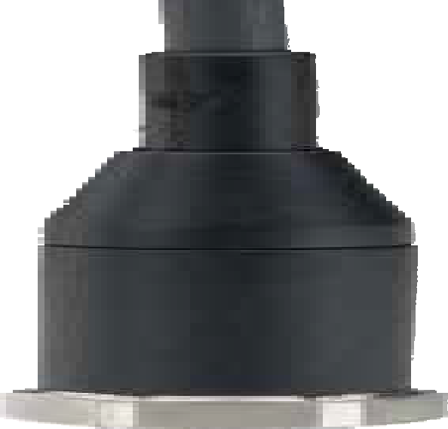0.78″ (19.7 mm)

0.36″
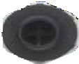
(9 mm)

0.80″ (20.3 mm)

0.78″ (19.7 mm)

1.47″ (37.3 mm)

0.67″
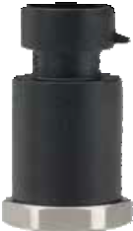(17 mm)

1.41″ (35.8 mm)
0.81″ (20.5 mm)
1.48″ (37.7 mm)

0.63″
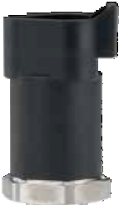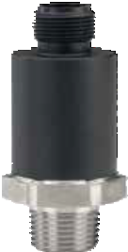(17 mm)
1.43"
(36.2 mm

)

0.80″ (20.2 mm)

0.47″
(12 mm)

1.47″ (37.3 mm)

18″ Integral cable Metri-Pack
AMP Superseal 1.5
Deutsch (3-pin)

150 Series

  - WIRE WIRING
DT04-3P

  - WIRE WIRING
  - ″ HEX
(22 mm) 1/4″ NPT

M12 X 1
(4-pin)

0.51″
(13 mm)

650 SERIES INFORMATION
ORDERING
DIMENSIONS
Wiring | Cable | M12 | Metri- Pack | AMP  Superseal | Deutsch DT04-3P
+ Supply | Brown | 1 | B | 3 | A
+ Output | Black | 3 | A | 1 | B

Wiring | Cable | M12 | Metri- Pack | AMP  Superseal | Deutsch DT04-3P
+ Supply | Brown | 1 | B | 3 | A
Common | Green | 3 | A | 1 | B
+ Output | White | 4 | C | 2 | C

83

non-repeatability, zero point and full scale errors)

Stability ≤±0.2% full scale for 1 year, non-accumulating Response time ≤1 ms (between 10% and 90% full scale) Service life >100,000,000 load cycles

APPLICATIONS
Temperature ranges Compensated
Zero effect Span effect
32 °F to 176 °F (0 °C to 80 °C)
±0.011% full scale/ °F
±0.011% full scale/ °F

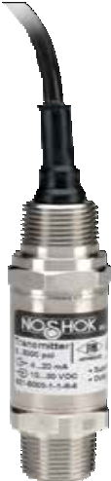Chemical processing
Hazardous Location Pressure T ransmitters
Explosion-Proof
APPROVED
621/622 SERIES
- Vacuum and compound ranges through 0 psig to 15,000 psig; absolute ranges from 0 psia to 15 psia through 0 psia to 100 psia
- Current and voltage outputs available
- 316 Stainless Steel and Elgiloy wetted parts
- CE compliant to suppress RFI, EMI and ESD
- NACE MR0175/ISO 15156 compliant
- NSI/ISA-12.27.01-2003 approved single seal
SPECIFICATIONS
Output signals 4 mA to 20 mA, 2-wire; 1 Vdc to 5 Vdc, 3-wire; 0.5 Vdc to 4.5 Vdc, 3-wire
Pressure ranges Vacuum through 0 psi to 15,000 psi
Absolute from 0 psia to 15 psia through 0 psia to 100 psia
Accuracy ±0.25% full scale (BFSL) (Includes the effects of non-linearity, hysteresis,
    - Gas pressure measurement
    - Oil field & offshore
    - Mining
    - Well head measurement

NOSHOK 621 and 622 Sereis transmitters are Factory Mutual and Canadian Standards Association approved for use in hazardous location applications as follows:
Explosion-proof with entity approve for: Class I, Division 1, Groups A, B, C and D. Dust Ignition-proof with entity approval for class II/ III, Division 1, Groups E, F and G. Maximum electrical ratings 30V, 20 mA.
CE compliant with pressure equipment directive 97/23EC. ANSI/ISA-12.27.01-2003, Approved single seal.

84
Media T6: -40 °F to 131 °F (-40 °C to 55 °C)
T5: -40 °F to 158 °F (-40 °C to 70 °C)
T4: -40 °F to 212 °F (-40 °C to 100 °C)

Ambient T6: -40 °F to 140 °F (-40 °C to 60 °C)
T5: -40 °F to 167 °F (-40 °C to 75 °C)
T4: -40 °F to 221 °F (-40 °C to 105 °C)

Storage -40 °F to 221 °F (-40 °C to 105 °C)

Power requirement* 10 Vdc to 30 Vdc (4 mA to 20 mA, 2-wire)
6 Vdc to 30 Vdc (1 Vdc to 5 Vdc, 3-wire, 0.5 Vdc to 4.5 Vdc, 3-wire)
14 Vdc to 30 Vdc (0 Vdc to 10 Vdc, 3-wire)

Load limitations ≤ (VPower-10)/0.020 Amp for 4 mA to 20 mA
≥ 10,000 Ω for 1 Vdc to 5 Vdc, 3-wire

Proof pressure 3 times full scale for ranges 0 psi to 15 psi through 0 psi to 200 psi
1.75 times full scale for ranges 0 psi to 300 psi through 0 psi to 10,000 psi
1.5 times full scale for 0 psi to 15,000 psi

Burst pressure 3.8 times full scale for ranges 0 psi to 15 psi through 0 psi to 200 psi
4 times full scale for ranges 0 psi to 300 psi through 0 psi to 10,000 psi 3 times full scale for 0 psi to 15,000 psi

Measuring element 621 Series is 316 Stainless Steel for ranges up through 0 psi to 300 psi, 316 Stainless Steel with Elgiloy ranges 0 psig to 500 psig and higher; 622 Series is 316 Stainless Steel with NBR o-ring; (FKM o-ring optional)

Connection 316 Stainless Steel

Housing material 316 Stainless Steel

Environmental rating IP67
Electromagnetic rating CE compliant to EMC norm EN 61326:1997/A1:1998
RFI, EMI and ESD protection

Electrical protection Reverse polarity, over-voltage and short circuit protected

Shock 1,000 g’s according to IEC 60068-2-27

Vibration 20 g’s according to IEC 60068-2-6

Weight Approximately 12 oz.

- Unregulated

WARNING: This product can expose you to chemicals including Chromium (VI) and Nickel, which are known to the State of
California to cause cancer and birth defects or other reproductive harm. For more information go to www.P65Warnings.ca.gov

ORDERING INFORMATION
SERIES | 621 Stainless Steel threaded connection | 622 316 Stainless Steel flush diaphragm | 622H Hastelloy C  flush diaphragm
PRESSURE RANGES | 30vac -30 inHg to 0 psig  30/30 -30 inHg to 30 psig  30/60 -30 inHg to 60 psig  30/100 -30 inHg to 100 psig  30/160 -30 inHg to 160 psig  30/200 -30 inHg to 200 psig  30/300 -30 inHg to 300 psig  psig = gauge pressure psia = absolute pressure | 5 0 psig to 5 psig  10 0 psig to 10 psig  15 0 psig to 15 psig  30 0 psig to 30 psig  60 0 psig to 60 psig  100 0 psig to 100 psig  200 0 psig to 200 psig  Other ranges available on request | 300 0 psig to 300 psig 6000 0 psig to 6,000 psig  500 0 psig to 500 psig 8000 0 psig to 8,000 psig 1000 0 psig to 1,000 psig 10000 0 psig to 10,000 psig 1500 0 psig to 1,500 psig 15000 0 psig to 15,000 psig 2000 0 psig to 2,000 psig 15A 0 psia to 15 psia  3000 0 psig to 3,000 psig 100A 0 psia to 100 psia  5000 0 psig to 5,000 psig  Note: 622 Series is available for pressure ranges up to 0 psig to 8,000 psig
ACCURACY | 1 ±0.25% full scale (BFSL)
OUTPUT SIGNALS | - 4 mA to 20 mA, 2-wire  - 0 Vdc to 5 Vdc, 3-wire | 3 1 Vdc to 5 Vdc, 3-wire, low power  5 0 Vdc to 10 Vdc, 3-wire | 31 0.5 Vdc to 4.5 Vdc 3-wire, low power
PROCESS CONNECTIONS | 2 1/4″ NPT male  8 1/2" NPT male | 11 G 1/2 B *  13 G 1 B (622 Series only, <30 psig)
ELECTRICAL CONNECTIONS 6 1/2″ NPT male conduit with 6' integral cable 37 1/2″ NPT male conduit with 6' flying leads with epoxy seal
OPTIONS | ST8 Threaded Orifice (621 Series only) | 20 20′ Cable/lead (attached to electrical connection 6 or 37) | 30 30′ Cable/lead (attached to electrical connection 6 or 37)
Please consult your local NOSHOK Distributor or NOSHOK, Inc. for availability and delivery information.
* 622 Series only, G 1/2 B Flush (≥ 30 psig).
EXAMPLE 621 – 500 – 1 – 1 – 8 – 6 – ST8

Series 621 Series
Pressure range 0 psig to 500 psig
Accuracy ±0.25% full scale (BFSL)
Output signal 4 mA to 20 mA, 2-wire
Process connection 1/2" NPT Male
Electrical connection 1/2" NPT Male conduit with 6' integral cable
Option Threaded Orifice

1.42″

0.61″
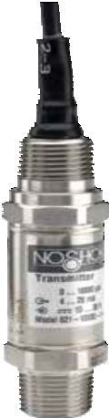(15.5 mm)

Front flush process connections
(36 mm)
0.75″
(19 mm)

For ranges 0 psi to 30 psi through 0 psi to 8,000 psi
1.06″ (27mm)

O-ring 0.73″ x 0.94" x 0.08″
(18.5mmx 23.9mm)
0.39″
(10mm) O-ring 0.59″ x 0.08″ (15mmx 2mm)

ø.71″ ±.003
(18mm)
G1/2 B

For ranges 0 to 30 psi and below
1.61″ (41mm)

O-ring 1.17″ x 1.41″ x 0.08″ (29.7mmx 35.7mm)

0.81″ (20.5mm)

1/2″ NPT

1.06″ HEX
(27 mm)

0.39″
0.81″ (20.5mm)
(10mm)

ø1.18″ ±.003
(30mm)
G1 B
O-ring 1.02″ x 0.08″ (26mmx 2mm)
2.56″
(65 mm)

Flush corresponding port weld-on adapters

1.06″ HEX
(27 mm)
1/2″ NPT
1.06″
(27 mm)
0.41″ (10.5mm)

0.75″
(19 mm)

621/622 SERIES INFORMATION
ORDERING
DIMENSIONS
2-WIRE WIRING 3-WIRE WIRING
ø1.97″ (50mm)
ø.84″ ±.007
x
A
ø.72″ ±.007 (18.2mm)
G1/2
.76″ ±.003 (19.4mm)
(21.3mm)
A
O,1
ø1.97″ (50mm)
ø1.32″ ±.007 (33.5mm)
x
A
ø1.19″ ±.003
(30.1mm)
G1
1.20″ ±.003 (30.5mm)
O,1 A
0.59″ ±.007
(15mm)
0.81″ ±.012 (20.5mm)
0.59″ ±.007
(15mm)
0.41″ (10.5mm)
0.81″ ±.012
(20.5mm)
x
x
+ Supply | Red
+ Output | Black
Ground | Gray

+ Supply | Red
Common | Black
+ Output | Brown
Ground | Gray

85

623/624

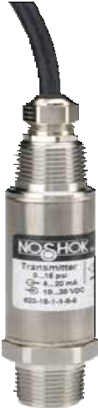
Hazardous Location Pressure T ransmitters
Non-Incendive Pressure Transmitters
APPROVED
SERIES
- Vacuum and compound ranges through 0 psig to 15,000 psig; absolute ranges from 0 psia to 15 psia through 0 psia to 100 psia
- Current and voltage outputs available
- 316 Stainless Steel and Elgiloy wetted parts
- Factory Mutual and Canadian Standards Association approved
- CE compliant to suppress RFI, EMI and ESD
- NACE MR0175/ISO 15156 compliant
- NSI/ISA-12.27.01-2003 approved single seal
SPECIFICATIONS

APPLICATIONS
  - Chemical processing
  - Gas pressure measurement
  - Oil field & offshore
  - Mining
  - Well head measurement

NOSHOK 623 and 624 Series transmitters are Factory Mutual and Canadian Standards Association approved for use in hazardous location applications as follows:
Non-Incendive for: Class I, Division 2, Groups A, B, C and D.I.P; Class II, Division 1, Groups E, F and G Maximum ratings 30 Vdc, 20 mA.
CE compliant with pressure equipment directive 97/23EC. ANSI/ISA-12.27.01-2003, Approved single seal.

86
Output signals 4 mA to 20 mA, 2-wire; 1 Vdc to 5 Vdc low power, 3-wire; 0.5 Vdc to 4.5 Vdc low power, 3-wire

Pressure ranges Vacuum through 0 psig to 15,000 psig
Absolute through 0 psia to 100 psia

Accuracy ±0.25% full scale (BFSL) (Includes the effects of non-linearity, hysteresis,
non-repeatability, zero point and full scale errors)

Stability ≤ ±0.2% full scale for 1 year, non-accumulating Response time ≤1 ms (between 10% and 90% full scale) Service life >100,000,000 load cycles
Temperature ranges Compensated 32 °F to 176 °F (0 °C to 80 °C)
Zero effect is ±0.011% full scale/ °F within compensated range Span effect is ±0.011% full scale/ °F within compensated range Media -40 °F to 212 °F (-40 to 100 °C)
Ambient -22 °F to 176 °F (-30 °C to 80 °C)
Storage -22 °F to 212 °F (-30 °C to 100 °C)

Power requirement* 10 Vdc to 30 Vdc (4 mA to 20 mA, 2-wire)
6 Vdc to 30 Vdc (1 Vdc to 5 Vdc, 3-wire, 0.5 Vdc to 4.5 Vdc, 3-wire)
14 Vdc to 30 Vdc (0 Vdc to 10 Vdc, 3-wire)

Load limitations ≤ (VPower -10)/0.020 Amp for 4 mA to 20 mA; ≥ 10,000 Ω for 1 Vdc to 5 Vdc, 3-wire

Proof pressure 3 times full scale for ranges 0 psi to 15 psi through 0 psi to 200 psi
1.75 times full scale for ranges 0 psi to 300 psi through 0 psi to 10,000 psi
1.5 times full scale for 0 psi to 15,000 psi range

Burst pressure 3.8 times full scale for ranges 0 psi to 15 psi through 0 psi to 200 psi
4 times full scale for ranges 0 psi to 300 psi through 0 psi to 10,000 psi 3 times full scale for 0 psi to 15,000 psi

Measuring element 623 Series is 316 Stainless Steel for ranges up through 0 psi to 300 psi, 316 Stainless Steel and Elgiloy for ranges 0 psig to 500 psig and higher; 624 Series is 316 Stainless Steel with NBR o-ring; FKM o-ring optional

Connection 316 Stainless Steel

Housing material 316 Stainless Steel

Environmental rating IP65 to IP67 dependent upon electrical connection

Electromagnetic rating CE compliant to EMC norm EN 61326:1997/A1:1998
RFI, EMI and ESD protection

Electrical protection Reverse polarity, over-voltage and short circuit protected

Shock 1000 g’s according to IEC 60068-2-27

Vibration 20 g’s according to IEC 60068-2-6

Weight Approximately 12 oz.

- Unregulated

WARNING: This product can expose you to chemicals including Chromium (VI) and Nickel, which are known to the State of
California to cause cancer and birth defects or other reproductive harm. For more information go to www.P65Warnings.ca.gov

ORDERING INFORMATION
SERIES | 623 Stainless Steel threaded connection |  | 624 316 Stainless Steel flush diaphragm *
PRESSURE RANGES | 30vac -30 inHg to 0 psig  30/30 -30 inHg to 30 psig  30/60 -30 inHg to 60 psig  30/100 -30 inHg to 100 psig  15 0 psig to 15 psig  psig = gauge pressure psia = absolute pressure | 30 0 psig to 30 psig  60 0 psig to 60 psig  100 0 psig to 100 psig  200 0 psig to 200 psig  300 0 psig to 300 psig  Other ranges available on request | 500 0 psig to 500 psig 6000 0 psig to 6,000 psig 1000 0 psig to 1,000 psig 8000 0 psig to 8,000 psig 1500 0 psig to 1,500 psig 10000 0 psig to 10,000 psig 2000 0 psig to 2,000 psig 15000 0 psig to 15,000 psig 3000 0 psig to 3,000 psig 15A 0 psia to 15 psia 5000 0 psig to 5,000 psig 100A 0 psia to 100 psia  Note: 624 Series is available for pressure ranges up to 0 psig to 8,000 psig
ACCURACY | 1 ±0.25% full scale (BFSL)
OUTPUT SIGNALS | 1 4 mA to 20 mA, 2-wire | 3 1 Vdc to 5 Vdc, 3-wire, low power | 31 0.5 Vdc to 4.5 Vdc, 3-wire, low power
PROCESS CONNECTIONS | 2 1/4″ NPT male  8 1/2″ NPT male | 11 G 1/2 B **  13 G 1 B (624 Series only, <30 psig)
ELECTRICAL CONNECTION 6 1/2″ NPT male conduit with 6' integral cable
OPTION | ST8 Threaded Orifice (623 Series only)
Please consult your local NOSHOK Distributor or NOSHOK, Inc. for availability and delivery information.
* Hastelloy flush diaphragm available upon request.
** 624 Series only, G 1/2 B Flush (≥ 30 psig).

EXAMPLE 623 – 500 – 1 – 1 – 8 – 6 – ST8

Series 623 Series
Pressure range 0 psig to 500 psig
Accuracy ±0.25% full scale (BFSL)
Output signal 4 mA to 20 mA, 2-wire
Process connection 1/2" NPT Male
Electrical connection 1/2" NPT Male conduit with 6' integral cable
Option Threaded Orifice

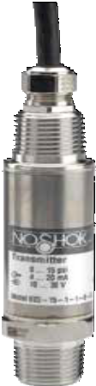0.70″
(18 mm)

Front flush process connections
For ranges 0 psi to 30 psi

0.59″ HEX
(15 mm)
0.75″
(19 mm)

through 0 psi to 8,000 psi
1.06″ (27mm)
For ranges 0 to 30 psi and below
1.61″ (41mm)

O-ring 0.73″ x 0.94" x 0.08″
(18.5mmx 23.9mm)
0.39″
(10mm) O-ring 0.59″ x 0.08″ (15mmx 2mm)

ø.71″ ±.003
(18mm)
G1/2 B
1/2″ NPT

0.39″
0.81″ (20.5mm)
0.81″ (20.5mm)
(10mm)

ø1.18″ ±.003
(30mm)
G1 B
O-ring 1.17″ x 1.41″ x 0.08″ (29.7mmx 35.7mm)
O-ring 1.02″ x 0.08″ (26mmx 2mm)

2.75″
(70 mm)

Flush corresponding port weld-on adapters
ø1.97″ (50mm) ø1.97″ (50mm)
ø.84″ ±.007
x
A
ø.72″ ±.007 (18.2mm)
G1/2
.76″ ±.003 (19.4mm)
(21.3mm)
A
O,1
ø1.32″ ±.007 (33.5mm)
G1
1.20″ ±.003 (30.5mm)
O,1 A
0.41″ (10.5mm)
0.41″ (10.5mm)

x
0.59″ ±.007
(15mm)
0.81″ ±.012 (20.5mm)
0.59″ ±.007
(15mm)

2-WIRE WIRING
0.81″ ±.012
(20.5mm)
  - ″ HEX
(27 mm) 1/2″ NPT
1.06″ (27 mm)

- WIRE WIRING

0.75″
(19 mm)

623/624 SERIES INFORMATION
ORDERING
DIMENSIONS

A
x
x
+ Supply | Brown
+ Output | Green

+ Supply | Brown
Common | Green
+ Output | White

ø1.19″ ±.003
(30.1mm)

87

Hazardous Location Pressure T ransmitters
Intrinsically Safe
APPROVED

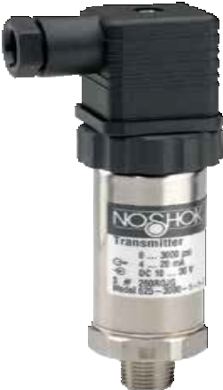

APPLICATIONS

Chemical processing
    - Gas pressure measurement
    - Oil field & offshore
    - Mining
    - Vapory recovery systems
    - Well head measurement

NOSHOK 625 and 626 Series transmitters are Factory Mutual and Canadian Standards Association approved for use in hazardous location applications as follows:
Intrinsically Safe, entity approval for Class I, II and III, Division 1, Groups A, B, C, D, E, F and G; and Class I, Zone 0 Aex ia IIC Dust Ignition-proof for Class II and III, Division 2, Groups F and G Non-incendive for Class I, Division 2, Groups A, B, C and D.
CE compliant with pressure equipment directive 97/23EC. ANSI/ISA-12.27.01-2003, Approved single seal.

88

SERIES

- Low pressure ranges for vapor recovery applications, vacuum and compound ranges through 0 psig to 15,000 psig;
625/626
absolute ranges from 0 psia to 15 psia through 0 psia to 300 psia
- Current output
- 316 and 14-4PH Stainless Steel wetted parts
- Factory Mutual and Canadian Standards Association approved
- CE compliant to suppress RFI, EMI and ESD
- NSI/ISA-12.27.01-2003 approved single seal

SPECIFICATIONS

Output signal 4 mA to 20 mA, 2-wire

Pressure ranges Vacuum through 0 psig to 15,000 psig
Absolute from 0 psia to 15 psia through 0 psia to 300 psia

Accuracy ±0.25% full scale (BFSL); optional ±0.125% full scale (BFSL) (Includes the
effects of non-linearity, hysteresis, non-repeatability, zero point and full scale errors)

Stability ≤ ±0.2% full scale for 1 year, non-accumulating

Adjustment ± 10% full scale for zero and span Response time ≤ 1 ms (between 10% and 90% full scale) Service life > 100,000,000 load cycles
Temperature ranges Compensated 32 °F to 176 °F (0 °C to 80 °C)
Zero effect is ±0.011% full scale/ °F Span effect is ±0.011% full scale/ °F Media -4 °F to 185 °F (-20 °C to 85 °C)
Ambient -4 °F to 176 °F (-20 °C to 80 °C)
Storage -22 °F to 221 °F (-30 °C to 105 °C)

Power requirement* 10 Vdc to 30 Vdc (4 mA to 20 mA, 2-wire)

Load limitations ≤ (VPower-10)/0.020 Amp

Proof pressure 3.5 times full scale for ranges 0 psi to 5 psi through 0 psi to 200 psi
- times full scale for ranges 0 psi to 300 psi through 0 psi to 10,000 psi
1.5 times full scale for 0 psi to 15,000 psi

Burst pressure 4 times full scale for ranges 0 psi to 5 psi through 0 psi to 200 psi
4 times full scale for ranges 0 psi to 300 psi through 0 psi to 10,000 psi 3 times full scale for 0 psi to 15,000 psi

Measuring element 625 Series is 316 Stainless Steel for ranges up through 0 psi to 300 psi, 316 Stainless Steel with 17-4PH Stainless Steel for ≥300 psi;
626 Series is 316 Stainless Steel with NBR o-ring

Connection 316 Stainless Steel

Housing material 316 Stainless Steel

Environmental rating IP65 to IP67 depending upon electrical connection

Electromagnetic rating CE compliant to EMC norm EN 61326:1997/A1:1998
RFI, EMI and ESD protection

Electrical protection Reverse polarity, over-voltage and short circuit protected

Shock 1,000 g’s according to IEC 60068-2-27

Vibration 20 g’s according to IEC 60068-2-6

Weight Approximately 7 oz.

- Unregulated

WARNING: This product can expose you to chemicals including Chromium (VI) and Nickel, which are known to the State of
California to cause cancer and birth defects or other reproductive harm. For more information go to www.P65Warnings.ca.gov

ORDERING INFORMATION
SERIES | 625 Stainless Steel threaded connection 626 | 316 Stainless Steel flush diaphragm | 626H | Hastelloy flush diaphragm
PRESSURE RANGES | 4/12 oz/in2 -4 oz/in2 to 12 oz/in2 30/100 -30 inHg to 100 psig 150  12 oz/in2 0 oz/in2 to 12 oz/in2 30/150 -30 inHg to 150 psig 200 | 0 psig to 150 psig 5000 0 psig to 5,000 psig 100A 0 psia to 100 psia  0 psig to 200 psig 6000 0 psig to 6,000 psig 150A 0 psia to 150 psia  0 psig to 300 psig 7500 0 psig to 7,500 psig 200A 0 psia to 200 psia  0 psig to 500 psig 8000 0 psig to 8,000 psig 250A 0 psia to 250 psia  0 psig to 750 psig 10000 0 psig to 10,000 psig  0 psig to 1,000 psig 15000 0 psig to 15,000 psig  0 psig to 1,500 psig 15A 0 psia to 15 psia  0 psig to 2,000 psig 30A 0 psia to 30 psia  0 psig to 3,000 psig 60A 0 psia to 60 psia  Note: 626 Series is available for pressure ranges up to 0 psig to 8,000 psig
 | 16 oz/in2 0 oz/in2 to 16 oz/in2 30/200 -30 inHg to 200 psig 300
50 inH2O 0 inH2O to 50 inH2O 3 0 psig to 3 psig 500
100 inH2O 0 inH2O to 100 inH2O 5 0 psig to 5 psig 750
30vac -30 inHg to 0 psig 15 0 psig to 15 psig 1000
 | 30/15 -30 inHg to 15 psig 30 0 psig to 30 psig 1500
 | 30/30 -30 inHg to 30 psig 60 0 psig to 60 psig 2000
 | 30/60 -30 inHg to 60 psig 100 0 psig to 100 psig 3000
 | psig = gauge pressure psia = absolute pressure Other ranges available on request
ACCURACY | 1 ±0.25% full scale (BFSL) 2 | ±0.125% full scale (BFSL)
OUTPUT SIGNAL | 1 4 mA to 20 mA, 2-wire
PROCESS CONNECTIONS | 2 1/4″ NPT male 13  8 1/2" NPT male 45  11 G 1/2 B * | G 1 B (626 Series only, <30 psig)  SAE J514 FIG B
ELECTRICAL CONNECTIONS | 1 36″ cable (connected to option 8) 14  3 6-pin Bendix - IP65 25  8 Hirschmann (DIN EN 175301-803 Form A) 36 | Hirschmann connector 1/2 ″ NPT conduit - IP65 M12x1 (4-pin) IP67  Integral cable 36″ - IP67
OPTION | ST8 Threaded Orifice (625 Series only)
Please consult your local NOSHOK Distributor or NOSHOK, Inc. for availability and delivery information.
* 626 Series only, G 1/2 B Flush (≥ 30 psig).
EXAMPLE 625 – 500 – 1 – 1 – 8 – 8 – ST8

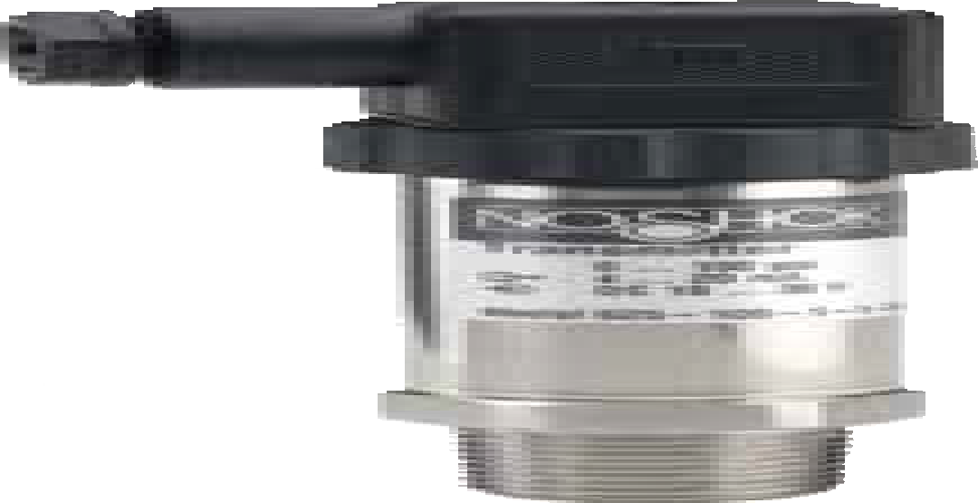Series 625 S
eries sig FSL)
wire ale m A) ifice
1.85"
(
47 mm)
1.06" sq.
(27 mm)
1.10"
(28 mm)
1.65"
(42 mm)
1.06" sq.
(27 mm)
2.91"
(74 mm)
Hirschmann with 1/2″ NPT Female ISO 4400 conduit
1.06" HEX
(27 mm) 1/2" NPT
1.06"
(27 mm)
0.75"
(19 mm)
NOTE
See 621/622 Series for G1/2B and G1B Front Flush Process
Connection Dimensions pg. 85
Pressure range 0 psig to 500 p
Accuracy ±0.25% full scale (B
Output signal 4 mA to 20 mA, 2-
Process connection 1/2" NPT M
Electrical connection Hirschmann (DIN EN 175301-803 For
Option Threaded Or

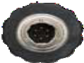1.36″ (34.5 mm)
1.36″ (34.5 mm)

0.68"
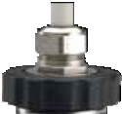(17.3 mm)

0.51"
(13 mm)

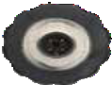0.54"
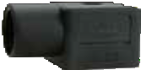(13.8 mm)

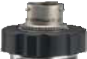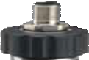

Integral 36″ cable
*6 pin Bendix
*M12 x 1 (4-pin)

*Note: mate supplied separately 2-WIRE WIRING

Hirschmann

625/626 SERIES INFORMATION
ORDERING
DIMENSIONS

89
 | Hirschmann | Cable | M12 | Bendix
+ Supply | 1 | Red/Brown | 1 | A
+ Output | 2 | Black/Green | 3 | B

Hazardous Location Level T ransmitters
Intrinsically Safe Submersible

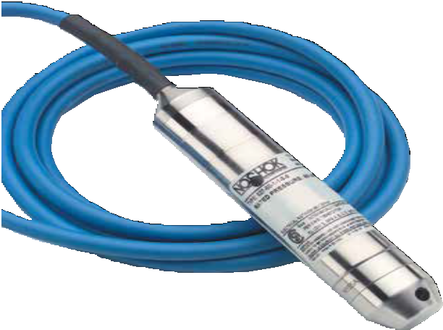

APPLICATIONS
  - Irrigation
  - Tank monitoring
  - Water & wastewater
  - Well head measurement

NOSHOK 627 Series transmitters are Canadian Standards Association approved for use in hazardous location applications as follows:
Intrinsically Safe, entity approval for Class I, II and III, Division 1, Groups A, B, C, D, E, F and G; and Class I, Zone 0 Aex ia IIC
Dust ignition-proof for Class II and III, Division 1, Groups E, F and G Non-incendive for Class I, Division 2, Groups A, B, C and D
FMRC 3600, 3610, 3611, 3810 (including supplement #1),
ISA-S12.0. 01, IEC 60529 (including amendment #1).
CE compliant with pressure equipment directive 97/23EC.

90

SERIES

- Ranges from 0 inH2O to 50 inH2O through 0 psig to 350 psig
627
- Current output
- 316 Stainless and 17-4PH Steel wetted parts
- Canadian Standards Association approved
- CE compliant to suppress RFI, EMI and ESD

SPECIFICATIONS

Output signal 4 mA to 20 mA, 2-wire

Pressure ranges 0 inH2O to 50 inH2O through 0 psig to 350 psig

Accuracy ±0.25 % full scale (BFSL); optional ±0.125% full scale (BFSL), for ranges
≥ 150 inH2O (Includes the effects of non-linearity, hysteresis, non-repeatability,
zero point and full scale errors)

Stability ≤ ±0.2% full scale for 1 year, non-accumulating Response time ≤1 ms (between 10% and 90% full scale) Service life >100,000,000 load cycles
Temperature ranges Compensated 32 °F to 122 °F (0 °C to 50 °C)
Zero effect is ±0.011% full scale/ °F within compensated range Span effect is ±0.011% full scale/ °F within compensated range Media 15 °F to 175 °F (-10 °C to 60 °C)
Ambient 15 °F to 122 °F (-10 °C to 50 °C)
Storage -30 °F to 175 °F (-34 °C to 60 °C)

Power requirement* 10 Vdc to 30 Vdc (4 mA to 20 mA, 2-wire)

Load limitations ≤ (VPower-10)/0.020 Amp-(0.043 Ω x length of cable in feet)

Proof pressure 2 times range

Burst pressure 3 times range

Measuring element Diaphragm and cap: 316 Stainless Steel
17-4PH Stainless Steel for 0 psig to 350 psig Cable: Polyurethane, optional FEP

Connection 316 Stainless Steel

Housing material 316 Stainless Steel

Environmental rating IP68

Electromagnetic rating CE compliant to EMC norm EN 61326:1997/A1:1998
RFI, EMI and ESD protection

Electrical protection Reverse polarity, over-voltage and short circuit protected

Weight Approximately 7 oz. with standard nosecone - cable extra

* Unregulated

WARNING: This product can expose you to chemicals including Chromium (VI) and Nickel, which are known to the State of
California to cause cancer and birth defects or other reproductive harm. For more information go to www.P65Warnings.ca.gov

ORDERING INFORMATION
SERIES 627
PRESSURE RANGES | 50inH2O 0 inH2O to 50 inH2O  100inH2O 0 inH2O to 100 inH2O  150inH2O 0 inH2O to 150 inH2O  250inH2O 0 inH2O to 250 inH2O  400inH2O 0 inH2O to 400 inH2O  psig = gauge pressure inH2O = inches of water |  | 5 0 psig to 5 psig (11.5 ftH2O) 100  10 0 psig to 10 psig (23.1 ftH2O) 160  15 0 psig to 15 psig (34.6 ftH2O) 200  25 0 psig to 25 psig (57.7 ftH2O) 300  30 0 psig to 30 psig (69.2 ftH2O) 350  60 0 psig to 60 psig (138.4 ftH2O)  ftH2O = feet of water Other ranges available on request. |  |  | 0 psig to 100 psig (230.7 ftH2O)  0 psig to 160 psig (369.1 ftH2O)  0 psig to 200 psig (461.3 ftH2O)  0 psig to 300 psig (692.3 ftH2O)  0 psig to 350 psig (807.3 ftH2O)
ACCURACIES | 1 | ±0.25% full scale (BFSL) |  | 2 | ±0.125% full scale (BFSL) on ≥ 150 inH2O
OUTPUT SIGNAL | 1 | 4 mA to 20 mA, 2-wire
PROCESS CONNECTIONS | N  T | Stainless Steel nosecone  G 1/2 B x 1/2″ NPT male with 1/4″ NPT female |  | W | Stainless Steel weighted nosecone (1.1 lb.)
ELECTRICAL CONNECTIONS | XX  38-XX | Standard Polyurethane cable  Optional FEP cable | NOTE: XX = length of cable in feet
OPTIONS | CBC  DC | Cable Clamp  Desiccant Cartridge | FE  JB |  | Filter Element  Cable Junction Box
Please consult your local NOSHOK Distributor or NOSHOK, Inc. for availability and delivery information.

EXAMPLE 627 – 350 – 1 – 1 – N – 300

Series 627 Series
Pressure range 0 psig to 350 psig
Accuracy ±0.25% full scale (BFSL)
Output signal 4 mA to 20 mA, 2-wire
Process connection Stainless Steel nosecone
Electrical connection 300' of submersible Polyurethane cable

Weighted Nosecone NPT Adapter

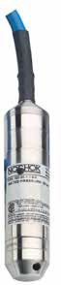0.20″ Dia (5 mm)

G1/2
1.06″
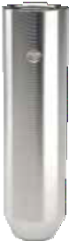(27 mm) FKM o-ring
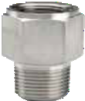1.06″ HEX
(27 mm)

5.12″ (130 mm)

5.12″ (130 mm)

1/2″ NPT
1.81″
(46 mm)

Male 1/4″ NPT
Female

0.73″
(18.5 mm)
  - ″ Dia (5 mm)

  - WIRE WIRING

1.06″ (26.92 mm)
627 SERIES INFORMATION
ORDERING
DIMENSIONS
+ Supply | Brown
+ Output | Green

91

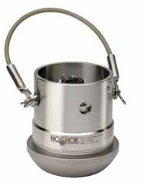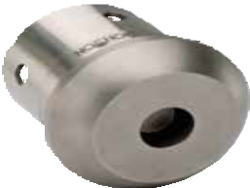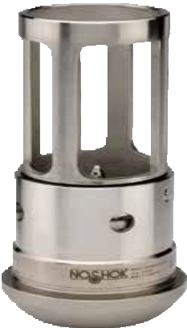SERIES
628

    - Ranges from 0 psig to 5,000 psig through 0 psig to 20,000 psig
    - Current output
    - Inconel X-750 wetted parts
    - Canadian Standards Association approved
    - Every sensor comes with a Certificate of Calibration
    - Certifications pending:
      - Factory Mutual
      - ATEX
      - CE

APPLICATIONS

Acidizing
    - Choke & kill manifold
    - Fracturing & cementing
    - Mud logging & mud pumps
    - Oil field & offshore
    - Well head measurement

Shown with optional Electrical Connector Cage
SPECIFICATIONS

Output signal 4 mA to 20 mA, 2-wire

Pressure ranges 0 psig to 5,000 psig through 0 psig to 20,000 psig

Accuracy ±0.25% full scale (BFSL) (Includes the effects of non-linearity, hysteresis,
non-repeatability, zero point and full scale errors)

Stability ≤ ±0.2% full scale for 1 year, non-accumulating
Response time < 2 m/s

Service life > 10,000,000 load cycles

Temperature ranges Compensated 40 °F to 140 °F (5 °C to 60 °C)
Zero effect is ±0.01% full scale/ °F Span effect is ±0.01% full scale/ °F
Media -40 °F to 185 °F (-40 °C to 85 °C)
Ambient -40 °F to 185 °F (-40 °C to 85 °C)
Storage -40 °F to 185 °F (-40 °C to 85 °C)

Power requirement* 10 Vdc to 28 Vdc

Load limitations ≤ (VPower-10)/0.020 Amp

Proof pressure 1.5 times full scale (22,500 psi maximum) Burst pressure 3 times full scale (22,500 psi maximum) Measuring element Inconel X-750
Connection Inconel X-750

Housing material 316 Stainless Steel

Environmental rating IP67 depending upon electrical connection

Electromagnetic rating CE compliant to EMC norm EN 61326:1997/A1:1998
RFI, EMI and ESD protection

Electrical protection Reverse polarity, over-voltage and short circuit protected

Shock 100 g's according to IEC 60068-2-27

Vibration 15 g's according to IEC 60068-2-6

NOSHOK 628 Series transmitters are Canadian Standards Association approved for use in hazardous location applications as follows:

Hazardous Location Pressure T ransmitters
Intrinsically Safe Hammer Union
Intrinsically Safe Class I, DIV 1, Groups A,B,C,D,
-40°C,Tamb<+85°C T4, Class II, DIV 1, Groups E,F,G, Class III, Class I, Zone 0 AEx/Ex ic IIC T4.
Non-Incendive Class I, DIV 2, Groups A,B,C,D,
-40°C,Tamb<+85°C T4, Class II, DIV 2, Groups F,G, Class III, Class I, Zone 2 AEx/Ex ic IIC T4.

92

Weight Approximately 6 lb.

* Unregulated

WARNING: This product can expose you to chemicals including Chromium (VI) and Nickel, which are known to the State of
California to cause cancer and birth defects or other reproductive harm. For more information go to www.P65Warnings.ca.gov

ORDERING INFORMATION
SERIES 628
PRESSURE RANGES | 5000 | 0 psig to 5,000 psig 6000 | 0 psig to 6,000 psig | 10000 | 0 psig to 10,000 psig | 15000 | 0 psig to 15,000 psig | 20000 | 0 psig to 20,000 psig
ACCURACY | 1 | ±0.25% full scale (BFSL)
OUTPUT SIGNAL | 1 | 4 mA to 20 mA, 2-wire
WIRING CODE  (See Wiring Code Schematics below) | A C  D | E F  G |  | H *  J
PROCESS CONNECTIONS | 14 | 2” Wing union (#1502)
ELECTRICAL CONNECTIONS | 3  36 | 6-pin Bendix (MIL-C-26482)  Integral cable with gland |  | 44 | 4-pin (MIL-C-5015)
OPTION CH Carrying Handle EC Electrical Connector Cage
Please consult your local NOSHOK Distributor or NOSHOK, Inc. for availability and delivery information.
* H is the standard wiring code.

EXAMPLE

Series 628 Series
1.36″ (34.5 mm)
Pressure range 0 psig to 5,000 psig
Accuracy ±0.25% full scale
Output signal 4 mA to 20 mA, 2-wire

Wiring code A
Process connection 2” wing union (#1502)
Electrical connection ..6-pin Bendix
Option Carrying Handle

628 – 5000 – 1 – 1 A – 14 – 3 – CH

628 SERIES INFORMATION
ORDERING
DIMENSIONS
WIRING CODE SCHEMATICS
A | Pin A | + Supply | E | Pin A | + Supply | G | Pin B | + Supply | J | Pin A | + Supply
 | Pin B | - Output |  | Pin B | - Output |  | Pin C | - Output |  | Pin B | - Output
 | Pin E | Ground |  | Pin E | + Shunt Cal |  | Pin D | Ground |  | Pin C | + Shunt Cal
C | Red | + Supply |  | Pin F | - Shunt Cal | H* | Pin A | + Supply |  | Pin D | - Shunt Cal
 | Black | - Output | F | Pin A | + Supply |  | Pin B | - Output |  | Pin E | SHIELD, NOT CONNECTED**
D | Red | + Supply |  | Pin B | - Output |  | Pin D | Ground |  | Pin F | SHIELD, NOT CONNECTED**
 | Black | - Output |  | Pin C | + Shunt Cal |  | Pin E | + Shunt Cal
 | White | - Shunt Cal |  | Pin D | - Shunt Cal |  | Pin F | - Shunt Cal
 | Green | Ground |  | Pin E | Ground
* H is the standard wiring code.
** No internal connection to E or F.

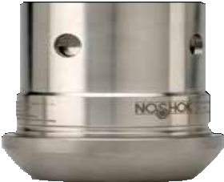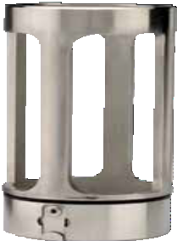Optional Electrical Connector Cage
3.84"
(97.5 mm)
0.97"
(24.6 mm)
3.69"
(93.7 mm)
Ø 2.88" (73.2 mm)
4.08" 5.00"
(103.6 mm) (127 mm)

93

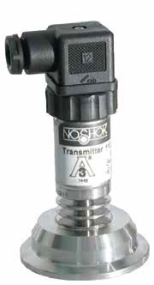

APPLICATIONS
    - Food & beverage processing
    - Pasteurization systems
    - Pharmaceutical
    - Medical

11 SERIES

Ranges from vacuum through 0 psig to 400 psig
- Current and voltage outputs available
- 316 Stainless Steel wetted parts
- Can be cleaned-in-place (CIP) or steamed-in-place (SIP)
- Meets 3A requirements for the food and beverage, dairy, pharmaceutical
and biotechnology industries
- ASME BPE compliant
- CE compliant to suppress RFI, EMI and ESD

SPECIFICATIONS

Output signals 4 mA to 20 mA 2-wire, 0 Vdc to 5 Vdc 3-wire, 1 Vdc to 5 Vdc 3-wire,
1 Vdc to 6 Vdc 3-wire, 0 Vdc to 10 Vdc, 3-wire, 1 Vdc to 11 Vdc 3-wire

Pressure ranges Vacuum through 0 psig to 400 psig

Accuracy ±0.25% full scale (BFSL); Optional ±0.125% full scale (BFSL); (Includes the
effects of non-linearity, hysteresis, non-repeatability, zero point and full scale errors)

Stability ±0.2% full scale for 1 year, non-accumulating

Adjustment ±10% full scale for zero and span

Response time < 10 ms

Service life > 100,000,000 load cycles

Temperature ranges Compensated 32 ºF to 175 ºF (0 ºC to 80 ºC)
Effect ±0.01%/ºF for zero and span Media -40 °F to 300 °F (-40 °C to 150 °C)
Ambient -40 ºF to 176 ºF (-40 ºC to 80 ºC)
Storage -40 °F to 212 °F (-40 °C to 100 °C)
Power requirement* 10 Vdc to 30 Vdc (4 mA to 20 mA, 2-wire, 0 Vdc to 5 Vdc, 3-wire, 1 Vdc to 5 Vdc, 3-wire, 1 Vdc to 6 Vdc, 3-wire)
14 Vdc to 30 Vdc (0 Vdc to 10 Vdc, 3-wire, Vdc to 11 Vdc, 3-wire)

Load limitations ≤ (VPower -10)/0.020 Amp for 4 mA to 20 mA output
≤ 5,000 Ω for 1 Vdc to 5 Vdc output
≤ 10,000 Ω for 0 Vdc to 10 Vdc output
≤ 4,500 Ω for 0.5 Vdc to 4.5 Vdc output

Proof pressure 3 times full scale for 0 psig to 2 psig through 0 psig to 200 psig
1.75 times full scale for 0 psig to 300 psig through 0 psig to 400 psig

Burst pressure 3.8 times full scale for 0 psig to 2 psig through 0 psig to 200 psig
4 times full scale for 0 psig to 300 psig through 0 psig to 400 psig

Measuring element 316 Stainless Steel

Connection 316 Stainless Steel

Housing material 316 Stainless Steel

Environmental rating IP65

Electromagnetic rating CE compliant to EMC norm EN 61326:1997/A1:1998
RFI, EMI and ESD protection

Electrical protection Reverse polarity, overvoltage and short circuit protection

Shock 1,000 g’s according to IEC 60068-2-27

Vibration 15 g’s according to IEC 60068-2-6

Weight Approximately 1.1 lb.

* Unregulated
Diaphragm seal must be installed facing downward or in a vertical position for drainability. Do not intall diaphragm seal facing in an upward position.

Sanitary Pressure T ransmitters
ASME-BPE Sanitary Clamp

WARNING: This product can expose you to chemicals including Chromium (VI) and Nickel, which are known to the State of
94 California to cause cancer and birth defects or other reproductive harm. For more information go to www.P65Warnings.ca.gov

ORDERING INFORMATION
SERIES 110
CLAMP SIZES | 12 | 1-1/2″ 16 2″
SEAL FILL FLUID | 4 | FFL77 White oil Other food grade quality fill fluids available — please consult factory
TRANSDUCER | 615 | 615 Series transducer
ACCURACIES | 1 | ±0.25% full scale (BFSL) 2 ±0.125% full scale
PRESSURE | 01 | -30 inHg to 0 psig 16 -30 inHg to 150 psig 37 0 psig to 10 psig | 55 | 0 psig to 160 psig
RANGES | 04 | -30 inHg to 15 psig 19 -30 inHg to 200 psig 40 0 psig to 15 psig | 58 | 0 psig to 200 psig
 | 07 | -30 inHg to 30 psig 22 -30 inHg to 300 psig 43 0 psig to 30 psig | 61 | 0 psig to 300 psig
 | 10 | -30 inHg to 60 psig 31 0 psig to 100 inH2O 46 0 psig to 60 psig | 64 | 0 psig to 400 psig
 | 13 | -30 inHg to 100 psig 34 0 psig to 5 psig 49 0 psig to 100 psig
OUTPUT SIGNALS | 1 | 4 mA to 20 mA, 2-wire 3 1 Vdc to 5 Vdc, 3-wire 5 0 Vdc to 10 Vdc, 3-wire
 | 2 | 0 Vdc to 5 Vdc, 3-wire 4 1 Vdc to 6 Vdc, 3-wire 6 1 Vdc to 11 Vdc, 3-wire
ELECTRICAL | 1 | 36″ Cable attached to Hirschmann 14 Hirschmann connection with ISO 4400 1/2″ NPT conduit
CONNECTIONS | 3 | 6-pin Bendix 25 M12 X 1 (4-pin)
 | 8 | Hirschmann (DIN EN 175301-803 form A) 36 Integral 36″ cable
Please consult your local NOSHOK Distributor or NOSHOK, Inc. for availability and delivery information.

EXAMPLE 110 – 12 – 4 – 615 – 1 – 34 – 1 – 1

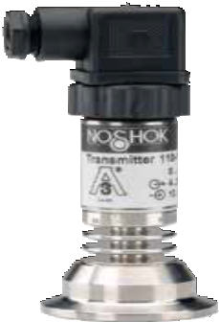Series 11 S
eries amp e oil eries FSL)
sig wire able
1.88"
(48 mm)
1.06" sq.
(27 mm)
1.10" sq.
(28 mm)
2.60"
(66 mm)
0.54"
(1 )
1.65"
(42 mm)

Integral cooling extension

3.8 mm
1.06" sq.
(27 mm)

0.750"
(19 mm)
0.116"
(2.95 mm)
Hirschmann with 1/2″ NPT Female ISO 4400 conduit
1.968"
(50 mm)
1-1/2" ASME-BPE
Sanitary Clamp
2.520"
(64 mm)
Clamp size .. 1-1/2" ASME-BPE Sanitary Cl
Seal fill fluid FFL77 Whit
Transmitter 615 S
Accuracy ±0.25% full scale (B
Pressure range 0 psig to 5 p
Output signal 4 mA to 20 mA, 2-
Electrical connection Hirschmann with 36" of c

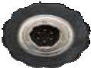1.36″ (34.5 mm)
1.36″ (34.5 mm)

0.68"
(17.3 mm)

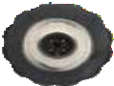0.51"
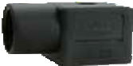(13 mm)

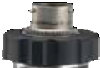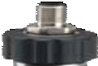

Integral 36″
cable
*6 pin Bendix
*Note: mate supplied separately or customer supplied

- WIRE WIRING
*M12 x 1 (4-pin)

  - WIRE WIRING
 | Hirschmann | Cable | M12 | Bendix
+ Supply | 1 | Red | 1 | A
Common | 2 | Black | 3 | B
+ Output | 3 | White | 4 | C

2" ASME-BPE
Sanitary Clamp

11 SERIES INFORMATION
ORDERING
DIMENSIONS
 | Hirschmann | Cable | M12 | Bendix
+ Supply | 1 | Red | 1 | A
+ Output | 2 | Black | 3 | B

95

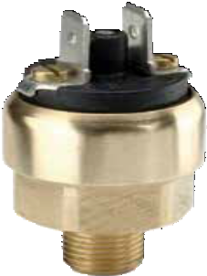
100 SERIES

Switch adjustment ranges from 15 psig to 30 psig through 15 psig to 150 psig
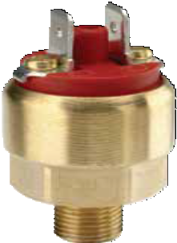
    - Standard Brass with NBR diaphragm wetted parts
    - 1 SPST N.O. or N.C. contact

N.C.

Switching parameters Number 1
SPECIFICATIONS

Pressure Switches
Mechanical Miniature Low Pressure

APPLICATIONS
- Hydraulics & pneumatics
- Pumps & compressors
- Tank monitoring
- Leak detection
- Water management

96
N.O.
Function SPST N.O. or N.C. contact
Contact rating Up to 42 Vdc 2A
Non-repeatability 5% of the adjusted value Contact material Silver-plated, optional gold-plated Frequency Max. 100 cycles/min
Pressure ranges 15 psig to 30 psig through 15 psig to 150 psig

Switch adjustment Adjustment screw from 5 psig to 150 psig dependent on full scale range
Switch point Full scale
Hysteresis < 10% of the adjusted value

Service life >1,000,000 load cycles

Temperature ranges Media -13 °F to 185 °F (-25 °C to 85 °C)
Ambient -13 °F to 185 °F (-25 °C to 85 °C)
Storage -13 °F to 185 °F (-25 °C to 85 °C)

Proof pressure Full scale

Measuring element NBR diaphragm
1/8" NPT Male Brass

Housing material Brass, optional Stainless Steel

Environmental rating IP65

Weight Approximately 0.07 lb

WARNING: This product can expose you to chemicals including Lead, which is known to the State of California to cause cancer and birth defects or other reproductive harm. For more information go to www.P65Warnings.ca.gov

100 SERIES INFORMATION
ORDERING
DIMENSIONS

ORDERING INFORMATION
SERIES 100
SWITCH FUNCTIONS | 1 | 1 Normally open | 2 | 1 Normally closed
PROCESS CONNECTION | 1 | 1/8″ NPT male
SWITCH ADJUSTMENT RANGES | 5/30 | 5 psig to 30 psig | 15/150 | 15 psig to 150 psig
ELECTRICAL CONNECTION | 4 | 6.3 mm spade terminals
SWITCH POINT (if required) |  | Specify pressure
Please consult your local NOSHOK Distributor or NOSHOK, Inc. for availability and delivery information.

EXAMPLE 100 – 2 – 1 – 15/150 – 4 – 100

Series 100 Series
Switch function 1 normally closed
Process connection 1/8" NPT Male
Adjustable range 15 psig to 150 psig
Electrical connection 6.3 mm spade terminals
Switch point 100 psig

Switching Output Schematic

Normally Closed Normally Open

P
P
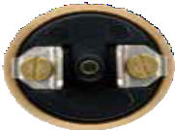
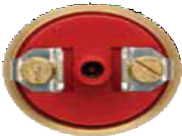

  - 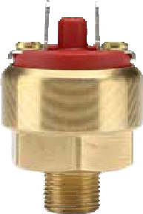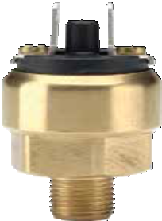" HE
0.91"
(23 mm)
0.38"
(9.8 mm)
0.91"
(23 mm)
X

1/8" NPT

0.35"
(9 mm)
(19 mm)

97

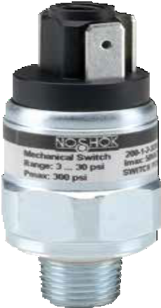
SERIES
200

    - Switch adjustment ranges from 3 psig to 30 psig through 450 psig to 4,600 psig
    - Zinc-plated Steel with NBR diaphragm (< 225 psig); Steel piston with NBR seal (> 225 psig) wetted parts
    - SPDT single changeover contact configuration
    - RoHS compliant

Switching parameters Number 1
SPECIFICATIONS

APPLICATIONS
- Hydraulics & pneumatics
- Pumps & compressors
Function SPDT, micro switch with silver-plated contacts,
gold plated contacts available on request
Contact rating Up to 28 Vdc 2A Up to 50 Vac 4A
Non-repeatability ±2% of full scale adjustment range
Contact material Silver-plated
Frequency Max. 100 cycles/min
Media Diaphragm type, compressed air or not corrosive liquids
Piston type, self lubricating fluids such as hydraulic oil or grease

Pressure ranges 3 psig to 30 psig through 450 psig to 4,600 psig
Diaphragm type: 870 psi max.; piston type: 5,000 psi max.

- Tank monitoring

Pressure Switches
Mechanical Compact SPDT
- Leak detection
- Water management

98

Switch adjustment
Switch point Full scale
Diaphragm type, ≤ 10% of full scale adjustment range, minimum 100 psig,
Hysteresis
Piston type, maximum 15% of full scale adjustment range

Service life >1,000,000 load cycles

Temperature ranges Media -4 °F to 176 °F (-20 °C to 80 °C)
Ambient -4 °F to 176 °F (-20 °C to 80 °C)
Storage -4 °F to 176 °F (-20 °C to 80 °C)

Proof pressure 870 psig or 5,000 psig depending on adjustment range

Measuring element NBR diaphragm < 225 psig; Steel piston with NBR seal > 225 psig
1/4″ NPT zinc-plated Steel

Housing material Zinc-plated Steel

Spade terminals IP00 Cable connection IP67
Environmental rating

Weight Approximately 0.2 lb.

WARNING: This product can expose you to chemicals including Lead, which is known to the State of California to cause cancer and birth defects or other reproductive harm. For more information go to www.P65Warnings.ca.gov

ORDERING INFORMATION
SERIES 200
SWITCH FUNCTION | 1 | Single changeover contact (SPDT)
PROCESS CONNECTION | 2 | 1/4″ NPT male
SWITCH ADJUSTMENT RANGES | 3/30 | 3 psig to 30 psig (870 psig) | 150/1700 | 150 psig to 1,700 psig (5,000 psig)
(Max. working pressure) | 7/115 | 7 psig to 115 psig (870 psig) | 150/2300 | 150 psig to 2,300 psig (5,000 psig)
 | 15/225 | 15 psig to 225 psig (870 psig) | 300/2900 | 300 psig to 2,900 psig (5,000 psig)
 | 150/425 | 150 psig to 425 psig (5,000 psig) | 300/3600 | 300 psig to 3,600 psig (5,000 psig)
 | 150/1150 | 150 psig to 1,150 psig (5,000 psig) | 450/4600 | 450 psig to 4,600 psig (5,000 psig)
ELECTRICAL CONNECTIONS | 4 | 6.3 mm Spade terminals | 36 | 18″ Integral cable
Please consult your local NOSHOK Distributor or NOSHOK, Inc. for availability and delivery information.

EXAMPLE 200 – 1 – 2 – 150/425 – 4

Series 200 Series
Switch function Single changeover contact
Process connection 1/4" NPT Male
Adjustable range 150 psig to 425 psig
Electrical connection 6.3 mm spade terminals

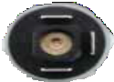
4 mm adjustment

0.82"
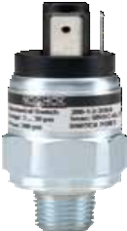(20.8 mm)

Switching Output Schematic

2

2.41"
(61.3 mm) 1.89"
(48 mm)
3
P
1
  - " (24 mm) HEX

0.47" (12 mm)
1/4" NPT

0.93"
(23.5 mm)

200 SERIES INFORMATION
ORDERING
DIMENSIONS

99

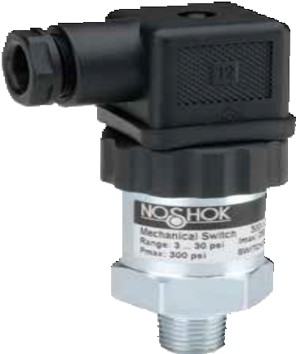
SERIES
300

    - Switch adjustment ranges from 3 psig to 30 psig through 450 psig to 4,600 psig
    - Standard zinc-plated Steel with NBR diaphragm (< 225 psig); Steel piston with NBR seal (> 225 psig) wetted parts
    - SPDT single changeover contact configuration
    - RoHS compliant

Switching parameters Number 1
SPECIFICATIONS

Pressure Switches
Mechanical Compact SPDT with Adjustable Hysteresis

APPLICATIONS
- Hydraulics & pneumatics
- Pumps & compressors
- Tank monitoring
- Leak detection
- Water management

100
Function SPDT, micro switch
Contact rating Up to 28 Vdc 2A Up to 125 Vac 4A Up to 250 Vac 4A
Non-repeatability ±2% of full scale adjustment range
Contact material Silver-plated
Frequency Max. 100 cycles/min
Media Diaphragm type, compressed air or not corrosive liquids
Piston type, self lubricating fluids such as hydraulic oil or grease

Pressure ranges 3 psig to 30 psig through 450 psig to 4,600 psig
Diaphragm type: 870 psi max.; Piston type: 5,000 psi max.
Switch adjustment
Switch point Full scale
Hysteresis Adjustable, see charts below

Service life >1,000,000 load cycles

Temperature ranges Media -4 °F to 176 °F (-20 °C to 80 °C)
Ambient -4 °F to 176 °F (-20 °C to 80 °C)
Storage -4 °F to 176 °F (-20 °C to 80 °C)

Proof pressure 870 psig or 5,000 psig depending on adjustment range

Measuring element NBR diaphragm < 225 psig; Steel piston with NBR seal > 225 psig
1/4″ NPT zinc-plated Steel standard connection, others available on request

Housing material Zinc-plated Steel

Environmental rating IP65

Weight Approximately 0.2 lb.

WARNING: This product can expose you to chemicals including Lead, which is known to the State of California to cause cancer and birth defects or other reproductive harm. For more information go to www.P65Warnings.ca.gov

ORDERING INFORMATION
SERIES 300
SWITCH FUNCTION | 1 | Single changeover contact, SPDT
PROCESS CONNECTION | 2 | 1/4″ NPT male
SWITCH ADJUSTMENT RANGES | 3/30 | 3 psig to 30 psig (870 psig) | 150/1700 | 150 psig to 1,700 psig (5,000 psig)
(Max. working pressure) | 7/115 | 7 psig to 115 psig (870 psig) | 150/2300 | 150 psig to 2,300 psig (5,000 psig)
 | 15/225 | 15 psig to 225 psig (870 psig) | 300/2900 | 300 psig to 2,900 psig (5,000 psig)
 | 150/425 | 150 psig to 425 psig (5,000 psig) | 300/3600 | 300 psig to 3,600 psig (5,000 psig)
 | 150/1150 | 150 psig to 1,150 psig (5,000 psig) | 450/4600 | 450 psig to 4,600 psig (5,000 psig)
ELECTRICAL CONNECTIONS | 1 | 36″ Cable (connected to option 8) | 8 | Hirschmann (DIN EN 175301-803 form A)

EXAMPLE 300 – 1 – 2 – 15/225 – 8
Please consult your local NOSHOK Distributor or NOSHOK, Inc. for availability and delivery information.

Series 300 Series
Switch function Single changeover contact
Process connection 1/4" NPT Male
Adjustable range 15 psig to 225 psig
Electrical connection Hirschmann

Additional Ordering Information Switch Set Point(s) (please specify)

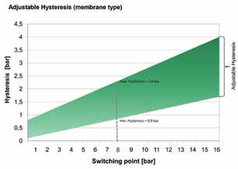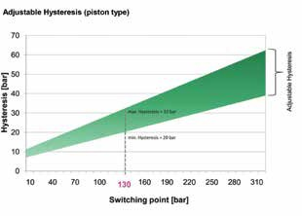

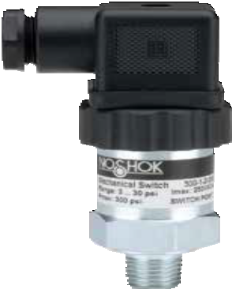Switching Output Schematic
1.85"
(47 mm)
1.06" sq.
(27 mm)
1.10"
(28 mm)
1.77"
(45 mm)
1.06" HEX
(27 mm)
0.47"
(12 m
1/4" NPT
1.06"
(27 mm)
1.35"
(34 mm)
2 / WHT

3 / RED
P

- / BLK

Switch Function
Hysteresis Function

300 SERIES INFORMATION
ORDERING
DIMENSIONS

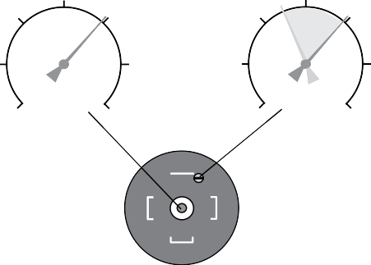m)
psi
psi
1
2
3

101

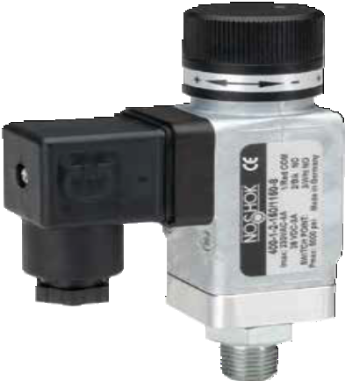
SERIES
400

- Switch adjustment ranges from 0 to 300 psig through 0 to 5,000 psig
- Standard zinc-plated Steel with NBR diaphragm (< 225 psig); Steel piston with NBR seal (> 225 psig) wetted parts
- SPDT single changeover contact configuration
- CE compliant to suppress RFI, EMI and ESD

Switching parameters Number 1
SPECIFICATIONS

APPLICATIONS
- Hydraulics & pneumatics
- Mobile hydraulics
- Power generation
- Pumps & compressors
Function SPDT, micro switch
Contact rating Up to 28 Vdc Max 4A Up to 250 Vac Max 3A
Non-repeatability ±2% of full scale of adjustment range Contact material Silver-plated, self-cleaning Frequency Max. 200 cycles/min.
Media Diaphragm type, compressed air or non-corrosive liquids
Piston type, self-lubricating fluids such as hydraulic oil or grease

Pressure ranges 0 psig to 300 psig through 0 psig to 5,000 psig
Adjustment knob from 3 psig to 4,600 psig dependent on full scale range

Switch adjustment
Switch point Full scale
Diaphragm type, 1% to 11% of adjustment range full scale

- Tank monitoring
Hysteresis
Piston type, 2% to 8% of adjustment range full scale

Water management

Pressure Switches
Mechanical Heavy-Duty

102
Service life >1,000,000 load cycles

Temperature ranges Media 14 °F to 176 °F (-10 °C to 80 °C)
Ambient 14 °F to 176 °F (-10 °C to 80 °C)
Storage 13 °F to 185 °F (-25 °C to 85 °C)

Proof pressure 300 psi or 5,000 psi depending on adjustment range

Measuring element NBR diaphragm ≤ 230 psig
Stainless Steel piston with NBR seal ≥ 500 psig
1/4″ NPT and 7/16-20 SAE zinc-plated Steel connections standard, others
available on request

Housing material Zinc-plated Steel

Environmental rating IP65 for Hirschmann
IP67 for M12 x 1

Electromagnetic rating CE compliant to EU Standard 73/23/EWG
RFI, EMI and ESD protection

Shock 30 g’s according to IEC 60068-2-27

Vibration 10 g’s according to IEC 60068-2-6

Weight Approximately 0.66 lb.

WARNING: This product can expose you to chemicals including Lead, which is known to the State of California to cause cancer and birth defects or other reproductive harm. For more information go to www.P65Warnings.ca.gov

ORDERING INFORMATION
SERIES | 400
SWITCH FUNCTION | 1 | Single Pole Double Throw (SPDT)
PROCESS CONNECTIONS * | 2 | 1/4″ NPT male | 19 | G 1/4 B female
 | 5 | 1/4″ NPT female | 45 | SAE J514 FIG B
 | 10 | G 1/4 B male
SWITCH ADJUSTMENT RANGES ** | 3/30 | 3 psig to 30 psig (300 psig) | 150/1700 | 150 psig to 1,700 psig (5,000 psig)
(Max. working pressure) | 7/115 | 7 psig to 115 psig (300 psig) | 150/2300 | 150 psig to 2,300 psig (5,000 psig)
 | 15/225 | 15 psig to 225 psig (300 psig) | 300/2900 | 300 psig to 2,900 psig (5,000 psig)
 | 150/425 | 150 psig to 425 psig (5,000 psig) | 300/3600 | 300 psig to 3,600 psig (5,000 psig)
 | 150/1150 | 150 psig to 1,150 psig (5,000 psig) | 450/4600 | 450 psig to 4,600 psig (5,000 psig)
ELECTRICAL CONNECTIONS | 1 | 36″ Cable (connected to option 8) | 8 | DIN EN 175301-803 Form A
 | 2 | M12 x 1 (4-pin) | 46 | Hirschmann with LED status indicator
Please consult your local NOSHOK Distributor or NOSHOK, Inc. for availability and delivery information.
- Note: Stainless Steel connection available, consult factory
** Please specify switch set point(s), rising or falling pressing, and switch hysteresis (if applicable)

EXAMPLE 400 – 1 – 2 – 3/30 – 8

Series 400 Series
Switch function Single pole double throw
Process connection 1/4" NPT Male
Adjustable range 3 psig to 30 psig
Electrical connection Hirschmann

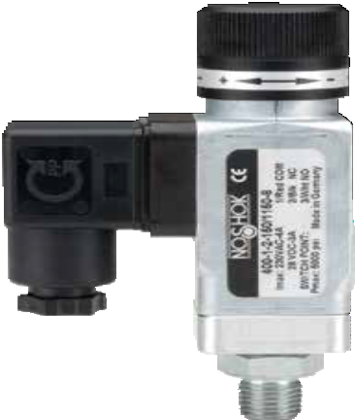Switching Output Schematic
1.18"
(30 mm)
Hirschmann
EN 175301-803
Form A
3.66"
(93 mm)
1.18"
(30 mm)
1.57"
(40 mm)

DIN
Hirschmann DIN 43650
M12 x 1
(4-pin)

Hirschmann DIN 43650

M12 x 1 (4-pin)

400 SERIES INFORMATION
ORDERING
DIMENSIONS
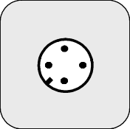
1
2
3
4
1
3
2

103

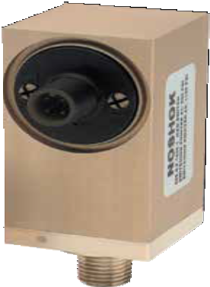
SERIES
500

  - Vacuum ranges through 0 psig to 10,000 psig
  - Standard copper alloy wetted parts
  - Normally open (N.O.) or normally closed (N.C.) switching functions
  - CE compliant to suppress RFI, EMI and ESD

Switching parameters
Number 1 or 2

SPECIFICATIONS

Pressure Switches
Electronic Mag-Switch

APPLICATIONS
- HVAC
- Hydraulics & pneumatics
- Pumps and compressors
- Stamping & forming presses
- Transportation

104
Function N.O. or N.C., p-switching
Contact rating Max. 100 mA (max. 30 Vdc)
Non-repeatability ≤ 1% of full scale

Pressure ranges Vacuum ranges through 0 psig to 10,000 psig

Switch adjustment
Switch point Adjustment screw
Switching point 5 ...100% of full scale
Hysteresis ≤ 5% of full scale

Service life >1,000,000 load cycles
Temperature ranges Compensated 32° to 175 °F / 0° to 80 °C
Zero ± 0.06% full scale/ °F Span ± 0.06% full scale/ °F
Media -5° to 175 °F (-20° to 80 °C)
Ambient -5° to 175 °F (-20° to 80 °C)
Storage -22° to 175 °F (-30° to 80 °C)

Power requirement* | 10 Vdc to 30 Vdc
Proof pressure | 30 psi & lower 60 psi  150 psi & higher | 5x 4x 2x
Measuring element Copper alloy
316 SS > 600 psi
1/4″ NPT Brass connection standard

Housing material Brass through 350 psi
Aluminum anodized 600 psi and higher

Environmental rating IP67 for M12 x 1

Electromagnetic rating CE compliant to EMC norm EN 61326:1997/A1:1998
RFI, EMI and ESD protection

Weight 0.2 lb. on ≤400 psi, 0.6 lb. on ≥600 psi

* Unregulated

WARNING: This product can expose you to chemicals including Lead, which is known to the State of California to cause cancer and birth defects or other reproductive harm. For more information go to www.P65Warnings.ca.gov

ORDERING INFORMATION
SERIES 500
SWITCH FUNCTIONS | 1 | 1 N.O. (PNP) | 2 | 1 N.C. (PNP) | 3 | 2 N.O. (PNP) | 4 | 2 N.C. (PNP)
PROCESS CONNECTIONS 1 1/8″ NPT male 2 1/4″ NPT male
PRESSURE RANGES | 30vac | -30 inHg to 0 psig | 100 | 0 psig to 100 psig | 750 | 0 psig to 750 psig | 5000 | 0 psig to 5,000 psig
 | 15 | 0 psig to 15 psig | 150 | 0 psig to 150 psig | 1000 | 0 psig to 1,000 psig | 7500 | 0 psig to 7,500 psig
 | 30 | 0 psig to 30 psig | 250 | 0 psig to 250 psig | 2000 | 0 psig to 2,000 psig
 | 60 | 0 psig to 60 psig | 350 | 0 psig to 350 psig | 3000 | 0 psig to 3,000 psig
ELECTRICAL CONNECTIONS | 2 | M12x1 (4-pin)
OPTIONS | BT8  Note: | Threaded Orifice  M12 mating connectors & cord sets are available as separate options.
Please consult your local NOSHOK Distributor or NOSHOK, Inc. for availability and delivery information.

EXAMPLE 500 – 3 – 2 – 750 – 2 – BT8

Series 500 Series
Switch function 2 N.O. (PNP)
Process connection 1/4" NPT Male
Adjustable range 0 psig to 750 psig
Electrical connection M12 x 1 (4-pin)
Option Threaded Orifice

Additional Ordering Information Switch Set Point(s)
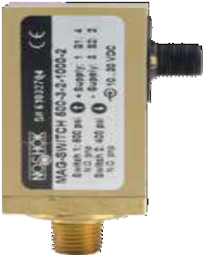(please specify)
1.93"
(49 mm)
1.42"
(36 mm)
2.80"
(71 mm)
0.51"
(13 mm)
1/4" NPT

1.26"
(SW 32 mm)

1.87"
(47.4 mm)
1.25"
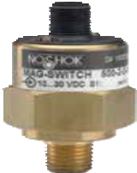(31.8 mm)

2.38"
(60.4 mm)

Switching Output Schematic

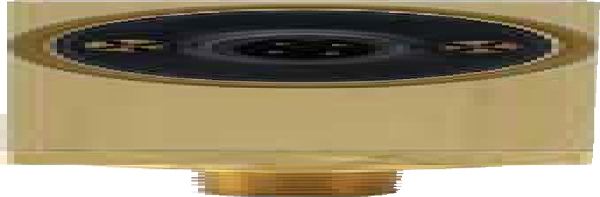
P-switching output

1/4" NPT
0.51"
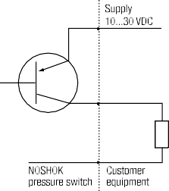(13 mm)

400 psi & lower 600 psi & higher

P-switching
Function | Connector M12 x 1 (4-pin)
Power supply: + | 1
Power supply: − | 3
Switching output: S1 | 4
Switching output: S2 | 2

Wiring Diagrams
Connection table for M12x1 (4-pin) connector

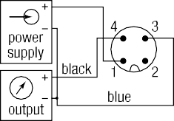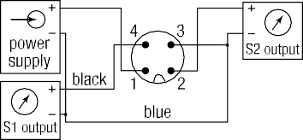1 switching output 2 switching outputs
500 SERIES INFORMATION
ORDERING
DIMENSIONS
105

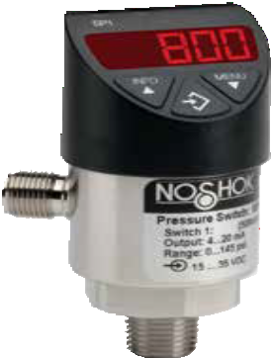

APPLICATIONS
- Hydraulics & pneumatics
- Power generation
- Pumps & compressors
- Stamping & forming presses
- Water & wastewater

SERIES

- Compound and standard ranges from 0 psig to 10 psig through 0 psig to 7,500 psig
800
- 316L Stainless steel wetted parts
- Current and voltage outputs available
- 7 different output configurations available
- Display and electrical connection can be rotated independently
- CE compliant to suppress RFI, EMI and ESD
- RoHS compliant

SPECIFICATIONS

Compound and standard ranges from 0 psig to 10 psig through
Pressure ranges
0 psig to 7,500 psig
Switching parameters Individually adjustable via external control keys
Number 1 or 2 (PNP or NPN)
Function N.O., N.C., window, hysteresis (freely adjustable)
Contact rating 250 mA max.
Response time ≤5 ms
Accuracy ≤ 0.5 % of span
Switch point .25 to 100% of full scale
Hysteresis Fully adjustable

Transmitter parameters
Output signal 4 mA to 20 mA or 0 Vdc to 10 Vdc; programmable and freely adjustable Accuracy ≤±0.5% of span including non-linearity, hysteresis, zero offset and end value
deviation (corresponds to measured error per IEC 61298-2)
Non-repeatability < 0.1% of span (IEC 61298-2)
Adjustment Freely scalable within the range of 5:1

Service life 100,000,000 load cycles

Temperature ranges Compensated 32 °F to 176 °F (0 °C to 80 °C)
Media -4 °F to 185 °F (-20 °C to 185 °C)
Ambient -4 °F to 176 °F (-20 °C to 80 °C)
Storage -4 °F to 158 °F (-20 °C to 70 °C)
Display 14 segment-LED, red 4-digit, height 0.35”

Power requirement* 15 - 35 Vdc

Max. 45 mA for versions without 4-20 mA output signal,

Current consumption Max. 70 mA for versions with 4-20 mA output signal,

Pressure Switches
Electronic Indicating Transmitter/Switch
Total consumtpion max. 600 mA including switching current
Proof pressure 2 times full scale

Measuring element <150 psi: 316L Stainless steel
≥150 psi: 316L, PH grade Stainless steel
Housing material 304 Stainless steel

Connection 316 stainless steel

Environmental rating IP65 and IP67 per IEC 60529

Electromagnetic rating CE compliant to EMC norm EN 61326:1997/A1:1998
RFI, EMI and ESD protection
Electrical protection Protected against reverse polarity, over-voltage and short circuit

Shock > 50 g’s according to IEC 60068-2-27

Vibration > 20 g’s according to IEC 60068-2-6

Weight Approx 0.49 lb.

* Unregulated

106

ORDERING INFORMATION
SERIES | 800 | 304 Stainless steel housing
SWITCH FUNCTIONS | 1  2  3  4 | 2 N.O. or N.C. (PNP or NPN)  1 N.O. or N.C. (PNP or NPN) with 4 mA to 20 mA 3-wire analog output  - N.O. or N.C. (PNP or NPN) with 0 Vdc to 10 Vdc 3-wire output  - N.O. or N.C. (PNP or NPN) with 4 mA to 20 mA analog output * | 5  6  7 | 2 N.O. or N.C. switch (PNP/NPN) with 0 Vdc to 10 Vdc 3-wire output *  - N.O. or N.C. switch (PNP/NPN) with 4 mA to 20 mA/0 Vdc to 10 Vdc 3-wire output 2 **  - N.O. or N.C. switch (PNP/NPN) with 4 mA to 20 mA/0 Vdc to 10 Vdc 3-wire output *, **
PROCESS CONNECTIONS | 2  8 | 1/4″ NPT male 10 G 1/4 B male  1/2″ NPT male 11 G 1/2 B male | 45 | SAE J514 FIG B (Non-Adjustable)
ADJUSTABLE RANGES  (Max. working pressure) | 14.5vac 14.5/15  14.5/30  14.5/50  14.5/100  14.5/160  14.5/200  14.5/300  10 | -14.5 psig to 0 psig 15 0 psig to 15 psig  -14.5 psig to 15 psig 25 0 psig to 25 psig  -14.5 psig to 30 psig 30 0 psig to 30 psig  -14.5 psig to 50 psig 50 0 psig to 50 psig  -14.5 psig to 100 psig 100 0 psig to 100 psig  -14.5 psig to 160 psig 160 0 psig to 160 psig  -14.5 psig to 200 psig 200 0 psig to 200 psig  -14.5 psig to 300 psig 300 0 psig to 300 psig  0 psig to 10 psig 500 0 psig to 500 psig | 1000  1500  2000  3000  5000  7500  10A  15A  25A | 0 psig to 1,000 psig 30A 0 psia to 30 psia  0 psig to 1,500 psig 50A 0 psia to 50 psia  0 psig to 2,000 psig 100A 0 psia to 100 psia  0 psig to 3,000 psig 160A 0 psia to 160 psia  0 psig to 5,000 psig 200A 0 psia to 200 psia  0 psig to 7,500 psig 300A 0 psia to 300 psia  0 psia to 10 psia  0 psia to 15 psia  0 psia to 25 psia
ELECTRICAL CONNECTIONS 2 M12 x 1 (4-pin) 3 M12 x 1 (5-pin), 2 switch and analog output
OPTIONS | ST8 | Threaded Orifice
Please consult your local NOSHOK Distributor or NOSHOK, Inc. for availability and delivery information.
* Available only with a M12 x 1 (5-pin) connector
** Can switch between 4 mA to 20 mA / 0 Vdc to 10 Vdc

EXAMPLE 800 – 1 – 2 – 160 – 2 – ST8

Series 800 Series
Switch function 2 N.O. or N.C. (PNP or NPN)
Process connection 1/4" NPT Male
Adjustable range 0 psig to 160 psig
Electrical connection M12 x 1 (4-pin)
Option Threaded Orifice

1 switching output (M12x1) with 4 mA to 20 mA signal† p-switching

1 switching output (M12x1) with 4 mA to 20 mA signal† n-switching

≈Ø1.50"
(38 mm)
x 1
1.06" HEX
(27 mm)

1.16"
(29.5 mm)
1/4" NPT

Display rotates >300°

2 switching output (M12x1)
1.42"
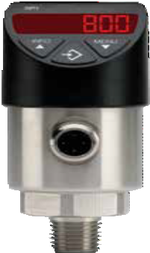(36 mm)
4 3
power supply
sig. output
1 2
S1 output
4 3
power supply
sig. output
1 2
S1 output

2 switching output (M12x1)

M12

p-switching
power supply
4 3
S2 output
1 2
S1 output
power supply
4 3
S2 output
1 2
S1 output

2 switching output (M12x1) with 4 mA to 20 mA signal†
p-switching
4 3
power supply
5
S2 output
1 2
S1 output
sig. output
  - witching

- switching output (M12x1) with 4 mA to 20 mA signal† n-switching
2.83"
(72 mm)

1.02"
(26 mm)

.51"
(13 mm)
power supply
4
S2 output
1
S1 output
sig. output
2
5
3

Ø1.38"
(35 mm)

Electrical Connection rotates >300°

† Also applies to 0 Vdc to 10 Vdc output
800 SERIES INFORMATION
ORDERING
DIMENSIONS
107

PISTON-TYPE SNUBBERS

Resist clogging and are self cleaning
    - Five different sized pistons included with each snubber to ensure the correct amount of snubbing for virtually every application
    - Available in Brass and 316 Stainless Steel in 1/4" NPT, 1/2” NPT or SAE J1926-3: 7/16-20
    - Weight approximately 0.2 lb. for 1/4" & 7/16", and approximately 0.4 lb. for 1/2"

Options & Accessories
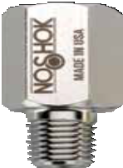
Piston-Type Snubbers Specifications
PART NO. | SIZE | MATERIAL | PRESSURE RATING
1325 | 1/4″ NPT | Brass | 6,000 psi
1335 | SAE J1926-3:7/16-20 | Brass | 5,000 psi
1350 | 1/2″ NPT | Brass | 6,000 psi
5025 | 1/4″ NPT | 316 Stainless Steel | 15,000 psi
5035 | SAE J1926-3:7/16-20 | 316 Stainless Steel | 8,000 psi
5050 | 1/2″ NPT | 316 Stainless Steel | 15,000 psi

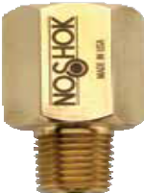

Piston-Type Snubbers

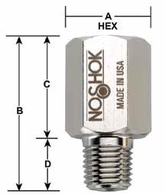
DIMENSIONS |  | 1/4″ NPT | 1/2″ NPT | SAE J1926-3: 7/16-20
A | IN | 0.812 | 1.125 | 0.812
 | MM | 20.6 | 28.6 | 20.6
B | IN | 1.60 | 1.875 | 1.60
 | MM | 40.6 | 47.6 | 40.6
C | IN | 1.04 | 1.25 | 1.24
 | MM | 26.4 | 31.8 | 31.5
D | IN | 0.56 | 0.625 | 0.36
 | MM | 14.2 | 15.9 | 9.1

All Pressure Measurement Instrumentation Options & Accessories
* Snubber assembled and shipped with the B piston installed
PISTON | SUGGESTED USE
A, B* | Gases
B, C | Water
C, D | Light Oil
E | Heavy Oil

108
For products shown that are composed of Brass or Carbon Steel:
WARNING: This product can expose you to chemicals including Lead, which is known to the State of California to cause cancer and birth defects or other reproductive harm. For more information go to www.P65Warnings.ca.gov

For products shown that are composed of Stainless Steel:
WARNING: This product can expose you to chemicals including Chromium (VI) and Nickel, which are known to the State of
California to cause cancer and birth defects or other reproductive harm. For more information go to www.P65Warnings.ca.gov

SINTERED SNUBBERS

Cost effective solution to protect expensive instrumentation
- Increases gauge readability by smoothing out pressure surges, pulsations
and spikes
- 5 basic elements available for each snubber to accommodate specific
application needs
- Snubbing action achieved by utilizing a corrosion resistant 316 Stainless Steel sintered porous element
- Exotic materials or intermediate disc grades available
- Provides long service life with no moving parts to wear out
- Weight approximately 0.2 lb. for 1/4" & 7/16", and approximately 0.4 lb. for 1/2"

Options & Accessories
Sintered Snubbers Specifications
PART NO. | SIZE | MATERIAL | PRESSURE RATING
1125-X | 1/4″ NPT | Brass | 6,000 psi
1135-X | SAE J1926-3:7/16-20 | Brass | 5,000 psi
1150-X | 1/2″ NPT | Brass | 6,000 psi
5125-X | 1/4″ NPT | 316 Stainless Steel | 15,000 psi
5150-X | 1/2″ NPT | 316 Stainless Steel | 15,000 psi
Note: The “X” in the part number denotes the Disc option (example: 1135-C).
See chart below for Disc options.

DIMENSIONS |  | 1/4″ NPT | 1/2″ NPT | SAE J1926-3 :7/16-20
A | IN | 0.812 | 1.125 | 0.812
 | MM | 20.6 | 28.6 | 20.6
B | IN | 1.60 | 1.875 | 1.60
 | MM | 40.6 | 47.6 | 40.6
C | IN | 1.04 | 1.25 | 1.24
 | MM | 26.4 | 31.8 | 31.5
D | IN | 0.56 | 0.625 | 0.36
 | MM | 14.2 | 15.9 | 9.1

Sintered Snubbers Replacement Disc Options
DISC GRADE | PART NO. | AVERAGE AIR FLOW ESTIMATE | MICRON GRADE  (reference) | SUGGESTED USE
A | PD8-A-SS1 | 0.25 L/MIN @ 1 psi | 2 | Gases
B | PD8-B-SS1 | 0.63 L/MIN @ 1 psi | 10 | Gases, Water
C | PD8-C-SS1 | 1.46 L/MIN @ 1 psi | 20 | Water, Light Oil
D | PD8-D-SS1 | 2.79 L/MIN @ 1 psi | 40 | Light Oil
E | PD8-E-SS1 | 3.14 L/MIN @ 1 psi | 60 | Heavy Oil

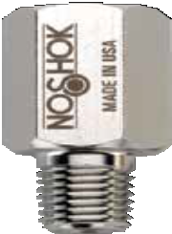
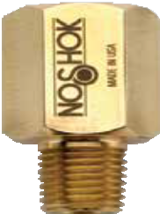
Sintered Snubbers

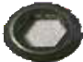

Sintered Snubbers Replacement Discs

109

PIGTAIL STEAM SYPHONS
- Protect the instrument from the damaging effects of high temperature steam
- Recommended for use in steam applications and systems that contain superheated vapor
- Available in 1/4" and 1/2" NPT sizes in welded Steel, welded 316 Stainless Steel
or seamless 316 Stainless Steel with ratings to 3,800 psi @ 850 ºF

Product Specifications
PART NO. | COIL STYLE | SIZE | MATERIAL
1225 | 90° | 1/4″ NPT | Welded Steel, schedule 40
1250 |  | 1/2″ NPT | Welded Steel, schedule 80
2225 |  | 1/4″ NPT | Welded 316SS, schedule 40
2250 |  | 1/2″ NPT | Seamless 316SS, schedule 80
1025 | 180° | 1/4″ NPT | Welded Steel, schedule 40
1050 |  | 1/2″ NPT | Welded Steel, schedule 80
2025 |  | 1/4″ NPT | Welded 316SS, schedule 40
2050 |  | 1/2″ NPT | Seamless 316SS, schedule 80
1425 | 270° | 1/4″ NPT | Welded Steel, schedule 40
1450 |  | 1/2″ NPT | Welded Steel, schedule 80
2325 |  | 1/4″ NPT | Welded 316SS, schedule 40
2350 |  | 1/2″ NPT | Seamless 316SS, schedule 80
1525 | 360° | 1/4″ NPT | Welded Steel, schedule 40
1550 |  | 1/2″ NPT | Welded Steel, schedule 80
2525 |  | 1/4″ NPT | Welded 316SS, schedule 40
2550 |  | 1/2″ NPT | Seamless 316SS, schedule 80

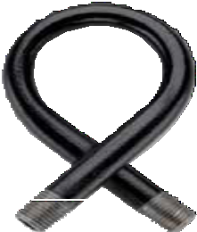

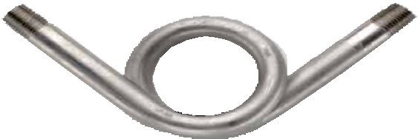

Pigtail Steam Syphons

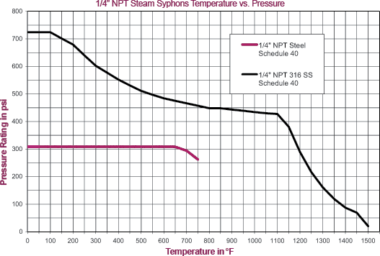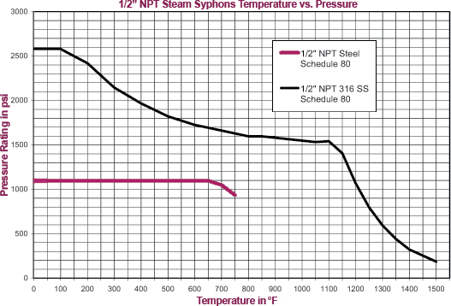

All Pressure Measurement Instrumentation Options & Accessories

110
For products shown that are composed of Brass or Carbon Steel:
WARNING: This product can expose you to chemicals including Lead, which is known to the State of California to cause cancer and birth defects or other reproductive harm. For more information go to www.P65Warnings.ca.gov

For products shown that are composed of Stainless Steel:
WARNING: This product can expose you to chemicals including Chromium (VI) and Nickel, which are known to the State of
California to cause cancer and birth defects or other reproductive harm. For more information go to www.P65Warnings.ca.gov

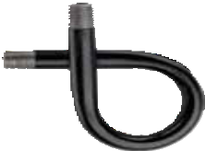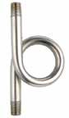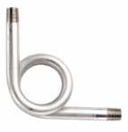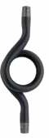90° Syphon 180° Syphon 270° Syphon 360° Syphon
B
A
A
B

B
A
A
B

CONNECTION SIZE |  |  | 1/4″ NPT | 1/2″ NPT
90° | A | IN MM | 4.25  107.95 | 6.5  165.1
 | B | IN MM | 2.625  66.675 | 4.0  101.6
180° | A | IN MM | 5.5  139.7 | 8.875  225.425
 | B | IN MM | 2.5  63.5 | 4.0  101.6
270° | A | IN MM | 4.5  114.3 | 7.5  190.5
 | B | IN MM | 2.625  66.675 | 4.0  101.6
360° | A | IN MM | 7.25  184.15 | 12.0  304.8
 | B | IN MM | 2.625  66.675 | 4.125  104.775

SWIVEL ADAPTORS
- Temperature ratings: 15,000 psi @ 200 °F and 3,000 psi @ 1,000 °F
- 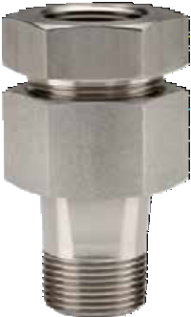Used with gauges and gauge valves to adjust the line of sight
1/4" HEX STOCK
3-1/8" (79.4 mm)

A
- Rotates 360° to allow the connected instrument to be positioned in the desired direction
- The pressure connection is achieved with a tapered cone style compression fitting simply by tightening the swivel hex nut
- All 316 Stainless Steel construction
- Standard with 1/2" NPT male process – 1/2" NPT female instrument connections
- Also available with 1/4" NPT connections, same specifications apply
- Weight approximately 0.8 lb.

1/2" NPT

WARNING: This product can expose you to chemicals including Chromium (VI) and Nickel, which are known to the State of
California to cause cancer and birth defects or other reproductive harm. For more information go to www.P65Warnings.ca.gov 111

Gauge Configurations for High Temperature Applications

140 °F is the maximum recommended ambient media temperature for NOSHOK pressure gauges with Brass wetted parts, and 212 °F for gauges with Stainless Steel wetted parts. For applications in which media reaches temperatures above 212 °F, NOSHOK offers several accessories designed to prevent damage to the gauge, and maintain maximum performance and accuracy.

Recommended gauge configurations are listed below. Please note that these guidelines are intended to be general recommendations. Many conditions may affect the amount of temperature reduction; including ambient temperature, media type, and process configuration.

- Up to 140 °F: All NOSHOK pressure gauges will provide peak performance in this range

- Up to 212 °F: A gauge with Stainless Steel wetted parts is required, such as the NOSHOK 400 and
740 Series. Do NOT use a gauge with Brass wetted parts.

- Up to 287 °F: Accessories must be used to maintain gauge integrity and accuracy. Options include:

  - Pigtail Steam Syphon: For use with a Stainless Steel wetted parts gauge. Should be used in steam applications and systems that contain superheated vapor. The pigtail buffers the instrument from the damaging effects of high temperature steam by holding system fluid in the coil to provide a steam trap for the fluid to condensate and dissipate the heat. Reduces temperature by 75° F/ft. on average. Multiple configurations are available.

  - Armored Capillary Tube: For use with a Stainless Steel wetted parts gauge. Average temperature reduction is 75 °F/ft. Two feet of capillary tube can increase the media temperature range to 362 °F. Standard length is five feet, provided with thread connections; other lengths available on request. Gauge must be separated from the process with a mounting bracket or flange, and the extra capillary length can be rolled up if necessary. Recommended for use with clean media or gases.

  - Long Pipe: 1/2″ in diameter or greater in either Steel or Stainless Steel construction with a Stainless Steel wetted parts gauge. Average temperature reduction is 75 °F/ft. Pipes can be cut and threaded for custom applications.

  - Cooling Element: For use with a Stainless Steel wetted parts gauge. Average temperature reduction is 75 °F/4″ element. Use with other accessories for additional temperature decrease (long pipe, syphon, diaphragm seal).

  - Cooling Tower: For use with a Stainless Steel wetted parts gauge. Approved usage up to
temperatures of 312 °F. Average temperature reduction is 100 °F/8″ cooling tower.
Recommended for use with clean media or gases.

- Up to 300 °F: A high temperature system fill is required, such as silicone D.C 550, and a diaphragm
seal is recommended on a Stainless Steel wetted parts gauge.

For more information, contact NOSHOK at 440.243.0888

112

Process Conditions That Affect Pressure Gauge Accuracy & Performance

The technology used in today’s pressure gauges has been around since the mid-eighteen hundreds, and the pressure gauge is still one of the most common methods of measuring pressure today. The majority of pressure gauges today still incorporate the Bourdon tube, socket, and geared movement; along with a pointer and dial to indicate process pressure.

Since the pressure gauge is a purely mechanical device, attention to three process conditions is necessary. The three factors that can adversely affect accuracy and performance are Temperature, Vibration and Pulsation.

Temperature Influence:
For every 18 °F (10 °C) shift in temperature from which the gauge is calibrated, the user can experience up to a ±0.4% additional error. The cause is the change in the elasticity or spring rate of the Bourdon tube element with temperature. While it is difficult to circumvent the influence of ambient temperature, we can address the influence of process temperature. In steam service, the common practice is to install coil syphons or pigtail syphons to dissipate process heat. Another common practice is to install a diaphragm seal with capillary to separate the gauge from the high heat source. There are many options available with fill fluid in the seal and capillary system to withstand temperatures up to 600 °F. In severe cold ambient conditions, many users elect to heat trace their instrumentation via electric or steam trace. Process and ambient temperature is an important consideration when selecting and applying pressure gauges.

Vibration Influence:
Vibration due to pumps, motors, and other rotating equipment can cause excess wear and possible premature failure of internal working parts of a pressure gauge, which include the Bourdon tube and the movement or gear mechanism. Vibration also causes difficulty in accurate reading of the gauge, due to pointer oscillation. One of the most common causes of pressure gauge failure is exposure to continuous vibration. The most widely accepted remedy is to utilize a liquid filled pressure gauge. The fill fluid of choice is either Glycerin or Silicone. Liquid filled gauges address not only pointer oscillation, but also serve to protect and lubricate the internal geared movement.

Pulsation Influence:
Process pulsation can occur around the discharge of pumps as well as quick operating valves. Many users assume that liquid filling a pressure gauge will fully address pulsation. Although a liquid filled gauge helps to dampen the effects of pulsation, it often does not fully address this process condition. Pulsation dampeners are installed upstream of the gauge socket and they can be a piston-type snubber, a sintered
metal snubber, or a threaded in-flow restrictor in the socket of the gauge. A needle valve installed upstream
of the gauge that is "pinched down" or slightly opened, is another common practice to address pulsation. It is not recommended to rely solely on a needle valve to address pulsation, due to the fact that the user could inadvertently open the valve, and thereby negate flow restriction. In clean fluids (gases or clean low viscosity liquids) a threaded orifice/flow restrictor or a sintered metal snubber is the least costly way to address pulsation. In dirtier and higher viscosity fluids a piston snubber is usually installed.

Summary:
Temperature, vibration and pulsation are three process conditions that adversely affect a pressure gauge. Being aware of these three process conditions, and taking the necessary steps to address them, can help minimize accuracy errors and add to the service life of the pressure gauge.

113

NOSHOK Reference Guide
NOSHOK Transducer and Transmitter Pressure Sensing Technologies

Diffused Silicon Semiconductor Strain Gauge Sensor (used in 100, 200, 612, 613, 615, 616, 621, 622, 623, 624, 625, 626, 627,
640 and 650 Series - ranges up to 0 psi to 300 psi)

semiconductor sensor

diffused silicon strain gauge sensor element

sensor support

intermediate ring

supply voltage
diffused silicon strain gauge as a resistor

output to the amplifier
R1
R2
R3
R4

strain gauges diffused into silicon chip

silicone oil
P

Stainless Steel diaphragm

wheatstone bridge

Sputtered Thin Film Strain Gauge Sensor (used in 100, 200, 612, 613, 615, 616, 621, 622, 623, 624, 625, 626, 627, 640, 650, 660, 800/810 Series - ranges 0 psi to 500 psi and higher)

compression force on strain gauge

tension force on strain gauges

P

compression
force on strain gauge

passivation

P

wire bond
strain gauge

glass insulation

Stainless Steel body

supply voltage

R1 R2

R3 R4

wheatstone bridge

thin film strain gauge as a resistor

output to the amplifier

Ceramic Thick Film Strain Gauge Sensor (used in 800/810 and 1000 Series)
R1
R2
R3
R4

tension ring
thick

o-rin
pressure connection
P

thick film strain gauge as a resistor

strain gauges ceramic body
glass
P
ceramic diaphragm
film cell g

supply voltage

output to the amplifier

wheatstone bridge

hall effect element

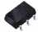
ceramic magnet

hall effect element

Hall Effect Sensor
ceramic magnet

output to the amplifier
input current

pressure sensitive
diaphragm P

magnetic current

114

NOSHOK Accuracy Specifications

Accuracy according to IEC 61298-2
full scale error
zero point error
pressure
signal

Non-linearity according to IEC 61298-2
Definitions
Characteristic Curves:
A smooth curve generated through data points recorded from actual input pressures and output signals
at increasing and decreasing pressures (upscale and downscale readings)
Ideal Characteristic Line :
A straight line representing an ideal linear relationship between
the input pressure and output signal.

Hysteresis:
The maximum dif ference between the characteristic lines recorded at increasing and decreasing pressure. Expressed in percent of ideal span.

Accuracy :
The maximum deviation from an ideal characteristic line including the ef fects of non-linearity , hysteresis, non-repeatability, zero point and full scale errors. Expressed in percent of ideal span
Non-Repeatability :
The maximum deviation between values
of output for any single input of multiple cycles considering decreasing and increasing pressures separately.
Expressed in percent of ideal span.

Averaged Characteristic Curve:
pressure
A single curve generated through the averaged data of input pressures and output
signals at increasing and decreasing pressures. (average of upscale and downscale curves)

Reference line (TP or BFSL):
A straight line coinciding with the actual output data and the averaged characteristic curve.
signal
(TP)Terminal Point connects the actual zero point value and the full scale value (BFSL) Best Fit Straight Line connects the data using the least square method
to minimize the maximum deviation
TP 2 X BFSL
Non-Linearity:
The maximum deviation from the averaged characteristic line to the the reference line.
Expressed in percent of ideal span.

115

Thermal Performance of NOSHOK Pressure Transducers

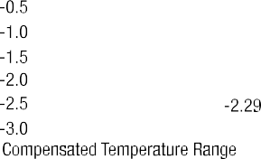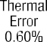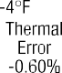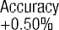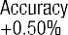

Temperature Performance 100 Series Pressure Transmitter

The above diagram illustrates transducer performance related to the temperature of the environment and media being measured.
The graph shows the worst case performance of the series 100 pressure transmitter as an example (other series follow the same pattern). The thermal specification as indicated in the 100 series specifications is given in a worst case coefficient for the combined effects on zero and span. The definitions are as follows.
The Compensated Temperature Range is the thermal band over which the effect specification is guaranteed. For the 100 series, the coefficient is +/-0.0167% full scale per °F. This means that over the compensated temperature range the thermal boundaries are straight lines as shown. This is sometimes called a “bow-tie effect” or “butterfly effect”.
The Ambient Temperature Range is the maximum and minimum ratings over which the transducer will output a correct signal.
The Media Temperature Range is the maximum and minimum ratings of the media at the process connection. The Storage Temperature Range is the maximum and minimum ratings for no damage on the shelf.

116

The Minimum Power Supply Voltage Required For A 2-Wire 4 mA to 20 mA Loop

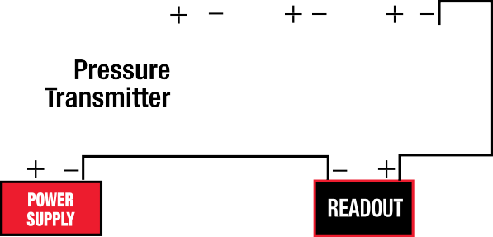

Single instrument 2 wire current loop Single instrument 2 wire current loop

For the single instrument 2 wire current loop, the minimum power supply voltage is equal to the required voltage across the
transmitter plus the voltage drop across the instrumentation plus the voltage drop caused by the resistance of the wiring.
As an example, for a 100 series (4 mA to 20 mA output) pressure transmitter, Vtransmitter = 10 Vdc
Vwiring = Resistance of the wiring (handbook data) X 20 mA maximum current flow in the circuit. If the instrumentation has an input resistance of 250 Ω and if the resistance of the wiring is minimal (100 ft of 24 AWG leadwire has less than 0. 6 Ω (negligible) of resistance), then the calculation including the leadwire is as follows:
Vmin = 10 Vdc + (250 Ω) x .020 Amp + (0.6 Ω) x .020 Amp = 15.012 Vdc
The power supply must provide at least this voltage with the current consumption of .020 Amp.
In a multiple instrument 2 wire current loop, if the second instrument also has an input resistance of 250 Ω, then a second component on the right side of the equation must be included. In this case, the Vmin= 20.012 Vdc. A power supply of 24 Vdc, 1 Amp would be a typical choice.
If there is more than 1 transmitter loop operating off of the same power supply then the current (.020 Amp) must be multiplied by the number of loops. It is recommended that the power supply provide 20% to 30% higher excitation voltage than that calculated above.
Load Limitations 4 mA to 20 mA output

Vmin = 10V + (.020 x RL)
RL = Loop resistance (Ω) RL = RS + RW
RS = Sensor resistance (Ω) RW = Wire Resistance (Ω)

117

Measuring The Pressure Of High Temperature Media

In many applications the medium that the transducer or transmitter will contact may be at an elevated temperature beyond the operational limit of the measuring instrument. Selecting an instrument with a high temperature rating or using diaphragm seals to provide isolation from the medium may not be feasible from a design or economic standpoint.
One way to address this situation is to mount the instrument with a short length of tubing away from the hot area where the measurement needs to be made. With a dead ended pressure chamber, the tubing will effectively dissipate much of the heat and bring the medium in contact with the measuring instrument down to a lower temperature that
is within its safe and accurate limit.
The following chart provides the basic information needed to determine the size and material of the tubing needed.

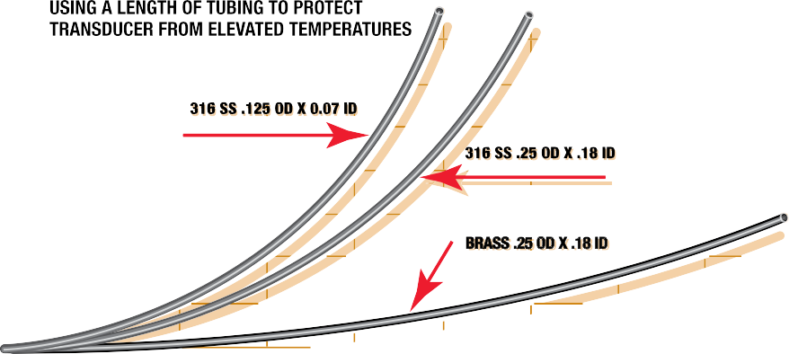

These curves are based upon the following assumptions:
- The pressure vessel is insulated to limit radiant heat transfer to the transducer – the major source of thermal input is via the connecting tube.
- The pressure medium has a coefficient of thermal conductivity less than .4btu / hr / ft2 / ft / °F. This figure encompasses a wide range of liquids and gases.
- The ambient temperature TA around the transducer is 100 °F.
- The heat transfer rate (convection) from the tubing to still air is 1.44btu / ft2 / hr / °F.

118

Environmental Ratings IP Environmental Protection Codes
First Numeral - Protection from Particles Second Numeral - Protection from Water
- No protection 0 No protection
- Particles >50 mm 1 Vertical falling water
- Particles >12 mm 2 Direct sprays up to 15° from vertical
- Particles >2.5 mm 3 Direct sprays up to 60° from vertical
- Particles >1 mm 4 Direct sprays from all directions - limited ingress permitted
- Dust protected - limited ingress, no deposits 5 Low pressure jets of water from all directions - limited ingress permitted 6 Strong jets of water from all directions
- Dust tight - totally protected 7 Immersion in water from 15 cm to 1 m
8 Immersion in water under pressure for long periods of time IP (first numeral, second numeral), for 9 High pressure steam jet up to 100 bar
example IP67

Environmental ratings on NOSHOK transducers are indicated with the individual specifications throughout this catalog. The following ratings are used and this is how they are defined.
IP65 Totally protected from dust as well as protection from low pressure jets of water from all directions - limited ingress permitted (no effect on performance)
IP67 Dust tight and capable of immersion in water from 15 cm to 1 m
IP68 Capable of immersion in water for long periods of time.
IP69K Capable of steam jet washdown.
Since IP65, NEMA 4 and NEMA 4X are related, the differences are in the standards used in qualification. Here they are:

 | IP65 | NEMA 4
Method | Stream of water | Stream of water
Nozzle Size | 1/2 ″ | 1 ″
Distance | 10 ft | 10 ft
Duration | 15 minutes | 5 minutes
Direction | All angles | All angles
Pressure/Flow | 10 m of water | 65 gallons/min.
In order to meet the standard, the IP65 test results allow some ingress of water as long as it does not affect the performance of the instrument. In order to meet the standard, the NEMA 4 test results do not allow any ingress of water. NEMA 4X includes the NEMA 4 standard requirements plus corrosion resistance.

119

Hazardous Location Classifications (NEC)

Class I: Areas in which flammable gases or vapors may be present in the air in sufficient quantities to be explosive
Group A: Atmospheres containing acetylene

Group B: Atmospheres such as butadiene, ethylene oxide, propylene oxide, acrolein, or hydrogen (gases or vapors
equivalent in hazard to hydrogen,such as manufactured gas)
Group C: Atmospheres such as cyclopropane, ethyl ether, ethylene, gas or vapors of equivalent hazard
Group D: Atmospheres such as acetone, alcohol, ammonia, benzene, benzol, butane, gasoline, hexane, lacquer solvent vapors, naphtha, natural gas, propane, or gas or vapors of equivalent hazard
Class II: Areas made hazardous by the presence of combustible dust
Group E: Atmospheres containing combustible metal dusts, regardless of resistivity; dust of similarly hazardous
characteristics having a resistivity of less than 100 KΩs-cm; electrically conductive dusts
Group F: Atmospheres containing combustible carbon black, charcoal, or coke dusts having more than 8% total volatile material; dusts so sensitized that they present an explosion hazard, and dusts having a resistivity of greater than 100 Ω-cm but less than or equal to 1x108 Ω-cm
Group G: Atmospheres containing combustible dust having resistivity equal to or greater than 100K Ω-cm; electrically
nonconductive dusts
Class III: Areas made hazardous by the presence of easily ignitable fibers or dust, but which are not likely to be in suspension in the air in quantities that are sufficient to ignite
Division 1: Atmospheres where hazardous concentrations exist continuously, intermittently or periodically under normal operating conditions
Division 2: Atmospheres where hazardous concentrations exist only in case of accidental rupture or breakdown of
equipment

Hazardous Location Pressure Measurement with NOSHOK Pressure Transmitters

NOSHOK has solutions to your applications in areas with flammable gases and liquids. Let’s start with the definitions related to equipment used in hazardous environments:
Intrinsic Safety Protection
Protection in which the measurement system contains only transmitters and associated equipment that are incapable of causing ignition of the surrounding flammable atmosphere. Normally an intrinsic safety barrier is employed between the transmitter which is located in the hazardous area and the downstream receiving equipment. This barrier contains a electrical network designed to limit the energy (voltage and current) available to the protected circuit in the hazardous location under specified fault conditions. NOSHOK 625, 626 and 627 Series are Factory Mutual and Canadian Standards Association approved as intrinsically safe.
Non-Incendive Protection
Protection in which the measurement may contain arcing or sparking equipment but is still incapable, under specified test conditions, of igniting the flammable gas, vapor or dust-air mixture. This applies only in Division 2 environments. An intrinsic safety barrier is not required in this measurement system. No special wiring is required. NOSHOK 623 and 624 Series are Factory Mutual and Canadian Standards Association approved as non-incendive.
Explosion-Proof Protection
Protection in which the enclosure of the transmitter is capable of withstanding an explosion of the specified gas or vapor that may occur within it and of preventing the ignition of a specified gas or vapor surrounding the enclosure by sparks, flashes or explosion of the gas or vapor within, and that operates at such an external temperature that a surrounding flammable atmosphere will not be ignited. Explosion-proof installation techniques are required including special electrical conduit and junction boxes. NOSHOK 621 and 622 Series are Factory Mutual approved as explosion-proof.
120

Why NOSHOK Is The Best Choice

  - Stable sensing technologies mean that there is no need for periodic recalibration. NOSHOK transducers do not have glues, epoxies or adhesives in the transduction portion of the sensor module because such organic agents cause calibration drift with temperature and pressure cycling, and over time in some applications, cause complete failure.
  - Broad product offering results in best fit of product configuration to customer application requirements.
  - CE compliance and an environmentally hardened design mean maximum performance and reliability in difficult real world
applications. Products are manufactured in an ISO 9001 certified facility.
  - All product specifications are conservatively stated in the literature so that product performance exceeds customer expectations.
  - No specsmanship or games are ever employed, only honest information.
  - The calibration of every product is verified in NOSHOK’s modern facility with the best available pressure controllers and
computerized readout equipment that are at least 4 times the accuracy of the product being checked.
  - Highly automated production minimizing the variations in product caused by human labor mean more consistency from unit to unit resulting in interchangeability and consistent performance.
  - Simple and proven dc electronics improves reliability and longer mean time between failure (MTBF) characteristics.
  - While field failures are few, NOSHOK backs it’s electronic products with a 3-year warranty that is the best in the market.
  - Products provide significant performance and application flexibility at competitive prices addressing the needs of the OEM and the user alike.
  - As a privately owned and run business, NOSHOK employees focus on continually improving customer satisfaction.

Specsmanship - What to Look for in Comparing Other Transducers and Transmitters to NOSHOK Products

  - Be on the lookout for suppliers specifying “high accuracy” with a low price. In many cases you will find indications of zero offsets and span offsets of up to 2% each. The specified accuracy of NOSHOK transducers includes any offsets and is a true accuracy upon which you can depend.
  - If the competitors do not specify a long term stability specification, then this bears out our contention that many of these
other sensing technologies do not yield an attractive stability specification otherwise it would be printed in the literature.
  - Look out for the “typical” nomenclature or the Root-Sum-Square (RSS) designation. While these methods provide a statistical probability of how most of the products will perform, it means that if a quantity of units is considered then a percentage of the products will not meet the listed specification. NOSHOK specifications are worst case, so all the transducers meet that specification.

121

NOSHOK Transmitters/Transducers Wiring Diagrams & Electrical Connections for 100, 200, 300, 612, 615/616, 640, 660 and 800 Series
Installation: NOSHOK pressure transmitters/transducers may be mounted in any plane with negligible effect on performance. Although these units are designed and manufactured to withstand substantial shock and vibration, it is recommended that they be mounted in an area of minimal vibration. Always use a wrench on the wrench flats when installing. NEVER use a pipe wrench on the housing or in the area of the electrical connection.
Maintenance/Calibration: NOSHOK pressure transmitters/transducers require no maintenance. Recalibration is dependent on the users Quality Assurance Program. If no program is in place, NOSHOK recommends a 1 year cycle.

Alignment Procedure
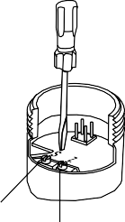
Using a pressure source and meter with adequate accuracy,
perform the following steps:
- Open sensor
- With no pressure applied,adjust the “Z”

SERIES 612 & 613
2 WIRE WIRING DIAGRAM EXAMPLE
Blue

potentiometer for the correct Zero output
Power
- Apply the correct full scale pressure to the unit
- Adjust the “S” potentiometer for the correct
Span output
SERIES 100

Span

Zero
Red

Supply
Black

Output

Wiring –
Mini-Hirschmann connector
2 WIRE WIRING DIAGRAM EXAMPLE

Load Limitations
4 mA to 20 mA Output Only
Vmin = [10V + (.020 x RL)] − 0.04352
cable length

+ Output
Output
Power Supply

Wiring –
M12 x 1 (4-pin) round connector
RL = RS + RW
RL = Loop Resistance (Ωs) RS = Sense Resistance (Ωs) RW = Wire Resistance (Ωs)
Series 612 | 4 mA to 20 mA 2-wire
+ Supply | Red
+Output | Black
Case ground | Blue

Load Limitations
Current output, 2 wire
+ Supply
Red
Black
Supply
Power
Output
1
3
2
Output + Output
2 WIRE
+ Supply WIRING DIAGRAM EXAMPLE
Power Supply
4 mA to 20 mA Output Only Vmin = 10V + (.020 x RL) RL = RS + RW
RL = Loop Resistance (Ωs) RS = Sense Resistance (Ωs) RW = Wire Resistance (Ωs)

Series 100 | 4 mA to 20 mA 2-wire
+ Supply | Red/1/A/1/Brown
+Output | Black/2/B/3/Blue
Example: Red/1/A/1 = Applicable color wire/din plug number/Bendix pin/M12 x 1 pin number/M12 integral cable color wire

3 WIRE WIRING DIAGRAM EXAMPLE

SERIES 200

Wiring –
Mini-Hirschmann connector
3 WIRE WIRING DIAGRAM EXAMPLE
Voltage output, 3 wire
+ Supply
Power
Supply

1

3 2
Output
+ Output
•

Power Supply
Red

- Black

White

Output
Red
Blue
White

Output

Black
•
Power Supply

Wiring –
M12 x 1 (4-pin) round connector
0-5, 1-6, -10
1 Vdc to 11 Vdc 3-WIRE
Series 200
Common

+ Supply
+ Output
•
Power Supply

Output
Common

3 WIRE WIRING DIAGRAM EXAMPLE

Load Limitations
4 mA to 20 mA Output Only
Vmin = [10V + (.020 x RL)] − 0.04354
cable length
RL = RS + RW
RL = Loop Resistance (Ωs) RS = Sense Resistance (Ωs) RW = Wire Resistance (Ωs)
+ Supply

Red/1/A/1/Brown

Example: Red/1/A/1 = Applicable color wire/din plug number/Bendix pin/ M12 x 1 pin number/M12 integral cable color wire
White/3/C/4/Black
+Output
Black/2/B/3/Blue
Common
Series 612 | Voltage Output
+ Supply | Red
Common | Black
+Output | White
Case ground | Blue

122

SERIES 615/616
SERIES 640

Load Limitations 4 mA to 20 mA Output Only
Red
Black
Output

Power Supply
Vmin = 10V + (.020 x RL)
RL = RS + RW
RL = Loop Resistance (Ωs) RS = Sense Resistance (Ωs) RW = Wire Resistance (Ωs)
Series 615/616 | 4 mA to 20 mA 2-wire
+ Supply | Red/1/A/1/1/Brown
+Output | Black/2/B/2/3/Blue

Wiring - M12 x 1 (4-pin)
round connector
Red
Power Supply
White
Output

- Black
Current output, 2 wire
+ Supply

+ Output
Output
Power Supply

Voltage output, 3 wire
+ Supply

+ Output
- Common
Output
Power Supply

2 WIRE WIRING DIAGRAM EXAMPLE
Series 615/616 | Voltage Output
+ Supply | Red/1/A/1/1/Brown
Common | Black/2/B/2/3/Blue
+Output | White/3/C/3/4/Black

Power Supply | Red
 |  | Black

Output
Example: Red/1/A/1/1 = Applicable color wire/ din plug number/Bendix pin/junction
box pin/M12 x 1 pin number/M12 integral cable color wire

SERIES 300

Load Limitations 4 mA to 20 mA Output Only
Vmin = 10V + (.020 x RL)
RL = RS + RW
RL = Loop Resistance (Ωs) RS = Sense Resistance (Ωs) RW = Wire Resistance (Ωs)
Series 300 | 4 mA to 20 mA 2-wire
+ Supply | Red/1/1/1/Brown
+Output | Black/2/2/3/Blue

Power Supply
3 WIRE WIRING DIAGRAM EXAMPLE

Red

- Black

White

Output

Load Limitations
4 mA to 20 mA Output Only Vmin = 10V + (.020 x RL) RL = RS + RW
RL = Loop Resistance (Ωs) RS = Sense Resistance (Ωs) RW = Wire Resistance (Ωs)
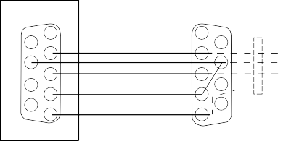RS 232 Interface

1 1
6
2 RX 2
7 RT
- TXD 3
8
- DT 4
9
- GND 5

Pressure Sensor
6
white
- brown yellow
- green
9

2 WIRE WIRING DIAGRAM EXAMPLE

Example: Red/1/1/1 = Applicable color wire/din plug number/junction box pin/
Series 300 | Voltage Output
+ Supply | Red/1/A/1/1/Brown
Common | Black/2/2/3/Blue
+Output | White/3/3/4/Black

M12 x 1 pin number/M12 integral cable color wire

3 WIRE WIRING DIAGRAM EXAMPLE

SERIES 800
4 mA to 20 mA, 2 wire
+ Supply
Power
Supply

Output + Output

0 Vdc to 10 Vdc, 3 wire
SERIES 660

Wiring - Mini-Hirschmann connector
Current output, 2 wire
+ Supply
1
3
2
Output
+ Output
Power Supply

Load Limitations 4 mA to 20 mA Output Only
Vmin = 10V + (.020 x RL)
RL = RS + RW
RL = Loop Resistance (Ωs) RS = Sense Resistance (Ωs) RW = Wire Resistance (Ωs)
Series 660 | 4 mA to 20 mA 2-wire
+ Supply | Brown/1/1/Brown
+Output | Green/2/3/Blue

Wiring - M12 x 1 (4-pin) round connector
Current output, 2 wire
+ Supply

+ Output
Output
Power Supply

Load Limitations
- Common
+ Output
Output
Power
Supply

+ Supply

Voltage output, 3 wire
+ Supply
1
3
2
- Common
+ Output
Output
Power Supply

Series 660 | Voltage Output
+ Supply | Brown/1/1/Brown
Common | Green/2/3/Blue
+Output | White/3/4/Black
Example: Brown/1/1 = Applicable color wire/ din plug number M12 x 1 pin number/M12 integral cable color wire

Voltage output, 3 wire
+ Supply

+ Output
- Common
Output
Power Supply
4 mA to 20 mA Output Only Vmin = 10V + (.020 x RL) RL = RS + RW
RL = Loop Resistance (Ωs) RS = Sense Resistance (Ωs) RW = Wire Resistance (Ωs)

Series 800 | 4 mA to 20 mA 2-wire
+ Supply | Red/1
+Output | Black/2

Series 800 | Voltage Output
+ Supply | Red/1
Common | Black/2
+Output | White/3
Example: Red/1 = Applicable color wire/din plug number.

123

Frequently Asked Questions - Dial Indicating Pressure Gauges

Q: What is the purpose of the ventable & non-ventable fill plug/relief plug?
A: A fill plug seals the fill hole in a pressure gauge case. On liquid filled pressure gauges, a ventable fill plug is used to relieve internal case pressures that occur due to thermal expansion of the fill fluid. In non-filled dry gauges, a non-ventable fill plug is used to occasionally drain the interior of the case from condensate or relieve internal case pressures. Ventable fill plugs incorporate a vent pin to open and close a hole for relieving internal case pressures and do not have to be removed from the case hole like non-ventable fill plugs.

Q: What are the designed overpressure ratings for NOSHOK gauges?
A: Overpressure ratings are specific to the gauge type, pressure range and accuracy ratings of the gauge. Normal overpressure protection can range from 1.1X to 1.3X depending on the gauge selected. NOSHOK gauges comply to the EN-837-1 and ASME B40.1 standards in regards to overpressure protection. When selecting a pressure gauge, it is recommended that the normal system pressure be maintained around half of the full range of the gauge as to avoid overpressure conditions. Overpressure protection of 3 times up to 10 times of the dial range is available on some series as a production option.

Q: How is the accuracy of a gauge affected by a Maximum Indicating Pointer?
A: A Maximum Indicating Pointer (MIP), also commonly referred to as a Tell Tale Pointer, adds an additional ±1% error to the
pressure gauge due to the increase load on the Bourdon tube.

Q: What is a Certified Calibration?
A: Certified Calibrations provide the user with a serial numbered gauge along with a calibration certificate that it has been certified in accordance to the pressure gauge standard with instruments that are traceable to NIST with accuracies of at least 4 to 1.

Q: What is a Certificate of Conformance?
A: A Certificate of Conformance is a formal statement on company letterhead stating that an instrument complies with a particular standard. It contains the signatures of the required personnel. These Certificates are often needed to show industry inspectors that a system and its components are in compliance.

Q: How often does a gauge need to be calibrated?
A: NOSHOK pressure gauges require little or no calibration within the Warranty period. Some applications may be more aggressive than others, resulting in an increased frequency in the need for calibration. The environmental limitations for the pressure gauge series should be observed in all cases. Gauges used in situations outside these requirements may result in inaccuracies, premature wear and/or failure of the gauge and would require additional maintenance. The frequency of calibration, therefore, is up to the user to judge.

Q: When is it recommended to use an orifice?
A: Orifices are a type of snubber. On pressure systems that have rapidly increasing or decreasing pressure spikes, orifices lessen the effects of these energy pulses by blocking the wave energy using restricted flow. They are recommended in dynamic pressure applications with mild pressure spikes.

Q: When is a diaphragm seal used, and when would you apply a diaphragm seal and capillary?
A: A diaphragm is used to isolate and protect the instrument from the process media. Damaging process media may include corrosives, particulates, temperatures, or any state that is not suitable for direct contact with the measuring element.
Diaphragms indirectly transmit system pressures by segregating the process pressure with a thin flexible membrane that in turn transfers the pressure through a fill fluid to the instrument. Diaphragms are often used in conjunction with capillaries to further distance the instrument from the process media. Capillary tubes transmit the diaphragm fill fluid to the instrument. Capillary tubes come in several lengths and provide the user a means to measure in a remote location and may also act as heat dissipaters in high temperature applications.

Q: What is the purpose of liquid filling a gauge, and in what applications would a liquid filled gauge be used?
A: Primarily, in applications that have vibrations or pulsations, liquid filling enables reading the dial pointer by dampening the movement. Liquid filling should be considered in any system that has high dynamic operating conditions. In general, liquid filling helps extend the life of a gauge. It reduces damaging resonance induced fracturing, reduces frictional wear, prevents aggressive ambient air from entering, prevents condensation formation, and improves reliability.

Q: How does temperature affect the accuracy of a pressure gauge?
A: Temperature changes affect the stiffness of a Bourdon tube. The stiffness change is produced by a combination of changes in the elastic (Young’s) modulus and a change in linear dimensions due to linear expansion and contraction. The error caused by temperature change will follow the approximate formula: ± 0.04 x (t2 –t,) % of the span.
124

Frequently Asked Questions - Dial Indicating Pressure Gauges

Q: How do you select a pressure gauge relative to process pressures, normal operating pressures, and maximum
pressures in the process? (Dynamic or static process pressures)
A: The pressure range of a gauge should be 10% over the maximum working pressure in static conditions (no pressure fluctuations). In dynamic conditions, the gauge range should be 40% over the maximum working pressure. Ideally, the pressure gauge range should be selected for a midscale reading during normal operating pressures.

Q: What applications require the various lens materials, and to what maximum temperature can each be subjected? A: Lens materials include Instrument Glass, Laminated Safety Glass, Tempered Glass, and plastic. Glass lenses are used for abrasion, chemical and wear resistant properties. Laminated Safety Glass reduces the possibility of shattering if the Bourdon tube ruptures. Tempered Glass is 2 to 5 times stronger than Instrument Glass. Plastic lenses are used for impact, corrosion and chemical resistance. Special attention should be paid to the temperature and corrosive environments. Polycarbonate is selected for its superior impact resistance, acrylic for its clarity and scratch resistance and Homalite for is superior chemical resistance. In general, gauges with plastic lenses should remain below 140° F.

Q: In what situation would a pigtail syphon be used?
A: Pigtail syphons should be used in steam applications and systems that contain superheated vapor. The pigtail buffers the instrument from the damaging effects high temperature steam by holding system fluid in the coil to provide a steam trap for the fluid to condensate and dissipate the heat.

Q: What is the application for a gauge cleaned for O2 service?
A: Oxygen (O2) cleaning is performed on gauges that are used on oxygen service applications. The cleaning removes all hydrocarbons (oil and grease are common hydrocarbons) that can react violently, resulting in explosions, fire, and injury to personnel and property. Oxygen clean gauges can be used in any application that requires the cleanliness level associated with oxygen clean gauge. Glycerin fill gauge cannot be used on oxygen systems.

Q: What fill fluids options are available, and in what applications would each be used?
A: Glycerin is the most common fill fluid. Because of its unique fluid properties, Glycerin has become the standard for liquid filled gauges (see "What is the purpose of liquid filling a gauge?"). Glycerin’s clarity, viscosity, stability, cost, solubility, low toxicity make Glycerin an ideal fluid for many applications. Mineral oils and silicon fluids are used when temperature extremes, chemical compatibility or viscosity fall outside of Glycerin use. Halocarbon® is an inert fluid that is compatible with chlorine, oxygen service, and some high temperature applications. Keep in mind that Glycerin is not compatible with strong oxidizers such as oxygen, chlorine, hydrogen peroxide, or nitric acid. Glycerin & Silicon are explosive in contact with chlorine.
Halocarbon® is explosive in contact with Aluminum and magnesium.

Q: What is the difference between the ASME B40.1 and EN 837-1 specification?
A: The American National Standards Institute (ANSI) approves American National Standards which include the American Society of Mechanical Engineers (ASME) standard ASME B40.100. This Standard (B40.100) is confined to analog, dial-type gauges, which, utilizing elastic elements, mechanically sense pressure and indicate it by means of a pointer moving over a graduated scale. The European Committee for Standardization (CEN) is the officially recognized European standards body that develops European Standards (ENs) which include EN 837-1. The EN 837-1 includes mandatory dimensions, metrology, and testing requirement for sale in the European Union. ASME B40.100 includes similar requirements in a mandatory appendix.

Q: What is the purpose of throttle devices such as throttle plugs and screws?
A: Throttle devices limit the flow to the pressure instrument. They are a type of snubber.

Q: What is the purpose of an over and under load stop in a pressure gauge?
A: The tip motion of a Bourdon tube is translated to rotary motion of a pointer by a linkage and sector gear acting on the pointer pinion gear. Stop pins limit the movement of the Bourdon tube, sector or pointer rotation in over and under pressure conditions that would otherwise move the pointer pinion off the sector gear which would damage the gauge.

125

Frequently Asked Questions - Electronics

- What is the difference between a transducer and transmitter?
  - When these terms originated there was a distinctive difference between the two. A transmitter was referred to as an instrument with a current output signal (i.e. 4 mA to 20 mA) and a transducer was referred to as an instrument with a voltage signal (i.e. 3 mV/V, 0 Vdc to 10 Vdc etc.). As time has progressed these terms are now commonly interchanged for reference to current, voltage and digital output signals.

- What is the difference between the proof pressure and burst pressure specifications?
  - Proof pressure which is higher than the full scale pressure point is the limit that you can go to without affecting the performance
and calibration of the transducer. The burst pressure on the other hand is the limit that you can go before there is pressure chamber rupture and
damage. An overload limit specification used sometimes means that proof and burst ratings are identical.

- Will the series 1800 Attachable Loop Indicator work with transmitters not made by NOSHOK?
  - The series 1800 indicator will work with any brand that has the same pin connections and style Hirschmann connector and sufficient power supply
voltage to drive all instruments in the loop. The series 1800 will use 3 Vdc to operate.

- What does RFI, EMI and ESD mean related to pressure transducers and transmitter?
  - Radio Frequency Interference and Electromagnetic Interference refer to the effects electrical noise can have on instruments. RFI frequently comes from hand held walkie-talkies and EMI comes from AC motors in the vicinity of the instrument.
ESD (Electrostatic Discharge) comes from many sources including the application itself. CE compliant transmitters and transducers incorporate
protection techniques and components to minimize most of the interference.

- Can traditional diaphragm seals or gauge protectors be used with pressure transducers and transmitters?
  - Most diaphragm seals can be used with pressure transducers and transmitters. The real key is to assemble and fill the seal properly, being careful not to entrap air in the fill fluid.

- Are pigtail steam syphons used in transmitter applications?
  - The steam syphon is necessary in steam pressure applications. It is important to isolate the transmitter sensing diaphragm from the high temperature
encountered with steam pressure applications.

- Can orifices and snubbers be used and why would they be needed?
  - As with other pressure measurement instruments including gauges, pressure pulsations and spikes, are issues with pressure transmitters. Whenever the pressure of an incompressible fluid is measured, there is the potential for pulsations and spikes, which can damage pressure transmitters. An orifice installed in the pressure connection by NOSHOK can protect the transmitter from damage. Where there is the possibility of clogging the small orifice, an attachable piston snubber is recommended.

- What is the reason for the vent tube in the cable of the 612 and 627 Series submersible level transmitters?
  - All pressure measurements are inherently differential in theory. Gauge pressure is referenced to ambient atmospheric, absolute pressure is referenced to vacuum contained in an evacuated chamber within the transmitter. The level measurement is also a differential measurement, with its reference to ambient atmospheric pressure. In order for the submersible level measurement to be referenced to atmospheric, the cable contains a vent tube which runs the complete length of the cable and “vents” into the atmospheric pressure at the junction box connection which is out of the liquid.

- How does the series 612 and 627 submersible level transmitter measure level?
  - The transmitter measures the hydrostatic pressure produced by the liquid level higher than the point where the instrument is located. The higher the liquid, the higher the pressure.

- NOSHOK transducers and transmitters are normally 2 wire or 3 wire in output configuration. Is a 4 wire transducer available?
  - Voltage output transducers are available with a 4th connection which is electrically the same as the power supply common to connect to wiring
configurations that require it.

126

Canadian Registration Numbers

CRN documents are available at www.noshok.com.

Category: F. Measuring Devices
Type of Fitting: | Including pressure gauges, level gauges, sight glasses, level  or pressure transmitters
Alberta | 0F15217.52
British Columbia | 0F15217.51
Manitoba | 0F15217.54
New Brunswick | 0F15217.57
Newfoundland & Labrador | 0F15217.50
Northwest Territories | 0F15217.5T
Nova Scotia | 0F15217.58
Nunavut | 0F15217.5N
Ontario | 0F15217.5
Prince Edward Island | 0F15217.59
Quebec | CSA-0F15217.56
Saskatchewan | CSA-0F15217.56
Yukon Territory | 0F15217.5Y

127

NOTES

128

NOTES

129

NOTES

130

NOTES

131

NOTES

132

NOTES

133

NOTES
134

TO DOWNLOAD OR ORDER CATALOGS, VISIT WWW.NOSHOK.COM
135

NOSHOK
is committed to providing
a high degree of value and continually improving processes to improve customer satisfaction by focusing on customer requirements for the design, manufacture and distribution of pressure, temperature, and force measurement instruments along with needle and manifold valves including
custom manifold systems for industrial applications.

And all from a company with a 50+ year record of customer satisfaction.
All from your Single Source Instrumentation Company.

All from world class technology. Combined with real-world stamina.
The highest value with the industry’s best warranty.

Corporate Headquarters
1010 West Bagley Road Berea, Ohio 44017
Ph: 440.243.0888
Fax: 440.243.3472
E-mail: noshok@noshok.com
Web: www.noshok.com
136

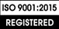

Catalog NK14PLMS-2

