Flexible Hose, Ducting and Accessories 2018-2019 Product Catalog

Flexaust® has manufactured durable, long lasting, flexible hose and ducting solutions for industrial and commercial applications for 80 years. Our flexible hose products are used in applications involving air, dust, fume and lightweight materials. We offer the largest selection of products including wire reinforced coated fabric hose, wire reinforced plastic hose in regular as well as stretch construction, hand-bendable metal ducting, all plastic wet or dry vacuum hose and blow molded corrugated tubing products.
Flexaust® Product Selection Guide
There are five critical factors in selecting the proper hose and ducting for your application. These are: Size, Temperature, Application, Media and Pressure. The superior strength of Flexaust® hose and ducting makes them suitable for the pressures and velocities normally required for industrial air movement, dust collection, fume control and light bulk material handling.
- SIZE: Specify the I.D. of the Flexaust hose or

duct required.
F D M

- TEMPERATURE: Specify media temperature (°F).

A APPLICATION: Specify if Air, Fume, Dust and/or Light Weight Materials will be flowing
through the hose or duct. See listings to the right.
M MEDIA: Specify what media is going

through the hose or duct.
P PRESSURE: Specify type of pressure.

Positive (psi), Negative (Inches Hg.) and/or Inches w.g.
Air
- Heating or Cooling
- Drying
- Dehumidifying
- Cleaning
- Dust Covers
- Supply
- Connectors
- Air Filter Intakes

Fume
- Laboratory
- Industrial
- Automotive
- Painting
- Welding
- Soldering
- Plating

Dust
  - Filtering
  - Movement
  - Exhaust
  - Duct Cleaning
  - Textile Fiber Collection
  - Vacuum Cleaning
  - Lint Collection
  - Loading (containment)
  - Cutting
  - Grinding
Materials
- Light Weight
- Material Handling
- Shavings
- Chips
- Powders
- Debris
- Leaf Collection
- Street Sweeping
- Lawn Vacuum
- Slurries
- Sawdust Collection
- Drains
- Packing Popcorn

Solve your hose, ducting, and accessory problems in just 24 hours!
Flexaust's guarantee is to ship your order (250 ft. maximum order) by the end of the next business day or we pay the freight. Look for the 24-hour ship icon throughout the catalog. Please review the chart below for specific diameters:

Product Line | Product Name | Available Sizes | Length
Flexadux® TR | T-7, T-7W, T-7SR | 2", 2.5", 3", 4", 5", 6", 8", 10",12" | 25'
Flexadux® PV | R-2 Blue or Clear R-3 Blue or Clear | 1.5", 2", 2.5", 3", 4", 5", 6", 8", 10", 12"  2", 3", 4", 5", 6" | 25'  25'
Flexadux® PU | Flx-Thane® LD Clear  Flx-Thane® MD Black or Clear | 4", 6", 8"  2", 2.5", 3", 4", 5", 6", 7", 8", 10", 12" | 25'  25'
Flex-Tube® | Flex-Tube® PV, Flex-Tube® PU | 4", 6", 8" | 25'
Flex-Tube® | FlexStat® | 1.25", 1.5", 2", 3", 4", 6" | 50'
Flexaust® | CWGP FSP-2 | 2", 2.5", 3", 3.5", 4", 5", 6", 7", 8", 10",12"  3", 4", 6" | 25'  25'
Heat-Flex® | CW-325 GS | 3", 4", 6"  1.25", 1.5", 1.75", 2", 2.5", 3", 4" | 25'  12'
Flex-Lok® | Flex-Lok® 550 | 4", 6", 8" | 25'
Springflex® | FSP-5, SD-W | 8", 12" | 25'
Genesis® | Commercial Gray or Black | 1.25", 1.5", 2", 3", 4" | 50'

FLEXADUX ® PV

R-2

Size Range (In) 1.25" to 18"
. . . . . . . . . . . . . . . . . . . . . . . . . . . custom to 24"
Standard Length (Ft) 25', 50'
. . . . . . . . . . . . . . . . . . . 14" and above in 25' only
Standard Colors blue, clear
Temperature Range (°F) 20° to 160°

F

R-3

Size Range (In) 1.25" to 12"
. . . . . . . . . . . . . . . . . . . . . . . . . . . custom to 24"
Standard Length (Ft) 25', 50'
. . . . . . . . . . . . . . . . . . .14" and above in 25' only
Standard Colors blue, clear
Temperature Range (°F) 20° to 160°

M

R-4

Size Range (In) 2" to 12"
Standard Length (Ft) 10', 25', 50'
Standard Color clear
Temperature Range (°F) 20° to 160°
F D M

AIR FUME DUST MATERIAL

  - Light weight PVC hose reinforced with a spring steel wire helix
  - Great flexibility with tight bending characteristics
  - Good chemical and moisture resistance
  - Good compressibility
  - Excellent choice for ventilation applications, dust and fume removal
  - Blue is listed as UL 94V-0 flame retardant
  - Clear is manufactured with FDA acceptable materials
  - Wall Thickness = .020"
  - Available in metric sizes, consult sales team on pricing and minimums
  - Available in an insulation vacuuming version (E-2)

  - Heavy weight PVC hose reinforced with a coated spring steel wire helix (sizes 14" I.D. and above not available with a coated wire)
  - Excellent internal and external abrasion resistance
  - Good chemical and moisture resistance
  - Excellent choice for ventilation applications, dust and fume removal
  - Blue is listed as UL 94V-0 flame retardant
  - Clear is manufactured with FDA acceptable materials
  - Wall Thickness = .045"
  - Available in metric sizes, consult sales team on pricing and minimums

  - Medium weight PVC hose reinforced with a spring steel wire helix
  - Good for positive pressure applications
  - Great compressibility
  - Construction allows for value packaging by reducing the box size, reducing warehouse space and shipping costs
  - Ideal for dust and woodworking applications
  - Good chemical and moisture resistance
  - Manufactured with FDA acceptable materials
  - Available in a stretch version (R-4 Stretch)
  - Wall Thickness = .028"

D M

ADC

Size range (In) 6" to 12"
. . . . . . . . . . . . . . . . . . . . . . . . . . . .custom to 18"
Standard Length (Ft) 25'
Standard Color clear
Temperature Range (°F) 20° to 160°

  - Very light weight PVC hose reinforced with a spring steel wire helix
  - Good for positive pressure applications
  - Great compressibility
  - Excellent flexibility with tight bending characteristics
  - Good chemical and moisture resistance
  - Manufactured with FDA acceptable materials
  - Wall Thickness = .015"

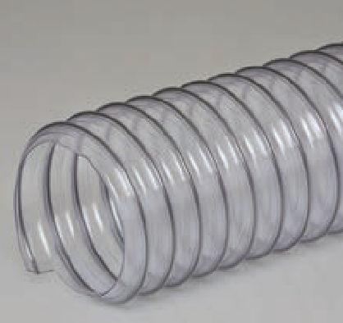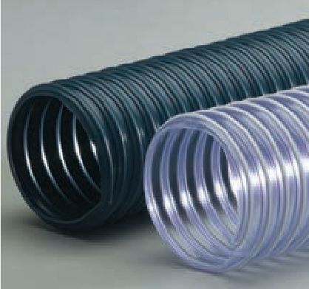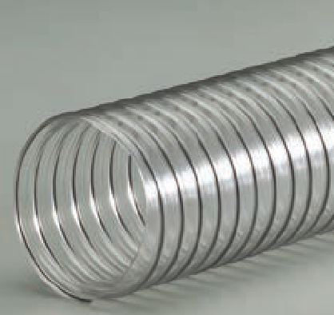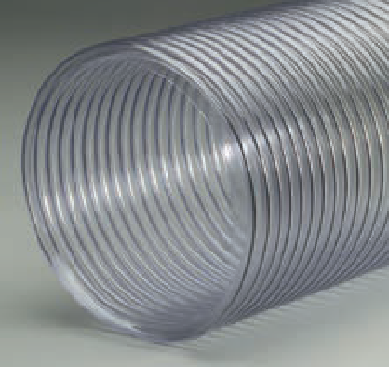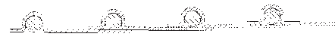

F

FLEXADUX ® TR

T-7

  - Medium weight thermoplastic rubber hose reinforced with a spring steel wire helix
  - Good abrasion resistance

F D M

AIR FUME DUST MATERIAL

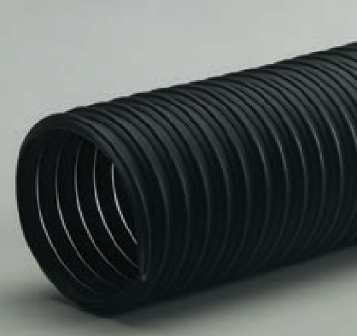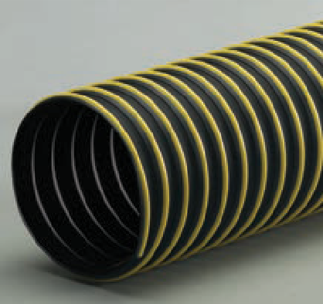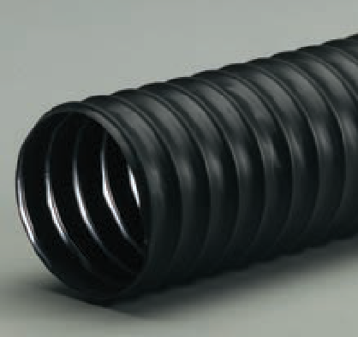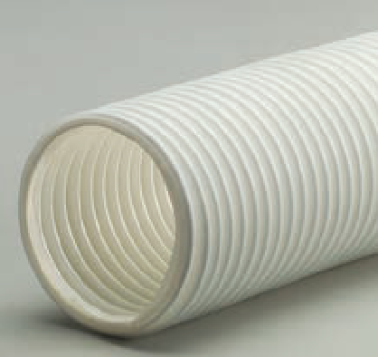

Size Range (In) 1.5" to 24"
Standard Length (Ft) 25', 50'
. . . . . . . . . . . . . . . . . . .14" and above in 25' only
Standard Color black
Temperature Range (°F) ........ -60° to 275°

D M

T-7W

Size Range (In) 2" to 24"
Standard Length (Ft) 25', 50'
. . . . . . . . . . . . . . . . . . .14" and above in 25' only Standard Color black with yellow wearstrip
Temperature Range (°F) ........ -60° to 275°

D M

T-7SR

Size Range (In) 2" to 12"
. . . . . . . . . . . . . . . . . . . . . . . . . . . custom to 18"
Standard Length (Ft) 25', 50'
. . . . . . . . . . . . . . . . . . .14" and above in 25' only
Standard Colors black
Temperature Range (°F) ........ -50° to 285°
. . . . . . . . . . . . . . . . . . . . . . . .intermittent to 325°

F D M

T-7 White

Size Range (In) 2" to 12"
. . . . . . . . . . . . . . . . . . . . . . . . . . . custom to 24"
Standard Length (Ft) 25', 50'
. . . . . . . . . . . . . . . . . . .14" and above in 25' only
Standard Color white
Temperature Range (°F) ........ -40° to 250°

D M
  - Designed for applications with wide temperature ranges
  - Great moisture and UV resistance
  - Excellent chemical resistance
  - Smooth interior assures minimal friction loss and efficient air flow
  - Wall Thickness = .030"
  - Available in metric sizes, consult sales team on pricing and minimums
  - Available with factory-installed 2" black soft cuffs

  - Medium weight thermoplastic rubber hose reinforced with a spring steel wire helix and external polypropylene wearstrip
  - Most general all-purpose hose
  - Wearstrip offers additional external abrasion and drag resistance
  - Designed for applications with wide temperature ranges
  - Great moisture and UV resistance
  - Excellent chemical resistance
  - Smooth interior assures minimal friction loss and efficient air flow
  - Wall Thickness = .030"
  - Available in metric sizes, consult sales team on pricing and minimums

  - Thermoplastic rubber coated super reinforced non-woven polyester fabric hose with a spring steel wire helix
  - Combines the ozone, UV, weathering and chemical resistance of thermoplastic rubber with the tensile strength and fatigue resistance of fabric hoses
  - Offers better tear strength, puncture and abrasion resistance than traditional reinforced woven neoprene and thermoplastic hoses
  - Handles higher positive pressures than non- reinforced thermoplastic rubber hoses
  - Wall Thickness =.024"
  - Available with factory-installed 2" black soft cuffs

  - Medium weight thermoplastic rubber hose reinforced with a spring steel wire helix
  - Good abrasion resistance
  - Designed for applications with wide temperature ranges
  - Great moisture and UV resistance
  - Excellent chemical resistance
  - Smooth interior assures minimal friction loss and efficient air flow
  - Wall Thickness = .030"
  - Manufactured with FDA acceptable materials

FLEXADUX® TR

XLT

    - Very light weight thermoplastic rubber hose reinforced with a spring steel wire helix
    - Excellent compressibility and flexibility

F D M

AIR FUME DUST MATERIAL

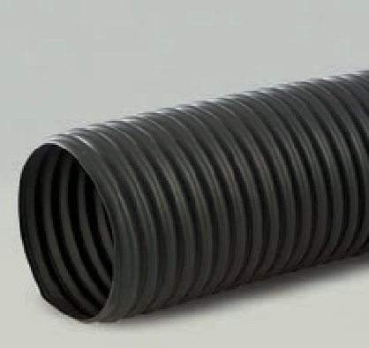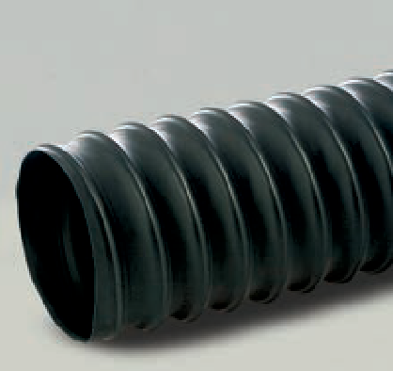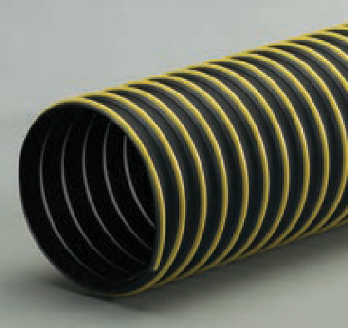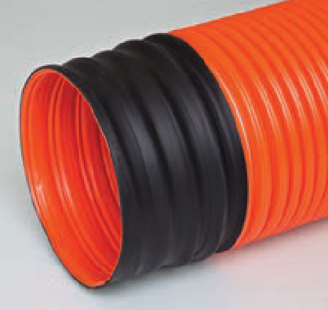

Size Range (In) 2" to 6"
Standard Length (Ft) 25'
Standard Color black
Temperature Range (°F) ........ -60° to 275°

F

LT

Size Range (In) 1.5" to 12"
. . . . . . . . . . . . . . . . . . . . . . . . . . . custom to 16"
Standard Length (Ft) 25', 50'
. . . . . . . . . . . . . . . . . . . 14" and above in 25' only
Standard Color black
Temperature Range (°F) ........ -60° to 275°

F

HT-W

Size Range (In) 8" to 12"
Standard Length (Ft) 25'
Standard Color black with yellow wearstrip
Temperature Range (°F) ........ -60° to 275°

M

L-Vac

Size Range (In) 5" to 7.87"
Standard Length (Ft) 10'
Standard Colors orange
Temperature Range (°F) .. -20° to 185°
  - Most compressible thermoplastic rubber hose in product line
  - Designed for applications with wide temperature ranges
  - Easy to install in tight spaces
  - Recommended for light duty, low pressure applications
  - Great moisture and UV resistance
  - Excellent chemical resistance
  - Wall Thickness = .012"

  - Light weight thermoplastic rubber hose reinforced with a spring steel wire helix
  - Excellent compressibility and flexibility
  - Designed for applications with wide temperature ranges
  - Great moisture and UV resistance
  - Excellent chemical resistance
  - Smooth interior assures minimal friction loss and efficient air flow
  - Wall Thickness = .020"
  - Available with factory-installed 2" black soft cuffs

  - Heavy weight thermoplastic rubber hose reinforced with a spring steel wire helix and external polypropylene wearstrip
  - Wearstrip offers additional external abrasion and drag resistance
  - Suitable for more demanding positive and negative pressure applications including lawn and leaf collection
  - Designed for applications with wide temperature ranges
  - Great moisture and UV resistance
  - Excellent chemical resistance
  - Smooth interior assures minimal friction loss and efficient air flow
  - Wall Thickness = .045"
  - Available without external wearstrip (HT)

  - Medium weight polypropylene elastomer hose reinforced with both a plastic and a spring steel helix
  - Vacuum lift tube fits most vacuum lift equipment
  - Encapsulated high tensile steel wire provides longer life than traditional neoprene PVC wrapped constructions
  - Ideally suited for use in environments requiring frequent wash downs
  - Available with factory-installed heat welded cuffs for easy clamping and an air tight seal
  - Available in yellow, metric sizes and 8'3" lengths, consult sales team for pricing and minimum

FLEXADUX ® PU

Flx-Thane® XLD

Size Range (In) 2" to 12"
Standard Length (Ft) 25'
Standard Colors clear
Temperature Range (°F) .. -65° to 200°

F D
F D M

AIR FUME DUST MATERIAL

  - Very light weight polyurethane hose reinforced with a bronze coated spring steel wire helix
  - Lighter weight and more economical alternative to heavier weight polyurethane hoses
  - Great compressibility
  - Great abrasion resistance
  - Superior chemical resistance
  - Excellent flexibility
  - Designed for applications with wide temperature ranges
  - Manufactured with FDA acceptable materials
  - Available in metric sizes, consult sales team on pricing and minimums
  - Wall Thickness = .015"

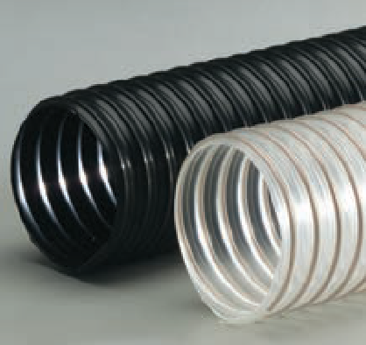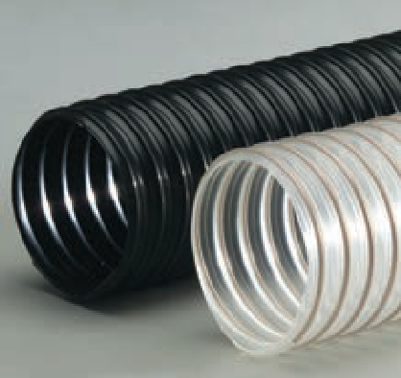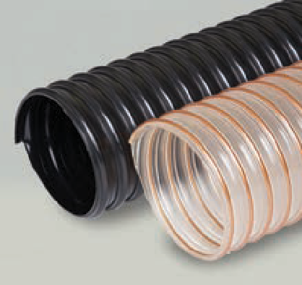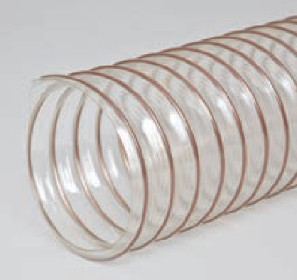Flx-Thane® LD

Size Range (In) 2" to 18"
Standard Length (Ft) 25'
Standard Colors clear, black
Temperature Range (°F) ........ -65° to 200°

F D

Flx-Thane® MD

Size Range (In) 2" to 18"
. . . . . . . . . . . . . . . . . . . . . . . . . . . custom to 24"
Standard Length (Ft) 25', 50'
. . . . . . . . . . . . . . . . . . .14" and above in 25' only
Standard Colors black, clear
Temperature Range (°F) ........ -65° to 200°

M

Flx-Thane® HD

Size Range (In) 2" to 18"
. . . . . . . . . . . . . . . . . . . . . . . . . . . custom to 24"
Standard Length (Ft) 25'
Standard Colors clear, black
. . . . . . . . . . . . . . . . . . . (translucent blue available)
Temperature Range (°F) ........ -65° to 200°

M
  - Light weight polyurethane hose reinforced with a bronze coated spring steel wire helix
  - Great compressibility
  - Great abrasion resistance
  - Superior chemical resistance
  - Excellent flexibility
  - Designed for applications with wide temperature ranges
  - Clear is manufactured with FDA acceptable materials
  - Available in metric sizes, consult sales team on pricing and minimums
  - Wall Thickness = .020"
  - Available with factory-installed 2" black soft cuffs

  - Medium weight polyurethane hose reinforced with a bronze coated spring steel wire helix
  - Good compressibility
  - Great abrasion resistance and high tear strength
  - Superior chemical resistance
  - Excellent flexibility
  - Designed for applications with wide temperature ranges
  - Very good low temperature flexibility
  - Clear is manufactured with FDA acceptable materials
  - Available in metric sizes, consult sales team on pricing and minimums
  - Wall Thickness = .030"
  - Available with factory-installed 2" black soft cuffs

  - Heavy weight polyurethane hose reinforced with a bronze coated spring steel wire helix
  - Great abrasion resistance and high tear strength
  - Superior chemical resistance
  - Excellent flexibility
  - Designed for applications with wide temperature ranges
  - Ideal for severe service applications
  - Very good low temperature flexibility
  - Clear is manufactured with FDA acceptable materials
  - Available in metric sizes, consult sales team on pricing and minimums
  - Wall Thickness = .045"
  - Available with factory-installed 2" black soft cuffs

FLEXADUX ® PU

Flx-Thane® VHD

Size Range (In) 4" to 18"
. . . . . . . . . . . . . . . . . . . . . . . . . . . custom to 24"
Standard Length (Ft) 25'
Standard Colors clear, black
. . . . . . . . . . . . . . . . . . (translucent blue available) Temperature Range (°F) ........ -65° to 200°

M

Flx-Thane® SD

Size Range (In) 2" to 12"
Standard Length (Ft) 25', 50'
. . . . . . . . . . . . . . . . . . .14" and above in 25' only Standard Colors clear (black available)
Temperature Range (°F) ........ -65° to 200°

D M

Flx-Thane® LD-SD

Size Range (In) 2" to 8"
. . . . . . . . . . . . . . . . . . . . . . . . . . . .custom to 12"
Standard Length (Ft) 25'
Standard Color clear
Temperature Range (°F) ........ -65° to 200°
F D M

AIR FUME DUST MATERIAL

  - Very heavy weight polyurethane hose reinforced with a bronze coated spring steel wire helix
  - Great abrasion resistance and high tear strength
  - Superior chemical resistance
  - Excellent flexibility
  - Designed for applications with wide temperature ranges
  - Ideal for severe service applications
  - Very good low temperature flexibility
  - Clear is manufactured with FDA acceptable materials
  - Available in metric sizes, consult sales team on pricing and minimums
  - Wall Thickness = .060"
  - Available with factory-installed 2" black soft cuffs

  - Medium weight static dissipative polyurethane hose reinforced with a bronze coated spring steel wire helix

S
  - Great abrasion resistance and high tear strength
  - Superior chemical resistance and excellent flexibility
  - Designed for applications with wide temperature ranges
  - Ideal for clean rooms and material plastic processing applications
  - Permanent and non-humidity dependent ESD (electrostatic discharge) protection
  - Surface resistance level: 108-1010 Ohms/Square
  - Clear is manufactured with FDA acceptable materials
  - Wall Thickness = .030"
  - Available with factory-installed 2" clear soft cuffs

  - Light weight clear static dissipative polyurethane hose reinforced with a bronze coated spring steel wire helix

S
  - Great compressibility and abrasion resistance
  - Superior chemical resistance and flexibility
  - Designed for applications with wide temperature ranges
  - Ideal for light duty woodworking dust collection applications
  - Permanent and non-humidity dependent ESD (electrostatic discharge) protection
  - Surface resistivity level: 108-1010 Ohms/Square
  - Manufactured with FDA acceptable materials
  - Wall Thickness = .015" (2" ID), .020" (2.5" ID and

F D above)
- Available with factory-installed 2" clear soft cuffs

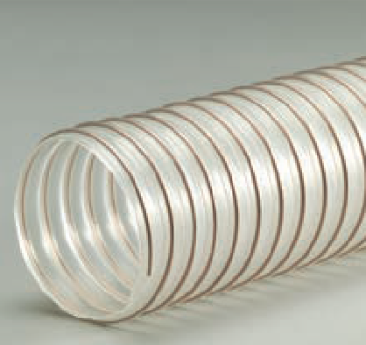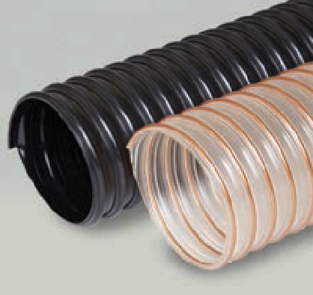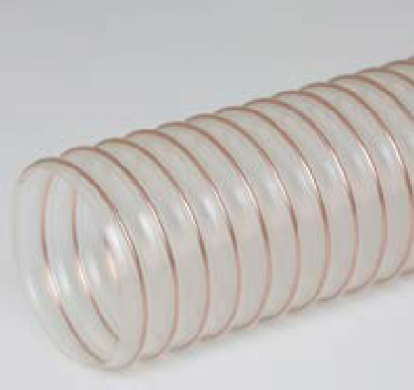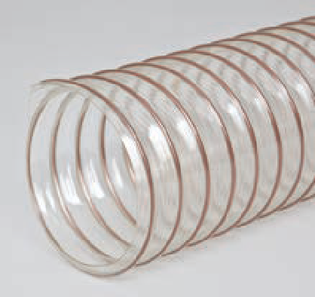Flx-Thane® SE

Size Range (In) 2" to 12"
. . . . . . . . . . . . . . . . . . . . . . . . . . . custom to 24"
Standard Length (Ft) 25', 50'
. . . . . . . . . . . . . . . . . . . 14" and above in 25' only
Standard Color clear
Temperature Range (°F) ........ -65° to 200°

D M
  - Self-extinguishing medium weight polyurethane hose reinforced with a bronze coated spring steel wire helix
  - Halogen-free
  - Good compressibility
  - Great abrasion resistance and high tear strength
  - Superior chemical resistance
  - Excellent flexibility
  - Designed for applications with wide temperature ranges
  - Good low temperature flexibility
  - Listed as UL 94V-2 flame retardant
  - Wall Thickness = .030"

FLEX-TUBE®

Flex-Tube® PV

Size Range (In) 75" to 12"
Standard Length (Ft) 12', 25'
. . . . . . . . . . .Available in 100' lengths up to 6" ID Standard Color clear with black helix
Temperature Range (°F) 20° to 160°

F D

Flex-Tube® PU

Size Range (In) 75" to 12"
Standard Length (Ft) 12', 25'
. . . . . . . . . . .Available in 100' lengths up to 6" ID Standard Color clear with yellow helix
Temperature Range (°F) ........ -40° to 200°

D M

Flex-Tube® TR

Size Range (In) 75" to 10"
Standard Length (Ft) .. 25', 50' (10" in 25' only) Standard Color black with black helix
Temperature Range (°F) ........ -60° to 275°
. . . . . . . . . . . . . . . . . . . . . . . .intermittent to 300°

F D
F D M

AIR FUME DUST MATERIAL

  - Medium weight co-extruded PVC hose with a rigid external PVC helix
  - Economical
  - Ultra smooth interior wall assures efficient airflow
  - Very flexible and crush resistant
  - Spiral co-extruded engineered construction
  - Helix acts as a wearstrip
  - Wall Thickness = .020" (.75"), .022" (1"), .024"
(1.25"), .026" (1.5" to 2"), .030" (2.5" to 3"), .032"
(4"), .035" (5" to 8"), .040" (9" to 12")
  - OEM lengths and colors available
  - Available in a flame retardant (Flex-Tube® PV-FR), static conductive (Flex-Tube® PV-SC) and static dissipative (Flex-Tube® PV SD-LW) versions
  - Cuffs and bridge clamps available

  - Medium weight co-extruded thermoplastic ether based polyurethane hose with a rigid external ABS helix
  - Ultra smooth interior assures efficient airflow
  - Great abrasion resistance
  - Excellent wear performance
  - Puncture and tear resistant, high tensile strength
  - Good low temperature flexibility
  - Crush resistant
  - Spiral co-extruded engineered construction
  - Helix acts as a wearstrip
  - Excellent hydrolysis and microbial resistance
  - Wall Thickness = .020" (.75"), .022" (1"), .025" (1.25"),
.026" (1.5"), .030" (1.75"), .032" (2" to 2.5"), .033" (3" to
5"), .035" (6" to 8"), .040" (9" to 12")
  - OEM lengths and colors available
  - Cuffs and bridge clamps available

  - Medium weight co-extruded thermoplastic rubber hose with a rigid external polypropylene helix
  - Ultra smooth interior wall assures efficient airflow
  - Very flexible and crush resistant
  - Tight bend radius
  - Moisture and chemical resistant
  - Designed for applications with wide temperature ranges
  - Spiral co-extruded engineered construction
  - Helix acts as a wearstrip
  - Wall Thickness = .020" (.75"), .022" (1"), .024" (1.25"),
.026" (1.5" to 5"), .035" (6" to 10")
  - OEM lengths and colors available
  - Available in a flame retardant version (Flex-Tube® TR-FR)
  - Cuffs and bridge clamps available

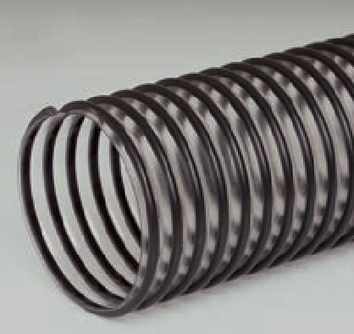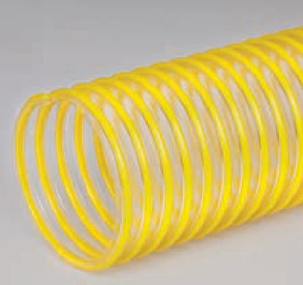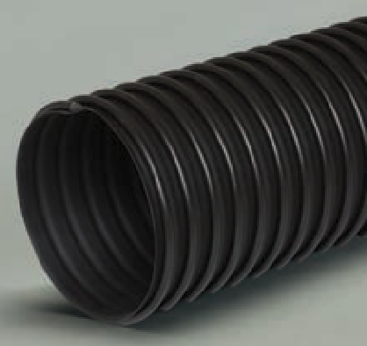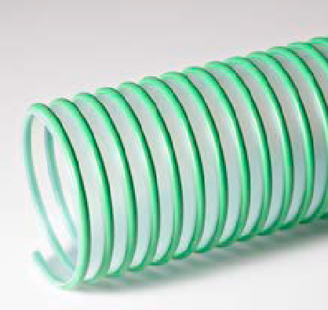Flex-Tube® EF

Size Range (In) 2.5" to 10"
Standard Length (Ft) 25', 50'
Standard Colors clear with green helix
Temperature Range (°F) .. -40° to 225°

F D
  - Medium weight co-extruded polyolefin elastomer hose with a rigid external polypropylene helix
  - Environmentally friendly PVC replacement hose
  - Ultra smooth interior assures efficient airflow
  - Spiral co-extruded engineered construction
  - Helix acts as a wearstrip
  - Good chemical and abrasion resistance
  - Low outgassing and low VOC vs. standard PVC hose
  - Available in a wire reinforced version (EF-4)
  - Available in a flame retardant version (EF-FR)
  - Wall Thickness = .028" (2.5" to 4"), .030" (5"),
.035" (6" to 10")
  - Cuffs and bridge clamps available

FLEX-TUBE®

Flex-Tube® PE

Size Range (In) 75" to 4"
Standard Length (Ft) 25', 50'
Standard Colors black with black helix
Temperature Range (°F) .. -40° to 160°

F D M

AIR FUME DUST MATERIAL

  - Light weight UV stabilized polyethylene copolymer hose with a rigid external polyethylene helix
  - Smooth interior wall assures efficient airflow
  - Very flexible and crush resistant
  - Ideal for lightweight vacuum applications
  - Helix acts as a wearstrip
  - Wall Thickness = .012"
  - Available with integral cuffs up to 12' lengths
  - OEM lengths and colors available

F

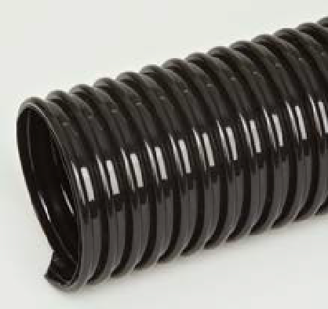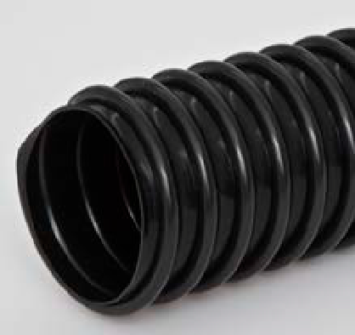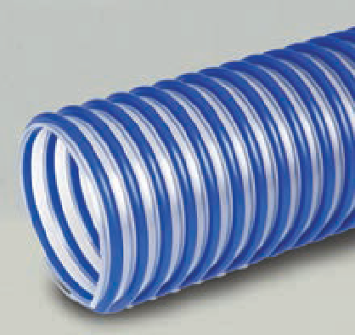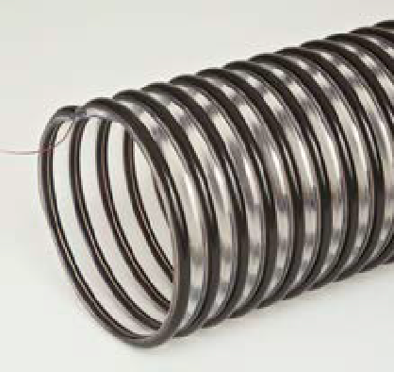Flex-Tube® PU-XT

Size Range (In) 2" to 8"
Standard Length (Ft) 12', 25'
Standard Colors black with black helix
Temperature Range (°F) .. -40° to 260°

F D

Flex-Tube® PU 60 HF

Size Range (In) 2" to 8"
. . . . . . . . . . . . . . . . . . . . . . . . . . . .custom to 12"
Standard Length (Ft) 25', 50'
Standard Color clear with blue helix
Temperature Range (°F) ........ -40° to 200°

M

Flex-Tube® PU 60 GV-GW

Size Range (In) 2" to 8"
Standard Length (Ft) 25'
Standard Colors clear with black helix
Temperature Range (°F) .. -20° to 160°

D M

  - Medium weight co-extruded thermoplastic ether based polyurethane hose with a rigid external ABS helix
  - Ultra smooth interior assures efficient airflow
  - Handles higher temperatures and offers more puncture and tear resistance with higher tensile strength than standard polyurethane hose
  - Great abrasion resistance
  - Excellent wear performance
  - Good low temperature flexibility
  - Crush resistant
  - Spiral co-extruded engineered construction
  - Helix acts as a wearstrip
  - Excellent hydrolysis and microbial resistance
  - Ideal for heat generating cutting and surface preparation applications
  - Wall Thickness = .032" (2" to 2.5"), .033" (3" to 5"), .035"
(6" to 8")
  - OEM lengths available

  - Highly flexible very heavy weight thermoplastic polyether polyurethane hose with a rigid external ABS helix
  - Ultra smooth interior assures efficient airflow
  - Highly flexible and extremely abrasion resistant
  - Excellent wear performance
  - Puncture and tear resistant with high tensile strength
  - Crush resistant
  - Spiral co-extruded engineered construction
  - Helix acts as a wearstrip
  - Excellent hydrolysis and microbial resistance
  - Wall Thickness = .055" (2" to 3"), .060" (4" to 8")
  - OEM lengths and colors available
  - Cuffs and bridge clamps available

  - Highly flexible very heavy weight polyurethane hose reinforced with a rigid external PVC helix and an embedded copper grounding wire
  - Highly flexible and extremely abrasion resistant
  - Handles high vacuum
  - Smooth interior assures minimal friction loss, efficient air flow and elimination of material build-up
  - Excellent wear performance
  - Puncture and tear resistant with high tensile strength
  - Crush resistant
  - Enclosed copper grounding wire reduces static build-up in material handling applications
  - Excellent hydrolysis and microbial resistance
  - Ideal for grain vac applications
  - Wall Thickness = .060"
  - Cuffs and bridge clamps available

FLEX-TUBE®

FlexStat®

Size Range (In) 1" to 8"
Standard Length (Ft) 25', 50'
Standard Color clear with black helix
Temperature Range (°F) ........ -40° to 200°

F D M

FlexStat® CR

Size Range (In) 1" to 8"
Standard Length (Ft) 25', 50'
Standard Color clear with white helix
Temperature Range (°F) ........ -40° to 200°

F D M
F D M

AIR FUME DUST MATERIAL

  - Specially formulated static dissipative polyurethane hose reinforced with a rigid ABS helix and an embedded copper grounding wire

S
  - Extremely flexible with great abrasion resistance vs. heavy walled PVC
  - Smooth interior assures minimal friction loss
  - Enclosed copper grounding wire reduces static build-up in material handling applications
  - Permanent and non-humidity dependent ESD (electrostatic discharge) protection
  - Surface Resistivity Level: 108-1010 Ohms/Square
  - Ideal for plastic pellet and powder transfer
  - Manufactured with FDA acceptable materials
  - Wall Thickness = .040"
  - Static conductive cuffs available

  - Specially formulated static dissipative polyurethane hose reinforced with a rigid

S
external ABS helix and an embedded copper grounding wire
  - Extremely flexible with great abrasion resistance vs. heavy walled PVC
  - Smooth interior assures minimal friction loss
  - Enclosed copper grounding wire reduces static build-up in material handling applications
  - Permanent and non-humidity dependent ESD (electrostatic discharge) protection
  - Ideal for clean room and pharmaceutical applications
  - Surface Resistivity Level: 108-1010 Ohms/Square
  - Manufactured with FDA acceptable materials
  - Wall Thickness = .040"
  - Static conductive cuffs available

FlexStat® 60

Size Range (In) 2" to 8"
Standard Length (Ft) 25', 50'
Standard Color clear with yellow helix
Temperature Range (°F) ........ -40° to 200°

D M

  - Specially formulated static dissipative polyurethane hose reinforced with a rigid external ABS helix and an embedded copper grounding wire
  - Extreme abrasion resistance and handles high vacuum

S
  - Smooth interior assures minimal friction loss
  - Enclosed copper grounding wire reduces static build-up in material handling applications
  - Permanent and non-humidity dependent ESD (electrostatic discharge) protection
  - Ideal for severe service applications, hopper loading systems and railcar loading/unloading
  - Surface Resistivity Level: 108-1010 Ohms/Square
  - Wall Thickness = .060"
  - Available in .080" wall thickness version (FlexStat® 80)
  - 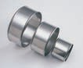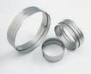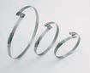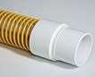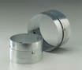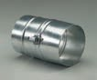Cuffs available for 4" ID

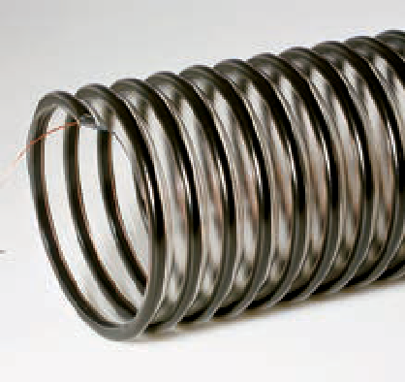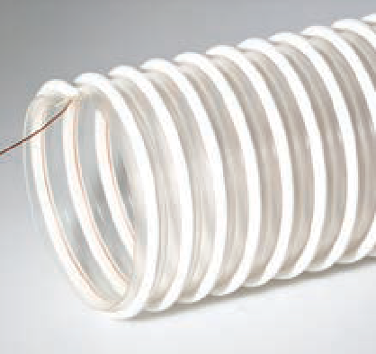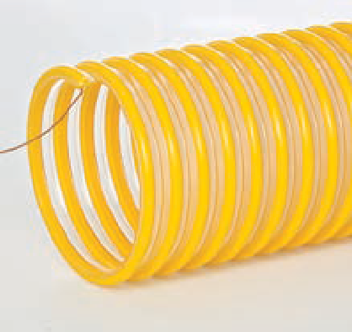
Accessories
Flex-Tube® Accessories
Also available for our Flexadux®, Flexaust®, Heat-Flex®, Flex-Lok® (excluding Screw Clamps) and Springflex® hoses.
Screw and Bridge Clamps J-Locks Connectors Pin-Locks | Latch-Locks
Swivel Cuffs

FLEXAUST ®

CWGP

    - Double-ply neoprene coated polyester fabric hose reinforced with a spring steel wire helix
    - Good crush resistance and tensile strength

F D M

AIR FUME DUST MATERIAL

Size Range (In) 1" to 24"
. . . . . . . . . . . . . . . . . . . . . . . . . . . custom to 60"
Standard Length (Ft) 25'
Standard Color black
Temperature Range (°F)......... -40° to 250°

D

CWC-W

Size Range (In) 3" to 12"
. . . . . . . . . . . . . . . . . . . . . . . . . . . custom to 60"
Standard Length (Ft) 25'
Standard Color black with yellow wearstrip
Temperature Range (°F)......... -40° to 250°
  - Neoprene coating offers excellent abrasion and chemical resistance
  - Good flexibility
  - More durable than double-ply cotton hoses
  - Listed as UL 94V-0 flame retardant
  - Additional coatings available for better abrasion and/or chemical resistance
  - Available in a static conductive version (Conduct- O-Flex)
  - Available in metric sizes, consult sales team on pricing and minimums

  - Double-ply neoprene coated polyester fabric hose reinforced with a spring steel wire helix and external PVC coated polyester wearstrip
  - Wearstrip offers additional external abrasion and drag resistance
  - Good crush resistance and tensile strength
  - Neoprene coating offers excellent abrasion and chemical resistance
  - Listed as UL 94V-0 flame retardant
  - Additional coatings available for better abrasion and/or chemical resistance

D M

CWS

Size Range (In) 1.5" to 12"
. . . . . . . . . . . . . . . . . . . . . . . . . . . custom to 20"
Standard Length (Ft) 25'
Standard Color black
Temperature Range (°F)......... -65° to 250°

F

CWY

Size Range (In) 4" to 24"
. . . . . . . . . . . . . . . . . . . . . . . . . . . .custom to 60"
Standard Length (Ft) 25'
Standard Color black
Temperature Range (°F)......... -40° to 250°

  - Single-ply neoprene coated polyester fabric hose reinforced with a spring steel wire helix
  - Recommended for light duty, low pressure applications
  - Extremely flexible
  - Neoprene coating offers excellent abrasion and chemical resistance
  - Designed for applications with wide temperature ranges
  - Listed as UL 94V-0 flame retardant
  - Additional coatings available for better abrasion and/or chemical resistance

  - Double-ply neoprene coated nylon fabric hose reinforced with a spring steel wire helix
  - Neoprene and nylon construction offers excellent abrasion resistance and superior flex life
  - Handles both positive and negative pressure
  - Excellent tensile strength
  - Available with an external PVC coated polyester wearstrip (CWY-W)
  - Additional coatings available for better abrasion and/or chemical resistance

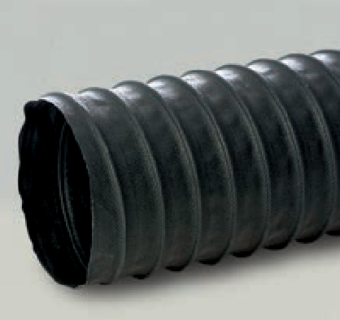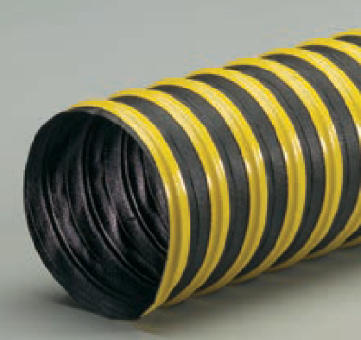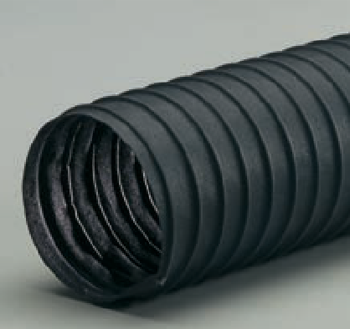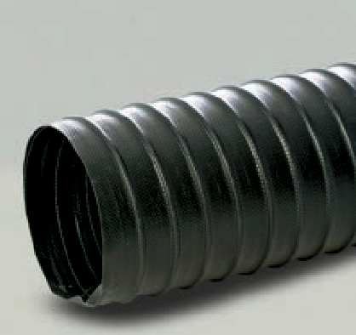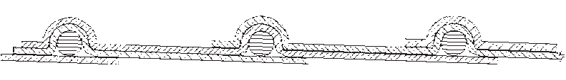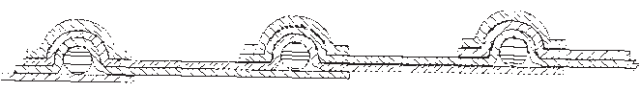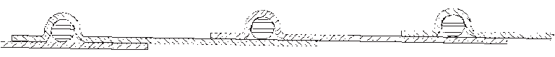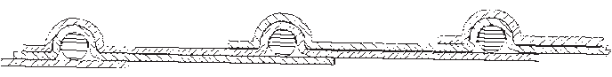

M

FLEXAUST ®

White

Size Range (In) 1.5" to 16"
. . . . . . . . . . . . . . . . . . . . . . . . . . . custom to 24"
Standard Length (Ft) 25'
Standard Color white
Temperature Range (°F) ........ -20° to 325°

F D M

AIR FUME DUST MATERIAL

  - Double-ply acrylic coated polyester fabric hose reinforced with a spring steel wire helix
  - Efficient flow characteristics
  - Designed for applications with wide temperature ranges
  - Good abrasion resistance
  - Ideal for clean room applications
  - Manufactured with FDA acceptable materials

F D M

FSP-1

Size Range (In) 3" to 12"
Standard Length (Ft) 25'
Standard Color black with orange wearstrip
Temperature Range (°F) ........ -20° to 180°

F

  - Single-ply PVC vinyl coated polyester fabric hose reinforced with a spring steel wire helix and external PVC wearstrip
  - Wearstrip offers additional external abrasion and drag resistance
  - Low friction loss
  - Great chemical and moisture resistance
  - Listed as UL 94V-0 flame retardant
  - Other wearstrip colors available
  - Available without a wearstrip for a more economical option
  - Available in metric sizes, consult sales team on pricing and minimums

FSP-2

Size Range (In) 3" to 12"
Standard Length (Ft) 25'
Standard Color black with orange wearstrip
Temperature Range (°F) ........ -20° to 180°

D

  - Double-ply PVC vinyl coated polyester fabric hose reinforced with a spring steel wire helix and external PVC wearstrip
  - Wearstrip offers additional external abrasion and drag resistance
  - Great moisture, mildew and chemical resistance
  - Low friction loss
  - Listed as UL 94V-0 flame retardant
  - Other wearstrip colors available
  - Available in a heavy duty bridge construction in sizes 12" to 24" (FSP Bridge)

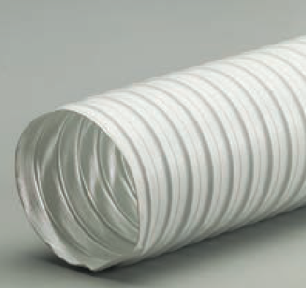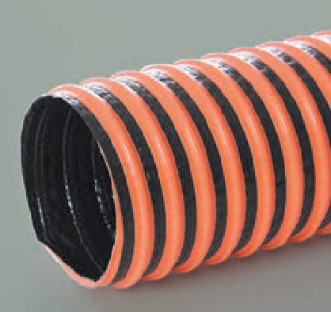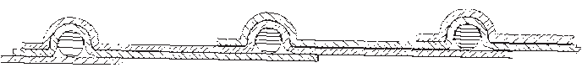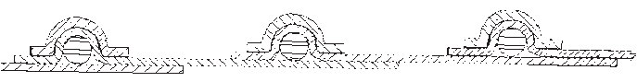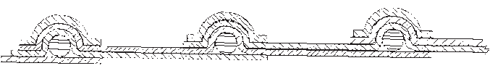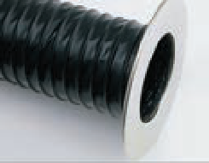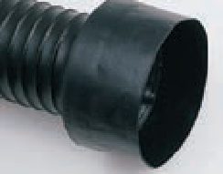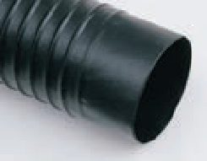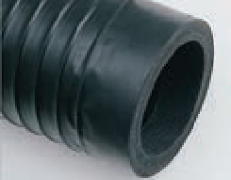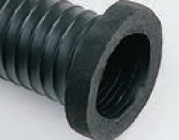
Accessories
Flexaust® End Finishes
Also available for our Heat-Flex® (excluding Reduced Cuff and Felt Flange) and Springflex® hoses.

Enlarged Cuff
Steel Flange
Fabric Cuff
Reduced Cuff
Felt Flange

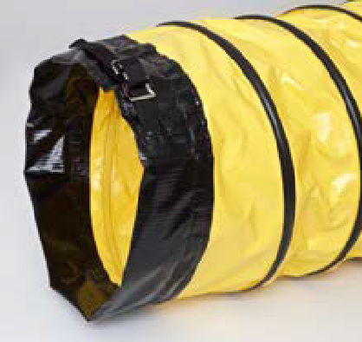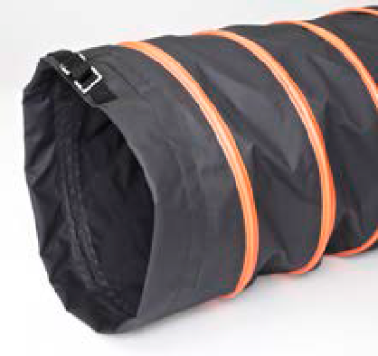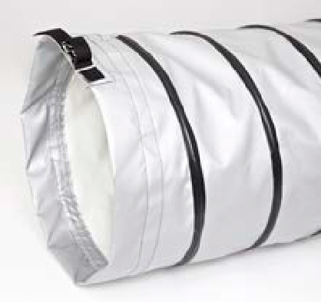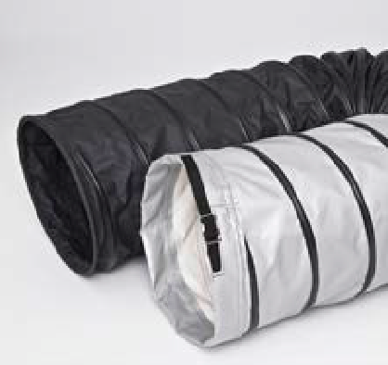SPRINGFLEX ®

FX-180

Size Range (In) 12" to 24"
Standard Length (Ft) 25'
Standard Colors yellow with black wearstrip
Temperature Range (°F) .. -20° to 180°

FX-400

Size Range (In) 12" to 24"
Standard Length (Ft) 25'
Standard Colors black with orange wearstrip
Temperature Range (°F) .. -60° to 400°

FX-550

Size Range (In) 12" to 24"
Standard Length (Ft) 25'
Standard Colors silver with black wearstrip
Temperature Range (°F) .. -50° to 550°

FX-Combo

Size Range (In) 12" to 24"
Standard Length (Ft) Customized lengths of
FX-400 and FX-550 combined (25' total length)
Standard Colors black with black wearstrip
and silver with black wearstrip
Temperature Range (°F) .. -60° to 550°

F D M

AIR FUME DUST MATERIAL

  - High strength sewn single-ply PVC vinyl coated polyester fabric hose reinforced with a spring steel wire helix and external PVC wearstrip
  - Sewn construction allows for better performance in lower and higher temperatures
  - Light weight duct designed for dehumidification applications
  - Wearstrip offers additional external abrasion and drag resistance
  - Moisture resistant and UV stabilized to prevent mold and mildew
  - Flame retardant to UL 94V-0
  - Also available in white with white wearstrip

  - High strength sewn single-ply polyurethane coated polyester fabric hose reinforced with a spring steel wire helix and external PVC wearstrip
  - Sewn construction allows for better performance in lower and higher temperatures
  - Light weight duct designed for portable/ temporary heating and dehumidification applications
  - Safety orange wearstrip offers additional external abrasion and drag resistance
  - Moisture resistant and UV stabilized to prevent mold and mildew
  - Polyurethane coating increases puncture, abrasion and tear resistance
  - Great chemical, fuel and oil resistance
  - Flame retardant to ASTMD6413

  - High strength sewn single-ply heavy duty silicone coated fiberglass fabric hose reinforced with a spring steel wire helix and external wearstrip
  - Sewn construction allows for better performance in lower and higher temperatures
  - Light weight duct designed for higher temperature portable/temporary heating and dehumidification applications
  - Flexible heater ducting able to withstand higher temperatures and maintain flexibility in cold weather conditions
  - Wearstrip offers additional external abrasion and drag resistance
  - Moisture resistant and UV stabilized to prevent mold and mildew
  - Great puncture resistance and high tear strength
  - Flame retardant to UL 94V-0

  - Sewn construction allows for better performance in low and higher temperatures
  - Combination ducting (FX-400 and FX-550) is an economical way to manage high heat
  - Excellent for open/direct heating units
  - Combo ducting allows for direct preheated air to be delivered to various shelters and workplaces

SPRINGFLEX ®

FSP-5

Size Range (In) 4" to 24"
. . . . . . . . . . . . . . . . . . . . . . . . . . . custom to 48"
Standard Length (Ft) 25'
Standard Color yellow with black wearstrip
Temperature Range (°F) ........ -20° to 180°

SD-W

Size Range (In) 4" to 24"
. . . . . . . . . . . . . . . . . . . . . . . . . . . custom to 60"
Standard Length (Ft) 25'
Standard Color yellow with black wearstrip
Temperature Range (°F) ........ -65° to 250°

SD

Size Range (In) 4" to 24"
. . . . . . . . . . . . . . . . . . . . . . . . . . . custom to 60"
Standard Length (Ft) 25'
Standard Color yellow
Temperature Range (°F) ........ -65° to 250°

F D M

AIR FUME DUST MATERIAL

  - Single-ply PVC vinyl coated polyester fabric hose reinforced with a spring steel wire helix and external PVC wearstrip
  - Lightweight duct for blower applications
  - Great compressibility with an 11:1 compressibility ratio
  - Retractability allows for convenient storage and easy transport in a fraction of its fully extended length
  - Wearstrip offers additional external abrasion and drag resistance
  - Listed as UL 94V-0 flame retardant
  - Manufactured with materials that meet NFPA 701 standards
  - Available in static conductive version (FSP-5 SC)
  - Shown with optional cuff

  - Single-ply neoprene coated polyester fabric hose reinforced with a spring steel wire helix and external PVC wearstrip
  - Ideal for moving large volumes of air in portable or permanent ventilation/exhaust systems
  - Wearstrip offers additional external abrasion and drag resistance
  - Great compressibility
  - Retractability allows for convenient storage and easy transport in a fraction of its fully extended length
  - Listed as UL 94V-0 flame retardant
  - Available in a self-retracting version (STO), 4" to 8" only
  - Shown with optional cuff

  - Single-ply neoprene coated polyester fabric hose reinforced with a spring steel wire helix
  - Ideal for moving large volumes of air in portable or permanent ventilation/exhaust systems
  - Great compressibility
  - Retractability allows for convenient storage and easy transport in a fraction of its fully extended length
  - Listed as UL 94V-0 flame retardant
  - Shown with optional cuff

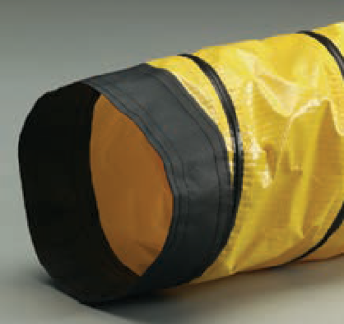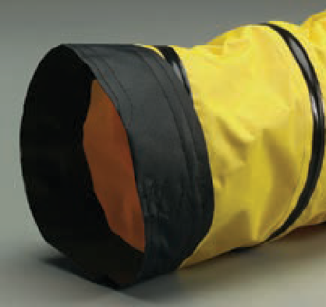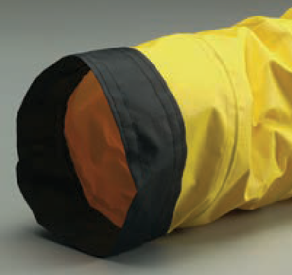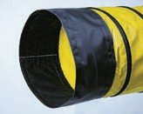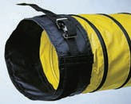

Accessories

Springflex® End Finishes
Flexaust® offers a variety of end finishes including several types of fabric cuffs for the Springflex® product line. Assembling hoses with various types of required end finishes is another way in which Flexaust® services its customers and reduces costs.

Sewn Cuff Standard/Enclosed Belted Cuff

SPRINGFLEX ®

AWP-W

Size Range (In) 8" to 24"
. . . . . . . . . . . . . . . . . . . . . . . . . . . custom to 48"
Standard Length (Ft) 25'
Standard Color yellow with black wearstrip
Temperature Range (°F) ........ -20° to 325°

Arctic Duct 3

Size Range (In) 4" to 24"
Standard Length (Ft) 25'
Standard Color yellow with black wearstrip
Temperature Range (°F)......... -20° to 180°

F D M

AIR FUME DUST MATERIAL

  - Single-ply acrylic coated polyester fabric hose reinforced with a spring steel wire helix and external PVC wearstrip
  - Ideal for moving large volumes of air in portable or permanent ventilation/exhaust systems
  - Wearstrip offers additional external abrasion and drag resistance
  - Great compressibility
  - Retractability allows for convenient storage and easy transport in a fraction of its fully extended length
  - Listed as UL 94V-0 flame retardant
  - Shown with optional cuff

  - Two single-ply PVC vinyl coated polyester fabric plies protecting an insulation barrier reinforced with a spring steel wire helix and external PVC wearstrip
  - Insulation; 1-inch fiberglass insulation (R-Value=4)
  - Ideal use for both permanent and mobile air conditioning applications
  - PVC material resists ozone, UV rays and moisture
  - Compressibility allows for convenient storage
  - Wearstrip offers additional external abrasion and drag resistance
  - Other Arctic Duct constructions available
  - Manufactured with flame retardant materials
  - Made with sewn cuff on each end

Arctic Duct U

Size Range (In) 4" to 20"
. . . . . . . . . . . . . . . . . . . . . . . . . . . custom to 48"
Standard Length (Ft) made to order
Standard Color yellow with black wearstrip
Temperature Range (°F) ........ -40° to 250°

  - Two single-ply neoprene coated polyester fabric plies protecting an insulation barrier reinforced with a spring steel wire helix and external PVC coated polyester wearstrip
  - Insulation; 1-inch fiberglass insulation (R-Value=4)
  - Good for air handling applications
  - High tensile strength
  - Wearstrip offers additional external abrasion and drag resistance
  - Compressibility allows for convenient storage
  - Designed for applications with wide temperature ranges
  - Manufactured with flame retardant materials
  - Made with sewn cuff on each end

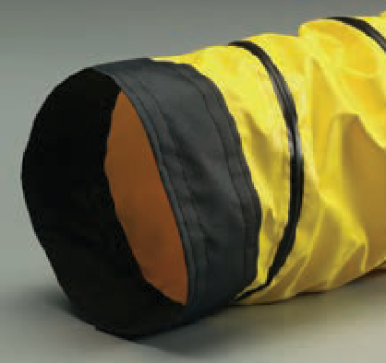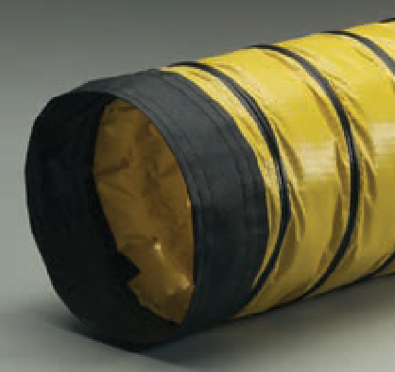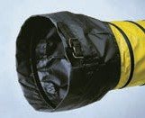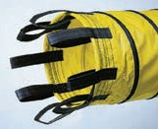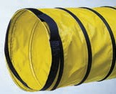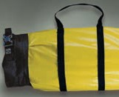Funnel Cuff
Belt Loop and Pull Tabs
Wire Rope/Nylon Ring Sto-Sack®

HEAT-FLEX ®

GS

Size Range (In) 75" to 12"
Standard Length (Ft) 12'
Standard Color iron oxide red
Temperature Range (°F) ........ -65° to 550°
. . . . . . . . . . . . . . . . . . . . . . . .intermittent to 600°

F

CWGS

Size Range (In) 2" to 12"
Standard Length (Ft) 25'
Standard Color iron oxide red
Temperature Range (°F) ........ -65° to 550°
F D M

AIR FUME DUST MATERIAL

  - Double-ply silicone coated fiberglass fabric hose reinforced with a spring steel wire helix and external filament fiberglass cord
  - Suited for high temperature air handling applications
  - The narrow pitch allows for tight bending radius while maintaining a smooth air flow
  - Ideal for plastic processing applications
  - Non-kinking
  - Resistant to many oils and solvents, ozone, water, fungus and alkalis
  - Not recommended for continuous flexing

  - Single-ply silicone coated fiberglass fabric hose reinforced with a spring steel wire helix
  - Light weight and flexible
  - Available in longer lengths than traditional mandrel-built hose
  - Resistant to many oils and solvents, ozone, water, fungus and alkalis
  - Not recommended for continuous flexing

F

BDS

Size Range (In) 1" to 10"
. . . . . . . . . . . . . . . . . . . . . . . . . . . .custom to 12"
Standard Length (Ft) 12'
Standard Color iron oxide red
Temperature Range (°F) ........ -65° to 500°

  - Single-ply silicone coated fiberglass fabric hose reinforced with a spring steel wire helix and external filament fiberglass cord
  - Suited for high temperature air handling applications
  - The narrow pitch allows for tight bending radius while maintaining a smooth air flow
  - Non-kinking
  - Resistant to many oils and solvents, ozone, water, fungus and alkalis
  - Not recommended for continuous flexing

F

CW-325

Size Range (In) 2" to 10"
. . . . . . . . . . . . . . . . . . . . . . . . . . . custom to 16"
Standard Length (Ft) 25'
Standard Color black
Temperature Range (°F) ........ -20° to 325°

  - Single-ply acrylic coated polyester fabric hose reinforced with a spring steel wire helix
  - Ideal for air and fume handling applications
  - Excellent choice for overhead vehicle exhaust systems
  - Light weight and flexible
  - Listed as UL 94V-0 flame retardant
  - Available with an external PVC wearstrip (CW-325-W)

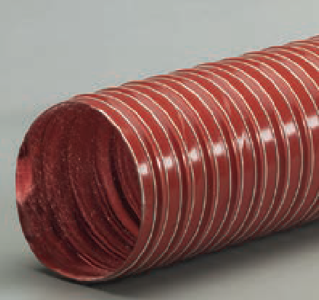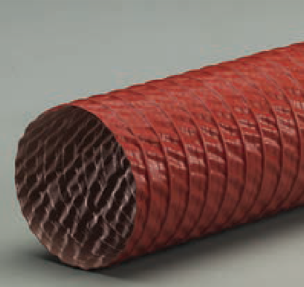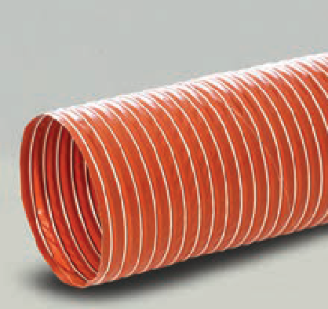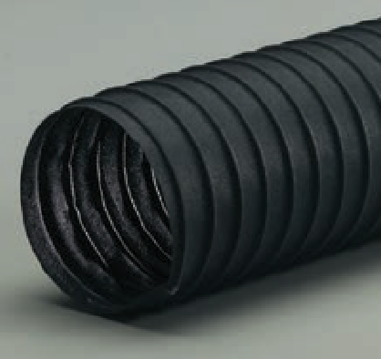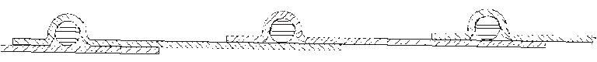

F

HEAT-FLEX ®

NS

Size Range (In) 1" to 12"
Standard Length (Ft) 12'
Standard Color iron oxide red inner layer
black outer layer Temperature Range (°F) ........ -65° to 550°

F

GN

Size Range (In) 1" to 12"
Standard Length (Ft) 12'
Standard Color black
Temperature Range (°F) ........ -40° to 300°

F D M

AIR FUME DUST MATERIAL

  - Double-ply fabric hose with a silicone coated fiberglass inner layer and a silicone coated Nomex® outer layer reinforced with a spring steel wire helix and external filament fiberglass cord
  - Nomex® material increases flex life and abrasion resistance
  - Suited for high temperature air handling applications
  - The narrow pitch allows for tight bending radius while maintaining a smooth air flow
  - Ideal for applications where constant flexing is involved
  - Non-kinking
  - Resistant to many oils and solvents, ozone, water, fungus and alkalis

  - Double-ply neoprene coated fiberglass fabric hose reinforced with a spring steel wire helix and external filament fiberglass cord
  - Offers higher temperature characteristics than traditional neoprene hoses
  - The narrow pitch allows for tight bending radius while maintaining a smooth air flow
  - Flame retardant to UL 94V-0
  - Non-kinking
  - Not recommended for continuous flexing

F

Flex-Vest®

Size Range (In) 1" to 6"
. . . . . . . . . . . . . . . . . . . . . . . . . . . . custom to 8"
Standard Length (Ft) 12'
. . . . . . . . . . . . . . . . . . . . . . . . . . . . custom to 25'
Standard Color iron oxide red inner layer
black outer layer
Temperature Range (°F) -65° to 550° inner layer
intermittent to 600°
-40° to 250° outer layer

Raceflex®

Size Range (In) 1.5" to 3"
. . . . . . . . . . . . . . . . . . . . . . . . . . . . custom to 8"
Standard Length (Ft) 12'
Standard Color silver
Temperature Range (°F) ........ -65° to 625°

  - Inner Layer; Double-ply silicone coated fiberglass fabric hose reinforced with a spring steel wire helix
  - Outer layer; Single-ply neoprene coated polyester fabric hose reinforced with a spring steel wire helix
  - Insulation; 1-inch fiberglass insulation (R Value = 4)
  - Insulated dryer hose
  - Combines flexibility with minimal heat loss
  - Suited for air handling applications at low positive and low negative pressures
  - Good flexibility
  - Excellent chemical resistance

  - Light weight laminate of fiberglass and vacuum metallized polyester film
  - Heat reflective to 625°F
  - Light weight and flexible
  - Smooth bend radius
  - 2.64-inch compression per foot of hose
  - Designed for brake ducting and ventilation of drive compartments in racecars

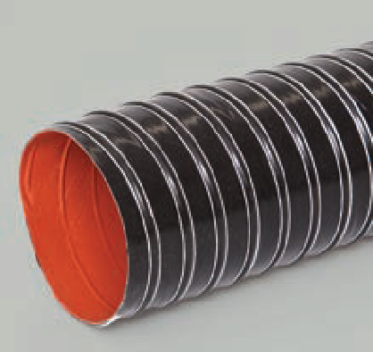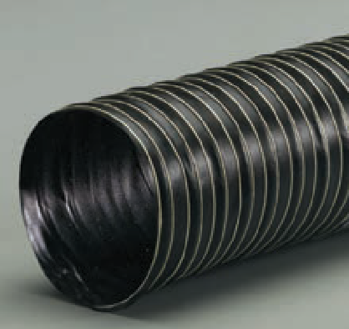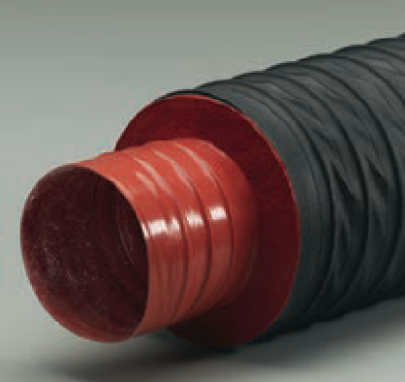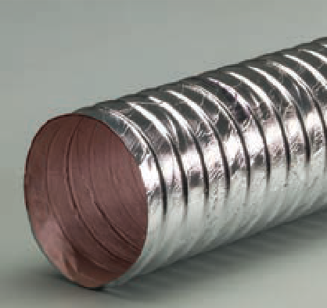

F

GENESIS®

STM

Size Range (In) 1.5", 2"
Standard Length (Ft) 25', 50'
Standard Colors orange, blue
Temperature Range (°F) ........ -40° to 160°

M

Commercial

Size Range (In) 1.25", 1.5", 2", 2.5", 3", 4"
Standard Length (Ft) 25', 50'
Standard Colors gray, black
Temperature Range (°F) ........ -40° to 140°

M

Flx Plus

Size Range (In) 1", 1.25", 1.5", 2"
. . . . . . . . . . . . . . . . . . . . . . . . . . . . . . . . 2.5", 3"
Standard Length (Ft) 25', 50'
Standard Color gray
Temperature Range (°F) ........ -40° to 140°

M
F D M

AIR FUME DUST MATERIAL

  - Polyethylene copolymer hose reinforced with an integral polyethylene helix
  - Double profile I-Helix construction for easy movement on surfaces
  - Ideal for both truck-mounted and portable carpet cleaning units
  - Very flexible
  - Superior abrasion resistance
  - Crush resistant
  - Designed to resist corrosion caused by the combination of hot water and chemical concentration of detergents
  - All sizes handle a full vacuum
  - Smooth interior assures efficient air flow
  - Made with factory-installed polyweld cuffs

  - Polyethylene copolymer hose reinforced with an integral polyethylene helix
  - Double profile I-Helix construction for easy movement on surfaces
  - For industrial and commercial vacuum applications
  - Crush resistant
  - Excellent flexing characteristics
  - Superior abrasion resistance
  - Smooth interior assures efficient air flow
  - Available in high temperature version (CHT)
  - All sizes handle a full vacuum
  - Cuffs available

  - Polyethylene copolymer hose reinforced with an integral polyethylene helix
  - Light weight and flexible even at low temperatures
  - Tight bending characteristics
  - High abrasion resistance
  - Wet or dry vacuum in car wash, commercial and industrial applications
  - Crush resistant
  - Smooth interior assures efficient air flow
  - Very good chemical resistance
  - Cuffs available

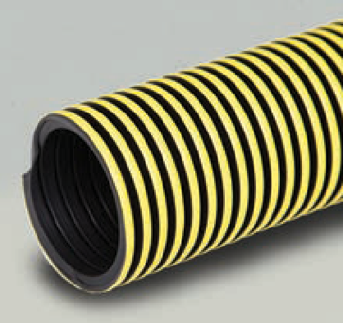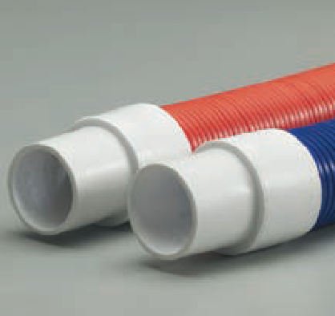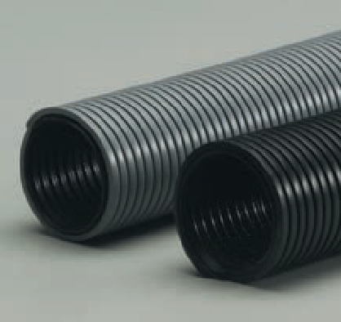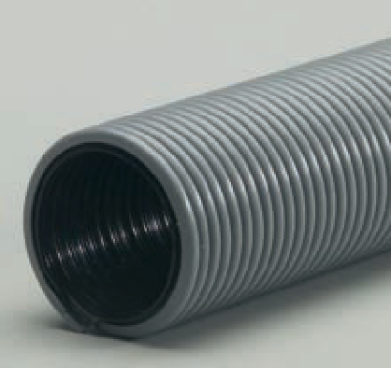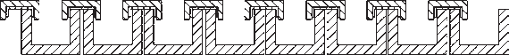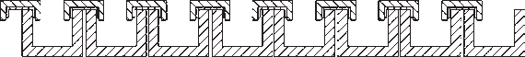StatPath® Plus

Size Range (In) 1", 1.25", 1.5", 2"
Standard Length (Ft) 25', 50'
Standard Color black with yellow skimcoat
Temperature Range (°F) ........ -40° to 140°

M

  - Light weight polyethylene conductive copolymer hose with a non-marking skimcoat reinforced with an integral polyethylene helix
  - Conductive

S
  - Surface Resistivity Level: 103-105 Ohms/Square
  - Smooth interior assures efficient air flow
  - Ideal for industrial vacuum and light bulk material applications where static may be an issue
  - Superior external abrasion resistance
  - Crush resistant
  - Conductive cuffs and custom colors available
  - Available without skimcoat (StatPath®)

GENESIS®

Uni-Loop

    - Light weight polyethylene copolymer hose reinforced with an integral polyethylene helix
    - Smooth interior assures efficient air flow
    - Superior external abrasion resistance

F D M

AIR FUME DUST MATERIAL

Size Range (In) 1", 1.25" , 1.5", 2"
Standard Length (Ft) 25', 50'
Standard Color gray
Temperature Range (°F) ........ -40° to 140°

M
  - Good flexibility with tight bending characteristics
  - Crush resistant
  - Ideal for use in light weight vacuum applications and as a drain hose
  - Suitable for conduit for wiring
  - Meets IAPMO compliance
  - Cuffs available
  - Available in a high temperature version (Uni-Loop HT)

ULT

Size Range (In) 1", 1.25", 1.5", 2"
Standard Length (Ft) 25', 50'
Standard Color platinum
Temperature Range (°F) ........ -40° to 140°

M

DPZ

Size Range (In) 1.25", 1.5", 2"
Standard Length (Ft) 25', 50'
Standard Color gray
Temperature Range (°F) ........ -40° to 140°

M
Industrial Shop Vacuum Clean-Up Kits
- 1.5" x 12' Flx Plus (orange)
- 1.5" Swivel Cuff
- 2.25" Adapter
- 4" Utility Tool
- 11" Crevice Tool
Commercial MRO General Pick-Up Kit
- 1.5" x 15' StatPath® Plus (blue)
- 1.5" Swivel Cuff
- 2.25" Adapter
- 4" Utility Tool
- 11" Crevice Tool
Industrial MRO General Pick-Up Kit

  - Light weight premium grade polyethylene copolymer hose reinforced with an integral polyethylene helix
  - Smooth interior assures very efficient air flow
  - Superior external abrasion resistance
  - Great flex life for long lasting hose life in applications
  - Crush resistant
  - Ideal for use in light weight vacuum applications and as a drain hose
  - Very durable and flexible in hot and cold applications – meets ASTM 595
  - Withstands severe twisting with nearly 100% bounce-back
  - Cuffs available

  - Light weight polyethylene copolymer hose reinforced with an integral polyethylene helix
  - Smooth interior assures efficient air flow
  - Light weight and flexible even at low temperatures
  - Superior external abrasion resistance
  - Ideal for wet/dry vacuum in car wash, commercial and industrial applications
  - Very good chemical resistance
  - Crush resistant
  - Cuffs and custom colors available

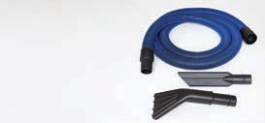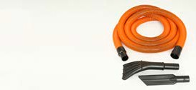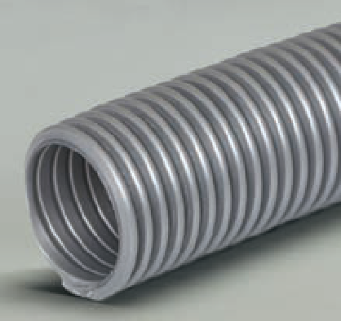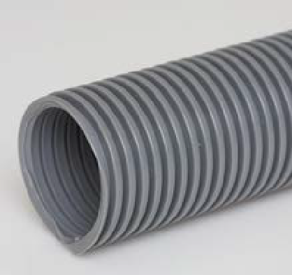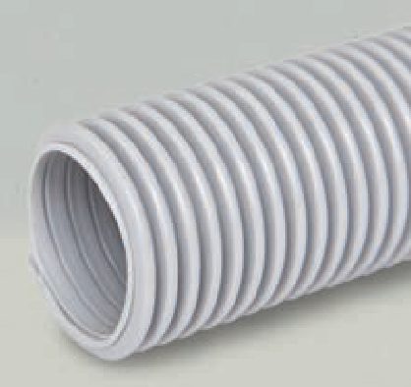

Clean-up kits offer a turnkey solution for general industrial clean- up needs. Flexaust® offers a variety of kit solutions depending on your cleaning environment.
Clean-up kits can also be customized to your specifications and needs. Please consult with inside sales.

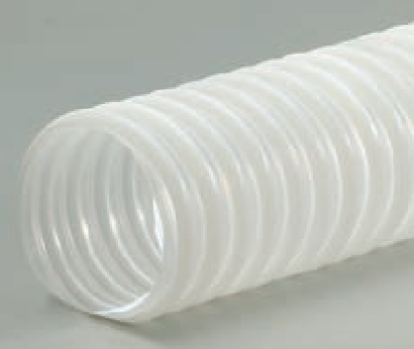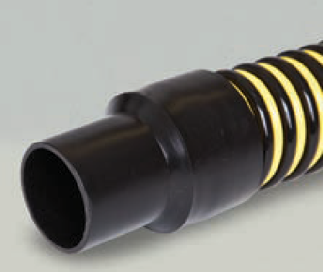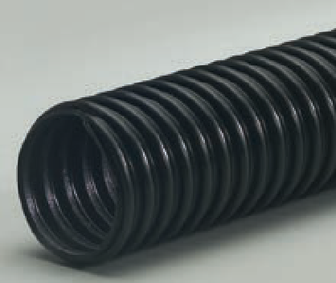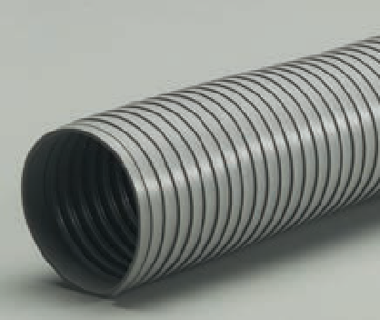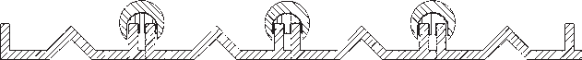GENESIS®

Mark 2®

Size Range (In) 1.5", 2", 2.5", 3", 3.5", 4"
Standard Length (Ft) 25', 50'
Standard Color clear
Temperature Range (°F) ........ -40° to 140°

M

Tiger Tail®

Size Range (In) 1.5", 2", 3", 4"
Standard Length (Ft) 25', 50'
Standard Color yellow and black
Temperature Range (°F) ........ -40° to 140°

M

GPE

Size Range (In) 2", 2.5", 3", 4"
Standard Length (Ft) 25', 50'
Standard Color black
Temperature Range (°F) ........ -40° to 140°

F

DAYFLEX®

Pliaduct®

Inside Diameter (In) 2" to 8"
. . . . . . . . . . . . . . . . . . . . . . . . . . . .custom to 12"
Standard Length (Ft) 25' (2"-6"), 10' (8"-12")
Standard Color gray
Temperature Range (°F) ........ -10° to 150°

F
F D M

AIR FUME DUST MATERIAL

  - Medium weight polyethylene hose reinforced with a translucent integral polyethylene helix
  - Ideal for insulation blowing applications
  - Easy to handle
  - Translucent walls offer easy monitoring of material flow and blockage
  - Convoluted interior design creates efficient air flow that aerates insulation materials and increases machine efficiency with regard to coverage and density
  - Crush resistant
  - Manufactured with FDA acceptable materials
  - Available with different color helixes to match OEM equipment

  - Rugged polyethylene copolymer hose reinforced with an integral polyethylene helix
  - Improved polymer formula and 25% thicker to extend life
  - Double helix design allows for superior flexibility and durability
  - Ideal for waste evacuation, septic pumping and sewer cleaning
  - Superior abrasion, better crush resistance and resists kinking
  - All sizes handle a full vacuum
  - Made with factory-installed leak proof polyweld cuffs
  - Threaded replacement screw cuffs and specially formulated replacement hose glue available

  - Light weight polyethylene hose reinforced with an integral polyethylene helix
  - Suited for low pressure air movement and fume extraction
  - Excellent for light vacuum applications
  - Light weight and very flexible
  - Economical choice for woodworking and dust collection applications
  - Moderate abrasion resistance
  - Crush resistant

 | F | D | M
AIR | FUME | DUST | MATERIAL

  - 100% rigid self-supporting PVC material with a ribbon-lock construction
  - Diameter is adjustable by hand and can be reduced or expanded by approximately 25% of original I.D.
  - Chemical resistant
  - May be shaped and reshaped and spliced together without special tools
  - Excellent for either temporary or permanent installation
  - Manufactured with flame retardant materials

DAYFLEX®

MG-V

Size Range (In) 75" to 2"
Standard Length (Ft) 50'
Standard Color gray
Temperature Range (°F) ........ -10° to 160°

F D M

AIR FUME DUST MATERIAL

  - PVC hose reinforced with a vinyl coated spring steel wire helix
  - Light weight and flexible
  - Good chemical resistance
  - Popular choice for floor care industry and general industrial vacuum applications
  - Cuffs available
  - Other colors available
  - Available in a stretch version (MG-S)

F D M

MG-U

Size Range (In) 75" to 2"
Standard Length (Ft) 50'
Standard Color black
Temperature Range (°F) ........ -60° to 160°

  - Elastomer polyurethane hose reinforced with a vinyl coated spring steel wire helix
  - Light weight and flexible
  - Good chemical resistance
  - Excellent abrasion resistance
  - Cuffs available
  - Other colors available

F D M

Saniflex®

Size Range (In) 75" to 2"
Standard Length (Ft) 50'
Standard Color natural
Temperature Range (°F) ......... -20° to 180°

  - Plastic helix supported PVC tape hose
  - Very smooth inner surface assures minimal friction loss and efficient air flow
  - Light weight and flexible
  - Can also be compounded in polyurethane and thermoplastic rubber elastomer materials
  - Ideal as a potable water hose in RV applications
  - Meets IAPMO compliance

M

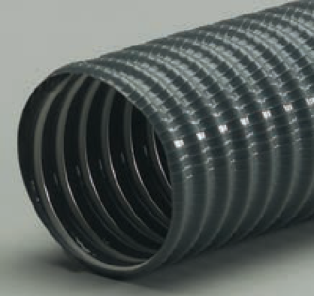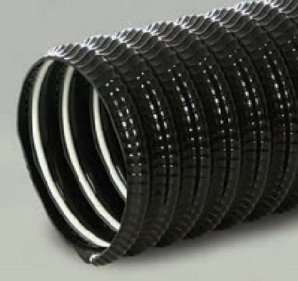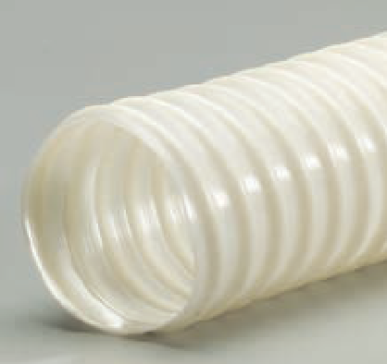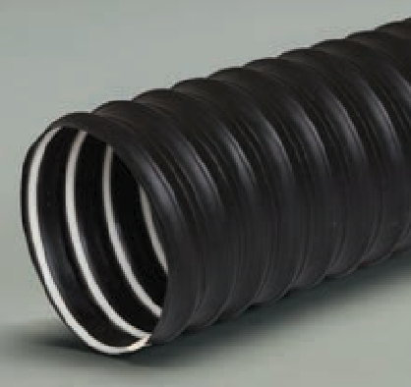DFD-T

Size Range (In) 1" to 4"
Standard Length (Ft) 25', 50'
Standard Color black
Temperature Range (°F) ........ -40° to 225°

  - Light weight thermoplastic rubber hose reinforced with an internal polypropylene helix
  - Pliable helix can be formed to fit various applications
  - Flexible, crush resistant and compressible
  - Meets FMVSS 302 flame standards
  - Great choice for heater/defroster and ventilation applications
  - Can also be manufactured with PVC materials

CUFFS and CONNECTORS
AIR
F
FUME
D
DUST
M
MATERIAL

Accessories and End Finishes for Flexaust® Vacuum Hose Product Line

Commercial Flx Plus Uni-Loop ULT DPZ StatPath® StatPath® Plus MG-V MG-U FlexStat®
Standard Screw Cuffs
Screw Cuff .75" Gray 075EW |  |  |  |  |  |  |  | ● | ●
Screw Cuff 1" Gray 03100754 |  |  |  |  |  |  |  | ● | ●
Screw Cuff 1" Gray 100EW |  |  |  |  |  |  |  | ● | ●
Screw Cuff 1" Black 100EB |  |  | ●
Screw Cuff 1.25" Gray 03100201 | ● | ● | ● | ● | ●
Screw Cuff 1.25" Gray 125E |  | ● | ● | ● | ●
Screw Cuff 1.25" Gray 03100755 |  |  |  |  |  |  |  | ● | ●
Screw Cuff 1.25" Gray 125EW |  |  |  |  |  |  |  | ● | ●
Screw Cuff 1.25" Black 125EWBK |  |  |  |  |  |  |  | ● | ●
Screw Cuff 1.25" Black 03100202 | ● | ● | ● | ● | ●
Screw Cuff 1.5" Gray 03100900 | ● | ● | ● | ● | ●
Screw Cuff 1.5" Gray 150EF |  |  | ● |  | ●
Screw Cuff 1.5" Gray 03100469 |  |  |  |  |  |  |  | ● | ●
Screw Cuff 1.5" Gray 150EW |  |  |  |  |  |  |  | ● | ●
Screw Cuff 1.5" Black 03100901 | ● | ● | ● | ● | ●
Screw Cuff 1.5" Black 150EFBK |  |  | ● |  | ●
Screw Cuff 1.5" Gray 150EO | ● | ●
Screw Cuff 1.5" Black 150EOBK | ● | ●
Screw Cuff 1.5" Black 150EWBK78 |  |  |  |  |  |  |  | ● | ●
Screw Cuff 1.5" White 03100902 | ● | ● | ● | ● | ●
Screw Cuff 1.5" White 150EWH |  |  |  |  |  |  |  | ● | ●
Screw Cuff 2" Gray 03100380 | ● | ● | ● | ●
Screw Cuff 2" Gray 03100384 |  |  |  |  | ●
Screw Cuff 2" Gray 03100615 |  |  |  |  |  |  |  | ● | ●
Screw Cuff 2" Black 03100381 | ● | ● | ● | ●
Screw Cuff 2" White 03100383 | ● | ● | ● | ●
Screw Cuff 2.5" Gray 03100800 | ●
Screw Cuff 3" Gray 03100801 | ●
Screw Cuff 4" Gray 03100802 | ●
Conductive Screw Cuffs
Conductive Screw Cuff 1" Black 100EBSC |  |  |  |  |  | ● | ●
Conductive Screw Cuff 1.25" Black 03100207 |  |  |  |  |  | ● | ●
Conductive Screw Cuff 1.25" Black 125EBKSC |  |  |  |  |  | ● | ●
Conductive Screw Cuff 1.25" Black GC1201 |  |  |  |  |  |  |  |  |  | ●
Conductive Screw Cuff 1.5" Black 03100907 |  |  |  |  |  | ●
Conductive Screw Cuff 1.5" Black 03100797 |  |  |  |  |  |  |  |  |  | ●
Conductive Screw Cuff 1.5" Black 150EFBKSC |  |  |  |  |  | ● | ●
Conductive Screw Cuff 2" Black 03100387 |  |  |  |  |  | ● | ●
Conductive Screw Cuff 2" Black 03100798 |  |  |  |  |  |  |  |  |  | ●
Conductive Screw Cuff 2" Black 200EBKSC |  |  |  |  |  | ● | ●
Enlarger Screw Cuffs
Enlarger Screw Cuff 1" to 1.5" Black 10015EB |  |  | ●
Enlarger Screw Cuff 1.25" to 1.5" Gray 12515E |  | ● | ● | ● | ●

CUFFS and CONNECTORS
AIR
F
FUME
D
DUST
M
MATERIAL

Commercial Flx Plus Uni-Loop ULT DPZ StatPath® StatPath® Plus MG-V MG-U FlexStat®
Enlarger Screw Cuff 1.25" to 1.5" Gray 12515EW |  |  |  |  |  |  |  | ● | ●
Enlarger Screw Cuff 1.25" to 1.5" Black 12515EWBK |  |  |  |  |  |  |  | ● | ●
Enlarger Screw Cuff 1.5" to 1.75" Gray 150ESU |  |  | ● | ● | ●
Enlarger Screw Cuff 1.5" to 2" Gray 03100280 | ● | ● | ● | ● | ●
Enlarger Screw Cuff 1.5" to 2" Gray 15200EW |  |  |  |  |  |  |  | ● | ●
Enlarger Screw Cuff 1.5" to 2" Black 15200EBK |  | ● | ● | ● | ●
Conductive Enlarger Screw Cuffs
Conductive Enlarger Screw Cuff 1" to 1.25" Black 10012EBKSC |  |  |  |  |  | ● | ●
Conductive Enlarger Screw Cuff 1.25" to 1.5" Black 12515EBKSC |  |  |  |  |  | ● | ●
Conductive Enlarger Screw Cuff 1.5" to 2" Black 15200EBKSC |  |  |  |  |  | ● | ●
Reducer Screw Cuffs
Reducer Screw Cuff 1.5" to 1.25" Gray 15125E |  | ● | ● | ● | ●
Reducer Screw Cuff 1.5" to 1.25" Gray 15125EW |  |  |  |  |  |  |  | ● | ●
Reducer Screw Cuff 1.5" to 1.25" Black 15125EBK |  | ● | ● | ● | ●
Reducer Screw Cuff 2" to 1.5" Gray 03100400 | ● | ● | ● | ●
Standard Swivel Cuffs
Swivel Cuff 1.25" Gray 03100430 | ● | ● | ● | ● | ●
Swivel Cuff 1.25" Black 125ESBK |  | ● | ● | ● | ●
Swivel Cuff 1.25" Black 125ESWBK |  |  |  |  |  |  |  | ● | ●
Swivel Cuff 1.5" Gray 03100440 | ● | ● | ● | ● | ●
Swivel Cuff 1.5" Gray 150ESF |  | ● | ● | ● | ●
Swivel Cuff 1.5" Black 150ESFBK |  | ● | ● | ● | ●
Swivel Cuff 1.5" Black 150ESWBK |  |  |  |  |  |  |  | ● | ●
Swivel Cuff 2" Gray 03100450 | ● | ● | ● | ●
Conductive Swivel Cuffs
Conductive Swivel Cuff 1.5" Black 03100957 |  |  |  |  |  | ●
Conductive Swivel Cuff 1.5" Black 150ESFBKSC |  |  |  |  |  | ● | ●
Conductive Swivel Cuff 2" Black 03100956 |  |  |  |  |  | ● | ●
Conductive Swivel Cuff 2" Black 200ESBKSC |  |  |  |  |  | ● | ●
Reducer Swivel Cuffs
Reducer Swivel Cuff 2" to 1.5" Gray 03100455 | ● | ● | ● | ●
Double Threaded Connectors
Connector 1.25" Gray 03100180 | ● | ● | ● | ● | ●
Connector 1.5" Gray 03100240 | ● | ● | ● | ● | ●
Connector 2" Gray 03100360 | ● | ● | ● | ●
Specialty Cuffs and Connectors
Conductive Enlarger Swivel Connector 1" to 1.25" Black 10012CSBKSC |  |  |  |  |  | ● | ●
Central Vac Screw Cuff 1.25" Black 125EBANDBK |  | ● | ● | ● | ●
45° Screw Cuff Nozzle 1.5" Gray 03100100 | ● | ● | ● | ● | ●
45° Screw Cuff Nozzle 2" Gray 03100160 | ● | ● | ● | ●
30° Reducer Screw Cuff Nozzle 2" to 1.5"  Gray 03100140 | ● | ● | ● | ●

FLEX-LOK ®

- Negative pressure fan system with ambient air inlet
recommended to maximize effectiveness and life of duct.

F D M

AIR FUME DUST MATERIAL

Flex-Lok® 550

Size Range (In) 4" to 18"
. . . . . . . . . . . . . . . . . . . . . . . . . . . custom to 20"
Standard Length (Ft) 25'
Standard Color silver
Temperature Range (°F) ........ -65° to 550°

F

Flex-Lok® 600

Size Range (In) 4" to 12"
. . . . . . . . . . . . . . . . . . . . . . . . . . . custom to 20"
Standard Length (Ft) 25'
Standard Color silver
Temperature Range (°F) ........ -65° to 600°

F

Flex-Lok® 1050

Size Range (In) 4" to 18"
. . . . . . . . . . . . . . . . . . . . . . . . . . . custom to 20"
Standard Length (Ft) 25'
Standard Color silver with a silver liner
Temperature Range (°F) .. -65° to 1050°

F
  - Single-ply silicone coated fiberglass fabric hose mechanically crimped in a continuous process
  - Fabric is locked around a coated steel wire by a metal strip formed into a clip
  - Metal strip acts as a wearstrip and offers outstanding external abrasion resistance
  - Extremely flexible and compressible
  - Manufactured with flame retardant materials
  - Ideal for medium temperature heater and floor exhaust applications
  - Available with a non-marking TPR rubber clip cover to protect the helix and the equipment that is attached to the hose

  - Double-ply construction silicone coated fiberglass fabric hose with a heat-resistant fiberglass liner mechanically crimped in a continuous process
  - Fabric is locked around a coated steel wire by a metal strip formed into a clip
  - Metal strip acts as a wearstrip and offers outstanding external abrasion resistance
  - Extremely flexible and compressible
  - Manufactured with flame retardant materials
  - Ideal for medium temperature fume control and vehicle exhaust applications
  - Available with a non-marking TPR clip cover to protect the helix and the equipment that is attached to the hose

  - Double-ply construction aluminum coated fiberglass fabric hose with a heat-resistant fiberglass liner mechanically crimped in a continuous process
  - Fabric is locked around a coated steel wire by a metal strip formed into a clip
  - Metal strip acts as a wearstrip and offers outstanding external abrasion resistance
  - Extremely flexible and compressible with good flex characteristics
  - Fiberglass liner increases tensile strength for a longer life cycle
  - Ideal for engine and dynamometer testing, reel, drop systems and paper mill drying applications

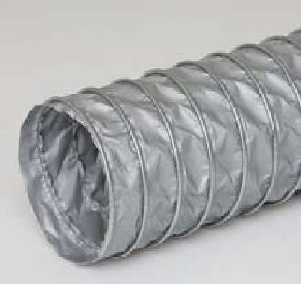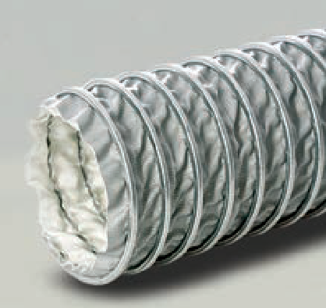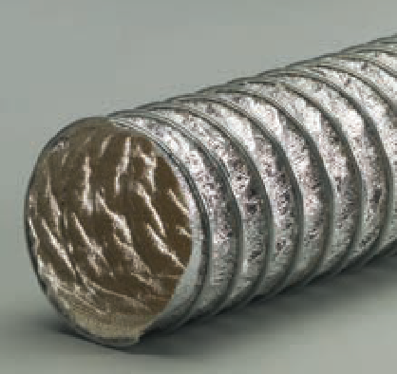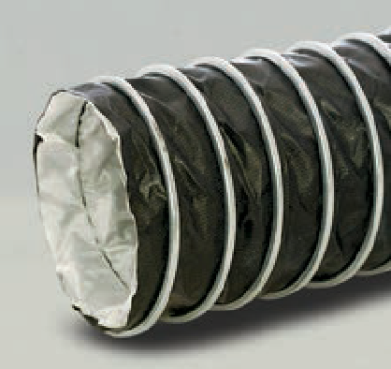Flex-Lok® TCF

Size Range (In) 4" to 12"
.......................... .custom to 20"
Standard Length (Ft) 25'
Standard Color black with a silver liner
Temperature Range (°F) ........ -60° to 600°

F

  - Double-ply construction Teflon® fabric hose with a heat-resistant fiberglass liner mechanically crimped in a continuous process
  - Fabric is locked around a coated steel wire by a metal strip formed into a clip
  - Metal strip acts as a wearstrip and offers outstanding external abrasion resistance
  - Excellent fatigue resistance and good flex characteristics
  - Sealed exterior prevents the escape of dangerous fumes
  - Ideal for reel, drop systems and venting many of today's harsh chemicals
  - Available with a non-marking TPR clip cover to protect the helix and the equipment that is attached to the hose

FLEX-LOK ®

- Negative pressure fan system with ambient air inlet
recommended to maximize effectiveness and life of duct.

F D M

AIR FUME DUST MATERIAL

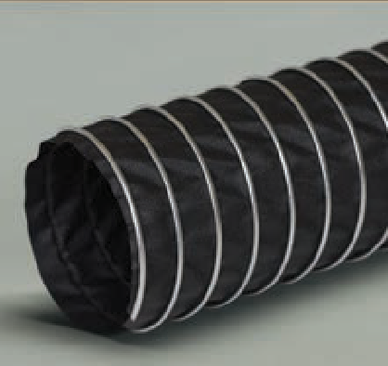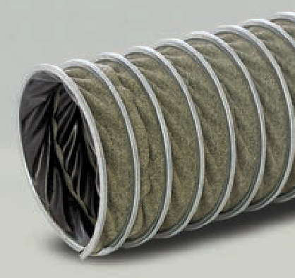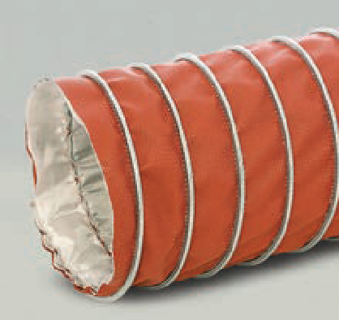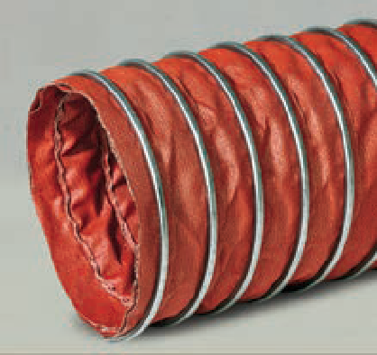Flex-Lok® 300

Size Range (In) 4" to 18"
. . . . . . . . . . . . . . . . . . . . . . . . . . . custom to 20"
Standard Length (Ft) 25'
Standard Color black
Temperature Range (°F) ........ -65° to 300°

F

Flex-Lok® 570

Size Range (In) 4" to 12"
. . . . . . . . . . . . . . . . . . . . . . . . . . . custom to 20"
Standard Length (Ft) 25'
Standard Color green outer layer
black inner layer Temperature Range (°F) ........ -40° to 570°

F

Flex-Lok® 750

Size Range (In) 4" to 18"
. . . . . . . . . . . . . . . . . . . . . . . . . . . custom to 20"
Standard Length (Ft) 25'
Standard Color red with a silver liner
Temperature Range ............ -40° to 750°

F

Flex-Lok® 1200

Size Range (In) 4" to 18"
. . . . . . . . . . . . . . . . . . . . . . . . . . . custom to 20"
Standard Length (Ft) 25'
Standard Color red
Temperature Range (°F) .. -40° to 1200°

F
  - Single-ply neoprene coated polyester fabric hose mechanically crimped in a continuous process
  - Fabric is locked around a coated steel wire by a metal strip formed into a clip
  - Metal strip acts as a wearstrip and offers outstanding external abrasion resistance
  - Extremely flexible and compressible
  - Manufactured with flame retardant materials
  - Ideal for low temperature fume control applications
  - Available with a non-marking thermoplastic rubber clip cover to protect the helix and the equipment that is attached to the hose (Flex-Lok® 300W)

  - Single-ply Para-Aramid fabric hose mechanically crimped in a continuous process
  - Fabric is locked around a coated steel wire by a metal strip formed into a clip
  - Metal strip acts as a wearstrip and offers outstanding external abrasion resistance
  - Excellent compressibility, puncture resistance and tensile strength
  - Excellent fatigue resistance and good flex characteristics
  - Ideal for medium temperature, high flex fume venting applications
  - Available with a non-marking TPR clip cover to protect the helix and the equipment that is attached to the hose

  - Double-ply construction wire inserted fiberglass fabric hose with a heat-resistant fiberglass liner mechanically crimped in a continuous-press
  - Fabric is locked around a coated steel wire by a metal strip formed into a clip
  - Metal strip acts as a wearstrip and offers outstanding external abrasion resistance
  - Excellent heat stability
  - Good flexibility, durability and flow characteristics
  - Inserted wire fabric and fiberglass liner increases tensile strength for a longer life cycle
  - Excellent for reel and drop systems
  - Ideal for high temperature diesel exhaust applications

  - Double-ply wire inserted fiberglass fabric hose mechanically crimped in a continuous process
  - Fabric is locked around a coated steel wire by a metal strip formed into a clip
  - Metal strip acts as a wearstrip and offers outstanding external abrasion resistance
  - Extreme temperature resistance with excellent heat stability
  - Good flexibility and flow characteristics
  - Inserted wire fabric increases tensile strength for a longer life cycle
  - Excellent for reel and drop systems
  - Ideal for applications where extreme temperatures are a factor

BENDWAY ®

Bendway® Plus

Size Range (In) 3" to 12"
Standard Length (Ft) 25' (3"-8"), 15' (9"-12")
Standard Color silver
Temperature Range (°F) up to 1650°

F D M
F D M

AIR FUME DUST MATERIAL

  - Manufactured using 316Ti Stainless Steel in a patented roll lock construction
  - Durable corrugations allow product to be dragged, bent and reshaped numerous times without damage or breaking
  - Suitable for fume and air exhaust applications with extremely high temperatures
  - Very flexible
  - Titanium stabilized 316 stainless alloy for superior high temperature corrosion resistance
  - Suitable for chemical fume exhausting, high temperature and corrosive applications where both positive and negative pressures are involved
  - 25' coils can ship via UPS in 3" to 4" diameters
  - Wall thickness = .006"

Bendway® S

Size Range (In) 2" to 12"
Standard Length (Ft) 5', 10'
Standard Color silver
Temperature Range (°F) .. -400° to 800°

F

  - Single-ply helically corrugated stainless steel alloy hose with a 4-ply finished seam that is folded flat and crimped for tightness and strength
  - Light weight and hand bendable allowing for elbows and turns to be formed easily during installation
  - Self-support construction allows for bends to stay in place
  - Resists metal fatigue, weathering and most corrosive fumes and chemicals
  - Not recommended for continuous flexing
  - Hose connectors available
  - Wall thickness = .005"

Bendway® A

Size Range (In) 2" to 12"
Standard Length (Ft) 5', 10'
Standard Color silver
Temperature Range (°F) .. -100° to 400°

F
3" 48 480

- All Bendway® Aluminum and Stainless Steel must ship freight collect.
- Consult us for specific packaging and freight requirements.
Bendway® Aluminum and Stainless Steel Shipping Information:

  - Single-ply helically corrugated aluminum alloy hose with a four-ply finished seam that is folded flat and crimped for tightness and strength
  - Light weight and hand bendable allowing for elbows and turns to be formed easily during installation
  - Self-supporting construction allows for bends to stay in place
  - Resists metal fatigue, weathering and most corrosive fumes and chemicals
  - Not recommended for continuous flexing
  - Hose connectors available
  - Wall thickness = .008"

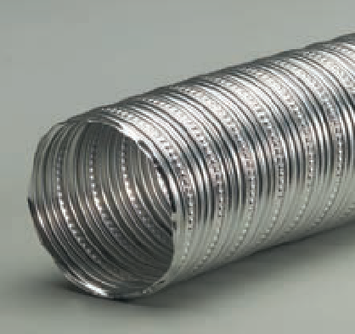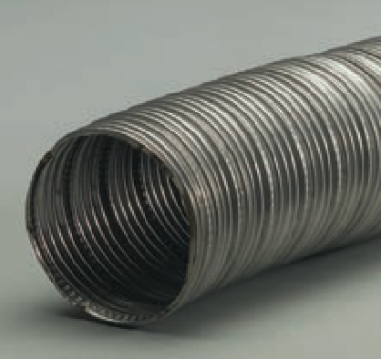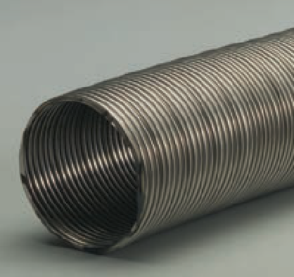
Bendway ® Packaging
Minimum Standard Box Quantities:
Size Lengths Per Box Feet Per Box
2"
100
1000

 | 4" | 30 | 300
- Each length packed in individual tube. (Suggested to reship from your stock.) Priced at list | 5" | 16 | 160
per foot with added net tube charge per length as stated. | 6" | 12 | 120
7" 9 90

8"
10"
12"
6
4
3
60
40
30

GARAGE EXHAUST
F D M

AIR FUME DUST MATERIAL

Flare-Lok®

Size Range (In) 2" to 4"
Standard Length (Ft) 11'
Standard Color black
Temperature Range (°F) up to 375°
  - Light weight rubber hose
  - Resistant to heat, aging, gasoline, oil and fumes
  - No wire or metal; even when flattened 100%, the hose immediately returns to its original shape
  - Ideal for carbon monoxide exhaust applications, small cars and small trucks
  - Flared end on each hose allows for connection to multiple lengths of the same size hose
  - Easily spliced, connected and re-connected as needed

F

ACT

Size Range (In) 5", 6"
Standard Length (Ft) 11'
Standard Color black
Temperature Range (°F) up to 375°

  - Light weight wire-reinforced rubber hose
  - Resistant to heat, aging, gasoline, oil and fumes
  - Wire insert prevents kinking
  - Ideal for carbon monoxide exhaust applications, diesel and gasoline trucks

F

Dyno Hose

Size Range (In) 4"
Standard Length (Ft) 11'
Standard Color gray
Temperature Range (°F) up to 450°

  - Special rubber blend to withstand the high temperature of a dynamometer when used with a fan assisted system
  - Heavy wall thickness increases durability
  - Designed to be used in IM240 and VMAS emission testing

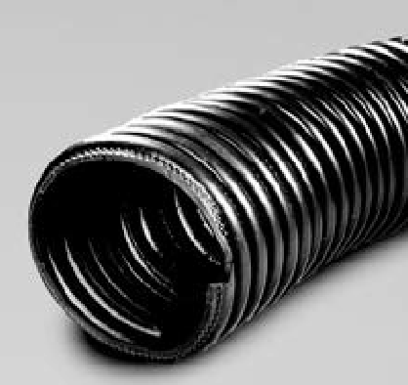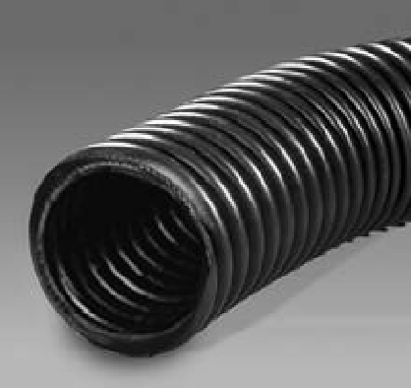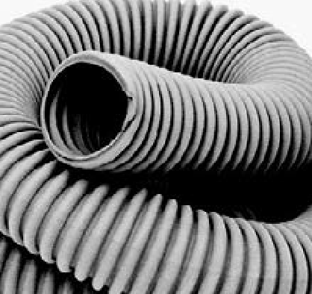

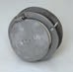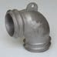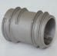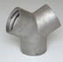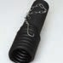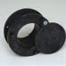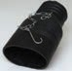 F

Accessories
Garage Exhaust Accessories
Aluminum Door Aluminum Aluminum Aluminum Y | Tail Pipe | Rubber Door | Twin Oval | Rubber Y
Port Pulley Elbow Splice Connector | Adapter | Port | Adapter | Connector
Connector

1510 Armstrong Road
Warsaw, IN 46580
Tel: 574-267-7909
Fax: 574-269-7491
sales@flexaust.com www.flexaust.com

4584 Calimesa Street Las Vegas, NV 89115

10 Industrial Way
Amesbury, MA 01913

5731 Harvey Wilson Drive Houston, TX 77020

5110 Fulton Industrial Blvd., Suites D and E Atlanta, GA 30336

Anytime. Anywhere.
Flexaust®Connect

Now you can access the depth of Introducing Flexaust Connect: your powerful, mobile, up to date
connection to everything Flexaust. Flexaust.com on mobile Platforms.

Find Us On:

DISTRIBUTED BY

M E M B E R

Google Play and the Google Play logo are trademarks of Google LLC.

