Automotive Plumbing Catalog
June 2017
Metal Tubing Tube Nuts Weld-On Studs Tube Unions
Clips and Brackets Bulkhead Nuts Tees
Thread Adapters Bump Tube Adapters
Transmission Line Adapters Copper Washers
Banjo Bolts Banjo Adapters
Weld-On Banjo Heads Bleed Screws
Fitting Caps and Plugs Assortment Kits
Tube Straighteners Cutters
Tube Benders Flaring Tools Specialty Tools
Fuel Line and Fittings

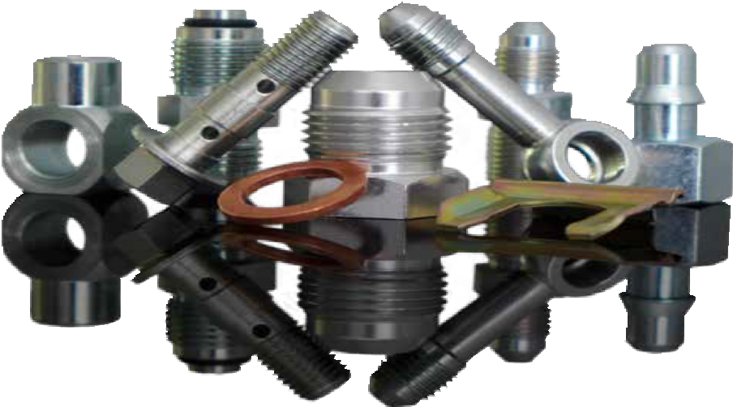

Tube and Hose BrakeQuip
90/10 Cunifer Tubing

For the ultimate combination of corrosion resistance and ease of use, choose the EziBend family of tubing. EziBend tubing meets UNS C70600 requirements for material composition and is compliant with
US Department of Transportation and Federal Motor Vehicle Safety Standards.
Volvo, Audi, Porsche, Rolls Royce, Lotus, Aston Martin, and other performance automobile makers use C70600 tubing. In the replacement market, C70600 tubing is the preferred tubing for brake lines, fuel, and transmission systems.

Durability
Unlike other similarly-priced tubing that attempts to protect the core material with a plating or coating, EziBend tubing is fabricated from a special alloy that is inherently rust and corrosion proof. There are no coatings to fail. EziBend will remain corrosion-proof after tube formation, scratches during installation, and nicks from road debris.

Ease of use
EziBend is strong, but easy to work with. It straightens, cuts, flares, and bends smoothly. And the same properties that make EziBend simple to shape allow it to achieve a superior sealing surface against fittings.

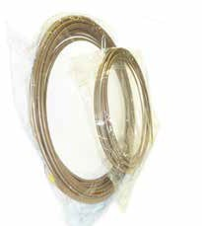
EziBend 2
- 0.028” wall thickness
- Polishes to a brilliant finish
- Seamless construction
- Ready for retail in pre-packaged coils
Original EziBend
- 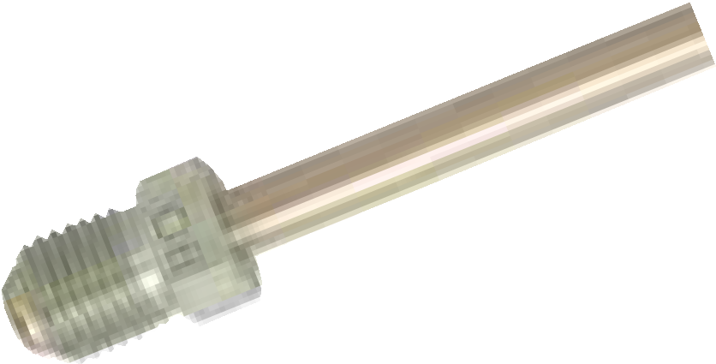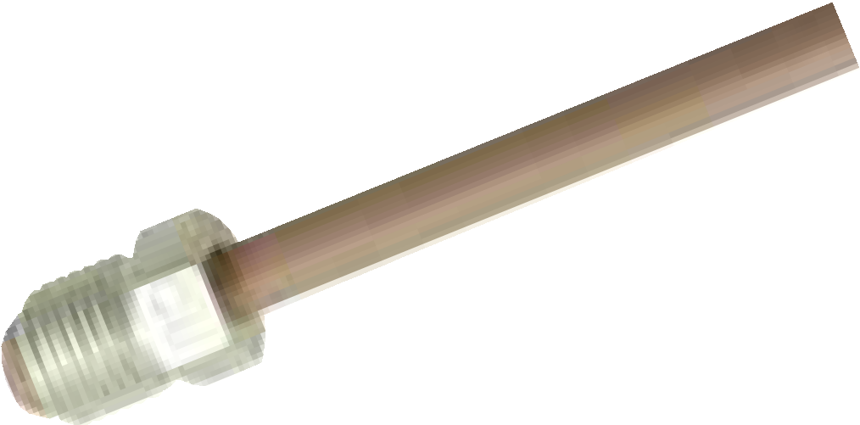0.028” wall thickness
- Polishes to a brilliant finish
- Made in the USA
- Unpackaged coils

Part Number | OD | Coil Length |  | Part Number | OD | Coil Length
T187-25SE | 3/16” | 25ft |  | T187-25CN | 3/16” | 25ft
T187-100SE | 3/16” | 100ft |  | T187-100CN | 3/16” | 100ft
T250-25SE | 1/4” | 25ft |  | T250-25CN | 1/4” | 25ft
T250-100SE | 1/4” | 100ft |  | T250-100CN | 1/4” | 100ft
T312-25SE | 5/16” | 25ft |  | T312-25CN | 5/16” | 25ft
T375-25SE | 3/8” | 25ft |  | T375-25CN | 3/8” | 25ft

On the right side of the standards
In cunifer tubing, nickel improves strength and corrosion resistance while allowing the tube to remain ductile. EziBend and EziBend 2 stood out in independent lab tests against three of the largest cunifer suppliers in the US and the UK.

”Wholesale” Tubing (US) |  | ”Parts Store” Tubing (US) | Leading UK Tubing | UNS C70600 | EziBend | EziBend 2
Nickel Content | 8.85% | 8.92% | 8.89% | 9.0%–11.0% | 10.30% | 10.40%

2

Innovative Solutions for Automotive Tubes and Hoses Tube and Hose
316L Stainless Tubing

The pinnacle of automotive plumbing, our 316L marine-grade tubing has the highest level of corrosion protection combined with the stunning appearance of polished stainless steel.

Corrosion resistance

316L contains molybdenum, a corrosion resistor that is not found in 304 grade stainless.

Proper wall thickness
Thick-walled 304 stainless tubing meant for heavy industrial applications will damage automotive tube-working tools. Our 0.028”-walled tubing is strong enough for automotive, marine, and light industrial applications, yet easy to work using DIY automotive tools.

Soft-annealed
BrakeQuip 316L is soft-annealed, a heat treatment process which makes straightening, cutting, bending, and flaring far easier than with non-annealed stainless.
See coil straighteners and benders on page 14 and 15,
flaring tools on page 16, and stainless fittings on page 20.

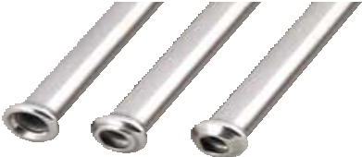

Part Number | OD | Coil Length
T187-20SS | 3/16” | 20ft
T250-20SS | 1/4” | 20ft
T312-20SS | 5/16” | 20ft
T375-20SS | 3/8” | 20ft

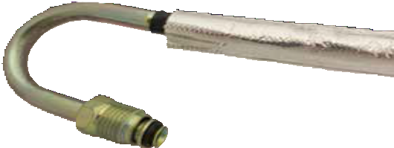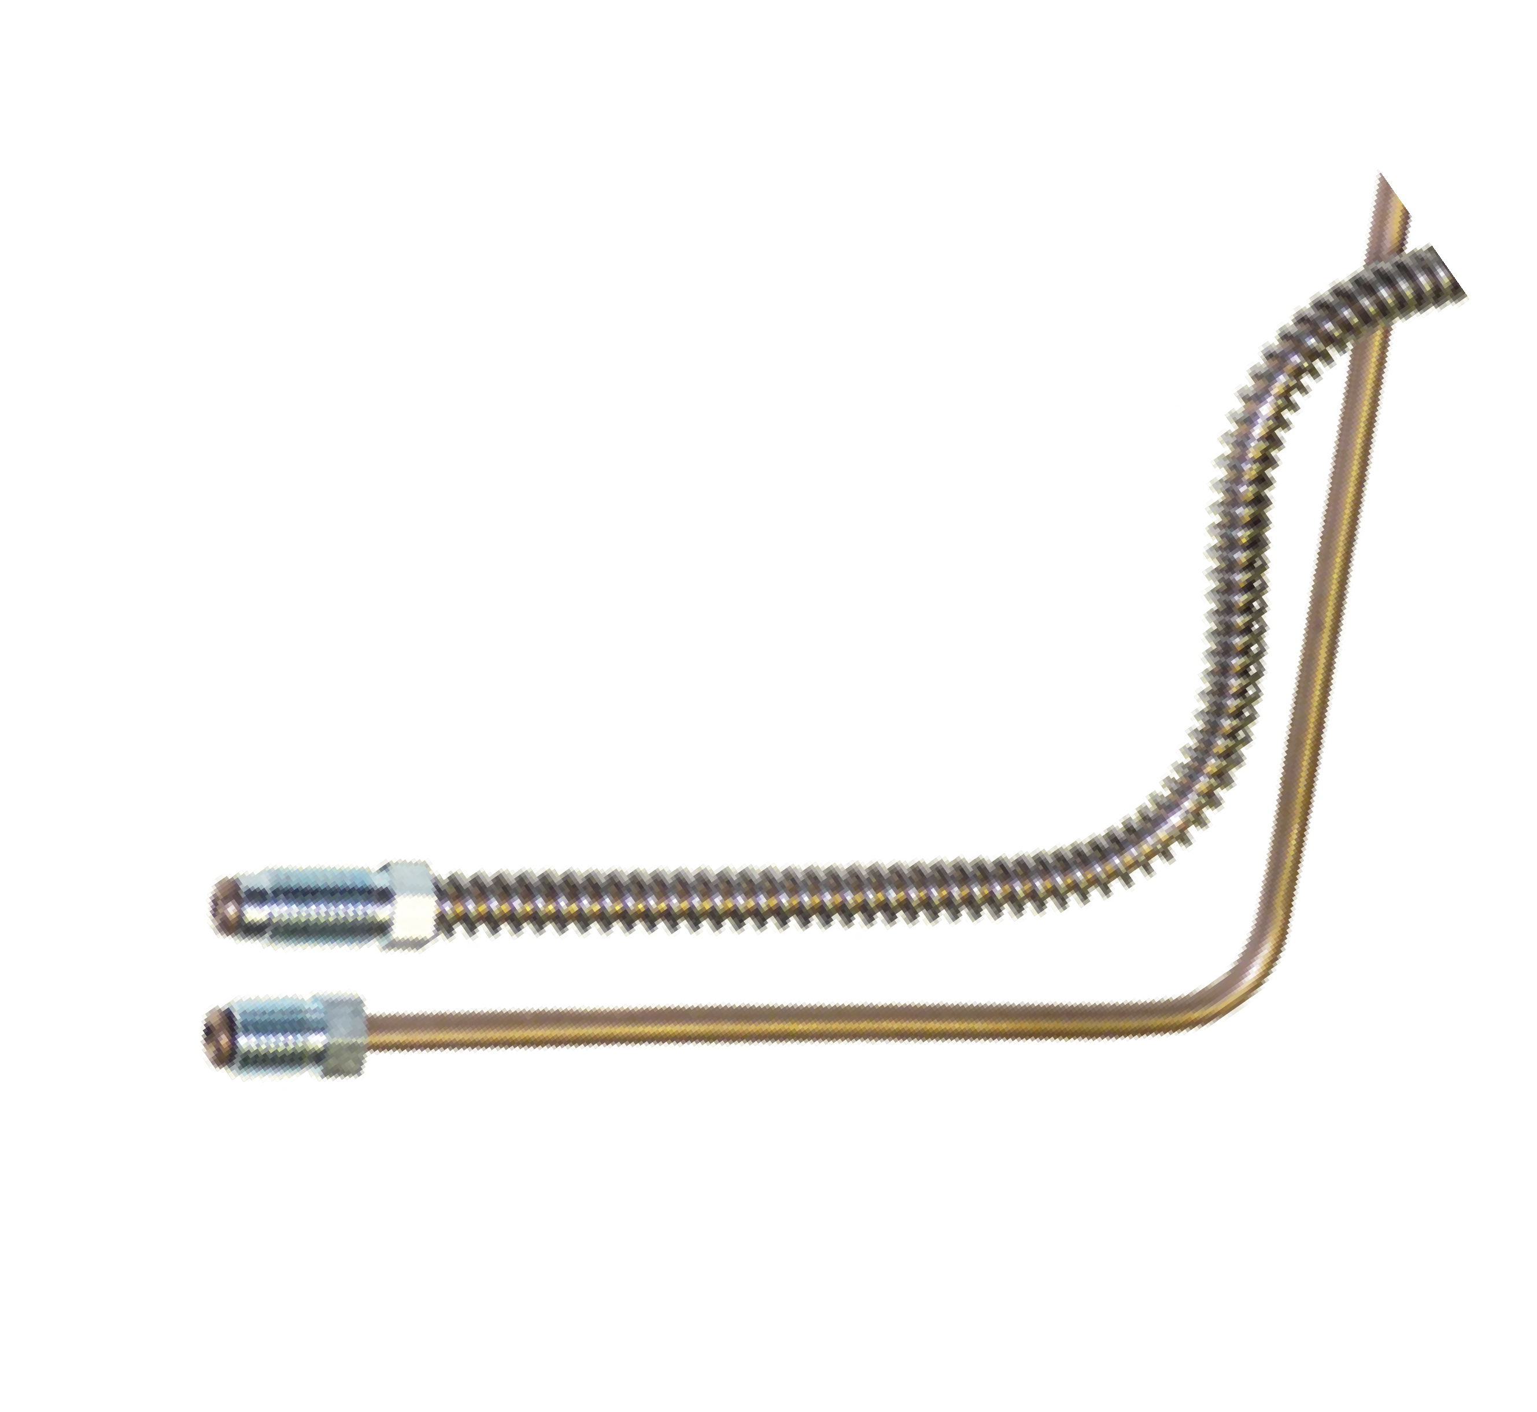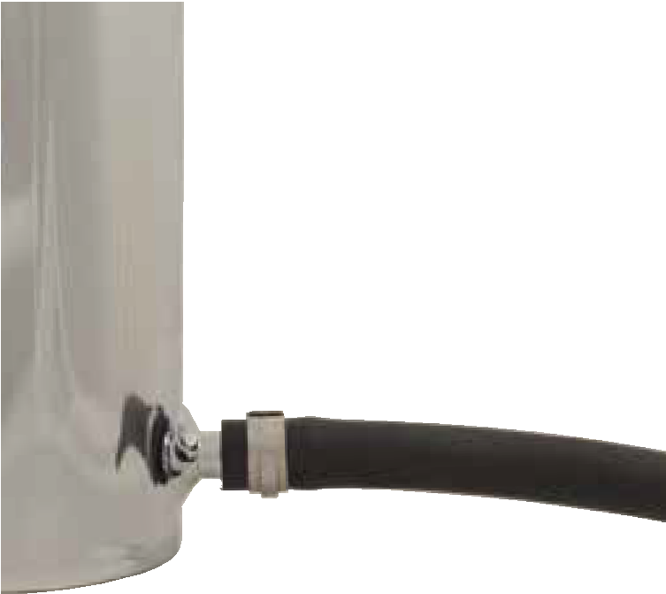
See inside back cover for brake and power steering hoses.
Remote Reservoir Hose
Part Number ID OD
BQ320 1/4” 7/16”
BQ321 5/16” 1/2”
BQ322 3/8” 9/16”
BQ313-SV Heat Shield
One size fits all. 5ft rolls.
Remote Reservoir
Spring Guards
Part Number ID OD Material BQ202 11.5mm 16. 5mm Black Nylon BQ231 3/16” Stainless Steel
BQ232 1/4” Stainless Steel
Remote Reservoir Hose
Master Cylinder
3
Other Tube and Hose Products

BrakeQuip can manufacture custom tubing OD, wall thickness, and coil length for large volume opportunities. For more information, contact sales@brakequip.com.

Part Number | Thread | Stud Length | Flare | Hex | Tube Size
BQ4276 | 3/8-20 BSF | 14mm | 45° | 3/8 | 3/16”
BQ5555 | 3/8-24 UNF | 9.1mm | 45° | 3/8 | 3/16”
BQ5555SS | 3/8-24 UNF | 9.1mm | 45° | 3/8 | 3/16”
BQ4285 | 3/8-24 UNF | 17mm | 45° | 3/8 | 3/16”
BQ4277 | 7/16-20 UNF | 18mm | 45° | 7/16 | 1/4”
BQ6118 | 7/16-20 UNF | 17.5mm | 45° | 11mm | 3/16”
BQ5842 | 7/16-24 UNS | 9.1mm | 45° | 11mm | 3/16”
BQ5842SS | 7/16-24 UNS | 9.1mm | 45° | 11mm | 3/16”
BQ2577 | 7/16-24 UNS | 12.5mm | 45° | 7/16 | 1/4”
BQ2577SS | 7/16-24 UNS | 12.5mm | 45° | 7/16 | 1/4”
BQ2578 | 1/2-20 UNF | 10.2mm | 45° | 1/2 | 5/16”
BQ9184 | 1/2-20 UNF | 10.2mm | 45° | 1/2 | 3/16”
BQ9187 | 1/2-20 UNF | 14mm | 45° | 1/2 | 1/4”
BQ9185 | 9/16-18 UNF | 14mm | 45° | 9/16 | 3/16”
BQ9186 | 9/16-18 UNF | 14mm | 45° | 9/16 | 1/4”
BQ9181 | 5/8-18 UNF | 10.2mm | 45° | 5/8 | 3/8”
BQ4510 | M9 × 1 | 14mm | 45° | 10mm | 3/16”
BQ4511 | M10 × 1 | 11.6mm | 45° | 11mm | 3/16”
BQ4511LT | M10 × 1 | 14mm | 45° | 11mm | 3/16”
BQ4511SS | M10 × 1 | 11.6mm | 45° | 11mm | 3/16”
BQ72 | M10 × 1 | 12.6mm | DIN | 11mm | 3/16”
BQ4512 | M10 × 1.25 | 11.6mm | 45° | 11mm | 3/16”
BQ9188 | M10 × 1.5 | 11.6mm | 45° | 11mm | 3/16”
BQ9189 | M11 × 1 | 15mm | 45° | 11mm | 3/16”
BQ9190 | M11 × 1.25 | 15mm | 45° | 11mm | 3/16”
BQ9191 | M11 × 1.5 | 13.1mm | 45° | 13mm | 3/16”
BQ9180 | M12 × 1 | 11.6mm | 45° | 13mm | 3/16”
BQ4513 | M12 × 1 | 11.6mm | 45° | 13mm | 1/4”
BQ4513LT | M12 × 1 | 14.6mm | 45° | 13mm | 1/4”
BQ4513SS | M12 × 1 | 11.6mm | 45° | 12mm | 1/4”
BQ9169 | M12 × 1 | 14.9mm | DIN | 13mm | 1/4”
BQ9182 | M12 × 1.5 | 11.6mm | 45° | 13mm | 1/4”
BQ9192 | M12 × 1.25 | 11.6mm | 45° | 13mm | 3/16”
BQ9157 | M12 × 1.25 | 11.6mm | 45° | 13mm | 1/4”
BQ9193 | M12 × 1.5 | 11.6mm | 45° | 13mm | 3/16”
BQ9194 | M13 × 1 | 15mm | 45° | 13mm | 3/16”
BQ9195 | M13 × 1.25 | 15mm | 45° | 13mm | 3/16”
BQ9196 | M13 × 1.5 | 15mm | 45° | 13mm | 3/16”
BQ9183 | M14 × 1.5 | 11.6mm | 45° | 15mm | 1/4”
BQ9197 | M14 × 1.5 | 11.6mm | 45° | 15mm | 5/16”
BQ9149 | M14 × 1.5 | 15mm | DIN | 16mm | 8mm
BQ9198 | M16 × 1.5 | 11.6mm | 45° | 17mm | 5/16”
BQ9166 | M16 × 1.5 | 16mm | 45° | 17mm | 3/8”
BQ9148 | M16 × 1.5 | 13.2mm | DIN | 16mm | 10mm
BQ9199 | M18 × 1.5 | 16mm | 45° | 18mm | 5/16”

See page 13 for assortment kits BQ7005 (metric tube nuts) and BQ7006 (imperial tube nuts).
Male Tube Nuts

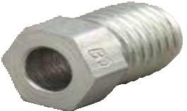

Stud Length
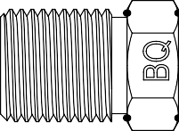

Tube Size
Hex

See page 13 for assortment kits BQ7005 (metric tube nuts) and BQ7006 (imperial tube nuts).
Female Tube Nuts
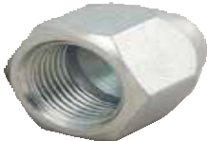

Thread Length
Part Number | Thread | Thread Length | Seat | Hex | Tube Size
BQ55 | 3/8-24 UNF | 7.5mm | 37° | 7/16” | 3/16”
BQ9176 | 3/8-24 UNF | 5.6mm | 45° | 7/16” | 3/16”
BQ57 | 7/16-20 UNF | 5.8mm | 37° | 1/2” | 1/4”
BQ9177 | 1/2-20 UNF | 10mm | 45° | 5/8” | 5/16”
BQ9201 | 9/16-18 UNF | 7.5mm | 37° | 11/16” | 3/8”
BQ9239 | 9/16-18 UNF | 8.6mm | 45° | 11/16” | 3/8”
BQ9207 | 9/16-18 UNF | 6.1mm | o-ring pilot | 5/8” | 3/8”
BQ9219 | 5/8-18 UNF | 8.6mm | 45° | 13/16” | 3/8”
BQ9175 | M10 × 1 | 9mm | 45° | 13mm | 3/16”
BQ9174 | M12 × 1 | 9mm | 45° | 16mm | 3/16”
BQ9179 | M12 × 1 | 9mm | 45° | 16mm | 1/4”
BQ9156 | M12 × 1.25 | 8mm | 45° | 16mm | 1/4”
BQ9178 | M12 × 1.5 | 9mm | 45° | 16mm | 1/4”
BQ9208 | M14 × 1.5 | 10.9mm | 37° | 17mm | 10mm
BQ9209 | M16 × 1.5 | 10.9mm | 37° | 19mm | 10mm
BQ9226 | M16 × 1.5 | 11mm | 45° | 19mm | 3/8”
BQ9210 | M18 × 1.5 | 14.4mm | 37° | 21mm | 12mm

Tube Size

See page 10 for copper seat seals (flare gaskets).

Part Number | Thread | Type | Tube Size | Stud Length | Hex
BQ170 | 9/16-18 UNF | -6 JIC | 3/8” | 14.1mm | 5/8”
BQ171 | 5/8-18 UNF | 45° inverted | 3/8” | 15.7mm | 11/16”
BQ172 | 3/4-16 UNF | -8 JIC | 1/2” | 16.7mm | 13/16”
BQ173 | 7/8-14 UNF | -10 JIC | 5/8” | 22.6mm | 15/16”
BQ174 | 1 1/16-14 UNS | 45° inverted | 3/4” | 25.4mm | 1 1/16”
BQ141 Swivel Elbow – 90°
3/8-24 UNF — 3/8-24 UNF
Handy for tight spots that require a connection with an inverted seat.
Weld-On Fittings

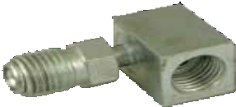

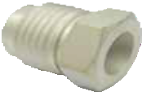
Aluminum

Steel
Stud Length

Tube Size

Part Number | Thread | Type | Tube Size | Stud Length | Hex
BQ153 | 3/8-24 UNF | -3 JIC | 3/16” | 12.2mm | 7/16”
BQ226 | 9/16-18 UNF | -6 JIC | 3/8” | 14.1mm | 5/8”
BQ228 | 9/16-18 UNF | -6 JIC | 1/2 ” | 14.1mm | 11/16”
BQ227 | 9/16-18 UNF | -6 JIC | 10mm | 14.1mm | 5/8”

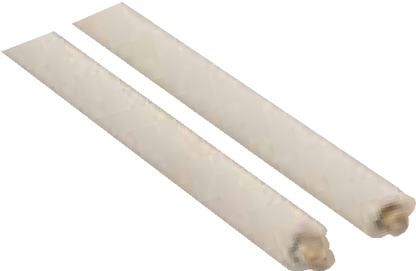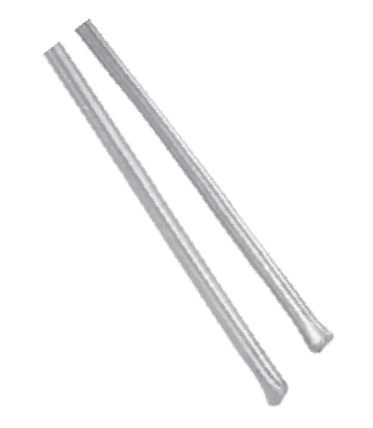
BQ33
Pre-fluxed Silver Brazing Rod
pack of 8
BQ34
Pre-fluxed Aluminum Brazing Rod
pack of 5
For professional brazing of steel, stainless, brass, or any combination of these metals. Designed for brazing high-pressure fittings. No cadmium. 18” long.
Brazing Rods

See page 13 for assortment kit BQ7009.
Female Unions
Part Number | Thread | Thread Length | Seat | Hex | Overall Length
BQ110 | 3/8-24 UNF | 5.16mm | 45° | 1/2” | 22.2mm
BQ115 | 3/8-24 UNF | 8mm | Bubble | 1/2” | 25mm
BQ111 | 7/16-24 UNS | 5.16mm | 45° | 9/16” | 22.2mm
BQ111SS | 7/16-24 UNS | 5.16mm | 45° | 9/16” | 22.2mm
BQ112 | 1/2-20 UNF | 5.94mm | 45° | 5/8” | 25mm
BQ119 | 9/16-18 UNF | 5.94mm | 45° | 3/4” | 27mm
BQ113 | 5/8-18 UNF | 6.76mm | 45° | 3/4” | 27mm
BQ114 | M10 × 1 | 7mm | DIN | 13mm | 25mm
BQ117 | M10 × 1 | 7.95mm | 45° | 13mm | 24mm
BQ116 | M12 × 1 | 7.95mm | 45° | 16mm | 25mm
BQ147 | M12 × 1 | 9mm | DIN | 16mm | 27mm

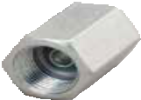

45° Inverted
Bubble or DIN

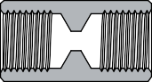

Tube Clamps – white nylon
BQ249 3/16” BQ250 1/4” FL35 5/16”
FL34 3/8”

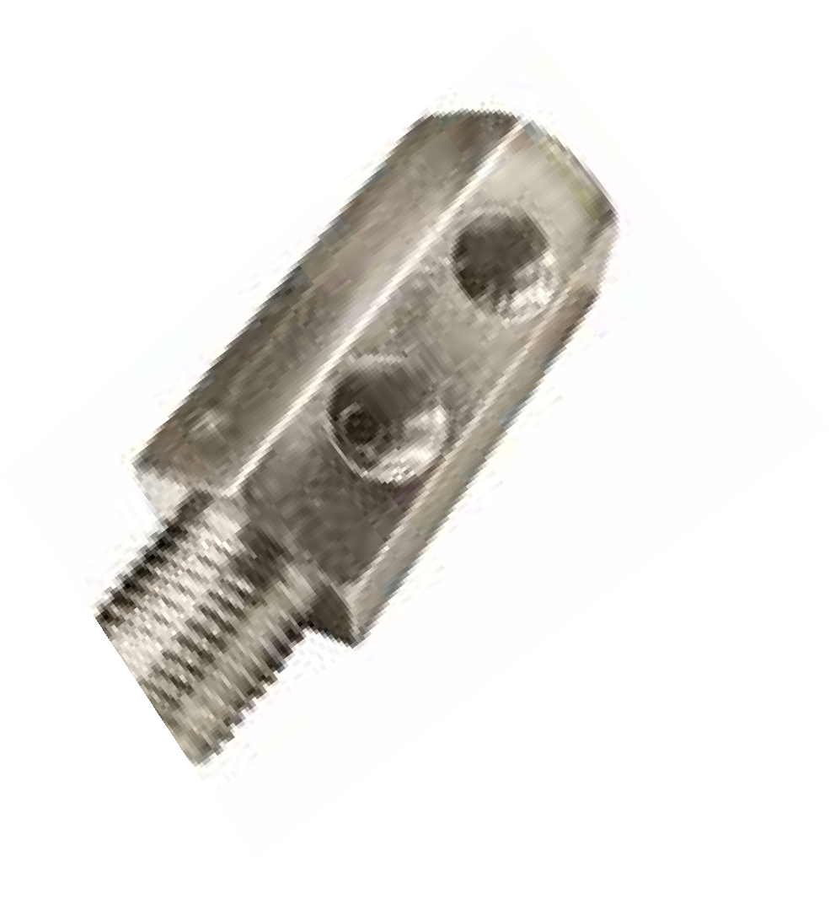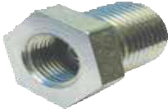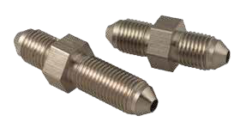BQB06 Universal Bracket
port here
7/16-24 UNS
internal threads
BQ148 Bulkhead Union 5/8-18 UNF external thread 45° inverted seat, 19mm hex
Secure with a BQ13 bulkhead nut - next page
port here
BQ222 Tandem Trailer Fitting Universal
Four ports: 3/8-24 UNF, inverted seat
Secure with BQ13 bulkhead nut – next page Block off excess ports with BQ19 plugs – page 12
BQ293SS -3 JIC Union, Stainless
3/8-24 UNF, 7/16” hex
45.9mm overall length
Requires BQ78 nut for bulkhead mount
BQ292 -3 JIC Union
BQ292SS Stainless version
3/8-24 UNF, 7/16” hex
30.7mm overall length
Male Unions
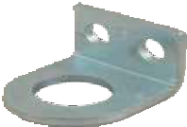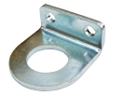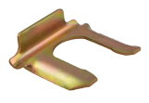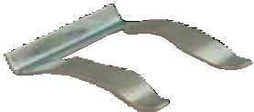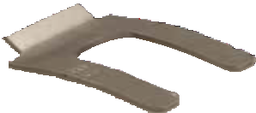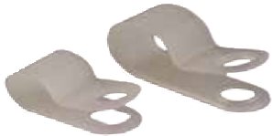19mm hole, 5mm mount holes
Clips and Brackets

BQB244 Universal Bracket
17mm hole
6.8mm mount holes

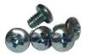

BQ3052

Universal Clip
BQ3052SS
Universal Clip - Stainless
BQ3053
Clip - suits Toyota
BQ71
Bracket Retaining Screws
pack of 50

Part Number | Thread | Hex Size | Thickness
BQ78 | 3/8-24 UNF | 1/2” | 5 mm
BQ80 | 7/16-20 UNF | 5/8” | 6 mm
BQ83 | 1/2-20 UNF | 3/4” | 6 mm
BQ13 | 5/8-18 UNF | 15/16” | 8 mm
BQ77 | 11/16-18 UNS | 1” | 8 mm
BQ84 | 3/4-16 UNF | 1 1/16” | 8 mm
BQ75 | 7/8-14 UNF | 1 1/8” | 8 mm
BQ89 | 7/8-18 UNS | 1 1/8” | 8 mm
BQ79 | M10 × 1 | 13 mm | 5 mm
BQ81 | M12 × 1 | 19 mm | 6 mm
BQ82 | M12 × 1.5 | 19 mm | 6 mm
BQ87 | M16 × 1.5 | 22 mm | 7 mm
BQ86 | M18 × 1.5 | 25 mm | 8 mm
BQ85 | M20 × 1.5 | 27 mm | 8 mm

See page 13 for assortment kit BQ7002.
Tees

Part Number | Thread | Seat | Diameter | Mount | Mount Hole | Thickness
BQ93A | 1/8-27 NPT | NPT | 31.75mm | Bolt | 8.2mm | 14mm
BQ264 BQ56A BQ56ASS BQ90A BQ94A  BQ92A | 3/8-24 UNF  3/8-24 UNF  3/8-24 UNF  3/8-24 UNF  7/16-20 UNF  7/16-24 UNS | 45°  45°  45°  45°  Bubble 45° | T shape 28.6mm 28.6mm 31.75mm  31.75mm  31.75mm | none Bolt Bolt Bolt Bolt  Bolt | none 8.2mm 8.2mm 8.2mm 8.2mm  8.2mm | 1/2”  1/2”  1/2”  1/2”  14mm 14mm
BQ91A  BQ95A | M10 × 1  M10 × 1 | 45°  DIN | 31.75mm  31.75mm | Bolt  Bolt | 8.2mm  7.2mm | 1/2”  14mm

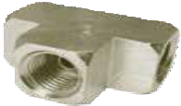
NPT

3/8-24 UNF
Inverted seat

M10 × 1 port 7/16-24 UNS port
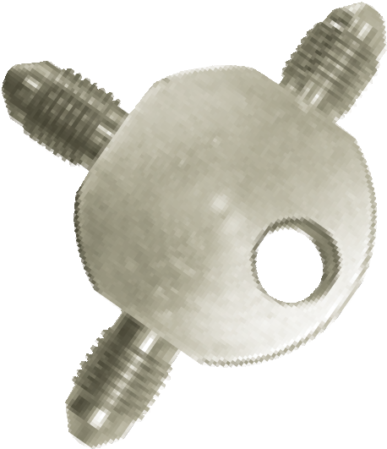
M10 × 1 tube nut, DIN flare
Male
BQ265 NPT Tee
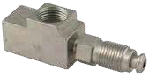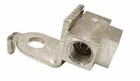Two 3/8-24 UNF ports One 1/8-27 NPT port
7/16-24 UNS
BQ7812 Tee with Bracket
BQ378 Swivel Tee

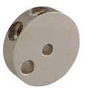3/8-24 UNF, inverted seat 47mm diameter

BQ177SS Tee
1/2” thick

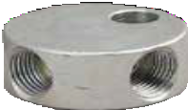
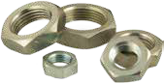
Bulkhead Nuts
Female

Part Number | Thread | JIC | Mount | Mount Hole | Diameter | Thickness
BQ360 | 3/8-24 UNF | -3 | Bolt | 8.2mm | 31.75mm | 1/2”
BQ361 | 7/16-20 UNF | -4 | Bolt | 8.2mm | 31.75mm | 1/2”

See page 13 for assortment kit BQ7004.
Male-Female Adapters

Part Number | Port Thread | Port Thread Length | Port Seat | Tube Size | Stud Thread | Stud Length | Stud Fit | Hex
BQ247 | 1/8-27 NPT | 6.92mm | NPT | — | 3/8-24 UNF | 11.2mm |  | 9/16”
BQ248 | 1/8-27 NPT | 6.92mm | NPT | — | 1/2-20 UNF | 11mm |  | 9/16”
BQ187 | 1/8-27 NPT | 6.92mm | NPT | — | M10 × 1.5 | 11mm |  | 9/16”
BQ48 | 3/8-24 UNF | 5.16mm | 45° | 3/16” | 1/8-27 NPT | 9.97mm | 3/16" | 1/2”
BQ156 | 3/8-24 UNF | 5.16mm | 45° | 3/16” | 3/8-24 UNF | 12mm | 3/16" | 9/16”
BQ47 | 3/8-24 UNF | 5.16mm | 45° | 3/16” | 7/16-20 UNF | 12mm | 3/16" | 9/16”
BQ46 | 3/8-24 UNF | 5.16mm | 45° | 3/16” | 7/16-24 UNS | 12mm | 3/16" | 9/16”
BQ9300 | 3/8-24 UNF | 6.19mm | 45° | 3/16” | 1/2-20 UNF | 12mm | 3/16" | 5/8”
BQ120 | 3/8-24 UNF | 5.16mm | 45° | 3/16” | 1/2-20 UNF | 12mm | 5/16" | 5/8”
BQ124 | 3/8-24 UNF | 5.16mm | 45° | 3/16” | 9/16-18 UNF | 12mm | 3/16" | 11/16”
BQ262 | 3/8-24 UNF | 9mm | Bubble | 3/16” | 9/16-18 UNF | 12mm | 3/16" | 11/16”
BQ121 | 3/8-24 UNF | 5.16mm | 45° | 3/16” | 9/16-20 UNS | 12mm | 3/16" | 11/16”
BQ49 | 3/8-24 UNF | 5.16mm | 45° | 3/16” | M10 × 1 | 12.6mm | 3/16" | 9/16”
BQ125 | 3/8-24 UNF | 9mm | Bubble | 3/16” | M10 × 1 | 12mm | 3/16" | 13mm
BQ383 | 3/8-24 UNF | 5.16mm | 45° | 3/16” | M12 × 1 | 12mm | 3/16" | 16mm
BQ45 | 7/16-24 UNS | 5.16mm | 45° | 1/4” | 3/8-24 UNF | 11.2mm | 3/16" | 9/16”
BQ9301 | 7/16-24 UNS | 6.19mm | 45° | 1/4” | 1/2-20 UNF | 12mm | 3/16" | 5/8”
BQ122 | 7/16-24 UNS | 5.16mm | 45° | 1/4” | 1/2-20 UNF | 12mm | 5/16" | 5/8”
BQ123 | 7/16-24 UNS | 5.16mm | 45° | 1/4” | 9/16-18 UNF | 12mm | 3/16" | 11/16”
BQ9304 | 1/2-20 UNF | 6.67mm | 45° | 3/16” | 3/8-24 UNF | 12mm | 3/16" | 11/16”
BQ260 | 1/2-20 UNF | 5.94mm | 45° | 5/16” | 3/8-24 UNF | 11.2mm | 3/16" | 16mm
BQ127 | 1/2-20 UNF | 5.94mm | 45° | 5/16” | 7/16-24 UNS | 12mm | 1/4" | 5/8”
BQ261 | 9/16-18 UNF | 5.94mm | 45° | 5/16” | 3/8-24 UNF | 11.2mm | 3/16" | 11/16”
BQ50 | M10 × 1 | 7.95mm | 45° | 3/16” | 3/8-24 UNF | 11.2mm | 3/16" | 1/2”
BQ40 | M10 × 1 | 7mm | DIN | 3/16” | M10 × 1 | 13mm | 3/16" | 16mm
BQ9305 | M10 × 1 | 7.3mm | 45° | 3/16” | M10 × 1 | 13mm | 3/16" | 15mm
BQ42 | M10 × 1 | 7.95mm | 45° | 3/16” | M10 × 1.25 | 12mm | 3/16" | 13mm
BQ43 | M10 × 1 | 7.95mm | 45° | 3/16” | M12 × 1 | 12mm | 3/16" | 16mm
BQ41 | M10 × 1.25 | 7.95mm | 45° | 3/16” | M10 × 1 | 12.6mm | 3/16" | 13mm
BQ246 | M12 × 1 | 9mm | DIN | 1/4” | 1/8-27 NPT | 9.97mm | 3/16" | 16mm
BQ44 | M12 × 1 | 7.95mm | 45° | 1/4” | M10 × 1 | 12.6mm | 3/16" | 16mm
BQ379 | M12 × 1.5 | 7.95mm | 45° | 3/16” | 1/8-27 NPT | 9.97mm | 3/16" | 14mm
BQ380 | M14 × 1.5 | 7.95mm | 45° | 3/16” | 1/8-27 NPT | 9.97mm | 3/16" | 17mm

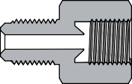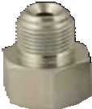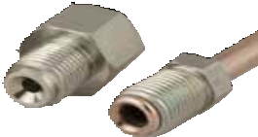Port Thread Length

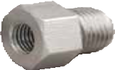
Inverted seat for 45° double flare

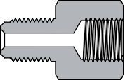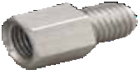
Stud Length
Drill-point seat for Bubble or DIN flare
When deciding if an adapter will work with a specific port, think of the Stud Fit as a "tube-size equivalent," in that the adapter will seat properly if the corresponding tube and tube nut would also seat properly. Most BrakeQuip adapters correspond to 3/16" tube but there are a few exceptions, as noted in the table.

See page 13 for assortment kit BQ7010.
Male-Male Adapters

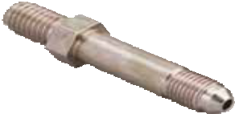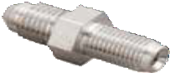BQ130 has an elongated JIC stud.
Part Number | JIC Stud Thread | Other Stud Thread | Other Stud Length | Hex | Overall Length
BQ135 | 3/8-24 UNF (-3 JIC) | 3/8-24 UNF | 16mm | 1/2” | 34.2mm
BQ132 | 3/8-24 UNF (-3 JIC) | 1/4-28 UNF | 16mm | 1/2” | 36mm
BQ168 | 3/8-24 UNF (-3 JIC) | 1/2-20 UNF | 13mm | 1/2” | 33mm
BQ129 | 3/8-24 UNF (-3 JIC) | M10 × 1 | 16mm | 1/2” | 34.2mm
BQ128 | 3/8-24 UNF (-3 JIC) | M10 × 1.25 | 16mm | 1/2” | 36mm
BQ130 | 3/8-24 UNF (-3 JIC) | M10 × 1.5 | 16mm | 1/2” | 60mm
BQ131 | 7/16-20 UNF (-4 JIC) | 3/8-24 UNF | 16mm | 1/2” | 37.1mm
BQ134 | 7/16-20 UNF (-4 JIC) | 7/16-24 UNS | 16mm | 9/16” | 36mm
BQ176 | 7/16-20 UNF (-4 JIC) | M10 × 1 | 11.6mm | 1/2” | 31.6mm
BQ144 | 7/16-20 UNF (-4 JIC) | M12 × 1 | 16mm | 14mm | 36mm
BQ149 | 7/16-20 UNF (-4 JIC) | M12 × 1.25 | 16mm | 14mm | 37mm

JIC Stud

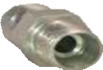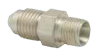BQ145 -4 JIC to M10 × 1
Non-JIC stud for use with ISO 24° cone connector: either compression or o-ring seal cone (DKO).
12mm hex, 29mm overall length
Male
Other Stud

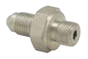
BQ157 -3 JIC to 1/8-28
5/8" hex, 25.9mm overall length
For use with bonded washer (dowty seal)

See page 13 for assortment kit BQ7003.
Bump Tube Adapters

Part Number | JIC Stud Thread | O-ring Pilot Thread | Hex | Overall Length
5MBT-5MJ | 1/2-20 UNF (-5 JIC) | 1/2-20 UNF | 9/16” | 37.4mm
7MBT-6MJ | 9/16-18 UNF (-6 JIC) | 11/16-18 UNS | 3/4” | 41.9mm
14MMBT-6MJ | 9/16-18 UNF (-6 JIC) | M14 × 1.5 | 5/8” | 38.8mm
16MMBT-6MJ | 9/16-18 UNF (-6 JIC) | M16 × 1.5 | 17mm | 38.9mm
18MMBT-6MJ | 9/16-18 UNF (-6 JIC) | M18 × 1.5 | 3/4” | 39.4mm

Part Number | Port O-ring Pilot  Thread Thread | Hex Overall Length
16MMBT-6FI | 5/8-18 UNF M16 × 1.5 | 3/4” 30.8mm

Transmission Line Adapters

Convert push-on connection transmission lines to double-flare connections to make and repair these lines in your shop.

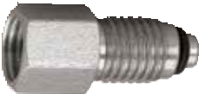
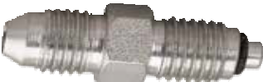
Female
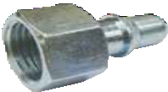
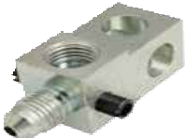BQ182 Straight

BQ252 -3 JIC Elbow
JIC Elbow
5/8-18 UNF
inverted seat

BQ183 90°
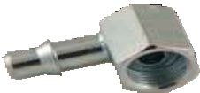
5/8-18 UNF
inverted seat

3/8-24 UNF port, inverted seat 3/8-24 UNF stud (-3 JIC)
for Nissan

See page 13 for assortment kit BQ7000.
Copper Washers

Part Number | Bolt Size | Diameter | Thickness
BQ3858 | 3/8” | 5/8” | 1.5mm
BQ1118 | 7/16” | 18mm | 1.5mm
BQ1320 | 1/2” | 20mm | 2mm
BQ1421 | 9/16” | 21mm | 2mm
BQ813 | 8mm | 13mm | 1.3mm
BQ1016 | 10mm | 16mm | 1.5mm
BQ1218 | 12mm | 18mm | 1.5mm
BQ1522 | 15mm | 22mm | 2mm
BQ1624 | 16mm | 24mm | 2mm
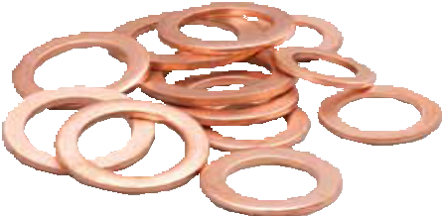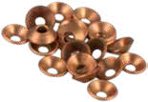BQ244

Copper Seat Seal (Flare Gasket)
See page 13 for assortment kit BQ7007.
Banjo Bolts
Standard

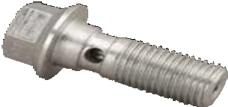

Stud Length
Part Number | Thread | Stud Length | Hex | Washer
BQ8093 | 3/8-24 UNF | 25mm | 11mm | BQ3858
BQ8089 | 7/16-20 UNF | 23.8mm | 1/2” | BQ1118
BQ8096 | 7/16-20 UNF | 27mm | 11mm | BQ1118
BQ8090 | 7/16-24 UNS | 26.5mm | 1/2” | BQ1118
BQ8097 | 1/2-20 UNF | 31mm | 9/16” | BQ1320
BQ8076 | M8 × 1 | 17mm | 10mm | BQ813
BQ8077 | M8 × 1.25 | 16mm | 10mm | BQ813
BQ8095 | M10 × 1 | 22mm | 11mm | BQ1016
BQ8094 | M10 × 1 | 26mm | 11mm | BQ1016
BQ8099 | M10 × 1.25 | 22mm | 11mm | BQ1016
BQ8075 | M10 × 1.5 | 20mm | 11mm | BQ1016
BQ8086 | M10 × 1.5 | 23mm | 11mm | BQ1016
BQ8086SS | M10 × 1.5 | 23mm | 11mm | BQ1016
BQ8088 | M10 × 1.5 | 27mm | 11mm | BQ1016
BQ8087 | M11 × 1.25 | 23mm | 11mm | BQ1118
BQ8098 | M12 × 1 | 21.3mm | 13mm | BQ1218
BQ8078 | M12 × 1.25 | 25mm | 13mm | BQ1218
BQ8092 | M12 × 1.5 | 25mm | 13mm | BQ1218

Profile

Double
Part Number | Thread | Stud Length | Hex | Washer
BQ8085 | 3/8-24 UNF | 34.5mm | 7/16” | BQ3858
BQ8083  BQ8084 | M10 × 1  M10 × 1.25 | 34.5mm  34.5mm | 11mm  11mm | BQ1016  BQ1016

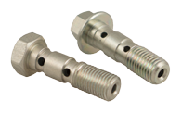BQ8085 has a plain hex profile rather than round.

See page 13 for assortment kit BQ7001.
Banjo Adapters
Part Number | Thread | Hole | Thickness | Width
BQ60 BQ62  BQ63 | 3/8-24 UNF  7/16-24 UNS  1/2-20 UNF | 10.2mm 11.2mm  12.9mm | 1/2”  14mm 16mm | 17mm 18mm  20mm
BQ61 | M10 × 1 | 10.2mm | 13mm | 17mm

Square

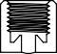Width
Hole

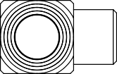Thickness

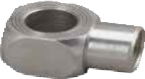
Inverted Seat

Round
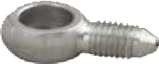
BQ151 and BQ271
are short.
Part Number | Thread | JIC | Hole | Thickness | Width | Overall Length
BQ150 | 3/8-24 UNF | -3 | 10mm | 10mm | 17mm | 42mm
BQ151 | 3/8-24 UNF | -3 | 10mm | 10mm | 17mm | 19.6mm
BQ152 | 3/8-24 UNF | -3 | 10mm | 10mm | 17mm | 39.2mm
BQ155 | 7/16-20 UNF | -4 | 10mm | 10mm | 18mm | 42mm
BQ271 | 1/2-20 UNF | -5 | 14mm | 14mm | 24mm | 26mm
BQ392 | 1/2-20 UNF | -5 | 14mm | 14mm | 24mm | 44mm
BQ393 | 9/16-18 UNF | -6 | 16mm | 16mm | 28mm | 44mm

Width
Thickness

Hole
Overall Length

BQ152

BQ150, BQ155, BQ392 and
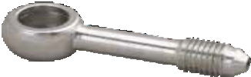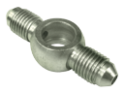BQ393 all have a long tube.

JIC Union
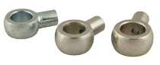
See page 5 for brazing/welding rods.
Weld-On Banjo Heads
Part Number | Hole | Thickness | Width | Tube Size | Overall Length
BQ225 | 7/16” | 10mm | 19mm | 3/16” | 27.5mm
BQ223 | 10.2mm | 8mm | 17mm | 3/16” | 25.5mm
BQ224 | 10.2mm | 10mm | 18mm | 3/16” | 26mm
BQ178 | 12.2mm | 12mm | 22mm | 3/8” | 27mm
BQ179 | 14.2mm | 14mm | 24mm | 3/8” | 28mm

Hole

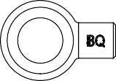Width Thickness Tube Size

Overall Length

See page 13 for assortment kit BQ7014.
Bleed Screws

Stud Length
Part Number | Thread | Stud Length | Hex Size | Cap Size
BQ4439 | 1/4-28 UNF | 15.3 mm | 7 mm | Small
BQ4438 | 5/16-24 UNF | 17.5 mm | 5/16” | Large
BQ4433 | 3/8-24 UNF | 20.8 mm | 3/8” | Large
BQ4445 | 7/16-20 UNF | 20.5 mm | 7/16” | Large
BQ4444 | 7/16-24 UNS | 24.5 mm | 7/16” | Large
BQ4436 | M7 × 1 | 12.5 mm | 8 mm | Small
BQ4441 | M7 × 1 | 21.5 mm | 7 mm | Small
BQ4443 | M8 × 1 | 17.5 mm | 8 mm | Large
BQ4442 | M8 × 1.25 | 22.1 mm | 8 mm | Large
BQ4435 | M10 × 1 | 19.5 mm | 10 mm | Large
BQ4434 | M10 × 1 | 24.1 mm | 10 mm | Large
BQ4446 | M10 × 1.25 | 20.4 mm | 10 mm | Large
BQ4440 | M10 × 1.5 | 17.9 mm | 10 mm | Large

Bleeder caps
BQ315 Small
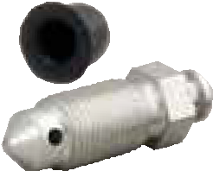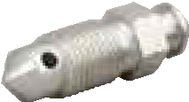BQ316 Large

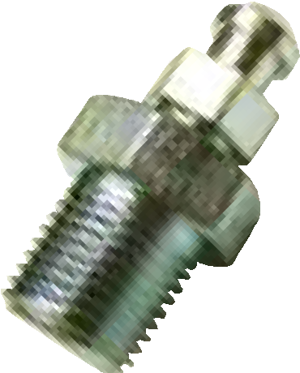
BQ181 Bleed Screw Repair Kit
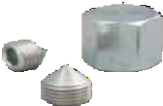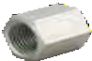Rescue your brake component that has a stripped or broken bleed screw. Simply drill and tap to 1/8-27 NPT.
See page 13 for assortment kit BQ7012.
Fitting Caps and Plugs

Caps

45° inverted seat 8mm thread length
Part Number | Thread | Hex Size
BQ160 | 3/8-24 UNF | 1/2”
BQ161 | 7/16-24 UNS | 9/16”
BQ162 | 7/16-20 UNF | 9/16”
BQ163 | 1/2-20 UNF | 5/8”
BQ164 | M10 × 1 | 13 mm
BQ165 | M10 × 1.25 | 13 mm
BQ166 | M12 × 1 | 16 mm
BQ167 | M12 × 1.5 | 16 mm

Part Number | Thread | Hex Size
BQ19  BQ26 | 3/8-24 UNF  7/16-24 UNS | 3/16”  1/4”
BQ18 | M10 × 1 | 5 mm

See page 17 for bleed screw removal solutions.

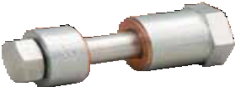
BQ1020 Banjo Blocking-Off Tool
Plugs

See page 17 for line-stopper kits.
Hex Length

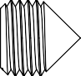

Assortment Kits

BQ7006 Imperial Tube Nuts
PN Description Qty
BQ9176 3/8-24 UNF female 4
BQ57 7/16-20 UNF female 4
BQ9177 1/2-20 UNF female 4
BQ4276 3/8-20 BSF male 4
BQ4285 3/8-24 UNF male 4
BQ5555 3/8-24 UNF male 10
BQ4277 7/16-20 UNF male 4
BQ6118 7/16-20 UNF male 6
BQ2577 7/16-24 UNS male 10
BQ5842 7/16-24 UNS male 10
BQ2578 1/2-20 UNF male 6
BQ9184 | 1/2-20 UNF male | 4 | BQ125 | M10 × 1 — 3/8-24 UNF drill-point | 4
BQ9187 | 1/2-20 UNF male | 4 | BQ49 | M10 × 1 — 3/8-24 UNF inverted | 4
BQ9185 | 9/16-18 UNF male | 4 | BQ40 | M10 × 1 — M10 × 1 drill-point | 2
BQ9186 | 9/16-18 UNF male | 4 | BQ41 | M10 × 1 — M10 × 1.25 inverted | 4
 |  |  | BQ44 | M10 × 1 — M12 × 1 inverted | 4

BQ7004 Male-Female Adapters
PN Description Qty

BQ48 1/8-27 NPT — 3/8-24 UNF inverted 4
BQ156 3/8-24 UNF — 3/8-24 UNF inverted 4
BQ45 3/8-24 UNF — 7/16-24 UNS inverted 4
BQ50 3/8-24 UNF — M10 × 1 inverted 4
BQ47 7/16-20 UNF — 3/8-24 UNF inverted 4
BQ46 7/16-24 UNS — 3/8-24 UNF inverted 4
BQ120 1/2-20 UNF — 3/8-24 UNF inverted 4
BQ122 1/2-20 UNF — 7/16-24 UNS inverted 4
BQ124 9/16-18 UNF — 3/8-24 UNF inverted 2
BQ123 9/16-18 UNF — 7/16-24 UNS inverted 2
BQ121 9/16-20 UNS — 3/8-24 UNF inverted 2
BQ7000 Copper Washers
PN Description Qty
BQ3858 3/8” ID 20
BQ1118 7/16” ID 20
BQ1320 1/2” ID 20
BQ1421 9/16” ID 10
BQ1016 10mm ID 20
BQ1218 12mm ID 20
BQ1522 15mm ID 10
BQ1624 16mm ID 10
BQ7007 Banjo Bolts
PN | Description | Qty
BQ8093 | 3/8-24 UNF | 6
BQ8096 | 7/16-20 UNF | 4
BQ8089 | 7/16-20 UNF | 4
BQ8090 | 7/16-24 UNS | 4

BQ7005 Metric Tube Nuts
PN Description Qty

BQ9175 M10 × 1 female 4
BQ9174 M12 × 1 female 4
BQ9179 M12 × 1 female 4
BQ9178 M12 × 1.5 female 4
BQ4511 M10 × 1 male 10
BQ72 M10 × 1 DIN male 4
BQ4512 M10 × 1.25 male 6
BQ9188 M10 × 1.5 male 4
BQ9191 M11 × 1.5 male 4
BQ4513 M12 × 1 male 6
BQ9180 | M12 × 1 male | 4
BQ9192 | M12 × 1.25 male | 4
BQ9193 | M12 × 1.5 male | 4
BQ9182 | M12 × 1.5 male | 4
BQ9183 | M14 × 1.5 male | 4

BQ7009 Female Unions
PN Description Qty

BQ115 3/8-24 UNF drill-point 4
BQ110 3/8-24 UNF inverted 4
BQ111 7/16-24 UNS inverted 4
BQ114 | M10 × 1 drill-point | 4 | PN | Description | Qty
BQ117 | M10 × 1 inverted | 4 | BQ160 | 3/8-24 UNF cap | 2
BQ116 | M12 × 1 inverted | 4 | BQ19 | 3/8-24 UNF plug | 2
 |  |  | BQ161 | 7/16-24 UNS cap | 2

BQ42 M10 × 1.25 — M10 × 1 inverted 4
BQ43 M12 × 1 — M10 × 1 inverted 4
BQ7010 Male-Male Adapters
PN Description Qty
BQ135 3/8-24 UNF — 3/8-24 UNF 4
BQ131 3/8-24 UNF — 7/16-20 UNF 4
BQ134 7/16-24 UNS — 7/16-20 UNF 4
BQ129 M10 × 1 — 3/8-24 UNF 4
BQ130 M10 × 1.5 — 3/8-24 UNF 4
BQ144 M12 × 1 — 3/8-24 UNF 4
BQ7003 Bump Tube Adapters
PN Description Qty
5MBT-5MJ 1/2-20 UNF — 1/2-20 UNF 4
7MBT-6MJ 11/16-18 UNS — 9/16-18 UNF 4

14MMBT-6MJ | M14 × 1.5 — 9/16-18 UNF | 4
16MMBT-6FI | M16 × 1.5 — 5/8-18 UNF | 4
16MMBT-6MJ | M16 × 1.5 — 9/16-18 UNF | 4
18MMBT-6MJ | M18 × 1.5 — 9/16-18 UNF | 4

BQ7012 Brake Hose Plugs and Caps

BQ8097 1/2-20 UNF 4
BQ8095 M10 × 1 6
BQ8099 M10 × 1.25 4
BQ8086 M10 × 1.5 4
BQ8088 M10 × 1.5 4
BQ8087 M11 × 1.25 4
BQ8098 M12 × 1 4
BQ8092 M12 × 1.5 4
BQ7001 Banjo Unions & Adapters

PN | Description | Qty
BQ60 | 3/8-24 UNF, 10mm hole | 4
BQ150 | 3/8-24 UNF, 10mm hole | 4
BQ151 | 3/8-24 UNF, 10mm hole | 4
BQ62 | 7/16-24 UNS, 7/16” hole | 4
BQ63 1/2-24 UNF, 1/2” hole 4
BQ61 M10 × 1, 10mm hole 4
BQ7014 Bleed Screws

PN | Description | Qty
BQ4439 | 1/4-28 UNF | 4
BQ4438 | 5/16-24 UNF | 4
BQ4433 | 3/8-24 UNF | 6
BQ4444 | 7/16-24 UNS | 4
BQ4445 7/16-20 UNF 4

BQ7002 3-way Tube Tees
PN Description Qty
BQ26 7/16-24 UNS plug 2
BQ163 1/2-20 UNF cap 2
BQ4441 | M7 × 1 | 4
BQ4443 | M8 × 1 | 4
BQ4442 | M8 × 1.25 | 4
BQ4435 | M10 × 1 short | 4
BQ4434 | M10 × 1 long | 4
BQ4446 | M10 × 1.25 | 4

BQ18 M10 × 1 plug 2

BQ93 1/8-27 NPT 2
BQ90A 3/8-24 UNF drill-point 2
BQ56A 3/8-24 UNF inverted 2
BQ92A 7/16-24 UNS inverted 2
BQ91A M10 × 1 inverted 2
BQ95A M10 × 1 DIN 2
BQ164 M10 × 1 cap 2
BQ165 M10 × 1.25 cap 2
BQ166 M12 × 1 cap 2
BQ167 M12 × 1.5 cap 2
BQ1020 Banjo Blocking-Off Tool 1
BQ4440 M10 × 1.5 4

BQ315 | Small Cap | 10
BQ316 | Large Cap | 10

Tube Workers — Straighteners

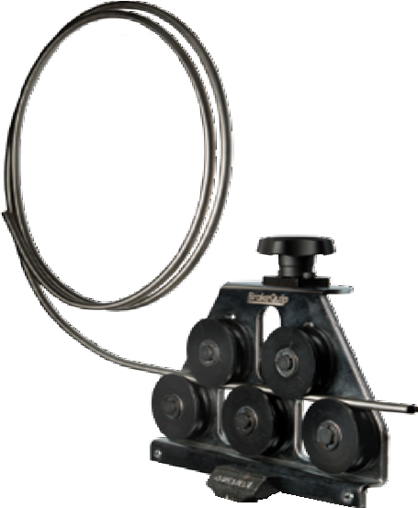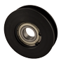BQ1028 Professional Tube Straightener
The BQ1028 provides the average shop the ability to complete a professional tube installation by forming coiled tube into straight sections of any length, offering precise tube routing and reducing the number of unions required. Adjust the wheels to the tube size and pull the tube through the tool to straighten.

  - for 3/16” to 1/2” light-walled, annealed tube, including stainless steel
  - Non-marking ABS wheels
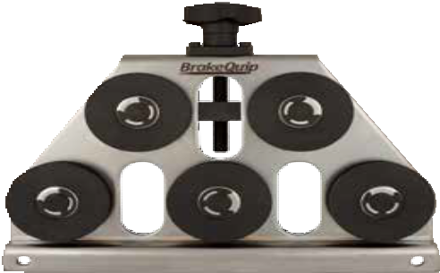
  - 5-point precision and fine-threaded adjustment
  - Vice mount or bolt straight to workbench
  - Smooth ball bearing action
  - Heavy-duty construction

BQ1028-75

Replacement wheel

BQ1030 Brake Tube Straightener

BQ1030-MB Mounting Bracket for Brake Tube Straightener
The BQ1030 was designed for the automotive DIY-er with a need to straighten coils of the most brake line sizes.

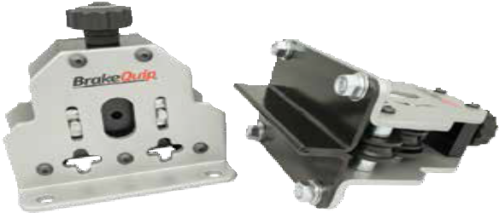
  - Straighten 3/16”–1/4” annealed tubing, including cunifer and stainless steel
  - U-shaped rollers straighten both tubing sizes — no need to change rollers
  - Hard polymer rollers leave a smooth finish on tubing
  - Smooth ball bearing action
  - Bench-mount ready
  - Optional vise-mount base (BQ1030-MB)

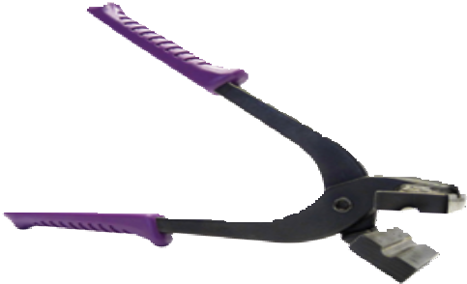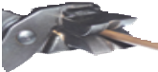BQ405 Tube-Straightening Pliers
Remove imperfections or fix mistakes with the BQ405 pliers.

    - Straightens incorrect bends in 3/16” and 1/4” tube, including stainless steel
    - Makes tight-radius bends, up to 90°, for both 3/16” and 1/4” tube
    - The flat side of the mandrel provides a guide surface for cutting

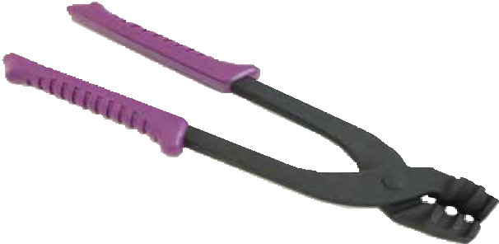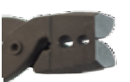BQ402 Brake Tube Pliers
Tube Workers — Benders
For use on 3/16” and 1/4” brake tube.
These pliers are perfect for working in constrained areas under a vehicle to
- align the tube and nut with the port during installation
- put a tight 90° bend behind a tube nut (such as a master cylinder drop)
One side of the tool end is flat to facilitate cutting.
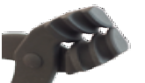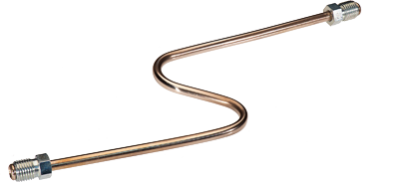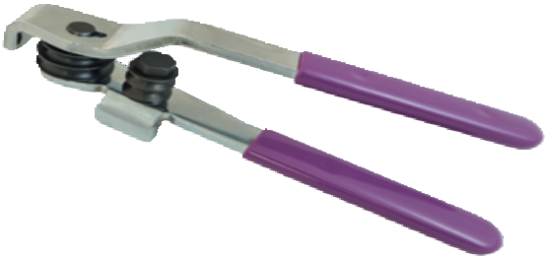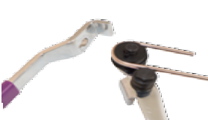

BQ406 Professional Tube Bender
For use on 3/16” and 1/4” brake tube, this bender is easy to use and yields professional results. Bend on the vehicle or mount the tool in a vise for precision work or mass production.

- Low-friction rollers make for easy precision work
- Smooth roller channels provide a clean, scratch free finish
- Tight radius bends up to 180°
- Handles separate for quick and easy tube removal

Metal Tube Cutters
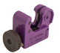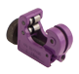These tube cutters have a heavy-duty wheel for cutting stainless steel or other light-walled tubing, 3/16” to 5/8”.

BQ601 Mini Tube Cutter
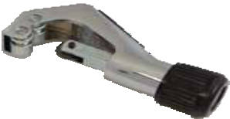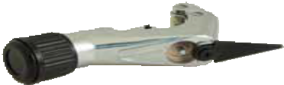Great for cutting in tight places.

BQ602 Professional Tube Cutter
Replacement blade is BQ602C.

BQ2103 Hose Cutter
Cutters
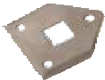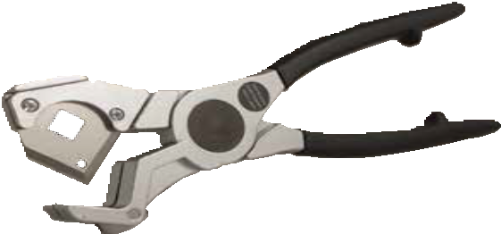This heavy duty tool cuts hose clean and square with ease. The blade has two cutting points for double life.

BQ2101B

Replacement blade

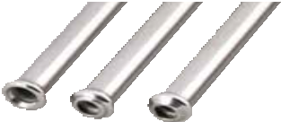See pages 2 and 3 for stainless steel and cunifer tubing.
Flaring Tools

BrakeQuip High-Speed Flaring Tools are the industry standard for accurate and consistent flares.
  - Smooth channel dies minimize tube scarring and deformation for a show quality finish.
  - The cam-and-lever design, combined with ball-detent turrets, provide fast and easy single, double, bubble, and DIN flares.
  - BrakeQuip flaring tools are designed to be used in a bench vise or with our table flange mount (BQ350-1).
  - Replacement components are available, all the way down to the individual punches on the turrets.

37° or 45°
Single

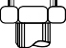37° or 45°
Double

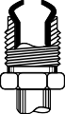
Bubble

DIN

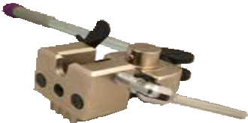
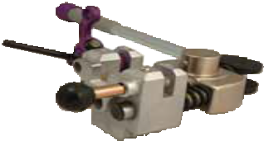
Tool Body and Handle

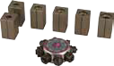
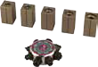
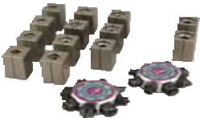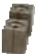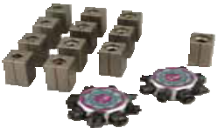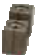Dies and Turrets

Part Number BQ350A BQ350 BQ351 BQ352

45° flares 3/16”, 1/4”, 5/16”, 3/8” 4.75mm, 6mm, 8mm, 10mm

3/16”, 1/4”, 5/16”, 3/8”, 1/2”
  - mm, 6mm, 8mm, 10mm

3/16”, 1/4”, 5/16”, 3/8”, 1/2”

none

37° flares 3/16”, 1/4”, 5/16”, 3/8”, 1/2” 3/16”, 1/4”, 5/16”, 3/8”, 1/2”

none

3/16”, 1/4”, 5/16”, 3/8”, 1/2”

DIN flares 3/16”, 1/4” 3/16”, 1/4” 3/16” none
Already have the BQ351 and just need 37° dies and turrets? Order BQ352-BQ to get the dies and turrets pictured with the BQ352.

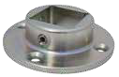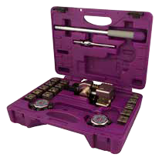The BQ350A features . . .
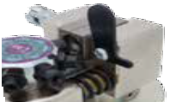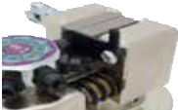
a tube-setting tab to ensure proper placement in the dies

a die-cast steel body for added strength and an extra-long handle for more leverage

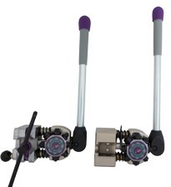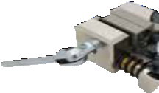a die-clamp bolt for quick die swaps
BQ350-1 Mounting Flange
Works will all BrakeQuip flaring tools. Included with the BQ350A.

Other Tools

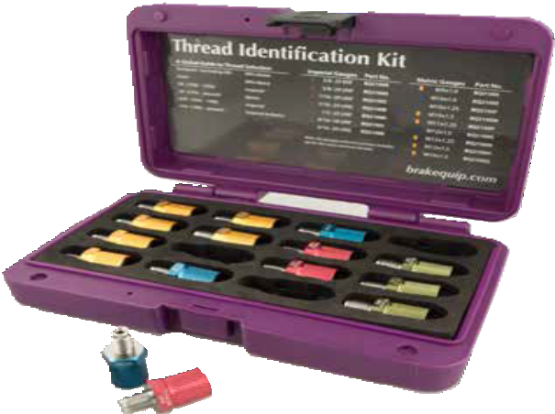BQ2100 Thread Identification Kit
A kit of the highest quality, the BQ2100 has gauges for the vast majority of brake plumbing threads, both male and female. Gauges are color-coded for fast selection. The threads are hardened for long life, and each gauge is available separately as a replacement part.
The gauges can also be used to block-off fluid ports during service.

Imperial Sizes
3/8-20 BSF
3/8-24 UNF
7/16-20 UNF
7/16-24 UNS
1/2-20 UNF
9/16-18 UNF
9/16-20 UNS
Metric Sizes

M9 × 1
M10 × 1
M10 × 1.25
M10 × 1.5
M11 × 1.25
M12 × 1
M12 × 1.25
M12 × 1.5
M14 × 1.5

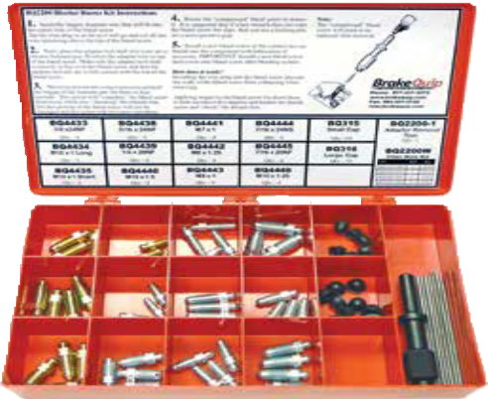
BQ2200 Bleeder Buster Kit
Remove and replace frozen bleeder screws like a pro. Here's how:
    - Insert filler wire into the bleed screw and cut flush with the end
    - Install the Bleed Screw Removal Tool into an air chisel and shock the bleed screw from the top
    - Unscrew the bleed screw with a conventional tool
The kit includes the bleed screw removal tool and an assortment of filler wire, bleed screws, and caps for all applications. The tool, screws, caps, and filler wire are all available individually as replacement parts.

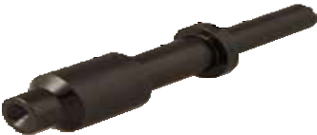
BQ2200-1

Bleed Screw Removal Tool
BQ2200W
Filler Wire Replenishment Kit
See page 12 for a complete selection of bleed screws and caps.

BQ407 and BQ408 Line Stopper Kits
Prevent fluid leaks and contamination during service. Simply slide the appropriate stopper around the tube nut or banjo head and release. The spring-loaded plunger will seal around the fitting and prevent leaks.
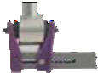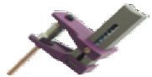Note: the 5/16” stopper in the BQ407 kit is also suitable for 3/16” and 1/4” lines.

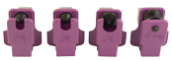
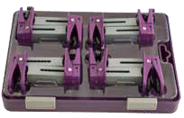
BQ407 4-Piece Stopper Kit

Stopper Size | BQ407 Qty | BQ408 Qty
3/16”–1/4” | — | 2
5/16” | 1 | 2
3/8” | 1 | 1
1/2” | 1 | 1
Banjo | 1 | 2
BQ408 8-Piece Stopper Kit
Comes in slide-lock clamshell case.

Fuel BrakeQuip
Fuel Fittings

Thumb-release convenience. No special tools required. Works with both domestic and foreign vehicles.
Quick Connects
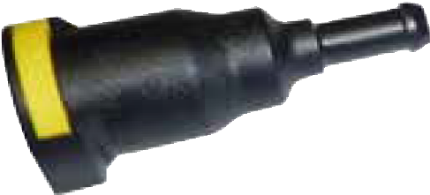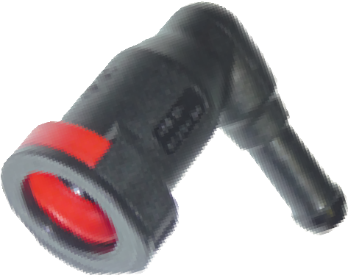
Straight  Part Number | Female | Male |  | 90° Bend  Part Number | Female | Male
FL08-4-5 | 1/4” | 5/16” |  | FL09-5-5 | 5/16” | 5/16”
FL08-5-5 | 5/16” | 5/16” |  | FL09-5-6 | 5/16” | 3/8”
FL08-5-6 | 5/16” | 3/8” |  | FL09-6-5 | 3/8” | 5/16”
FL08-6-5 | 3/8” | 5/16” |  | FL09-6-6 | 3/8” | 3/8”
FL08-6-6 | 3/8” | 3/8”

Quick Connector Tubes
Part Number Description
FL05-4 1/4” quick connect to 8mm FuelFlex - straight
FL03-5 5/16” quick connect to 8mm FuelFlex - straight
FL03-6 3/8” quick connect to 10mm FuelFlex - straight
FL04-6 3/8” quick connect to 3/8” quick connect - straight
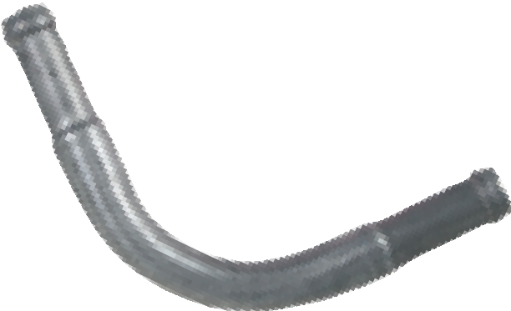

Part Number Description
FL20-5 8mm FuelFlex to 8mm FuelFlex - 90°
FL20-6 10mm FuelFlex to 10mm FuelFlex - 90°
FuelFlex Connectors

Part Number Description
FuelFlex Reducers
FL06-5-4 8mm FuelFlex to 1/4” FuelFlex
FL06-6-5 10mm FuelFlex to 8mm FuelFlex

Part Number Description FL02-5 8mm FuelFlex to 5/16” rubber hose
FuelFlex to Rubber Hose
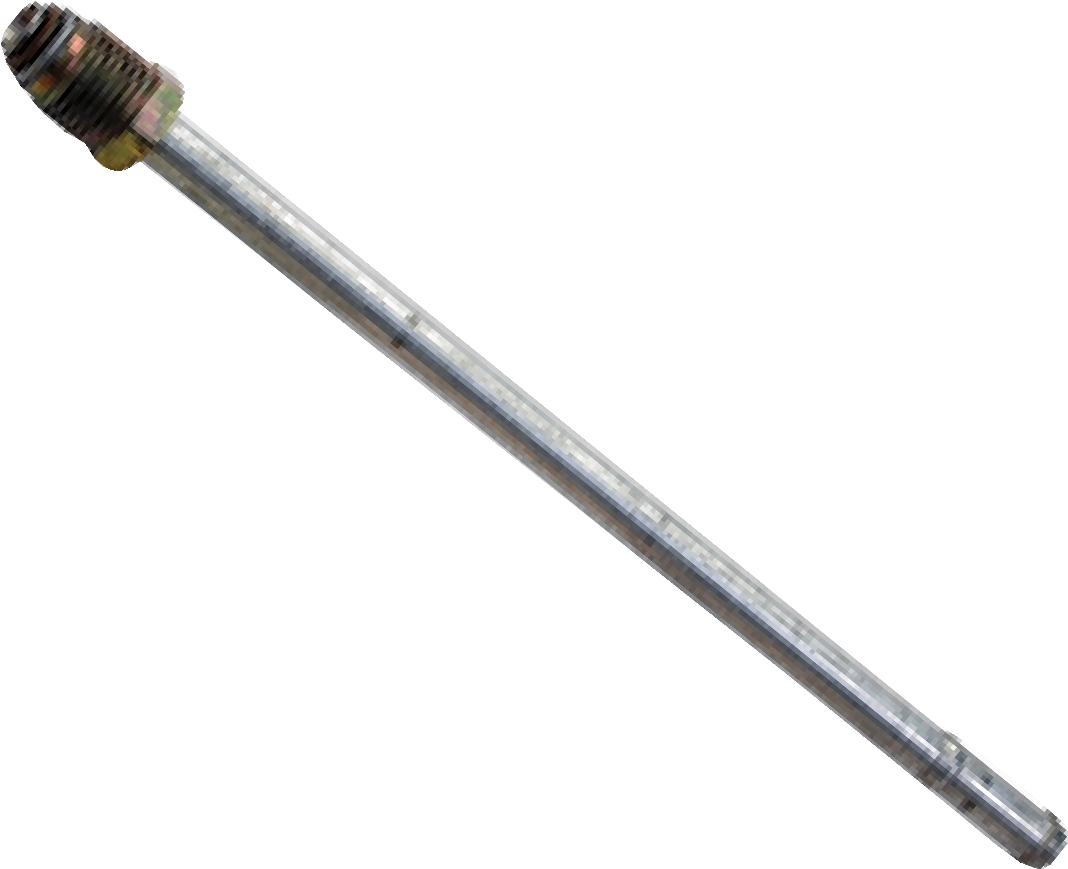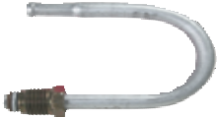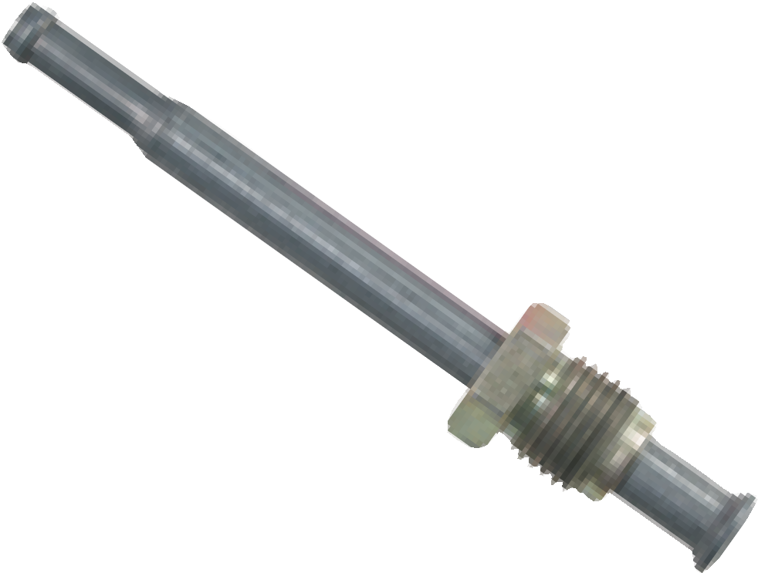FL02-6 10mm FuelFlex to 3/8” rubber hose

Threaded Connectors
 | Straight  Part Number | Tube End | End Form | Thread | Length
 | FL07-5 | 5/16” rubber hose | bump | M14 × 1.5 | 230mm
 | FL07-6 | 3/8” rubber hose | bump | M16 × 1.5 | 230mm
 | FL12-14mm | 8mm FuelFlex | double flare | M14 × 1.5 | 90mm
 | FL13-5 | 8mm FuelFlex | bump | M14 × 1.5 | 155mm
 | FL14-5 | 8mm FuelFlex | bump | M14 × 1.5 | 100mm
 | FL13-6 | 10mm FuelFlex | bump | M16 × 1.5 | 155mm
 | FL14-6 | 10mm FuelFlex | bump | M16 × 1.5 | 100mm
 | Bent  Part Number | Tube End | End Form | Thread | Angle
 | FL11-14mm | 8mm FuelFlex | double flare | M14 × 1.5 | 30°
 | FL15 | 10mm FuelFlex | bump | M16 × 1.5 | 180°

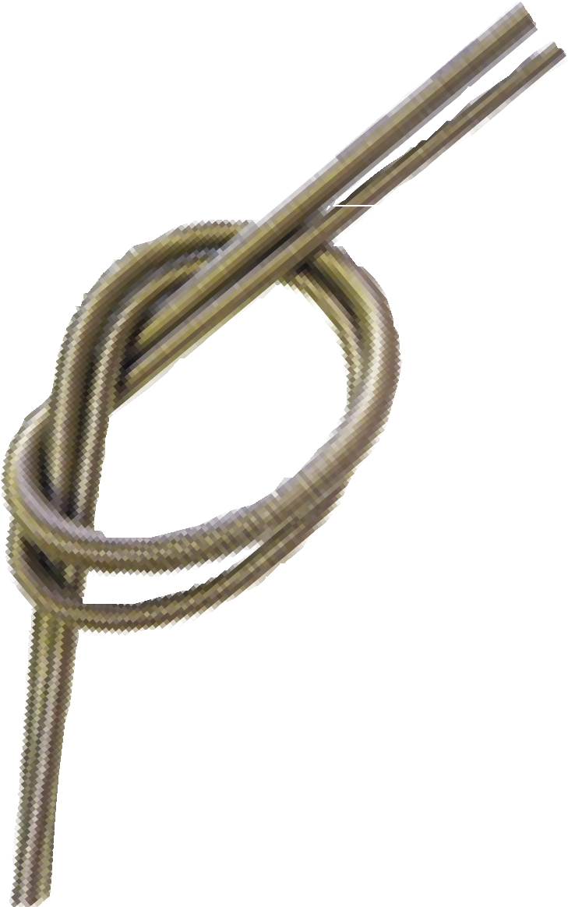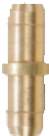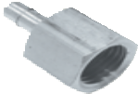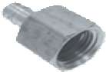Innovative Solutions for Automotive Tubes and Hoses Fuel
FuelFlex Tubing
Part Number Size
T8-FF 8mm (5/16”)
T10-FF 10mm (3/8”)
Coil Length
25ft 25ft
Spring Mandrels
Part Number Size
BQ318
BQ319
8mm (5/16”)
10mm (3/8”)
Note: In keeping with industry conventions for plastic tubing sizes, FuelFlex tubing is measured by outer diameter.
Permanently form fuel tubing without kinking.
FuelFlex Unions
Part Number
FL01-5
Male-Female Adapters
Size
8mm
Part Number
FL10-5S
Male
8mm FuelFlex
Female
M14 × 1.5
Seat
bump
FL01-6 10mm
Fuel Fittings

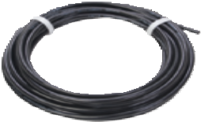

FL10-6S | 10mm FuelFlex | M16 × 1.5 | bump
FL10-14mm | 8mm FuelFlex | M14 × 1.5 | inverted

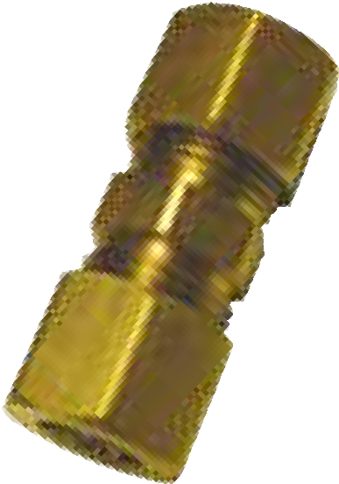
Compression Fittings
Part Number Description

Bump Tube Nuts
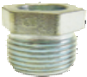
Part Number Size

FL37 | 8mm FuelFlex — 8mm FuelFlex |  | BQ9148 | M16 × 1.5 – 3/8”
FL36 | 8mm FuelFlex — 5/16” metal tube |  | BQ9149 | M14 × 1.5 – 5/16”
FL39 | 10mm FuelFlex — 10mm FuelFlex
FL38 | 10mm FuelFlex — 3/8” metal tube |  |  | 360° Tube Clamps

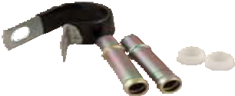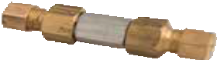Tube Support Clamps
FL34 10mm (3/8”)
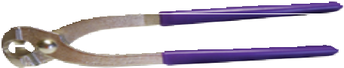
FL35 8mm (5/16”)
FL26 10mm (3/8”)
FL25 8mm (5/16”)

Fuel Pressure Repair Kit (Check Valve)
FL21 8mm (5/16”)
FL22 10mm (3/8”)

BQ412 Tube Clamp Pliers

Part Number | Qty | Part Number | Qty | Part Number | Qty | BQFL4500 Fuel Line Kit
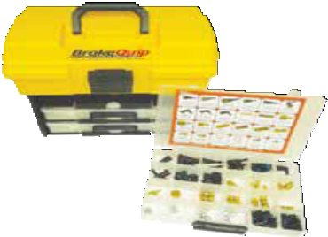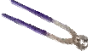

FL20-6 2
Tubing |  | FuelFlex Reducers |  | Compression Fittings
T8-FF | 25ft | FL06-6-5 | 2 | FL36 | 2
T10-FF | 25ft | FuelFlex Adapters |  | FL37 | 2
Quick Connects |  | FL02-5 | 2 | FL38 | 2
FL08-4-5 | 2 | FL02-6 | 2 | FL39 | 2
FL08-5-5 | 2 | Theaded Connectors |  | Bump Tube Nuts
FL08-5-6 | 2 | FL07-5 | 2 | BQ9148 | 4
FL08-6-5 | 2 | FL07-6 | 2 | BQ9149 | 4
FL08-6-6 | 2 | FL11-14mm | 2 | Screws and Clamps
FL09-5-5 | 2 | FL12-14mm | 2 | BQ811 | 20
FL09-5-6 | 2 | FL13-5 | 2 | FL25 | 20
FL09-6-5 | 2 | FL13-6 | 2 | FL26 | 20
FL09-6-6 | 2 | FL14-5 | 2 | FL34 | 20
Quick Connector | Tubes | FL14-6 | 2 | FL35 | 20
FL03-5 | 2 | FL15 | 1 | Tools
FL03-6 | 2 | FuelFlex Unions |  | BQ318 | 1
FL04-6 | 2 | FL01-5 | 2 | BQ319 | 1
FL05-4 | 2 | FL01-6 | 2 | BQ-01 cutter | 1
FuelFlex Connectors Male-Female Adapters BQ412 1
FL20-5 | 2 | FL10-5 | 1 | Tube Protection

FL10-6S 1
FL10-14mm 1

BQ313-SV 5ft
The BrakeQuip Professional Fuel Line Kit comes with dozens of components and fittings, from quick connects and adapters to pliers, clamps, and heat shields. With over 180 pieces and 50 feet of FuelFlex Tubing, this kit is a complete fuel line solution for almost any vehicle.

JIC Fittings

JIC (Joint Industry Council) fittings are defined by SAE J514 and use a 37° sealing surface. They are commonly found on aftermarket adapters, bias valves, calipers, and gauges. JIC fittings should not be mixed with 45° flares, or vice-versa.
37°

Note on JIC vs AN fittings: JIC fittings have the same dimensions as their AN (Army-Navy) counterparts. The difference is that
AN fittings are specified to extreme tolerances for aerospace applications.

Part Number JIC Description Page
Banjo Adapters 11
Part Number JIC Description Page
Male-Male Adapters (continued) 9

BQ150 | -3 | Round banjo head, long |  | BQ130 | -3 | JIC to M10 × 1.5
BQ151 | -3 | Round banjo head |  | BQ131 | -4 | JIC to 3/8-24 UNF
BQ152 | -3 | Round banjo union (2 studs) |  | BQ134 | -4 | JIC to 7/16-24 UNS
BQ155 | -4 | Round banjo head, long |  | BQ145 | -4 | JIC to M10 × 1
BQ271 | -5 | Round banjo head |  | BQ176 | -4 | JIC to M10 × 1, long
BQ392 | -5 | Round banjo head, long |  | BQ144 | -4 | JIC to M12 × 1
BQ393 | -6 | Round banjo head, long |  | BQ149 | -4 | JIC to M12 × 1.25
Bump Tube Adapters  5MBT-5MJ | -5 | JIC to 1/2-20 UNF | 9 | Male Tees  BQ360 | -3 | Bolt mount male tube tee | 7
7MBT-6MJ | -6 | JIC to 11/16-18 UNS |  | BQ361 | -4 | Bolt mount male tube tee
14MMBT-6MJ | -6 | JIC to M14 × 1.5 |  | Male Unions |  |  | 6
16MMBT-6MJ | -6 | JIC to M16 × 1.5 |  | BQ292 | -3 | Steel JIC union
18MMBT-6MJ | -6 | JIC to M18 × 1.5 |  | BQ292SS | -3 | Stainless steel JIC union
Elbow  BQ252 | -3 | JIC to 3/8-24 UNF, elbow | 9 | BQ293SS  Weld-On Studs | -3 | Stainless steel JIC union, long | 5
Male-Male Adapters |  |  | 9 | BQ153 | -3 | Steel stud for 3/16” tube
BQ135 | -3 | JIC to 3/8-24 UNF |  | BQ170 | -6 | Aluminum stud for 3/8” tube
BQ132 | -3 | JIC to 1/4-28 UNF |  | BQ172 | -8 | Aluminum stud for 1/2” tube
BQ168 | -3 | JIC to 1/2-20 UNF |  | BQ173 | -10 | Aluminum stud for 5/8” tube
BQ157 | -3 | JIC to 1/8-28 BSPP |  | BQ226 | -6 | Steel stud for 3/8” tube
BQ129 | -3 | JIC to M10 × 1 |  | BQ227 | -6 | Steel stud for 10mm tube
BQ128 | -3 | JIC to M10 × 1.25 |  | BQ228 | -6 | Steel stud for 1/2” tube

Stainless Steel

Part Number | Description | Page |  | Part Number | Description | Page
Banjo Bolts  BQ8086SS | M10 × 1.5 | 10 |  | Male Tube Nuts  BQ5555SS | 3/8-24 UNF | 4
Clips  BQ3052SS | Universal Clip | 6 |  | BQ5842SS  BQ2577SS | 7/16-24 UNS  7/16-24 UNS
Female Tees  BQ56ASS | 3/8-24 UNF, bolt mount | 7 |  | BQ4511SS  BQ4513SS | M10 × 1  M12 × 1
BQ177SS | 3/8-24 UNF, special tube tee |  |  | Spring Guards |  | 3
Female Unions  BQ111SS | 7/16-24 UNS | 6 |  | BQ231  BQ232 | for 3/16” tube  for 1/4” tube
Male Unions  BQ292SS | 3/8-24 UNF (-3 JIC) | 6 |  | Tubing  T187-20SS | 3/16” tube, 20ft coil | 3
BQ293SS | 3/8-24 UNF (-3 JIC), long |  |  | T250-20SS | 1/4” tube, 20ft coil
 |  |  |  | T312-20SS | 5/16” tube, 20ft coil
 |  |  |  | T375-20SS | 3/8” tube, 20ft coil

Index

Part Number | Page | Part Number | Page | Part Number | Page | Part Number | Page
5MBT-5MJ | 9 | BQ89 | 7 | BQ162 | 12 | BQ313-SV | 3
7MBT-6MJ | 9 | BQ90A | 7 | BQ163 | 12 | BQ315 | 12
14MMBT-6MJ | 9 | BQ91A | 7 | BQ164 | 12 | BQ316 | 12
16MMBT-6FI | 9 | BQ92A | 7 | BQ165 | 12 | BQ318 | 19
16MMBT-6MJ | 9 | BQ93A | 7 | BQ166 | 12 | BQ319 | 19
18MMBT-6MJ | 9 | BQ94A | 7 | BQ167 | 12 | BQ320 | 3
BQ-01 | 19 | BQ95A | 7 | BQ168 | 9 | BQ321 | 3
BQ13 | 7 | BQ110 | 6 | BQ170 | 5 | BQ322 | 3
BQ18 | 12 | BQ111 | 6 | BQ171 | 5 | BQ350 | 16
BQ19 | 12 | BQ111SS | 6 | BQ172 | 5 | BQ350-1 | 16
BQ26 | 12 | BQ112 | 6 | BQ173 | 5 | BQ350A | 16
BQ33 | 5 | BQ113 | 6 | BQ174 | 5 | BQ351 | 16
BQ34 | 5 | BQ114 | 6 | BQ176 | 9 | BQ352 | 16
BQ40 | 8 | BQ115 | 6 | BQ177SS | 7 | BQ352-BQ | 16
BQ41 | 8 | BQ116 | 6 | BQ178 | 11 | BQ360 | 7
BQ42 | 8 | BQ117 | 6 | BQ179 | 11 | BQ361 | 7
BQ43 | 8 | BQ119 | 6 | BQ181 | 12 | BQ378 | 7
BQ44 | 8 | BQ120 | 8 | BQ182 | 9 | BQ379 | 8
BQ45 | 8 | BQ121 | 8 | BQ183 | 9 | BQ380 | 8
BQ46 | 8 | BQ122 | 8 | BQ187 | 8 | BQ383 | 8
BQ47 | 8 | BQ123 | 8 | BQ202 | 3 | BQ392 | 11
BQ48 | 8 | BQ124 | 8 | BQ222 | 6 | BQ393 | 11
BQ49 | 8 | BQ125 | 8 | BQ223 | 11 | BQ402 | 15
BQ50 | 8 | BQ127 | 8 | BQ224 | 11 | BQ405 | 14
BQ55 | 5 | BQ128 | 9 | BQ225 | 11 | BQ406 | 15
BQ56A | 7 | BQ129 | 9 | BQ226 | 5 | BQ407 | 17
BQ56ASS | 7 | BQ130 | 9 | BQ227 | 5 | BQ408 | 17
BQ57 | 5 | BQ131 | 9 | BQ228 | 5 | BQ412 | 19
BQ60 | 11 | BQ132 | 9 | BQ231 | 3 | BQ601 | 15
BQ61 | 11 | BQ134 | 9 | BQ232 | 3 | BQ602 | 15
BQ62 | 11 | BQ135 | 9 | BQ244 | 10 | BQ602C | 15
BQ63 | 11 | BQ141 | 5 | BQ246 | 8 | BQ813 | 10
BQ71 | 6 | BQ144 | 9 | BQ247 | 8 | BQ1016 | 10
BQ72 | 4 | BQ145 | 9 | BQ248 | 8 | BQ1020 | 12
BQ75 | 7 | BQ147 | 6 | BQ249 | 6 | BQ1028 | 14
BQ77 | 7 | BQ148 | 6 | BQ250 | 6 | BQ1028-75 | 14
BQ78 | 7 | BQ149 | 9 | BQ252 | 9 | BQ1030 | 14
BQ79 | 7 | BQ150 | 11 | BQ260 | 8 | BQ1030-MB | 14
BQ80 | 7 | BQ151 | 11 | BQ261 | 8 | BQ1118 | 10
BQ81 | 7 | BQ152 | 11 | BQ262 | 8 | BQ1218 | 10
BQ82 | 7 | BQ153 | 5 | BQ264 | 7 | BQ1320 | 10
BQ83 | 7 | BQ155 | 11 | BQ265 | 7 | BQ1421 | 10
BQ84 | 7 | BQ156 | 8 | BQ271 | 11 | BQ1522 | 10
BQ85 | 7 | BQ157 | 9 | BQ292 | 6 | BQ1624 | 10
BQ86 | 7 | BQ160 | 12 | BQ292SS | 6 | BQ2100 | 17
BQ87 | 7 | BQ161 | 12 | BQ293SS | 6 | BQ2101B | 15

Index

Part Number | Page | Part Number | Page | Part Number | Page | Part Number | Page
BQ2103 | 15 | BQ7006 | 13 | BQ9186 | 4 | FL10-5S | 19
BQ2200 | 17 | BQ7007 | 13 | BQ9187 | 4 | FL10-6S | 19
BQ2200-1 | 17 | BQ7009 | 13 | BQ9188 | 4 | FL10-14mm | 19
BQ2200W | 17 | BQ7010 | 13 | BQ9189 | 4 | FL11-14mm | 18
BQ2577 | 4 | BQ7012 | 13 | BQ9190 | 4 | FL12-14mm | 18
BQ2577SS | 4 | BQ7014 | 13 | BQ9191 | 4 | FL13-5 | 18
BQ2578 | 4 | BQ7812 | 7 | BQ9192 | 4 | FL13-6 | 18
BQ3052 | 6 | BQ8075 | 10 | BQ9193 | 4 | FL14-5 | 18
BQ3053 | 6 | BQ8076 | 10 | BQ9194 | 4 | FL14-6 | 18
BQ3052SS | 6 | BQ8077 | 10 | BQ9195 | 4 | FL15 | 18
BQ3858 | 10 | BQ8078 | 10 | BQ9196 | 4 | FL20-5 | 18
BQ4276 | 4 | BQ8083 | 10 | BQ9197 | 4 | FL20-6 | 18
BQ4277 | 4 | BQ8084 | 10 | BQ9198 | 4 | FL21 | 19
BQ4285 | 4 | BQ8085 | 10 | BQ9199 | 4 | FL22 | 19
BQ4433 | 12 | BQ8086 | 10 | BQ9207 | 5 | FL25 | 19
BQ4434 | 12 | BQ8086SS | 10 | BQ9208 | 5 | FL26 | 19
BQ4435 | 12 | BQ8087 | 10 | BQ9209 | 5 | FL34 | 6, 19
BQ4436 | 12 | BQ8088 | 10 | BQ9210 | 5 | FL35 | 6, 19
BQ4438 | 12 | BQ8089 | 10 | BQ9300 | 8 | FL36 | 19
BQ4439 | 12 | BQ8090 | 10 | BQ9301 | 8 | FL37 | 19
BQ4440 | 12 | BQ8092 | 10 | BQ9304 | 8 | FL38 | 19
BQ4441 | 12 | BQ8093 | 10 | BQ9305 | 8 | FL39 | 19
BQ4442 | 12 | BQ8094 | 10 | BQB06 | 6 | T8-FF | 19
BQ4443 | 12 | BQ8095 | 10 | BQB244 | 6 | T10-FF | 19
BQ4444 | 12 | BQ8096 | 10 | BQFL4500 | 19 | T187-20SS | 3
BQ4445 | 12 | BQ8097 | 10 | FL01-5 | 19 | T187-25CN | 2
BQ4446 | 12 | BQ8098 | 10 | FL01-6 | 19 | T187-25SE | 2
BQ4510 | 4 | BQ8099 | 10 | FL02-5 | 18 | T187-100CN | 2
BQ4511 | 4 | BQ9148 | 4, 19 | FL02-6 | 18 | T187-100SE | 2
BQ4511LT | 4 | BQ9149 | 4, 19 | FL03-5 | 18 | T250-20SS | 3
BQ4511SS | 4 | BQ9156 | 5 | FL03-6 | 18 | T250-25CN | 2
BQ4512 | 4 | BQ9157 | 4 | FL04-6 | 18 | T250-25SE | 2
BQ4513 | 4 | BQ9166 | 4 | FL05-4 | 18 | T250-100CN | 2
BQ4513LT | 4 | BQ9169 | 4 | FL06-5-4 | 18 | T250-100SE | 2
BQ4513SS | 4 | BQ9174 | 5 | FL06-6-5 | 18 | T312-20SS | 3
BQ5555 | 4 | BQ9175 | 5 | FL07-5 | 18 | T312-25CN | 2
BQ5555SS | 4 | BQ9176 | 5 | FL07-6 | 18 | T312-25SE | 2
BQ5842 | 4 | BQ9177 | 5 | FL08-4-5 | 18 | T375-20SS | 3
BQ5842SS | 4 | BQ9178 | 5 | FL08-5-5 | 18 | T375-25CN | 2
BQ6118 | 4 | BQ9179 | 5 | FL08-5-6 | 18 | T375-25SE | 2
BQ7000 | 13 | BQ9180 | 4 | FL08-6-5 | 18
BQ7001 | 13 | BQ9181 | 4 | FL08-6-6 | 18
BQ7002 | 13 | BQ9182 | 4 | FL09-5-5 | 18
BQ7003 | 13 | BQ9183 | 4 | FL09-5-6 | 18
BQ7004 | 13 | BQ9184 | 4 | FL09-6-5 | 18
BQ7005 | 13 | BQ9185 | 4 | FL09-6-6 | 18

Find a Dealer

BrakeQuip Products are Available
from Authorized Dealers in more than 60 Countries
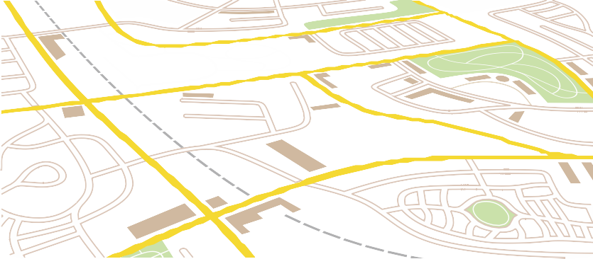Find your local dealer at
brakequip.com/find-a-dealer

Standard Profile Brake Hoses Low-Profile Brake Hoses Power Steering Hoses
Metal Tube Hardware Tools

Replacement or Custom Brake, Clutch, and Power Steering Hoses
Replace your old hoses to improve system performance. Custom hoses can reduce the number of leak points, provide for proper hose routing, and offer a personalized touch.
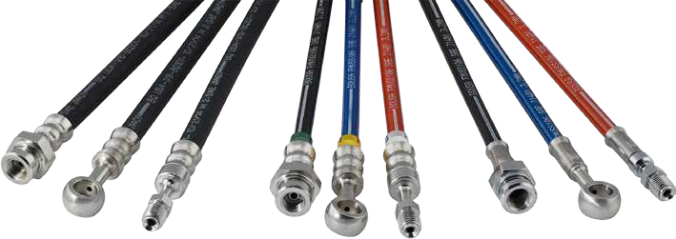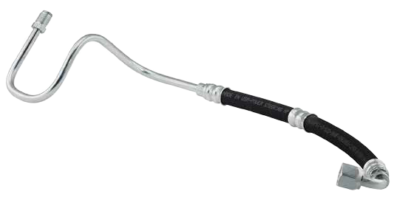
Standard crimp on rubber hose
Low-profile crimp on braided hose
Standard crimp on braided hose
High-pressure power steering hose with a custom tube form
BrakeQuip hoses, tubes, and fittings are designed to meet or exceed all international safety and quality standards.
Every BrakeQuip brake hose is pressure tested to 3000 psi for quality that you can trust.

Complete your next build with the right tools. Whether double flaring our stainless steel or shaping our signature EziBend copper-nickel, BrakeQuip hand tools are fast and consistent and deliver clean, professional results.
BrakeQuip offers a comprehensive selection of fuel line and hardware components.
Every BrakeQuip hose assembly is DOT compliant and meets all international standards. For replacement or custom hoses, contact one of over 600 local BrakeQuip dealers.
Learn more at brakequip.com.

SINCE 1998
V
DOT

ULLY
O PL ANT
B

To find a local hose dealer, visit
brakequip.com/find-a-dealer

