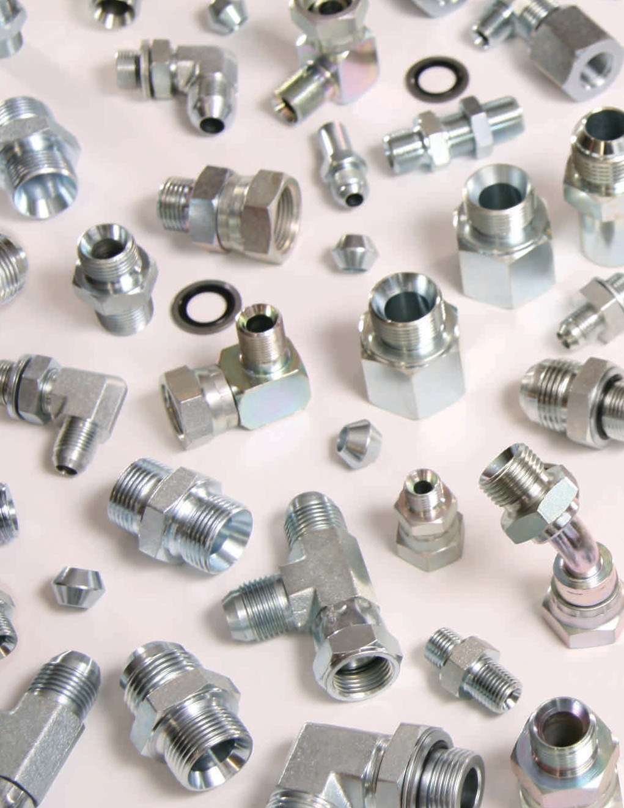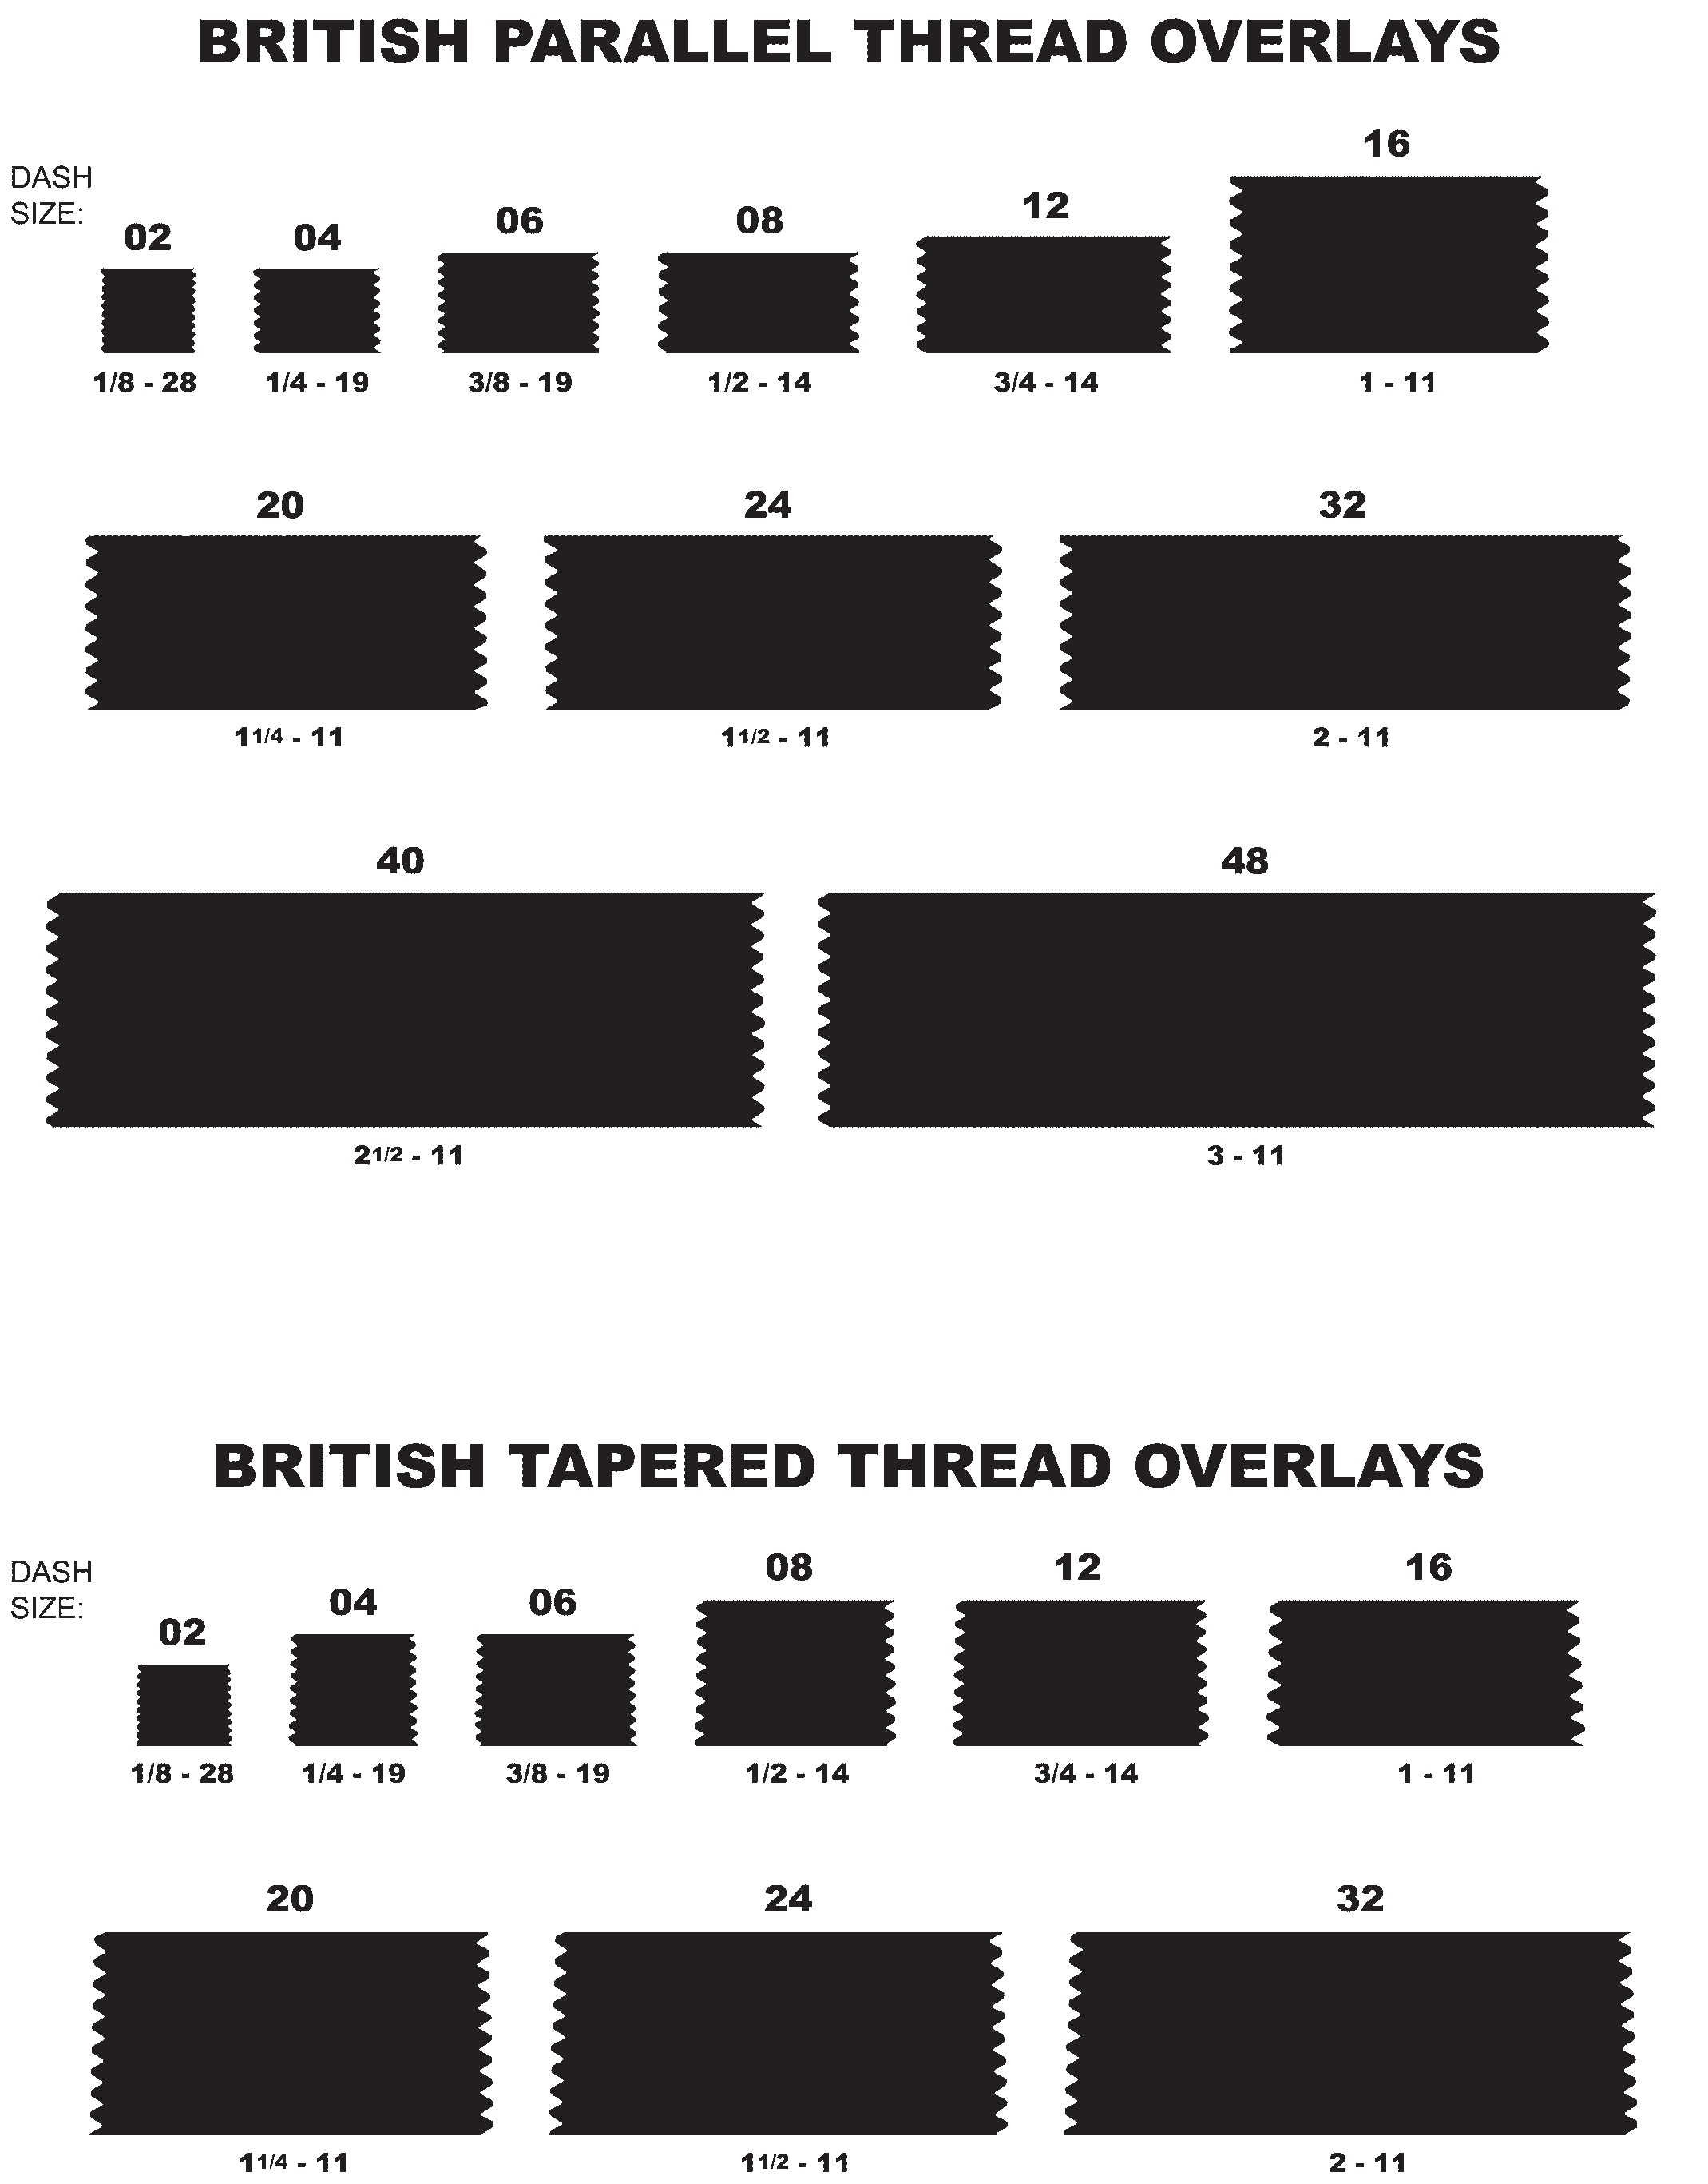

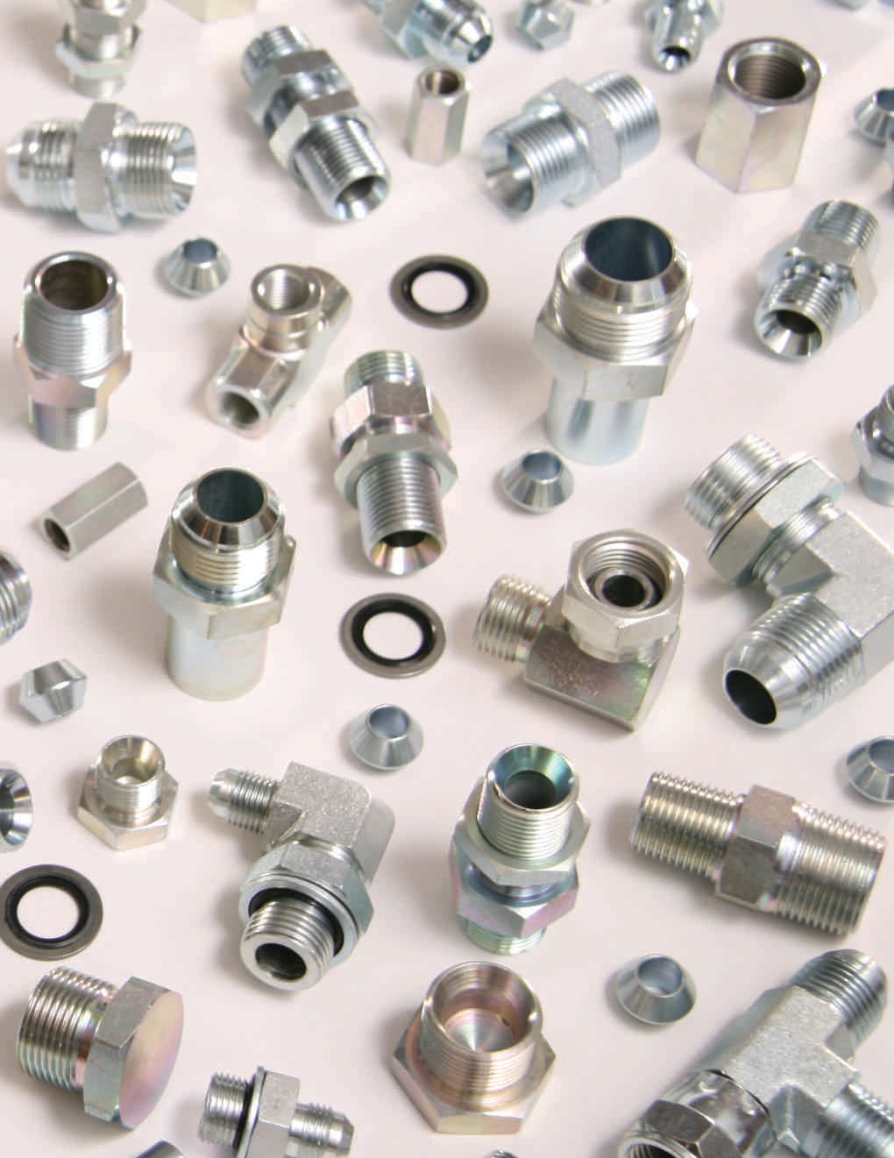Table of Contents

Introduction – About Adaptall Quick Reference Guide
5
3
MALE X MALE 5-6
ADAPTERS, UNIONS, NIPPLES, ELBOWS
MALE X FEMALE 7-8
ADAPTERS, BUSHINGS, EXPANDERS/REDUCERS, ELBOWS
FEMALE X FEMALE 8-9
COUPLINGS, UNIONS, ELBOWS
ELBOWS 9-10
45° & 90°
TEES & CROSSES 11-12
BRANCH TEES, BRANCH “Y’s”, CROSSES, RUN TEES, TEES, TEST PORT TEES
PLUGS & CAPS 13
CAPS (SOLID, SWIVEL, TUBE) &
PLUGS (COUNTERSUNK, HEX, SEALED, SQUARE-HEAD, TUBE)
MISC. 14-15
BRASS COMPRESSION, BRASS POLYTUBE COMPRESSION, KOMATSU FLANGE, METRIC COMPRESSION, PUSH ON (HOSE BARB), PUSH TO CONNECT (POLYTUBE)
ACCESSORIES 16
BONDED SEALS, CUTTING RINGS, NUTS, O-RINGS, RETAINING RINGS, SEALING SEATS, WASHERS

Conversion Adapter Identification Guide
17
Products
24
CARBON STEEL 24
BRASS 64
STAINLESS STEEL 74
MALLEABLE IRON 81
Warranty, Terms & Conditions
84

1

Notes

2

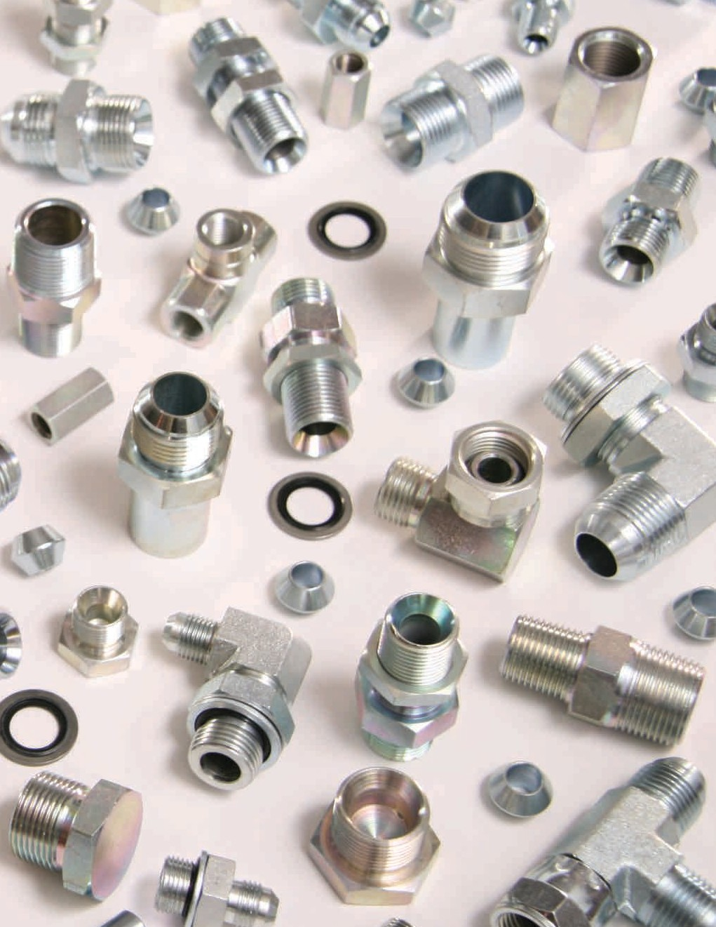
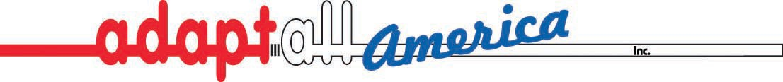

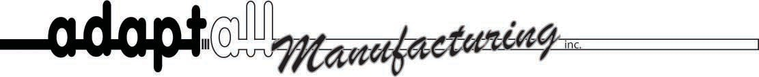

Introduction:

Adaptall opened its doors in the spring of 1985, with the hope that there was a market for a rather unique type of threaded connector for the hydraulic hose and fitting industry. A couple of Canadian mailing lists were pur- chased, a two-page brochure was drafted, and three partners stuffed envelopes and worked late into the evening to launch the company’s first marketing campaign. Adaptall’s opening inventory was based on guesswork as to what might sell and was modestly valued.

The response from the hose and fitting distributors in Canada was very positive, so four years later a U.S pub- lication and advertising program was initiated with the intent of attracting a similar but larger target market south of the border. Much to Adaptall’s surprise, the company set records with an industrial publication for the number of leads generated over a two-year period using a rather modest ad.

In 1992, Adaptall packaged up a supply of samples, a few hundred catalogs, and rented a tiny booth at a Fluid Power (NFPA) trade show in Chicago. The crowds were most receptive to Adaptall’s product line, and to this day the company has exhibited in around 25 shows across North America. Since then the company has grown to include a production/manufacturing facility, as well as a U.S distribution centre. Over 20 years later, the company remains committed to its original goals of achieving: a high quality product offering, vast stocks of inventory (in terms of both selection and availability), as well as providing friendly, knowledgeable, and helpful customer service representatives.

Adaptall America was launched in 2002, answering the need for shorter lead times in the U.S as well as increased inventory stocking capabilities. The U.S division has been a tremendous success for the company, and has allowed Adaptall to give more intimate attention to its U.S customers. Located in Twinsburg, Ohio, Adaptall America expects to see continued growth into the future thanks to you, our valued customers!

Initiated in January 1998, Adaptall Manufacturing has benefitted the company by providing custom machining capabilities, dedicated production, quality monitoring/assurance, as well as shortened lead times. Located in Pickering, Ontario, the facility is equipped with both screw machines and modern five-axis CNC technology.

3

About Adaptall

Industry Associations:
For a few years now, Adaptall Inc. has been registered under the ISO 9001 classification for international quality control standardization. Adaptall has taken this step to increase product quality and improve business operations. This classification also exists to assure our customers that Adaptall has adhered to a long list of rules and regulations regarding quality control; we worry about it so you don’t have to!

Adaptall is also C-TPAT and PIP compliant, indicating that all cooperative steps have been taken with various government agencies to enhance border security against terrorism, organized crime, and trafficking of various contraband items.

Lastly, Adaptall is a proud member of NAHAD – the National Association of Hose and Accessories Distributors.

Quality Policy Statement:
“To have the customers return, NOT the product”
- Consistently meeting customers’ expectations is a major objective
- Adopting a disciplined approach to all facets of the business
- Nothing is too small an item to be missed
- Objectives will be met and problems will be solved
- Creative & modern approaches leading to simple, effective solutions
- Long term, mutually beneficial relationships with customers and suppliers
- Provide a friendly work atmosphere for all employees
- Provide a safe working environment for all employees

Sponsorships:
In 2006, Adaptall America had the privilege of witnessing Chad Hedrick of Spring, Texas, achieve Olympic glory in Torino, Italy. A world class ice speed skater (long track), Chad also holds dozens of records for inline racing around the world. After dominating the land-based sport, Chad decided to make the transition over to ice – a rather diffi- cult task. Two years later, Chad held the all-around world title (only the third American in 100 years), and two years after that in 2006 he won gold, silver, and bronze at the Torino winter Olympics, becoming the most highly decorated American athlete of the entire games! Adaptall is proud to have supported him through the complete transition and continues to do so as he trains for the next Olympics in Vancouver, Canada.

Adaptall has for years lent considerable financial support to its local Crime Stoppers, a program that partners the community, the media, and local law enforcement officials with the goal of combating crime and keeping communities safe.

4

INSTRUCTIONS
Quick Reference Guide

- 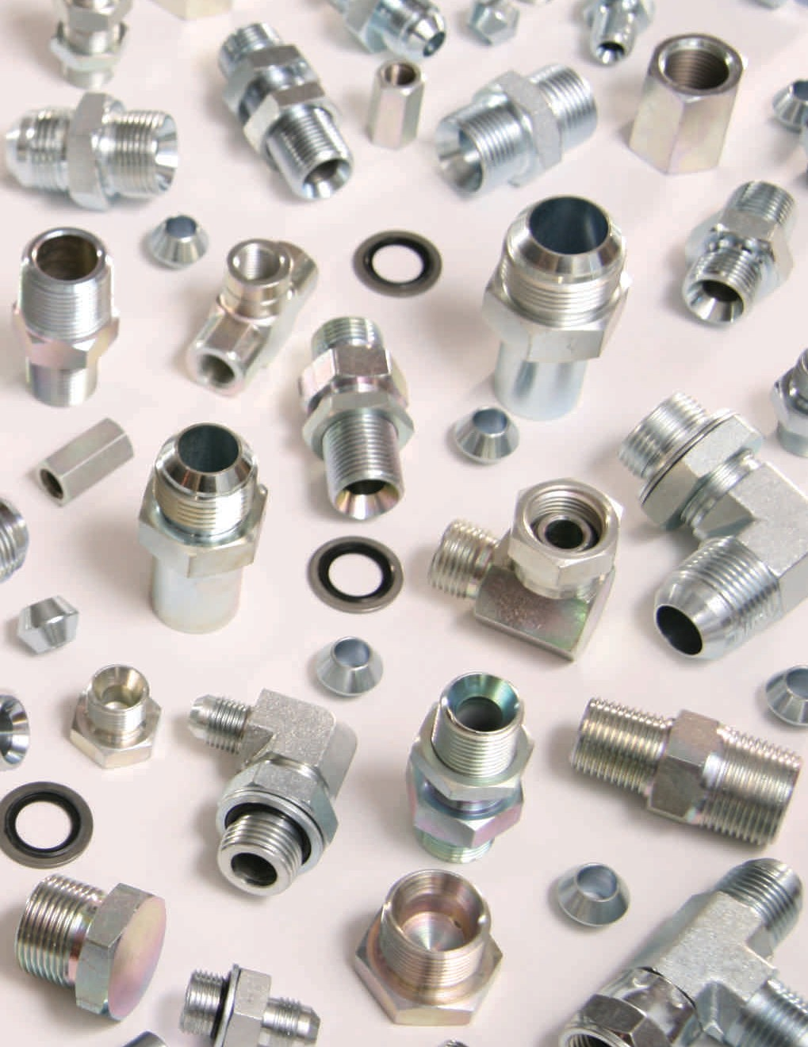The thread types for each description are displayed hose/tube and/or male side first, then port and/or female side (please refer to the Conversion Adapter Identification Guide for details).
- If both sides of a fitting are the same (both hose/tube or both port) they are displayed alphabetically. For example, a BSPP x NPT nipple has two port threads; according to alphabetization, this description would read: BSPP male x NPT male.
- Part descriptions are then arranged in alphabetical order, with males appearing before females. For example, a male BSPP is typically the first listed while a female SAE O-ring Boss is last.
- Thread types are displayed first to allow for quick searching along the margin (as opposed to thread gender first which is common).
MALE X MALE (ADAPTERS, UNIONS, NIPPLES, ELBOWS)

DESCRIPTION | STEEL |  | BRASS |  | STAINLESS |  | M. IRON
 | PART | PAGE | PART | PAGE | PART | PAGE | PART | PAGE
ADAPTERS, NIPPLES, UNIONS: | 9000  9040  9040L  9003  9004  9007  9006 | 28  37  NL 29  29  30  30 | 8000  8040  8003  8007 | 68  NL NL 68 | SS9000 SS9000CL  SS9003 SS9004 SS9007 SS9006 | 74  NL  74  NL 74 NL
BSPP MALE X BSPP MALE  BSPP MALE X BSPP MALE (CLOSE NIPPLE) |  |  |  |  |  |  | B1808CL | NL
BSPP MALE X BSPP MALE BULKHEAD
BSPP MALE X BSPP MALE BULKHEAD (EXTENDED)
BSPP MALE X BSPT MALE
BSPP MALE X METRIC MALE
BSPP MALE X NPT MALE
BSPP MALE X SAE O-RING BOSS MALE
BSPT MALE X BSPT MALE | 9010  9008  9012 | 31  30  NL | 8010  8010CL  8008  8012 | 69  NL  69  NL | SS9010  SS1808L SS9008 | NL  NL 75 | B1808H | 82
BSPT MALE X BSPT MALE (CLOSE NIPPLE) BSPT MALE X BSPT MALE (LONG) |  |  |  |  |  |  | B1808L | 82
BSPT MALE X NPT MALE
BSPT MALE X SAE O-RING BOSS MALE
JIC MALE X BSPP MALE | 9005  9005EL  9005L  9002  9002L  9011  9337  9245  9247  9237  9067  9606  9605  9068  9228 | 29  30  30  28  28  31  58  55  55  54  42  61  60  43  52 | 8005 | 68 | SS9005  SS9002 SS9011  SS9606 SS9605 | 74  74  75  80  80
JIC MALE X BSPP MALE (EXTRA LONG)
JIC MALE X BSPP MALE (LONG)
JIC MALE X BSPP MALE (WASHER & O-RING)
JIC MALE X BSPP MALE (WASHER & O-RING) (LONG) JIC MALE X BSPT MALE |  |  | 8011 | NL
JIC MALE X JIS MALE
JIC MALE X JSW MALE (JAPAN STEEL WORKS)
JIC MALE X KOBELCO MALE
JIC MALE X KOMATSU MALE JIC MALE X METRIC MALE |  |  | 8067 | NL
JIC MALE X METRIC MALE HEAVY (PORT/TUBE) DIN 2353 S
JIC MALE X METRIC MALE LIGHT (PORT/TUBE) DIN 2353 L
JIC MALE X METRIC MALE (WASHER & O-RING)
JIC MALE X NISSAN MALE
JIS MALE X BSPP MALE JIS MALE X BSPT MALE | 9339  9223  9336  9338  6337  9277 | NL 51  58  58  27  56 | 8223 | NL | SS9223 | NL
JIS MALE X JIS MALE
JIS MALE X NPT MALE
JIS MALE X ORFS MALE
JIS MALE X SAE O-RING BOSS MALE
*NL=Not listed; please call for prices/sizes/availability
5

Quick Reference Guide

DESCRIPTION  ADAPTERS, NIPPLES, UNIONS: (cont’d) | STEEL |  | BRASS |  | STAINLESS |  | M. IRON
 | PART | PAGE | PART | PAGE | PART | PAGE | PART | PAGE
KOMATSU MALE X BSPT MALE KOMATSU MALE X KOMATSU MALE KOMATSU MALE X METRIC MALE KOMATSU MALE X ORFS MALE | 9233  9236  9395  6237 | 53  53  NL 27
METRIC MALE X METRIC MALE METRIC MALE X NPT MALE METRIC MALE X NPT MALE (LONG)
METRIC MALE (PORT/TUBE) DIN 2353 S/L X NPT MALE METRIC MALE X SAE O-RING BOSS MALE
 | 9001  9607  9607EL  9607  9608 | 28  61  NL 61 NL | 8607 | NL | SS9607 | NL
ORFS MALE X BSPP MALE | 6005  6002  6002L  6011  6247  6606  6605  6068 | NL 24  24  24  27  27  27  25
ORFS MALE X BSPP MALE (WASHER & O-RING)
ORFS MALE X BSPP MALE (WASHER & O-RING) (LONG)
ORFS MALE X BSPT MALE
ORFS MALE X KOBELCO MALE
ORFS MALE X METRIC MALE HEAVY (PORT/TUBE) DIN 2353 S
ORFS MALE X METRIC MALE LIGHT (PORT/TUBE) DIN 2353 L
ORFS MALE X METRIC MALE (WASHER & O-RING)
45° ELBOWS:
BSPP MALE X BSPP MALE (ADJ.) BSPP MALE X BSPT MALE | 9051  9054 | 39  40
JIC MALE X BSPP MALE (ADJ.) JIC MALE X BSPT MALE  JIC MALE X METRIC MALE (ADJ.) | 9058  9064  9066 | 40  42  42 |  |  | SS9058 | NL
JIS MALE X BSPT MALE | 9225 | 51
ORFS MALE X BSPP MALE (ADJ.) | 6058 | 25
90° ELBOWS: | 9055  9052  9057  9070  9077 | 40  39  40  43  44
BSPP MALE X BSPP MALE
BSPP MALE X BSPP MALE (ADJ.)
BSPP MALE X BSPT MALE
BSPP MALE X NPT MALE
BSPP MALE X SAE O-RING BOSS MALE (ADJ.)
BSPT MALE X BSPT MALE |  |  | 8055 | 71
JIC MALE X BSPP MALE | 9065  9059  9059L  9063  9069  9069L | 42  41  41  42  43  43 |  |  | SS9059  SS9063 SS9069 | 77  78  78
JIC MALE X BSPP MALE (ADJ.)
JIC MALE X BSPP MALE (ADJ.) (LONG)
JIC MALE X BSPT MALE
JIC MALE X METRIC MALE (ADJ.)
JIC MALE X METRIC MALE (ADJ.) (LONG)
JIS MALE X BSPP MALE (ADJ.) JIS MALE X BSPT MALE  JIS MALE X SAE O-RING BOSS MALE (ADJ.) | 9259  9224  9278 | 56  51  56
ORFS MALE X BSPP MALE (ADJ.) ORFS MALE X METRIC MALE (ADJ.)  *NL=Not listed; please call for prices/sizes/availability | 6059  6069 | 25  25
6

Quick Reference Guide
MALE X FEMALE (ADAPTERS, BUSHINGS, EXPANDERS/REDUCERS, ELBOWS)

DESCRIPTION | STEEL |  | BRASS |  | STAINLESS |  | M. IRON
 | PART | PAGE | PART | PAGE | PART | PAGE | PART | PAGE
ADAPTERS, BUSHINGS, EXPANDERS/REDUCERS:  BSPP MALE X BSP FEMALE (SOLID) (BUSHING) | 9038  9039  9015  9034  9021  9019  9035  9035S  6021  9036 | 37  37  31  36  32  32  36  36  NL 36 | 8039 | 70 | SS9038 SS9039  SS9015 SS9021 SS9035 | NL NL  75  75  77
BSPP MALE X BSP FEMALE (SOLID) (EXTENDED
BUSHING)
BSPP MALE X BSPP FEMALE (SWIVEL)
BSPP MALE X BSPT FEMALE (SOLID)
BSPP MALE X JIC FEMALE (SWIVEL)
BSPP MALE X METRIC FEMALE (SWIVEL) BSPP MALE X NPT FEMALE (SOLID) |  |  | 8035 | 70
BSPP MALE (WASHER & O-RING) X NPT FEMALE (SOLID)
BSPP MALE X ORFS FEMALE (SWIVEL)
BSPP MALE X SAE O-RING BOSS FEMALE (SOLID)
BSPT MALE X BSP FEMALE (SOLID)  BSPT MALE X BSP FEMALE (SOLID) (BUSHING) | 9032  9032S  9031  9042  9536 | 35  NL 35  38  60 | 8038  8031  8036 | 70  NL 70 | SS9032 | NL | B1804 | 81
BSPT MALE X BSPP FEMALE (SWIVEL)
BSPT MALE X BSPT FEMALE (SOLID) (BUSHING) BSPT MALE X NPT FEMALE (SOLID) |  |  |  |  | SS9042 | 77
BSPT MALE X SAE O-RING BOSS FEMALE (SOLID)
JIC MALE X BSP FEMALE (SOLID) JIC MALE X BSPP FEMALE (SWIVEL) | 9009  9240  9210  9020  9220  9230  9622  9022  9022F  9229  6620 | 31  54  50  32  50  52  61  33  33  52  28 |  |  | SS9240 | 79
JIC MALE X BSPP FEMALE (SWIVEL) FLAT-FACE - HIAB JIC MALE X JIC FEMALE (SWIVEL) |  |  |  |  | SS9020 | NL
JIC MALE X JIS FEMALE (SOLID)
JIC MALE X KOMATSU FEMALE (SOLID)
JIC MALE X METRIC FEMALE (SOLID)
JIC MALE X METRIC FEMALE (SWIVEL)
JIC MALE X METRIC (FLAT-FACE) FEMALE (SWIVEL)
JIC MALE X NISSAN FEMALE (SOLID)
JIC MALE X ORFS FEMALE (SOLID)
JIS MALE X JIS FEMALE (SOLID) | 9227B | NL
KOMATSU MALE X METRIC FEMALE (SOLID) | 9390 | NL
METRIC MALE X BSPP FEMALE (SWIVEL) | 9018  9234  9024  9638  9235  9635  9335 | 32  NL 33  62  53  61  58
METRIC MALE X BSPT FEMALE (SOLID)
METRIC MALE X JIC FEMALE (SWIVEL)  METRIC MALE X METRIC FEMALE (SOLID) (BUSHING) METRIC MALE X NPT FEMALE (SOLID) |  |  | 8235 | NL | SS9638 SS9235 | NL 79
METRIC MALE (PORT/TUBE) DIN 2353 S/L X NPT
FEMALE (SOLID)
METRIC MALE X SAE O-RING BOSS FEMALE (SOLID)
NPT MALE X BSP FEMALE (SOLID) NPT MALE X BSPP FEMALE (SWIVEL) | 9037  9023  9017  9325 | 37  33  32  57 | 8037  8037T  8325 | 70  NL NL | SS9037 SS9023 | 77  NL
NPT MALE X BSPT FEMALE (SOLID)
NPT MALE X JIC FEMALE (SWIVEL)
NPT MALE X METRIC FEMALE (SOLID)
*NL=Not listed; please call for prices/sizes/availability
7

Quick Reference Guide

DESCRIPTION | STEEL |  | BRASS |  | STAINLESS |  | M. IRON
 | PART | PAGE | PART | PAGE | PART | PAGE | PART | PAGE
ADAPTERS, BUSHINGS, EXPANDERS/REDUCERS: (cont’d)  ORFS MALE X JIS FEMALE (SOLID)  ORFS MALE X KOMATSU FEMALE (SOLID) | 6220  6230 | 26  26
SAE O-RING BOSS MALE X BSP FEMALE (SOLID) | 9120 | NL
45° ELBOWS:  BSPP MALE X BSPP FEMALE (SWIVEL) FORGED BSPP MALE X BSPP FEMALE (SWIVEL) TUBE ELB. | 9048  9047 | NL 39
BSPT MALE X BSP FEMALE (SOLID) BSPT MALE X BSPT FEMALE (SOLID) |  |  | 8047 | NL |  |  | B2804 | 82
JIC MALE X BSPP FEMALE (SWIVEL) | 9260 | 56
90° ELBOWS:  BSPP MALE X BSPP FEMALE (SWIVEL)  BSPP MALE X BSPP FEMALE (SWIVEL) TUBE ELB. BSPP MALE X JIC FEMALE (SWIVEL) | 9060  9045  9061 | 41  38  41
BSPT MALE X BSP FEMALE (SOLID) BSPT MALE X BSPP FEMALE (SWIVEL) | 9062 | 41 | 8060 | 71 |  |  | B3804 | 83
JIC MALE X BSPP FEMALE (SWIVEL)  JIC MALE X BSPP FEMALE (SWIVEL) TUBE ELB. | 9056  9250 | 40  56
JIS MALE X JIS FEMALE (SWIVEL) | 9292 | 57
KOMATSU MALE X KOMATSU FEMALE (SWIVEL) | 9392 | 59
NPT MALE X BSPP FEMALE (SWIVEL) NPT MALE X BSPP FEMALE (SWIVEL) | 9072  9049 | 43  NL
FLAT-FACE - HIAB
FEMALE X FEMALE (COUPLINGS, UNIONS, ELBOWS)

DESCRIPTION | STEEL |  | BRASS |  | STAINLESS |  | M. IRON
 | PART | PAGE | PART | PAGE | PART | PAGE | PART | PAGE
COUPLINGS, UNIONS:  BSP FEMALE X BSP FEMALE (SOLID)  BSP FEMALE X BSP FEMALE - NO SEAT (SWIVEL) BSP FEMALE X NPT FEMALE (SOLID) | 9043  9044 | 38  38 | 8043  8044 | 71  71 | SS9043 SS9044 | 77  NL | B1404 B1404U | 81  81
BSPP FEMALE X BSPP FEMALE (SWIVEL) | 9025 | 33 |  |  | SS9025 | NL
JIC FEMALE X BSPP FEMALE (SWIVEL) JIC FEMALE X JIC FEMALE (SWIVEL) JIC FEMALE X JIS FEMALE (SWIVEL)  JIC FEMALE X KOMATSU FEMALE (SWIVEL) | 9027  9026  9226  9326 | 34  34  52  57 |  |  | SS9026 | 75
JIS FEMALE X JIS FEMALE (SWIVEL) | 9227 | 52
*NL=Not listed; please call for prices/sizes/availability
8

Quick Reference Guide

DESCRIPTION | STEEL |  | BRASS |  | STAINLESS |  | M. IRON
 | PART | PAGE | PART | PAGE | PART | PAGE | PART | PAGE
COUPLINGS, UNIONS: (cont’d)
KOMATSU FEMALE X KOMATSU FEMALE (SWIVEL) | 9327 | 58
METRIC FEMALE X METRIC FEMALE (SOLID) | 9043M | 38
METRIC FEMALE X NPT FEMALE (SOLID) | 9643 | 62 | 8045 | NL
45° ELBOWS:
BSP FEMALE X BSP FEMALE (SOLID) |  |  |  |  |  |  | B2404 | 82
BSPP FEMALE X BSPP FEMALE (SWIVEL) | 9053 | 39
90° ELBOWS:
BSP FEMALE X BSP FEMALE (SOLID) | 9076 | 44 | 8075 | 71 |  |  | B3404 | 83
BSPP FEMALE X BSPP FEMALE (SWIVEL) | 9075 | 44
BSPP FEMALE X BSPP FEMALE (SWIVEL) TUBE ELB. | 9050 | 39
JIC FEMALE X JIC FEMALE (SWIVEL) | 9355 | 59
**COUPLINGS = SOLID FEMALE, UNIONS = SWIVEL FEMALE

ELBOWS (45° & 90°)
DESCRIPTION | STEEL |  | BRASS |  | STAINLESS |  | M. IRON
 | PART | PAGE | PART | PAGE | PART | PAGE | PART | PAGE
45° ELBOWS:
BSP FEMALE X BSP FEMALE (SOLID) |  |  |  |  |  |  | B2404 | 82
BSPP MALE X BSPP MALE (ADJ.) | 9051 | 39
BSPP MALE X BSPP FEMALE (SWIVEL) FORGED | 9048 | NL
BSPP MALE X BSPP FEMALE (SWIVEL) TUBE ELB. | 9047 | 39
BSPP MALE X BSPT MALE | 9054 | 40
BSPP FEMALE X BSPP FEMALE (SWIVEL) | 9053 | 39
BSPP FEMALE (SWIVEL) X PUSH-ON | 9905 | 62
BSPT MALE X BSP FEMALE (SOLID) |  |  |  |  |  |  | B2804 | 82
BSPT MALE X BSPT FEMALE (SOLID) |  |  | 8047 | NL
JIC MALE X BSPP MALE (ADJ.) | 9058 | 40 |  |  | SS9058 | NL
JIC MALE X BSPP FEMALE (SWIVEL) | 9260 | 56
JIC MALE X BSPT MALE | 9064 | 42
JIC MALE X KOMATSU FLANGE | 9241 | 54
JIC MALE X METRIC MALE (ADJ.) | 9066 | 42
JIC MALE X METRIC STANDPIPE | 9198 | 48
JIS MALE X BSPT MALE | 9225 | 51
ORFS MALE X BSPP MALE (ADJ.) | 6058 | 25
90° ELBOWS:
BRASS COMPRESSION X BSPT MALE |  |  | 169 | 64
*NL=Not listed; please call for prices/sizes/availability
9

Quick Reference Guide

DESCRIPTION | STEEL |  | BRASS |  | STAINLESS |  | M. IRON
 | PART | PAGE | PART | PAGE | PART | PAGE | PART | PAGE
90° ELBOWS: (cont’d)
BRASS POLYTUBE COMPRESSION X BSP FEMALE (SOLID) BRASS POLYTUBE COMPRESSION X BSPT MALE |  |  | 270  269 | 65  65
BSP FEMALE X BSP FEMALE (SOLID) | 9076 | 44 | 8075 | 71 |  |  | B3404 | 83
BSPP MALE X BSPP MALE | 9055  9052  9060  9045  9057  9061  9070  9077 | 40  39  41  38  40  41  43  44
BSPP MALE X BSPP MALE (ADJ.)
BSPP MALE X BSPP FEMALE (SWIVEL)
BSPP MALE X BSPP FEMALE (SWIVEL) TUBE ELB.
BSPP MALE X BSPT MALE
BSPP MALE X JIC FEMALE (SWIVEL)
BSPP MALE X NPT MALE
BSPP MALE X SAE O-RING BOSS MALE (ADJ.)
BSPP FEMALE X BSPP FEMALE (SWIVEL)  BSPP FEMALE X BSPP FEMALE (SWIVEL) TUBE ELB. BSPP FEMALE (SWIVEL) X PUSH-ON | 9075  9050  9910 | 44  39  63
BSPT MALE X BSP FEMALE (SOLID) BSPT MALE X BSPP FEMALE (SWIVEL) BSPT MALE X BSPT MALE | 9062 | 41 | 8060  8055 | 71  71 |  |  | B3804 | 83
JIC MALE X BSPP MALE | 9065  9059  9059L  9056  9250  9063  9239  9069  9069L  9199 | 42  41  41  40  56  42  54  43  43  48 |  |  | SS9059  SS9063 SS9069 | 77  78  78
JIC MALE X BSPP MALE (ADJ.)
JIC MALE X BSPP MALE (ADJ.) (LONG)
JIC MALE X BSPP FEMALE (SWIVEL)
JIC MALE X BSPP FEMALE (SWIVEL) TUBE ELB.
JIC MALE X BSPT MALE
JIC MALE X KOMATSU FLANGE
JIC MALE X METRIC MALE (ADJ.)
JIC MALE X METRIC MALE (ADJ.) (LONG)
JIC MALE X METRIC STANDPIPE
JIC FEMALE X JIC FEMALE (SWIVEL) | 9355 | 59
JIS MALE X BSPP MALE (ADJ.) JIS MALE X BSPT MALE  JIS MALE X JIS FEMALE (SWIVEL)  JIS MALE X SAE O-RING BOSS MALE (ADJ.) | 9259  9224  9292  9278 | 56  51  57  56
KOMATSU MALE X KOMATSU FEMALE (SWIVEL) | 9392 | 59
NPT MALE X BSPP FEMALE (SWIVEL)  NPT MALE X BSPP FEMALE (SWIVEL) FLAT-FACE - HIAB | 9072  9049 | 43  NL
PUSH TO CONNECT X BSPT MALE  PUSH TO CONNECT X BSPT MALE (LONG) PUSH TO CONNECT (BANJO) X BSPT MALE  PUSH TO CONNECT ("METERING IN" VALVE) X BSPT MALE |  |  | 569  569L  569BJ  581 | 66  67  67  68
ORFS MALE X BSPP MALE (ADJ.) ORFS MALE X METRIC MALE (ADJ.) | 6059  6069 | 25  25
*NL=Not listed; please call for prices/sizes/availability
10

Quick Reference Guide
Instructions for Tees & Crosses
Tees & Crosses:
These are described as fittings with entirely identical threads (3 for tees, 4 for crosses). They are all the same gender and thread type. For example, a Male BSPP Tee is a fitting with 3 identical male BSPP threads, while a Female BSPP Cross has 4 identical female BSPP threads.

Branch Tees & Run Tees:
Branch Tees are 3 ended fittings with the common threads located straight across from one another, while Run Tees have the common threads located at 90° from each other. The rules for listing both branch and run tees are the same: if there is one thread type only, the part is listed by the odd thread gender first. For example, a Female JIS Run Tee has 2 male threads and one female (all JIS). Alternatively, if there are 2 thread types, the common threads are listed first, then the odd end (with gender reference). For example, a Male JIC X Male BSPT Run Tee has 2 male JIC threads and one male BSPT thread.

Test Port Tees:
Test port tees are not conversion adapters, rather they are meant to be placed in line with your current hydraulic system allowing for the implementation of a pressure gauge, for example. They consist of a male and female (swivel) that are always identical thread types. Test port thread types and sizes vary from fitting to fitting but are always female.
TEES & CROSSES (BRANCH TEES, BRANCH “Y’s”, CROSSES, RUN TEES, TEES, TEST PORT TEES)

DESCRIPTION | STEEL |  | BRASS |  | STAINLESS |  | M. IRON
 | PART | PAGE | PART | PAGE | PART | PAGE | PART | PAGE
BRANCH TEES:
BRASS COMPRESSION X BSPT MALE BRANCH TEE |  |  | 172 | 64
BRASS POLYTUBE COMPRESSION X BSPT MALE BRANCH TEE |  |  | 272 | 66
BSP FEMALE (SOLID) X BSPT MALE BRANCH TEE |  |  | 8093 | 72
BSPP MALE (ADJ.) BRANCH TEE | 9152 | 46
BSPP MALE X SAE O-RING BOSS MALE BRANCH TEE | 9079 | 44
BSPP FEMALE (SWIVEL) BRANCH TEE | 9087 | 45 |  |  | SS9087 | NL
BSPT MALE X BSP FEMALE (SOLID) BRANCH TEE |  |  | 8087 | 72
JIC MALE X BSPP MALE (ADJ.) BRANCH TEE | 9159 | 47
JIC MALE X BSPT MALE BRANCH TEE | 9164 | 47
JIC MALE X METRIC MALE (ADJ.) BRANCH TEE | 9169 | 47
ORFS MALE X BSPP MALE (ADJ.) BRANCH TEE | 6159 | 26
ORFS MALE X METRIC MALE (ADJ.) BRANCH TEE | 6169 | 26
PUSH TO CONNECT X BSPT MALE BRANCH TEE |  |  | 572 | 67
BRANCH "Y":
PUSH TO CONNECT X BSPT MALE BRANCH "Y" |  |  | 575 | 67
CROSSES:
BSP FEMALE CROSS (SOLID) | 9097 | 46 | 8097 | 73 |  |  | B5444 | NL
BSPP MALE CROSS | 9096 | NL
*NL=Not listed; please call for prices/sizes/availability
11

Quick Reference Guide

o
DESCRIPTION | STEEL |  | BRASS |  | STAINLESS |  | M. IRON
 | PART | PAGE | PART | PAGE | PART | PAGE | PART | PAGE
RUN TEES:  BRASS COMPRESSION X BSPT MALE RUN TEE |  |  | 171 | 64
BRASS POLYTUBE COMPRESSION X BSPT MALE RUN TEE |  |  | 271 | 65
BSP FEMALE (SOLID) X BSPT MALE RUN TEE |  |  | 8095 | 73
BSPP MALE RUN TEE (SWIVEL) BSPP MALE (ADJ.) RUN TEE  BSPP MALE X SAE O-RING BOSS MALE RUN TEE | 9095  9151  9078 | 46  46  44
BSPP FEMALE (SWIVEL) RUN TEE | 9090 | 45
BSPT MALE X BSP FEMALE (SOLID) RUN TEE |  |  | 8090 | 72
JIC MALE X BSPP MALE (ADJ.) RUN TEE JIC MALE X BSPT MALE RUN TEE  JIC MALE X METRIC MALE (ADJ.) RUN TEE | 9158  9163  9168 | 46  47  47
JIS FEMALE (SWIVEL) RUN TEE | 9291 | 57
KOMATSU FEMALE (SWIVEL) RUN TEE | 9391 | 59
ORFS MALE X BSPP MALE (ADJ.) RUN TEE ORFS MALE X METRIC MALE (ADJ.) RUN TEE | 6158  6168 | 25  26
PUSH TO CONNECT X BSPT MALE RUN TEE |  |  | 571 | 67
TEES:  BSP FEMALE (SOLID) TEE | 9086 | 45 | 8085 | 72 |  |  | B4444 | 83
BSPP MALE TEE | 9080 | 45
BSPP FEMALE (SWIVEL) TEE | 9085 | 45
BSPT MALE TEE Should read: BSPP
 |  |  | 8080 | 72
JIC FEMALE (SWIVEL) TEE | 9555 | 60
TEST PORT TEES:
 | 9015TP | 31 | Coming So |  | n!
BSPP TEST PORT (SWIVEL) TEE (TP=NPT FEMALE)
JIC TEST PORT (SWIVEL) TEE (TP=METRIC FEMALE) | 9020TP | NL | Adaptall wi |  | ll be expandi |  | g its offer-
JIS TEST PORT (SWIVEL) TEE (TP=SAE ORB FEMALE) | 9293TP | 57 | ing of Test  of threads. also be off |  | Port adapters  The Test Por ered in vario |  | in a variety  t itself will us threads
KOMATSU TEST PORT (SWIVEL) TEE (TP=SAE ORB FEMALE) | 9634TP | 61 | allowing fo existing sy |  | r a connectio stems from |  | n to most round the
ORFS TEST PORT (SWIVEL) TEE | 6020TP | NL | world.
(TP=METRIC FEMALE)
*NL=Not listed; please call for prices/sizes/availability

n

12

Quick Reference Guide
PLUGS & CAPS (CAPS: SOLID, SWIVEL, TUBE, & PLUGS: COUNTERSUNK, HEX, SEALED, SQUARE- HEAD, TUBE)
DESCRIPTION | STEEL |  | BRASS |  | STAINLESS |  | M. IRON
 | PART | PAGE | PART | PAGE | PART | PAGE | PART | PAGE
CAPS:
BSP CAP (SOLID) |  |  | 8033 | 69 |  |  | B14C | 81
BSPP SWIVEL CAP | 9033 | 36 |  |  | SS9033 | 76
JIS CAP (SOLID) | 9222 | 51
KOBELCO TUBE CAP | 9249 | 55
KOMATSU CAP (SOLID) | 9232 | 53
METRIC TUBE CAP (HEAVY) DIN 2353 S | 9204S | 50
METRIC TUBE CAP (LIGHT) DIN 2353 L | 9204L | 50
PLUGS:
BSPP COUNTERSUNK PLUG (NO SEAL) | 9028A | NL | 8028Z | NL
BSPP COUNTERSUNK SEALED PLUG | 9028 | 34 | 8028 | 69 | SS9028 | 76
BSPP HEX PLUG | 9030 | 34 |  |  | SS9030 | 76
BSPT COUNTERSUNK PLUG | 9030TCSP | 35 | 8030CSP | 69
BSPT HEX PLUG | 9030T | 35 |  |  | SS9030T | 76
BSPT SQUARE HEAD PLUG |  |  | 8030SQP | NL |  |  | B18SQP | 82
JIS HEX PLUG | 9221 | 51
JSW (JAPAN STEEL WORKS) TUBE PLUG | 9246 | 55
KOBELCO TUBE PLUG | 9248 | 55
KOMATSU HEX PLUG | 9231 | 53
METRIC COUNTERSUNK PLUG (NO SEAL) | 9029A | NL
METRIC COUNTERSUNK SEALED PLUG | 9029 | 34 |  |  | SS9029 | 76
METRIC HEX PLUG | 9030M | 35
METRIC TUBE PLUG (HEAVY) DIN 2353 S | 9203S | 50
METRIC TUBE PLUG (LIGHT) DIN 2353 L | 9203L | 49

*NL=Not listed; please call for prices/sizes/availability
13

Quick Reference Guide
MISC. (BRASS COMPRESSION, BRASS POLYTUBE COMPRESSION, KOMATSU FLANGE, METRIC COMPRESSION, PUSH-ON, PUSH TO CONNECT)
DESCRIPTION | STEEL |  | BRASS |  | STAINLESS |  | M. IRON
 | PART | PAGE | PART | PAGE | PART | PAGE | PART | PAGE
BRASS COMPRESSION:  BRASS COMPRESSION X BSP FEMALE (SOLID) BRASS COMPRESSION X BSPT MALE  BRASS COMPRESSION X BSPT MALE (90° ELB.) BRASS COMPRESSION X BSPT MALE BRANCH TEE BRASS COMPRESSION X BSPT MALE RUN TEE  BRASS POLYTUBE COMPRESSION:  BRASS POLYTUBE COMPRESSION X BSP FEMALE (SOLID)  BRASS POLYTUBE COMPRESSION X BSP FEMALE (90° ELB.)  BRASS POLYTUBE COMPRESSION X BSPT MALE BRASS POLYTUBE COMPRESSION X BSPT MALE  (90° ELB.)  BRASS POLYTUBE COMPRESSION X BSPT MALE BRANCH TEE  BRASS POLYTUBE COMPRESSION X BSPT MALE RUN TEE  KOMATSU FLANGE:  JIC MALE X KOMATSU FLANGE  JIC MALE X KOMATSU FLANGE (45° ELB.) JIC MALE X KOMATSU FLANGE (90° ELB.)  METRIC COMPRESSION:  JIC MALE X JSW MALE (JAPAN STEEL WORKS) JIC MALE X KOBELCO MALE  JIC MALE X METRIC MALE HEAVY (PORT/TUBE) DIN 2353 S  JIC MALE X METRIC MALE LIGHT (PORT/TUBE) DIN 2353 L  JIC MALE X METRIC STANDPIPE  JIC MALE X METRIC STANDPIPE (45° ELB.) JIC MALE X METRIC STANDPIPE (90° ELB.) JIC (BRAZE) MALE X METRIC BORE  JSW (JAPAN STEEL WORKS) TUBE PLUG KOBELCO TUBE CAP  KOBELCO TUBE PLUG  METRIC MALE (PORT/TUBE) DIN 2353 S/L X NPT MALE  METRIC MALE (PORT/TUBE) DIN 2353 S/L X NPT FEMALE (SOLID) |  |  | 166  168  169  172  171 | 64  64  64  64  64
 |  |  | 266  270  268  269  272  271 | 65  65  65  65  66  65
 | 9238  9241  9239 | 54  54  54
 | 9245  9247  9606  9605  9200  9198  9199  9197 | 55  55  61  60  48  48  48  48 |  |  | SS9606 SS9605 SS9200 | 80  80  78
 | 9246 | 55
 | 9249  9248 | 55  55
 | 9607  9635 | 61  61
*NL=Not listed; please call for prices/sizes/availability

14

Quick Reference Guide

DESCRIPTION | STEEL |  | BRASS |  | STAINLESS |  | M. IRON
 | PART | PAGE | PART | PAGE | PART | PAGE | PART | PAGE
METRIC COMPRESSION: (cont’d)
METRIC TUBE CAP (HEAVY) DIN 2353 S | 9204S | 50
METRIC TUBE CAP (LIGHT) DIN 2353 L | 9204L | 50
METRIC TUBE CUTTING RING - DIN 2353 S/L | 9202 | 49 |  |  | SS9202 | 79
METRIC TUBE CUTTING RING (EXTRA LIGHT) | 9202LL | 49 |  |  | SS9202LL | NL
DIN 2353 LL
METRIC TUBE NUT (EXTRA LIGHT) DIN 2353 LL | 9201LL | 49 |  |  | SS9201LL | NL
METRIC TUBE NUT (HEAVY) DIN 2353 S | 9201S | 49 |  |  | SS9201S | 78
METRIC TUBE NUT (LIGHT) DIN 2353 L | 9201L | 48 |  |  | SS9201L | 78
METRIC TUBE PLUG (HEAVY) DIN 2353 S | 9203S | 50
METRIC TUBE PLUG (LIGHT) DIN 2353 L | 9203L | 49
ORFS MALE X KOBELCO MALE | 6247 | 27
ORFS MALE X METRIC MALE HEAVY (PORT/TUBE) | 6606 | 27
DIN 2353 S
ORFS MALE X METRIC MALE LIGHT (PORT/TUBE) | 6605 | 27
DIN 2353 L
PUSH-ON (HOSE BARB):
BSPP MALE X PUSH-ON | 9920 | 63 | 8920 | NL | SS9920 | NL
BSPP FEMALE (SWIVEL) X PUSH-ON | 9900 | 62 | 8900 | 73
BSPP FEMALE (SWIVEL) X PUSH-ON (45° ELB.) | 9905 | 62
BSPP FEMALE (SWIVEL) X PUSH-ON (90° ELB.) | 9910 | 63
BSPT MALE X PUSH-ON | 9915 | 63 | 8920T | 73 | SS9920T | NL
PUSH TO CONNECT (POLYTUBE):
PUSH TO CONNECT X BSP FEMALE (SOLID) |  |  | 566 | 66
PUSH TO CONNECT X BSPT MALE |  |  | 568 | 66
PUSH TO CONNECT X BSPT MALE (90° ELB.) |  |  | 569 | 66
PUSH TO CONNECT X BSPT MALE (90° ELB.) (LONG) |  |  | 569L | 67
PUSH TO CONNECT X BSPT MALE (90° BANJO ELB.) |  |  | 569BJ | 67
PUSH TO CONNECT X BSPT MALE ("FLOW CONTROL" |  |  | 582 | 68
VALVE)
PUSH TO CONNECT X BSPT MALE (90° "METERING |  |  | 581 | 68
IN" VALVE)
PUSH TO CONNECT X BSPT MALE BRANCH TEE |  |  | 572 | 67
PUSH TO CONNECT X BSPT MALE BRANCH "Y" |  |  | 575 | 67
PUSH TO CONNECT X BSPT MALE RUN TEE |  |  | 571 | 67

*NL=Not listed; please call for prices/sizes/availability
15

Quick Reference Guide
ACCESSORIES (BONDED SEALS, CUTTING RINGS, NUTS, O-RINGS, RETAINING RINGS, SEALING SEATS, WASHERS)

DESCRIPTION | STEEL |  | BRASS |  | STAINLESS |  | M. IRON
 | PART | PAGE | PART | PAGE | PART | PAGE | PART | PAGE
BONDED SEALS:  BONDED SEAL (BRITISH THREAD) BONDED SEAL (METRIC THREAD) BONDED VITON SEAL (BRITISH THREAD) BONDED VITON SEAL (METRIC THREAD)  CUTTING RINGS:  METRIC TUBE CUTTING RING - DIN 2353 S/L METRIC TUBE CUTTING RING (EXTRA LIGHT)  NUTS:  BSPP BULKHEAD LOCKNUT  METRIC TUBE NUT (EXTRA LIGHT) DIN 2353 LL METRIC TUBE NUT (HEAVY) DIN 2353 S METRIC TUBE NUT (LIGHT) DIN 2353 L  O-RINGS:  O-RING (BRITISH THREAD) O-RING (ORFS THREAD)  O-RING (SAE O-RING BOSS THREAD)  RETAINING RINGS:  RETAINING RING (BRITISH THREAD)  SEALING SEATS:  BSPP FLAT-FACE 30° SEALING SEAT (HIAB) JIS SEALING SEAT  WASHERS:  ALUMINUM WASHER FOR BRITISH THREAD COPPER WASHER FOR BRITISH THREAD COPPER WASHER FOR METRIC THREAD | 9500  9500MM  9500V  9500MMV | 59  59  60  60 |  |  | SS9500 SS9500MM SS9500V SS9500MMV | 79  79  80  80
 | 9202  9202LL | 49  49 |  |  | SS9202 SS9202LL | 79  NL
 | 9041 | 37 |  |  | SS9041 | NL
 | 9201LL  9201S  9201L | 49  49  48 |  |  | SS9201LL  SS9201S SS9201L | NL  78  78
 | OR ORFS 3-9XX | NL NL NL | OR | NL | OR ORFS 3-9XX | NL NL NL
 | RR | NL |  |  | SSRR | NL
 | 9777 | 62
 | 9999 | 63
 |  |  | 8400  CWR CWM | 73  NL NL

*NL=Not listed; please call for prices/sizes/availability
16

Conversion Adapter Indentification Guide
Terms and Definitions

Metric Fittings vs. Metric Threads:
The terminology used to describe the majority of foreign threaded fittings can be confusing to some. Metric fit- ting is a term describing a number of foreign threads including BSP, JIS, Kobelco, Komatsu, and Metric, even though some of these have imperial dimensions. Metric threads, however, refers to a specific type of foreign thread and is part of the Metric fitting category.

Hose/Tube Side vs. Port Side:
When fittings are classified, they are usually done so tube 1 2
or hose side first, meaning that the end connecting to a hose or tube is typically listed first. The port side is usu- ally listed second.

Thread Form vs. Thread Pitch:
When identifying fittings, another important factor to look at is thread form and thread pitch. Thread form refers to the angle (in degrees) that exists between adjacent flanks of a thread. Thread pitch however, refers to the distance measured between adjacent thread crests.

Sealing Methods

Tapered vs. Parallel Threads:

THREAD FORM
55°

1.5mm
THREAD PITCH

A good first step towards thread identification is to determine whether the thread is parallel or tapered. Parallel means the thread walls are straight; while tapered means the thread walls, if continued lengthwise, would even- tually meet. A seal must be used for all parallel fittings in port application.

TAPERED
Seal is accomplished via metal-to-metal wedging

PARALLEL
TAPERED MALE INTO
PARALLEL FEMALE Seal is accomplished
via metal-to-metal wedging

Seal is accomplished via use of 0-ring, seal, or bonded washer

17

Conversion Adapter Indentification Guide
This first step will help you eliminate a number of possible thread types, as well as explain the method of seal. For a parallel thread in port application, the fitting will usually seal at the top of the thread by means of an O-ring or seal. With a tapered thread, the fitting typically seals via metal-to-metal wedging of the threads. It is also possible for some tapered males to thread into certain parallel female threads, however, there are many variables involved so caution should be taken. Sometimes a thread sealant is applied prior to installation to reduce instances of leakage on tapered threads.

Here are some examples of tapered and parallel threads that seal in the examples given:

Tapered Male X Tapered Female  (seal via thread wedging) | Parallel Male X Parallel Female  (seal via O-ring/bonded seal) | Tapered Male X Parallel Female  (seal via thread wedging)
NPT | SAE O-ring Boss | M-NPTF X F-NPSM (fixed female)
BSPT | Kobelco (port) | M-BSPT X F-BSPP (fixed female)
 | Metric (port)
 | BSPP (fixed female)

Flared Seat vs. Ball Seat
The ability to properly identify seats, chamfers, and their corresponding angles can also be a benefit to
overall fitting identification. Flared Seats refer to the protruding “nose cone” on a male thread, or the internal flare on a female thread. Ball seats however refer to the nose cone inside a female thread (swivel only) that seals with the bevel/chamfer on the inside of a male thread. As opposed to other methods of sealing previously men- tioned, this form of seal is created between the flared seats or between the chamfer and ball seat, as is the case in the latter example.

SEAT-TO-SEAT SEAL EXAMPLE
1 (JIS) 2
MALE SEAT
FEMALE FLARED SEAT
SEAL CREATED
1 CHAMFER-TO-BALL SEAT SEAL EXAMPLE 2
(BSPP)

CHAMFER/
BALL/CONE SEAT SEAT

SEAL CREATED

18

Conversion Adapter Indentification Guide
Here are some examples of seat-to-seat sealing and ball seat-to-chamfer sealing threads:

Flared Seat-to-Flared Seat Sealing Fittings | Ball Seat-to-Chamfer Sealing Fittings
JIC | M-NPTF X F-NPSM (swivel female)
JIS | M-BSPP X F-BSPP (swivel female)
Komatsu

24° Metric Compression Fittings
Most metric threads available from Adaptall are described as “dual purpose,” meaning they are capable of tube application as well as port. This also includes Kobelco fittings which are essentially an L-series metric thread with a 1.5mm thread pitch in all sizes. Most metric and Kobelco threads are tube application capable because of a 24° tapered throat angle that exists inside the male threads. To achieve a tube connection, a tube nut is tightened over the metric threads forcing a ferrule or cutting ring to grip the tube. By having the nut securely fastened, the ferrule squeezes the tube which holds the tube itself in place.

TUBE FERRULE/
CUTTING RING
24° fittings and accessories are made in three different series: LL series for low pressure, L series for medium pressure, and S series for high pressure applications.

24° Metric Compression Fittings

24° THROAT

O-ring Face Seal Fittings
TUBE NUT
Metric (tube)

Kobelco (tube)
Japan Steel Works (tube)

Adaptall also stocks O-ring face seal conversion fittings. This is a very common fitting in North America so a detailed explanation is not needed. Essentially ORFS fittings seal between an O-ring located in the face of the straight male thread, and the flat face seat on the female thread.

How to ID Metric Threads

Parallel or tapered?
The first thing you should always do when attempting to identify a foreign thread is to determine if it’s parallel or tapered. You can then measure the thread pitch in millimeters by using gauges overtop of the thread crests. For example, this could be 1.5 millimeters. Once this is completed you can proceed to the next step.

19

Conversion Adapter Indentification Guide
Metric Thread Callout System

For parallel threads, the next thing to do is to identify the thread O.D (outer diameter) by use of calipers (for tapered threads, see next section). Once you identify the O.D of the metric thread you can combine it with the thread pitch to determine the metric thread “callout.” For example, if you identified the thread O.D as 22 mil- limeters and thread pitch as 1.5 millimeters (from the last example), you would achieve a metric thread callout of M22 X 1.5, or 22mm X 1.5. Refer to the following chart for metric thread “callouts” and their corresponding tube O.D’s, tube nut part numbers, cutting ring part numbers, and tube plug/cap part numbers.

SERIES | TUBE O.D. | METRIC THREAD | TUBE NUT PART NO. | CUTTING RING PART NO. | TUBE PLUG PART NO. | TUBE CAP PART NO.
LL | 4 mm | 8 mm x 1.0 | 9201LL-04 | 9202LL-04 | 9203LL-04
 | 6 mm | 10 mm x 1.0 | 9201LL-06 | 9202LL-06 | 9203LL-06
 | 8 mm | 12 mm x 1.0 | 9201LL-08 | 9202LL-08 | 9203LL-08
 | 10 mm | 14 mm x 1.0 | 9201LL-10 | 9202LL-10
 | 12 mm | 16 mm x 1.0 | 9201LL-12 | 9202LL-12
L | 6 mm | 12 mm x 1.5 | 9201L-06 | 9202-06 | 9203L-06 | 9204L-06
 | 8 mm | 14 mm x 1.5 | 9201L-08 | 9202-08 | 9203L-08 | 9204L-08
 | 10 mm | 16 mm x 1.5 | 9201L-10 | 9202-10 | 9203L-10 | 9204L-10
 | 12 mm | 18 mm x 1.5 | 9201L-12 | 9202-12 | 9203L-12 | 9204L-12
 | 15 mm | 22 mm x 1.5 | 9201L-15 | 9202-15 | 9203L-15 | 9204L-15
 | 18 mm | 26 mm x 1.5 | 9201L-18 | 9202-18 | 9203L-18 | 9204L-18
 | 22 mm | 30 mm x 2.0 | 9201L-22 | 9202-22 | 9203L-22 | 9204L-22
 | 28 mm | 36 mm x 2.0 | 9201L-28 | 9202-28 | 9203L-28 | 9204L-28
 | 35 mm | 45 mm x 2.0 | 9201L-35 | 9202-35 | 9203L-35 | 9204L-35
 | 42 mm | 52 mm x 2.0 | 9201L-42 | 9202-42 | 9203L-42 | 9204L-42
S | 6 mm | 14 mm x 1.5 | 9201S-06 | 9202-06 | 9203S-06 | 9204S-06
 | 8 mm | 16 mm x 1.5 | 9201S-08 | 9202-08 | 9203S-08 | 9204S-08
 | 10 mm | 18 mm x 1.5 | 9201S-10 | 9202-10 | 9203S-10 | 9204S-10
 | 12 mm | 20 mm x 1.5 | 9201S-12 | 9202-12 | 9203S-12 | 9204S-12
 | 14 mm | 22 mm x 1.5 | 9201S-14 | 9202-14 | 9203S-14 | 9204S-14
 | 16 mm | 24 mm x 1.5 | 9201S-16 | 9202-16 | 9203S-16 | 9204S-16
 | 20 mm | 30 mm x 2.0 | 9201S-20 | 9202-20 | 9203S-20 | 9204S-20
 | 25 mm | 36 mm x 2.0 | 9201S-25 | 9202-25 | 9203S-25 | 9204S-25
 | 30 mm | 42 mm x 2.0 | 9201S-30 | 9202-30 | 9203S-30 | 9204S-30
 | 38 mm | 52 mm x 2.0 | 9201S-38 | 9202-38 | 9203S-38 | 9204S-38

20

Metric Tapered Threads
Conversion Adapter Indentification Guide

If you have a metric tapered thread, one would undergo the same initial steps for identification of thread pitch; however, thread O.D can only be identified properly by placing the calipers over the third row of threads from the end of the fitting. Because the thread is tapered, a different O.D will be identified depending on where you place the calipers; this is why the 3rd row of threads is used as a standard. Adaptall does not usually stock metric tapered threads, however, we should be able to accommodate most requests.

MEASURE AT 3RD ROW OF THREADS FROM END OF FITTING
22mm

Identifying Tube O.D
If you are using a metric thread for tube application, it is very important that you identify the tube O.D, as this can affect what fitting assembly is used. Simply use a set of calipers to take a measurement of the tube, mak- ing sure the results are displayed in millimeters. Then refer to the previous chart to properly determine the thread callout and the related accessories that go with your tube assembly.
4

SERIES USUALLY LISTED ON NUT

Identifying 24° Fittings
Identifying accessories for a 24° compression fitting assem- bly can be fairly confusing. Some 24° metric fitting acces- sories have the dimensions marked on the part itself, such as a tube nut for example. Once again, you can refer to the chart provided for examples of sizes and their corresponding assemblies.

A common problem is the inability to distinguish which series is being used or should be used. If the series is not listed on the part, match the tube O.D with the metric thread callout on the chart provided to find the corresponding series.

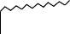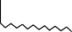

How to ID British (BSP) Threads
British Pipe Standard fittings are amongst the most popular of all foreign threads in the world today. These threads come in two versions: parallel (BSPP), and tapered (BSPT). The thread flank angle for both tapered and parallel British threads is 55°. NOTE: It is a fairly common mistake to identify a BSPT (tapered) as an NPT. Always remember that NPT threads have a 60° thread flank angle, and BSPT has a 55° angle (this can be ver- ified with a thread gauge). Although BSP is a foreign thread, it isn’t actually metric. This is why it comes in imperial sizes: 1/8, 1/4, 1/2, 3/4, and so on.

BSP parallel threads commonly seal via a 30° chamfer on the male thread to a 30° recessed cone inside the female thread (swivel only). If it is a port application, an O-ring and washer or a bonded washer are needed to achieve a proper seal for parallel threads. For tapered BSP threads, a seal is acquired via thread wedging with additional support from thread dope or Teflon tape. As previously mentioned, it is possible for a male BSPT (tapered) to thread into a female BSPP (parallel), so long as the female thread is fixed and not swivel (this is because of the recessed cone seat).

21

Conversion Adapter Indentification Guide
BSP parallel fittings and their specifications can be identified by a completing few calculations. To find the thread size:
- Measure the O.D (outer diameter) of the BSP thread.
- Take the O.D measurement (in inches) and subtract 1/4 inch (.25”).

For example, a BSP parallel male thread measures out to O.D 1”. Subtracting 1/4 gives a thread size of 3/4, also known as “dash” 12.

Once you have the thread size, you then need to determine the number of threads per inch to verify that it is a BSP fitting. You can do this by counting the number of thread crests over a 1/4” length, then multiply it by 4 to get the number of threads/inch. For example, if over a 1/4” distance you find 3.5 thread crests:
- Multiply 3.5 by 4 to get 14. This is the number of threads per inch.
- Combine the thread size with the number of threads per inch and refer to the following chart to find your desired size and its related specifications.

British Pipe Thread - Parallel (BSPP/BSPF)
18.631 1.814
20.587 1.814
24.117 1.814
Nominal Size | Dash Size | Outer Diameter (mm) | Inner Diameter Male Thread (mm) |  | Pitch (mm) | Threads per inch | Pitch Diameter (mm) | Thread Height (mm) | Tap Drill  Diameter (mm)
1/8" | 02 | 9.728 | 8.566 |  | 0.907 | 28 | 9.147 | 0.581 | 8.7
1/4" | 04 | 13.157 | 11.445 |  | 1.337 | 19 | 12.301 | 0.856 | 11.6
3/8"  1/2"  5/8"  3/4"  7/8" | 06  08  10  12  14 | 16.662  20.955  22.911  26.441  30.201 | 14.95 |  | 1.337 | 19 | 15.806 | 0.856 | 15
 |  |  |  | Inaccurate data.  Use caution when using any info from this list. |  | 14 | 19.793 | 1.162 | 19
 |  |  |  |  |  | 14 | 21.749 | 1.162 | 20.75
 |  |  |  |  |  | 14 | 25.279 | 1.162 | 24.5
 |  |  | 27.877 |  | 1.814 | 14 | 29.039 | 1.162 | 28
1" | 16 | 33.249 | 30.291 |  | 2.309 | 11 | 31.77 | 1.479 | 30.5
1 1/8" | 18 | 37.897 | 34.939 |  | 2.309 | 11 | 36.418 | 1.479 | 35
1 1/4" | 20 | 41.91 | 38.952 |  | 2.309 | 11 | 40.431 | 1.479 | 39.5
1 3/8" | 22 | 44.323 | 41.365 |  | 2.309 | 11 | 42.844 | 1.479 | 41.5
1 1/2" | 24 | 47.803 | 44.845 |  | 2.309 | 11 | 46.324 | 1.479 | 45
1 3/4" | 28 | 53.746 | 50.788 |  | 2.309 | 11 | 52.267 | 1.479 | 51
2" | 32 | 59.614 | 56.656 |  | 2.309 | 11 | 58.135 | 1.479 | 57
2 1/4" | 36 | 65.71 | 62.752 |  | 2.309 | 11 | 64.231 | 1.479 | 63
2 1/2" | 40 | 75.184 | 72.226 |  | 2.309 | 11 | 73.705 | 1.479 | 72.5
2 3/4" | 44 | 81.534 | 78.576 |  | 2.309 | 11 | 80.055 | 1.479 | 79
3" | 48 | 87.884 | 84.926 |  | 2.309 | 11 | 86.405 | 1.479 | 85.5
For British tapered threads (BSPT), the process is almost the same. To determine the threads per inch count, you would undergo the same steps as for a parallel thread. Using the O.D to identify a tapered fitting is not rec- ommended for the reason that the outer diameter changes throughout the length of the taper. However, the I.D

22

Conversion Adapter Indentification Guide
(inner diameter) is a good reference point to start from. To determine the I.D of a BSP tapered fitting, simply obtain a caliper reading from inside the bore of the fitting. You can cross-reference the bore size on the follow- ing chart with thread pitch and threads per inch to find your desired size and its related specifications.

British Pipe Thread - Tapered (BSPT)
1.814 14
2.309 11
2.309 11

Nominal Size | Dash Size | Outer Diameter (mm) | Inner Diameter Male Thd. (mm) | Pitch (mm) | Threads per inch | Pitch Diameter (mm) |  | Tap Thread Height (mm) | Drill Diameter (mm) | Thread Crest Rounding
1/16" | 01 | 7.723 | 6.561 | 0.907 | 28 | 7.142 |  | 0.581 | 6.4 | 0.125
1/8" | 02 | 9.728 | 8.566 | 0.907 | 28 | 9.147 |  | 0.581 | 8.4 | 0.125
1/4" | 04 | 13.157 | 11.445 | 1.337 | 19 | 12.301 |  | 0.856 | 11.2 | 0.184
3/8" | 06 | 16.662 | 14.95 | 1.337 | 19 | 15.806 |  | 0.856 | 14.75 | 0.184
1/2" | 08 | 20.955 | 18.631 | 1.814 | 14 | 19.793 |  | 1.162 | 18.25 | 0.249
3/4" | 12 | 26.441 | 24.117 | Inaccurate data. |  |  | 25.279 | 1.162 | 23.75 | 0.249
1" | 16 | 33.249 | 30.291 | Use caution when |  |  | 31.77 | 1.479 | 30 | 0.317
1 1/4"  1 1/2" | 20  24 | 41.91  47.803 | 38.952  44.845 | using any info from  this list. |  |  | 40.431 | 1.479  1.479 | 38.5  44.5 | 0.317  0.317
 |  |  |  | 2.309 | 11 | 46.324
2" | 32 | 59.614 | 56.656 | 2.309 | 11 | 58.135 |  | 1.479 | 56 | 0.317
2 1/2" | 40 | 75.184 | 72.226 | 2.309 | 11 | 73.705 |  | 1.479 | 71 | 0.317
3" | 48 | 87.884 | 84.926 | 2.309 | 11 | 86.405 |  | 1.479 | 85.5 | 0.317
4" | 64 | 113.03 | 110.072 | 2.309 | 11 | 111.551 |  | 1.479 | 110.5 | 0.317
5" | 80 | 138.43 | 135.472 | 2.309 | 11 | 136.951 |  | 1.479 | 136 | 0.317
6" | 96 | 163.83 | 160.872 | 2.309 | 11 | 162.351 |  | 1.479 | 161.5 | 0.317
How to ID Japanese (JIS) threads
Japanese (JIS) tapered and parallel threads are identical to British standard pipe threads. The only difference is that parallel JIS threads have a 30° seat on the male end, and a 30° flared seat on the female ends. JIS tapered threads are identical to BSPT threads.

How to ID Kobelco threads
Kobelco threads are essentially the same as metric threads, with some minor variations. All sizes of Kobelco threads have a 1.5mm (millimeter) pitch. All tube accessories for Kobelco fittings belong to the L-series (for medium pressure).

How to ID Komatsu threads
Komatsu fittings have 1.5mm metric threads with a 30° seat. Tube application is not possible.

23

Carbon Steel
A note on Trivalent Plating:
For those who are unaware, the hydraulic fitting industry has been forced to stop using hexavalent (chromium 6) plating due to environmental and health concerns. Used to prevent white rust/corrosion, this material coats the fittings during the final stage of production. While the chromium 6 plating has a gold finish, the new trivalent plating is silver in appearance. This can cause some confusion as it appears to be stain- less steel or even carbon steel that missed the plating stage.

The trivalent plating is, however, just as resistant to corrosion as the chromium 6 plating. Customers must be advised that Adaptall cannot guarantee which type of plating will be applied to items purchased as we are cur- rently dealing with an inventory of mixed plating. If you have any concerns related to plating, our customer serv- ice representatives should be able to accommodate your requests.

PRICES FOR CARBON STEEL FITTINGS ARE LOCATED IN THE MOST RECENT PRICE LIST CALL US TO REQUEST ONE @ 1-800-463-8134 OR VISIT OUR WEBSITE www.adaptall.com

Part Number
Sizes
Descripton

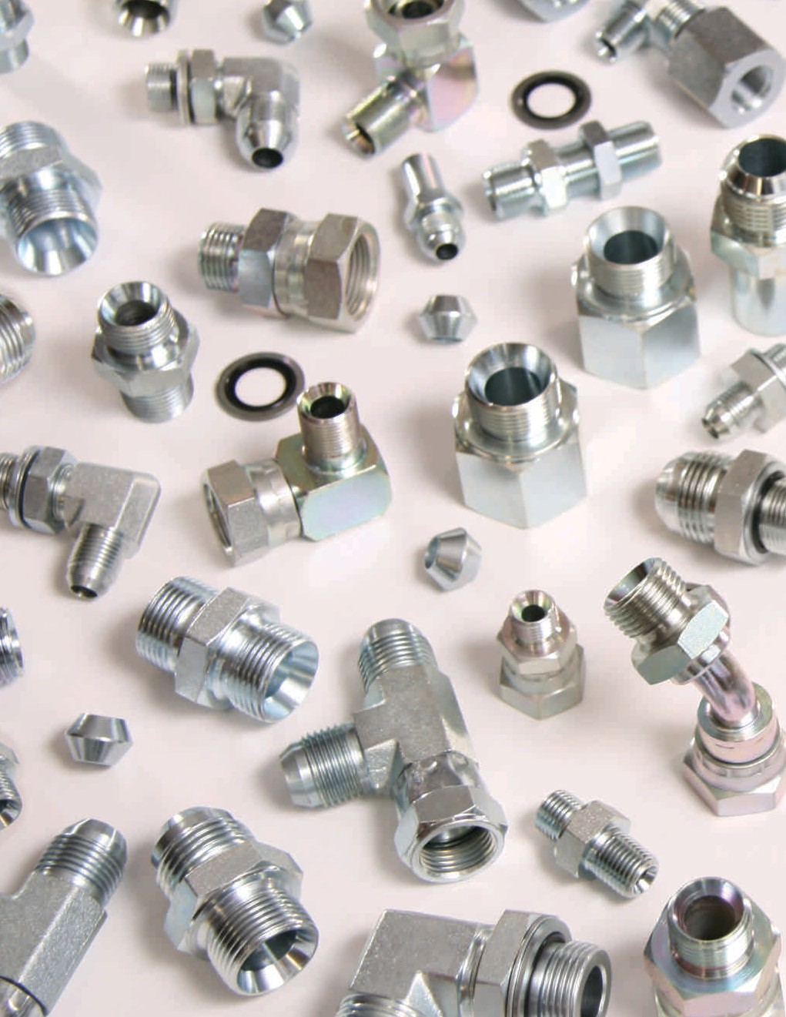
6002  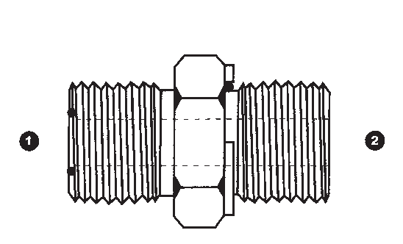 | ❶ ❷ ❶ ❷  6002-04-02 6002-10-08  6002-04-04 6002-12-08  6002-04-06 6002-12-12  6002-06-04 6002-12-16  6002-06-06 6002-16-12  6002-06-08 6002-16-16  6002-08-04 6002-20-16  6002-08-06 6002-20-20  6002-08-08 6002-24-24  6002-08-12  6002-08-16 | MALE ORFS X  MALE BSPP  C/W WASHER & O-RING
6002L  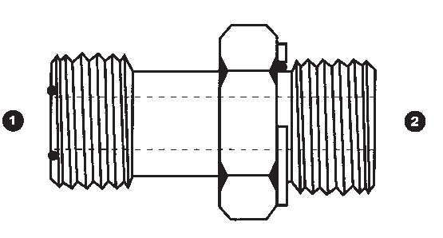 | ❶ ❷  6002L-08-06  6002L-08-08  6002L-10-08  6002L-10-12  6002L-12-12  6002L-16-16  6002L-20-20 | MALE ORFS X  MALE BSPP LONG  C/W WASHER & O-RING
6011  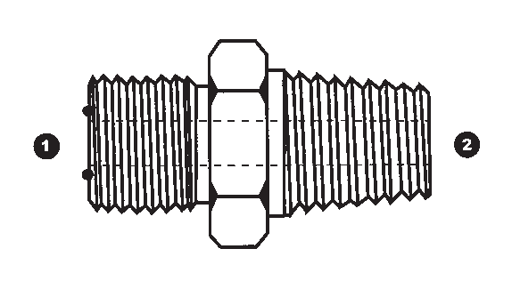 | CALL FOR SIZES | MALE ORFS X  MALE BSPT

24

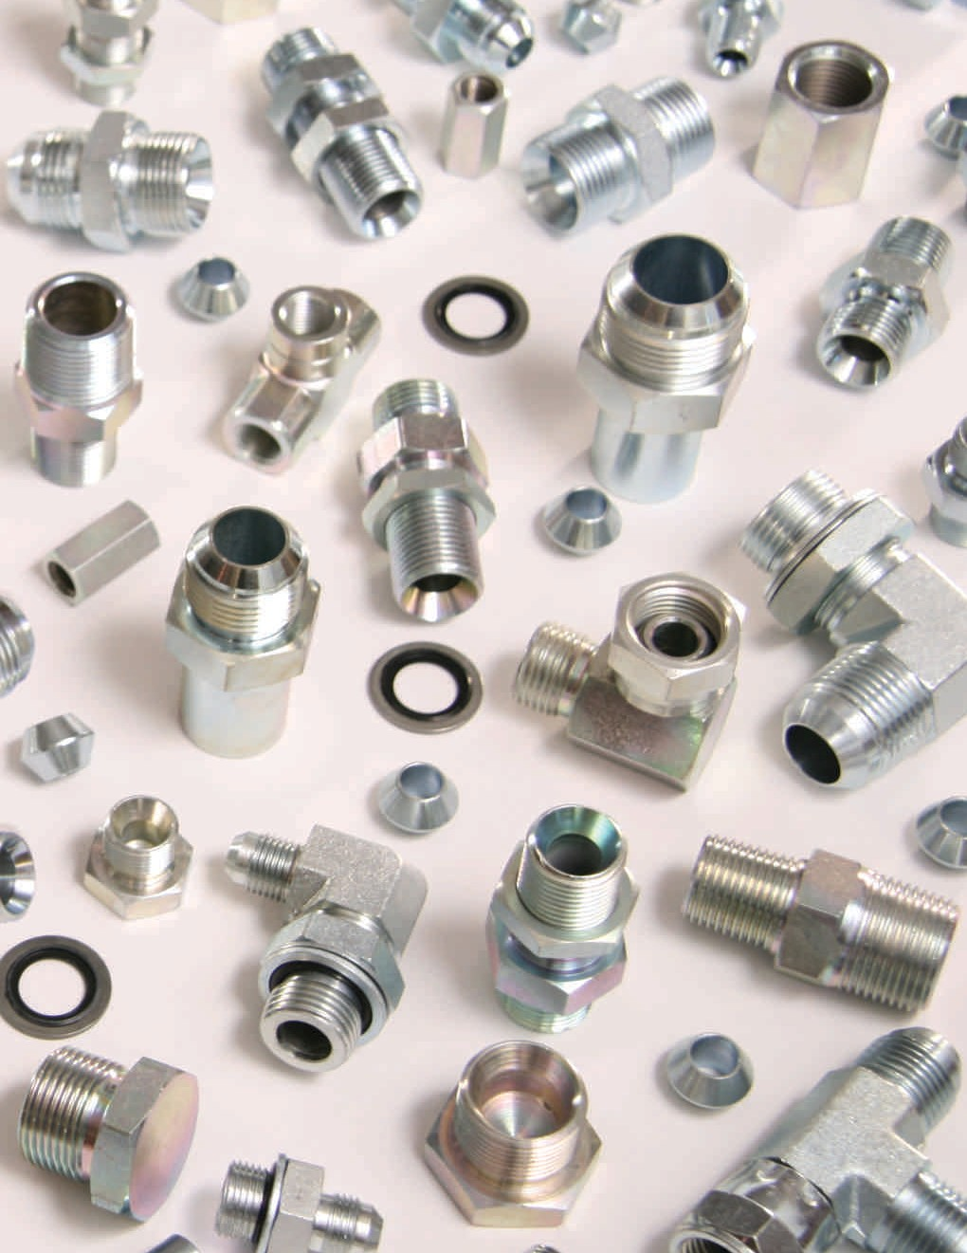Carbon Steel
Descripton Sizes Part Number
45° MALE ORFS | ❶ ❷  6058-04-02  6058-04-04  6058-06-04  6058-06-06  6058-08-06  6058-08-08  6058-10-08 |  | 6058  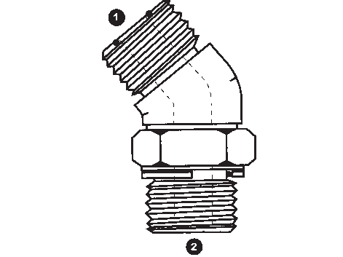
X
MALE BSPP ADJ.
ELBOW
(FORGED STEEL)
90° MALE ORFS X  MALE BSPP ADJ. ELBOW | ❶ ❷  6059-04-02  6059-04-04  6059-06-04  6059-06-06 | ❶ ❷  6059-10-08  6059-12-08  6059-12-12  6059-12-16 | 6059  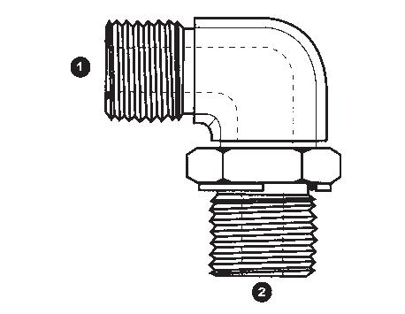
(FORGED STEEL) | 6059-06-08  6059-08-04 | 6059-16-12  6059-16-16
 | 6059-08-06 | 6059-16-20
 | 6059-08-08 | 6059-20-20
 |  | 6059-24-24
MALE ORFS X  MALE METRIC  C/W WASHER & O-RING | ❶ ❷  6068-04-10  6068-06-12  6068-06-14 | ❶ ❷  6068-06-16  6068-08-16  6068-08-18  6068-10-18 | 6068  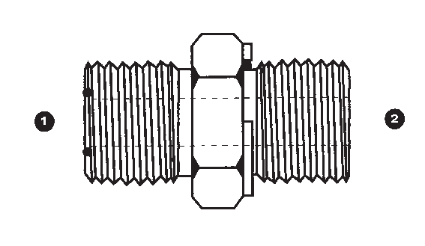
 |  | 6068-10-22
 |  | 6068-12-22
 |  | 6068-12-26
 |  | 6068-12-27
 |  | 6068-16-33
90° MALE ORFS X  MALE METRIC ADJ.  ELBOW | ❶ ❷  6069-04-10  6069-04-12 | ❶ ❷  6069-06-14  6069-06-16  6069-08-16  6069-08-18 | 6069  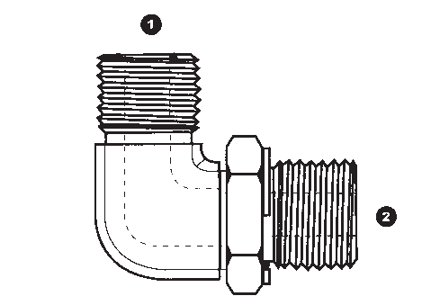
 |  | 6069-10-18
(FORGED STEEL) |  | 6069-10-22  6069-12-27
 |  | 6069-16-33
 |  | 6069-20-33
MALE ORFS | ❶ ❷ ❸  6158-06-06-04  6158-06-06-06  6158-08-08-06  6158-08-08-08  6158-10-10-08  6158-12-12-12  6158-12-12-16  6158-16-16-16 |  | 6158  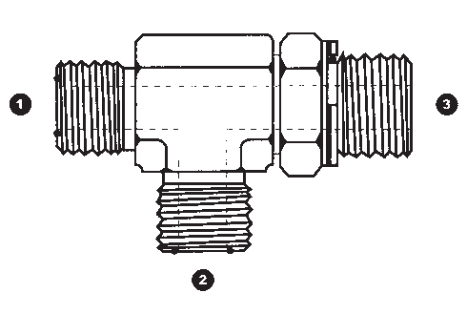
X
MALE BSPP ADJ. RUN
TEE
(FORGED STEEL)
25

Carbon Steel
Part Number

Sizes

Descripton

6159  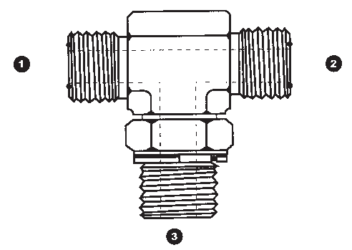 | ❶ ❷ ❸  6159-04-04-02  6159-04-04-04  6159-06-06-04  6159-06-06-06  6159-08-08-06  6159-08-08-08  6159-10-10-08 | MALE ORFS X  MALE BSPP ADJ. BRANCH TEE  (FORGED STEEL)
6168  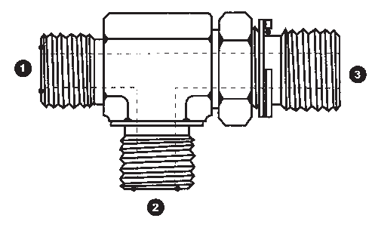 | ❶ ❷ ❸  6168-04-04-10  6168-04-04-12  6168-06-06-14  6168-06-06-16  6168-08-08-16  6168-08-08-18  6168-10-10-22 | MALE ORFS X  MALE METRIC ADJ. RUN TEE  (FORGED STEEL)
6169 | ❶ ❷ ❸  6169-04-04-10  6169-06-06-14  6169-08-08-16 | MALE ORFS X  MALE METRIC ADJ.
 | 6169-08-08-18  6169-10-10-22 | BRANCH TEE
 |  | (FORGED STEEL)
6220  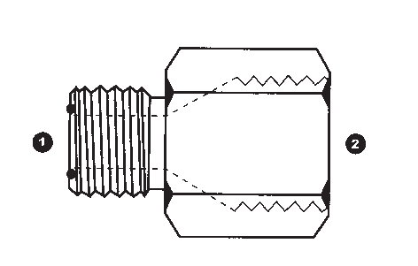 | ❶ ❷  6220-04-04  6220-06-06  6220-08-08  6220-12-12 | MALE ORFS X  FEMALE JIS (SOLID)  30° SEAT, BSPP THREAD
6230  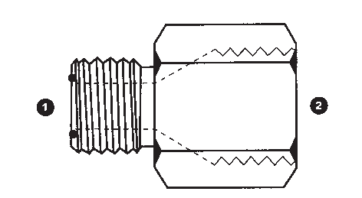 | ❶ ❷  6230-04-14  6230-06-18  6230-08-22  6230-10-24  6230-12-30  6230-16-33 | MALE ORFS X  FEMALE KOMATSU (SOLID)  30° SEAT,  1.5mm PITCH, METRIC THREADS

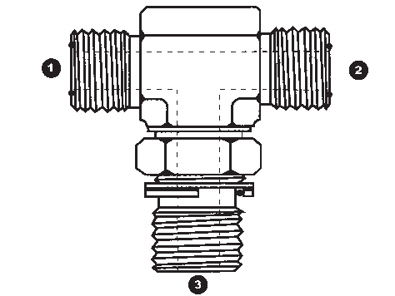
26

Carbon Steel
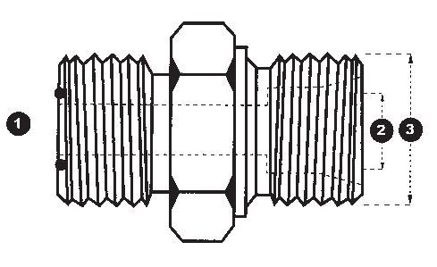
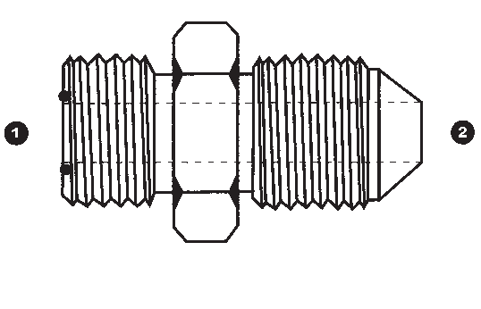
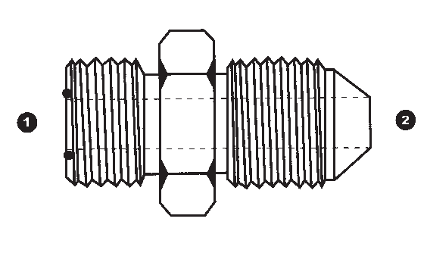
Descripton Sizes Part Number

MALE ORFS | ❶ ❷ ❸  6605-04-L06-12  6605-04-L08-14  6605-06-L08-14 | ❶ ❷  6237-04-14  6237-06-18  6237-08-22  6237-10-24  6237-12-30  6237-16-33  ❶ ❷ ❸  6247-12-22-30  6247-12-28-36  6247-16-28-36  6247-16-35-45  ❶ ❷  6337-04-04  6337-06-06  6337-08-08  ❶ ❷ ❸  6605-06-L10-16  6605-06-L12-18  6605-08-L10-16  6605-08-L12-18  6605-08-L15-22  6605-12-L12-18  6605-12-L15-22  6605-12-L18-26  6605-12-L22-30  6605-16-L22-30 | 1 | 6237  6247  6337  6605 | 2 | 3
X
MALE KOMATSU
30° SEAT,
1.5mm PITCH,
METRIC THREADS
MALE ORFS
X
MALE KOBELCO
1.5mm PITCH,
METRIC THREADS
MALE ORFS
X
MALE JIS
30° SEAT,
BSPP THREAD
MALE ORFS
X
MALE METRIC DUAL
PURPOSE
PORT OR TUBE
(DIN 2353 L)
MALE ORFS | ❶ ❷ ❸  6606-04-S06-14  6606-04-S08-16  6606-06-S08-16  6606-06-S10-18  6606-08-S12-20 | ❶ ❷ ❸  6606-08-S14-22  6606-10-S12-20  6606-12-S20-30  6606-12-S25-36  6606-16-S25-36  6606-16-S30-42 | 6606  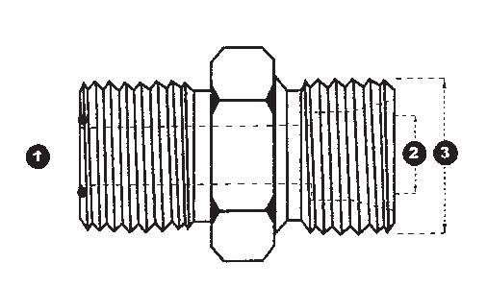
X
MALE METRIC DUAL
PURPOSE
PORT OR TUBE
(DIN 2353 S)
27

Carbon Steel
Part Number

Sizes

Descripton

6620 | ❶ ❷ | ❶ ❷ |  | MALE JIC X  FEMALE ORFS (SOLID)
 | 6620-04-04 | 6620-20-20
 | 6620-06-04 | 6620-24-24
 | 6620-06-06
 | 6620-06-08
 | 6620-08-08
 | 6620-10-10
 | 6620-10-12
 | 6620-12-12
 | 6620-12-16
 | 6620-16-16
9000 | ❶ ❷ | ❶ ❷ | ❶ ❷ | MALE BSPP X  MALE BSPP
 | 9000-02-02 | 9000-12-08 | 9000-24-12
 | 9000-04-02 | 9000-12-10 | 9000-24-16
 | 9000-04-04 | 9000-12-12 | 9000-24-20
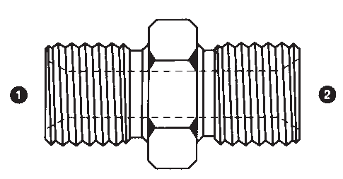 | 9000-06-02  9000-06-04 | 9000-16-04  9000-16-06 | 9000-24-24  9000-32-16 | (BSPP NIPPLE)
 | 9000-06-06 | 9000-16-08 | 9000-32-20
 | 9000-08-02 | 9000-16-10 | 9000-32-24
 | 9000-08-04 | 9000-16-12 | 9000-32-32
 | 9000-08-06 | 9000-16-16 | 9000-40-24
 | 9000-08-08 | 9000-20-06 | 9000-40-32
 | 9000-10-04 | 9000-20-08 | 9000-40-40
 | 9000-10-06 | 9000-20-10 | 9000-48-32
 | 9000-10-08 | 9000-20-12 | 9000-48-40
 | 9000-10-10 | 9000-20-16 | 9000-48-48
 | 9000-12-04 | 9000-20-20
 | 9000-12-06 | 9000-24-08
9001 | ❶ ❷  9001-10-10  9001-12-10  9001-12-12 | ❶ ❷  9001-18-18  9001-20-18  9001-20-20 | ❶ ❷  9001-26-18  9001-26-22  9001-26-26 | MALE METRIC X  MALE METRIC
 | 9001-14-12 | 9001-22-16 | 9001-30-30
 | 9001-14-14  9001-16-12 | 9001-22-18  9001-22-22 |  | (METRIC NIPPLE)
 | 9001-16-14 | 9001-24-20
 | 9001-16-16 | 9001-24-22
 | 9001-18-16 | 9001-24-24
9002 | ❶ ❷  9002-04-02  9002-04-04  9002-04-06 | ❶ ❷  9002-08-08  9002-08-12  9002-10-08 | ❶ ❷  9002-20-20  9002-24-20  9002-24-24 | MALE JIC X  MALE BSPP  C/W WASHER & O-RING
 | 9002-05-04 | 9002-10-12
 | 9002-05-06 | 9002-12-08
 | 9002-06-04 | 9002-12-12
 | 9002-06-06 | 9002-12-16
 | 9002-06-08 | 9002-16-12
 | 9002-08-06 | 9002-16-16
9002L | ❶ ❷  9002L-06-04  9002L-08-06  9002L-08-08  9002L-10-08 | ❶ ❷  9002L-16-16  9002L-20-20 |  | MALE JIC X  MALE BSPP LONG  C/W WASHER & O-RING
 | 9002L-12-12
 | 9002L-12-16

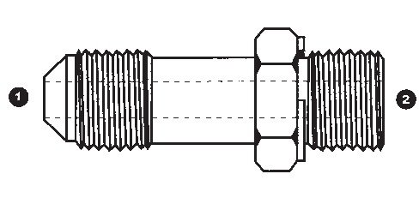
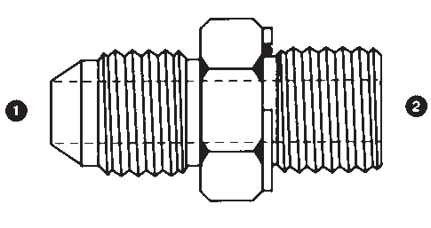
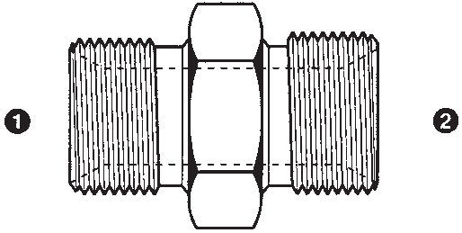
28

Carbon Steel
Descripton Sizes Part Number
MALE BSPP X  MALE BSPT | ❶ ❷  9003-02-02  9003-02-04  9003-02-06 | ❶ ❷  9003-08-08  9003-08-10  9003-08-12 | ❶ ❷  9003-16-20  9003-16-24  9003-16-32 | 9003  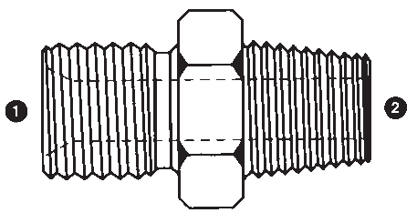
 | 9003-04-02 | 9003-10-06 | 9003-20-12
 | 9003-04-04 | 9003-10-08 | 9003-20-16
 | 9003-04-06 | 9003-10-10 | 9003-20-20
 | 9003-04-08 | 9003-10-12 | 9003-20-24
 | 9003-06-02 | 9003-12-04 | 9003-20-32
 | 9003-06-04 | 9003-12-06 | 9003-24-16
 | 9003-06-06 | 9003-12-08 | 9003-24-20
 | 9003-06-08 | 9003-12-12 | 9003-24-24
 | 9003-06-12 | 9003-12-16 | 9003-24-32
 | 9003-06-16 | 9003-12-20 | 9003-32-24
 | 9003-08-04 | 9003-16-08 | 9003-32-32
 | 9003-08-06 | 9003-16-12 | 9003-40-40
 |  | 9003-16-16 | 9003-48-48
MALE BSPP X  MALE METRIC | ❶ ❷  9004-02-10  9004-02-12  9004-02-14 | ❶ ❷  9004-06-12  9004-06-14  9004-06-16 | ❶ ❷  9004-12-20  9004-12-22  9004-12-24 | 9004  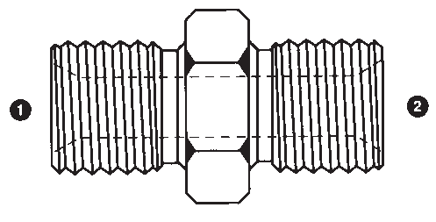
 | 9004-04-10 | 9004-06-18 | 9004-12-26
 | 9004-04-10X1.0 | 9004-06-20 | 9004-12-30
 | 9004-04-12 | 9004-06-22 | 9004-16-18
 | 9004-04-14 | 9004-08-12 | 9004-16-22
 | 9004-04-16 | 9004-08-14 | 9004-16-26
 | 9004-04-18 | 9004-08-16 | 9004-16-28
 | 9004-04-22 | 9004-08-18 | 9004-16-30
 |  | 9004-08-20 | 9004-16-36
 |  | 9004-08-22 | 9004-16-38
 |  | 9004-08-24 | 9004-20-30
 |  | 9004-08-26 | 9004-20-38
 |  | 9004-10-22 | 9004-24-38
 |  | 9004-10-26 | 9004-24-45
 |  | 9004-12-16 | 9004-32-45
 |  | 9004-12-18 | 9004-32-52
MALE JIC X  MALE BSPP | ❶ ❷  9005-04-02  9005-04-04  9005-04-06 | ❶ ❷  9005-08-04  9005-08-06  9005-08-08 | ❶ ❷  9005-14-12  9005-14-16  9005-16-08 | 9005  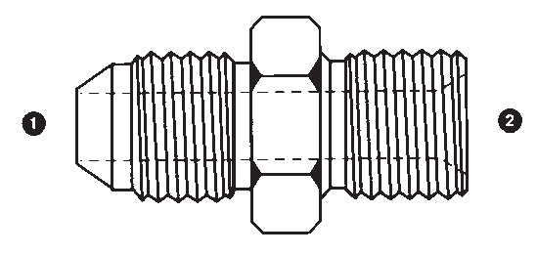
 | 9005-04-08 | 9005-08-10 | 9005-16-10
 | 9005-04-12 | 9005-08-12 | 9005-16-12
 | 9005-05-02 | 9005-08-16 | 9005-16-16
 | 9005-05-04 | 9005-10-04 | 9005-16-20
 | 9005-05-06 | 9005-10-06 | 9005-16-24
 | 9005-05-08 | 9005-10-08 | 9005-20-12
 | 9005-06-02 | 9005-10-10 | 9005-20-16
 | 9005-06-04 | 9005-10-12 | 9005-20-20
 | 9005-06-06 | 9005-10-16 | 9005-20-24
 | 9005-06-08 | 9005-12-04 | 9005-24-16
 | 9005-06-10 | 9005-12-06 | 9005-24-20
 | 9005-06-12 | 9005-12-08 | 9005-24-24
 |  | 9005-12-10 | 9005-24-32
 |  | 9005-12-12 | 9005-32-16
 |  | 9005-12-16 | 9005-32-20
 |  | 9005-12-20 | 9005-32-24
 |  |  | 9005-32-32
29

Carbon Steel
Part Number

Sizes

Descripton

9005EL | ❶ ❷  9005EL-04-04  9005EL-06-04 | ❶ ❷  9005EL-12-10  9005EL-12-12 |  | MALE JIC X  MALE BSPP EXTRA LONG
 | 9005EL-06-06
 | 9005EL-08-06
 | 9005EL-08-08
 | 9005EL-12-08
9005L | ❶ ❷  9005L-04-04  9005L-06-06  9005L-08-06 |  |  | MALE JIC X  MALE BSPP LONG
 | 9005L-10-08
9006 | ❶ ❷  9006-04-04  9006-04-06  9006-04-08 | ❶ ❷  9006-08-08  9006-08-10  9006-08-12 | ❶ ❷  9006-16-12  9006-16-16  9006-16-20 | MALE SAE O-RING BOSS X  MALE BSPP
 | 9006-05-04 | 9006-10-06 | 9006-20-16
 | 9006-05-06 | 9006-10-08 | 9006-20-20
 | 9006-06-04 | 9006-10-10 | 9006-20-24
 | 9006-06-06 | 9006-10-12 | 9006-24-20
 | 9006-06-08 | 9006-12-08 | 9006-24-24
 | 9006-08-04 | 9006-12-12
 | 9006-08-06 | 9006-12-16
9007 | ❶ ❷ | ❶ ❷ | ❶ ❷ | MALE BSPP X  MALE NPT
 | 9007-02-02 | 9007-10-08 | 9007-24-12
 | 9007-02-04 | 9007-10-12 | 9007-24-16
 | 9007-04-02 | 9007-12-04 | 9007-24-20
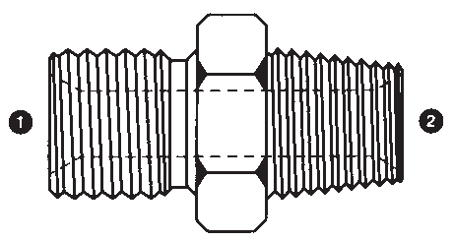 | 9007-04-04 | 9007-12-06 | 9007-24-24
 | 9007-04-06 | 9007-12-08 | 9007-24-32
 | 9007-04-08 | 9007-12-12 | 9007-32-20
 | 9007-06-02 | 9007-12-16 | 9007-32-24
 | 9007-06-04 | 9007-12-20 | 9007-32-32
 | 9007-06-06 | 9007-16-08 | 9007-32-40
 | 9007-06-08 | 9007-16-12 | 9007-32-48
 | 9007-06-12 | 9007-16-16 | 9007-40-32
 | 9007-06-16 | 9007-16-20 | 9007-40-40
 | 9007-08-04 | 9007-16-24 | 9007-40-48
 | 9007-08-06 | 9007-16-32 | 9007-48-48
 | 9007-08-08 | 9007-20-16 | 9007-64-64
 | 9007-08-12 | 9007-20-20
 | 9007-08-16 | 9007-20-24
9008 | ❶ ❷  9008-02-02  9008-02-04  9008-04-02 | ❶ ❷  9008-12-12  9008-16-16  9008-20-20 |  | MALE BSPT X  MALE NPT
 | 9008-04-04 | 9008-24-24
 | 9008-04-06 | 9008-32-32
 | 9008-06-04 | 9008-40-40
 | 9008-06-06 | 9008-48-48
 | 9008-08-08

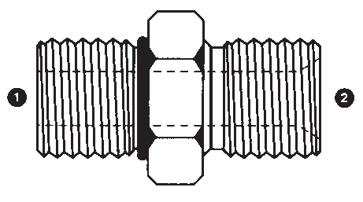
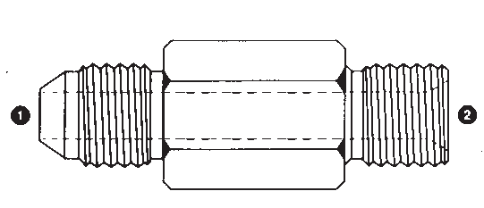
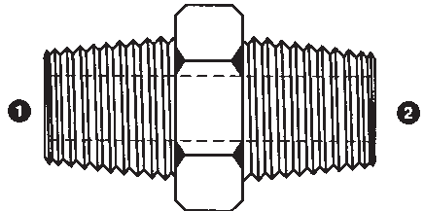
30

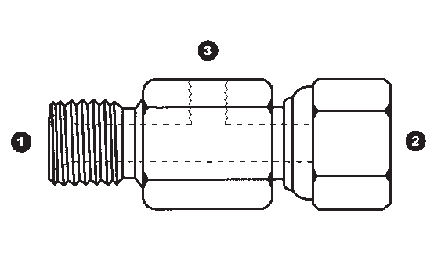Carbon Steel
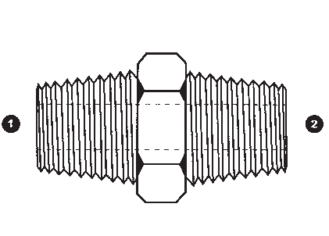
Descripton Sizes Part Number
MALE JIC |  | ❶ ❷  9009-04-02  9009-04-04  9009-06-02  9009-06-04  9009-06-06 | ❶ ❷  9009-08-02  9009-08-06  9009-08-08  9009-12-12  9009-16-16  9009-20-20  9009-24-24 | 9009  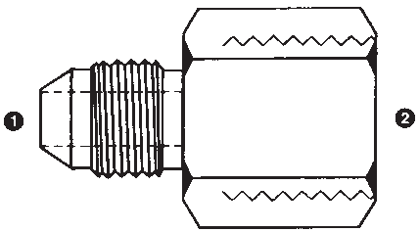
X
FEMALE BSP (SOLID)
FEMALE BSP’S ARE
CAPABLE OF
SEALING WITH BSPP &
BSPT MALES
MALE BSPT X  MALE BSPT | ❶ ❷  9010-02-02  9010-04-02  9010-04-04 | ❶ ❷  9010-06-04  9010-06-06  9010-08-04 | ❶ ❷  9010-16-12  9010-16-16  9010-20-16 | 9010
(BSPT NIPPLE) | 9010-06-02 | 9010-08-06 | 9010-20-20
 |  | 9010-08-08 | 9010-24-24
 |  | 9010-10-10 | 9010-32-32
 |  | 9010-12-08 | 9010-40-40
 |  | 9010-12-12 | 9010-48-48
MALE JIC | ❶ ❷  9011-04-02  9011-04-04  9011-04-06 | ❶ ❷  9011-06-08  9011-08-04  9011-08-06 | ❶ ❷  9011-12-16  9011-14-12  9011-16-12 | 9011  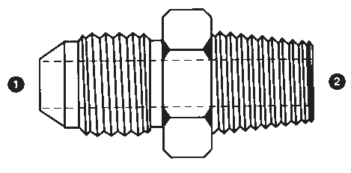
X
MALE BSPT
 | 9011-05-02 | 9011-08-08 | 9011-16-16
 | 9011-05-04 | 9011-08-12 | 9011-16-20
 | 9011-05-06 | 9011-08-16 | 9011-20-16
 | 9011-06-02 | 9011-10-06 | 9011-20-20
 | 9011-06-04 | 9011-10-08 | 9011-20-24
 | 9011-06-06 | 9011-10-12 | 9011-24-24
 |  | 9011-12-08 | 9011-24-32
 |  | 9011-12-12 | 9011-32-32
MALE BSPP | ❶ ❷  9015-02-02  9015-02-04  9015-04-02 | ❶ ❷  9015-08-08  9015-08-10  9015-08-12 | ❶ ❷  9015-16-10  9015-16-12  9015-16-16 | 9015  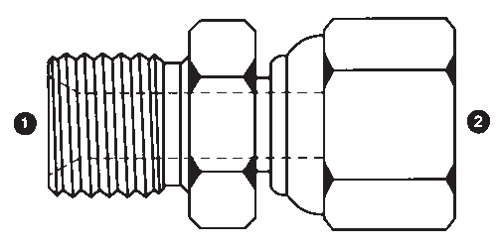
X
FEMALE BSPP (SWIVEL)
 | 9015-04-04 | 9015-08-16 | 9015-16-20
 | 9015-04-06 | 9015-10-08 | 9015-20-12
 | 9015-04-08 | 9015-10-10 | 9015-20-16
 | 9015-06-04 | 9015-10-12 | 9015-20-20
 | 9015-06-06 | 9015-12-06 | 9015-20-24
 | 9015-06-08 | 9015-12-08 | 9015-24-16
 | 9015-06-12 | 9015-12-10 | 9015-24-20
 | 9015-08-04 | 9015-12-12 | 9015-24-24
 | 9015-08-06 | 9015-12-16 | 9015-24-32
 |  | 9015-12-20 | 9015-32-24
 |  | 9015-16-08 | 9015-32-32
BSPP TEST PORT (SWIVEL) TEE | ❶ ❷ ❸  9015TP-04-04-02  9015TP-06-06-02 |  |  | 9015TP
TEST PORT = FEMALE NPT (SOLID) | 9015TP-08-08-04  9015TP-12-12-04  9015TP-16-16-02
31

Carbon Steel
Part Number

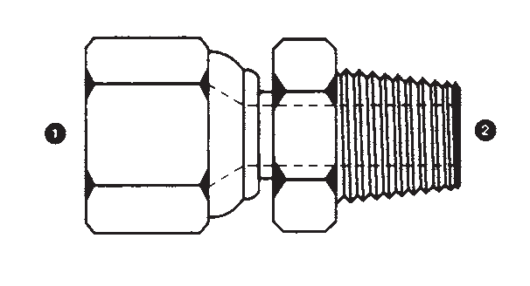
Sizes

Descripton

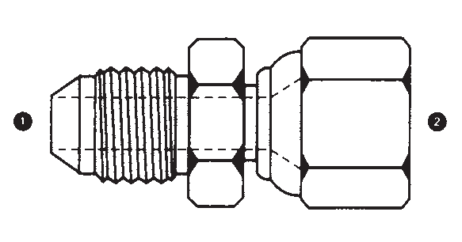
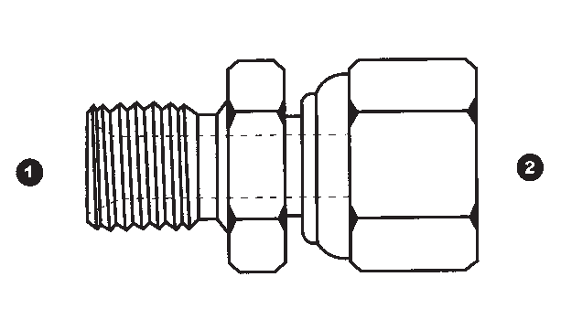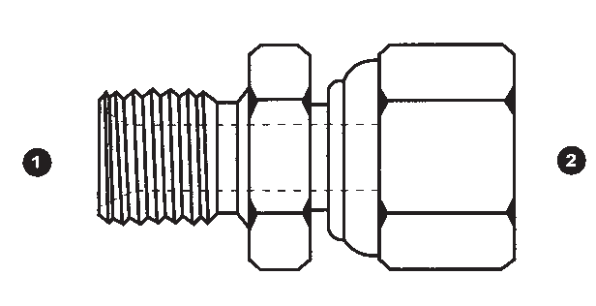
9017 | ❶ ❷  9017-04-02  9017-04-04  9017-05-04 | ❶ ❷  9017-16-12  9017-16-16  9017-20-20 |  | FEMALE JIC (SWIVEL) X  MALE NPT
 | 9017-06-04
 | 9017-06-06
 | 9017-08-06
 | 9017-08-08
 | 9017-10-08
 | 9017-12-12
9018 | ❶ ❷ | ❶ ❷ |  | MALE METRIC X  FEMALE BSPP (SWIVEL)
 | 9018-12-04 | 9018-22-12
 | 9018-14-04 | 9018-26-08
 | 9018-14-06 | 9018-26-12
 | 9018-16-06 | 9018-30X1.5-06
 | 9018-18-06 | 9018-30X1.5-08
 | 9018-18-08
 | 9018-20-08
 | 9018-22-08
9019 | ❶ ❷ | ❶ ❷ |  | MALE BSPP X  FEMALE METRIC (SWIVEL)
 | 9019-04-L06-12 | 9019-08-L12-18
 | 9019-04-L08-14 | 9019-08-L15-22
 | 9019-04-L10-16 | 9019-08-S12-20
 | 9019-06-L06-12 | 9019-08-S16-24
 | 9019-06-L08-14 | 9019-10-L15-22
 | 9019-06-L10-16 | 9019-12-L12-18
 | 9019-06-L12-18 | 9019-12-L15-22
 | 9019-06-S12-20 | 9019-12-S12-20
 | 9019-08-L08-14
 | 9019-08-L10-16
9020 | ❶ ❷  9020-04-04  9020-04-06  9020-05-05 | ❶ ❷  9020-08-08  9020-08-10  9020-08-12 | ❶ ❷  9020-16-12  9020-16-16  9020-16-20 | MALE JIC X  FEMALE JIC
 | 9020-05-06  9020-06-04 | 9020-10-08  9020-10-10 | 9020-20-20  9020-20-24 | (SWIVEL)
 | 9020-06-05 | 9020-10-12 | 9020-24-24
 | 9020-06-06 | 9020-12-08 | 9020-32-32
 | 9020-06-08 | 9020-12-10
 | 9020-06-10 | 9020-12-12
 | 9020-08-06 | 9020-12-16
9021 | ❶ ❷  9021-02-04  9021-04-04  9021-04-05  9021-04-06 | ❶ ❷  9021-08-08  9021-08-10  9021-08-12  9021-10-08 | ❶ ❷  9021-16-16  9021-16-20  9021-20-16  9021-20-20 | MALE BSPP X  FEMALE JIC  (SWIVEL)
 | 9021-06-04 | 9021-10-10 | 9021-24-24
 | 9021-06-06 | 9021-10-12 | 9021-32-24
 | 9021-06-08 | 9021-12-08 | 9021-32-32
 | 9021-06-10 | 9021-12-12
 | 9021-08-04 | 9021-12-16
 | 9021-08-06 | 9021-16-12

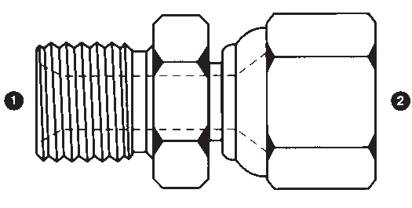
32

Carbon Steel
Descripton Sizes Part Number
MALE JIC X  FEMALE METRIC (SWIVEL) | ❶ ❷  9022-04-L06-12  9022-04-L08-14  9022-05-L06-12  9022-06-L08-14  9022-06-L10-16 | ❶ ❷  9022-06-L15-22  9022-06-S12-20  9022-08-L10-16  9022-08-L12-18  9022-08-L15-22 | 9022  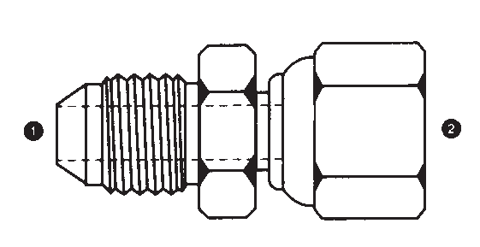
 | 9022-06-L12-18 | 9022-08-S12-20
 |  | 9022-10-L12-18
 |  | 9022-10-L15-22
 |  | 9022-10-S12-20
MALE JIC X  FEMALE FLAT-FACE METRIC (SOLID) | CALL FOR SIZES |  | 9022F  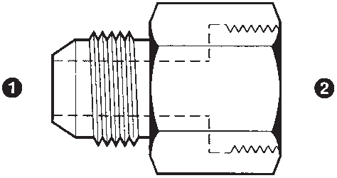
MALE NPT X  FEMAL BSPP  (SWIVEL) | ❶ ❷  9023-02-02  9023-04-04 | ❶ ❷  9023-06-04  9023-06-06  9023-06-08  9023-08-06 | 9023  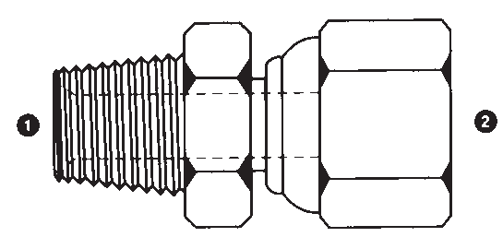
 |  | 9023-08-08
 |  | 9023-12-08
 |  | 9023-12-12
 |  | 9023-16-12
 |  | 9023-16-16
MALE METRIC X  FEMALE JIC  (SWIVEL) | ❶ ❷  9024-12-05  9024-14-06  9024-16-06  9024-16-08 | ❶ ❷  9024-18-08  9024-18-10  9024-20-06  9024-20-08 | 9024  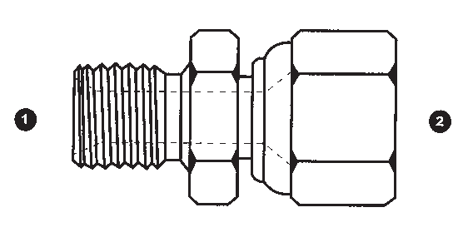
 | 9024-16-10 | 9024-20-10
 | 9024-18-06 | 9024-22-06
 |  | 9024-22-08
 |  | 9024-22-10
FEMALE BSPP (SWIVEL) X  FEMALE BSPP (SWIVEL) | ❶ ❷  9025-02-02  9025-04-04  9025-06-04 | ❶ ❷  9025-12-08  9025-12-10  9025-12-12 | 9025  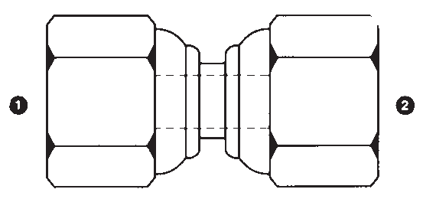
(BSPP UNION) | 9025-06-06  9025-08-04 | 9025-16-08  9025-16-10
 | 9025-08-06 | 9025-16-12
 | 9025-08-08 | 9025-16-16
 | 9025-10-08 | 9025-20-12
 | 9025-10-10 | 9025-20-20
 |  | 9025-24-24
 |  | 9025-32-24
 |  | 9025-32-32
33

Carbon Steel
Part Number

Sizes

Descripton

9026 | ❶ ❷  9026-04-04  9026-05-05  9026-06-04 | ❶ ❷  9026-12-08  9026-12-10  9026-12-12 | FEMALE JIC (SWIVEL) X  FEMALE JIC (SWIVEL)
 | 9026-06-05 | 9026-16-12 | (JIC UNION)
 | 9026-06-06 | 9026-16-16
 | 9026-08-04 | 9026-20-20
 | 9026-08-06 | 9026-24-24
 | 9026-08-08 | 9026-32-32
 | 9026-10-08
 | 9026-10-10
9027  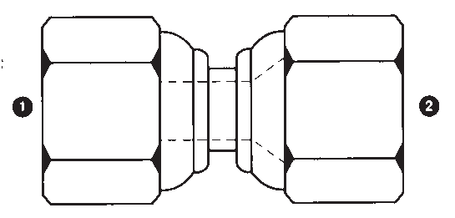 | ❶ ❷  9027-04-04  9027-04-05  9027-04-06  9027-06-04  9027-06-05  9027-06-06  9027-06-08  9027-08-06  9027-08-08 | ❶ ❷  9027-12-08  9027-12-12  9027-12-16  9027-16-12  9027-16-16  9027-20-20 | FEMALE BSPP (SWIVEL) X  FEMALE JIC (SWIVEL)
 | 9027-10-10
9028 | ❶  9028-02  9028-04 |  | BSPP COUNTERSUNK SEALED PLUG
 | 9028-06
 | 9028-08
 | 9028-12
 | 9028-16
 | 9028-20
 | 9028-24
9029  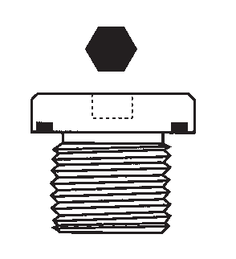 | ❶  9029-08X1.0  9029-10X1.0  9029-12X1.5  9029-14X1.5  9029-16X1.5  9029-18X1.5  9029-20X1.5  9029-22X1.5  9029-24X1.5  9029-26X1.5 | ❶  9029-27X2.0  9029-33X2.0  9029-42X2.0  9029-48X2.0 | METRIC COUNTERSUNK SEALED PLUG
9030 | ❶  9030-02 | ❶  9030-32 | BSPP HEX PLUG
 | 9030-04 | 9030-40
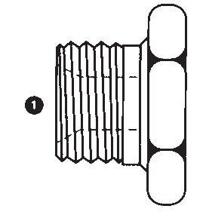 | 9030-06 | 9030-48
 | 9030-08
 | 9030-10
 | 9030-12
 | 9030-16
 | 9030-20
 | 9030-24

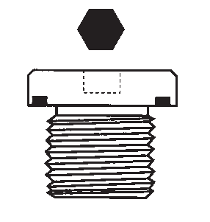
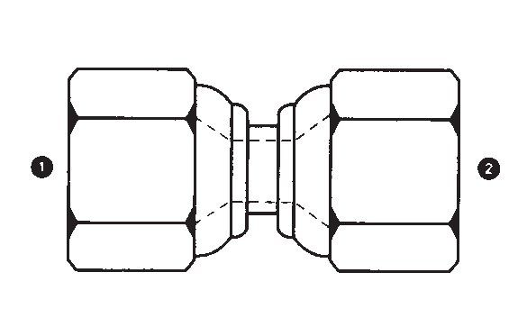
34

Carbon Steel
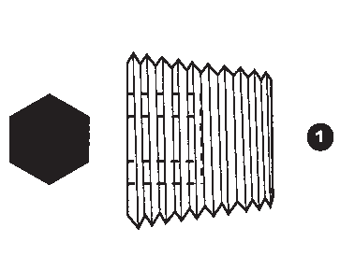
Descripton Sizes Part Number
METRIC HEX PLUG | ❶  9030M-08X1.0 | ❶  9030M-12X1.0 | 9030M  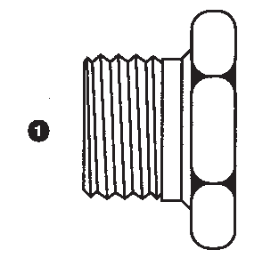
 | 9030M-10X1.0 | 9030M-12X1.5
 | 9030M-10X1.5 | 9030M-14X1.5
 |  | 9030M-16X1.5
 |  | 9030M-18X1.5
 |  | 9030M-20X1.5
 |  | 9030M-22X1.5
 |  | 9030M-24X1.5
 |  | 9030M-26X1.5
 |  | 9030M-30X1.5
BSPT HEX PLUG | ❶  9030T-02  9030T-04 |  | 9030T
 | 9030T-06
 | 9030T-08
 | 9030T-10
 | 9030T-12
 | 9030T-16
 | 9030T-20
 | 9030T-24
 | 9030T-32
BSPT COUNTERSUNK PLUG | ❶  9030TCSP-02  9030TCSP-04  9030TCSP-06  9030TCSP-08  9030TCSP-12  9030TCSP-16 |  | 9030TCSP
MALE BSPT X  FEMALE BSPT (SOLID) | ❶ ❷  9031-04-02  9031-06-02  9031-06-04 |  | 9031  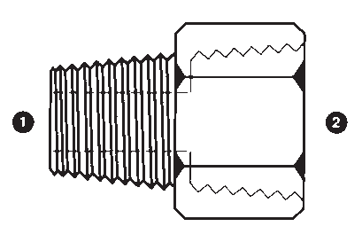
(BSPT BUSHING) | 9031-08-04  9031-08-06
 | 9031-12-06
 | 9031-12-08
 | 9031-16-08
 | 9031-16-12
 | 9031-32-24
MALE BSPT | ❶ ❷  9032-02-04  9032-04-02  9032-04-04  9032-04-06  9032-06-02  9032-06-04  9032-06-06  9032-08-08 | ❶ ❷  9032-12-04  9032-12-06  9032-12-08  9032-12-12  9032-16-08  9032-16-12  9032-16-16  9032-20-16  9032-20-20  9032-24-20 | 9032  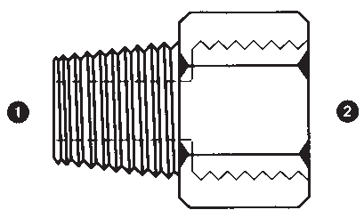
X
FEMALE BSP (SOLID)
FEMALE BSP’S ARE
CAPABLE OF
SEALING WITH BSPP &
BSPT MALES
35

Carbon Steel
Part Number

Sizes

Descripton

 | 9033 |  | ❶  9033-02  9033-04 |  |  | BSPP SWIVEL CAP  MALE BSPP X  FEMALE BSPT (SOLID)  MALE BSPP X  FEMALE NPT (SOLID)  MALE BSPP  C/W WASHER & O-RING  X  FEMALE NPT (SOLID)
 |  |  | 9033-06
 |  |  | 9033-08
 |  |  | 9033-10
 |  |  | 9033-12
 |  |  | 9033-16
 |  |  | 9033-20
 |  |  | 9033-24
 |  |  | 9033-32
 | 9034 |  | ❶ ❷  9034-04-02  9034-04-04
 |  |  | 9034-06-04
 |  |  | 9034-06-06
 |  |  | 9034-08-08
 |  |  | 9034-12-12
 | 9035 |  | ❶ ❷  9035-02-02  9035-02-04 | ❶ ❷  9035-10-06  9035-12-04 | ❶ ❷  9035-24-16  9035-24-20
 |  |  | 9035-04-02 | 9035-12-06 | 9035-24-24
 |  |  | 9035-04-04 | 9035-12-08 | 9035-24-32
 |  |  | 9035-04-06 | 9035-12-12 | 9035-32-12
 |  |  | 9035-04-08 | 9035-16-04 | 9035-32-24
 |  |  | 9035-06-02 | 9035-16-06 | 9035-32-32
 |  |  | 9035-06-04 | 9035-16-08 | 9035-40-24
 |  |  | 9035-06-06 | 9035-16-12 | 9035-40-32
 |  |  | 9035-06-08 | 9035-16-16 | 9035-40-40
 |  |  | 9035-08-02 | 9035-20-12 | 9035-40-48
 |  |  | 9035-08-04 | 9035-20-16 | 9035-48-32
 |  |  | 9035-08-06 | 9035-20-20 | 9035-48-48
 |  |  | 9035-08-08 | 9035-24-12
 | 9035S |  | ❶ ❷  9035S-02-02  9035S-04-02 | ❶ ❷  9035S-12-12  9035S-16-16
 |  |  | 9035S-04-04 | 9035S-20-20
 |  |  | 9035S-06-04 | 9035S-24-24
 |  |  | 9035S-06-06 | 9035S-32-32
1 |  | 2 | 9035S-08-06
 |  |  | 9035S-08-08
 |  |  | 9035S-12-08
9036 |  |  | ❶ ❷  9036-02-04  9036-04-04 | ❶ ❷  9036-08-10  9036-08-16 | ❶ ❷  9036-24-24  9036-32-24 | MALE BSPP X  FEMALE SAE O-RING BOSS (SOLID)
 |  |  | 9036-04-05 | 9036-10-10
 |  |  | 9036-04-06 | 9036-12-12
 |  |  | 9036-06-05 | 9036-12-16
 |  |  | 9036-06-06 | 9036-16-16
 |  |  | 9036-06-08 | 9036-20-20
 |  |  | 9036-08-08 | 9036-20-24

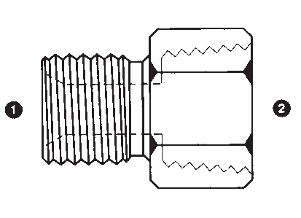
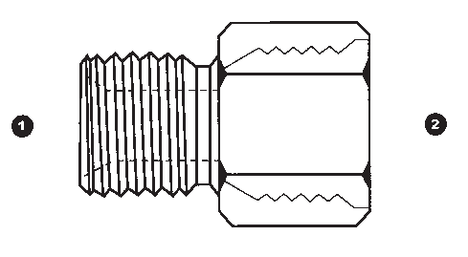
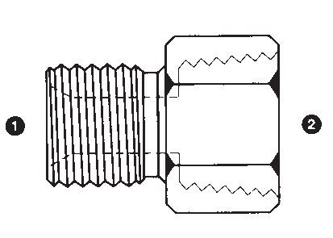
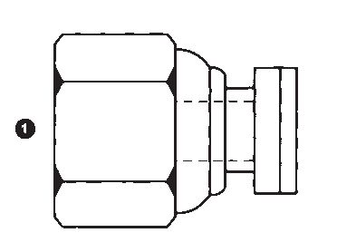
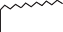36

Carbon Steel
Descripton Sizes Part Number
MALE NPT | ❶ ❷  9037-02-02  9037-02-04  9037-04-02  9037-04-04  9037-04-06  9037-06-04  9037-06-06  9037-08-04  9037-08-06  9037-08-08 | ❶ ❷  9037-08-12  9037-12-04  9037-12-06  9037-12-08  9037-12-12  9037-16-06  9037-16-08  9037-16-12  9037-16-16  9037-20-08 | ❶ ❷  9037-20-20  9037-24-16  9037-24-20  9037-24-24  9037-32-16  9037-32-20  9037-32-32  9037-40-40  9037-48-32  9037-48-48 | 9037  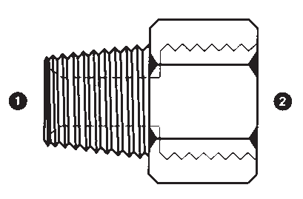
X
FEMALE BSP (SOLID)
FEMALE BSP’S ARE
CAPABLE OF
SEALING WITH BSPP &
BSPT MALES
MALE BSPP | ❶ ❷  9038-06-02  9038-08-02  9038-08-04 | ❶ ❷  9038-12-04  9038-12-06  9038-16-04  9038-16-06  9038-16-08  9038-20-08  9038-20-12  9038-20-16 | ❶ ❷  9038-24-08  9038-24-12  9038-24-16  9038-32-12  9038-32-16  9038-32-20  9038-32-24  9038-40-32 | 9038  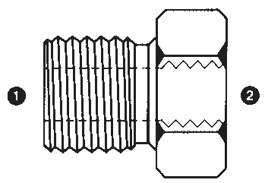
X
FEMALE BSP (SOLID)
(BSPP BUSHING)
FEMALE BSP’S ARE
CAPABLE OF
SEALING WITH BSPP &
BSPT MALES
MALE BSPP | ❶ ❷  9039-02-02  9039-02-04  9039-02-06  9039-04-02  9039-04-04  9039-04-06  9039-04-08  9039-06-04  9039-06-06 | ❶ ❷  9039-06-08  9039-06-12  9039-08-06  9039-08-08  9039-08-12  9039-08-16  9039-10-08  9039-12-08  9039-12-10 | ❶ ❷  9039-12-12  9039-12-16  9039-12-20  9039-16-12  9039-16-16  9039-16-20  9039-16-24  9039-20-20  9039-24-20  9039-24-24  9039-32-32 | 9039  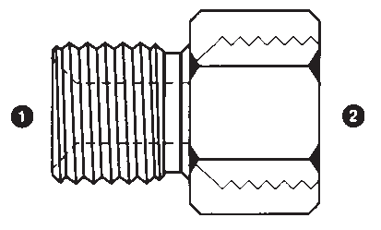
X
FEMALE BSP EXTENDED
(SOLID)
(BSPP EXTENDED
BUSHING)
FEMALE BSP’S ARE
CAPABLE OF
SEALING WITH BSPP &
BSPT MALES
MALE BSPP X  MALE BSPP BULKHEAD |  | ❶ ❷  9040-02-02  9040-04-04  9040-04-06 | ❶ ❷  9040-08-12  9040-10-10  9040-12-08 | 9040  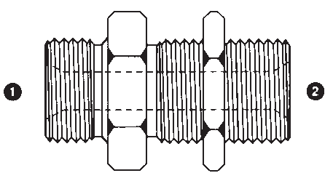
 |  | 9040-06-04 | 9040-12-12
 |  | 9040-06-06 | 9040-12-16
 |  | 9040-06-08 | 9040-16-16
 |  | 9040-08-06 | 9040-20-20
 |  | 9040-08-08 | 9040-24-24
 |  |  | 9040-32-32
BSPP BULKHEAD LOCKNUT | ❶  9041-02  9041-04 |  |  | 9041
 | 9041-06
 | 9041-08
 | 9041-10
 | 9041-12
 | 9041-16
 | 9041-20
 | 9041-24
 | 9041-32
37

Carbon Steel
Part Number

Sizes

Descripton

9042 | ❶ ❷ | ❶ ❷ | ❶ ❷ | MALE BSPT X  FEMALE NPT (SOLID)
 | 9042-02-02 | 9042-12-06 | 9042-20-20
 | 9042-02-04 | 9042-12-08 | 9042-24-20
 | 9042-04-02 | 9042-12-12 | 9042-24-24
 | 9042-04-04 | 9042-16-04 | 9042-32-32
 | 9042-06-02 | 9042-16-12 | 9042-48-48
 | 9042-06-06 | 9042-16-16
 | 9042-08-04 | 9042-20-12
 | 9042-08-08 | 9042-20-16
9043 | ❶ ❷  9043-02-02  9043-04-02 | ❶ ❷  9043-12-08  9043-12-12 |  | FEMALE BSP (SOLID) X  FEMALE BSP (SOLID)  (BSP COUPLING)  FEMALE BSP’S ARE CAPABLE OF  SEALING WITH BSPP &
 | 9043-04-04 | 9043-16-12
 | 9043-06-04 | 9043-16-16
 | 9043-06-06 | 9043-20-20
 | 9043-08-06 | 9043-24-24
 | 9043-08-08 | 9043-32-32
 | 9043-10-08 | 9043-40-40
 | 9043-10-10
 |  |  |  | BSPT MALES
9043M | ❶ ❷  9043M-12-12  9043M-14-14 |  |  | FEMALE METRIC (SOLID)  X FEMALE METRIC  (SOLID)  (METRIC COUPLING)
 | 9043M-16-12
 | 9043M-16-16
 | 9043M-18-18
 | 9043M-20-20
 | 9043M-22-16
 | 9043M-22-22
9044 | ❶ ❷  9044-02-02  9044-04-04 | ❶ ❷  9044-24-24  9044-32-32 |  | FEMALE BSP (SOLID) X  FEMALE NPT (SOLID)  FEMALE BSP’S ARE CAPABLE OF  SEALING WITH BSPP & BSPT MALES
 | 9044-06-04 | 9044-40-40
 | 9044-06-06 | 9044-48-48
 | 9044-08-08
 | 9044-12-12
 | 9044-16-16
 | 9044-20-16
 | 9044-20-20
9045 | ❶ ❷  9045-04-04  9045-06-06 |  |  | 90° MALE BSPP X  FEMALE BSPP (SWIVEL) ELBOW  (TUBE ELBOW)
 | 9045-08-08
 | 9045-10-10
 | 9045-12-12
 | 9045-16-16
 | 9045-20-20
 | 9045-24-24
 | 9045-32-32

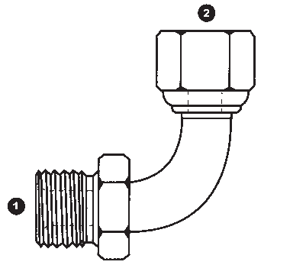
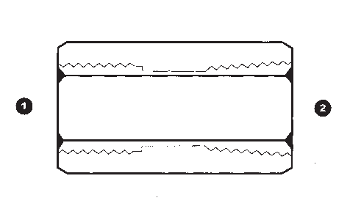
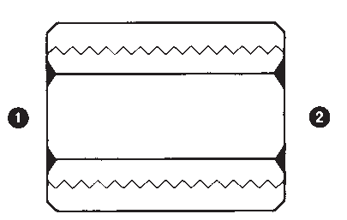
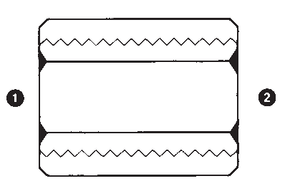
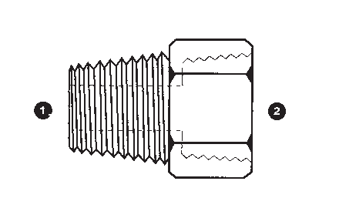
38

Carbon Steel
Descripton Sizes Part Number
45° MALE BSPP | ❶ ❷  9047-04-04  9047-06-06  9047-08-08  9047-10-10  9047-12-12  9047-16-16  9047-20-20 |  | 9047  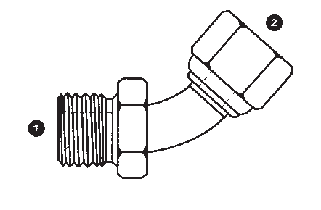
X
FEMALE BSPP
(SWIVEL) ELBOW
(TUBE ELBOW)
90° FEMALE | ❶ ❷  9050-04-04  9050-06-06  9050-08-08  9050-10-10  9050-12-12  9050-16-16  9050-20-20  9050-24-24 |  | 9050  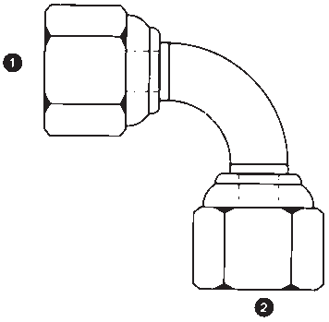
BSPP (SWIVEL)
X
FEMALE BSPP
(SWIVEL) ELBOW
(TUBE ELBOW)
45° MALE BSPP | ❶ ❷  9051-04-04  9051-06-04  9051-06-06  9051-08-06  9051-08-08  9051-12-12  9051-16-16 |  | 9051  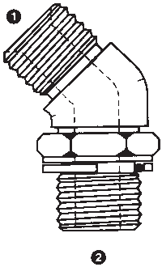
X
MALE BSPP ADJ.
ELBOW
(FORGED STEEL)
90° MALE BSPP X  MALE BSPP ADJ. ELBOW | ❶ ❷  9052-04-04  9052-04-06 | ❶ ❷  9052-06-04  9052-06-06  9052-06-08  9052-08-06 | 9052  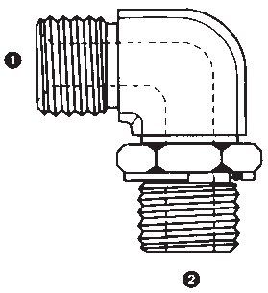
(FORGED STEEL) |  | 9052-08-08  9052-08-12
 |  | 9052-12-08
 |  | 9052-12-12
 |  | 9052-16-16
 |  | 9052-20-20
45° FEMALE BSPP | ❶ ❷  9053-04-04  9053-06-06  9053-08-08  9053-10-10  9053-12-12  9053-16-16  9053-20-20 |  | 9053  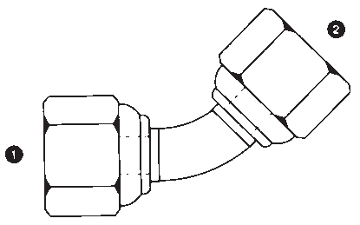
(SWIVEL)
X
FEMALE BSPP
(SWIVEL) ELBOW
(TUBE ELBOW)
39

Carbon Steel
Part Number

Sizes

Descripton

9054  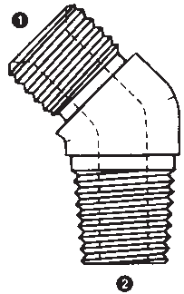 | ❶ ❷  9054-04-02  9054-04-04  9054-04-06  9054-06-04  9054-06-06  9054-08-06  9054-08-08  9054-12-12  9054-16-16 |  | 45° MALE BSPP X  MALE BSPT ELBOW  (FORGED STEEL)
9055  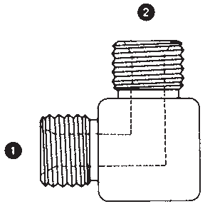 | ❶ ❷  9055-02-02  9055-04-04  9055-06-04  9055-06-06  9055-08-06  9055-08-08  9055-10-10  9055-12-08  9055-12-10 | ❶ ❷  9055-16-12  9055-16-16  9055-20-20  9055-24-24  9055-32-32 | 90° MALE BSPP X  MALE BSPP ELBOW
 | 9055-12-12
9056  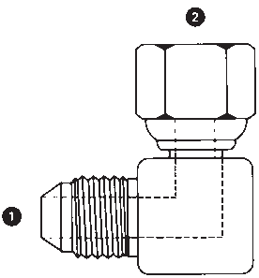 | ❶ ❷  9056-04-04  9056-06-06  9056-08-06  9056-08-08  9056-12-12 |  | 90° MALE JIC X  FEMALE BSPP (SWIVEL) ELBOW
9057  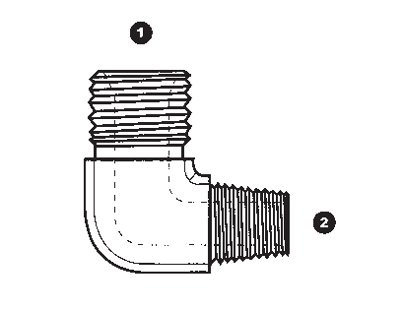 | ❶ ❷  9057-02-02  9057-02-04  9057-04-02  9057-04-04  9057-04-06  9057-06-04  9057-06-06  9057-08-06  9057-08-08 | ❶ ❷  9057-16-16 | 90° MALE BSPP X  MALE BSPT ELBOW  (FORGED STEEL)
 | 9057-12-12
9058  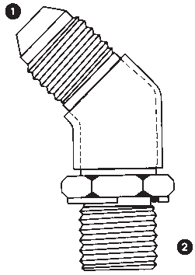 | ❶ ❷  9058-04-02  9058-04-04  9058-06-04  9058-06-06  9058-08-06  9058-08-08  9058-10-08  9058-12-08  9058-12-12  9058-16-16 |  | 45° MALE JIC X  MALE BSPP ADJ. ELBOW  (FORGED STEEL)

40

Carbon Steel
Descripton Sizes Part Number
90° MALE JIC X  MALE BSPP ADJ. ELBOW | ❶ ❷  9059-04-02  9059-04-04  9059-04-06  9059-05-04 | ❶ ❷  9059-05-06  9059-06-04  9059-06-06  9059-06-08 | ❶ ❷  9059-10-12  9059-12-08  9059-12-12  9059-12-16 | 9059  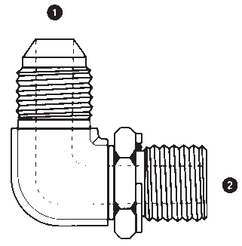
(FORGED STEEL) |  | 9059-08-04  9059-08-06  9059-08-08 | 9059-16-12  9059-16-16  9059-16-20
 |  | 9059-08-12 | 9059-20-16
 |  | 9059-10-06 | 9059-20-20
 |  | 9059-10-08 | 9059-24-24
90° MALE JIC | ❶ ❷  9059L-06-06  9059L-08-06  9059L-08-08 |  |  | 9059L  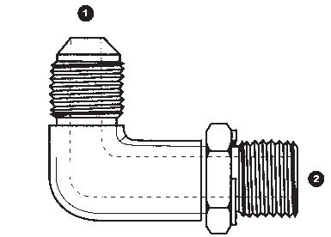
X
MALE BSPP ADJ. LONG
ELBOW
(FORGED STEEL)
90° MALE BSPP X  FEMALE BSPP  (SWIVEL) ELBOW |  | ❶ ❷  9060-02-02  9060-04-04  9060-04-06  9060-06-04 | ❶ ❷  9060-06-08  9060-08-06  9060-08-08  9060-10-10 | 9060  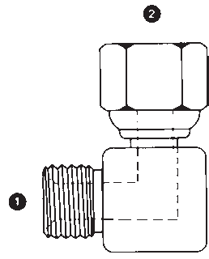
 |  | 9060-06-06 | 9060-12-12
 |  |  | 9060-16-12
 |  |  | 9060-16-16
 |  |  | 9060-20-20
 |  |  | 9060-24-24
 |  |  | 9060-32-32
90° MALE BSPP X  FEMALE JIC (SWIVEL) ELBOW | ❶ ❷  9061-04-04  9061-04-06  9061-06-06  9061-06-08 |  |  | 9061  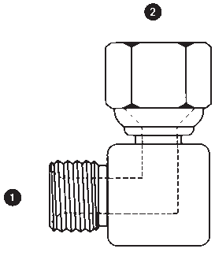
 | 9061-08-06
 | 9061-08-08
 | 9061-08-10
 | 9061-10-10
 | 9061-12-12
90° MALE BSPT X  FEMALE BSPP (SWIVEL) ELBOW | ❶ ❷  9062-02-02  9062-04-04  9062-06-06  9062-08-08  9062-12-12  9062-16-16 |  |  | 9062  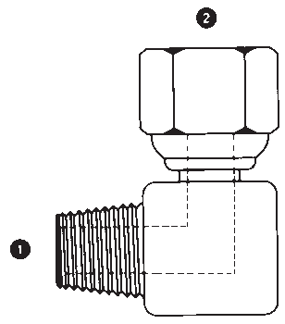
41

Carbon Steel
Part Number

Sizes

Descripton

9063 | ❶ ❷  9063-04-02  9063-04-04 | ❶ ❷  9063-10-08  9063-12-08 |  | 90° MALE JIC X  MALE BSPT ELBOW  (FORGED STEEL)
 | 9063-05-02 | 9063-12-12
 | 9063-05-04 | 9063-12-16
 | 9063-06-04 | 9063-16-12
 | 9063-06-06 | 9063-16-16
 | 9063-06-08 | 9063-20-20
 | 9063-08-06 | 9063-24-24
 | 9063-08-08 | 9063-32-32
9064 | ❶ ❷  9064-04-02  9064-04-04  9064-06-04  9064-06-06  9064-08-06  9064-08-08  9064-10-08  9064-12-12  9064-16-12  9064-16-16 | ❶ ❷  9064-20-20 |  | 45° MALE JIC X  MALE BSPT ELBOW
 |  |  |  | (FORGED STEEL)
9065 | ❶ ❷  9065-04-04  9065-06-04  9065-06-06 | ❶ ❷  9065-16-16  9065-20-20 |  | 90° MALE JIC X  MALE BSPP ELBOW
 | 9065-08-06
 | 9065-08-08
 | 9065-10-08
 | 9065-10-12
 | 9065-12-12
 | 9065-12-16
9066 | ❶ ❷  9066-04-10  9066-06-14 |  |  | 45° MALE JIC X  MALE METRIC ADJ. ELBOW  (FORGED STEEL)
 | 9066-08-16
 | 9066-08-18
 | 9066-10-18
 | 9066-10-22
 | 9066-12-22
 | 9066-12-27
9067 | ❶ ❷  9067-04-12  9067-04-14  9067-06-12 | ❶ ❷  9067-08-14  9067-08-16  9067-08-18 | ❶ ❷  9067-10-26  9067-12-26 | MALE JIC X  MALE METRIC
 | 9067-06-14 | 9067-08-20
 | 9067-06-16 | 9067-08-22
 | 9067-06-18 | 9067-10-16
 | 9067-06-20 | 9067-10-18
 | 9067-06-22 | 9067-10-20
 | 9067-08-12 | 9067-10-22

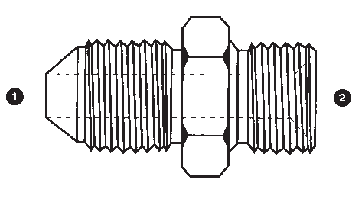
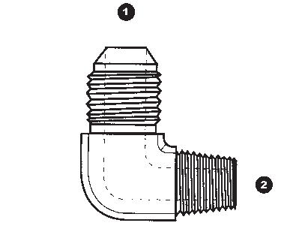
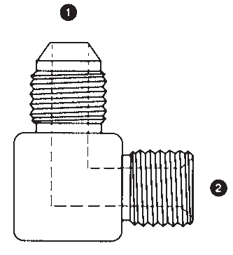
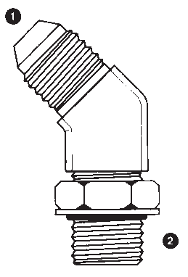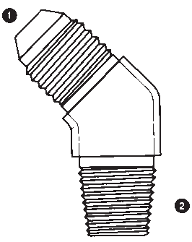42

Carbon Steel
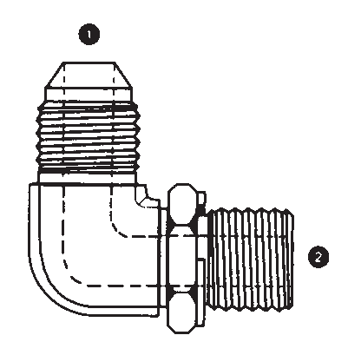
Descripton Sizes Part Number
MALE JIC X  MALE METRIC  C/W WASHER & O-RING | ❶ ❷  9068-04-10  9068-04-12  9068-04-14 | ❶ ❷  9068-05-12  9068-05-16  9068-06-12  9068-06-14 | ❶ ❷  9068-10-20  9068-10-22  9068-12-22  9068-12-26 | 9068  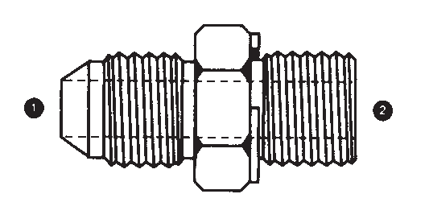
 |  | 9068-06-16 | 9068-12-27
 |  | 9068-08-14 | 9068-16-27
 |  | 9068-08-16 | 9068-16-33
 |  | 9068-08-18 | 9068-20-33
 |  | 9068-08-22 | 9068-20-42
 |  | 9068-10-18 | 9068-24-48
90° MALE JIC X  MALE METRIC ADJ. ELBOW | ❶ ❷  9069-04-10  9069-04-12  9069-04-14 | ❶ ❷  9069-05-10  9069-05-12  9069-05-14  9069-06-12 | ❶ ❷  9069-10-18  9069-10-20  9069-10-22  9069-12-22 | 9069
(FORGED STEEL) |  | 9069-06-14  9069-06-16 | 9069-12-26  9069-12-27
 |  | 9069-06-18 | 9069-12-30X1.5
 |  | 9069-08-16 | 9069-16-27
 |  | 9069-08-18 | 9069-16-33
 |  | 9069-08-20 | 9069-20-42
 |  | 9069-08-22 | 9069-24-48
90° MALE JIC | ❶ ❷  9069L-08-18  9069L-10-22 |  |  | 9069L  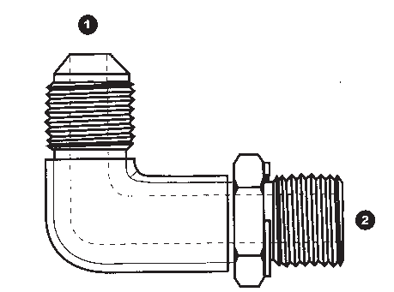
X
MALE METRIC ADJ.
LONG ELBOW
(FORGED STEEL)
90° MALE BSPP X  MALE NPT ELBOW | ❶ ❷  9070-02-02  9070-04-04  9070-06-06 |  |  | 9070
(FORGED STEEL) | 9070-08-08  9070-12-12
 | 9070-16-16
90° MALE NPT X  FEMALE BSPP (SWIVEL) ELBOW | ❶ ❷  9072-02-02  9072-04-04  9072-06-06  9072-08-08 |  |  | 9072
 | 9072-12-12
 | 9072-16-16
 | 9072-20-20
 | 9072-24-24
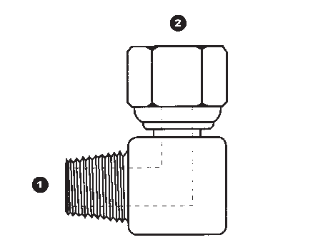
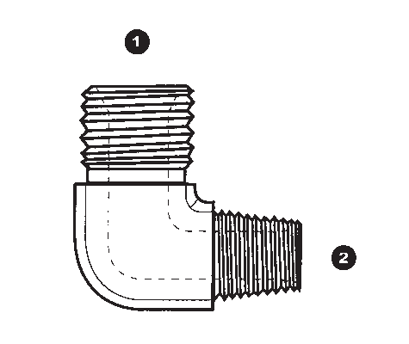
43

Carbon Steel
Part Number

Sizes

Descripton

)
9075  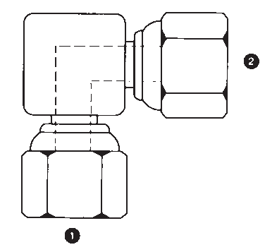 | ❶ ❷  9075-02-02  9075-04-04  9075-06-06  9075-08-08  9075-10-10  9075-12-12  9075-16-16  9075-20-20  9075-24-24  9075-32-32 | 90° FEMALE BSPP (SWIVEL)  X  FEMALE BSPP (SWIVEL) ELBOW
9076  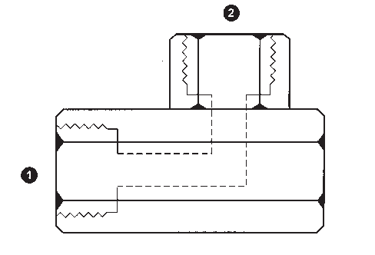 | ❶ ❷  9076-04-04  9076-06-06  9076-08-08  9076-12-12  9076-16-16 | 90° FEMALE BSP (SOLID X  FEMALE BSP (SOLID) ELBOW  FEMALE BSP’S ARE CAPABLE OF  SEALING WITH BSPP & BSPT MALES
9077  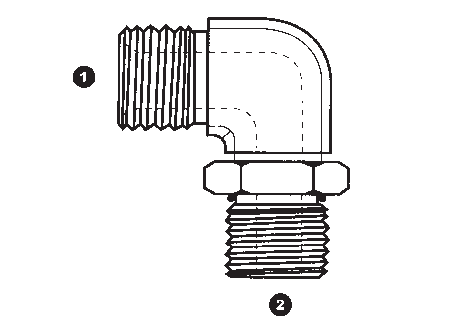 | ❶ ❷  9077-02-04  9077-04-06  9077-06-06  9077-06-08  9077-08-08  9077-08-10  9077-12-12  9077-16-16 | 90° MALE BSPP X  MALE SAE O-RING BOSS ADJ. ELBOW  (FORGED STEEL)
9078  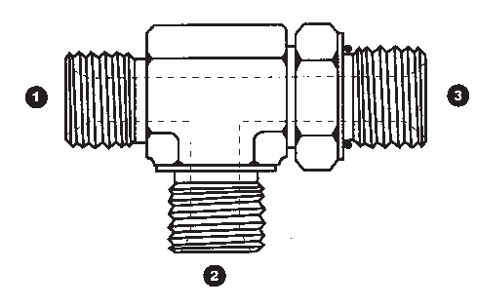 | ❶ ❷ ❸  9078-02-02-04  9078-04-04-06  9078-06-06-08  9078-08-08-10  9078-12-12-10  9078-12-12-12  9078-16-16-16 | MALE BSPP X  MALE SAE O-RING BOSS RUN TEE  (FORGED STEEL)
9079  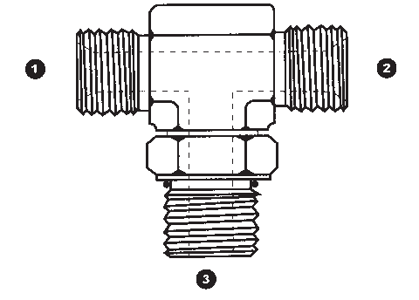 | ❶ ❷ ❸  9079-02-02-04  9079-04-04-06  9079-06-06-08  9079-08-08-08  9079-08-08-10  9079-12-12-12  9079-16-16-16 | MALE BSPP X  MALE SAE O-RING BOSS BRANCH TEE  (FORGED STEEL)

44

Carbon Steel
Descripton Sizes Part Number
MALE BSPP TEE | ❶ ❷ ❸  9080-02-02-02 | 9080  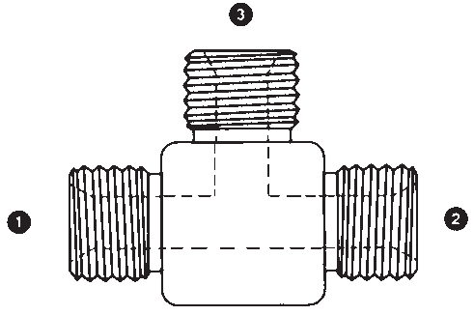
 | 9080-04-04-04
 | 9080-06-06-06
 | 9080-08-08-08
 | 9080-10-10-10
 | 9080-12-12-12
 | 9080-16-16-16
 | 9080-20-20-20
 | 9080-24-24-24
 | 9080-32-32-32
FEMALE BSPP (SWIVEL) TEE | ❶ ❷ ❸  9085-02-02-02  9085-04-04-04 | 9085  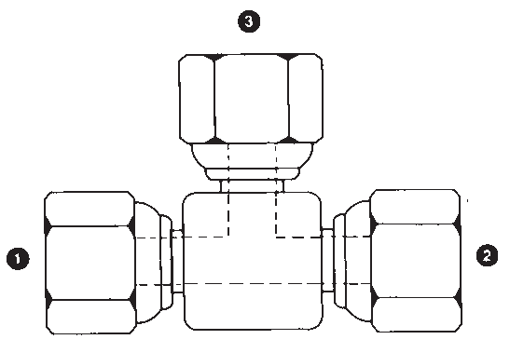
 | 9085-06-06-06
 | 9085-08-08-08
 | 9085-10-10-10
 | 9085-12-12-12
 | 9085-16-16-16
 | 9085-20-20-20
 | 9085-24-24-24
 | 9085-32-32-32
FEMALE BSP (SOLID) | ❶ ❷ ❸  9086-02-02-02  9086-04-04-04  9086-06-06-06  9086-08-08-08  9086-12-12-12  9086-16-16-16  9086-20-20-20 | 9086  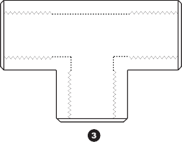
TEE
FEMALE BSP’S ARE
CAPABLE OF SEALING
WITH BSPP & BSPT
MALES
FEMALE BSPP (SWIVEL) BRANCH TEE | ❶ ❷ ❸  9087-02-02-02  9087-04-04-04 | 9087  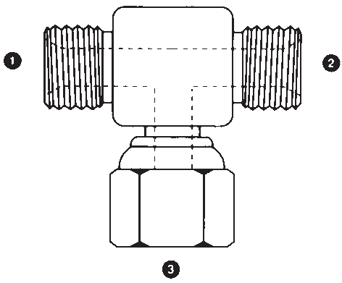
 | 9087-06-06-06
 | 9087-08-08-08
 | 9087-10-10-10
 | 9087-12-12-12
 | 9087-16-16-16
 | 9087-20-20-20
FEMALE BSPP (SWIVEL) RUN TEE | ❶ ❷ ❸  9090-02-02-02  9090-04-04-04 | 9090  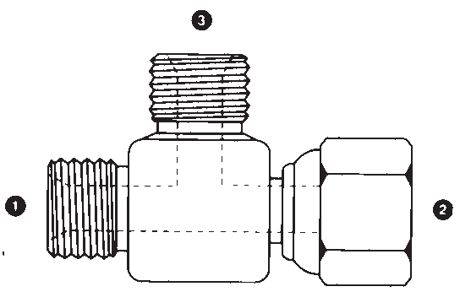
 | 9090-06-06-06
 | 9090-08-08-08
 | 9090-10-10-10
 | 9090-12-12-12
 | 9090-16-16-16
 | 9090-20-20-20
45

Carbon Steel
Part Number

Sizes

Descripton

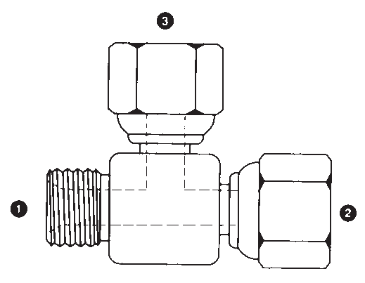

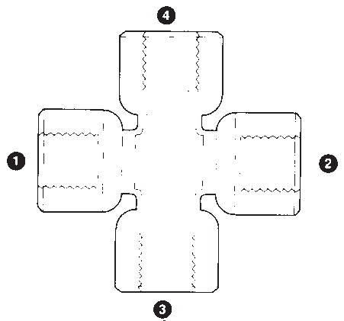H
9095 | ❶ ❷ ❸  9095-02-02-02  9095-04-04-04 | MALE BSPP RUN TEE (SWIVEL)
 | 9095-06-06-06
 | 9095-08-08-08
 | 9095-10-10-10
 | 9095-12-12-12
 | 9095-16-16-16
 | 9095-20-20-20
9097 | ❶  9097-04  9097-08  9097-16  9097-20 | FEMALE BSP (SOLID) CROSS  FEMALE BSP’S ARE CAPABLE OF SEALING WIT BSPP & BSPT MALES
9151 | ❶ ❷ ❸  9151-04-04-04  9151-06-06-04 | MALE BSPP ADJ. RUN TEE
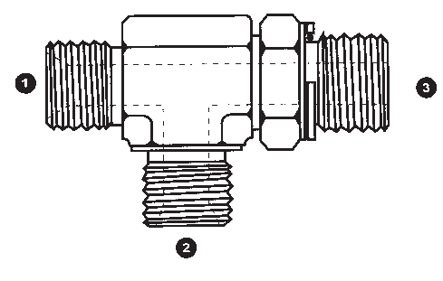 | 9151-06-06-06  9151-08-08-06  9151-08-08-08  9151-12-12-12 | (FORGED STEEL)
9152  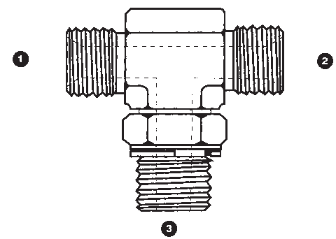 | ❶ ❷ ❸  9152-04-04-04  9152-06-06-04  9152-06-06-06  9152-08-08-06  9152-08-08-08  9152-12-12-12 | MALE BSPP ADJ. BRANCH TEE  (FORGED STEEL))
9158  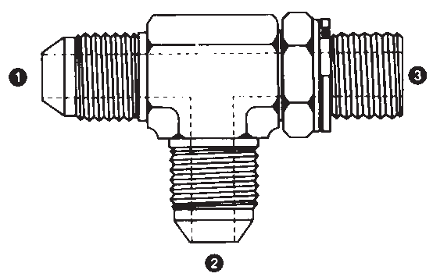 | ❶ ❷ ❸  9158-04-04-04  9158-05-05-04  9158-06-06-04  9158-06-06-06  9158-08-08-06  9158-08-08-08  9158-10-10-08  9158-12-12-12  9158-16-16-16  9158-20-20-20 | MALE JIC X  MALE BSPP ADJ. RUN TEE  (FORGED STEEL)

46

Carbon Steel
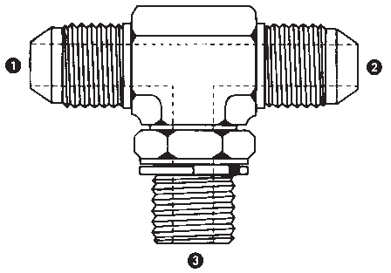
Descripton Sizes Part Number
MALE JIC X  MALE BSPP ADJ BRANCH TEE | ❶ ❷ ❸  9159-04-04-04  9159-05-05-04  9159-06-06-04  9159-06-06-06 | 9159
(FORGED STEEL) | 9159-08-08-06  9159-08-08-08
 | 9159-10-10-08
 | 9159-12-12-12
 | 9159-16-16-16
MALE JIC X  MALE BSPT RUN TEE | ❶ ❷ ❸  9163-04-04-04  9163-06-06-04  9163-08-08-06 | 9163
(FORGED STEEL) | 9163-10-10-08  9163-12-12-12 | 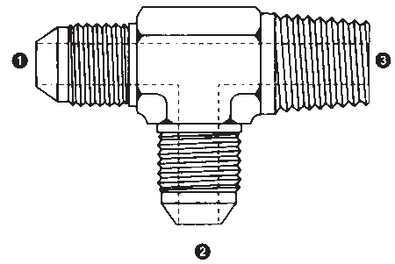
MALE JIC | ❶ ❷ ❸  9164-04-04-04  9164-06-06-04  9164-08-08-06  9164-10-10-08  9164-12-12-12 | 9164  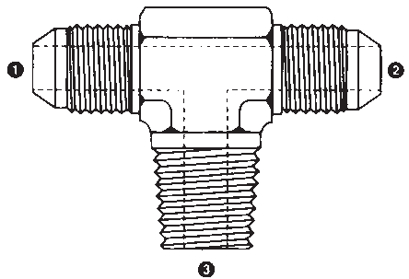
X
MALE BSPT BRANCH
TEE
(FORGED STEEL)
MALE JIC X  MALE METRIC ADJ. RUN TEE | ❶ ❷ ❸  9168-04-04-10  9168-04-04-12  9168-06-06-14  9168-08-08-16 | 9168
(FORGED STEEL) | 9168-08-08-18  9168-10-10-22
 | 9168-12-12-27
 | 9168-16-16-33
MALE JIC X  MALE METRIC ADJ. BRANCH TEE | ❶ ❷ ❸  9169-04-04-10  9169-04-04-12  9169-06-06-14  9169-08-08-16 | 9169
(FORGED STEEL) | 9169-08-08-18  9169-10-10-22
 | 9169-12-12-27
 | 9169-16-16-33
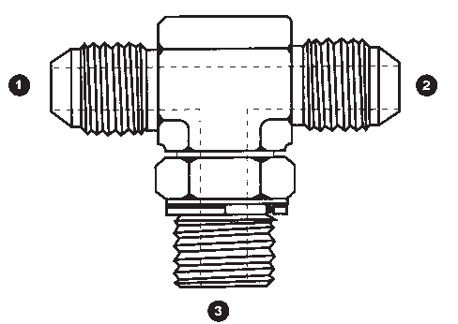
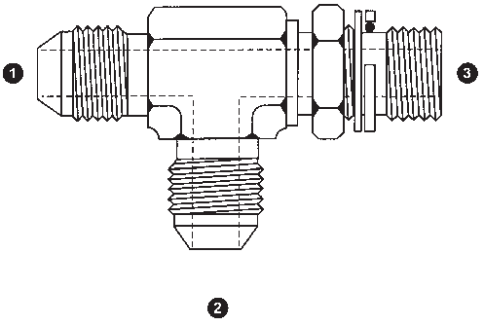
47

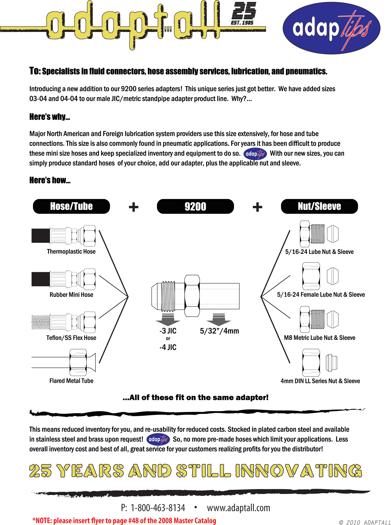

Carbon Steel
Part Number

Sizes

Descripton

9197 | CALL FOR SIZES |  |  | BRAZE MALE JIC X  METRIC BORE
9198 | CALL FOR SIZES |  |  | 45° MALE JIC X  METRIC STANDPIPE
 |  |  |  | ELBOW
9199 | CALL FOR SIZES |  |  | 90° MALE JIC X  METRIC STANDPIPE
 |  |  |  | ELBOW
9200 | ❶ ❷  9200-04-06  9200-04-08  9200-04-10 | ❶ ❷  9200-08-14  9200-08-15  9200-08-16 | ❶ ❷  9200-12-25  9200-16-25  9200-16-28 | MALE JIC X  METRIC STANDPIPE
 | 9200-05-12 | 9200-10-16 | 9200-16-30
 | 9200-06-08 | 9200-10-18 | 9200-20-28
 | 9200-06-10 | 9200-10-20 | 9200-20-35
 | 9200-06-12 | 9200-12-16 | 9200-20-38
 | 9200-06-14 | 9200-12-18 | 9200-24-35
 | 9200-08-10 | 9200-12-20 | 9200-24-38
 | 9200-08-12 | 9200-12-22 | 9200-24-42
9201L | ❶  9201L-06  9201L-08 | ❶  9201L-28-36X1.5  9201L-35 |  | METRIC LIGHT SERIES TUBE NUT
 | 9201L-10  9201L-12 | 9201L-42 |  | (DIN 2353 L)
 | 9201L-15
 | 9201L-18
 | 9201L-22
 | 9201L-22-30X1.5
 | 9201L-28

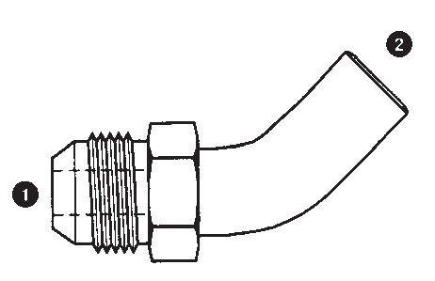
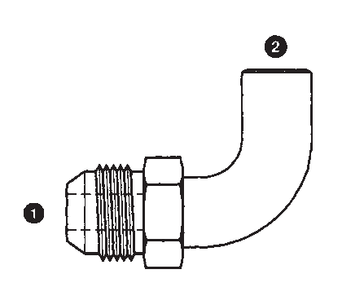
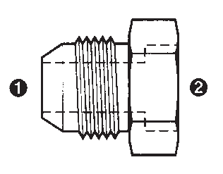
48

Carbon Steel
Descripton Sizes Part Number
METRIC EXTRA LIGHT SERIES  TUBE NUT  (DIN 2353 LL) | ❶  9201LL-04  9201LL-06  9201LL-08  9201LL-10  9201LL-12 |  | 9201LL
METRIC HEAVY SERIES TUBE NUT | ❶  9201S-06  9201S-08 |  | 9201S
(DIN 2353 S) | 9201S-10
 | 9201S-12
 | 9201S-14
 | 9201S-16
 | 9201S-20
 | 9201S-25
 | 9201S-30
 | 9201S-38
METRIC TUBE CUTTING RING | ❶  9202-06  9202-08 | ❶  9202-16  9202-18 | 9202
(DIN 2353 S OR L) | 9202-10 | 9202-20
 | 9202-12 | 9202-22
 | 9202-14 | 9202-25
 | 9202-15 | 9202-28
 |  | 9202-30
 |  | 9202-35
 |  | 9202-38
 |  | 9202-42
METRIC EXTRA LIGHT SERIES  TUBE CUTTING RING  (DIN 2353 LL) | ❶  9202LL-04  9202LL-06  9202LL-08  9202LL-10  9202LL-12 |  | 9202LL
METRIC LIGHT SERIES TUBE PLUG  (DIN 2353 L) | ❶  9203L-06  9203L-08  9203L-10  9203L-12 | ❶  9203L-15  9203L-18  9203L-22  9203L-28 | 9203L
 |  | 9203L-35
 |  | 9203L-42
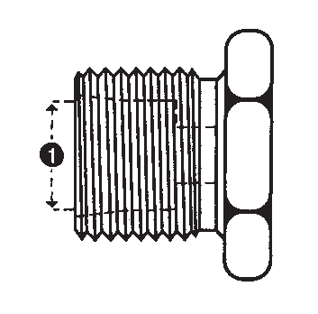
49

Carbon Steel
Part Number

Sizes

Descripton

9203S | ❶  9203S-06  9203S-08 |  | METRIC HEAVY SERIES TUBE PLUG
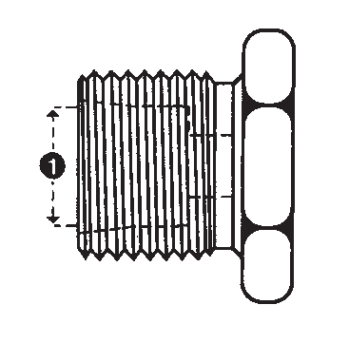 | 9203S-10  9203S-12 |  | (DIN 2353 S)
 | 9203S-14
 | 9203S-16
 | 9203S-20
 | 9203S-25
 | 9203S-30
 | 9203S-38
9204L | ❶  9204L-06  9204L-08 |  | METRIC LIGHT SERIES TUBE CAP
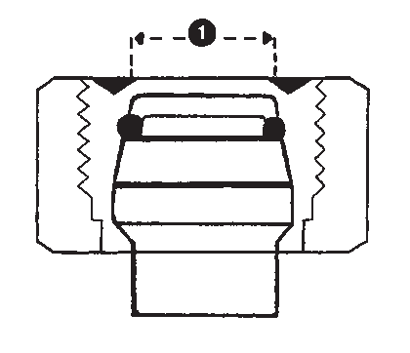 | 9204L-10  9204L-12 |  | (DIN 2353 L)
 | 9204L-15
 | 9204L-18
 | 9204L-22
 | 9204L-28
 | 9204L-35
 | 9204L-42
9204S | ❶  9204S-06  9204S-08 | ❶  9204S-38 | METRIC HEAVY SERIES TUBE CAP
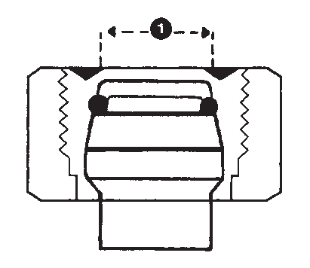 | 9204S-10  9204S-12  9204S-14  9204S-16  9204S-20  9204S-25  9204S-30 |  | (DIN 2353 S)
9210 | ❶ ❷  9210-04-04  9210-06-04  9210-06-06  9210-06-08 | ❶ ❷  9210-10-10  9210-10-12  9210-12-12  9210-12-16 | MALE JIC X  FEMALE FLAT-FACE BSPP - HIAB (SWIVEL)
 | 9210-08-06 | 9210-16-16
 | 9210-08-08*
 | 9210-08-10
 | 9210-08-12  9210-10-08 | *= SOLID FEMALE ONLY
9220  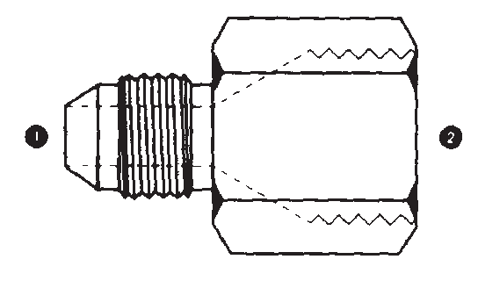 | ❶ ❷  9220-04-02  9220-04-04  9220-06-04  9220-06-06  9220-08-06  9220-08-08  9220-10-10  9220-12-12  9220-16-16 | ❶ ❷  9220-20-20  9220-24-24  9220-32-32 | MALE JIC X  FEMALE JIS (SOLID)  30° SEAT, BSPP THREAD

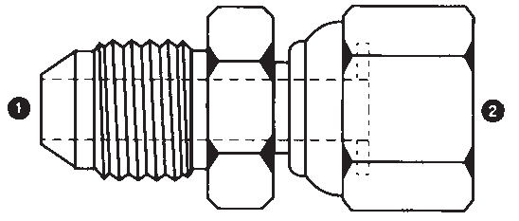
50

Carbon Steel
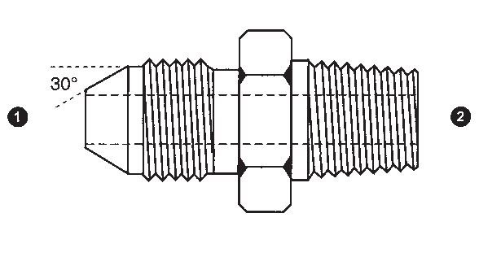
Descripton Sizes Part Number
JIS HEX PLUG 30° SEAT, BSPP THREAD | ❶  9221-02  9221-04 | ❶  9221-06  9221-08  9221-10 | 9221  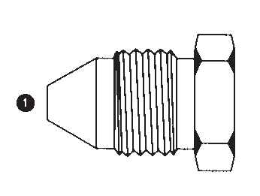
 |  | 9221-12
 |  | 9221-16
 |  | 9221-20
 |  | 9221-24
 |  | 9221-32
JIS CAP (SOLID)  30° SEAT, BSPP THREAD | ❶  9222-02  9222-04  9222-06 |  | 9222  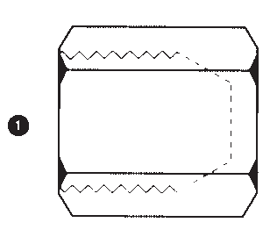
 | 9222-08
 | 9222-10
 | 9222-12
 | 9222-16
 | 9222-20
 | 9222-24
 | 9222-32
MALE JIS  30° SEAT, BSPP THREAD X  MALE BSPT | ❶ ❷  9223-04-04  9223-04-06  9223-06-04  9223-06-06  9223-08-06 |  | 9223
 | 9223-08-08
 | 9223-12-08
 | 9223-12-12
 | 9223-16-16
90° MALE JIS | ❶ ❷  9224-04-04  9224-06-06  9224-08-08  9224-12-12  9224-16-16 |  | 9224  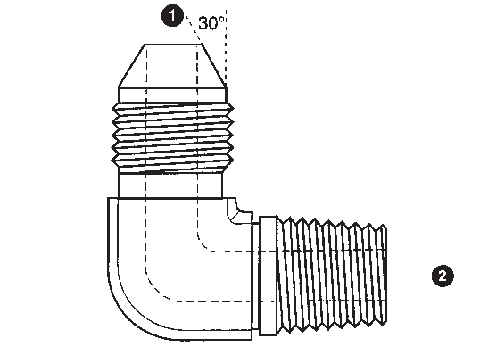
30° SEAT,
BSPP THREAD
X
MALE BSPT ELBOW
(FORGED STEEL)
45° MALE JIS | ❶ ❷  9225-04-04  9225-06-06  9225-08-08  9225-12-12  9225-16-16 |  | 9225  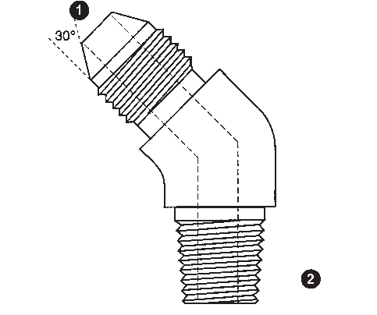
30° SEAT,
BSPP THREAD
X
MALE BSPT ELBOW
(FORGED STEEL)
51

Carbon Steel
Part Number
❶ ❷

Sizes

Descripton
FEMALE JIC (SWIVEL)

9226
9226-04-04
9226-06-06
9226-08-08

X
FEMALE JIS (SWIVEL)
30° SEAT, BSPP THREAD

9227
❶ ❷
9227-06-06
9227-08-08
FEMALE JIS (SWIVEL) X
FEMALE JIS (SWIVEL)
30° SEAT, BSPP THREAD

(JIS UNION)

9228

CALL FOR SIZES

MALE JIC X
MALE NISSAN
50° SEAT, METRIC THREAD

9229

9230

CALL FOR SIZES

❶ ❷
9230-04-12
9230-04-14
9230-06-16
9230-06-18
9230-08-22
9230-10-24
9230-12-30
9230-16-33
MALE JIC X
FEMALE NISSAN (SOLID)
50° SEAT, METRIC THREAD

MALE JIC X
FEMALE KOMATSU (SOLID)
30° SEAT,
1.5mm PITCH, METRIC THREADS

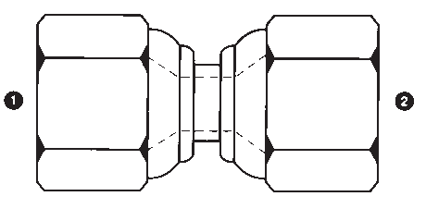

52

Carbon Steel
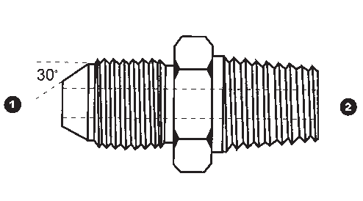
Descripton Sizes Part Number
KOMATSU HEX PLUG  30° SEAT,  1.5mm PITCH, METRIC THREADS |  | ❶  9231-14  9231-16 | ❶  9231-18  9231-22  9231-24  9231-30  9231-33  9231-36  9231-42 | 9231  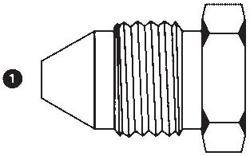
KOMATSU CAP (SOLID)  30° SEAT,  1.5mm PITCH, METRIC THREADS | ❶  9232-14  9232-16  9232-18  9232-22 |  |  | 9232  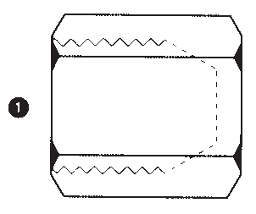
 | 9232-24
 | 9232-30
 | 9232-33
 | 9232-42
MALE KOMATSU | ❶ ❷  9233-14-02  9233-16-04 |  |  | 9233
30° SEAT,
1.5mm PITCH,
METRIC THREADS
X
MALE BSPT
MALE METRIC X  FEMALE NPT (SOLID) | ❶ ❷  9235-04X.70-02  9235-06X.75-02  9235-06X.75-04 | ❶ ❷  9235-14-04  9235-14-06  9235-16-04 | ❶ ❷  9235-26-04  9235-26-08  9235-26-12 | 9235  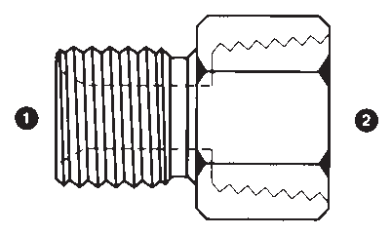
 | 9235-06X1.0-02 | 9235-16-06 | 9235-27-12
 | 9235-08X1.0-02 | 9235-16-08 | 9235-27X1.5-12
 | 9235-10-02 | 9235-18-04 | 9235-30-12
 | 9235-10-04 | 9235-18-06 | 9235-30X1.5-06
 | 9235-10X1.25-02 | 9235-18-08 | 9235-30X1.5-08
 | 9235-10X1.5-02 | 9235-20-04 | 9235-30X1.5-12
 | 9235-10X1.5-04 | 9235-20-06 | 9235-33-16
 | 9235-12-02 | 9235-20-08 | 9235-33X1.5-08
 | 9235-12-04 | 9235-22-04 | 9235-40-24
 | 9235-12-06 | 9235-22-06 | 9235-42-16
 | 9235-12X1.0-02 | 9235-22-08 | 9235-42-20
 | 9235-12X1.0-04 | 9235-22-12 | 9235-42X1.5-24
 | 9235-12X1.25-04 | 9235-24-12 | 9235-48-24
MALE KOMATSU | ❶ ❷  9236-14-14  9236-18-18  9236-22-22  9236-24-24  9236-30-30  9236-33-33 |  |  | 9236  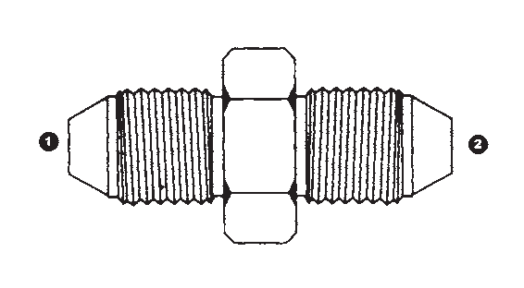
X
MALE KOMATSU
30° SEAT,
1.5mm PITCH,
METRIC THREADS
(KOMATSU UNION)
53

Carbon Steel
Part Number
❶ ❷

Sizes

Descripton
MALE JIC

9237
9237-04-14
9237-06-16
9237-06-18
9237-08-22 | 30° SEAT,
9237-10-24 | 1.5mm PITCH,
9237-12-30 | METRIC THREADS
9237-16-33
9238 CALL FOR SIZES | MALE JIC X  KOMATSU FLANGE

X
MALE KOMATSU

9239
CALL FOR SIZES
90° MALE JIC X
KOMATSU FLANGE ELBOW

(TUBE ELBOW)

❶ ❷ ❶ ❷ ❶ ❷

9240 9240-04-02
9240-04-04 | 9240-08-10 | 9240-20-20 | X
9240-04-06 | 9240-08-12 | 9240-24-24 | FEMALE BSPP
9240-04-08 | 9240-10-06 | 9240-32-32 | (SWIVEL)
9240-05-04 | 9240-10-08
9240-05-06 | 9240-10-10
9240-06-04 | 9240-10-12
9240-06-06 | 9240-12-12
9240-06-08 | 9240-12-16
9240-08-06 | 9240-16-12

9240-08-08
9240-16-16
MALE JIC

9241

CALL FOR SIZES

45° MALE JIC X
KOMATSU FLANGE ELBOW

(TUBE ELBOW)

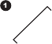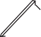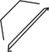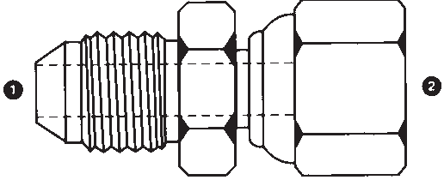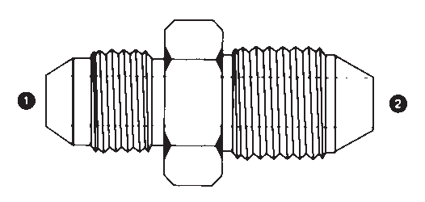

54

Carbon Steel
Descripton Sizes Part Number

MALE JIC X
MALE JSW
(JAPAN STEEL WORKS)

JSW TUBE PLUG
(JAPAN STEEL WORKS)

MALE JIC X
❶ ❷ ❸
9245-12-25-34
9245-16-30-40
9245-20-38-48

❶ ❷
9246-25-34

❶ ❷ ❸
9247-12-22-30
9247-12-28-36
MALE KOBELCO | 9247-16-22-30
1.5mm PITCH, | 9247-16-28-36
METRIC THREADS | 9247-16-35-45
 | 9247-20-35-45

9245

9246

9247

KOBELCO TUBE PLUG 1.5mm PITCH, METRIC THREADS
❶ ❷
9248-22-30
9248-28-36
9248-35-45

9248

KOBELCO TUBE CAP 1.5mm PITCH, METRIC THREADS
❶ ❷
9249-22-30
9249-28-36
9249-35-45

9249

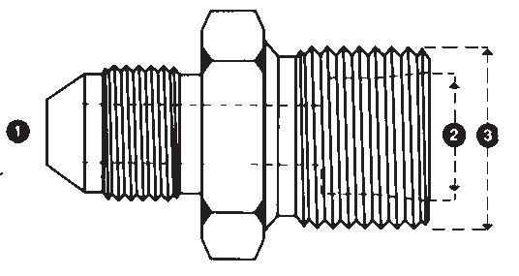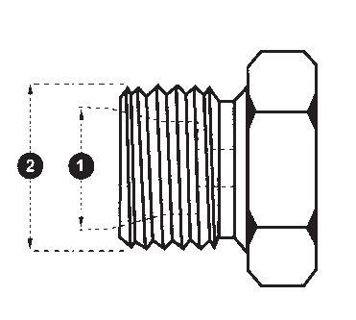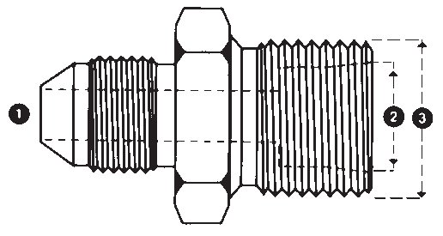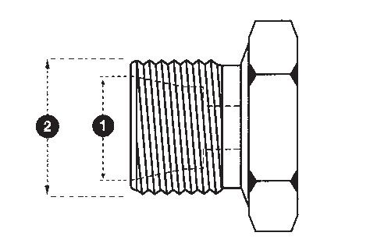

55

Carbon Steel
Part Number

Sizes

Descripton

9250  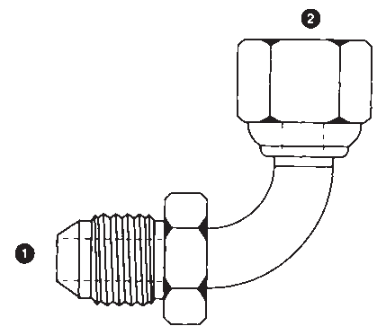 | ❶ ❷  9250-04-04  9250-06-06  9250-08-08  9250-10-10  9250-12-12  9250-16-16 | 90° MALE JIC X  FEMALE BSPP (SWIVEL) ELBOW  (TUBE ELBOW)
9259  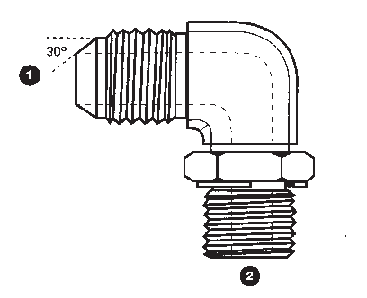 | ❶ ❷  9259-06-06  9259-08-08 | 90° MALE JIS  30° SEAT, BSPP THREAD X  MALE BSPP ADJ. ELBOW  (FORGED STEEL)
9260  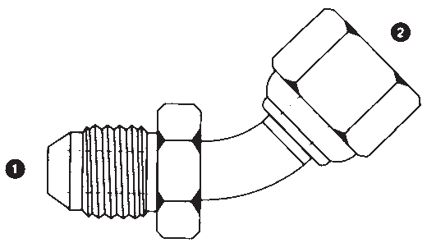 | ❶ ❷  9260-04-04  9260-06-06  9260-08-08  9260-10-10  9260-12-12  9260-16-16 | 45° MALE JIC X  FEMALE BSPP (SWIVEL) ELBOW  (TUBE ELBOW)
9277  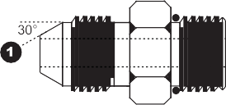 | ❶ ❷  9277-04-06  9277-06-04  9277-06-06  9277-08-06 | MALE JIS  30° SEAT, BSPP THREAD X  MALE SAE O-RING BOSS
9278 | ❶ ❷  9278-04-04  9278-08-06 | 90° MALE JIS  30° SEAT,  BSPP THREAD
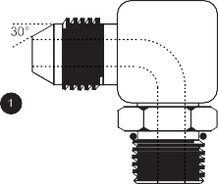 |  | X  MALE SAE O-RING BOSS ADJ. ELBOW

56

Carbon Steel
Descripton Sizes Part Number
FEMALE JIS (SWIVEL) | ❶ ❷ ❸  9291-04-04-04  9291-06-06-06  9291-08-08-08  9291-12-12-12 |  |  | 9291  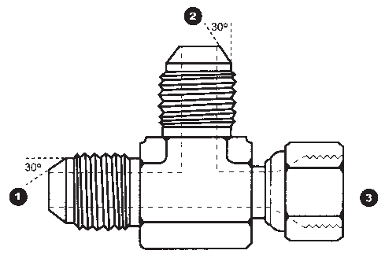
RUN TEE
30° SEAT,
BSPP THREAD
(FORGED STEEL)
90° MALE JIS | ❶ ❷  9292-04-04  9292-06-06  9292-08-08  9292-12-12 |  |  | 9292  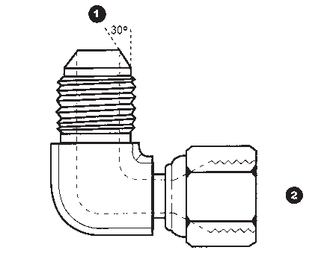
X
FEMALE JIS (SWIVEL)
ELBOW
30° SEAT,
BSPP THREAD
(FORGED STEEL)
JIS TEST PORT (SWIVEL) TEE 30° SEAT, BSPP THREAD | ❶ ❷  9293TP-04-04  9293TP-06-06  9293TP-08-08 |  |  | 9293TP  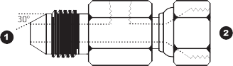
 | TEST PORT = FEMALE 10X1.0mm METRIC (SOLID)
MALE NPT X  FEMALE METRIC  (SOLID) | ❶ ❷  9325-02-06X1.0  9325-02-08X1.0  9325-02-10X1.0  9325-02-10X1.25 | ❶ ❷  9325-02-12X1.5  9325-04-10X1.0  9325-04-12X1.5  9325-04-14X1.5 | ❶ ❷  9325-08-20X1.5  9325-08-22X1.5  9325-08-24X1.5  9325-12-18X1.5 | 9325  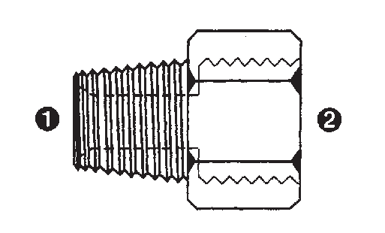
 | 9325-02-10X1.5 | 9325-04-16X1.5 | 9325-12-20X1.5
 | 9325-02-12X1.0 | 9325-06-14X1.5 | 9325-12-26X1.5
 |  | 9325-06-16X1.5 | 9325-12-30X1.5
 |  | 9325-06-18X1.5 | 9325-12-30X2.0
 |  | 9325-08-14X1.5 | 9325-16-26X1.5
 |  | 9325-08-18X1.5 | 9325-20-30X1.5
FEMALE JIC (SWIVEL) | ❶ ❷  9326-04-14  9326-06-18  9326-08-22  9326-10-24  9326-12-30 |  |  | 9326  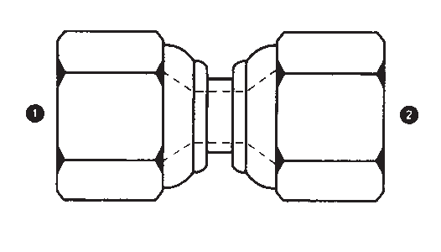
X
FEMALE KOMATSU
(SWIVEL)
30° SEAT, 1.5mm
PITCH, METRIC
THREADS
57

Carbon Steel
Part Number

Sizes

Descripton

9327  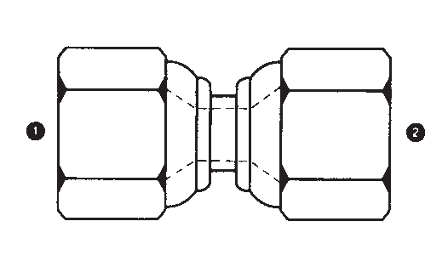 | ❶ ❷  9327-14-14  9327-18-18  9327-22-22  9327-24-24  9327-30-30 | FEMALE KOMATSU (SWIVEL)  X FEMALE KOMATSU  (SWIVEL) 30° SEAT, 1.5mm PITCH, METRIC  THREADS
 |  | (KOMATSU UNION)
9335  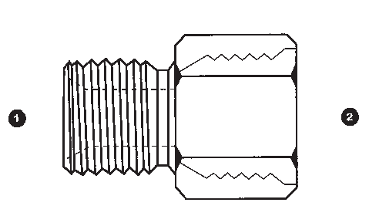 | ❶ ❷  9335-08X1.0-04  9335-12X1.0-04  9335-14-06  9335-16-06  9335-18-08  9335-21-06  9335-22-12  9335-26-12 | MALE METRIC X  FEMALE SAE O-RING BOSS (SOLID)
 | 9335-27-12
 | 9335-33-16
9336  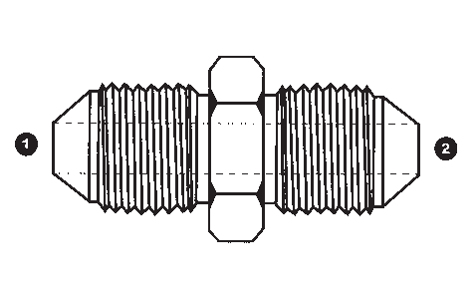 | ❶ ❷  9336-02-02  9336-04-04  9336-06-06  9336-08-08  9336-12-12  9336-16-16  9336-20-20 | MALE JIS X  MALE JIS  30° SEAT, BSPP THREAD  (JIS UNION)
9337  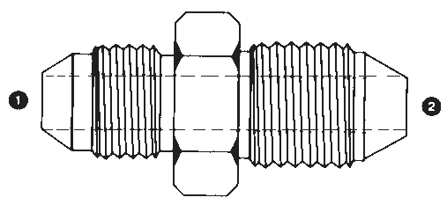 | ❶ ❷  9337-04-02  9337-04-04  9337-06-06  9337-08-08  9337-12-12  9337-16-16 | MALE JIC X  MALE JIS  30° SEAT, BSPP THREAD
9338  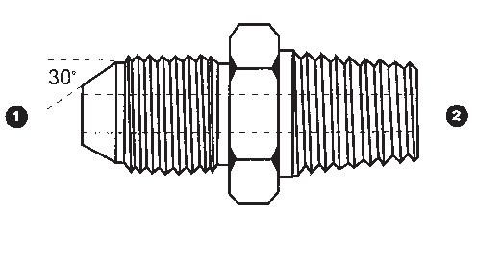 | CALL FOR SIZES | MALE JIS  30° SEAT, BSPP THREAD X  MALE NPT

58

Carbon Steel
Descripton Sizes Part Number
90° FEMALE JIC | ❶ ❷  9355-04-04  9355-05-05  9355-06-06  9355-08-08  9355-10-10  9355-12-12  9355-16-16 |  | 9355  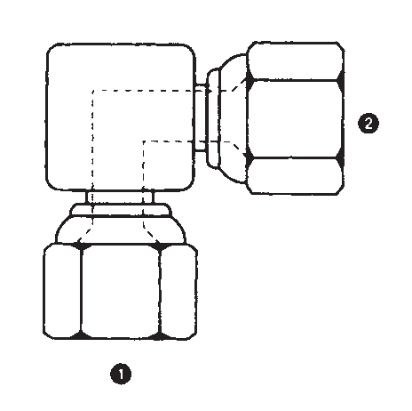
(SWIVEL)
X
FEMALE JIC (SWIVEL)
ELBOW
FEMALE KOMATSU | ❶ ❷ ❸  9391-14-14-14  9391-16-16-16  9391-18-18-18  9391-22-22-22  9391-24-24-24  9391-30-30-30  9391-33-33-33 |  | 9391  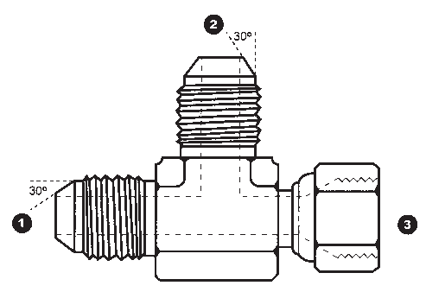
(SWIVEL) RUN TEE
30° SEAT,
1.5mm PITCH,
METRIC THREADS
(FORGED STEEL)
90° MALE KOMATSU | ❶ ❷  9392-14-14  9392-16-16  9392-18-18  9392-22-22  9392-24-24  9392-30-30  9392-33-33 |  | 9392  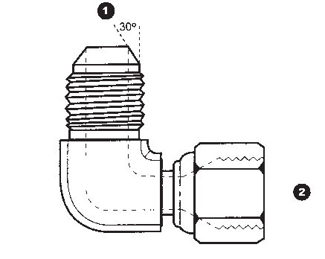
X
FEMALE KOMATSU
(SWIVEL) ELBOW
30° SEAT,
1.5mm PITCH,
METRIC THREADS
(FORGED STEEL)
BONDED SEAL FOR BRITISH THREAD | ❶  9500-02  9500-04 | ❶  9500-10  9500-12 | 9500
 | 9500-06 | 9500-16
 | 9500-08 | 9500-20
 |  | 9500-24
 |  | 9500-28
 |  | 9500-32
 |  | 9500-40
 |  | 9500-48
BONDED SEAL FOR METRIC THREAD | ❶  9500-04MM  9500-06MM  9500-08MM  9500-10MM  9500-12MM  9500-14MM  9500-16MM  9500-18MM  9500-20MM  9500-22MM | ❶  9500-24MM  9500-26MM  9500-27MM  9500-30MM  9500-33MM  9500-36MM  9500-42MM  9500-45MM  9500-50MM  9500-52MM | 9500MM
59

Carbon Steel
Part Number

Sizes

Descripton

9500MMV | ❶  9500-12MMV  9500-14MMV |  |  | BONDED VITON SEAL FOR METRIC THREAD
9500V | ❶  9500-02V  9500-04V | ❶  9500-24V  9500-32V |  | BONDED VITON SEAL FOR BRITISH THREAD
9500-06V
9500-08V
9500-10V
9500-12V
9500-16V
 | 9500-20V
9536  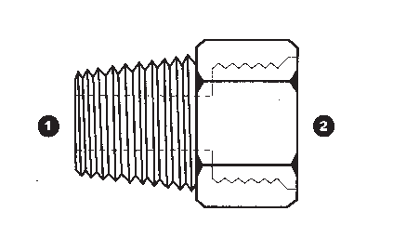 | ❶ ❷  9536-02-04  9536-04-06  9536-06-08  9536-08-08  9536-08-10  9536-12-12  9536-16-16 |  |  | MALE BSPT X  FEMALE SAE O-RING BOSS (SOLID)
9555 | ❶ ❷ ❸  9555-04-04-04  9555-05-05-05 |  |  | FEMALE JIC (SWIVEL) TEE
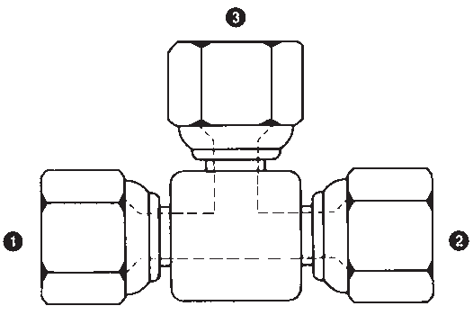 | 9555-06-06-06  9555-08-08-08  9555-10-10-10  9555-12-12-12  9555-16-16-16  9555-20-20-20
9605 | ❶ ❷ ❸  9605-04-06X1.0*  9605-04-08X1.0*  9605-04-08X1.25* | ❶ ❷ ❸  9605-06-L08-14  9605-06-L10-16  9605-06-L12-18 | ❶ ❷ ❸  9605-12-L15-22  9605-12-L18-24X1.5  9605-12-L18-26 | MALE JIC X  MALE METRIC DUAL PURPOSE  PORT OR TUBE (DIN 2353 L)  *=PORT ONLY; THREAD DIMENSIONS  (1) & (3) APPLY ONLY.
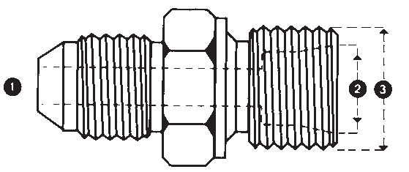 | 9605-04-10X1.25*  9605-04-10X1.5*  9605-04-12X1.0*  9605-04-L06-12  9605-04-L08-14  9605-04-L10-16 | 9605-06-L15-22  9605-06-LL06-10  9605-06-LL08-12  9605-08-12X1.25*  9605-08-L10-16  9605-08-L12-18 | 9605-12-L22-30  9605-12-L22-30X1.5  9605-16-L18-26  9605-16-L22-30X1.5  9605-16-L28-36  9605-20-33X2.0*
 | 9605-04-LL06-10 | 9605-08-L15-22 | 9605-20-48X2.0*
 | 9605-04-LL08-12 | 9605-10-25X1.5* | 9605-20-50X1.5*
 | 9605-04-LL10-14 | 9605-10-L12-18 | 9605-20-L27-38X1.5
 | 9605-05-12X1.0* | 9605-10-L15-22 | 9605-20-L35-45
 | 9605-05-12X1.25* | 9605-10-L18-26 | 9605-24-45X2.0*
 | 9605-06-10X1.5* | 9605-12-25X1.5* | 9605-24-L27-38X1.5
 | 9605-06-12X1.25* | 9605-12-30X1.5* | 9605-24-L42-52

60

Carbon Steel
Descripton Sizes Part Number
MALE JIC X  MALE METRIC DUAL PURPOSE  PORT OR TUBE  (DIN 2353 S) | ❶ ❷ ❸  9606-04-S06-14  9606-04-S08-16  9606-04-S10-18 | ❶ ❷ ❸  9606-06-S08-16  9606-06-S10-18  9606-06-S12-20  9606-06-S14-22  9606-08-S10-18  9606-08-S12-20 | ❶ ❷ ❸  9606-10-S16-24  9606-12-S16-24  9606-12-S20-30  9606-12-S25-36  9606-16-S20-30  9606-16-S25-36 | 9606  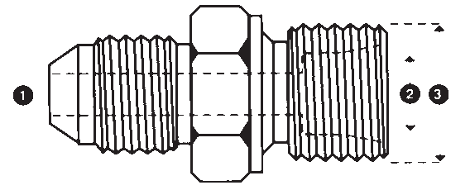
 |  | 9606-08-S14-22 | 9606-16-S30-42
 |  | 9606-08-S16-24 | 9606-20-S30-42
 |  | 9606-10-S12-20 | 9606-20-S38-52
 |  | 9606-10-S14-22 | 9606-24-S38-52
MALE NPT |  | ❶ ❷ ❸  9607-02-12*  9607-02-LL06-10  9607-04-08X1.25*  9607-04-10X1.0*  9607-04-12*  9607-04-12X1.25*  9607-04-14* | ❶ ❷ ❸  9607-06-12X1.25*  9607-06-18*  9607-08-12X1.25*  9607-08-16*  9607-08-18*  9607-08-22*  9607-08-S12-20  9607-16-30*  9607-24-S30-42 | 9607  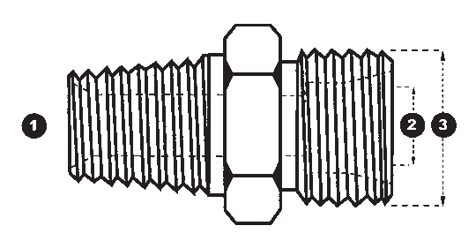
X
MALE METRIC DUAL
PURPOSE
PORT OR TUBE
(DIN 2353 S OR L)
*=PORT ONLY;
THREAD DIMENSIONS
(1) & (3) APPLY ONLY.
MALE JIC X  FEMALE METRIC (SOLID) | ❶ ❷  9622-04-06X1.0  9622-04-08X1.0  9622-04-10X1.0 |  |  | 9622
KOMATSU TEST PORT | ❶ ❷ ❸  9634TP-14-14-02*  9634TP-18-18-04  9634TP-22-22-06  9634TP-24-24-06  9634TP-30-30-06  9634TP-33-33-08 |  |  | 9634TP  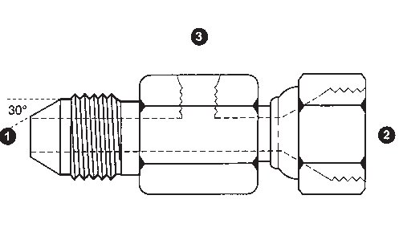
(SWIVEL) TEE
*=FEMALE NPT FOR
TEST PORT
(ALL OTHERS FEMALE
SAE O-RING BOSS)
MALE METRIC DUAL PURPOSE  PORT OR TUBE (DIN 2353 S OR L) X  FEMALE NPT (SOLID) |  | ❶ ❷ ❸  9635-12-L06-04  9635-12-L06-06  9635-14-L08-04  9635-16-L10-04  9635-16-L10-06 | ❶ ❷ ❸  9635-18-L12-04  9635-18-L12-06  9635-18-L12-08  9635-20-S12-04  9635-22-L15-08  9635-22-L15-12 | 9635  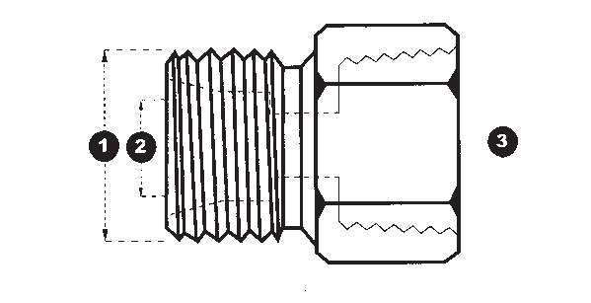
 |  |  | 9635-24-S16-12
 |  |  | 9635-26-L18-12
 |  |  | 9635-42-S30-16
 |  |  | 9635-42-S30-20
61

Carbon Steel
Part Number

Sizes

Descripton

9638 | ❶ ❷  9638-08X1.0-06X1.0  9638-10X1.0-08X1.0 | ❶ ❷  9638-24X1.5-20X1.5  9638-26X1.5-22X1.5 | MALE METRIC X  FEMALE METRIC (SOLID)  (METRIC BUSHING)  FEMALE NPT (SOLID) X  FEMALE METRIC (SOLID)  BSPP FLAT-FACE 30° SEALING SEAT (HIAB)
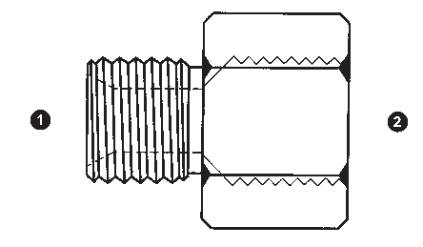 | 9638-14X1.5-10X1.0  9638-16X1.5-12X1.5  9638-18X1.5-14X1.5  9638-18X1.5-16X1.5  9638-18X1.5-27X2.0  9638-20X1.5-16X1.5  9638-22X1.5-14X1.5 | 9638-27X2.0-18X1.5  9638-30X2.0-26X1.5  9638-33X2.0-14X1.5  9638-36X2.0-30X2.0  9638-42X2.0-14X1.5  9638-48X2.0-42X2.0
 | 9638-22X1.5-18X1.5
9643 | ❶ ❷  9643-02-06X1.0  9643-02-08X1.0
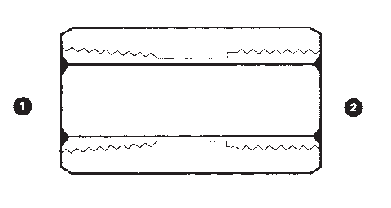 | 9643-02-10X1.0  9643-04-12X1.5  9643-04-14X1.5  9643-04-16X1.5
9777 | ❶  9777-06  9777-08
 | 9777-12
9900  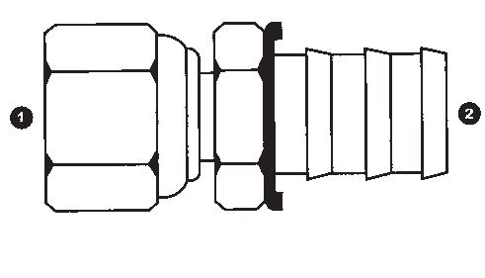 | ❶ ❷  9900-04-04  9900-06-06  9900-08-08  9900-10-10  9900-12-12  9900-16-16 |  | FEMALE BSPP (SWIVEL) X  PUSH-ON HOSE BARB
9905 | ❶ ❷  9905-04-04  9905-06-06 |  | 45° FEMALE BSPP (SWIVEL)  X  PUSH-ON HOSE BARB ELBOW
 | 9905-08-08
 | 9905-10-10
 | 9905-12-12
 | 9905-16-16

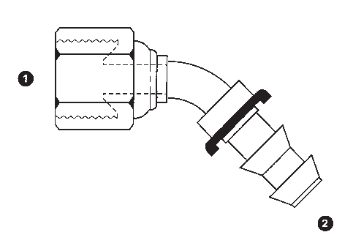
62

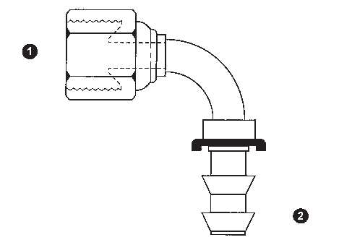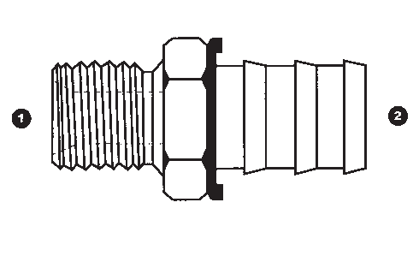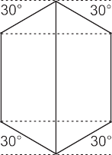Carbon Steel
Descripton Sizes Part Number
90° FEMALE BSPP | ❶ ❷  9910-04-04  9910-06-06  9910-08-08  9910-10-10  9910-12-12  9910-16-16 | 9910
(SWIVEL)
X
PUSH-ON HOSE BARB
ELBOW
MALE BSPT X  PUSH-ON HOSE BARB | ❶ ❷  9915-04-04  9915-06-06  9915-06-08 | 9915
 | 9915-08-06
 | 9915-08-08
 | 9915-12-12
 | 9915-16-16
MALE BSPP X  PUSH-ON HOSE BARB | ❶ ❷  9920-04-04  9920-06-06  9920-08-08  9920-12-12  9920-16-16 | 9920
JIS SEALING SEAT | ❶  9999-02 | 9999
(USED TO CONVERT A MALE BSPP TO JIS) | 9999-04  9999-06  9999-08
 | 9999-10
 | 9999-12
 | 9999-16
 | 9999-20
 | 9999-24
63

Brass
BRASS COMPRESSION FITTINGS: FOR USE WITH “INCH” COPPER TUBING TO BSP & BSPT THREADS
ALL BRASS COMPRESSION FITTINGS ARE P.O.R

Part Number
Sizes
Descripton

166 | ❶ ❷  166-04-02  166-04-04  166-05-02 |  | BRASS COMPRESSION X  FEMALE BSP (SOLID)
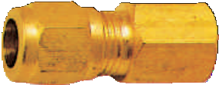 | 166-05-04  166-06-04  166-06-06  166-08-08 |  | FEMALE BSP’S ARE CAPABLE OF  SEALING WITH BSPP & BSPT MALES
168 | ❶ ❷  168-04-02  168-04-04  168-04-06 | ❶ ❷  168-08-04  168-08-06  168-08-08 | BRASS COMPRESSION X  MALE BSPT
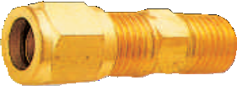 | 168-05-02  168-05-04  168-06-04  168-06-06  168-06-08
169 | ❶ ❷  169-04-02  169-04-04  169-04-06 | ❶ ❷  169-08-04  169-08-06  169-08-08 | 90° BRASS COMPRESSION X
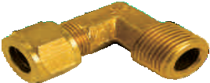 | 169-05-02  169-05-04  169-06-04  169-06-06  169-06-08 |  | MALE BSPT ELBOW
171  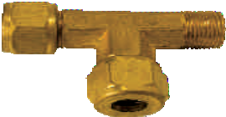 | ❶ ❷  171-04-02  171-04-04  171-05-02  171-05-04  171-06-04  171-06-06  171-08-06 |  | BRASS COMPRESSION X  MALE BSPT RUN TEE
172  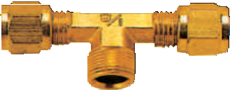 | ❶ ❷  172-04-02  172-04-04  172-05-02  172-05-04  172-06-04  172-06-06  172-08-06 |  | BRASS COMPRESSION X  MALE BSPT BRANCH TEE

64

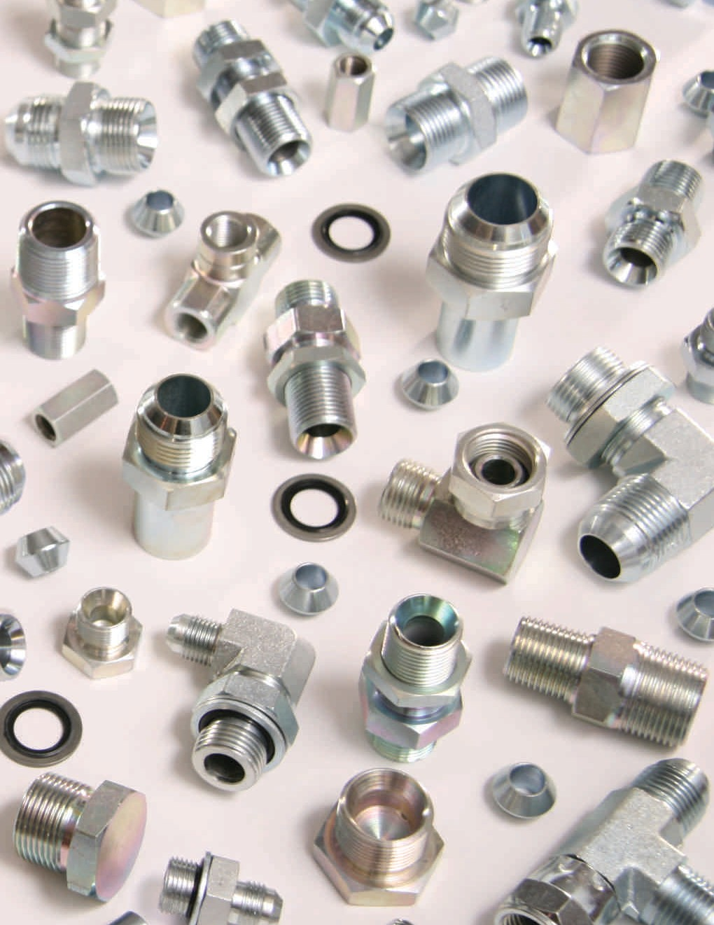Brass
BRASS POLYTUBE COMPRESSION FITTINGS: FOR USE WITH “INCH” NYLON OR POLYETHYLENE TUBING TO BSP & BSPT THREADS ALL BRASS POLYTUBE COMPRESSION FITTINGS ARE P.O.R

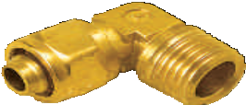Descripton Sizes Part Number
BRASS POLYTUBE | ❶ ❷  266-04-02  266-04-04  266-05-04  266-06-04  266-06-06  266-08-06 |  | 266  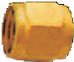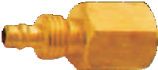
COMPRESSION
X
FEMALE BSP (SOLID)
FEMALE BSP’S ARE
CAPABLE OF
SEALING WITH BSPP &
BSPT MALES
 | ❶ ❷ | ❶ ❷ | 268  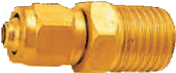
BRASS POLYTUBE COMPRESSION  X MALE BSPT | 268-04-02  268-04-04  268-04-06  268-05-02 | 268-05-04  268-05-06  268-06-02  268-06-04  268-06-06
 |  | 268-06-08
 |  | 268-08-04
 |  | 268-08-06
 |  | 268-08-08
 | ❶ ❷ | ❶ ❷ | 269
90° BRASS POLYTUBE COMPRESSION  X  MALE BSPT ELBOW | 269-04-02  269-04-04  269-04-06  269-04-08  269-05-02 | 269-05-04  269-05-06  269-06-02  269-06-04  269-06-06
 |  | 269-06-08
 |  | 269-08-04
 |  | 269-08-06
 |  | 269-08-08
90° BRASS POLYTUBE | ❶ ❷  270-04-02  270-04-04  270-05-04  270-06-04  270-06-06  270-08-06 |  | 270  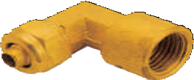
COMPRESSION
X
FEMALE BSP (SOLID)
ELBOW
FEMALE BSP’S ARE
CAPABLE OF
SEALING WITH BSPP &
BSPT MALES
 | ❶ ❷ |  | 271  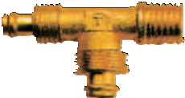
BRASS POLYTUBE COMPRESSION  X  MALE BSPT RUN TEE | 271-04-02  271-04-04  271-05-02  271-05-04  271-06-04
 | 271-06-06
 | 271-08-06
 | 271-08-08
65

Brass
Part Number

Sizes

Descripton

272 | ❶ ❷  272-04-02  272-04-04 | BRASS POLYTUBE COMPRESSION  X  MALE BSPT BRANCH TEE
 | 272-04-06
 | 272-05-02
 | 272-05-04
 | 272-06-04
 | 272-06-06
 | 272-08-06
 | 272-08-08

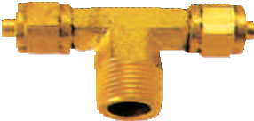
BRASS PUSH TO CONNECT FITTINGS: FOR USE WITH “INCH” POLYETHYLENE TUBING TO BSP & BSPT THREADS
ALL BRASS PUSH TO CONNECT FITTINGS ARE P.O.R

WARNING:
  - Push to connect fittings are to be used in pneumatic applications ONLY.
  - NEVER use them with liquids.
  - Maximum recommended working pressure: 150 PSI.
  - Temperature range: -40°F to 175°F.

566  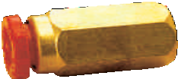 | ❶ ❷  566-04-02  566-04-04  566-05-02  566-05-04  566-05-06  566-06-04  566-06-06  566-06-08 |  | POLYTUBE PUSH TO CONNECT  X  FEMALE BSP (SOLID)  FEMALE BSP’S ARE CAPABLE OF  SEALING WITH BSPP &
 |  |  | BSPT MALES
568  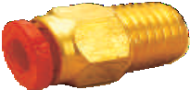 | ❶ ❷  568-02-02  568-04-02  568-04-04  568-04-06  568-05-02  568-05-04  568-06-02 | ❶ ❷  568-06-04  568-06-06  568-06-08  568-08-04  568-08-06  568-08-08 | POLYTUBE PUSH TO CONNECT  X MALE BSPT
569 | ❶ ❷  569-04-02  569-04-04  569-05-02  569-05-04  569-05-06  569-06-02  569-06-04  569-06-06  569-06-08 | ❶ ❷  569-08-04  569-08-06  569-08-08 | 90° POLYTUBE PUSH TO CONNECT  X  MALE BSPT ELBOW

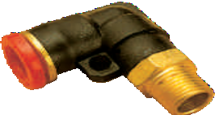66

Brass
Descripton Sizes Part Number

90° BANJO POLYTUBE PUSH TO CONNECT  X  MALE BSPT ELBOW | ❶ ❷  569BJ-04-02  569BJ-04-04  569BJ-04-06  569BJ-05-02  569BJ-05-04  569BJ-06-04  569BJ-06-06 | 569BJ  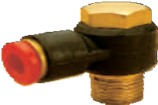
90° POLYTUBE PUSH TO CONNECT  X  MALE BSPT (LONG) ELBOW | ❶ ❷  569L-04-02  569L-04-04  569L-05-02  569L-05-04  569L-06-04  569L-06-06  569L-08-06 | 569L  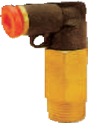
POLYTUBE PUSH TO CONNECT  X  MALE BSPT RUN TEE | ❶ ❷  571-04-02  571-04-04  571-05-02  571-05-04  571-06-02  571-06-04  571-06-06 | 571  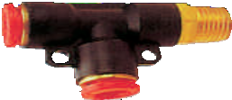
POLYTUBE PUSH TO CONNECT  X  MALE BSPT BRANCH  TEE | ❶ ❷  572-04-02  572-04-04  572-05-02  572-05-04  572-06-04 | 572  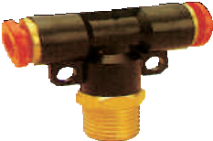
 | 572-06-06
 | 572-08-04
 | 572-08-06
 | 572-08-08
POLYTUBE PUSH TO | ❶ ❷  575-04-02  575-04-04  575-05-02  575-05-04  575-06-04  575-06-06 | 575  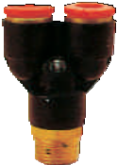
CONNECT
X
MALE BSPT BRANCH
"Y"
67

Brass
Part Number

Sizes

Descripton

581  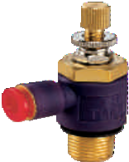 | ❶ ❷  581-04-02  581-04-04  581-05-02  581-05-04  581-06-02  581-06-04  581-06-06 | 90° POLYTUBE PUSH TO CONNECT "METERING IN" VALVE X  MALE BSPT
582  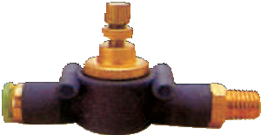 | ❶ ❷  582-04-02  582-04-04  582-05-02  582-05-04  582-06-02  582-06-04  582-06-06 | STRAIGHT POLYTUBE PUSH TO CONNECT "FLOW CONTROL VALVE"  X MALE BSPT

BRASS CONVERSION ADAPTERS
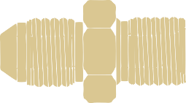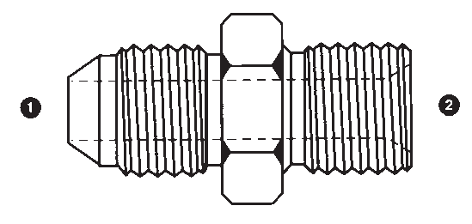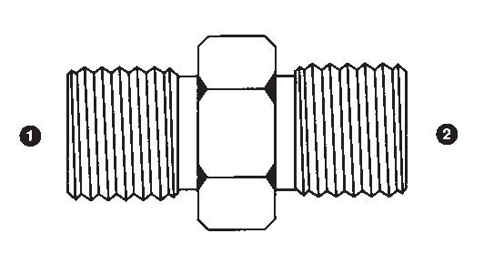ALL BRASS CONVERSION ADAPTERS ARE P.O.R

8000 | ❶ ❷  8000-02-02  8000-04-02 | ❶ ❷  8000-08-08  8000-12-08 | MALE BSPP X  MALE BSPP
 | 8000-04-04  8000-06-02 | 8000-12-12  8000-16-12 | (BSPP NIPPLE)
 | 8000-06-04 | 8000-16-16
 | 8000-06-06 | 8000-24-20
 | 8000-08-04
 | 8000-08-06
8005 | ❶ ❷  8005-06-04  8005-12-12 |  | MALE JIC X  MALE BSPP
8007 | ❶ ❷ |  | MALE BSPP X  MALE NPT
 | 8007-04-04
 | 8007-06-04
 | 8007-06-06
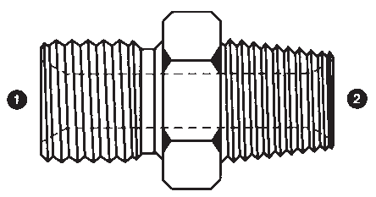 | 8007-08-08

68

Brass
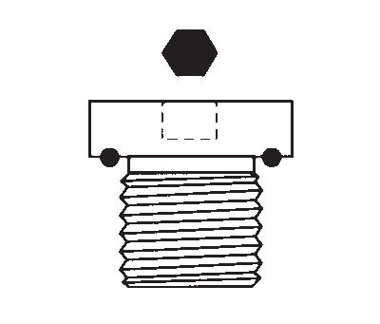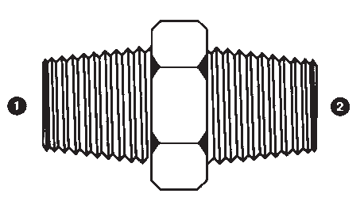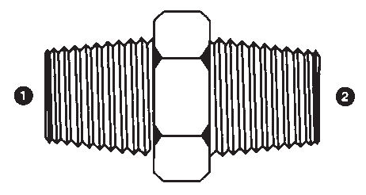Descripton Sizes Part Number
MALE BSPT X  MALE NPT | ❶ ❷  8008-02-02  8008-02-04  8008-04-04 |  | 8008
 | 8008-06-06
 | 8008-08-08
 | 8008-12-12
 | 8008-16-16
MALE BSPT X  MALE BSPT | ❶ ❷  8010-02-02  8010-04-02  8010-04-04 | ❶ ❷  8010-08-02  8010-08-04  8010-08-06 | 8010
(BSPT NIPPLE) | 8010-06-02  8010-06-04 | 8010-08-08  8010-12-04
 | 8010-06-06 | 8010-12-06
 |  | 8010-12-08
 |  | 8010-12-12
 |  | 8010-16-12
 |  | 8010-16-16
BSPP COUNTERSUNK SEALED PLUG | ❶  8028-02  8028-04  8028-06  8028-08 |  | 8028
BSPT COUNTERSUNK PLUG | ❶  8030CSP-02  8030CSP-04  8030CSP-06  8030CSP-08  8030CSP-12  8030CSP-16 |  | 8030CSP
BSP CAP (SOLID) | ❶  8033-02  8033-04  8033-06  8033-08  8033-12 |  | 8033
FEMALE BSP’S ARE
CAPABLE OF
SEALING WITH BSPP &
BSPT MALES
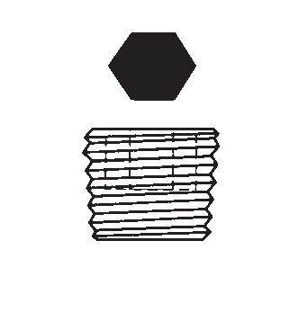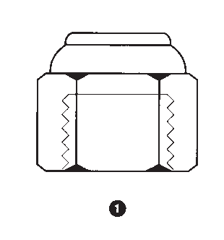69

Brass
Part Number

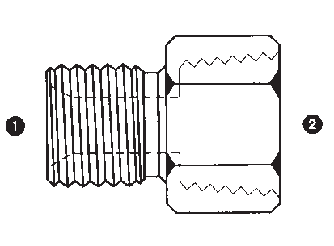Sizes

Descripton

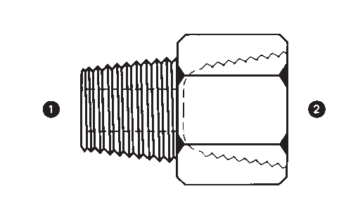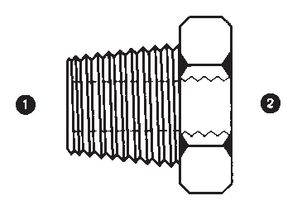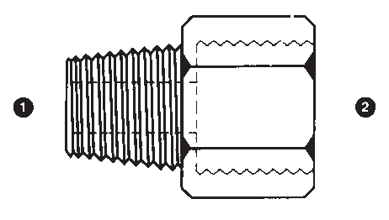
8035 | ❶ ❷  8035-04-04  8035-08-08 |  | MALE BSPP X  FEMALE NPT (SOLID)
8036 | ❶ ❷  8036-02-02  8036-04-04  8036-06-06  8036-08-08  8036-12-12  8036-16-16  8036-20-20 |  | MALE BSPT X  FEMALE NPT (SOLID)
8037 | ❶ ❷  8037-02-02  8037-04-04  8037-06-06  8037-08-08  8037-12-12 |  | MALE NPT X  FEMALE BSP (SOLID)  FEMALE BSP’S ARE CAPABLE OF  SEALING WITH BSPP & BSPT MALES
8038 | ❶ ❷  8038-02-02  8038-04-02  8038-04-06  8038-06-02  8038-06-04  8038-06-06  8038-08-04  8038-08-06  8038-12-08 |  | MALE BSPT X  FEMALE BSP (SOLID)  FEMALE BSP’S ARE CAPABLE OF  SEALING WITH BSPP & BSPT MALES
 | 8038-16-12
8039 | ❶ ❷  8039-02-02  8039-02-04  8039-04-02 | ❶ ❷  8039-08-04  8039-08-06  8039-08-08 | MALE BSPP X  FEMALE BSP (SOLID)
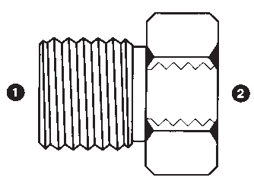 | 8039-04-04  8039-04-06  8039-06-02  8039-06-04  8039-06-06  8039-06-08  8039-08-02 | 8039-12-04  8039-12-06  8039-12-08 | (BSPP BUSHING)  FEMALE BSP’S ARE CAPABLE OF  SEALING WITH BSPP & BSPT MALES

70

Brass
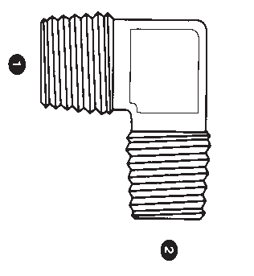Descripton Sizes Part Number

FEMALE BSP (SOLID) | ❶ ❷  8043-02-02 | ❶ ❷  8043-04-02  8043-04-04  8043-06-02  8043-06-04  8043-06-06  8043-08-04  8043-08-06  8043-08-08  8043-12-12  8043-32-32  ❶ ❷  8044-02-02  8044-04-04  8044-06-04  8044-06-06  8044-08-08  8044-16-16  8044-20-20  8044-24-24  8044-32-32  8044-48-40 | 8043  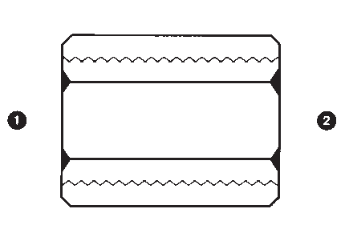  8044
X
FEMALE BSP (SOLID)
(BSP COUPLING)
FEMALE BSP’S ARE
CAPABLE OF
SEALING WITH BSPP &
BSPT MALES
FEMALE BSP (SOLID)
X
FEMALE NPT (SOLID)
FEMALE BSP’S ARE
CAPABLE OF
SEALING WITH BSPP &
BSPT MALES
90° MALE BSPT X  MALE BSPT ELBOW | ❶ ❷  8055-02-02  8055-04-04  8055-06-06 |  | 8055
 | 8055-08-08
 | 8055-12-12
90° MALE BSPT | ❶ ❷  8060-02-02  8060-04-04  8060-06-06  8060-08-08  8060-12-12 |  | 8060
X
FEMALE BSP (SOLID)
ELBOW
FEMALE BSP’S ARE
CAPABLE OF
SEALING WITH BSPP &
BSPT MALES
90° FEMALE BSP (SOLID)  X | ❶ ❷  8075-02-02  8075-04-04  8075-06-06  8075-08-08  8075-12-12 |  | 8075
FEMALE BSP (SOLID)
ELBOW
FEMALE BSP’S ARE
CAPABLE OF
SEALING WITH BSPP &
BSPT MALES
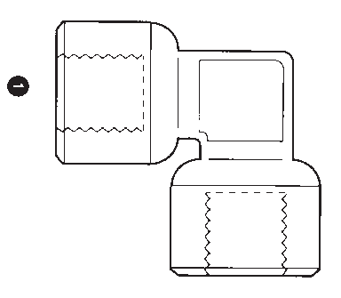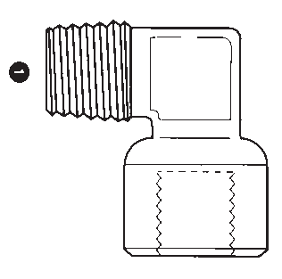71

Brass
Part Number

Sizes

Descripton

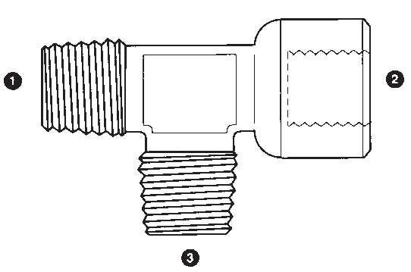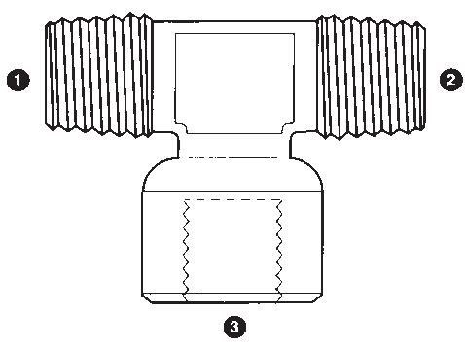
8080 | ❶ ❷ ❸  8080-02-02-02  8080-04-04-04 | MALE BSPT TEE
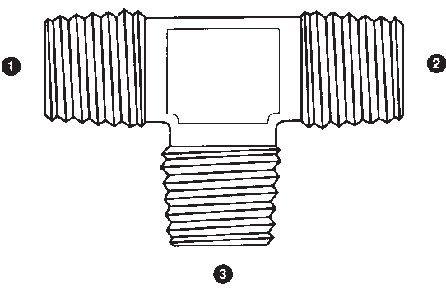 | 8080-06-06-06  8080-08-08-08  8080-12-12-12
8085 | ❶ ❷ ❸  8085-02-02-02  8085-04-04-04 | FEMALE BSP (SOLID) TEE
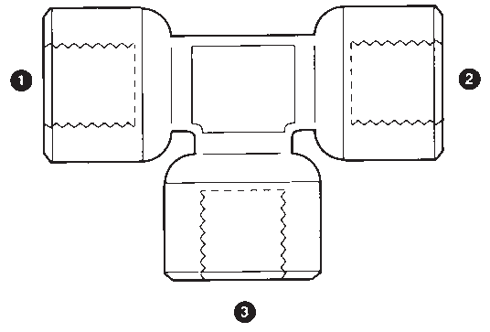 | 8085-06-06-06  8085-08-08-08  8085-12-12-12 | FEMALE BSP’S ARE CAPABLE OF  SEALING WITH BSPP & BSPT MALES
8087 | ❶ ❷ ❸  8087-04-04-04 | BSPT MALE X  FEMALE BSP (SOLID) BRANCH TEE  FEMALE BSP’S ARE CAPABLE OF  SEALING WITH BSPP & BSPT MALES
8090 | ❶ ❷ ❸  8090-04-04-04 | BSPT MALE X  FEMALE BSP (SOLID) RUN TEE  FEMALE BSP’S ARE CAPABLE OF  SEALING WITH BSPP & BSPT MALES
8093 | ❶ ❷ ❸  8093-02-02-02  8093-04-04-04  8093-06-06-06  8093-08-08-08  8093-12-12-12 | BSP FEMALE (SOLID) X  MALE BSPT BRANCH TEE  FEMALE BSP’S ARE CAPABLE OF  SEALING WITH BSPP & BSPT MALES

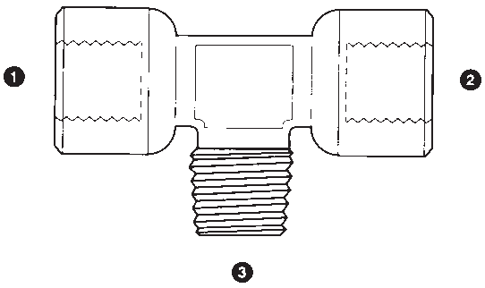72

Brass
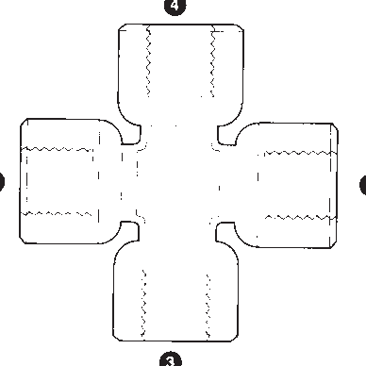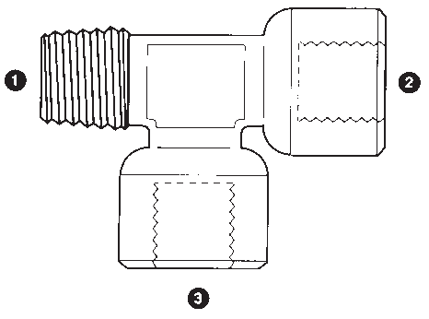Descripton Sizes Part Number
BSP FEMALE (SOLID) | ❶ ❷ ❸  8095-02-02-02  8095-04-04-04  8095-06-06-06  8095-08-08-08 |  | 8095
X
MALE BSPT RUN TEE
FEMALE BSP’S ARE
CAPABLE OF
SEALING WITH BSPP &
BSPT MALES
 | ❶ ❷ ❸ ❹ |  | 8097
FEMALE BSP (SOLID) CROSS | 8097-02-02-02-02  8097-04-04-04-04  8097-06-06-06-06
FEMALE BSP’S ARE
CAPABLE OF
SEALING WITH BSPP &
BSPT MALES
ALUMINUM WASHER FOR BRITISH THREAD | ❶  8400-02  8400-04 |  | 8400
 | 8400-06
 | 8400-08
FEMALE BSPP (SWIVEL) X  PUSH-ON HOSE BARB | ❶ ❷  8900-04-04  8900-06-06  8900-08-08 |  | 8900
 | 8900-12-12
MALE BSPT X  PUSH-ON HOSE BARB | ❶ ❷  8920T-02-03  8920T-02-04  8920T-02-05 | ❶ ❷  8920T-06-08  8920T-08-06  8920T-08-08 | 8920T
 | 8920T-04-03 | 8920T-08-12
 | 8920T-04-04 | 8920T-12-08
 | 8920T-04-06 | 8920T-12-12
 | 8920T-04-08 | 8920T-16-16
 | 8920T-06-04 | 8920T-20-20
 | 8920T-06-06 | 8920T-24-24
 |  | 8920T-32-32
73

Stainless Steel
A note on Stainless Steel fittings:
Many other Stainless Steel configurations and sizes are available upon request. Normal production can usually be achieved within two weeks.
ALL STAINLESS STEEL FITTINGS ARE P.O.R

Part Number
Sizes
Descripton

SS9000 | ❶ ❷  SS9000-02-02 SS9000-04-04 | ❶ ❷  SS9000-24-24 SS9000-32-32 |  | MALE BSPP X  MALE BSPP  (BSPP NIPPLE)
 | SS9000-06-06
 | SS9000-08-08
 | SS9000-10-08
 | SS9000-12-12
 | SS9000-16-16
 | SS9000-20-20
SS9002 | ❶ ❷  SS9002-04-02 SS9002-04-04 | ❶ ❷  SS9002-08-08 SS9002-08-12 | ❶ ❷  SS9002-16-20 SS9002-20-20 | MALE JIC X  MALE BSPP  C/W WASHER & O-RING
 | SS9002-04-06 | SS9002-10-08 | SS9002-24-24
 | SS9002-06-04 | SS9002-12-08
 | SS9002-06-06 | SS9002-12-12
 | SS9002-06-08 | SS9002-12-16
 | SS9002-08-04 | SS9002-16-12
 | SS9002-08-06 | SS9002-16-16
SS9003 | ❶ ❷  SS9003-04-04 SS9003-06-04 SS9003-06-06 |  |  | MALE BSPP X  MALE BSPT
 | SS9003-08-06
 | SS9003-08-08
 | SS9003-12-12
SS9005 | ❶ ❷  SS9005-04-02 SS9005-04-04 SS9005-06-04 | ❶ ❷  SS9005-16-16 |  | MALE JIC X  MALE BSPP
 | SS9005-06-06
 | SS9005-06-08
 | SS9005-08-06
 | SS9005-08-08
 | SS9005-10-08
 | SS9005-12-12
SS9007 | ❶ ❷  SS9007-02-02 SS9007-04-04 SS9007-06-04 | ❶ ❷  SS9007-20-20 SS9007-24-24 SS9007-32-32 |  | MALE BSPP X  MALE NPT
 | SS9007-06-06
 | SS9007-08-06
 | SS9007-08-08
 | SS9007-12-12
 | SS9007-16-16
 | SS9007-20-16

74

Stainless Steel
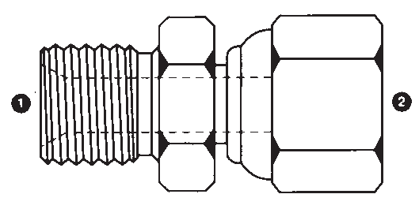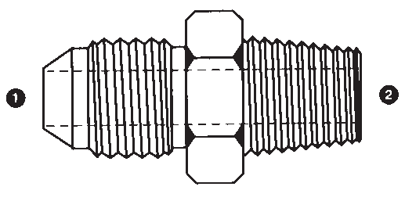Descripton Sizes Part Number
MALE BSPT X  MALE NPT | ❶ ❷  SS9008-04-04 SS9008-06-06 SS9008-08-08 SS9008-12-12 SS9008-16-16 SS9008-20-20 |  | SS9008
MALE JIC X  MALE BSPT | ❶ ❷  SS9011-04-02 SS9011-04-04 SS9011-06-04 | ❶ ❷  SS9011-06-06 SS9011-08-06 SS9011-08-08 | SS9011
 |  | SS9011-08-12
 |  | SS9011-10-08
 |  | SS9011-12-12
 |  | SS9011-16-16
 |  | SS9011-20-20
 |  | SS9011-24-24
MALE BSPP X  FEMALE BSPP (SWIVEL) | ❶ ❷  SS9015-04-04 SS9015-06-06 SS9015-08-08 |  | SS9015
 | SS9015-12-12
 | SS9015-16-16
 | SS9015-20-20
 | SS9015-24-24
MALE BSPP X  FEMALE JIC (SWIVEL) | ❶ ❷  SS9021-04-04 SS9021-06-06 SS9021-08-08 SS9021-12-12 SS9021-16-16 |  | SS9021
FEMALE JIC (SWIVEL) X  FEMALE JIC (SWIVEL)  (JIC UNION) | ❶ ❷  SS9026-04-04 SS9026-06-06 SS9026-08-08 SS9026-10-10 SS9026-12-12 |  | SS9026
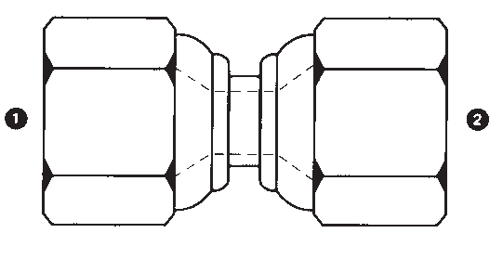75

Stainless Steel
Part Number

Sizes

Descripton

SS9028 | ❶  SS9028-02 SS9028-04 SS9028-06 SS9028-08 SS9028-12 SS9028-16 SS9028-20 SS9028-24 | BSPP COUNTERSUNK SEALED PLUG  C/W VITON SEAL
SS9029  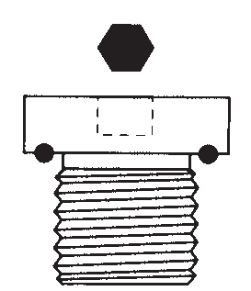 | ❶ ❶  SS9029-10X1.0 SS9029-42X2.0  SS9029-12X1.5 SS9029-48X2.0 SS9029-14X1.5  SS9029-16X1.5 SS9029-18X1.5 SS9029-20X1.5 SS9029-22X1.5 SS9029-26X1.5 SS9029-27X2.0 SS9029-33X2.0 | METRIC COUNTERSUNK SEALED PLUG  C/W VITON SEAL
SS9030 | ❶  SS9030-02 SS9030-04 SS9030-06 SS9030-08 SS9030-12 SS9030-16 SS9030-20 SS9030-24 SS9030-32 | BSPP HEX PLUG
SS9030T | ❶  SS9030T-02 SS9030T-04 SS9030T-06 SS9030T-08 SS9030T-12 SS9030T-16 SS9030T-20 SS9030T-24 | BSPT HEX PLUG
SS9033 | ❶  SS9033-02 SS9033-04 SS9033-06 SS9033-08 SS9033-12 SS9033-16 SS9033-20 SS9033-24 | BSPP SWIVEL CAP

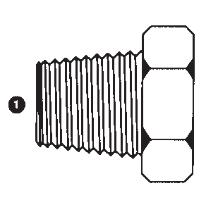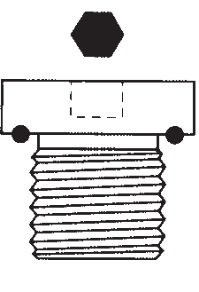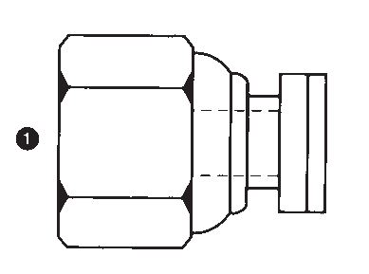76

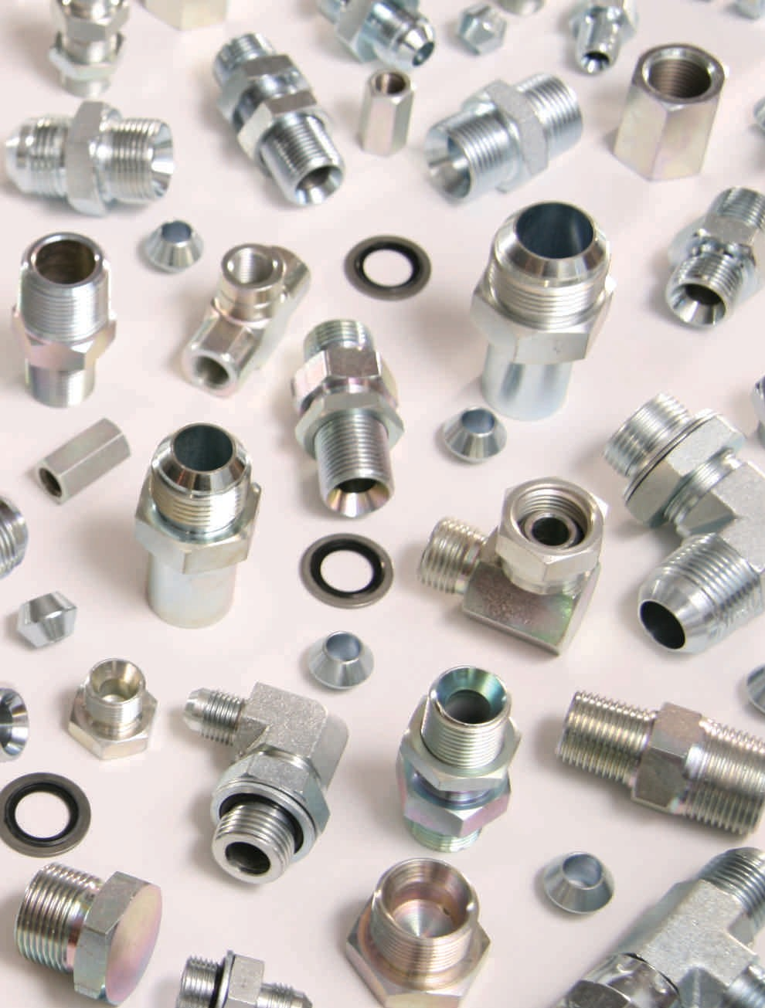Stainless Steel
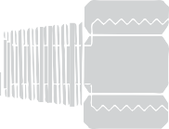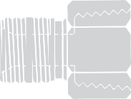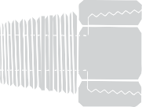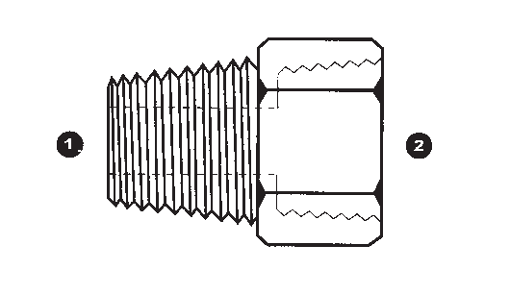Descripton Sizes Part Number
MALE BSPP X  FEMALE NPT (SOLID) | ❶ ❷  SS9035-02-02 SS9035-04-02 | ❶ ❷  SS9035-04-04 SS9035-06-04 SS9035-06-06 | SS9035
 |  | SS9035-08-06
 |  | SS9035-08-08
 |  | SS9035-12-12
 |  | SS9035-16-16
 |  | SS9035-20-20
 |  | SS9035-24-24
 |  | SS9035-32-32
MALE NPT | ❶ ❷  SS9037-02-02 SS9037-04-04 SS9037-06-06 SS9037-08-08 SS9037-12-12 SS9037-16-16 SS9037-20-20 SS9037-24-24 |  | SS9037
X
FEMALE BSP (SOLID)
FEMALE BSP’S ARE
CAPABLE OF
SEALING WITH BSPP &
BSPT MALES
MALE BSPT X  FEMALE NPT (SOLID) | ❶ ❷  SS9042-02-02 SS9042-04-04 SS9042-06-06 SS9042-08-08 SS9042-12-12 |  | SS9042
FEMALE BSP (SOLID) | ❶ ❷  SS9043-02-02 SS9043-04-04 SS9043-06-06 SS9043-08-08 SS9043-12-12 SS9043-16-16 SS9043-20-20 SS9043-24-24 |  | SS9043
X
FEMALE BSP (SOLID)
(BSP COUPLING)
FEMALE BSP’S ARE
CAPABLE OF
SEALING WITH BSPP &
BSPT MALES
90° MALE JIC X  MALE BSPP ADJ. ELBOW | ❶ ❷  SS9059-04-02 SS9059-04-04 | ❶ ❷  SS9059-06-04 SS9059-06-06 SS9059-06-08 SS9059-08-06 | SS9059
 |  | SS9059-08-08
 |  | SS9059-10-08
 |  | SS9059-12-08
 |  | SS9059-12-12
 |  | SS9059-16-16
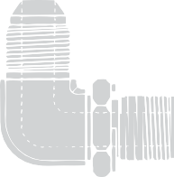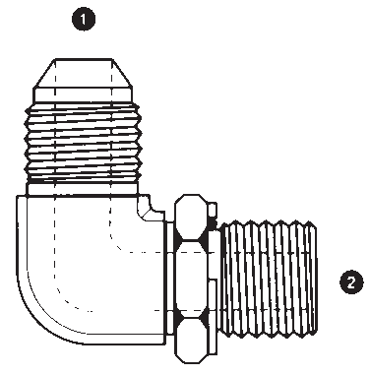77

Stainless Steel
Part Number

Sizes

Descripton

SS9063 | ❶ ❷  SS9063-04-02 SS9063-04-04 SS9063-06-04 SS9063-06-06 SS9063-08-08 SS9063-10-08 SS9063-12-12 SS9063-16-16 |  |  | 90° MALE JIC X  MALE BSPT ELBOW
SS9069 | ❶ ❷  SS9069-04-10 SS9069-04-12 SS9069-06-14 SS9069-06-16 SS9069-08-18 |  |  | 90° MALE JIC X  MALE METRIC ADJ. ELBOW
SS9200 | ❶ ❷  SS9200-04-06 SS9200-04-08 SS9200-04-10 | ❶ ❷  SS9200-08-16 SS9200-12-18 SS9200-12-20 | ❶ ❷  SS9200-20-38 SS9200-24-42 | MALE JIC X  METRIC STANDPIPE
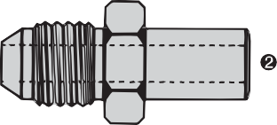 | SS9200-06-08 SS9200-06-10 SS9200-06-12 SS9200-08-10 SS9200-08-12 SS9200-08-14 | SS9200-12-22 SS9200-12-25 SS9200-16-25 SS9200-16-28 SS9200-16-30 SS9200-20-28
 | SS9200-08-15 | SS9200-20-35
SS9201L | ❶  SS9201L-06 SS9201L-08 SS9201L-10 SS9201L-12 SS9201L-15 SS9201L-18 SS9201L-22 SS9201L-28 SS9201L-35 SS9201L-42 |  |  | METRIC LIGHT SERIES TUBE NUT
 |  |  |  | (DIN 2353 L)
SS9201S | ❶  SS9201S-06 SS9201S-08 SS9201S-10 SS9201S-12 SS9201S-14 SS9201S-16 SS9201S-20 SS9201S-25 SS9201S-30 SS9201S-38 |  |  | METRIC HEAVY SERIES TUBE NUT  (DIN 2353 S)

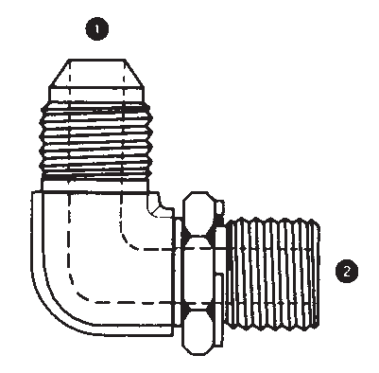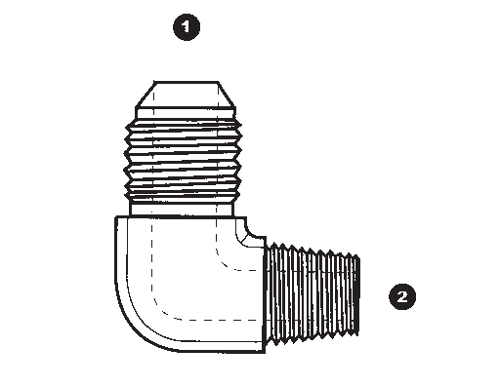78

Stainless Steel
Descripton Sizes Part Number
METRIC TUBE CUTTING RING  (DIN 2353 S OR L) | ❶  SS9202-06 SS9202-08 SS9202-10 SS9202-12 SS9202-14 SS9202-15 | ❶  SS9202-16 SS9202-18 SS9202-20 SS9202-22 SS9202-25 SS9202-28 SS9202-30 SS9202-35 SS9202-38 SS9202-42 | SS9202
MALE METRIC X  FEMALE NPT (SOLID) | ❶ ❷  SS9235-10-02 SS9235-12-04 SS9235-14-04 |  | SS9235
 | SS9235-18-06
 | SS9235-18-08
 | SS9235-20-08
 | SS9235-22-08
MALE JIC X  FEMALE BSPP (SWIVEL) | ❶ ❷  SS9240-04-04 SS9240-06-06 SS9240-08-06 |  | SS9240
 | SS9240-08-08
 | SS9240-12-12
 | SS9240-16-12
 | SS9240-16-16
BONDED SEAL FOR BRITISH THREAD | ❶  SS9500-02 SS9500-04 SS9500-06 SS9500-08 SS9500-12 SS9500-16 SS9500-20 SS9500-24 SS9500-32 |  | SS9500
BONDED SEAL FOR METRIC THREAD | ❶ SS9500-06MM SS9500-08MM | ❶ SS9500-10MM SS9500-12MM  SS9500-14MM SS9500-16MM SS9500-18MM SS9500-20MM SS9500-26MM SS9500-30MM SS9500-33MM | SS9500MM
79

Stainless Steel
Part Number

Sizes

Descripton

SS9500V

SS9500MMV
❶ SS9500-02V SS9500-04V SS9500-06V SS9500-08V SS9500-12V SS9500-16V

❶ SS9500-10MMV SS9500-16MMV SS9500-20MMV
SS9500-26MMV SS9500-33MMV
BONDED VITON SEAL FOR BRITISH THREAD

BONDED VITON SEAL FOR METRIC THREAD

❶ ❷ ❸ ❶ ❷ ❸

SS9605
SS9605-04-L06-12 SS9605-04-L08-14 SS9605-06-L10-16 SS9605-06-L12-18 SS9605-08-L12-18 SS9605-08-L15-22 SS9605-10-L15-22 SS9605-12-L18-26 SS9605-12-L22-30 SS9605-16-L28-36
SS9605-20-L35-45 SS9605-20-L42-52 SS9605-24-L42-52
MALE JIC X
MALE METRIC DUAL PURPOSE
PORT OR TUBE (DIN 2353 L)

SS9606
❶ ❷ ❸ ❶ ❷ ❸
MALE JIC

SS9606-04-S06-14 SS9606-04-S08-16 SS9606-06-S10-18 SS9606-06-S12-20 SS9606-08-S10-18 SS9606-08-S12-20 SS9606-08-S14-22 SS9606-08-S16-24 SS9606-10-S16-24 SS9606-12-S20-30
SS9606-12-S25-36 SS9606-16-S25-36 SS9606-16-S30-42 SS9606-20-S38-52 SS9606-24-S38-52
X
MALE METRIC DUAL PURPOSE
PORT OR TUBE (DIN 2353 S)

80

A note on Malleable Iron pipe fittings:

Malleable Iron

MATERIAL: Adaptall’s malleable iron fittings are specified to BS310-BS340/12.
FINISH: Malleable iron fittings are varnished for protection during storage and transit. Most patterns are also available in hot dip galvanized.
THREADS: Both male and female threads are specified to ISO-R7 = BS21 : 1957.
SIZES: Most patterns are available up to 6” on request.
PRESSURE: MAXIMUM working pressures and temperatures; DO NOT EXCEED!
Black ..................1/8” to 4” = 365PSI @ 400°F
Galvanized ..........1/8” to 4” = 365PSI @ 125°F
Galvanized fittings are not normal stock but can be supplied on request.
FOR CURRENT PRICING ON MALLEABLE IRON FITTINGS PLEASE CALL US @ 1-800-463-8134

Descripton Sizes Part Number
BSP CAP (SOLID)  FEMALE BSP’S ARE APABLE OF SEALING WITH BSPP & BSPT MALES | ❶  B14C-04 B14C-06 B14C-08 |  | ❶  B14C-12 B14C-16 B14C-20 B14C-24 B14C-32 B14C-40 | B14C
FEMALE BSP (SOLID) X  FEMALE BSP (SOLID) | ❶ ❷  B1404-04-04 B1404-06-04 B1404-06-06 | ❶ ❷  B1404-16-08 B1404-16-12 B1404-16-16 | ❶ ❷  B1404-32-16 B1404-32-20 B1404-32-24 | B1404
(BSP COUPLING) | B1404-08-04  B1404-08-06 | B1404-20-16  B1404-20-20 | B1404-32-32  B1404-40-32
 | B1404-08-08 | B1404-24-20 | B1404-40-40
FEMALE BSP’S ARE | B1404-12-08 | B1404-24-24 | B1404-48-40
APABLE OF SEALING WITH | B1404-12-12 | B1404-32-12 | B1404-48-48
BSPP & BSPT MALES
FEMALE BSP (SWIVEL) |  | ❶ ❷  B1404U-04-04 B1404U-06-06 B1404U-08-08 | ❶ ❷  B1404U-12-12 B1404U-16-16 B1404U-20-20 B1404U-24-24 B1404U-32-32 B1404U-40-40 B1404U-48-48 | B1404U
X
FEMALE BSP (SWIVEL)
- NO SEAT
(BSP UNION)
FEMALE BSP’S ARE
APABLE OF SEALING WITH
BSPP & BSPT MALES
MALE BSPT X  FEMALE BSP (SOLID) | ❶ ❷  B1804-04-02 B1804-06-02 B1804-06-04 | ❶ ❷  B1804-12-08 B1804-16-06 B1804-16-08 | ❶ ❷  B1804-24-20 B1804-32-16 B1804-32-20 | B1804  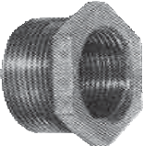
FEMALE BSP’S ARE APABLE OF SEALING WITH BSPP & BSPT MALES | B1804-08-02 B1804-08-04 B1804-08-06 B1804-12-04 | B1804-16-12 B1804-20-08 B1804-20-12 B1804-20-16 | B1804-32-24 B1804-40-20 B1804-40-24 B1804-40-32
 | B1804-12-06 | B1804-24-08 | B1804-48-24
 |  | B1804-24-12 | B1804-48-32
 |  | B1804-24-16 | B1804-48-40

C

C C 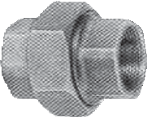
C

81

Malleable Iron
Part Number

Sizes

Descripton

B1808H | ❶ ❷  B1808H-02-02 B1808H-04-02 B1808H-04-04 | ❶ ❷  B1808H-12-08 B1808H-12-12 B1808H-16-08 | ❶ ❷  B1808H-24-24 B1808H-32-20 B1808H-32-24 | MALE BSPT X  MALE BSPT
 | B1808H-06-02 B1808H-06-04 | B1808H-16-12 B1808H-16-16 | B1808H-32-32 B1808H-40-32 | (BSPT NIPPLE)
 | B1808H-06-06 | B1808H-20-12
 | B1808H-08-04 | B1808H-20-16
 | B1808H-08-06 | B1808H-20-20
 | B1808H-08-08 | B1808H-24-16
 | B1808H-12-06 | B1808H-24-20
B1808L | CALL FOR SIZES |  |  | MALE BSPT X  MALE BSPT LONG  (BSPT EXTENDED NIPPLE)
B18SQP | ❶  B18SQP-04 B18SQP-06 B18SQP-08 B18SQP-12 B18SQP-16 B18SQP-20 B18SQP-24 B18SQP-32 B18SQP-40 B18SQP-48 |  |  | BSPT SQUARE HEAD PLUG
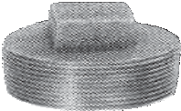
B2404 | ❶ ❷  B2404-08-08 B2404-12-12 B2404-16-16 B2404-20-20 B2404-24-24 |  |  | 45° FEMALE BSP (SOLID)  X  FEMALE BSP (SOLID)  ELBOW
 | B2404-32-32
 |  |  |  | FEMALE BSP’S ARE
 |  |  |  | CAPABLE OF SEALING WITH
 |  |  |  | BSPP & BSPT MALES
B2804 | ❶ ❷  B2804-06-06 B2804-08-08 B2804-12-12 B2804-16-16 |  |  | 45° MALE BSPT X  FEMALE BSP (SOLID) ELBOW
 | B2804-20-20 |  |  | FEMALE BSP’S ARE
 |  |  |  | CAPABLE OF SEALING WITH
 |  |  |  | BSPP & BSPT MALES
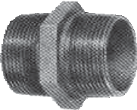
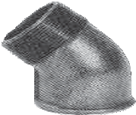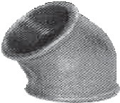82

Malleable Iron
Descripton Sizes Part Number
90° FEMALE BSP | ❶ ❷  B3404-02-02 B3404-04-04 | ❶ ❷  B3404-06-04 B3404-06-06 B3404-08-04 B3404-08-06 B3404-08-08 B3404-12-06 B3404-12-08 B3404-12-12 B3404-16-08 B3404-16-12 | ❶ ❷  B3404-16-16 B3404-20-12 B3404-20-16 B3404-20-20 B3404-24-16 B3404-24-20 B3404-24-24 B3404-32-32 B3404-40-40 B3404-48-48 | B3404  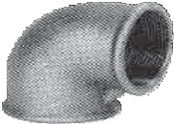
(SOLID)
X
FEMALE BSP (SOLID)
ELBOW
FEMALE BSP’S ARE
CAPABLE OF SEALING WITH
BSPP & BSPT MALES
90° MALE BSPT | ❶ ❷  B3804-04-04 B3804-06-06 B3804-08-08 B3804-12-12 B3804-16-16 B3804-20-20 B3804-24-24 B3804-32-32 B3804-40-40 B3804-48-48 |  |  | B3804  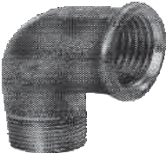
X
FEMALE BSP (SOLID)
ELBOW
FEMALE BSP’S ARE
CAPABLE OF SEALING WITH
BSPP & BSPT MALES
FEMALE BSP (SOLID) TEE | ❶  B4444-04 B4444-06 |  |  | B4444  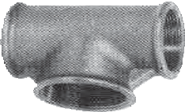
FEMALE BSP’S ARE CAPABLE OF SEALING WITH BSPP & BSPT MALES | B4444-08  B4444-12 B4444-16  B4444-20
 | B4444-24
 | B4444-32
 | B4444-40
 | B4444-48

83

Warranty, Terms & Conditions
Warranty
warrants it’s products to be free of defects in material and workmanship. No warranty of merchantability or other warranty, express or implied, is made.

Liability for and the exclusive remedy for defective materials or workmanship is limited to replacement or repair of defective products returned within 60 days after receipt. No allowance will be made for repairs performed by the purchaser or on his order. is not liable for consequential or other damages or any expense incurred through the use of it’s products.

All design and dimensional data are subject to change without notice. Working pressures, corrosion data and other technical information have been prepared from actual test results and other data considered to be reliable. However, no responsibility can be assumed for the accuracy of this information under varied field conditions and should be considered as a recommendation only and not a guarantee.

Terms & Conditions
  - Prices subject to change without prior notice.
  - F.O.B. our plant.
  - All taxes and government surcharges are extra where applicable.
  - No returns without prior written consent.
  - All sales to U.S.customers are payable in U.S. funds.
  - Minimum billing: $25.00 plus taxes.

is a registered trademark. The use of the trademark is not permitted without the prior written consent of inc.
Reproduction of this literature in whole or in part is not permitted without the prior written consent of inc.

84

