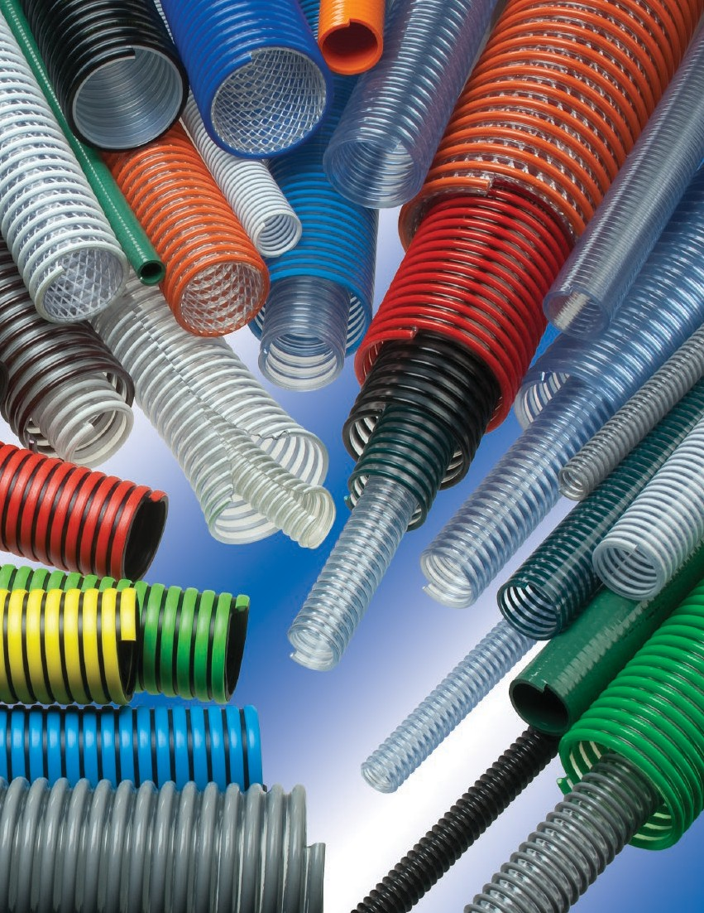

Thermoplastic Industrial Hoses

THE ASSOCIATION FOR HOSEAND ACCESSORIES DISTRIBUTION
TIGERFLEX™ ISO 9001 QUALITY M.S.
EDITION 0218

2001™ Series Hose 10
2020™ Series Hose 12
AMPH™ Amphibian™ Series Hose 22
BARK™ “Bark Hose” Series Hose 33
BCCF™ Banding Coils 56
BCRT™ Banding Coils 56
BCWF™ Banding Coils 56
BW™ “Blue Water” Series Hose 40
CF™ Cold Flex™ Series Hose 41
CG™/CG-SL™ “Cover Guard” Series Hose 37
F™ Tiger™ Suction Series Hose 39
FMCR™ “Spa Hose” Series Hose 47
FT™ Series Hose 17
G™ Tiger™ Suction Series Hose 39
GC-C™ “Ground Cover” Series Hose 31
GT™ Series Hose 36
GTF™ Series Hose 18
GTFE™ Series Hose 18
GTG™ Series Hose 36
H™ Series Hose 38
J™ Series Hose 38
K™ Series Hose 38
LK™ Lawn King™ Series Hose 34
LKC™ Lawn King™ Series Hose 34
MH™ “Marine Hose” Series Hose 46
MILK™ Series Hose 16
MILK-LT™ Series Hose 16
MULCH™ Series Hose 32
MULCH-LT™ Series Hose 32
ORV™ Series Hose 54
OV™ Oil Vac™ Series Hose 55
PF™ Plas-T-Flow™ Series Hose 27
S™ Tiger™ Suction Series Hose 39
SBDC™ TigerClamps™ 58
SBDCR™ TigerClamps™ 58
SH™ Series Hose 43
SLV-DRP™ Banding Sleeves 57
SLV-VAP™ Banding Sleeves 57
SLV-VLT™ Banding Sleeves 57
STIG™ Series Hose.......................N...E..W 52
TBLU™ Tiger™ Blue Series Hose 50
TG™ Tiger™ Green Series Hose 48
TR1™ Tiger™ Series Hose 20
THT™ Tiger™ Series Hose 21
TRED™ Tiger™ Red Series Hose 50
TSD™ Tiger™ Series Hose 51
TY™ Tiger™ Yellow Series Hose 49
UBK™ Series Hose 25
UF1™ Ureflex™ Series Hose 24
UF2™ Ureflex™ Series Hose 23
UFC™ Ureflex™ Series Hose 26
UV1™ Urevac™ Series Hose 35
UVE™ Urevac™ Series Hose ..........N...E..W 35
UV2™ Urevac™ Series Hose 29
UV3™ Urevac™ Series Hose 28
UVF™ Series Hose 19
UVPE™ Series Hose 30
VLT-SD™ Voltbuster™ Series Hose 13
VOLT™ Voltbuster™ Series Hose 11
W™ Series Hose 42
WBS™ Series Hose 14
WE™ Series Hose 9
WG™ Series Hose 45
WH™ Series Hose 43
WOR™ Series Hose 53
WST™ Series Hose 44
WSTF™ Series Hose 15
WT™ Series Hose 8

Application Guide 6-7
Index of Reference Pages
Care and Maintenance 64
Cautionary Statement and Limited Warranty Back Cover
Chemical Resistance Guides and Warning 67-73
Compliance Footnotes for Tigerflex™ Catalog Products 62
Effect of Temperature on Working Pressure & Vacuum Ratings 66
EPDM Chemical Resistance Guide 72
Features and Advantages Catalog Icon Guide 4
Features and Advantages Guide by Hose Series 5
Flexibility 63
Index of Products by Series 2

Index of Reference Pages 2
Kuriyama Value™ 75
PVC and Polyurethane Resistance Guide 68-71
Quality Assurance 62
Recommended Practices 64
SBR Chemical Resistance Guide 73
Storage and Handling 65
Table of Contents 3
Tigerflex™ Accessories Compatability Chart 59-61
Tigerflex™ Products Custom Inquiry Form 74
Working Pressure Ratings 66

Index of Products by Series
NOTE: Although every effort has been made to accurately show the color of the Tigerflex™ hoses in this catalog, because of the limitations of four-color process printing some of the colors shown herein may not be exact.

Table of Contents

Index of Products by Series 2
Index of Reference Pages 2
Table of Contents 3
Features and Advantages Catalog Icon Guide 4
Features and Advantages Guide by Hose Series 5
Application Guide 6-7
Liquid Suction:
H™ Series Hose 38
J™ Series Hose 38
K™ Series Hose 38
Tiger™ Suction F™ Series Hose 39
Tiger™ Suction G™ Series Hose 39
Lawn King™ LK™ Series Hose 34
Lawn King™ LKC™ Series Hose 34
Urevac™ UV1™/UVE™ Series Hose 35
GT™ Series Hose 36
GTG™ Series Hose 36
“Cover Guard” CG™/CG-SL™ Series Hose 37
Ducting:
Tiger™ TR1™ Series Hose 20
Tiger™ THT™ Series Hose 21
Amphibian™ AMPH™ Series Hose 22
Ureflex™ UF2™ Series Hose 23
Ureflex™ UF1™ Series Hose 24
UBK™ Series Hose 25
Ureflex™ UFC™ Series Hose 26
Urevac™ UV3™ Series Hose 28
Urevac™ UV2™ Series Hose 29
UVPE™ Series Hose 30
“Ground Cover” GC™ Series Hose 31
“Ground Cover” GC-C™ Series Hose 31
MULCH™ Series Hose 32
MULCH-LT™ Series Hose 32
“Bark Hose” BARK™ Series Hose 33
STIG™ Series Hose............................N..E..W 52
Material Handling:
WT™ Series Hose 8
WE™ Series Hose 9
2001™ Series Hose 10
Voltbuster™ VOLT™ Series Hose 11
2020™ Series Hose 12
Voltbuster™ VLT-SD™ Series Hose 13
WBS™ Series Hose 14
WSTF™ Series Hose 15
MILK™ Series Hose 16
MILK-LT™ Series Hose 16
FT™ Series Hose 17
GTF™ Series Hose 18
GTFE™ Series Hose 18
UVF™ Series Hose 19
Plas-T-Flow™ PF™ Series Hose 27
Food Grade:
Tiger™ Suction S™ Series Hose 39
“Blue Water” BW™ Series Hose 40
Coldflex™ CF™ Series Hose 41
W™ Series Hose 42
WH™ Series Hose 43
SH™ Series Hose 43
WST™ Series Hose 44
WG™ Series Hose 45
“Marine Hose” MH™ Series Hose 46
“Spa Hose” FMCR™ Series Hose 47
Tiger™ Green TG™ Series Hose 48
Tiger™ Yellow TY™ Series Hose 49
Tiger™ Red TRED™ Series Hose 50
Tiger™ Blue TBLU™ Series Hose 50
Tiger™ TSD™ Series Hose 51
WOR™ Series Hose 53
ORV™ Series Hose 54
Oil Vac™ OV™ Series Hose 55
Accessories:
Banding Coils 56
Banding Sleeves 57
TigerClamps™ 58
Tigerflex™ Accessories Compatability Chart 59-61
References:
Quality Assurance 62
Compliance Footnotes for Tigerflex™ Catalog Products 62
Flexibility 63
Care and Maintenance 64
Recommended Practices 64
Storage and Handling 65
Effect of Temperature on Working Pressure & Vacuum Ratings 66
Working Pressure Ratings 66
Chemical Resistance Guides and Warning 67
PVC and Polyurethane Resistance Guide 68-71
EPDM Chemical Resistance Guide 72
SBR Chemical Resistance Guide 73
Tigerflex™ Products Custom Inquiry Form 74
Kuriyama Value™ 75
Cautionary Statement and Limited Warranty Back Cover

The trademarks contained in this publication are trademarks of Kuriyama of America, Inc.
The “Tigerflex” design trademarks contained in this publication are trademarks of Tigers Polymer Corporation.
NOTE: Although every effort has been made to accurately show the color of the Tigerflex™ hoses in this catalog, because of the limitations of four-color process printing some of the colors shown herein may not be exact.

Features & Advantages Catalog Icon Guide

Abrasion Resistant – Indicates hoses designed to help resist internal wear caused by the transfer of abrasive materials.

Abrasion Resistant Plus – Indicates hoses designed to help resist internal wear caused by the transfer of highly abrasive materials.

“Cold-Flex” Materials – Indicates hoses formulated to remain flexible in sub-zero temperatures.

Easy Slide – Indicates hoses with an external rigid helix designed to slide easily over rough surfaces. Easy-to-handle.

Food Grade – Indicates hoses which comply with applicable FDA requirements for food contact. Several of these hoses also meet USDA and 3-A requirements.

Oil Resistant – Indicates hoses which exhibit resistance to animal and petroleum based oils.

Static Dissipative – Indicates hoses formulated with static dis- sipative compounds or hoses containing a grounding wire to help prevent the build-up of static electricity.

Transparent Construction – Indicates hoses with a transparent or semi- transparent tube. These hoses allow the user visual confirmation of material flow, and the ability to see if material or condensation has collected in the hose tube.

Water – Indicates hoses which can be used for freshwater and saltwater transfer.

Features & Advantages Guide By Hose Series

Food Grade:
2001 |  | X |  |  | X | X | X | X
2020 |  | X | X | X | X | X | X | X
FT |  |  |  |  | X |  |  | X | X
GTF |  |  |  | X | X |  |  | X | X
GTFE |  |  |  | X | X |  | X | X | X
MILK |  |  |  |  | X |  |  | X | X
MILK-LT |  |  | X |  | X |  |  | X | X
PF |  | X | X | X |  | X | X | X
UVF | X |  | X | X | X | X |  | X
VOLT/VLT-SD |  | X | X | X | X | X | X | X
WBS | X |  |  |  | X |  | X | X | X
WE | X |  |  |  | X |  | X | X | X
WSTF |  |  |  | X | X |  |  | X | X
WT | X |  |  |  | X |  |  | X | X
Material Handling:
AMPH |  | X | X |  |  | X | X |  | X
BARK | X |  |  | X |  |  |  | X | X
GC-C | X |  | X |  |  | X |  | X
MULCH | X |  |  |  |  |  |  | X | X
MULCH-LT | X |  | X |  |  |  |  | X | X
STIG |  | X | X |  |  | X | X
TR1 |  | X | X |  |  |  | X |  | X
THT | X |  | X | X |  |  | X |  | X
UBK |  | X | X | X |  | X | X
UF1 |  | X | X |  |  | X | X
UF2 |  | X | X |  |  | X | X
UFC |  | X | X |  |  | X | X | X
UV-2 | X |  | X | X |  | X | X | X
UV-3 |  | X | X | X |  | X | X | X
UVPE | X |  | X |  |  | X | X | X
Ducting:
CG/CG-SL |  |  |  | X |  |  |  | X | X
GT |  |  |  | X |  |  |  | X | X
GTG |  |  |  | X |  |  |  |  | X
LK | X |  | X | X |  |  |  |  | X
LKC | X |  | X | X |  |  |  | X | X
UV1/UVE | X |  | X | X |  | X | X | X
Liquid Suction:
BW |  |  | X |  |  |  |  | X | X
CF | X |  | X |  |  |  | X |  | X
F/G/S |  |  |  |  |  |  |  | X | X
H/J/K |  |  |  |  |  |  |  | X | X
MH |  |  |  |  |  |  |  |  | X
ORV |  |  |  |  |  | X |  |  | X
OV |  | X | X |  |  | X |  | X
SPA |  |  |  |  |  |  |  |  | X
TG/TY/TRED/TBLU |  |  | X | X |  |  |  |  | X
TSD |  |  | X | X |  |  |  |  | X
W |  |  | X |  |  |  |  | X | X
WG |  |  |  |  |  |  |  |  | X
WH/SH |  |  | X |  |  |  |  | X | X
WOR |  |  |  |  |  | X |  |  | X
WST |  |  |  |  |  |  |  | X | X

NOTE: For details regarding the features & advantages listed, refer to the catalog page for each product.

✚ = Primary Applications
✔ = Secondary Applications
Food Grade
Material Handling
Application Guide

 | 2001 | 2020 | FT | GTF/ GT FE | MILK/ MILK- LT | PF | UVF | VLT- SD | VOLT | WBS | WE | WSTF | WT | AMPH | BARK | GC- C | MULCH/ MULCH- LT | STIG | TR1 | THT | UBK | UF1 | UF2 | UFC | UV2 | UV3 | UVPE
Agricultural dry fertilizers  Agricultural liquid fertilizers Agri-foam systems |  |  |  |  |  |  |  |  |  |  |  |  |  | ✚ |  |  |  |  |  | ✚ | ✚ | ✚ |  | ✚ | ✚
Air seeder lines  Bulk truck and railcar unloading Cable and hose bundle protection | ✔ | ✚ |  |  |  | ✚ |  | ✚ | ✚ |  | ✔ |  | ✔ | ✚ |  |  |  | ✔ | ✔ |  | ✚ | ✚  ✔ | ✔ | ✚ | ✚
Concrete resurfacing dust collection Drain lines  Ducting, ventilation & fume removal |  |  |  | ✚ |  |  | ✚ |  |  |  |  |  | ✔ |  |  |  |  |  |  | ✔  ✔ |  |  |  |  | ✔
Dust collection Fish suction  Fly ash collection |  |  |  | ✔ |  |  | ✚ |  | ✚ |  |  | ✔ |  | ✚ |  |  |  | ✚ | ✚ | ✔  ✚ | ✚ | ✚ | ✚ |  | ✚ | ✚
Food grade blower and ducting systems Food grade liquids - water, beer, wine and juice  Food grade material handling - heavy duty abrasive | ✚ | ✚ | ✚ | ✚ | ✚ |  | ✚ | ✚ | ✚ | ✔ | ✔ | ✚ | ✚  ✔
Food grade material handling - standard duty Gold dredging  Hydro excavation | ✔ | ✔ | ✔ | ✔ |  |  | ✔ | ✔ | ✔ | ✚ | ✚ | ✚ | ✚ | ✚ |  |  | ✔ |  | ✚ | ✚
Ice transfer  Industrial vacuum equipment Insulation blowing | ✔ | ✔ | ✚ | ✔ | ✚ |  |  | ✚ | ✚ | ✔ | ✔ | ✚ | ✔  ✔ | ✚ |  |  |  | ✚ | ✚ | ✚ | ✚ | ✚ | ✚ | ✚ | ✔ | ✔  ✔ | ✔
Irrigation lines  Lawn and leaf collection Liquid manure handling |  |  |  |  |  |  |  |  |  |  |  |  |  |  | ✚ | ✔ | ✔
Marine bilge discharge Marine plumbing  Material chutes | ✔ | ✔ |  | ✔ |  | ✔ | ✔ | ✚ | ✚ | ✔ | ✔ |  | ✔ | ✔ |  |  |  | ✚ | ✔ | ✚ | ✔ | ✚ | ✚ | ✚ | ✚ | ✔ | ✔
Material handling - heavy duty abrasive Material handling - standard duty  Material handling - light duty | ✚  ✔ | ✚  ✔ | ✔ | ✔  ✚ |  | ✚ | ✔  ✔ | ✚  ✔ | ✚  ✔ | ✔  ✚  ✔ | ✔  ✚  ✔ |  | ✔  ✚  ✔ | ✚  ✔ | ✚ | ✚  ✚ | ✚ | ✚  ✔ | ✚  ✚ | ✔  ✚  ✔ | ✚  ✔ | ✚  ✔ | ✚  ✔ | ✚  ✔ | ✔  ✚ | ✚  ✔ | ✚  ✚
Milk and dairy product transfer  Milling machine scrap recovery Mining applications (MSHA) |  |  | ✚ |  | ✚ | ✚ |  | ✚ | ✚ |  |  |  |  | ✚ |  |  |  | ✚ | ✚ | ✚ | ✚ | ✚ | ✚ | ✚ |  | ✚ | ✔
Mulch, bark, wood chips, other surfacing materials Oil skimming  Oil sluries |  |  |  |  |  |  |  |  |  |  |  |  |  | ✔ | ✚ | ✚ | ✚
Oil suction  Pharmaceutical product transfer Plastic processing equipment | ✚  ✚ | ✔  ✔ | ✔ | ✚  ✔ |  | ✔  ✚ | ✚  ✔ | ✔  ✚ | ✔  ✚  ✚ | ✚  ✚ | ✚  ✚ | ✔ | ✚  ✚ | ✔ |  |  |  | ✔ |  |  | ✔  ✔ | ✔  ✔ | ✔ | ✔  ✚ | ✔ | ✔  ✚ | ✔  ✚
Pneumatic conveying systems Poultry processing  Pumps, rental and construction dewatering | ✚ |  | ✔  ✚ |  | ✔ |  |  | ✚ | ✚ | ✚ | ✚ |  | ✚  ✚ |  |  |  |  |  |  | ✔
Pumps, trash  Recreational vehicle (RV) pluming Rock dusting |  |  |  |  |  |  |  |  |  |  |  |  |  |  |  |  |  |  |  | ✔
Rock, gravel, sand and crushed concrete vacuuming Septic and wastewater handling  Sewer truck boom hose |  |  |  |  |  | ✔ |  |  |  |  |  |  |  | ✚  ✚ |  |  |  | ✚  ✔ | ✚  ✚ | ✚  ✔  ✚ | ✚  ✔ | ✚  ✔ | ✚  ✔ |  |  | ✔ | ✔
Shot blast recovery Slurry handling  Soil, seed and compost delivery |  |  |  |  |  |  |  |  |  |  |  |  |  | ✚  ✚ | ✚ | ✚ | ✚ | ✚ | ✚  ✚ | ✚ | ✚ | ✚ | ✚ | ✚ |  | ✔
Spa, pool and hot tub pluming Suction and discharge  Wand hose |  | ✚ |  |  |  |  |  | ✚ |  |  |  | ✚ |  |  | ✔ |  |  |  | ✚ |  | ✔ |  |  |  | ✚
Water suction - heavy duty  Water suction - standard duty |  |  | ✚  ✔ |  | ✚ |  |  |  |  | ✔ |  | ✚  ✔ | ✔ | ✔ |  |  |  | ✔ | ✔ |  |  |  | ✔

CAUTION NOTE: This application guide provides information on typical hose applications. Actual results may vary due to variances in the operating conditions involving temperature, chemical resistance, working pressure, etc. Please refer to the specifications printed for each product in this catalog, along with information regarding chemical resistance and our Cautionary Statement, to better insure successful results.

✚ = Primary Applications
✔ = Secondary Applications
Ducting Liquid Suction

 | CG/ CG-SL | GT/ GTG | LK/ LKC | UV1/ UVE | BW | CF | F/G/S | H/J/K | MH | OV | SPA | TG/TY/ TRED/ TBLU | TSD | W | WG | WH/ SH | WOR/ ORV | WST
Agricultural dry fertilizers Agricultural liquid fertilizers  Agri-foam systems |  |  |  |  | ✔ | ✔  ✔  ✔ | ✔  ✔  ✔ | ✔  ✚  ✔ |  |  |  | ✚  ✔ | ✚  ✚ | ✔ | ✔
Air seeder lines  Bulk truck and railcar unloading  Cable and hose bundle protection | ✚ | ✔ | ✔ |  |  | ✔ | ✔ | ✚ |  |  |  |  |  |  |  | ✔
Concrete resurfacing dust collection Drain lines  Ducting, ventilation & fume removal | ✔  ✔ | ✚  ✚ | ✔ | ✚  ✚ | ✔ |  | ✔ | ✚ | ✚ |  | ✚ |  |  | ✔ | ✔ | ✚
Dust collection Fish suction  Fly ash collection | ✔ | ✚ | ✚ | ✚ | ✔ |  |  |  |  |  |  |  |  | ✚ | ✚ | ✚ |  | ✚
Food grade blower and ducting systems
Food grade liquids - water, beer, wine and juice Food grade material handling - heavy duty abrasive
Food grade material handling - standard duty Gold dredging  Hydro excavation |  |  |  |  | ✔ |  |  |  |  |  |  |  |  | ✚ | ✚ | ✚ |  | ✔
Ice transfer  Industrial vacuum equipment Insulation blowing |  | ✔ |  | ✚ | ✔ | ✔ |  |  |  |  |  |  |  | ✔  ✔ | ✔ | ✔
Irrigation lines  Lawn and leaf collection Liquid manure handling |  | ✔ | ✚ | ✔ | ✔ | ✚  ✔ | ✚ | ✚ |  |  |  | ✚  ✚ | ✔  ✚ | ✔ | ✔ | ✔ |  | ✚
Marine bilge discharge  Marine plumbing Material chutes |  | ✔ | ✔ | ✚ | ✔ | ✔ |  | ✔ | ✚  ✚ | ✚ |  | ✚ | ✔ |  |  | ✔
Material handling - heavy duty abrasive  Material handling - standard duty Material handling - light duty |  | ✔  ✚ | ✔  ✚ | ✚  ✔ |  | ✚ |  |  |  | ✚  ✔ |  |  |  | ✔ | ✔ | ✔
Milk and dairy product transfer Milling machine scrap recovery  Mining applications (MSHA) | ✚ |  |  |  |  |  |  | ✚ |  | ✔
Mulch, bark, wood chips, other surfacing materials Oil skimming  Oil sluries |  | ✔ | ✔ |  |  |  |  |  |  | ✔  ✔ |  |  |  |  |  |  | ✚  ✚
Oil suction  Pharmaceutical product transfer Plastic processing equipment |  |  |  |  |  |  |  |  |  | ✚ |  |  |  |  |  |  | ✚
Pneumatic conveying systems Poultry processing  Pumps, rental and construction dewatering |  |  |  |  | ✚ | ✚ | ✚ | ✚ |  |  |  | ✚ | ✚ | ✚ | ✚ |  |  | ✚
Pumps, trash  Recreational vehicle (RV) pluming Rock dusting |  |  |  |  | ✚ | ✚ | ✚  ✔ | ✚  ✚ | ✚ |  |  | ✚ | ✚ | ✚ | ✚  ✚ | ✔ |  | ✚
Rock, gravel, sand and crushed concrete vacuuming Septic and wastewater handling  Sewer truck boom hose |  |  |  |  | ✔ | ✔ |  |  |  |  |  | ✚ | ✚
Shot blast recovery Slurry handling  Soil, seed and compost delivery |  |  | ✔ |  | ✔ | ✚ | ✔ |  |  |  |  |  | ✔ | ✚ |  | ✔
Spa, pool and hot tub pluming Suction and discharge  Wand hose |  |  | ✔ | ✔ |  |  |  |  |  |  | ✚ |  | ✚ |  |  |  |  | ✚
Water suction - heavy duty  Water suction - standard duty |  |  |  |  | ✔  ✚ | ✚  ✔ | ✚  ✔ | ✔  ✚ | ✔ | ✔ | ✔ | ✚ | ✚  ✔ | ✚  ✔ | ✚  ✔ | ✚ | ✔ | ✚  ✔
Application Guide

- Superior Product Design – Tigerflex™ WT™ series hoses are an industry standard for pneumatic material handling due to our specially engineered compound, innovative design and
uncompromising quality control. Provides the ideal combination of light weight, flexibility and durability.
- Food Grade Materials – Hose complies with applicable FDA(03) and 3-A(01) requirements. Hose approved by USDA(11) for use in meat and poultry plants.

- Transparent Construction – “See-the-flow.” Allows for visual confirmation of material flow.
- Convoluted Outer Cover – Provides increased hose flexibility.
- Phthalate Free

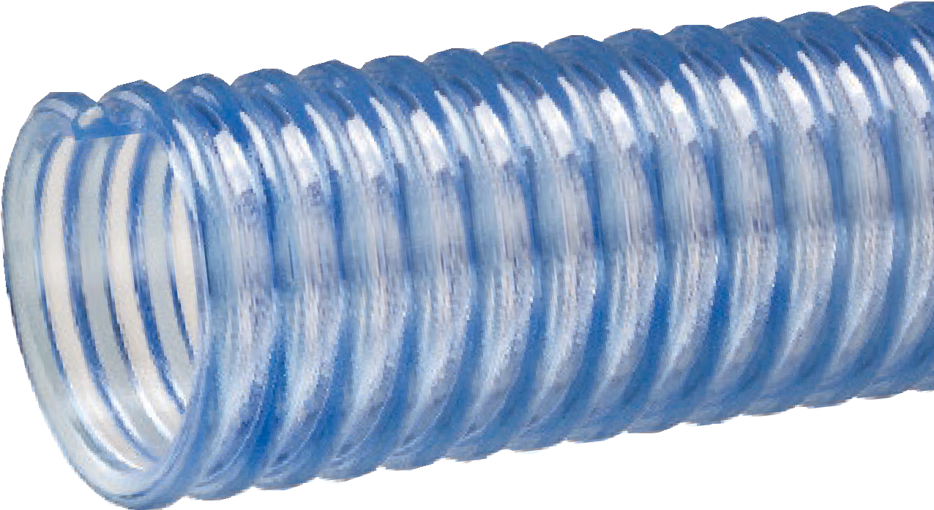
WT™ Series
Food Grade PVC Material Handling Hose
General Applications:
- Food grade liquids such as potable water, beer, wine and juice
- Food grade material handling – standard duty
- Material handling – standard duty
- Pharmaceutical product transfer
- Plastic processing equipment
- Pneumatic conveying equipment
- Poultry processing
Construction: PVC tube with rigid PVC helix.
Service Temperature: -4°F (-20°C) to 150°F (+65°C)*
Features and Advantages:
Nominal Specifications
Series | ID  (in.) | ID  (mm) | OD  (in.) | OD  (mm) | Working Pressure (psi) |  | Vacuum Rating (in. Hg) |  | Min. Bending Radius  (in. @ 68°F) | Standard Length (ft.) | Weight (lbs/ft.)
 |  |  |  |  | 68°F | 104°F | 68°F | 104°F
WT100 | 1 | 25.4 | 1.30 | 33.0 | 55 | 30 | 28 | 28 | 2 | 100/50 | 0.21
WT125 | 1-1/4 | 31.7 | 1.60 | 40.6 | 50 | 25 | 28 | 28 | 2 | 100/50 | 0.28
WT150 | 1-1/2 | 38.1 | 1.92 | 48.8 | 50 | 25 | 28 | 28 | 3 | 100/50 | 0.35
WT200 | 2 | 50.8 | 2.40 | 61.0 | 40 | 20 | 28 | 24 | 4 | 100/50 | 0.56
WT225 | 2-1/4 | 57.2 | 2.74 | 69.6 | 40 | 20 | 28 | 24 | 4.5 | 100/50 | 0.65
WT250 | 2-1/2 | 63.5 | 2.99 | 75.9 | 40 | 20 | 28 | 24 | 5 | 100/50 | 0.77
WT300 | 3 | 76.2 | 3.64 | 92.5 | 40 | 20 | 28 | 24 | 6 | 100/50 | 1.10
WT350 | 3-1/2 | 88.9 | 4.21 | 107.0 | 35 | 18 | 28 | 24 | 8 | 100/50 | 1.48
WT400 | 4 | 101.6 | 4.72 | 120.0 | 35 | 18 | 24 | 22 | 10 | 100/50 | 1.80
WT500 | 5 | 127.0 | 5.74 | 145.8 | 30 | 15 | 24 | 22 | 16 | 100/50/20 | 2.34
WT600 | 6 | 152.4 | 6.91 | 175.5 | 30 | 15 | 24 | 22 | 18 | 100/50/20 | 3.70
WT800 | 8 | 203.2 | 8.97 | 227.8 | 20 | 10 | 20 | 18 | 36 | 50/20 | 5.53
WT45M | 1.77 | 45.0 | 2.09 | 53.0 | 45 | 25 | 28 | 24 | 4 | 100/50 | 0.44
WT57M | 2.24 | 57.0 | 2.68 | 68.0 | 40 | 20 | 28 | 24 | 4.5 | 100/50 | 0.64
WT60M | 2.36 | 60 | 2.8 | 71.1 | 40 | 20 | 28 | 24 | 4.5 | 100/50 | 0.71
NOTE: Service life may vary depending on operating conditions and type of material being conveyed.
NOTE: For details of the following compliances, refer to footnotes listed on page 62.
*Actual service temperature range is application dependent.

3A(01), BSE/TSE(02) , FDA(03), Phthalate Free(09), RoHS(10), USDA(11)

  - Superior Product Design – Tigerflex™ WE™ series hoses are an industry standard for pneumatic material handling, due to our specially engineered compound, innovative design and
uncompromising quality control. Provides the ideal combination of light weight, flexibility and durability.
- Food Grade Materials – Hose complies with applicable FDA(03) requirements. Hose approved by USDA(11) for use in meat and poultry plants.
- Grounding Wire – Multi-strand wire helps prevent the build-up of static electricity for added safety and to help keep material flowing smoothly. It’s embedded within the rigid helix to prevent contamination of transferred materials.
- Transparent Construction – “See-the-flow.” Allows for visual confirmation of material flow.
- Convoluted Outer Cover – Provides increased hose flexibility.
- Phthalate Free

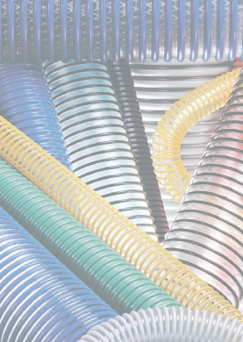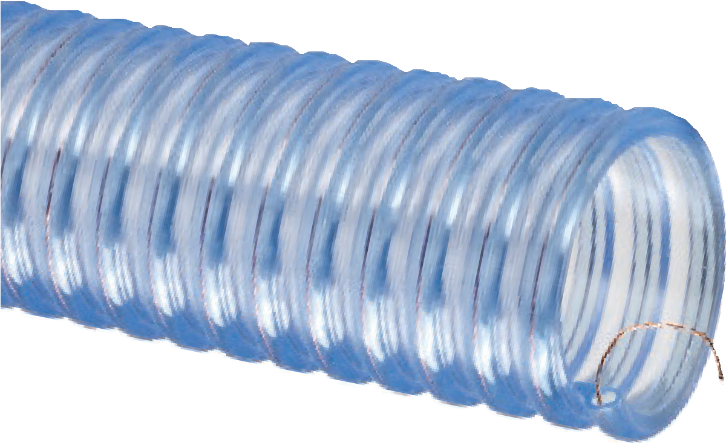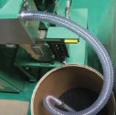
WE™ Series
Food Grade PVC Material Handling Hose With Grounding Wire
General Applications:
- Food grade material handling – standard duty
- Material handling – standard duty
- Pharmaceutical product transfer
- Plastic processing equipment
- Pneumatic conveying equipment
Construction: PVC tube with rigid PVC helix and grounding wire.
Service Temperature: -4°F (-20°C) to 150°F (+65°C)*
Features and Advantages:
Nominal Specifications
Series | ID  (in.) | ID  (mm) | OD  (in.) | OD  (mm) | Working Pressure (psi) |  | Vacuum Rating (in. Hg) |  | Min. Bending Radius  (in. @ 68°F) | Standard Length (ft.) | Weight (lbs/ft.)
 |  |  |  |  | 68°F | 104°F | 68°F | 104°F
WE100 | 1 | 25.4 | 1.30 | 33.0 | 55 | 30 | 28 | 28 | 2 | 100/50 | 0.21
WE125 | 1-1/4 | 32.0 | 1.65 | 42.0 | 50 | 25 | 28 | 28 | 2 | 100/60/50 | 0.33
WE150 | 1-1/2 | 38.1 | 1.93 | 49.0 | 50 | 25 | 28 | 28 | 3 | 100/60/50 | 0.43
WE200 | 2 | 50.8 | 2.48 | 63.0 | 40 | 20 | 28 | 24 | 4 | 100/60/50 | 0.58
WE225 | 2-1/4 | 57.2 | 2.80 | 71.0 | 40 | 20 | 28 | 24 | 4.5 | 100/60/50 | 0.65
WE250 | 2-1/2 | 63.5 | 3.07 | 76.5 | 40 | 20 | 28 | 24 | 5 | 100/60/50 | 0.89
WE300 | 3 | 76.2 | 3.64 | 91.5 | 40 | 20 | 28 | 24 | 6 | 100/60/50 | 1.25
WE350 | 3-1/2 | 88.9 | 4.27 | 108.5 | 35 | 18 | 28 | 24 | 8 | 100/60/50 | 1.55
WE400 | 4 | 101.6 | 4.72 | 120.0 | 35 | 18 | 24 | 20 | 10 | 100/60/50 | 1.93
WE500 | 5 | 127.0 | 5.74 | 146.0 | 30 | 15 | 24 | 20 | 16 | 60/50/20 | 2.40
WE600 | 6 | 152.4 | 6.81 | 175.5 | 30 | 15 | 24 | 20 | 18 | 60/50/20 | 3.70
WE800 | 8 | 204.8 | 9.06 | 230.0 | 20 | 10 | 20 | 18 | 36 | 20 | 5.62
WE45M | 1.77 | 45.0 | 2.20 | 55.8 | 45 | 25 | 28 | 24 | 4 | 60 | 0.46
WE57M | 2.24 | 57.0 | 2.76 | 70.0 | 40 | 20 | 28 | 24 | 4.5 | 60 | 0.64
WE60M | 2.36 | 60.0 | 2.80 | 71.1 | 40 | 20 | 28 | 24 | 4.5 | 100/50 | 0.71
NOTE: Service life may vary depending on operating conditions and type of material being conveyed.
NOTE: For details of the following compliances, refer to footnotes listed on page 62.
*Actual service temperature range is application dependent.
CAUTION: This product is designed to dissipate static electricity when the embedded grounding wire is physically extracted and securely connected to ground, through the fitting or by other means.
BSE/TSE(02), FDA(03), Phthalate Free(09), RoHS(10), USDA(11)

2001™ Series
Heavy Duty Food Grade Polyurethane Lined Material Handling Hose With Grounding Wire

General Applications:

Food grade material handling
– heavy duty abrasive
  - Material handling – heavy duty abrasive
  - Pharmaceutical product transfer
  - Plastic processing equipment
  - Pneumatic conveying equipment
Construction: PVC cover with polyurethane liner, rigid PVC helix and grounding wire.
Service Temperature: -4°F (-20°C) to 150°F (+65°C)*

Features and Advantages:
  - Extra Thick Abrasion Resistant Polyurethane Liner – Designed for dry applications where severe abrasion is a factor. Provides for longer hose life and lower operating costs versus rubber or PVC hoses.
  - Food Grade Materials – Hose cover complies with applicable FDA(03) requirements. Hose liner complies with applicable FDA(04) requirements. Hose approved by USDA(12) for use in meat and poultry plants.
- Phthalate Free

- Grounding Wire – Multi-strand wire helps prevent the build-up of static electricity for added safety and to help keep material flowing smoothly. It’s embedded within the rigid helix to prevent contamination of transferred materials.
- Transparent Construction – “See-the-flow.” Allows for visual confirmation of material flow.
- Convoluted Outer Cover – Provides increased hose flexibility.
- Oil Resistant Polyurethane Liner – Resists most animal and petroleum based oils.

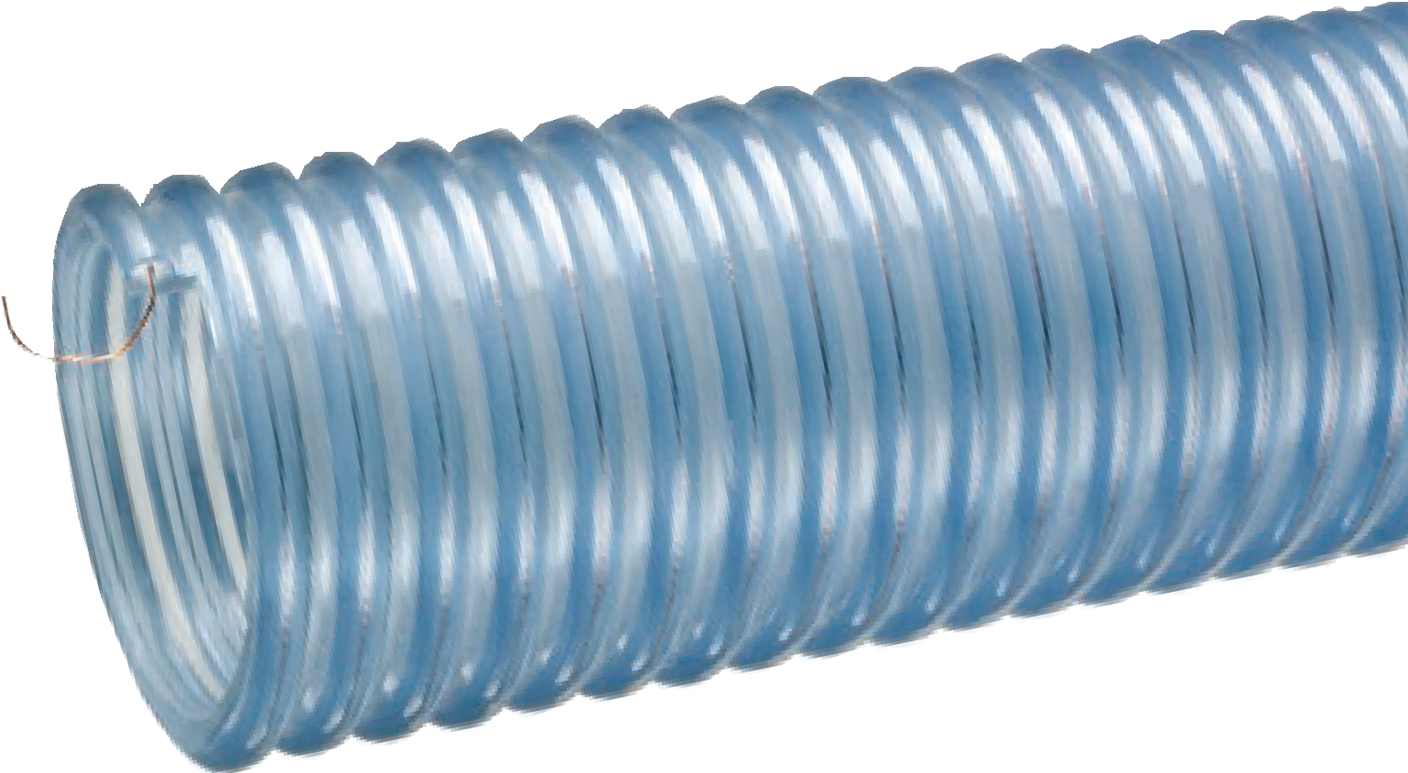
Nominal Specifications
Series | ID  (in.) | ID  (mm) | OD  (in.) | OD  (mm) | Working Pressure (psi) |  | Vacuum Rating (in. Hg) |  | Min. Bending Radius  (in. @ 68°F) | Standard Length (ft.) | Weight (lbs/ft.)
 |  |  |  |  | 68°F | 104°F | 68°F | 104°F
2001–150 | 1-1/2 | 38.1 | 1.88 | 47.8 | 50 | 25 | Full | 28 | 6 | 60 | 0.48
2001–200 | 2 | 50.8 | 2.44 | 62.0 | 40 | 20 | Full | 28 | 7 | 60 | 0.67
2001–250 | 2-1/2 | 63.5 | 3.12 | 77.2 | 40 | 20 | Full | 28 | 8 | 60 | 0.92
2001–300 | 3 | 76.2 | 3.70 | 94.1 | 40 | 20 | Full | 28 | 9 | 60 | 1.35
2001–400 | 4 | 101.6 | 4.80 | 122.0 | 35 | 18 | Full | 28 | 15 | 60/20 | 2.17
2001–500 | 5 | 127.0 | 5.81 | 147.6 | 35 | 18 | 28 | 25 | 23 | 60/20 | 2.77
2001–600 | 6 | 152.4 | 6.93 | 176.0 | 30 | 15 | 28 | 25 | 26 | 60/20 | 3.90
2001–700 | 7 | 178.8 | 8.08 | 205.2 | 30 | 15 | 28 | 25 | 30 | 60/20 | 5.20
2001–800 | 8 | 203.2 | 9.28 | 235.8 | 30 | 15 | 28 | 25 | 36 | 20 | 6.65
NOTE: Service life may vary depending on operating conditions and type of material being conveyed.
NOTE: For details of the following compliances, refer to footnotes listed on page 62.
*Actual service temperature range is application dependent.
CAUTION: This product is designed to dissipate static electricity when the embedded grounding wire is physically extracted and securely connected to ground, through the fitting or by other means.

Features and Advantages:
  - Superior Static Protection! – A properly grounded Voltbuster™ hose will not retain an electrostatic charge sufficient to create a propagating brush discharge. Hose material, using the embedded grounding wire, shows a charge decay time constant of < 1 second, based on independent lab testing.
  - Food Grade Materials – Hose tube complies with FDA(05) requirements. Grounding wire embedded in external helix to prevent material contamination.
  - Extra Thick Abrasion Resistant Single-Ply Polyurethane Tube – Provides for longer hose life and lower operating costs versus rubber or PVC hoses.
(+65°C)*

- Transparent Construction – “See-the-flow”. Allows for visual confirmation of material flow.
- “Cold-Flex” Materials – Hose remains flexible in sub-zero temperatures.
- Easy Slide Helix – Rigid helix design protects hose tube from wear; allows hose to slide easily over rough surfaces. Easy to handle.
• Oil Resistant Polyurethane Tube – Resists most animal and petroleum based oils.
- Phthalate Free

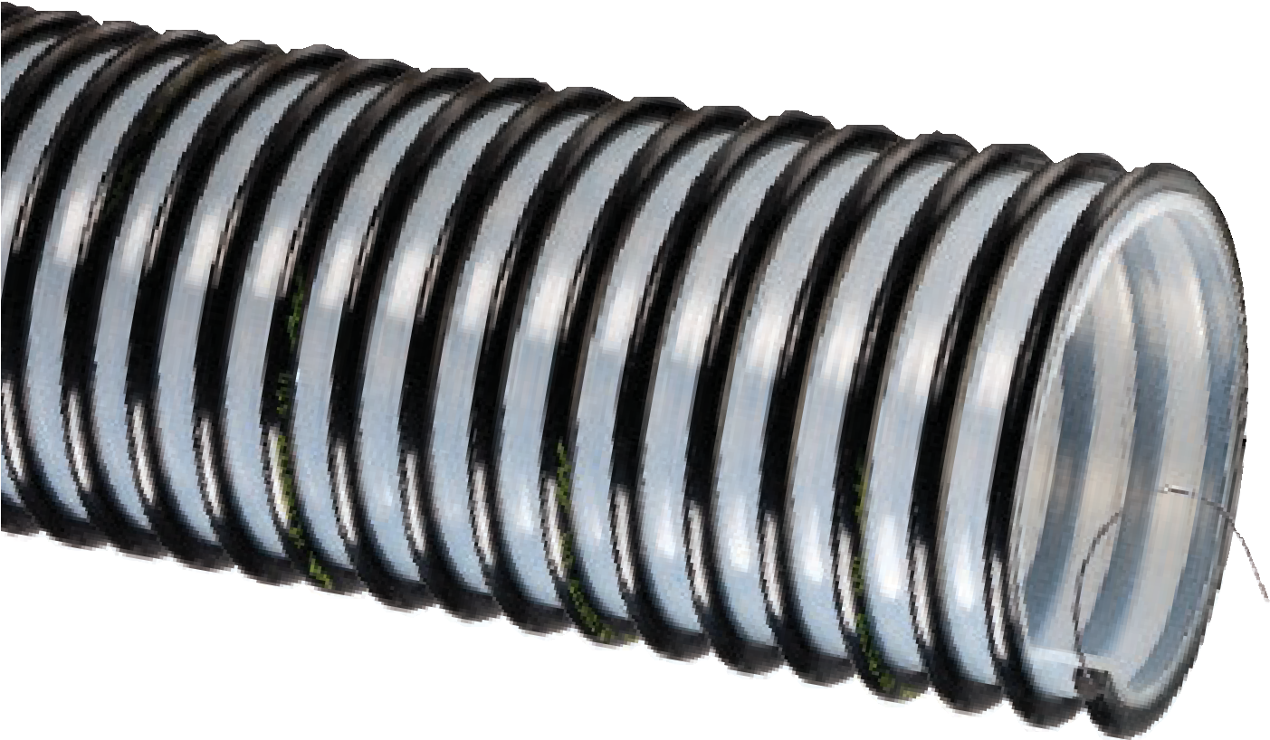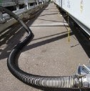

VOLT™ Series
Heavy Duty Food Grade Static Dissipative Polyurethane
Material Handling Hose
General Applications:
- Bulk truck and railcar unloading
- Fly ash collection
- Food grade material handling – heavy duty abrasive
- Material handling – heavy duty abrasive
- Milling machine scrap recovery
- Pharmaceutical product transfer
- Plastic processing equipment
- Pneumatic conveying equipment
Construction: Static dissipative polyurethane tube, rigid helix and grounding wire (patent pending).
Service Temperature: -40°F (-40°C) to 150°F
Nominal Specifications
Series | ID  (in.) | ID  (mm) | OD  (in.) | OD  (mm) | Working Pressure (psi) |  | Vacuum Rating (in. Hg) |  | Min. Bending Radius  (in. @ 68°F) | Standard Length (ft.) | Weight (lbs/ft.)
 |  |  |  |  | 68°F | 104°F | 68°F | 104°F
VOLT150 | 1-1/2 | 38.35 | 1.87 | 47.5 | 40 | 20 | Full | 28 | 2 | 100/60 | 0.31
VOLT200 | 2 | 51.1 | 2.52 | 63.9 | 40 | 20 | Full | 28 | 6 | 100/60 | 0.61
VOLT250 | 2-1/2 | 63.75 | 2.96 | 75.2 | 40 | 20 | Full | 28 | 7 | 100/50 | 0.76
VOLT300 | 3 | 76.2 | 3.60 | 91.4 | 40 | 20 | Full | 28 | 9 | 100/60 | 0.91
VOLT400 | 4 | 101.6 | 4.69 | 121.0 | 35 | 17 | 28 | 25 | 12 | 100/60/20 | 1.70
VOLT500 | 5 | 127.0 | 5.75 | 146.8 | 35 | 17 | 28 | 25 | 14 | 60/20 | 2.13
VOLT600 | 6 | 153.4 | 6.81 | 173.2 | 30 | 15 | 25 | 20 | 16 | 60/20 | 2.53
VOLT800 | 8 | 203.5 | 8.76 | 223.3 | 30 | 15 | 25 | 20 | 18 | 20 | 3.30
NOTE: Service life may vary depending on operating conditions and type of material being conveyed.
NOTE: For details of the following compliances, refer to footnotes listed on page 62.
*Actual service temperature range is application dependent.
CAUTION: This product is designed to dissipate static electricity when the embedded grounding wire is physically extracted and securely connected to ground, through the fitting or by other means.
BSE/TSE(02), FDA(05), Phthalate Free(09),RoHS(10)
BBeeccaauussee wwee ccoonnttiinnuuaallllyy eexxaammiinnee wwaayyss ttoo iimmpprroovvee oouurr pprroodduuccttss,, wwee rreesseerrvvee tthhee rriigghhtt ttoo aalltteerr ssppeecciifificcaattiioonnss oorr ddiissccoonnttiinnuuee pprroodduuccttss wwiitthhoouutt pprriioorr nnoottiiccee..

Features and Advantages:
  - Extra Thick Abrasion Resistant Double-Ply Polyurethane Tube – Designed for dry applications where severe abrasion is a factor. Provides for longer hose life and lower operating costs versus rubber or PVC hoses.
  - Food Grade Materials – Hose liner complies with applicable FDA(04) requirements. Hose approved by USDA(12) for use in meat and poultry plants.
  - Fabric Reinforcement – Designed with high tensile strength, food grade(05), polyester yarn jacket to handle both suction, and higher pressure discharge applications.
  - Grounding Wire – Multi-strand wire helps prevent the build-up of static electricity for added safety and to help keep material flowing smoothly. It’s embedded within the rigid helix to prevent contamination of transferred materials.

- Transparent Construction – “See-the-flow.” Allows for visual confirmation of material flow.
- “Cold-Flex” Materials – Hose remains flexible in sub-zero temperatures.
- Easy Slide Helix – Rigid helix design protects hose tube from cover wear, and allows hose to slide easily over rough surfaces. Easy-to- handle.
- Oil Resistant Polyurethane Tube – Resists most animal and petroleum based oils.
- Phthalate Free

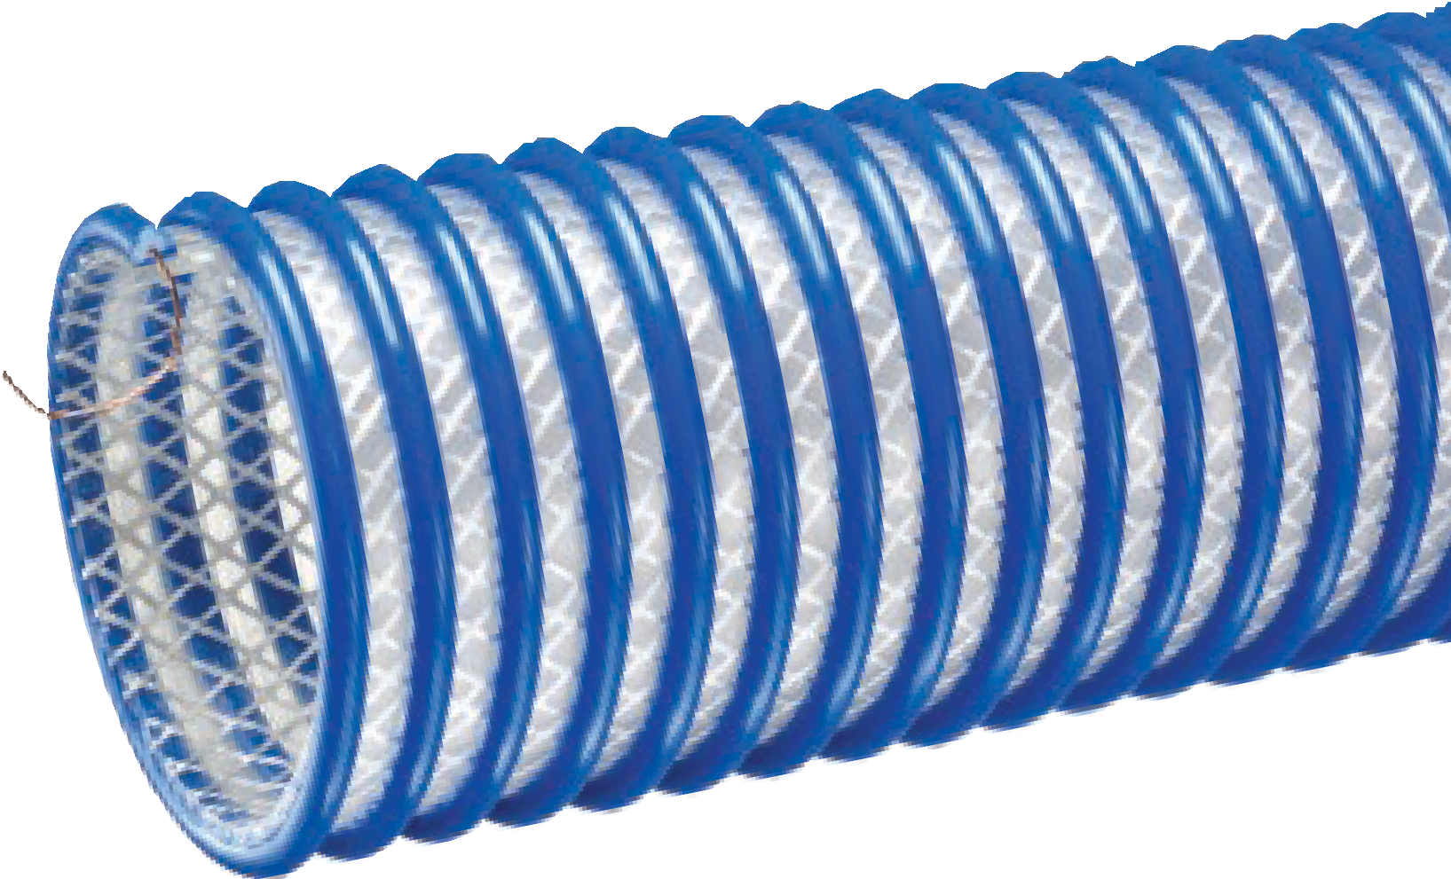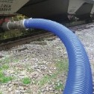

2020™ Series
Heavy Duty Food Grade Polyurethane Fabric Reinforced Material Handling Hose With Grounding Wire
General Applications:
- Bulk truck and railcar unloading
- Food grade material handling – heavy duty abrasive
- Material handling – heavy duty abrasive
- Suction and discharge
Construction: Extra thick double-ply polyurethane tube, polyester fabric reinforcement, rigid PVC helix and grounding wire.
Service Temperature: -40°F (-40°C) to 150°F (+65°C)*
Nominal Specifications
Series | ID  (in.) | ID  (mm) | OD  (in.) | OD  (mm) | Working Pressure (psi) |  | Vacuum Rating (in. Hg) |  | Min. Bending Radius  (in. @ 68°F) | Standard Length (ft.) | Weight (lbs/ft.)
 |  |  |  |  | 68°F | 104°F | 68°F | 104°F
2020-200 | 2 | 50.1 | 2.65 | 67.5 | 75 | 40 | Full | 28 | 9 | 100 | 0.94
2020-300 | 3 | 76.2 | 3.78 | 96.0 | 70 | 35 | Full | 28 | 10 | 100/50/20 | 1.20
2020-400 | 4 | 101.6 | 4.84 | 123.0 | 65 | 30 | Full | 28 | 12 | 100/50/20 | 1.60
2020-500 | 5 | 127.0 | 5.79 | 147.0 | 45 | 22 | 28 | 25 | 14 | 50/25/20 | 2.45
2020-600 | 6 | 152.4 | 6.93 | 176.0 | 40 | 22 | 28 | 25 | 16 | 50/25/20 | 2.86
2020-800 | 8 | 206.0 | 9.21 | 234.0 | 30 | 15 | 24 | 20 | 22 | 50/20 | 4.69
NOTE: Service life may vary depending on operating conditions and type of material being conveyed.
NOTE: For details of the following compliances, refer to footnotes listed on page 62.
*Actual service temperature range is application dependent.
CAUTION: This product is designed to dissipate static electricity when the embedded grounding wire is physically extracted and securely connected to ground, through the fitting or by other means.

VLT-SD™ Series

Heavy Duty Food Grade Static Dissipative Polyurethane
Fabric Reinforced Material Handling Hose

Features and Advantages:
  - Superior Static Protection! – A properly grounded Voltbuster™ hose will not retain an electrostatic charge sufficient to create a propagating brush discharge. Hose material, using the embedded grounding wire, shows a charge decay time constant of < 1 second, based on independent lab testing.
  - Food Grade Materials – Hose tube complies with FDA(05) requirements. Grounding wire embedded in external helix to prevent material contamination.
  - Extra Thick Abrasion Resistant Double-Ply Polyurethane Tube – Provides for longer hose life and lower operating costs versus rubber or PVC hoses.
- Phthalate Free
General Applications:
- Bulk truck and railcar unloading
- Food grade material handling – heavy duty abrasive
- Material handling – heavy duty abrasive
- Milling machine scrap recovery
- Plastic processing equipment
- Pneumatic conveying equipment
- Suction and discharge
Construction: Static dissipative polyurethane tube, polyester fabric reinforcement, rigid helix and grounding wire (patent pending).
Service Temperature: -40°F (-40°C) to 150°F (+65°C)*

- Fabric Reinforcement – Designed with high tensile strength, food grade FDA(06), polyester yarn jacket to handle both suction, and higher pressure discharge applications.
- Transparent Construction – “See-the-flow”. Allows for visual conformation of material flow.
- “Cold-Flex” Materials – Hose remains flexible in sub-zero temperatures.
- Easy Slide Helix – Rigid helix design protects hose
from wear; allows hose to slide easily over rough surfaces. Easy to handle.
- Oil Resistant Polyurethane Tube – Resists most animal and petroleum based oils.

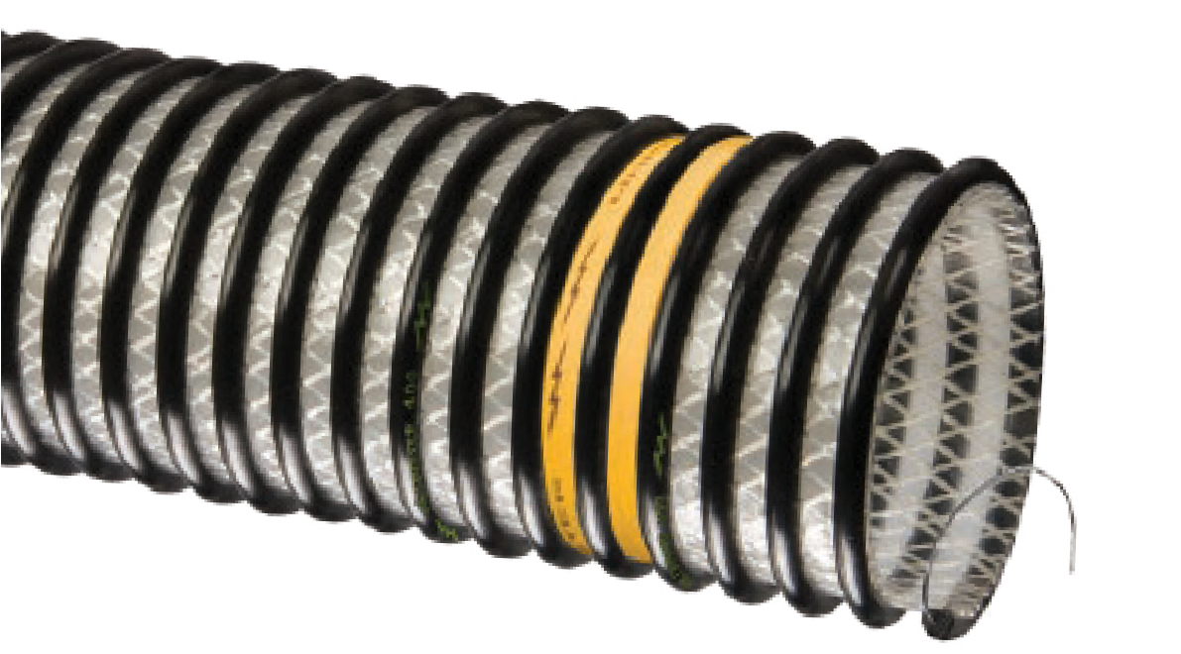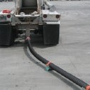
Nominal Specifications
Series | ID  (in.) | ID  (mm) | OD  (in.) | OD  (mm) | Working Pressure (psi) |  | Vacuum Rating (in. Hg) |  | Min. Bending Radius  (in. @ 68°F) | Standard Length (ft.) | Weight (lbs/ft.)
 |  |  |  |  | 68°F | 104°F | 68°F | 104°F
VLT-SD200 | 2 | 51.1 | 2.67 | 67.0 | 75 | 40 | Full | 28 | 9 | 100/50 | 0.77
VLT-SD300 | 3 | 77.0 | 3.78 | 96.0 | 70 | 35 | Full | 28 | 12 | 100/20 | 1.22
VLT-SD400 | 4 | 102.2 | 4.84 | 123.0 | 65 | 30 | Full | 28 | 13 | 100/60/20 | 1.85
VLT-SD500 | 5 | 128.0 | 5.79 | 152.0 | 45 | 22 | 28 | 25 | 14 | 60/20 | 2.43
VLT-SD600 | 6 | 153.4 | 6.93 | 177.4 | 40 | 22 | 28 | 25 | 17 | 60/20 | 3.05
VLT-SD800 | 8 | 206.0 | 9.25 | 235.0 | 35 | 25 | 26 | 20 | 23 | 20 | 4.70
NOTE: Service life may vary depending on operating conditions and type of material being conveyed.
NOTE: For details of the following compliances, refer to footnotes listed on page 62.
*Actual service temperature range is application dependent.
CAUTION: This product is designed to dissipate static electricity when the embedded grounding wire is physically extracted and securely connected to ground, through the fitting or by other means.

BSE/TSE(02), FDA(05), FDA(06), Phthalate Free(09), RoHS(10)

WBS™ Series

Food Grade PVC Material Handling Hose

With Static Dissipative Additives

General Applications:

Food grade material handling – standard duty
  - Material handling – standard duty
  - Pharmaceutical product transfer
  - Plastic processing equipment
  - Pneumatic conveying equipment
Construction: Static dissipative PVC tube with rigid PVC helix.
Service Temperature: -4°F (-20°C) to 150°F (+65°C)*

Features and Advantages:
  - Abrasion Resistant PVC Tube – Formulated from highly durable PVC compounds for increased abrasion resistance.
  - Food Grade Materials – Hose complies with applicable FDA(03) requirements. Hose approved by USDA(11) for use in meat and poultry plants.
  - Static Dissipative Tube – Specially formulated to help
prevent the build-up of static electricity for added safety and to help keep material flowing smoothly.

- Transparent Construction – “See-the-flow.” Allows for visual confirmation of material flow.
- Convoluted Outer Cover – Provides increased hose flexibility.
- Phthalate Free

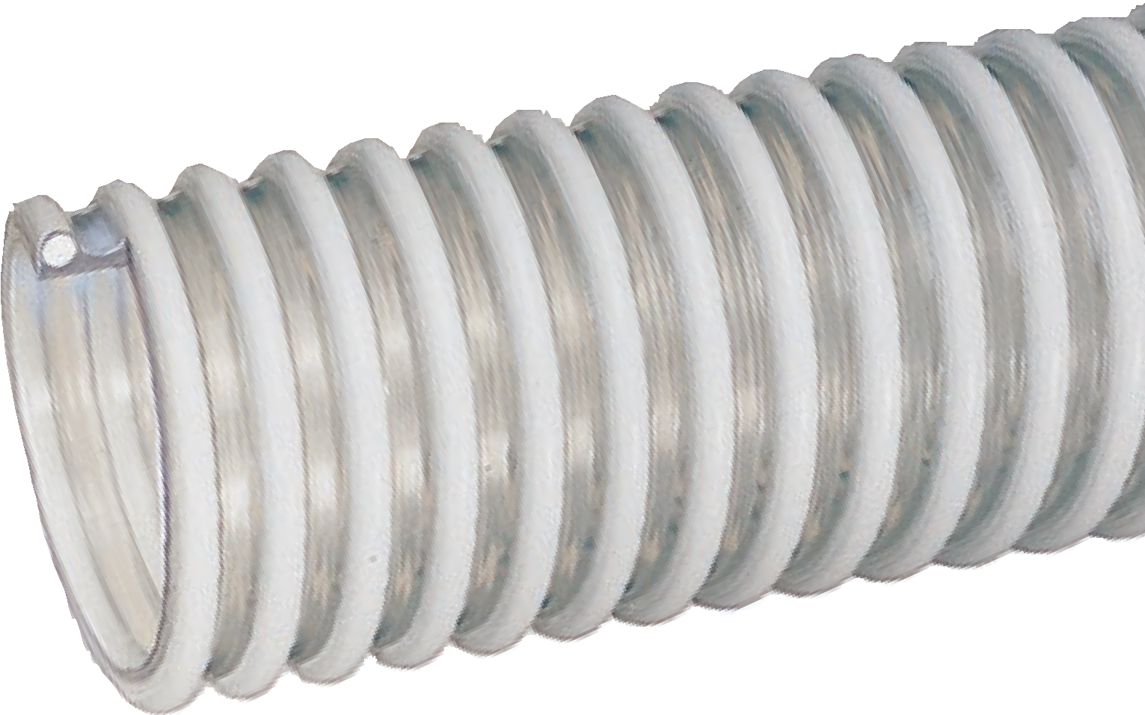

Nominal Specifications
Series | ID  (in.) | ID  (mm) | OD  (in.) | OD  (mm) | Working Pressure (psi) |  | Vacuum Rating (in. Hg) |  | Min. Bending Radius  (in. @ 68°F) | Standard Length (ft.) | Weight (lbs/ft.)
 |  |  |  |  | 68°F | 104°F | 68°F | 104°F
WBS150 | 1-1/2 | 38.1 | 1.92 | 48.8 | 50 | 25 | 28 | 28 | 3 | 100 | 0.35
WBS200 | 2 | 50.8 | 2.40 | 61.0 | 40 | 20 | 28 | 24 | 4 | 100 | 0.56
WBS250 | 2-1/2 | 63.5 | 2.99 | 75.9 | 40 | 20 | 28 | 24 | 5 | 100 | 0.77
WBS300 | 3 | 76.2 | 3.64 | 92.5 | 40 | 20 | 28 | 24 | 6 | 100 | 1.10
WBS400 | 4 | 101.6 | 4.76 | 121.0 | 35 | 20 | 24 | 20 | 10 | 100/50 | 1.92
NOTE: Service life may vary depending on operating conditions and type of material being conveyed.
NOTE: The effectiveness of static dissipation is application-dependent, based upon humidity, material conveyed, and length of hose.
NOTE: For details of the following compliances, refer to footnotes listed on page 62.
*Actual service temperature range is application dependent.

BSE/TSE(02), FDA(03), Phthalate Free(09), RoHS(10), USDA(11)

Features and Advantages:
  - Food Grade Materials – Hose complies with applicable FDA(03) and 3-A(01) requirements. Hose approved by USDA(12) for use in meat and poultry plants.
  - Fabric Reinforcement – Designed with high tensile strength, food grade, FDA(06) polyester yarn jacket to handle both suction, and higher pressure discharge applications.
Service Temperature: -4°F (-20°C) to 150°F (+65°C)*

- Transparent Construction – “See-the-flow.” Allows for visual confirmation of material flow.
- Easy Slide Helix – Rigid helix design protects hose tube from cover wear, and allows hose to slide easily over rough surfaces. Easy-to-handle.
- Phthalate Free

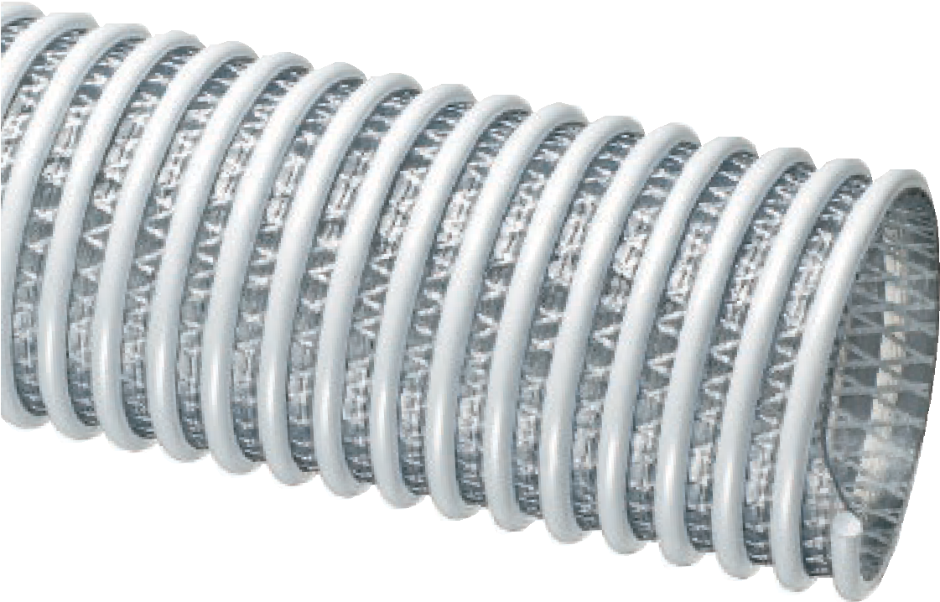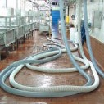
WSTF™ Series
Food Grade PVC Fabric Reinforced
Suction & Discharge Hose
eneral Applications:
- Food grade liquids such as potable water, beer, wine and juice
- Food grade material handling – standard duty
- Ice transfer
- Suction and discharge
- Water suction – heavy duty
Construction: Double-ply PVC tube, polyester fabric reinforcement and rigid PVC helix.
G

Nominal Specifications
Series | ID  (in.) | ID  (mm) | OD  (in.) | OD  (mm) | Working Pressure (psi) |  | Vacuum Rating (in. Hg) |  | Min. Bending Radius  (in. @ 68°F) | Standard Length (ft.) | Weight (lbs/ft.)
 |  |  |  |  | 68°F | 104°F | 68°F | 104°F
WSTF150 | 1-1/2 | 38.1 | 1.95 | 49.5 | 110 | 70 | Full | 28 | 2.5 | 100 | 0.42
WSTF200 | 2 | 50.8 | 2.60 | 66.0 | 100 | 65 | Full | 28 | 4 | 100 | 0.74
WSTF300 | 3 | 76.2 | 3.62 | 92.0 | 100 | 50 | Full | 28 | 6 | 100/20 | 1.13
WSTF400 | 4 | 101.6 | 4.76 | 121.0 | 75 | 37 | Full | 28 | 8 | 100/20 | 1.74
WSTF600 | 6 | 152.4 | 7.17 | 182.1 | 70 | 35 | 28 | 25 | 13 | 100/20 | 3.88
NOTE: Service life may vary depending on operating conditions and type of material being conveyed.
NOTE: For details of the following compliances, refer to footnotes listed on page 62.
*Actual service temperature range is application dependent.

3A(01), BSE/TSE(02), FDA(03), FDA(06), Phthalate Free(09), RoHS(10), USDA(11)

MILK™ Series

Food Grade
PVC Liquid Suction Hose
MILK-LT™ Series
Low Temperature Food Grade
PVC Liquid Suction Hose

General Applications:

MILK

MILK-LT
(low temp)

  - Food grade liquids such as potable water, beer, wine and juice
  - Ice transfer
  - Milk and dairy product transfer
  - Water suction – standard duty

Construction: PVC tube with rigid PVC helix. Service Temperature (MILK): -4°F (-20°C) to 150°F (+65°C)*
Service Temperature (MILK-LT): -40°F (-40°C) to 150°F (+65°C)*

Features and Advantages:
  - Precision Controlled ID and OD Dimensions – Facilitates insertion of sanitary fittings.
  - Food Grade Materials – Hose complies with applicable FDA(03) and 3-A(01) requirements. Hose approved by USDA(11) for use in meat and poultry plants.
  - “Cold-Flex” Materials (MILK-LT only) – Hose remains flexible in severe sub-zero temperatures.

- Transparent Construction – “See-the-flow.” Allows for visual confirmation of material flow.
- Smooth Outer Cover – Provides increased pressure rating and smooth surface for banding.
- Phthalate Free

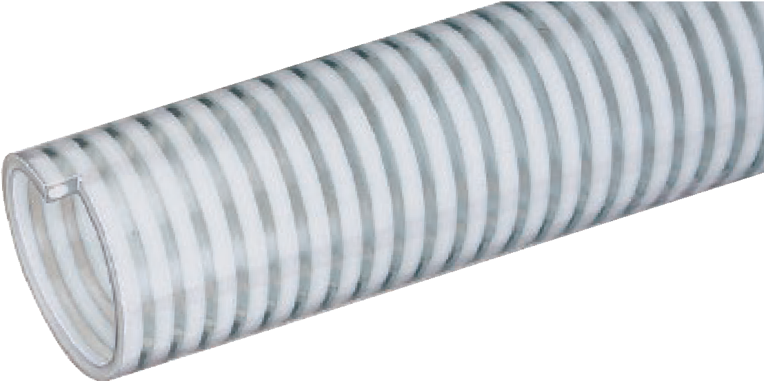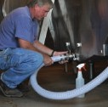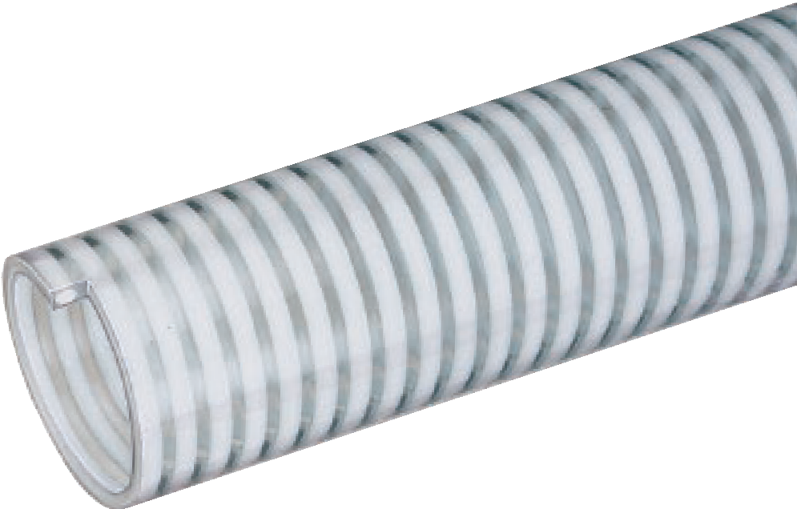

Nominal Specifications
Series | ID  (in.) | ID  (mm) | OD  (in.) | OD  (mm) | Working Pressure (psi) |  | Vacuum Rating (in. Hg) |  | Min. Bending Radius  (in. @ 68°F) | Standard Length (ft.) | Weight (lbs/ft.)
 |  |  |  |  | 68°F | 104°F | 68°F | 104°F
MILK150 | 1-1/2 | 38.1 | 1.79 | 45.5 | 75 | 50 | Full | 26 | 4 | 100 | 0.45
MILK200 | 2 | 50.8 | 2.33 | 59.2 | 75 | 50 | 28 | 25 | 6 | 100 | 0.63
MILK250 | 2-1/2 | 63.5 | 2.87 | 73.0 | 55 | 40 | 28 | 24 | 10 | 100 | 0.81
MILK300 | 3 | 76.2 | 3.42 | 86.9 | 55 | 40 | 28 | 24 | 11 | 100 | 1.18
MILK-LT150 | 1-1/2 | 38.1 | 1.79 | 45.5 | 75 | 50 | Full | 26 | 4 | 100 | 0.45
MILK-LT200 | 2 | 50.8 | 2.33 | 59.2 | 75 | 50 | 28 | 25 | 5 | 100 | 0.65
MILK-LT250 | 2-1/2 | 63.5 | 2.87 | 73.0 | 55 | 40 | 28 | 24 | 8 | 100 | 0.84
MILK-LT300 | 3 | 76.2 | 3.42 | 86.9 | 55 | 40 | 28 | 24 | 11 | 100 | 1.20
NOTE: Service life may vary depending on operating conditions and type of material being conveyed.
NOTE: For details of the following compliances, refer to footnotes listed on page 62.
*Actual service temperature range is application dependent.

Features and Advantages:
  - Food Grade Materials – Hose complies with applicable FDA(03) and 3-A(01) requirements. Hose approved by USDA(11) for use in meat and poultry plants.
  - Transparent Construction – “See-the-flow.” Allows for visual confirmation of material flow.

- Smooth Outer Cover – Provides increased pressure rating and smooth surface for banding.
- Phthalate Free

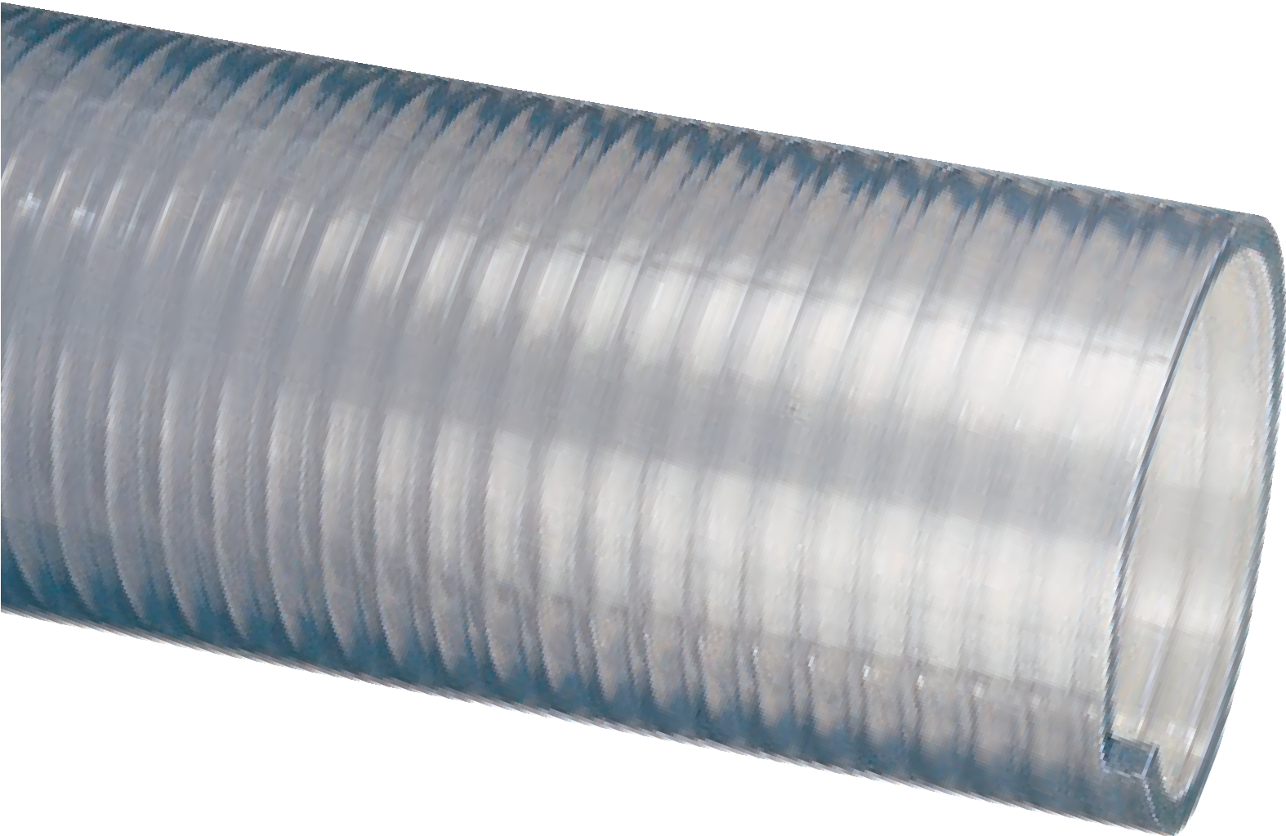

FT™ Series
Heavy Duty Food Grade PVC Suction Hose
General Applications:
- Food grade liquids such as potable water, beer, wine and juice
- Food grade material handling – standard duty
- Ice transfer
- Milk and dairy product transfer
- Poultry processing
- Water suction – heavy duty
Construction: PVC tube with rigid PVC helix. Service Temperature: -4°F (-20°C) to 150°F (+65°C)*

Nominal Specifications
Series | ID  (in.) | ID  (mm) | OD  (in.) | OD  (mm) | Working Pressure (psi) |  | Vacuum Rating (in. Hg) |  | Min. Bending Radius  (in. @ 68°F) | Standard Length (ft.) | Weight (lbs/ft.)
 |  |  |  |  | 68°F | 104°F | 68°F | 104°F
FT075 | 3/4 | 19.0 | 0.94 | 24.0 | 115 | 75 | Full | 28 | 3 | 100 | 0.17
FT100 | 1 | 25.5 | 1.28 | 32.5 | 100 | 70 | Full | 28 | 3 | 100 | 0.24
FT125 | 1-1/4 | 32.0 | 1.56 | 39.6 | 90 | 65 | Full | 28 | 4 | 100 | 0.44
FT150 | 1-1/2 | 38.1 | 1.80 | 46.5 | 85 | 60 | Full | 28 | 6 | 100 | 0.50
FT200 | 2 | 50.8 | 2.36 | 60.0 | 85 | 60 | Full | 26 | 8 | 100 | 0.71
FT250 | 2-1/2 | 63.5 | 2.88 | 73.2 | 65 | 45 | Full | 26 | 10 | 100 | 0.94
FT300 | 3 | 76.2 | 3.42 | 86.9 | 55 | 40 | Full | 24 | 11 | 100 | 1.14
FT400 | 4 | 101.6 | 4.51 | 114.6 | 50 | 35 | Full | 24 | 18 | 100/60 | 1.91
FT500 | 5 | 127.0 | 5.51 | 140.0 | 40 | 25 | 28 | 23 | 28 | 100/20 | 2.41
FT600 | 6 | 153.4 | 6.59 | 167.4 | 30 | 20 | 28 | 15 | 48 | 20 | 3.28
FT800 | 8 | 204.7 | 8.85 | 224.7 | 25 | 15 | 28 | 10 | 60 | 20 | 5.67
NOTE: Service life may vary depending on operating conditions and type of material being conveyed.
NOTE: For details of the following compliances, refer to footnotes listed on page 62.
*Actual service temperature range is application dependent.
3A(01), BSE/TSE(02), FDA(03), Phthalate Free(09), RoHS(10), USDA(11)

GTF™ Series

Food Grade PVC Ducting/Material Handling Hose
GTFE™ Series
Food Grade PVC Ducting/Material Handling Hose
with Grounding Wire

General Applications:

Ducting, ventilation and fume removal
  - Food grade blower and ducting systems
  - Material handling – light duty
  - Pharmaceutical product transfer

GTF

GTFE
ed e)
(with embedd grounding wir

Construction: PVC tube with rigid PVC helix and grounding wire (GTFE Series).
Service Temperature: -4°F (-20°C) to 150°F (+65°C)*

Features and Advantages:
  - Food Grade Materials – Hose complies with applicable FDA(03) and 3-A(01) requirements. Hose approved by USDA(11) (GTF only) for use in meat and poultry plants.
  - Grounding Wire (GTFE only) – Multi-strand wire helps prevent the build-up of static electricity for added safety and to help keep material flowing smoothly. It’s embedded within the rigid helix to prevent contamination of transferred materials.

- Transparent Construction – “See-the-flow.” Allows for visual confirmation of material flow.
- Easy Slide Helix – Exposed rigid helix design protects hose tube from cover wear, and allows hose to slide easily over rough surfaces. Easy-to-handle.
- Phthalate Free

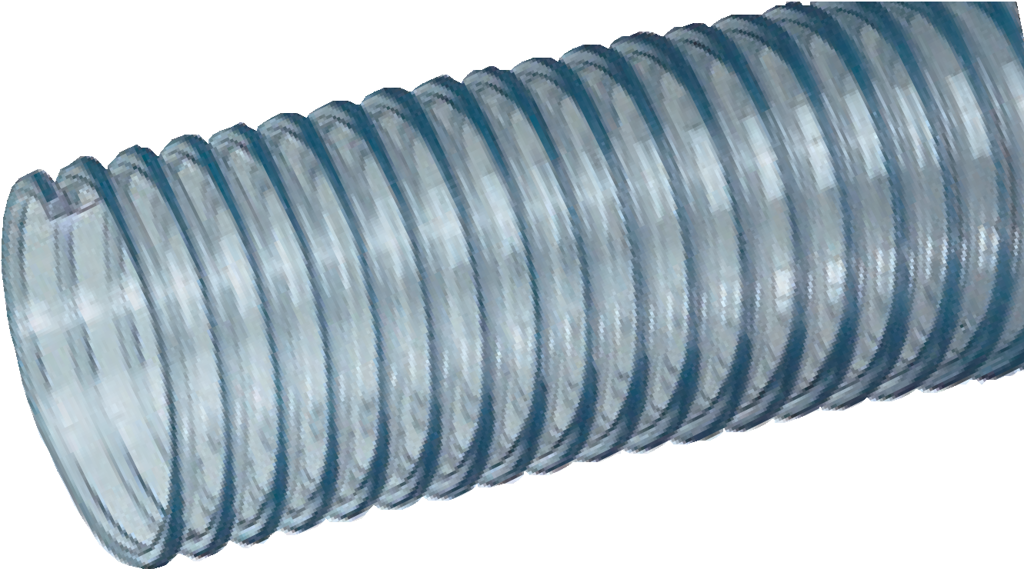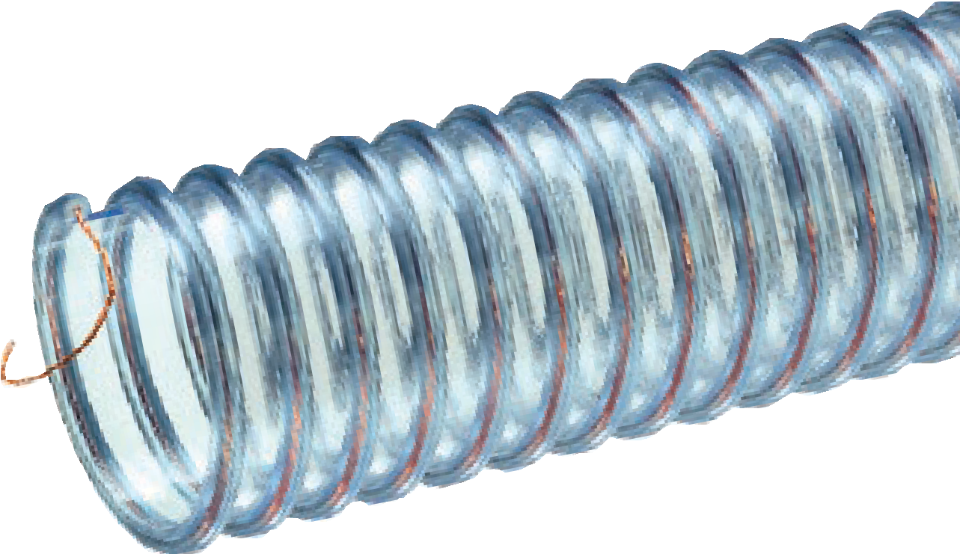

Nominal Specifications
Series | ID  (in.) | ID  (mm) | OD  (in.) | OD  (mm) | Working Pressure (psi) |  | Vacuum Rating (in. Hg) |  | Min. Bending Radius  (in. @ 68°F) | Standard Length (ft.) | Weight (lbs/ft.)
 |  |  |  |  | 68°F | 104°F | 68°F | 104°F
GTF/GTFE150 | 1-1/2 | 38.1 | 1.82 | 46.2 | 20 | 7 | 22 | 14 | 1 | 100 | 0.23
GTF/GTFE200 | 2 | 50.8 | 2.39 | 60.8 | 15 | 6 | 21 | 12 | 2 | 100 | 0.30
GTF/GTFE250 | 2-1/2 | 63.5 | 2.89 | 73.4 | 10 | 5 | 19 | 10 | 2 | 100 | 0.39
GTF/GTFE300 | 3 | 76.2 | 3.46 | 87.9 | 10 | 5 | 18 | 10 | 3 | 100/50 | 0.50
GTF/GTFE400 | 4 | 101.6 | 4.50 | 114.3 | 8 | 4 | 13 | 7 | 3 | 100/50 | 0.77
GTF/GTFE600 | 6 | 152.4 | 6.54 | 166.1 | 6 | 3 | 7 | 5 | 6 | 50 | 1.08
GTF/GTFE800 | 8 | 203.2 | 8.59 | 218.2 | 4 | 2 | 5 | 3 | 8 | 50 | 1.74
NOTE: Service life may vary depending on operating conditions and type of material being conveyed. Not for liquid handling use.
NOTE: For details of the following compliances, refer to footnotes listed on page 62.
*Actual service temperature range is application dependent.
CAUTION: This product is designed to dissipate static electricity when the embedded grounding wire is physically extracted and securely connected to ground, through the fitting or by other means.

UVF™ Series

Food Grade Polyurethane Ducting/ Material Handling Hose

General Applications:

Ducting, ventilation and fume removal
  - Dust collection
  - Food grade blower and ducting systems
  - Food grade material handling – standard duty
  - Pharmaceutical product transfer Construction: Polyurethane tube with rigid PVC helix.
Service Temperature: -40°F (-40°C) to 150°F (+65°C)*

Features and Advantages:
- Durable Lightweight Polyurethane Tube – Designed for dry applications where abrasion is a factor. Provides longer hose life and lower operating costs versus rubber or PVC hoses.
- Food Grade Materials – Hose complies with applicable FDA(04) requirements. Hose approved by USDA(12) for use in meat and poultry plants.
- Transparent Construction – “See-the-flow”. Allows for visual confirmation of material flow.

- “Cold-Flex” Materials – Hose remains flexible in sub-zero temperatures.
- Easy Slide Helix – Exposed rigid helix design protects hose tube from cover wear, and allows hose to slide easily over rough surfaces. Easy-to-handle.
- Oil Resistant Polyurethane Hose – Resists most animal and petroleum based oils.
- Phthalate Free

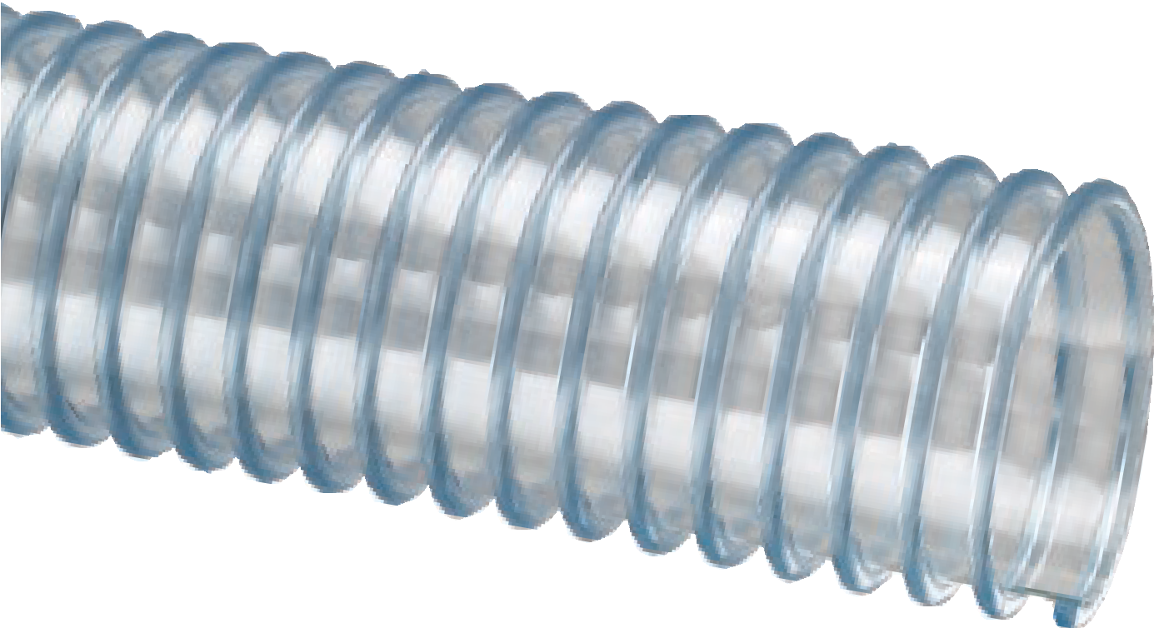

Nominal Specifications
Series | ID  (in.) | ID  (mm) | OD  (in.) | OD  (mm) | Working Pressure (psi) |  | Vacuum Rating (in. Hg) |  | Min. Bending Radius  (in. @ 68°F) | Standard Length (ft.) | Weight (lbs/ft.)
 |  |  |  |  | 68°F | 104°F | 68°F | 104°F
UVF150 | 1-1/2 | 38.1 | 1.82 | 46.2 | 20 | 7 | 22 | 14 | 1 | 50 | 0.23
UVF200 | 2 | 50.8 | 2.39 | 60.7 | 15 | 6 | 21 | 12 | 1.5 | 50 | 0.32
UVF250 | 2-1/2 | 63.5 | 2.89 | 73.4 | 10 | 5 | 19 | 10 | 1.5 | 50 | 0.39
UVF300 | 3 | 76.2 | 3.46 | 87.9 | 10 | 5 | 18 | 10 | 2.5 | 50 | 0.55
UVF400 | 4 | 101.6 | 4.50 | 114.3 | 8 | 4 | 13 | 8 | 3 | 50 | 0.77
UVF500 | 5 | 127.0 | 5.50 | 139.7 | 7 | 3 | 10 | 7 | 4 | 50 | 0.89
UVF600 | 6 | 152.4 | 6.54 | 166.1 | 6 | 3 | 7 | 5 | 5 | 50 | 1.15
UVF800 | 8 | 203.2 | 8.59 | 218.1 | 4 | 2 | 5 | 3 | 7 | 50/20 | 1.75
NOTE: Service life may vary depending on operating conditions and type of material being conveyed.
NOTE: For details of the following compliances, refer to footnotes listed on page 62.
*Actual service temperature range is application dependent.

BSE/TSE(02), FDA(04), Phthalate Free(09), RoHS(10), USDA(11)

Features and Advantages:
  - Superior Rubber Compounds – Tigerflex™ uses specially engineered compounds which provide the ideal combina- tion of excellent abrasion resistance, light weight, flexibility, static dissipation and superior long-lasting durability.
  - Static Dissipative Tube – Specially formulated to help prevent the build-up of static electricity for added safety and to help keep material flowing smoothly.

- “Cold-Flex” Materials – Hose remains flexible in sub-zero temperatures.
- Convoluted Outer Cover – Provides increased hose flexibility.
- Phthalate Free

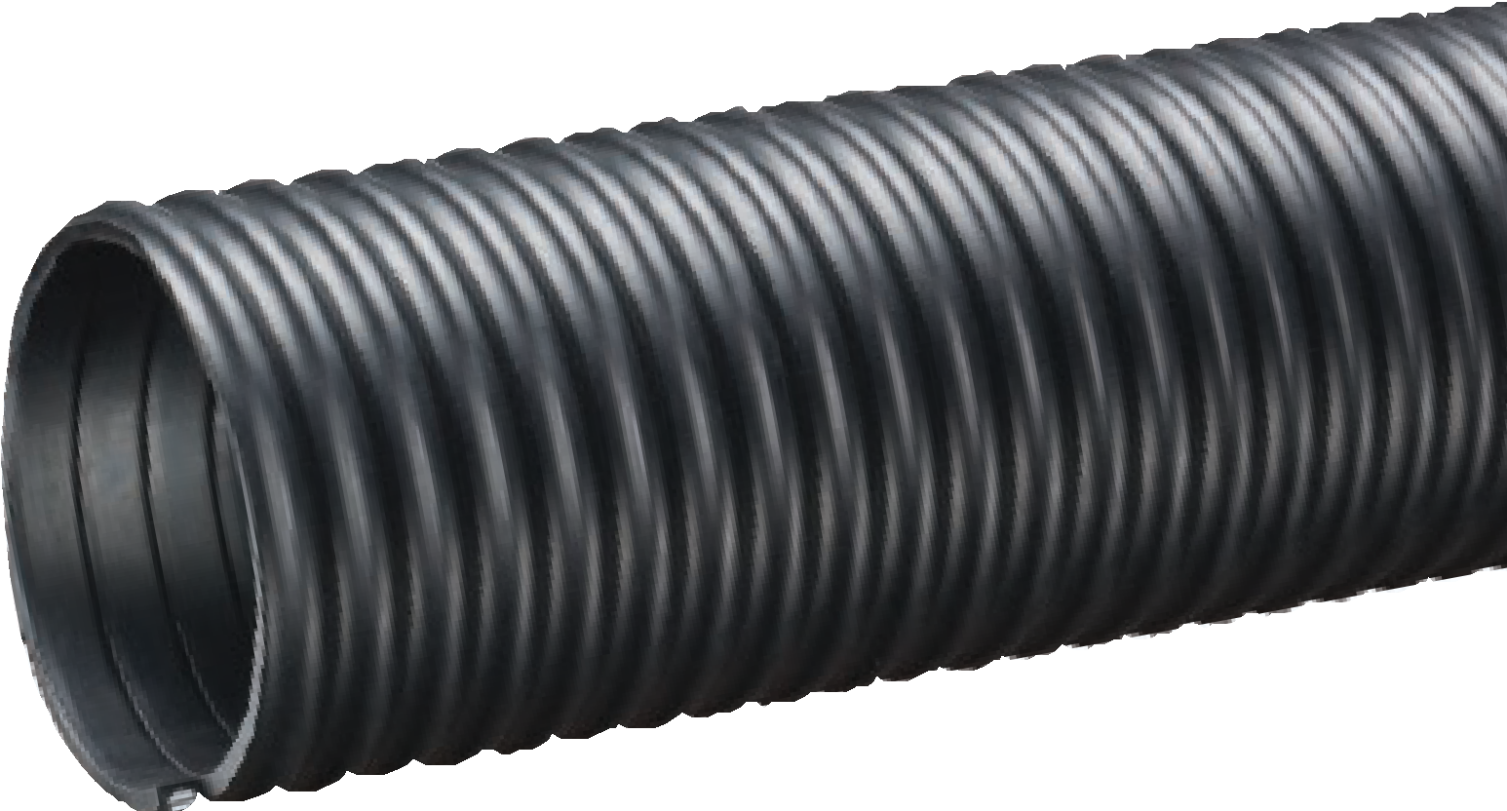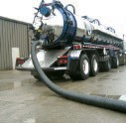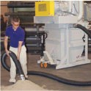

Tiger™ TR1™ Series
Heavy Duty SBR Wet or Dry Material Handling Hose
General Applications:
- Fly ash collection
- Grain Handling
- Hydro excavation
- Industrial vacuum equipment
- Material handling – heavy duty abrasive
- Milling machine scrap recovery
- Rock, gravel, sand and crushed concrete vacuuming
- Sewer truck boom hose
- Shot blast recovery
- Slurry handling
Construction: SBR rubber tube with rigid PVC helix.
Service Temperature: -40°F (-40°C) to 150°F (+65°C)*
Nominal Specifications
Series | ID  (in.) | ID  (mm) | OD  (in.) | OD  (mm) | Working Pressure (psi) |  | Vacuum Rating (in. Hg) |  | Approx. Bending Radius  (in. @ 68°F) | Standard Length (ft.) | Weight (lbs/ft.)
 |  |  |  |  | 68°F | 104°F | 68°F | 104°F
TR1-150 | 1-1/2 | 38.5 | 1.94 | 49.2 | 35 | 26 | Full | 28 | 1.5 | 100 | 0.50
TR1-200 | 2 | 50.8 | 2.38 | 60.5 | 32 | 23 | Full | 26 | 1.5 | 100/50 | 0.70
TR1-250 | 2-1/2 | 63.4 | 3.05 | 77.5 | 30 | 22 | Full | 26 | 2.0 | 100/50 | 0.84
TR1-300 | 3 | 76.2 | 3.56 | 90.5 | 28 | 20 | Full | 26 | 2.5 | 100/50 | 1.00
TR1-400 | 4 | 101.6 | 4.67 | 118.5 | 26 | 18 | Full | 26 | 4.5 | 100/50 | 1.70
TR1-500 | 5 | 126.8 | 5.73 | 145.5 | 21 | 16 | 28 | 24 | 5.0 | 100/50 | 2.38
TR1-600 | 6 | 153.4 | 7.03 | 178.8 | 19 | 13 | 28 | 24 | 9.5 | 100/50/20 | 5.13
TR1-800 | 8 | 204.8 | 9.27 | 255.6 | 19 | 13 | 27 | 23 | 14 | 50/20 | 7.34
NOTE: Service life may vary depending on operating conditions and type of material being conveyed.
*Actual service temperature range is application dependent.
Available with grounding wire upon request. Minimum order required, contact Kuriyama customer service for details.

Service Temperature: -40°F (-40°C) to 220°F (+104°C)*

Features and Advantages:
  - Wire Reinforced Helix – Highly durable steel helical wire provides strength and allows for use at higher temperatures without risk of hose deformation. Wire can be grounded for additional static dissipation.
  - Static Dissipative Tube - Specially formulated to help prevent the build-up of static electricity for added safety and to help keep material flowing smoothly.

- “Cold-Flex” Materials – Hose remains flexible in sub-zero temperatures.
- Convoluted Cover Design – Provides increased hose flexibility.
- Phthalate Free

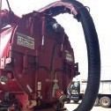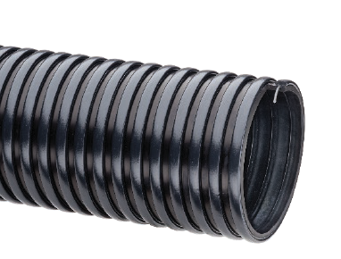
Rated up to 220°F!
Tiger™ “HiTemp” THT™ Series
Wire Reinforced EPDM Wet or Dry Material Handling Hose
General Applications:
- Agricultural liquid fertilizer
- Fly ash collection
- Hydroexcavation
- Industrial vacuum equipment
- Material chutes
- Milling machine scrap recovery
- Rock, gravel, sand and crushed concrete vacuuming
- Sewer truck boom hose
- Slurry handling
Construction: EPDM tube and polyethylene helix with steel helical wire.

Nominal Specifications
Series | ID  (in.) | ID  (mm) | OD  (in.) | OD  (mm) | Working Pressure (psi) |  | Vacuum Rating (in. Hg) |  | Min. Bending Radius  (in. @ 68°F) | Standard Lengths (ft.) | Weight (lbs./ft.)
 |  |  |  |  | 68°F | 104°F | 68°F | 104°F
THT400 | 4 | 101.6 | 4.63 | 117.6 | 29 | 21 | Full | 26 | 5.5 | 100/20 | 1.90
THT600 | 6 | 152.4 | 6.87 | 178.4 | 19 | 14 | 27 | 24 | 10.0 | 100/50/20 | 3.65
THT800 | 8 | 204.8 | 9.06 | 229.8 | 14 | 10 | 27 | 24 | 15.0 | 50/20 | 5.94
NOTE: Service life may vary depending on operating conditions and type of material being conveyed.
*Actual service temperature range is application dependent.
CAUTION: This product is designed to dissipate static electricity when the embedded grounding wire is physically extracted and securely connected to ground, through the fitting or by other means.

Amphibian™ AMPH™ Series

Heavy Duty Polyurethane
Lined Wet or Dry Material Handling Hose

General Applications:

Agricultural dry fertilizers
  - Air seeder lines
  - Fly ash collection
  - Hydro excavation
  - Industrial vacuum equipment
  - Material handling – heavy duty abrasive
  - Milling machine scrap recovery
  - Rock, gravel, sand and crushed concrete vacuuming
  - Sewer truck boom hose
  - Shot blast recovery
  - Slurry handling
Construction: PVC cover with polyurethane liner and rigid PVC helix.
Service Temperature: -40°F (-40°C) to 150°F (+65°C)*

Features and Advantages:
  - Thick Amphibian™ Abrasion Resistant Polyurethane Liner – Designed for wet or dry applications where severe abrasion is a factor. Provides longer hose life and lower operating costs versus rubber or PVC hoses.
  - Static Dissipative Cover – Specially formulated to help prevent the build-up of static electricity for added safety and to help keep material flowing smoothly.

- “Cold-Flex” Materials – Hose remains flexible in sub-zero temperatures.
- Convoluted Cover Design – Provides increased hose flexibility.
- Oil Resistant Polyurethane Liner – Resists most animal and petroleum based oils.
- Phthalate Free

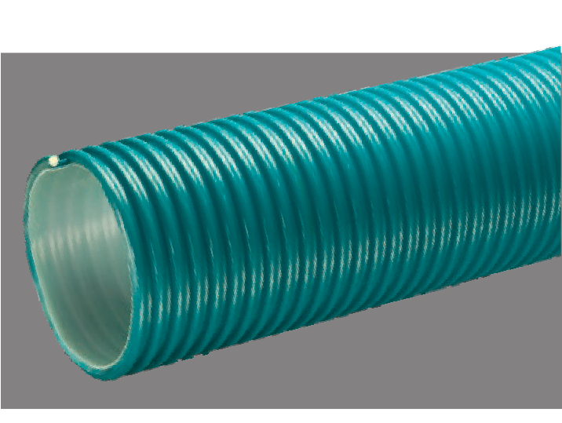
Nominal Specifications
Series | ID  (in.) | ID  (mm) | OD  (in.) | OD  (mm) | Working Pressure (psi) |  | Vacuum Rating (in. Hg) |  | Approx. Bending Radius  (in. @ 68°F) | Standard Length (ft.) | Weight (lbs/ft.)
 |  |  |  |  | 68°F | 104°F | 68°F | 104°F
AMPH400 | 4 | 101.6 | 4.76 | 120.9 | 35 | 18 | Full | 28 | 8 | 100 | 1.95
AMPH500 | 5 | 127.0 | 5.75 | 146.0 | 36 | 18 | 28 | 25 | 15 | 100/20 | 2.42
AMPH600 | 6 | 152.4 | 6.81 | 173.0 | 30 | 15 | 28 | 25 | 18 | 100/20 | 3.50
AMPH800 | 8 | 203.2 | 9.18 | 233.2 | 30 | 15 | 28 | 25 | 22 | 60/21 | 5.91

Features and Advantages:
  - Extra Thick Abrasion Resistant Polyurethane Liner – Designed for dry applications where severe abrasion is a factor. Provides for longer hose life and lower operating costs versus rubber or PVC hoses.
  - Static Dissipative Cover – Specially formulated to help prevent the build-up of static electricity for added safety and to help keep material flowing smoothly.

- “Cold-Flex” Materials – Hose remains flexible in sub-zero temperatures.
- Convoluted Outer Cover – Provides increased hose flexibility.
- Oil Resistant Polyurethane Liner – Resists most animal and petroleum based oils.
- Phthalate Free

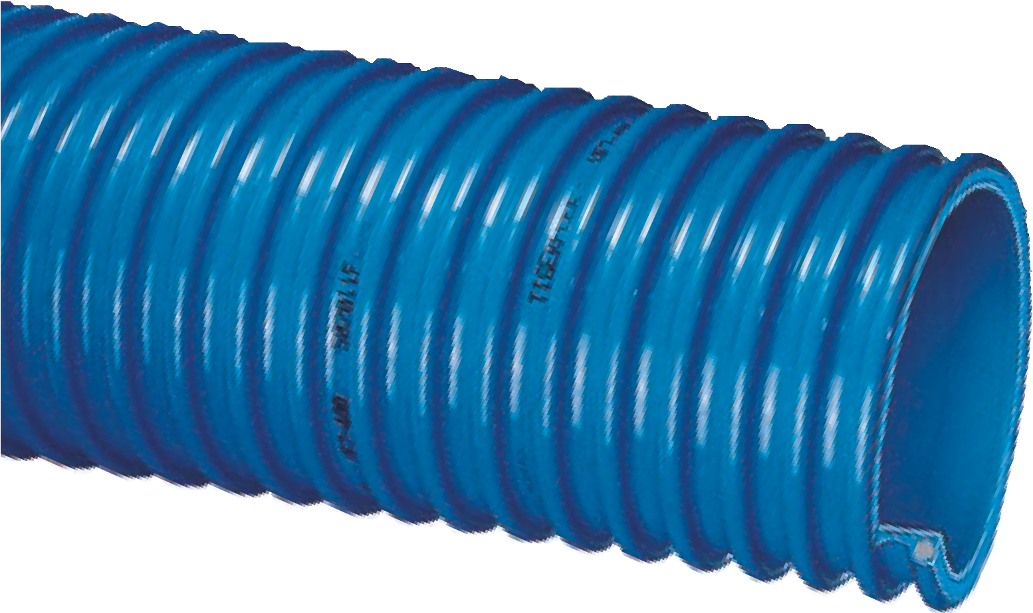

Ureflex™ UF2™ Series
Extra Heavy Duty
Polyurethane Lined Material Handling Hose
General Applications:
- Fly ash collection
- Industrial vacuum equipment
- Material chutes
- Material handling – heavy duty abrasive
- Milling machine scrap recovery
- Rock, gravel, sand and crushed concrete vacuuming
- Shot blast recovery
Construction: PVC cover with polyurethane liner and rigid PVC helix.
Service Temperature: -40°F (-40°C) to 150°F (+65°C)*
Nominal Specifications
Series | ID  (in.) | ID  (mm) | OD  (in.) | OD  (mm) | Working Pressure (psi) |  | Vacuum Rating (in. Hg) |  | Approx. Bending Radius  (in. @ 68°F) | Standard Length (ft.) | Weight (lbs/ft.)
 |  |  |  |  | 68°F | 104°F | 68°F | 104°F
UF2-150 | 1-1/2 | 38.1 | 1.88 | 47.8 | 50 | 25 | Full | 28 | 3 | 100 | 0.46
UF2-200 | 2 | 50.8 | 2.44 | 62.0 | 40 | 20 | Full | 28 | 4 | 100 | 0.65
UF2-250 | 2-1/2 | 63.5 | 3.12 | 79.2 | 40 | 20 | Full | 28 | 5 | 100 | 0.89
UF2-300 | 3 | 76.2 | 3.70 | 94.1 | 40 | 20 | Full | 28 | 6 | 100/50 | 1.23
UF2-400 | 4 | 101.6 | 4.80 | 122.0 | 35 | 18 | Full | 28 | 10 | 100/50 | 2.02
UF2-500 | 5 | 127.0 | 5.81 | 147.6 | 35 | 18 | 28 | 25 | 15 | 100/50/20 | 2.50
UF2-600 | 6 | 152.4 | 6.87 | 174.5 | 30 | 15 | 28 | 25 | 18 | 100/50/20 | 3.84
UF2-800 | 8 | 203.2 | 9.18 | 233.2 | 30 | 15 | 28 | 25 | 22 | 50/20 | 6.52
UF2-1000 | 10 | 254.0 | 11.61 | 295.0 | 25 | 12 | 26 | 20 | 26 | 20 | 10.92
NOTE: Service life may vary depending on operating conditions and type of material being conveyed.
NOTE: For details of the following compliances, refer to footnotes listed on page 62.
*Actual service temperature range is application dependent.

Ureflex™ UF1™ Series
Heavy Duty Polyurethane
Lined Material Handling Hose
General Applications:
  - Agricultural dry fertilizers
  - Air seeder lines
  - Fly ash collection
  - Industrial vacuum equipment
  - Material chutes
  - Material handling – heavy duty abrasive
  - Milling machine scrap recovery
  - Rock, gravel, sand and crushed concrete vacuuming
  - Shot blast recovery
Construction: PVC cover with polyurethane liner and rigid PVC helix.
Service Temperature: -40°F (-40°C) to 150°F (+65°C)*

Features and Advantages:
  - Thick Abrasion Resistant Polyurethane Liner – Designed for dry applications where severe abrasion is a factor. Provides for longer hose life and lower operating costs versus rubber or PVC hoses.
  - Static Dissipative Cover – Specially formulated to help prevent the build-up of static electricity for added safety and to help keep material flowing smoothly.

- “Cold-Flex” Materials – Hose remains flexible in sub-zero temperatures.
- Convoluted Outer Cover – Provides increased hose flexibility.
- Oil Resistant Polyurethane Liner – Resists most animal and petroleum based oils.
- Phthalate Free

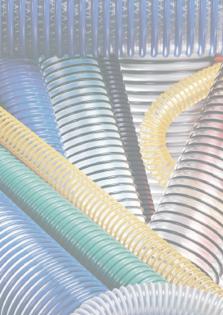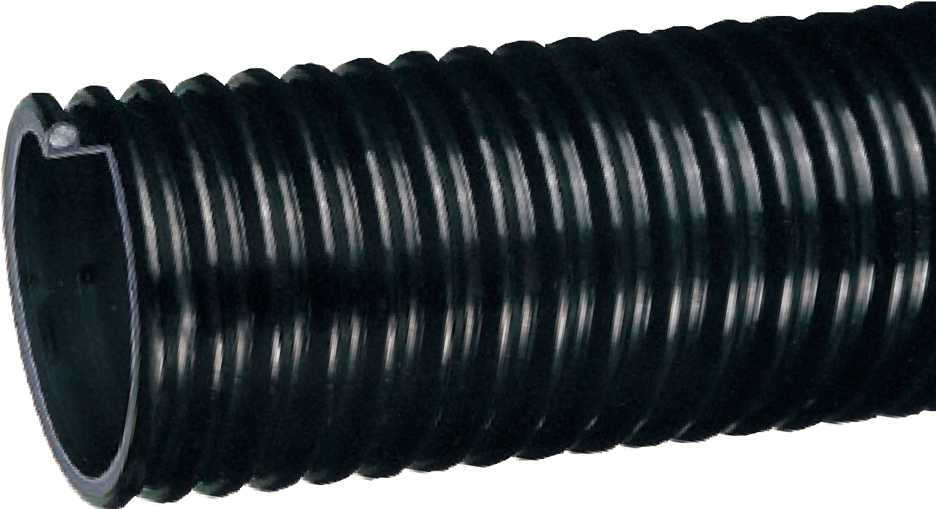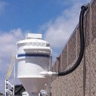

Nominal Specifications
Series | ID  (in.) | ID  (mm) | OD  (in.) | OD  (mm) | Working Pressure (psi) |  | Vacuum Rating (in. Hg) |  | Approx. Bending Radius  (in. @ 68°F) | Standard Length (ft.) | Weight (lbs/ft.)
 |  |  |  |  | 68°F | 104°F | 68°F | 104°F
UF1-125 | 1-1/4 | 31.8 | 1.53 | 39.0 | 50 | 25 | Full | 28 | 2 | 100 | 0.22
UF1-150 | 1-1/2 | 38.1 | 1.85 | 47.0 | 50 | 25 | Full | 28 | 2 | 100/50 | 0.42
UF1-200 | 2 | 50.8 | 2.40 | 61.0 | 40 | 20 | Full | 28 | 3 | 100/50 | 0.59
UF1-250 | 2-1/2 | 63.5 | 3.07 | 78.0 | 40 | 20 | Full | 28 | 3 | 100/50 | 0.80
UF1-300 | 3 | 76.2 | 3.64 | 92.5 | 40 | 20 | Full | 28 | 4 | 100/50 | 1.18
UF1-350 | 3-1/2 | 88.9 | 4.21 | 107.0 | 35 | 18 | Full | 28 | 5 | 100/50 | 1.48
UF1-400 | 4 | 101.6 | 4.76 | 120.9 | 35 | 18 | Full | 28 | 6 | 100/50 | 1.95
UF1-500 | 5 | 127.0 | 5.75 | 146.0 | 35 | 18 | 28 | 25 | 10 | 100/50/20 | 2.42
UF1-600 | 6 | 152.4 | 6.81 | 173.0 | 30 | 15 | 28 | 25 | 12 | 100/50/20 | 3.50
UF1-800 | 8 | 203.2 | 9.18 | 233.2 | 30 | 15 | 28 | 25 | 18 | 50/20 | 5.91
UF1-1000 | 10 | 255.0 | 11.60 | 294.5 | 22 | 10 | 24 | 18 | 26 | 20 | 9.90

UBK™ Series
Heavy Duty Polyurethane Lined Material Handling Hose

General Applications:
  - Agricultural dry fertilizers
  - Air seeder lines
  - Fly ash collection
  - Industrial vacuum equipment
  - Material handling – heavy duty abrasive
  - Milling machine scrap recovery
  - Rock, gravel, sand and crushed concrete vacuuming
  - Shot blast recovery
Construction: PVC cover with polyurethane liner and rigid PVC helix.
Service Temperature: -40°F (-40°C) to 150°F (+65°C)*

Features and Advantages:
- Thick Abrasion Resistant Polyurethane Liner – Designed for dry applications where severe abrasion is a factor. Provides for longer hose life and lower operating costs versus rubber or PVC hoses.
- Static Dissipative Cover – Specially formulated to help prevent the build-up of static electricity for added safety and to help keep material flowing smoothly.

- “Cold-Flex” Materials – Hose remains flexible in sub-zero temperatures.
- Easy Slide Helix – Rigid helix design protects hose tube from cover wear, and allows hose to slide easily over rough surfaces. Easy-to-handle.
- Oil Resistant Polyurethane Liner – Resists most animal and petroleum based oils.
- Phthalate Free

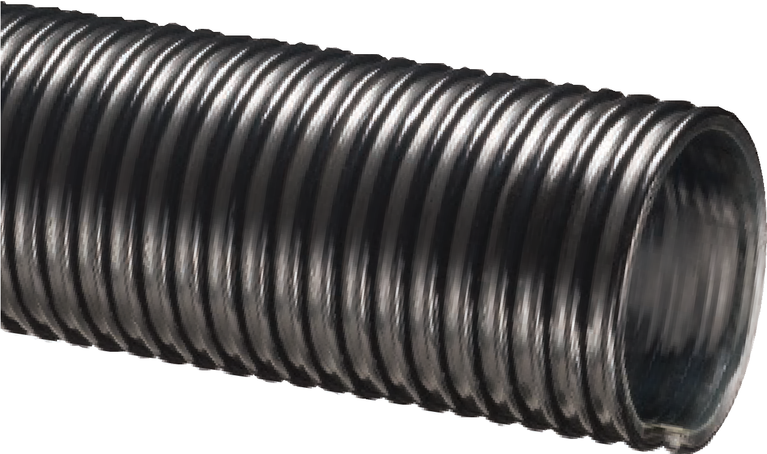
Nominal Specifications
Series | ID  (in.) | ID  (mm) | OD  (in.) | OD  (mm) | Working Pressure (psi) |  | Vacuum Rating (in. Hg) |  | Approx. Bending Radius  (in. @ 68°F) | Standard Length (ft.) | Weight (lbs/ft.)
 |  |  |  |  | 68°F | 104°F | 68°F | 104°F
UBK200 | 2 | 50.8 | 2.40 | 61.0 | 40 | 15 | Full | 28 | 2 | 100/50 | 0.59
UBK250 | 2-1/2 | 63.5 | 3.07 | 78.0 | 40 | 15 | Full | 28 | 4 | 100/50 | 0.79
UBK300 | 3 | 76.2 | 3.64 | 92.5 | 40 | 15 | Full | 28 | 4 | 100/50 | 0.83
UBK400 | 4 | 101.6 | 4.76 | 120.9 | 35 | 13 | Full | 28 | 6 | 100/50 | 1.37
UBK500 | 5 | 127.0 | 5.69 | 144.5 | 30 | 10 | 28 | 15 | 10 | 100/50/20 | 2.28
UBK600 | 6 | 152.4 | 6.81 | 173.0 | 30 | 10 | 28 | 15 | 12 | 100/50/20 | 3.10
UBK800 | 8 | 203.2 | 9.02 | 229.0 | 30 | 10 | 28 | 15 | 15 | 50/20 | 4.51
NOTE: Service life may vary depending on operating conditions and type of material being conveyed.
NOTE: For details of the following compliances, refer to footnotes listed on page 62.
*Actual service temperature range is application dependent.

Ureflex™ UFC™ Series
Heavy Duty Polyurethane
Lined Material Handling Hose

General Applications:
  - Agricultural dry fertilizer
  - Air seeder lines
  - Industrial vacuum equipment
  - Material handling – heavy duty abrasive
  - Milling machine scrap recovery
  - Plastic processing equipment
  - Shot blast recovery
Construction: PVC cover with polyurethane liner and rigid PVC helix.
Service Temperature: -40°F (-40°C) to 150°F (+65°C)*

Features and Advantages:
  - Thick Abrasion Resistant Polyurethane Liner – Designed for dry applications where severe abrasion is a factor. Provides for longer hose life and lower operating costs versus rubber or PVC hoses.
  - Static Dissipative Cover – Specially formulated to help prevent the build-up of static electricity for added safety and to help keep material flowing smoothly.
- Phthalate Free

- Transparent Construction – “See-the-flow.” Allows for visual confirmation of material flow.
- “Cold-Flex” Materials – Hose remains flexible in sub-zero temperatures.
- Convoluted Outer Cover – Provides increased hose flexibility.
- Oil Resistant Polyurethane Liner – Resists most animal and petroleum based oils.

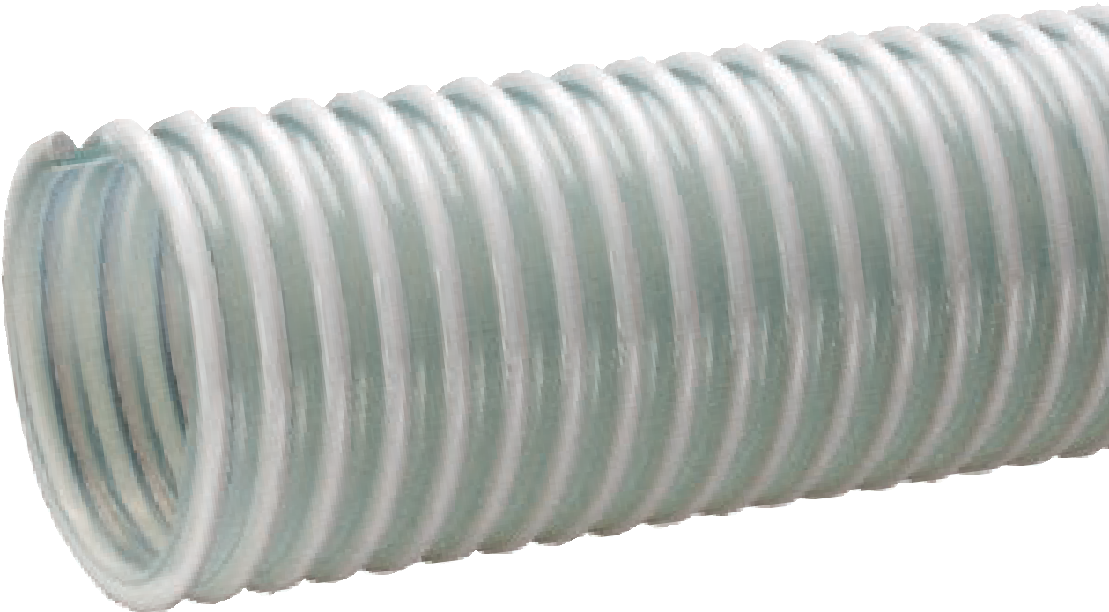

Nominal Specifications
Series | ID  (in.) | ID  (mm) | OD  (in.) | OD  (mm) | Working Pressure (psi) |  | Vacuum Rating (in. Hg) |  | Approx. Bending Radius  (in. @ 68°F) | Standard Length (ft.) | Weight (lbs/ft.)
 |  |  |  |  | 68°F | 104°F | 68°F | 104°F
UFC150 | 1-1/2 | 38.1 | 1.85 | 47.0 | 50 | 25 | Full | 28 | 2 | 100 | 0.42
UFC200 | 2 | 50.8 | 2.40 | 61.0 | 40 | 20 | Full | 28 | 3 | 100 | 0.59
UFC250 | 2-1/2 | 63.5 | 3.07 | 78.0 | 40 | 20 | Full | 28 | 3 | 100 | 0.80
UFC300 | 3 | 76.2 | 3.64 | 92.5 | 40 | 20 | Full | 28 | 4 | 100 | 1.18
UFC400 | 4 | 101.6 | 4.76 | 120.9 | 35 | 18 | Full | 28 | 6 | 100 | 1.95
NOTE: Service life may vary depending on operating conditions and type of material being conveyed.
NOTE: For details of the following compliances, refer to footnotes listed on page 62.
*Actual service temperature range is application dependent.

Features and Advantages:
  - Extra Thick Single-Ply Abrasion Resistant Polyurethane Tube – Our thickest single-ply polyurethane tube! Designed for dry applications where severe abrasion is a factor. Provides for longer hose life and lower operating costs versus rubber or PVC hoses.
  - Grounding Wire – Multi-strand wire helps prevent the
build-up of static electricity for added safety and to help keep material flowing smoothly. It’s embedded within the rigid helix to prevent contamination of transferred materials.
  - Transparent Construction – “See-the-flow.” Allows for visual confirmation of material flow.

- “Cold-Flex” Materials – Hose remains flexible in sub-zero temperatures.
- Easy Slide Helix – Rigid helix design protects hose tube from cover wear, and allows hose to slide easily over rough surfaces. Easy-to-handle.
- Oil Resistant Polyurethane Tube – Resists most animal and petroleum based oils.
- Phthalate Free

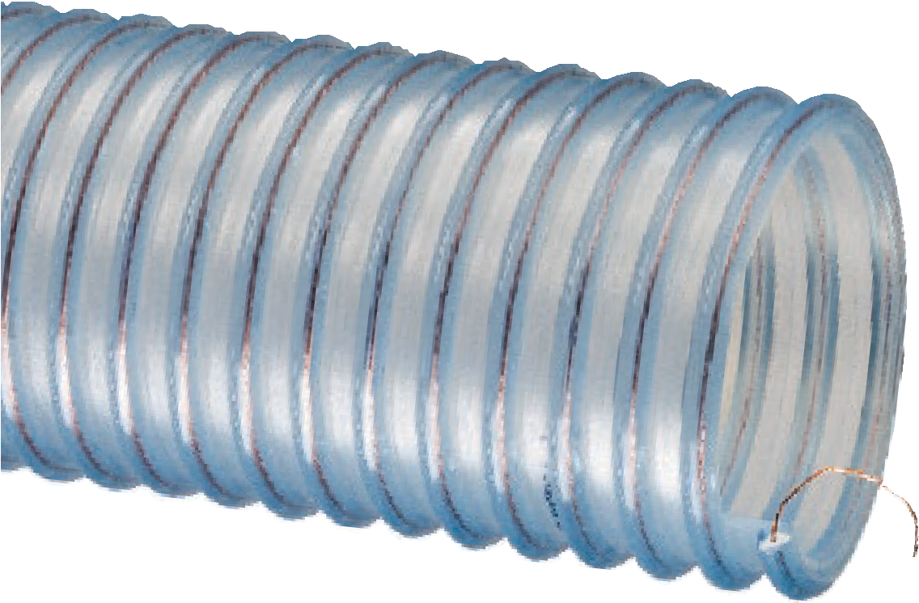
G

Plas-T-Flo™ PF™ Series
Heavy Duty Food Grade Polyurethane Material Handling Hose
With Grounding Wire
eneral Applications:
- Bulk truck & railcar unloading
- Material handling – heavy duty abrasive
- Milling machine scrap recovery
- Plastic processing equipment
Construction: Polyurethane tube with rigid PVC helix and grounding wire.
Service Temperature: -40°F (-40°C) to 150°F (+65°C)*

Nominal Specifications
Series | ID  (in.) | ID  (mm) | OD  (in.) | OD  (mm) | Working Pressure (psi) |  | Vacuum Rating (in. Hg) |  | Approx. Bending Radius  (in. @ 68°F) | Standard Length (ft.) | Weight (lbs/ft.)
 |  |  |  |  | 68°F | 104°F | 68°F | 104°F
PF300 | 3 | 76.2 | 3.39 | 86.0 | 35 | 15 | 28 | 25 | 10 | 100/20 | 1.50
PF400 | 4 | 101.6 | 4.84 | 123.0 | 30 | 15 | 28 | 25 | 12 | 100/50/20 | 1.96
PF500 | 5 | 127.0 | 5.87 | 149.0 | 30 | 15 | 25 | 22 | 13 | 100/50/20 | 2.50
PF600 | 6 | 152.4 | 6.91 | 175.5 | 30 | 15 | 25 | 22 | 16 | 100/50/20 | 3.18
NOTE: Service life may vary depending on operating conditions and type of material being conveyed.
NOTE: For details of the following compliances, refer to footnotes listed on page 62.
*Actual service temperature range is application dependent.
CAUTION: This product is designed to dissipate static electricity when the embedded grounding wire is physically extracted and securely connected to ground, through the fitting or by other means.

BSe/tSe(02), FDA(03), FDA(04), Phthalate Free(09), RoHS(10), USDA(11)

Urevac™ UV3™ Series

Heavy Duty Polyurethane
Material Handling Hose With Grounding Wire

General Applications:

Dust collection
  - Material handling – heavy duty abrasive
  - Milling machine scrap recovery
  - Plastic processing equipment
  - Trench suction
Construction: Single-ply polyurethane tube with rigid PVC helix and grounding wire.
Service Temperature: -40°F (-40°C) to 150°F (+65°C)*

Features and Advantages:
  - Thick Abrasion Resistant Single-Ply Polyurethane Tube – Designed for dry applications where severe abrasion is a factor. Provides for longer hose life and lower operating costs versus rubber or PVC hoses.
  - Grounding Wire – Multi-strand wire helps prevent the
build-up of static electricity for added safety and to help keep material flowing smoothly. It’s embedded within the rigid helix to prevent contamination of transferred materials.
- Phthalate Free

- Transparent Construction – “See-the-flow.” Allows for visual confirmation of material flow.
- “Cold-Flex” Materials – Hose remains flexible in sub-zero temperatures.
- Easy Slide Helix – Rigid helix design protects hose tube from cover wear, and allows hose to slide easily over rough surfaces. Easy-to-handle.
- Oil Resistant Polyurethane Tube – Resists most animal and petroleum based oils.

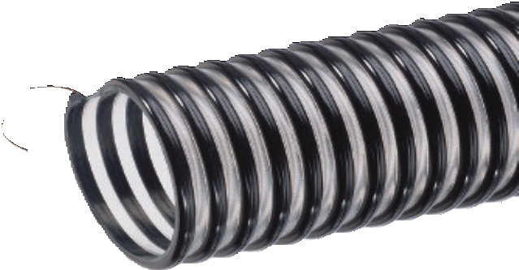

Nominal Specifications
Series | ID  (in.) | ID  (mm) | OD  (in.) | OD  (mm) | Working Pressure (psi) |  | Vacuum Rating (in. Hg) |  | Approx. Bending Radius  (in. @ 68°F) | Standard Length (ft.) | Weight (lbs/ft.)
 |  |  |  |  | 68°F | 104°F | 68°F | 104°F
UV3-300 | 3 | 76.2 | 3.60 | 91.4 | 40 | 20 | Full | 28 | 9 | 100/50 | 0.91
UV3-400 | 4 | 101.6 | 4.66 | 118.4 | 35 | 17 | 28 | 25 | 12 | 100/50 | 1.50
UV3-500 | 5 | 127.0 | 5.50 | 145.0 | 35 | 17 | 28 | 25 | 14 | 50/20 | 1.82
UV3-600 | 6 | 152.4 | 6.65 | 172.0 | 30 | 15 | 25 | 20 | 16 | 50/20 | 2.24
UV3-800 | 8 | 203.5 | 8.76 | 223.0 | 30 | 15 | 25 | 20 | 18 | 50/20 | 3.00
NOTE: Service life may vary depending on operating conditions and type of material being conveyed.
NOTE: For details of the following compliances, refer to footnotes listed on page 62.
*Actual service temperature range is application dependent.
CAUTION: This product is designed to dissipate static electricity when the embedded grounding wire is physically extracted and securely connected to ground, through the fitting or by other means.

Features and Advantages:
  - Abrasion Resistant Polyurethane Liner – Designed for dry applications where severe abrasion is a factor. Provides for longer hose life and lower operating costs versus similar rubber or PVC hoses.
  - “Cold-Flex” Materials – Hose remains flexible in sub-zero temperatures.
  - Static Dissipative Cover – Specially formulated to help prevent the build-up of static electricity for added safety and to help keep material flowing smoothly.

Urevac™ UV2™ Series

Heavy Duty Polyurethane
Lined Ducting/Material Handling Hose

General Applications:

Agricultural dry fertilizer
- Air seeder lines
- Dust control
- Material handling – standard duty
- Wand hose
Construction: PVC cover with ester polyurethane (TPU) liner and rigid PVC helix.
Service Temperature: -40°F (-40°C) to 150°F (+65°C)*

- Transparent Construction – “See-the-flow.” Allows for visual confirmation of material flow.
- Easy Slide Helix – Rigid helix design protects hose tube from cover wear, and allows hose to slide easily over rough surfaces. Easy-to-handle.
- Oil Resistant Polyurethane Liner – Resists most animal and petroleum based oils.
- Phthalate Free

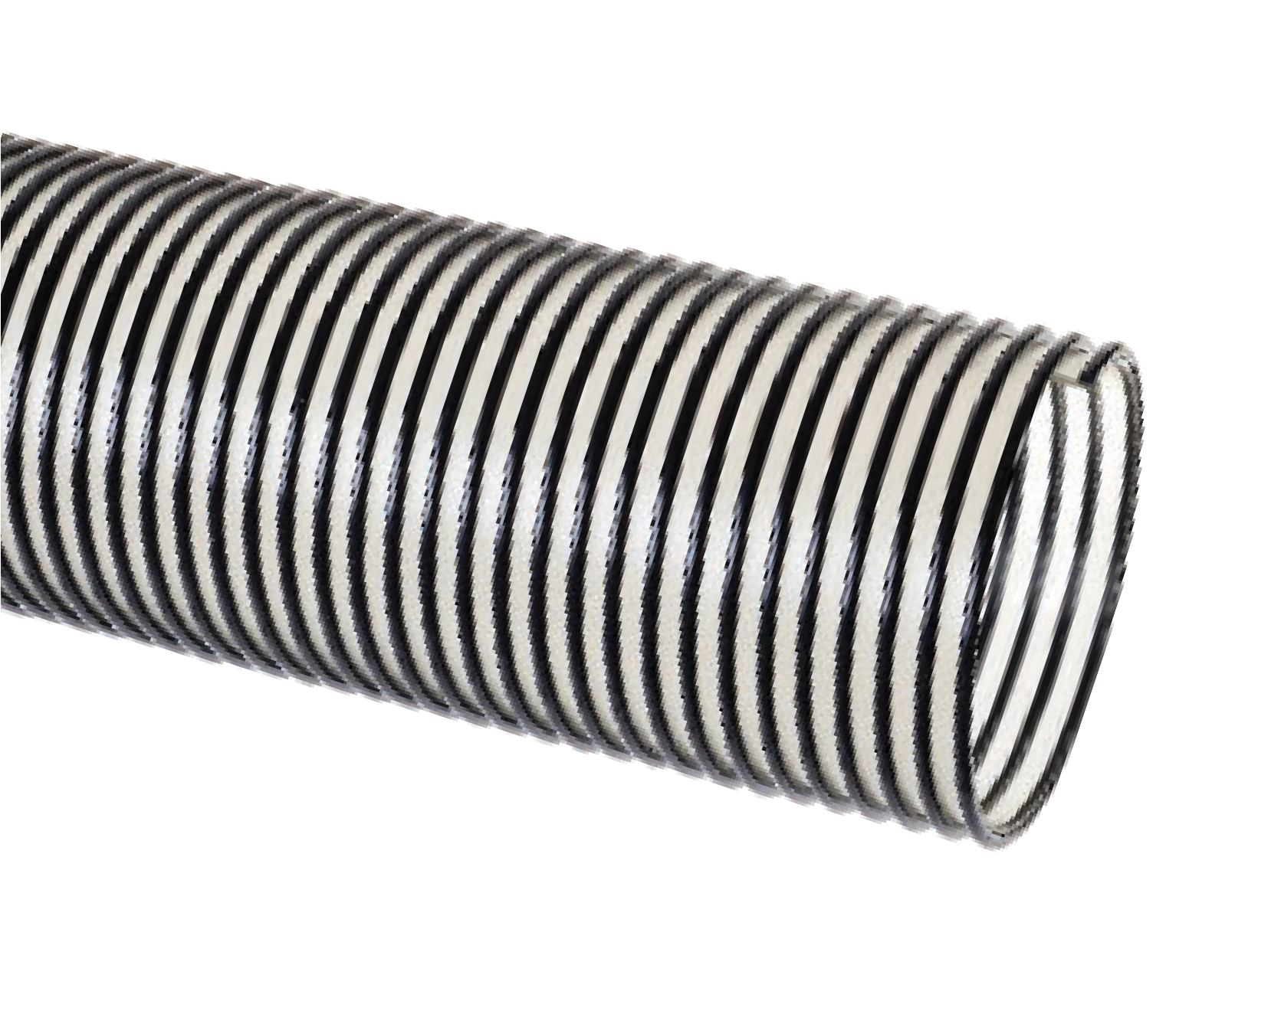
Nominal Specifications
Series | ID |  | OD |  | Working Pressure (PSI) |  | Vacuum Rating (in Hg) |  | Min. Bending Radius (in.) @ 68°F | Standard Length (ft.) | Weight (lbs/ ft)
 | (in.) | (mm) | (in.) | (mm) | 68°F | 104°F | 68°F | 104°F
UV2-150 | 1-1/2 | 38.1 | 1.87 | 47.5 | 25 | 10 | 22 | 16 | 1.5 | 60 | 0.29
UV2-200 | 2 | 50.8 | 2.47 | 62.7 | 25 | 10 | 21 | 14 | 2.5 | 60 | 0.40
UV2-250 | 2-1/2 | 63.5 | 2.96 | 75.2 | 20 | 8 | 19 | 12 | 3 | 60 | 0.53
UV2-300 | 3 | 76.2 | 3.54 | 89.8 | 20 | 8 | 18 | 11 | 4 | 60 | 0.67
UV2-400 | 4 | 101.6 | 4.57 | 116.1 | 15 | 7 | 13 | 9 | 6 | 60 | 1.02
UV2-500 | 5 | 127.0 | 5.58 | 141.7 | 15 | 7 | 10 | 7 | 8 | 60 | 1.22
UV2-600 | 6 | 152.4 | 6.62 | 168.1 | 10 | 5 | 7 | 5 | 10 | 60 | 1.68
UV2-800 | 8 | 203.2 | 8.67 | 220.2 | 10 | 5 | 5 | 3 | 14 | 20 | 2.24
NOTE: Service life may vary depending on operating conditions and type of material being conveyed.
NOTE: For details of the following compliances, refer to footnotes listed on page 62.
*Actual service temperature range is application dependent.

Service Temperature: -40°F (-40°C) to 150°F (+65°C)*

Features and Advantages:
  - Thick Abrasion Resistant Polyurethane Tube – Designed for dry applications where severe abrasion is a factor. Provides for longer hose life and lower operating costs versus rubber or PVC hoses.
  - Crush Resistant Construction – Hose rebounds to shape without structural damage when crushed; material keeps flowing.
  - Grounding Wire – Multi-strand wire helps prevent the
build-up of static electricity for added safety and to help keep material flowing smoothly.

- “Cold-Flex” Materials – Hose remains flexible in sub-zero temperatures.
- Convoluted Outer Cover – Provides increased hose flexibility.
- Transparent Construction – “See-the-flow.” Allows for visual confirmation of material flow.
- Oil Resistant Polyurethane Tube – Resists most animal and petroleum based oils.
- Phthalate Free

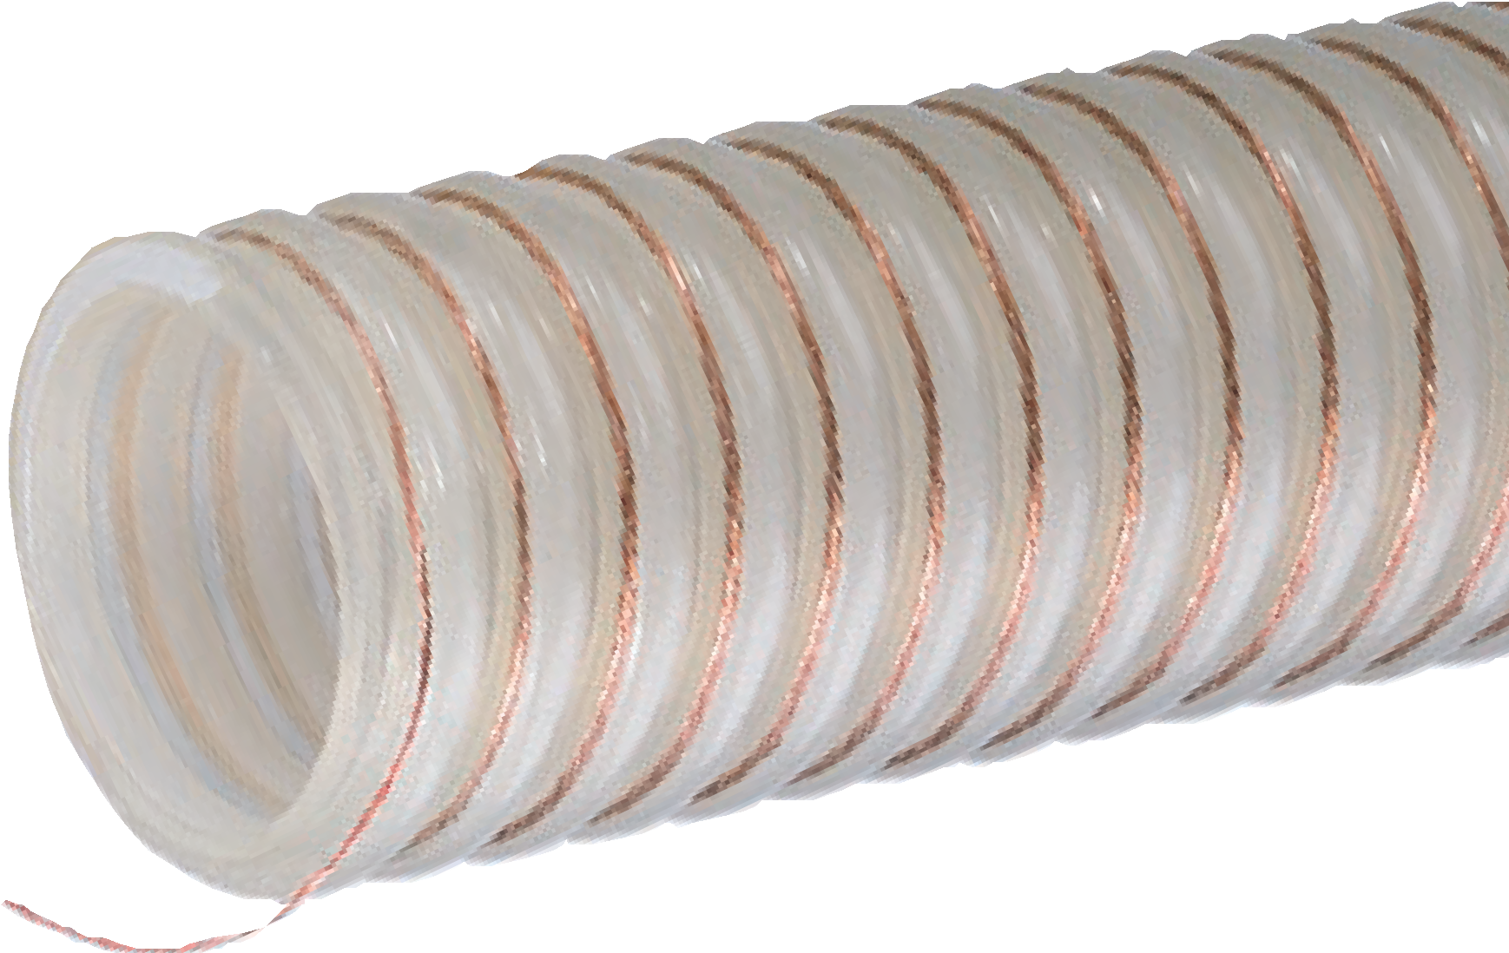
UVPE™ Series
Heavy Duty Polyurethane Material Handling Hose With Grounding Wire
General Applications:
- Material handling – heavy duty abrasive
- Plastic processing equipment Construction: Polyurethane tube with rigid polypropylene helix.

Nominal Specifications
Series | ID  (in.) | ID  (mm) | OD  (in.) | OD  (mm) | Working Pressure (psi) |  | Vacuum Rating (in. Hg) |  | Approx. Bending Radius  (in. @ 68°F) | Standard Length (ft.) | Weight (lbs/ft.)
 |  |  |  |  | 68°F | 104°F | 68°F | 104°F
UVPE150 | 1-1/2 | 38.1 | 1.87 | 47.5 | 20 | 7 | 22 | 14 | 3 | 100 | 0.39
UVPE200 | 2 | 50.8 | 2.44 | 62.0 | 15 | 6 | 21 | 12 | 4 | 100 | 0.48
UVPE250 | 2-1/2 | 63.5 | 2.99 | 75.9 | 10 | 5 | 19 | 10 | 5 | 100 | 0.55
UVPE300 | 3 | 76.2 | 3.64 | 92.5 | 10 | 5 | 18 | 10 | 6 | 100 | 0.68
NOTE: Service life may vary depending on operating conditions and type of material being conveyed.
NOTE: For details of the following compliances, refer to footnotes listed on page 62.
*Actual service temperature range is application dependent.
CAUTION: This product is designed to dissipate static electricity when the embedded grounding wire is physically extracted and securely connected to ground, through the fitting or by other means.

“Ground Cover” GC-C™ Series

Heavy Duty Polyurethane Lined Material Handling Hose

Features and Advantages:
  - Abrasion Resistant Polyurethane Liner – Designed for dry applications where severe abrasion is a factor. Provides longer hose life and lower operating costs versus rubber or PVC hoses.
  - “Cold-Flex” Materials – Hose remains flexible in sub-zero temperatures.
- Phthalate Free

General Applications:
- Material handling – heavy duty abrasive
- Mulch, bark, wood chips and other surfacing material delivery
- Soil, seed and compost delivery
Construction: PVC cover with Polyurethane liner and rigid PVC helix.
Service Temperature: -40°F (-40°C) to 150°F (+65°C)*

- Transparent Construction – “See-the-flow.” Allows for visual confirmation of material flow.
- Convoluted Outer Cover – Provides increased hose flexibility. Allows for easier unwinding and winding on hose reels.
- Oil Resistant Polyurethane Liner – Resists most animal and petroleum based oils.

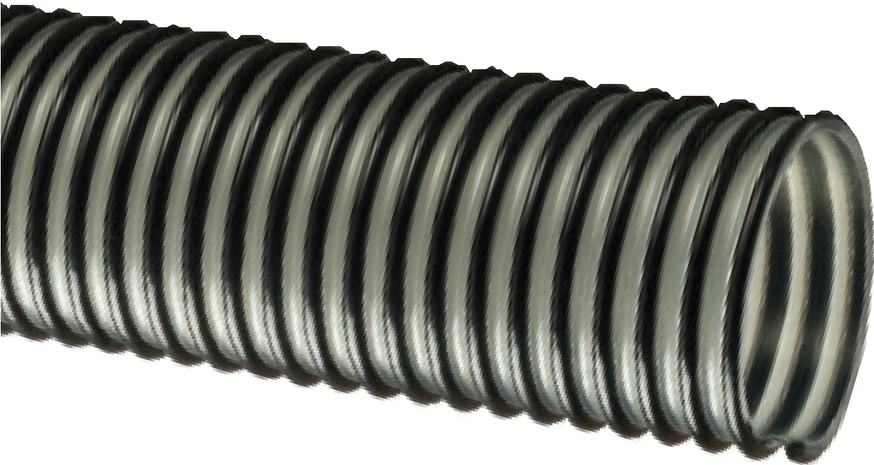

Nominal Specifications
Series | ID  (in.) | ID  (mm) | OD  (in.) | OD  (mm) | Working Pressure (psi) |  | Vacuum Rating (in. Hg) |  | Approx. Bending Radius  (in. @ 68°F) | Standard Length (ft.) | Weight (lbs/ft.)
 |  |  |  |  | 68°F | 104°F | 68°F | 104°F
GC-C400 | 4 | 101.6 | 4.59 | 116.6 | 30 | 15 | 28 | 25 | 6 | 100 | 1.00
GC-C500 | 5 | 127.0 | 5.57 | 141.5 | 30 | 15 | 25 | 20 | 10 | 100 | 1.80
NOTE: Service life may vary depending on operating conditions and type of material being conveyed.
NOTE: For details of the following compliances, refer to footnotes listed on page 62.
*Actual service temperature range is application dependent.

“Mulch Hose” MULCH™ Series
Heavy Duty PVC
Material Handling Hose
MULCH-LT™ Series
Heavy Duty PVC Low Temperature
Material Handling Hose
General Applications:
  - Material handling – standard duty
  - Mulch, bark, wood chips and other surfacing material delivery
  - Soil, seed and compost delivery
Construction: PVC tube and rigid PVC helix. Service Temperature (MULCH): -4°F (-20°C) to 150°F (+65°C)*
Service Temperature (MULCH-LT): -40°F (-40°C) to 150°F (+65°C)*

MUL

MULCH-LT
CH
(low temp)

Features and Advantages:
  - Abrasion Resistant PVC Tube – Formulated from highly durable PVC compounds for increased abrasion and tear resistance versus standard PVC hoses.
  - “Cold-Flex” Materials (MULCH-LT only) – Hose remains flexible in sub-zero temperatures.

- Transparent Construction – “See-the-flow.” Allows for visual confirmation of material flow.
- Convoluted Outer Cover – Provides increased hose flexibility.
- Phthalate Free

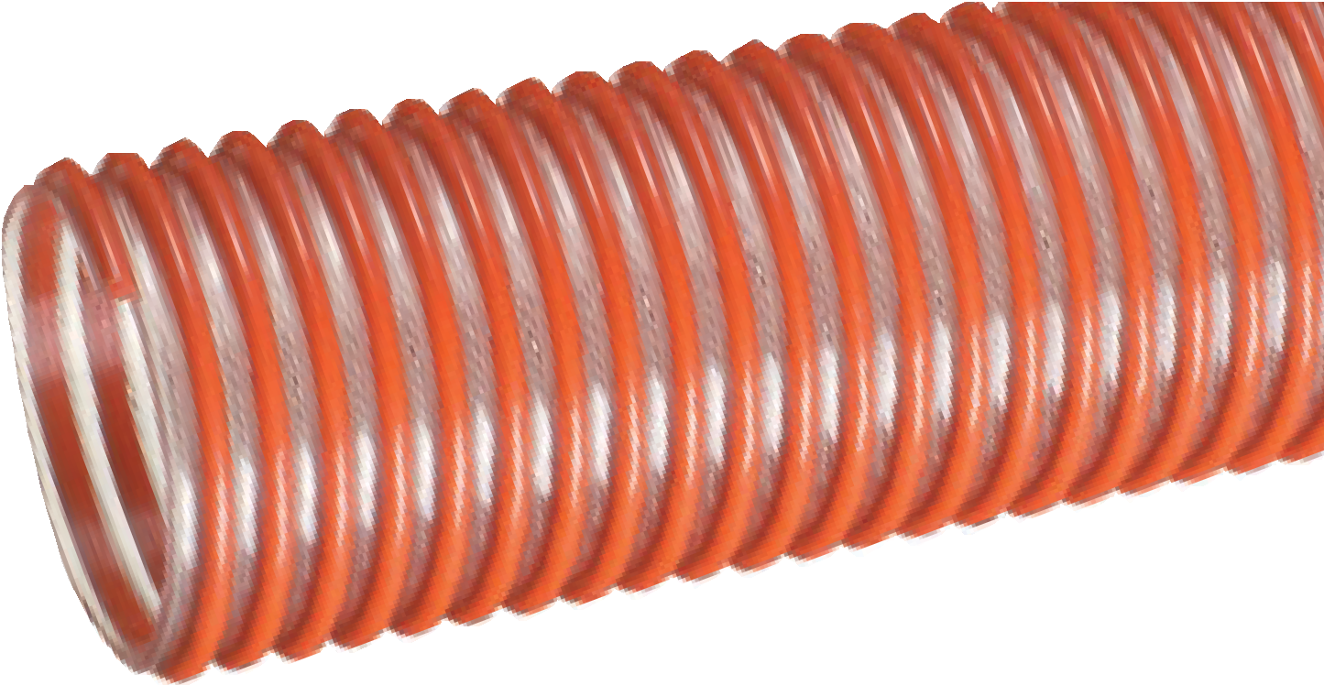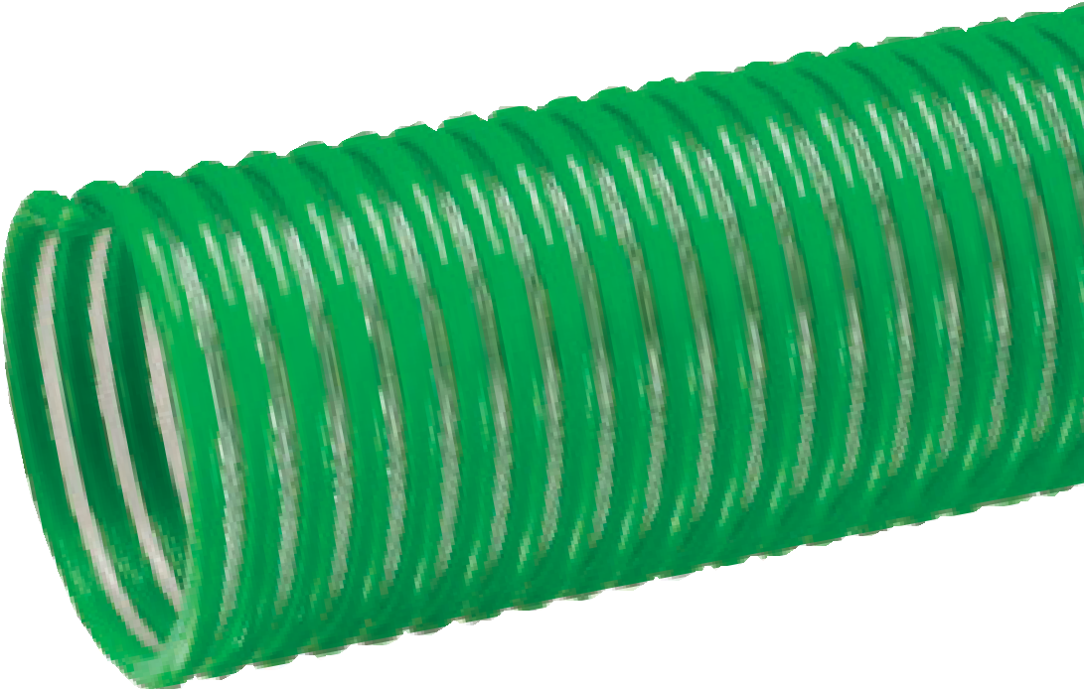

Nominal Specifications
Series | ID  (in.) | ID  (mm) | OD  (in.) | OD  (mm) | Working Pressure (psi) |  | Vacuum Rating (in. Hg) |  | Approx. Bending Radius  (in. @ 68°F) | Standard Length (ft.) | Weight (lbs/ft.)
 |  |  |  |  | 68°F | 104°F | 68°F | 104°F
MULCH400 | 4 | 101.6 | 4.57 | 116.0 | 35 | 15 | Full | 28 | 8 | 100 | 1.42
MULCH500 | 5 | 127.0 | 5.61 | 142.6 | 30 | 12 | 24 | 22 | 14 | 100 | 1.75
MULCH600 | 6 | 153.4 | 6.79 | 172.4 | 25 | 10 | 24 | 22 | 16 | 100 | 2.42
MULCH-LT400 | 4 | 101.6 | 4.57 | 116.0 | 35 | 15 | Full | 28 | 8 | 100 | 1.35
NOTE: Service life may vary depending on operating conditions and type of material being conveyed.
NOTE: For details of the following compliances, refer to footnotes listed on page 62.
*Actual service temperature range is application dependent.

Features and Advantages:
  - Abrasion Resistant PVC Tube – Formulated from highly durable PVC compounds for increased abrasion and tear resistance versus standard PVC hoses.
  - Convoluted Outer Cover – Provides increased hose flexibility. Allows for easier unwinding and winding on hose reels.

- Easy Slide Helix – Rigid helix design protects hose tube from cover wear, and allows hose to slide easily over rough surfaces. Easy-to-handle.
- Transparent Construction – “See-the-flow.” Allows for visual confirmation of material flow.
- Phthalate Free

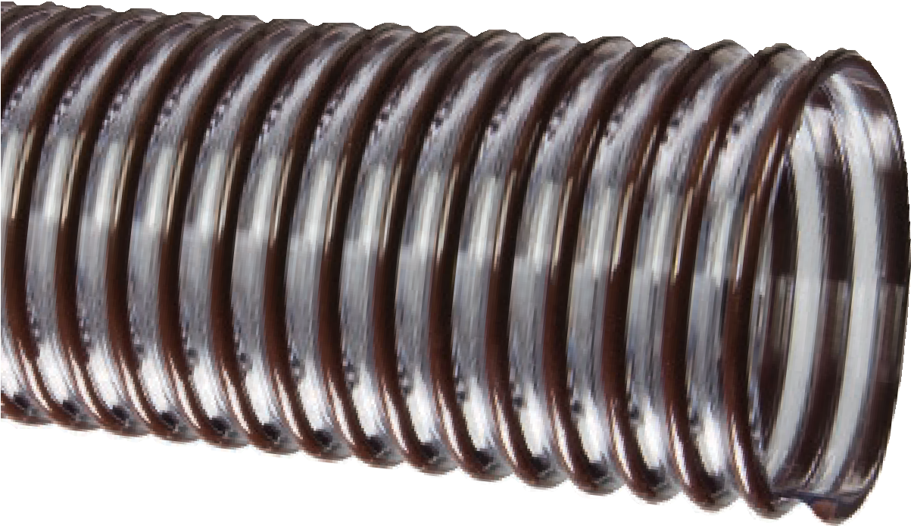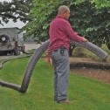
“Bark Hose”
BARK™ Series
Standard Duty PVC Material Handling Hose
General Applications:
- Lawn and leaf collection
- Material handling – standard duty
- Mulch, bark, wood chips and other surfacing material delivery
- Soil, seed and compost delivery
Construction: PVC tube with rigid PVC helix. Service Temperature: -4°F (-20°C) to 150°F (+65°C)*

Nominal Specifications
Series | ID  (in.) | ID  (mm) | OD  (in.) | OD  (mm) | Working Pressure (psi) |  | Vacuum Rating (in. Hg) |  | Approx. Bending Radius  (in. @ 68°F) | Standard Length (ft.) | Weight (lbs/ft.)
 |  |  |  |  | 68°F | 104°F | 68°F | 104°F
BARK400 | 4 | 101.6 | 4.45 | 113 | 18 | 11 | 15 | 10 | 10 | 100 | 0.95
BARK500 | 5 | 127.0 | 5.47 | 139 | 17 | 10 | 14 | 8 | 11 | 100 | 1.29
NOTE: Service life may vary depending on operating conditions and type of material being conveyed.
NOTE: For details of the following compliances, refer to footnotes listed on page 62.
*Actual service temperature range is application dependent.

Features and Advantages:
  - “Cold-Flex” Materials – Hose remains flexible in sub-zero temperatures.
  - Transparent Construction (LKC series only) – “See-the- flow.” Allows for visual confirmation of material flow.

- Easy Slide Helix – Rigid helix design protects hose tube from cover wear, and allows hose to slide easily over rough surfaces. Easy-to-handle.
- Phthalate Free

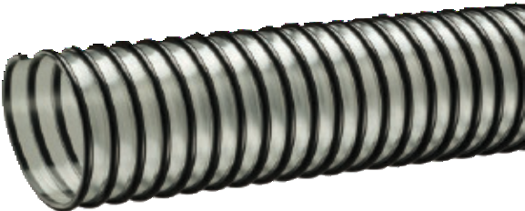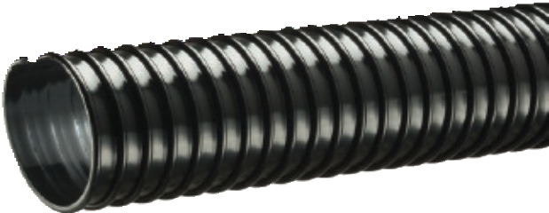
Lawn King™
LK™ Series LKC™ Series
PVC Ducting/Material Handling Hose
General Applications:
- Dust collection
- Lawn and leaf collection
- Material handling – light duty
Construction: PVC tube with rigid PVC helix.
Service Temperature: -20°F (-29°C) to 150°F (+65°C)*
LK
LKC

Nominal Specifications
Series | ID  (in.) | ID  (mm) | OD  (in.) | OD  (mm) | Working Pressure (psi) |  | Vacuum Rating (in. Hg) |  | Approx. Bending Radius  (in. @ 68°F) | Standard Length (ft.) | Weight (lbs/ft.)
 |  |  |  |  | 68°F | 104°F | 68°F | 104°F
LK/LKC400 | 4 | 101.6 | 4.57 | 114.8 | 8 | 4 | 13 | 7 | 3 | 100/50 | 0.85
LKC500 | 5 | 128.0 | 5.55 | 141.0 | 7 | 3 | 10 | 6 | 5 | 100 | 0.93
LK600 | 6 | 152.4 | 6.63 | 168.3 | 6 | 3 | 7 | 5 | 6 | 50 | 1.34
LKC600 | 6 | 152.4 | 6.63 | 168.3 | 6 | 3 | 7 | 5 | 6 | 100/50 | 1.34
LKC700 | 7 | 177.8 | 7.56 | 192.0 | 4 | 2 | 6 | 4 | 7 | 50 | 1.53
LK/LKC800 | 8 | 203.2 | 8.63 | 219.3 | 4 | 2 | 5 | 3 | 8 | 50 | 2.00
NOTE: Service life may vary depending on operating conditions and type of material being conveyed.
NOTE: For details of the following compliances, refer to footnotes listed on page 62.
*Actual service temperature range is application dependent.

NEW

Features and Advantages:

UV1

UVE
Urevac™ UV1™ Series

Polyurethane Ducting/
Material Handling Hose
UVE™ Series
Polyurethane Ducting/ Material Handling Hose With Grounding Wire

General Applications:

Concrete resurfacing dust collection
- Ducting, ventilation and fume removal
- Dust collection
- Insulation blowing
- Material chutes
- Material handling – standard duty
Construction: Ester polyurethane (TPU) tube with rigid PVC helix.
Service Temperature: -40°F (-40°C) to 150°F (+65°C)*

  - Durable Lightweight Polyurethane Tube – Designed for dry applications where abrasion is a factor. Provides longer hose life and lower operating costs versus rubber or PVC hoses.
  - Transparent Construction – “See-the-flow.” Allows for visual confirmation of material flow.
  - Easy Slide Helix – Rigid helix design protects hose tube from cover wear, and allows hose to slide easily over rough surfaces. Easy-to-handle.
  - “Cold-Flex” Materials – Hose remains flexible in sub-zero temperatures.
- Oil Resistant Polyurethane Tube – Resists most animal and petroleum based oils.
- Grounding Wire (UVE only) – Multi-strand wire helps prevent the build-up of static electricity for added safety and to help keep material flowing smoothly. It’s embedded within the rigid helix to prevent contamination of transferred materials.
- Phthalate Free

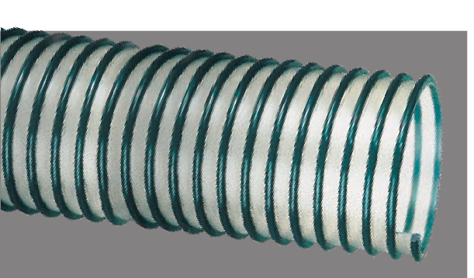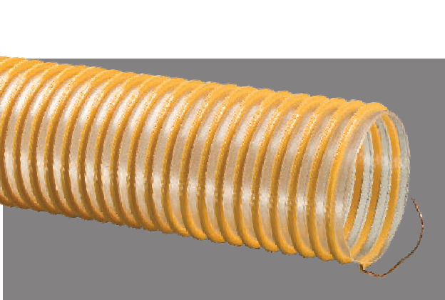
Nominal Specifications
Series | ID |  | OD |  | Working Pressure (PSI) |  | Vacuum Rating (in. Hg) |  | Min.  Bending Radius (in.)  @ 68°F | Standard Length (ft.) |  | Weight (lbs/ ft)
 | (in.) | (mm) | (in.) | (mm) | 68°F | 104°F | 68°F | 104°F |  | UV1 50 | UVE 100/50
UV1-150 | 1 1/2 | 38.1 | 1.82 | 46.2 | 20 | 7 | 22 | 14 | 0.75 | 50 |  | 0.23
UV1/UVE-200 | 2 | 50.8 | 2.39 | 60.7 | 15 | 6 | 21 | 12 | 1.5 | 100/50 |  | 0.32
UV1-250 | 2 1/2 | 63.5 | 2.89 | 73.4 | 10 | 5 | 19 | 10 | 1.5 | 50 |  | 0.39
UV1/UVE-300 | 3 | 76.2 | 3.46 | 87.9 | 10 | 5 | 18 | 10 | 2.5 | 100/50 |  | 0.58
UV1/UVE-400 | 4 | 101.6 | 4.50 | 114.3 | 8 | 4 | 13 | 8 | 3 | 100/50 |  | 0.77
UV1-500 | 5 | 127.0 | 5.50 | 139.7 | 7 | 3 | 10 | 7 | 4 | 50 |  | 0.89
UV1/UVE-600 | 6 | 152.4 | 6.54 | 166.1 | 6 | 3 | 7 | 5 | 5 | 100/50 |  | 1.15
UV1-800 | 8 | 203.2 | 8.59 | 218.2 | 4 | 2 | 5 | 3 | 7 | 50 |  | 1.75
NOTE: Service life may vary depending on operating conditions and type of material being conveyed.
NOTE: For details of the following compliances, refer to footnotes listed on page 62.
*Actual service temperature range is application dependent.
CAUTION: This product is designed to dissipate static electricity when the embedded grounding wire is physically extracted and securely connected to ground, through the fitting or by other means.

Service Temperature: -4°F (-20°C) to 150°F (+65°C)*
GTG now Anti-Microbial!

Features and Advantages:
  - Transparent Construction (GT series only) – “See-the- flow.” Allows for visual confirmation of material flow.
  - Easy Slide Helix – Rigid helix design protects hose tube from cover wear, and allows hose to slide easily over rough surfaces. Easy-to-handle.

- Anti-Microbial Tube (GTG series only) – Inhibits growth of bacteria, fungi, mold and yeast.
- Phthalate Free

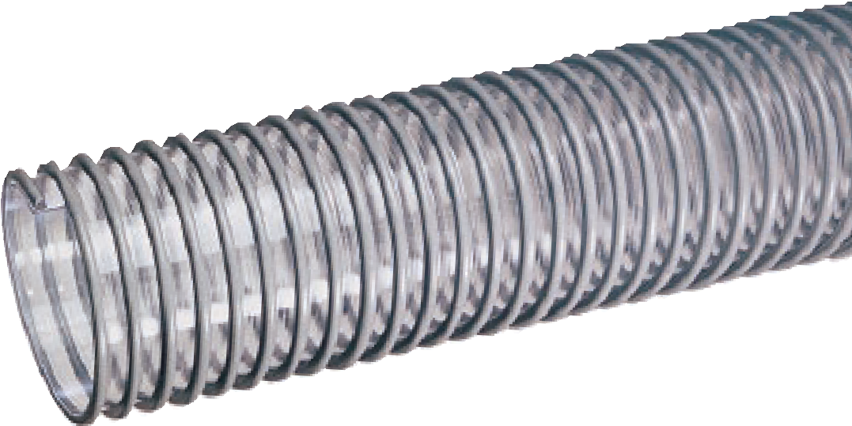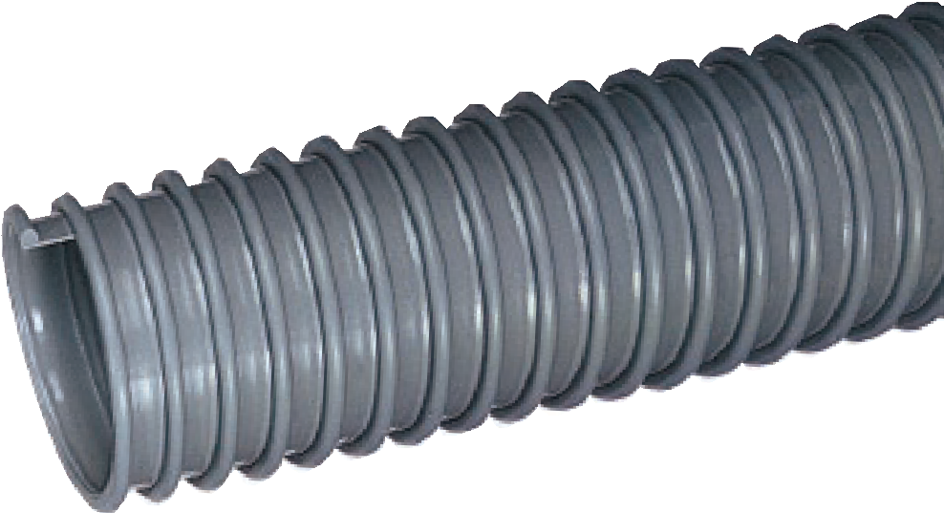
GT™ Series GTG™ Series
PVC Ducting/Material Handling Hose
General Applications:
- Cable protection
- Drain lines
- Ducting, ventilation and fume removal
- Dust collection
- Material handling – light duty
Construction: PVC tube with rigid PVC helix.
GT
G
GT

Nominal Specifications
Series | ID  (in.) | ID  (mm) | OD  (in.) | OD  (mm) | Working Pressure (psi) |  | Vacuum Rating (in. Hg) |  | Approx. Bending Radius  (in. @ 68°F) | Standard Length (ft.) | Weight (lbs/ft.)
 |  |  |  |  | 68°F | 104°F | 68°F | 104°F
GT/GTG150 | 1-1/2 | 38.1 | 1.82 | 46.2 | 20 | 7 | 22 | 14 | 1 | 100/50 | 0.23
GT/GTG200 | 2 | 50.8 | 2.39 | 60.8 | 15 | 6 | 21 | 12 | 2 | 100/50 | 0.30
GT238 | 2-3/8 | 60.3 | 2.76 | 70.1 | 12 | 6 | 10 | 5 | 2 | 100 | 0.38
GT/GTG250 | 2-1/2 | 63.5 | 2.89 | 73.4 | 10 | 5 | 19 | 10 | 2 | 100/50 | 0.39
GT/GTG300 | 3 | 76.2 | 3.46 | 87.9 | 10 | 5 | 18 | 10 | 3 | 100/50 | 0.50
GT350 | 3-1/2 | 88.9 | 4.02 | 102.0 | 9 | 4 | 15 | 8 | 3 | 100/50 | 0.68
GT/GTG400 | 4 | 101.6 | 4.50 | 114.3 | 8 | 4 | 13 | 7 | 3 | 100/50 | 0.77
GT500 | 5 | 127.0 | 5.50 | 139.7 | 7 | 3 | 10 | 6 | 5 | 100/50 | 0.91
GT600 | 6 | 152.4 | 6.54 | 166.1 | 6 | 3 | 7 | 5 | 6 | 100/50 | 1.08
GT800 | 8 | 203.2 | 8.59 | 218.2 | 4 | 2 | 5 | 3 | 8 | 50 | 1.74
GT1000 | 10 | 254.0 | 11.68 | 296.6 | 2 | — | 2 | — | 10 | 50 | 2.70
NOTE: Service life may vary depending on operating conditions and type of material being conveyed.
NOTE: For details of the following compliances, refer to footnotes listed on page 62.
*Actual service temperature range is application dependent.

Features and Advantages:
  - MSHA(08) Approved – Meets U.S. Dept. of Labor Administration requirements for flame-resistance for use in mines for protection of hose bundles. Optional, special order, red or green colored helix also approved.
  - Transparent Construction – “See-the-flow.” Allows for visual confiurmation of material flow.

- Easy Slide Helix – Rigid helix design protects hose tube from cover wear, and allows hose to slide easily over rough surfaces. Easy-to-handle.
- CG-SL Series – pre-slit for easy insertion of hose bundles.
- Phthalate Free

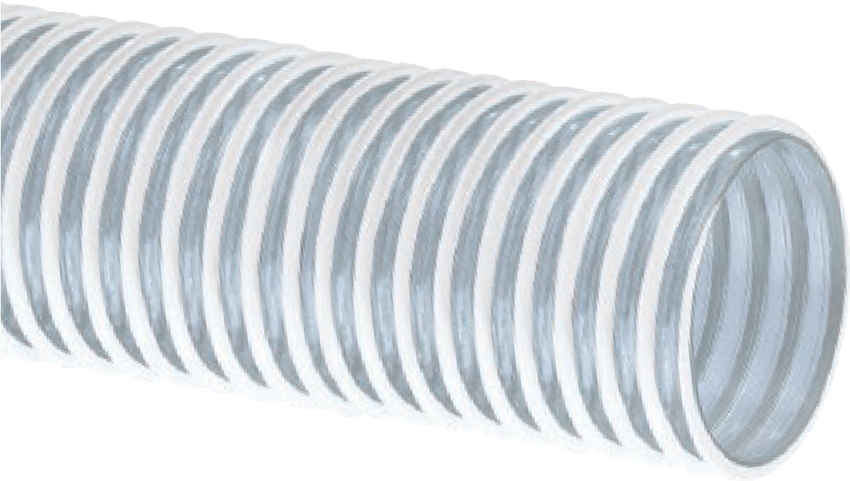
“Cover Guard”
CG™/CG-SL™ Series
PVC Ducting and Cover Protection Hose
General Applications:
- Cable and hose bundle protection (MSHA)
- Dust collection
- Ducting, ventilation and fume removal
- Mine supply line cover protection
Construction: PVC tube with rigid PVC helix.
Service Temperature: -4°F (-20°C) to 150°F (+65°C)*
CG-SL
(pre-slit)

Nominal Specifications
Series | ID  (in.) | ID  (mm) | OD  (in.) | OD  (mm) | Working Pressure (psi) |  | Vacuum Rating (in. Hg) |  | Approx. Bending Radius  (in. @ 68°F) | Standard Length (ft.) | Weight (lbs/ft.)
 |  |  |  |  | 68°F | 104°F | 68°F | 104°F
CG-SL100 | 1 | 25.4 | 1.28 | 31.9 | n/a | n/a | n/a | n/a | .5 | 100 | 0.14
CG-SL125 | 1-1/4 | 31.8 | 1.51 | 38.4 | n/a | n/a | n/a | n/a | .75 | 100 | 0.18
CG-SL150 | 1-1/2 | 38.1 | 1.76 | 45.1 | n/a | n/a | n/a | n/a | 1 | 100 | 0.21
CG/CG-SL200 | 2 | 50.8 | 2.30 | 58.4 | 12 | 6 | 10 | 5 | 2 | 100 | 0.28
CG238 | 2-3/8 | 60.3 | 2.76 | 70.1 | 12 | 6 | 10 | 5 | 2 | 100 | 0.38
CG/CG-SL250 | 2-1/2 | 63.5 | 2.81 | 71.3 | 10 | 5 | 8 | 4 | 2 | 100 | 0.39
CG/CG-SL300 | 3 | 76.2 | 3.35 | 85.0 | 8 | 4 | 7 | 3 | 3 | 100 | 0.45
CG/CG-SL350 | 3-1/2 | 88.9 | 3.83 | 97.4 | 8 | 4 | 7 | 3 | 3 | 100 | 0.51
CG/CG-SL400 | 4 | 102.4 | 4.39 | 111.4 | 6 | 3 | 6 | 3 | 3 | 100 | 0.64
NOTE: Service life may vary depending on operating conditions and type of material being conveyed.
NOTE: For details of the following compliances, refer to footnotes listed on page 62.
*Actual service temperature range is application dependent.

MSHA(08), Phthalate Free(09), RoHS(10)

Features and Advantages:
  - Transparent Construction (H & K Series only) – “See-the- flow.” Allows for visual confirmation of material flow.
  - MSHA(07) Approved (J Series only) – Approved by the Mine Safety and Health Administration for flame-resistance for use in underground mines as water transfer hose.

- Smooth Outer Cover (Sizes 3/4” – 5”) – Provides increased pressure rating and smooth surface for banding.
- Convoluted Outer Cover (Sizes 6” & 8”) – Provides increased hose flexibility.
- Phthalate Free

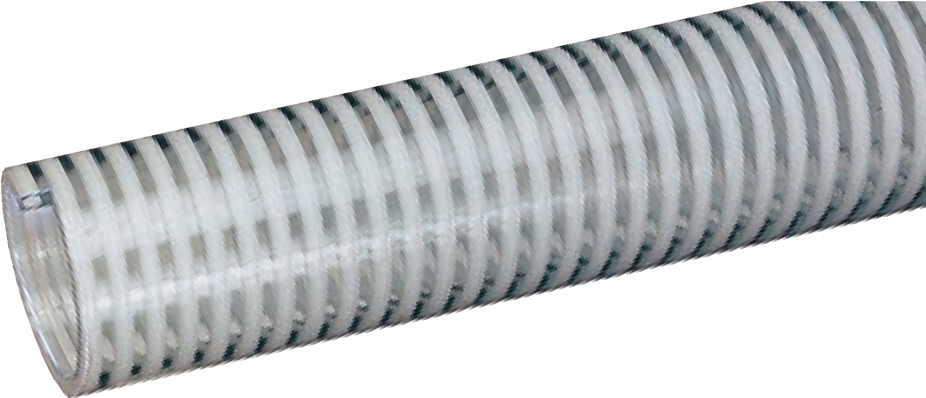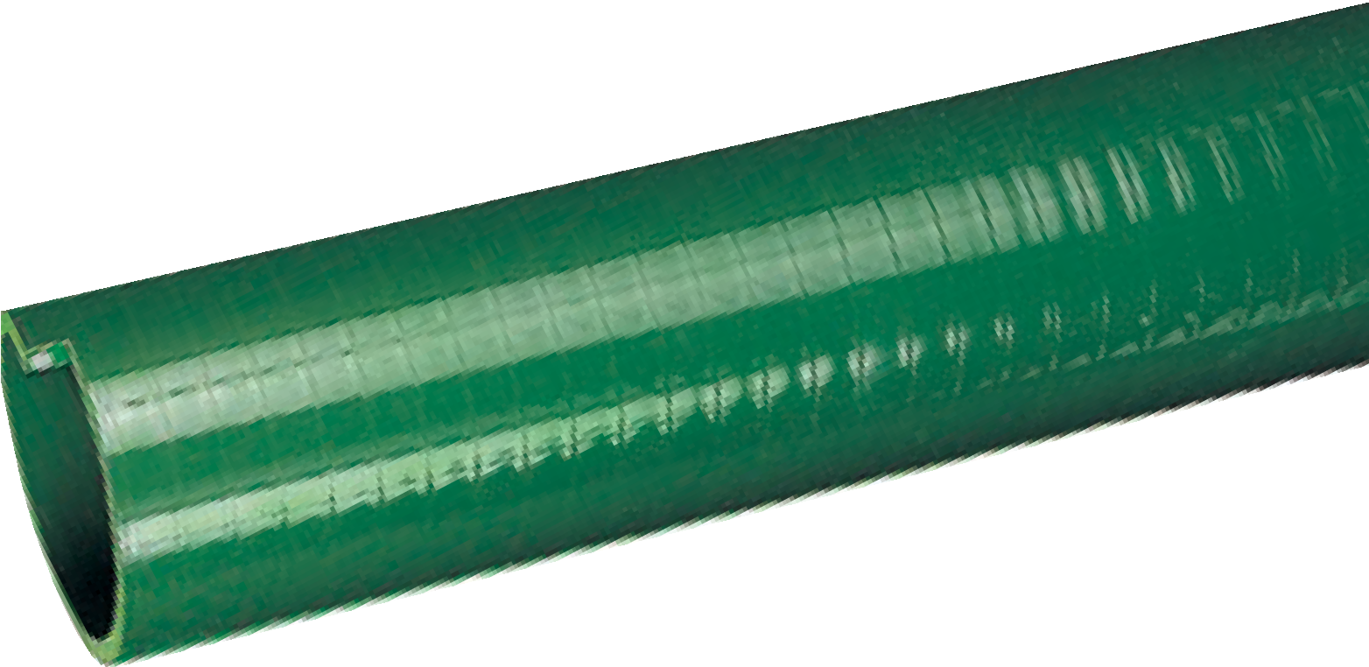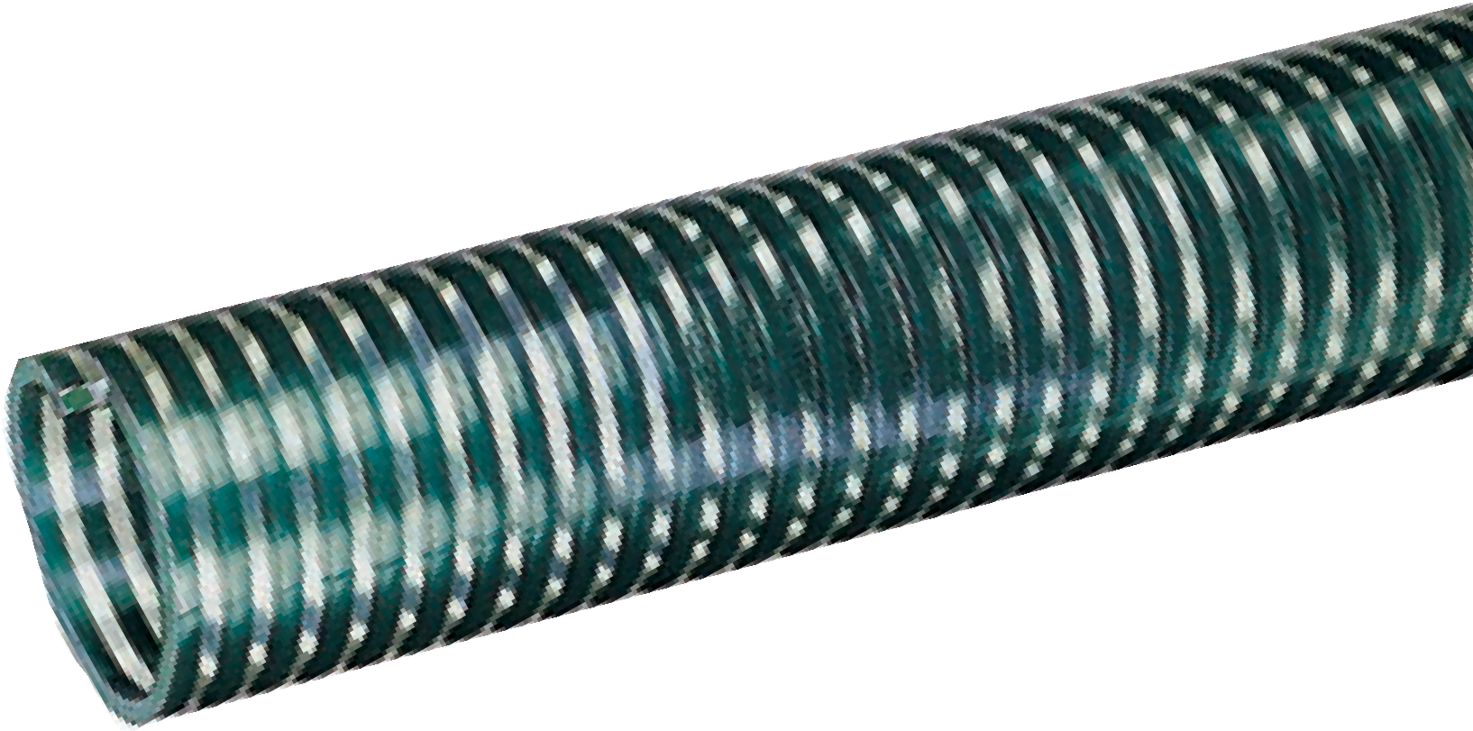
H™/J™/K™ Series
Standard Duty PVC Suction Hose
H
J

General Applications:
- Agricultural liquid fertilizer
- Air seeder lines
- Drain lines
- Irrigation lines
- Mining applications
- Pumps, rental and construction dewatering
- Pumps, trash
- Rock dusting
- Water suction – standard duty
Construction: PVC tube with rigid PVC helix. Service Temperature: -4°F (-20°C) to 150°F (+65°C)*
K

Nominal Specifications
Series | ID  (in.) | ID  (mm) | OD  (in.) | OD  (mm) | Working Pressure (psi) |  | Vacuum Rating (in. Hg) |  | Approx. Bending Radius  (in. @ 68°F) | Standard Length (ft.) | Weight (lbs/ft.)
 |  |  |  |  | 68°F | 104°F | 68°F | 104°F
H/J/K075 | 3/4 | 19.0 | 1.01 | 25.6 | 110 | 70 | 28 | 26 | 3 | 100 | 0.19
H/J/K100 | 1 | 25.4 | 1.26 | 32.0 | 85 | 60 | 28 | 26 | 3 | 100 | 0.26
H/J/K125 | 1-1/4 | 31.7 | 1.56 | 39.6 | 85 | 60 | 28 | 24 | 4 | 100 | 0.35
H/J/K150 | 1-1/2 | 38.1 | 1.83 | 46.5 | 70 | 50 | 28 | 24 | 5 | 100 | 0.48
H/J/K200 | 2 | 50.8 | 2.32 | 59.0 | 65 | 45 | 28 | 24 | 7 | 100 | 0.66
H/J/K250 | 2-1/2 | 63.5 | 2.87 | 73.0 | 65 | 45 | 28 | 24 | 8 | 100 | 0.87
H/J/K300 | 3 | 76.2 | 3.43 | 87.0 | 60 | 40 | 28 | 22 | 10 | 100 | 1.24
H/J/K400 | 4 | 101.6 | 4.50 | 114.7 | 50 | 35 | 28 | 22 | 15 | 100 | 1.85
H500 | 5 | 127.0 | 5.58 | 141.3 | 45 | 30 | 28 | 24 | 22 | 100/20 | 2.42
H/J/K600 | 6 | 152.4 | 6.75 | 171.4 | 40 | 25 | 28 | 20 | 30 | 100/20 | 3.39
H/J/K800 | 8 | 203.2 | 8.86 | 225.0 | 30 | 20 | 26 | 20 | 35 | 20 | 5.63
NOTE: For details of the following compliances, refer to footnotes listed on page 62.
*Actual service temperature range is application dependent.

MSHA(07), Phthalate Free(09), RoHS(10)

Features and Advantages:
  - Transparent Construction (F Series only) – “See-the-flow.” Allows for visual confirmation of material flow.
  - “Safety Orange” Color (G Series Only) – For high visibility on job site. Reduces risk of running or tripping over hose.

- Smooth Outer Cover (Sizes 3/4” – 5”) – Provides increased pressure rating and smooth surface for banding.
- Convoluted Outer Cover (Sizes 6” & 8”) – Provides increased hose flexibility.
- Phthalate Free

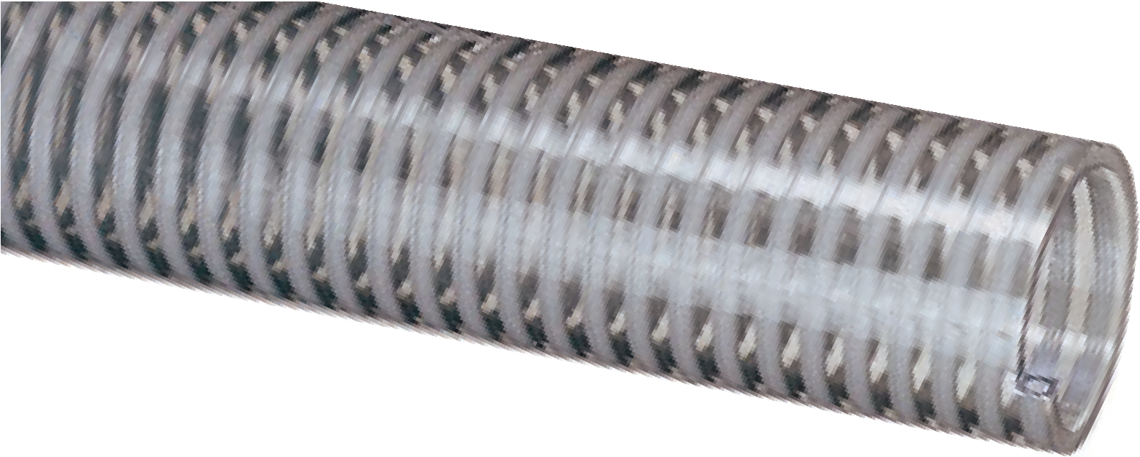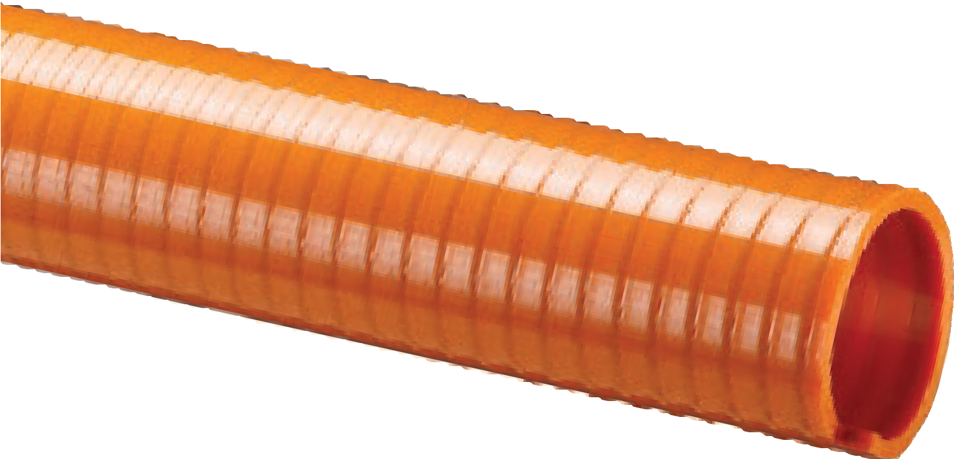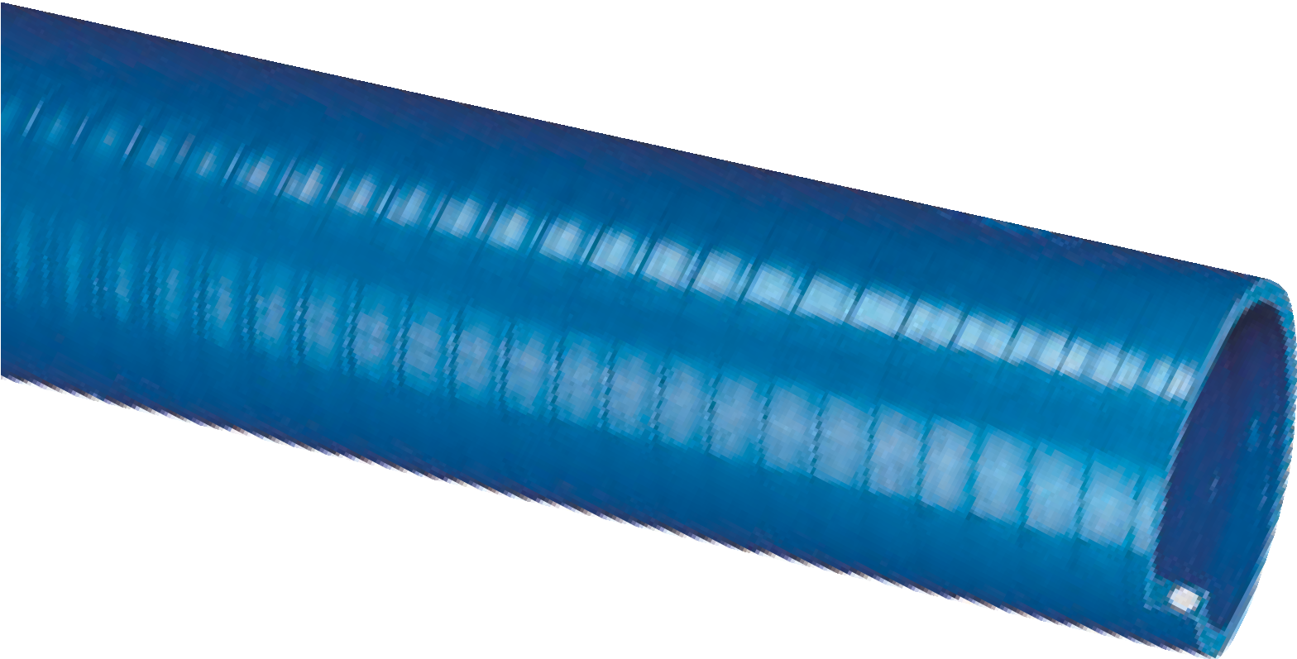
F
G
S
Tiger™ Suction F™/G™/S™ Series
Heavy Duty PVC
Suction Hose
General Applications:
- Irrigation lines
- Pumps, rental and construction dewatering
- Pumps, trash
- Water suction – heavy duty
Construction: PVC tube with rigid PVC helix. Service Temperature: -4°F (-20°C) to 150°F (+65°C)*
Nominal Specifications
Series | ID  (in.) | ID  (mm) | OD  (in.) | OD  (mm) | Working Pressure (psi) |  | Vacuum Rating (in. Hg) |  | Approx. Bending Radius  (in. @ 68°F) | Standard Length (ft.) | Weight (lbs/ft.)
 |  |  |  |  | 68°F | 104°F | 68°F | 104°F
F075 | 3/4 | 19.0 | 1.01 | 25.6 | 115 | 75 | Full | 28 | 3 | 100 | 0.21
F/G/S100 | 1 | 25.4 | 1.26 | 32.0 | 100 | 65 | Full | 28 | 3 | 100 | 0.27
F/S125 | 1-1/4 | 31.7 | 1.56 | 39.6 | 100 | 65 | Full | 26 | 4 | 100 | 0.36
F/G/S150 | 1-1/2 | 38.1 | 1.83 | 46.5 | 100 | 65 | Full | 26 | 5 | 100 | 0.48
F/G/S200 | 2 | 50.8 | 2.38 | 60.4 | 100 | 65 | Full | 26 | 7 | 100 | 0.71
F/G250 | 2-1/2 | 63.5 | 2.89 | 73.4 | 70 | 48 | Full | 26 | 8 | 100 | 0.96
F/G/S300 | 3 | 76.2 | 3.44 | 87.4 | 70 | 45 | Full | 26 | 10 | 100 | 1.25
F/G/S400 | 4 | 101.6 | 4.57 | 116.1 | 60 | 40 | Full | 26 | 15 | 100 | 1.95
F500 | 5 | 127.0 | 5.59 | 141.9 | 45 | 30 | 28 | 24 | 22 | 100/20 | 2.45
F/G600 | 6 | 152.4 | 6.77 | 172.0 | 40 | 25 | 28 | 22 | 25 | 100/20 | 3.76
F/G800 | 8 | 203.2 | 8.90 | 226.1 | 30 | 20 | 28 | 18 | 30 | 20 | 6.00

“Blue Water” BW™ Series
Low Temperature PVC Suction Hose

General Applications:
  - Extreme cold conditions
  - Pumps, rental and construction dewatering
  - Pumps, trash
  - Water suction – standard duty
Construction: PVC tube with rigid PVC helix. Service Temperature: -40°F (-40°C) to 150°F (+65°C)*

Features and Advantages:
  - “Cold-Flex” Materials – Hose remains flexible in sub-zero temperatures. Beware of imitations! Blue Water™ truly remains flexible in extreme cold.
  - Transparent Construction – “See-the-flow.” Allows for visual confirmation of material flow.

- Smooth Outer Cover (Sizes 1” - 4”) – Provides increased pressure rating and smooth surface for banding.
- Convoluted Outer Cover (Sizes 5” & 6”) – Provides increased hose flexibility.
- Phthalate Free

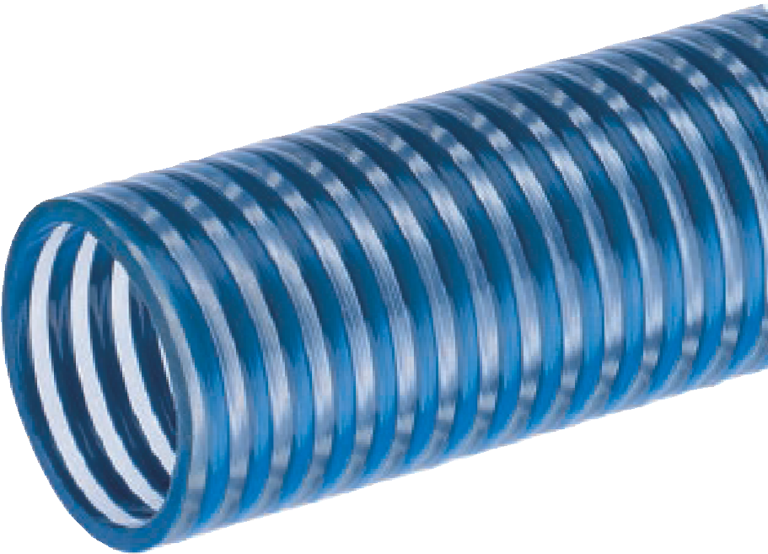

Nominal Specifications
Series | ID  (in.) | ID  (mm) | OD  (in.) | OD  (mm) | Working Pressure (psi) |  | Vacuum Rating (in. Hg) |  | Approx. Bending Radius  (in. @ 68°F) | Standard Length (ft.) | Weight (lbs/ft.)
 |  |  |  |  | 68°F | 104°F | 68°F | 104°F
BW075 | 3/4 | 19.1 | 1.01 | 25.6 | 115 | 75 | Full | 28 | 3 | 100 | 0.19
BW100 | 1 | 25.4 | 1.26 | 32.0 | 90 | 65 | Full | 28 | 3 | 100 | 0.22
BW125 | 1-1/4 | 31.8 | 1.56 | 39.6 | 90 | 65 | Full | 26 | 4 | 100 | 0.36
BW150 | 1-1/2 | 38.1 | 1.79 | 45.5 | 90 | 65 | Full | 26 | 5 | 100 | 0.48
BW200 | 2 | 50.8 | 2.35 | 59.8 | 90 | 65 | Full | 26 | 7 | 100 | 0.62
BW250 | 2-1/2 | 63.5 | 2.87 | 73.0 | 70 | 48 | Full | 26 | 8 | 100 | 0.87
BW300 | 3 | 76.2 | 3.43 | 87.0 | 65 | 45 | Full | 26 | 10 | 100 | 1.23
BW400 | 4 | 101.6 | 4.49 | 114.0 | 55 | 40 | Full | 26 | 15 | 100 | 1.83
BW500 | 5 | 127.0 | 5.57 | 141.5 | 45 | 30 | 28 | 24 | 25 | 100/20 | 2.42
BW600 | 6 | 152.4 | 6.69 | 170.0 | 40 | 25 | 28 | 22 | 30 | 100/20 | 3.36
NOTE: Service life may vary depending on operating conditions and type of material being conveyed.
NOTE: For details of the following compliances, refer to footnotes listed on page 62.
NOTE: Refer to Storage and Handling, and Max Coil Stack Height on page 65.
*Actual service temperature range is application dependent.

Cold Flex™ CF™ Series

Extra Heavy Duty Low Temperature PVC Suction Hose

General Applications:

Extreme cold conditions
  - Irrigation lines
  - Material handling – standard duty
  - Pumps, rental and construction dewatering
  - Pumps, trash
  - Slurry handling
  - Water suction – heavy duty
Construction: PVC tube with rigid PVC helix. Service Temperature: -40°F (-40°C) to 150°F (+65°C)*

Features and Advantages:
- Superior Vacuum Rating – Our toughest and most durable liquid suction hose! Extremely thick hose tube and extra large helix provide for a tough, durable hose with all sizes rated to full vacuum (at 68°F).
- Cold Flex™ Materials – Hose remains flexible in severe sub-zero temperatures.

- Convoluted Outer Cover – Provides increased hose flexibility.
- Static Dissipative Tube – Specially formulated to help prevent the build-up of static electricity for added safety and help keep material flowing smoothly.
- Phthalate Free

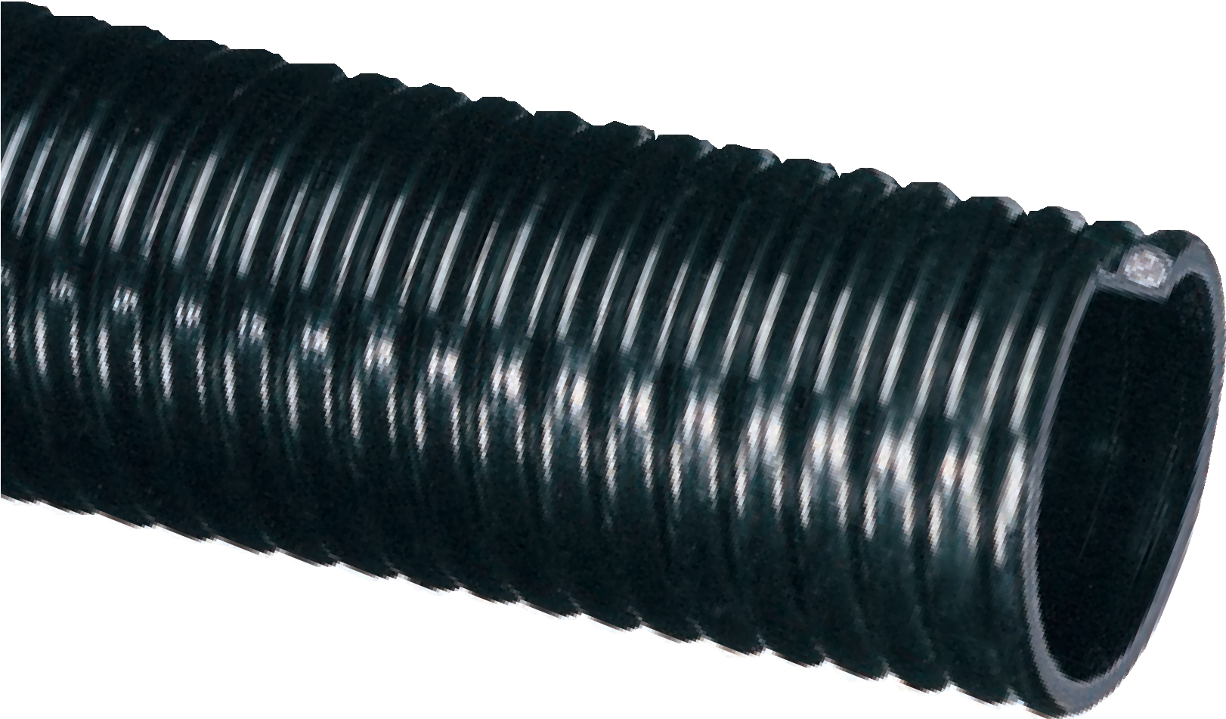

Nominal Specifications
Series | ID  (in.) | ID  (mm) | OD  (in.) | OD  (mm) | Working Pressure (psi) |  | Vacuum Rating (in. Hg) |  | Approx. Bending Radius  (in. @ 68°F) | Standard Length (ft.) | Weight (lbs/ft.)
 |  |  |  |  | 68°F | 104°F | 68°F | 104°F
CF150 | 1-1/2 | 38.1 | 1.84 | 46.7 | 100 | 65 | Full | 28 | 3 | 100 | 0.40
CF200 | 2 | 50.8 | 2.41 | 61.2 | 100 | 65 | Full | 28 | 4 | 100 | 0.75
CF250 | 2-1/2 | 63.5 | 2.93 | 74.5 | 90 | 55 | Full | 28 | 6 | 100 | 0.99
CF300 | 3 | 76.2 | 3.59 | 91.2 | 80 | 50 | Full | 28 | 7 | 100 | 1.34
CF400 | 4 | 101.6 | 4.67 | 118.6 | 65 | 35 | Full | 28 | 11 | 100 | 2.15
CF600 | 6 | 152.4 | 6.87 | 174.4 | 50 | 25 | Full | 28 | 18 | 100/50/20 | 3.76
CF800† | 8 | 204.75 | 9.13 | 232.0 | 35 | 15 | Full | 26 | 24 | 20 | 6.59

W™ Series

Heavy Duty PVC Liquid Suction Hose

General Applications:

Extreme cold conditions (Sizes 4" - 16")
  - Fish suction
  - Gold dredging
  - Pumps, rental and construction dewatering
  - Pumps, trash
  - Slurry handling
  - Water suction – heavy duty
Construction: PVC tube with rigid PVC helix.

Service Temperature:

Sizes 1" - 3": -4°F (-20°C) to 150°F (+65°C)*; Sizes 4" - 16": -40°F (-40°C) to 150°F (+65°C)*

Features and Advantages:
  - “Cold-Flex” Materials (Sizes 4" - 16") – Hose remains flexible in sub-zero temperatures.
  - Transparent Construction – “See-the-flow.” Allows for visual confirmation of material flow.

- Convoluted Outer Cover – Provides increased hose flexibility.
- Phthalate Free
The Original Heavy Duty Suction
Hose

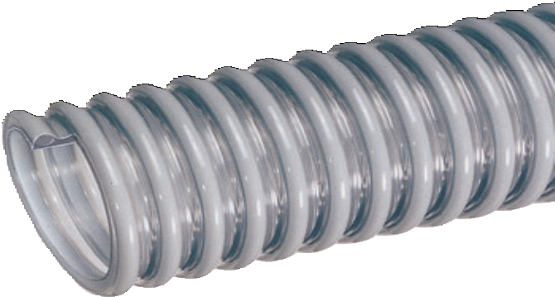

Nominal Specifications
Series | ID  (in.) | ID  (mm) | OD  (in.) | OD  (mm) | Working Pressure (psi) |  | Vacuum Rating (in. Hg) |  | Approx. Bending Radius  (in. @ 68°F) | Standard Length (ft.) | Weight (lbs/ft.)
 |  |  |  |  | 68°F | 104°F | 68°F | 104°F
W100 | 1 | 25.4 | 1.30 | 33.0 | 55 | 35 | Full | 28 | 1 | 100 | 0.21
W125 | 1-1/4 | 31.7 | 1.60 | 40.6 | 50 | 30 | Full | 28 | 2 | 100 | 0.28
W150 | 1-1/2 | 38.1 | 1.85 | 47.0 | 50 | 30 | Full | 28 | 2 | 100 | 0.34
W200 | 2 | 50.8 | 2.40 | 61.0 | 50 | 30 | Full | 28 | 3 | 100 | 0.52
W250 | 2-1/2 | 63.5 | 2.99 | 75.9 | 45 | 25 | Full | 28 | 4 | 100 | 0.77
W300 | 3 | 76.2 | 3.64 | 92.5 | 45 | 25 | Full | 28 | 6 | 100 | 1.18
W400 | 4 | 101.6 | 4.76 | 121.0 | 35 | 18 | Full | 28 | 8 | 100 | 1.92
W500 | 5 | 127.0 | 5.75 | 146.0 | 35 | 18 | 28 | 25 | 12 | 100/20 | 2.42
W600 | 6 | 152.4 | 7.00 | 177.8 | 30 | 15 | 28 | 25 | 14 | 100/20 | 3.76
W800 | 8 | 203.2 | 9.18 | 233.2 | 30 | 15 | 28 | 25 | 24 | 40/20 | 5.99
W1000 | 10 | 254.0 | 11.56 | 293.5 | 25 | 12 | 28 | 25 | 39 | 40/20 | 9.74
W1200 | 12 | 304.8 | 13.64 | 346.5 | 20 | 10 | 28 | 25 | 59 | 40/20 | 12.77
W1400† | 14 | 357.6 | 15.59 | 396.0 | 18 | 8 | 26 | 23 | 80 | 20 | 13.50
W1600† | 16 | 408.4 | 17.72 | 450.0 | 12 | 5 | 24 | 20 | 95 | 20 | 16.00
NOTE: Service life may vary depending on operating conditions and type of material being conveyed.
NOTE: For details of the following compliances, refer to footnotes listed on page 62.
*Actual service temperature range is application dependent.
†Non-stock item, minimum order required. Contact Kuriyama customer service for details.

Our Most Flexible Suction Hose

Features and Advantages:
  - “Cold-Flex” Materials (SH Series; Sizes 2½" - 8") –
Hose remains flexible in sub-zero temperatures.
  - Transparent Construction – “See-the-flow.” Allows for visual conformation of material flow.
- Drain lines
- Dust collection
- Gold dredging
- Water suction – standard duty
Construction: PVC tube with rigid PVC helix. Service Temperature (WH Series): -4ºF (-20ºC) to 150ºF (+65ºC)*
Service Temperature (SH Series): -40ºF (-40ºC) to 150ºF (+65ºC)*

- Convoluted Outer Cover – Provides increased hose flexibility.
- Phthalate Free

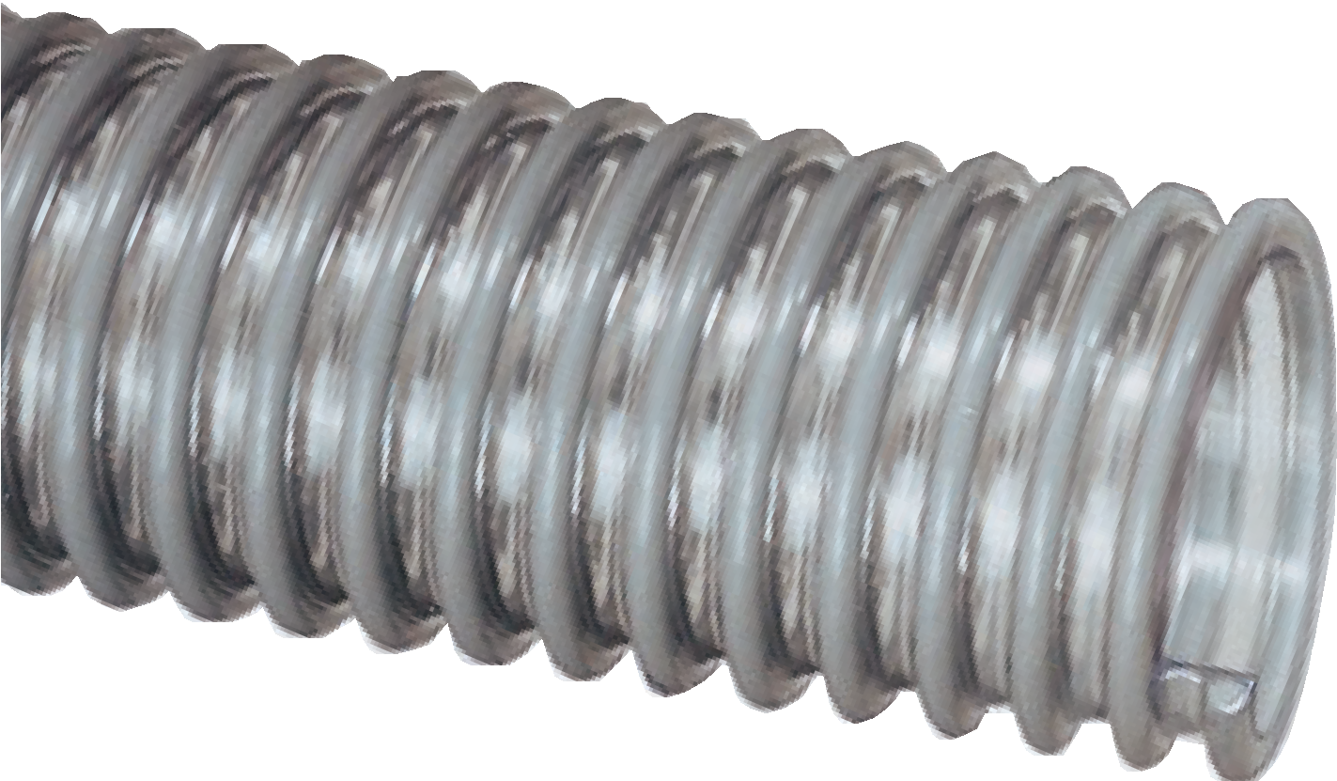

WH™ Series
Standard Duty PVC Liquid Suction Hose
SH™ Series
Standard Duty Low Temperature
PVC Liquid Suction Hose
General Applications:

Nominal Specifications
Series | ID  (in.) | ID  (mm) | OD  (in.) | OD  (mm) | Working Pressure (psi) |  | Vacuum Rating (in. Hg) |  | Approx. Bending Radius  (in. @ 68°F) | Standard Length (ft.) | Weight (lbs/ft.)
 |  |  |  |  | 68°F | 104°F | 68°F | 104°F
WH100 | 1 | 25.4 | 1.22 | 31.0 | 45 | 15 | Full | 24 | 1 | 100 | 0.15
WH125 | 1-1/4 | 31.8 | 1.54 | 39.2 | 40 | 12 | Full | 24 | 1 | 100 | 0.20
WH150 | 1-1/2 | 38.1 | 1.80 | 45.7 | 40 | 12 | Full | 24 | 1.5 | 100 | 0.25
WH200 | 2 | 50.8 | 2.32 | 58.7 | 35 | 10 | 26 | 20 | 2.5 | 100 | 0.31
SH250 | 2-1/2 | 63.5 | 9.97 | 75.5 | 30 | 9 | 24 | 18 | 3 | 100 | 0.43
SH300 | 3 | 76.2 | 3.48 | 88.4 | 25 | 7 | 24 | 18 | 4 | 100 | 0.64
SH400 | 4 | 101.6 | 5.52 | 114.8 | 25 | 7 | 18 | 14 | 6 | 100 | 1.06
SH500 | 5 | 127.0 | 5.57 | 141.5 | 20 | 6 | 16 | 12 | 10 | 100 | 1.47
SH600 | 6 | 153.4 | 6.69 | 169.9 | 20 | 6 | 14 | 10 | 12 | 100 | 2.27
SH800 | 8 | 204.8 | 8.86 | 225.0 | 10 | 3 | 12 | 8 | 24 | 60 | 3.34
NOTE: Service life may vary depending on operating conditions and type of material being conveyed.
NOTE: For details of the following compliances, refer to footnotes listed on page 62.
*Actual service temperature range is application dependent.

WST™ Series
Heavy Duty PVC Fabric Reinforced Suction & Discharge Hose
General Applications:
  - Fish suction
  - Irrigation lines
  - Pumps, rental and construction dewatering
  - Pumps, trash
  - Suction and discharge
  - Water suction – heavy duty

Construction: Double-ply PVC tube, polyester fabric reinforcement and rigid PVC helix.
Service Temperature: -4°F (-20°C) to 150°F (+65°C)*

Features and Advantages:
  - Fabric Reinforcement – Designed with high tensile strength polyester yarn jacket to handle both suction and higher pressure discharge applications.
  - Transparent Construction – “See-the-flow.” Allows for visual confirmation of material flow.

- Easy Slide Helix – Rigid helix design protects hose tube from cover wear, and allows hose to slide easily over rough surfaces. Easy-to-handle.
- Phthalate Free

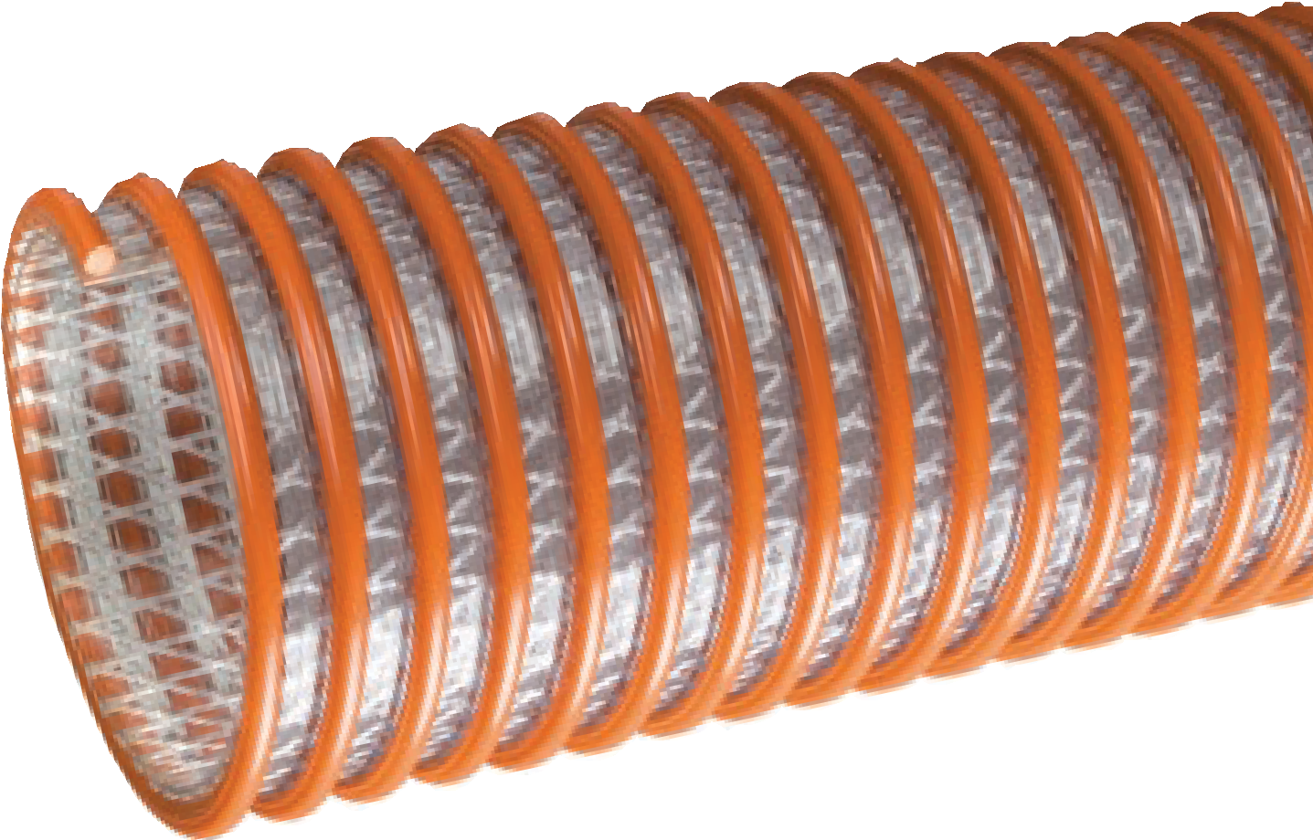

Nominal Specifications
Series | ID  (in.) | ID  (mm) | OD  (in.) | OD  (mm) | Working Pressure (psi) |  | Vacuum Rating (in. Hg) |  | Approx. Bending Radius  (in. @ 68°F) | Standard Length (ft.) | Weight (lbs/ft.)
 |  |  |  |  | 68°F | 104°F | 68°F | 104°F
WST150 | 1-1/2 | 38.1 | 1.95 | 49.5 | 110 | 70 | Full | 28 | 2.5 | 100 | 0.42
WST200 | 2 | 50.8 | 2.60 | 66.0 | 100 | 65 | Full | 28 | 4 | 100 | 0.74
WST300 | 3 | 76.2 | 3.62 | 92.0 | 100 | 50 | Full | 28 | 6 | 100/20 | 1.13
WST400 | 4 | 101.6 | 4.76 | 121.0 | 75 | 37 | Full | 28 | 8 | 100/20 | 1.74
WST500 | 5 | 127.0 | 5.98 | 151.9 | 70 | 35 | 28 | 25 | 11 | 100/20 | 2.95
WST600 | 6 | 152.4 | 7.17 | 182.1 | 70 | 35 | 28 | 25 | 13 | 100/20 | 3.88
WST800 | 8 | 203.5 | 9.21 | 234.0 | 60 | 30 | 26 | 20 | 18 | 25/20 | 5.57

Features and Advantages:
  - Highly Durable PVC Tube – Formulated from highly durable PVC compound for increased abrasion and tear resistance.
  - Convoluted Outer Cover – Provides increased hose flexibility.
- Phthalate Free
Construction: PVC tube with rigid PVC helix. Service Temperature: -4°F (-20°C) to 150°F (+65°C)*

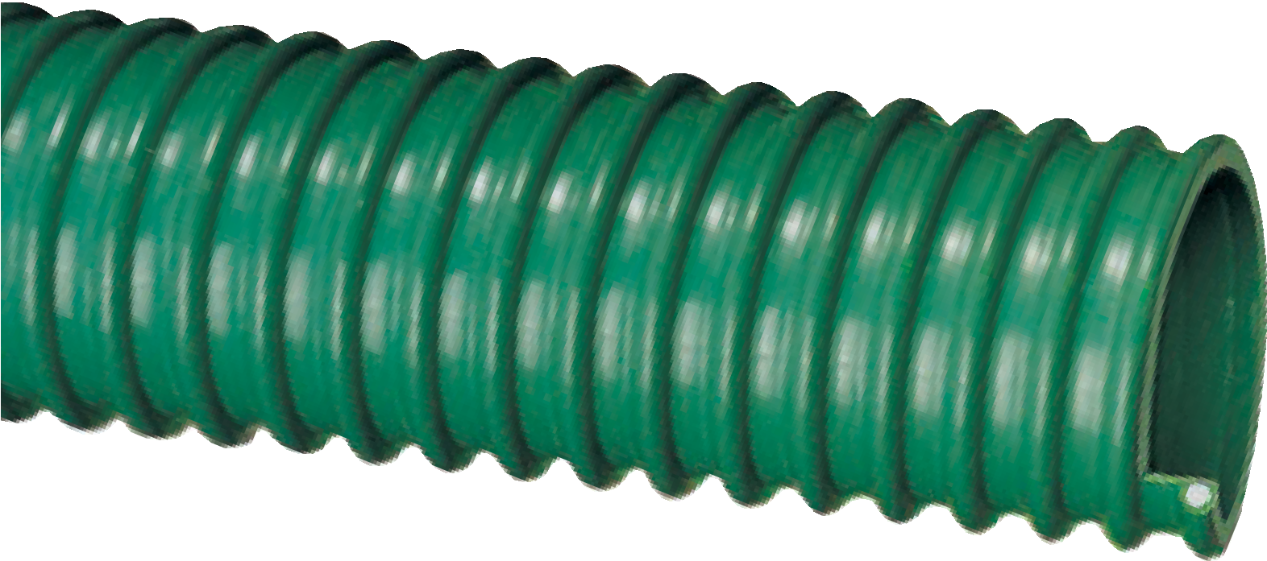
WG™ Series
Heavy Duty PVC Liquid Suction Hose
General Applications:
- Fish suction
- Irrigation lines
- Pumps, rental and construction dewatering
- Pumps, trash
- Rock dusting
- Water suction – heavy duty

Nominal Specifications
Series | ID  (in.) | ID  (mm) | OD  (in.) | OD  (mm) | Working Pressure (psi) |  | Vacuum Rating (in. Hg) |  | Approx. Bending Radius  (in. @ 68°F) | Standard Length (ft.) | Weight (lbs/ft.)
 |  |  |  |  | 68°F | 104°F | 68°F | 104°F
WG150 | 1-1/2 | 38.1 | 1.85 | 47.0 | 50 | 25 | Full | 28 | 2 | 100 | 0.34
WG200 | 2 | 50.8 | 2.40 | 61.0 | 50 | 25 | Full | 28 | 3 | 100 | 0.52
WG300 | 3 | 76.2 | 3.64 | 92.5 | 45 | 25 | Full | 28 | 6 | 100 | 1.18
WG400 | 4 | 101.6 | 4.76 | 120.9 | 35 | 18 | Full | 28 | 8 | 100 | 1.93
NOTE: Service life may vary depending on operating conditions and type of material being conveyed.
NOTE: For details of the following compliances, refer to footnotes listed on page 62.
*Actual service temperature range is application dependent.

“Marine Hose” MH™ Series
PVC Suction Hose

General Applications:
- Drain lines
- Marine bilge discharge
- Marine plumbing
- Recreational vehicle (RV) plumbing
Construction: PVC tube with rigid PVC helix. Service Temperature: -4°F (-20°C) to 150°F (+65°C)*

Features and Advantages:
- Odor-resistant Tube – Special additives help eliminate the build-up of unwanted odors.
- Convoluted Outer Cover – Provides increased hose flexibility.
- Easy Installation – Ideal for working in confined areas. Permits installers to make smooth, tight turns. Requires fewer fittings than rigid pipe.
- Phthalate Free

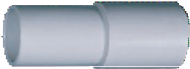

Part No. A2150L1
Custom Molded Cuff — 11/2" Molded cuff (shown above) is designed for use with Tigerflex® Series MH150 marine hose.

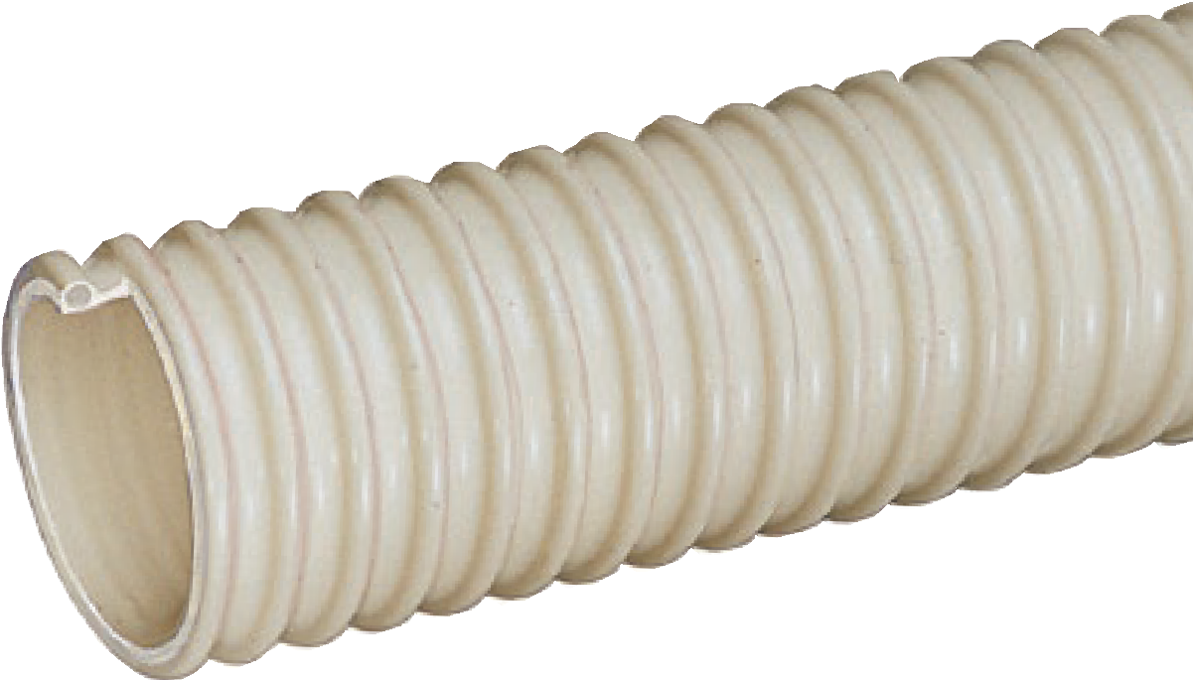

Nominal Specifications
Series | ID  (in.) | ID  (mm) | OD  (in.) | OD  (mm) | Working Pressure (psi) |  | Vacuum Rating (in. Hg) |  | Approx. Bending Radius  (in. @ 68°F) | Standard Length (ft.) | Weight (lbs/ft.)
 |  |  |  |  | 68°F | 104°F | 68°F | 104°F
MH100 | 1 | 25.4 | 1.22 | 31.0 | 45 | 15 | Full | 24 | 1 | 100 | 0.15
MH125 | 1-1/4 | 32.0 | 1.49 | 38.0 | 40 | 12 | Full | 24 | 1.5 | 100 | 0.20
MH150 | 1-1/2 | 38.1 | 1.77 | 45.0 | 40 | 12 | Full | 24 | 2 | 100 | 0.25
MH200 | 2 | 50.8 | 2.32 | 59.0 | 35 | 10 | 26 | 20 | 2.5 | 100 | 0.31

“Spa Hose” FMCR™ Series

PVC Suction Hose

General Applications:

Commonly referred to as “flex pipe”
  - Drain lines
  - Spa, pool and hot tub plumbing
Construction: PVC tube with rigid PVC helix.
Service Temperature: -4°F (-20°C) to 150°F (+65°C)*

Features and Advantages:
- Precision Controlled OD – Designed to be glued into Schedule 40 PVC fittings.
- Easy Installation – Ideal for working in confined areas. Permits installers to make smooth, tight turns. Requires fewer fittings than rigid pipe when plumbing a normal spa or hot tub application.

- Phthalate Free

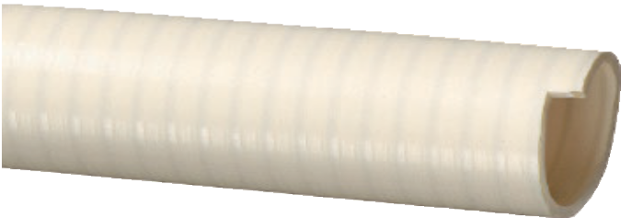

Nominal Specifications
Series | IPS Size (in.) | OD  (in.) | OD  (mm) | Working Pressure (psi) |  | Vacuum Rating (in. Hg) |  | Approx. Bending Radius  (in. @ 68°F) | Standard Length (ft.) | Weight (lbs/ft.)
 |  |  |  | 68°F | 104°F | 68°F | 104°F
F16MCR | 1/2 | 0.850 | 21.50 | 100 | 70 | 28 | 26 | 2 | 100/50 | 0.14
F20MCR | 3/4 | 1.053 | 26.75 | 100 | 70 | 28 | 26 | 2 | 100/50 | 0.21
F27MCR | 1 | 1.320 | 33.52 | 100 | 70 | 28 | 24 | 3 | 100/50 | 0.28
F36MCR | 1-1/4 | 1.663 | 42.25 | 80 | 55 | 28 | 24 | 4 | 100/50 | 0.37
F42MCR | 1-1/2 | 1.904 | 48.35 | 70 | 50 | 28 | 24 | 4 | 100/50 | 0.44
F52MCR | 2 | 2.381 | 60.48 | 70 | 50 | 28 | 24 | 6 | 100/50 | 0.58
F78MCR | 3 | 3.500 | 89.00 | 65 | 40 | 28 | 22 | 8 | 50 | 1.20
NOTE: For details of the following compliances, refer to footnotes listed on page 62.
NOTE: Use with recommended primers and PVC cements; consult with glue supplier for recommendations. Coils of Tigerflex® Spa Hose should not be stacked more than five coils high. Hose which has been stacked high may be damaged over time.
NOTE: Black color available upon request. Minimum order quantity may apply. Contact Kuriyama customer service for details.
*Actual service temperature range is application dependent.

Product Warning
Like other materials, Spa Hoses can be damaged by rodents or insects, including termites. Our warranty does not cover damages caused by them. Spa Hose should not be used underground in areas infested by termites. This product warning shall be given to every purchaser of Spa Hose. (Rev. 7/98)

Features and Advantages:
  - Superior Rubber Compounds – Tigerflex™ uses only the best available EPDM compounds, which provide the ideal combination of light-weight, flexibility, durability and chemical resistance.
  - Superior Flexibility – Our tests show up to 22% more flexible than the competition, especially in sub-zero weather! Tiger™ Green comes off the trucks more flexible and easier to handle than other similar hoses.

- Easy Slide Helix – Rigid helix design protects hose tube from cover wear, and allows hose to slide easily over rough surfaces and around corners. Easy-to-handle.
- Convoluted Outer Cover – Provides increased hose flexibility.
- “Cold-Flex” Materials – Hose remains flexible in sub-zero temperatures.
- Phthalate Free

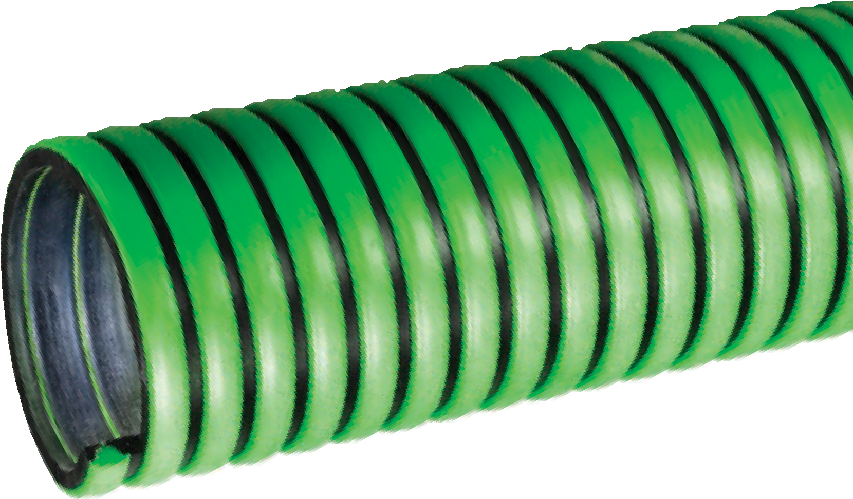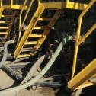

Tiger™ Green TG™ Series
EPDM Suction Hose
General Applications:
- Agriculture liquid fertilizers
- Irrigation lines
- Liquid manure handling
- Marine bilge discharge
- Pumps, rental and construction dewatering
- Pumps, trash
- Septic and wastewater handling
- Used frack solution removal
- Water suction – standard duty
Construction: EPDM tube with polyethylene helix. Service Temperature: -40°F (-40°C) to 160°F (+71°C)*

Nominal Specifications
Series | ID  (in.) | ID  (mm) | OD  (in.) | OD  (mm) | Working Pressure (psi) |  | Vacuum Rating (in. Hg) |  | Approx. Bending Radius  (in. @ 68°F) | Standard Length (ft.) | Weight (lbs/ft.)
 |  |  |  |  | 68°F | 104°F | 68°F | 104°F
TG100 | 1 | 25.4 | 1.40 | 35.5 | 65 | 45 | FULL | 28 | 2 | 100 | 0.28
TG125 | 1-1/4 | 31.8 | 1.63 | 41.4 | 60 | 40 | FULL | 28 | 3 | 100 | 0.33
TG150 | 1-1/2 | 38.1 | 1.93 | 49.0 | 50 | 35 | FULL | 28 | 3 | 100 | 0.44
TG200 | 2 | 50.8 | 2.51 | 63.8 | 50 | 35 | FULL | 28 | 5 | 100 | 0.67
TG250 | 2-1/2 | 63.5 | 3.07 | 78.0 | 45 | 30 | FULL | 28 | 5.5 | 100 | 0.95
TG300 | 3 | 76.2 | 3.60 | 91.5 | 45 | 30 | FULL | 26 | 7 | 100 | 1.14
TG400 | 4 | 101.6 | 4.70 | 119.5 | 40 | 25 | FULL | 26 | 11.5 | 100 | 1.84
TG600 | 6 | 152.4 | 6.85 | 174.0 | 30 | 20 | 28 | 24 | 20 | 100/20 | 3.07
NOTE: Service life may vary depending on operating conditions and type of material being conveyed.
NOTE: For details of the following compliances, refer to footnotes listed on page 62.
NOTE: Other colors available upon request. Minimum order quantity may apply. Contact Kuriyama Tigerflex department for details.

Service Temperature: -40°F (-40°C) to 160°F (+71°C)*

Features and Advantages:
  - Superior Rubber Compounds – Tigerflex™ uses only the best available EPDM compounds, which provide the ideal combination of light-weight, flexibility, durability and chemical resistance.
  - Superior Flexibility – Our tests show up to 22% more flexible than the competition, especially in sub-zero weather! Tiger™ Green comes off the trucks more flexible and easier to handle than other similar hoses.

- Easy Slide Helix – Rigid helix design protects hose tube from cover wear, and allows hose to slide easily over rough surfaces and around corners. Easy-to-handle.
- Convoluted Outer Cover – Provides increased hose flexibility.
- “Cold-Flex” Materials – Hose remains flexible in sub-zero temperatures.
- Phthalate Free

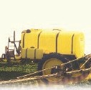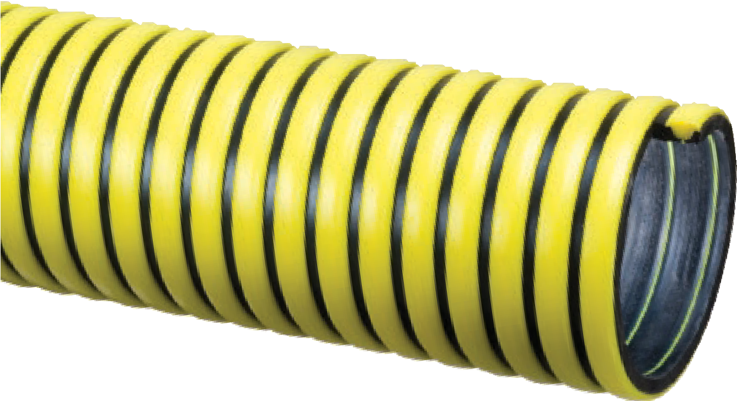
G
•
•
Tiger™ Yellow
TY™ Series
EPDM Suction Hose
eneral Applications:
Agriculture liquid fertilizers Irrigation lines
- Liquid manure handling
- Marine bilge discharge
- Pumps, rental and construction dewatering
- Pumps, trash
- Septic and wastewater handling
- Used frack solution removal
- Water suction – standard duty
Construction: EPDM tube with polyethylene helix.

Nominal Specifications
Series | ID  (in.) | ID  (mm) | OD  (in.) | OD  (mm) | Working Pressure (psi) |  | Vacuum Rating (in. Hg) |  | Approx. Bending Radius  (in. @ 68°F) | Standard Length (ft.) | Weight (lbs/ft.)
 |  |  |  |  | 68°F | 104°F | 68°F | 104°F
TY100 | 1 | 25.4 | 1.40 | 35.5 | 65 | 45 | FULL | 28 | 2 | 100 | 0.28
TY125 | 1-1/4 | 31.8 | 1.63 | 41.4 | 60 | 40 | FULL | 28 | 3 | 100 | 0.33
TY150 | 1-1/2 | 38.1 | 1.93 | 49.0 | 50 | 35 | FULL | 28 | 3 | 100 | 0.44
TY200 | 2 | 50.8 | 2.51 | 63.8 | 50 | 35 | FULL | 28 | 5 | 100 | 0.67
TY300 | 3 | 76.2 | 3.60 | 91.5 | 45 | 30 | FULL | 26 | 7 | 100 | 1.14
TY400 | 4 | 101.6 | 4.70 | 119.5 | 40 | 25 | FULL | 26 | 11.5 | 100 | 1.84
NOTE: Service life may vary depending on operating conditions and type of material being conveyed.
NOTE: For details of the following compliances, refer to footnotes listed on page 62.
NOTE: Contact your nearest KOA warehouse for availability of 50 ft. lengths.
*Actual service temperature range is application dependent.

Tiger™ Red TRED™ Series

Tiger™ Blue TBLU™ Series

EPDM Suction Hoses

General Applications:

Agriculture liquid fertilizers
  - Irrigation lines
  - Liquid manure handling
  - Marine bilge discharge
  - Pumps, rental and construction dewatering
  - Pumps, trash
  - Septic and wastewater handling
  - Used frack solution removal
  - Water suction – standard duty
Construction: EPDM tube with polyethylene helix.
Service Temperature: -40°F (-40°C) to 160°F (+71°C)*

Features and Benefits:
  - Superior Rubber Compounds – Tigerflex™ uses only the best available EPDM compounds, which provide the ideal combination of light-weight, flexibility, durability and chemical resistance.
  - Superior Flexibility – Our tests show up to 22% more flexible than the competition, especially in sub-zero weather! Tiger™ Green comes off the trucks more flexible and easier to handle than other similar hoses.
TRED

TBLU

- Easy Slide Helix – Rigid helix design protects hose tube from cover wear, and allows hose to slide easily over rough surfaces and around corners. Easy-to-handle.
- Convoluted Outer Cover – Provides increased hose flexibility.
- “Cold-Flex” Materials – Hose remains flexible in sub-zero temperatures.
- Color Choices – Choose from colors red or blue to match company equipment.
- Phthalate Free

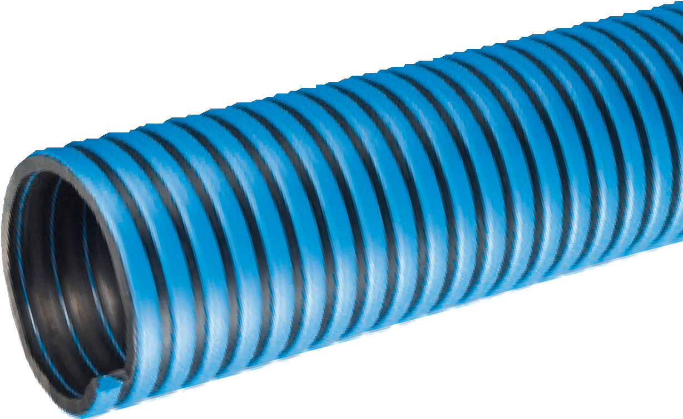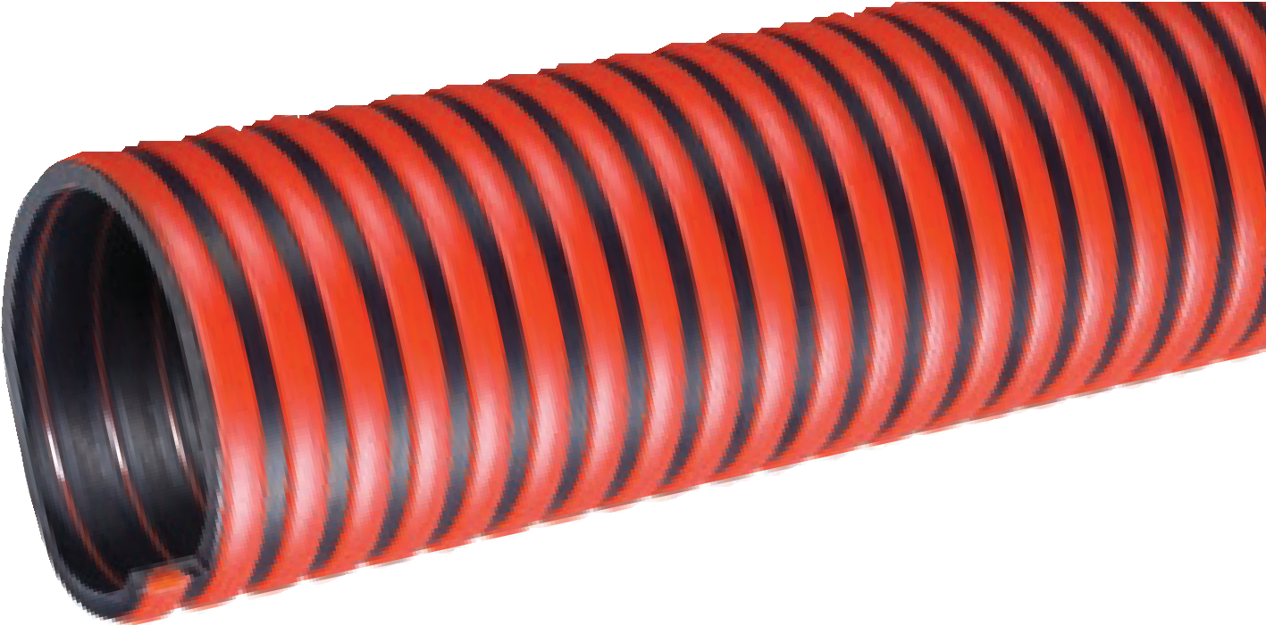

Nominal Specifications
Series | ID  (in.) | ID  (mm) | OD  (in.) | OD  (mm) | Working Pressure (psi) |  | Vacuum Rating (in. Hg) |  | Approx. Bending Radius  (in. @ 68°F) | Standard Length (ft.) | Weight (lbs/ft.)
 |  |  |  |  | 68°F | 104°F | 68°F | 104°F
TRED/TBLU200 | 2 | 50.8 | 2.51 | 63.8 | 50 | 35 | FULL | 28 | 5 | 100 | 0.67
TRED/TBLU300 | 3 | 76.2 | 3.60 | 91.5 | 45 | 30 | FULL | 26 | 7 | 100 | 1.14
TRED/TBLU400 | 4 | 101.6 | 4.70 | 119.5 | 40 | 25 | FULL | 26 | 11.5 | 100 | 1.84
NOTE: Service life may vary depending on operating conditions and type of material being conveyed.
NOTE: For details of the following compliances, refer to footnotes listed on page 62.

Tiger™ TSD™ Series

EPDM Fabric Reinforced Suction & Discharge Hose

eneral Applications:
G
• Agricultur
• Agri-foam

e liquid fertilizers systems
  - Liquid manure handling
  - Pumps, rental and construction dewatering
  - Pumps, trash
  - Septic and wastewater handling
  - Suction and discharge
  - Water suction – heavy duty
Construction: Double-ply EPDM, polyester fabric reinforcement and polyethylene helix.
Service Temperature: -40°F (-40°C) to 160°F (+71°C)*

Features and Advantages:
- Superior Rubber Compounds – Tigerflex™ uses only the best available EPDM compounds, which provide the ideal combination of light-weight, flexibility, durability and chemical resistance.
- Fabric Reinforcement – Designed with high tensile strength polyester yarn jacket to handle both suction, and higher pressure discharge applications.
- “Cold-Flex” Materials – Hose remains flexible in sub-zero temperatures.

- Easy Slide Helix – Rigid helix design protects hose tube from cover wear, and allows hose to slide easily over rough surfaces and around corners. Easy-to-handle.
- Convoluted Outer Cover – Provides increased hose flexibility.
- Phthalate Free

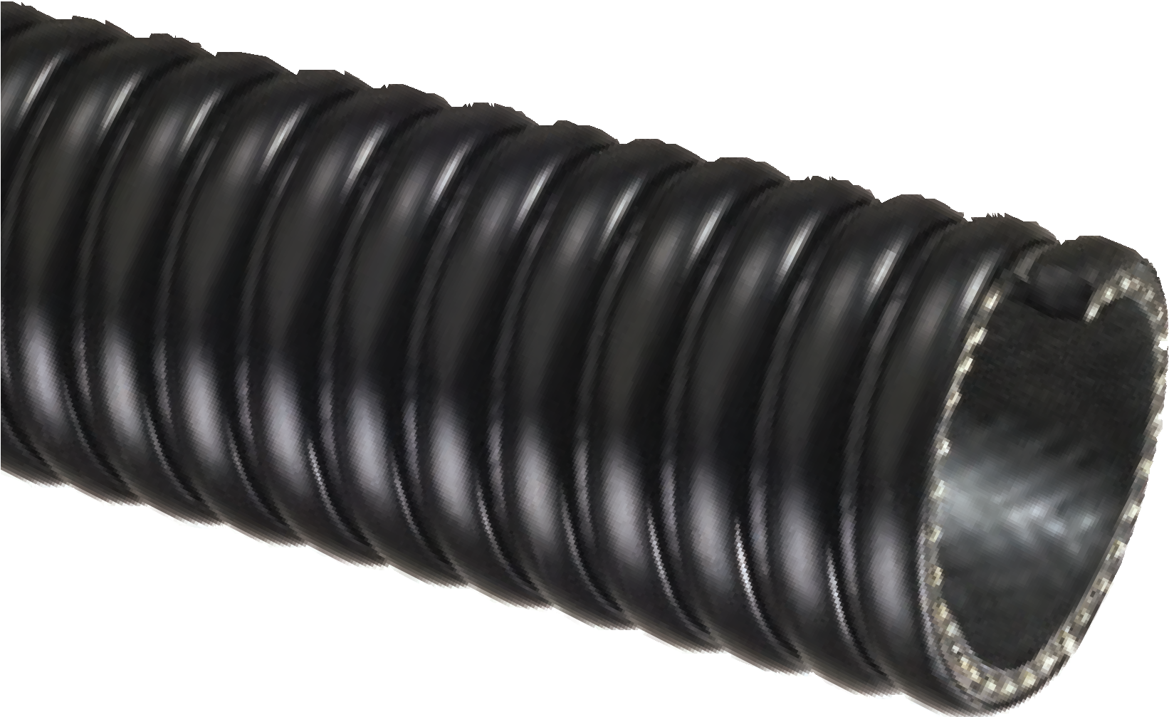

Nominal Specifications
Series | ID  (in.) | ID  (mm) | OD  (in.) | OD  (mm) | Working Pressure (psi) |  | Vacuum Rating (in. Hg) |  | Approx. Bending Radius  (in. @ 68°F) | Standard Length (ft.) | Weight (lbs/ft.)
 |  |  |  |  | 68°F | 104°F | 68°F | 104°F
TSD125 | 1-1/4 | 31.8 | 1.70 | 43.2 | 100 | 75 | FULL | 28 | 3 | 100 | 0.41
TSD150 | 1-1/2 | 38.1 | 2.00 | 50.7 | 100 | 75 | FULL | 28 | 3 | 100 | 0.51
TSD200 | 2 | 50.8 | 2.54 | 64.5 | 100 | 75 | FULL | 28 | 5 | 100 | 0.73
TSD300 | 3 | 76.2 | 3.62 | 92.0 | 90 | 65 | FULL | 26 | 8 | 100 | 1.18
NOTE: Service life may vary depending on operating conditions and type of material being conveyed.
NOTE: For details of the following compliances, refer to footnotes listed on page 62.
NOTE: Contact your nearest KOA warehouse for availability of 50 ft. lengths.

STIG™ Series

Extremely Heavy Duty
Polyurethane Lined Material Handling Hose

General Applications:

Fly ash collection
  - Industrial Vacuum Equipment
  - Material chutes
  - Material handling – heavy duty abrasive
  - Milling machine scrap recovery
NEW

Our Most Internal Abrasion Resistant Hose!

Rock, gravel, sand and crushed concrete vacuuming
  - Shot blast recovery
Construction: PVC cover with extra thick polyurethane liner, rigid PVC helix and grounding wire.
Service Temperature: -4°F (-20°C) to 150°F (+65°C)*

Features and Advantages:

  - Extra Thick Abrasion Resistant Polyurethane Liner – Designed for dry applications where severe abrasion is a factor. Provides for longer hose life and lower operating costs versus rubber or PVC hoses.
  - Grounding Wire – Multi-strand wire helps prevent the build-up of static electricity for added safety and to help keep material flowing smoothly. It’s embedded within the rigid helix to prevent contamination of transferred materials.
- Convoluted Outer Cover – Provides increased hose flexibility.
• Oil Resistant Polyurethane Liner – Resists most animal and petroleum based oils.
- Phthalate Free

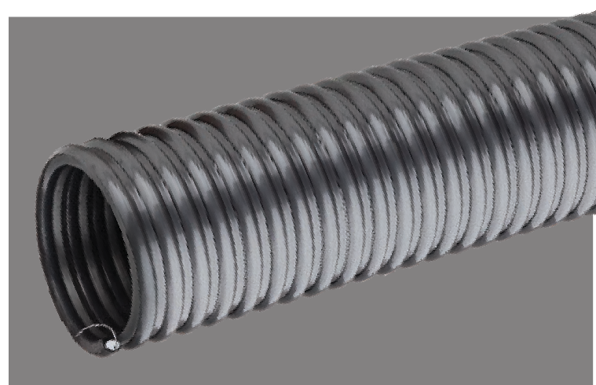

Nominal Specifications
Series | ID  (in.) | ID  (mm) | OD  (in.) | OD  (mm) | Working Pressure (psi) |  | Vacuum Rating (in. Hg.) |  | Min. Bending Radius  (in. @ 68ºF) | Standard Length (ft.) | Weight (lbs./ft.)
 |  |  |  |  | 68ºF | 104ºF | 68ºF | 104ºF
STIG250 | 2-1/2 | 63.5 | 3.04 | 77.2 | 45 | 22 | Full | 28 | 7 | 100 | 0.92
STIG300 | 3 | 76.2 | 3.77 | 95.8 | 45 | 22 | Full | 28 | 8 | 100 | 1.50
STIG400 | 4 | 101.6 | 4.86 | 123.5 | 40 | 20 | Full | 28 | 12 | 100/20 | 2.32
STIG500 | 5 | 127.0 | 5.86 | 148.8 | 35 | 18 | Full | 28 | 16 | 60/20 | 3.43
STIG600 | 6 | 153.4 | 7.18 | 182.4 | 35 | 18 | Full | 28 | 20 | 100/50/20 | 4.54
STIG800 | 8 | 204.8 | 9.49 | 241.0 | 35 | 18 | 28 | 25 | 25 | 50/20 | 7.53
NOTE: Service life may vary depending on operating conditions and type of material being conveyed.
*Actual service temperature range is application dependent.
CAUTION: This product is designed to dissipate static electricity when the embedded grounding wire is physically extracted and securely connected to ground, through the fitting or by other means.

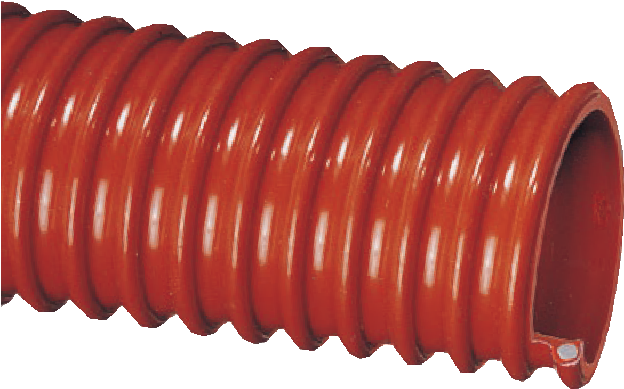

WOR™ Series

Standard Duty Oil Resistant PVC Suction Hose

General Applications:

Environmental clean-up
  - Oil skimming
  - Oil slurries
  - Oil suction
  - Vapor recovery – hydrocarbon emmissions
Construction: Oil resistant PVC tube with rigid PVC helix.
Service Temperature: 5°F (-15°C) to 150°F (+65°C)*

Features and Advantages:
- Oil Resistant PVC – Made with special oil resistant compounds which exhibit medium resistance to oil and other hydrocarbons.
- Convoluted Outer Cover – Provides increased hose flexibility.
- Phthalate Free

Nominal Specifications
Series | ID  (in.) | ID  (mm) | OD  (in.) | OD  (mm) | Working Pressure (psi) |  | Vacuum Rating (in. Hg) |  | Approx. Bending Radius  (in. @ 68°F) | Standard Length (ft.) | Weight (lbs/ft.)
 |  |  |  |  | 68°F | 104°F | 68°F | 104°F
WOR150 | 1-1/2 | 38.1 | 1.92 | 48.8 | 50 | 25 | 28 | 24 | 3 | 100 | 0.31
WOR200 | 2 | 50.8 | 2.40 | 61.0 | 40 | 20 | 28 | 24 | 4 | 100 | 0.50
WOR300 | 3 | 76.2 | 3.64 | 92.5 | 40 | 20 | 28 | 24 | 6 | 100 | 1.17
WOR400 | 4 | 101.6 | 4.72 | 119.9 | 35 | 18 | 28 | 22 | 10 | 100 | 1.74

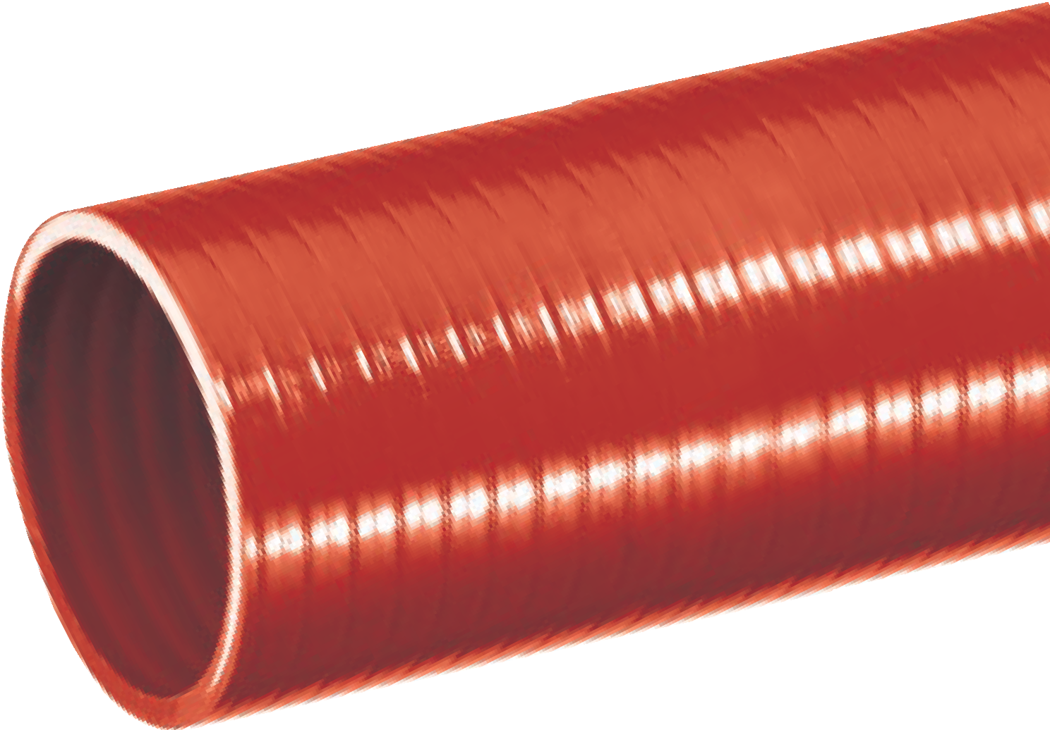

ORV™ Series
Standard Duty Oil Resistant
PVC Suction Hose

General Applications:
- Environmental cleanup
- Oil skimming
- Oil slurries
- Oil suction
- Vapor recovery – hydrocarbon emissions
Construction: Oil resistant PVC tube with rigid PVC helix.
Service Temperature: 5°F (-15°C) to 150°F (+65°C)*

Features and Benefits:
- Oil Resistant PVC Tube – Made with special oil resistant compounds which exhibit medium resistance to oil and other hydrocarbons.
- Smooth Outer Cover – Provides increased pressure rating and smooth surface for banding.
- Phthalate Free

Nominal Specifications
Series | ID  (in.) | ID  (mm) | OD  (in.) | OD  (mm) | Working Pressure (psi) |  | Vacuum Rating (in. Hg) |  | Approx. Bending Radius  (in. @ 68°F) | Standard Length (ft.) | Weight (lbs/ft.)
 |  |  |  |  | 68°F | 104°F | 68°F | 104°F
ORV075 | 3/4 | 19.0 | 1.01 | 25.6 | 100 | 60 | 28 | 26 | 3 | 100 | 0.19
ORV100 | 1 | 25.4 | 1.26 | 32.0 | 80 | 50 | 28 | 26 | 3 | 100 | 0.24
ORV150 | 1-1/2 | 38.1 | 1.76 | 44.6 | 60 | 40 | 28 | 24 | 5 | 100 | 0.35
ORV200 | 2 | 50.8 | 2.32 | 59.0 | 60 | 40 | 28 | 24 | 7 | 100 | 0.55
ORV300 | 3 | 76.2 | 3.41 | 86.7 | 65 | 40 | 28 | 22 | 10 | 100 | 1.09
NOTE: Service life may vary depending on operating conditions and type of material being conveyed.
NOTE: For details of the following compliances, refer to footnotes listed on page 62.
*Actual service temperature range is application dependent.

Oil Vac™ OV™ Series

Heavy Duty Oil Resistant Polyurethane Suction Hose

Features and Advantages:
TM
  - Oil Resistant Polyurethane Tube – Handles most fuels and oils. Excellent resistance to gasoline, diesel, ethanol, blends (up to E30) and biodiesels (up to B100).
  - Abrasion Resistant Polyurethane Tube – Solid polyurethane tube outlasts other materials when severe abrasion is a factor. Provides for longer hose life and lower operating costs versus rubber or PVC hoses.

General Applications:
- Material handling - heavy duty abrasive
- Material chutes
- Oil suction – heavy duty
Construction: Polyurethane tube with rigid PVC helix.
Service Temperature: -40°F (-40°C) to 150°F (+65°C)*

- Transparent Construction – “See-the-flow.” Allows for visual confirmation of material flow.
- “Cold-Flex” Materials – Hose remains flexible in sub-zero temperatures.
- Phthalate Free

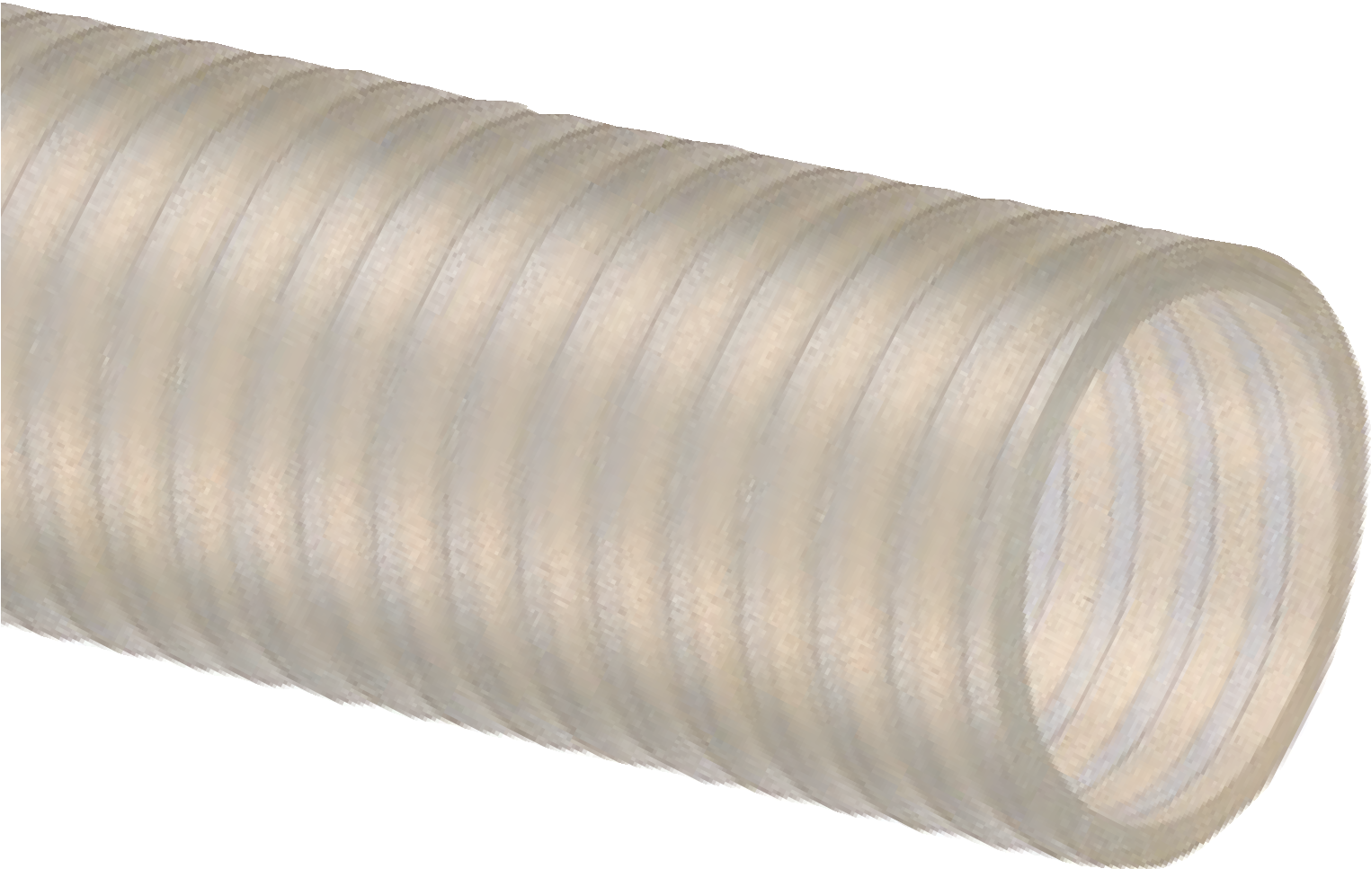

Nominal Specifications
Series | ID  (in.) | ID  (mm) | OD  (in.) | OD  (mm) | Working Pressure (psi) |  | Vacuum Rating (in. Hg) |  | Approx. Bending Radius  (in. @ 68°F) | Standard Length (ft.) | Weight (lbs/ft.)
 |  |  |  |  | 68°F | 104°F | 68°F | 104°F
OV100 | 1 | 25.4 | 1.26 | 32.0 | 85 | 60 | 28 | 26 | 3 | 100 | 0.23
OV125 | 1-1/4 | 31.7 | 1.49 | 37.8 | 85 | 60 | 28 | 24 | 5 | 100 | 0.30
OV150 | 1-1/2 | 38.1 | 1.76 | 44.6 | 70 | 50 | 28 | 24 | 5 | 100 | 0.35
OV200 | 2 | 50.8 | 2.32 | 59.0 | 65 | 45 | 28 | 24 | 7 | 100 | 0.55

  - For food grade and non-food grade applications.
  - Easy assembly.
  - Provides smoother surface for banding behind coupling.
BCCF™ Series
  - Clear, food grade, rigid PVC coils
  - For hoses with a high-profile, counterclockwise helix*
Food Grade, High-Profile, Counterclockwise Coils
Nominal Specifications
Part No. | Fits Hose ID | Color | Weight (lbs/ea.)
BCCF1.5 | 1-1/2" | Clear | 0.20
BCCF2 | 2" | Clear | 0.30
BCCF3 | 3" | Clear | 0.60
BCCF4 | 4" | Clear | 0.90
BCCF5 | 5" | Clear | 1.10
BCCF6 | 6" | Clear | 1.30
BCCF8 | 8" | Clear | 1.40

- Packaged singly: One piece to make one complete hose assembly coupled at each end.
- 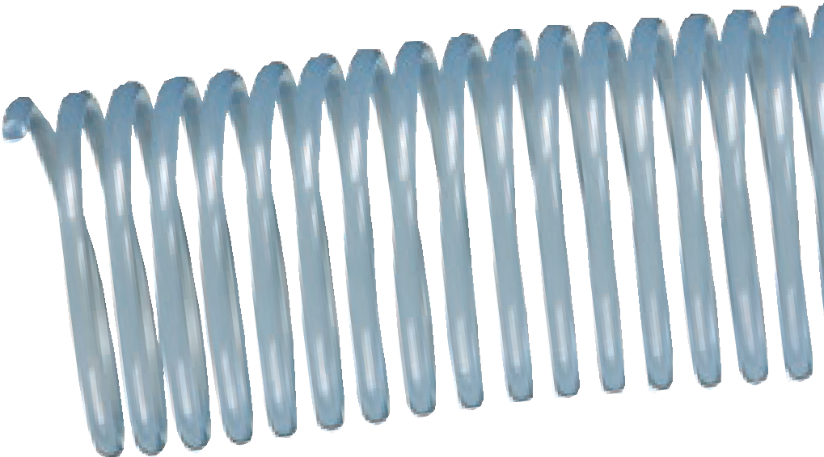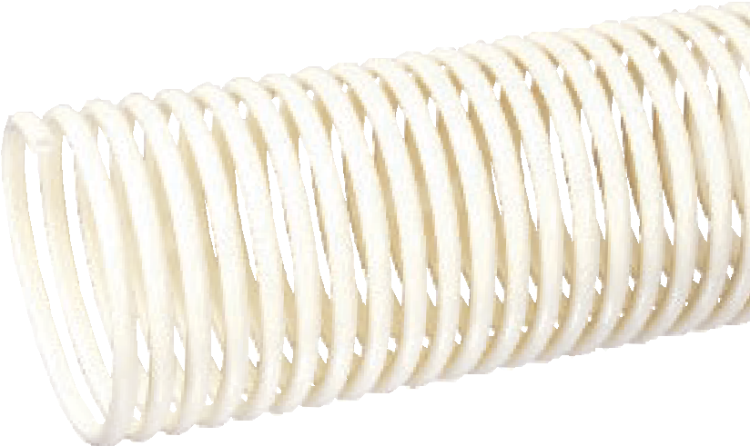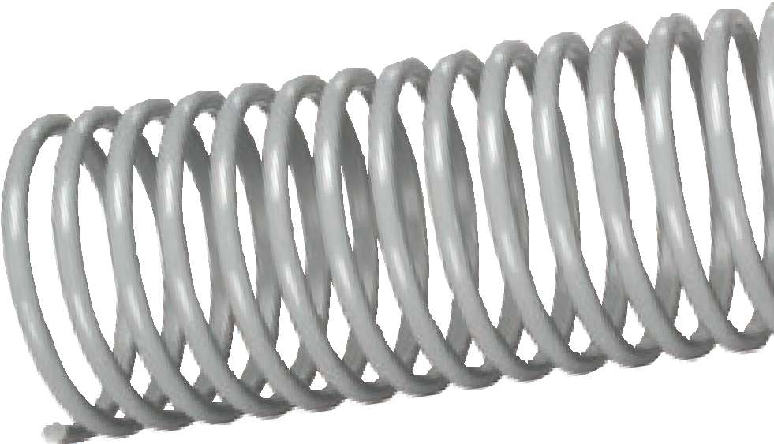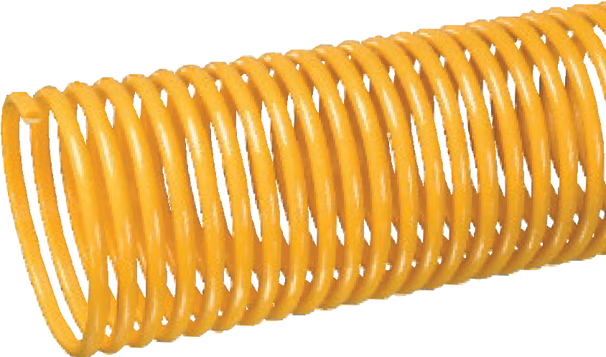Cut one piece in half into two equal pieces; thread between hose helix.

Banding Coils
Rigid PVC Coils
Accessories

BCWF™ Series
  - White, food grade, rigid PVC coils
  - For hoses with a low-profile, counterclockwise helix*
Food Grade, Low-Profile, Counterclockwise Coils
Nominal Specifications
Part No. | Fits Hose ID | Color | Weight (lbs/ea.)
BCWF2 | 2" | White | 0.25
BCWF3 | 3" | White | 0.45
BCRT™ Series
  - Grey, non-food grade, rigid PVC coils
  - For hoses with a high-profile, clockwise helix*
Non-Food Grade, High-Profile, Clockwise Coils
Nominal Specifications
Part No. | Fits Hose ID | Color | Weight (lbs/ea.)
BCRT2 | 2" Grey 0.30
BCRT3 | 3" Grey 0.60
BCRT4 | 4" Grey 0.90

BCYL™ Series
  - Yellow, non-food grade, rigid PVC coils
  - For hoses with a low-profile, counterclockwise helix*
Non-Food Grade, Low-Profile, Counterclockwise Coils
Nominal Specifications
Part No. | Fits Hose ID | Color | Weight (lbs./ea.)
BCYL2 | 2.02" Yellow 0.25
BCYL3 | 3.03" Yellow 0.45
BCYL4 | 4.04" Yellow 0.75
BCCF

BCWF

BCRT

BCYL

*Refer to Tigerflex Accessories compatability chart on page 59-61.

SLV-VLT

SLV-DRP

SLV-NDH
SLV-VAP
Flexible PVC Sleeves

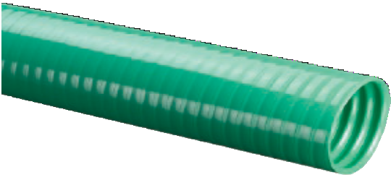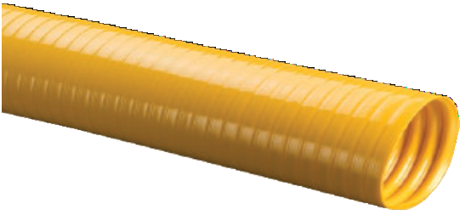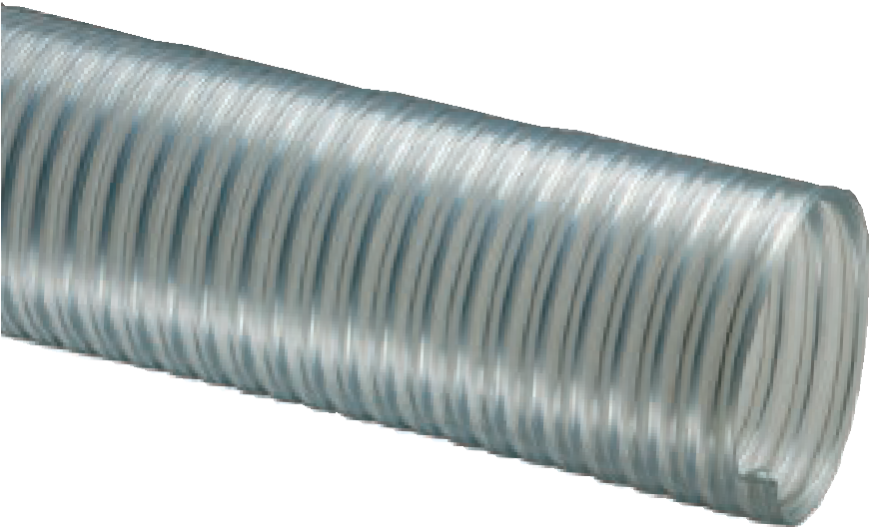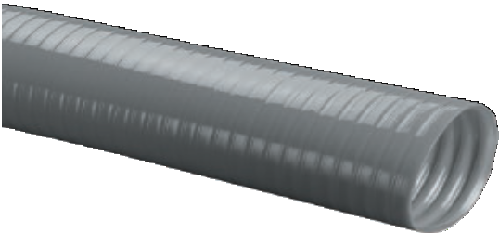Helps prevent overbending near the coupling.
- Cut into approximately 12-inch lengths; screw onto hose at each end. thalate Free
• Ph

SLV-VLT™ Series
  - Clear, food grade, static dissipative PVC
  - For hoses with a high-profile, counterclockwise helix*

Nominal Specifications
Part No. | Fits Hose ID | Color | Weight (lbs/ea.)
SLV-VLT3X3 | 3" | Clear | 3.50
SLV-VLT4x3 | 4" | Clear | 4.29
SLV-DRP™ Series
  - Green, non-food grade flexible PVC
  - For hoses with a high-profile, counterclockwise helix*

Nominal Specifications
Part No. | Fits Hose ID | Color | Weight (lbs/ea.)
SLV-DRP3X3 | 3" | Green | 3.06
SLV-DRP4X3 | 4" | Green | 4.29

SLV-VAP™ Series
  - Yellow, non-food grade flexible PVC
  - For hoses with low-profile, counterclockwise helix*

Nominal Specifications
Part No. | Fits Hose ID | Color | Weight (lbs/ea.)
SLV-VAP2X3 | 2" Yellow 1.80
SLV-VAP3X3 | 3" Yellow 3.09
SLV-VAP4X3 | 4" Yellow 4.20

SLV-NDH™ Series
  - Grey, non-food grade flexible PVC
  - For hoses with high-profile, clockwise helix*
Nominal Specifications
Part No. | Fits Hose ID | Color | Standard Length (ft.) | Weight (lbs./ea.)
SLV-NDH2X3 | 2.02" Grey 3 1.83
SLV-NDH3X3 | 3.03" Grey 3 3.06
SLV-NDH4X3 | 4.04" Grey 3 4.29

Banding Sleeves
Accessories

*Refer to Tigerflex Accessories compatability chart on pages 59-61.

Zinc plated carbon steel.
TigerClamps™
Spiral Double Bolt Clamps
Accessories

Two or more TigerClamps™ are suggested for 3” ID and larger hoses.
- Both hex nuts should be tightened equally to prevent leakage.
- Caution: proper evaluation of holding power for each clamp must be determined for each individual application.

For Counterclockwise Helix Hoses
Designed to fit most Tigerflex Hoses*

Nominal Specifications
Part No. | Fits Hose (ID) | Weight ea. (lbs.) | Standard Carton Qty.
SDBC-1.5 | 1-1/2" | 0.18 | 100
SDBC-2 | 2" | 0.36 | 100
SDBC-2.25 | 2-1/4" | 0.40 | 100
SDBC-2.5 | 2-1/2" | 0.48 | 100
SDBC-3 | 3" | 0.66 | 70
SDBC-3.5 | 3-1/2" | 0.70 | 70
SDBC-4 | 4" | 1.02 | 40
SDBC-5 | 5" | 1.76 | 30
SDBC-6 | 6" | 2.00 | 20
SDBC-8 | 8" | 2.76 | 10
SDBC-10 | 10" | 3.46 | 10
SDBC-12 | 12" | 4.14 | 10

For Clockwise Helix Hoses
Designed to fit Tigerflex TR1 and THT-series hoses*
Nominal Specifications

 | Fits | Weight ea. Standard
Part No. | Hose (ID) | (lbs.) | Carton Qty.
SDBCR-1.5 | 1.5" | 0.18 | 100
SDBCR-2 | 2" | 0.36 | 100
SDBCR-3 | 3" | 0.66 | 70
SDBCR-4 | 4" | 1.02 | 40
SDBCR-5 | 5" | 1.76 | 30
SDBCR-6 | 6" | 2.00 | 20
SDBCR-8 | 8" | 2.76 | 10
SDBCR-10 | 10" | 3.46 | 10
SDBCR-12 | 12" | 4.14 | 10

*Refer to Tigerflex Accessories compatability chart on pages 59-61.
TigerClamp™ Stainless Steel Spiral Double Bolt Clamp
(For Counterclockwise Spiral)

Designed to Fit Tigerflex™ PVC Suction Hoses
Nominal Specifications
Fits Weight ea.
Standard

Part No. | Hose (ID) | (lbs.) | Carton Qty.
SDBC-SS-1.5 | 1 1/2" | 0.40 | 100
SDBC-SS-2 | 2" | 0.42 | 100
SDBC-SS-2.5 | 2.5" | 0.53 | 100
SDBC-SS-3 | 3" | 0.88 | 50
SDBC-SS-3.5 | 3.5" | 0.77 | 70
SDBC-SS-4 | 4" | 1.01 | 40
SDBC-SS-6 | 6" | 2.09 | 20
SDBC-SS-8 | 8" | 2.97 | 10

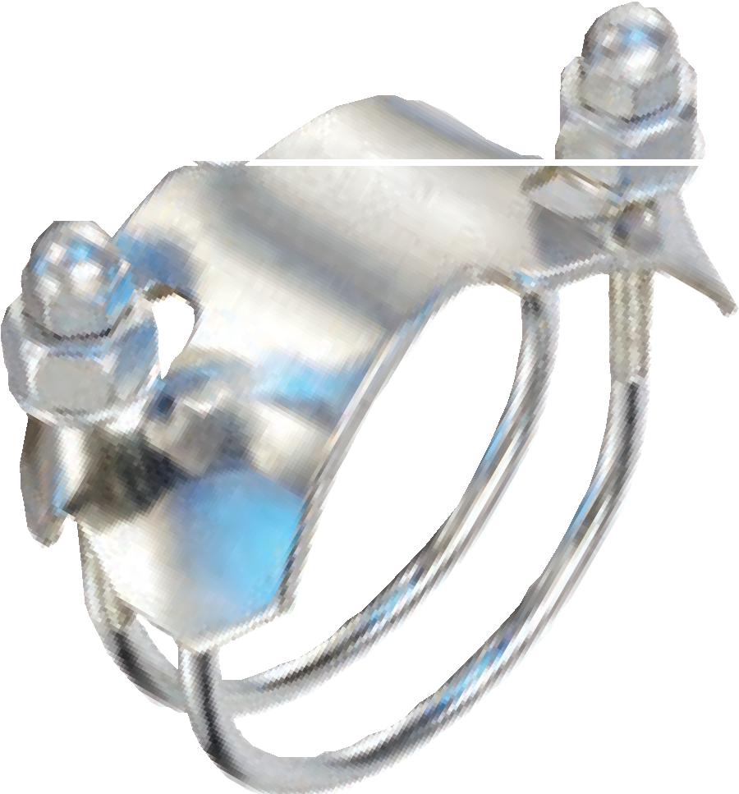Threaded protective cap for safety

Tigerflex™ Accessories Compatability Chart
G = Suggested  -- = Not Suggested | Series | Banding Coils  BCCF BCWF BCRT |  |  | Banding Sleeves  SLV-VLT SLV-DRP SLV-VAP |  |  | Clamps  SDBC SDBC-R |  | Cuff  A2150L1
 | 2001-200 | -- | G | -- | -- | -- | -- | G | -- | --
 | 2001-300 | G | G | -- | -- | -- | -- | G | -- | --
 | 2001-400 | G | -- | -- | G | G | -- | G | -- | --
 | 2001 other sizes | G | -- | -- | -- | -- | -- | G | -- | --
 | 2020-300 | G | -- | -- | -- | G | -- | G | -- | --
 | 2020-400 | G | -- | -- | G | G | -- | G | -- | --
 | 2020 other sizes | G | -- | -- | -- | -- | -- | G | -- | --
 | AMPH400 | G | -- | -- | -- | -- | -- | G | -- | --
 | AMPH other sizes | G | -- | -- | -- | -- | -- | G | -- | --
 | BARK400 | G | -- | -- | -- | -- | -- | G | -- | --
 | BARK500 | G | -- | -- | -- | -- | -- | G | -- | --
 | BW500 | -- | -- | -- | -- | -- | -- | G | -- | --
 | BW600 | -- | -- | -- | -- | -- | -- | G | -- | --
 | BW other sizes | -- | -- | -- | -- | -- | -- | -- | -- | --
 | CF200 | -- | -- | -- | -- | -- | -- | -- | -- | --
 | CF300 | -- | -- | -- | -- | -- | -- | -- | -- | --
 | CF400 | -- | -- | -- | -- | -- | -- | -- | -- | --
 | CF600 | -- | -- | -- | -- | -- | -- | G | -- | --
 | CF other sizes | -- | -- | -- | -- | -- | -- | -- | -- | --
 | F600 | -- | -- | -- | -- | -- | -- | G | -- | --
 | F800 | G | -- | -- | -- | -- | -- | G | -- | --
 | F other sizes | -- | -- | -- | -- | -- | -- | -- | -- | --
 | FT all sizes | -- | -- | -- | -- | -- | -- | -- | -- | --
 | G600 | -- | -- | -- | -- | -- | -- | G | -- | --
 | G800 | G | -- | -- | -- | -- | -- | G | -- | --
 | G other sizes | -- | -- | -- | -- | -- | -- | -- | -- | --
 | GC-C400 | G | -- | -- | -- | -- | -- | G | -- | --
 | GC-C500 | G | -- | -- | -- | -- | -- | G | -- | --
 | GC-C600 | G | -- | -- | -- | -- | -- | G | -- | --
 | GT/GTG/GTFE150 | G | -- | -- | -- | -- | -- | G | -- | G
 | GT/GTG/GTFE200 | -- | G | -- | -- | -- | G | G | -- | --
 | GT/GTG/GTFE300 | -- | G | -- | -- | -- | G | G | -- | --
 | GT/GTG/GTFE400 | G | -- | -- | -- | -- | G | G | -- | --
 | GT/GTG/GTFE other sizes | G | -- | -- | -- | -- | -- | G | -- | --
 | H600 | -- | -- | -- | -- | -- | -- | G | -- | --
 | H800 | G | -- | -- | -- | -- | -- | G | -- | --
 | H other sizes | -- | -- | -- | -- | -- | -- | -- | -- | --
 | J600 | -- | -- | -- | -- | -- | -- | G | -- | --
 | J800 | G | -- | -- | -- | -- | -- | G | -- | --
 | J other sizes | -- | -- | -- | -- | -- | -- | -- | -- | --
 | K600 | -- | -- | -- | -- | -- | -- | G | -- | --
 | K800 | G | -- | -- | -- | -- | -- | G | -- | --
 | K other sizes | -- | -- | -- | -- | -- | -- | -- | -- | --
 | LK/LKC300 | G | -- | -- | -- | -- | G | G | -- | --
 | LK/LKC400 | G | -- | -- | -- | -- | -- | G | -- | --
 | LK/LKC other sizes | G | -- | -- | -- | -- | -- | G | -- | --

NOTE: Banding coils and sleeves must be used in conjunction with a suitable hose clamp.
Refer to individual accessory pages in our Kuriyama-Couplings™ Catalog for detailed information on size availability.

Tigerflex™ Accessories Compatability Chart
G = Suggested  -- = Not Suggested | Series | Banding Coils  BCCF BCWF BCRT |  |  | Banding Sleeves  SLV-VLT SLV-DRP SLV-VAP |  |  | Clamps  SDBC SDBC-R |  | Cuff  A2150L1
 | MH150 | -- | -- | -- | -- | -- | -- | G | -- | G
 | MH200 | -- | G | -- | -- | -- | -- | G | -- | --
 | MH other sizes | -- | -- | -- | -- | -- | -- | -- | -- | --
 | MILK | -- | -- | -- | -- | -- | -- | -- | -- | --
 | MILK-LT | -- | -- | -- | -- | -- | -- | -- | -- | --
 | MULCH400 | -- | -- | -- | -- | -- | -- | G | -- | --
 | MULCH500 | G | -- | -- | -- | -- | -- | G | -- | --
 | MULCH600 | G | -- | -- | -- | -- | -- | G | -- | --
 | ORV all sizes | -- | -- | -- | -- | -- | -- | -- | -- | --
 | OV all sizes | -- | -- | -- | -- | -- | -- | -- | -- | --
 | PF300 | G | -- | -- | -- | -- | -- | G | -- | --
 | PF400 | G | -- | -- | G | G | -- | G | -- | --
 | PF other sizes | G | -- | -- | -- | -- | -- | G | -- | --
 | S300 | -- | -- | -- | -- | -- | -- | G | -- | --
 | S400 | -- | -- | -- | -- | -- | -- | G | -- | --
 | S other sizes | -- | -- | -- | -- | -- | -- | -- | -- | --
 | SH300 | -- | G | -- | -- | -- | -- | G | -- | --
 | SH400 | G | -- | -- | G | G | -- | G | -- | --
 | SH other sizes | G | -- | -- | -- | -- | -- | G | -- | --
 | TG/TY/TRED/TBLU all sizes | -- | -- | -- | -- | -- | -- | -- | -- | --
 | TR1-200 | -- | -- | G | -- | -- | -- | -- | G | --
 | TR1-300 | -- | -- | G | -- | -- | -- | -- | G | --
 | TR1-400 | -- | -- | G | -- | -- | -- | -- | G | --
 | TR1 other sizes | -- | -- | -- | -- | -- | -- | -- | G | --
 | TSD all sizes | -- | -- | -- | -- | -- | -- | -- | -- | --
 | UBK200 | -- | G | -- | -- | -- | -- | G | -- | --
 | UBK300 | -- | G | -- | -- | -- | -- | G | -- | --
 | UBK400 | G | -- | -- | -- | -- | -- | G | -- | --
 | UBK other sizes | G | -- | -- | -- | -- | -- | G | -- | --
 | UF1-200 | -- | G | -- | -- | -- | -- | G | -- | --
 | UF1-300 | G | -- | -- | -- | -- | -- | G | -- | --
 | UF1-400 | G | -- | -- | -- | -- | -- | G | -- | --
 | UF1 other sizes | G | -- | -- | -- | -- | -- | G | -- | --
 | UF2-200 | -- | G | -- | -- | -- | -- | G | -- | --
 | UF2-300 | G | -- | -- | -- | G | -- | G | -- | --
 | UF2-400 | G | -- | -- | G | G | -- | G | -- | --
 | UF2 other sizes | G | -- | -- | -- | -- | -- | G | -- | --
 | UFC200 | -- | G | -- | -- | -- | -- | G | -- | --
 | UFC300 | -- | G | -- | -- | -- | -- | G | -- | --
 | UFC400 | G | -- | -- | -- | -- | -- | G | -- | --
 | UV1/UVF150 | G | -- | -- | -- | -- | -- | G | -- | --
 | UV1/UVF200 | -- | G | -- | -- | -- | G | G | -- | --
 | UV1/UVF300 | -- | G | -- | -- | -- | G | G | -- | --
 | UV1/UVF400 | G | -- | -- | -- | -- | G | G | -- | --
 | UV2-200 | G | -- | -- | -- | -- | G | G | -- | --
 | UV2-400 | G | G | X | X | X | G | G | X | X

NOTE: Banding coils and sleeves must be used in conjunction with a suitable hose clamp.
Refer to the individual accessory pages in our Kuriyama-Couplings™ Catalog for detailed information on size availability.
CAUTION NOTE: This chart is provided only as a guideline for selection of hose accessories. Actual results will vary due to manufacturing tolerances.

Tigerflex™ Accessories Compatability Chart
G = Suggested  -- = Not Suggested | Series | Banding Coils  BCCF BCWF BCRT |  |  | Banding Sleeves  SLV-VLT SLV-DRP SLV-VAP |  |  | Clamps  SDBC SDBC-R |  | Cuff  A2150L1
 | UV1/UVF/UVE other sizes | G | -- | -- | -- | -- | -- | G | -- | --
 | UV2-300 | G | -- | -- | -- | -- | -- | G | -- | --
 | UV2 other sizes | G | -- | -- | -- | -- | -- | G | -- | --
 | UV3-300 | G | G | -- | -- | -- | G | G | -- | --
 | UV3-400 | G | -- | -- | -- | -- | -- | G | -- | --
 | UV3 other sizes | G | -- | -- | -- | -- | -- | G | -- | --
 | UVPE all sizes | -- | -- | -- | -- | -- | -- | G | -- | --
 | VOLT200 | G | -- | -- | -- | -- | G | G | -- | --
 | VOLT300 | G | G | -- | -- | -- | G | G | -- | --
 | VOLT400 | G | -- | -- | G | G | -- | G | -- | --
 | VOLT other sizes | G | -- | -- | -- | -- | -- | G | -- | --
 | VLT-SD300 | G | -- | -- | -- | G | -- | G | -- | --
 | VLT-SD400 | G | -- | -- | G | G | -- | G | -- | --
 | VLT-SD other sizes | G | -- | -- | -- | -- | -- | G | -- | --
 | W200 | -- | G | -- | -- | -- | -- | G | -- | --
 | W300 | -- | G | -- | -- | -- | -- | G | -- | --
 | W400 | G | -- | -- | G | G | -- | G | -- | --
 | W other sizes | G | -- | -- | -- | -- | -- | G | -- | --
 | WBS200 | -- | G | -- | -- | -- | -- | G | -- | --
 | WBS300 | -- | G | -- | -- | -- | -- | G | -- | --
 | WBS400 | G | -- | -- | -- | -- | -- | G | -- | --
 | WBS other sizes | G | -- | -- | -- | -- | -- | G | -- | --
 | WE200 | -- | G | -- | -- | -- | -- | G | -- | --
 | WE300 | -- | G | -- | -- | G | -- | G | -- | --
 | WE400 | G | -- | -- | -- | -- | -- | G | -- | --
 | WE other sizes | G | -- | -- | -- | -- | -- | G | -- | --
 | WG200 | -- | G | -- | -- | -- | -- | G | -- | --
 | WG300 | -- | G | -- | -- | -- | -- | G | -- | --
 | WG400 | G | -- | -- | G | G | -- | G | -- | --
 | WG other sizes | G | -- | -- | -- | -- | -- | G | -- | --
 | WH200 | -- | G | -- | -- | -- | -- | G | -- | --
 | WOR150 | G | -- | -- | -- | -- | -- | G | -- | --
 | WOR200 | -- | G | -- | -- | -- | G | G | -- | --
 | WOR300 | G | G | -- | -- | G | -- | G | -- | --
 | WOR400 | G | -- | -- | G | G | -- | G | -- | --
 | WST/WSTF300 | G | G | -- | -- | G | -- | G | -- | --
 | WST/WSTF400 | G | G | -- | G | G | -- | G | -- | --
 | WST/WSTF other sizes | G | -- | -- | -- | -- | -- | G | -- | --
 | WT200 | -- | G | -- | -- | -- | -- | G | -- | --
 | WT300 | G | G | -- | -- | -- | -- | G | -- | --
 | WT400 | G | -- | -- | G | G | -- | G | -- | --
 | WT other sizes | G | -- | -- | -- | -- | -- | G | -- | --

NOTE: Banding coils and sleeves must be used in conjunction with a suitable hose clamp.
Refer to the individual accessory pages in our Kuriyama-Couplings™ Catalog for detailed information on size availability.

Quality Assurance

ISO 9001 Registration

Tigerflex™ hoses are manufactured with ISO 9001 registered quality management systems.

The ISO 9001 family of standards represents an international consensus on good manufacturing practices with the aim of ensuring that the organization consistently delivers the product or services that meet the customer’s quality requirements.

ISO 9001 is a quality assurance model against which a plant’s quality system can be independently audited.

  - 3A – Material approved by 3-A Sanitary Standards, Inc. for multi-use plastic materials, number: 20-25, as product contact surfaces in equipment for production, processing and handling of milk and milk products.
Compliance Footnotes for Tigerflex™ Catalog Products
  - BSE/TSE – The majority of the raw materials used in our formulations are not manufactured or derived from materials of animal origin. Nor do our products come into contact with materials of animal origin during processing. Our suppliers of raw materials have assured
us their compounds exceed the relevant European Guidance on minimizing the Risk of Transmitting Animal Spongiform Encephalophy Agents Via Human and Veterinary Medical Products.
  - FDA – Material conforms to CFR title 21, parts 170-199.
  - FDA – Material conforms to CFR title 21, parts 177.1680 and 177.2600.
  - FDA – Material conforms to CFR title 21, parts 177.2600 and 175.105.
  - FDA – Material conforms to CFR title 21, parts 177.2800 (5)(i), 21 CFR 170.39.
  - MSHA – Hose approved by the United States Department of Labor’s Mine Safety and Health Administration as having met Part 18, Title 30 CFR, and the Interim Fire Criteria for Acceptance of Products Taken into Underground Mines as water transfer hose.
  - MSHA – Hose approved by the United States Department of Labor’s Mine Safety and Health Administration as having met the Interim Fire Criteria Acceptance of Products Taken Into Underground Mines as a hydraulic hose/hose bundle protection sleeve. Not intended for protection of electrical cables, and not intended for the repair or conveying of damaged hydraulic hoses.
  - Phthalate Free – Manufactured from all phthalate free materials.
- RoHS – The product complies with the requirements of the EU directive 2002/95/EC which is on the restriction of the use of certain hazardous substances in electrical and electronic equipment.
- USDA – Hose approved by the US Department of Agriculture for use in federally inspected meat and poultry plants.

Because we continually examine ways to improve our products, we reserve the right to alter specifications or discontinue products without prior notice.
62 KTFC0218

Flexibility

The terms Flexibility and Minimum Bend Radius are often used interchangeably. However, while closely related, their meanings are different.

Minimum Bend Radius is generally defined as the smallest radius to which a hose can be bent without damage. Tiger- flex™ defines damage as a 5% reduction of the hose OD at the bend point (before kinking/collapse). Other manufactur- ers may define damage as complete hose kinking/collapse.

Flexibility is defined as the amount of force required in order to bend the hose to a specified radius without kinking. In order to provide a better understanding of the flexibility of Tigerflex™ hoses we’ve performed extensive force-to-bend testing. This data provides a clearer picture of the actual flexibility of our hoses in order to assist in your hose selection process.
Food Grade
Series | Force to Bend (Lbs./F) *
 | 2” ID x 3 ft. | 3” ID x 5 ft. | 4” ID x 7 ft.
GTF/GTFE | 0.3 | 0.8 | 3.5
UVF | 2.5 | 3.6 | 5.5
WT | 4.5 | 6.5 | 16.0
WE | 5.5 | 8.8 | 21.4
2001 | 5.6 | 9.0 | 21.0
PF | - | 13.0 | 19.0
WBS | 5.5 | 13.1 | 22.0
WSTF | - | 14.0 | 22.0
VOLT | 7.8 | 15.0 | 22.0
MILK-LT | 10.0 | 15.0 | -
MILK | 11.0 | 17.0 | -
FT | 13.0 | 24.0 | 41.0
2020 | - | 31.0 | 41.0
VLT-SD | - | 33.0 | 42.4

Ducting
Series | Force to Bend (Lbs./F) *
 | 2” ID x 3 ft. | 3” ID x 5 ft. | 4” ID x 7 ft.
CG/CG-SL | 0.5 | 1.2 | 2.1
GT/GTG | 0.5 | 1.5 | 2.8
LK/LKC | - | 1.8 | 3.0
UV1/UVE | 3.0 | 3.7 | 5.5

Liquid Suction
Series | Force to Bend (Lbs./F) *
 | 2” ID x 3 ft. | 3” ID x 5 ft. | 4” ID x 7 ft.
WH/SH | 2.8 | 2.5 | 3.5
MH | 2.8 | - | -
WOR | 2.8 | 5.3 | 10.0
W | 4.0 | 9.5 | 7.3
WG | 4.5 | 10.0 | 15.0
BW | 7.8 | 12.3 | 19.5
ORV | 10.0 | 12.0 | -
TG/TY | 12.0 | 11.2 | 22.0
TRED/TBLU | 12.0 | 11.2 | 22.0
WST | - | 14.0 | 21.0
CF | 14.5 | 14.0 | 28.5
TSD | 14.8 | 18.8 | -
H/J/K | 12.1 | 24.0 | 34.0
OV | 19.0 | 29.0 | -
S | 24.6 | 29.0 | 35.5
F/G | 26.0 | 31.0 | 47.0

A lower force-to-bend value indicates a more flexible hose.
Material Handling
Series | Force to Bend (Lbs./F) *
 | 2” ID x 3 ft. | 3” ID x 5 ft. | 4” ID x 7 ft.
UV2 | 3.4 | 5.5 | 7.0
BARK | - | - | 7.6
MULCH-LT | - | - | 8.0
TR1 | 3.4 | 5.0 | 8.0
GC-C | - | - | 9.0
UBK | 6 | 8 | 11.5
UV3 | - | 7.0 | 13.0
UFC | 4.8 | 8.0 | 12.2
UF1 | 4.8 | 8.0 | 12.2
UVPE | 5.5 | 7.5 | -
AMPH | 5.5 | 10.0 | 15.5
UF2 | 5.5 | 10.1 | 17.2
MULCH | - | - | 18.2

*Values listed indicated pounds of force required to bend a straight length of hose to 180º at 68ºF.

These recommendations are based on our laboratory test reports which are, to the best of our knowledge, complete and accurate. However, actual hose force-to-bend requirements can vary due to many factors such as hose age and manufacturing tolerances. Therefore, no guarantee is expressed or implied by our publication of this chart. If doubt exists, we advise that a sample of the hose in question be obtained and tested under actual conditions. These values are provided for reference only and are subject to change.

Hoses have a limited service life and users must be alert to signs of impending failure. Users of industrial hose should have safety and inspection procedures in place. Hose users should be trained how to properly inspect a hose for signs of impending failure. Hose should be routinely inspected for signs of damage.

Length of hose service life is affected by several factors includ- ing the type of material conveyed, pressure, vacuum, number and degree of bends, amount of flexing and
exposure to environmental elements. Since we have no control over the way in which the hose is used, we do not warrant our hose for any particular service life.
Hoses and fittings should be routinely inspected for signs of damage, such as:
- Cuts, cracks, severe abrasions or holes in the hose tube, helical support or grounding wire
- Ovaling, kinking, bulging or any other deformation of the hose’s normal shape
- Hardening or soft spots
- Flaking or chipping
- Misalignment or weakening of the coupling retention
- Fitting or clamp damage such as loose clamps, missing pins, worn threads excessive corrosion

If any of these signs of damage are observed, contact your hose supplier for replacement or repair.

Hoses should only be used to convey materials compatible with hose construction. Refer to the Chemical Resistance and Application Guides in this catalog.
Care and Maintenance
Recommended Practices

Hoses should not be used at levels that exceed their working pressure or vacuum ratings, and should not be subjected to severe pressure spikes or abrupt drops in pressure.

Hoses can sustain damage at high temperatures. Care should be exercised to not exceed the temperature limits of the hose. Hose should not be installed near sources of high heat.

Do not subject hose to abuse during service. Hose should not be thrown, dropped or subjected to severe impacts.
Machinery should not be moved by pulling on the hose. Protect the hose from sharp edges and corners by using
appropriate hose covers or sleeves.

If hose is used in a suspended position it should be supported in multiple points with use of proper hose slings in order to evenly distribute the hose weight.

Hose should not be used in applications where hose failure would result in contents exposure to open flame or other igni- tion sources.

When not in service hoses should be drained and stored prop- erly.

Storage and Handling

The following storage conditions and handling procedures can enhance and substantially extend the ultimate life of Tigerflex™ hose.

Upon receipt of Tigerflex™ product, skids should be broken down and product inspected for shipping damage. Skids are configured for shipping purposes only.

Hose should be stored indoors out of direct sunlight. Hose should be stored a minimum of ten feet from fluorescent light fixtures.

Hose should always be stored flat on smooth surfaces. Hose should not be stored on its side as this can cause the section of the hose resting on the ground to become deformed, or “egg shaped”.

Hose coils should not be stacked more than six coils high. Larger diameter hoses, 4” and above, should be stacked fewer than six coils high. Please refer to the following chart for recommended maximum stacking height requirements by hose size:

Hose Size (ID) | 3/4” | 1” | 1-1/4” | 1-1/2” | 2” | 2-1/2” | 3” | 4” | 5” | 6” | 8”+
Max Coil Stack Height | 6 | 6 | 6 | 6 | 6 | 6 | 6 | 5 | 3 | 2 | 1

Exceeding these coil stacking requirements may cause the compression load factor on the bottom coil to exceed the hose’s load limitations, causing the bottom coil to flatten out.

Hose should be pulled from inventory on a first-in, first-out (FIFO) basis.

During storage, hose should be kept in its original wrapping when possible, and kept free of dust and dirt.

Hose should not be exposed to water, oils, solvents, or corrosive liquids and fumes during storage. Hose should be protected from rodents and insects.

Rubber hoses should not be stored near electrical equipment. The motor in the equipment can generate ozone, which can attack and damage rubber hose.

Hose should not be subjected to extreme temperatures. Ideal hose storage temperature is between 50°F and 70°F, and ideally should not exceed 100°F. Be aware, when the air temperature is over 90°F outdoor ground surfaces such as asphalt, concrete and gravel can be in excess of 150°F. Such extreme heat conditions could reduce service life of thermoplastic products. Do not store hoses near heat sources such as heat vents, heaters or radiators. Hoses should not be exposed to dampness or high humidity during storage.

Hose should not be kinked or run over by any equipment. Do not drag the hose during storage & shipping. In the handling of larger ID hose, dollies should be used in transporting whenever possible. Slings or handling rigs, properly placed in multiple locations throughout the hose, should be used to support heavier hose. Hanging and supporting coils using forklift forks without protection may damages hose.

The Effect of Temperature
on Working Pressure & Vacuum Ratings
As a general rule, the working pressure and vacuum ratings for plastic reinforced hoses are based
on room temperature conditions. The maximum allowable working pressure or vacuum/suction for a hose decreases as the temperature increases and the material becomes softer and more elastic. Excessive bending of a hose while in service can

Pressure and vacuum hose strength decreases as temperature increases
Working Pressure Ratings

Working pressure and vacuum ratings are given in this catalog at 68°F and 104°F. Between 104°F and the maximum service temperature, it must be noted that a rapid decline in the pressure or vacuum rating of the hose may occur, and all factors relating to the hose, fittings and service conditions must be taken into consideration.

also affect the allowable service application working pressure and vacuum.
Working pressure and vacuum ratings can be affected significantly by the type of fitting used, the method of attachment, and the temperature to which the hose assembly is exposed in service. The graph below demonstrates the overall trend.

No warranty is expressed or implied, as applications and methods of fitting installation may vary widely. Before placing a hose in service, the user must determine the suitability of the product under the correct working conditions, and assumes all risk and liability in connection therewith.

Many new materials have been developed to handle the wide range of modern chemicals being used
in industry today. Many of these materials are now being used in the construction of Tigerflex™ hose.
The Chemical Resistance Guides which appears on the following pages have been prepared to assist the user in the selection of the correct hose for the application.
These recommendations are based on laboratory and test reports which are, to the best of our knowledge, complete and accurate. However, the degree of chemical resistance of any given material depends upon many variables, including such factors as length of exposure, temperature, pressure, fluid velocity, and chemical concentration.

Therefore, no guarantee is expressed or implied by our publication of these Chemical Resistance
Guides. If an element of doubt exists, we advise that a sample of the specific hose selected be obtained and tested under actual conditions.
Furthermore, listings in these Chemical Resistance Guides do not imply conformance to any U. S. Department of Agriculture (USDA), Food and
Drug Administration (FDA) or any other federal, provincial or state laws which may be applicable when handling food products. For information on the conformance of any specific hose product with FDA, USDA, or 3-A Sanitary Standards, please refer to the notes accompanying the information and specifications for each hose featured in this catalog.

The Chemical Resistance Guides shown on the following pages are intended for general guidance only. The information contained therein is based upon tests we believe to be reliable, but the accuracy or completeness thereof is not guaranteed. No warranty is expressed or implied, as specific application parameters, such as temperature,
Warning
pressure and chemical concentrations vary widely. Furthermore, use of these hoses for handling multiple chemical products, either singly or as
a mixture, may introduce uncontrollable factors relating to chemical resistance.

Chemical Resistance Guides
Before using any hose, the user is responsible for determining the suitability of the hose for the intended application. Therefore, the user assumes all risk and responsibility for determining the suitability of any hose for handling any chemical or chemicals.

PVC and Polyurethane Chemical Resistance Guide

Key: E — Excellent G — Good L — Limited U — Unsatisfactory
Material Handled | Hose Materials of Construction and Temperatures
 | PVC |  | Thermoplastic Polyurethane
 | 68°F | 104°F | 68°F | 104°F
Acetaldehyde Acetaldehyde 40 Pct. Acetate Solvents-Crude Acetate Solvents-Pure Acetic Acid 0-10 Pct. Acetic Acid 10-20 Pct. | U  — U U G G | U  — U U L L | U  — L L U U | U  — U U U U
Acetic Acid 20-30 Pct  Acetic Acid 30-60 Pct. Acetic Acid 80 Pct.  Acetic Acid Vapors Acetic Acid-Glacial Acetic Anhydride | G  G L G L U | L  L L G U U | U  U U U U U | U  U U U U U
Acetone  Acetylene Acrylonitrile Adipic Acid Alcohol (See Type)  Allyl Alcohol 96 Pct. | U  E E G  — U | U  E G L  — U | L  E  — U  — U | U  E  — U  — U
Allyl Chloride  Alum  Aluminum Acetate Aluminum Chloride Aluminum Fluoride Aluminum Hydroxide | L  E G E E E | L  E L E E L | U  E  — L E G | U  E  — L E L
Aluminum Nitrate  Aluminum Oxalate Aluminum Oxychloride Aluminum Sulfate Ammonia – Aqueous Ammonia – Dry Gas | E  — E E L L | E  — E E U U | E  —  — E L L | E  —  — E U U
Ammonia-Liquid  Ammoniated Latex Ammonium Bicarbonate Ammonium Carbonate Ammonium Chloride Ammonium Fluoride 25 Pct. | U  E  — E E U | U  L  — E E U | L  —  — E G L | U  —  — E L U
Ammonium Hydrosulphide  Ammonium Hydroxide 28 Pct. Ammonium Metaphosphate Ammonium Nitrate Ammonium Persulfate Ammonium Phosphate | —  G E E E | —  G E E E | —  L G G G | —  U G G G
(Ammoniacal)  Ammonium Phosphate-Neutral Ammonium Sulfate Ammonium Sulfide Ammonium Thiocyanate  Amyl Acetate | —  E E E E U | —  E E E E U | —  G E E G U | —  G E E G U
Amyl Alcohol  Amyl Chloride Aniline  Aniline Chlorohydrate Aniline Hydrochloride Aniline Sulphate | L  U L U U  — | U  U U U U  — | U  — U U U  — | U  — U U U  —
Animal Oils  Anthraquinone Anthraqunonesulfonic Acid Antimony Pentaculcride Antimony Trichloride  Apple (Sauce or Juice) | E  E E  — E E | G  E E  — E E | —  — U  — E  — | —  — U  — E  —
Aqua Regia  Aromatic Hydrocarbons Arsenic Acid 80 Pct.  Arylsulfonic Acid Asphalt  ASTM Fuel #1 Oil | L  U E L U G | U  U G U U L | U  — U U E E | U  — U U E E
ASTM Fuel #3 Oil  ASTM Fuel A ASTM Fuel B ASTM Fuel C Baby Food Barium Carbonate | L  G U U E E | U  L U U E E | E  E G G  — E | E  E L L  — E
Barium Chloride  Barium Hydroxide Barium Sulfate Barium Sulfide | E  E E E | E  E E E | E  G E E | E  L E E

Material Handled | Hose Materials of Construction and Temperatures
 | PVC |  | Thermoplastic Polyurethane
 | 68°F | 104°F | 68°F | 104°F
Barley Beer  Beet-Sugar Liquor Benzaldehyde Benzene  Benzene-Sulfonic Acid 10 Pct. | E E E U U E | U E E U U E | —  —  — U L U | —  —  — U U U
Benzoic Acid  Benzol  Benzyl Alcohol Berries  Bismuth Carbonate  Black Liquor (Paper industry) | G  U  — E E E | L  U  — E E E | U  L  —  — E  — | U  U  —  — E  —
Bleach-12.5 Pct. Active CL  Borax  Bordeaux Mixture Boric Acid  Boron Trifluoride Brine | G  E E E E E | L  G E E E E | L  E  — U E G | U  E  — U E U
Bromic Acid  Bromine-Liquid Bromine-Water Brussel Sprouts Butadiene Butane | E  U U E L E | L  U U E U E | U  U U  —  — E | U  U U  —  — E
Butanediol  Butanol-Primary Butanol-Secondary Butter  Butyl Acetate Butyl Alcohol | —  U U G U E | —  U U L U L | —  L L  — L L | —  U U  — U U
Butyl Cellosolve  Butyl Phenol Butylene  Butynedial (Erythritol) Butyraldehyde Butyric Acid 20 Pct. | U  L E U  — L | U  U G U  — U | —  — E U  — L | —  — E U  — U
Calcium Bisulfite  Calcium Carbonate Calcium Chlorate Calcium Chloride Calcium Hydroxide Calcium Hypochlorite | E  E E E E E | E  E E E E E | E  E G L G U | E  E L U L U
Calcium Nitrate  Calcium Phosphate Calcium Sulfate Camphor Oil  Cane Sugar Liquors Carbon Bisulfide | E  — E  — E U | E  — E  — E U | E  — E  —  —  — | E  — E  —  —  —
Carbon Dioxide (Aqueous Solution)  Carbon Dioxide Gas (Wet) Carbon Disulphide Carbon Monoxide  Carbon Tetrachloride Carbonic Acid | E  E U E U E | E  E U E U E | E  E  — E L U | E  E  — E U U
Carrots  Casein Castor Oil Catsup  Caustic Potash Caustic Soda | E  E E E E L | E  G E G E L | —  E E  — L L | —  E E  — U U
Cellosolve  Cheese Cherries Chloracetic Acid Chloral Hydrate  Chloric Acid 20 Pct. | L  E E E E E | U  G E U E E | G  —  — U G U | L  —  — U L U
Chlorinated Hydrocarbons  Chlorine Gas (Dry) Chlorine Gas (Moist) Chlorine Water 2 Pct. Chlorine Water Saturated Chlorobenzene | U  E L L  — U | U  E U U  — U | —  U U L  — U | —  U U U  — U
Chloroform  Chlorsulfonic Acid Chocolate Chrome Alum | U  L G E | U  U L E | U  U  — E | U  U  — E

PVC and Polyurethane Chemical Resistance Guide

Key: E — Excellent G — Good L — Limited U — Unsatisfactory
Material Handled | Hose Materials of Construction and Temperatures
 | PVC |  | Thermoplastic Polyurethane
 | 68°F | 104°F | 68°F | 104°F
Chromic Acid 10 Pct. Chromic Acid 25 Pct. Chromic Acid 30 Pct. Chromic Acid 40 Pct. Chromic Acid 50 Pct. Chromic Acid Plating Solution | G G L L L  — | L L U U U  — | U U U U U U | U U U U U U
Cider  Citric Acid Coal Tar Coconut Oil Cola Drinks  Copper Chloride | —  E U L E E | —  E U U E G | —  U U E  — E | —  U U E  — E
Copper Cyanide  Copper Fluoride 2 Pct. Copper Nitrate Copper Sulfate  Core Oils Corn Oils | E  E E E E E | E  E G G E G | —  E E E E  — | —  E E E E  —
Cottonseed Oil  Creosote Cresol  Cresylic Acid 50 Pct. Crude Oil-Sour Crude Oil-Sweet | G  U U U E E | L  U U U E E | E  — L U E E | E  — U U E E
Cyclohexane  Cyclohexanol Cyclohexanone Demineralized Water Detergents, Synthetic Developers, Photographic | L  U U E E E | U  U U E G E | —  L U G  —  — | —  U U U  —  —
Dextrin  Dextrose  Di-acetone Alcohol Di-isodecyl Phthalate Diazo Salts  Dibutyl Phthalate | E  E  — U E U | E  G  — U E U | E  E  —  —  —  — | E  E  —  —  —  —
Dichlorobenzene  Diesel Oils Diethyl Ether Diethyl Ether Diethylene Glycol Diglycolic Acid | U  L  — L E E | U  U  — U E G | —  —  —  —  —  — | —  —  —  —  —  —
Dimethylamine  Dioctyl Phthalate Diotylphthalate Disodium Phosphate Distilled Water  Eggs (yolks or white) | U  U U E E E | U  U U E E E | U  — G E G  — | U  — L E U  —
Emulsifiers  Emulsions, Photographic Ethers  Ethyl Acetate Ethyl Acrylate Ethyl Alcohol | E  E U U U G | E  E U U U L | —  — G L  —  — | —  — L U  —  —
Ethyl Alcohol 0-50 Pct.  Ethyl Alcohol 50-98 Pct. Ethyl Butyrate  Ethyl Chloride Ethyl Ether Ethyl Formate | G  L  — U U  — | L  U  — U U  — | G  L  — U G  — | L  U  — U L  —
Ethylene Bromide  Ethylene Dichloride Ethylene Glycol Ethylene Oxide Fatty Acids  Ferric Chloride | E  U E U E E | U  U E U G E | U  U G U G G | U  U L U L L
Ferric Nitrate  Ferric Sulfate  Ferrous Ammonium Citrate Ferrous Chloride  Ferrous Sulfate Figs | E  E  — E E E | E  E  — E E E | E  E  — E E  — | E  E  — E E  —
Fish Solubles  Fixing Solution Photographic Flour  Fluorine Gas-Dry | E  E E U | E  G U U | E  —  — U | G  —  — U

Material Handled | Hose Materials of Construction and Temperatures
 | PVC |  | Thermoplastic Polyurethane
 | 68°F | 104°F | 68°F | 104°F
Fluorine Gas-Wet Fluoroboric Acid Fluorosilicic Acid Fluorosilicic Acid 40 Pct.  Fluorosilicic Acid Concentrate  Food Products, such as Milk, Buttermilk, | U E E  —  — | U E E  —  — | U E U  —  — | U E U  —  —
Molasses, Salad Oils, Fruit  Foric Acid  Formaldehyde 40 Pct. Aqueous Formic Acid 10 Pct.  Formic Acid 100 Pct. Formic Acid 25 Pct. | E  E U E U E | E  L U G U G | —  U  — U U  — | —  U  — U U  —
Formic Acid 3 Pct.  Formic Acid 50 Pct. Freon-12  Fructose  Fruit Pulps and Juices Fuel Oil | E  L E E E G | G  U G E E L | U  U E E E E | U  U E E E E
Furfural  Furfuryl Alcohol Gallic Acid  Gas-Coke Oven Gas-Manufactured Gas-Natural (Dry) | U  E E G U E | U  L E G U E | U  —  — G  — E | U  —  — G  — E
Gas-Natural (Wet)  Gasoline  Gasoline – Refined Gasoline – Sour Gelatine  Gin | E  U L L E E | E  U U U E G | E  — E E E  — | E  — G G E  —
Ginger Ale  Glucose  Glycerine (Glycerol) Glycol  Glycolic Acid 30 Pct. Grade Sugar | E  E E E E  — | E  E E E E  — | —  E E G U  — | —  E E G U  —
Grape Juice  Grapefruit Juice Grease  Green Liquor (Paper industry) Heptachlor  Heptane | E  E E E E L | E  E L E L U | —  —  —  —  — E | —  —  —  —  —  —
Hexadecanol  Hexane Hexanol, Tertiary Honey  Hydrochloric Acid 10 Pct. Hydrochloric Acid 48 Pct. | —  L L E E E | —  U U E E L | —  — G  — U U | —  —  —  — U U
Hydrocyanic Acid 10 Pct.  Hydrofluoric Acid 10 Pct. Hydrofluoric Acid 4 Pct. Hydrofluoric Acid 48 Pct. Hydrofluoric Acid 60 Pct. Hydrofluoroboric Acid | —  G G G G E | —  L G U U E | —  U U U U  — | —  U U U U  —
Hydrofluorosilic Acid  Hydrogen  Hydrogen Bromide (Dry) Hydrogen Chloride (Dry) (Liquid) Hydrogen Cyanide  Hydrogen Peroxide 3 –12 Pct. | G  E  —  — E E | L  G  —  — E G | U  E  — E U  — | U  E  — E U  —
Hydrogen Peroxide 30 Pct.  Hydrogen Peroxide 50 Pct. Hydrogen Peroxide 90 Pct. Hydrogen Phosphide  Hydrogen Sulfide – Aqueous Solution Hydrogen Sulfide – Dry | E  E U E E E | G  L U L E E | G  L U  —  —  — | L  U U  —  —  —
Hydrombromic Acid 20 Pct.  Hydroquinone Hydroxylamine Sulfate Hypochlorous Acid Inks  Iodine (In Alcohol) | E  E E E  — U | G  E E E  — U | U  E  — L  — U | U  E  — U  — U
Iso-octane  Isopropyl Acetate Isopropyl Alcohol Jelly | G  U E E | L  U G E | —  —  —  — | —  —  —  —

PVC and Polyurethane Chemical Resistance Guide

Key: E — Excellent G — Good L — Limited U — Unsatisfactory
Material Handled | Hose Materials of Construction and Temperatures
 | PVC |  | Thermoplastic Polyurethane
 | 68°F | 104°F | 68°F | 104°F
Jet Fuels JP 3,4,5 Kerosene Ketones  Kraft Liquor (Paper industry) Lacquer Thinners  Lactic Acid 28 Pct. | U U U E L E | U U U E U E | G E  —  — G U | L G  —  —  — U
Lard (marginal)  Lard Oil Lauric Acid  Lauryl Chloride Lauryl Sulfate Lead Acetate | G  E E E E E | L  G E E E E | —  E L E  — E | —  G U G  — E
Lead Arsenate  Lead Nitrate Lead Tetra-ethyl Lemon Juice Lime Sulfur Linoleic Acid | —  —  — E E E | —  —  — G E E | —  —  —  —  — L | —  —  —  —  — U
Linseed Oil  Liquors (Chemical) Lubricating Oils Magnesium Carbonate Magnesium Chloride Magnesium Hydroxide | E  E U E E E | E  G U E E E | E  — E E G G | E  — E E L L
Magnesium Nitrate  Magnesium Sulfate  Maleic Acid 25 Pct. Aqueous Maleic Acid 50 Pct.  Maleic Acid Concentrated Malic Acid | E  E E  —  — E | E  E E  —  — E | E  E L  —  — L | E  E U  —  — U
Manganese Suphate  Mayonnaise Mercuric Chloride Mercuric Cyanide Mercurous Nitrate Mercury | —  E G G G G | —  E G G G G | —  — G  — G  — | —  — L  — G  —
Metallic Soaps  Methyl Acetate Methyl Alcohol Methyl Bromide Methyl Chloride Methyl Ethyl Ketone | —  U L U U U | —  U U U U U | —  — L  — U L | —  — U  — U U
Methyl lsobutyl Ketone  Methyl Sulfate Methyl Sulfuric Acid Methylated Spirit Methylene Chloride Milk | U  E E  — U E | U  G E  — U E | —  E U  — U  — | —  G U  — U  —
Mineral Oils  Mineral Spirits Molasses Monochlorobenzene Naphtha Napthalene | E  — E U U L | G  — E U U U | E  — E  — E  — | E  — E  — E  —
Nickel Acetate  Nickel Chloride Nickel Nitrate Nickel Sulphate Nicotine Nicotine Acid | E  E E E E E | E  E E E E G | E  E E E E L | E  E E E E U
Nitric Acid (Anhydrous)  Nitric Acid 10 Pct. Nitric Acid 25 Pct. Nitric Acid 35 Pct. Nitric Acid 40 Pct. Nitric Acid 50 Pct. | U  E G G G  — | U  G L L L  — | U  U U U U  — | U  U U U U  —
Nitric Acid 60 Pct.  Nitric Acid 68 Pct. Nitric Acid 70 Pct. Nitrobenzene Nitrous Oxide Oats | G  L U U E E | U  U U U E U | U  U  — U E  — | U  U  — U E  —
Octyl Alcohol  Oils and Fats Oils, Petroleum Oleic Acid | —  E E G | —  G G L | —  E E U | —  E E U

Material Handled | Hose Materials of Construction and Temperatures
 | PVC |  | Thermoplastic Polyurethane
 | 68°F | 104°F | 68°F | 104°F
Oleum Olives  Orange Juice Oxalic Acid Oxygen Ozone | U E E E E L | U E E E E U | U  —  — U E  — | U  —  — U E  —
Palmitic Acid 10 Pct.  Palmitic Acid 70 Pct. Paraffin  Peaches Peanut Butter Peas | E  L E E E E | G  U G E G E | U  U  —  —  —  — | U  U  —  —  —  —
Pentachlorophenol in Oil  Pentane  Peracetic Acid 40 Pct. Perchloric Acid 10 Pct. Perchloric Acid 70 Pct. Perchlorethylene | G  G U G L U | L  U U L U U | —  — U U U  — | —  — U U U  —
Petrol  Petroleum Ether Phenol Phenylhydrazine  Phenylhydrazine Hydrochloride Phosgene (Gas) | U  L U U L E | U  L U U U G | —  — U  —  —  — | —  — U  —  —  —
Phosgene (Liquid)  Phosphoric Acid — 0-25 Pct. Phosphoric Acid — 25-50 Pct. Phosphoric Acid — 50-90 Pct. Phosphorus (Yellow) Phosphorus Pentoxide | U  E E E G U | U  E E E L U | —  U U U  —  — | —  U U U  —  —
Phosphorus Trichloride  Photographic Chemicals Photographic Developers Photographic Emulsions Photographic Fixers Picric Acid | U  E  —  —  — U | U  E  —  —  — U | —  E  —  —  — U | —  G  —  —  — U
Pineapple Juice  Pitch  Plating Solutions Brass Cadmium Chromium | E  G  — E E G | E  L  — E E G | —  —  — E E G | —  —  — E E G
Copper  Gold Judium Lead Nickel Rhodium | E  E E E E E | E  E E E E E | E  E E E E E | E  E E E E E
Silver  Tin Zinc  Potassium Acid Sulfate Potassium Antimonate Potassium Bicarbonate | E  E E E E E | E  E G E E E | E  E E E E E | E  E E E E E
Potassium Bichromate  Potassium Bisulfite Potassium Bisulphate Potassium Borate 1 Pct. Potassium Bromate 10 Pct. Potassium Bromide | E  E  — E E E | E  E  — E E E | E  E  — E E E | E  E  — E E E
Potassium Carbonate  Potassium Chlorate Potassium Chloride Potassium Chromate 40 Pct. Potassium Cuprocyanide Potassium Cyanide | E  E E E E E | E  E E E E E | E  G E G  — E | E  G G G  — E
Potassium Dichromate 40 Pct.  Potassium Ferricyanide Potassium Fluoride Potassium Hydroxide 10 Pct. Potassium Hydroxide 20 Pct. Potassium Hydroxide 35 Pct. | E  E E E E E | E  E E E E E | G  E E L U U | G  E G U U U
Potassium Hydroxide Conc.  Potassium Hypochlorite Potassium Nitrate Potassium Perborate | —  G E E | —  L E E | —  U E E | —  U E E

PVC and Polyurethane Chemical Resistance Guide

Key: E — Excellent G — Good L — Limited U — Unsatisfactory
Material Handled | Hose Materials of Construction and Temperatures
 | PVC |  | Thermoplastic Polyurethane
 | 68°F | 104°F | 68°F | 104°F
Potassium Perchlorite  Potassium Permanganate 10 Pct. Potassium Persulfate  Potassium Phosphate Potassium Sulfate Potassium Sulfide | E G E  — E E | E G E  — E E | G G E  — E E | L L E  — E E
Potassium Thiosulfate  Potatoes Propane Propargyl Alcohol Propyl Alcohol  Propylene Dichloride | E  E E E E U | E  E E E L U | E  — E  — G U | E  — E  — L U
Propylene Glycol  Prune Juice Raisins  Ritchfield "A" Weed Killer Salicylic Acid  Salt Water | U  E E E  — E | U  E E L  — E | U  —  —  —  — G | U  —  —  —  — U
Selenic Acid  Shortening Silicic Acid Silicone Fluids Silver Cyanide Silver Nitrate | E  G E  — E E | G  L E  — E E | U  — U  — E E | U  — U  — E E
Silver Plating Solutions  Soap Solution Soda  Sodium Acetate Sodium Acid Sulfate Sodium Aluminate | E  E E E E  — | G  E E E E  — | E  G  — E E  — | E  U  — E E  —
Sodium Antimonate  Sodium Arsenite Sodium Benzoate Sodium Bicarbonate Sodium Bisulfate Sodium Bisulfite | E  E E E E E | E  E G E E E | E  E E E E E | E  E E E E E
Sodium Bromide  Sodium Carbonate (Soda Ash) Sodium Chlorate  Sodium Chloride Sodium Cyanide Sodium Dichromate | E  E G E E E | E  E L E E G | E  E G E E E | G  E G G E G
Sodium Ferricyanide  Sodium Ferrocyanide Sodium Fluoride  Sodium Hydroxide 10 Pct. Sodium Hydroxide 35 Pct. Sodium Hydroxide 50 Pct. | E  E E L U U | E  E E L U U | E  E E L U  — | E  E G U U  —
Sodium Hydroxide Saturated  Sodium Hypochlorite Sodium Nitrate Sodium Nitrite  Sodium Phosphate-Acid Sodium Silicate | E  E E E G E | E  E E E G E | U  U E E U E | U  U E E U E
Sodium Sulfate  Sodium Sulfide Sodium Sulfite  Sodium Thisulfate (Hypo) Soya Beans  Soya Oil | E  E E E E E | E  E E E U G | E  E E E  —  — | E  E E G  —  —
Soybean Oil  Spinach Squash  Stannic Chloride Stannous Chloride Starch | E  E E E E  — | E  E E E G  — | —  —  — E E  — | —  —  — G G  —
Stearic Acid  Stoddard Solvent Styrene  Sucrose  Sugar (All Forms) Sulfur | E  L U  — E G | G  U U  — E G | L  G  —  —  —  — | U  G  —  —  —  —
Sulfuric Acid 0-10 Pct.  Sulfuric Acid 10-40 Pct. Sulfuric Acid 50-60 Pct. Sulfuric Acid 70 Pct. | E  E E E | G  G G G | L  U U U | U  U U U

Material Handled | Hose Materials of Construction and Temperatures
 | PVC |  | Thermoplastic Polyurethane
 | 68°F | 104°F | 68°F | 104°F
Sulfuric Acid 95 Pct.  Sulfuric Acid 95 Pct. to Fuming Sulfurous Acid  Sulphur Dioxide Gas-Dry Sulphur Dioxide Gas-Wet Sulphur Dioxide-Liquid | U L G E U L | U L L E U U | U U U  —  —  — | U U U  —  —  —
Sulphur Trioxide  Sulphurous Acid 10 Pct. Sulphurous Acid 30 Pct. Tall Oil  Tallow Tannic Acid | E  —  — U  — E | G  —  — U  — E | —  —  —  —  — L | —  —  —  —  — U
Tanning Extracts  Tanning Liquors Tartaric Acid Tea (Brewed) Tetraethyl Lead  Tetrahydrofurane | —  E E E G U | —  E G E L U | —  — L  — G U | —  — U  — G U
Tetrahydronaphihalene  Thionyl Chloride Tin Chloride  Titanium Tertachloride Titanium Trichloride Toluol or Toluene | —  U E E  — U | —  U E U  — U | —  U E L  — L | —  U E U  — U
Tomato Juice  Tomato Puree & Paste Tomatoes Transformer Oil Tributyl Phosphate Trichlorobenzene | E  E E  — U  — | E  E E  — U  — | —  —  —  —  —  — | —  —  —  —  —  —
Trichloroethylene  Tricresyl Phosphate Triethanolamine Triethylamine Trimethyl Propane Trisodium Phosphate | U  U L G L E | U  U U L U E | L  U  —  —  — E | U  U  —  —  — E
Turpentine  Urea Urine  Vanilla Extract Varnish Vegetable Oils | L  E E  — U G | U  G E  — U L | E  E E  — E  — | G  E E  — G  —
Vinegar  Vinyl Acetate Vinyl Chloride Vodka  Water-Acid Mine Water Water-Distilled | E  U U E E E | G  U U G E E | G  U  —  — G G | L  U  —  — U U
Water-Fresh  Water-Salt Wetting Agents Whey  Whiskey  White Gasoline | E  E  —  — E E | E  E  —  — G E | G  G  —  —  — E | U  U  —  —  — G
White Liquor (Paper industry)  Wines  Xylene or Xylol Yeast  Yogurt  Zinc Chloride | E  E U E E E | E  G U U G E | —  — G  —  — E | —  — L  —  — E
Zinc Chromate  Zinc Cyanide Zinc Nitrate Zinc Sulfate | E  E E E | E  E E E | E  E E E | E  E E E
Mixtures of Acids:  Nitric 15 Pct., Hydrofluoric 4 Pct.  Sodium Dichromate 13 Pct., Nitric Acid 16 Pct., Water 71 Pct. | E E | G G | U U | U U

Key: G — Good L — Limited U — Unsatisfactory

Material Handled
68˚F 104˚F
Material Handled
68˚F 104˚F
Material Handled
68˚F 104˚F

Acetic Acid G G
EPDM Chemical Resistance Guide
Acetone G G
Aluminum Acetate G G
Aluminum Chloride G G
Aluminum Hydroxide G G
Aluminum Sulfate G G
Ammonia (Gas) G G
Ammonia (Liquid) G G
Ammonium Acetate (Conc.) G G
Ammonium Chloride G G
Ammonium Hydroxide G G
Ammonium Nitrate G G
Aniline L L
Aniline Sulfate U U
Barium Chloride G G
Barium Hydroxide G G
Beer G G
Benzen Alcohol L L
Benzene U U
Bromine U U
Butyl Alcohol L L
Calcium Carbonate G G
Calcium Chloride (Conc.) G G Calcium Hyprocholite (Conc.)L L
Carbon Monoxide G G
Carbon Tetrachloride L L
Carbonic Acid G G
Carbonic Acid Gas G G
Cetyl Alcohol L L

Chlorine - 10% Gas L L
- 100% Gas L L
(Solution) L L
Chloroform U U
Chromate (Plating Solution) L L
Citric Acid G G
Copper Chloride G G
Copper Nitrate G G
Copper Sulfate G G
Creosote Oil U U
Development Sol. L L
Dextrin G G
Dichlorethylene U U
Dichloro Benzene U U
Diethyl Ether G G
Emulsifier G G
Ether G G
Ethyl Acetate L L
Ethyl Alcohol - 6% G G
- 100% G G
Ethylene Chloride L L
Ethylene Glycol G G
Fluorine U U
Glycerol G G
Grape Sugar G G
Hormamide- 40% G G
Hydrochloric Acid - 10% G L
- 20% G L
Concentrate G L
Hydrogen G G
Hydrogen Chloride (Anhydrous) G L Hydrogen Peroxide - 3% U U
- 30% U U
(Above 80%) U U
Hydrogen Sulfide G G
Iodine U U
Iron Chloride G G
Iron Sulfate G G
Isopropyl Alcohol G G
Magnesium Carbonate G G
Magnesium Chloride G G
Magnesium Hydroxide G G
Magnesium Sulfate G G
Methanol - 20% G G
Monochloro Benzene U U
Nitric Acid - 5% L L
- 50% L L
- 70% U U
- 95% U U
Oleic Acid L L
Ozone G G
Parraffin U U
Perchlorethylene U U
Phenol L L
Phosphoric Acid - 30% G G
Photosensitive Emulsion G G
Potassium Bichromate U U
Potassium Bromide G G
Potassium Chloride G G
Potassium Cyanide G G
Potassium Fluoride G G Potassium Hydroxide - 10% G G
(Conc.) G G
Potassium Permanganate U U
Potassium Phosphate G G
Propylene Glycol G G
Sake (Alcohol) G G
Salt Water G G
Sauce G G
Sodium Bicarbonate G G
Sodium Chloride G G
Sodium Hydroxide - 10% G G
(Conc.) G G
Sodium Hypoclorite - 15% G G
Soy Sauce G G
Stearic acid L L
Sulfur Dioxide U U
Sulfuric Acid L L
Sulfurous Acid - 30% L L
Methyl Alcohol- 6%
- 100%
Methyl Ethel Ketone Methylene Chloride Mineral Oil
G G G L U
G G G L U
Tetrahydrofuron L L
Toluene U U
Transformer Oil U U
Water G G
Zinc Chloride G G

SBR Chemical Resistance Guide
Ethylene Glycol G
Fluorine U
Formaldehyde (40%) L
Glycerol G
Grape Sugar G

Potassium Bichromate | U
Potassium Bromide | G
Potassium Chloride | G
Potassium Cyanide | G
Potassium Fluoride | G

Hydrogen Peroxide (3%) U
Hydrogen Peroxide (30%) U
Hydrogen Peroxide (80% or more) U
Hydrogen Sulfide U
Iodine U

Sake | G
Salt Water | G
Sodium Bicarbonate | G
Sodium Chloride | G
Sodium Hydroxide (10%) | G

Key: G — Good L — Limited U — Unsatisfactory
Creosote Oil U
Dextrin G
Dichlorobenzene U
Dichloromethane U
Diethyl Ether U

Nitric Acid (70%) | U
Nitric Acid (95%) | U
Nitrous Acid (10%) | L
Oleic Acid | U
Oxalic Acid | L

Material Handled 68ºF Material Handled 68ºF Material Handled 68ºF
1,1-dichloroethylene U  1,2-dichloroethane U  Acetic Acid (10%) L  Acetone L  Aluminum Acetate L  Aluminum Chloride G  Aluminum Hydroxide G  Aluminum Sulfide L  Ammonia (Gas) G  Ammonia (Liquid) G  Ammonium Acetate (Conc.) G  Ammonium Bicarbonate G  Ammonium Chloride G  Ammonium Hydroxide U  Ammonium Nitrate G  Aniline U  Aniline Sulfate U  Barium Chloride G  Barium Hydroxide G  Beer L  Benzene U  Benzyl Alcohol U  Bromine U  Butyl Alcohol G  Calcium Carbonate G  Calcium Chloride (Conc.) G  Calcium Chloride (in 20% Mesh) G  Calcium Hypochlorite (15% Cl2) U  Calcium Hypochlorite (Conc.) U  Carbon Dioxide U  Carbon Monoxide L  Carbon Tetrachloride U  Carbonic Acid L  Carbonic Acid Gas G  Cetyl Alcohol L  Chlorine (10% Gas) U  Chlorine (100% Gas) U  Chlorine (Solution) U  Chloroform U | Chromate (25%) U  Citric Acid G  Copper Chloride G  Copper Nitrate G  Copper Sulfate L  Emulsifier G  Ether L  Ethyl Acetate U  Ethyl Alcohol (100%) G  Ethyl Alcohol (6%) G  Hydrochloric Acid (10%) L  Hydrochloric Acid (20%) L  Hydrochloric Acid (Conc.) L  Hydrogen L  Hydrogen Chloride (Anhydride) L  Iron Chloride G  Iron Sulfate G  Isopropyl Alcohol L  Magnesium Carbonate G  Magnesium Chloride G  Magnesium Hydroxide L  Magnesium Sulfate L  Methyl Alcohol (100%) G  Methyl Alcohol (6%) G | Methyl Ethyl Ketone (MEK) U  Mineral Oil U  Monochlorobenzene U  Nitric Acid (5%) U  Nitric Acid (50%) U  Ozone U  Paraffin U  Perchloroethylene U  Phenol U  Phosphoric Acid (30%) U  Potassium Hydroxide (10%) L  Potassium Hydroxide (Conc.) L  Potassium Permanganate U  Potassium Sulfate G  Propylene Glycol L  Sodium Hydroxide (Conc.) G  Soy Sauce G  Stearic Acid L  Sulfuric Acid (10%) U  Tetrahydrofuran U  Toluene U  Transformer Oil U  Water G  Zinc chloride G

Company Profile
Company Name Contact Address City State Zip Phone Fax E-mail

Application Details
Application
Indoor ❏ Outdoor ❏
Material conveyed Solid ❏ Liquid ❏ Gas ❏
Type of fittings to be used

Hose Construction
Hose style:
  - Smooth profile (e.g. F series): ❏
  - Convoluted profile (e.g. W series): ❏
  - Externally reinforced (e.g. GT series): ❏
  - Other: ❏ Describe Similar to existing Tigerflex™ hose part number(s) (if applicable)

Flex material Helix material
Flex color Helix color
Food Grade? Yes ❏ No ❏
Food Grade? Yes ❏ No ❏

Yarn reinforcement? Yes ❏ No ❏ Polyurethane liner? Yes ❏ No ❏ Grounding wire? Yes ❏ No ❏
Tigerflex™ Products Custom Inquiry Form
Hose size(s) (ID) Required working pressure PSI @ 68º F Required vacuum rating in/g @ 68º F
Required bending radius in Required hose weight lbs Hose Length ft Tolerance +/- in
Approvals required? Other requirements

Delivery Information
Estimated annual volume Reoccurring? Yes ❏ No ❏ Required ship date Special packaging or shipping requirements

Submit to:
Fax: (847) 885-9010 • Email: customerservice@kuriyama.com • Submission date

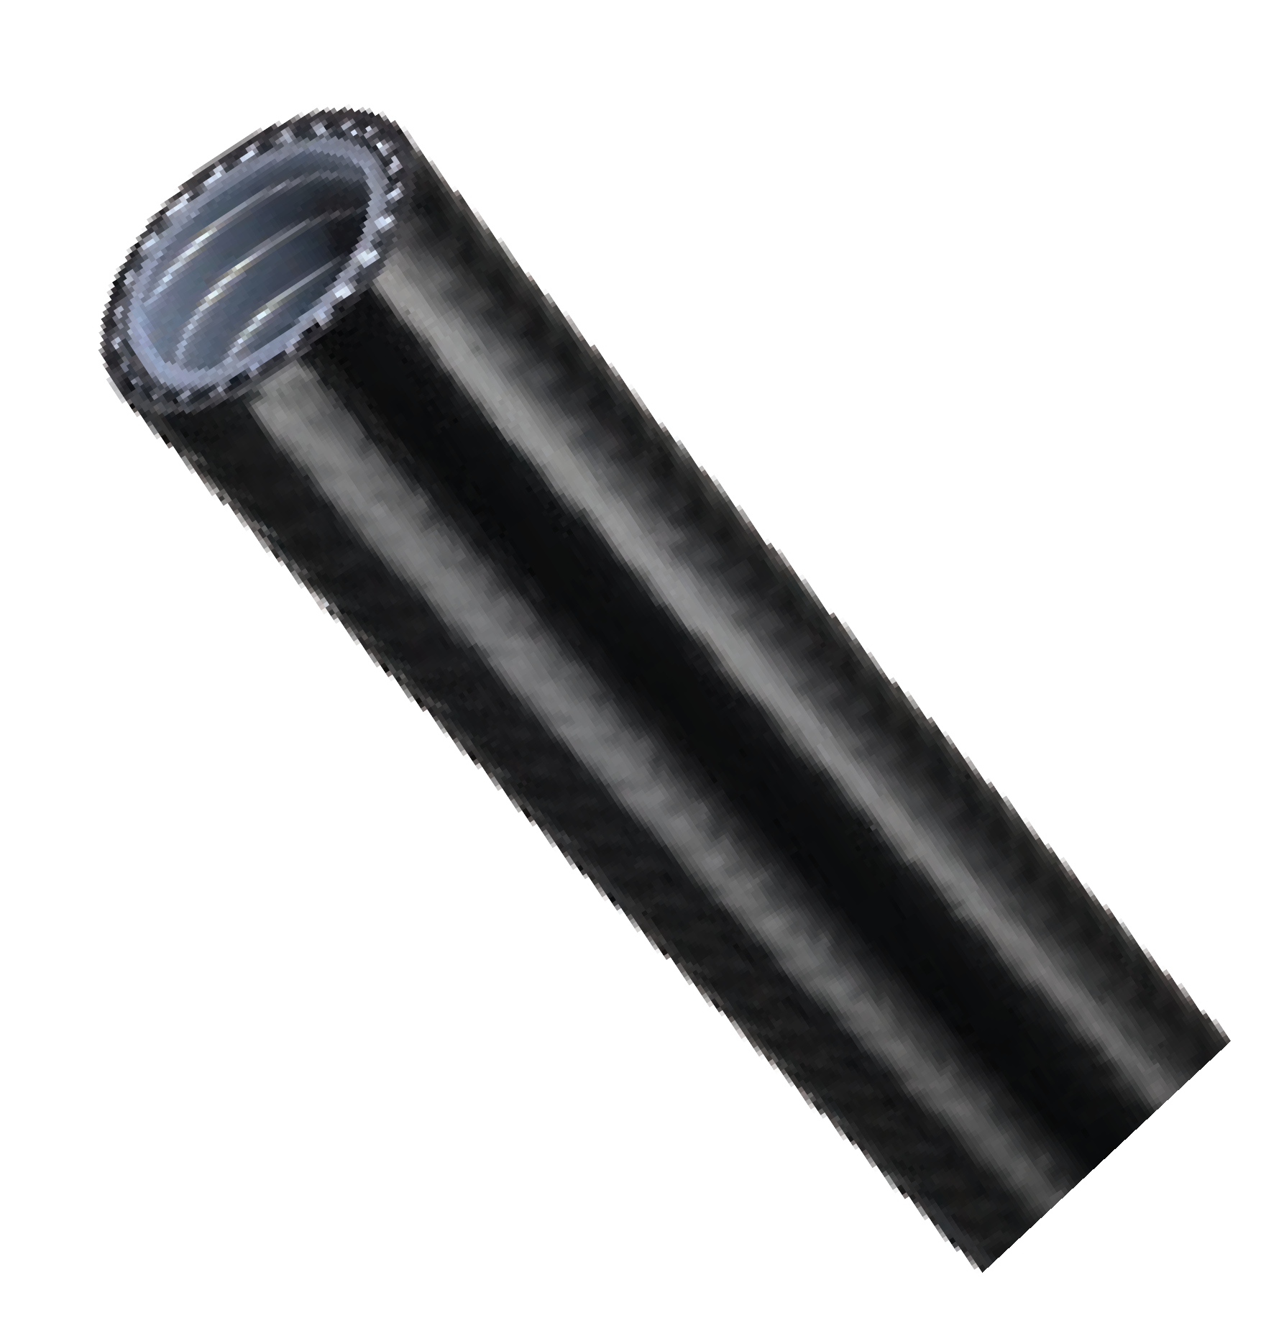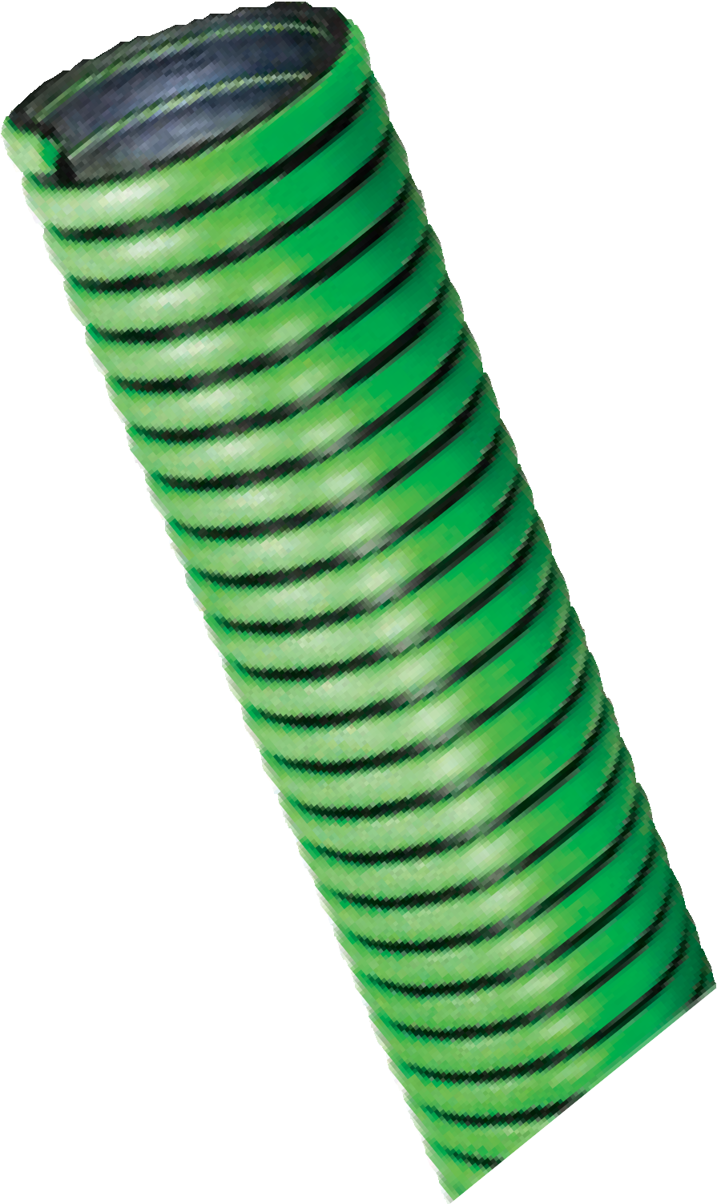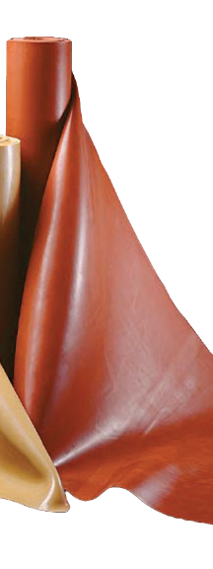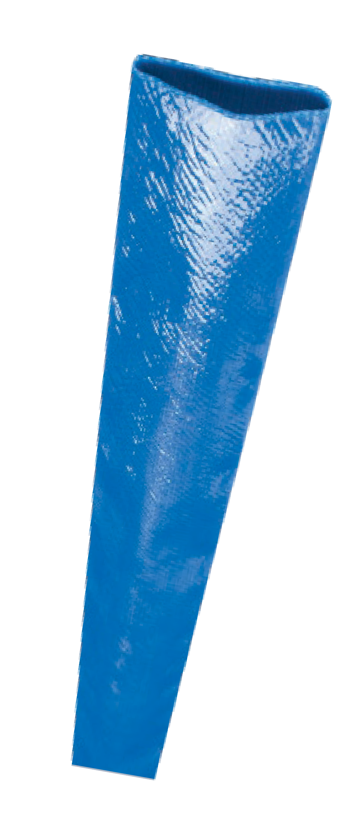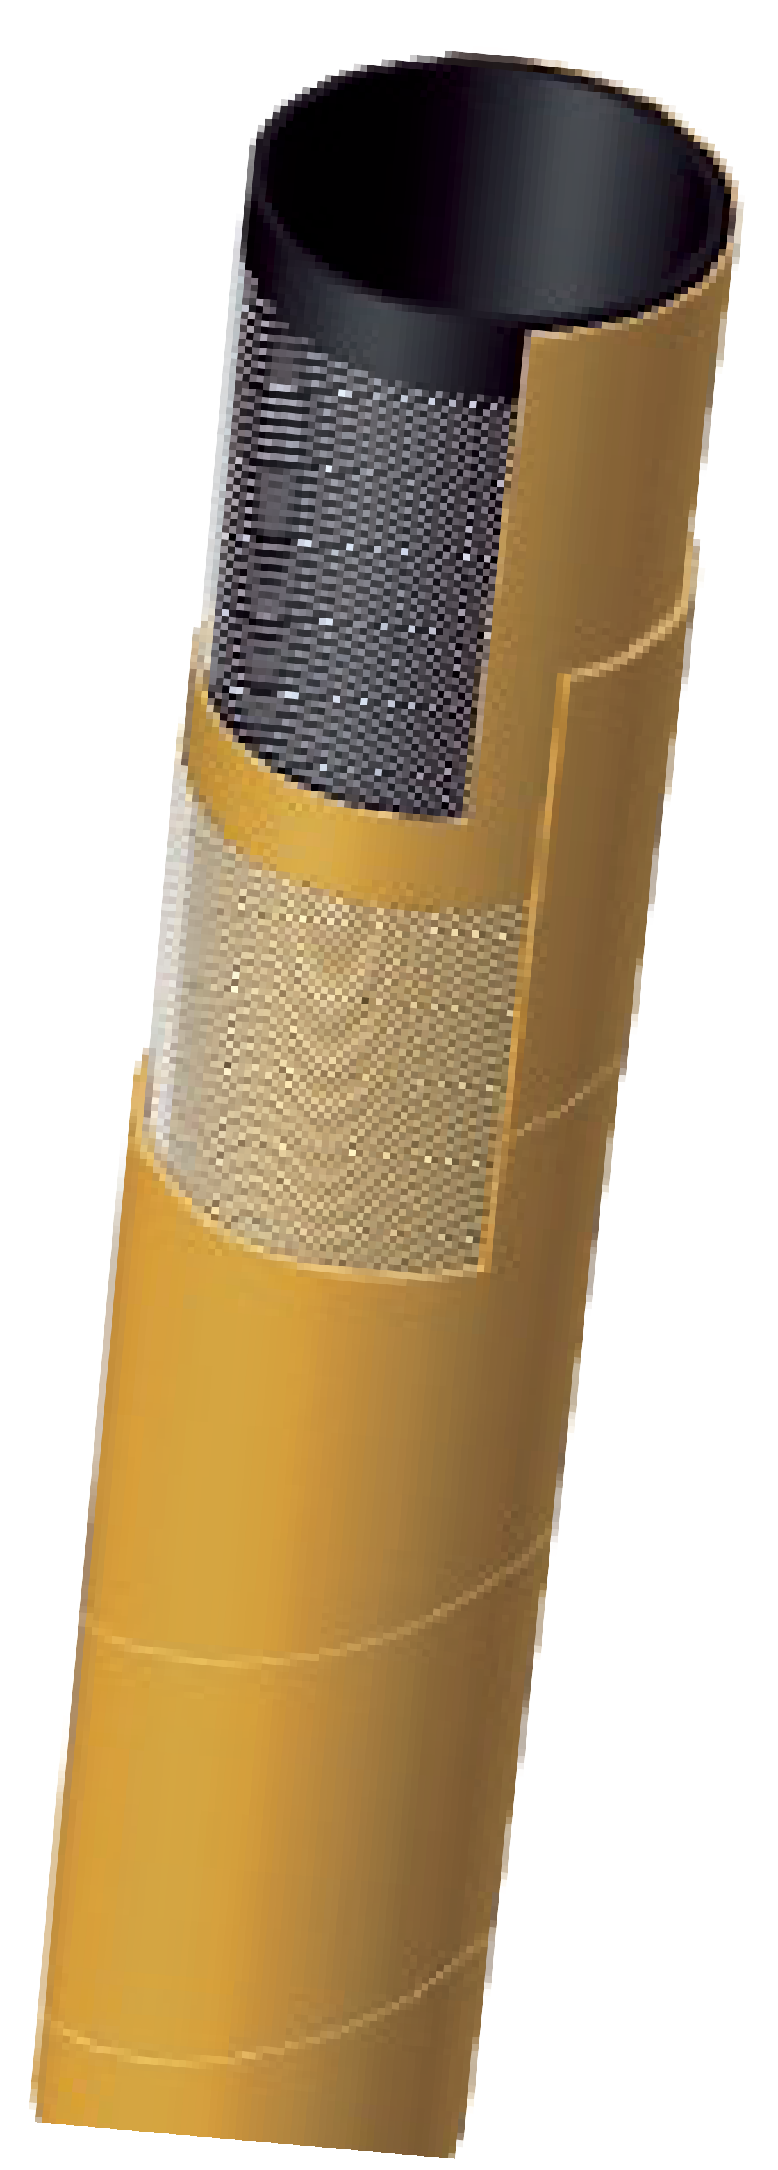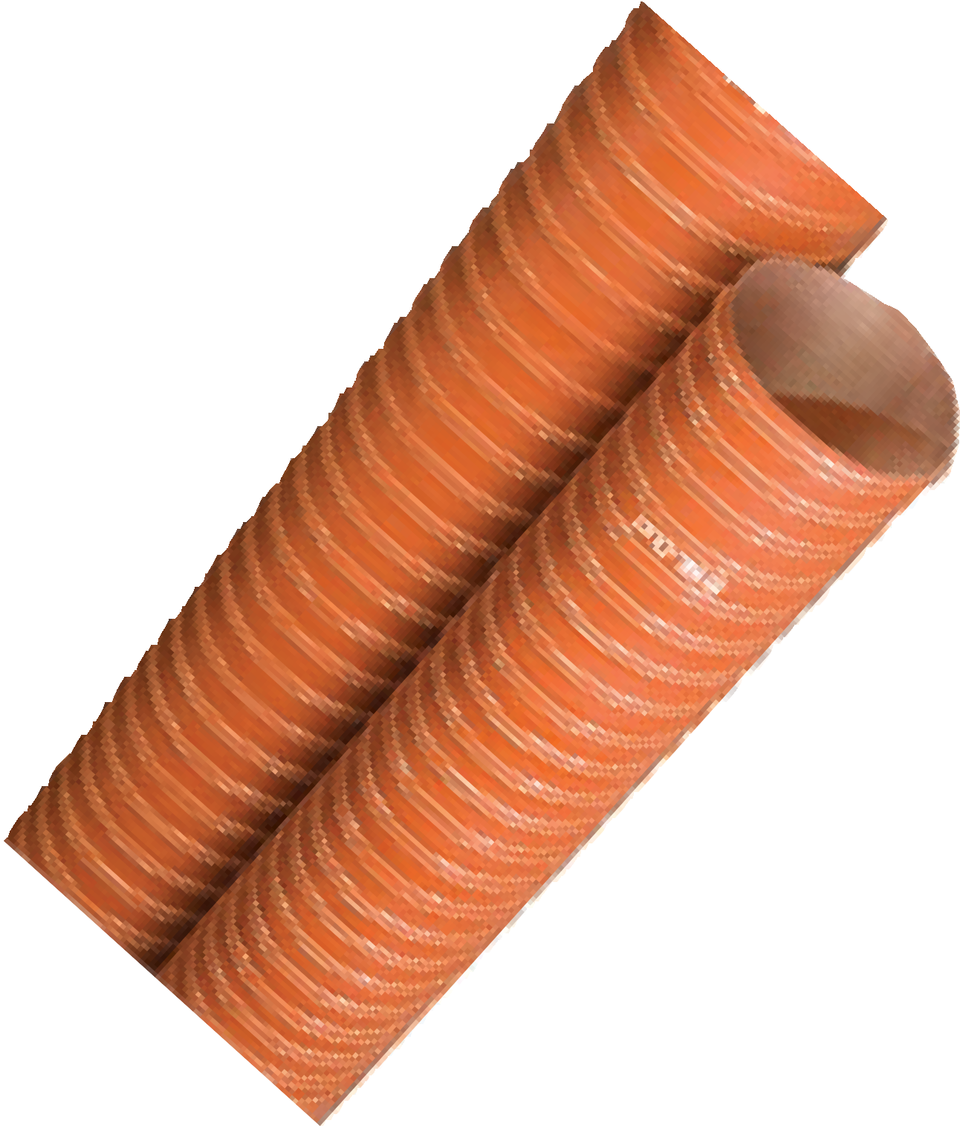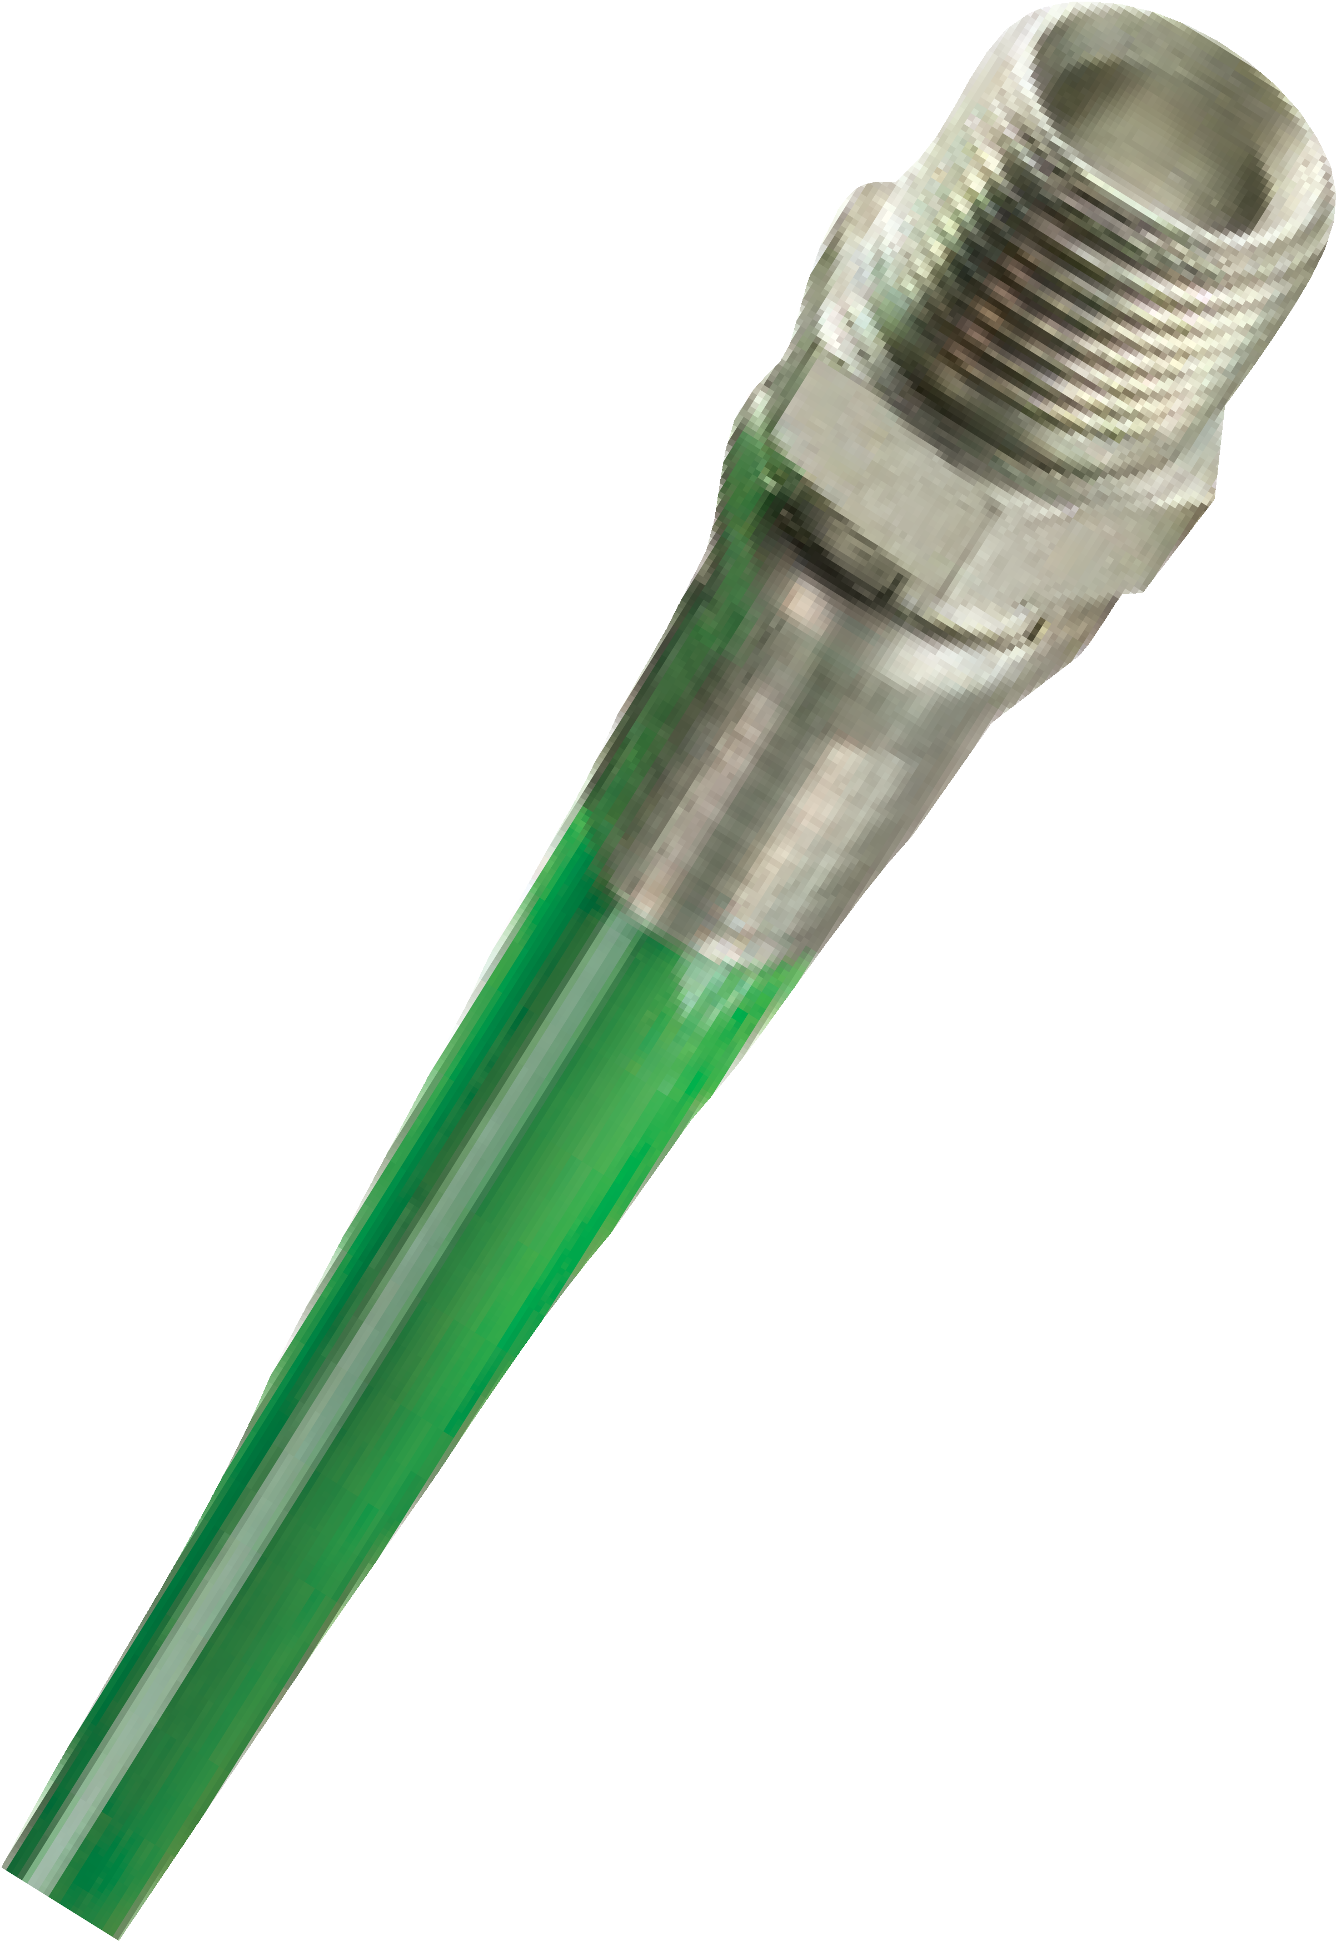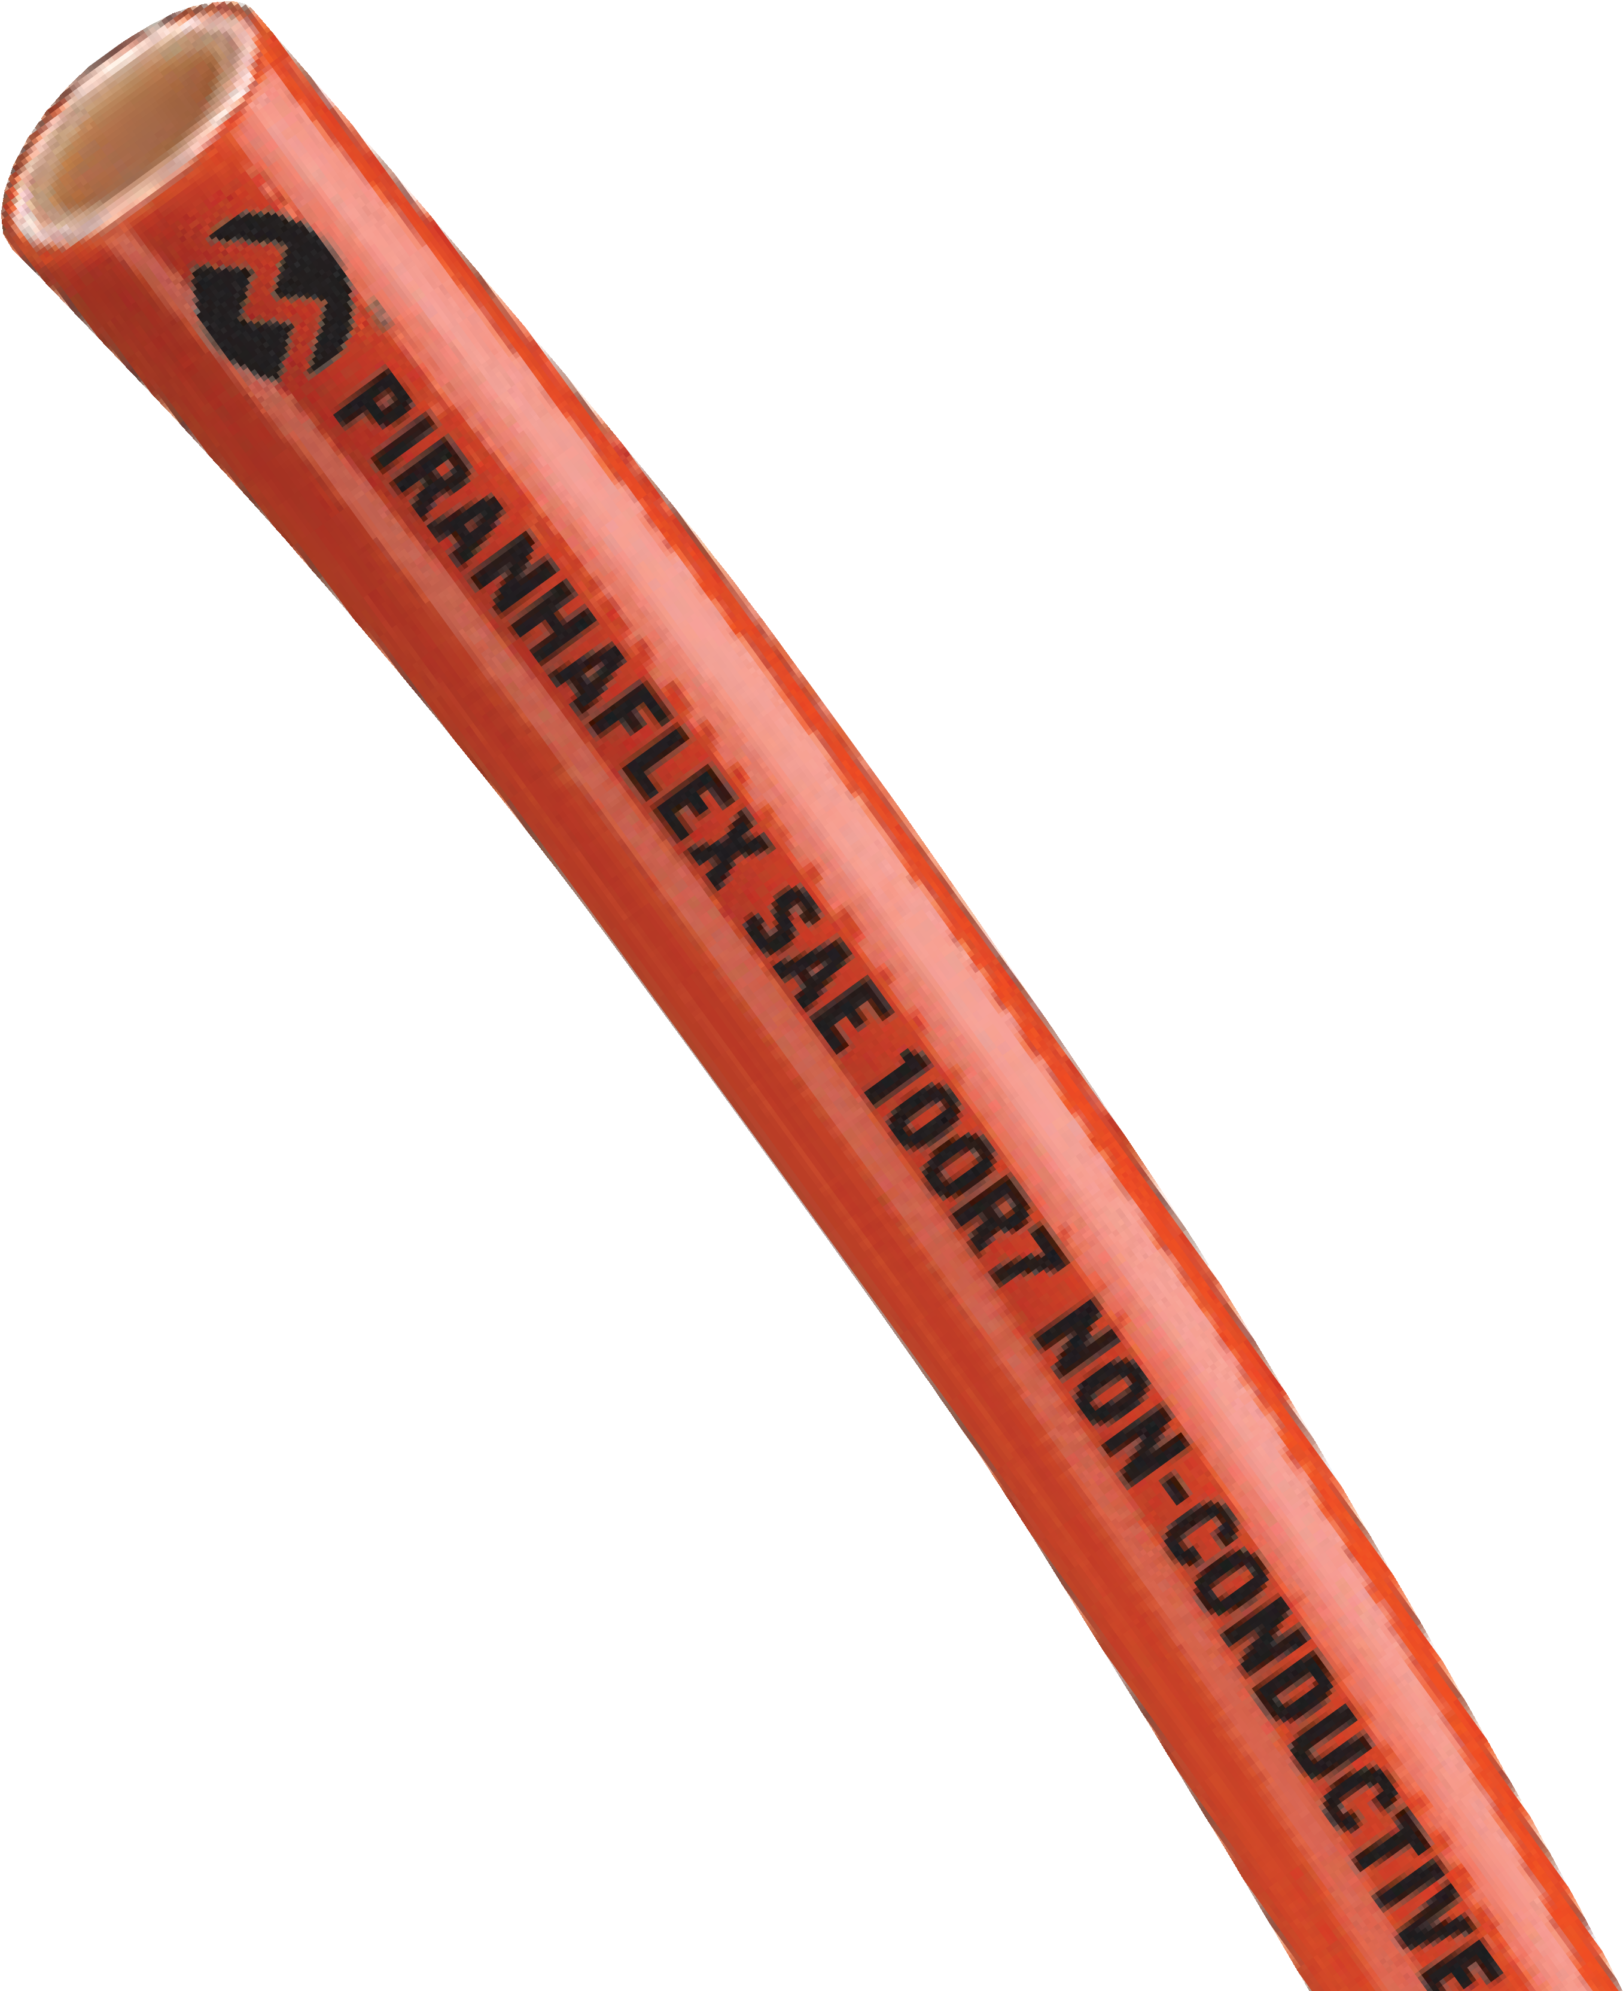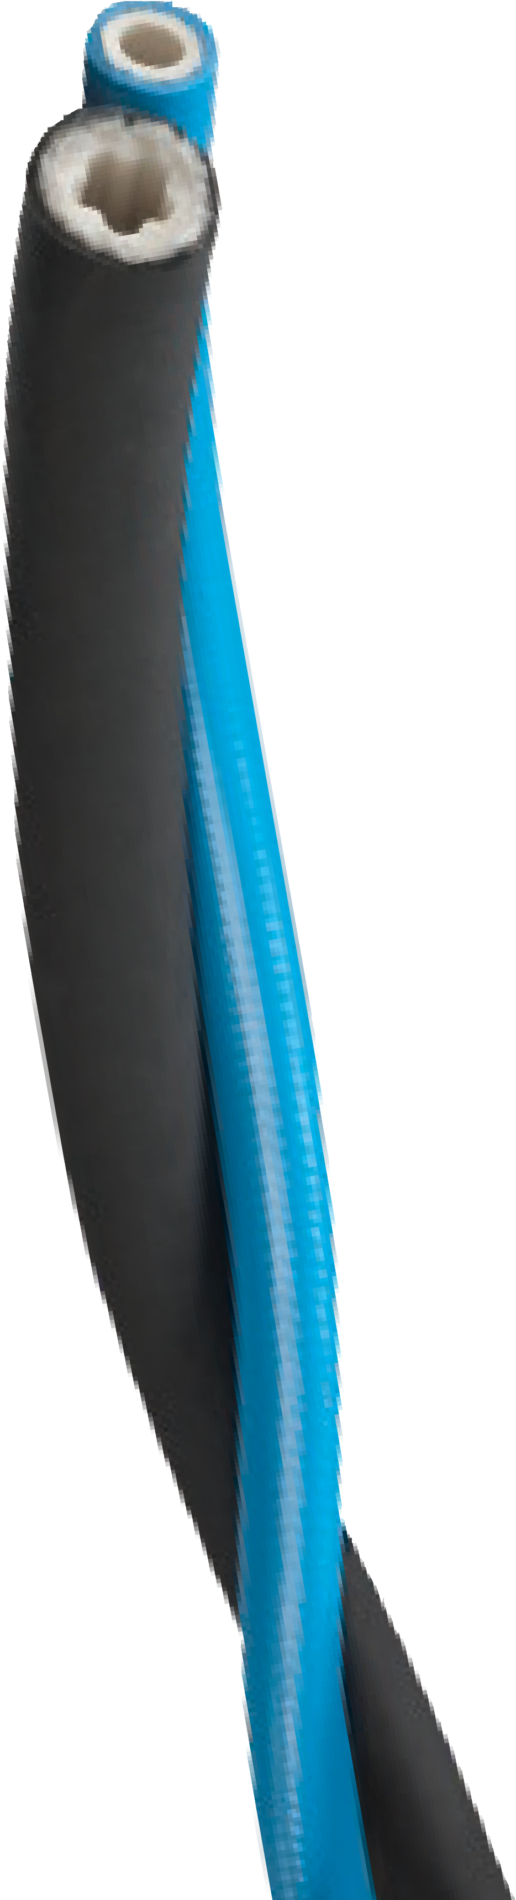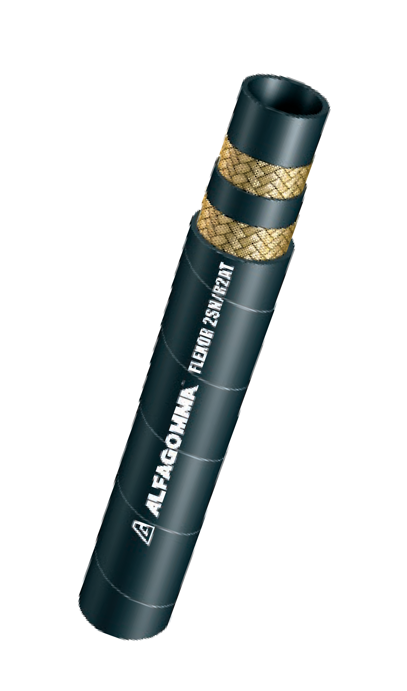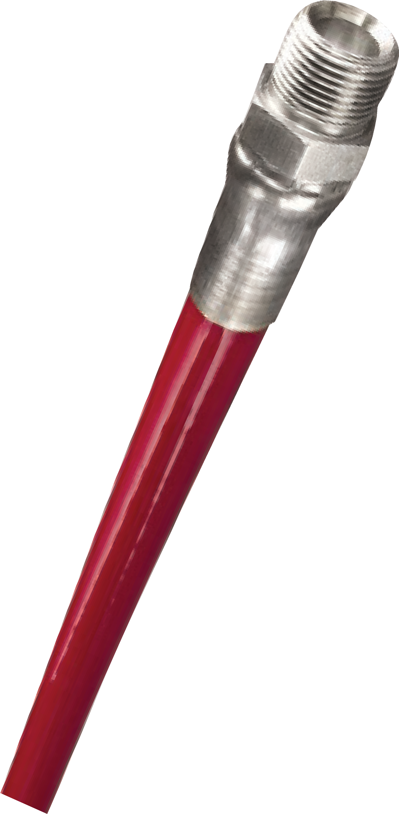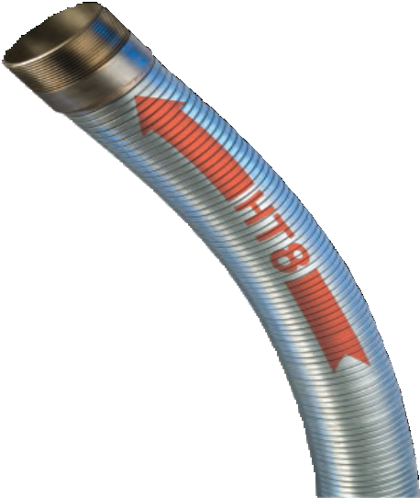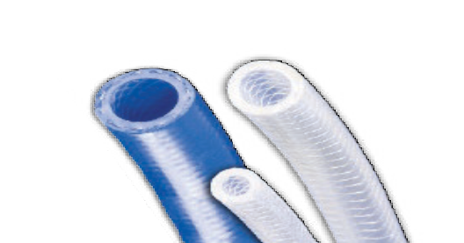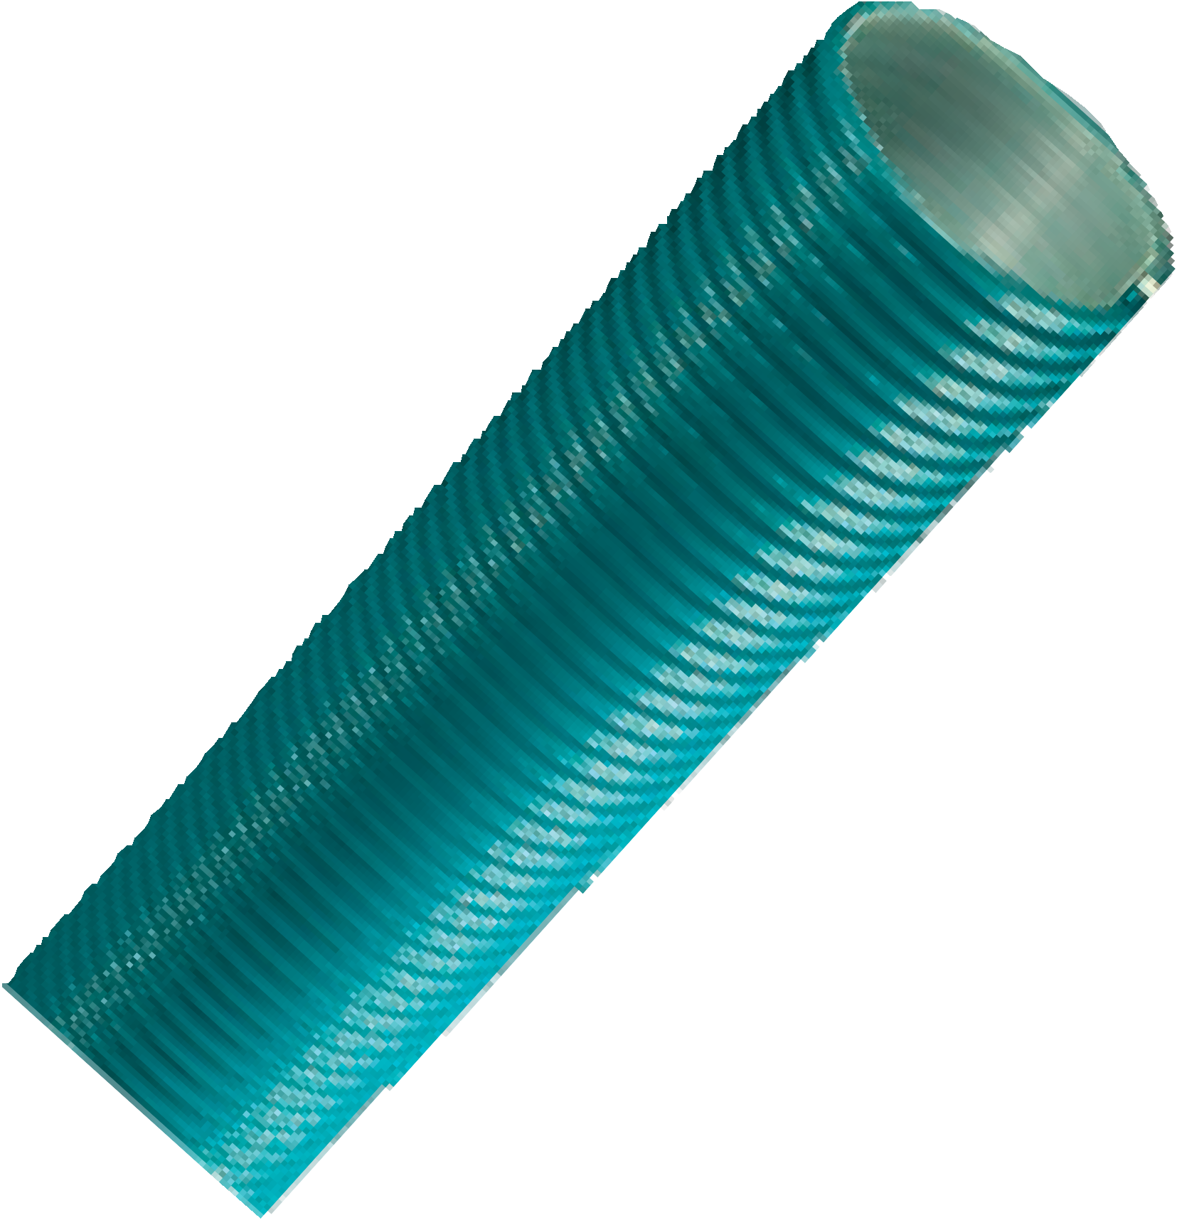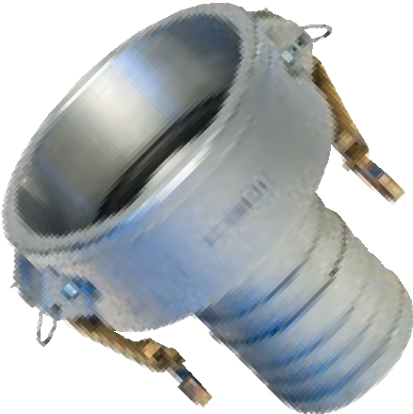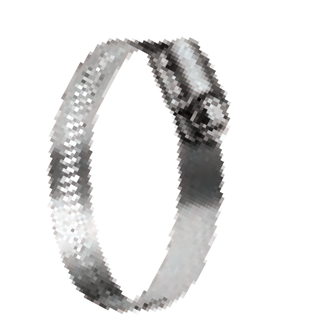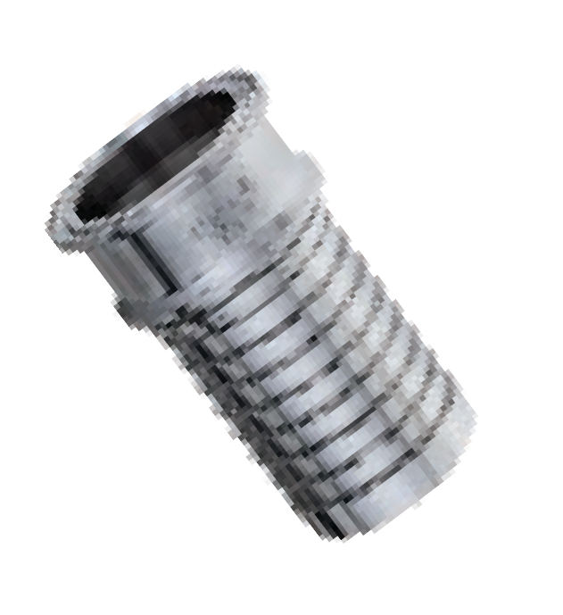For Over 50 Years THE KURIYAMA VALUE
75
Innovative and Effective Application Solutions
kuriyama.com/50years

Cautionary Statement
All Products sold and distributed by Kuriyama of America, Inc. are in the nature of commodities and they are sold by published specifications and not for particular purposes, uses or applications. Purchaser shall first determine their suitability for the intended purposes, uses or applications and shall either conduct its own engineering studies or tests, or retain qualified engineers, consultants or testing laboratories and consult with them before determining the proper use, suitability or propriety of the merchandise or Products for the intended purposes, uses or applications.
Kuriyama of America, Inc. (“Seller”) does not recommend the Products for any particular purpose, use or application, and the Purchaser or user thereof shall assume full responsibility for the suitability, propriety, use and application of the Products. Purchaser shall follow all instructions contained in Seller’s catalogs, brochures, technical bulletins and other documents regarding the Products. The Products, including but not limited to, hose, tubing or couplings, may fail due to the use or conveyance of substances at elevated or lowered temperatures or at excessive pressure, the conveyance of abrasive, injurious, flammable, explosive or damaging substances.
Hose or tubing used in bent configurations will be subjected to increased abrasion. Hose clamps or couplings may loosen after initial installation and all sections of hose and tubing including connections, couplings, clamps, con- ductivity and bonding should be inspected frequently, regularly and consistently, and should be replaced, adjusted or re-tightened for the avoidance of leakage, for the prevention of injuries or damages, and for general safety purposes. Except as indicated in its Limited Warranty, Seller shall not be liable or responsible for direct or indirect injuries or damages caused by or attributed to the failure or malfunction of any Products sold or distributed by it.
Purchasers or users of the Products should frequently and consistently undertake inspections and protective measures with respect to the use and application of Products, which should include the examination of tube and cover, conditions of the hose or tubing, and the identification, repair or replacement of sections showing cracking, blistering, separations, internal and external abrasions, leaking or slipped couplings or connections and make proper proof tests.

Limited Warranty
The Products sold or distributed by Seller are warranted to its customers to be free from defects in mate- rial and workmanship at the time of shipment by us, subject to the following provisions. ALL WARRANTY CLAIMS SHALL BE MADE WITHIN SIX (6) MONTHS AFTER SELLER SHIPPED THE PRODUCTS. SELLER’S LIABILITY HEREUNDER IS LIMITED AT SELLER’S EXCLUSIVE DISCRETION, TO 1) THE PURCHASE PRICE OF ANY PRODUCTS PROVING DEFECTIVE; 2) REPAIR OF ANY DEFECTIVE PRODUCT OR PART THEREOF; OR 3) REPLACEMENT OF ANY DEFECTIVE PRODUCT OR PART UPON ITS AUTHORIZED RETURN TO SELLER.

THIS WARRANTY IS IN LIEU OF AND EXCLUDES ALL OTHER WARRANTIES, EXPRESSED, IMPLIED, STATUTORY, OR OTHERWISE CREATED UNDER APPLICABLE LAW INCLUDING, BUT NOT LIMITED TO, THE WARRANTY OF MERCHANTABILITY AND THE WARRANTY OF FITNESS FOR A PARTICULAR PURPOSE. IN NO EVENT SHALL SELLER OR THE MANUFACTURER OF THE PRODUCT BE LIABLE FOR SPECIAL, INCIDENTAL, OR CONSEQUEN- TIAL DAMAGES, INCLUDING LOSS OF PROFITS, WHETHER OR NOT CAUSED BY OR RESULTING FROM THE NEGLIGENCE OF SELLER AND/OR THE MANUFACTURER OF THE PRODUCT, UNLESS SPECIFICALLY PROVIDED HEREIN. IN ADDITION, THIS WARRANTY SHALL NOT APPLY TO ANY PRODUCTS OR PORTIONS THEREOF WHICH HAVE BEEN SUBJECTED TO ABUSE, MISUSE, IMPROPER INSTALLATION, MAINTENANCE, OR OPERATION, ELECTRICAL FAILURE OR ABNORMAL CONDITIONS, AND TO PRODUCTS WHICH HAVE BEEN TAMPERED WITH, ALTERED, MODIFIED, REPAIRED, REWORKED BY ANYONE NOT APPROVED BY SELLER, OR USED IN ANY MANNER INCONSISTENT WITH THE PROVISIONS OF THE “CAUTIONARY STATEMENT” ABOVE OR ANY INSTRUCTIONS OR SPECIFICATIONS PROVIDED WITH OR FOR THE PRODUCT.
09/2005
Distributed by:

CONTACT OUR SALES/WAREHOUSE LOCATIONS BELOW WHICH SERVE YOUR AREA
SOUTHWEST WAREHOUSE KURIYAMA OF AMERICA, INC.
HOUSTON
200 PORTWALL STREET, SUITE 100
HOUSTON, TX 77029
Phone: (713) 674-8212
Toll Free Phone: (800) 501-6808
FAX: (713) 674-5214
Toll Free FAX: (800) 800-5214
E-Mail: sales@kuriyama.com

WESTERN WAREHOUSE KURIYAMA OF AMERICA, INC.
SANTA FE SPRINGS
10749 SHOEMAKER AVENUE SANTA FE SPRINGS, CA 90670-4039 Phone: (562) 941-4507
FAX: (562) 941-8940
Toll-Free FAX: (800) 326-8940
E-Mail: sales@kuriyama.com

SOUTHEAST WAREHOUSE FORTNEY SALES CO., INC. 4221 CANTRELL ROAD NW ACWORTH, GA 30101
PHONE: (770) 427-6528
FAX: (770) 423-9249
Toll Free FAX: (800) 423-9249
Web Site: www.fortneysales.com E-Mail: sales@fortneysales.com

EASTERN WAREHOUSE
EASTERN RUBBER & PLASTICS CO., INC.
100 GOLDMAN DR. PLUMSTED INDUSTRIAL PARK CREAM RIDGE, NJ 08514 Phone: (609) 758-0100
FAX: (609) 758-0102
Toll Free FAX: (800) 445-7138
Web Site: www.easternrubber.com E-Mail: sales@easternrubber.com

IN CANADA:
KURI TEC CORPORATION
140 ROY BOULEVARD
BRANTFORD, ON, CANADA N3R 7K2 Phone: (519) 753-6717
FAX: (519) 753-7737
Web Site: http://www.kuritec.com E-Mail: sales@kuritec.com

IN MEXICO:
KURIYAMA DE MÉXICO S DE RL DE CV AV JOSE PALOMO MARTINEZ NO 520-20 BODEGA 5
PARQUE INDUSTRIAL OMOLAP APODACA, N.L. CP:66633, MÉXICO
Telefonos: (81) 1086-1870 O 71
Lada sin Costo 01 800 822 52 00
FAX: (81) 1086-1869
Internet: www.kuriyama.com
Correo Electronico: ventas@kuriyama.com

Headquarters, Sales Office and Warehouse Location
360 E. State Parkway, Schaumburg, IL 60173-5335 Phone: (847) 755-0360 • Toll-free FAX: (800) 800-0320
International FAX: (847) 885-0996
Web Site: http://www.kuriyama.com
E-Mail: sales@kuriyama.com
② ①  kuriyama.com/50years

THE ASSOCIATION FOR HOSEAND ACCESSORIES DISTRIBUTION

©2019 Kuriyama of America, Inc. All rights reserved. 4.5M 02/19 Printed in U. S. A. KTFCA0219

