Solutions in Spill Control
Automotive Industrial Environmental
Marine

Sorbents & Containment Products Catalog

Spills Happen

be prepared

PAGE Oil-Only
PAGE
Rapid-Response
PAGE 4-Drum

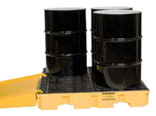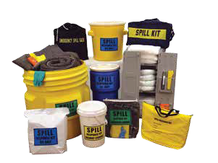12 Pads & Rolls
29 Spill Kits
69 Spill Pallet

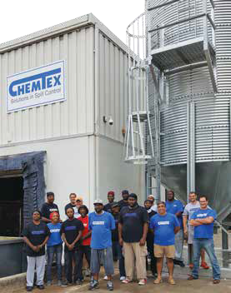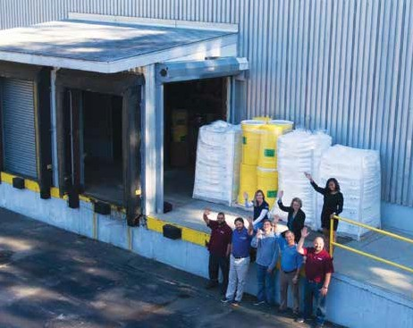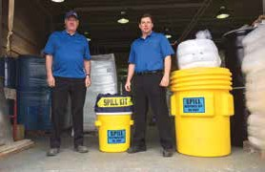

Service with a smile 24/7

Georgia facility

Corporate headquarters
in Rhode Island Canada facility
With distributors located in over 40 states in the U.S. and over 25 different countries throughout the world, we’ve got you covered for spills of all sizes.
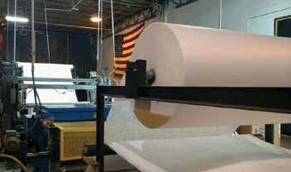
WE’RE MANUFACTURING GREAT PRODUCTS FOR THE SPILL CONTROL INDUSTRY!

Chemtex’s new facility in Georgia uses an Exxon-patented extrusion die for the manufacturing of all of its meltblown polypropylene absorbent products.

To order, call 1-877-431-0200

Safety First! Companies are responsible for maintaining a clean and safe workplace for their employees. They are also responsible for protecting our environment, especially when working with petroleum liquids and
hazardous chemicals. This means having a proper spill control plan in place at all times. Chemtex helps companies comply with all of the above by manufacturing a variety of premium meltblown polypropylene sorbent products, including sorbent pads, rolls, booms, socks, pillows and spill kits. These items and more are used in day-to-day MRO applications for catching drips and leaks and for major catastrophic incidents by oil spill response organizations
all over the world.
In our 90,000 ft2 factory located in Milledgeville, Georgia, we maintain an automated manufacturing process which includes polypropylene extrusion, thermal bonding, bidirectional perforating, sheeting, stacking and rewinding. We also have a scrap converting operation, where we reprocess over 95% of our post-industrial waste into accessory absorbent products, such as booms, socks, pillows and spill kits. By reprocessing our own waste, we are eliminating what goes to the landfills and manufacturing useful products at the same time. We offer Superior Service and High-Quality Products at Fair Prices.
This is what we do best!
With three stocking locations on the East Coast of North America—two in the U.S. and one in Canada—Chemtex has what you want when you need it. We know oil spills don’t punch a time clock, so for that reason we carry a huge variety of inventory at all times. When it comes to cleaning oil or chemical spills, we want you to think Chemtex!
Universal Absorbents. 7
Oil-Only Absorbents. 11
Hazmat Absorbents. 18
Absorbents – Other 20
Spill Kits. 29
Marine Spill Response. 38
Wipers & Rags. 44
Granulars, Neutralizers
& Bioremediation. 48
Cleaners & Degreasers. 56
Storm Water Management. 59
Personal Protection. 64
Secondary Containment. 67
Specialty Products. 78
Lenny Johnson President
PAGE 33
Truck Spill Kits

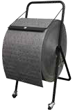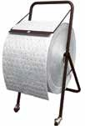

BR200G New Universal Bonded Meltblown Roll in a compact size that fits on a new Dispenser on Wheels Page 9
Universal Dimpled Meltblown Pads & Rolls are an economical alternative to our Bonded SM Pads & Rolls
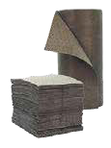
Page 10
BR200W New Oil-Only Bonded Meltblown Roll in a compact size that fits on a new Dispenser on Wheels Page 13
Oil-Only Dimpled Meltblown Pads & Rolls are an economical alternative to our Bonded SM Pads & Rolls Page 14

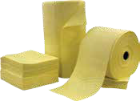

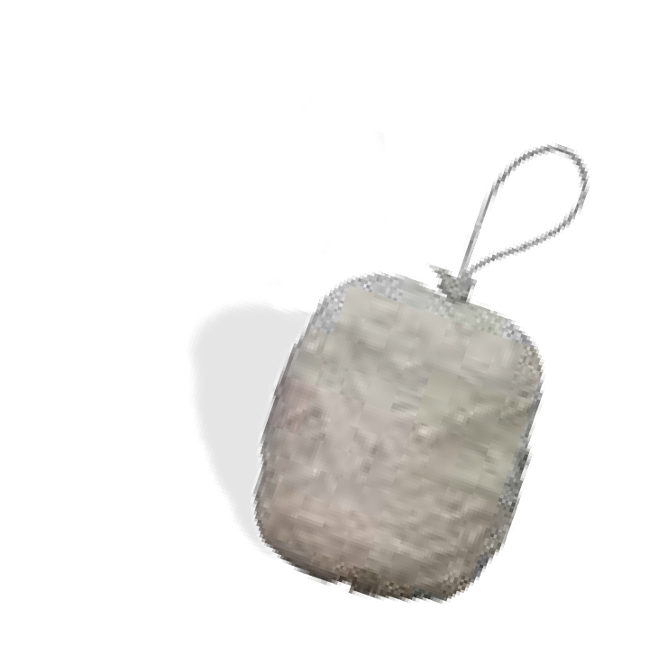Hazmat Fine Fiber Meltblown Pads & Rolls
Page 19
A new, more economical version of our Poly-backed Sorbent Pads Page 21
SMP Track Mat is a more economical version from our original track matting Page 23
Spaghetti Pillows are ideal for the pick-up of hydrocarbons in fast-flowing waters
Page 24

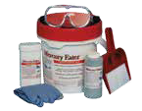

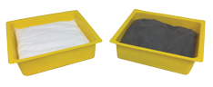
New version of our Drip Pans with removable replacement pillows that allow re-use
Page 28

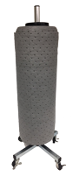
New Vertical Roll Rack on Wheels replaces our OILM5005 freestanding roll rack
Page 28
New Mercury Spill Kit replaces both the large & small kits from our last catalog.
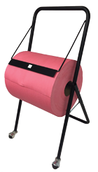
One kit does it all.
Page 37
NWP381 Red Spunlace Wipers on a roll with available roll rack on wheels
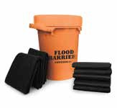
Page 45

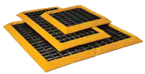

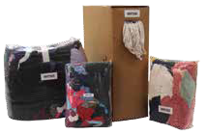
New packaging for WIP500 Polo Rags. A compressed dispenser box allows double the quantity/pallet.
Page 47
New Flood Control Kit. You can never be too prepared for flood waters.
Page 63
Spill Nests are an economical alternative to hard plastic spill pallets for temporary containment.
Page 70

NEW PRODUCTS
4 Chemtex | Delivering Solutions in Spill Control

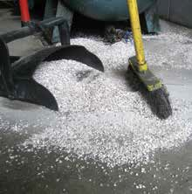SORBENTS: CLAY VS POLY

Are you still using clay to clean your leaks, drips and spills?
You may think you’re saving money because the cost of a bag of clay is so cheap, but in reality you are spending more—a lot more! In addition to the financial savings that we list below, these are a few other reasons not to use clay:
- Clay is very messy; cleanup is difficult and labor-intensive.
- Clay is an abrasive, which causes damage to machinery and moving parts.
- Silica is considered a serious health hazard by OSHA.
- Clay is heavy to work with compared to polypropylene pads.
- Clay is not a good absorbent.
To learn more details about clay vs. polypropylene, please call our office and ask to speak with a customer service representative.

CLAY MINERAL POLYPROPYLENE
PRODUCT QUANTITY AND COST

10 Bags
$9.50/bag x 10 bags = $95
1 Bale
$58/bale x 1 bale = $58

DISPOSAL CONTAINERS REQUIRED

2 Drums
$75/drum x 2 drums = $150
1 Drum
$75.00/drum x 1 drum = $75

LABOR AND TIME REQUIRED

3 People x 2 hours
$45/hour @ $15/hour x 2 hours = $90
1 Person x 1 hour
$15/hour x 1 hour = $15

ACCESSORY SPILL CLEANUP MATERIALS

3 Shovels & 3 Brooms
$20/shovel x 3 + $15/broom x 3 = $105
Gloves
$1

AVERAGE DISPOSAL COST PER DRUM

2 Drums
$150/drum x 2 drums = $300
1 Drum
$150/drum x 1 drum = $150

$740.00 TOTAL CLEANUP & DISPOSAL COSTS $299.00

Quality Rating of Pads & Rolls

HH
Single layer of standard fiber meltblown polypropylene

Meltblown
Standard Meltblown Pads & Rolls
- Fast-absorbing with an economical price
- Contractor Grade
- No perforations
- For short-term use

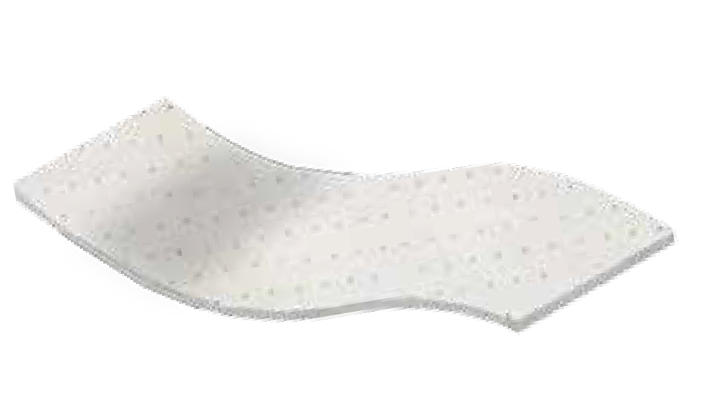HHH
Single layer of dimpled meltblown polypropylene
Dimpled

Meltblown
Dimpled Meltblown Pads & Rolls
- Stronger than Contractor Grade pads & rolls
- The dimples reduce linting in pads & rolls
- Perforated to waste less

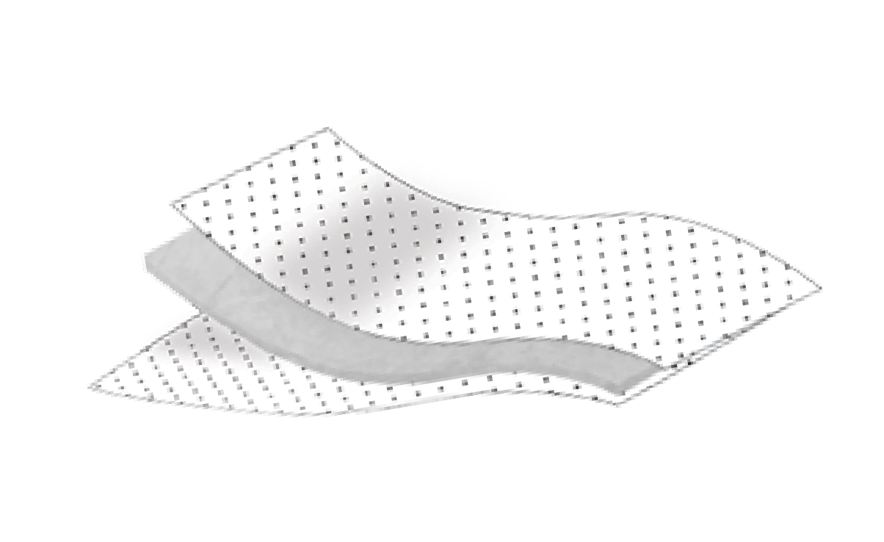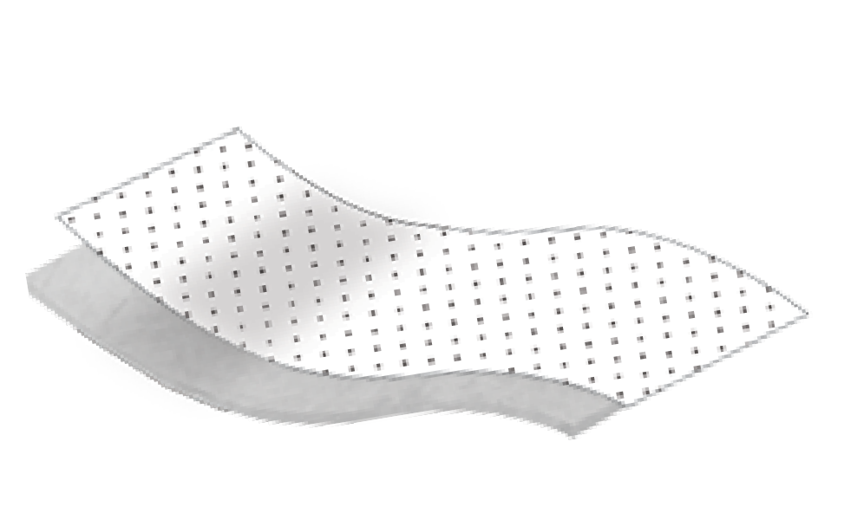HHHH
Two layers of low-linting fine fiber polypropylene are bonded around a meltblown core.
Meltblown
Fine Fiber
Fine Fiber
A meltblown sorbent core is bonded between two layers of lint-free spunbond fabric.
Meltblown
Spunbond
Spunbond
6 Chemtex | Delivering Solutions in Spill Control
One layer of spunbond fabric is bonded to a single layer of meltblown polypropylene.
Spunbond

Meltblown
Bonded-SM Pads & Rolls
- Stronger tensile strength than the dimpled pads & rolls
- One side is lint-free that can be used for wiping
- Perforated every 7.5" vertically and 19" horizontally to waste less
HHHHH
Fine Fiber Meltblown Pads & Rolls
- Super-strong tensile strength
- Very low lint
- Grips floors
- Perforated every 7.5" vertically and 19" horizontally to waste less
HHHHH
SMS Bonded Pads & Rolls
- Super-strong tensile strength
- No lint
- Perforated every 7.5" vertically and 19" horizontally to waste less

UNIVERSAL ABSORBENTS
Ideal for use in maintenance and repair operations, MRO.
These pads and rolls will absorb, oil, water and water-based chemicals. Universal sorbents are left on the ground under and around machinery to catch drips and spills from leaking machinery or equipment. Pads and rolls come in four qualities— Fine Fiber-FMF, Bonded-SM, Dimpled and SMS Bonded Meltblown.

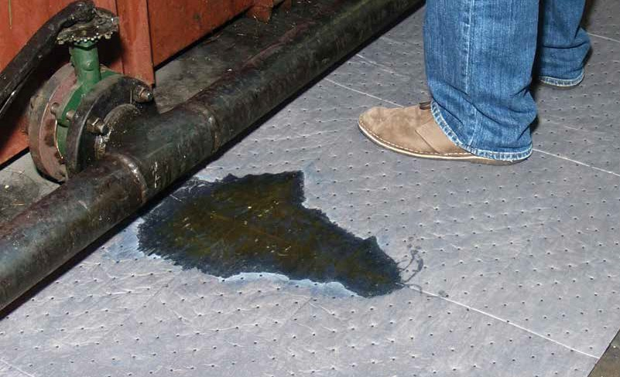Fluids Absorbed
For Oils, Coolants, Solvents and Water
- Hydraulic Oil
- Ethanol
- Gasoline
- Kerosene
- Water
- Mineral Spirits
- Turpentine
Full list of fluids absorbed on page 81
Quality Rating of Pads & Rolls
HHH
DIMPLED / Stronger than Contractor Grade pads & rolls / the dimples reduce linting / perforated to waste less
HHHH
BONDED–SM / Stronger tensile strength than the dimpled pads & rolls / one side is lint-free / perforated every 7.5" vertically and 19" horizontally to waste less
HHHHH
FINE FIBER / Super-strong tensile strength / very low lint / grips floors / perforated every 7.5" vertically and 19" horizontally to waste less
HHHHH
SMS BONDED / Super-strong tensile strength / no lint / perforated every 7.5" vertically and 19" horizontally to waste less
www.chemtexinc.com | Toll-free 1-877-431-0200 | Fax 401-305-3033 7

UNIVERSAL / MAINTENANCE ABSORBENTS

Universal Fine Fiber Meltblown Pads & Rolls (FMF)
The highest quality pads and rolls we manufacture
Our fine fiber sorbents are constructed with 3 plies of polypropylene—fine fiber/meltblown/fine fiber. These pads and rolls are universal so they are used to absorb oil, water, and water-based chemicals. Dark gray pads hide grime, which makes pads last longer. High-strength, low-linting sorbents are used where added durability is a must. The smooth, fine fiber surface adds the strength needed for high-traffic areas. Using small-diameter strands of fiber increases surface area, which enables pads and rolls to grip surfaces securely. Both pads and rolls are used to contain and absorb splashes
and spills under and around machinery. These are the highest quality pads and rolls that we manufacture. The fine fiber polypropylene increases the strength and durability of the pads and rolls so they can be perforated like a paper towel. Perforations will help reduce waste and allow you to use the exact amount needed for the job.
Pads
Model # Mfg # Description Absorbs Packaging

FFP12G PHGFF100 15" x 19", Double Wt., Gray 25 gallons 100/bale FFP12G-BX PHGFF100-BX 15" x 19", Double Wt., Gray 25 gallons 100/box FFP9G PMGFF100 15" x 19", Medium Wt., Gray 20 gallons 100/bale FFP9G-BX PMGFFBX100 15" x 19", Medium Wt., Gray 20 gallons 100/box FFP6G PSGFF200 15" x 19", Single Wt., Gray 27 gallons 200/bale FFP12GR PHGRFF100 15" x 19", Double Wt., Green 25 gallons 100/bale
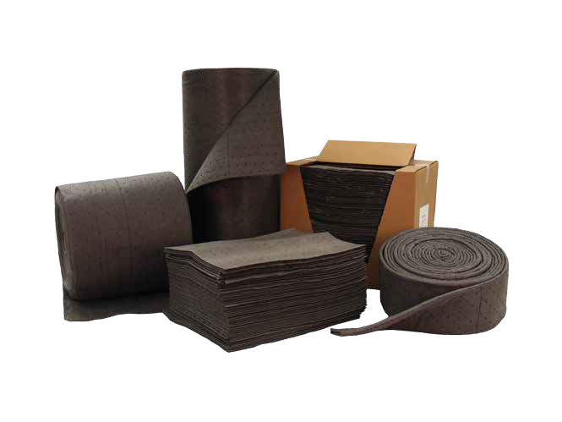Rolls

Model # | Mfg # | Description | Absorbs | Packaging
FFR12G | RHGFF150 | 30" x 150', Double Wt., Gray | 47 gallons | 1 roll
FFR12G-2 | RHGFF1502 | 15" x 150', Double Wt., Gray | 47 gallons | 2 rolls
FFR9G | RMGFF150 | 30" x 150', Medium Wt., Gray | 37 gallons | 1 roll
FFR9G-2 | RMGFF1502 | 15" x 150', Medium Wt., Gray | 37 gallons | 2 rolls
FFR6G | RSGFF300 | 30" x 300', Single Wt., Gray | 47 gallons | 1 roll
FFR6G-2 | RSGFF3002 | 15" x 300', Single Wt., Gray | 47 gallons | 2 rolls
FFR12G50 | RHGFF50 | 6.33" x 50', Double Wt., Gray Mat | 9 gallons | 1 roll
FFR12GR RHGRFF150 30" x 150', Double Wt., Green 47 gallons 1 roll
FOR INDUSTRIAL AND AUTOMOTIVE APPLICATIONS. ABSORBS OIL, WATER AND MOST NONAGGRESSIVE FLUIDS

UNIVERSAL ABSORBENTS

HHHHH
QUALITY

8 Chemtex | Delivering Solutions in Spill Control

UNIVERSAL / MAINTENANCE ABSORBENTS
UNIVERSAL ABSORBENTS

Universal Bonded Meltblown Pads & Rolls (SM)
Our bonded-SM sorbents are constructed with 2 plies of
HHHH
QUALITY

polypropylene—spunbond/meltblown. These pads and rolls are universal so they are used to absorb oil, water and water-based chemicals. Bonded-SM pads and rolls share the same features as
our dimpled meltblown pads and rolls, plus an extra layer of spunbond polypropylene that is bonded to the top to make the pads and rolls low-linting on one side and highly absorbent on the opposite side. The bonding process increases the
strength and durability of the pads and rolls so they can be perforated like a paper towel. Perforations will help reduce waste and allow you to use the exact amount needed for the job. These pads and rolls are the best of both worlds—the lint-free top sheet side can be used to clean and wipe tanks, tools, walls, etc. without leaving lint, but you also can use the meltblown side for quick absorption of fluids. We recommend these pads as the “best bang for your buck.”
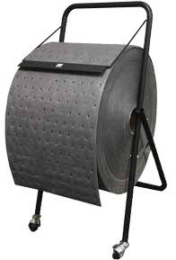
Pads

Model # | Mfg # | Description | Absorbs | Packaging
BP12G | PHGS100 | 15" x 19", Double Wt. | 28 gallons/bale | 100/bale
BP9G | PMGS100 | 15" x 19", Medium Wt. | 23 gallons/bale | 100/bale
BP6G | PSGS200 | 15" x 19", Single Wt. | 30 gallons/bale | 200/bale
BP3030G* | PHGS50 | 30" x 30", Double Wt. | 43 gallons/bale | 50/bale
BP12GHPS | PGB100HL | 15" x18", High Loft | 25 gallons/box | 100/box
BP6GHPS | PGB200HL | 15" x18", High Loft | 27 gallons/box | 200/box
*Part # change from BP3438G to model # BP3030G
Rolls

Model # | Mfg # | Description | Absorbs | Packaging
BR12G | RHGS150 | 30" x 150', Double Wt. | 52 gallons/roll | 1 roll
BR12G-2 | RHGS1502 | 15" x 150', Double Wt. | 52 gallons/roll | 2 rolls
BR9G | RMGS150 | 30" x 150', Medium Wt. | 44 gallons/roll | 1 roll
BR9G-2 | RMGS1502 | 15" x 150', Medium Wt. | 44 gallons/roll | 2 rolls

BR6G RSGS300 30" x 300', Single Wt. 55 gallons/roll 1 roll BR6G-2 RSGS3002 15" x 300', Single Wt. 55 gallons/roll 2 rolls BR200G RHGS200 12" x 200', Double Wt. 30 gallons/roll 1 roll OILM5041 WRRACK Roll Rack on Wheels for model #BR200G
Roll rack sold separately.

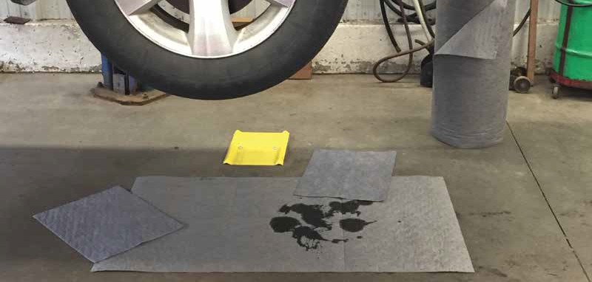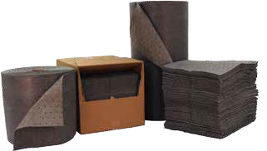www.chemtexinc.com | Toll-free 1-877-431-0200 | Fax 401-305-3033 9

UNIVERSAL / MAINTENANCE ABSORBENTS

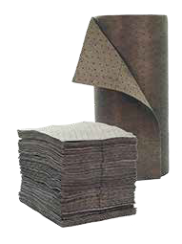Universal Dimpled Meltblown Pads & Rolls
Our dimpled sorbents are constructed with 1 ply of meltblown polypropylene. These pads and rolls are universal so they are used to absorb oil, water and water-based chemicals. Dimpled pads and rolls share the same features as our bonded-SM pads and rolls without the added layer of spunbond. By not adding the extra layer of spunbond, it makes the
pads and rolls more economical. The dimpling process increases the strength and durability of the pads and rolls so they can be perforated like a paper towel. Perforations will help reduce waste and allow you to use the exact amount needed for the job.
Universal Pads

Model # | Mfg # | Description | Absorbs | Packaging
DP100G* | PGS100HL | 15" x 18", High Loft | 18 gallons/bale | 100/bale
DP12G | PHGB100 | 15" X 18", Double Wt. | 25 gallons/bale | 100/bale
DP9G | PMGB100 | 15" x 18", Medium Wt. | 20 gallons/bale | 100/bale
DP6G | PSGB200 | 15" x 18", Single Wt. | 29 gallons/bale | 200/bale
DP3030G | PHGB50 | 30" x 30", Double Wt. | 36 gallons/bale | 50/bale
*Part # change from BP100G to model # DP100G
Universal Rolls

Model # | Mfg # | Description | Absorbs | Packaging
DR12G | RHGB150 | 30" x 150', Double Wt. | 44 gallons/roll | 1 roll
DR12G-2 | RHGB1502 | 15" x 150', Double Wt. | 44 galllons/roll | 2 rolls
DR9G | RMGB150 | 30" x 150', Medium Wt. | 40 gallons/roll | 1 roll
DR9G-2 | RMGB1502 | 15" x 150', Medium Wt. | 40 gallons/roll | 2 rolls
DR6G | RSGB300 | 30" x 300', Single Wt. | 58 gallons/roll | 1 roll
DR6G-2 RSGB3002 15" x 300', Single Wt. 58 gallons/roll 2 rolls

HHH
QUALITY

UNIVERSAL ABSORBENTS

SMS–Universal Bonded Meltblown Pads & Rolls
Our SMS bonded sorbents are constructed with 3 plies of polypropylene— spunbond/meltblown/spunbond. These pads and rolls are universal so they are used to absorb oil, water and water-based chemicals. These are our most durable sorbent pad and rolls combining two technologies to form one super-strong pad. A thirsty absorbent layer of meltblown is bonded between two layers of lint-free, spunbond fabric. These lint-free pads and rolls will not contaminate your equipment. Use in areas that require a durable, long-lasting pad or roll. The spunbond polypropylene increases the strength and durability of the pads and rolls so they can be perforated like a paper towel. Perforations will help reduce waste and allow you to use the exact amount needed for the job.

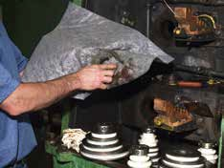SMS–Universal Pads
HHHHH
QUALITY
Model # Mfg # Description Absorbs Packaging OILM5126 PGSS100HL 15" x 18", High Loft, Gray 19 gallons/bale 100/bale OILM1060 PHGSS100 15" x 19", Double Wt., Gray 27 gallons/bale 100/bale

SMS–Universal Rolls

Model# | Mfg # Description | Absorbs | Packaging
OILM5125 | RGSS150HL 30" x 150', High Loft, Gray | 48 gallons/roll | 1 roll
OILM5026 RHGSS150 30" x 150', Double Wt., Gray 51 gallons/roll 1 roll

OIL-ONLY ABSORBENTS

Ideal for responding to petroleum-based spills on both land and water.
These pads will float on water so they are best suited for spills outdoors or on bodies of water. Can also be used indoors for any petroleum-based fluid such as oils, gasoline, diesel, etc. These pads and rolls come in 5 qualities—
Fine Fiber-FMF, Bonded-SM, Dimpled, SMS Bonded and Standard Meltblown.

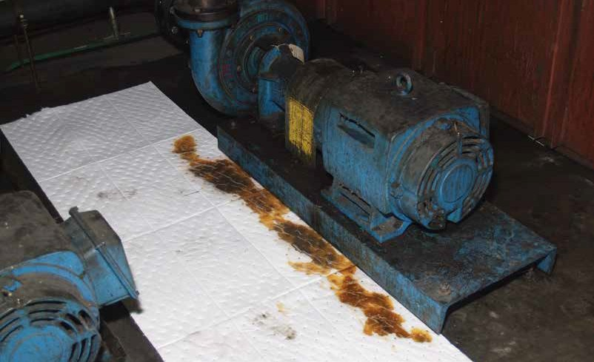Fluids Absorbed
For absorbing oil while repelling water
- Motor Oil
- Hydraulic Oil
- Gasoline
- Diesel Fuel
- Jet Fuel

Full list of fluids absorbed on page 81
www.chemtexinc.com | Toll-free 1-877-431-0200 | Fax 401-305-3033 11
Quality Rating for Pads & Rolls
HH
STANDARD / Fast-absorbing with an economical price / Contractor Grade / no perforations / for short-term use
HHH
DIMPLED / Stronger than Contractor Grade pads & rolls / the dimples reduce linting / perforated to waste less
HHHH
BONDED–SM / Stronger tensile strength / one side is lint-free / perforated every 7.5" vertically and 19" horizontally to waste less
HHHHH
FINE FIBER / Super-strong tensile strength / very low lint / grips floors / perforated every 7.5" vertically and 19" horizontally to waste less HHHHH
SMS BONDED / Super-strong tensile strength / no lint / perforated every 7.5" vertically and 19" horizontally to waste less

OIL-ONLY FOR INDUSTRIAL APPLICATIONS
OIL-ONLY ABSORBENTS

Oil-Only Fine Fiber Meltblown Pads & Rolls (FMF)
The highest quality pads and rolls we manufacture
Our fine fiber sorbents are constructed with 3 plies of polypropylene—fine fiber/meltblown/fine fiber. These pads and rolls are oil-only so they are used to absorb oil and other oil-based fluids. They will not absorb water or water-based chemicals. High-strength, low-linting sorbents are used where added durability is a must. The smooth, fine fiber surface adds the strength needed for high-traffic areas. Using small-diameter strands of fiber increases surface area, which enables pads and rolls to grip surfaces securely. Both pads and rolls are used to contain and absorb splashes and spills under and around machinery.

HHHHH
QUALITY

Pads
Model # | Mfg # | Description | Absorbs | Packaging
FFP12W | PHWFF100 | 15" x 19", Double Wt., White | 25 gallons/bale | 100/bale
FFP9W | PMWFF100 | 15" x 19", Medium Wt., White | 20 gallons/bale | 100/bale
FFP6W | PSWFF200 | 15" x 19", Single Wt., White | 27 gallons/bale | 200/bale
FFP12B | PHBFF100 | 15" x 19", Double Wt., Blue | 25 gallons/bale | 100/bale
FFP6B PSBFF200 15" x 19", Single Wt., Blue 27 gallons/bale 200/bale
Rolls

Model # | Mfg # | Description | Absorbs | Packaging
FFR12W | RHWFF150 | 30" x 150', Double Wt., White | 47 gallons/roll | 1 roll
FFR12W-2 | RHWFF1502 | 15" x 150', Double Wt., White | 47 gallons/roll | 2 rolls
FFR9W | RMWFF150 | 30" x 150', Medium Wt., White | 38 gallons/roll | 1 roll
FFR9W-2 | RMWFF1502 | 15" x 150', Medium Wt., White | 38 gallons/roll | 2 rolls
FFR6W | RSWFF300 | 30" x 300', Single Wt., White | 51 gallons/roll | 1 roll
FFR12B RHBFF150 30" x 150', Double Wt., Blue 47 gallons/roll 1 roll

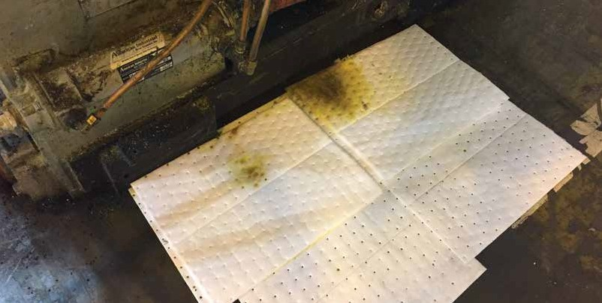
OIL-ONLY FOR INDUSTRIAL APPLICATIONS

Oil-Only Bonded Meltblown Pads & Rolls (SM)
OIL-ONLY ABSORBENTS

Versatility that gives you the best bang for your buck
Our bonded-SM sorbents are constructed with 2 plies of polypropylene—spunbond/meltblown. These pads and rolls are oil-only so they are used to absorb oil, gasoline and other hydrocarbon-based liquids. These pads will not absorb water so they can be used to remove oil off water. SM bonded pads and rolls share the same features as our dimpled meltblown pads and rolls, plus an extra layer of spunbond polypropylene that is bonded to the top to make the pads and rolls
low-linting on one side and highly absorbent on the opposite side. The bonding process increases the
ated like a paper towel. act amount
lds—
HHHH
QUALITY
strength and durability of the pads and rolls so they can be perfor Perforations will help reduce waste and allow you to use the ex needed for the job. These pads and rolls are the best of both wor the lint-free top sheet side can be used to clean and wipe tanks, tools, walls, etc. without leaving lint, but you also can use the meltblown side for quick absorption of fluids. We recommend these pads as the “best bang for your buck.”
Pads
Model # Mfg # |  | Description | Absorbs | Packaging
BP12W PHWS100 |  | 15" x 19", Double Wt. | 30 gallons/bale | 100/bale
BP9W PMWS100 15" x 19", Medium Wt. 25 gallons/bale 100/bale BP6W PSWS200 15" x 19", Single Wt. 32 gallons/bale 200/bale BP3030W PHWS50 30" x 30", Double Wt. 43 gallons/bale 50/bale
Rolls
Model # | Mfg # | Description | Absorbs | Packaging
BR12W | RHWS150 | 30" x 150', Double Wt. | 52 gallons/roll | 1 roll
BR12W-2 | RHWS1502 | 15" x 150', Double Wt. | 52 gallons/roll | 2 rolls
BR9W | RMWS150 | 30" x 150', Medium Wt. | 44 gallons/roll | 1 roll
BR9W-2 | RMWS1502 | 15" x 150', Medium Wt. | 44 gallons/roll | 2 rolls
BR6W | RSWS300 | 30" x 300', Single Wt. | 55 gallons/roll | 1 roll
BR6W-2 | RSWS3002 | 15" x 300', Single Wt. | 55 gallons/roll | 2 rolls

BR200W RHWS200 12" x 200', Double Wt. 30 gallons/roll 1 roll

OIL-ONLY FOR INDUSTRIAL APPLICATIONS
& Rolls
wn e
OIL-ONLY ABSORBENTS
Oil-Only Dimpled Meltblown Pads
Our dimpled sorbents are constructed with 1 ply of meltblo polypropylene. These pads and rolls are oil-only so they ar used to absorb oil, gasoline and other oil-based fluids.
Dimpled pads and rolls share the same features as our SM bonded pads and rolls without the added layer of spunbond. By not adding the extra layer of spunbond, it makes the pads and rolls more economical. The dimpling process still increases the strength and durability of the pads and rolls so they can be perforated like a paper towel. Perforations will help reduce waste and allow you to use the exact amount needed for the job.
Oil-Only Pads
HHH
QUALITY
Model # Mfg # Description Absorbs Packaging

DP12W-HP* PWB100HL 15" x 18", High Loft 26 gallons/bale 100/bale DP6W-HP* PWB200HL 15" x 18", High Loft 28 gallons/bale 200/bale DP12W PHWB100 15" X 18", Double Wt. 25 gallons/bale 100/bale DP9W PMWB100 15" X 18", Medium Wt. 20 gallons/bale 100/bale DP6W PSWB200 15" x 18", Single Wt. 29 gallons/bale 200/bale DP3030W PHWB50 30" x 30", Double Wt. 32 gallons/bale 50/bale
*Part # changes from BP12WHP to model # DP12W-HP and BP6WHP to model # DP6W-HP
Oil-Only Rolls

Model # | Mfg # | Description | Absorbs | Packaging
DR12W | RHWB150 | 30" x 150', Double Wt. | 44 gallons/roll | 1 roll
DR12W-2 | RHWB1502 | 15" X 150', Double Wt. | 44 gallons/roll | 2 rolls
DR9W | RMWB150 | 30" x 150', Medium Wt. | 40 gallons/roll | 1 roll
DR9W-2 | RMWB1502 | 15" x 150', Medium Wt. | 40 gallons/roll | 2 rolls

DR6W RSWB300 30" x 300', Single Wt. 58 gallons/roll 1 roll

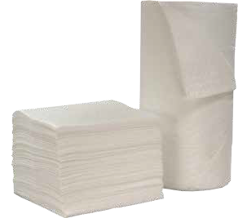SMS–Oil-Only Bonded Meltblown Pads & Rolls
Our SMS bonded sorbents are constructed with 3 plies of polypropylene— spunbond/meltblown/spunbond. These pads and rolls are oil-only so they are used to absorb oil, gasoline and other hydrocarbon-based fluids. These pads and rolls will not absorb water so they can be used to remove oil off water. These are our most durable sorbent pad and rolls combining two technologies to form one super-strong pad. A thirsty absorbent layer of meltblown is bonded between
two layers of lint-free, spunbond fabric. These lint-free pads and rolls will not contaminate your equipment. Use in areas that require a durable, long-lasting pad or roll. The spunbond polypropylene increases the strength and durability of the pads and rolls so they can be perforated like a paper towel. Perforations will help reduce waste and allow you to use the exact amount needed for the job.

HHHHH
QUALITY

SMS–Oil-Only Pads

Model # | Mfg # Description | Absorbs | Packaging
OILM5122 | PWSS100HL 15" x 18", High Loft, White | 19 gallons/bale | 100/bale
OILM1006 PHWSS100 15" x 19", Double Wt., White 27 gallons/bale 100/bale
SMS–Oil-Only Rolls

Model # | Mfg # Description Absorbs | Packaging
OILM5120 | RWSS150HL 30" x 150', High Loft, White 46 gallons/roll | 1 roll
OILM5116 RHWSS150 30" x 150', Double Wt., White 51 gallons/roll 1 roll

OIL-ONLY SPILL RESPONSE PRODUCTS
OIL-ONLY ABSORBENTS

Oil-Only Standard Meltblown Pads & R
olls
nd rolls al for a
Quick-absorbing and highly versatile. Use standard meltblown pads a for cleaning spills on land and water. These low-cost sorbents are ide variety of environmental applications.
Oil-Only Standard Pads
Model # Mfg # Description Absorbs Packaging P12W PHW100 15" x 19", Double Wt. 32 gallons/bale 100/bale P9W PMW100 15" x 19", Medium Wt. 25 gallons/bale 100/bale
P6W | PSW200 | 15" x 19", Single Wt. | 36 gallons/bale | 200/bale
P9WG | PW100HL | 15" x 18", High Loft | 20 gallons/bale | 100/bale

P3030W PHW50 30" x 30", Double Wt. 53 gallons/bale 50/bale
Oil-Only Standard Rolls

Model # | Mfg # | Description | Absorbs | Packaging
R12W | RHW150 | 30" x 150', Double Wt. | 60 gallons/roll | 1 roll
R12W-2 | RHW1502 | 15" x 150', Double Wt. | 60 gallons/roll | 2 rolls
R9W | RMW150 | 30" x 150', Medium Wt. | 41 gallons/roll | 1 roll
R9W-2 | RMW1502 | 15" x 150', Medium Wt. | 41 gallons/roll | 2 rolls
R6W RSW300 30" x 300', Single Wt. 68 gallons/roll 1 roll

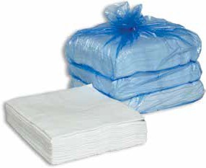
Anti-Static Meltblown Pads & Rolls
Use static-resistant sorbents where static electricity poses a problem. Deploy around flammable liquids. Ideally used in dry environments with low humidity or in confined spaces where flammable vapors may be present.
Anti-Static Meltblown Pad
Model # Mfg # Description Absorbs Packaging

SRP12W PWAS25 15" x 19", Double Wt. 9 gallons/bale 25/bale
Anti-Static Meltblown Roll
Model # Mfg # Description Absorbs Packaging

SRR12W RHWAS150 30" x 150', Double Wt. 64 gallons/roll 1 roll

HH
QUALITY

Booms
Linkable booms are used to contain and absorb spills on or off water. The built-in steel connectors link booms
together to cover large areas of water. Booms are encased with a lint-free poly sock that prevents shedding.

Booms

Model # Mfg # Description Absorbs Packaging

B8 BW8104 8" x 10', Lint-free 65 gallons/bale 4 booms/bale B820* BW8202 8" x 20', Lint-free 65 gallons/bale 2 booms/bale B5 BW5104 5" x 10', Lint-free 35 gallons/bale 4 booms/bale
B520* BW5202 5" x 20', Lint-free 35 gallons/bale 2 booms/bale

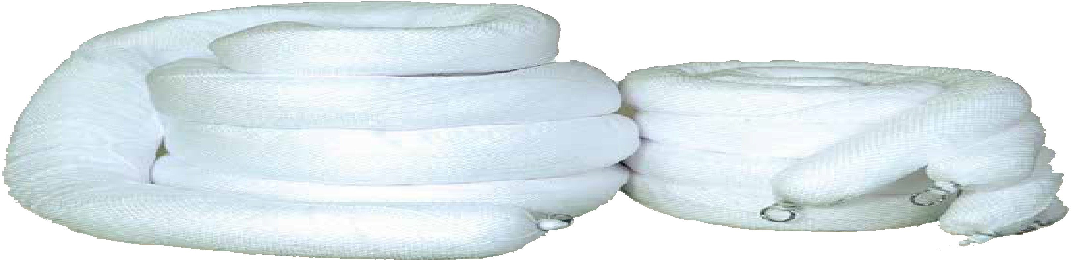B310* BW3104 3" x 10', Lint-free 12 gallons/bale 4 booms/bale

B3 BW3202 3" x 20', Lint-free 12 gallons/bale 2 booms/bale
OIL-ONLY SPILL RESPONSE PRODUCTS
OIL-ONLY ABSORBENTS
*These new sized booms are made to order and not kept in inventory.

OIL-ONLY SPILL RESPONSE PRODUCTS
OIL-ONLY ABSORBENTS

Boom XT
Are you using sorbent boom near rocky shoreline? Does the tide go out and leave your boom lying high and dry on a rocky bottom? Rocks and barnacles will rip and tear standard sorbent booms and cause the shredded polypropylene to release, making more of a mess than when you started. Introducing the Boom XT—the Boom XT is made from HDPE netting, which is a lot stronger than traditional boom nets. The HDPE netting also is UV-treated to protect the polypropylene from the sun’s damaging UV rays. If you are working in harsh marine environments, you need Boom XT.

Sweeps

Boom XT

Model # Mfg # Description Absorbs Packaging B5XT BW510XT 5" x 10', Lint-free 35 gallons/bale 4 booms/bale B8XT BW810XT 8" x 10', Lint-free 65 gallons/bale 4 booms/bale

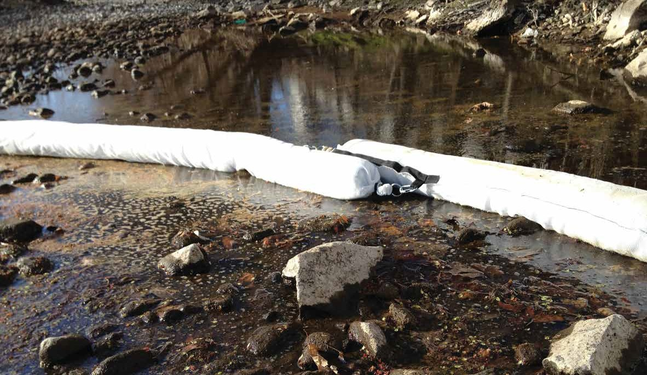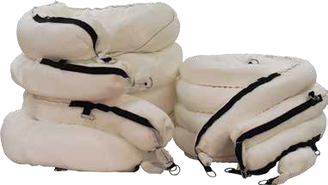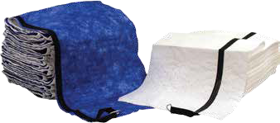Designed for rapid spill cleanup/containment on or off water. Reinforced nylon straps, together with laminated spunbond fabric, add the extra strength needed for towing capabilities. Sweeps are ideal for removing thin slicks off water.

Sweeps
Model# Mfg # Description Absorbs Packaging SW100* SHWS100 White, 19” x 100’ w/Straps 18 gallons/bale 1/bale SW100B SHBS100 Blue, 19” x 100’ w/Straps 18 gallons/bale 1/bale
*White sweep is special order. Please call our office for ordering details.

HAZMAT ABSORBENTS

Ideal for responding to spills of unknown liquids.
These pads and rolls will absorb virtually all acid and base liquids. Hazmat sorbents are quickly deployed and recovered in hazardous spill applications. Pads and rolls come in two qualities, both Fine Fiber-FMF and Bonded-SM Meltblown.

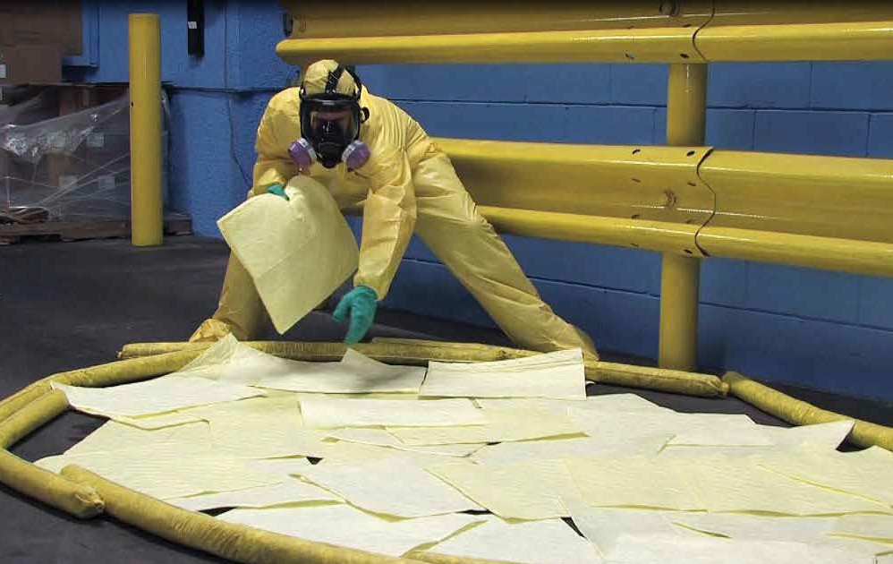Fluids Absorbed
- Acids & Bases
- Aggressive Chemicals
- Oils
- Solvents
- Citric Acid
- Water-based Fluids
- Sodium Hydroxide
- Other Unknown Liquids
18 Chemtex | Delivering Solutions in Spill Control
Full list of fluids absorbed on page 81
Quality Rating of Pads & Rolls
HHHH
BONDED-SM / Stronger tensile strength / one side is lint-free / perforated every 7.5" vertically and 19" horizontally to waste less
HHHHH
FINE FIBER / Super-strong tensile strength / very low lint / grips floors / perforated every 7.5" vertically and 19" horizontally to waste less

HAZMAT SORBENTS

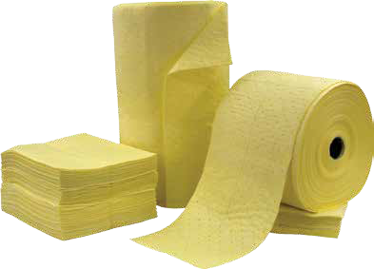Hazmat Fine Fiber Meltbl Pads & Rolls (FMF)
own

es of polypropylene— w-linting sorbents smooth, fine fiber
ic areas. Using ce

the job.
Our fine fiber sorbents are constructed with 3 pli fine fiber/meltblown/fine fiber. High-strength, lo are used where added durability is a must. The surface adds the strength needed for high-traff small-diameter strands of fiber increases surfa area, which enables pads and rolls to grip surfaces securely. These are the highest quality pads and rolls that we manufacture.
The fine fiber polypropylene increases the strength and durability of the pads and rolls so they can be perforated like a paper towel.
Perforations will help reduce waste and
allow you to use the exact amount needed for
HHHHH
QUALITY

FMF Hazmat Pads

Model # Mfg # Description Absorbs Packaging

FFP1113Y PHYFF1001014 10" x 14" , Double Wt. 18 gallons/bale 100/bale FFP12Y PHYFF100 15" x 19" , Double Wt. 27 gallons/bale 100/bale FFP6Y PSYFF200 15" x 19" , Single Wt. 28 gallons/bale 200/bale
FMF Hazmat Rolls

Model # Mfg # Description Absorbs Packaging FFR12Y RHYFF150 30" x 150', Double Wt. 47 gallons/bale 1 roll FFR12Y-2 RHYFF1502 15" x 150', Double Wt. 47 gallons/bale 2 rolls

SM Hazmat Pads
Hazmat Bonded Meltblown Pads & Rolls (SM)
Our bonded–SM sorbents are constructed with 2 plies of polypropylene—spunbond/ meltblown. Bonded–SM pads and rolls share the same features as our

HHHH
QUALITY
dimpled meltblown pads and rolls, plus an extra layer of spunbond polypropylene that is bonded to the top to make the pads and rolls low-linting on one side and highly absorbent

on the opposite side. The bonding process

Model # Mfg # Description Absorbs Packaging

BP12Y PHYB100 15" x 19", Double Wt. 28 gallons/bale 100/bale BP6Y PSYB200 15" x 19", Single Wt. 30 gallons/bale 200 pads/bale
SM Hazmat Rolls
Model # Mfg # Description Absorbs Packaging BR12Y RHYB150 30" x 150', Double Wt. 52 gallons/roll 1 roll BR12Y-2 RHYB1502 15" x 150', Double Wt. 52 gallons/roll 2 rolls
increases the strength and durability of the pads and rolls so they can be perforated like a paper towel. Perforations will help reduce waste and allow you to use the exact amount needed for the job. These pads and rolls are the best of both worlds—the lint-free top sheet side can be used to clean and wipe tanks, tools, walls, etc. without leaving a mess, but you also can use the meltblown side for quick absorption
of fluids.

HAZMAT ABSORBENTS
Hazmat Booms  Linkable booms are used to confine and absorb large spills on land. Absorbs hazardous or unknown liquids including oil and water based chemicals. The built-in durable connectors link booms together to cover large areas. Booms are encased with a lint-free poly sock that prevents shedding.  Hazmat Booms |  |  |  |  | 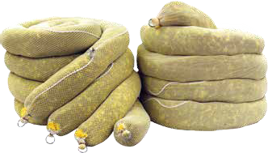
Model # | Mfg # | Description | Absorbs | Packaging
B5-H | BY5104 | 5" x 10', Lint-free | 30 gallons/bale | 4/bale
B8-H | BY8104 | 8" x 10', Lint-free | 48 gallons/bale | 4/bale

EARTH FRIENDLY ABSORBENTS

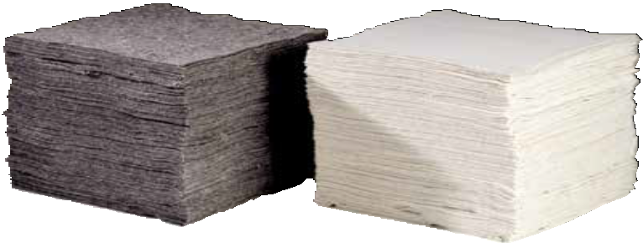Natural White – Oil-Only — Absorbs oil only; will not absorb water.
%
led
ural absorbency.

To help save our planet, we all need to contribute. Now more than ever, we need to consider using recycled products when at all possible. We also need to cut back on our use of petroleum and petroleum-based products. Using Eco-Sop™ Sorbents will do just that.
Unlike traditional meltblown polypropylene pads and rolls, these sorbents are not made from petroleum. This will not only help save our environment, but will help to keep the
cost down. These products are made using 95 American-grown, natural, renewable and recyc resources. Additives increase the sorbents’ nat
ECO-SOPTM
Saving our Planet with “Earth Friendly” Absorbents Gone Green
Gray – Universal — Absorbs oil, water, and water-based chemicals.

Aqua Lock Absorbents

Natural White — Oil-Only

Model # | Mfg # | Description | Absorbs | Packaging
OILM1082 | PHWC100 | Heavy Weight Pads, 16" x 18" | 24 gallons | 100/bale
OILM1083 | PMWC100 | Medium Weight Pads, 16" x 18" | 21 gallons | 100/bale
OILM1084 RWC28150H Heavy Weight Roll, 28" x 150' 42 gallons 1 roll
Gray — Universal

Model # | Mfg # | Description | Absorbs | Packaging
OILM1087 | PHGCU100 | Heavy Weight Pads, 16" x 18” | 26 gallons | 100/bale
OILM1088 | PMGCU100 | Medium Weight Pads, 16" x 18” | 20 gallons | 100/bale
OILM1089 RHCU150 Heavy Weight Roll, 28" x 150' 45 gallons 1 roll

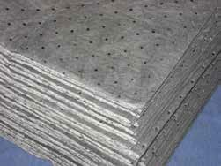
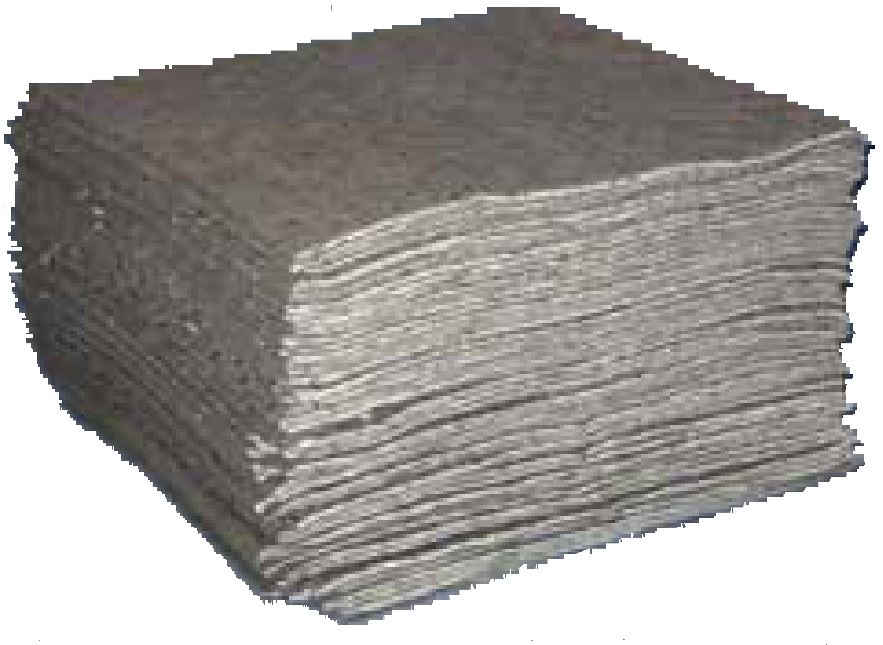Gray Universal Aqua Lock Sorbents — Absorbs oil- and water-based spills. A hybrid pad combining a fine fiber polypropylene cover stock which makes this pad low-linting and very durable. Added SAF technology that turns absorbed water-based liquids into a gel and prevents leaking from used sorbent pads and rolls. These pads are super thirsty and will encapsulate absorbed fluids with ease.
ABSORBENTS

Gray — Universal Aqua Lock
Model # Mfg # Description Absorbs Packaging OILM1092 PHGSSCA100 Heavy Weight Pads, 16” x 18” 27 gallons 100/bale OILM1093 RHGSCA150 Heavy Weight Roll, 28” x 150’ 47 gallons 1 roll

SPECIALTY ABSORBENTS
ABSORBENTS

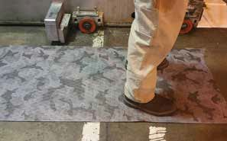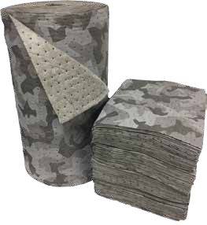Added protection for your floors. Great strength and absorbency, combined with a nonskid poly backing to prevent liquids from seeping through to the floor.
Camo Matting
The camouflage design makes leaks and drips disappear. Lasts longer than the standard gray and white meltblown rolls. This allows you to leave it on the ground for longer lengths of time, which will cut back on your spending. A spunbond top sheet provides extra strength and durability. The bottom layer of fine fiber meltblown grips the floor and provides a safe, secure walkway. Multiple perforations allow you to tear off and use only what you need.
Camo Matting
Model # Mfg # Description Absorbs Packaging
OILM6013 PHCSF100 Camo Mat Pad, 15" x 18"
OILM6019 RHCSF1502 Camo Mat Roll, 15" x 150'
30 gallons/bale 100/bale
36 gallons
2 rolls
OILM6012 RHCSF150 Camo Mat Roll, 30" x 150' 36 gallons 1 roll
Poly-backed Pads

Poly-backed Pads
Model # Mfg # Description Absorbs Packaging

DP12GPB PHGB100PB 15" x 19", Double Wt. Pads 25 gallons 50/bale

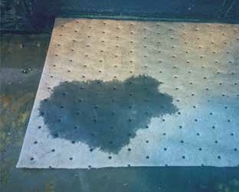
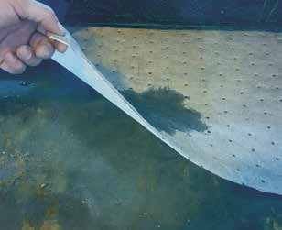

INDUSTRIAL RUGS
ABSORBENTS

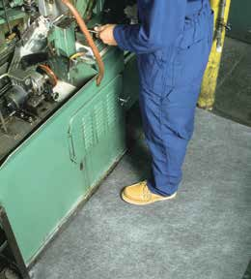
Industrial Rugs are used in place of sorbent rolls when durability is a “must.” Industrial rugs are manufactured to last. These rugs can withstand foot and forklift traffic much better than traditional sorbent rolls.

Needle-Punch
Constructed of 100% polypropylene, this rug is made to withstand constant foot and forklift traffic. Will absorb oil, water, coolants and solvents. Also used in decontamination areas on job sites.
Needle-Punch
Model # | Mfg # | Description | Absorbs | Packaging
RNP | RMGNP300 | 36" x 300', Needle-punch Rug, Black | 64 gallons/rug | 1 rug
RNP-S | RMGNP300S | 36" x 300', Needle-punch Rug, (seconds), Gray | 60 gallons/rug | 1 rug
OILM6004 | RHGNP150 | 36" x 150', Needle-punch Rug, | 64 gallons/rug | 1 rug

Gray

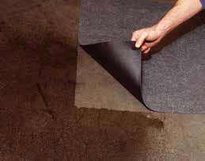
Poly-backed Needle-Punch
These are needle-punch rugs that are coated with an impermeable, nonskid backing. This prevents liquids from seeping through to the floor.
Poly-backed Needle-Punch
Model # | Mfg # Description | Absorbs | Packaging
PBRNP | RSNPPB100 36" x 100', Poly-back | 16 gallons/rug | 1 rug

Needle-punch Rug

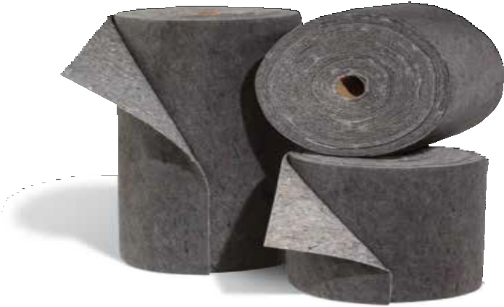
Rag Rug
This rug is made from recycled textiles and is very thick and durable. Dark-colored mats absorb the grunge from oils, coolants, solvents and water without looking dirty. The tough, durable rag rug is ideal for use in high-traffic areas.
Rag Rug
Model # Mfg # Description Absorbs Packaging
RTR-1 RHRAG150 36" x 150', Rag Rug 50 gallons/rug 1 rug

SORBENT MATTING
ABSORBENTS

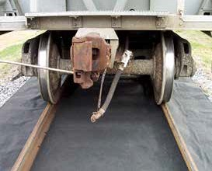
Railroad Track Matting
Absorbs Oils, Fuels and Other Hydrocarbon-based Fuels
Strong 3-ply construction—1 layer UV-resistant, extra tough needle-punch polypropylene, 1 layer oil-only cotton, and a poly backing to prevent seepage. Use the two 19" rolls outside the tracks and the 59" roll between the rails. Can be used to absorb oil, fuels and other hydrocarbon-based fuels in railroad yards.
Railroad Track Matting
Model # Mfg # Description Absorbs Packaging

OILM5997 RRT191002 RR Track Mats, 19" x 100', 40 gallons 2/pack
Outside Pieces OILM5996 RRT59100 RR Track Mat, 59" x 100', 60 gallons 1 roll
Center Pieces

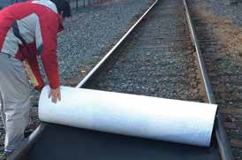
SMP Track Mat
The ultimate barrier sorbent used most commonly in railroad maintenance yards, but can also be used as a barrier matting in garages and service centers. The 3-ply construction consists of a tough UV-resistant spunbond top sheet, a highly absorbent oil-absorbing meltblown polypropylene on the inside, and a super strong impermeable polyurethane bottom sheet. These are sized to fit between a set of
railroad tracks.
SMP Track Mat
Model # Mfg # Description Absorbs Packaging OILM5992 RHRR59100 SMP Track Mat, 59" x 100' 68 gallons 1/bag OILM5991 RHRR191002 SMP Track Mat, 19" x 100' 45 gallons 2/bag

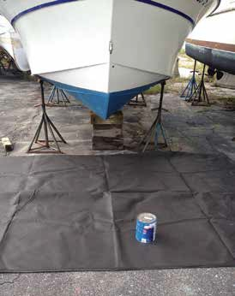
Ground Guards
Ground Guards are an economical way to help keep your boatyard clean and to help protect waterways from harmful, contaminated run-off. Two sizes to choose from depending on the size of your boat. The geotextile is made from a
high-quality polypropylene which will not rip or tear. Ground Guards will catch paint chips and oils that run off boats during power washing or just general maintenance or painting.
Ground Guards will act as a filter for contaminants. This product is reusable.
Ground Guard
Model # Mfg # Description Packaging OILM6023 RHGNP50 15' x 50', Geotextile Ground Guard 1/pack OILM6024 RHGNP25 15' x 25', Geotextile Ground Guard 1/pack

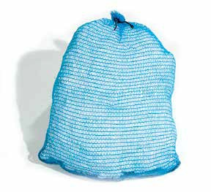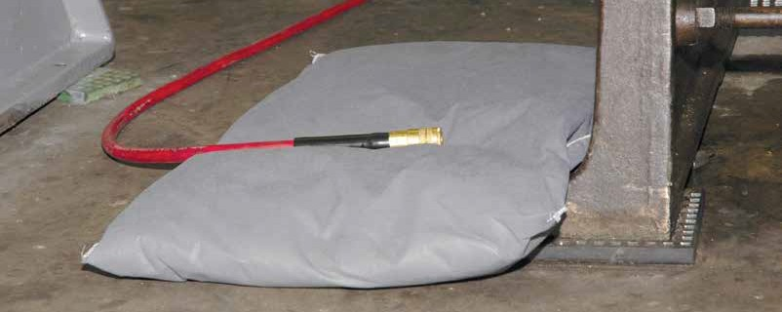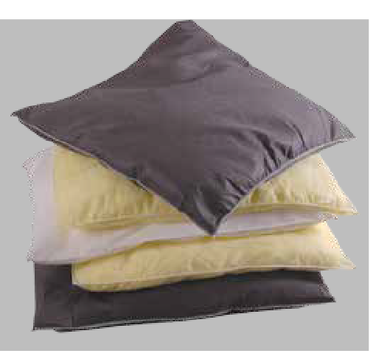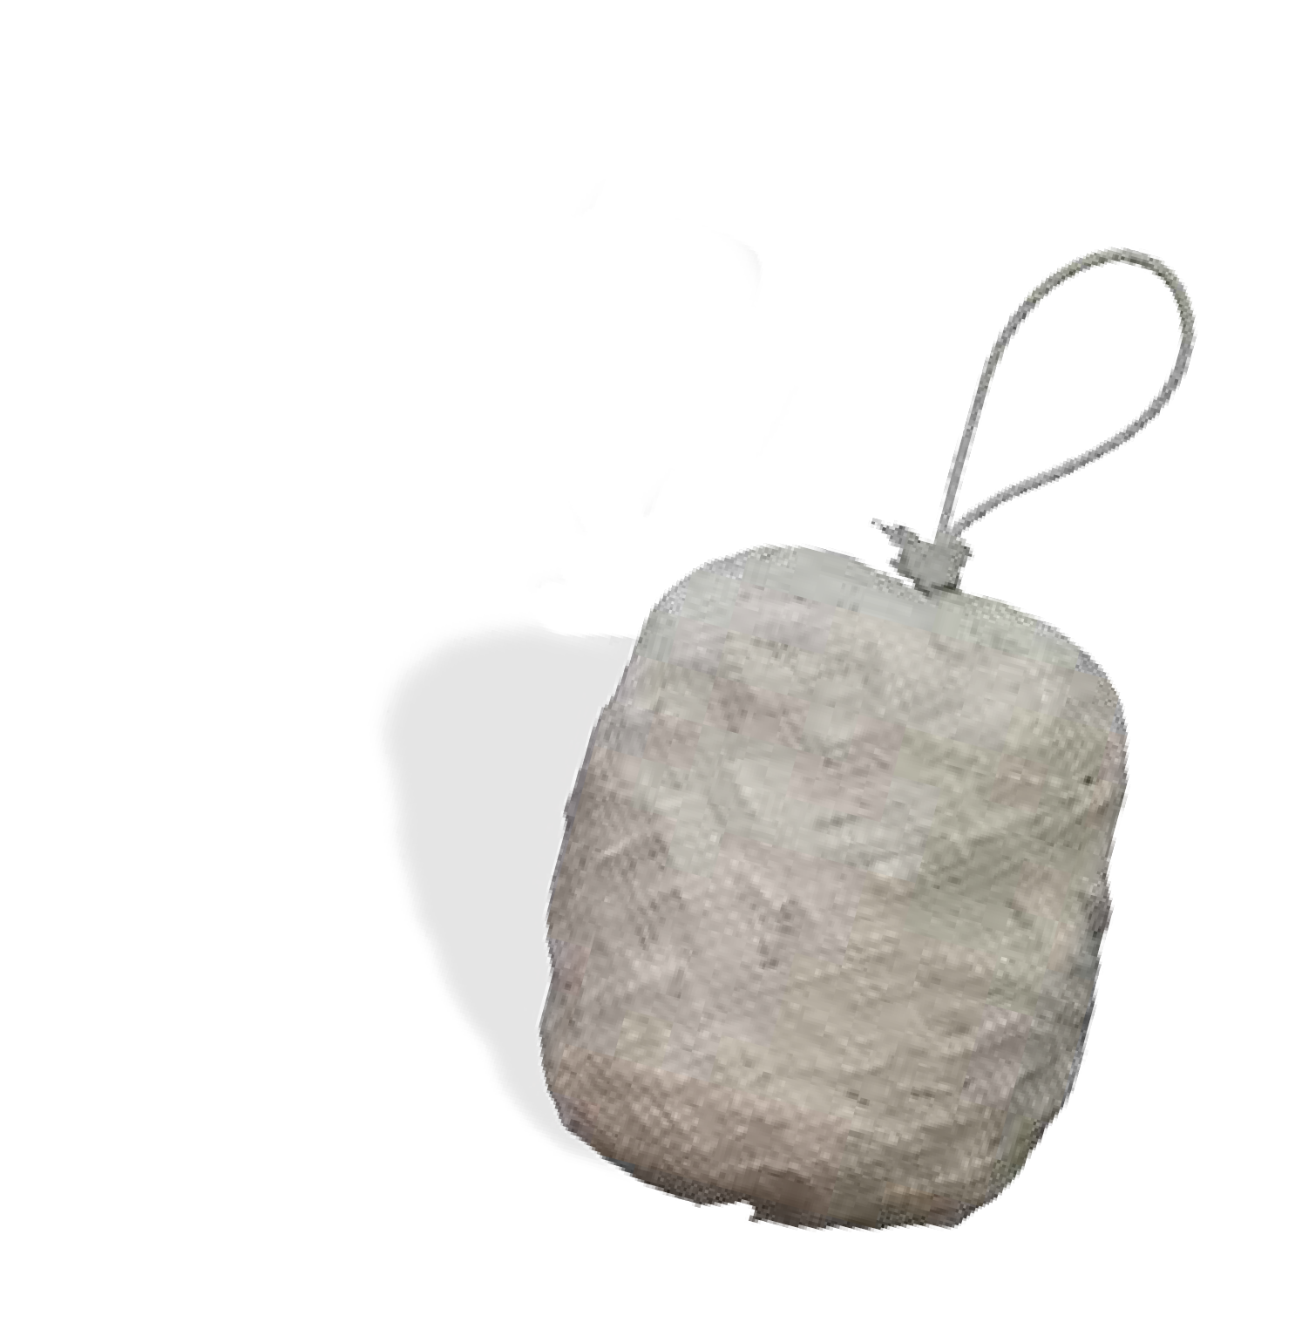SORBENT PILLOWS
ABSORBENTS

Pillows
Used to absorb large amounts of fluids where a pad just isn’t enough. Also good to use in tight, hard-to-reach areas. Use oil-only pillows on both land and water. Great in coolant tanks and sump wells. Use our universal pillows for MRO liquids and our hazmat pillows for acids, bases and unknown liquids.
Pillows

Model # | Mfg # | Description | Sorbent Capacity | Packaging | Absorbs
915-O | PILW91516 | 9" x 15" | 17 gallons/case | 16/case | oil-only
1818-O | PILW181816 | 18" x 18" | 28 gallons/case | 16/case | oil-only
1824-O | PILW182415 | 18" x 24" | 30 gallons/case | 15/case | oil-only
915-U | PILG91516 | 9" x 15" | 17 gallons/case | 16/case | universal
1818-U | PILG181816 | 18" x 18" | 28 gallons/case | 16/case | universal
1824-U | PILG182415 | 18" x 24" | 30 gallons/case | 15/case | universal
915-H | PILY91516 | 9" x 15" | 17 gallons/case | 16/case | hazmat
1818-H | PILY181816 | 18" x 18" | 28 gallons/case | 16/case | hazmat
1824-H PILY182415 18" x 24" 30 gallons/case 15/case hazmat

Mesh Bag Pillow
Polypropylene particulate encased in a nylon mesh bag. Used to absorb larger spills on water. Just toss it on the spill. Floats for easy retrieval, even when saturated.
Mesh Bag Pillow
Model # Mfg # Description Absorbs Packaging
OILM3598 PILWMB142410 Mesh Bag Pillow, 14" x 24" 37 gallons 10/bale

Spaghetti Pillow
For oil-based liquids, not water or water-based chemicals. These pillows are filled with hydrophobic polypropylene spaghetti strips designed to absorb thick oils off water. Ideal for use in fast-flowing waters. Easily deployed into storm drains. Rope loop allows for easy retrieval from land or boat. The tough outer mesh is UV-resistant for long-term outdoor use.
Spaghetti Pillow
Model # Mfg # Description Sorbent Capacity Packaging
OILM3597 PILWMS24245 Spaghetti Pillows, 15" x 15" 31 gallons/bag 10 pillows/bag

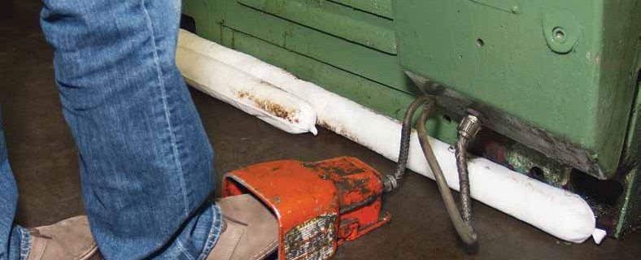

SORBENT SOCKS

Sturdy, absorbent socks are used to absorb and contain spills around machines or drums. Wrap socks around machinery to act as a dike. Also use socks to surround the spill, preventing liquids from spreading over the plant floor or down drains. These products are available in many types and sizes. Socks are color-coded to match our pads and rolls for safety and ease of use—choose the right one for your application.
ABSORBENTS
Oil-Only Sock
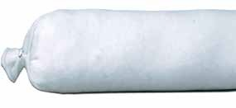These socks will not absorb water or water-based liquids. Highly absorbent and dust-free, these socks help keep a clean and safe working environment. Use these socks outdoors if needed.
Oil-Only Sock

Model # | Mfg # | Description | Sorbent Capacity | Packaging
S4B | SOCW34830 | 3" x 4' | 30 gallons/case | 30 socks/case
S4B-10 | SOCW34810 | 3" x 4' | 10 gallons/case | 10 socks/case
S8B | SOCW39615 | 3" x 8' | 30 gallons/case | 15 socks/case
S12B | SOCW314410 | 3" x 12' | 30 gallons/case | 10 socks/case
S20B | SOCW32406 | 3" x 20' | 30 gallons/case | 6 socks/case
Universal/Maintenance Sock
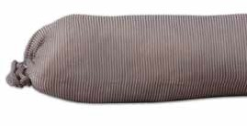Our most versatile sock, specially treated to absorb oils, coolants, solvents and water-based fluids. These socks also can be used for some
chemicals as well, but to be extra safe when picking up caustic chemicals, we recommend using our hazmat socks, which are color-coded yellow for safety.
Universal/Maintenance Sock

Model # | Mfg # | Description | Sorbent Capacity | Packaging
S4G | SOCG34830 | 3" x 4' | 30 gallons/case | 30 socks/case
S8G | SOCG39615 | 3" x 8' | 30 gallons/case | 15 socks/case
S12G | SOCG314410 | 3" x 12' | 30 gallons/case | 10 socks/case
S20G | SOCG32406 | 3" x 20' | 30 gallons/case | 6 socks/case

SORBENT SOCKS
ABSORBENTS

Hazmat Sock
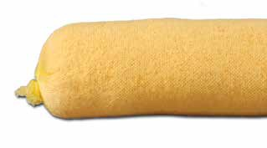Use hazmat socks for caustic fluids or fluids of an unknown origin. These 100% polypropylene socks soak up nearly any acid, base or solvent. Color-coded, so you know what to expect when you see them being used.
Hazmat Sock

Model # | Mfg # | Description | Sorbent Capacity | Packaging
S4Y | SOCY34830 | 3" x 4' | 30 gallons/case | 30/case
S4Y-10 | SOCY34810 | 3" x 4' | 10 gallons/case | 10/case
S8Y | SOCY39615 | 3" x 8' | 30 gallons/case | 15/case
S12Y SOCY314410 3" x 12' 30 gallons/case 10/case

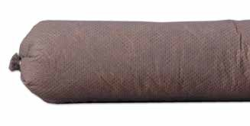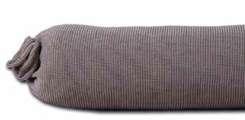Corn Cob Sock
This is an excellent sock at a great value. Corn cob filler makes the socks highly flexible and easily moldable around tight corners. These socks will not absorb aggressive fluids.
Corn Cob Sock
Model # Mfg # Description Sorbent Capacity Packaging

S4CC SOCCC34220 3" x 42" 20 gallons/case 40/case

Universal Super Sock
This sturdy, absorbent sock, filled with superabsorbent foam, will soak up gasoline, water and water-based fluids faster than any other sock. This sock also retains fluids better than any other sock.
Universal Super Sock
Model # Mfg # Description Sorbent Capacity Packaging

S4CPB SOCCLU34830 3" x 4' 30 gallons/case 30/case

Roll-off Super Sock
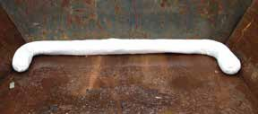These super-absorbent socks are made with a blend of recycled cellulose and SAP (super-absorbent polymer). The SAP will lock the water in place so no leaching will occur. Best used in the tail end of roll-off containers or dump trucks to prevent leakage while on the road.
Roll-off Super Sock
Model # Mfg # Description Sorbent Capacity Packaging

S7CPB SOCXLDS7965 7" x 8' 41 gallons/bale 5/bale

SPECIALTY SOCKS
ABSORBENTS

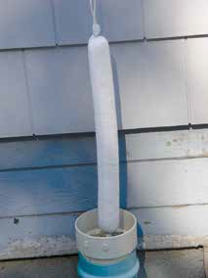
Well Sock
Designed specifically for absorbing hydrocarbons from wells. The 1½" diameter and the loop-on end allow for easy lowering and retrieval from monitoring wells.
Well Sock
Model # Mfg # Description Size Absorbs Packaging

OILM206 SOCW32420 Well Socks 1.5" x 2' 5.5 gallons 20/case

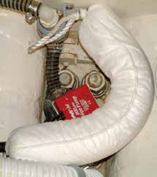
Bilge Sock
Prevent costly fines from oil discharge into navigable waters. Bilge socks prevent pollution by absorbing the oil, gasoline and diesel that can accumulate in the bilge of a boat. Most boats are expected to require one or two bilge socks during each boating season to capture oil and fuel leaking into their bilge compartments.
Bilge Sock
Model # Mfg # Description Size Absorbs Packaging

OIL450 BW31820 Bilge Socks 3" x 18" 8 gallons 20/case

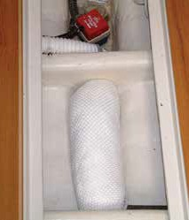
Bilge Boom (Mini Boom)
For use in boat bilges of all sizes. Use the 8" x 18" in commercial size boats and the 5" x 15" in smaller pleasure crafts. Like the smaller bilge sock, these highly absorbent mini booms will help prevent pollution of our marine waters. Booms will absorb oils and fuels and will float on water.
Bilge Boom

Model # Mfg # Description | Size | Absorbs | Packaging
OILM3017 BW51512 Mini Boom | 5" x 15" | 12 gallons | 12/case
OILM3019 BW81810 Mini Boom 8" x 18" 28 gallons 10/case

SORBENT ACCESSORIES
ABSORBENTS

Drip Pans
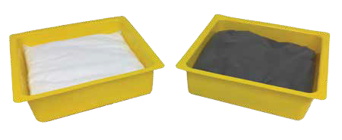This new style drip pan comes with a removable sorbent pillow which allows you to keep the pan and just change out the pillow.
This means you spend less, and you help save the environment by not throwing out the pan every time
it needs to be changed. The low profile is easy to fit in tight spaces where leaking spigots are a problem. When full, tray will hold up to three-quarters of a gallon.
Replacement pillows sold separately.

Drip Pans

Model # | Mfg # | Description | Sorbent Capacity | Absorbs | Packaging
DP-U | DPU1010 | Drip Pans, 10.5" x 10.5" x 3" | 12 gallons/case | universal | 16/case
DP-O | DP01010 | Drip Pans, 10.5" x 10.5" x 3" | 12 gallons/case | oil only | 16/case
DPP-U | DPUR1010 | Drip Pan Replacement Pillows | 12 gallons/case | universal | 16/case
DPP-O | DPOR1010 | Drip Pan Replacement Pillows | 12 gallons/case | oil only | 16/case

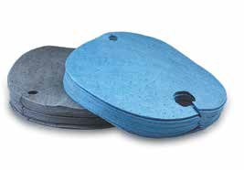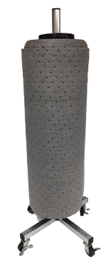Drum Tops
Keep your drum containment area neat and clean with pre-cut 55-gallon drum tops. Available in both oil-only and universal.

Drum Tops

Model # | Mfg # | Description | Sorbent Capacity | Absorbs | Packaging
D22-O | PHWFFDT25 | Drum Tops, 22" diameter | 7 gallons/bale | oil-only | 25/bale
D22-U | PHDTGFF25 | Drum Tops, 22" diameter | 7 gallons/bale | universal | 25/bale
DL22-O | PSBFFDT25 | Lt. Wt. Drum Tops, 22" diameter | 3.5 gallons/bale | oil-only | 25/bale
DL22-U PSDTGFF25 Lt. Wt. Drum Tops, 22" diameter 3.5 gallons/bale universal 25/bale

Particulate
Chopped polypropylene can be used on both land and water. A dust-free alternative to clay.
Particulate

Model # | Mfg # | Description | Sorbent Capacity | Absorbs | Packaging
PT-O | PART25W | Shredded Particulate | 35 gallons/bale | oil-only | 1 box

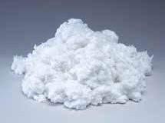
Roll Rack
This freestanding vertical roll rack on wheels keeps rolls off messy floors for easy access when you need them. Fits any roll up to 30" wide.
Roll Rack
Model # Mfg # Description
OILM5040 SRRACK Vertical Sorbent Roll Rack on Wheels, holds rolls up to 30” in width

SPILL KITS

Nobody wants an oil spill—
but accidents do happen. Don’t be caught unprepared! Like a fire extinguisher is to a fire, a spill kit is to an oil or chemical spill.
Choose the right kit for your company’s needs.

TOP SELLERS

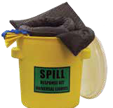

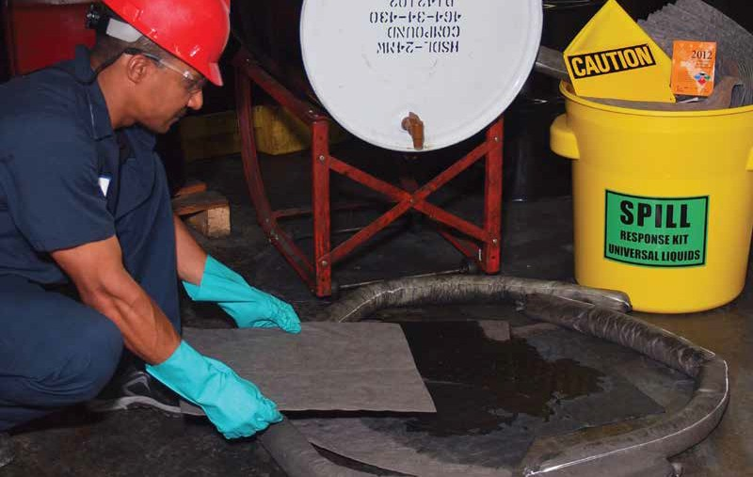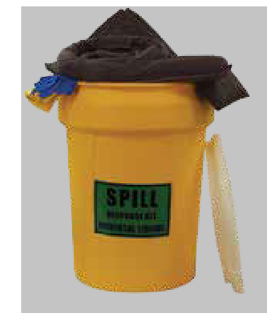30-gallon Universal Spill Kit
Page 32
20-gallon Universal Spill Kit
Page 32
www.chemtexinc.com | Toll-free 1-877-431-0200 | Fax 401-305-3033 29
5-gallon Truck Spill Kit
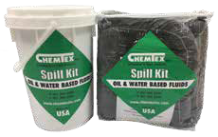Page 33

SPILL KITS

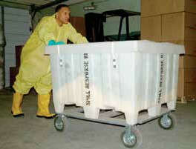
X-Large Spill Cart on Wheels
This kit was designed for maximum mobility. Spill cart comes with all-terrain, 8" semi-pneumatic wheels. Decrease your response times by having a spill cart on site. Locking clasp is optional.

X-Large Spill Cart
Kit Contents

150 Pads (15" x 19")

Model # Mfg # Description Absorbs
OILM7066 KITO1026 Oil-only 170 gallons OILM7068 KITU1024 Universal 170 gallons OILM7069 KITH1016 Hazmat 170 gallons
Cart only
Model # Mfg # Description

KIT1061 KITX1101 44" x 44" x 29.5" ID, 8"
Semi-pneumatic Wheels

Large Spill Cart on Wheels
Large Spill Cart
Model # Mfg # Description Absorbs

OILM7092 KITO1035 Oil-only 108 gallons OILM7093 KITU1031 Universal 108 gallons OILM7094 KITH1022 Hazmat 108 gallons
Cart only
18 Socks (3" x 10')
55 Socks (3" x 4')
17 Pillows (18" x 18")
200 Wipes
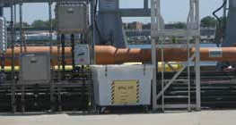
30 Disposal Bags w/Ties 2 Pairs Nitrile Gloves
1 Emergency Response Guidebook

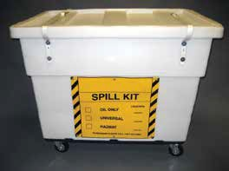
Kit Contents
100 Pads (15" x 19")
24 Socks (3" x 4')
12 Socks (3" x 12')
8 Pillows (18" x 18")
5 Disposal Bags w/Ties 1 Pair Goggles

1 Pair Nitrile Gloves

Model # Mfg # Description

OILM7095 KITX1102 43.5" x 29" x 34", 4" Rubber Casters
1 Emergency Response Guidebook

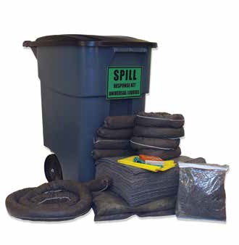50-Gallon Mobile Spill Kit
SPILL KITS
50-gallon polyethylene container with hinged lid helps to protect absorbents from moisture, dirt and damage; hinged lid provides easy access. Packed with a wide variety of absorbents (socks, pads, pillows and loose absorbents). Ideal for quick response to spills anywhere in your plant. Heavy-duty 8" rubber wheels roll easily over any terrain, indoors or out. Built-in handles allow you to steer this kit easily.

50-Gallon Mobile Spill Kit
Model # Mfg # Description Absorbs Packaging Weight KIT1040 KITO1004 Oil-only 37 gallons 1 107 lbs. KIT1041 KITU1004 Universal 37 gallons 1 107 lbs.

Kit Contents
50 Pads (15" x 19")
4 Socks (3" x 4')
1 Sock (3" x 10')
2 Pillows (18" x 24")
5 Disposal Bags w/Ties 2 Bags of Granular Cellulose

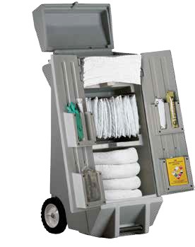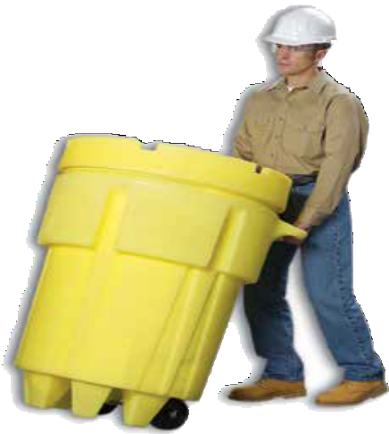 SPILL KITS

Spill Kaddie Kit
Are you sick of digging through overpacks to find your pads or pillows? If so, try this convenient kaddie kit on wheels. Two barn-style doors allow you to open the kit from the front and see the total kit contents so you can grab what you need immediately. Since the kaddie is on wheels, you also can wheel over to the spill with ease.

Spill Kaddie Kit

Model # Mfg # Description Absorbs

OILM6986 KITO1009 Oil-only 30 gallons OILM6987 KITU1007 Universal 30 gallons OILM6988 KITH1002 Hazmat 30 gallons
Cart only

Model # Mfg # Description

OILM6985 KITX1100 40" x 20" x 20", 4" Rubber Casters
Kit Contents
100 Pads (10" x 14")
6 Socks (3" x 4')
4 Pillows (9" x 15")
3 Disposal Bags w/Ties 1 Pair Goggles
1 Pair Nitrile Gloves 1 Epoxy Stick
1 Emergency Response Guidebook

Spill Kits on Wheels
Wheeled overpack spill kits are very popular in industrial plants and factories. Since you can’t bring the spill to the kit, bring the kit
to the spill with a wheeled salvage drum. Both the 95-gallon and 50-gallon models allow the user to maneuver
ample absorbents wherever a spill occurs.

95-Gallon Spill Kit on Wheels
Model # Mfg # Description Absorbs

SPK95-O-W KITO1033 Oil-only w/Wheels 73 gallons SPK95-U-W KITU1029 Universal w/Wheels 73 gallons SPK95-H-W KITH1020 Hazmat w/Wheels 73 gallons

Kit Contents
1 95-gallon Overpack on Wheels
100 Pads (15" x 19")
12 Socks (3" x 4')
8 Socks (3" x 12')
8 Pillows (18" x 18")
3 Disposal Bags w/Ties 1 Pair Nitrile Gloves
1 Emergency Response Guidebook

50-Gallon Spill Kit on Wheels
SPILL KITS

Model # Mfg # Description Absorbs

SPK50-O-W KITO1016 Oil-only w/Wheels 47 gallons SPK50-U-W KITU1016 Universal w/Wheels 47 gallons SPK50-H-W KITH1008 Hazmat w/Wheels 47 gallons

Kit Contents
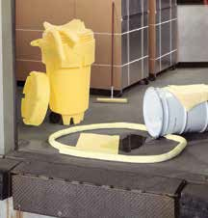
1 50-gallon Overpack on Wheels
100 Pads (15" x 19")
6 Socks (3" x 4')
4 Pillows (18" x 18") 2 Pairs Nitrile Gloves
10 Disposable Bags w/Ties 1 Emergency Response
Guidebook
1 Jar of Plug ‘n’ Dike 1 Pair Goggles

SPILL KITS

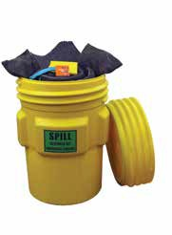95-Gallon Spill Kit
SPILL KITS
Model # Mfg # Description Absorbs

SPK95-O KITO1022 Oil-only 73 gallons SPK95-U KITU1022 Universal 73 gallons SPK95-H KITH1014 Hazmat 73 gallons

Kit Contents
1 95-gallon Overpack
100 Pads (15" x 19")
12 Socks (3" x 4')
8 Socks (3" x 12')
8 Pillows (18" x 18")
3 Disposal Bags w/Ties 1 Pair Nitrile Gloves
1 Emergency Response Guidebook

55-Gallon Spill Kit
Model # Mfg # Description Absorbs

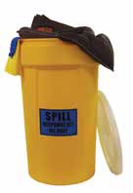
SPK55-O KITO1028 Oil-only 44 gallons SPK55-U KITU1026 Universal 44 gallons SPK55-H KITH1018 Hazmat 44 gallons

Kit Contents
1 55-gallon Drum
50 Pads (15" x 19")
12 Socks (3" x 4')
8 Pillows (18" x 18")
1 Pair Goggles
5 Disposal Bags w/Ties 1 Pair Nitrile Gloves
1 Emergency Response Guidebook

20-Gallon Spill Kit
Model # Mfg # Description Absorbs

SPK20-O KITO1013 Oil-only 14 gallons SPK20-U KITU1011 Universal 14 gallons SPK20-H KITH1005 Hazmat 14 gallons

Kit Contents
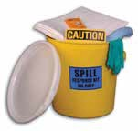
1 20-gallon Lab Pack 15 Pads (15" x 19")
4 Socks (3" x 4')
1 Sock (3" x 12')
- Pillows (18" x 18")
- Disposal Bags w/Ties 1 Spill Caution Sign
1 Pair Nitrile Gloves
1 Emergency Response Guidebook

65-Gallon Spill Kit

Model # Mfg # Description Absorbs

SPK65-O KITO1020 Oil-only 46 gallons SPK65-U KITU1020 Universal 46 gallons SPK65-H KITH1012 Hazmat 46 gallons

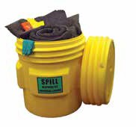
Kit Contents
1 65-gallon Overpack
50 Pads (15" x 19")
10 Socks (3" x 4')
5 Socks (3" x 10')
6 Pillows (18" x 24")
3 Disposal Bags w/Ties 1 Pair Nitrile Gloves
1 Emergency Response Guidebook

30-Gallon Spill Kit

Model # Mfg # Description Absorbs

SPK30-O KITO1018 Oil-only 18 gallons SPK30-U KITU1018 Universal 18 gallons SPK30-H KITH1010 Hazmat 18 gallons

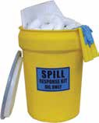
Kit Contents
1 30-gallon Drum
25 Pads (15" x 19")
4 Socks (3" x 4')
4 Pillows (18" x 24")
3 Disposal Bags w/Ties 1 Pair Nitrile Gloves
1 Emergency Response Guidebook

Gallon Spill Kit

Model # Mfg # Description Absorbs

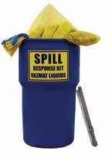
SPK14-O KITO1011 Oil-only 9 gallons SPK14-U KITU1014 Universal 9 gallons

Kit Contents
  - 14-gallon Lab Pack 10 Pads (15" x 19")
1 Sock (3" x 4')
  - Socks (3" x 8') 1 Bag of Universal
Granular Absorbent 2 Disposal Bags w/Ties

SPILL KITS

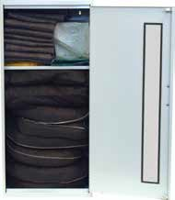
Wall Mount Cabinet Spill Kit
Spill cabinet is manufactured with rugged, welded-steel construction and easily installs on wall. The see-through front panel allows you to check absorbent inventory levels quickly and easily.

Large Wall Mount Kit Contents
80 Pads (15" x 19")
2 Socks (3" x 4')
3 Socks (3" x 10')
8 Pillows (18" x 24")
10 Disposal Bags w/Ties 50 DRC Wipers
1 Pair Nitrile Gloves 1 20"W x 12.25"D x
32.25"H Cabinet
Large Wall Mount Cabinet*
Small Wall Mount Kit Contents
10 Pads (15" x 19")
- Socks (3" x 4')
2 Socks (3" x 10')
- Pillows (9" x 15")
5 Disposal Bags w/Ties 50 DRC Wipers
1 Pair Nitrile Gloves
1 13.75"W x 12.75"D x
30"H Cabinet

KIT1013

Model # | Mfg # | Description | Absorbs | Packaging | Weight
KIT1015 | KITO1001 | Oil-only, large | 18 gallons | 1 | 49 lbs.
KIT1016 | KITU1001 | Universal, large | 18 gallons | 1 | 49 lbs.
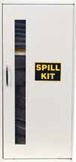
KIT1017 KITH1000 Hazmat, large 18 gallons 1 49 lbs.
*Cabinet color is yellow only. Not available in white.

Small Wall Mount Cabinet**

Model # | Mfg # | Description | Absorbs | Packaging | Weight
KIT1012 | KITO1000 | Oil-only, small | 12 gallons | 1 | 15 lbs.
KIT1013 | KITU1000 | Universal, small | 12 gallons | 1 | 15 lbs.
KIT1014 KITH1034 Hazmat, small 12 gallons 1 15 lbs.
**Cabinet color is white. Yellow is available through special order.

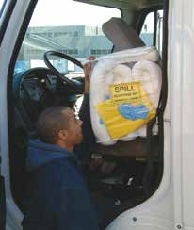
Truck Spill Kit
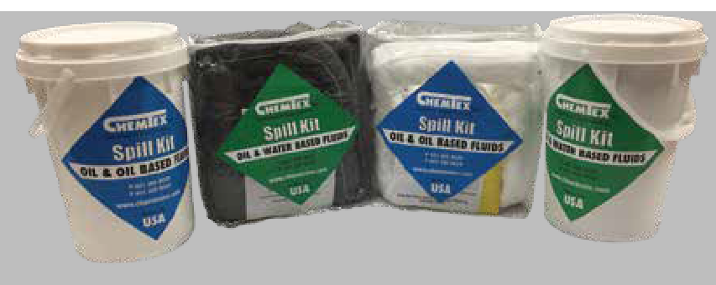
The compact design of our truck spill kit allows for easy storage behind the seat or in a storage compartment. The kit allows drivers to act quickly when responding to a spill. Kits also come in a plastic bucket that can be stored outside of the cab for easy access.

SPILL KITS

Model # Mfg # Description Absorbs

SK5-O KITO1007 Oil-only, in 6.5 Gallon Bucket 5 gallons SK5-U KITU1010 Universal, in 6.5 Gallon Bucket 5 gallons SKB-O KITO1006 Oil-only, in Clear Poly Bag w/Zipper 5 gallons SKB-U KITU1009 Universal, in Clear Poly Bag w/Zipper 5 gallons
Poly-Zip Bag and Bucket Kits Contents
10 Pads (15" x 19")
3 Socks (3" x 4')
2 Disposal Bags w/Ties 1 Pair Nitrile Gloves

SPILL KITS

Foil Bag Response Kit
Heat-sealed kits allow you to determine if the kit h been used or not. Economical and space-saving. This kit is packed in a puncture-proof, water- and UV-resistant sealed bag and is intended for single use. Packed 5 kits/case.
as

Foil Bag Kit Contents
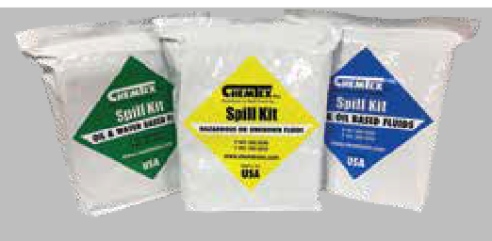
15 Pads (15" x 19")
3 Socks (3" x 4')
2 Disposal Bags w/Ties 1 Pair Nitrile Gloves
1 Pair Goggles

Model # | Mfg # | Description | Absorbs
SKFB-0 | KITO1008 | Oil-only Foil Kit | absorbs up to 5 gallons
SKFB-U | KITU1006 | Universal Foil Kit | absorbs up to 5 gallons

SKFB-H KITH1001 Hazmat Foil Kit absorbs up to 5 gallons

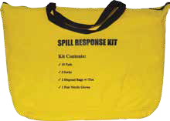Spill Kit in High-Visibility Bag
- Durable, water-resistant bag with zipper closure
- Temporary disposal bags help make cleanup easier
Kit Y 10
it 3
2
1
- Bright yellow bag makes the kit easy to locate
- Strap for easy carrying and hanging
- Compact and easy to store — makes a great truck spill k

Model # | Mfg # Description | Absorbs | Packaging
SKYB-O | KITO1015 Oil-only | 5 gallons | 1
SKYB-U KITU1013 Universal 5 gallons 1

Contents
ellow Carrying Bag Pads (15" x 19")
Socks (3" x 4') Disposal Bags w/Ties Pair Nitrile Gloves

Emergency Spill Sack
Portable spill kit packed in a reusable drawstring sack.

Model # Mfg # Description Absorbs

OILM7076 KITU1028 Universal Spill Sack absorbs up to 7 gallons OILM7077 KITO1030 Oil-only Spill Sack absorbs up to 7 gallons
on the go a quick

Kit Contents
- 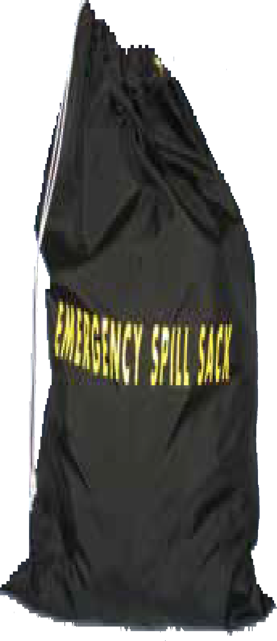Black Nylon Sack 10 Pads (15" x 19")
- Socks (3" x 4')
1 Pillow (18" x 18")
2 Disposal Bags w/Ties 1 Pair Nitrile Gloves

SPILL KITS

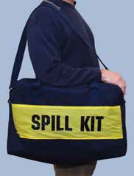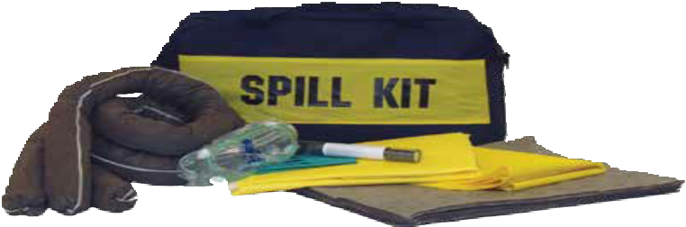Model # Mfg # Description Absorbs Packaging Weight
Tote Bag Spill Response Kit
This durable tote bag kit is constructed of double-wall, vinyl-coated canvas that stands up to demanding industrial environments. Makes responding to small spills
and easy task.

Kit Contents
1 Zipper Tote Bag 15 Pads (15" x 19")
3 Socks (3" x 4')
1 Repair Putty Stick
1 Tychem QC Protective Suit 1 Pair Chemical Goggles
1 Pair Nitrile Gloves
5 Disposable Bags w/Ties
OILM7107 KITU1033 Universal Tote Bag Kit absorbs up to 6 gallons 1 11 lbs.

SPILL KITS
SPILL KITS

Marine Spill Kit
Response time is crucial when it comes to cleaning a fuel or oil spill on water.
The faster you respond, the easier it is to minimize damage to the environment and avoid costly fines. This kit provides you with almost everything you need to become an efficient first responder.

Kit Contents
65 Gallon Overpack
75 Oil-only Pads (15" x 19")
4 Booms (5" x 10')
4 Pillows (18" x 24")
3 Disposal Bags w/Ties

Model # Mfg # Description Absorbs

OILM7065 KITO1024 Oil-only 62 gallons

Marine Dock Box Spill Kit
Sometimes you don’t want your spill kit to stand out as much as our “safety yellow” commercial version. This kit comes packed in a high-quality dock box that can be secured to the dock.

Model # Mfg # Description Absorbs

OILM7083 KITO1031 Oil-only 86 gallons

Overpack Covers

Kit Contents
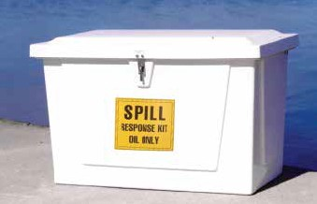
1 Dock Box
100 Pads (15" x 19")
4 Booms (5" x 10')
4 Pillows (18" x 18") 1 Bag Absorbent W Granular (10 lbs.)
1 Brick of Rags (5 lbs.)
1 Folding Shovel
5 Disposal Bags w/Ties 1 Pair Goggles
2 Pairs Nitrile Gloves
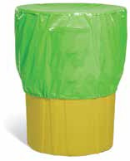
1 Emergency Response Guidebook

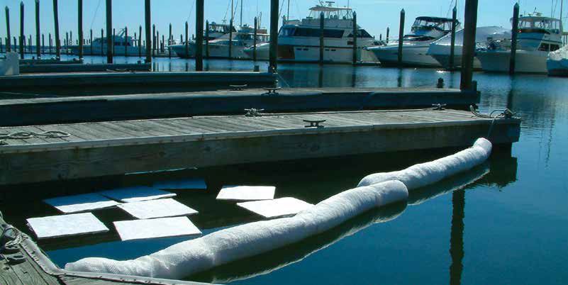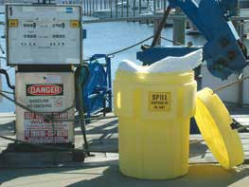Hi-viz overpack cover protects spill response supplies indoors and out. Impermeable material blocks water, dust and debris, as well as UV light that can damage polypropylene sorbents.

Model # Mfg # Description Packaging

CON0210 KITX1000 Large Overpack Cover, fits 65 and 95 gallon overpacks 1/package CON0211 KITX1001 Small Overpack Cover, fits 20, 30 and 55 gallon overpacks & drums 1/package

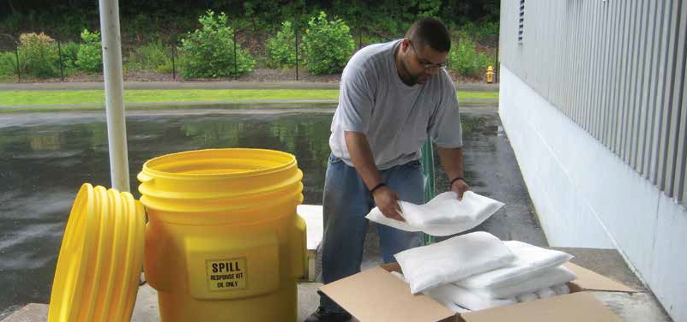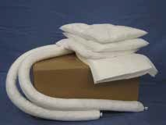X-Large Spill Cart on Wheels
SPILL KIT REFILLS
Spill Kit Refills
Why buy a new spill kit every time you use it? Instead of buying the complete kit, just purchase the kit contents. Spill kit contents come packed in a cardboard box.
SPILL KITS

Model # Mfg # Description

OILM7066-R KITO1027 X-Large Spill Cart on Wheels, Oil-only Refill OILM7068-R KITU1025 X-Large Spill Cart on Wheels, Universal Refill OILM7069-R KITH1017 X-Large Spill Cart on Wheels, Hazmat Refill

Large Spill Cart on Wheels

Model # Mfg # Description

OILM7092-R KITO1036 Large Spill Cart on Wheels, Oil-only Refill OILM7093-R KITU1032 Large Spill Cart on Wheels, Universal Refill OILM7094-R KITH1023 Large Spill Cart on Wheels, Hazmat Refill

95-Gallon Overpack

Model # Mfg # Description

SPK95-O-R KITO1023 95-Gallon Oil-only Refill SPK95-U-R KITU1023 95-Gallon Universal Refill SPK95-H-R KITH1015 95-Gallon Hazmat Refill
50-Gallon Overpack on Wheels

Model # Mfg # Description

SPK50-O-W-R KITO1017 50-Gallon Overpack on Wheels, Oil-only Refill SPK50-U-W-R KITU1017 50-Gallon Overpack on Wheels, Universal Refill SPK50-H-W-R KITH1009 50-Gallon Overpack on Wheels, Hazmat Refill
Spill Kaddie Kit

Model # Mfg # Description

OILM6986-R KITO1010 Spill Kaddie Kit, Oil-only Refill OILM6987-R KITU1008 Spill Kaddie Kit, Universal Refill OILM6988-R KITH1003 Spill Kaddie Kit, Hazmat Refill
50-Gallon Mobile

Model # Mfg # Description

KIT1040-R KITO1005 50-Gallon Mobile Spill Kit, Oil-only Refill KIT1041-R KITU1005 20-Gallon Mobile Spill Kit, Universal Refill
65-Gallon Overpack

Model # Mfg # Description

SPK65-O-R KITO1021 65-Gallon Oil-only Refill SPK65-U-R KITU1021 65-Gallon Universal Refill SPK65-H-R KITH1013 65-Gallon Hazmat Refill

55-Gallon Drum

Model # Mfg # Description

SPK55-O-R KITO1029 55-Gallon Oil-only Refill SPK55-U-R KITU1027 55-Gallon Universal Refill SPK55-H-R KITH1019 55-Gallon Hazmat Refill
30-Gallon Drum

Model # Mfg # Description

SPK30-O-R KITO1019 30-Gallon Oil-only Refill SPK30-U-R KITU1019 30-Gallon Universal Refill SPK30-H-R KITH1011 30-Gallon Hazmat Refill
20-Gallon Lab Pack

Model # Mfg # Description

SPK20-O-R KITO1014 20-Gallon Oil-only Refill SPK20-U-R KITU1012 20-Gallon Universal Refill SPK20-H-R KITH1006 20-Gallon Hazmat Refill
14-Gallon Lab Pack

Model # Mfg # Description

SPK14-O-R KITO1012 14-Gallon Oil-only Refill SPK14-U-R KITU1015 14-Gallon Universal Refill

Marine

Model # Mfg # Description

OILM7065-R KITO1025 65-Gallon Oil-only Refill OILM7083-R KITO1032 Dock Box Oil-only Refill

SPECIALTY SPILL KITS

Acid Spill Kit
Ideally used in battery shops or any area prone to leaking caustics. Have one on hand in case of an emergency. Absorbs up to 5 gallons.

Model # Mfg # Description Weight

OILM7005 KITA1000 Acid Spill Kit 9 lbs.

Wall Mount Chemical/ Solvent Kit
This kit includes everything needed to neutralize and clean up chemicals and solvents. Mount this kit or take it with you to a spill. This spill treatment kit neutralizes and solidifies caustic spills and will absorb organic solvents.

Model # Mfg # Description Weight

OILM7021 KITH1007 Wall Mount Spill Kit 30 lbs.

Kit Contents
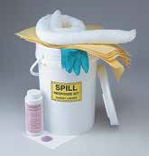
- 2-lb. Shaker Neutralizers 5 Acid-absorbing Pads
- Socks
2 Disposal Bags w/Ties 1 Scoop
1 Pair Goggles
1 Pair Nitrile Gloves

Kit Contents
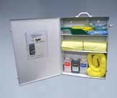
1 Wall Mount Cabinet
5 Absorbent Pads (15" x 19")
1 Sock (3" x 4')
1 Shaker Acid Neutralizers 1 Shaker Base Neutralizers
1 Shaker Solvent Neutralizers 1 Scoop
- Pair Goggles
- Disposal Bags w/Ties 2 Pairs Nitrile Gloves

Mercury Spill Kit
Provides safe cleanup and vapor suppression when responding to a mercury spills

Model # Mfg # Description Weight

KIT7006 KITM1000 Mercury Spill Kit 6 lbs.

Emergency Response Guidebook
Anyone responding to spills should have one.
Kit Contents
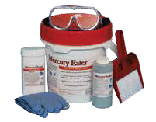
900 grams of Mercury Absorbent Powder
- count Mercury Wipes 1 Pair Goggles
1 Pair of Gloves
1 Broom and Dust Pan
1 each Disposal Bag and Tie

3-D Spill Response Equipment Sign
Mounts on wall in your spill kit location area.

This book provides important information

regarding various kinds of spilled chemicals and liquids.

Model # Mfg # Description Weight

OILM001 KITX1003 Emergency Response Guidebook 1 lb.
Model # Mfg # Description Size

OILM7096 KITX1004 Spill Response Equipment Sign, 14" L x 9" H
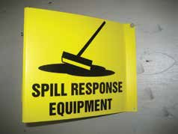
Stand-Out Sign

SPILL KITS
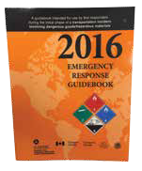

MARINE SPILL RESPONSE

The oceans cover 71 percent of the earth’s surface
and contain 97 percent of the earth's water.
With this in mind, we need to make sure we protect them and keep them clean for generations to come. We carry a variety of containment booms, skimmers and accessories to help aid in the protection of our waters and shorelines.

TOP SELLERS

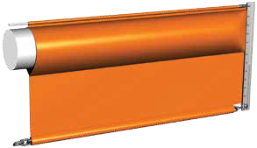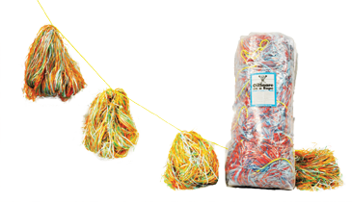Oil Snare on a Rope
38 Chemtex | Delivering Solutions in Spill Control
Page 39
Response Boom
Page 41

Oil SnareTM products were developed for the recovery of Bunker C, Crude Oil, and Numbers 4, 5 & 6 oil. Oil Snare utilizes the oil’s natural stickiness to entrap it within thousands of plastic tentacles. Operative even in subfreezing conditions. Oil Snare products are made up of flat polypropylene ribbon yarn configured into two different products
(Oil Snare Singles, Oil Snare on a Rope).
Oil Snare is hydrophobic, oleophilic, nontoxic or corrosive, non-scattering, inert, floats (will not sink) indefinitely. Oil Snare is resistant to rot and mildew after long storage and does not have a shelf life. Oil Snare products can be drained or doused with #1 or #2 oil which removes the heavy oils, allowing units to be reused if desired, and allowing recycling of extracted oil as downgraded fuel.

Oil Snare will typically recover from 20 to 60 times its own weight, depending on the viscosity of the oil. The thicker the oil, the better Oil Snare adsorbent will work.
#6 oil – 64 lbs. @ 35˚F #6 oil – 32 lbs. @ 70˚F
#5 oil – 24 lbs. @ 70˚F #5 oil – 16 lbs. @ 82˚F #4 oil – 18 lbs. @ 65˚F
Alaskan crude – 40 lbs. @ -2˚F
TYPICAL RECOVERY RATES
(Lbs. of oil per lb. of Oil Snare adsorbent)

Model # Mfg # Description Weight

OILM6050 MSRSNS30 Oil Snare Singles, 30/bag 15 lbs. OILM6052 MSRSNR50 Oil Snare on a Rope, 30/50' rope 16 lbs.

Skimmers
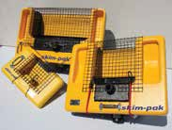
Skim-pak weir-type skimmers are simply the best skimmers money can buy. Skim-paks are lightweight and compact, easily deployed and operated by one person. The weir automatically adjusts
to the pump rate, continually maintaining a skim. Skim-pak skimmers can be set up for unattended operation or fitted with an operator control accessory package.

Drum Skimmers
Drum skimmers are constructed of lightweight aluminum and are designed for both portability and extreme durability on the toughest jobs. Available in 24", 36" and 48" versions.
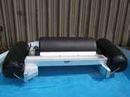
Single or multiple drum designs are also available. Ideal for use on inland and
marsh spills since it is capable of operating at water depths as shallow as 3". Recovery rates
of up to 35 gallons per minute.

SNARES AND SKIMMERS
Oil SnareTM
MARINE SPILL RESPONSE
Call our office for further details on skimmers.

Permanent Containment Boom
MARINE SPILL RESPONSE
The economical solution to provide continuous facility protection and containment. This permanent boom system features easy deployment, high visibility, and abrasion resistance. Permanent containment booms are designed for deployment
at permanent sites such as waterfront oil

handling facilities, or around ships in repair or storage. This containment boom is more economical, lighter weight per foot, and has a higher buoyancy-to-weight ratio than other permanent booms.

Model # Mfg # Description Weight

OILM092 MSRCBP1000 18" Permanent Boom, Universal Connectors, 175 oz. PVC 18" x 100' OILM094 MSRCBP1001 18" Permanent Boom, Universal Connectors, 175 oz. PVC 18" x 50' OILM262 MSRCBP1002 24" Permanent Boom, Universal Connectors, 175 oz. PVC 24" x 100' OILM263 MSRCBP1003 24" Permanent Boom, Universal Connectors, 175 oz. PVC 24" x 50'

CONTAINMENT BOOMS
Galvanized Steel Ballast Weights
Heavy-duty PVC Barrier Fabric
Universal Connector
SIDE VIEW
Floats
Heavy-duty PVC Barrier Fabric
Universal Connector

TOP VIEW
Superflex Permanent Containment Boom
Floats

OILM099 MSRCBR1000 6" Float, 12" Skirt, Universal Connectors, with Top Tension Cable 18" x 100' OILM097 MSRCBR1001 6" Float, 12" Skirt, Universal Connectors, with Top Tension Cable 18" x 50' OILM100 MSRCBR1003 6" Float, 12" Skirt, Universal Connectors 18" x 100'
OILM200 MSRCBR1004 3" Float, 5" Skirt, Slotted Tube Connectors 8" x 100'

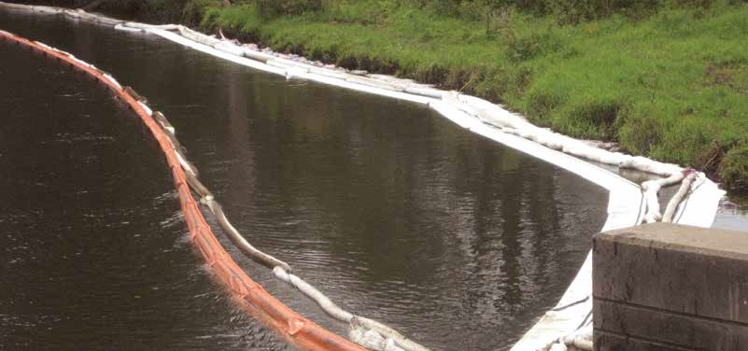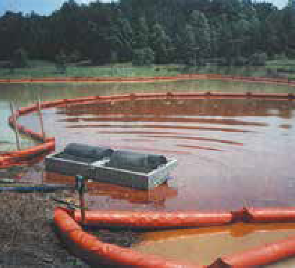
CONTAINMENT BOOMS
Response Boom
Use containment booms to surround and contain oil or sewage spills. Also used to retain debris. Can be used in fresh or salt water. Ideal for holding ponds, marinas, or spill response teams.
Model # Mfg #
Description
Weight
MARINE SPILL RESPONSE
5/16" dia. Galvanized Top Tension Cable

6" Closed Cell Foam Float

5/16" Galvanized Chain Ballast
Aluminum Universal Connector

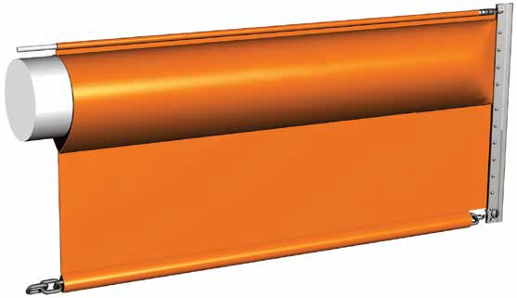12" PVC
Skirt

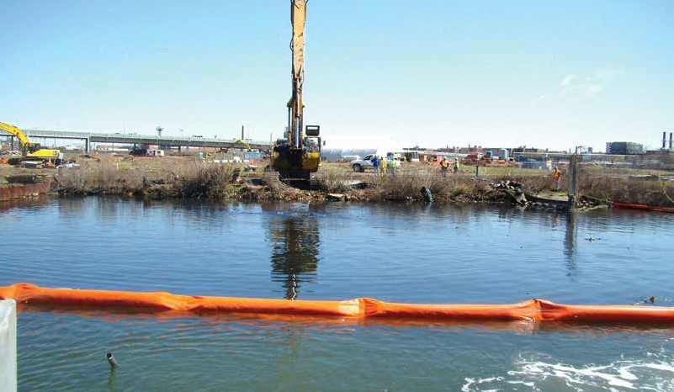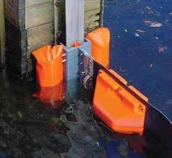
BOOM ACCESSORIES
MARINE SPILL RESPONSE

Bulkhead Risers
Bulkhead risers are used to allow your containment booms to rise and fall with the tide. Fiberglass bulkhead riser with floats and connectors for 6" flange H beam. Easily mounted on docks or piers.

Model # Mfg # Description
OILM259 MSRCBA1001 24" Fiberglass Bulkhead Riser/Universal ASTM connectors
OILM267 MSRCBA1002 18" Fiberglass Bulkhead Riser/Universal ASTM connectors

Boom in a Bag
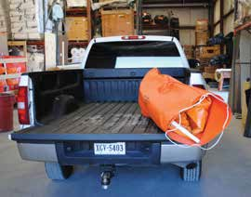
Ever find yourself needing a containment boom in a pinch, but you don’t have the manpower to deploy the standard 18" containment boom? Or maybe an 18" boom is just too much for the job. Our new Boom in a Bag is the perfect solution. This highly compact, featherlight response boom is great for small spills of all kinds. Boom in a Bag has 50' of 8" containment boom, which consists of a 3" float and a 5" skirt. Made out of 22 oz. PVC, this boom uses lightweight, easy-to-use slotted tube connectors for easy connections. Stored in a PVC bag, one person is all it takes to carry and deploy. Great for marinas, because it won’t take up much space. In fact, this boom could be stored in a closet or in the back of a pickup truck.

Model # Mfg # Description Size

BOOM1035 MSRCBS1500 Boom in a Bag, 3" Float, 5" Skirt, Slotted Tube Connectors 8" x 50' BOOM1036 MSRCBS1501 PVC Bag for storing “Boom in a Bag”*
*Bag sold separately

BOOM ACCESSORIES

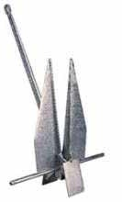Danforth® Anchors
Danforth® anchors are used to secure booms to the ocean floor. This anchor has the traditional holding power which
has always been associated with Danforth® anchors. The shank is made of high-strength steel. The steel flukes are strong and wide. Each anchor has a hot-dipped, galvanized coating for long-lasting protection.

Model # Mfg # Description
OILM090 MSRCBA1004 22 lb. Danforth® Anchor

Anchor Chain
Our 3/8" anchor chain is used to secure boom anchoring systems. Strengthens anchor hold and eliminates fouled anchor lines. Galvanized, oil-proof chain comes
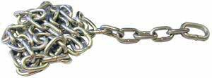
packed as 63' of chain in a
5-gallon bucket.

Model # Mfg # Description

OILM087 MSRCBA1005 3/8" Anchor Chain, holds up 6,600 lbs.

Polyform Anchor Buoys
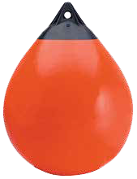
Polyform anchor buoys are a one-piece construction with a reinforced, rigid “rope hold” eye and unique vinyl valving system. Applications include
commercial fishing, offshore oil research, and general commercial marine. Use the buoys with your containment boom anchoring system.

Galvanized Shackles
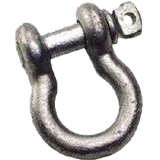
Galvanized shackles are used to connect anchors
to chain.

Model # Mfg # Description
MARINE SPILL RESPONSE
OILM088 MSRCBA1003 Polyform Anchor Buoys, A-O Red

Polypropylene Line
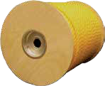
Polypropylene line is strong and resistant to mildew, rot and most chemicals. Use this in your containment boom anchoring system.

Model # Mfg # Description

OIL753 MSRCBA1008 Polypropylene Line, 1/2" x 600',
3-Strand Twisted Rope
Model # Mfg # Description

OILM089 MSRCBA1002 3/8" Screw Pin, Galvanized Shackles

Tow Bridals
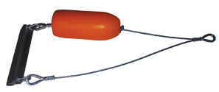
Use tow bridals to tow containment boom behind a boat. Fits all 18" booms with universal connectors.

Model # Mfg # Description

BOOM1008 MSRCBA1007 Tow Bridal for 18" Containment Boom

WIPERS & RAGS

Maintaining a neat and clean workplace is essential for workers morale and safety.
Since the beginning of the industrial revolution, manufacturers have used knit rags to keep tools and equipment clean and looking good. Another common use is for personal hygiene while working on dirty jobs. In addition to the traditional knit rags, we also have a great selection of nonwoven wipers that are much more efficient to use in this day and age. Wipers come in
a variety of sizes and put-ups. Choose the wipe best suited to your needs.

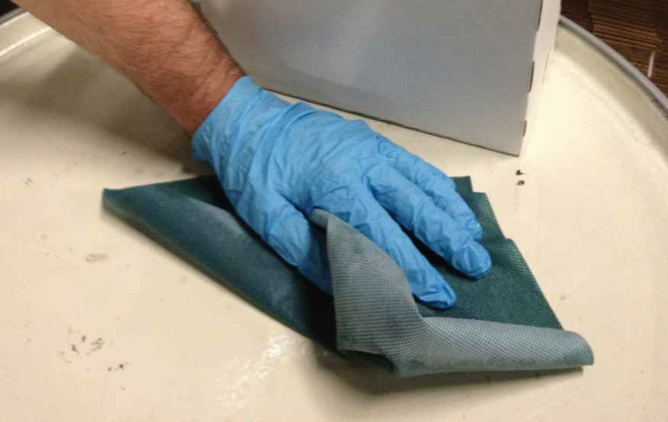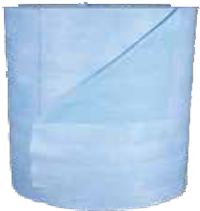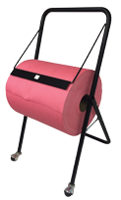TOP SELLERS

Red Spunlace Wipers on a Roll
44 Chemtex | Delivering Solutions in Spill Control
Page 45
Blue Spunlace Wipers on a Roll
Page 46

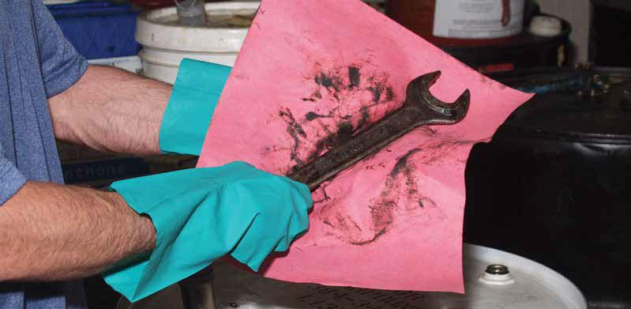
ALL-PURPOSE WIPERS
Spunlace Wipers
No more expensive shop towels
WIPERS & RAGS

Are you renting your shop rags from a uniform/linen rental company? Are you tired of getting overage charges on your monthly bills for lost rags? Ever wonder how you could lose so many rags? Do you find that each month
there are extra charges for a damage fee, energy charge, delivery charge, replacement fee, or environmental/fuel surcharge? Rental companies are notorious for all of these extra fees. When you buy a disposal wiper that works just as well, if not better, you can eliminate all of those “add-on” charges. In addition to the obvious cost savings, there is also a real benefit that will help to ensure the safety of your employees or equipment. Metal shavings, oils and hazardous chemicals can be present on “clean” laundered rental shop towels, presenting both possible hazards to health and the possibility of machinery getting snagged. Spunlace wipers are great on heavy industrial tasks, cleaning oil, grease and grime. Also good for wiping solvents and cleaning rough surfaces.

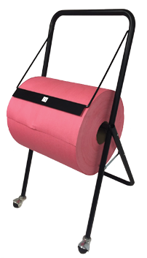Red Spunlace Wipers
Holds Rolls up to 12" wide

Model # Mfg # | Size & Description | Put-Up | Application
NWP400 WIP1100 | 13" x 14" Red Spunlace, Flatlay, Wiper | 500/case | heavy duty
NWP401 WIP1101 13" x 20" Red Spunlace, Flatlay, Wiper 500/case heavy duty
Red Spunlace on Roll
Model # Mfg # Size & Description Put-Up Application

NWP381 WIP1105 12" x 13" Red Spunlace on a Roll 475'/roll heavy duty

White Spunlace Wipers

Model # | Mfg # | Size & Description | Put-Up | Application
NWP402 | WIP1102 | 13" x 14" White Spunlace, Flatlay, Wiper | 500/case | heavy duty
NWP403 | WIP1103 | 20" x 13" White Spunlace, Flatlay, Wiper | 500/case | heavy duty
NWP380 WIP1104 13" x 12" White Spunlace, Wiper 475'/roll heavy duty

Wiper Roll Rack on Wheels
Model # Mfg # Size & Description

OILM5041 WRRACK Wiper Roll Stand on Wheels

ALL-PURPOSE WIPERS
WIPERS & RAGS

Blue Spunlace Wipers
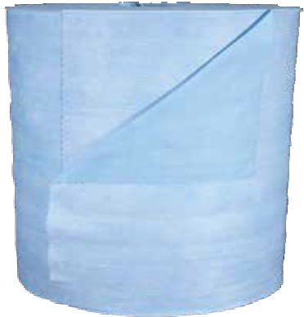Exceptionally clean, low-linting, absorbent, strong and durable wiping product. Soaks up to four times its weight in water; also absorbs oil and solvents. Washes easily. Can be reused again and again, yet is inexpensive enough to be disposable. Available in quarter fold
or on a roll.
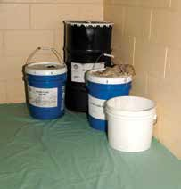
*Hydrophobic Drop Cloth
Blue Spunlace Wipers
Model # Mfg # Size & Description Put-Up Application
NWP398 WIP1001 12" x 15" Blue Spunlace, Wiper 440/roll heavy duty NWP351 WIP1000 12" x 13" Blue Spunlace, 1/4 Fold, Wiper 1,000/case heavy duty NWP356* WIP1500 40" x 72" Spunlace Disposable Drop Cloths 72/case heavy duty

All-Purpose DRC Wetlay Wipers
A cellulose-based disposable wiper offering incredible absorbency and softness with an unmatched wipe-dry ability. Made from 100% bonded cellulose, this general purpose, highly absorbent wiper is ideal for medium- to heavy-duty wiping applications and is an excellent replacement for airlay wipers. Best used for wiping up grease, oils and small spills. Used for cleaning parts and tools;
soft enough for hands and face.
DRC Wetlay Wipers
Model # Mfg # Size & Description Put-Up Application
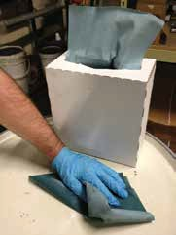
NWP02311 WIP1302 9" x 15" All-purpose Wetlay, Pop-up 8 boxes of 100 medium duty NWP0252 WIP1301 9" x 240' Center-pull Wetlay in Box, 221 Wipes 1 box medium duty NWP026 WIP1300 12.5" x 13.5" All-purpose Wetlay, 1/4 Fold 20 packs of 50 medium duty

Polypropylene Wipers
Polypropylene wipers are designed for wiping tasks where low lint or use of chemicals is required. Made for critical applications involving solvents, inks and paints. Acid/base and solvent-resistant. Perfect for use with lubricants, oil and grease. Applications include: furniture finishing, engine assembly/repair, pre- packaging wipe-down, LCD panel assembly, appliance assembly, printing and glass or window cleaning.
Polypropylene Wipers
Model # Mfg # Size & Description Put-Up Application

NWP395 WIP1200 9” x 17” Polypropylene Wipers 100 wipers/box, 5 boxes/case heavy duty

46 Chemtex | Delivering Solutions in Spill Control

RAGS & WIPING CLOTHS
WIPERS & RAGS

Model # | Mfg # | Description | Weight
WIP900 | RAG1006 | White T-Shirt | 50 lbs.
WIP500 | RAG1003 | Colored T-Shirt (polo) | 50 lbs.
WIP750 | RAG1004 | Underwear | 50 lbs.
WIP60 | RAG1001 | Colored Sweatshirt (fleece) | 50 lbs.

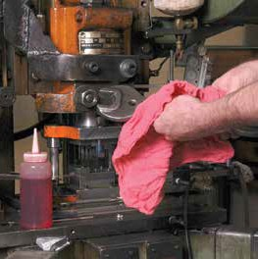
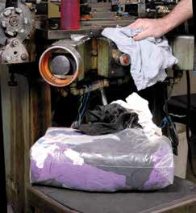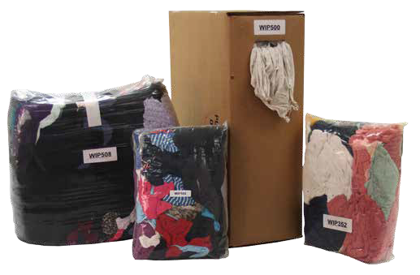Red Shop Towels
Rags & Wiping Cloths
Sturdy, absorbent knit materials are used for general cleanup in maintenance and repair operations.
WIP975 RAG1000 Colored Flannel 50 lbs.

Brick of Rags (with easy access dispenser)
Model # Mfg # Description Weight
WIP502 RAG1204 Polo T-Shirt Rags 5-lb. brick
WIP508 RAG1205 Polo T-Shirt Rags 25-lb. brick
WIP6008 RAG1200 Sweatshirt Rags 25-lb. brick
WIP352 RAG1202 Colored Terry Rags 5-lb. brick
WIP358 RAG1203 Colored Terry Rags 20-lb. brick
50-lb. compressed box allows us to fit double the amount on a pallet, thus reducing freight costs by 50%
Absorbent and strong, prewashed and preshrunk red shop towels. Made with 100% heavyweight cotton fabric. Frequently used for wiping spills, grease, oil, tools, grime and fluids. Used in industrial facilities, machine shops and garages.
Red Shop Towels
Model # Mfg # Description Weight

TOW802 RAG1007 New Shop Rags, red, 14" x 14" 500/case

GRANULARS/NEUTRALIZERS/ BIOREMEDIATION

Granulars are used to clean the residuals from a spill that pads and rolls just won’t get.
Some specialty granulars like hydrocarbon solidifiers will actually encapsulate oils, which is much better for the environment compared to being absorbed by traditional sorbents. Our large variety of specialty granulars will not only absorb hazardous chemicals, but will also neutralize them at the same time. This is something that sorbent pads and rolls won’t do.

TOP SELLERS

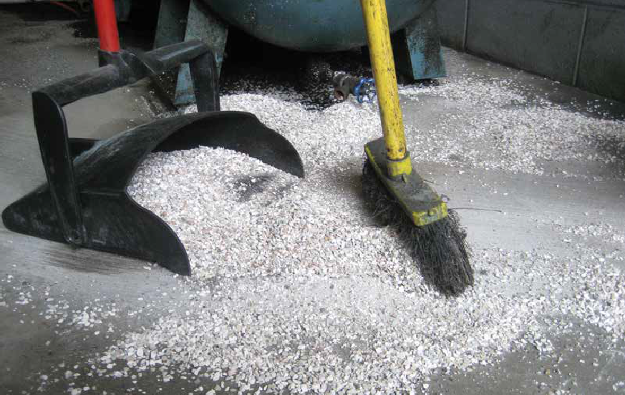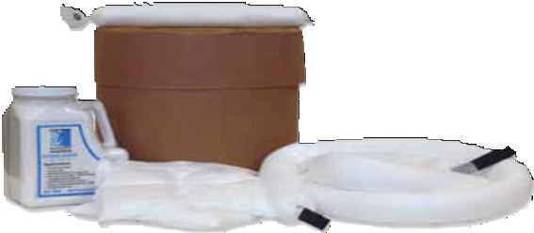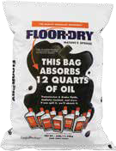Floor-Dry
48 Chemtex | Delivering Solutions in Spill Control
Page 49
HCS Polymers
Page 51

MINERAL-BASED GRANULARS

Oil-DriTM
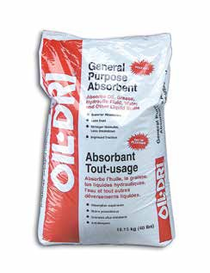All-purpose floor absorbent. This clay-based product is packaged in poly bags to protect against moisture.
Floor-Dry
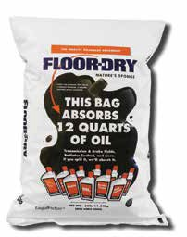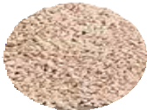Contains millions of natural microscopic diatom “sponges.” Great, dust-free oil absorbent. Excellent lab pack media. A 20-lb. bag of Floor-Dry will absorb more than a 40-lb. bag of clay. All-purpose absorbent absorbs most liquids.

Perlite
Perlite is a nontoxic, nonflammable, lightweight, environmentally safe and friendly absorbent that can absorb and hold most liquids, while leaving little or no residue. Less than half a pound of Perlite can completely absorb one quart of motor oil without leaving any residue to clean up. Clay, earth and sand products require 15 pounds of material to absorb the same amount and would leave a slippery residue.

Vermiculite
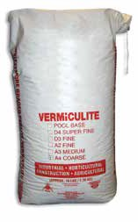Vermiculite is used as a lightweight filler, liquid absorbent, paint filler/texturing agent, and liquid waste solidification agent. Used during shipping and lab packing. Can be used on all liquids.

GRANULARS/NEUTRALIZERS

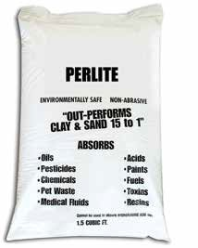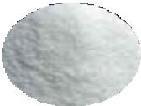Model # Mfg # Description Packaging Bags/Pallet
OIL040 GRAN1000 Oil-Dri™ Floor Absorbent 40 lb. bag 50
OIL046 GRAN1001 Floor-Dry, Diatomaceous Earth 20 lb. bag 84
OIL051 GRAN1002 Perlite, #720 Floor Absorbent 25 lb. bag 30
OIL067 GRAN1003 Perlite, #720 Floor Absorbent 1.5 lb. handled canister 8/box, 240 boxes/pallet OIL052 GRAN1004 Vermiculite 20 lb. bag 30

BIODEGRADABLE GRANULARS

Cellulose
A universal/maintenance sorbent made from recycled cellulose. It absorbs six times more than clay. Other benefits: noncarcinogenic, lightweight, low dust and nonabrasive. Absorbs both oil and water.

Absorbent W
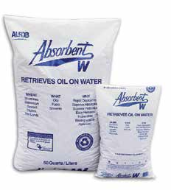Made from 100% recycled cellulose pulp, treated to absorb oil-based liquids — not water. Hydrocarbons are absorbed into the fibers and will not leach or drain. Ideal for removing contaminants from water.

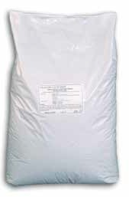

Gran-sorbTM
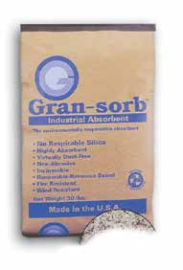Lightweight, recycled paper waste soaks up oils, coolants, solvents, water, fuels and antifreeze. This is a safe product because paper waste is nontoxic and nonhazardous.
Dri-ZorbTM
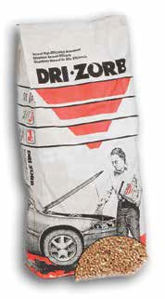All-natural coarse corn cob is a great replacement for clay. Use this in most industrial applications. A great absorbent for cutting oils, greases, water, etc. This is not intended for use with aggressive fluids.

GRANULARS/NEUTRALIZERS

Model # | Mfg # | Size & Description | Packaging | Bags/Pallet
OILM7911 | GRAN2000 | Cellulose Floor Sweep | 25 lb. bag | 80
OIL057 | GRAN2001 | Absorbent W, Oil-only Cellulose | 8 lb. bag | 35
OIL041 | GRAN2005 | Gran-sorbTM Cellulose Absorbent | 30 lb. bag | 65
OIL055 | GRAN2003 | Dri-ZorbTM Coarse Corn Cob | 40 lb. bag | 50

HYDROCARBON SOLIDIFYING POLYMERS
Turn hydrocarbons into rubber!

Our HCS Polymer Boom is ideal
for use in the marine environment.
Perfect for use at fuel docks and marinas. The HCS Polymer Boom can be placed in scuppers on ships to prevent hydrocarbon run-off from the decks of commercial vessels, and in engine rooms or bilges to remove oil from water. Booms also can be used on land applications to prevent hydrocarbons from entering storm drains.

A leap beyond absorption!
HCS polymers are used to solidify and suppress harmful vapors of sheen, gasoline, diesel and oils, including crudes, upon contact. The byproduct is a solid, rubber-like material that floats in water.
Environmentally friendly, HCS polymer has been tested not harmful to aquatic life and waterfowl. The solidified byproduct is 100% recyclable as raw material for rubber and plastic production or asphalt, or can be burned as fuel.
Depending on your local and state regulations, HCS polymer also can be disposed of in a landfill. Other uses and applications are in the utility industry for SPCC Secondary Containment, and in
oil contamination removal in underground vaults and manholes; HCS polymer also can be used to filter water in storm drains or industrial waste streams.
- Nontoxic, noncarcinogenic, noncorrosive, nonhazardous
- Nonbiodegradable; encapsulated waste will not produce a hazardous leachate
- Solidifies up to 8 times its own weight
- Versatile — hydrophobic by nature, so you can use it to clean spills on both land and water
- Safe and easy disposal

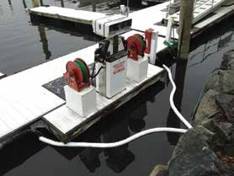
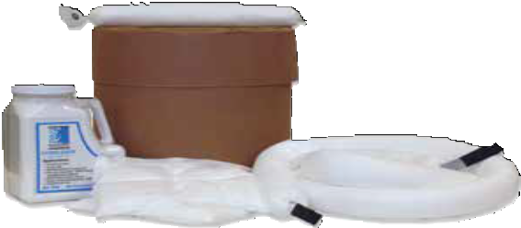

Model # Mfg # Description

OIL898 HCSP1000 HCS Polymer, 2.25" x 150' Boom, 2/drum OIL900 HCSP1002 HCS Polymer, 2.25" x 25' Boom, 2/case OIL940 HCSP1003 HCS Polymer, 3" x 10' Booms, 4/case OIL899 HCSP1004 HCS Polymer, 3" x 18" Bilge Sock, 20/case OIL941 HCSP1005 HCS Polymer, 12" x 12" Pillows, 2/case OIL901 HCSP1006 HCS Polymer, Granular in 2.75 lb. Shaker Bottle OIL897 HCSP1007 HCS Polymer, Granular, 20 lb. Drum
GRANULARS/NEUTRALIZERS
OIL915 HCSP1008 HCS Polymer, Granular, 100 lb. Drum

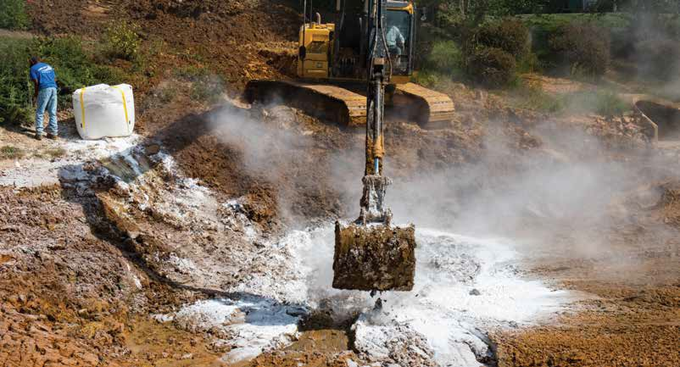
POLYMERS

Super Absorbent Aqueous Polymer
GRANULARS/NEUTRALIZERS

Minimal Volume & Weight Increase = Lower Transportation & Disposal Costs
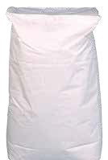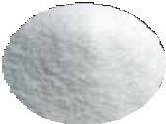Used for cleaning water-based spills and sludge stabilization. Hazardous and nonhazardous industrial waste streams often must be solidified and stabilized to pass the paint filter test prior to placement in appropriately permitted landfills. Industrial solidification traditionally has involved the addition of various agents, including kiln dust, saw dust and portland cement. This significantly increases the volume of material requiring transportation and disposal. The polymers solidify industrial liquid wastes with a nominal volume increase and ensure that liquid wastes pass the paint filter liquids test. Given the capacity to retain substantial volumes of water, there is limited increase in weight of solidified mass, thereby minimizing transportation and disposal costs.
Used in the solidification and removal of hazardous, nonhazardous and radioactive waste, super absorbent polymers are finding new uses in industry. Our polymers have been proven to be more cost-effective than alternatives on the market. In fact, Super Absorbent Polymers can absorb up to 275 times their weight in liquid. (Also available in super sacks.)
Super Absorbent Aqueous Polymer
Model # Mfg # Description Packaging

OIL906 AQP1000 Aqueous Polymer 50 lbs.

Aqueous Polymer/Bentonite Blend

Rapid solidification of aqueous sludge streams with residual organics and petroleum contamination
This is a blend of super absorbent aqueous polymers and bentonite and organo clay. The polymers will absorb up to 275 times their weight in water, and the bentonite clay will absorb the oil. This product is great for sludge stabilization prior to and during transportation. If you have hydrocarbons mixed in with your sludge, the aqueous polymer alone will not work; bentonite is needed to absorb the hydrocarbons.
Aqueous Polymer/Bentonite Blend
Model # Mfg # Description Packaging

OIL927 AQP1001 Aqueous Polymer/Bentonite Blend 50 lbs.

NEUTRALIZERS

Acid and Base Neutralizing Polymers: Pads, Socks, Pillows & Granulars
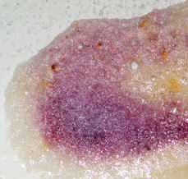Used to neutralize and solidify a wide range of both acid and base spills, thus reducing the risk of possible workplace injuries. These highly effective spill control products contain a neutralizer, pH indicator and a super absorbent polymer to safely clean up aggressive chemical spills. Its unique formula reacts with the spilled chemical, converting the fluid into a gelled mass for safe, easy cleanup. A color change will appear letting you know that neutralization is taking place. Neutralizers are available in pillows, socks, pads and granular form.
In Use

Model # Mfg # Description Packaging Weight
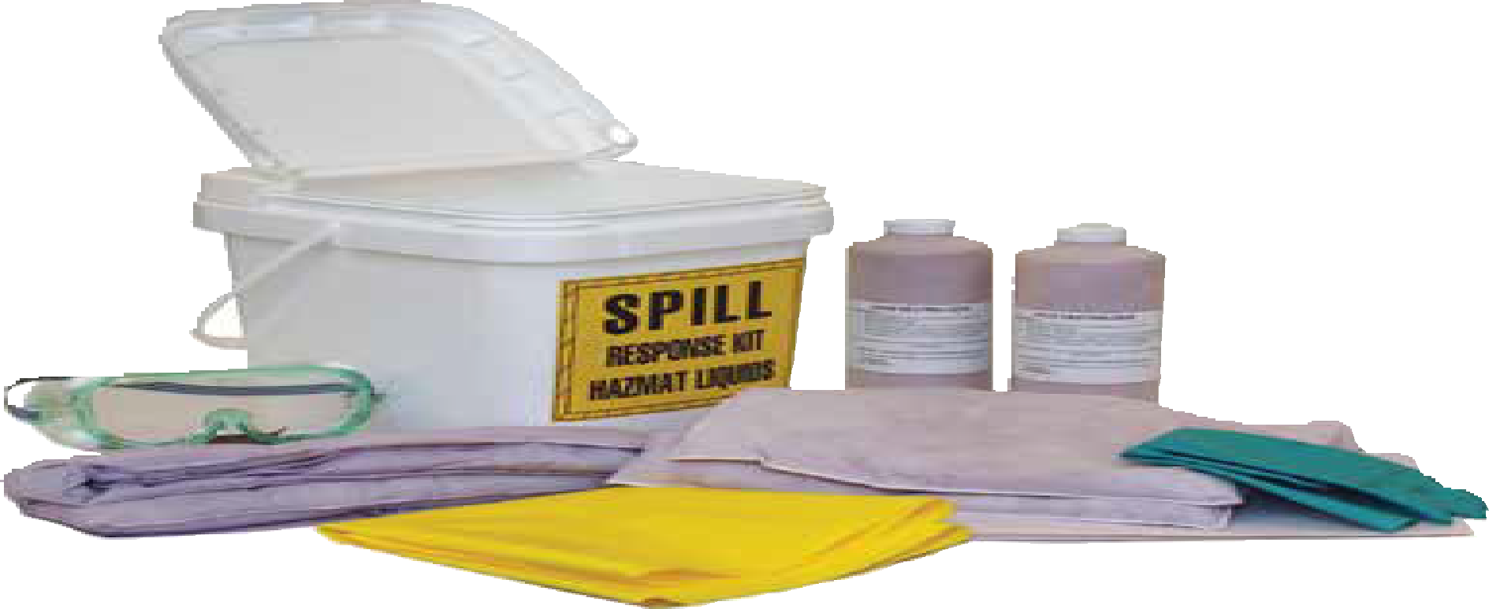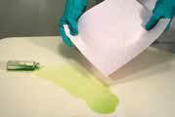OILM280020 NEUT1000 Acid Neutralizer, 2 lb. Shaker 10/case 20 lbs. OIL905 NEUT1001 Acid Neutralizers 5-gallon pail 40 lbs. OILM280025 NEUT1002 Acid Pads, 11" x 12", 10 pads/pack 10 packs/case 7 lbs. OILM280022 NEUT1003 Acid Socks, 2" x 4' 4/box 6 lbs. OILM280023 NEUT1004 Acid Pillows, 12" x 12" 4/box 6 lbs. OILM280030 NEUT2000 Base Neutralizer, 2 lb. Shaker 10/case 20 lbs. OIL903 NEUT2001 Base Neutralizers 5-gallon pail 36 lbs. OILM280031 NEUT2002 Base Pads, 11" x 12", 10 pads/pack 10 packs/case 7 lbs. OILM280032 NEUT2003 Base Socks, 2" x 4' 4/box 6 lbs. OILM280033 NEUT2004 Base Pillows, 12" x 12" 4/box 6 lbs. OIL914 NEUT3000 Hydrofluoric Acid Neutralizers, 10 lb. bag 1/case 10 lbs.

Acid Neutralizing Spill Kit
All absorbents in this specially designed kit both neutralize and soak up acidic spills; cleanups are more complete and safer. Use socks to confine spill before it can spread; use pads, pillows and granular neutralizer to soak up spill. Not for use on hydrofluoric acids.

Kit Contents
10 Acid Encapsulating/Neutralizing Mats (12" x 12")
2 Acid Neutralizing Socks (2" x 4')
2 Acid Neutralizing Pillows (12" x 12")
2 Shaker Bottles Granular Neutralizer (2.5 lb.) 1 Splash Goggles
- Pair Nitrile Gloves 1 Apron
- Temporary Disposal Bags w/Ties

Acid Neutralizer, 2 lb. Shaker
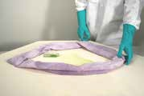
Acid Neutralizer, Sock
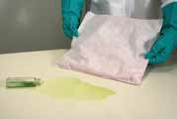
Acid Neutralizer, Pillow

Acid Neutralizer, Pads

GRANULARS/NEUTRALIZERS

Model # | Mfg # | Description | Sorbent Capacity | Packaging | Weight
KIT1050 | KITA1001 | Acid Neutralizing Spill Kit | absorbs up to 4 gallons | 1 | 20 lbs.

Liquid Neutralizers
Liquid neutralizers generate less gas and heat during neutralization than dry formulas. Use liquid formula by spraying on vertical surfaces or pouring into tight corners and hard-to-reach areas. Use liquid HF Acid Eater for hydrofluoric acids. The standard liquid acid neutralizers cannot be used on hydrofluoric acid.
Liquid Neutralizers

Model # Mfg # Description Weight

OIL904 NEUT1501 Acid Neutralizers in Liquid Form, 1 gallon, 4/case 36 lbs. OIL918 NEUT1502 Acid Neutralizers in Liquid Form, 5 gallons 45 lbs. OIL916 NEUT1503 Acid Neutralizers in Liquid Form, 55-gallon drum 510 lbs. OIL928 NEUT3500 Hydrofluoric Acid Eater, 5 gallons 38 lbs.
HF

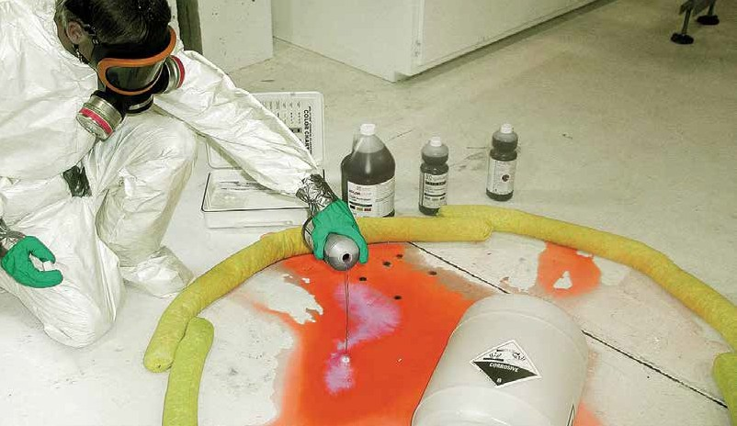
NEUTRALIZERS
GRANULARS/NEUTRALIZERS

HgX® Mercury Decontaminant Powder
For the reduction of toxic mercury vapor, HgX® is an inexpensive, water-soluble, nonhazardous, metallic-mercury/ sulfide-converting powder with a chelating compound and dispersing agent. It reacts
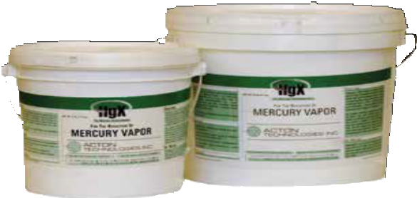rapidly, forming a film over the finely divided, nearly invisible reacting to produce a nonvaporizing sulfide. Further, HgX® keeps working. Particles of HgX® left on cleaned surfaces are reactivat- ed during subsequent cleaning.
beads of mercury and on
HgX® is not harmful. None of its components are classified as toxic. It leaves no odor. And no allergic reactions ever have been reported, even after continuous use under various conditions.
HgX® is stable. It is supplied in polyethylene drums and can be stored safely up to one year without any loss of activity.

HgX® Mercury Decontaminant Powder
Model # Mfg # Description Packaging
OILM7034 NEUT3600 Mercury Decontaminant Powder 5 lb. drum OILM7035 NEUT3601 Mercury Decontaminant Powder 20 lb. drum OILM7038 NEUT3602 Mercury Decontaminant Powder 1.5 lb. tub

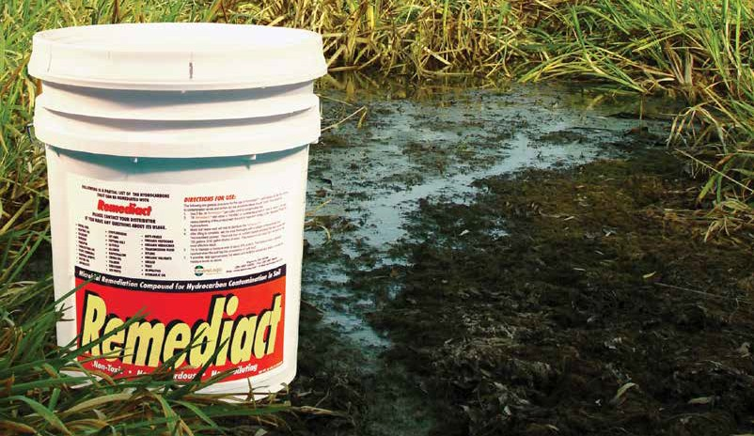
BIOREMEDIATION
BIOREMEDIATION

Bioremediation is the process of using microorganisms to digest harmful contaminants and turn them into nontoxic compounds. Nature will heal itself, but it often takes a great amount of time. Using microbes helps speed up this process by concentrating the number of helpful microorganisms within a given area. Microscopic organisms digest hydrocarbons and transform them into harmless carbon dioxide and water. Bioremediation is a safe, natural process that produces no harmful byproducts. Since it can be done on site, it is often more cost-effective than having soil or water hauled away for burning or other reclamation. It is also safer for workers, because no harmful chemicals are used in the process.

RemediactTM
Remediact™ is an innovative concept in the remediation of soil saturated with hydrocarbon contaminants. It is designed to allow industry to clean up and restore soil to its pre-contaminated condition. Remediact™ is a natural absorbent that has been specially treated with hydrocarbon-digesting microbes. These microbes have the ability to turn most hydrocarbons into carbon dioxide (CO2) and water. When used according to the directions, Remediact™ safely and effectively solves your contamination problems with very little labor and equipment expense, thereby making this product an essential part of your pollution control efforts.

RemediactTM

Model # | Mfg # | Description | Packaging | Weight
OILM9023 | BIOR1000 | 5-Gallon Container, Dry (no deeper than 2-3 feet) | 1 each | 35 lbs.
OILM9024 | BIOR1001 | 5-Gallon Container, Liquid (used for 3 feet and deeper) | 1 each | 42 lbs.

CLEANERS/DEGREASERS
The title says it all—these products are used to clean and
maintain your workplace, whether it be for industrial or commercial use.
We only offer products that won’t harm you when in use. Our popular line of Simple Green® cleaners and degreasers helps keep your shop or plant clean at all times, and the best part about it—they won’t harm the person using them, unlike some of the other hazardous cleaners that are on the market today.

TOP SELLERS

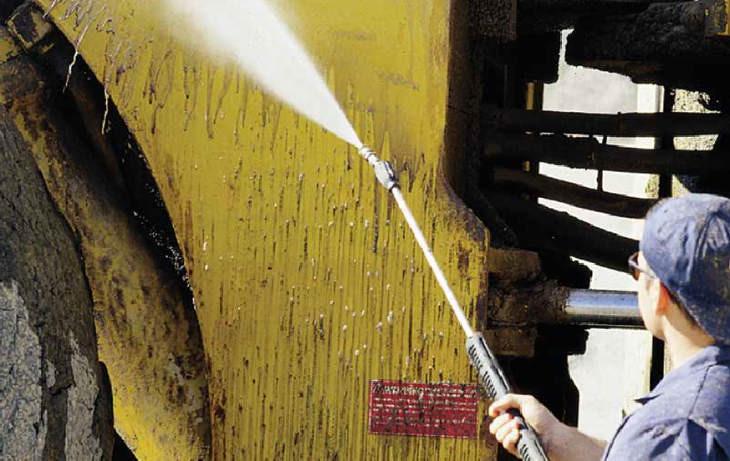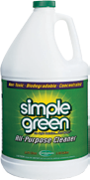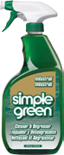Simple Green®
56 Chemtex | Delivering Solutions in Spill Control
Page 57
Simple Green® Spray Bottle
Page 57

CLEANERS/DEGREASERS
CLEANERS/DEGREASERS

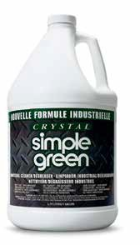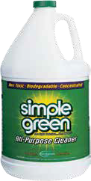Original
Simple Green® is one of the most versatile all-purpose cleaners you can buy! It’s nontoxic and biodegradable, without harmful bleach or ammonia. Because it is a concentrate, you can use Simple Green® full-strength or add water to clean just about anything. It replaces most cleaners, detergents, degreasers and solvents you’re using now!
Simple Green®

Model # | Mfg # | Description | Packaging
SGR354 | CDSG1000 | 24 oz. Bottle w/Sprayer | 12/case
SGR353 | CDSG1001 | 1-Gallon Bottle | 6/case
SGR101 | CDSG1002 | 5-Gallon Pail | 1 each
SGR350 CDSG1003 55-Gallon Drum 1 each

Crystal
Crystal Simple Green® is formulated for critical cleaning applications that demand a fragrance-free solution. It is a highly effective, concentrated, all-purpose degreaser and cleaner. Because Crystal Simple Green® is fragrance-free, color-free, and has high rinsibility, it is an ideal and effective degreaser/cleaner for use in many industries.
Crystal Simple Green®

Model # | Mfg # | Description | Packaging
SGR200 | CDSG1004 | 1-Gallon Bottle | 6/case
SGR100 | CDSG1005 | 5-Gallon Pail | 1 each
SGR300 CDSG1006 55-Gallon Drum 1 each

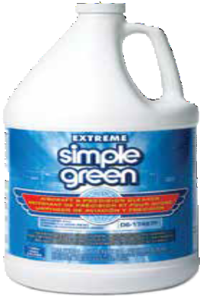Extreme
Extreme Simple Green®, Simple Green’s® new aircraft and precision cleaning product, cuts through tough, built-up grease, oil, dirt, pollution, insect residue, and impact soils. We’ve found no other aircraft-approved product on the market that matches Extreme Simple Green’s® cleaning performance. Yet it causes no harm to aircraft structural metals, plastics, paints or coatings.
Extreme Simple Green®

Model # | Mfg # | Description | Packaging
SGR450 | CDSG1007 | 1-Gallon Bottle | 4/case
SGR452 | CDSG1008 | 5-Gallon Pail | 1 each
SGR451 CDSG1009 55-Gallon Drum 1 each

Simple Green® is on the U.S. Environmental Protection Agency’s National Contingency Plan schedule as a surface-washing agent for use in oil spills occurring in open waterways.

CLEANERS/DEGREASERS
CLEANERS/DEGREASERS

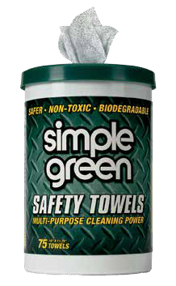Simple Green Safety Towels®
Simple Green Safety Towels® are premoistened with nontoxic, biodegradable, industrial strength Crystal Simple Green.® These multi-purpose cleaning towels are the fast, easy, safe and effective way to remove soils from skin and industrial surfaces. Crystal Simple Green® is USDA-authorized for use in federally inspected meat and poultry plants. Colorless and odorless, both nonabrasive and abrasive sides.

Simple Green Safety Towels®

Model # Mfg # | Description | Packaging
SGR1000 CDSG1010 | Simple Green Safety Towels® | 75 wipes/bucket, 6 buckets/case

Oil Grabber®
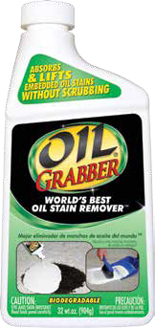Oil Stain Remover
Oil Grabber® Oil Stain Remover absorbs and lifts embedded oil stains without scrubbing!
Outperforms conventional liquid degreasers. Absorbs and lifts embedded oil stains as it dries from liquid to powder. The world’s best oil stain remover. The only product proven effective on concrete. Also works on asphalt, composite/ wood decks, patios, pavers and more!
Removes stains from: antifreeze, brake fluid, cooking oils, diesel fluid, grease, hydraulic fluid, power steering fluid, tar, transmission fluid, tree sap and wax.
Use on: Asphalt (blacktop), concrete, composite decks, driveways, garage floors, masonry, patios, walkways, wood and more. A 32 oz. bottle treats 18 sq. ft.
No other single product removes really tough soils as quickly and effectively from so many different surfaces. Cuts grease, grime, oil, tar and wax fast! Re- moves dried latex paint — excellent tile and grout cleaner as well.

Oil Grabber®
Model # Mfg # Description Packaging

KRUD1004 CDKK1004 32 oz. Bottle 6/case

STORM WATER MANAGEMENT

Clean water is essential for life on earth.
There are laws in the U.S. that prevent the discharge of pollutants into storm drains and/or directly into bodies of water. We offer a variety of products that are used in industrial, commercial and residential environments. These products protect our waters from being contaminated not only with oils and chemicals, but with loose sediments that are found on construction sites as well. You can never be over-prepared for situations like this. Check out the new Flood Control section as well.
Lots of people have experienced flooding at one point in time—be prepared!

TOP SELLERS

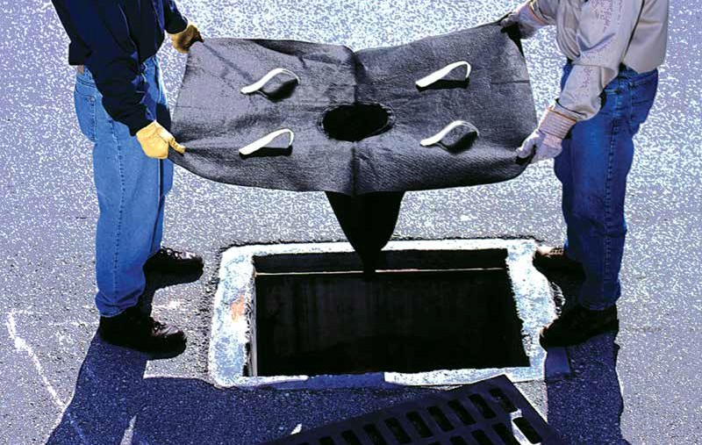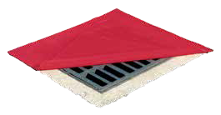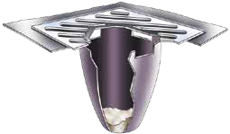Drain Protectors
Page 60
Drain Guard
Page 62
www.chemtexinc.com | Toll-free 1-877-431-0200 | Fax 401-305-3033 59

DRAIN SEALS
STORM WATER MANAGEMENT

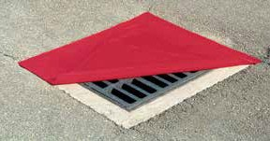
Red Alert DrainProtectorTM II
This DrainProtector™ is red in color and, unlike the Original DrainProtector,™ it’s reversible. Either side can be used to form a tight seal to block out liquids. The lighter weight makes it easier to respond in an emergency and is less expensive.
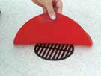
Red Alert DrainProtectorTM II
Model # | Mfg # | Description | Weight
OIL812 | SWMDS1300 | 18" x 18" x 1/4" thick, square | 4 lbs.
OIL813 | SWMDS1301 | 24" x 24" x 1/4" thick, square | 7 lbs.
OIL810 | SWMDS1000 | 36" x 36" x 1/4" thick, square | 15 lbs.
OIL797 | SWMDS1201 | 42" x 42" x 1/4" thick, square | 20 lbs.
OIL811 | SWMDS1009 | 48" x 48” x 1/4" thick, square | 26 lbs.
OIL824 | SWMDS1006 | 36" x 60" x 1/4" thick, rectangle | 27 lbs.
OIL816 | SWMDS1002 | 12" diameter x 1/4" thick, round | 2 lbs.
OIL815 | SWMDS1003 | 20" diameter x 1/4" thick, round | 5 lbs.
OIL818 | SWMDS1004 | 30" diameter x 1/4" thick, round | 10 lbs.

OIL819 SWMDS1005 42" diameter x 1/4" thick, round 17 lbs.

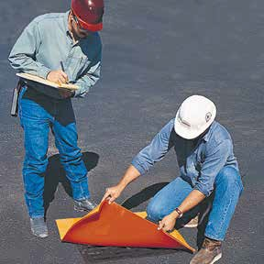
Original DrainProtectorTM
Stop spills before they go down the drain. These durable orange and yellow polyurethane drain covers are available in four different sizes. They adhere to the drain, making them virtually leak-proof. Overlap drain by at least 3".
Original DrainProtectorTM

Model # | Mfg # | Description | Weight
OIL802 | SWMDS1100 | 18" x 18" x 1/2" thick | 8 lbs.
OIL801 | SWMDS1101 | 24" x 24" x 1/2" thick | 13 lbs.
OIL800 | SWMDS1102 | 36" x 36" x 1/2" thick | 29 lbs.
OIL803 SWMDS1103 48" x 48" x 1/2" thick 51 lbs.

DrainProtectorTM +
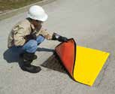
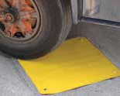
A modern version of the Original DrainProtectorTM. What makes this drain protector special is the extra-durable, glass fiber-reinforced top layer that allows you to drive over while being used, as well as protecting it from damaging UV rays.
DrainProtectorTM +

Model # | Mfg # Description | Weight
OIL836 | SWMDS1008 36" x 36" square | 23 lbs.
OIL835 SWMDS1011 42" x 42" square 27 lbs.

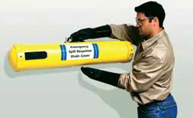
Drain Cover Carrying Case
Store and protect your drain cover in this hard plastic carrying case.
Drain Cover Carrying Case
Model # Mfg # Description Weight OIL808 SWMDS1200 Drain Cover Carrying Case for 36" square 6 lbs. OIL842 SWMDS1010 Drain Cover Carrying Case for 48" square 8 lbs.
Other sizes are available

SAFETY SEALS
STORM WATER MANAGEMENT

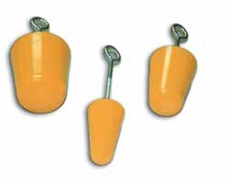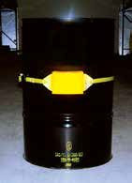Conical Plugs
Ideal for blocking circular drains before a spill, or as soon as one occurs. Kits are available and include 2", 3" and 4" plugs.
Conical Plugs

Model # | Mfg # | Description | Quantity | Weight
OIL805 | SWMSS1002 | 2" Conical Plug | 1 | 2 lbs.
OIL806 | SWMSS1003 | 3" Conical Plug | 1 | 2 lbs.
OIL804 | SWMSS1004 | 4" Conical Plug | 1 | 3 lbs.
OIL807 SWMSS1008 Conical Plug Kit 3 8 lbs.

Barrel Patch
Seals leaks fast on any 55-gallon drum. Use the 11' strap for larger tanks. Tough nylon belt fits around drums. Easy-to-use, ratcheting buckle ensures a tight seal. Simply place over the barrel, align patch over leak, and tighten. Cleans easily with soap and water.
Barrel Patch

Model # | Mfg # Description | Size | Weight
OIL814 | SWMSS1000 Barrel Patch | 1" x 5" x 7", 11' strap | 4 lbs.
OIL820 SWMSS1001 Barrel Patch 1" x 5" x 7", 6' strap 3 lbs.

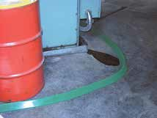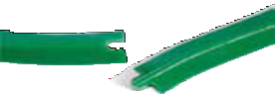Spill Dams
Contain and divert spills before contamination takes place. Made out of the same durable polyurethane as the drain covers, these dikes will temporarily bond to any smooth surface. Available in large and small. Use the connector to contain larger areas.
Spill Dams
Model # Mfg # Description Size Weight OIL796 SWMSD1001 Small Connectable Spill Dam 10' l x 2 ¼" w x 1 3/8" h 13 lbs. OIL798 SWMSD1000 Original 10' Spill Dam 10' l x 3 3/4" w x 2 ¼" h 30 lbs.
Spill Dam Connectors
Model # Mfg # Description

OIL799 SWMSD1002 Use connectors to connect original spill dams for more coverage

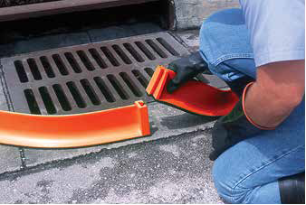
Tall Spill Dams
The taller version of the spill dam is used to contain and divert larger volumes of liquid. Flexible polyurethane construction is nonabsorbent and chemical-resistant. Easily cleans up with soap and water for repeated use. Built-in connectors allow you to attach them end to end.
Tall Spill Dams
Part # Model # Description Size Weight

OILM7378 SWM1211 Tall Spill Dam 5' x 4" x 4.5" 16 lbs.

DRAIN GUARDS & SPECIALTY PRODUCTS
STORM WATER MANAGEMENT

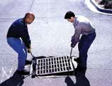
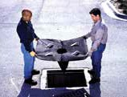
Drain Guard
Storm water drain guard is designed for use in industrial facilities, construction sites and parking lots. Contains an oil-absorbent pillow that removes oils and greases from water flow as it passes through the drain guard.
Nonwoven fabric removes dirt, sand and other sediments from storm water. Absorbs up to .87 gallons of oil and holds up to 40 pounds of sediment.

Model # Mfg # Description Weight

OILM7322 SWM1101 Drain Guard, Oil & Sediment Model, 48" x 36" x 18" 2 lbs.

Helps comply with NPDES, 40 CFR 122.26 (1999)

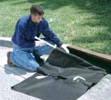
Drain Guard, Curb-Insert Style
For use with combination catch basins with a street grate and curb opening. Heavy-duty tension rod secures drain guard inside curb inlet — stopping sediment and other contaminants from entering curb portion of storm drain. Fits grate sizes up to 40" x 40" and curb inlets up to 60" wide.

Model # Mfg # Description Weight

OILM7326 SWM1102 Drain Guard, Curb-Insert Style, Oil & Sediment Model, Inlets 24"-42" 4 lbs. OILM7330 SWM1103 Drain Guard, Curb-Insert Style, Oil & Sediment Model, Inlets 42"-60" 5 lbs. Helps comply with NPDES, 40 CFR 122.26 (1999)

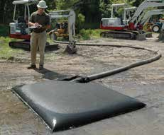
Dewatering Bags
Use to remove both oils and sediment from a body of water. Attach to the end of a hose and pump water through it. The highly durable geotextile will eliminate hydrocarbons and sediment, while allowing the clean water to filter through. Choose from four different sizes.

Model # | Mfg # | Description | Capacity (cu. ft.)
OILM7396 | SWM1203 | 3' x 4' | 6
OILM7397 | SWM1204 | 6' x 6' | 18
OILM7398 | SWM1205 | 10' x 15' | 150
OILM7399 SWM1206 15' x 15' 225

Inflatable Pipe Plugs
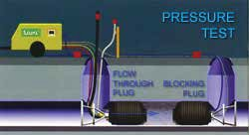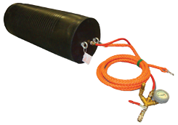Multi-size pipe plugs reinforced with Kevlar® have a wide application range. Plugs are made from a high-quality Neoprene rubber that will stand up to hydrocarbons. Each plug covers several pipe sizes. Multi-size ranges overlap for more user selectivity. For pipes from 8" diameter to 24" diameter. These sizes work on most municipal storm drains and sewers. Plugs are flexible and bend easily around tight corners or when installing through manholes.
Plug accessories are sold separately — please call our office for details.

Model # | Mfg # | Description | Packaging
CON2010 | SWMSS1009 | Inflatable Pipe Plug, 8"–16" | 1 each
CON2011 | SWMSS1006 | Inflatable Pipe Plug, 12"–21" | 1 each
CON2012 | SWMSS1007 | Inflatable Pipe Plug, 14"–24" | 1 each
CON2013 | SWM1252 | Single Fitting Controller, 36 psi | 1 each
CON2014 | SWM1250 | Inflation Lift Hose, 16" | 1 each
CON2015 SWM1251 Inflation Lift Hose, 32" 1 each

“Sandless” sand bags are compact and lightweight for storing, but will grow to 32 lbs. in times of need. Just add water and watch them grow.
Contains super-absorbing polymers that will swell and gel with water.
Contents are nontoxic, nonhazardous and biodegradable. Stagger multiple bags to build a retaining wall.
H20 Dam*
Model # Mfg # | Description | Size | Packaging
OILM7368 SWM1210 | H20 Dam, absorbs up to 4 gallons | 12"W x 24"L x 3.5" H | 20/case
Flood Barriers*

Divert problem water away from your home or business. Self-activating flood barriers— simply expose them to fresh water. They absorb water and grow to full size at
STORM WATER MANAGEMENT
  - " high in 5 minutes. Swelled barriers contain and divert flood water. Leave in place for ongoing protection. Lasts for up to 8 months of continuous use. Safe,
nonhazardous and nontoxic, environmentally friendly and decomposes over time.

    - Ready to use, activates and grows when wet
    - Compact and lightweight
    - No sand or labor needed
    - Reusable and lasts for months, leave in place for ongoing protection
    - Reactivates when wet and evaporates when dry
    - Safe, nonhazardous and
nontoxic, environmentally friendly
    - Stagger multiple H20 Dams to build a retaining wall
    - Compared to heavy traditional sand bags, you can carry

Model # Mfg # Description Size Packaging
OILM7387 SWM1207 Flood Barrier, absorbs up to 4 gallons 3.5" x 5' 26/case OILM7388 SWM1208 Flood Barrier, absorbs up to 8 gallons 3.5" x 10' 12/case OILM7389 SWM1209 Flood Barrier, absorbs up to 13.5 gallons 3.5" x 17' 8/case
*Not for use with salt water

Grab & Go Flood Protection
This kit is designed for quick and easy deployment when timing means everything. The compact container takes up minimal space and is ideal for rapid emergency deployment. Store in closets, cabinets, vehicles and more. The bucket can be used to preactivate your H20 Dams/Flood Barriers—just add water to the bucket and go!
several of these at a time, making your job much easier

Model # Mfg # Description Absorbs
KIT8001 SWM1210 Grab & Go Flood Control Kit up to 60 gallons
Kit Contents
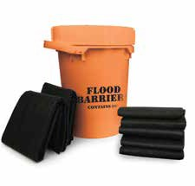
5 Barriers, 5' x 3.5"
10 H20 Dams, 24" x 12" x 3.5"

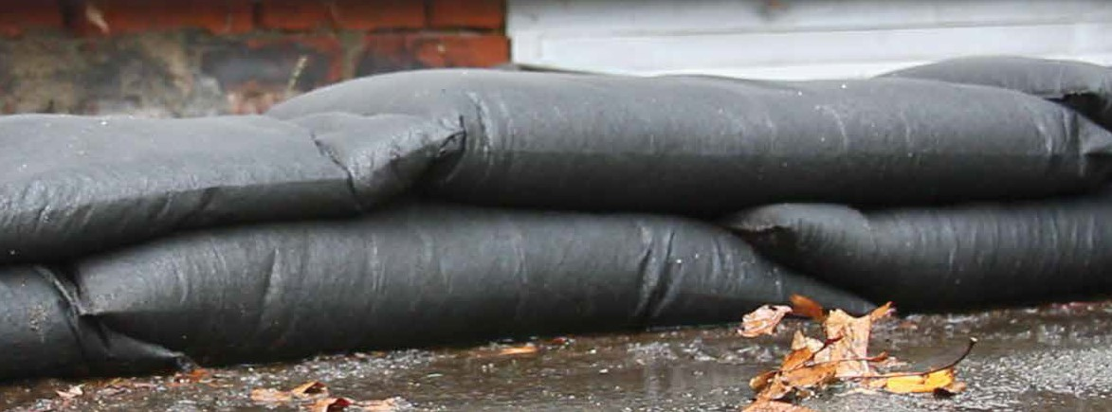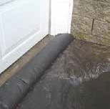
FLOOD CONTROL
H2O Dam
H20 Dams & Flood Barriers
These compact “sandless” sand bags absorb, contain and divert water
H20 Dam
Flood Barriers
Flood Barrier
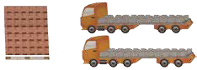
2 Flatbed Trucks (92,160 lbs. of Sand)
1 Pallet
(2,880 Flood Bags)
HOW MUCH DO SAND BAGS COST YOU?
1 Pallet of H2O Dams: Sand bags:
- 2,880 Dams > 2,880 empty sand bags
- Activate on site with flood water > 92,160 lbs. of sand,
transport sand to fill site
  - labor to fill bags
  - transport filled bags to deployment site

PERSONAL PROTECTION

Spills can not only be a very messy job when it comes to cleaning them up.
Depending on the liquid, they can be life-threatening as well.
Timing is everything when responding to spills, and without the proper PPE, the time to respond could cost you thousands, if not millions of dollars. Make sure you are prepared for your worst- case scenario when it comes to your PPE. Protecting your health is first and foremost.
Remember the saying: “SAFETY FIRST”

TOP SELLERS

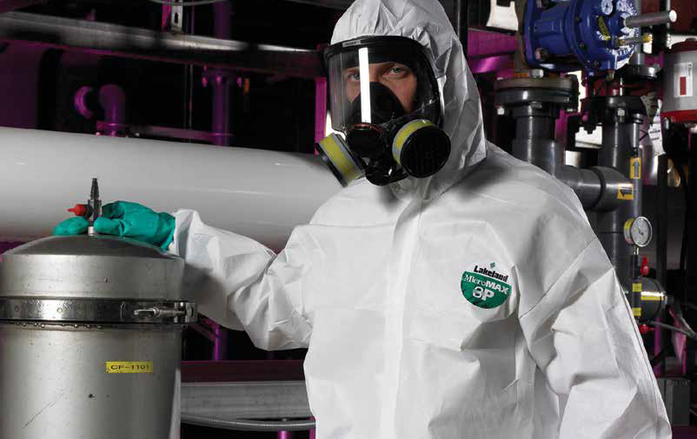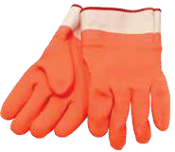Nuke Boots
64 Chemtex | Delivering Solutions in Spill Control
Page 65
Oilmen Gloves
Page 66

PERSONAL PROTECTION

Nuke Boots
Nuke Boots are heavyweight latex shoe covers. These highly stretchable latex rubber overboots go on easily over shoes. Hazmat boots are slip-on shoe covers for controlling the spread of hazardous materials. Protect your boots and yourself against worksite debris. Economical enough for one-time use, but durable enough
for repeat wear. Heavily textured soles give reliable traction on wet, slippery surfaces.
Nuke Boots

Model # | Mfg # | Description | Size | Packaging
PCL0583 | PPEB1000 | Latex Nuke/Chicken Boots | L | 50/case
PCL0585 | PPEB1001 | Latex Nuke/Chicken Boots | XL | 50/case
PCL0584 PPEB1002 Latex Nuke/Chicken Boots 2XL 50/case
Chemical Goggles
Designed for chemical splash application, features a clear vinyl body and a fogless lens. Meets ANSI Z87.1+ standards.
Chemical Goggles
Model # Mfg # Description

PCL0976 PPEH1100 Clear Goggles PCL0978 PPEH1101 Clear Goggles, Anti-Fog Lens

Tyvek® Suits
PERSONAL PROTECTION
With Tyvek®, you don’t have to compromise. That’s because Tyvek® delivers the best balance of protection, durability and comfort. Made using a proprietary manufacturing process, Tyvek® features an inherent barrier. So, unlike other protective apparel fabrics which have either a film or coating that can be easily scratched or worn away, Tyvek® provides a barrier through the entire fabric.

MicroMAX® Suits
The MicroMAX® pattern design features a tailored pattern cut, inset sleeves, elastic back, and a double- gusseted crotch that allows unparalleled freedom of movement. What’s the difference between this suit and competitive products?
Competitive, non-gusseted coveralls have a crotch dropped lower to allow
for reaching without ripping out, and yoke-style sleeves put a seam in the chest which is vulnerable to chemical
penetration. MicroMAX® 3P Super B with the double-gusseted crotch and inset sleeves eliminates these flaws—the result being a garment that is designed to fit and is not just a larger bag. Perfect for general duty work environments, MicroMAX® utilizes three barrier layers to provide an excellent level of protection. Dirt, grease, grime and light liquid splashes and spills are no problem for MicroMAX®. It’s an excellent, low-cost alternative that provides you with high-quality protection. This is a great alternative to Tyvek® suits.

Polycoated Tychem® Suits
Tychem® QC — a DuPont™ Tyvek® protective fabric coated with 1.25 mils of polyethylene. It is reliable protection for minor chemical spills and where there is potential for mist or light splash. Bright yellow in color.

ChemMax 1® Suits
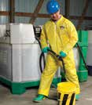
Offering quality along with durability, this cost-effective, entry level product will please distributors, safety engineers, and plant purchasing managers.
Whether you are in manufacturing, environmental cleanup, or chemical handling, you can trust the Chem- Max® family of products to protect your workers from harm. ChemMax®
is constructed with a unique polyethylene barrier film and a continuous filament polypropylene nonwoven. ChemMax 1® garments bar many harmful contaminants from penetrating to inner clothing. This is a great alternative to Tychem® suits.
Available in sizes
Small to 5X
Please call our office
for specific part numbers and ordering details.
AVAILABLE STYLES
- Coverall w/Collar
- Coverall w/Elastic Wrist & Ankles
- Coverall w/Attached Hood
- Coverall w/Attached Hood & Elastic Wrists & Ankles
- Coverall w/Attached Hood & Boots & Elastic Wrists (Bunny Suit)

GLOVES

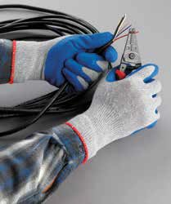
SpiderGrip® Work
Job-fitted for applications where dexterity, flexibility and comfort are desired! SpiderGrip® gloves will make slips a thing of the past! SpiderGrip® crinkle dip latex gloves have a textured palm to provide an excellent grip. The palm of the glove is liquid-repellent, while the back provides excellent breathability
to keep hands cool on the job.
Features: seamless design, puncture-resistant, ergonomic fit, long-wearing Applications: light to medium fabrication, parts handling, general warehousing, maintenance and general purpose handling where light liquids or oils are present
SpiderGrip® Work

Model # | Mfg # | Description
GLO1421 | PPEG1000 | SpiderGrip® Polyester Cotton Latex Dipped Gloves, L
GLO1420 | PPEG1001 | SpiderGrip® Polyester Cotton Latex Dipped Gloves, XL

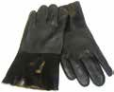
PVC
PVC-coated gloves provide durable protection from grease, liquids and abrasion. They are ideal for working outside in the rain or handling petroleum-based solvents.

Oilmen
Oilmen gloves with safety cuff. Orange in color for high visibility. Rough texture for a better grip. Flock-lined for warmth in the winter. Rugged PVC material protects
against oils and other hydrocarbon-based liquids.

Model # Mfg # Description

GLO1217 PPEG1100 PVC, Black, 12", Rough, Jersey Lining
Model # Mfg # Description

GLO1221 PPEG1101 Oilmen Gloves w/Safety Cuff

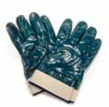
Blue Full-Dipped Nitrile
Blue full-dipped nitrile gloves with safety cuff. Jersey-lined for added comfort. Nitrile gloves are used for oils and chemicals.

Leather Palm with Safety Cuff
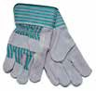
Leather palm with safety cuff. Use for a variety of applications. Not for use
with liquids.

Model # Mfg # Description
PERSONAL PROTECTION

GLO1049 PPEG1200 Blue Full-Dipped Nitrile w/Safety Cuff

13" Green Nitrile Gloves
13" green nitrile unsupported gloves, unlined with straight cuff. These are used to protect against oil and chemicals.

Model # Mfg # Description

GLO1055 PPEG1210 13" Green Nitrile Unsupported Gloves
Model # Mfg # Description

GLO0500 PPEG1300 Leather Palm w/Safety Cuff

Disposable Nitrile Gloves
Nitrile gloves offer excellent protection against certain solvents, chemicals, caustic compounds, oils, animal fats and blood products. Disposable nitrile gloves are available in different powder formulations
and mil thickness for both laboratory and industrial settings.

Model # Mfg # Description

GLO1059 PPEG1220 Disposable Nitrile, blue, 4 mil, 100/box, XL GLO1065 PPEG1221 Disposable Nitrile, Powder-Free, blue,
4 mil, 100/box, XL

GLO1062 PPEG1222 Disposable Nitrile, Powder-Free, black,
6 mil, 100/box, XL

SECONDARY CONTAINMENT

When it comes to the storage of your fuels, oils or hazardous chemicals at your facility, are you prepared should you have a release?
We offer a complete line of products that will help make your facility EPA & SPCC Compliant. Secondary containment products are used to contain your accidental leaks from entering walkways or drains, thus promoting workplace safety as well as protection of our environment.

TOP SELLERS

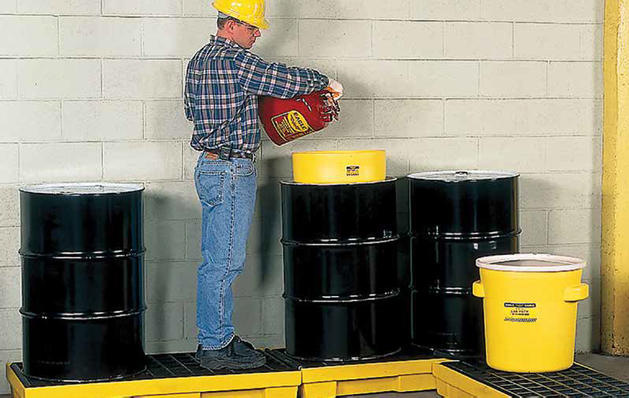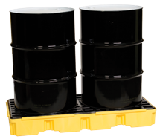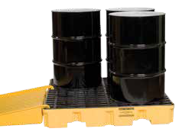2-Drum Spill Pallet
Page 69
4-Drum Spill Pallet
Page 69
www.chemtexinc.com | Toll-free 1-877-431-0200 | Fax 401-305-3033 67

OVERPACKS AND LAB PACKS

Overpacks and Lab Packs
These days, the EPA requirements for secondary spill containment
Model # | Mfg # | Description | Weight
OILM7304 | CON5075 | 6-Gallon Bucket w/Screw-on Lid | 3.4 lbs.
CON0176 | CON5000 | 14-Gallon Lab Pack w/Lid & Lever Lock | 10 lbs.
CON0159 | CON5001 | 20-Gallon Lab Pack w/Lid & Lever Lock | 13 lbs.
CON0158 | CON5002 | 20-Gallon Lab Pack w/Screw-on Lid | 13 lbs.
CON0217 | CON5009 | 30-Gallon Lab Pack w/Lid and Plastic Lever Lock, Yellow | 16 lbs.
CON0154 | CON5005 | 30-Gallon Lab Pack w/Screw-on Top Lid | 18 lbs.
CON0255 | CON5003 | 55-Gallon Lab Pack w/Lid and Plastic Lever Lock, Yellow | 24 lbs.
OILM7306 | CON5051 | 55-Gallon Open Head Poly Drum, Blue | 26 lbs.
OILM7318 | CON5050 | 55-Gallon Closed Head Poly Drum, Translucent | 26 lbs.
CON0160 | CON5006 | 65-Gallon Overpack w/Screw-on Lid | 47 lbs.
CON0161 | CON5008 | 95-Gallon Overpack w/Screw-on Lid | 50 lbs.
CON0171 | CON5007 | 95-Gallon Overpack on Wheels | 56 lbs.
OILM7315 | CON5300 | Dolly for 65- & 95-Gallon Overpacks | 32 lbs.

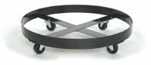
of hazardous materials are more stringent than ever. We stock a large selection from most of the major manufacturers. These high-quality products will help maintain a neat and clean working environment.
OILM7315 Dolly for
65- & 95-Gallon Overpacks
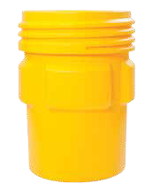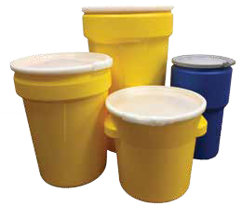

CON0160 - CON0161
SECONDARY CONTAINMENT
65- & 95-gallon overpacks

CON0154 30-gallon lab packs w/ screw-on lid
CON0171 95-gallon overpack on wheels

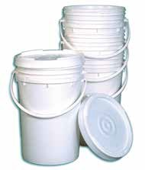
OILM7304 6-gallon buckets w/ screw-on lid
CON0255 55-gallon, CON0217 30-gallon, CONO159 20-gallon and CONO176
  - gallon lab packs w/lever lock lids
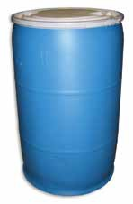
OILM7306 55-gallon poly drums

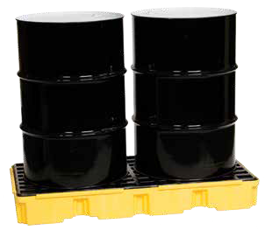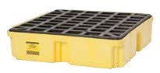Spill Pallets
SPILL PALLETS

CON0112 1-drum spill pallet 26.25" x 26" x 6.5"

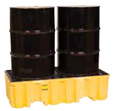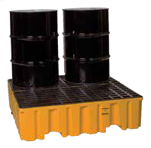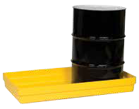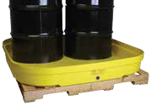CON0119 2-drum spill pallet, high profile 51" x 26.25" x 13.75"
CON0111 2-drum spill pallet, low profile 26.25" x 51.5" x 6.5"

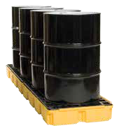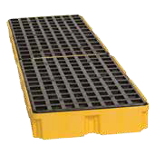CON0180 4-drum spill pallet, high profile 52.5" x 51" x 13.75"

CON0120 4-drum spill pallet, low profile 51.5" x 51.5" x 8"

CON0110 2-drum budget basin
51.5" x 26.25" x 6.5"

SECONDARY CONTAINMENT

CON0184 4-drum budget basin 51.5" x 51.5" x 7"
Model # | Mfg # | Description | Weight | Contains
CON0112 | CON5601 | 1-Drum Spill Pallet | 16 lbs. | 12 gallons
CON0111 | CON5607 | 2-Drum Spill Pallet, Low Profile | 32 lbs. | 30 gallons
CON0119 | CON5606 | 2-Drum Spill Pallet, High Profile | 52 lbs. | 66 gallons
CON0120 | CON5615 | 4-Drum Spill Pallet, Low Profile | 67 lbs. | 66 gallons
CON0180 | CON5613 | 4-Drum Spill Pallet, High Profile | 104 lbs. | 132 gallons
CON0115 | CON5614 | 4-Drum Spill Pallet, In-Line | 64 lbs. | 60.5 gallons
CON0114 | CON5619 | Poly Ramp for CON0120, CON0115, CON0111 | 32 lbs. | N/A
CON0126-3 | CON5618 | IBC Containment Unit | 245 lbs. | 400 gallons
CON0110 | CON5603 | 2-Drum Budget Basin | 20 lbs. | 34 gallons
CON0184 | CON5610 | 4-Drum Budget Basin | 25 lbs. | 66 gallons

CON0115 4-drum spill pallet, in-line 103.5" x 26.25" x 6.5"

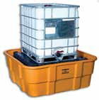
CON0126-3 IBC Containment Unit 67" x 67" x 26"

SPILL PALLETS
SECONDARY CONTAINMENT

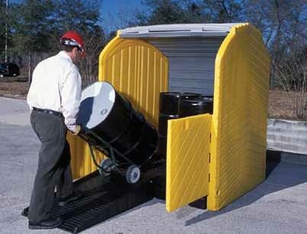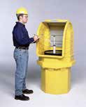Roll Top Hard Cover Spill Pallets
    - Roll top easily slides up and out of the way to allow quick access to pumps or funnels
    - Roll top covers can be padlocked (does not include padlock)
    - Protects drums and their contents while being stored outdoors
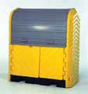
    - All models are forklift accessible

Model # | Mfg # | Description | Size | Weight | Contains
CON3012 | CON5600 | 1-Drum Roll Top Spill Pallet, no drain | 36" x 36" x 66" | 62 lbs. | 70 gallons
CON3007 | CON5604 | 2-Drum Roll Top Spill Pallet, no drain | 67.25" x 41.25" x 74" | 260 lbs. | 66 gallons
CON3008 | CON5611 | 4-Drum Roll Top Spill Pallet, w/drain | 64.25" x 62" x 79" | 440 lbs. | 75 gallons
CON3011 | CON5620 | Ramp for Roll Top Spill Pallets | 55.5" x 28.5" x 8.75" | 43 lbs. | N/A

Spill Nest

An affordable and convenient temporary storage for drums or equipment
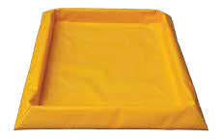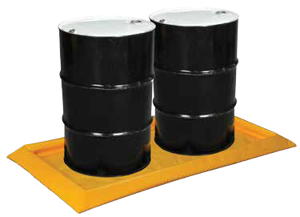The flexible-sidewall Spill Nest delivers easy-to-use, affordable, temporary spill containment for drums, machine parts, tanks, generators, small equipment and other job site needs. It also can be
used as a wash-down pad or pumping station. A great alternative to hard plastic pallets. Features foam sidewalls that easily spring back into place after pressure is applied. Units are constructed of high- quality PVC fabric. Units are drive-in and drive-out with hand truck or forklift—no need for a ramp. Made in the USA.
Black HDPE gratings are available and sold separately. Larger sizes are available but are not kept in stock.
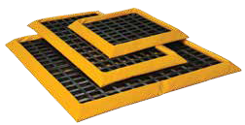
Some capacities may not meet EPA guidelines.

Model # | Mfg # | Description | Weight | Contains
BERM1060 | BERM1060 | 2-Drum Spill Nest, 32.25" x 57.75" | 4 lbs. | 15 gallons
BERM1061 | BERM1061 | 4-Drum Square Spill Nest, 57.75" x 57.75" | 8 lbs. | 30 gallons
BERM1062 | BERM1062 | 4-Drum In-Line Spill Nest, 32.25" x 107.75" | 8 lbs. | 30 gallons
BERM1063 | BERM1063 | Grates, 25.25" x 51.25" | 11 lbs. | N/A

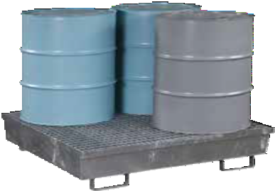
SECONDARY CONTAINMENT
SECONDARY CONTAINMENT

Rugged Steel Spill Pallets
Steel pallets constructed of 11-gauge, hot-rolled steel. Galvanized steel bar grading keeps drums out of overflow and removes for easy cleaning. Large forklift pockets in front and back make relocation easy. Hot-dipped galvanized after fabrication for greater protection against rust and corrosion.

Model # Mfg # Description Weight Contains Load Bearing

CON1011 CON5627 2-Drum Pallet, 47.25" x 31.5" x 16.31" 165 lbs. 72 gallons 1,200 lbs.

CON1012 CON5628 4-Drum Pallet, 47.25" x 47.25" x 13.06" 215 lbs. 77 gallons 2,400 lbs. Steel pallets drop ship from manufacturer.

Containment Sump
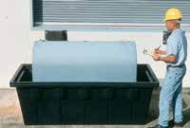
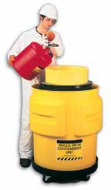Complete containment for 275-gallon up to 1,000-gallon oval tanks— indoors or outdoors. SPCC Compliant.
CON0118

Model # | Mfg # | Description | Contains
CON0801 | CON5608 | 275-Gallon Sump, No Drain, 84.5" x 43.75" x 29" | 360 gallons
CON0803 | CON5609 | 275-Gallon Sump, w/Drain, 84.5" x 43.75" x 29" | 360 gallons
CON0804 | CON5617 | 550-Gallon Sump, w/Drain, 87" x 62.25" x 32.75" | 605 gallons
CON0814 | CON5616 | 550-Gallon Sump, No Drain, 87" x 62.25" x 32.75" | 605 gallons
CON0815 | CON5602 | 1,000 Gallon Sump, w/Drain, 148" x 63" x 33" | 1,100 gallons
Single Drum Containment
Model # Mfg # Description |  |  | Weight | Contains
CON0118 CON5621 Single Drum Containment Unit, 31" x 33" |  |  | 30 lbs. | 65 gallons

Drum Funnel with Screen and Cover

Model # | Mfg # | Description | Weight | Contains
CON0136 | CON5102 | Poly Drum Funnel w/Screen, 18" x 7" | 6.5 lbs. | N/A
CON0137 | CON5100 | Poly Drum Funnel Cover | 1 lb. | N/A

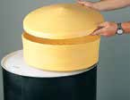
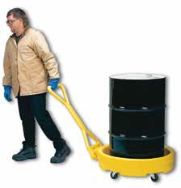Single Drum Tray*
Drum Bogie on Wheels
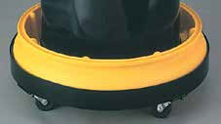
*Drum dolly and drum tray
sold separately
Model # | Mfg # | Description | Weight | Contains
CON0128 | CON5301 | Drum Bogie on Wheels | 30 lbs. | 12 gallons
CON0130 | CON5622 | Single Drum Tray w/Grating, Round, 31" x 6", 18" x 7" | 24 lbs. | 10 gallons
CON0131 | CON5302 | Drum Tray Dolly w/3" Casters | 32 lbs. | N/A

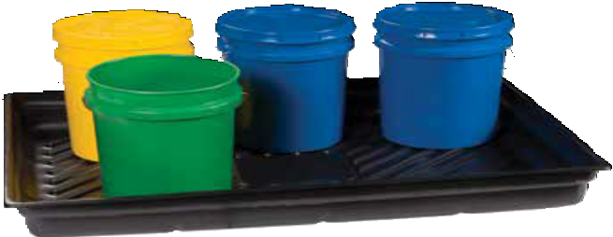
SECONDARY CONTAINMENT
SECONDARY CONTAINMENT

Spill Containment Trays
Spill trays are made of 100% post-industrial recycled polyethylene. They are ideal for catching drips and leaks from small equipment, vehicle batteries, or pouring and filling activities. Lightweight and durable, these HDPE spill trays have excellent chemical resistance.

Model # | Mfg # | Description | Weight | Contains
OIL745 | CON5625 | Spill Tray, 46" x 16" x 5.5" | 4 lbs. | 12 gallons
OIL746 | CON5623 | Spill Tray, 38" x 26" x 5.5" | 5 lbs. | 20 gallons
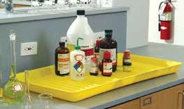
OIL747 CON5624 Spill Tray, 47" x 33" x 5.5" 8 lbs. 29 gallons

Containment Utility Tray
This HDPE tray is an affordable way to contain small spills up to 5 gallons. Ideal for countertop use or as a floor tray under machinery.

Model # Mfg # Description Weight

CON0142 CON5629 Containment Utility Tray, 18" x 36" x 2" 6 lbs.

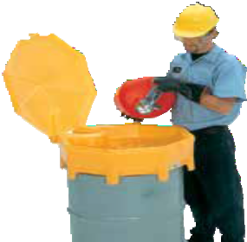
Poly Drum Funnel with Hinged Lid
Durable polyethylene drum funnel resists rust, corrosion and most chemicals. Lid is attached by hinge to allow for easy use.

Model # Mfg # Description Weight Contains

CON0209 CON5101 Poly Drum Funnel w/Attached Lid, 26.5" diameter 17 lbs. 5 gallons

Steel Drum Funnel

10.75" diameter, 10" height, fits into 2" Drum Bung, 6" Brass Flame Arrestor
- Easy pouring during liquid waste collection
- 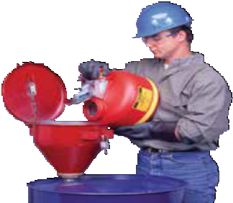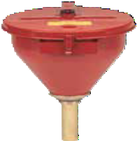Wide-mouth opening with hinged, stay-open lid
- Built-in flame arrestor on most models to prevent fire intrusion
- Self-closing in case of fire
These funnels offer superior safety features that make them ideal for use with solvent, thinner, oil and paint wastes. Heavy 18-gauge galvanized steel with electrostatically applied epoxy powder coat paint provides durability and chemical resistance. Larger funnels accept a lock to prevent unauthorized access. Funnels intended for use with flammables are fitted with a brass flame arrestor that absorbs and dissipates heat, preventing any external ignition source (like sparks from power tools, static electricity or cigarettes) from reaching the drum’s flammable contents.

Model # Mfg # Description Weight

CON0173 CON5103 Large Steel Funnel with Self-closing Cover 10 lbs.

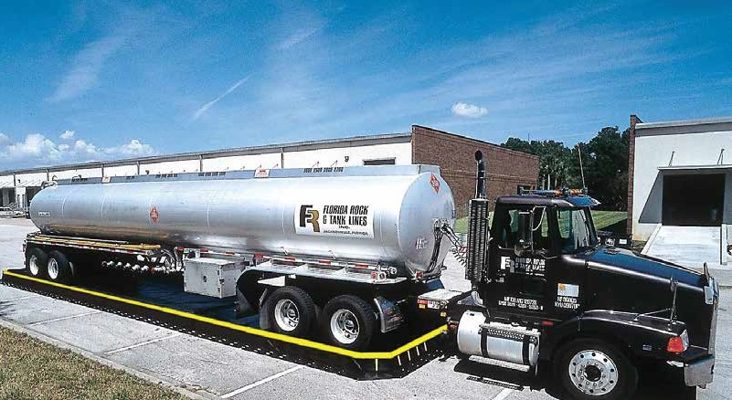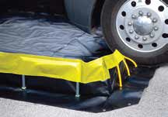
H
22 oz. PVC
HH
BERMS
DURABILITY
Extremely durable, very compatible with most chemicals, 32 mil average thickness. Not susceptible to UV damage.
Very durable, wide chemical compatibility, 30 mil average thickness. Not susceptible to UV damage.
Reinforced PVC, very durable fabric, compatible with most chemicals, 42 mil average thickness.
Reinforced PVC, durable fabric, very compatible with most chemicals, 24 mil average thickness.
18.5 oz. PVC Reinforced PVC, durable fabric, very compatible with most chemicals, 20 mil average thickness.
HHHHH XR5

HHHH XR3*

HHH 40 oz. PVC
BERM FABRIC
RATING
SECONDARY CONTAINMENT
BERM FABRIC SELECTION

*XR3 Fabric is our most popular. The default berm fabric for all of the part numbers below is XR3.

Drive In/Drive Out Containment Berms
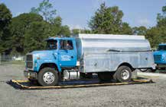
Entry and exit walls automatically spring back to their vertical position. No need to manually raise or lower the end walls. Both of the long sidewalls are held upright by PVC side wall assemblies—simply swivel the feet to lower and transport the berm.

Model # | Mfg # | Dimensions | Weight | Contains
BERM1000 | BERM1000 | 12' x 60' x 1' | 309 lbs. | 5,385 gallons
BERM1001 | BERM1001 | 15' x 50' x 1' | 326 lbs. | 5,610 gallons
BERM1002 BERM1002 15' x 66' x 1' 405 lbs. 7,405 gallons

Rapid-Rise Containment Berms
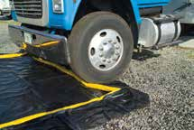
Sidewalls stay lowered and out of the way until they are needed. No sidewall set-up or take-down required. In the case of a spill, the foam ring around the top of the side walls will rise with the level of the liquid.

Model # | Mfg # | Dimensions | Weight | Contains
BERM1010 | BERM1010 | 10' x 10' x 1' | 63 lbs. | 748 gallons
BERM1011 | BERM1011 | 12' x 26' x 1' | 149 lbs. | 2,333 gallons
BERM1012 | BERM1012 | 15' x 50' x 1' | 278 lbs. | 5,610 gallons
BERM1013 BERM1013 15' x 66' x 1' 357 lbs. 7,405 gallons

Take care of your berms and prolong their life by using Ground Tarps and Track Guards. Call our office for details.

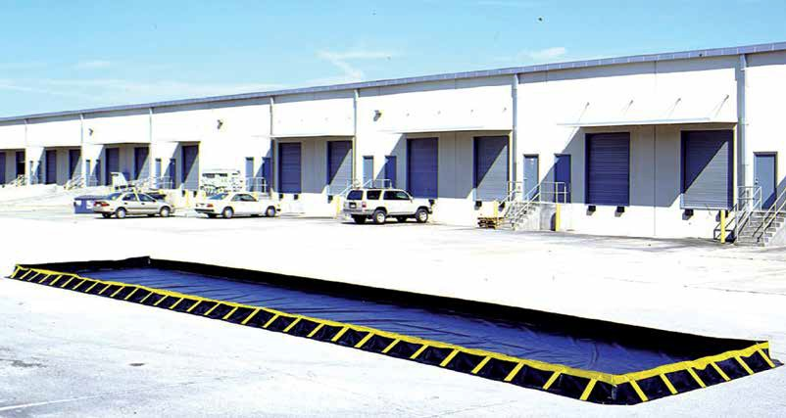
BERMS
SECONDARY CONTAINMENT

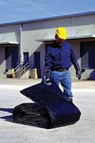
Compact Containment Berms
Compact design folds into tight package — minimal space required to store on board trucks or hazmat response vehicles. Compact, lightweight, portable design, no inflation required. Just insert sidewall struts into their pockets and berms are ready to go.

Model # | Mfg # | Dimensions | Weight | Contains
BERM1020 | BERM1020 | 10' x 10' x 1' | 72 lbs. | 748 gallons
BERM1021 | BERM1021 | 12' x 26' x 1' | 335 lbs. | 5,385 gallons
BERM1022 | BERM1022 | 15' x 50' x 1' | 317 lbs. | 5,610 gallons
BERM1023 BERM1023 15' x 66' x 1' 404 lbs. 7,405 gallons

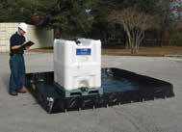
Economy Containment Berms
Economical design offers cost savings and secure containment.
L-shaped aluminum brackets provide sturdy sidewall support. Brackets are easily inserted into sleeves spaced around the perimeter of the berm. These are available in both XR3 or 18.5 oz. PVC.

Model # | Mfg # | Materials Used | Dimensions | Weight | Contains
BERM1030 | BERM1030 | 22 oz. PVC | 4' x 6' x 1' | 21 lbs. | 179 gallons
BERM1031 | BERM1031 | 22 oz. PVC | 6' x 6' x 1' | 26 lbs. | 269 gallons
BERM1032 | BERM1032 | 22 oz. PVC | 10' x 10' x 1' | 72 lbs. | 748 gallons
BERM1033 | BERM1032 | 22 oz. PVC | 12' x 60' x 1' | 335 lbs. | 5,385 gallons
BERM1034 | BERM1034 | 22 oz. PVC | 15' x 50' x 1' | 317 lbs. | 5,610 gallons
BERM1035 | BERM1035 | 22 oz. PVC | 15' x 66' x 1' | 404 lbs. | 7,405 gallons
BERM1040 | BERM1040 | 18.5 oz. PVC | 12' x 12' x 1' | 58 lbs. | 1,077 gallons
BERM1041 | BERM1041 | 18.5 oz. PVC | 12' x 25' x 1' | 94 lbs. | 2,244 gallons
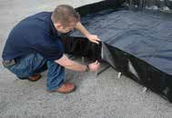
BERM1042 BERM1042 18.5 oz. PVC 12' x 50' x 1' 166 lbs. 4,488 gallons

BERMS & POP-UP POOLS
SECONDARY CONTAINMENT

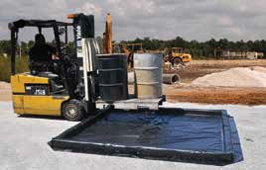
Foam Wall "Drive-in/ Drive-out" Model
Foam walls allow you to drive over walls without damaging. No set-up necessary.
Foam Wall "Drive-in/Drive-out" Model
Model # Mfg # Description Weight Contains OILM7323 BERM1102 10' x 10' x 4", XR3 fabric 58 lbs. 249 gallons BERM1100 BERM1100 12' x 50' x 4", XR5 fabric 339 lbs. 1,496 gallons

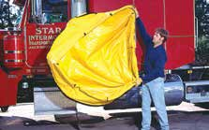
Portable Pop-Up Pools
Pop-Up Pools instantly expand to capture leaks from saddle tanks, pipes, hydraulic lines and many other industrial incidents. Compact folded size stores efficiently inside
spill kits. Excellent chemical resistance.

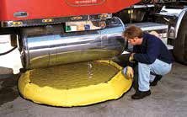
Portable Pop-Up Pools

Model # | Mfg # | Description
CON0810 | CON5504 | Econo Pop-Up Pool, contains 20 Gallons
OILM7360 | CON5506 | Econo Pop-Up Pool, contains 66 Gallons
OILM7320 | CON5505 | Econo Pop-Up Pool, contains 100 Gallons
CON0800 | CON5503 | Econo Pop-Up Pool, contains 150 Gallons
CON0799 | CON5502 | 100/150 Gallon Pop-Up Pool Canvas Carrying Case
CON0806 CON5500 100/150 Gallon Pop-Up Pool Cab Mount Container

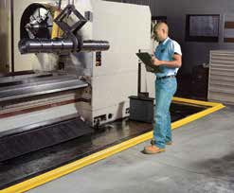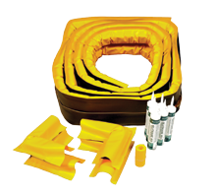BYOB — Build Your Own Berm
Build a barrier around machinery or equipment that is permanently mounted or cannot easily be moved, or wherever a berm wall is needed. Economical containment for leaks and spills around machinery and equipment — no need to build expensive cement or angle iron curbs. This component system provides flexibility to create a semipermanent, high-visibility custom barrier. Its durable, vinyl covering resists oils,
coolants and most chemicals. Cut to length and secure to floor with included sealant, then seal seams with the vinyl adhesive. High-visibility yellow color draws attention to barrier for increased safety. Easy removal requires only a flat-bladed shovel.

Model # Mfg # Description Weight
CON3106 BERMBYOB BYOB – Build Your Own Berm Component System 22 lbs. Individual parts are sold separately. Please call for details.

BYOB Component System includes:
2 – 25' Berm Walls 4 – Berm Corners
6 – Floor Sealant Tubes
1 – 10' Section Connector Collar
1 – 10.3 oz. Industrial Vinyl Adhesive

SAFETY STORAGE CABINETS
SECONDARY CONTAINMENT

Safety Storage Cabinets
Storage cabinets are available from 4 gallons to 120 gallons, with many sizes in between to meet your needs.
Whether you’re storing flammables, paints, inks, acids, corrosives or pesticides, we’ll have a cabinet that will best
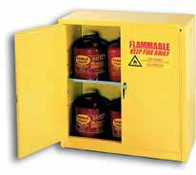
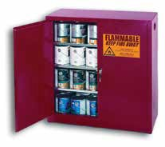
suit your needs. Cabinets are available in three door styles: 2-door manual close, sliding door self-closing, and 2-door self-closing. If you don’t see the cabinet you’re looking for, please call customer service for additional specifications.

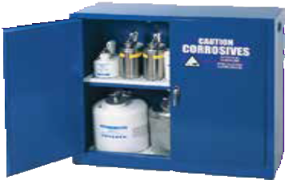
30-gallon flammable 40-gallon paint and ink 30-gallon acid

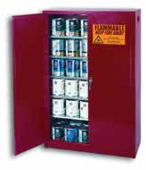
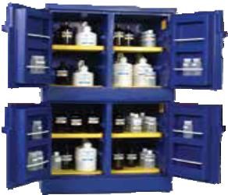
45-gallon flammable 60-gallon flammable 60-gallon paint and ink 44-gallon acid

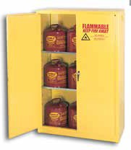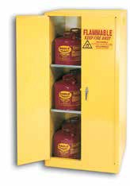Safety Storage Cabinets

Model # | Mfg # | Capacity | Description | Weight | Color & Storage
PI-32 | CAB2000 | 40 gallon | 43" x 18" x 44", Manual Close, 3 Shelves | 281 lbs. | Red—Paint & Ink
PI-47 | CAB2001 | 60 gallon | 43" x 18" x 65", Manual Close, 5 Shelves | 389 lbs. | Red—Paint & Ink
6010 | CAB2003 | 60 gallon | 31.25" x 31.25" x 65", Self-Close, 2 Shelves | 364 lbs. | Yellow—Flammables
1962 | CAB1003 | 60 gallon | 31.25" x 31.25" x 65", Manual Close, 2 Shelves | 364 lbs. | Yellow—Flammables
1947 | CAB1002 | 45 gallon | 43" x 18" x 65", Manual Close, 2 Shelves | 353 lbs. | Yellow—Flammables
4510 | CAB2002 | 45 gallon | 43" x 18" x 65", Self-Close, 2 Shelves | 353 lbs. | Yellow—Flammables
1932 | CAB1000 | 30 gallon | 43" x 18” x 44", Manual Close, 1 Shelf | 257 lbs. | Yellow—Flammables
1904 | CAB1001 | 4 gallon | 17.5" x 18" x 22.5", Manual Close, 1 Shelf | 70 lbs. | Yellow—Flammables
CRA-32 | CAB3001 | 30 gallon | 43" x 18" x 44", Steel, Manual Close, 1 Shelf | 253 lbs. | Blue—Acids*
CRA-P44 | CAB3000 | 44 gallon | 35" x 22" x 65", Poly, Manual Close, 4-Door | 130 lbs. | Blue—Acids
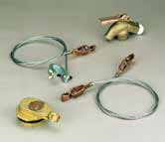
*Steel cabinets not recommended for use with Sulfuric, Nitric or Hydrochloric Acid
Grounding Wires
Model # Mfg # Description

CON0020 CAB0001 Bonding Wires (3'), helps meet UFC Div8, Sec. 79803

SORBENT DISPOSAL OPTIONS

Oil Waste Cans
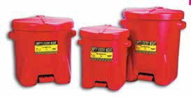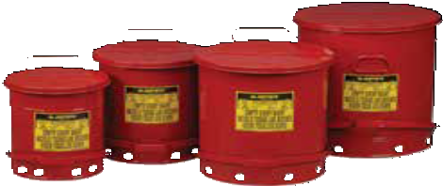Oily waste cans offer fire-safe, temporary storage of solvent, waste rags, shavings and other materials subject to spontaneous combustion. Available in either galvanized steel or polyethylene. Cans feature self-closing lid with foot lever. OSHA-compliant cans are essential whenever solvent-soaked cloths and wiping rags are used. Available in many different sizes. Compliance: OSHA 29CFR 1910.108 and OSHA 29 CFR 1910.106

Oil Waste Cans

Model # | Mfg # | Description | Contains | Weight
933-FL | CON5205 | Poly, 16.5" x 13.5" x 16" | 6 gallons | 9 lbs.
935-FL | CON5200 | Poly, 22" x 18" x 18" | 10 gallons | 14 lbs.
937-FL CON5202 Poly, 22" x 18" x 21" 14 gallons 16 lbs.

Model # | Mfg # | Description | Contains | Weight
CON0411 | CON5206 | Steel, 11 7/8" x 15 7/8" | 6 gallons | 10 lbs.
CON0410 | CON5201 | Steel, 13 15/16" x 18 1/4" | 10 gallons | 13 lbs.
CON0412 | CON5203 | Steel, 16 1/16" x 20 1/4" | 14 gallons | 16 lbs.
CON0413 CON5204 Steel, 18 3/8" x 23 7/16" 21 gallons 22 lbs.

Corrugated Waste Container
Heavy-duty box will hold the equivalent of four 55-gallon drums. This will save you money in transportation and disposal. Corrugated waste containers are rated for packing groups l, ll and lll. They come complete with
a corrugated box, 8 mil liner, pallet and nail kit.
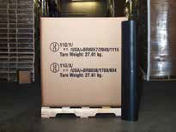

Model # Mfg # Description Packaging

OIL762 CON080 36" x 36" x 36" Corrugated Box, 35/pallet 8 Mil Liner, Pallet & Nail Kit

55-Gallon Steel Drums (reconditioned)
Use 55-gallon open top drums to store used sorbents and for use in transportation. Closed head drums are used for storing free-flowing liquids. Drums are UN-rated UN1A2/Y1.2/100.

Poly-Lined Corrugated Waste Container
These flexible wall bulk bag waste containers are enclosed with layers of polypropylene. UN-approved for Packing Groups l, ll & lll at 3,000 lbs. X-rated flex pack
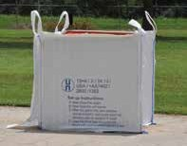
includes 6 mil inner polyethylene liner. Has four 10" lifting loops and
a 36" x 36" x 36"
inner dimension.

Model # Mfg # Description Packaging

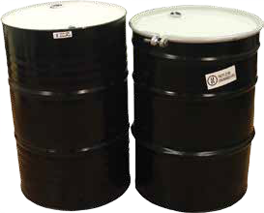
OIL776 CON081 36" x 36" x 36", w/4 Lifting Loops 20/pallet

SECONDARY CONTAINMENT
Model # | Part # | Description | Packaging
OIL760 | CON5053 | 55-Gallon Steel Drum, Open Head, DOT Approved | 1
OIL761 | CON5052 | 55-Gallon Steel Drum, Closed Head, DOT Approved | 1

SPECIALTY PRODUCTS

We offer so many cool products when it comes to cleaning spills or maintaining a neat and clean workplace.
This section is our offering of products that work great in certain situations. Please take the time to scan the section—you don’t want to miss some of these niche products.

TOP SELLERS

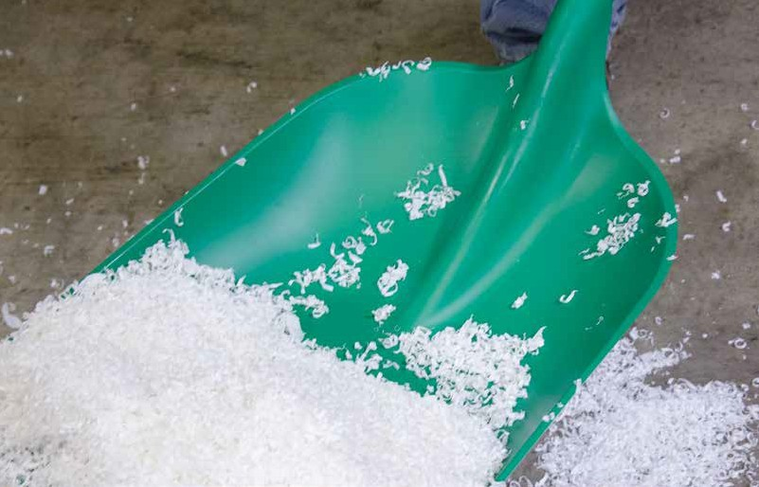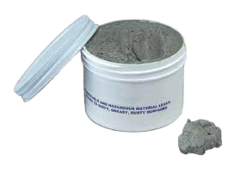Plug 'n' Dike
78 Chemtex | Delivering Solutions in Spill Control
Page 79
H20Zorb
Page 80

SPECIALTY PRODUCTS
SPECIALTY PRODUCTS

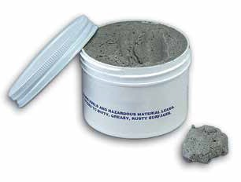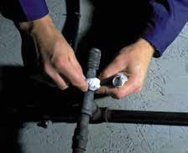Plug 'n' Dike Tank Repair Compound
Seals off fuels, solvents and many other chemicals. Seals immediately and sticks to dirty, crumpled surfaces, even with the fluid flowing out.

Model # Mfg # Description Packaging Weight

OILM9100 CON6100 Tank Repair Compound 1 jar 1 lb. OILM9101* CON6101 Tank Repair Compound 5-gallon pail 48 lbs.
*In powder form; mix and make your own 1 lb. jars.

Epoxy Putty Stick
Repair leaking pipes. Simply pinch off the amount desired, knead to a uniform gray, and press into place.

Model # Mfg # Description Packaging Weight

OILM9103 CON6102 Epoxy Putty Stick, 7" x 7/8" diameter 12/box 4 lbs.

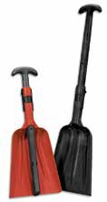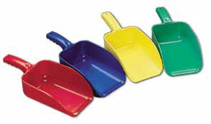
Non-Sparking and Chemically Resistant Tools
Specially designed for spill kits and environmental and industrial cleanup applications, these tools are rugged, non-sparking and chemically resistant.
Collapsible Shovels
Model # Mfg # Description
OILM7314 TOOL1002 2-Piece Shovel, 10.5" x 14" x 38.5"
Weight
2 lbs.
OILM7316 TOOL1003 Economy Blade Spill Kit Shovel, 2-piece, 11" x 13" x 36" 2 lbs.
Scoops
Model # Mfg # Description
OILM7313 TOOL1001 Non-Sparking/Polypropylene, large scoop, 82 oz.
Weight
1 lb.
OILM7307 TOOL1000 Non-Sparking/Polypropylene, small scoop, 32 oz. 1 lb.

SPECIALTY PRODUCTS
SPECIALTY PRODUCTS

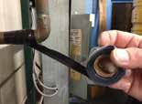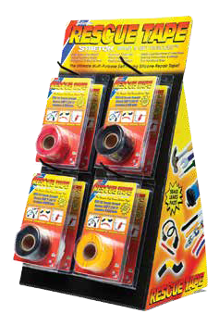Rescue Tape®
Got a leaking hose?
Wrap it up tight with silicone tape! Just stretch, wrap & get rescued™ Seals Leaks Fast!
- 950 PSI tensile strength > Resists 500° F
- Resists fuels, oil, acids, solvents, > Insulates 8,000 volts salt water, road salt, UV rays
Most versatile tape on the market, even better than duct tape. Repair leaking hoses and insulated wires, or use it in place of heat shrink tubing. This is a self-fusing silicone repair product for emergencies and all-purpose repairs. By wrapping it around and onto itself, Rescue Tape® will quickly and easily create a permanent, airtight, watertight seal in just minutes or even seconds. You can repair leaks on hoses, pipes and air lines, or use it on electrical wiring and as shrink wrap.

Model # | Mfg # | Description | Color | Packaging
TPE100 | TPE1000 | Industrial Size, 2" wide x 36' | Black | 6/case
TPE101 | TPE1001 | Industrial Size, 2" wide x 36' | Clear | 6/case
TPE102 | TPE1002 | Standard Size, 1" wide x 12' | Black | 36/case
TPE103 | TPE1003 | Standard Size, 1" wide x 12' | Clear | 36/case
TPE104 | TPE1004 | Standard Size, 1" wide x 12' | Yellow | 36/case
TPE105 TPE1005 Retail Display Pack w/1" Rolls Assorted 24/case

H20Zorb

Pull water from fuel tanks before it causes damage.
Maintain peak performance and prevent engine failure. H2OZorb sorbent pulls in water that collects in fuel tanks before it can cause damage. Helps preserve engine life and prevent frozen lines by removing water from fuel stores; also minimizes filter-clogging rust and algae. Ballast forces H2OZorb to bottom of tank, where unwanted water settles; highly absorbent filler pulls in water, but repels gas and diesel fuel. The tough nylon line makes deployment and retrieval easy. Choose from four sizes.

Model # | Mfg # | Description | Sorbent Capacity | Packaging
CON2007 | CON6001 | 1" D x 9" L | 3 oz. bag | 1
CON2006 | CON6000 | 1.5" D x 12" L | 8 oz. bag | 1
CON2008 | CON6002 | 2" D x 12" L | 12 oz. bag | 1
CON2009 CON6003 3.5" D x 12" L 36 oz. bag 1

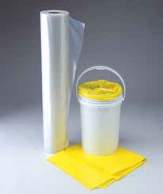
Poly Sheeting and Poly Liners
Poly Sheeting

Model # | Mfg # | Description | Packaging
OILM9500 | CON6200 | 6 Mil Poly Sheeting, 20' x 100' | 58 lbs.
OILM9502 | CON6201 | 6 Mil Poly Sheeting, 20' x 100', Fire Retardant | 58 lbs.
OILM9503 CON6203 6 Mil Poly Sheeting, 40' x 100' 116 lbs.
Poly Liners

Model # | Mfg # | Description | Packaging
OIL620 | BAG1003 | 4 Mil, Yellow Bags, 18" x 30" | 250/case
BAG13983 | BAG1002 | 6 Mil, Yellow Bags, 36" x 48" | 50/case
BAG13982 BAG1001 6 Mil, Clear Bags, 38" x 60" 50/roll

80 Chemtex | Delivering Solutions in Spill Control

Chemical Application Guide
The following guide is a list of common industrial fluids. Choose the sorbent that best suits your needs.

CHEMICAL POLYPROPYLENE POLYPROPYLENE ORGANIC
UNIVERSAL
UNIVERSAL/HAZMAT
OIL-ONLY
CHEMICAL POLYPROPYLENE POLYPROPYLENE ORGANIC
UNIVERSAL
UNIVERSAL/HAZMAT
OIL-ONLY

Acetaldehyde • •
Acetic Acid • Acetic Anhydride •
Acetone • • •
Acetyl Chloride •
Acrolein • •
Acrylonitrile • •
Acrylic Acid •
Acrylic Emulsions • •
Allyl Alcohol • •
Aminobenzoic Acid •
Ammonia (Anhydrous) • • •
Ammonium Hydroxide • • •
Amyl Acetate • •
Amyl Alcohol • •
Aniline • •
Antifreeze • • Aqua Regia •
Aviation Fuel • • •
Benzene • • •
Benzoic Acid •
Benzonitrile •
Benzyl Chloride • Benzyl Alcohol • •
Boric Acid •
Brake Fluid • • •
Bromine •
Butyl Acetate • •
Butyl Alcohol • • •
Butyric Acid • •
Butylamine • •
Calcium Hydroxide • Carbolic Acid •
Carbon Disulfide •
Carbon Tetrachloride • • •
Castor Oil • • •
Chlorine Water •
Chloroacetic Acid •
Chlorobenzene •
Chloroform • • •
Chromic Acid (50%) • Chlorosulfonic Acid •
Citric Acid •
Clorox (Full-strength Bleach) • •
Corn Oil • • •
Cottonseed Oil • • •
Cresol • • •
Cyclohexane • • •
Detergents • •
Dichlorobenzene • •
Diethylamine • •
Diethyl Ether • • •
Dioctyl Phthalate • • •
Dinitrobenzene • •
Dioxan • •
Ether • • •
Ethyl Acetate • • •
Ethyl Alcohol • • •
Ethyl Benzene • •
Ethyl Chloride • •
Ethyl Ether • • •
Ethyl Propionate • • •
Ethylene Glycol • •
Formaldehyde • •
Formic Acid • Fuel Oil • • •
Gasoline • • •
Gearbox Oil • • •
Glacial Acetic Acid •
Heptane • • •
Hexane • • • Hydrazine •
Hydrochloric Acid •
Hydrofluoric Acid •
Hydrogen Cyanide • •
Hydrogen Peroxide • •
Isobutyl Alcohol • • •
Isobutyl Acid • •
Isopropyl Acetate • • •
Isopropyl Alcohol • • •
Kerosene • • •
Ketones • • •
Linseed Oil • • •
Lubricating Oil • • •
Magnesium Hydroxide •
Methyl Alcohol • • • Methyl Chloride • •
Methyl Ether • • •
Methyl Ether Ketone • • •
Methyl Propionate • • •
Mineral Oil • • •
Motor Oil • • • Naphthalene • • •
Nitric Acid •
Nitrobenzene •
Nitrobenzoic Acid • •
Nitrotoluene • • •
Octane • • •
Oleic Acid • •
Olive Oil • • •
Paraffin • • • Perchloroethylene • • •
Petroleum Ether • • •
Phenol • •
Phosphoric Acid •
Plating Solutions •
Potassium Hydroxide •
Propanol • •
Propionic Acid • •
Propyl Alcohol • • • Propylene Glycol • • •
Quinoline •
Resorcinol •
Salt Solutions (Metallic) • •
Silicone Oil • • •
Silver Nitrate • •
Soap Solution (Concentrated) • • •
Sodium Bicarbonate • •
Sodium Chloride • •
Sodium Hydroxide •
Sodium Hypochlorite • •
Sodium Nitrate • •
Stannic Chloride •
Starch • •
Styrene • • •
Sucrose • •
Sulfuric Acid •
Synthetic Motor Oil • • •
Tannic Acid •
Toluene • • •
Transformer Oil • • •
Trichloroethylene • • •
Triethylene Glycol • • •
Turpentine • • • Urine • •
Vinyl Acetate • • •
Vinegar • •
Xylene • • •

Glycerol • •

Product Specifications OIL UNIVERSAL HAZMAT NON-AGGRESSIVE NON-APPLICABLE
Model # Part # Mfg # Description Size Ply Color Packaging Wt. Class Absorbency Perforated Ship Wt. Qty/Pallet Page #

ABSORBENTS
82 Chemtex | Delivering Solutions in Spill Control
FFP12G | OILM1058 | PHGFF100 | universal fine fiber meltblown pads | 15" x 19" | 3 | gray | 100 | double | 25 | - 14 | 30 | 8
FFP12G-BX | OILM1058-BX | PHGFFBX100 | universal fine fiber meltblown pads | 15" x 19" | 3 | gray | 100 | double | 25 | - 14 | 30 | 8
FFP9G | OILM1056 | PMGFF100 | universal fine fiber meltblown pads | 15" x 19" | 3 | gray | 100 | medium | 20 | - 11 | 36 | 8
FFP9G-BX | OILM1056-BX | PMGFFBX100 | universal fine fiber meltblown pads | 15" x 19" | 3 | gray | 100 | medium | 20 | - 11 | 30 | 8
FFP6G | OILM1059 | PSGFF200 | universal fine fiber meltblown pads | 15" x 19" | 3 | gray | 200 | single | 27 | - 15 | 30 | 8
FFP12GR | OILM1061 | PHGRFF100 | universal fine fiber meltblown pads | 15" x 19" | 3 | green | 100 | double | 25 | - 14 | 30 | 8
FFR12G | OILM5011 | RHGFF150 | universal fine fiber meltblown rolls | 30" x 150" | 3 | gray | 1 | double | 47 | - 23 | 15 | 8
FFR12G-2 | OILM5010 | RHGFF1502 | universal fine fiber meltblown rolls | 15" x 150" | 3 | gray | 2 | double | 47 | - 23 | 15 | 8
FFR9G | OILM5023 | RMGFF150 | universal fine fiber meltblown rolls | 30" x 150" | 3 | gray | 1 | medium | 37 | - 17 | 21 | 8
FFR9G-2 | OILM5029 | RMGFF1502 | universal fine fiber meltblown rolls | 15" x 150" | 3 | gray | 2 | medium | 37 | - 17 | 21 | 8
FFR6G | OILM5012 | RSGFF300 | universal fine fiber meltblown rolls | 30" x 300" | 3 | gray | 1 | single | 47 | - 25 | 15 | 8
FFR6G-2 | OILM5210 | RSGFF3002 | universal fine fiber meltblown rolls | 15" x 300' | 3 | gray | 2 | single | 47 | - 25 | 15 | 8
FFR12G50 | OILM5004 | RHGFF50 | universal fine fiber meltblown rolls | 5" x 50' | 3 | gray | 1 | double | 9 | - 6 | 18 | 8
FFR12GR | OILM5020 | RHGRFF150 | universal fine fiber meltblown rolls | 30" x 150" | 3 | green | 1 | double | 47 | - 23 | 15 | 8
BP12G | OILM1050 | PHGS100 | universal SM bonded meltblown pads | 15" x 19" | 2 | gray | 100 | double | 28 | - 14 | 30 | 9
BP9G | OILM1052 | PMGS100 | universal SM bonded meltblown pads | 15" x 19" | 2 | gray | 100 | medium | 23 | - 11 | 36 | 9
BP6G | OILM1054 | PSGS200 | universal SM bonded meltblown pads | 15" x 19" | 2 | gray | 200 | single | 30 | - 15 | 30 | 9
BP3030G | OILM10007 | PHGS50 | universal SM bonded meltblown pads | 30" x 30" | 2 | gray | 50 | double | 43 | - 23 | 15 | 9
BP12G-HPS | OILM1050HPS | PGB100HL | universal SM bonded meltblown pads | 15" x 18" | 2 | gray | 100 | high loft | 25 | - 12 | 36 | 9
BP6G-HPS | OILM1054HPS | PGB200HL | universal SM bonded meltblown pads | 15" x 18" | 2 | gray | 200 | high loft | 27 | - 13 | 36 | 9
BR12G | OILM5015 | RHGS150 | universal SM bonded meltblown rolls | 30" x 150' | 2 | gray | 1 | double | 52 | - 23 | 15 | 9
BR12G-2 | OILM5016 | RHGS1502 | universal SM bonded meltblown rolls | 15" x 150' | 2 | gray | 2 | double | 52 | - 23 | 15 | 9
BR9G | OILM5017 | RMGS150 | universal SM bonded meltblown rolls | 30" x 150' | 2 | gray | 1 | medium | 44 | - 17 | 21 | 9
BR9G-2 | OILM5037 | RMGS1502 | universal SM bonded meltblown rolls | 15" x 150' | 2 | gray | 2 | medium | 44 | - 17 | 21 | 9
BR6G | OILM5021 | RSGS300 | universal SM bonded meltblown rolls | 30" x 300' | 2 | gray | 1 | single | 55 | - 25 | 15 | 9
BR6G-2 | OILM5211 | RSGS3002 | universal SM bonded meltblown rolls | 15" x 150' | 2 | gray | 2 | single | 55 | - 25 | 15 | 9
BR200G | OILM5212 | RHGS200 | universal SM bonded meltblown rolls | 12" x 200' | 2 | gray | 1 | double | 30 | - 13 | 20 | 9
OILM5041 | OILM5041 | WRRACK | 12" wiper/sorbent roll rack on wheels, horizontal | 33" x 28" x 12" | n/a | black | 1 | n/a | n/a | 7 | n/a | 9
DP100G | OILM1150 | PGS100HL | universal dimpled meltblown pads | 15" x 18" | 1 | gray | 100 | high loft | 18 | - 10 | 42 | 10
DP12G | OILM2200 | PHGB100 | universal dimpled meltblown pads | 15" x 18" | 1 | gray | 100 | double | 25 | - 14 | 30 | 10
DP9G | OILM2201 | PMGB100 | universal dimpled meltblown pads | 15" x 18" | 1 | gray | 100 | medium | 20 | - 11 | 36 | 10
DP6G | OILM2202 | PSGB200 | universal dimpled meltblown pads | 15" x 18" | 1 | gray | 200 | single | 29 | - 15 | 30 | 10
DP3030G | OILM2203 | PHGB50 | universal dimpled meltblown pads | 30" x 30" | 1 | gray | 50 | double | 36 | - 23 | 15 | 10
DR12G | OILM2204 | RHGB150 | universal dimpled meltblown rolls | 30" x 150' | 1 | gray | 1 | double | 44 | - 23 | 15 | 10
DR12G-2 | OILM2205 | RHGB1502 | universal dimpled meltblown rolls | 15" x 150' | 1 | gray | 2 | double | 44 | - 23 | 15 | 10
DR9G | OILM2206 | RMGB150 | universal dimpled meltblown rolls | 30" x 150' | 1 | gray | 1 | medium | 40 | - 17 | 21 | 10
DR9G-2 | OILM2207 | RMGB1502 | universal dimpled meltblown rolls | 15" x 150' | 1 | gray | 2 | medium | 40 | - 17 | 21 | 10
DR6G | OILM2208 | RSGB300 | universal dimpled meltblown rolls | 30" x 150' | 1 | gray | 1 | single | 58 | - 25 | 15 | 10
DR6G-2 | OILM2209 | RSGB3002 | universal dimpled meltblown rolls | 15" x 150' | 1 | gray | 2 | single | 58 | - 25 | 15 | 10
UPSMSHL | OILM5126 | PGSS100HL | universal SMS pads | 15" x 18" | 3 | gray | 100 | high loft | 19 | - 11 | 30 | 10
OILM1060 | OILM1060 | PHGSS100 | universal SMS pads | 15" x 19" | 3 | gray | 100 | double | 27 | - 14 | 30 | 10
URSMSHL | OILM5125 | RGSS150HL | universal SMS rolls | 30" x 150' | 3 | gray | 1 | high loft | 48 | - 22 | 18 | 10
OILM5026 | OILM5026 | RHGSS150 | universal SMS rolls | 30" x 150' | 3 | gray | 1 | double | 51 | - 23 | 15 | 10
FFP12W | OILM1000FF | PHWFF100 | oil-only fine fiber meltblown pads | 15" x 19" | 3 | white | 100 | double | 25 | - 14 | 30 | 12
FFP9W | OILM1004FF | PMWFF100 | oil-only fine fiber meltblown pads | 15" x 19" | 3 | white | 100 | medium | 20 | - 11 | 36 | 12
FFP6W | OILM1002FF | PSWFF200 | oil-only fine fiber meltblown pads | 15" x 19" | 3 | white | 200 | single | 27 | - 15 | 30 | 12
FFP12B | OILM1016 | PHBFF100 | oil-only fine fiber meltblown pads | 15" x 19" | 3 | blue | 100 | double | 25 | - 14 | 30 | 12

www.chemtexinc.com | Toll-free 1-877-431-0200 | Fax 401-305-3033 83
Product Specifications OIL UNIVERSAL HAZMAT NON-AGGRESSIVE NON-APPLICABLE

Model # | Part # | Mfg # | Description | Size | Ply | Color | Packaging | Wt. Class | Absorbency | Perforated Ship Wt. | Qty/Pallet | Page #
FFP6B | OILM1011 | PSBFF200 | oil-only fine fiber meltblown pads | 15" x 19" | 3 | blue | 200 | single | 27 | - 15 | 30 | 12
FFR12W | OILM5095 | RHWFF150 | oil-only fine fiber meltblown rolls | 30" x 150' | 3 | white | 1 | double | 47 | - 23 | 15 | 12
FFR12W-2 | OILM5096 | RHWFF1502 | oil-only fine fiber meltblown rolls | 15" x 150' | 3 | white | 2 | double | 47 | - 23 | 15 | 12
FFR9W | OILM5092 | RMWFF150 | oil-only fine fiber meltblown rolls | 30" x 150' | 3 | white | 1 | medium | 38 | - 17 | 21 | 12
FFR9W-2 | OILM5310 | RMWFF1502 | oil-only fine fiber meltblown rolls | 15" x 150' | 3 | white | 1 | medium | 38 | - 17 | 21 | 12
FFR6W | OILM5106 | RSWFF300 | oil-only fine fiber meltblown rolls | 30" x 300' | 3 | white | 1 | single | 51 | - 25 | 15 | 12
FFR12B | OILM5094 | RHBFF150 | oil-only fine fiber meltblown rolls | 30" x 150' | 3 | blue | 1 | double | 47 | - 23 | 15 | 12
BP12W | OILM1005 | PHWS100 | oil-only SM bonded meltblown pads | 15" x 19" | 2 | white | 100 | double | 28 | - 14 | 30 | 13
BP9W | OILM1010 | PMWS100 | oil-only SM bonded meltblown pads | 15" x 19" | 2 | white | 100 | medium | 23 | - 11 | 36 | 13
BP6W | OILM1009 | PSWS200 | oil-only SM bonded meltblown pads | 15" x 19" | 2 | white | 200 | single | 30 | - 15 | 30 | 13
BP3030W | OILM10005 | PHWS50 | oil-only SM bonded meltblown pads | 30" x 30" | 2 | white | 50 | double | 43 | - 23 | 15 | 13
BR12W | OILM5099 | RHWS150 | oil-only SM bonded meltblown rolls | 30" x 150' | 2 | white | 1 | double | 52 | - 23 | 15 | 13
BR12W-2 | OILM5098 | RHWS1502 | oil-only SM bonded meltblown rolls | 15" x 150' | 2 | white | 2 | double | 52 | - 23 | 15 | 13
BR9W | OILM5113 | RMWS150 | oil-only SM bonded meltblown rolls | 30" x 150' | 2 | white | 1 | medium | 44 | - 17 | 21 | 13
BR9W-2 | OILM5311 | RMWS1502 | oil-only SM bonded meltblown rolls | 15" x 150' | 2 | white | 2 | medium | 44 | - 17 | 21 | 13
BR6W | OILM5114 | RSWS300 | oil-only SM bonded meltblown rolls | 30" x 300' | 2 | white | 1 | single | 55 | - 25 | 15 | 13
BR6W-2 | OILM5121 | RSWS3002 | oil-only SM bonded meltblown rolls | 15" x 300' | 2 | white | 2 | single | 55 | - 25 | 15 | 13
BR200W | OILM5123 | RHWS200 | oil-only SM bonded meltblown rolls | 12" x 200' | 2 | white | 1 | double | 30 | - 13 | 20 | 13
DP12W-HP | OILM1005HP | PWB100HL | oil-only dimpled meltblown pads | 15" x 18" | 1 | white | 100 | high loft | 26 | - 12 | 36 | 14
DP6W-HP | OILM1009HP | PWB200HL | oil-only dimpled meltblown pads | 15" x 18" | 1 | white | 200 | high loft | 28 | - 13 | 36 | 14
DP12W | OILM2300 | PHWB100 | oil-only dimpled meltblown pads | 15" x 18" | 1 | white | 100 | double | 25 | - 14 | 30 | 14
DP9W | OILM2301 | PMWB100 | oil-only dimpled meltblown pads | 15" x 18" | 1 | white | 100 | medium | 20 | - 11 | 36 | 14
DP6W | OILM2302 | PSWB200 | oil-only dimpled meltblown pads | 15" x 18" | 1 | white | 200 | single | 29 | - 15 | 30 | 14
DP3030W | OILM2303 | PHWB50 | oil-only dimpled meltblown pads | 30" x 30" | 1 | white | 50 | double | 32 | - 23 | 15 | 14
DR12W | OILM2304 | RHWB150 | oil-only dimpled meltblown rolls | 30" x 150' | 1 | white | 1 | double | 44 | - 23 | 15 | 14
DR12W-2 | OILM2305 | RHWB1502 | oil-only dimpled meltblown rolls | 15" x 150' | 1 | white | 2 | double | 44 | - 23 | 15 | 14
DR9W | OILM2306 | RMWB150 | oil-only dimpled meltblown rolls | 30" x 150' | 1 | white | 1 | medium | 40 | - 17 | 21 | 14
DR9W-2 | OILM2307 | RMWB1502 | oil-only dimpled meltblown rolls | 15" x 150' | 1 | white | 2 | medium | 40 | - 17 | 21 | 14
DR6W | OILM2308 | RSWB300 | oil-only dimpled meltblown rolls | 30" x 300' | 1 | white | 1 | single | 58 | - 25 | 15 | 14
OPSMSHL | OILM5122 | PWSS100HL | oil-only SMS pads | 15" x 18" | 3 | white | 100 | high loft | 19 | - 11 | 30 | 14
OILM1006 | OILM1006 | PHWSS100 | oil-only SMS pads | 15" x 19" | 3 | white | 100 | double | 27 | - 14 | 30 | 14
OILM5120 | OILM5120 | RWSS150HL | oil-only SMS rolls | 30" x 150' | 3 | white | 1 | high loft | 46 | - 22 | 18 | 14
OILM5116 | OILM5116 | RHWSS150 | oil-only SMS rolls | 30" x 150' | 3 | white | 1 | double | 51 | - 23 | 15 | 14
P12W | OILM1000 | PHW100 | oil-only standard meltblown pads | 15" x 19" | 1 | white | 100 | double | 32 | 14 | 30 | 15
P9W | OILM1004 | PMW100 | oil-only standard meltblown pads | 15" x 19" | 1 | white | 100 | medium | 25 | 11 | 36 | 15
P6W | OILM1002 | PSW200 | oil-only standard meltblown pads | 15" x 19" | 1 | white | 200 | single | 36 | 15 | 30 | 15
P9WG | OILM1018 | PW100HL | oil-only standard meltblown pads | 15" x 18" | 1 | white | 100 | economy | 20 | 10.5 | 42 | 15
P3030W | OILM10006 | PHW50 | oil-only standard meltblown pads | 30" x 30" | 1 | white | 50 | double | 53 | 23 | 15 | 15
R12W | OILM5100 | RHW150 | oil-only standard meltblown rolls | 30" x 150' | 1 | white | 1 | double | 60 | 23 | 15 | 15
R12W-2 | OILM5097 | RHW1502 | oil-only standard meltblown rolls | 15" x 150' | 1 | white | 2 | double | 60 | 23 | 15 | 15
R9W | OILM5112 | RMW150 | oil-only standard meltblown rolls | 30" x 150' | 1 | white | 1 | medium | 41 | 17 | 21 | 15
R9W-2 | OILM5125 | RMW1502 | oil-only standard meltblown rolls | 15" x 150' | 1 | white | 2 | medium | 41 | 17 | 21 | 15
R6W | OILM5110 | RSW300 | oil-only standard meltblown rolls | 30" x 300' | 1 | white | 1 | single | 68 | 25 | 15 | 15
SRP12W | OILM1008 | PWAS25 | oil-only anti-stat meltblown pads | 15" x 19" | 1 | white | 25 | double | 9 | 4 | 120 | 15
SRR12W | OILM5104 | RHWAS150 | oil-only anti-stat meltblown rolls | 30" x 150' | 1 | white | 1 | double | 64 | 28 | 15 | 15
B8 | OILM3000 | BW8104 | oil-only booms | 8" x 10' | n/a | white | 4 | n/a | 65 | 40 | 12 | 16
B820 | OILM3007 | BW8202 | oil-only booms | 8" x 20' | n/a | white | 2 | n/a | 65 | 40 | 12 | 16
B5 | OILM3002 | BW5104 | oil-only booms | 5" x 10' | n/a | white | 4 | n/a | 35 | 22 | 20 | 16

84 Chemtex | Delivering Solutions in Spill Control
Product Specifications OIL UNIVERSAL HAZMAT NON-AGGRESSIVE NON-APPLICABLE

Model # | Part # | Mfg # | Description | Size | Ply | Color Packaging |  | Wt. Class | Absorbency | Perforated Ship Wt. | Qty/Pallet | Page #
B520 | OILM3023 | BW5202 | oil-only booms | 5" x 20' | n/a | white | 2 | n/a | 35 | 22 | 20 | 16
B3 | OILM3013 | BW3202 | oil-only booms | 3" x 20' | n/a | white | 2 | n/a | 12 | 11 | 24 | 16
B310 | OILM3024 | BW3104 | oil-only booms | 3" x 10' | n/a | white | 4 | n/a | 12 | 11 | 24 | 16
B8XT | OILM3025 | BW810XT | oil-only booms | 8" x 10' | n/a | white | 4 | n/a | 65 | 42 | 12 | 17
B5XT | OILM3026 | BW510XT | oil-only booms | 5" x 10' | n/a | white | 4 | n/a | 35 | 24 | 20 | 17
SW100 | OILM1108 | SHWS100 | oil-only sweep | 19" x 100' | 2 | white | 1 | n/a | 18 | 13 | 42 | 17
SW100B | OILM2030 | SHBS100 | oil-only sweep | 19" x 100' | 2 | blue | 1 | n/a | 18 | 13 | 42 | 17
FFP1113Y | OILM1047 | PHYFF1001014 | hazmat fine fiber pads | 10" x 14" | 3 | yellow | 100 | double | 18 | - 8 | 36 | 19
FFP12Y | OILM1073 | PHYFF100 | hazmat fine fiber pads | 15" x 19" | 3 | yellow | 100 | double | 27 | - 14 | 30 | 19
FFP6Y | OILM1072 | PSYFF200 | hazmat fine fiber pads | 15" x 19" | 3 | yellow | 200 | single | 29 | - 15 | 30 | 19
FFR12Y | OILM5091 | RHYFF150 | hazmat fine fiber rolls | 30" x 150' | 3 | yellow | 1 | double | 47 | - 23 | 15 | 19
FFR12Y-2 | OILM5090 | RHYFF1502 | hazmat fine fiber rolls | 15" x 150' | 3 | yellow | 2 | double | 47 | - 23 | 15 | 19
BP12Y | OILM1075 | PHYB100 | hazmat SM bonded pads | 15" x 19" | 2 | yellow | 100 | double | 28 | - 14 | 30 | 19
BP6Y | OILM1077 | PSYB200 | hazmat SM bonded pads | 15" x 19" | 2 | yellow | 200 | single | 30 | - 15 | 30 | 19
BR12Y | OILM5000 | RHYB150 | hazmat SM bonded rolls | 30" x 150' | 2 | yellow | 1 | double | 52 | - 23 | 15 | 19
BR12Y-2 | OILM4999 | RHYB1502 | hazmat SM bonded rolls | 15" x 150' | 2 | yellow | 2 | double | 52 | - 23 | 15 | 19
B5-H | OILM3010 | BY5104 | hazmat booms | 5" x 10' | n/a | yellow | 4 | n/a | 30 | 22 | 16 | 19
B8-H | OILM3001 | BY8104 | hazmat booms | 8" x 10' | n/a | yellow | 4 | n/a | 48 | 42 | 12 | 19
OILM1082 | OILM1082 | PHWC100 | Eco-Sop, oil-only cotton pads | 16" x 18" | 3 | natural | 100 | double | 26 | 12 | 36 | 20
OILM1083 | OILM1083 | PMWC100 | Eco-Sop, oil-only cotton pads | 16" x 18" | 3 | natural | 100 | medium | 23 | 10 | 42 | 20
OILM1084 | OILM1084 | RWC28150H | Eco-Sop, oil-only cotton rolls | 28" x 150' | 3 | natural | 1 | double | 38 | 17 | 27 | 20
OILM1087 | OILM1087 | PHGCU100 | Eco-Sop, universal cotton pads | 16" x 18" | 3 | gray | 100 | double | 26 | 12 | 36 | 20
OILM1088 | OILM1088 | PMGCU100 | Eco-Sop, universal cotton pads | 16" x 18" | 3 | gray | 100 | medium | 20 | 10 | 42 | 20
OILM1089 | OILM1089 | RHCU150 | Eco-Sop, universal cotton rolls | 28" x 150' | 3 | gray | 1 | double | 45 | 17 | 27 | 20
OILM1092 | OILM1092 | PHGSSCA100 | Aqua Lock universal cotton pads | 16" x 18" | 3 | gray | 100 | double | 20 | 12.5 | 36 | 20
OILM1093 | OILM1093 | RHGSCA150 | Aqua Lock universal cotton rolls | 28" x 150' | 3 | gray | 1 | double | 35 | 22 | 27 | 20
OILM6013 | OILM6013 | PHCSF100 | camo matting pads, universal | 15" x 18" | 3 | camo | 100 | double | 30 | - 14 | 30 | 21
OILM6019 | OILM6019 | RHCSF1502 | camo matting rolls, universal | 15" x 150' | 3 | camo | 2 | double | 36 | - 23 | 15 | 21
OILM6012 | OILM6012 | RHCSF150 | camo matting rolls, universal | 30" x 150' | 3 | camo | 1 | double | 36 | - 23 | 15 | 21
DP12GPB | OILM1095 | PHGB100PB | universal poly-backed pads | 15" x 19" | 2 | gray | 100 | double | 25 | 15 | 30 | 21
RNP | OILM6000 | RMGNP300 | needlepunch rug | 36" x 300' | 1 | gray | 1 | single | 64 | 50 | 12 | 22
RNP-S | OILM6006 | RMGNP300S | needlepunch rug (seconds) | 36" x 300' | 1 | gray | 1 | single | 60 | 50 | 12 | 22
OILM6004 | OILM6004 | RHGNP150 | needlepunch rug | 36" x 150' | 1 | gray | 1 | double | 64 | 50 | 12 | 22
PBRNP | OILM6010 | RSNPPB100 | poly-back needle punch rug | 36" x 100' | 2 | gray | 1 | single | 16 | 34 | 24 | 22
RTR-1 | OILM6015 | RHRAG150 | recycled textile | 36" x 150' | 1 | gray | 1 | double | 50 | 60 | 12 | 22
OILM5996 | OILM5996 | RRT59100 | RR track mat | 59" x 100' | 3 | black | 1 | n/a | 60 | 70 | 15 | 23
OILM5997 | OILM5997 | RRT191002 | RR track mat | 19" x 100' | 3 | black | 2 | n/a | 40 | 60 | 15 | 23
OILM5992 | OILM5992 | RHRR59100 | SMP track mat | 59" x 100' | 3 | black/white | 1 | n/a | 85 | 41 | 9 | 23
OILM5991 | OILM5991 | RHRR191002 | SMP track mat | 19" x 100' | 3 | black/white | 2 | n/a | 45 | 27 | 27 | 23
OILM6023 | OILM6023 | RHGNP50 | ground guards | 15' x 50' | 1 | black | 1 | n/a | n/a | 42 | 10 | 23
OILM6024 | OILM6024 | RHGNP25 | ground guards | 15' x 25' | 1 | black | 1 | n/a | n/a | 21 | 20 | 23
915-O | OILM4010 | PILW91516 | pillow, oil-only | 9" x 15" | n/a | white | 16 | n/a | 17 | 12 | 35 | 24
1818-O | OILM4014 | PILW181816 | pillow, oil-only | 18" x 18" | n/a | white | 16 | n/a | 28 | 20 | 20 | 24
1824-O | OILM4012 | PILW182415 | pillow, oil-only | 18" x 24" | n/a | white | 15 | n/a | 30 | 21 | 20 | 24
915-U | OILM4003 | PILG91516 | pillow, universal | 9" x 15" | n/a | gray | 16 | n/a | 17 | 12 | 35 | 24
1818-U | OILM4002 | PILG181816 | pillow, universal | 18" x 18" | n/a | gray | 16 | n/a | 28 | 20 | 20 | 24
1824-U | OILM4000 | PILG182415 | pillow, universal | 18" x 24" | n/a | gray | 15 | n/a | 30 | 21 | 20 | 24
915-H | OILM4011 | PILY91516 | pillow, hazmat | 9" x 15" | n/a | yellow | 16 | n/a | 17 | 12 | 35 | 24

Product Specifications OIL UNIVERSAL HAZMAT NON-AGGRESSIVE NON-APPLICABLE

Model # | Part # | Mfg # | Description | Size | Ply | Color | Packaging | Wt. Class | Absorbency | Perforated | Ship Wt. | Qty/Pallet | Page #
1818-H | OILM4016 | PILY181816 | pillow, hazmat | 18" x 18" | n/a | yellow | 16 | n/a | 28 | 20 |  | 20 | 24
1824-H | OILM4017 | PILY182415 | pillow, hazmat | 18" x 24" | n/a | yellow | 15 | n/a | 30 | 21 |  | 20 | 24
OILM3598 | OILM3598 | PILWMB142410 | mesh bag pillow, oil-only | 14" x 24" | n/a | blue | 10 | n/a | 37 | 35 |  | 15 | 24
OILM3597 | OILM3597 | PILWMS24245 | spaghetti pillows | 15" x 15" | n/a | white | 10 | n/a | 25 | 12 |  | 24 | 24
S4B | OILM2100 | SOCW34830 | socks, oil-only PP | 3" x 4' | n/a | white | 30 | n/a | 30 | 35 |  | 20 | 25
S4B-10 | OILM2105 | SOCW34810 | socks, oil-only PP | 3" x 4' | n/a | white | 10 | n/a | 10 | 11 |  | 60 | 25
S8B | OILM2101 | SOCW39615 | socks, oil-only PP | 3" x 8' | n/a | white | 15 | n/a | 30 | 35 |  | 20 | 25
S12B | OILM2104 | SOCW314410 | socks, oil-only PP | 3" x 12' | n/a | white | 10 | n/a | 30 | 35 |  | 20 | 25
S20B | OILM2103 | SOCW32406 | socks, oil-only PP | 3" x 20' | n/a | white | 6 | n/a | 30 | 35 |  | 20 | 25
S4G | OILM2110 | SOCG34830 | socks, universal PP | 3" x 4' | n/a | gray | 30 | n/a | 30 | 35 |  | 20 | 25
S8G | OILM2113 | SOCG39615 | socks, universal PP | 3" x 8' | n/a | gray | 15 | n/a | 30 | 35 |  | 20 | 25
S12G | OILM2114 | SOCG314410 | socks, universal PP | 3" x 12' | n/a | gray | 10 | n/a | 30 | 35 |  | 20 | 25
S20G | OILM2109 | SOCG32406 | socks, universal PP | 3" x 20' | n/a | gray | 6 | n/a | 30 | 35 |  | 20 | 25
S4CC | OILM2019 | SOCCC34220 | socks, universal, corn cob | 3" x 42" | n/a | gray | 40 | n/a | 20 | 47 |  | 20 | 26
S4CPB | OILM2023 | SOCCLU34830 | socks, universal super sock | 3" x 4' | n/a | gray | 30 | n/a | 30 | 23 |  | 20 | 26
S7CPB | OILM2024 | SOCXLDS7965 | socks, universal cellulose polymer blend | 7" x 8' | n/a | gray | 5 | n/a | 41 | 40 |  | 16 | 26
S4Y | OILM2121 | SOCY34830 | socks, hazmat PP | 3" x 4' | n/a | yellow | 30 | n/a | 30 | 35 |  | 20 | 26
S4Y-10 | OILM2122 | SOCY34810 | socks, hazmat PP | 3" x 4' | n/a | yellow | 10 | n/a | 10 | 11 |  | 60 | 26
S8Y | OILM2123 | SOCY39615 | socks, hazmat PP | 3" x 8' | n/a | yellow | 15 | n/a | 30 | 35 |  | 20 | 26
S12Y | OILM2124 | SOCY314410 | socks, hazmat PP | 3" x 12' | n/a | yellow | 10 | n/a | 30 | 35 |  | 20 | 26
OILM206 | OILM206 | SOCW32420 | well sock, oil-only | 1.5" x 2' | n/a | white | 20 | n/a | 5.5 | 4 |  | 32 | 27
OIL450 | OIL450 | BW31820 | bilge sock, oil-only | 3" x 18" | n/a | white | 20 | n/a | 8 | 8 |  | 32 | 27
OILM3017 | OILM3017 | BW51512 | mini boom, oil-only | 5" x 15" | n/a | white | 12 | n/a | 12 | 7 |  | 25 | 27
OILM3019 | OILM3019 | BW81810 | mini boom, oil-only | 8" x 18" | n/a | white | 10 | n/a | 28 | 18 |  | 25 | 27
DP-U | OILM8010 | DPU1010 | universal drip pans | 10.5" x 10.5" x 3" | n/a | gray | 16 | n/a | 12 | 19 |  | 16 | 28
DP-O | OILM8011 | DPO1010 | oil-only drip pans | 10.5" x 10.5" x 3" | n/a | white | 16 | n/a | 12 | 19 |  | 16 | 28
DPP-U | OILM8012 | DPUR1010 | drip pan replacement pillows | 10" x 10' | n/a | gray | 16 | n/a | 12 | 12 |  | 16 | 28
DPP-O | OILM8013 | DPOR1010 | drip pan replacement pillows | 10" x 10" | n/a | white | 16 | n/a | 12 | 12 |  | 16 | 28
D22-O | OILM3500 | PHWFFDT25 | drum top, oil-only | 22" | 3 | blue | 25 | double | 7 | 7 |  | 72 | 28
D22-U | OILM3502 | PHDTGFF25 | drum top, universal | 22" | 3 | gray | 25 | double | 7 | 7 |  | 72 | 28
DL22-O | OILM3503 | PSBFFDT25 | drum top, oil-only | 22" | 3 | blue | 25 | single | 3.5 | 3.5 |  | 72 | 28
DL22-U | OILM3504 | PSDTGFF25 | drum top, universal | 22" | 3 | gray | 25 | single | 3.5 | 3.5 |  | 72 | 28
PT-O | OILM8000 | PART25W | particulate, oil-only | n/a | n/a | white | 1 | n/a | 35 | 25 |  | 15 | 28
OILM5040 | OILM5040 | SRRACK | sorbent roll rack on wheels, verticle | 22" x 13" x 19" | n/a | metal | 1 | n/a | n/a | 7 |  | n/a | 28
OILM5041 | OILM5041 | WRRACK | 12" wiper/sorbent roll rack on wheels, horizontal | 33" x 28" x 17" | n/a | black | 1 | n/a | n/a | 7 |  | n/a | 9
SPILL KITS
www.chemtexinc.com | Toll-free 1-877-431-0200 | Fax 401-305-3033 85
OILM7066 | OILM7066 | KITO1026 | X-Large spill cart on wheels, oil-only | XL | n/a | white | 1 | n/a | 170 | 245 | 1 | 30
OILM7066R | OILM7066R | KITO1027 | X-Large spill cart on wheels, oil-only refill | XL | n/a | n/a | 1 | n/a | 170 | 158 | n/a | 36
OILM7068 | OILM7068 | KITU1024 | X-Large spill cart on wheels, universal | XL | n/a | white | 1 | n/a | 170 | 245 | 1 | 30
OILM7068R | OILM7068R | KITU1025 | X-Large spill cart on wheels, universal refill | XL | n/a | n/a | 1 | n/a | 170 | 158 | n/a | 36
OILM7069 | OILM7069 | KITH1016 | X-Large spill cart on wheels, hazmat | XL | n/a | white | 1 | n/a | 170 | 245 | 1 | 30
OILM7069R | OILM7069R | KITH1017 | X-Large spill cart on wheels, hazmat refill | XL | n/a | n/a | 1 | n/a | 170 | 158 | n/a | 36
OILM7067 | OILM7067 | KITX1101 | cart only, 44" x 44" x 29.5" ID, 8" pneumatic wheel | XL | n/a | white | 1 | n/a | n/a | 116 | 1 | 30
OILM7092 | OILM7092 | KITO1035 | Large spill cart on wheels, oil-only | L | n/a | white | 1 | n/a | 108 | 155 | 2 | 30
OILM7092R | OILM7092R | KITO1036 | Large spill cart on wheels, oil-only refill | L | n/a | n/a | 1 | n/a | 108 | 90 | n/a | 36
OILM7093 | OILM7093 | KITU1031 | Large spill cart on wheels, universal | L | n/a | white | 1 | n/a | 108 | 155 | 2 | 30
OILM7093R | OILM7093R | KITU1032 | Large spill cart on wheels, universal refill | L | n/a | n/a | 1 | n/a | 108 | 90 | n/a | 36
OILM7094 | OILM7094 | KITH1022 | Large spill cart on wheels, hazmat | L | n/a | white | 1 | n/a | 108 | 155 | 2 | 30
OILM7094R | OILM7094R | KITH1023 | Large spill cart on wheels, hazmat refill | L | n/a | n/a | 1 | n/a | 108 | 90 | n/a | 36

86 Chemtex | Delivering Solutions in Spill Control
Product Specifications OIL UNIVERSAL HAZMAT NON-AGGRESSIVE NON-APPLICABLE

Model # | Part # | Mfg # | Description | Size | Ply | Color | Packaging | Wt. Class | Absorbency | Perforated | Ship Wt. | Qty/Pallet | Page #
OILM7095 | OILM7095 | KITX1102 | cart only, 43.5" x 29" x 34", 4" rubber casters | L | n/a | white | 1 | n/a | n/a | 80 |  | 2 | 30
KIT1040 | KIT1040 | KITO1004 | 50-gallon mobile spill kit, oil-only | 50 gal | n/a | gray | 1 | n/a | 37 | 43 |  | 4 | 30
KIT1040-R | KIT1040-R | KITO1005 | 50-gallon mobile spill kit, oil-only refill | 50 gal | n/a | n/a | 1 | n/a | 37 | 24 |  | n/a | 36
KIT1041 | KIT1041 | KITU1004 | 50-gallon mobile spill kit, universal | 50 gal | n/a | gray | 1 | n/a | 37 | 43 |  | 4 | 30
KIT1041-R | KIT1041-R | KITU1005 | 50-gallon mobile spill kit, universal refill | 50 gal | n/a | n/a | 1 | n/a | 37 | 24 |  | n/a | 36
OILM6986 | OILM6986 | KITO1009 | Spill kaddie kit, oil-only | 40" x 20" x 20" | n/a | gray | 1 | n/a | 30 | 54 |  | 1 | 31
OILM6986R | OILM6986-R | KITO1010 | Spill kaddie kit, oil-only refill | 40" x 20" x 20" | n/a | n/a | 1 | n/a | 30 | 19 |  | n/a | 36
OILM6987 | OILM6987 | KITU1007 | Spill kaddie kit, universal | 40" x 20" x 20" | n/a | gray | 1 | n/a | 30 | 34 |  | 1 | 31
OILM6987R | OILM6987-R | KITU1008 | Spill kaddie kit, universal refill | 40" x 20" x 20" | n/a | n/a | 1 | n/a | 30 | 19 |  | n/a | 36
OILM6988 | OILM6988 | KITH1002 | Spill kaddie kit, hazmat | 40" x 20" x 20" | n/a | gray | 1 | n/a | 30 | 54 |  | 1 | 31
OILM6988R | OILM6988-R | KITH1003 | Spill kaddie kit, hazmat refill | 40" x 20" x 20" | n/a | n/a | 1 | n/a | 30 | 19 |  | n/a | 36
OILM6985 | OILM6985 | KITX1100 | kaddie only, 40" x 20" x 20", 4" rubber casters | 40" x 20" x 20" | n/a | gray | 1 | n/a | n/a | 38 |  | 1 | 31
SPK95-O-W | OILM7086 | KITO1033 | 95-gallon oil-only, with wheels | 95 gal | n/a | yellow | 1 | n/a | 73 | 119 |  | 2 | 31
SPK95-O-W-R | OILM7086R | KITO1034 | 95-gallon oil-only, with wheels refill | 95 gal | n/a | n/a | 1 | n/a | 73 | 61 |  | n/a | 36
SPK95-U-W | OILM7087 | KITU1029 | 95-gallon universal, with wheels | 95 gal | n/a | yellow | 1 | n/a | 73 | 119 |  | 2 | 31
SPK95-U-W-R | OILM7087R | KITU1030 | 95-gallon universal, with wheels refill | 95 gal | n/a | n/a | 1 | n/a | 73 | 61 |  | n/a | 36
SPK95-H-W | OILM7088 | KITH1020 | 95-gallon hazmat, with wheels | 95 gal | n/a | yellow | 1 | n/a | 73 | 119 |  | 2 | 31
SPK95-H-W-R | OILM7088R | KITH1021 | 95-gallon hazmat, with wheels refill | 95 gal | n/a | n/a | 1 | n/a | 73 | 61 |  | n/a | 36
SPK50-O-W | OILM7031 | KITO1016 | 50-gallon oil-only, with wheels | 50 gal | n/a | yellow | 1 | n/a | 47 | 71 |  | 2 | 31
SPK50-O-W-R | OILM7031R | KITO1017 | 50-gallon oil-only, with wheels refill | 50 gal | n/a | n/a | 1 | n/a | 47 | 30 |  | n/a | 36
SPK50-U-W | OILM7032 | KITU1016 | 50-gallon universal, with wheels | 50 gal | n/a | yellow | 1 | n/a | 47 | 71 |  | 2 | 31
SPK50-U-W-R | OILM7032R | KITU1017 | 50-gallon universal, with wheels refill | 50 gal | n/a | n/a | 1 | n/a | 47 | 30 |  | n/a | 36
SPK50-H-W | OILM7033 | KITH1008 | 50-gallon hazmat, with wheels | 50 gal | n/a | yellow | 1 | n/a | 47 | 71 |  | 2 | 31
SPK50-H-W-R | OILM7033R | KITH1009 | 50-gallon hazmat, with wheels refill | 50 gal | n/a | n/a | 1 | n/a | 47 | 30 |  | n/a | 36
SPK95-O | OILM7062 | KITO1022 | 95-gallon oil-only | 95 gal | n/a | yellow | 1 | n/a | 73 | 104 |  | 2 | 32
SPK95-O-R | OILM7062R | KITO1023 | 95-gallon oil-only refill | 95 gal | n/a | n/a | 1 | n/a | 73 | 61 |  | n/a | 36
SPK95-U | OILM7063 | KITU1022 | 95-gallon universal | 95 gal | n/a | yellow | 1 | n/a | 73 | 104 |  | 2 | 32
SPK95-U-R | OILM7063R | KITU1023 | 95-gallon universal refill | 95 gal | n/a | n/a | 1 | n/a | 73 | 61 |  | n/a | 36
SPK95-H | OILM7064 | KITH1014 | 95-gallon hazmat | 95 gal | n/a | yellow | 1 | n/a | 73 | 104 |  | 2 | 32
SPK95-H-R | OILM7064R | KITH1015 | 95-gallon hazmat refill | 95 gal | n/a | n/a | 1 | n/a | 73 | 61 |  | n/a | 36
SPK65-O | OILM7060 | KITO1020 | 65-gallon oil-only | 65 gal | n/a | yellow | 1 | n/a | 46 | 82 |  | 2 | 32
SPK65-O-R | OILM7060R | KITO1021 | 65-gallon oil-only refill | 65 gal | n/a | n/a | 1 | n/a | 46 | 41 |  | n/a | 36
SPK65-U | OILM7061 | KITU1020 | 65-gallon universal | 65 gal | n/a | yellow | 1 | n/a | 46 | 82 |  | 2 | 32
SPK65-U-R | OILM7061R | KITU1021 | 65-gallon universal refill | 65 gal | n/a | n/a | 1 | n/a | 46 | 41 |  | n/a | 36
SPK65-H | OILM7059 | KITH1012 | 65-gallon hazmat | 65 gal | n/a | yellow | 1 | n/a | 46 | 82 |  | 2 | 32
SPK65-H-R | OILM7059R | KITH1013 | 65-gallon hazmat refill | 65 gal | n/a | n/a | 1 | n/a | 46 | 41 |  | n/a | 36
SPK55-O | OILM7070 | KITO1028 | 55-gallon oil-only | 55 gal | n/a | blue | 1 | n/a | 44 | 49 |  | 8 | 32
SPK55-O-R | OILM7070R | KITO1029 | 55-gallon oil-only refill | 55 gal | n/a | n/a | 1 | n/a | 44 | 29 |  | n/a | 36
SPK55-U | OILM7071 | KITU1026 | 55-gallon universal | 55 gal | n/a | blue | 1 | n/a | 44 | 52 |  | 8 | 32
SPK55-U-R | OILM7071R | KITU1027 | 55-gallon universal refill | 55 gal | n/a | n/a | 1 | n/a | 44 | 49 |  | n/a | 36
SPK55-H | OILM7084 | KITH1018 | 55-gallon hazmat | 55 gal | n/a | blue | 1 | n/a | 44 | 52 |  | 8 | 32
SPK55-H-R | OILM7084R | KITH1019 | 55-gallon hazmat refill | 55 gal | n/a | n/a | 1 | n/a | 44 | 49 |  | n/a | 36
SPK30-O | OILM7054 | KITO1018 | 30-gallon oil-only | 30 gal | n/a | yellow | 1 | n/a | 18 | 32 |  | 12 | 32
SPK30-O-R | OILM7054R | KITO1019 | 30-gallon oil-only refill | 30 gal | n/a | n/a | 1 | n/a | 18 | 13 |  | n/a | 36
SPK30-U | OILM7056 | KITU1018 | 30-gallon universal | 30 gal | n/a | yellow | 1 | n/a | 18 | 32 |  | 12 | 32
SPK30-U-R | OILM7056R | KITU1019 | 30-gallon universal refill | 30 gal | n/a | n/a | 1 | n/a | 18 | 13 |  | n/a | 36
SPK30-H | OILM7055 | KITH1010 | 30-gallon hazmat | 30 gal | n/a | yellow | 1 | n/a | 18 | 32 |  | 12 | 32
SPK30-H-R | OILM7055R | KITH1011 | 30-gallon hazmat refill | 30 gal | n/a | n/a | 1 | n/a | 18 | 13 |  | n/a | 36

Product Specifications OIL UNIVERSAL HAZMAT NON-AGGRESSIVE NON-APPLICABLE

Model # | Part # | Mfg # | Description | Size | Ply | Color Packaging |  | Wt. Class | Absorbency | Perforated | Ship Wt. | Qty/Pallet | Page #
SPK20-O | OILM7010 | KITO1013 | 20-gallon oil-only | 20 gal | n/a | yellow | 1 | n/a | 14 | 25 |  | 18 | 32
SPK20-O-R | OILM7010R | KITO1014 | 20-gallon oil-only refill | 20 gal | n/a | n/a | 1 | n/a | 14 | 13 |  | n/a | 36
SPK20-U | OILM7014 | KITU1011 | 20-gallon universal | 20 gal | n/a | yellow | 1 | n/a | 14 | 25 |  | 18 | 32
SPK20-U-R | OILM7014R | KITU1012 | 20-gallon universal refill | 20 gal | n/a | n/a | 1 | n/a | 14 | 13 |  | n/a | 36
SPK20-H | OILM7015 | KITH1005 | 20-gallon hazmat | 20 gal | n/a | yellow | 1 | n/a | 14 | 25 |  | 18 | 32
SPK20-H-R | OILM7015R | KITH1006 | 20-gallon hazmat refill | 20 gal | n/a | n/a | 1 | n/a | 14 | 13 |  | n/a | 36
SPK14-O | OILM7009 | KITO1011 | 14-gallon oil-only | 14 gal | n/a | blue | 1 | n/a | 9 | 22 |  | 27 | 32
SPK14-O-R | OILM7042 | KITO1012 | 14-gallon oil-only refill | 14 gal | n/a | n/a | 1 | n/a | 9 | 15 |  | n/a | 36
SPK14-U | OILM7028 | KITU1014 | 14-gallon universal | 14 gal | n/a | blue | 1 | n/a | 9 | 22 |  | 27 | 32
SPK14-U-R | OILM7043 | KITU1015 | 14-gallon universal refill | 14 gal | n/a | n/a | 1 | n/a | 9 | 15 |  | n/a | 36
KIT1015 | KIT1015 | KITO1001 | large cabinet kit, oil-only | L | n/a | white | 1 | n/a | 18 | 55 |  | n/a | 33
KIT1016 | KIT1016 | KITU1001 | large cabinet kit, universal | L | n/a | white | 1 | n/a | 18 | 55 |  | n/a | 33
KIT1017 | KIT1017 | KITH1000 | large cabinet kit, hazmat | L | n/a | white | 1 | n/a | 18 | 55 |  | n/a | 33
KIT1012 | KIT1012 | KITO1000 | small cabinet kit, oil only | SM | n/a | white | 1 | n/a | 12 | 33 |  | n/a | 33
KIT1013 | KIT1013 | KITU1000 | small cabinet kit, universal | SM | n/a | white | 1 | n/a | 12 | 33 |  | n/a | 33
KIT1014 | KIT1014 | KITU1034 | small cabinet kit, hazmat | SM | n/a | white | 1 | n/a | 12 | 33 |  | n/a | 33
SK5-O | OIL714 | KITO1007 | 6-gallon oil only in pail | 6 gal | n/a | white | 1 | n/a | 5 | 10 |  | 48 | 33
SK5-U | OILM7004 | KITU1010 | 6-gallon universal in pail | 6 gal | n/a | white | 1 | n/a | 5 | 10 |  | 48 | 33
SKB-O | OIL712 | KITO1006 | 6-gallon oil-only in bag | 18" x 15" x 7" | n/a | n/a | 1 | n/a | 5 | 7 |  | 80 | 33
SKB-U | OILM7000 | KITU1009 | 6-gallon universal in bag | 18" x 15" x 7" | n/a | n/a | 1 | n/a | 5 | 7 |  | 80 | 33
SKFB-O | OIL717 | KITO1008 | oil-only foil kit | 20.25" x 20" x 6" | n/a | white | 1 | n/a | 5 | 6 |  | 100 | 34
SKFB-U | OIL718 | KITU1006 | universal foil kit | 20.25" x 20" x 6" | n/a | white | 1 | n/a | 5 | 6 |  | 100 | 34
SKFB-H | OIL720 | KITH1001 | hazmat foil kit | 20.25" x 20" x 6" | n/a | white | 1 | n/a | 5 | 6 |  | 100 | 34
SKYB-O | OILM7026 | KITO1015 | high-viz bag spill kit, oil only | 22" x 15" | n/a | yellow | 1 | n/a | 5 | 8 |  | 100 | 34
SKYB-U | OILM7027 | KITU1013 | high-viz bag spill kit, universal | 22" x 15" | n/a | yellow | 1 | n/a | 5 | 8 |  | 100 | 34
OILM7076 | OILM7076 | KITU1028 | universal spill sack | 28" x 21" | n/a | black | 1 | n/a | 7 | 6 |  | n/a | 34
OILM7077 | OILM7077 | KITO1030 | oil-only spill sack | 28" x 21" | n/a | black | 1 | n/a | 7 | 6 |  | n/a | 34
OILM7107 | OILM7107 | KITU1033 | tote bag kit, universal | 20" x 10" x 12" | n/a | blue/yellow | 1 | n/a | 6 | 9 |  | n/a | 34
OILM7065 | OILM7065 | KITO1024 | marine spill kit | 65 gal | n/a | yellow | 1 | n/a | 62 | 77 |  | 2 | 35
OILM7065-R | OILM7065R | KITO1025 | 65-gallon oil-only marine spill kit refill | 65 gal | n/a | n/a | 1 | n/a | 62 | 41 |  | N/A | 36
OILM7083 | OILM7083 | KITO1031 | dock box spill kit, oil-only | 44.25" x 26.5" x 27.5" | n/a | white | 1 | n/a | 86 | 140 |  | 1 | 35
OILM7083-R | OILM7083R | KITO1032 | dock box spill kit refill, oil-only refill | n/a | n/a | n/a | 1 | n/a | 86 | 71 |  | N/A | 36
CON0210 | CON0210 | KITX1000 | large overpack cover | n/a | n/a | green | 1 | n/a | n/a | 3 |  | N/A | 35
CON0211 | CON0211 | KITX1001 | small overpack cover | n/a | n/a | green | 1 | n/a | n/a | 2 |  | N/A | 35
OILM7005 | OILM7005 | KITA1000 | acid spill kit | 6 gal | n/a | white | 1 | n/a | 5 | 10 |  | 48 | 37
OILM7021 | OILM7021 | KITH1007 | wall mount chemical/solvent kit | 13.75" x 12.75" x 30" | n/a | white | 1 | n/a | n/a | 29 |  | N/A | 37
KIT7006 | KIT7006 | KITM1000 | mercury spill kit | n/a | n/a | n/a | 1 | n/a | n/a | 6 |  | N/A | 37
OILM001 | OILM001 | KITX1003 | ER guide book | n/a | n/a | n/a | 1 | n/a | n/a | 1 |  | N/A | 37
OILM7096 | OILM7096 | KITX1004 | 3D Spill Response Sign | 14" x 9" | n/a | yellow | 1 | n/a | n/a | 1 |  | N/A | 37
MARINE SPILL RESPONSE
www.chemtexinc.com | Toll-free 1-877-431-0200 | Fax 401-305-3033 87
OILM6050 | OILM6050 | MSRSNS30 | oil snare singles, 30/bag | n/a | n/a | various | 30 | n/a | n/a | 19 | 30 | 39
OILM6052 | OILM6052 | MSRSNR50 | oil snare on a rope, 30 snares/50' rope | n/a | n/a | various | 1 | n/a | n/a | 19 | 30 | 39
OILM092 | OILM092 | MSRCBP1000 | permanent containment boom, 175 oz PVC | 18" x 100" | n/a | orange/black | 100' | n/a | n/a | 420 | 400' | 40
OILM094 | OILM094 | MSRCBP1001 | permanent containment boom, 175 oz PVC | 18" x 50' | n/a | orange/black | 50' | n/a | n/a | 245 | 400' | 40
OILM262 | OILM262 | MSRCBP1002 | permanent containment boom, 175 oz PVC | 24" x 100' | n/a | orange/black | 100' | n/a | n/a | 570 | 400' | 40
OILM263 | OILM263 | MSRCBP1003 | permanent containment boom, 175 oz PVC | 24" x 50'" | n/a | orange/black | 50' | n/a | n/a | 260 | 400' | 40
OILM099 | OILM099 | MSRCBR1000 | containment boom, w/ tension cable | 18" x 100' | n/a | orange | 100' | n/a | n/a | 240 | 500' | 41

Product Specifications OIL UNIVERSAL HAZMAT NON-AGGRESSIVE NON-APPLICABLE

Model # | Part # | Mfg # | Description | Size | Ply | Color | Packaging | Wt. Class | Absorbency | Perforated | Ship Wt. | Qty/Pallet | Page #
OILM097 | OILM097 | MSRCBR1001 | containment boom, w/ tension cable | 18" x 50' | n/a | orange | 50' | n/a | n/a | 140 |  | 500' | 41
OILM100 | OILM100 | MSRCBR1003 | containment boom, no tension cable | 18" x 100' | n/a | orange | 100' | n/a | n/a | 220 |  | 500' | 41
OILM200 | OILM200 | MSRCBR1004 | containment boom, w/ slotted tube connectors | 8" x 100' | n/a | orange | 100' | n/a | n/a | 120 |  | 500' | 41
OILM267 | OILM267 | MSRCBA1000 | bulk head riser, 18", fiberglass | 18" x 16" x 16" | n/a | orange | 1 | n/a | n/a | 35 |  | n/a | 42
OILM259 | OILM259 | MSRCBA1001 | bulkhead riser, 24", fiberglass | 24" x 16" x 16" | n/a | orange | 1 | n/a | n/a | 40 |  | n/a | 42
BOOM1035 | BOOM1035 | MSRCBS1500 | boom in a bag | 8" x 50' | n/a | orange | 1 | n/a | n/a | 40 |  | n/a | 42
BOOM1036 | BOOM1036 | MSRCBS1501 | PVC bag for boom in a bag | 19" x 62" x 12" | n/a | orange | 1 | n/a | n/a | 10 |  | n/a | 42
OILM090 | OILM090 | MSRCBA1004 | Danforth anchor, 22 lbs. | 22 lbs | n/a | metal | 1 | n/a | n/a | 22 |  | n/a | 43
OILM087 | OILM087 | MSRCBA1005 | anchor chain, 3/8" | 3/8" x 63' | n/a | metal | 63' | n/a | n/a | 50 |  | n/a | 43
OILM089 | OILM089 | MSRCBA1002 | galvanized shackles | 3/8" screw pin | n/a | metal | 1 | n/a | n/a | 1 |  | n/a | 43
OILM088 | OILM088 | MSRCBA1003 | polyform anchor buoys | 9" x 11.5" | n/a | orange | 1 | n/a | n/a | 2 |  | n/a | 43
OIL753 | OIL753 | MSRCBA1008 | polypropylene line, 3-strand | 1/2" x 600' | n/a | yellow | 1 | n/a | n/a | 32 |  | n/a | 43
BOOM1008 | BOOM1008 | MSRCBA1007 | containment boom tow bridal | 18" | n/a | orange | 1 | n/a | n/a | 5 |  | n/a | 43
WIPERS & RAGS
88 Chemtex | Delivering Solutions in Spill Control
NWP400 | NWP400 | WIP1100 | Red Spunlace, Flatlay | 13" x 14" | n/a | red | 500 | n/a | n/a | 19 | 54 | 45
NWP401 | NWP401 | WIP1101 | Red Spunlace, Flatlay | 20" x 13" | n/a | red | 500 | n/a | n/a | 27 | 35 | 45
NWP381 | NWP381 | WIP1105 | Red Spunlace, Roll | 12" x 13" | n/a | red | 475 | n/a | n/a | - 12 | 72 | 45
NWP402 | NWP402 | WIP1102 | White Spunlace, Flatlay | 13" x 14" | n/a | white | 500 | n/a | n/a | 18 | 54 | 45
NWP403 | NWP403 | WIP1103 | White Spunlace, Flatlay | 20" x 13" | n/a | white | 500 | n/a | n/a | 25 | 35 | 45
NWP380 | NWP380 | WIP1104 | White Spunlace, Roll | 13" x 12" | n/a | white | 475' | n/a | n/a | - 8 | 60 | 45
OILM5041 | OILM5041 | WRRACK | 12" wiper/sorbent roll rack on wheels, horizontal | 33" x 28" x 17" | n/a | black | 1 | n/a | n/a | 7 | n/a | 45
NWP398 | NWP398 | WIP1001 | Blue Spunlace, Roll | 12" x 15" | n/a | blue | 440 | n/a | n/a | - 9 | 64 | 46
NWP351 | NWP351 | WIP1000 | Blue Spunlace, 1/4 fold | 12" x 13" | n/a | blue | 1000 | n/a | n/a | 19 | 32 | 46
NWP356 | NWP356 | WIP1500 | disposable drop cloths (oil-only) | 40" x 72" | n/a | blue | 72 | n/a | n/a | 22 | 30 | 46
NWP02311 | NWP02311 | WIP1302 | all-purpose wetlay, pop-up | 9" x 15" | n/a | white | 800 | n/a | n/a | 18 | 32 | 46
NWP0252 | NWP0252 | WIP1301 | all-purpose wetlay, center pull in box | 9" x 240' | n/a | white | 1 | n/a | n/a | 3 | 160 | 46
NWP026 | NWP026 | WIP1300 | all-purpose wetlay, 1/4 fold | 12.5" x 13.5" | n/a | white | 1000 | n/a | n/a | 21 | 32 | 46
NWP395 | NWP395 | WIP1200 | polypropylene wipers | 9" x 17" | n/a | blue | 500 | n/a | n/a | 10 | 60 | 46
WIP900 | WIP900 | RAG1006 | white T-shirt, new | various | n/a | white | 50 lbs | n/a | n/a | 51 | 16 | 47
WIP500 | WIP500 | RAG1003 | colored T-shirt (polo) | various | n/a | various | 50 lbs | n/a | n/a | 51 | 20 | 47
WIP750 | WIP750 | RAG1004 | white underwear | various | n/a | white | 50 lbs | n/a | n/a | 51 | 16 | 47
WIP60 | WIP60 | RAG1001 | colored sweatshirt (fleece) | various | n/a | various | 50 lbs | n/a | n/a | 50 | 16 | 47
WIP975 | WIP975 | RAG1000 | colored flannel | various | n/a | various | 50 lbs | n/a | n/a | 50 | 16 | 47
WIP502 | WIP502 | RAG1204 | colored T-shirt (polo), compressed brick | various | n/a | various | 5 lbs | n/a | n/a | 6 | 160 | 47
WIP508 | WIP508 | RAG1205 | colored T-shirt (polo), compressed brick | various | n/a | various | 25 lbs | n/a | n/a | 26 | 32 | 47
WIP6008 | WIP6008 | RAG1200 | colored sweatshirt, compressed brick | various | n/a | various | 25 lbs | n/a | n/a | 22 | 32 | 47
WIP352 | WIP352 | RAG1202 | colored terry rags, compressed brick | various | n/a | various | 5 lbs | n/a | n/a | 6 | 160 | 47
WIP358 | WIP358 | RAG1203 | colored terry rags, compressed brick | various | n/a | various | 20 lbs | n/a | n/a | 27 | 40 | 47
WIP6010 | WIP6010 | RAG1005 | sweatshirt rags in a dispenser box, 10 lbs. | various | n/a | various | 10 lb | n/a | n/a | 10 | 800 | 94
TOW802 | TOW802 | RAG1007 | new shop rags, red | 14" x 14" | n/a | red | 500 | n/a | n/a | 33 | n/a | 47
GRANULARS/NEUTRALIZERS/BIOREMEDIATION
OIL040 | OIL040 | GRAN1000 | Oil-DriTM, absorbent clay | 40 lb bag | n/a | gray | 1 | n/a | n/a | 43 | 50 | 49
OIL046 | OIL046 | GRAN1001 | Floor-Dry, diatomaceous earth | 20 lb bag | n/a | tan | 1 | n/a | n/a | 22 | 84 | 49
OIL051 | OIL051 | GRAN1002 | Perlite floor sweep | 25 lb bag | n/a | white | 1 | n/a | n/a | 28 | 30 | 49
OIL067 | OIL067 | GRAN1003 | Perlite floor sweep | 1.5 lb canister | n/a | white | 8 | n/a | n/a | 2 | 240 | 49
OIL052 | OIL052 | GRAN1004 | Vermiculite | 20 lb bag | n/a | brown | 1 | n/a | n/a | 24 | 30 | 49
OILM7911 | OILM7911 | GRAN2000 | Cellulose floor sweep, 2ft 3 | 25 lb bag | n/a | gray | 1 | n/a | n/a | 29 | 80 | 50
OIL057 | OIL057 | GRAN2001 | Absorbent W, oil-only cellulose | 10 lb bag | n/a | brown | 1 | n/a | n/a | 12 | 35 | 50

Product Specifications OIL UNIVERSAL HAZMAT NON-AGGRESSIVE NON-APPLICABLE

Model # | Part # | Mfg # | Description | Size | Ply | Color | Packaging | Wt. Class | Absorbency Perforated | Ship Wt. | Qty/Pallet | Page #
OIL055 | OIL055 | GRAN2003 | Dri-ZorbTM, corn cob | 40 lb bag | n/a | brown | 1 | n/a | n/a | 45 | 50 | 50
OIL041 | OIL041 | GRAN2005 | GransorbTM | 30 lb bag | n/a | gray | 1 | n/a | n/a | 32 | 65 | 50
OIL898 | OIL898 | HCSP1000 | hc polymer, boom | 2.25" x 150' | n/a | white | 2 | n/a | from 3:1 to 8:1 | 158 | n/a | 51
OIL900 | OIL900 | HCSP1002 | hc polymer, boom | 2.25" x 25' | n/a | white | 2 | n/a | from 3:1 to 8:1 | 20 | n/a | 51
OIL940 | OIL940 | HCSP1003 | hc polymer, booms | 3" x 10" | n/a | white | 4 | n/a | from 3:1 to 8:1 | 37 | n/a | 51
OIL899 | OIL899 | HCSP1004 | hc polymer, bilge sock | 3" x 18" | n/a | white | 20 | n/a | from 3:1 to 8:1 | 12 | n/a | 51
OIL941 | OIL941 | HCSP1005 | hc polymer, pillows | 12" x 12" | n/a | white | 2 | n/a | from 3:1 to 8:1 | 3 | n/a | 51
OIL901 | OIL901 | HCSP1006 | hc polymer, granular | 2.75 lb shaker | n/a | white | 1 | n/a | from 3:1 to 8:1 | 4 | n/a | 51
OIL897 | OIL897 | HSCP1007 | hc polymer, granular | 20 lb drum | n/a | white | 1 | n/a | from 3:1 to 8:1 | 25 | n/a | 51
OIL915 | OIL915 | HCSP1008 | hc polymer, granular | 100 lb drum | n/a | white | 1 | n/a | from 3:1 to 8:1 | 117 | n/a | 51
OIL906 | OIL906 | AQP1000 | aqueous polymer | 50 lb bag | n/a | white | 1 | n/a | up to 275 X | 52 | 40 | 52
OIL927 | OIL927 | AQP1001 | aqueous polymer/bentonite blend | 50 lb bag | n/a | brown | 1 | n/a | varies | 54 | 40 | 52
OILM280020 | OILM280020 | NEUT1000 | acid Neutralizing Polymer | 2 lb shaker | n/a | off-white | 10 | n/a | varies | 22 | n/a | 53
OIL905 | OIL905 | NEUT1001 | acid Neutralizing Polymer, 40 lbs | 5 gal pail | n/a | off-white | 1 | n/a | varies | 50 | n/a | 53
OILM280025 | OILM280025 | NEUT1002 | acid Neutralizing Pads, 10pads/pack, 10 packs/case | 11" x 12" | n/a | off-white | 10 | n/a | varies | 10 | n/a | 53
OILM280022 | OILM280022 | NEUT1003 | acid Neutralizing Socks | 2" x 4' | n/a | off-white | 4 | n/a | varies | 8 | n/a | 53
OILM280023 | OILM280023 | NEUT1004 | acid Neutralizing Pillows | 12" x 12" | n/a | off-white | 4 | n/a | varies | 7 | n/a | 53
OILM280030 | OILM280030 | NEUT2000 | base neutralizing polymer | 2 lb shaker | n/a | off-white | 10 | n/a | varies | 23 | n/a | 53
OIL903 | OIL903 | NEUT2001 | base neutralizing polymer, 36 lbs | 5 gal pail | n/a | off-white | 1 | n/a | varies | 37 | n/a | 53
OILM280031 | OILM280031 | NEUT2002 | base neutralizing pads, 10 pads/pack, 10 packs/case | 11" x 12" | n/a | off-white | 10 | n/a | varies | 6 | n/a | 53
OILM280032 | OILM280032 | NEUT2003 | base neutralizing socks | 2" x 4' | n/a | off-white | 4 | n/a | varies | 7 | n/a | 53
OILM280033 | OILM280033 | NEUT2004 | base neutralizing pillows | 12" x 12" | n/a | off-white | 4 | n/a | varies | 7 | n/a | 53
OIL914 | OIL914 | NEUT3000 | hydrofloric acid neutralizer | 10 lb shaker | n/a | off-white | 1 | n/a | varies | 11 | n/a | 53
KIT1050 | KIT1050 | KITA1001 | acid neutralizing spill kit | 26" | n/a | n/a | 1 | n/a | 4 | 11 | n/a | 53
OIL904 | OIL904 | NEUT1501 | acid neutralizer, liquid form | 1 gal | n/a | n/a | 4 | n/a | n/a | 39 | 48 | 54
OIL918 | OIL918 | NEUT1502 | acid neutralizer, liquid form | 5 gal | n/a | n/a | 1 | n/a | n/a | 47 | 36 | 54
OIL916 | OIL916 | NEUT1503 | acid neutralizer, liquid form | 55 gal | n/a | n/a | 1 | n/a | n/a | 525 | 4 | 54
OIL928 | OIL928 | NEUT3500 | hydrofloric acid neutralizer | 5 gal | n/a | n/a | 1 | n/a | n/a | 45 | 48 | 54
OILM7034 | OILM7034 | NEUT3600 | mercury decontaminant powder | 5 lbs | n/a | n/a | 1 | n/a | n/a | 7 | n/a | 54
OILM7035 | OILM7035 | NEUT3601 | mercury decontaminant powder | 20 lbs | n/a | n/a | 1 | n/a | n/a | 22 | n/a | 54
OILM7038 | OILM7038 | NEUT3601 | mercury decontaiminat powder | 1.5 lbs |  |  |  |  |  |  |  | 54
OILM9023 | OILM9023 | BIOR1000 | Remediact, 5-gallon container, dry | 5 gal pail | n/a | n/a | 1 | n/a | n/a | 40 | n/a | 55
OILM9024 | OILM9024 | BIOR1001 | Remediact, 5-gallon container, liquid | 5 gal pail | n/a | n/a | 1 | n/a | n/a | 45 | n/a | 55
CLEANERS/DEGREASERS
www.chemtexinc.com | Toll-free 1-877-431-0200 | Fax 401-305-3033 89
13013 | SGR354 | CDSG1000 | 24-oz bottle simple green w/sprayer | 24 oz | n/a | n/a | 12 | n/a | n/a | 23 | 78 | 57
13005 | SGR353 | CDSG1001 | 1-gallon bottle simple green, liquid | 1 gal | n/a | n/a | 6 | n/a | n/a | 56 | 35 | 57
13006 | SGR101 | CDSG1002 | 5-gallon pail, simple green,liquid | 5 gal pail | n/a | n/a | 1 | n/a | n/a | 49 | 48 | 57
13008 | SGR350 | CDSG1003 | 55-gallon drum, simple green, liquid | 55 gal | n/a | n/a | 1 | n/a | n/a | 495 | 4 | 57
19128 | SGR200 | CDSG1004 | 1-gallon bottle simple green, crystal | 1 gal | n/a | n/a | 6 | n/a | n/a | 49 | 35 | 57
19005 | SGR100 | CDSG1005 | 5-gallon pail, simple green, crystal | 5 gal pail | n/a | n/a | 1 | n/a | n/a | 49 | 48 | 57
19055 | SGR300 | CDSG1006 | 55-gallon drum, simple green, crystal | 55 gal | n/a | n/a | 1 | n/a | n/a | 495 | 4 | 57
13406 | SGR450 | CDSG1007 | 1-gallon bottle simple green, extreme | 1 gal | n/a | n/a | 4 | n/a | n/a | 49 | 36 | 57
13405 | SGR452 | CDSG1008 | 5-gallon pail, simple green, extreme | 5 gal pail | n/a | n/a | 1 | n/a | n/a | 49 | 32 | 57
13455 | SGR451 | CDSG1009 | 55-gallon drum, simple green, extreme | 55 gal | n/a | n/a | 1 | n/a | n/a | 495 | 4 | 57
13351 | SGR1000 | CDSG1010 | safety towels, simple green, 75 wipes | n/a | n/a | n/a | 6 | n/a | n/a | 15 | 45 | 58
OG32/6 | KRUD1004 | CDKK1004 | Oil Grabber oil stain remover | 32 oz | n/a | n/a | 6 | n/a | n/a | 14 | 90 | 58

90 Chemtex | Delivering Solutions in Spill Control
Product Specifications OIL UNIVERSAL HAZMAT NON-AGGRESSIVE NON-APPLICABLE
Model # Part # Mfg # Description Size Ply Color Packaging Wt. Class Absorbency Perforated Ship Wt. Qty/Pallet Page #
STORM WATER MANAGEMENT
OIL812 | OIL812 | SWMDS1300 | reversible drain cover, red, square | 18" x 18" | n/a | red | 1 | n/a | n/a |  | 5 | n/a | 60
OIL813 | OIL813 | SWMDS1301 | reversible drain cover, red, square | 24" x 24" | n/a | red | 1 | n/a | n/a |  | 6 | n/a | 60
OIL810 | OIL810 | SWMDS1000 | reversible drain cover, red, square | 36" x 36" | n/a | red | 1 | n/a | n/a |  | 13 | n/a | 60
OIL797 | OIL797 | SWMDS1201 | reversible drain cover, red, square | 42" x 42" | n/a | red | 1 | n/a | n/a |  | 18 | n/a | 60
OIL811 | OIL811 | SWMDS1009 | reversible drain cover, red, square | 48" x 48" | n/a | red | 1 | n/a | n/a |  | 23 | n/a | 60
OIL824 | OIL824 | SWMDS1006 | reversible drain cover, red, rectangle | 36" x 60" | n/a | red | 1 | n/a | n/a |  | 27 | n/a | 60
OIL816 | OIL816 | SWMDS1002 | drain cover, round | 12" | n/a | red | 1 | n/a | n/a |  | 2 | n/a | 60
OIL815 | OIL815 | SWMDS1003 | drain cover, round | 20" | n/a | red | 1 | n/a | n/a |  | 6 | n/a | 60
OIL818 | OIL818 | SWMDS1004 | drain cover, round | 30" | n/a | red | 1 | n/a | n/a |  | 9 | n/a | 60
OIL819 | OIL819 | SWMDS1005 | drain cover, round | 42" | n/a | red | 1 | n/a |  | n/a | 18 | n/a | 60
OIL802 | OIL802 | SWMDS1100 | drain cover, orange/yellow | 18" x 18" | n/a | orange/yellow | 1 | n/a |  | n/a | 8 | n/a | 60
OIL801 | OIL801 | SWMDS1101 | drain cover, orange/yellow | 24" x 24" | n/a | orange/yellow | 1 | n/a |  | n/a | 13 | n/a | 60
OIL800 | OIL800 | SWMDS1102 | drain cover, orange/yellow | 36" x 36" | n/a | orange/yellow | 1 | n/a |  | n/a | 27 | n/a | 60
OIL803 | OIL803 | SWMDS1103 | drain cover, orange/yellow | 48" x 48" | n/a | orange/yellow | 1 | n/a |  | n/a | 47 | n/a | 60
OIL836 | OIL836 | SWMDS1008 | drain protector + | 36' x 36" | n/a | orange/yellow | 1 | n/a |  | n/a | 28 | n/a | 60
OIL835 | OIL835 | SWMDS1011 | drain protector + | 42" x 42" | n/a | orange/yellow | 1 | n/a |  | n/a | 38 | n/a | 60
OIL808 | OIL808 | SWMDS1200 | drain cover carrying case, 36" wall mount | 36" | n/a | yellow | 1 | n/a |  | n/a | 7 | n/a | 60
OIL842 | OIL842 | SWMDS1010 | drain cover carrying case, 48" wall mount | 48" | n/a | yellow | 1 | n/a |  | n/a | 9 | n/a | 60
OIL805 | OIL805 | SWMSS1002 | 2" Plug | 2" | n/a | yellow | 1 | n/a |  | n/a | 3 | n/a | 61
OIL806 | OIL806 | SWMSS1003 | 3" Plug | 3" | n/a | yellow | 1 | n/a |  | n/a | 3 | n/a | 61
OIL804 | OIL804 | SWMSS1004 | 4" Plug | 4" | n/a | yellow | 1 | n/a |  | n/a | 4 | n/a | 61
OIL807 | OIL807 | SWMSS1008 | Plug Kit, includes: 2", 3", 4" Plugs | 2", 3", 4" | n/a | yellow | 3 | n/a |  | n/a | 11 | n/a | 61
OIL814 | OIL814 | SWMSS1000 | 1" x 5" x 7", barrel patch w/ 11' strap | 11' | n/a | yellow | 1 | n/a |  | n/a | 3 | n/a | 61
OIL820 | OIL820 | SWMSS1001 | 1" x 5" x 7", barrel patch w/ 6' strap | 6' | n/a | yellow | 1 | n/a |  | n/a | 3 | n/a | 61
OIL798 | OIL798 | SWMSD1000 | 2 1/4" x 10' spill dam | 2.25" x 10' | n/a | green | 1 | n/a |  | n/a | 28 | n/a | 61
OIL799 | OIL799 | SWMSD1002 | spill dam connectors | n/a | n/a | black | 1 | n/a |  | n/a | 1 | n/a | 61
OIL796 | OIL796 | SWMSD1001 | Connectable spill dam, 10' x 2 1/4" x 1 3/8" | 2.25" x 10' | n/a | green | 1 | n/a |  | n/a | 11 | n/a | 61
OILM7378 | OILM7378 | SWM1211 | tall spill dam, 5' x 4" x 4.5" | 4" x 5' | n/a | orange | 1 | n/a |  | n/a | 17 | n/a | 61
OILM7322 | OILM7322 | SWM1101 | oil & sediment drain guard | 48" x 36" x 18" | n/a | red | 1 | n/a |  | n/a | 11 | n/a | 62
OILM7326 | OILM7326 | SWM1102 | oil & sediment drain guard, curb-inset style | 24" - 42" | n/a | curb-inset style | 1 | n/a |  | n/a | 2 | n/a | 62
OILM7330 | OILM7330 | SWM1103 | oil & sediment drain guard, curb-inset style | 42" - 60" | n/a | curb-inset style | 1 | n/a |  | n/a | 3 | n/a | 62
OILM7396 | OILM7396 | SWM1203 | dewatering bags | 3' x 4' | n/a | black | 1 | n/a |  | n/a | 2 | n/a | 62
OILM7397 | OILM7397 | SWM1204 | dewatering bags | 6' x 6' | n/a | black | 1 | n/a |  | n/a | 5 | n/a | 62
OILM7398 | OILM7398 | SWM1205 | dewatering bags | 10' x 15' | n/a | black | 1 | n/a |  | n/a | 25 | n/a | 62
OILM7399 | OILM7399 | SWM1206 | dewatering bags | 15' x 15' | n/a | black | 1 | n/a |  | n/a | 30 | n/a | 62
CON2010 | CON2010 | SWMSS1009 | inflatable pipe plugs | 8" - 16" | n/a | black | 1 | n/a |  | n/a | 12 | n/a | 62
CON2011 | CON2011 | SWMSS1006 | inflatable pipe plugs | 12" - 21" | n/a | black | 1 | n/a |  | n/a | 20 | n/a | 62
CON2012 | CON2012 | SWMSS1007 | inflatable pipe plugs | 14" - 2" | n/a | black | 1 | n/a |  | n/a | 25 | n/a | 62
CON2013 | CON2013 | SWM1252 | single fitting controller, 36 psi | n/a | n/a | n/a | 1 | n/a |  | n/a | 8 | n/a | 62
CON2014 | CON2014 | SWM1250 | inflation lift hose, 16" | 16" | n/a | n/a | 1 | n/a |  | n/a | 5 | n/a | 62
CON2015 | CON2015 | SWM1251 | inflation lift hose, 32" | 32" | n/a | n/a | 1 | n/a |  | n/a | 8 | n/a | 62
OILM7368 | OILM7368 | SWM1210 | H20 dam, 12" x 24" | 12" x 24" | n/a | gray | 20 | n/a |  | 4 | 14 | 144 | 63
OILM7387 | OILM7387 | SWM1207 | flood barrier | 3.5" x 5' | n/a | gray | 26 | n/a |  | 4 | 21 | 56 | 63
OILM7388 | OILM7388 | SWM1208 | flood barrier | 3.5" x 10' | n/a | gray | 12 | n/a |  | 8 | 20 | 56 | 63
OILM7389 | OILM7389 | SWM1209 | flood barrier | 3.5" x 17' | n/a | gray | 8 | n/a |  | 13.5 | 23 | 56 | 63
KIT8001 | KIT8001 | SWM1210 | grab & go flood control kit | 5 gal bucket | n/a | orange | 1 | n/a |  | 60 | 15 | 45 | 63

Product Specifications OIL UNIVERSAL HAZMAT NON-AGGRESSIVE NON-APPLICABLE
Model # Part # Mfg # Description Size Ply Color Packaging Wt. Class Absorbency Perforated Ship Wt. Qty/Pallet Page #
PERSONAL PROTECTION
PCL0583 | PCL0583 | PPEB1000 | latex chicken boots, L | L | n/a | yellow | 50 | n/a | n/a | 30 | 36 | 65
PCL0585 | PCL0585 | PPEB1001 | latex chicken boots, XL | XL | n/a | yellow | 50 | n/a | n/a | 28 | 36 | 65
PCL0584 | PCL0584 | PPEB1002 | latex chicken boots, 2XL | 2XL | n/a | yellow | 50 | n/a | n/a | 31 | 36 | 65
PCL0976 | PCL0976 | PPEH1100 | clear goggles | n/a | n/a | clear | 1 | n/a | n/a | 1 | n/a | 65
PCL0978 | PCL0978 | PPEH1101 | clear goggles, anti-fog lens | n/a | n/a | clear | 1 | n/a | n/a | 1 | n/a | 65
GLO1421 | GLO1421 | PPEG1000 | spider-grip work gloves | n/a | n/a | blue/gray | 10 doz | n/a | n/a | 3 | n/a | 66
GLO1420 | GLO1420 | PPEG1001 | spider-grip work gloves | n/a | n/a | blue/gray | 10 doz | n/a | n/a | 3 | n/a | 66
GLO1217 | GLO1217 | PPEG1100 | PVC, black 12" rough, jersey lining | n/a | n/a | black | 12 | n/a | n/a | 7 | 32 | 66
GLO1221 | GLO1221 | PPEG1101 | oilmen gloves w/safety cuff | n/a | n/a | orange | 12 | n/a | n/a | 9 | 32 | 66
GLO1049 | GLO1049 | PPEG1200 | blue full-dipped nitrile gloves w/safety cuff | n/a | n/a | blue | 12 | n/a | n/a | 5 | 32 | 66
GLO0500 | GLO0500 | PPEG1300 | leather palm w/safety cuff | n/a | n/a | gray/green | 12 | n/a | n/a | 6 | 24 | 66
GLO1055 | GLO1055 | PPEG1210 | nitrile, unsupported gloves, 13" | n/a | n/a | green | 12 | n/a | n/a | 3 | 44 | 66
GLO1059 | GLO1059 | PPEG1220 | nitrile, disposable, 4 mil | XL | n/a | blue | 1000 | n/a | n/a | 2 | 55 | 66
GLO1065 | GLO1065 | PPEG1221 | nitrile, disposable, powder-free, 4 mil | XL | n/a | blue | 1000 | n/a | n/a | 2 | 55 | 66
GLO1062 | GLO1062 | PPEG1222 | nitrile, disposable, powder-free, 6 mil | XL | n/a | black | 1000 | n/a | n/a | 2 | 55 | 66
SECONDARY CONTAINMENT
www.chemtexinc.com | Toll-free 1-877-431-0200 | Fax 401-305-3033 91
OILM7304 | OILM7304 | CON5075 | 6-gallon bucket w/screw-on lid | 6 gal | n/a | white | 1 | n/a | 6 | 4 | 96 | 68
1610 | CON0176 | CON5000 | 14-gallon lab pack w/lid & lever lock | 14 gal | n/a | blue | 1 | n/a | 14 | 10 | 54 | 68
1652 | CON0159 | CON5001 | 20-gallon lab pack w/lid & plastic lever lock | 20 gal | n/a | yellow | 1 | n/a | 20 | 13 | 40 | 68
1650 | CON0158 | CON5002 | 20-gallon lab pack w/screw-on lid | 20 gal | n/a | yellow | 1 | n/a | 20 | 12 | 24 | 68
1601 | CON0217 | CON5009 | 30-gallon lab pack w/lid & plastic lever lock, yellow | 30 gal | n/a | yellow | 1 | n/a | 30 | 19 | 40 | 68
1600SL | CON0154 | CON5005 | 30-gallon lab pack w/ screw on lid | 30 gal | n/a | yellow | 1 | n/a | 30 | 19 | 24 | 68
1655 | CON0255 | CON5003 | 55-gallon lab pack w/lid & plastic lever lock, yellow | 55 gal | n/a | yellow | 1 | n/a | 55 | 24 | 36 | 68
OILM7306 | OILM7306 | CON5051 | 55-gallon open head poly drum, blue | 55 gal | n/a | blue | 1 | n/a | 55 | 24 | 8 | 68
OILM7318 | OILM7318 | CON5050 | 55-gallon closed head poly drum, translucent | 55 gal | n/a | translucent | 1 | n/a | 55 | 24 | 8 | 68
1661 | CON0160 | CON5006 | 65-gallon overpack w/screw-on lid | 65 gal | n/a | yellow | 1 | n/a | 65 | 44 | 3 | 68
1690 | CON0161 | CON5008 | 95-gallon overpack w/screw-on lid | 95 gal | n/a | yellow | 1 | n/a | 95 | 51 | 3 | 68
CON0171 | CON0171 | CON5007 | 95-gallon overpack on wheels | 95 gal | n/a | yellow | 1 | n/a | 95 | 59 | 3 | 68
1698 | OILM7315 | CON5300 | dolly for 65- & 95-gallon overpacks | 27.5" x 7" | n/a | black | 1 | n/a | n/a | 23 | n/a | 68
1633 | CON0112 | CON5601 | 1-drum spill pallet, 15-gallon | 1 drum | n/a | yellow | 1 | n/a | 15 | 19 | 36 | 69
1632 | CON0111 | CON5607 | 2-drum spill pallet, low-profile, 30-gallon | 2 drum | n/a | yellow | 1 | n/a | 30 | 35 | 18 | 69
1620 | CON0119 | CON5606 | 2-drum spill pallet, 66-gallon | 2 drum | n/a | yellow | 1 | n/a | 66 | 55 | 10 | 69
1645 | CON0120 | CON5615 | 4-drum spill pallet, low-profile, 66-gallon | 4 drum | n/a | yellow | 1 | n/a | 66 | 67 | 9 | 69
1647 | CON0115 | CON5614 | 4-drum spill pallet, in-line, 60.5-gallon | 4 drum | n/a | yellow | 1 | n/a | 60.5 | 64 | 10 | 69
1640 | CON0180 | CON5613 | 4-drum spill pallet, high profile, 132-gallon | 4 drum | n/a | yellow | 1 | n/a | 132 | 104 | 6 | 69
1689 | CON0114 | CON5619 | poly ramp for CON0120 & CON0115 | 45.5" x 32" x 8" | n/a | yellow | 1 | n/a | n/a | 39 | 12 | 69
1683 | CON0126-3 | CON5618 | IBC containment unit, 6" x 67" x 26", 400-gallon | 67" x 67" x 26" | n/a | yellow | 1 | n/a | 400 | 245 | 1 | 69
1631 | CON0110 | CON5603 | 2-drum budget basin | 2 drum | n/a | yellow | 1 | n/a | 34 | 20 | 18 | 69
1638 | CON0184 | CON5610 | 4-drum budget basin | 4 drum | n/a | yellow | 1 | n/a | 66 | 29 | 15 | 69
CON3012 | CON3012 | CON5600 | 1-drum roll-top spill pallet | 1 drum | n/a | yellow | 1 | n/a | 70 | 75 | 1 | 70
CON3007 | CON3007 | CON5604 | 2-drum roll-top spill pallet | 2 drum | n/a | yellow | 1 | n/a | 66 | 260 | 1 | 70
CON3008 | CON3008 | CON5611 | 4-drum roll-top spill pallet | 4 drum | n/a | yellow | 1 | n/a | 75 | 440 | 1 | 70
CON3011 | CON3011 | CON5620 | ramp for roll-top spill pallets | 55.5" x 28.5" x 8.75" | n/a | yellow | 1 | n/a | n/a | 43 | 10 | 70
T8102 | BERM1060 | BERM1060 | 2-drum spill nest | 32.25" x 57.75" | n/a | yellow | 1 | n/a | 15 | 4 | n/a | 70
T8103 | BERM1061 | BERM1061 | 4-drum square spill nest | 57.75" x 57.75" | n/a | yellow | 1 | n/a | 30 | 8 | n/a | 70
T8104 | BERM1062 | BERM1062 | 4-drum in-line spill nest | 32.25" x 107.75" | n/a | yellow | 1 | n/a | 30 | 8 | n/a | 70

92 Chemtex | Delivering Solutions in Spill Control
Product Specifications OIL UNIVERSAL HAZMAT NON-AGGRESSIVE NON-APPLICABLE

Model # | Part # | Mfg # | Description | Size | Ply | Color | Packaging | Wt. Class | Absorbency | Perforated | Ship Wt. | Qty/Pallet | Page #
1642-B | BERM1063 | BERM1063 | grate-only for spill nest | 25.25" x 51.25" | n/a | yellow | 1 | n/a | n/a | 11 |  | n/a | 70
CON1011 | CON1011 | CON5627 | steel spill pallet (this ships FOB from the Mfr.) | 2 drum | n/a | gray | 1 | n/a | 74 | 169 |  | n/a | 71
CON1012 | CON1012 | CON5628 | steel spill pallet (this ships FOB from the Mfr.) | 4 drum | n/a | gray | 1 | n/a | 92 | 254 |  | n/a | 71
CON0801 | CON0801 | CON5608 | 275-gallon sump, 360 gal | 275 gal | n/a | black | 1 | n/a | 275 | 82 |  | n/a | 71
CON0803 | CON0803 | CON5609 | 275-gallon sump, 360 gal, with drain | 275 gal | n/a | black | 1 | n/a | 275 | 82 |  | n/a | 71
CON0804 | CON0804 | CON5617 | 550-gallon sump, 605 gal, with drain (drop-ship only) | 550 gal | n/a | black | 1 | n/a | 550 | 108 |  | n/a | 71
CON0814 | CON0814 | CON5616 | 550-gallon sump, 605 gal, no drain (drop-ship only) | 550 gal | n/a | black | 1 | n/a | 550 | 108 |  | n/a | 71
CON0815 | CON0815 | CON5602 | 1000-gallon sump, 1100-gallon, with drain (drop-ship only) | 1000 gal | n/a | black | 1 | n/a | 1000 | 255 |  | n/a | 71
1612 | CON0118 | CON5621 | single drum containment unit, 65-gallon | 1 drum | n/a | yellow | 1 | n/a | n/a | 44 |  | 4 | 71
1664 | CON0137 | CON5100 | poly drum funnel cover | 18" | n/a | yellow | 1 | n/a | n/a | 3 |  | 240 | 71
1662 | CON0136 | CON5102 | poly drum funnel screen | 18" x 7" | n/a | yellow | 1 | n/a | n/a | 10 |  | 40 | 71
1615 | CON0130 | CON5622 | single-drum tray w/grating, round, 10-gallon | 10 gal | n/a | yellow | 1 | n/a | n/a | 27 |  | n/a | 71
1613 | CON0128 | CON5301 | drum bogie on wheels, 12-gallon | 12 gal | n/a | yellow | 1 | n/a | n/a | 39 |  | 20 | 71
1618 | CON0131 | CON5302 | drum tray dolly w/casters | 31" x 7" | n/a | black | 1 | n/a | n/a | 27 |  | n/a | 71
OIL745 | OIL745 | CON5625 | spill containment trays | 46" x 16" x 5.5" | n/a | black | 1 | n/a | n/a | 4 |  | n/a | 72
OIL746 | OIL746 | CON5623 | spill containment tray | 38" x 26" x 5.5" | n/a | black | 1 | n/a | n/a | 5 |  | n/a | 72
OIL747 | OIL747 | CON5624 | spill containment tray | 47" x 33" x 5.5" | n/a | black | 1 | n/a | n/a | 8 |  | n/a | 72
1677 | CON0142 | CON5629 | containment utility tray | 18" x 36" x 2" | n/a | black | 1 | n/a | n/a | 4 |  | n/a | 72
0499 | CON0209 | CON5101 | poly drum funnel w/hinged lid | 26.5" diameter | n/a | yellow | 1 | n/a | n/a | 17 |  | n/a | 72
CON0173 | CON0173 | CON5103 | steel safety drum funnel | 10.75" x 10" | n/a | red | 1 | n/a | n/a | 10 |  | n/a | 72
BERM1000 | BERM1000 | BERM1000 | drive in/out containment berm | 12' x 60' x 1' | n/a | black | 1 | n/a | 5385 | 309 |  | n/a | 73
BERM1001 | BERM1001 | BERM1001 | drive in/out containment berm | 15' x 50' x 1' | n/a | black | 1 | n/a | 5610 | 326 |  | n/a | 73
BERM1002 | BERM1002 | BERM1002 | drive in/out containment berm | 15' x 66' x 1' | n/a | black | 1 | n/a | 7405 | 405 |  | n/a | 73
BERM1010 | BERM1010 | BERM1010 | rapid-rise containment berm | 10' x 10' x 1' | n/a | black | 1 | n/a | 748 | 103 |  | n/a | 73
BERM1011 | BERM1011 | BERM1011 | rapid-rise containment berm | 12' x 26' x 1' | n/a | black | 1 | n/a | 2333 | 149 |  | n/a | 73
BERM1012 | BERM1012 | BERM1012 | rapid-rise containment berm | 15' x 50' x 1' | n/a | black | 1 | n/a | 5610 | 278 |  | n/a | 73
BERM1013 | BERM1013 | BERM1013 | rapid-rise containment berm | 15' x 66' x 1' | n/a | black | 1 | n/a | 7405 | 357 |  | n/a | 73
BERM1020 | BERM1020 | BERM1020 | compact containment berm | 10' x 10' x 1' | n/a | black | 1 | n/a | 748 | 72 |  | n/a | 74
BERM1021 | BERM1021 | BERM1021 | compact containment berm | 12' x 26' x 1' | n/a | black | 1 | n/a | 5385 | 191 |  | n/a | 74
BERM1022 | BERM1022 | BERM1022 | compact containment berm | 15' x 50' x 1' | n/a | black | 1 | n/a | 5610 | 317 |  | n/a | 74
BERM1023 | BERM1023 | BERM1023 | compact containment berm | 15' x 66' x 1' | n/a | black | 1 | n/a | 7405 | 404 |  | n/a | 74
BERM1030 | BERM1030 | BERM1030 | economy containment berm | 4' x 6' x 1' | n/a | black | 1 | n/a | 179 | 25 |  | n/a | 74
BERM1031 | BERM1031 | BERM1031 | economy containment berm | 6' x 6' x 1' | n/a | black | 1 | n/a | 269 | 29 |  | n/a | 74
BERM1032 | BERM1032 | BERM1032 | economy containment berm | 10' x 10' x 1' | n/a | black | 1 | n/a | 748 | 57 |  | n/a | 74
BERM1033 | BERM1033 | BERM1033 | economy containment berm | 12' x 60' x 1' | n/a | black | 1 | n/a | 5385 | 353 |  | n/a | 74
BERM1034 | BERM1034 | BERM1034 | economy containment berm | 15' x 50' x 1' | n/a | black | 1 | n/a | 5610 | 344 |  | n/a | 74
BERM1035 | BERM1035 | BERM1035 | economy containment berm | 15' x 66' x 1' | n/a | black | 1 | n/a | 7405 | 417 |  | n/a | 74
BERM1040 | BERM1040 | BERM1040 | economy containment berm | 12' x 12' x 1' | n/a | black | 1 | n/a | 1077 | 58 |  | n/a | 74
BERM1041 | BERM1041 | BERM1041 | economy containment berm | 12' x 25' x 1' | n/a | black | 1 | n/a | 2244 | 94 |  | n/a | 74
BERM1042 | BERM1042 | BERM1042 | economy containment berm | 12' x 50' x 1' | n/a | black | 1 | n/a | 4488 | 166 |  | n/a | 74
OILM7323 | OILM7323 | BERM1102 | foam wall containment berm, made w/22 oz PVC | 10' x 10' x 4" | n/a | black | 1 | n/a | 249 | 52 |  | n/a | 75
BERM1100 | BERM1100 | BERM1100 | foam wall containment berm, made w/XR5 | 12' x 50' x 4" | n/a | black | 1 | n/a | 1496 | 284 |  | n/a | 75
CON0810 | CON0810 | CON5504 | econo, pop-up pool | 20 gal | n/a | yellow | 1 | n/a | n/a | 2 |  | n/a | 75
OILM7360 | OILM7360 | CON5506 | econo, pop-up pool | 66 gal | n/a | yellow | 1 | n/a | n/a | 4 |  | n/a | 75
OILM7320 | OILM7320 | CON5505 | econo, pop-up pool | 100 gal | n/a | yellow | 1 | n/a | n/a | 5 |  | n/a | 75
CON0800 | CON0800 | CON5503 | econo pop-up pool | 150 gal | n/a | yellow | 1 | n/a | n/a | 6 |  | n/a | 75
CON0799 | CON0799 | CON5502 | canvas, carrying case for 150 gal pop up pool | 150 gal | n/a | yellow | 1 | n/a | n/a | 1 |  | n/a | 75
CON0806 | CON0806 | CON5500 | 100/150 gallon pop-up pool cab mount container | 28.25" x 13" x 10.75" | n/a | gray | 1 | n/a | n/a | 10 |  | n/a | 75
CON3106 | CON3106 | BERMBYOB | BYOB, build your own berm system | 25' x 5.5" x 2" | n/a | yellow | 1 | n/a | n/a | 30 |  | n/a | 75
PI-32 | CON0001 | CAB2000 | manual close, 3 shelves, 40-gallon, paint & ink | 43" x 18" x 44" | n/a | red | 1 | n/a | n/a | 253 |  | n/a | 76

Product Specifications OIL UNIVERSAL HAZMAT NON-AGGRESSIVE NON-APPLICABLE

Model # | Part # | Mfg # | Description | Size | Ply | Color | Packaging | Wt. Class | Absorbency | Perforated | Ship Wt. | Qty/Pallet | Page #
PI-47 | CON0003 | CAB2001 | manual close, 5 shelves, 60-gallon, paint & ink | 43" x 18" x 65" | n/a | red | 1 | n/a | n/a | 351 |  | n/a | 76
6010 | CON0024 | CAB2003 | self close, 2 shelves, 60-gallon,flammables | 31.25" x 31.25" x 65" | n/a | yellow | 1 | n/a | n/a | 332 |  | n/a | 76
1962 | CON0025 | CAB1003 | manual close, 2 shelves, 60-gallon,flammables | 31.25" x 31.25" x 65" | n/a | yellow | 1 | n/a | n/a | 332 |  | n/a | 76
1947 | CON0019 | CAB1002 | manual close, 2 shelves, 45-gallon, flammables | 43" x 18" x 65" | n/a | yellow | 1 | n/a | n/a | 312 |  | n/a | 76
4510 | CON0027 | CAB2002 | self-close, 2 shelves, 45-gallon, flammables | 43" x 18" x 65" | n/a | yellow | 1 | n/a | n/a | 312 |  | n/a | 76
1932 | CON0028 | CAB1000 | manual close, 1 shelf, 30-gallon,flammables | 43" x 18" x 44" | n/a | yellow | 1 | n/a | n/a | 231 |  | n/a | 76
1904 | CON0026 | CAB1001 | manual close, 1 shelf, 4-gallon, flammables | 17.5" x 18" x 22.5' | n/a | yellow | 1 | n/a | n/a | 74 |  | n/a | 76
CRA-32 | CON0011 | CAB3001 | manual close, steel, 1 shelf, 30-gallon, acids/corrosives | 43" x 18" x 44" | n/a | blue | 1 | n/a | n/a | 234 |  | n/a | 76
CRA-P44 | CON0029 | CAB3000 | manual close, poly, 4-door, 44-gallon, acids/corrosives | 35" x 22" x 65" | n/a | blue | 1 | n/a | n/a | 178 |  | n/a | 76
1951 | CON0020 | CAB0001 | 3' bonding wires | 3' | n/a | n/a | 1 | n/a | n/a | 1 |  | n/a | 76
933-FL | CON0401 | CON5205 | 6-gallon | 6 gal | n/a | red | 1 | n/a | n/a | 9 |  | n/a | 77
935-FL | CON0400 | CON5200 | 10-gallon | 10 gal | n/a | red | 1 | n/a | n/a | 14 |  | n/a | 77
937-FL | CON0402 | CON5202 | 14-gallon | 14 gal | n/a | red | 1 | n/a | n/a | 15 |  | n/a | 77
CON0411 | CON0411 | CON5206 | 6-gallon | 6 gal | n/a | red | 1 | n/a | n/a | 11 |  | n/a | 77
CON0410 | CON0410 | CON5201 | 10-gallon | 10 gal | n/a | red | 1 | n/a | n/a | 14 |  | n/a | 77
CON0412 | CON0412 | CON5203 | 14-gallon | 14 gal | n/a | red | 1 | n/a | n/a | 17 |  | n/a | 77
CON0413 | CON0413 | CON5204 | 21-gallon | 21 gal | n/a | red | 1 | n/a | n/a | 23 |  | n/a | 77
OIL762 | OIL762 | CON080 | corrugated disposal container | 36" x 36" x 3" | n/a | brown | 1 | n/a | n/a | 65 |  | 25 | 77
OIL776 | OIL776 | CON081 | poly-lined corrugated disposal container | 36" x 36" x 36" | n/a | white | 1 | n/a | n/a | 20 |  | 20 | 77
OIL760 | OIL760 | CON5053 | 55-gallon steel drum, open head | 55 gal | n/a | black | 1 | n/a | n/a | 35 |  | 8 | 77
OIL761 | OIL761 | CON5052 | 55-gallon steel drum, closed head | 55 gal | n/a | black | 1 | n/a | n/a | 34 |  | 8 | 77
SPECIALTY PRODUCTS
www.chemtexinc.com | Toll-free 1-877-431-0200 | Fax 401-305-3033 93
OILM9100 | OILM9100 | CON6100 | Tank repair compound, 1-lb jar | 1 lb | n/a | gray | 1 | n/a | n/a | 4 | n/a | 79
OILM9101 | OILM9101 | CON6101 | Tank repair compound, 5-gallon pail, premix | 5 gal pail | n/a | gray | 1 | n/a | n/a | 50 | n/a | 79
OILM9103 | OILM9103 | CON6102 | epoxy putty stick | 7" x 7/8" diameter | n/a | putty | 12 | n/a | n/a | 4 | n/a | 79
OILM7314 | OILM7314 | TOOL1002 | 2-piece shovel | 10.5" x 14" x 38.5" | n/a | green/black | 1 | n/a | n/a | 5 | n/a | 79
OILM7316 | OILM7316 | TOOL1003 | 2-piece, economy blade, spill kit shovel | 9.5" x 10" x 36.5" | n/a | gray/red | 1 | n/a | n/a | 4 | n/a | 79
OILM7313 | OILM7313 | TOOL1001 | 82 oz, large scoop, non sparking polypropylene | 82 oz | n/a | green | 1 | n/a | n/a | 2 | n/a | 79
OILM7307 | OILM7307 | TOOL1000 | 32 oz, small scoop, non sparking polypropylene | 32 oz | n/a | green | 1 | n/a | n/a | 1 | n/a | 79
TPE100 | TPE100 | TPE1000 | industrial size, 2" x 36', black | 2" x 36' | n/a | black | 6 | n/a | n/a | 8 | n/a | 80
TPE101 | TPE101 | TPE1001 | industrial size, 2" x 36', clear | 2" x 36' | n/a | clear | 6 | n/a | n/a | 9 | n/a | 80
TPE102 | TPE102 | TPE1002 | standard size, 1" x 12', black | 1" x 12' | n/a | black | 36 | n/a | n/a | 7 | n/a | 80
TPE103 | TPE103 | TPE1003 | standard size, 1" x 12', clear | 1" x 12' | n/a | clear | 36 | n/a | n/a | 7 | n/a | 80
TPE104 | TPE104 | TPE1004 | standard size, 1" x 12', yellow | 1" x 12' | n/a | yellow | 36 | n/a | n/a | 7 | n/a | 80
TPE105 | TPE105 | TPE1005 | retail display pack w/1" rolls, assorted colors | 1" x 12' | n/a | assorted | 24 | n/a | n/a | 9 | n/a | 80
CON2007 | CON2007 | CON6001 | H20Zorb | 1" x 9" | n/a | n/a | 1 | n/a | n/a | 1 | n/a | 80
CON2006 | CON2006 | CON6000 | H20Zorb | 1.5" x 12" | n/a | n/a | 1 | n/a | n/a | 1 | n/a | 80
CON2008 | CON2008 | CON6002 | H20Zorb | 2" x 12" | n/a | n/a | 1 | n/a | n/a | 1 | n/a | 80
CON2009 | CON2009 | CON6003 | H20Zorb | 3.5" x 1" | n/a | n/a | 1 | n/a | n/a | 1 | n/a | 80
OILM9500 | OILM9500 | CON6200 | 6 Mil clear poly sheeting | 20' x 100' | n/a | clear | 1 | n/a | n/a | 56 | 25 | 80
OILM9502 | OILM9502 | CON6201 | 6 Mil clear poly sheeting, fire retardant | 20' x 100' | n/a | clear | 1 | n/a | n/a | 58 | 25 | 80
OILM9503 | OILM9503 | CON6203 | 6 Mil clear poly sheeting | 40' x 100' | n/a | clear | 1 | n/a | n/a | 65 | 25 | 80
OIL620 | OIL620 | BAG1003 | 4 Mil yellow bags | 18" x 30" | n/a | yellow | 250 | n/a | n/a | 37 | 36 | 80
BAG13983 | BAG13983 | BAG1002 | 6 Mil yellow bags | 36" x 4" | n/a | yellow | 50 | n/a | n/a | 34 | 25 | 80
BAG13982 | BAG13982 | BAG1001 | 6 Mil clear bags | 38" x 60" | n/a | clear | 50 | n/a | n/a | 48 | 25 | 80

The following items were removed from the last catalog, which means we will no longer be stocking them. Some of the items are discontinued and no longer available, and some of the items still will be available through special orders only. Special order only products also will be considered web-only products, and we will indicate this on the website as well. Please allow up to 5–10 days for delivery on all special orders. Shipping costs will all be FOB the manufacturing facilities on all special orders. We apologize for any inconvenience.
SPECIAL ORDER ITEMS

Absorbents
SW100 white oil-only sweep
OILM1080 cellulose pads, general purpose OILM5002 cellulose rolls, general purpose OILM1057 all-in-one matting, oil only OILM1067 all-in-one matting, universal OILM5998 blue RR track matting OILM5999 blue RR track matting OILM7369 spill bucket socks
Spill Kits
KIT1018 universal cab mount spill kit
KIT1022 oil-only cab mount spill kit
Wipers & Rags
NWP101 oi-only airlay, poly 1/4 fold
WIP6010 sweatshirt rags in a dispenser box, 10 lbs.
Granulars/Neutralizers/Bioremediation
OIL056 Peat Moss
OIL059 Gator-sorb
OIL930 Battery Acid Eater
OILM9030 BioRem2000 Surface Cleaner, 1 gal OILM9031 BioRem2000 Surface Cleaner, 5 gal OILM9032 BioRem2000 Surface Cleaner, 55 gal OILM9025 Oil Vanish stain remover
Cleaners/Degreasers
KK32/12 Krud Kutter cleaner/degreaser, 32 oz. KK01/6 Krud Kutter cleaner/degreaser, 1 gal KK05 Krud Kutter cleaner/degreaser, 5 gal
KK55 Krud Kutter cleaner/degreaser, 55 gal
Storm Water Management
OILM7327 gutter guard
Personal Protection
PCL0587 slush boots, 11
PCL0588 slush boots, 12
Secondary Containment
CON2000 12" x 15", pipe kit
CON2001 5' x 5', roof kit
CON2002 5' x 10', roof kit
CON2003 10' x 10', roof kit 1208BEIGE 17.25" dia x 43.25"h, beige 1206BEIGE 15.25" dia x 43.75" h, beige 1202BEIGE 2 gal, metal/poly
1202 2 gal, metal/poly

DISCONTINUED ITEMS (no longer available)
Absorbents
OILM1007 oil-only airlaid pads OILM1049 universal airlaid pads OILM5115 oil-only airlaid rolls OILM5025 universal airlaid rolls PBFFP12G universal poly-backed pads PBFFR12G universal poly-backed rolls S4UC socks, universal cellulose
S8UC socks, universal cellulose OILM5005 sorbent roll rack, up to 32" wide
Spill Kits
KIT1030 eco-friendly 95 gal oil-only spill kit KIT1031 eco-friendly 95 gal universal spill kit OILM7006 large mercury spill kit
OILM7007 small mercury spill kit
Marine Spill Response
BOOM1030 The Eliminator Boom Jacket BOOM1031 The Eliminator Boom Jacket BOOM1032 The Eliminator Sorbent Boom Insert BOOM1033 The Eliminator Sorbent Boom Insert
Wipers & Rags
WIP350 colored terry
Granulars/Neutralizers/Bioremediation

PCL0589 slush boots, 13 OILM280019 |  |  | Chemical Classifier Kit
PCL0586 slush boots, 14
PCL0709 safety glasses Cleaners/Degreasers
PCL0710 | mask, 50 /box, 20 boxes/case | 988-8168 | Odorgon, 25 oz.
PCL0974 | white, w/ratchet | 988-8167 | Odorgon, 1 gal
PCL0975 | yellow, w/ratchet | 988-8166 | Odorgon, 5 gal
PCL0971 | green, w/ratchet | 988-8165 | Odorgon, 55 gal
PCL1000 | rain gear, blue, 3-piece, S Personal Protection
PCL1001 | rain gear, blue, 3-piece, M PCL4000 10-Person First Aid Kit
PCL1002 | rain gear, blue, 3-piece, L | PCL4001 | 25-Person First Aid Kit

PCL1003 rain gear, blue, 3-piece, XL
PCL1004 rain gear, blue, 3-piece, 2XL PCL1005 rain gear, blue, 3-piece, 3 XL PCL1006 rain gear, blue, 3-piece, 4XL TPE400 silver duct tape
TPE401 black duct tape
Secondary Containment
OILM7357 2-drum Spill Pal, 2' x 4' x 4"
OILM7358 4-drum Spill Pal, 4' x 4' x 4"
Specialty Products
BAG1180 6 mil clear poly bags

Special Order & Discontinued Products
94 Chemtex | Delivering Solutions in Spill Control

New Products. 4
Sorbents: Clay vs Poly 5
Quality Rating of Pads & Rolls. 6
Chemical Application Guide. 81
Product Specifications. 82–93
ABSORBENTS 7–28
Booms, Hazmat
Booms. 19
Booms, Oil-Only
Booms. 16
Boom XT 17
Sweeps. 17
Earth Friendly
Aqua Lock. 20
ECO-SOP Pads & Rolls. 20
Hazmat Pads & Rolls
Bonded Meltblown Pads & Rolls (SM). 19
Fine Fiber Meltblown Pads & Rolls (FMF). 19
Industrial Rugs
Needle-Punch. 22
Poly-backed Needle-Punch. 22
Rag Rug. 22
Oil-Only Pads & Rolls
Anti-Static Meltblown Pads. 15
Bonded Meltblown Pads & Rolls (SM). 13
Dimpled Meltblown Pads & Rolls. 14
Fine Fiber Meltblown Pads & Rolls (FMF). 12
SMS Bonded Meltblown Pads & Rolls. 14
Standard Meltblown Pads & Rolls. 15
Pillows
Mesh Bag Pillow 24
Pillows. 24
Spaghetti Pillow 24
Railroad Track Mat
Ground Guards. 23
Railroad Track Matting. 23
SMP Track Mat. 23
Socks
Corn Cob. 26
Hazmat. 26
Oil-Only 25
Roll-Off Super Sock. 26
Universal/Maintenance. 25
Universal Super Sock. 26
Sorbent Accessories
Drip Pans. 28
Drum Tops. 28
Particulate. 28
Roll Rack. 9, 28
Specialty Socks
Bilge Boom (Mini Boom). 27
Bilge Sock. 27
Well Sock. 27
Universal Pads & Rolls
Bonded Meltblown Pads & Rolls (SM). 9
Camo Matting. 21
Dimpled Meltblown Pads & Rolls. 10
Fine Fiber Meltblown Pads & Rolls (FMF). 8
Poly-backed Pads. 21
SMS Bonded Meltblown Pads & Rolls. 10
CLEANERS/DEGREASERS 56–58
Oil Grabber 58
Simple Green. 57
Simple Green Safety Towels. 58

GRANULARS, NEUTRALIZERS
& BIOREMEDIATION 48–55
Biodegradable Granulars
Absorbent W 50
Cellulose. 50
Dri-Zorb. 50
Gran-sorbTM 50
Bioremediation
Remediact. 55
Mineral-based Granulars
Floor-Dry 49
Oil-Dri. 49
Perlite. 49
Vermiculite. 49
Neutralizers
Acid & Base Neutralizers. 53, 54
Acid Neutralizing Spill Kit. 53
Aqueous Polymer 52
Aqueous Polymer/Bentonite Blend. 52
Hydrocarbon Solidifying Polymers. 51
Mercury Decontaminant Powder 54

MARINE SPILL RESPONSE 38–43
Boom Accessories
Anchor 43
Anchor Buoys, Polyform. 43
Anchor Chain. 43
Bulkhead Risers. 42
Polypropylene Line. 43
Shackles. 43
Tow Bridal. 43
Containment Booms
Boom in a Bag. 42
Permanent Containment Boom. 40
Response Boom. 41
Skimmers
Drum Skimmers. 39
Weir Skimmers. 39
Snares
Oil Snare (pom poms). 39

PERSONAL PROTECTION 64–66
Boots. 65
Chemical Goggles. 65
Gloves. 66
Suits (PPE)
ChemMax 1. 65
Micromax. 65
Tychem. 65
Tyvek. 65
SECONDARY CONTAINMENT 67–77
Berms. 73, 74, 75
Containment Sumps. 71
Containment Trays. 71, 72
Drum Bogie on Wheels. 71
Drum Containment Unit (single drum). 71
Drum Funnels. 71, 72
Grounding Wires. 76
Overpacks and Lab Packs. 68
Pop-Up Pools. 75
Safety Storage Cabinets. 76
Single Drum Containment Unit. 71
Sorbent Disposal. 77
Spill Nest. 70
Spill Pallets. 69, 70, 71
SPECIALTY PRODUCTS 78–80
Epoxy Putty Stick. 79
H2OZorb. 80
Non-Sparking Tools. 79
Plug ‘n’ Dike Tank Repair Compound. 79
Poly Sheeting and Poly Liners. 80
Rescue Tape. 80
SPILL KITS 29–37
Marine Spill Kits. 35
Mobile Spill Kits on Wheels. 30, 31
Overpack Spill Kits. 32
Portable Spill Kits. 33, 34
Specialty Spill Kits. 33, 37
Spill Kit Refills. 36
STORM WATER MANAGEMENT 59–63
Dewatering Bags. 62
Drain Guards. 62
Drain Protectors. 60
Flood Control. 63
Inflatable Pipe Plugs. 62
Safety Seals. 61
WIPERS & RAGS 44–47
Rags and Wiping Cloths. 47
Red Shop Towels. 47
Wipers
DRC Wetlay 46
Polypropylene. 46
Spunlace (Blue). 46
Spunlace (Red or White). 45
Wiper Roll Stand on Wheels. 45

Product Index

www.chemtexinc.com | Toll-free 1-877-431-0200 | Fax 401-305-3033 95

RHODE ISLAND, USA
1 Front Street
Cumberland, RI 02864 USA Toll Free 877-431-0200
Office 401-305-3030
Fax 401-305-3033
www.chemtexinc.com

GEORGIA, USA
Manufacturing/Distribution Center 143 Garrett Way
Milledgeville, GA 31061 USA Toll Free 877-431-0200 www.chemtexinc.com

NOVA SCOTIA, CANADA
Lasec Spill Solutions
475 MacElmon Road, Unit 8 Halifax, NS, B0M 1G0 Canada 902-662-3360
www.lasecspillsolutions.com

Looking for a mobile spill kit?

Check out our Spill Kaddie on Wheels on page 31.

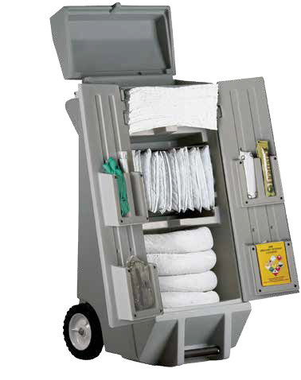
Warranty and Disclaimer: There are no express warranties which extend beyond the description on the face hereof. Seller disclaims any implied warranties of merchantability or of fitness for any particular purpose. Since seller cannot control the use of its products after their resale, seller will not be responsible for any consequential or indirect damages. Rather, seller will, at its option, either replace the products sold or refund the purchase price. No warranties will apply if the products are in any way altered or modified after delivery by seller. Sorbent capac- ities vary depending on the types of fluids being absorbed.
Handling, Storage, and Disposal: Handling, storage, and disposal of products must be carried out in compliance with all local, state, and federal regulations. Various sorbed fluids may
be toxic or hazardous in nature and should be disposed of in the approved manner.
Warning: Flammable and other hazardous liquids when contaminated in any sorbent material continue to be unsafe and are subject to spontaneous ignition. Appropriate respiratory devices and protective clothing should be worn. Exercise extreme care when handling, storing, and disposing of absorbent materials contain- ing such liquids to avoid personal injury and environmental pollution.

DISTRIBUTED BY:

