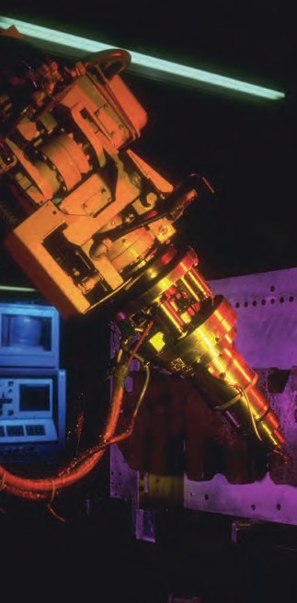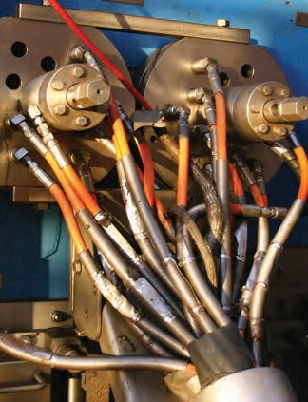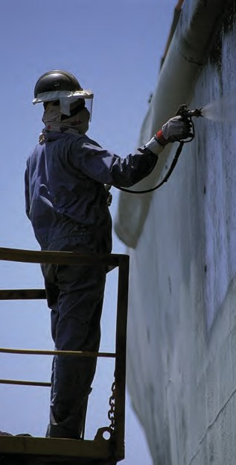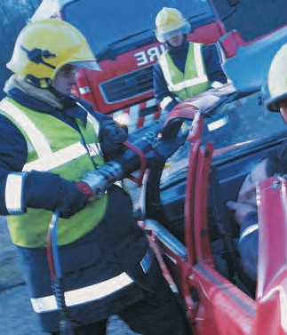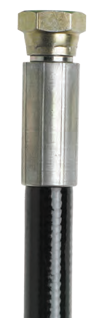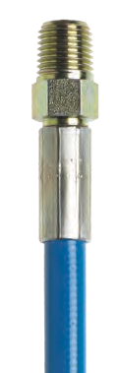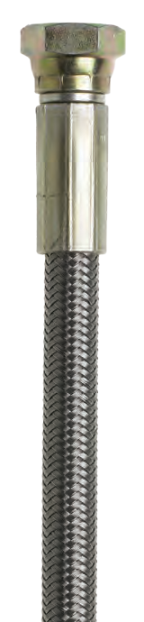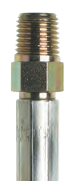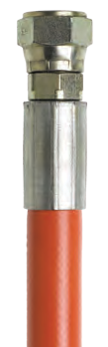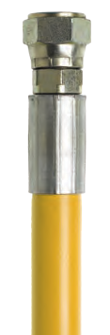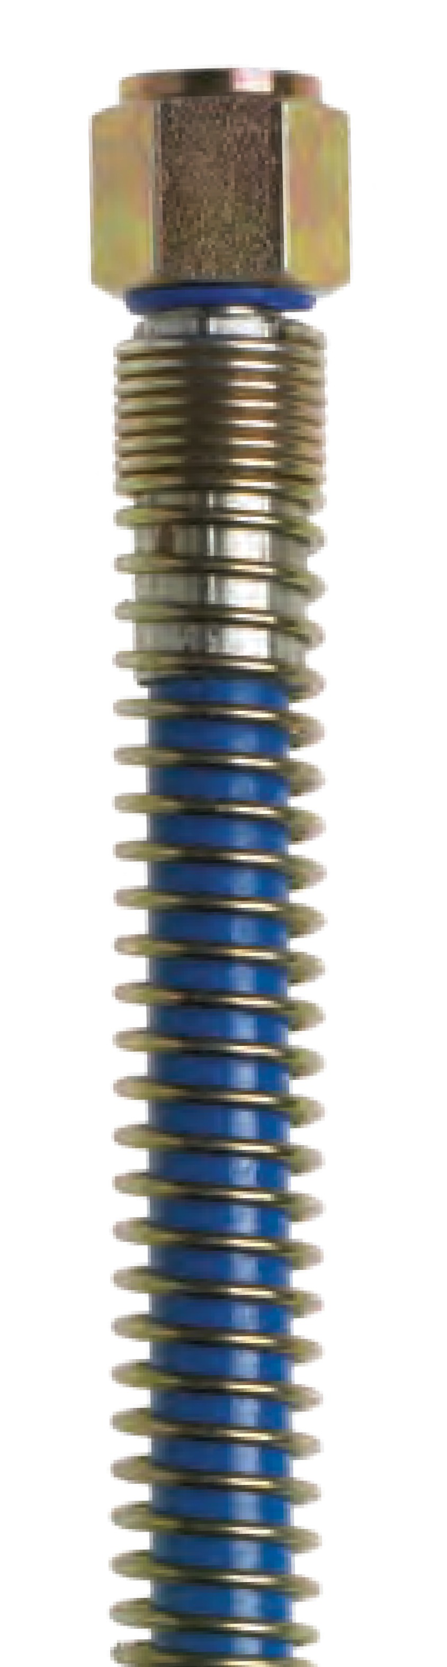

U
E

S S

r
y

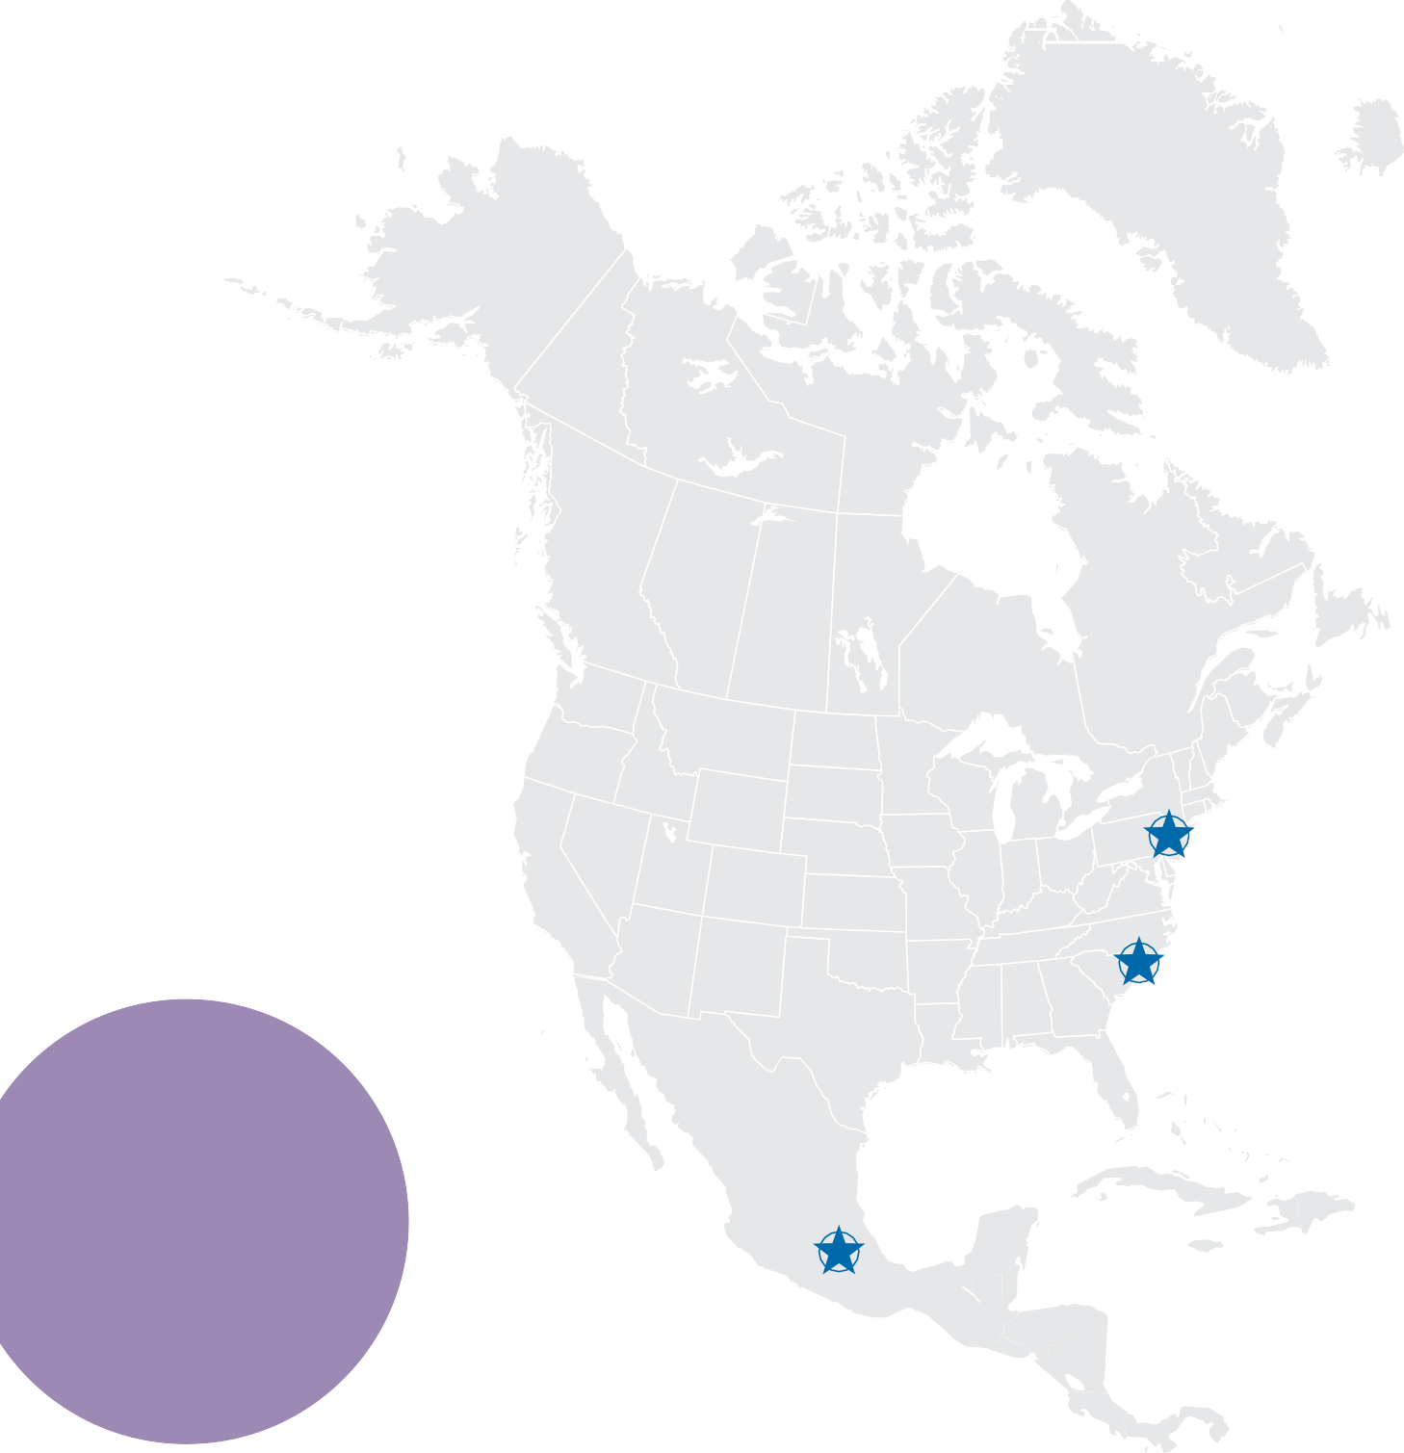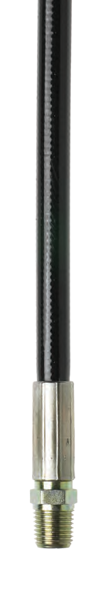At CRP, we’re big enough to help, but small enough to care.
WITH MORE THAN 30 YEARS IN THE THERMOPLASTIC HOSE BUSINESS, CRP UNDERSTANDS THE CHALLENGES AND NEEDS OF CUSTOMERS ACROSS ALL INDUSTRIES.

Cranbury, NJ

Tabor City, NC

Puebla, Mexico

Cranbury, NJ Headquarters & Warehouse

www.crpreinflex.com

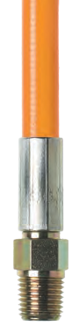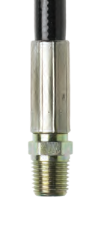

We take enormous pride in our ability to listen and communicate with our customers. That’s why CRP excels at providing clients with exactly what they need.
Be it fast delivery, competitive pricing, exceptional market knowledge, precise
hose replacements, a vast selection, custom lengths, or a variety
of end fittings. No matter what the issue, our highly trained customer service staff stands ready to solve
every customer’s request. Because of these commitments, CRP is proud
to have achieved a lengthy list of
high profile clients.
ROBUST HIGH PRESSURE HOSE PROGRAM

From hose construction materials and colors, to sizes and working pressures, we offer a wide and abundant selection of hose types for a variety of applications.
In addition, we are able to customize hose assemblies for virtually any requirement.

QUALITY CONTROL

With many of our high pressure hoses manufactured to DM&Q
ANSI/ISO/ASQ 9001-2000 standards, product quality is certain. And because CRP is
ISO 9001:2015 certified, customers can rest assured that we have a quality management system in place that delivers service satisfaction. In fact, CRP’s Quality Control Technicians randomly pressure test hoses and in most cases our hoses are identical to the original equipment specified.

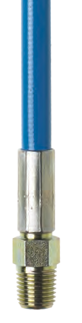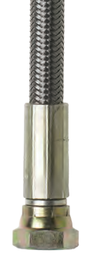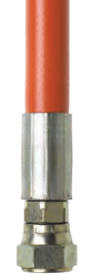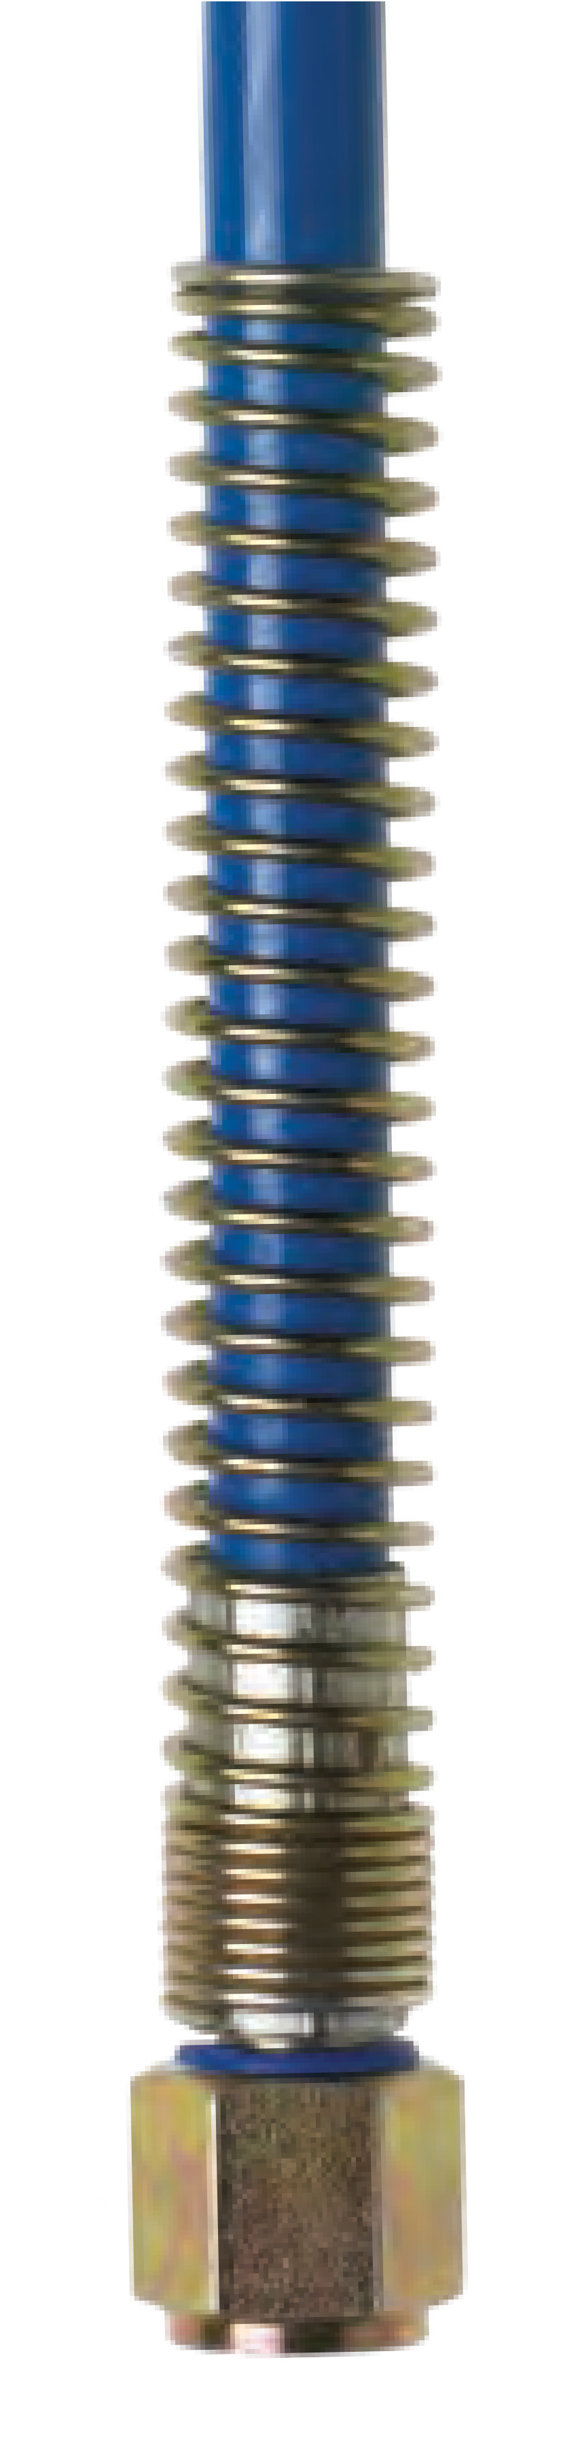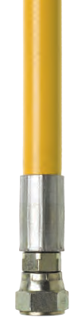

TABLE OF CONTENTS PAGE
Airless Paint Spray 4
Air Cascade Systems 12
Emergency Rescue Equipment 14
Fluid Transfer 20
High Pressure Hydraulics 24
Micro-bore Hoses 32
Moisture Resistant 34
Non-Conductive 36
PTFE Hose 40
Sewer Jetting 42
Water Jetting 46
Accessories 48
Notes 64
PROMPT TURNAROUND

For many of our customers, a speedy response is crucial. Fortunately, due to our vast selection of stock hose types and fittings, our turnaround time for orders is typically 24 to 48 hours. Of course, if time is of the essence, we may even be able to ship same day.

TOP-NOTCH SERVICE

A proud NAHAD member, CRP has been an expert in hose assembly
fabrication for over 30 years. Backed by a team of extraordinary customer service representatives, we excel at understanding and meeting the needs of all our customers. As CRP continues to grow and evolve, one thing will remain constant: CRP will always be big
enough to help, and small enough to care. 3

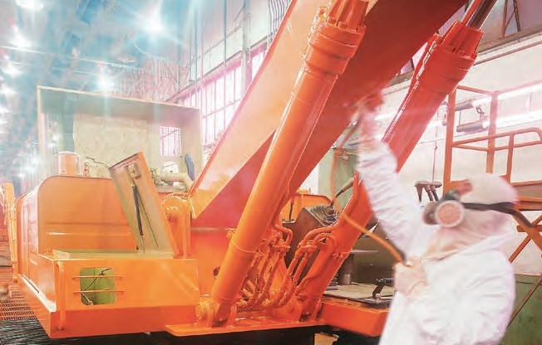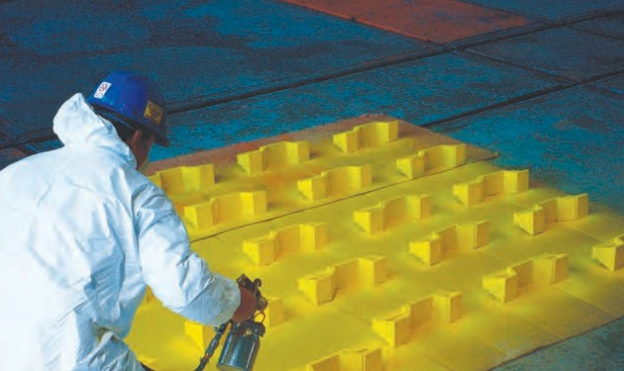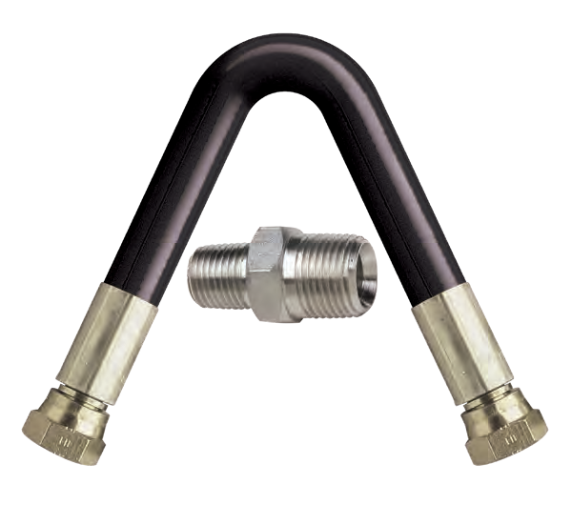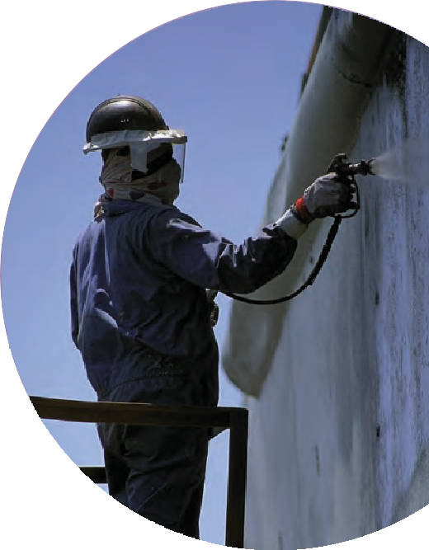

CRP’s customer service team excels in understanding your needs. That’s why our Airless Paint Spray Hoses are shipped out quickly, because we know time is of the essence in your industry. In fact, if required, same day turnaround may even be possible. CRP’s expertise ensures the hoses you receive will work right and fit right the first time and every time,
s
no matter what pump system. We carry many standard stock assemblies as well as offer custom fabrication options. Virtually anything you need from the pump up to the gun. We are your Airless Paint Spray Hose provider.

AIRLESS PAINT SPRAY HOSE FEATURES:
- Working pressures from 1,000 psi to 10,000 psi
- Excellent flexibility and flex fatigue
- Hose sizes from 1/8” to 1 1/4”
- Fitting options — NPT, NPSM, and JIC in plated or Stainless Steel – male (M) and female (F)
- Lengths from 4”up to 500’
- Wide range of hose whip assemblies
- Suitable for paints, solvents, lacquers, foams, caulks, resins, and roof coatings

4

1006P SERIES FABRIC BRAID REINFORCED THERMOPLASTIC PAINT HOSE

A high pressure semi-conductive economy thermoplastic hose that will not swell or degrade when in contact with most paints, chemicals, oils, and solvents. Extremely durable and lightweight. Ideal for situations where electrostatic charge must be dissipated.

CONSTRUCTION:
Inner: Seamless Nylon Liner
Outer: Abrasion and Chemical Resistant Polyurethane Cover

COUPLING CAPABILITIES: NPT, NPSM, JIC Plated or Stainless Steel – M or F
CRP PART NUMBER | COLORS | # OF BRAIDS | NOMINAL I.D.  Inches (MM) | NOMINAL O.D.  Inches (MM) | MINIMUM BEND RADIUS  Inches (MM) | DYNAMIC WORKING PRESSURE | MINIMUM BURST PRESSURE | WEIGHT (LBS/FT) | MAXIMUM LENGTH | TEMPERATURE RANGE
1006P | n | 2 | 1/4 (6.4) | 0.49 (12.5) | 2.5 (63.5) | 3,300 psi | 13,200 psi | 0.06 | 50’ | -40 to 180ºF

1000AV SERIES FABRIC BRAID REINFORCED THERMOPLASTIC PAINT HOSE
*Only sold in 25’ and 50’ lengths

A high pressure semi-conductive thermoplastic hose that will not swell or degrade when in contact with most paints, chemicals, oils, and solvents. Extremely durable and lightweight. Ideal for situations where electrostatic charge must be dissipated.

CONSTRUCTION:
Inner: Seamless Nylon Liner
Outer: Abrasion and Chemical Resistant Polyurethane Cover

COUPLING CAPABILITIES: NPT, NPSM, JIC Plated or Stainless Steel – M or F
CRP PART NUMBER | COLORS | # OF BRAIDS | NOMINAL I.D.  Inches (MM) | NOMINAL O.D.  Inches (MM) | MINIMUM BEND RADIUS  Inches (MM) | DYNAMIC WORKING PRESSURE | MINIMUM BURST PRESSURE | WEIGHT (LBS/FT) | MAXIMUM LENGTH | TEMPERATURE RANGE
1003AV | n | 1 | 1/8 (3.2) | 0.32 (8.1) | 1.25 (31.8) | 3,500 psi | 14,000 psi | 0.03 | 4” up to 500’ | 0 to +180ºF
1004AV | n n | 2 | 3/16 (4.8) | 0.43 (10.9) | 1.75 (44.5) | 3,500 psi | 14,000 psi | 0.05 | 4” up to 500’ | 0 to +180ºF
1006AV | n n | 2 | 1/4 (6.4) | 0.49 (12.5) | 2.50 (63.5) | 3,300 psi | 13,200 psi | 0.06 | 4” up to 500’ | 0 to +180ºF
1010AV | n n | 2 | 3/8 (9.5) | 0.72 (18.2) | 3.00 (76.2) | 3,300 psi | 13,200 psi | 0.11 | 4” up to 500’ | 0 to +180ºF

2000AVS SERIES FABRIC BRAID REINFORCED THERMOPLASTIC PAINT HOSE

A high pressure, semi-conductive thermoplastic airless hose that will not swell or degrade when in contact with most paints, chemicals, oils, and solvents. Extremely durable and lightweight.

CONSTRUCTION:
Inner: Seamless Nylon Liner
Outer: Abrasion and Chemical Resistant Polyurethane Cover

COUPLING CAPABILITIES: NPT, NPSM, JIC Plated or Stainless Steel – M or F
CRP PART NUMBER | COLORS | # OF BRAIDS | NOMINAL I.D.  Inches (MM) | NOMINAL O.D.  Inches (MM) | MINIMUM BEND RADIUS  Inches (MM) | DYNAMIC WORKING PRESSURE | MINIMUM BURST PRESSURE | WEIGHT (LBS/FT) | MAXIMUM LENGTH | TEMPERATURE RANGE
2006AVS | n | 2 | 1/4 (6.4) | 0.51 (12.9) | 2.5 (63.5) | 4,000 psi | 16,000 psi | 0.07 | 4” up to 500’ | 0 to 180ºF

1006AVB SERIES FABRIC BRAID REINFORCEMENT THERMOPLASTIC LACQUER HOSE

A high pressure, semi-conductive thermoplastic airless hose that will not swell or degrade when used with most lacquer or solvent based coatins. Durable and lightweight.

CONSTRUCTION:
Inner: Seamless Nylon Liner
Outer: Abrasion and Chemical Resistant Polyurethane Cover

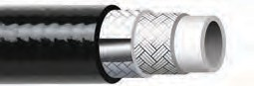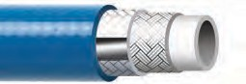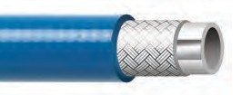
AIRLESS PAINT SPRAY

COUPLING CAPABILITIES: NPT, NPSM, JIC Plated or Stainless Steel – M or F
CRP PART NUMBER | COLORS | # OF BRAIDS | NOMINAL I.D.  Inches (MM) | NOMINAL O.D.  Inches (MM) | MINIMUM BEND RADIUS  Inches (MM) | DYNAMIC WORKING PRESSURE | MINIMUM BURST PRESSURE | WEIGHT (LBS/FT) | MAXIMUM LENGTH | TEMPERATURE RANGE
1006AVB35FXF | n | 2 | 1/4 (6.4) | 0.51 (12.9) | 2.5 (63.5) | 3,300 psi | 13,200 psi | 0.06 | N/A | 0 to 180ºF
*Sold as 35’ assemblies only
5

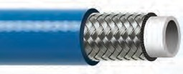1000UK SERIES WIRE REINFORCED THERMOPLASTIC PAINT HOSE

A high pressure, high performance airless paint spray hose with steel braid reinforcement for strength and guaranteed electrical conductivity. Offers optimum resistance to a wide range of paints, chlorinated solvents, and other chemicals. Extremely durable. Cover is pin-pricked standard.

CONSTRUCTION:
Inner: Seamless Nylon 6 Liner
Outer: Abrasion and Chemical Resistant Polyurethane Cover

COUPLING CAPABILITIES: NPT, NPSM, JIC Plated or Stainless Steel – M or F
CRP PART NUMBER | COLORS | # OF BRAIDS | NOMINAL I.D.  Inches (MM) | NOMINAL O.D.  Inches (MM) | MINIMUM BEND RADIUS  Inches (MM) | DYNAMIC WORKING PRESSURE | MINIMUM BURST PRESSURE | WEIGHT (LBS/FT) | MAXIMUM LENGTH | TEMPERATURE RANGE
1003K | n | 1 | 1/8 (3.2) | 0.27 (7.0) | 1.2 (30) | 5,075 psi | 20,300 psi | 0.04 | 4” up to 500’ | -40 to +212ºF
1004UK | n n | 1 | 3/16 (4.8) | 0.37 (9.4) | 1.0 (25) | 5,250 psi | 21,000 psi | 0.08 | 4” up to 500’ | -40 to +212ºF
1006UK | n n | 1 | 1/4 (6.4) | 0.46 (11.7) | 1.5 (37) | 5,000 psi | 18,000 psi | 0.11 | 4” up to 500’ | -40 to +212ºF
1010UK | n n | 1 | 3/8 (9.5) | 0.60 (15.1) | 2.0 (50) | 3,500 psi | 13,000 psi | 0.15 | 4” up to 500’ | -40 to +212ºF
1013UK | n n | 1 | 1/2 (12.7) | 0.72 (18.3) | 3.0 (75) | 3,000 psi | 12,000 psi | 0.20 | 4” up to 500’ | -40 to +212ºF
1020UK | n | 1 | 3/4 (19.1) | 1.0 (25.4) | 6.7 (170) | 1,750 psi | 7,000 psi | 0.29 | 4” up to 300’ | -40 to +212ºF
1025UK | n | 2 | 1 (25.4) | 1.3 (32.5) | 9.1 (231) | 2,750 psi | 11,000 psi | 0.65 | 4” up to 300’ | -40 to +212ºF

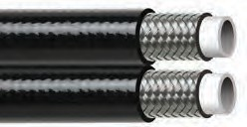1000UKT SERIES WIRE REINFORCED TWIN LINE THERMOPLASTIC PAINT HOSE

A high pressure, high performance twin line airless paint spray hose with steel braid reinforcement for strength and guaranteed electrical conductivity. Offers optimum resistance to a wide range of paints, chlorinated solvents, and other chemicals. Extremely durable. Cover is pin-pricked standard.

CONSTRUCTION:
Inner: Seamless Nylon 6 Liner
Outer: Abrasion and Chemical Resistant Polyurethane Cover

COUPLING CAPABILITIES: NPT, NPSM, JIC Plated or Stainless Steel – M or F
CRP PART NUMBER | COLORS | # OF BRAIDS | NOMINAL I.D.  Inches (MM) | NOMINAL O.D.  Inches (MM) | MINIMUM BEND RADIUS  Inches (MM) | DYNAMIC WORKING PRESSURE | MINIMUM BURST PRESSURE | WEIGHT (LBS/FT) | MAXIMUM LENGTH | TEMPERATURE RANGE
1006UKT | n | 1 | 1/4 (6.4) | 0.46 (11.7) | 1.5 (37) | 5,000 psi | 18,000 psi | 0.22 | 4” up to 200’ | -40 to +212ºF
1010UKT | n | 1 | 3/8 (9.5) | 0.60 (15.1) | 2.0 (50) | 3,500 psi | 13,000 psi | 0.30 | 4” up to 200’ | -40 to +212ºF
1013UKT | n | 1 | 1/2 (12.7) | 0.72 (18.3) | 3.0 (75) | 3,000 psi | 12,000 psi | 0.40 | 4” up to 200’ | -40 to +212ºF

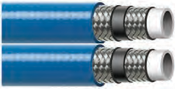2000UKT SERIES WIRE REINFORCED THERMOPLASTIC PAINT HOSE

A high pressure, high performance twin line hose with steel reinforcement braiding for strength and electrical conductivity. Offers reistantce to paints, chlorinated solvents and other chemicals, Extremely flexible. Cover is pin-pricked.

CONSTRUCTION:
Inner: Nylon 6 Liner
Outer: Abrasion and chemical resistant Polyurethane cover

COUPLING CAPABILITIES: NPT, NPSM, JIC Plated or Stainless Steel – M or F
CRP PART NUMBER | COLORS | # OF BRAIDS | NOMINAL I.D.  Inches (MM) | NOMINAL O.D.  Inches (MM) | MINIMUM BEND RADIUS  Inches (MM) | DYNAMIC WORKING PRESSURE | MINIMUM BURST PRESSURE | WEIGHT (LBS/FT) | MAXIMUM LENGTH | TEMPERATURE RANGE
2010UKT | n n | 2 | 3/8 (9.5) | 0.67 (17.0) | 1.5 (37) | 6,000 psi | 24,000 psi | 0.21 | 4” up to 200’ | -40 to +212ºF
2013UKT | n n | 2 | 1/2 (12.7) | 0.80 (20.2) | 2.5 (62) | 5,000 psi | 17,000 psi | 0.28 | 4” up to 200’ | -40 to +212ºF

6

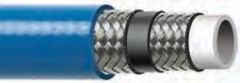2000UK SERIES WIRE REINFORCED THERMOPLASTIC PAINT HOSE
AIRLESS PAINT SPRAY

A high pressure, high performance Airless Paint Spray Hose with steel braid reinforcement for strength and guaranteed electrical conductivity. Offers optimum resistance to a wide range of paints, chlorinated solvents, and other chemicals. Extremely durable. Cover is pin-pricked standard.

CONSTRUCTION:
Inner: Seamless Nylon 6 Liner = 2006/2010/2013 Seamless Nylon 12 Liner = 2020/2025
Outer: Abrasion and Chemical Resistant Polyurethane Cover

COUPLING CAPABILITIES: NPT, NPSM, JIC Plated or Stainless Steel – M or F
CRP PART NUMBER | COLORS | # OF BRAIDS | NOMINAL I.D.  Inches (MM) | NOMINAL O.D.  Inches (MM) | MINIMUM BEND RADIUS  Inches (MM) | DYNAMIC WORKING PRESSURE | MINIMUM BURST PRESSURE | WEIGHT (LBS/FT) | MAXIMUM LENGTH | TEMPERATURE RANGE
2006UK | n | 2 | 1/4 (6.4) | 0.54 (13.7) | 1.0 (25) | 6,170 psi | 28,000 psi | 0.21 | 4” up to 500’ | -40 to +212ºF
2010UK | n n | 2 | 3/8 (9.5) | 0.67 (17.0) | 1.5 (37) | 6,000 psi | 24,000 psi | 0.28 | 4” up to 500’ | -40 to +212ºF
2013UK | n n | 2 | 1/2 (12.7) | 0.80 (20.2) | 2.5 (62) | 5,000 psi | 17,000 psi | 0.34 | 4” up to 300’ | -40 to +212ºF
2020UK | n | 2 | 3/4 (19.1) | 1.07 (27.1) | 6.7 (170) | 3,100 psi | 13,000 psi | 0.50 | 4” up to 300’ | -40 to +212ºF
2025UK | n | 3** | 1 (25.4) | 1.46 (37.1) | 10.0 (254) | 4,750 psi | 19,000 psi | 0.61 | 4” up to 300’ | -40 to +212ºF*

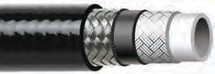2100UKN SERIES WIRE & FABRIC REINFORCED THERMOPLASTIC PAINT HOSE
*+158ºF for water based fluids
**Wire and Kevlar reinforced

High pressure, high performance Airless Paint Spray Hose with steel and Kevlar braid reinforcement to ensure mechanical strength. Superior resistance to most paints, chemicals, and solvents.

CONSTRUCTION:
Inner: Seamless Nylon 12 Liner
Outer: Abrasion and Chemical Resistant Polyurethane Cover

COUPLING CAPABILITIES: NPT, NPSM, JIC Plated or Stainless Steel – M or F
CRP PART NUMBER | COLORS | # OF BRAIDS | NOMINAL I.D.  Inches (MM) | NOMINAL O.D.  Inches (MM) | MINIMUM BEND RADIUS  Inches (MM) | DYNAMIC WORKING PRESSURE | MINIMUM BURST PRESSURE | WEIGHT (LBS/FT) | MAXIMUM LENGTH | TEMPERATURE RANGE
2104UKN | n | 2 | 3/16 (4.8) | 0.45 (11.3) | 1.2 (32) | 8,000 psi | 32,000 psi | 0.11 | 4” up to 500’ | -40 to +212ºF*
2106UKN | n | 2 | 1/4 (6.4) | 0.54 (13.7) | 1.5 (38) | 10,000 psi | 40,000 psi | 0.15 | 4” up to 500’ | -40 to +212ºF*
2110UKN | n | 2 | 3/8 (9.5) | 0.68 (17.3) | 3.5 (89) | 8,000 psi | 32,000 psi | 0.22 | 4” up to 500’ | -40 to +212ºF*
2113UKN | n | 2 | 1/2 (12.7) | 0.82 (20.8) | 5.0 (127) | 6,500 psi | 26,000 psi | 0.28 | 4” up to 300’ | -40 to +212ºF*
2120UKN | n | 3 | 3/4 (19.1) | 1.16 (29.5) | 8.0 (203) | 6,500 psi | 26,000 psi | 0.45 | 4” up to 300’ | -40 to +212ºF*

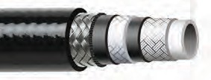3000UK SERIES WIRE & FABRIC REINFORCED THERMOPLASTIC PAINT HOSE
*+158ºF for water based fluids

High pressure, high performance Large
Bore Airless Paint Spray Hose with steel braid reinforcement to ensure superior resistance to most chemicals, paints, and solvents.

CONSTRUCTION:
Inner: Seamless Nylon 12 Liner
Outer: Abrasion and Chemical Resistant Polyurethane Cover

7

COUPLING CAPABILITIES: NPT, NPSM, JIC Plated or Stainless Steel – M or F
CRP PART NUMBER | COLORS | # OF BRAIDS | NOMINAL I.D.  Inches (MM) | NOMINAL O.D.  Inches (MM) | MINIMUM BEND RADIUS  Inches (MM) | DYNAMIC WORKING PRESSURE | MINIMUM BURST PRESSURE | WEIGHT (LBS/FT) | MAXIMUM LENGTH | TEMPERATURE RANGE
3013UK | n | 3 | 1/2 (12.7) | 0.90 (22.9) | 5.0 (127) | 8,500 psi | 34,000 psi | 0.33 | 4” up to 300’ | -40 to +212ºF*
3113UK | n | 3 | 1/2 (12.7) | 0.90 (22.9) | 5.0 (127) | 10,000 psi | 34,000 psi | 0.33 | 4” up to 300’ | -40 to +212ºF*
*+158ºF for water based fluids

CUSTOM SIZES AND OTHER COUPLING CAPABILITIES AVAILABLE ON ALL HOSES.
TO PLACE AN ORDER OR SPEAK WITH A CRP REPRESENTATIVE, CALL 800-526-4066.

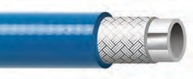404UK SERIES FABRIC REINFORCED THERMOPLASTIC PAINT HOSE

Medium pressure Airless Paint Spray Hose reinforced with polyester braids for paint spraying where anti-static properties are re- quired. Conductivity is by means of a conductive polymer strip. Resistant to most chemicals, paints, and solvents.

CONSTRUCTION:
Inner: Seamless Nylon 6 Liner
Outer: Abrasion and Chemical Resistant Polyurethane Cover

COUPLING CAPABILITIES: NPT, NPSM, JIC Plated or Stainless Steel – M or F
CRP PART NUMBER | COLORS | # OF BRAIDS | NOMINAL I.D.  Inches (MM) | NOMINAL O.D.  Inches (MM) | MINIMUM BEND RADIUS  Inches (MM) | DYNAMIC WORKING PRESSURE | MINIMUM BURST PRESSURE | WEIGHT (LBS/FT) | MAXIMUM LENGTH | TEMPERATURE RANGE
404UK | n | 1 | 3/16 (4.8) | 0.38 (9.7) | 1.2 (30) | 1,900 psi | 6,960 psi | 0.04 | 4” up to 500’ | -40 to +212ºF

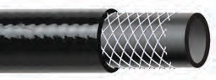FLUID HOSE SERIES SYNTHETIC REINFORCED RUBBER LOW PRESSURE PAINT TRANSFER HOSE

Premium quality all purpose hose for handling a variety of applications such as paint or agricultural spray. Suitable for paints, lacquers, thinners, oil, and solvents.

CONSTRUCTION:
Inner: Nylon, RMA Class B Branded Synthetic Yarn
Outer: Synthetic Neoprene

COUPLING CAPABILITIES: NPT, NPSM, JIC Plated or Stainless Steel – M or F
CRP PART NUMBER | COLORS | # OF BRAIDS | NOMINAL I.D.  Inches (MM) | NOMINAL O.D.  Inches (MM) | MINIMUM BEND RADIUS  Inches (MM) | DYNAMIC WORKING PRESSURE | MINIMUM BURST PRESSURE | WEIGHT (LBS/FT) | MAXIMUM LENGTH | TEMPERATURE RANGE
55-1942-04 | n | 1 | 1/4 (6.7) | 0.50 (12.7) | 2.5 (63.5) | 750 psi | 3,000 psi | 0.08 | 500’* | -40 to +190ºF
55-1942-10 | n | 1 | 5/16 (7.9) | 0.56 (14.3) | 2.8 (69.9) | 750 psi | 3,000 psi | 0.13 | 500’* | -40 to +190ºF
55-1942-16 | n | 1 | 3/8 (9.5) | 0.68 (17.5) | 3.0 (76.2) | 750 psi | 3,000 psi | 0.15 | 500’* | -40 to +190ºF
55-1942-25 | n | 1 | 1/2 (12.7) | 0.81 (20.6) | 4.5 (114.3) | 750 psi | 3,000 psi | 0.22 | 500’* | -40 to +190ºF
55-1942-37 | n | 1 | 3/4 (19.0) | 1.19 (30.2) | 6.0 (152.4) | 750 psi | 3,000 psi | 0.36 | 500’* | -40 to +190ºF
55-1942-43 | n | 1 | 1 (25.4) | 1.50 (38) | 7.0 (177.8) | 750 psi | 3,000 psi | 0.49 | 500’* | -40 to +190ºF
*Coils may contain multiple lengths (max. 3)

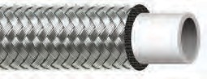100K PTFE SERIES STAINLESS STEEL BRAID REINFORCED PTFE PAINT HOSE

High pressure, high performance PTFE lined hose with stainless steel braid reinforcement for strength and guaranteed electrical conductivity. Superior resistance to most chemicals, paints, and solvents. Lightweight and flexible in comparison to conventional multi-spirals.

CONSTRUCTION:
Inner: Seamless PTFE Liner
Outer: Abrasion Resistant Stainless Steel Braid Cover

COUPLING CAPABILITIES: NPT, NPSM, JIC Plated or Stainless Steel – M or F
CRP PART NUMBER | COLORS | # OF BRAIDS | NOMINAL I.D.  Inches (MM) | NOMINAL O.D.  Inches (MM) | MINIMUM BEND RADIUS  Inches (MM) | DYNAMIC WORKING PRESSURE | MINIMUM BURST PRESSURE | WEIGHT (LBS/FT) | MAXIMUM LENGTH | TEMPERATURE RANGE
105K | n | 1 | 3/16 (4.8) | 0.31 (7.9) | 2.5 (63.5) | 3,000 psi | 12,000 psi | 0.07 | 4” up to 200’ | -65 to +450ºF
106K | n | 1 | 1/4 (6.4) | 0.37 (9.4) | 3.0 (76) | 3,000 psi | 12,000 psi | 0.10 | 4” up to 200’ | -65 to +450ºF
110K | n | 1 | 3/8 (9.5) | 0.51 (13.0) | 5.0 (127) | 2,000 psi | 8,000 psi | 0.11 | 4” up to 200’ | -65 to +450ºF
113K | n | 1 | 1/2 (12.7) | 0.63 (16.0) | 6.5 (165.1) | 1,750 psi | 7,000 psi | 0.16 | 4” up to 200’ | -65 to +450ºF
120K | n | 1 | 3/4 (19) | 0.88 (2.4) | 8.5 (216) | 1,000 psi | 4,000 psi | 0.20 | 4” up to 50’ | -65 to +450ºF

8

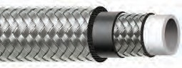200K PTFE SERIES STAINLESS STEEL BRAID REINFORCED PTFE PAINT HOSE
AIRLESS PAINT SPRAY

Very high pressure, high performance PTFE lined hose with stainless steel braid reinforcement for strength and guaranteed electrical conductivity. Superior resistance to most chemicals, paints, and solvents. Lightweight and flexible in comparison to conventional multi-spirals.

CONSTRUCTION:
Inner: Seamless PTFE Liner
Outer: Abrasion Resistant Stainless Steel Braid Cover

COUPLING CAPABILITIES: NPT, NPSM, JIC Plated or Stainless Steel – M or F
CRP PART NUMBER | COLORS | # OF BRAIDS | NOMINAL I.D.  Inches (MM) | NOMINAL O.D.  Inches (MM) | MINIMUM BEND RADIUS  Inches (MM) | DYNAMIC WORKING PRESSURE | MINIMUM BURST PRESSURE | WEIGHT (LBS/FT) | MAXIMUM LENGTH | TEMPERATURE RANGE
206K | n | 2 | 1/4 (6.4) | 0.44 (11.4) | 3.0 (76) | 3,990 psi | 15,950 psi | 0.16 | 200” | -65 to +450ºF
210K | n | 2 | 3/8 (9.5) | 0.60 (15.2) | 4.3 (108) | 3,260 psi | 13,050 psi | 0.24 | 4” up to 200’ | -65 to +450ºF
213K | n | 2 | 1/2 (12.7) | 0.74 (18.8) | 5.3 (135) | 2,900 psi | 11,600 psi | 0.32 | 4” up to 100’ | -65 to +450ºF
220K | n | 2 | 3/4 (19.0) | 1.0 (25.4) | 7.9 (200) | 2,180 psi | 8,700 psi | 0.45 | 4” up to 50’ | -65 to +450ºF
225K | n | 2 | 1 (25.4) | 1.3 (33) | 13.0 (330.2) | 1,810 psi | 7,540 psi | 0.50 | 4” up to 50’ | -65 to +450ºF

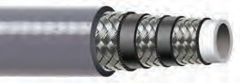200ST FEP SERIES POLYURETHANE COVERED STEEL BRAID REINFORCED FEP PAINT HOSE

Ultra high pressure, high performance FEP lined hose with steel spiral and braid reinforcement for strength and guaranteed electrical conductivity. Lightweight, flexible, with a tight bend radius and superior resistance to most chemicals, paints, and solvents.

CONSTRUCTION:
Inner: Seamless FEP Liner
Outer: Abrasion and Chemical Resistant Polyurethane Cover

COUPLING CAPABILITIES: NPT, NPSM, JIC Plated or Stainless Steel – M or F
CRP PART NUMBER | COLORS | # OF BRAIDS | NOMINAL I.D.  Inches (MM) | NOMINAL O.D.  Inches (MM) | MINIMUM BEND RADIUS  Inches (MM) | DYNAMIC WORKING PRESSURE | MINIMUM BURST PRESSURE | WEIGHT (LBS/FT) | MAXIMUM LENGTH | TEMPERATURE RANGE
206ST | n | 3 | 1/4 (6.4) | 0.49 (12.4) | 2.5 (63.5) | 6,162 psi | 24,650 psi | 0.18 | 4” up to 100’ | -40 to +176ºF
210ST | n | 3 | 3/8 (9.5) | 0.68 (17.3) | 4.5 (114.3) | 5,000 psi | 20,000 psi | 0.31 | 4” up to 50’ | -40 to +176ºF
213ST | n | 3 | 1/2 (12.7) | 0.81 (20.6) | 5.5 (139.7) | 4,710 psi | 18,850 psi | 0.39 | 4” up to 50’ | -40 to +176ºF
220ST | n | 3 | 3/4 (19.0) | 1.14 (29.0) | 8.0 (203.2) | 3,840 psi | 15,230 psi | 0.67 | 4” up to 50’ | -40 to +176ºF
225ST | n | 3 | 1 (25.4) | 1.33 (34.0) | 9.4 (240) | 3,262 psi | 13,050 psi | 0.87 | 4” up to 50’ | -40 to +176ºF

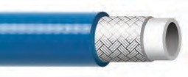1000HB SERIES FABRIC REINFORCED MOISTURE RESISTANT THERMOPLASTIC PAINT HOSE

Moisture resistant, high performance Airless Paint Spray Hose with fabric braid reinforcement. Resis- tant to most chemicals, solvents, and paints. Ideal for the transfer of aggressive mediums that are reactive to moisture.

CONSTRUCTION:
Inner: Polyaimide Tube
Outer: Abrasion and Chemical Resistant Polyurethane Cover

9

COUPLING CAPABILITIES: NPT, NPSM, JIC Plated or Stainless Steel – M or F
CRP PART NUMBER | COLORS | # OF BRAIDS | NOMINAL I.D.  Inches (MM) | NOMINAL O.D.  Inches (MM) | MINIMUM BEND RADIUS  Inches (MM) | DYNAMIC WORKING PRESSURE | MINIMUM BURST PRESSURE | WEIGHT (LBS/FT) | MAXIMUM LENGTH | TEMPERATURE RANGE
1006HB | n | 1 | 1/4 (6.4) | 0.47 (11.8) | 1.4 (35) | 2,900 psi | 11,600 psi | 0.07 | 4” up to 300’ | -40 to +212ºF
1010HB | n | 1 | 3/8 (9.5) | 0.63 (16.0) | 2.2 (55) | 2,537 psi | 10,150 psi | 0.09 | 4” up to 300’ | -40 to +212ºF
1013HB | n | 1 | 1/2 (12.7) | 0.80 (20.3) | 3.0 (75) | 2,030 psi | 8,120 psi | 0.12 | 4” up to 300’ | -40 to +212ºF
1020HB | n | 1 | 3/4 (19.1) | 1.04 (26.5) | 5.7 (145) | 1,305 psi | 5,220 psi | 0.25 | 4” up to 300’ | -40 to +212ºF

CUSTOM SIZES AND OTHER COUPLING CAPABILITIES AVAILABLE ON ALL HOSES.
TO PLACE AN ORDER OR SPEAK WITH A CRP REPRESENTATIVE, CALL 800-526-4066.

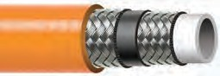2000UHB SERIES WIRE REINFORCED MOISTURE RESISTANT THERMOPLASTIC PAINT HOSE

Moisture resistant high pressure, high performance hose with steel braid reinforcement for strength. Resistant to most chemicals, solvents, and paints. Ideal for the transfer of aggressive mediums that are reactive to moisture.

CONSTRUCTION:
Inner: Seamless Nylon 12 Liner
Outer: Abrasion and Chemical Resistant Polyester Elastomer Cover

COUPLING CAPABILITIES: NPT, NPSM, JIC Plated or Stainless Steel – M or F
CRP PART NUMBER | COLORS | # OF BRAIDS | NOMINAL I.D.  Inches (MM) | NOMINAL O.D.  Inches (MM) | MINIMUM BEND RADIUS  Inches (MM) | DYNAMIC WORKING PRESSURE | MINIMUM BURST PRESSURE | WEIGHT (LBS/FT) | MAXIMUM LENGTH | TEMPERATURE RANGE
1004UHB | n | 1 | 3/16 (4.8) | 0.37 (9.4) | 1.0 (25.4) | 5,250 psi | 21,000 psi | 0.08 | 4” up to 300’ | -40 to +212ºF
2006UHB | n | 2 | 1/4 (6.4) | 0.54 (13.7) | 1.0 (25) | 6,170 psi | 24,680 psi | 0.21 | 4” up to 300’ | -40 to +212ºF
2010UHB | n | 2 | 3/8 (9.5) | 0.67 (17.0) | 1.5 (37) | 5,100 psi | 20,400 psi | 0.28 | 4” up to 300’ | -40 to +212ºF
2013UHB | n | 2 | 1/2 (12.7) | 0.80 (20.2) | 2.5 (62) | 4,250 psi | 17,000 psi | 0.34 | 4” up to 300’ | -40 to +212ºF
2020UHB | n | 2 | 3/4 (19.1) | 1.07 (27.1) | 6.7 (170) | 3,100 psi | 12,400 psi | 0.50 | 4” up to 300’ | -40 to +212ºF
2120UHB | n | 3** | 3/4 (19.1) | 1.16 (29.5) | 8.0 (203) | 6,000 psi | 24,000 psi | 0.44 | 4” up to 300’ | -40 to +212ºF*
*+158ºF for water based fluids
**2 Kevlar and 1 wire reinforced
NYLON TUBING SERIES
LOW PRESSURE NYLON TUBING
Nylon tubing absorbs very little water so it will not become brittle or swell because of water. Resistant to solvents, alkalies, oils, greases, petroleum products, fungus, and molds.
Generally good resistance to dilute mineral and organic acids. Excellent bend radii.
CONSTRUCTION:
Extruded Nylon

CRP PART NUMBER | COLORS | # OF BRAIDS | NOMINAL I.D.  Inches (MM) | NOMINAL O.D.  Inches (MM) | MINIMUM BEND RADIUS  Inches (MM) | DYNAMIC WORKING PRESSURE | MINIMUM BURST PRESSURE | WEIGHT (LBS/FT) | MAXIMUM LENGTH | TEMPERATURE RANGE
TN75-25 | Opaque | — | 1/4 (6.4) | 0.35 (8.9) | — | 250 psi | 1,000 psi | 0.03 | 100’ | -90 to +212ºF
TN75-38 | Opaque | — | 3/8 (9.5) | 0.50 (12.7) | — | 225 psi | 900 psi | 0.04 | 100’ | -90 to +212ºF
Additional sizes are available

CRP PART NUMBER | COLORS | # OF BRAIDS | NOMINAL I.D.  Inches (MM) | NOMINAL O.D.  Inches (MM) | MINIMUM BEND RADIUS  Inches (MM) | DYNAMIC WORKING PRESSURE | MINIMUM BURST PRESSURE | WEIGHT (LBS/FT) | MAXIMUM LENGTH | TEMPERATURE RANGE
FEP-20 | Opaque | — | 1/4 (6.4) | 0.38 (9.5) | — | 200 psi | 800 psi | 0.03 | 50’ | -275 to +500ºF
FEP-38 | Opaque | — | 3/8 (9.5) | 0.50 (12.7) | — | 150 psi | 600 psi | 0.04 | 50’ | -275 to +500ºF
Additional sizes are available
FEP TUBING SERIES
LOW PRESSURE FEP TUBING

FEP tubing has the lowest coefficient of friction of any solid material. Excellent electrical and weatherability properties. It can be used with virtually all industrial solvents, chemicals, and corrosive materials, even at elevated temperatures. Outstanding age resistance.
CONSTRUCTION:
Extruded FEP

Reinflex also carries all the hose accessories you need. See pages 48-62 for details.

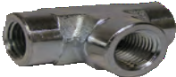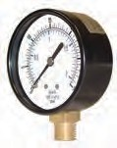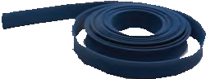 10

ADAPTERS

PRESSURE GAUGES

HOSE JACKETS

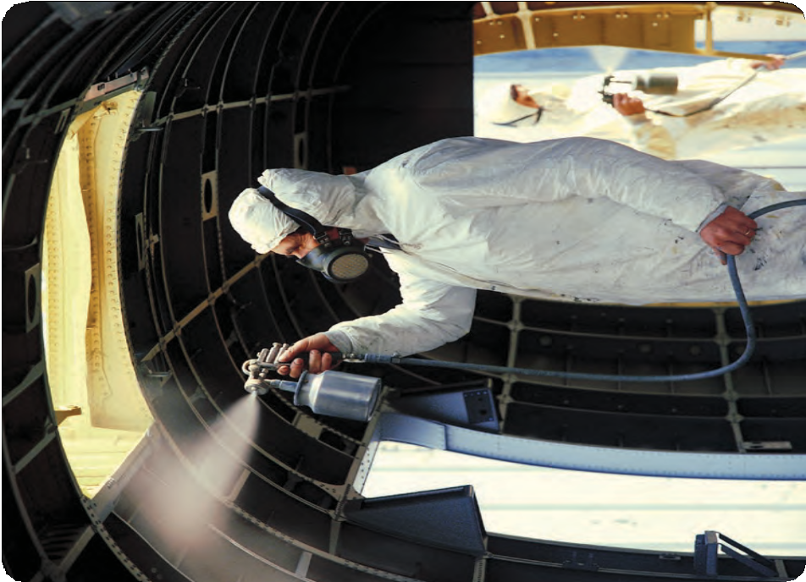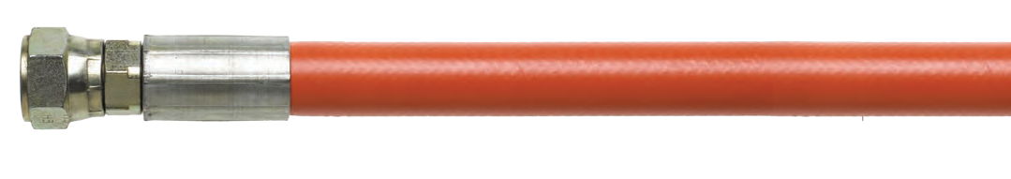AIRLESS PAINT SPRAY
11

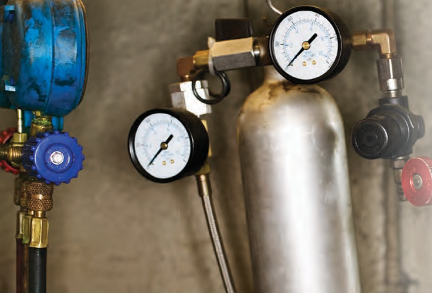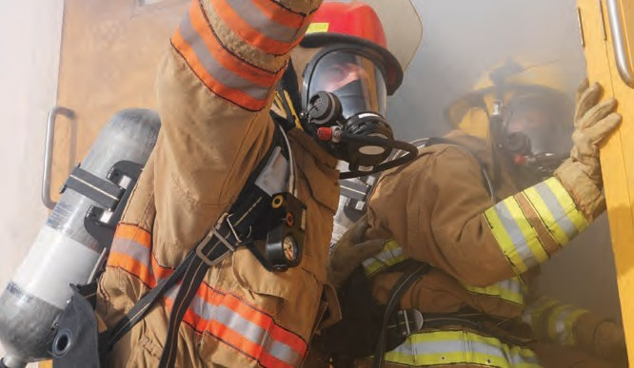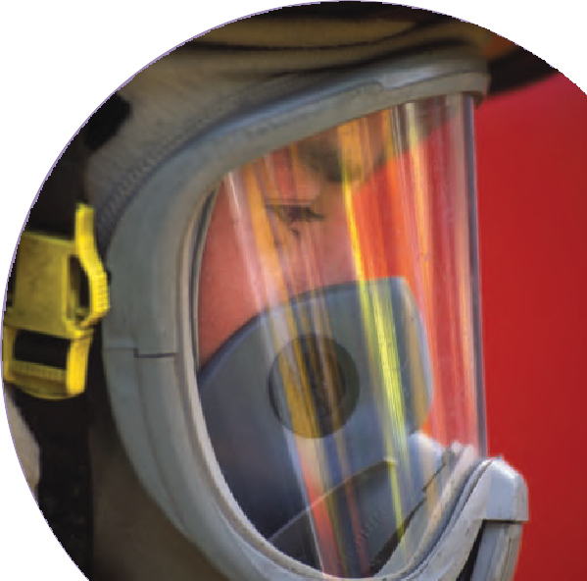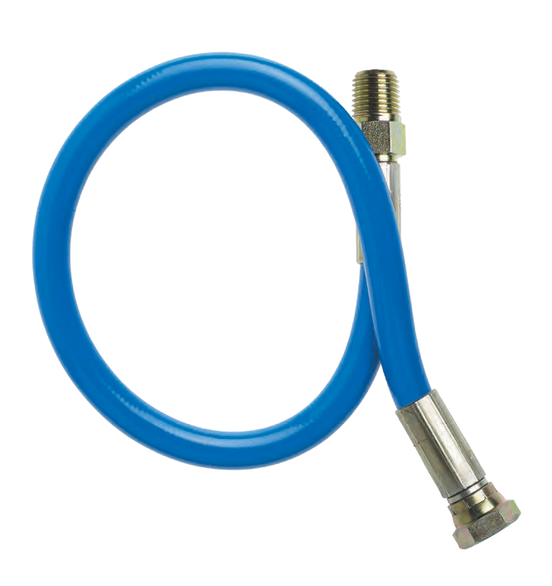

At CRP, our highly trained customer service staff will be happy to discuss custom lengths and accommodate all of your Air Cascade Hose needs. And unlike other manufacturers, no order is too big or too small, so there’s never a required minimum. Most importantly, we understand how vital it is for your business that your hoses be shipped as quickly as possible. So rest assured, you can count on us for timeliness when it counts.

AIR CASCADE HOSE FEATURES:
- Working pressures from 1,750 psi to 10,000 psi
- Hose sizes from 1/8” to 1”
- Wide variety of fitting options — NPT, NPSM, and JIC in plated or Stainless Steel – male (M) or female (F)
- Lengths up to 500’
- Suitable for filling breathing tanks and air lines

12

1000UK SERIES WIRE REINFORCED THERMOPLASTIC AIR CASCADE HOSE

High pressure, high performance hose with steel braid reinforcement for strength. Offers optimum resistance to most chemicals, gases, and air with no absorption.

CONSTRUCTION:
Inner: Seamless Nylon 6 Liner
Outer: Abrasion Resistant Polyurethane Cover

COUPLING CAPABILITIES: NPT, NPSM, JIC Plated or Stainless Steel – M or F
CRP PART NUMBER | COLORS | # OF BRAIDS | NOMINAL I.D.  Inches (MM) | NOMINAL O.D.  Inches (MM) | MINIMUM BEND RADIUS  Inches (MM) | DYNAMIC WORKING PRESSURE | MINIMUM BURST PRESSURE | WEIGHT (LBS/FT) | MAXIMUM LENGTH | TEMPERATURE RANGE
1003K | n | 1 | 1/8 (3.2) | 0.27 (7.0) | 1.2 (30) | 5,075 psi | 20,300 psi | 0.04 | 4” up to 500’ | -40 to +212ºF
1004UK | n n | 1 | 3/16 (4.8) | 0.37 (9.4) | 1.0 (25) | 5,250 psi | 21,000 psi | 0.08 | 4” up to 500’ | -40 to +212ºF
1006UK | n n | 1 | 1/4 (6.4) | 0.46 (11.7) | 1.5 (37) | 5,000 psi | 18,000 psi | 0.11 | 4” up to 500’ | -40 to +212ºF
1010UK | n n | 1 | 3/8 (9.5) | 0.60 (15.1) | 2.0 (50) | 3,500 psi | 13,000 psi | 0.15 | 4” up to 500’ | -40 to +212ºF
1013UK | n n | 1 | 1/2 (12.7) | 0.72 (18.3) | 3.0 (75) | 3,000 psi | 12,000 psi | 0.20 | 4” up to 500’ | -40 to +212ºF
1020UK | n | 1 | 3/4 (19.1) | 1.0 (25.5) | 6.7 (170) | 1,750 psi | 7,000 psi | 0.29 | 4” up to 300’ | -40 to +212ºF
1025UK | n | 2 | 1 (25.4) | 1.3 (32.5) | 9.1 (231) | 2,750 psi | 11,000 psi | 0.65 | 4” up to 300’ | -40 to +212ºF

2000UK SERIES WIRE REINFORCED THERMOPLASTIC AIR CASCADE HOSE

High pressure, high performance hose with steel braid reinforcement for strength. Offers optimum resistance to most chemicals, gases, and air with no absorption.

CONSTRUCTION:
Inner: Seamless Nylon 6 Liner = 2006/2010/2013 Seamless Nylon 12 Liner = 2020/2025
Outer: Abrasion Resistant Polyurethane Cover

COUPLING CAPABILITIES: NPT, NPSM, JIC Plated or Stainless Steel – M or F
CRP PART NUMBER | COLORS | # OF BRAIDS | NOMINAL I.D.  Inches (MM) | NOMINAL O.D.  Inches (MM) | MINIMUM BEND RADIUS  Inches (MM) | DYNAMIC WORKING PRESSURE | MINIMUM BURST PRESSURE | WEIGHT (LBS/FT) | MAXIMUM LENGTH | TEMPERATURE RANGE
2006UK | n | 2 | 1/4 (6.4) | 0.54 (13.7) | 1.0 (25) | 6,170 psi | 28,000 psi | 0.21 | 4” up to 500’ | -40 to +212ºF
2010UK | n n | 2 | 3/8 (9.5) | 0.67 (17.0) | 1.5 (37) | 6,000 psi | 24,000 psi | 0.28 | 4” up to 500’ | -40 to +212ºF
2013UK | n n | 2 | 1/2 (12.7) | 0.80 (20.2) | 2.5 (62) | 5,000 psi | 17,000 psi | 0.34 | 4” up to 300’ | -40 to +212ºF
2020UK | n n | 2 | 3/4 (19.1) | 1.07 (27.1) | 6.7 (170) | 3,100 psi | 13,000 psi | 0.50 | 4” up to 300’ | -40 to +212ºF
2025UK | n | 3** | 1 (25.4) | 1.46 (37.1) | 10.0 (254) | 4,750 psi | 19,000 psi | 0.61 | 4” up to 300’ | -40 to +212ºF*

FABRIC REINFORCED THERMOPLASTIC BREATHING AND AIR CYLINDER CHARGING HOSE
2000AB SERIES
*+158ºF for water based fluids
**2 Kevlar and 1 Wire Reinforced Braid

High pressure, high performance hose with Aramid yarn braid reinforcement designed for air cylinder charging and breathing air applications. Cover is pin-pricked standard.

CONSTRUCTION:
Inner: Food Grade Polyester Elastomer Tube Tube Liner materials comply with FDA Reg. 21 CFR 177.2600 and EU Directive 90/128 Annex II (Sec A&B) and Annex III

Outer: Abrasion Resistant Polyurethane Cover

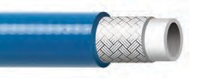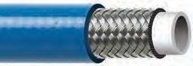
3
AIR CASCADE SYSTEMS
COUPLING CAPABILITIES: NPT, NPSM, JIC Plated or Stainless Steel – M or F
CRP PART NUMBER | COLORS | # OF BRAIDS | NOMINAL I.D.  Inches (MM) | NOMINAL O.D.  Inches (MM) | MINIMUM BEND RADIUS  Inches (MM) | DYNAMIC WORKING PRESSURE | MINIMUM BURST PRESSURE | WEIGHT (LBS/FT) | MAXIMUM LENGTH | TEMPERATURE RANGE
2004AB | n n | 1 | 3/16 (4.8) | 0.41 (10.4) | 1.5 (38.1) | 6,000 psi | 24,000 psi | 0.05 | 4” up to 500’ | -40 to +176ºF
2006AB | n n | 1 | 1/4 (6.4) | 0.48 (12.2) | 2.0 (50.8) | 6,000 psi | 24,000 psi | 0.10 | 4” up to 500’ | -40 to +176ºF
NOTE: This hose is designed for Air Charging Applications and should not be connected between air breathing masks and pressure regulators in breathing apparatus. Hose should not be used with explosive gases such as hydrogen and oxygen.

CUSTOM SIZES AND OTHER COUPLING CAPABILITIES AVAILABLE ON ALL HOSES.
TO PLACE AN ORDER OR SPEAK WITH A CRP REPRESENTATIVE, CALL 800-526-4066. 1

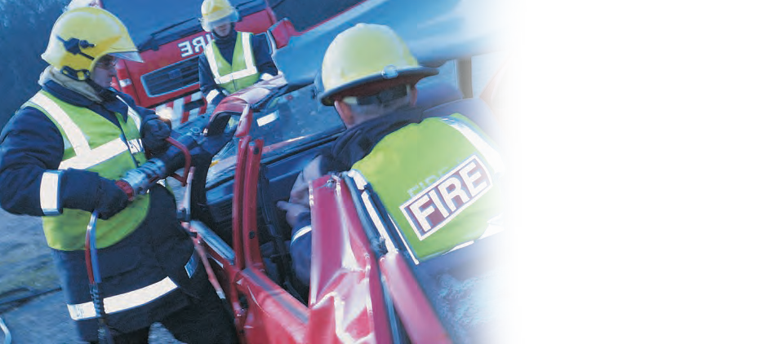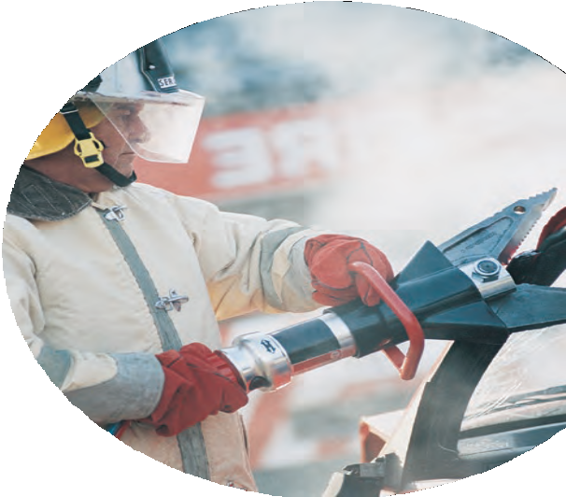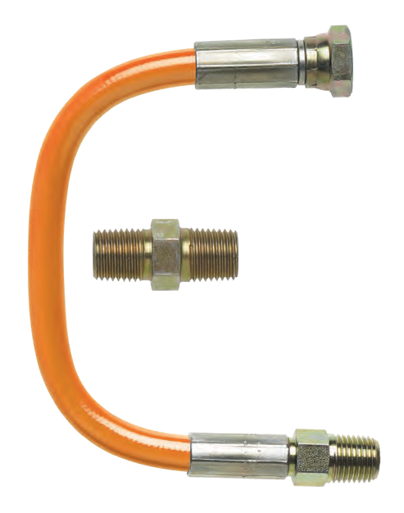

Reinflex’s Emergency Rescue Equipment Hoses are specifically designed just for the industry. In fact, several leading rescue equipment manufacturers are our satisfied customers. We provide custom sizes, fittings, and color options to cater to each and every tool manufacturer, even those that are often times unavailable anywhere else. Competitively priced, Reinflex’s Emergency Rescue Equipment Hose is suitable for high pressure applications in the toughest of environments.

EMERGENCY RESCUE HOSE FEATURES:
  - Working pressure from 1,000 psi to 10,000 psi
  - Hose sizes from 3/16” to 1”
  - Twin-line is welded (not taped or clamped together) for longer service life and durability
  - Many fitting combinations and color options to meet OEM specs
  - Custom lengths up to 500’
  - Low volumetric expansion providing excellent hydraulic response times
i

m
14

1000UKNC SERIES FABRIC BRAID REINFORCED THERMOPLASTIC EMERGENCY RESCUE HOSE

All-purpose medium pressure hose reinforced with a single braid of polyester fiber. Ideal where non-conductivity is required. Suitable for hydraulic oils, mineral oils, and phosphate esters. Excellent flexibility and flex fatigue resistance.

CONSTRUCTION:
Inner: Polyester Elastomer Liner
Outer: Abrasion Resistant Polyurethane Cover

COUPLING CAPABILITIES: NPT, NPSM, JIC Plated or Stainless Steel – M or F SPECIFICATION: SAE 100R7
MINIMUM DYNAMIC MINIMUM
CRP PART # OF NOMINAL I.D. NOMINAL O.D. BEND RADIUS WORKING BURST WEIGHT MAXIMUM TEMPERATURE NUMBER COLORS BRAIDS Inches (MM) Inches (MM) Inches (MM) PRESSURE PRESSURE (LBS/FT) LENGTH RANGE
1004UKNC n 1 3/16 (4.8) 0.41 (10.4) 1.5 (38) 3,000 psi 12,000 psi 0.05 4” up to 500’ -40 to +212ºF*
1006UKNC n 1 1/4 (6.4) 0.49 (12.4) 2.0 (51) 2,750 psi 11,000 psi 0.07 4” up to 500’ -40 to +212ºF*
1010UKNC n 1 3/8 (9.5) 0.64 (16.3) 2.5 (64) 2,250 psi 9,000 psi 0.10 4” up to 300’ -40 to +212ºF*
1013UKNC n 1 1/2 (12.7) 0.78 (19.9) 3.2 (82) 2,000 psi 8,000 psi 0.14 4” up to 300’ -40 to +212ºF*
1020UKNC n 1 3/4 (19.1) 1.03 (26.1) 7.0 (178) 1,250 psi 5,000 psi 0.20 4” up to 200’ -40 to +212ºF*
1025UKNC n 1 1 (25.4) 1.28 (32.5) 8.0 (203) 1,000 psi 4,000 psi 0.25 4” up to 200’ -40 to +212ºF*
*+158ºF for water based fluids

2000UKNC SERIES FABRIC BRAID REINFORCED THERMOPLASTIC EMERGENCY RESCUE HOSE

All-purpose medium pressure hose reinforced with a single braid of polyester fiber. Ideal where non-conductivity is required. Suitable for hydraulic oils, mineral oils, and phosphate esters. Excellent flexibility and flex fatigue resistance.

CONSTRUCTION:
Inner: Polyester Elastomer Liner
Outer: Abrasion Resistant Polyurethane Cover

COUPLING CAPABILITIES: NPT, NPSM, JIC Plated or Stainless Steel – M or F SPECIFICATION: SAE 100R8
MINIMUM DYNAMIC MINIMUM
CRP PART # OF NOMINAL I.D. NOMINAL O.D. BEND RADIUS WORKING BURST WEIGHT MAXIMUM TEMPERATURE NUMBER COLORS BRAIDS Inches (MM) Inches (MM) Inches (MM) PRESSURE PRESSURE (LBS/FT) LENGTH RANGE
2004UKNC n 1 3/16 (4.8) 0.41 (10.4) 1.5 (38) 5,000 psi 20,000 psi 0.05 4” up to 500’ -40 to +212ºF*
2006UKNC n 1 1/4 (6.4) 0.49 (12.4) 2.0 (51) 5,000 psi 20,000 psi 0.07 4” up to 500’ -40 to +212ºF*
2010UKNC n 1 3/8 (9.5) 0.63 (15.9) 2.5 (64) 4,000 psi 16,000 psi 0.10 4” up to 500’ -40 to +212ºF*
2013UKNC n 1 1/2 (12.7) 0.78 (19.9) 3.2 (82) 3,500 psi 14,000 psi 0.13 4” up to 300’ -40 to +212ºF*
2020UKNC n 1 3/4 (19.1) 1.04 (26.5) 5.91 (150) 2,300 psi 9,200 psi 0.24 4” up to 300’ -40 to +212ºF*
*+158ºF for water based fluids

2000UK SERIES WIRE REINFORCED THERMOPLASTIC EMERGENCY RESCUE HOSE

A high pressure, high performance hose with steel braid reinforcement for strength and guaranteed electrical conductivity. Offers optimum resistance to a wide range of oils
and chemicals. Extremely durable. Cover is pin- pricked standard.

CONSTRUCTION:
Inner: Seamless Nylon 6
Outer: Abrasion Resistant Polyurethane Cover

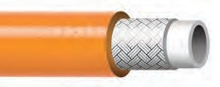
EMERGENCY RESCUE EQUIPMENT
COUPLING CAPABILITIES: NPT, NPSM, JIC Plated or Stainless Steel – M or F
MINIMUM DYNAMIC MINIMUM
CRP PART # OF NOMINAL I.D. NOMINAL O.D. BEND RADIUS WORKING BURST WEIGHT MAXIMUM TEMPERATURE NUMBER COLORS BRAIDS Inches (MM) Inches (MM) Inches (MM) PRESSURE PRESSURE (LBS/FT) LENGTH RANGE
2006UK n 2 1/4 (6.4) 0.54 (13.7) 1.0 (25) 6,170 psi 28,000 psi 0.21 4” up to 500’ -40 to +212ºF
*+158ºF for water based fluids

CUSTOM SIZES AND OTHER COUPLING CAPABILITIES AVAILABLE ON ALL HOSES.
TO PLACE AN ORDER OR SPEAK WITH A CRP REPRESENTATIVE, CALL 800-526-4066. 15

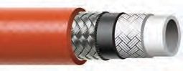2100UK SERIES WIRE & FABRIC REINFORCED THERMOPLASTIC EMERGENCY RESCUE HOSE

High pressure, high performance hydraulic hose reinforced with a braid of steel and a polyaramid yard. Compatible with hydraulic oils, grease, fuel oils, mineral oils, and most phosphate esters.
Superior flexibility and bend radii.

CONSTRUCTION:
Inner: Polyester Elastomer Liner
Outer: Abrasion Resistant Polyurethane Cover

COUPLING CAPABILITIES: NPT, NPSM, JIC Plated or Stainless Steel – M or F
CRP PART NUMBER | COLORS | # OF BRAIDS | NOMINAL I.D.  Inches (MM) | NOMINAL O.D.  Inches (MM) | MINIMUM BEND RADIUS  Inches (MM) | DYNAMIC WORKING PRESSURE | MINIMUM BURST PRESSURE | WEIGHT (LBS/FT) | MAXIMUM LENGTH | TEMPERATURE RANGE
2106UK | nnnn | 2 | 1/4 (6.4) | 0.54 (13.7) | 1.5 (38) | 10,000 psi | 40,000 psi | 0.15 | 4” up to 500’ | -40 to +212ºF*
2110UK | n | 2 | 3/8 (9.5) | 0.74 (18.8) | 3.8 (95) | 10,000 psi | 40,000 psi | 0.24 | 4” up to 300’ | -40 to +212ºF*
3113UK | n | 3 | 1/2 (12.7) | 0.90 (22.9) | 5.0 (127) | 10,000 psi | 34,000 psi | 0.33 | 4” up to 300’ | -40 to +212ºF*
*+158ºF for water based fluids

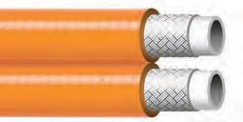1000UKTNC SERIES FABRIC REINFORCED TWIN LINE THERMOPLASTIC EMERGENCY RESCUE HOSE

All-purpose high pressure non-conductive twin line hose suitable for many hydraulic and pneumatic systems. Reinforced with a single braid of polyaramid fiber. Compatible with hydraulic oils, mineral oils, phosphate esters, and many industrial gases.
Excellent flexibility and flex fatigue resistance.

CONSTRUCTION:
Inner: Polyester Elastomer Liner
Outer: Abrasion Resistant Polyurethane Cover

COUPLING CAPABILITIES: NPT, NPSM, JIC Plated or Stainless Steel – M or F |  |  |  |  |  | SPECIFICATIONS: SAE 100R7
CRP PART NUMBER | COLORS | # OF BRAIDS | NOMINAL I.D.  Inches (MM) | NOMINAL O.D.  Inches (MM) | MINIMUM BEND RADIUS  Inches (MM) |  | DYNAMIC WORKING PRESSURE | MINIMUM BURST PRESSURE | WEIGHT (LBS/FT) | MAXIMUM LENGTH | TEMPERATURE RANGE
1010UKTNC | n | 1 | 3/8 (9.5) | 0.64 (16.3) | 2.5 (64) |  | 2,250 psi | 9,000 psi | 0.20 | 4” up to 200’ | -40 to +212ºF*
1013UKTNC | n | 1 | 1/2 (12.7) | 0.78 (19.9) | 3.2 (82) |  | 2,000 psi | 8,000 psi | 0.28 | 4” up to 200’ | -40 to +212ºF*
*+158ºF for water based fluids

2000UKTNC SERIES FABRIC REINFORCED TWIN LINE THERMOPLASTIC EMERGENCY RESCUE HOSE

All-purpose high pressure non-conductive twin line hose suitable for many hydraulic and pneumatic systems. Reinforced with a single braid of polyaramid fiber. Compatible with hydraulic oils, mineral oils, phosphate esters, and many industrial gases. Excellent flexibility and flex fatigue resistance.

CONSTRUCTION:
Inner: Polyester Elastomer Liner
Outer: Abrasion Resistant Polyurethane Cover

COUPLING CAPABILITIES: NPT, NPSM, JIC Plated or Stainless Steel – M or F |  |  |  |  |  | SPECIFICATION: SAE 100R8
CRP PART NUMBER | COLORS | # OF BRAIDS | NOMINAL I.D.  Inches (MM) | NOMINAL O.D.  Inches (MM) | MINIMUM BEND RADIUS  Inches (MM) |  | DYNAMIC WORKING PRESSURE | MINIMUM BURST PRESSURE | WEIGHT (LBS/FT) | MAXIMUM LENGTH | TEMPERATURE RANGE
2006UKTNC | n | 1 | 1/4 (6.4) | 0.46 (11.7) | 2.0 (51) |  | 5,000 psi | 20,000 psi | 0.14 | 4” up to 200’ | -40 to +212ºF*
2010UKTNC | n | 1 | 3/8 (9.5) | 0.63 (15.9) | 5.0 (127) |  | 4,000 psi | 16,000 psi | 0.20 | 4” up to 200’ | -40 to +212ºF*
*+158ºF for water based fluids

16

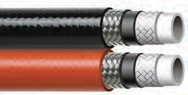2100UKT SERIES WIRE & FABRIC REINFORCED TWIN LINE THERMOPLASTIC EMERGENCY RESCUE HOSE

High pressure, high performance hydraulic hose reinforced with a braid of steel and a polyaramid yard. Compatible with hydraulic oils, grease, fuel oils, mineral oils, and most phosphate esters.
Superior flexibility and bend radii.

CONSTRUCTION:
Inner: Polyester Elastomer Liner
Outer: Abrasion Resistant Polyurethane Cover

COUPLING CAPABILITIES: NPT, NPSM, JIC Plated or Stainless Steel – M or F
CRP PART NUMBER | COLORS | # OF BRAIDS | NOMINAL I.D.  Inches (MM) | NOMINAL O.D.  Inches (MM) | MINIMUM BEND RADIUS  Inches (MM) | DYNAMIC WORKING PRESSURE | MINIMUM BURST PRESSURE | WEIGHT (LBS/FT) | MAXIMUM LENGTH | TEMPERATURE RANGE
2106UKT |  | 2 | 1/4 (6.4) | 0.54 (13.7) | 1.5 (38) | 10,000 psi | 40,000 psi | 0.30 | 4” up to 200’ | -40 to +212ºF*
NOTE: Other colors available upon request. *+158ºF for water based fluids

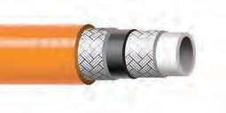2100UKNC SERIES
FABRIC REINFORCED THERMOPLASTIC EMERGENCY RESCUE HOSE

All-purpose high pressure non-conductive hose suitable for many hydraulic and pneumatic systems. Reinforced with two braids of polyaramid fiber.
Compatible with hydraulic oils, grease, fuel oils, mineral oils, phosphate esters, and many industrial gases. Excellent flexibilty and flex fatigue resistance.

CONSTRUCTION:
Inner: Polyester Elastomer Liner
Outer: Abrasion Resistant Polyurethane Cover

7
EMERGENCY RESCUE EQUIPMENT
COUPLING CAPABILITIES: NPT, NPSM, JIC Plated or Stainless Steel – M or F
CRP PART NUMBER | COLORS | # OF BRAIDS | NOMINAL I.D.  Inches (MM) | NOMINAL O.D.  Inches (MM) | MINIMUM BEND RADIUS  Inches (MM) | DYNAMIC WORKING PRESSURE | MINIMUM BURST PRESSURE | WEIGHT (LBS/FT) | MAXIMUM LENGTH | TEMPERATURE RANGE
2104KNC | n | 2 | 3/16 (4.8) | 0.43 (10.9) | 1.2 (30.5) | 10,000 psi | 40,000 psi | 0.06 | 4” up to 300’ | -40 to +212ºF*
2106UKNC | n | 2 | 1/4 (6.4) | 0.54 (13.7) | 1.5 (38) | 10,000 psi | 40,000 psi | 0.11 | 4” up to 200’ | -40 to +212ºF*
*+158ºF for water based fluids

CUSTOM SIZES AND OTHER COUPLING CAPABILITIES AVAILABLE ON ALL HOSES.
TO PLACE AN ORDER OR SPEAK WITH A CRP REPRESENTATIVE, CALL 800-526-4066. 1

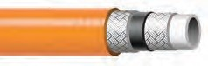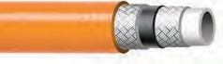2100TNC SERIES FABRIC REINFORCED TWIN LINE THERMOPLASTIC EMERGENCY RESCUE HOSE

All purpose high pressure non-conductive hose suitable for many hydraulic and pneumetic systems. Reinforced with two braids of polyamid fiber.
Compatable with hydraulic oils, grease, fuel oils, phosphat esters, and many industrial gases. Excellent flexiblity and flex fatigue resistance.

CONSTRUCTION:
Inner: Polyester Elastomer Liner
Outer: Abrasion Resistant Polyurethane Cover

COUPLING CAPABILITIES: NPT, NPSM, JIC Plated or Stainless Steel – M or F
CRP PART NUMBER | COLORS | # OF BRAIDS | NOMINAL I.D.  Inches (MM) | NOMINAL O.D.  Inches (MM) | MINIMUM BEND RADIUS  Inches (MM) | DYNAMIC WORKING PRESSURE | MINIMUM BURST PRESSURE | WEIGHT (LBS/FT) | MAXIMUM LENGTH | TEMPERATURE RANGE
2104TNC | n | 2 | 3/16 (4.8) | 0.43 (10.9) | 1.2 (30.5) | 10,000 psi | 40,000 psi | 0.15 | 4” up to 300’ | -40 to +212ºF*
2106KNC | n | 2 | 1/4 (6.4) | 0.54 (13.7) | 1.5 (38) | 10,000 psi | 40,000 psi | 0.24 | 4” up to 300’ | -40 to +212ºF*
*+158ºF for water based fluids

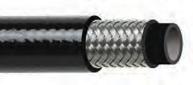2100RH SERIES
WIRE REINFORCED RUBBER EMERGENCY RESCUE HOSE

All purpose high pressure rubber hose for many hydraulic and pneumetic systems. Reinforced with two braids of high tensile wire. Compatable with hydraulic oils, grease, fuel oils, phosphat esters, and many industrial gases. Excellent flexiblity and flex fatigue resistance.

CONSTRUCTION:
Inner: Synethic Rubber
Outer: Abrasion Resistant Rubber Cover

COUPLING CAPABILITIES: NPT, NPSM, JIC Plated or Stainless Steel – M or F
CRP PART NUMBER | COLORS | # OF BRAIDS | NOMINAL I.D.  Inches (MM) | NOMINAL O.D.  Inches (MM) | MINIMUM BEND RADIUS  Inches (MM) | DYNAMIC WORKING PRESSURE | MINIMUM BURST PRESSURE | WEIGHT (LBS/FT) | MAXIMUM LENGTH | TEMPERATURE RANGE
2106RH | n | 2 | 1/4 (6.4) | 0.58 (14.7) | 4.0 (101.6) | 10,000 psi | 20,000 psi | 0.27 | 4” up to 300’ | -40 to +212ºF*
2110RH | n | 2 | 3/8 (9.5) | 0.71 (18.0) | 4.0 (101.6) | 10,150 psi | 20,300 psi | 0.32 | 4” up to 300’ | -40 to +212ºF*
*+158ºF for water based fluids

Reinflex also carries all the hose accessories you need. See pages 48-62 for details.
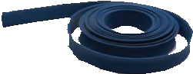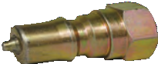

HOSE JACKETS

QUICK COUPLERS

18

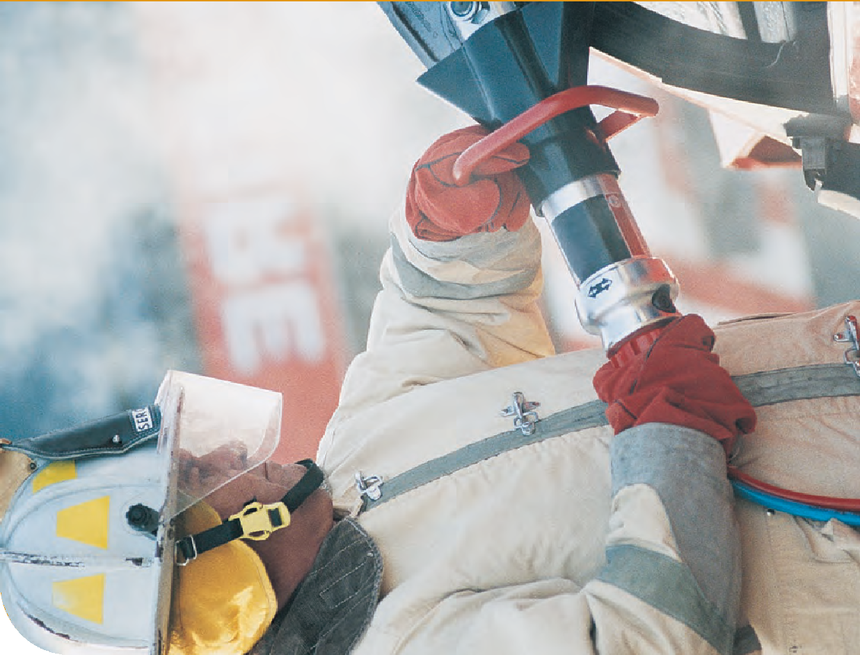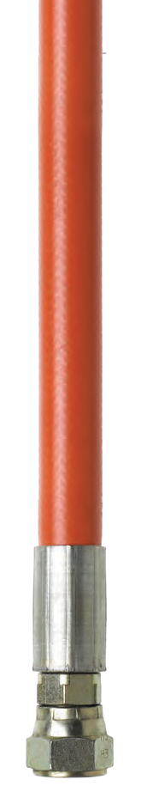EMERGENCY RESCUE EQUIPMENT
19

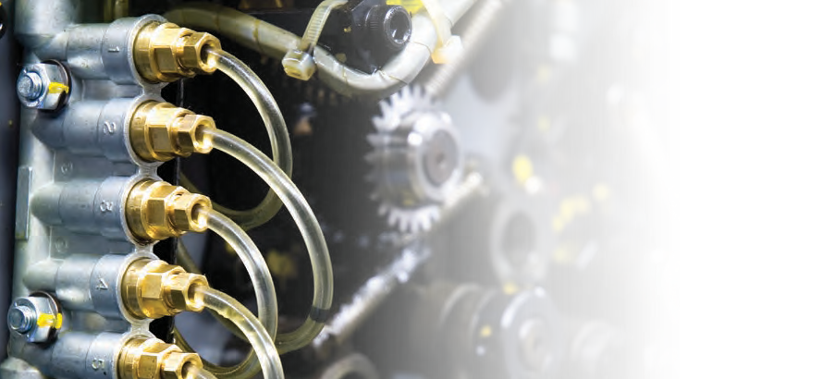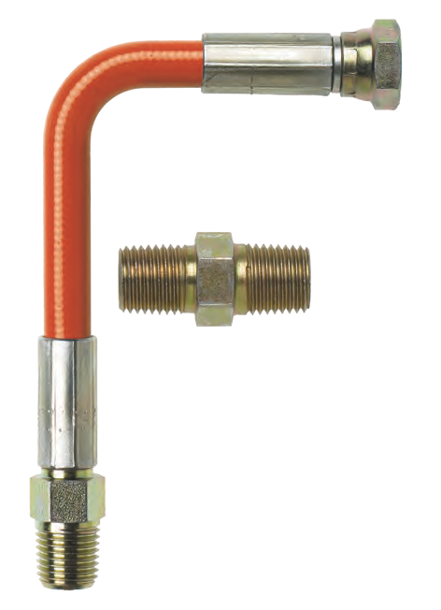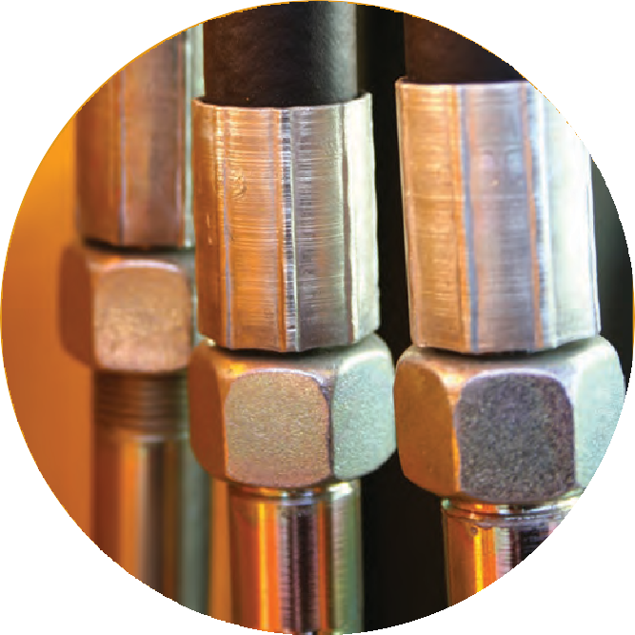

With more than 30 years experience, it’s no wonder Reinflex is often called upon by the air and fluid transfer industry. Our Air and Fluid Transfer Hoses are competitively priced and ideal for low pressure applications. Full reels are available or we can create custom assemblies specifically designed to suit
your application needs. The hoses are compatible with most re-usable fittings.

AIR AND FLUID TRANSFER HOSE FEATURES:
- Working pressure from 1,750 psi to 5,000 psi
- Hose sizes from 3/16” to 1”
- Custom assemblies
- Available in continuous lengths up to 200’
- Minimal change in length at operating pressures
- Suitable for a wide range of industrial and agricultural applications, including suction, syphon kits and paint pick up

20

1004T SERIES SYNTHETIC REINFORCED RUBBER LOW PRESSURE AIR & FLUID TRANSFER HOSE
AIR & FLUID TRANSFER

Ideal for flexible air transfer for abrasives material blasting systems and other industrial, construction or agricultural applications. EPDM hose and tube with spiral yarn reinforcement.

CONSTRUCTION:
Inner: EPDM
Outer: EPDM

COUPLING CAPABILITIES: NPT, NPSM, JIC Plated or Stainless Steel – M or F
CRP PART NUMBER | COLORS | # OF BRAIDS | NOMINAL I.D.  Inches (MM) | NOMINAL O.D.  Inches (MM) | MINIMUM BEND RADIUS  Inches (MM) | DYNAMIC WORKING PRESSURE | MINIMUM BURST PRESSURE | WEIGHT (LBS/FT) | COIL SIZE | TEMPERATURE RANGE
1004TYG | n n | 1 | 3/16 (4.8) | 0.44 (11.2) | N/A | 200 psi | N/A | 0.14 | 800’* | -40 to +190ºF
1004TYY | n n | 1 | 3/16 (4.8) | 0.44 (11.2) | N/A | 200 psi | N/A | 0.14 | 800’* | -40 to +190ºF
*Coils may contain multiple lengths (max. 3)

AIR HOSE SERIES SYNTHETIC REINFORCED RUBBER LOW PRESSURE AIR & FLUID TRANSFER HOSE

Ideal for a wide range of applications including industrial, construction, and agricultural. Reinforced synthetic rubber with spiral synthetic yarn.
Medium oil resistance.

CONSTRUCTION:
Inner: Synthetic Rubber RMA Class C
Outer: Synthetic Rubber

COUPLING CAPABILITIES: NPT, NPSM, JIC Plated or Stainless Steel – M or F
CRP PART NUMBER | COLORS | # OF BRAIDS | NOMINAL I.D.  Inches (MM) | NOMINAL O.D.  Inches (MM) | MINIMUM BEND RADIUS  Inches (MM) | DYNAMIC WORKING PRESSURE | MINIMUM BURST PRESSURE | WEIGHT (LBS/FT) | MAXIMUM LENGTH | TEMPERATURE RANGE
55-1982-04 | n | 1 | 1/4 (6.4) | 0.50 (12.7) | N/A | 200 psi | 800 psi | 0.09 | 500’* | -40 to +190ºF
55-1982-10 | n | 1 | 5/16 (7.9) | 0.58 (14.7) | N/A | 200 psi | 800 psi | 0.12 | 500’* | -40 to +190ºF
55-1982-16 | n | 1 | 3/8 (9.5) | 0.67 (17.0) | N/A | 200 psi | 800 psi | 0.15 | 500’* | -40 to +190ºF
55-1982-22 | n | 1 | 1/2 (12.7) | 0.81 (20.6) | N/A | 200 psi | 800 psi | 0.22 | 500’* | -40 to +190ºF
*Coils may contain multiple lengths (max. 3)

FLUID HOSE SERIES SYNTHETIC REINFORCED RUBBER LOW PRESSURE AIR & FLUID TRANSFER HOSE

Premium quality all purpose hose for handling a variety of applications such as paint or agricultural spray. Suitable for paints, lacquers, thinners, oil, and solvents.

CONSTRUCTION:
Inner: Nylon, RMA Class B Branded Synthetic Yarn
Outer: Synthetic Neoprene

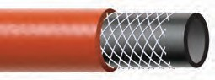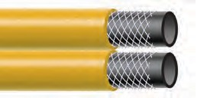
1

COUPLING CAPABILITIES: NPT, NPSM, JIC Plated or Stainless Steel – M or F
CRP PART NUMBER | COLORS | # OF BRAIDS | NOMINAL I.D.  Inches (MM) | NOMINAL O.D.  Inches (MM) | MINIMUM BEND RADIUS  Inches (MM) | DYNAMIC WORKING PRESSURE | MINIMUM BURST PRESSURE | WEIGHT (LBS/FT) | MAXIMUM LENGTH | TEMPERATURE RANGE
55-1942-04 | n | 1 | 1/4 (6.7) | 0.50 (12.7) | 2.5 (63.5) | 750 psi | 3,000 psi | 0.08 | 500’* | -40 to +190ºF
55-1942-10 | n | 1 | 5/16 (7.9) | 0.56 (14.3) | 2.8 (69.9) | 750 psi | 3,000 psi | 0.13 | 500’* | -40 to +190ºF
55-1942-16 | n | 1 | 3/8 (9.5) | 0.68 (17.5) | 3.0 (76.2) | 750 psi | 3,000 psi | 0.15 | 500’* | -40 to +190ºF
55-1942-25 | n | 2 | 1/2 (12.7) | 0.88 (22.4) | 4.5 (114.3) | 750 psi | 3,000 psi | 0.22 | 500’* | -40 to +190ºF
55-1942-37 | n | 2 | 3/4 (19.0) | 1.19 (30.2) | 6.0 (152.4) | 750 psi | 3,000 psi | 0.36 | 500’* | -40 to +190ºF
55-1942-43 | n | 2 | 1 (25.4) | 1.50 (38) | 7.0 (177.8) | 750 psi | 3,000 psi | 0.49 | 500’* | -40 to +190ºF
*Coils may contain multiple lengths (max. 3)

CUSTOM SIZES AND OTHER COUPLING CAPABILITIES AVAILABLE ON ALL HOSES.
TO PLACE AN ORDER OR SPEAK WITH A CRP REPRESENTATIVE, CALL 800-526-4066. 2

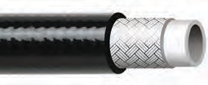1100UKH SERIES
FABRIC REINFORCED THERMOPLASTIC AIR & FLUID HOSE (100R7)

All-purpose medium pressure 100R7 hose that is compatible with hydraulic oils, grease, fuel oils, mineral oils, and most phosphate esters, as well as many industrial gases. Excellent flexibility and flex fatigue resistance. Cover is pin-pricked standard.

CONSTRUCTION:
Inner: Polyester Elastomer
Outer: Abrasion and Chemical Resistant Polyurethane Cover

COUPLING CAPABILITIES: NPT, NPSM, JIC Plated or Stainless Steel – M or F |  |  |  |  |  |  |  | SPECIFICATION: SAE 100R7
CRP PART NUMBER | COLORS | # OF BRAIDS | NOMINAL I.D.  Inches (MM) |  | NOMINAL O.D.  Inches (MM) |  | MINIMUM BEND RADIUS  Inches (MM) |  |  | DYNAMIC WORKING PRESSURE | MINIMUM BURST PRESSURE | WEIGHT (LBS/FT) | MAXIMUM LENGTH | TEMPERATURE RANGE
1104UKH | n | 1 | 3/16 | (4.8) | 0.41 | (10.4) | 1.5 |  | (38) | 3,000 psi | 12,000 psi | 0.05 | 4” up to 500’ | -40 to +212ºF*
1106UKH | n | 1 | 1/4 | (6.4) | 0.49 | (12.4) | 2.0 |  | (51) | 2,750 psi | 11,000 psi | 0.07 | 4” up to 500’ | -40 to +212ºF*
1110UKH | n | 1 | 3/8 | (9.5) | 0.64 | (16.3) | 2.5 |  | (64) | 2,250 psi | 9,000 psi | 0.10 | 4” up to 500’ | -40 to +212ºF*
1113UKH | n | 1 | 1/2 | (12.7) | 0.78 | (19.9) | 3.2 |  | (82) | 2,000 psi | 8,000 psi | 0.14 | 4” up to 500’ | -40 to +212ºF*
1120UKH | n | 1 | 3/4 | (19.1) | 1.03 | (26.1) | 7.0 |  | (178) | 1,250 psi | 5,000 psi | 0.20 | 4” up to 300’ | -40 to +212ºF*
1125UKH | n | 1 | 1 | (25.4) | 1.28 | (32.5) | 8.0 |  | (203) | 1,000 psi | 4,000 psi | 0.25 | 4” up to 300’ | -40 to +212ºF*
*+158ºF for water based fluids

1200UKH SERIES

FABRIC REINFORCED THERMOPLASTIC AIR & FLUID HOSE (100R8)

All-purpose medium pressure 100R8 hose that is compatible with hydraulic oils, grease, fuel oils, mineral oils, and most phosphate esters, as well as many industrial gases. Excellent flexibility and flex fatigue resistance. Cover is pin-pricked standard.
MSHA cover available upon request.
CONSTRUCTION:
Inner: Polyester Elastomer
Outer: Abrasion and Chemical Resistant Polyurethane Cover

COUPLING CAPABILITIES: NPT, NPSM, JIC Plated or Stainless Steel – M or F |  |  |  |  |  |  |  | SPECIFICATION: SAE 100R8
CRP PART NUMBER | COLORS | # OF BRAIDS | NOMINAL I.D.  Inches (MM) |  | NOMINAL O.D.  Inches (MM) |  | MINIMUM BEND RADIUS  Inches (MM) |  |  | DYNAMIC WORKING PRESSURE | MINIMUM BURST PRESSURE | WEIGHT (LBS/FT) | MAXIMUM LENGTH | TEMPERATURE RANGE
1204UKH | n | 1 | 3/16 | (4.8) | 0.35 | (8.9) | 1.2 |  | (31) | 5,000 psi | 20,000 psi | 0.04 | 4” up to 500’ | -40 to +212ºF*
1206UKH | n | 1 | 1/4 | (6.4) | 0.45 | (11.4) | 2.0 |  | (51) | 5,000 psi | 20,000 psi | 0.06 | 4” up to 500’ | -40 to +212ºF*
1210UKH | n | 1 | 3/8 | (9.5) | 0.61 | (15.5) | 2.4 |  | (61) | 4,000 psi | 16,000 psi | 0.09 | 4” up to 500’ | -40 to +212ºF*
1213UKH | n | 1 | 1/2 | (12.7) | 0.78 | (19.8) | 3.2 |  | (82) | 3,500 psi | 14,000 psi | 0.14 | 4” up to 500’ | -40 to +212ºF*
1220UKH | n | 1 | 3/4 | (19.1) | 1.06 | (26.9) | 6.0 |  | (152) | 2,300 psi | 9,200 psi | 0.21 | 4” up to 300’ | -40 to +212ºF*
1225UKH | n | 1 | 1 | (25.4) | 1.35 | (34.3) | 8.0 |  | (203) | 2,000 psi | 8,000 psi | 0.31 | 4” up to 300’ | -40 to +212ºF*
*+158ºF for water based fluids
NYLON TUBING SERIES
LOW PRESSURE NYLON TUBING
Nylon tubing absorbs very little water so it will not become brittle or swell because of water. Resistant to solvents, alkalies, oils, greases, petroleum products, fungus, and molds.
Generally good resistance to dilute mineral and organic acids. Excellent bend radii.
CONSTRUCTION:
Extruded Nylon

CRP PART NUMBER | COLORS | # OF BRAIDS | NOMINAL I.D.  Inches (MM) | NOMINAL O.D.  Inches (MM) | MINIMUM BEND RADIUS  Inches (MM) | DYNAMIC WORKING PRESSURE | MINIMUM BURST PRESSURE | WEIGHT (LBS/FT) | MAXIMUM LENGTH | TEMPERATURE RANGE
TN75-25 | Opaque | N/A | 1/4 (6.4) | 0.35 (8.9) | N/A | 250 psi | 1,000 psi | 0.03 | 100’ | -90 to +212ºF
TN75-38 | Opaque | N/A | 3/8 (9.5) | 0.50 (12.7) | N/A | 225 psi | 900 psi | 0.04 | 100’ | -90 to +212ºF
Additional sizes are available

22

FEP TUBING SERIES
LOW PRESSURE FEP TUBING

FEP tubing has the lowest coefficient of friction of any solid material. Excellent electrical and weatherability properties. It can be used with virtually all industrial solvents, chemicals, and corrosive materials, even at elevated temperatures. Outstanding age resistance.

CONSTRUCTION:
Extruded FEP

CRP PART NUMBER | COLORS | # OF BRAIDS | NOMINAL I.D.  Inches (MM) | NOMINAL O.D.  Inches (MM) | MINIMUM BEND RADIUS  Inches (MM) | DYNAMIC WORKING PRESSURE | MINIMUM BURST PRESSURE | WEIGHT (LBS/FT) | MAXIMUM LENGTH | TEMPERATURE RANGE
FEP-20 | Opaque | — | 1/4 (6.4) | 0.38 (9.5) | — | 200 psi | 800 psi | 0.03 | 50’ | -275 to +500ºF
FEP-38 | Opaque | — | 3/8 (9.5) | 0.50 (12.7) | — | 150 psi | 600 psi | 0.04 | 50’ | -275 to +500ºF

Reinflex also carries all the hose accessories you need. See pages 48-62 for details.
Additional sizes are available

ADAPTERS

HOSE JACKETS

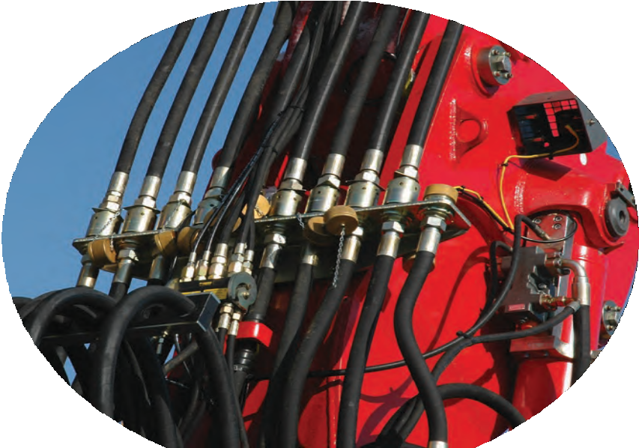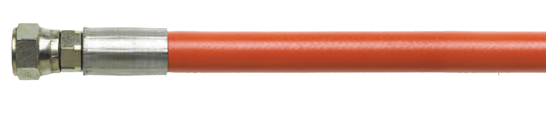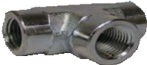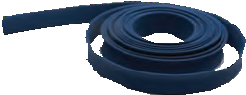CUSTOM SIZES AND OTHER COUPLING CAPABILITIES AVAILABLE ON ALL HOSES. TO PLACE AN ORDER OR SPEAK WITH A CRP REPRESENTATIVE, CALL 800-526-4066.
AIR & FLUID TRANSFER

23

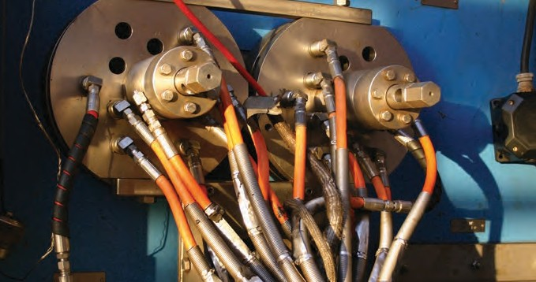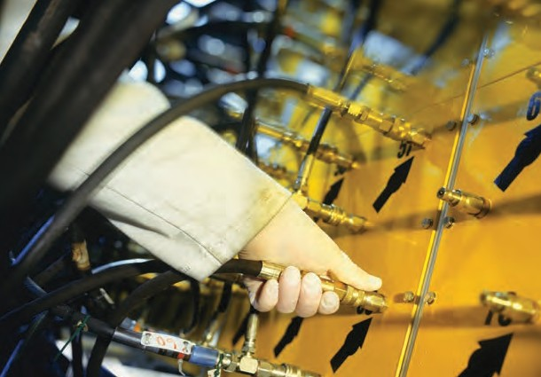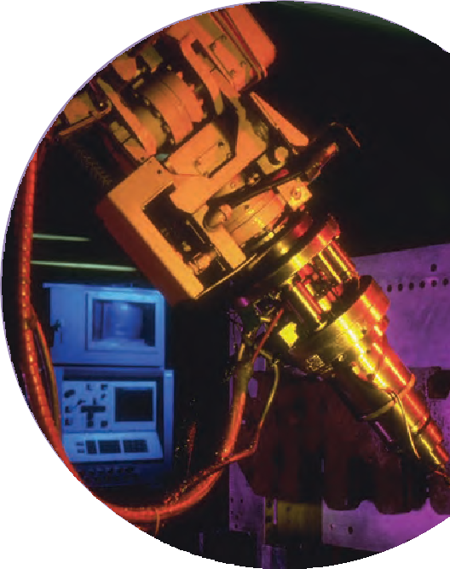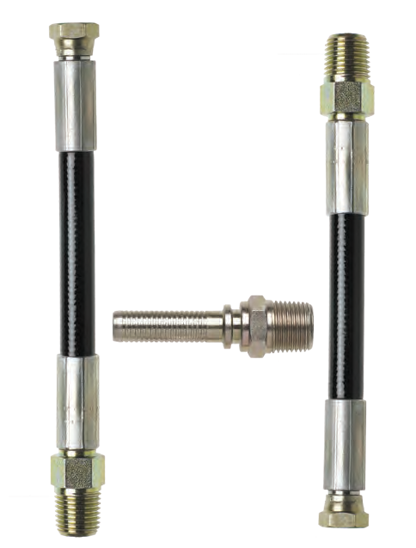

Reinflex’s High Pressure Hydraulic Hoses provide excellent hydraulic response times due to their low volumetric expansion. Unlike some other hose manufacturers, Reinflex offers a TRUE 4 to 1 safety factor on burst pressure. Our thermoplastic hose is lightweight, compact, and won’t deteriorate like rubber hoses. We carry hard to find and custom sizes that will fill in your gaps and prevent your customers from shopping elsewhere. And because CRP is customer service focused, no order is too big or too small, even if you’re ordering
just one hose. CRP Industries is a member of NAHAD.

HIGH PRESSURE HYDRAULIC HOSE FEATURES:
- Low to very high working pressures (up to 10,000 psi)
- UV resistant—does not deteriorate
- Standard fitting options including NPT, NPSM, and JIC in plated or Stainless Steel—male (M) or female (F); other fitting types are available
- Hose sizes from 3/32” up to 1”ID
- Suitable for general hydraulics, bolt torquing, and jacking
- Custom colors available
- Twin line hoses are welded, not taped or clamped

24

1000MK SERIES FABRIC REINFORCED THERMOPLASTIC MICRO-BORE HYDRAULIC HOSE
HIGH PRESSURE HYDRAULICS

High pressure mini bore hose reinforced with synthetic yarn. Ideal for use with petroleum or synthetic hydraulic fluids and gases. Superior electrical conductivity. Resistant to most chemicals, paints, and solvents.

CONSTRUCTION:
Inner: Seamless Poly Tube
Outer: Abrasion and Chemical Resistant Polyurethane Cover

COUPLING CAPABILITIES: NPT, NPSM, JIC Plated or Stainless Steel – M or F
CRP PART NUMBER | COLORS | # OF BRAIDS | NOMINAL I.D.  Inches (MM) | NOMINAL O.D.  Inches (MM) | MINIMUM BEND RADIUS  Inches (MM) | DYNAMIC WORKING PRESSURE | MINIMUM BURST PRESSURE | WEIGHT (LBS/FT) | MAXIMUM LENGTH | TEMPERATURE RANGE
1002MK | n | 1 | 5/64 (2.0) | 0.2 (5.0) | 0.8 (20) | 6,825 psi | 27,300 psi | 0.04 | 4” up to 500’ | -40 to +150ºF
1002MKP | n | 1 | 5/64 (2.0) | 0.2 (5.0) | 0.8 (20) | 6,890 psi | 27,550 psi | 0.04 | 4” up to 500’ | -40 to +150ºF
1003MK | n | 1 | 1/8 (3.0) | 0.28 (7.0) | 1.6 (40) | 5,800 psi | 23,200 psi | 0.07 | 4” up to 500’ | -40 to +150ºF
1004MKP | n | 1 | 5/32 (4.0) | 0.32 (8.0) | 1.4 (35) | 5,980 psi | 23,925 psi | 0.09 | 4” up to 500’ | -40 to +150ºF
1004MK | n | 1 | 5/32 (4.0) | 0.34 (8.6) | 1.6 (40) | 6,380 psi | 25,520 psi | 0.09 | 4” up to 500’ | -40 to +150ºF

1000UKH SERIES FABRIC BRAID REINFORCED LOW TEMP THERMOPLASTIC HYDRAULIC HOSE (100R18)

All-purpose medium pressure 100R18 hose that is compatabile with hydraulic oils, grease, fuel oils, mineral oils, and most phosphate esters, as well as many industrial gases. Offers improved flexiblity at low temperatures and can be used for lift truck applications. Cover is pin-pricked standard.

CONSTRUCTION:
Inner: Polyester Elastomer
Outer: Black Abrasion & Chemical Resistant Polyurethane Cover

COUPLING CAPABILITIES: NPT, NPSM, JIC Plated or Stainless Steel – M or F |  |  |  |  |  |  |  | SPECIFICATION: SAE 100R7
CRP PART NUMBER | COLORS | # OF BRAIDS | NOMINAL I.D.  Inches (MM) |  | NOMINAL O.D.  Inches (MM) |  | MINIMUM BEND RADIUS  Inches (MM) |  |  | DYNAMIC WORKING PRESSURE | MINIMUM BURST PRESSURE | WEIGHT (LBS/FT) | MAXIMUM LENGTH | TEMPERATURE RANGE
1004UKH | n | 1 | 3/16 | (4.8) | 0.38 | (9.6) | 0.98 |  | (25) | 3000 PSI | 12,000 PSI | 0.04 | 4” up to 500’ | -67 to +212ºF*
1006UKH | n | 2 | 1/4 | (6.4) | 0.48 | (12.2) | 1.4 |  | (35) | 3000 PSI | 12,000 PSI | 0.06 | 4” up to 500’ | -67 to +212ºF*
1010UKH | n | 2 | 3/8 | (9.5) | 0.65 (16.6) |  | 1.8 (45) |  |  | 3000 PSI | 12,000 PSI | 0.11 | 4” up to 500’ | -67 to +212ºF*
1013UKH | n | 2 | 1/2 | (12.7) | 0.91 (23.1) |  | 2.8 (70) |  |  | 3000 PSI | 12,000 PSI | 0.20 | 4” up to 500’ | -67 to +212ºF*
1020UKH | n | 2 | 3/4 | (19.1) | 1.24 (31.4) |  | 5.1 |  | (130) | 3000 PSI | 12,000 PSI | 0.33 | 4” up to 500’ | -67 to +212ºF*
*+158ºF for water based fluids

1100UKH SERIES
FABRIC REINFORCED THERMOPLASTIC HYDRAULIC HOSE (100R7)

All-purpose medium pressure 100R7 hose that is compatible with hydraulic oils, grease, fuel oils, mineral oils, and most phosphate esters, as well as many industrial gases. Excellent flexibility and flex fatigue resistance. Cover is pin-pricked standard.

CONSTRUCTION:
Inner: Polyester Elastomer
Outer: Abrasion and Chemical Resistant Polyurethane Cover

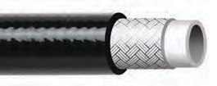
5

COUPLING CAPABILITIES: NPT, NPSM, JIC Plated or Stainless Steel – M or F |  |  |  |  |  |  |  | SPECIFICATION: SAE 100R7
CRP PART NUMBER | COLORS | # OF BRAIDS | NOMINAL I.D.  Inches (MM) |  | NOMINAL O.D.  Inches (MM) |  | MINIMUM BEND RADIUS  Inches (MM) |  |  | DYNAMIC WORKING PRESSURE | MINIMUM BURST PRESSURE | WEIGHT (LBS/FT) | MAXIMUM LENGTH | TEMPERATURE RANGE
1104UKH | n | 1 | 3/16 | (4.8) | 0.41 | (10.4) | 1.5 |  | (38) | 3,000 psi | 12,000 psi | 0.05 | 4” up to 500’ | -40 to +212ºF*
1106UKH | n | 1 | 1/4 | (6.4) | 0.49 | (12.4) | 2.0 |  | (51) | 2,750 psi | 11,000 psi | 0.07 | 4” up to 500’ | -40 to +212ºF*
1110UKH | n | 1 | 3/8 | (9.5) | 0.64 | (16.3) | 2.5 |  | (64) | 2,250 psi | 9,000 psi | 0.10 | 4” up to 500’ | -40 to +212ºF*
1113UKH | n | 1 | 1/2 | (12.7) | 0.78 | (19.9) | 3.2 |  | (82) | 2,000 psi | 8,000 psi | 0.14 | 4” up to 500’ | -40 to +212ºF*
1120UKH | n | 1 | 3/4 | (19.1) | 1.03 | (26.1) | 7.0 |  | (178) | 1,250 psi | 5,000 psi | 0.20 | 4” up to 300’ | -40 to +212ºF*
1125UKH | n | 1 | 1 | (25.4) | 1.28 | (32.5) | 8.0 |  | (203) | 1,000 psi | 4,000 psi | 0.25 | 4” up to 300’ | -40 to +212ºF*
*+158ºF for water based fluids

CUSTOM SIZES AND OTHER COUPLING CAPABILITIES AVAILABLE ON ALL HOSES.
TO PLACE AN ORDER OR SPEAK WITH A CRP REPRESENTATIVE, CALL 800-526-4066. 2

1200UKH SERIES
FABRIC REINFORCED THERMOPLASTIC HYDRAULIC HOSE (100R8)

All-purpose medium pressure 100R8 hose that is compatible with hydraulic oils, grease, fuel oils, mineral oils, and most phosphate esters, as well as many industrial gases. Excellent flexibility and flex fatigue resistance. Cover is pin-pricked standard.
MSHA cover available upon request.
CONSTRUCTION:
Inner: Polyester Elastomer
Outer: Abrasion and Chemical Resistant Polyurethane Cover

COUPLING CAPABILITIES: NPT, NPSM, JIC Plated or Stainless Steel – M or F |  |  |  |  |  |  |  | SPECIFICATION: SAE 100R8
CRP PART NUMBER | COLORS | # OF BRAIDS | NOMINAL I.D.  Inches (MM) |  | NOMINAL O.D.  Inches (MM) |  | MINIMUM BEND RADIUS  Inches (MM) |  |  | DYNAMIC WORKING PRESSURE | MINIMUM BURST PRESSURE | WEIGHT (LBS/FT) | MAXIMUM LENGTH | TEMPERATURE RANGE
1204UKH | n | 1 | 3/16 | (4.8) | 0.35 | (8.9) | 1.2 |  | (31) | 5,000 psi | 20,000 psi | 0.04 | 4” up to 500’ | -40 to +212ºF*
1206UKH | n | 1 | 1/4 | (6.4) | 0.45 | (11.4) | 2.0 |  | (51) | 5,000 psi | 20,000 psi | 0.06 | 4” up to 500’ | -40 to +212ºF*
1210UKH | n | 1 | 3/8 | (9.5) | 0.61 | (15.5) | 2.4 |  | (61) | 4,000 psi | 16,000 psi | 0.09 | 4” up to 500’ | -40 to +212ºF*
1213UKH | n | 1 | 1/2 | (12.7) | 0.78 | (19.8) | 3.2 |  | (82) | 3,500 psi | 14,000 psi | 0.14 | 4” up to 500’ | -40 to +212ºF*
1220UKH | n | 1 | 3/4 | (19.1) | 1.06 | (26.9) | 6.0 |  | (152) | 2,300 psi | 9,200 psi | 0.21 | 4” up to 300’ | -40 to +212ºF*
1225UKH | n | 1 | 1 | (25.4) | 1.35 | (34.3) | 8.0 |  | (203) | 2,000 psi | 8,000 psi | 0.31 | 4” up to 300’ | -40 to +212ºF*
*+158ºF for water based fluids

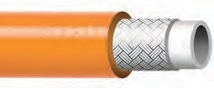1000UKNC SERIES FABRIC BRAID REINFORCED THERMOPLASTIC HYDRAULIC HOSE

All-purpose medium pressure non-conductive hose reinforced with a single braid of polyester fiber. Ideal where non-conductivity is required. Suitable for grease, fuel oils, mineral oils, and phosphate esters. Excellent flexibility and flex fatigue resistance.

CONSTRUCTION:
Inner: Polyester Elastomer
Outer: Abrasion and Chemical Resistant Polyurethane Cover

COUPLING CAPABILITIES: NPT, NPSM, JIC Plated or Stainless Steel – M or F |  |  |  |  |  |  |  | SPECIFICATION: SAE 100R7
CRP PART NUMBER | COLORS | # OF BRAIDS | NOMINAL I.D.  Inches (MM) |  | NOMINAL O.D.  Inches (MM) |  | BEND RADIUS  Inches (MM) |  |  | MINIMUM WORKING PRESSURE | DYNAMIC BURST PRESSURE | MINIMUM WEIGHT (LBS/FT) | MAXIMUM LENGTH | TEMPERATURE RANGE
1004UKNC | n | 1 | 3/16 | (4.8) | 0.41 | (10.4) | 1.5 |  | (38) | 3,000 psi | 12,000 psi | 0.05 | 4” up to 500’ | -40 to +212ºF*
1006UKNC | n | 1 | 1/4 | (6.4) | 0.49 | (12.4) | 2.0 |  | (51) | 2,750 psi | 11,000 psi | 0.07 | 4” up to 500’ | -40 to +212ºF*
1010UKNC | n | 1 | 3/8 | (9.5) | 0.64 | (16.3) | 2.5 |  | (64) | 2,250 psi | 9,000 psi | 0.10 | 4” up to 300’ | -40 to +212ºF*
1013UKNC | n | 1 | 1/2 | (12.7) | 0.78 | (19.9) | 3.2 |  | (82) | 2,000 psi | 8,000 psi | 0.14 | 4” up to 300’ | -40 to +212ºF*
1020UKNC | n | 1 | 3/4 | (19.0) | 1.03 | (26.1) | 7.0 |  | (178) | 1,250 psi | 5,000 psi | 0.20 | 4” up to 200’ | -40 to +212ºF*
1025UKNC | n | 1 | 1 | (25.4) | 1.28 | (32.5) | 8.0 |  | (203) | 1,000 psi | 4,000 psi | 0.25 | 4” up to 200’ | -40 to +212ºF*
*+158ºF for water based fluids

1000UKT SERIES WIRE REINFORCED TWIN LINE THERMOPLASTIC HYDRAULIC HOSE

High pressure, high performance twin line hose reinforced with a steel braid. Guaranteed electrical conductivity. Resistant to a wide range of paints, chlorinated solvents, and other chemicals. Extremely durable. Cover is pin-pricked standard.

CONSTRUCTION:
Inner: Seamless Nylon 6 Liner
Outer: Abrasion and Chemical Resistant Polyurethane Cover

COUPLING CAPABILITIES: NPT, NPSM, JIC Standard-Plated or Stainless Steel, M or F
CRP PART NUMBER | COLORS | # OF BRAIDS | NOMINAL I.D.  Inches (MM) | NOMINAL O.D.  Inches (MM) | MINIMUM BEND RADIUS  Inches (MM) | DYNAMIC WORKING PRESSURE | MINIMUM BURST PRESSURE | WEIGHT (LBS/FT) | MAXIMUM LENGTH | TEMPERATURE RANGE
1006UKT |  | 1 | 1/4 (6.4) | 0.46 (11.7) | 1.5 (37) | 5,000 psi | 18,000 psi | 0.22 | 4” up to 200’ | -40 to +212ºF
1010UKT |  | 1 | 3/8 (9.5) | 0.60 (15.1) | 2.0 (50) | 3,500 psi | 13,000 psi | 0.30 | 4” up to 200’ | -40 to +212ºF
1013UKT |  | 1 | 1/2 (12.7) | 0.72 (18.3) | 3.0 (75) | 3,000 psi | 12,000 psi | 0.40 | 4” up to 200’ | -40 to +212ºF

26

1000UKTNC SERIES FABRIC REINFORCED TWIN LINE THERMOPLASTIC HYDRAULIC HOSE
HIGH PRESSURE HYDRAULICS

All-purpose medium pressure non-conductive twin line hose reinforced with a single braid of polyester fiber. Ideal where non-conductivity is required. Suitable for grease, fuel oils, mineral oils, and phosphate esters. Excellent flexibility and flex fatigue resistance.

CONSTRUCTION:
Inner: Polyester Elastomer Liner
Outer: Abrasion and Chemical Resistant Polyurethane Cover

COUPLING CAPABILITIES: NPT, NPSM, JIC Plated or Stainless Steel – M or F |  |  |  |  |  | SPECIFICATION: SAE 100R7
CRP PART NUMBER | COLORS | # OF BRAIDS | NOMINAL I.D.  Inches (MM) | NOMINAL O.D.  Inches (MM) | MINIMUM BEND RADIUS  Inches (MM) |  | DYNAMIC WORKING PRESSURE | MINIMUM BURST PRESSURE | WEIGHT (LBS/FT) | MAXIMUM LENGTH | TEMPERATURE RANGE
1010UKTNC | n | 1 | 3/8 (9.5) | 0.64 (16.3) | 2.5 (64) |  | 2,250 psi | 9,000 psi | 0.20 | 4” up to 200’ | -40 to +212ºF*
1013UKTNC | n | 1 | 1/2 (12.7) | 0.78 (19.9) | 3.2 (82) |  | 2,000 psi | 8,000 psi | 0.28 | 4” up to 200’ | -40 to +212ºF*
*+158ºF for water based fluids

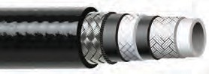2000UK SERIES WIRE AND FABRIC REINFORCED THERMOPLASTIC HYDRAULIC HOSE

A high pressure, high performance hydraulic hose with wire and Kevlar braid reinforcement for strength and guaranteed electrical conductivity. Offers optimum resistance to a wide range of paints, chlorinated solvents, and other chemicals. Extremely durable. Cover is pin-pricked standard.

CONSTRUCTION:
Inner: Seamless Nylon 12 Liner
Outer: Abrasion and Chemical Resistant Polyurethane Cover

COUPLING CAPABILITIES: NPT, NPSM, JIC Plated or Stainless Steel – M or F
CRP PART NUMBER | COLORS | # OF BRAIDS | NOMINAL I.D.  Inches (MM) | NOMINAL O.D.  Inches (MM) | MINIMUM BEND RADIUS  Inches (MM) | DYNAMIC WORKING PRESSURE | MINIMUM BURST PRESSURE | WEIGHT (LBS/FT) | MAXIMUM LENGTH | TEMPERATURE RANGE
2025UK | n | 3 | 1 (25.4) | 1.46 (37.1) | 10.0 (254) | 4,750 psi | 19,000 psi | 0.61 | 4” up to 300’ | -40 to +212ºF*
*+158ºF for water based fluids

2000UKNC SERIES FABRIC BRAID REINFORCED THERMOPLASTIC HYDRAULIC HOSE

All-purpose medium pressure non-conductive hose reinforced with a single braid of polyester fiber. Ideal where non-conductivity is required. Suitable for grease, fuel oils, mineral oils, and phosphate esters. Excellent flexibility and flex fatigue resistance.

CONSTRUCTION:
Inner: Polyester Elastomer Liner
Outer: Abrasion and Chemical Resistant Polyurethane Cover

7
COUPLING CAPABILITIES: NPT, NPSM, JIC Plated or Stainless Steel – M or F |  |  |  |  |  |  |  | SPECIFICATION: SAE 100R8
CRP PART NUMBER | COLORS | # OF BRAIDS | NOMINAL I.D.  Inches (MM) |  | NOMINAL O.D.  Inches (MM) |  | MINIMUM BEND RADIUS  Inches (MM) |  |  | DYNAMIC WORKING PRESSURE | MINIMUM BURST PRESSURE | WEIGHT (LBS/FT) | MAXIMUM LENGTH | TEMPERATURE RANGE
2004UKNC | n | 1 | 3/16 | (4.8) | 0.41 | (10.4) | 1.5 |  | (38) | 5,000 psi | 20,000 psi | 0.05 | 4” up to 500’ | -40 to +212ºF*
2006UKNC | n | 1 | 1/4 | (6.4) | 0.49 | (12.4) | 2.0 |  | (51) | 5,000 psi | 20,000 psi | 0.07 | 4” up to 500’ | -40 to +212ºF*
2010UKNC | n | 1 | 3/8 | (9.5) | 0.63 | (15.9) | 2.5 |  | (64) | 4,000 psi | 16,000 psi | 0.10 | 4” up to 500’ | -40 to +212ºF*
2013UKNC | n | 1 | 1/2 | (12.7) | 0.78 | (19.9) | 3.2 |  | (82) | 3,500 psi | 14,000 psi | 0.13 | 4” up to 300’ | -40 to +212ºF*
2020UKNC | n | 1 | 3/4 | (19.1) | 1.04 | (26.5) | 5.91 |  | (150) | 2,300 psi | 9,200 psi | 0.24 | 4” up to 300’ | -40 to +212ºF*
*+158ºF for water based fluids

CUSTOM SIZES AND OTHER COUPLING CAPABILITIES AVAILABLE ON ALL HOSES.
TO PLACE AN ORDER OR SPEAK WITH A CRP REPRESENTATIVE, CALL 800-526-4066. 2

2000UKTNC SERIES FABRIC BRAID REINFORCED TWIN LINE THERMOPLASTIC HYDRAULIC HOSE

All-purpose medium pressure non-conductive twin line welded hose reinforced with a single braid of polyester fiber. Ideal where non-conductivity is required. Suitable for grease, fuel oils, mineral oils, and phosphate esters. Excellent flexibility and flex fatigue resistance.

CONSTRUCTION:
Inner: Polyester Elastomer Liner
Outer: Abrasion and Chemical Resistant Polyurethane Cover

COUPLING CAPABILITIES: NPT, NPSM, JIC Plated or Stainless Steel – M or F |  |  |  |  |  | SPECIFICATION: SAE 100R8
CRP PART NUMBER | COLORS | # OF BRAIDS | NOMINAL I.D.  Inches (MM) | NOMINAL O.D.  Inches (MM) | MINIMUM BEND RADIUS  Inches (MM) |  | DYNAMIC WORKING PRESSURE | MINIMUM BURST PRESSURE | WEIGHT (LBS/FT) | MAXIMUM LENGTH | TEMPERATURE RANGE
2006UKTNC | n | 1 | 1/4 (6.4) | 0.46 (11.7) | 2.0 (51) |  | 5,000 psi | 20,000 psi | 0.14 | 4” up to 200’ | -40 to +212ºF*
2010UKTNC | n | 1 | 3/8 (9.5) | 0.63 (15.9) | 5.0 (127) |  | 4,000 psi | 16,000 psi | 0.20 | 4” up to 200’ | -40 to +212ºF*
*+158ºF for water based fluids

2100UK SERIES WIRE & FABRIC BRAID REINFORCED THERMOPLASTIC HYDRAULIC HOSE

High pressure, high performance hydraulic hose reinforced with a braid of steel and polyaramid yarn. Compatible with hydraulic oils, grease, fuel oils, mineral oils, and most phosphate esters. Superior flexibility and bend radii.

CONSTRUCTION:
Inner: Polyester Elastomer Liner
Outer: Abrasion and Chemical Resistant Polyurethane Cover

COUPLING CAPABILITIES: NPT, NPSM, JIC Plated or Stainless Steel – M or F
CRP PART NUMBER | COLORS | # OF BRAIDS | NOMINAL I.D.  Inches (MM) | NOMINAL O.D.  Inches (MM) | MINIMUM BEND RADIUS  Inches (MM) | DYNAMIC WORKING PRESSURE | MINIMUM BURST PRESSURE | WEIGHT (LBS/FT) | MAXIMUM LENGTH | TEMPERATURE RANGE
2106UK | nnnn | 2 | 1/4 (6.4) | 0.54 (13.7) | 1.5 (38) | 10,000 psi | 40,000 psi | 0.15 | 4” up to 500’ | -40 to +212ºF*
2110UK | n | 2 | 3/8 (9.5) | 0.74 (18.8) | 3.8 (95) | 10,000 psi | 40,000 psi | 0.24 | 4” up to 300’ | -40 to +212ºF*
*+158ºF for water based fluids

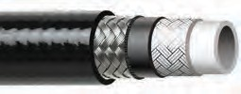2100UKN SERIES WIRE & FABRIC BRAID REINFORCED THERMOPLASTIC HYDRAULIC HOSE

High pressure, high performance hose with steel and Kevlar braid reinforcement to ensure mechanical strength. Superior resistance to most
paints, chemicals, and solvents. Cover is pin-pricked for gas applications.

CONSTRUCTION:
Inner: Seamless Nylon 12 Liner
Outer: Abrasion and Chemical Resistant Polyurethane Cover

COUPLING CAPABILITIES: NPT, NPSM, JIC Plated or Stainless Steel – M or F
CRP PART NUMBER | COLORS | # OF BRAIDS | NOMINAL I.D.  Inches (MM) | NOMINAL O.D.  Inches (MM) | MINIMUM BEND RADIUS  Inches (MM) | DYNAMIC WORKING PRESSURE | MINIMUM BURST PRESSURE | WEIGHT (LBS/FT) | MAXIMUM LENGTH | TEMPERATURE RANGE
2113UKN | n | 2 | 1/2 (12.7) | 0.82 (20.8) | 5.0 (127) | 6,500 psi | 26,000 psi | 0.28 | 4” up to 300’ | -40 to +212ºF*
2120UKN | n | 3 | 3/4 (19.1) | 1.16 (29.5) | 8.0 (203) | 6,500 psi | 26,000 psi | 0.45 | 4” up to 300’ | -40 to +212ºF*
*+158ºF for water based fluids

28

2100UKT SERIES WIRE & FABRIC BRAID TWIN LINE THERMOPLASTIC HYDRAULIC HOSE
HIGH PRESSURE HYDRAULICS

High pressure, high performance twin line welded hose reinforced with a braid of steel and polyaramid yarn. Compatible with hydraulic oils, grease, fuel oils, mineral oils, and most phosphate esters. Superior flexibility and bend radii.

CONSTRUCTION:
Inner: Polyester Elastomer Liner
Outer: Abrasion and Chemical Resistant Polyurethane Cover

COUPLING CAPABILITIES: NPT, NPSM, JIC Plated or Stainless Steel – M or F
CRP PART NUMBER | COLORS | # OF BRAIDS | NOMINAL I.D.  Inches (MM) | NOMINAL O.D.  Inches (MM) | MINIMUM BEND RADIUS  Inches (MM) | DYNAMIC WORKING PRESSURE | MINIMUM BURST PRESSURE | WEIGHT (LBS/FT) | MAXIMUM LENGTH | TEMPERATURE RANGE
2106UKT |  | 2 | 1/4 (6.4) | 0.54 (13.7) | 1.5 (38) | 10,000 psi | 40,000 psi | 0.30 | 4” up to 500’ | -40 to +212ºF*
NOTE: Other colors available upon request. *+158ºF for water based fluids

2100TNC SERIES FABRIC REINFORCED THERMOPLASTIC HYDRAULIC HOSE

All purpose high pressure non conductive hose suitable for many hydraulic and pneumetic systems. Reinforced with two braids of polyamid fiber.
Compatable with hydraulic oils, grease, fuel oils, phosphat esters, and many industrial gases. Excel- lent flexiblity and flex fatigue resistance.

CONSTRUCTION:
Inner: Polyester Elastomer Liner
Outer: Abrasion Resistant Polyurethane Cover

COUPLING CAPABILITIES: NPT, NPSM, JIC Plated or Stainless Steel – M or F
CRP PART NUMBER | COLORS | # OF BRAIDS | NOMINAL I.D.  Inches (MM) | NOMINAL O.D.  Inches (MM) | MINIMUM BEND RADIUS  Inches (MM) | DYNAMIC WORKING PRESSURE | MINIMUM BURST PRESSURE | WEIGHT (LBS/FT) | MAXIMUM LENGTH | TEMPERATURE RANGE
2104TNC | n | 2 | 3/16 (4.8) | 0.43 (10.9) | 1.2 (30.5) | 10,000 psi | 40,000 psi | 0.15 | 4” up to 300’ | -40 to +212ºF*
2106KNC | n | 2 | 1/4 (6.4) | 0.54 (13.7) | 1.5 (38) | 10,000 psi | 40,000 psi | 0.24 | 4” up to 300’ | -40 to +212ºF*
*+158ºF for water based fluids

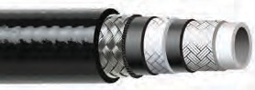3000UK SERIES WIRE & FABRIC REINFORCED THERMOPLASTIC HYDRAULIC HOSE

High pressure, high performance hose with steel and Kevlar braid reinforcement to ensure strength. Superior resistance to most chemicals, paints, and solvents.

CONSTRUCTION:
Inner: Seamless Nylon 12 Liner
Outer: Abrasion and Chemical Resistant Polyurethane Cover

9

COUPLING CAPABILITIES: NPT, NPSM, JIC Plated or Stainless Steel – M or F
CRP PART NUMBER | COLORS | # OF BRAIDS | NOMINAL I.D.  Inches (MM) | NOMINAL O.D.  Inches (MM) | MINIMUM BEND RADIUS  Inches (MM) | DYNAMIC WORKING PRESSURE | MINIMUM BURST PRESSURE | WEIGHT (LBS/FT) | MAXIMUM LENGTH | TEMPERATURE RANGE
3013UK | n | 3 | 1/2 (12.7) | 0.90 (22.9) | 5.0 (127) | 8,500 psi | 34,000 psi | 0.33 | 4” up to 300’ | -40 to +212ºF*
3113UK | n | 3 | 1/2 (12.7) | 0.90 (22.9) | 5.0 (127) | 10,000 psi | 32,000 psi | 0.33 | 4” up to 300’ | -40 to +212ºF*
*+158ºF for water based fluids

CUSTOM SIZES AND OTHER COUPLING CAPABILITIES AVAILABLE ON ALL HOSES.
TO PLACE AN ORDER OR SPEAK WITH A CRP REPRESENTATIVE, CALL 800-526-4066. 2

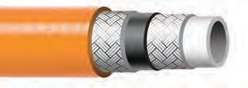2100UKNC SERIES FABRIC REINFORCED THERMOPLASTIC HYDRAULIC HOSE

All-purpose high pressure non-conductive hose suitable for many hydraulic and pneumatic systems. Reinforced with a single braid of polyamid fibers. Compatible with hydraulic oils, grease, fuel oils, mineral oils, phosphate esters, and many industrial gases. Excellent flexibility and flex fatigue resistance.

CONSTRUCTION:
Inner: Polyester Elastomer Liner
Outer: Abrasion Resistant Polyurethane Cover

COUPLING CAPABILITIES: NPT, NPSM, JIC Plated or Stainless Steel – M or F
CRP PART NUMBER | COLORS | # OF BRAIDS | NOMINAL I.D.  Inches (MM) | NOMINAL O.D.  Inches (MM) | MINIMUM BEND RADIUS  Inches (MM) | DYNAMIC WORKING PRESSURE | MINIMUM BURST PRESSURE | WEIGHT (LBS/FT) | MAXIMUM LENGTH | TEMPERATURE RANGE
2104KNC | n | 2 | 3/16 (4.8) | 0.43 (10.9) | 1.2 (30.5) | 10,000 psi | 40,000 psi | 0.06 | 4” up to 300’ | -40 to +212ºF*
2106UKNC | n | 2 | 1/4 (6.4) | 0.54 (13.7) | 1.5 (38) | 10,000 psi | 40,000 psi | 0.11 | 4” up to 200’ | -40 to +212ºF*
*+158ºF for water based fluids

2100RH SERIES
WIRE REINFORCED RUBBER HYDRAULIC HOSE

All purpose high pressure rubber hose for many hydraulic and pneumetic systems. Reinforced with two braids of high tensile wire. Compatable with hydraulic oils, grease, fuel oils, phosphat esters, and many industrial gases. Excellent flexiblity and flex fatigue resistance.

CONSTRUCTION:
Inner: Synethic Rubber
Outer: Abrasion Resistant Rubber Cover

COUPLING CAPABILITIES: NPT, NPSM, JIC Plated or Stainless Steel – M or F
CRP PART NUMBER | COLORS | # OF BRAIDS | NOMINAL I.D.  Inches (MM) | NOMINAL O.D.  Inches (MM) | MINIMUM BEND RADIUS  Inches (MM) | DYNAMIC WORKING PRESSURE | MINIMUM BURST PRESSURE | WEIGHT (LBS/FT) | MAXIMUM LENGTH | TEMPERATURE RANGE
2106RH | n | 2 | 1/4 (6.4) | 0.58 (14.7) | 4.0 (101.6) | 10,000 psi | 20,000 psi | 0.27 | 4” up to 300’ | -40 to +212ºF*
2110RH | n | 2 | 3/8 (9.5) | 0.71 (18.0) | 4.0 (101.6) | 10,150 psi | 20,300 psi | 0.32 | 4” up to 300’ | -40 to +212ºF*
*+158ºF for water based fluids

Reinflex also carries all the hose accessories you need. See pages 48-62 for details.

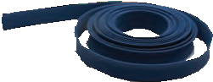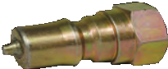

HOSE JACKETS

PRESSURE GAUGES

QUICK COUPLERS

30

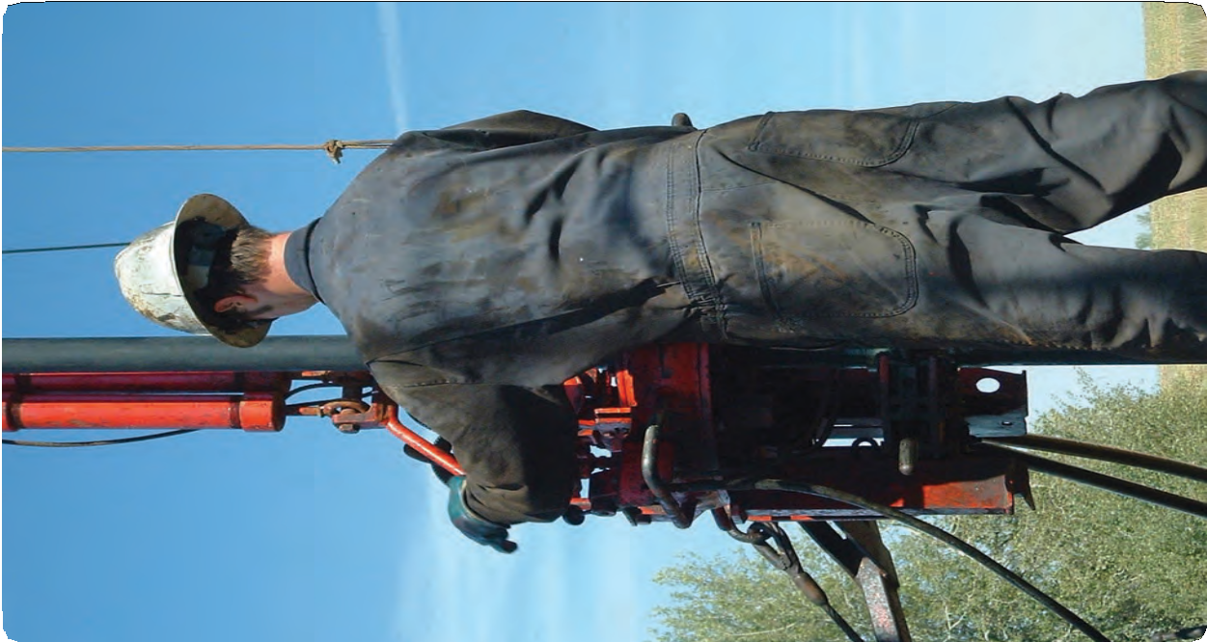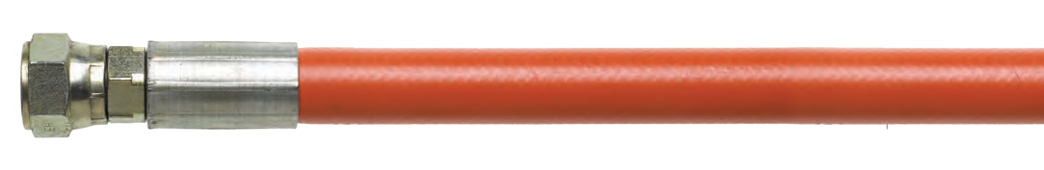HIGH PRESSURE HYDRAULICS
31

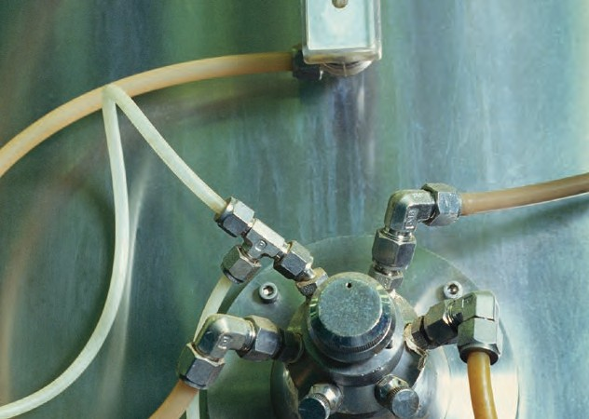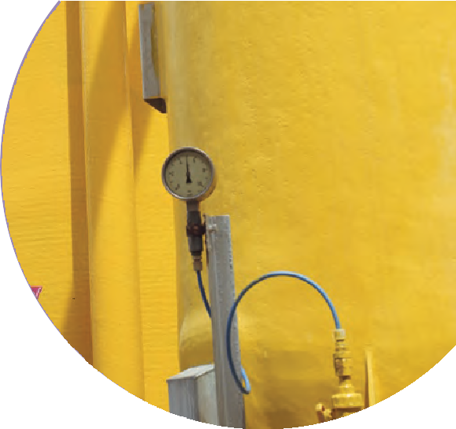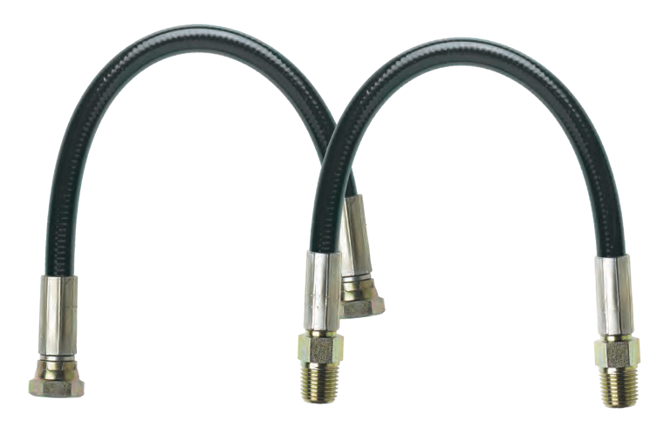
32

1000MK SERIES FABRIC REINFORCED THERMOPLASTIC MICRO-BORE HOSE

High pressure micro-bore hose reinforced with synthetic yarn. Ideal for use with petroleum or synthetic hydraulic fluids and gases. Resistant to most chemicals, paints, and solvents.

CONSTRUCTION:
Inner: Seamless Poly Tube
Outer: Abrasion and Chemical Resistant Polyurethane Cover

COUPLING CAPABILITIES: NPT, NPSM, JIC Standard-Plated or Stainless Steel – M or F
CRP PART NUMBER | COLORS | # OF BRAIDS | NOMINAL I.D.  Inches (MM) | NOMINAL O.D.  Inches (MM) | MINIMUM BEND RADIUS  Inches (MM) | DYNAMIC WORKING PRESSURE | MINIMUM BURST PRESSURE | WEIGHT (LBS/FT) | MAXIMUM LENGTH | TEMPERATURE RANGE
1002MK | n | 1 | 5/64 (2.0) | 0.2 (5.0) | 0.8 (20) | 6,825 psi | 27,300 psi | 0.04 | 4” up to 500’ | -40 to +150ºF
1002MKP | n | 1 | 5/64 (2.0) | 0.2 (5.0) | 0.8 (20) | 6,890 psi | 27,550 psi | 0.07 | 4” up to 500’ | -40 to +150ºF
1003MK | n | 1 | 1/8 (3.0) | 0.28 (7.0) | 1.6 (40) | 5,800 psi | 23,200 psi | 0.07 | 4” up to 500’ | -40 to +150ºF
1004MKP | n | 1 | 5/32 (4.0) | 0.32 (8.0) | 1.4 (35) | 5,980 psi | 23,925 psi | 0.09 | 4” up to 500’ | -40 to +150ºF
1004MK | n | 1 | 5/32 (4.0) | 0.34 (8.6) | 1.6 (40) | 6,380 psi | 25,520 psi | 0.09 | 4” up to 500’ | -40 to +150ºF

Reinflex also carries all the hose accessories you need. See pages 48-62 for details.

BALL VALVES PRESSURE GAUGES

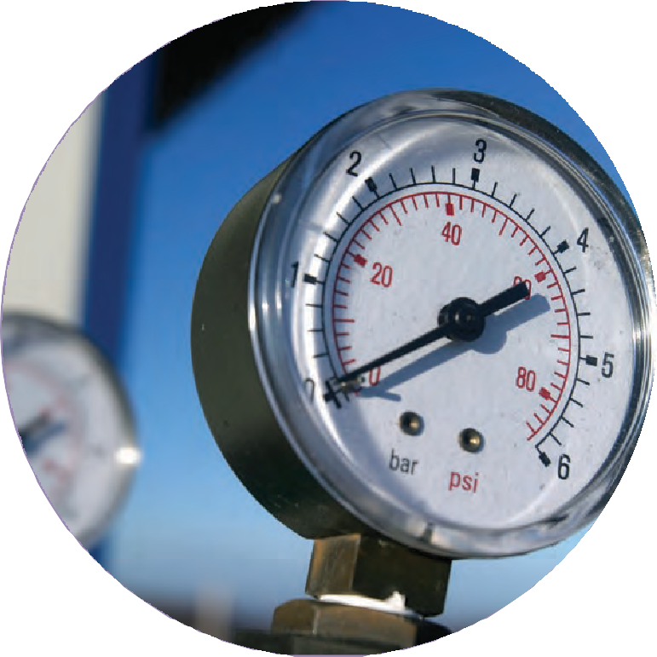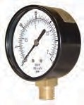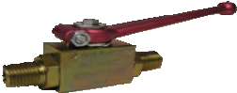CUSTOM SIZES AND OTHER COUPLING CAPABILITIES AVAILABLE ON ALL HOSES. TO PLACE AN ORDER OR SPEAK WITH A CRP REPRESENTATIVE, CALL 800-526-4066.
MICRO-BORE HOSES

33

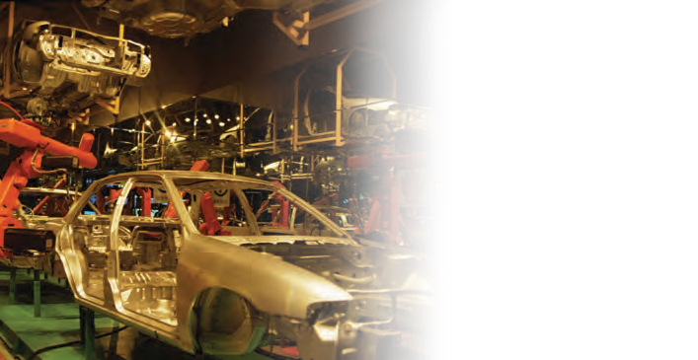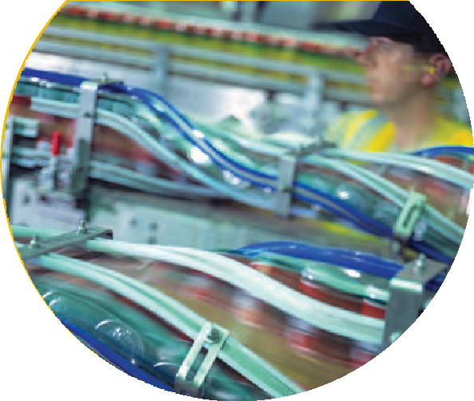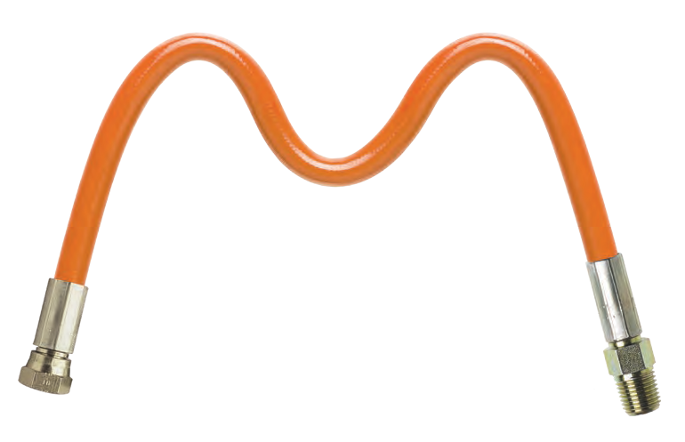
”

n

Reinflex is one of only a few suppliers of moisture resistant hose. Our hydro-bloc thermoplastic high pressure hose
is an excellent alternative to PTFE and is ideal for a wide variety of applications using simple to medium moisture sensitive products. We carry a wide range of fittings as well as offering custom fabrication options, so you can enjoy the convenience of one-stop shopping for all of your moisture resistant hose needs.

MOISTURE RESISTANT FEATURES:
  - Working pressures from low to high (up to 6,000 psi)
  - Hose sizes from 1/4” to 3/4”
  - Wide range of fittings including NPT, NPSM, and JIC
  - Custom fabrications available
  - Lengths up to 300’
  - Suitable for a wide variety of applications including caulking, foam, and polyurea

To expedite delivery, our orders are often drop shipped from CRP. So sometimes we don’t see products before the customer does
“
— but we trust CRP to get it right.
34

1000HB SERIES FABRIC REINFORCED THERMOPLASTIC MOISTURE RESISTANT HOSE
MOISTURE RESISTANT

Moisture resistant high performance hose with fabric braid reinforcement. Resistant to most chemicals, solvents, and paint. Ideal for the transfer of aggressive mediums that are reactive to moisture.

CONSTRUCTION:
Inner: Polyaimide Tube
Outer: Abrasion and Chemical Resistant Polyurethane Cover

COUPLING CAPABILITIES: NPT, NPSM, JIC Plated or Stainless Steel – M or F |  |  |  |  |  | SPECIFICATION: SAE 100R7
CRP PART NUMBER | COLORS | # OF BRAIDS | NOMINAL I.D.  Inches (MM) | NOMINAL O.D.  Inches (MM) | MINIMUM BEND RADIUS  Inches (MM) |  | DYNAMIC WORKING PRESSURE | MINIMUM BURST PRESSURE | WEIGHT (LBS/FT) | MAXIMUM LENGTH | TEMPERATURE RANGE
1006HB | n | 1 | 1/4 (6.4) | 0.47 (11.8) | 1.4 (35) |  | 2,900 psi | 11,600 psi | 0.07 | 4” up to 300’ | -40 to +212ºF
1010HB | n | 1 | 3/8 (9.5) | 0.63 (16.0) | 2.2 (55) |  | 2,537 psi | 10,150 psi | 0.09 | 4” up to 300’ | -40 to +212ºF
1013HB | n | 1 | 1/2 (12.7) | 0.80 (20.3) | 3.0 (75) |  | 2,030 psi | 8,120 psi | 0.12 | 4” up to 300’ | -40 to +212ºF
1020HB | n | 1 | 3/4 (19.1) | 1.04 (26.5) | 5.7 (145) |  | 1,305 psi | 5,220 psi | 0.25 | 4” up to 300’ | -40 to +212ºF

2000UHB SERIES WIRE REINFORCED THERMOPLASTIC MOISTURE RESISTANT HOSE

Moisture resistant high pressure, high performance hose with steel braid reinforcement for strength and guaranteed electrical conductivity in the order of 1.0 ohms/meter. Resistant to most chemicals, solvents, and paint. Ideal for the transfer of aggressive mediums that are reactive to moisture.

CONSTRUCTION:
Inner: Seamless Nylon 12 Liner
Outer: Abrasion and Chemical Resistant Polyester Elastomer Non-Pin Pricked Cover

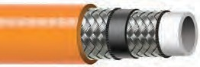
5
COUPLING CAPABILITIES: NPT, NPSM, JIC Plated or Stainless Steel – M or F
CRP PART NUMBER | COLORS | # OF BRAIDS | NOMINAL I.D.  Inches (MM) | NOMINAL O.D.  Inches (MM) | MINIMUM BEND RADIUS  Inches (MM) | DYNAMIC WORKING PRESSURE | MINIMUM BURST PRESSURE | WEIGHT (LBS/FT) | MAXIMUM LENGTH | TEMPERATURE RANGE
1004UHB | n | 1 | 3/16 (4.8) | 0.37 (9.4) | 1.0 (25.4) | 5,250 psi | 21,000 psi | 0.21 | 4” up to 300’ | -40 to +212ºF
2006UHB | n | 2 | 1/4 (6.4) | 0.54 (13.7) | 1.0 (25) | 6,170 psi | 24,680 psi | 0.21 | 4” up to 300’ | -40 to +212ºF
2010UHB | n | 2 | 3/8 (9.5) | 0.67 (17.0) | 1.5 (37) | 5,100 psi | 20,400 psi | 0.28 | 4” up to 300’ | -40 to +212ºF
2013UHB | n | 2 | 1/2 (12.7) | 0.80 (20.2) | 2.5 (62) | 5,000 psi | 17,000 psi | 0.34 | 4” up to 300’ | -40 to +212ºF
2020UHB | n | 2 | 3/4 (19.1) | 1.07 (27.1) | 6.7 (170) | 3,100 psi | 12,400 psi | 0.50 | 4” up to 300’ | -40 to +212ºF
2120UHB | n | 3 | 3/4 (19.1) | 1.16 (29.5) | 8.0 (203) | 6,000 psi | 24,000 psi | 0.44 | 4” up to 300’ | -40 to +212ºF*
*+158ºF for water based fluids

CUSTOM SIZES AND OTHER COUPLING CAPABILITIES AVAILABLE ON ALL HOSES.
TO PLACE AN ORDER OR SPEAK WITH A CRP REPRESENTATIVE, CALL 800-526-4066. 3

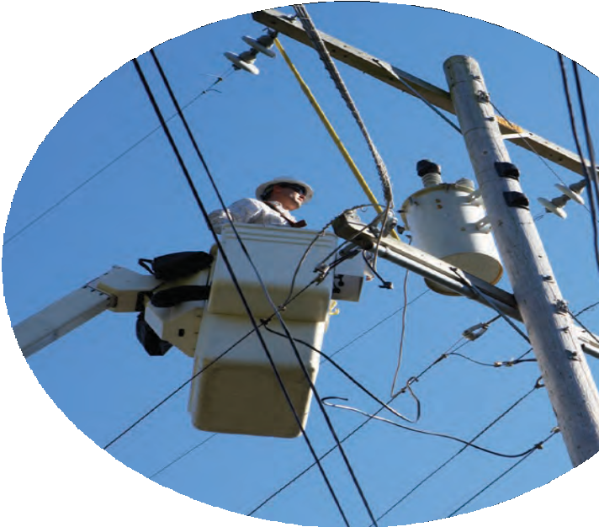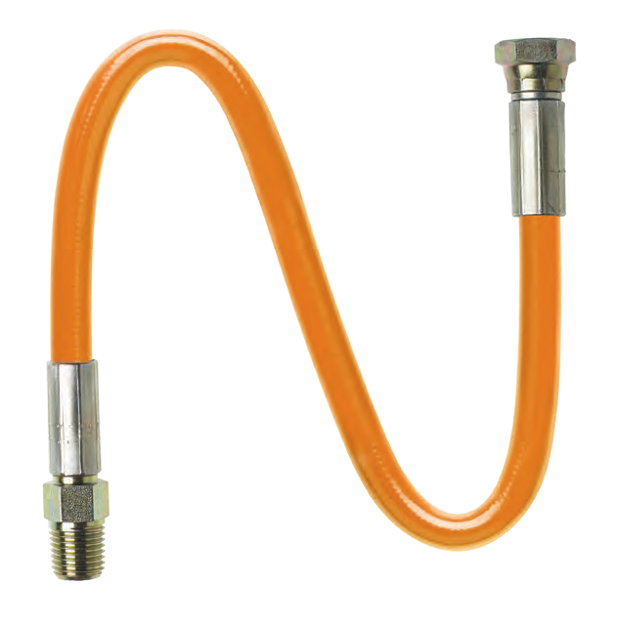

36

1000UKNC SERIES FABRIC BRAID REINFORCED THERMOPLASTIC HOSE
NON-CONDUCTIVE HOSE

All-purpose medium pressure hose reinforced with a single braid of polyester fiber. Ideal where non-conductivity is required. Suitable for grease, fuel oils, mineral oils, and phosphate esters. Excellent flexibility and flex fatigue resistance.

CONSTRUCTION:
Inner: Polyester Elastomer Liner
Outer: Abrasion Resistant Polyurethane Cover

COUPLING CAPABILITIES: NPT, NPSM, JIC Plated or Stainless Steel – M or F |  |  |  |  |  | SPECIFICATION: SAE 100R7
CRP PART NUMBER | COLORS | # OF BRAIDS | NOMINAL I.D.  Inches (MM) | NOMINAL O.D.  Inches (MM) | MINIMUM BEND RADIUS  Inches (MM) |  | DYNAMIC WORKING PRESSURE | MINIMUM BURST PRESSURE | WEIGHT (LBS/FT) | MAXIMUM LENGTH | TEMPERATURE RANGE
1004UKNC | n | 1 | 3/16 (4.8) | 0.41 (10.4) | 1.5 (38) |  | 3,000 psi | 12,000 psi | 0.05 | 4” up to 500’ | -40 to +212ºF*
1006UKNC | n | 1 | 1/4 (6.4) | 0.49 (12.4) | 2.0 (51) |  | 2,750 psi | 11,000 psi | 0.07 | 4” up to 500’ | -40 to +212ºF*
1010UKNC | n | 1 | 3/8 (9.5) | 0.64 (16.3) | 2.5 (64) |  | 2,250 psi | 9,000 psi | 0.10 | 4” up to 300’ | -40 to +212ºF*
1013UKNC | n | 1 | 1/2 (12.7) | 0.78 (19.9) | 3.2 (82) |  | 2,000 psi | 8,000 psi | 0.14 | 4” up to 300’ | -40 to +212ºF*
1020UKNC | n | 1 | 3/4 (19.1) | 1.03 (26.1) | 7.0 (178) |  | 1,250 psi | 5,000 psi | 0.20 | 4” up to 200’ | -40 to +212ºF*
1025UKNC | n | 1 | 1 (25.4) | 1.28 (32.5) | 8.0 (203) |  | 1,000 psi | 4,000 psi | 0.25 | 4” up to 200’ | -40 to +212ºF*
*+158ºF for water based fluids

1000UKTNC SERIES FABRIC REINFORCED TWIN LINE THERMOPLASTIC HOSE

All-purpose high pressure non-conductive twin line hose suitable for many hydraulic and pneumatic systems. Reinforced with a single braid of polyaramid fiber. Compatible with hydraulic oils, grease, fuel oils, mineral oils, phosphate esters, and many industrial gases. Excellent flexibilty and flex fatigue resistance.

CONSTRUCTION:
Inner: Polyester Elastomer Liner
Outer: Abrasion Resistant Polyurethane Cover

COUPLING CAPABILITIES: NPT, NPSM, JIC Plated or Stainless Steel – M or F |  |  |  |  |  | SPECIFICATION: SAE 100R7
CRP PART NUMBER | COLORS | # OF BRAIDS | NOMINAL I.D.  Inches (MM) | NOMINAL O.D.  Inches (MM) | MINIMUM BEND RADIUS  Inches (MM) |  | DYNAMIC WORKING PRESSURE | MINIMUM BURST PRESSURE | WEIGHT (LBS/FT) | MAXIMUM LENGTH | TEMPERATURE RANGE
1010UKTNC | n | 1 | 3/8 (9.5) | 0.64 (16.3) | 2.5 (64) |  | 2,250 psi | 9,000 psi | 0.20 | 4” up to 200’ | -40 to +212ºF*
1013UKTNC | n | 1 | 1/2 (12.7) | 0.78 (19.9) | 3.2 (82) |  | 2,000 psi | 8,000 psi | 0.28 | 4” up to 200’ | -40 to +212ºF*
*+158ºF for water based fluids

2000UKNC SERIES FABRIC BRAID REINFORCED THERMOPLASTIC HOSE

All-purpose medium pressure hose reinforced with a single braid of polyester fiber. Ideal where non-conductivity is required. Suitable for grease, fuel oils, mineral oils, and phosphate esters. Excellent flexibility and flex fatigue resistance.

CONSTRUCTION:
Inner: Polyester Elastomer Liner
Outer: Abrasion Resistant Polyurethane Cover

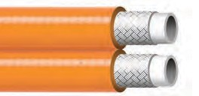
7
COUPLING CAPABILITIES: NPT, NPSM, JIC Plated or Stainless Steel – M or F |  |  |  |  |  |  |  | SPECIFICATION: SAE 100R8
CRP PART NUMBER | COLORS | # OF BRAIDS | NOMINAL I.D.  Inches (MM) |  | NOMINAL O.D.  Inches (MM) |  | MINIMUM BEND RADIUS  Inches (MM) |  |  | DYNAMIC WORKING PRESSURE | MINIMUM BURST PRESSURE | WEIGHT (LBS/FT) | MAXIMUM LENGTH | TEMPERATURE RANGE
2004UKNC | n | 1 | 3/16 | (4.8) | 0.41 | (10.4) | 1.5 |  | (38) | 5,000 psi | 20,000 psi | 0.05 | 4” up to 500’ | -40 to +212ºF*
2006UKNC | n | 1 | 1/4 | (6.4) | 0.49 | (12.4) | 2.0 |  | (51) | 5,000 psi | 20,000 psi | 0.07 | 4” up to 500’ | -40 to +212ºF*
2010UKNC | n | 1 | 3/8 | (9.5) | 0.63 | (15.9) | 2.5 |  | (64) | 4,000 psi | 16,000 psi | 0.10 | 4” up to 500’ | -40 to +212ºF*
2013UKNC | n | 1 | 1/2 | (12.7) | 0.78 | (19.9) | 3.2 |  | (82) | 3,500 psi | 14,000 psi | 0.13 | 4” up to 300’ | -40 to +212ºF*
2020UKNC | n | 1 | 3/4 | (19.1) | 1.04 | (26.5) | 5.91 |  | (150) | 2300 psi | 9200 psi | 0.24 | 4” up to 300’ | -40 to +212ºF*
*+158ºF for water based fluids

CUSTOM SIZES AND OTHER COUPLING CAPABILITIES AVAILABLE ON ALL HOSES.
TO PLACE AN ORDER OR SPEAK WITH A CRP REPRESENTATIVE, CALL 800-526-4066. 3

2000UKTNC SERIES FABRIC REINFORCED TWIN LINE THERMOPLASTIC HOSE

All-purpose high pressure non-conductive twin line hose suitable for many hydraulic and pneumatic systems. Reinforced with a single braid of polyaramid fiber. Compatible with hydraulic oils, grease, fuel oils, mineral oils, phosphate esters, and many industrial gases. Excellent flexibility and flex fatigue resistance.

CONSTRUCTION:
Inner: Polyester Elastomer Liner
Outer: Abrasion Resistant Polyurethane Cover

COUPLING CAPABILITIES: NPT, NPSM, JIC Plated or Stainless Steel – M or F |  |  |  |  |  | SPECIFICATION: SAE 100R8
CRP PART NUMBER | COLORS | # OF BRAIDS | NOMINAL I.D.  Inches (MM) | NOMINAL O.D.  Inches (MM) | MINIMUM BEND RADIUS  Inches (MM) |  | DYNAMIC WORKING PRESSURE | MINIMUM BURST PRESSURE | WEIGHT (LBS/FT) | MAXIMUM LENGTH | TEMPERATURE RANGE
2006UKTNC | n | 1 | 1/4 (6.4) | 0.46 (11.7) | 2.0 (51) |  | 5,000 psi | 20,000 psi | 0.14 | 4” up to 200’ | -40 to +212ºF*
2010UKTNC | n | 1 | 3/8 (9.5) | 0.63 (15.) | 5.0 (127) |  | 4,000 psi | 16,000 psi | 0.20 | 4” up to 200’ | -40 to +212ºF*
*+158ºF for water based fluids

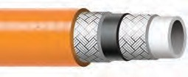2100UKNC SERIES FABRIC REINFORCED THERMOPLASTIC HOSE

All-purpose high pressure non-conductive hose suitable for many hydraulic and pneumatic systems. Reinforced with a single braid of polyaramid fiber. Compatible with hydraulic oils, grease, fuel oils, mineral oils, phosphate esters, and many industrial gases. Excellent flexibility and flex fatigue resistance.

CONSTRUCTION:
Inner: Polyester Elastomer Liner
Outer: Abrasion Resistant Polyurethane Cover

COUPLING CAPABILITIES: NPT, NPSM, JIC Plated or Stainless Steel – M or F
CRP PART NUMBER | COLORS | # OF BRAIDS | NOMINAL I.D.  Inches (MM) | NOMINAL O.D.  Inches (MM) | MINIMUM BEND RADIUS  Inches (MM) | DYNAMIC WORKING PRESSURE | MINIMUM BURST PRESSURE | WEIGHT (LBS/FT) | MAXIMUM LENGTH | TEMPERATURE RANGE
2104KNC | n | 2 | 3/16 (4.8) | 0.43 (10.9) | 1.2 (30.5) | 10,000 psi | 40,000 psi | 0.06 | 4” up to 300’ | -40 to +212ºF*
2106UKNC | n | 2 | 1/4 (6.4) | 0.54 (13.7) | 1.5 (38) | 10,000 psi | 40,000 psi | 0.11 | 4” up to 200’ | -40 to +212ºF*
*+158ºF for water based fluids

2100TNC SERIES FABRIC REINFORCED TWIN LINE THERMOPLASTIC HOSE

All purpose high pressure non-conductive hose suitable for many hydraulic and pneumetic systems. Reinforced with two braids of polyamid fiber.
Compatable with hydraulic oils, grease, fuel oils, phosphat esters, and many industrial gases. Excellent flexiblity and flex fatigue resistance.

CONSTRUCTION:
Inner: Polyester Elastomer Liner
Outer: Abrasion Resistant Polyurethane Cover

COUPLING CAPABILITIES: NPT, NPSM, JIC Plated or Stainless Steel – M or F
CRP PART NUMBER | COLORS | # OF BRAIDS | NOMINAL I.D.  Inches (MM) | NOMINAL O.D.  Inches (MM) | MINIMUM BEND RADIUS  Inches (MM) | DYNAMIC WORKING PRESSURE | MINIMUM BURST PRESSURE | WEIGHT (LBS/FT) | MAXIMUM LENGTH | TEMPERATURE RANGE
2104TNC | n | 2 | 3/16 (4.8) | 0.43 (10.9) | 1.2 (30.5) | 10,000 psi | 40,000 psi | 0.15 | 4” up to 300’ | -40 to +212ºF*
2106KNC | n | 2 | 1/4 (6.4) | 0.54 (13.7) | 1.5 (38) | 10,000 psi | 40,000 psi | 0.24 | 4” up to 300’ | -40 to +212ºF*
*+158ºF for water based fluids

Reinflex also carries all the hose accessories you need. See pages 48-62 for details.

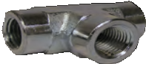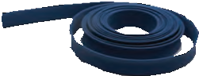 38

ADAPTERS

PRESSURE GAUGES

HOSE JACKETS

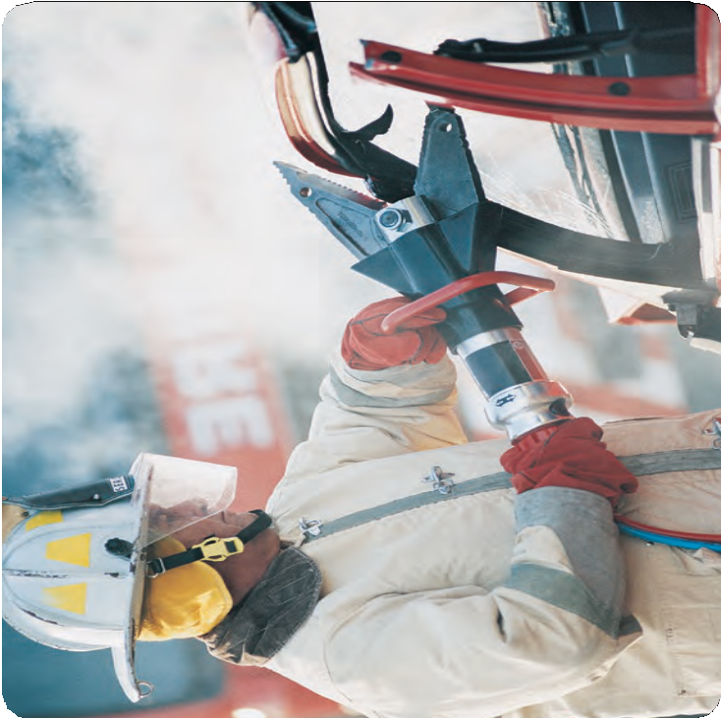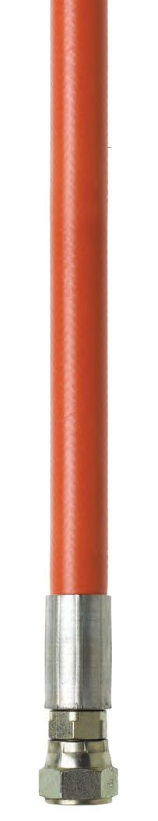NON-CONDUCTIVE HOSE
Non-Conductive
39

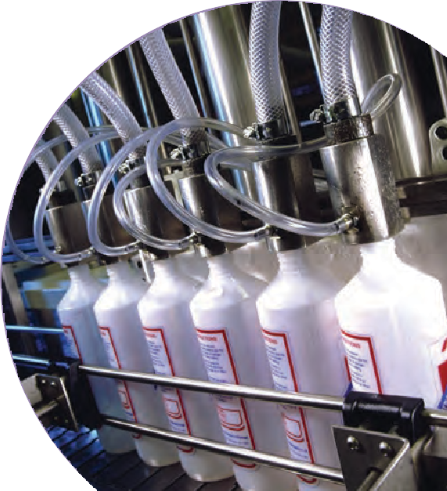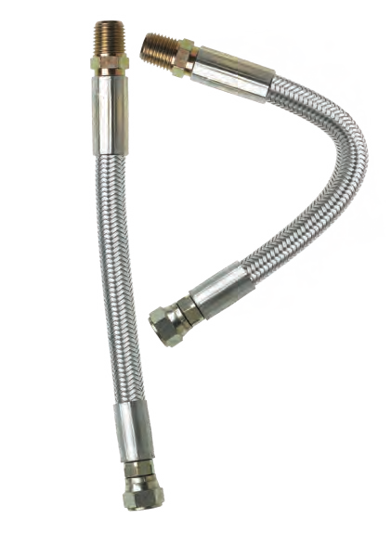

From lightweight to steel wire reinforced, Reinflex’s PTFE and FEP Hoses are the ultimate moisture barrier and are non-clogging. Unlike many PTFE hoses on the market, ours are True Bore to ensure that the system performance meets flow rate specifications. In addition, Reinflex’s PTFE and FEP Hoses are available in very long lengths — another benefit that is atypical for the industry. We carry a multitude of end fittings, including plated and stainless steel that allow for quick shipping turnaround. Of course, custom lengths and fittings are also available depending on your application needs.

PTFE HOSE FEATURES:
- Working pressures from low to high (up to 6,162 psi)
- Hose sizes from 3/16” to 1”
- Fitting options include NPT, NPSM, and JIC in Stainless Steel, male (M) or female (F). (No need for adapters.)
- Lengths from 4” up to 200’
- Suitable for foams, caulks, and products that require heating or are moisture sensitive

40

100K SERIES STAINLESS STEEL BRAID REINFORCED PTFE HOSE

High pressure, high performance PTFE hose with stainless steel braid reinforcement for strength and guaranteed electrical conductivity. Superior resistance to most chemicals, paints, and solvents. Lightweight and flexible in comparison to conventional multi-spirals.

CONSTRUCTION:
Inner: Seamless PTFE Liner
Outer: Abrasion Resistant Stainless Steel Braid Cover

COUPLING CAPABILITIES: NPT, NPSM, JIC Plated or Stainless Steel – M or F
CRP PART NUMBER | COLORS | # OF BRAIDS | NOMINAL I.D.  Inches (MM) | NOMINAL O.D.  Inches (MM) | MINIMUM BEND RADIUS  Inches (MM) | DYNAMIC WORKING PRESSURE | MINIMUM BURST PRESSURE | WEIGHT (LBS/FT) | MAXIMUM LENGTH | TEMPERATURE RANGE
105K | n | 1 | 3/16 (4.7) | 0.31 (7.9) | 2.5 (64) | 3,000 psi | 12,000 psi | 0.07 | 4” up to 200’ | -65 to +450ºF
106K | n | 1 | 1/4 (6.4) | 0.37 (9.4) | 3.0 (76) | 3,000 psi | 12,000 psi | 0.10 | 4” up to 200’ | -65 to +450ºF
110K | n | 1 | 3/8 (9.5) | 0.51 (13.0) | 5.0 (127) | 2,000 psi | 8,000 psi | 0.11 | 4” up to 200’ | -65 to +450ºF
113K | n | 1 | 1/2 (12.7) | 0.63 (16.0) | 6.5 (165) | 1,750 psi | 7,000 psi | 0.16 | 4” up to 200’ | -65 to +450ºF
120K | n | 1 | 3/4 (19) | 0.88 (2.4) | 8.5 (216) | 1,000 psi | 4,000 psi | 0.20 | 4” up to 50’ | -65 to +450ºF

200K SERIES STAINLESS STEEL BRAID REINFORCED PTFE HOSE

Very high pressure, high performance PTFE lined hose with stainless steel braid reinforcement for strength and guaranteed electrical conductivity. Superior resistance to most chemicals, paints, and solvents. Lightweight and flexible in comparison to conventional multi-spirals.

CONSTRUCTION:
Inner: Seamless PTFE Liner
Outer: Abrasion Resistant Stainless Steel Braid Cover

COUPLING CAPABILITIES: NPT, NPSM, JIC Plated or Stainless Steel – M or F
CRP PART NUMBER | COLORS | # OF BRAIDS | NOMINAL I.D.  Inches (MM) | NOMINAL O.D.  Inches (MM) | MINIMUM BEND RADIUS  Inches (MM) | DYNAMIC WORKING PRESSURE | MINIMUM BURST PRESSURE | WEIGHT (LBS/FT) | MAXIMUM LENGTH | TEMPERATURE RANGE
206K | n | 2 | 1/4 (6.4) | 0.44 (11.4) | 3.0 (76) | 3,990 psi | 15,950 psi | 0.16 | 4” up to 200’ | -65 to +450ºF
210K | n | 2 | 3/8 (9.5) | 0.60 (15.2) | 4.25 (108) | 3,260 psi | 13,050 psi | 0.24 | 4” up to 200’ | -65 to +450ºF
213K | n | 2 | 1/2 (12.7) | 0.74 (18.8) | 5.32 (135) | 2,900 psi | 11,600 psi | 0.32 | 4” up to 100’ | -65 to +450ºF
220K | n | 2 | 3/4 (19.0) | 1.0 (25.4) | 7.9 (200) | 2,180 psi | 8,700 psi | 0.45 | 4” up to 50’ | -65 to +450ºF
225K | n | 2 | 1 (25.4) | 1.3 (33) | 13.0 (330) | 1,810 psi | 7,540 psi | 0.50 | 4” up to 50’ | -65 to +450ºF

200ST SERIES STEEL BRAID REINFORCED FEP CORE THERMOPLASTIC HOSE

Ultra high pressure, high performance hose with steel braid and spiral reinforcement for strength and guaranteed electrical conductivity. Lightweight, flexible, and a tight bend radius, with superior resistance to most chemicals, paints, and solvents.

CONSTRUCTION:
Inner: Seamless FEP Liner
Outer: Abrasion and Chemical Resistant Polyurethane Cover

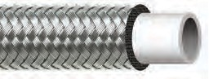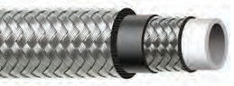
1
PTFE HOSE

COUPLING CAPABILITIES: NPT, NPSM, JIC Plated or Stainless Steel – M or F
CRP PART NUMBER | COLORS | # OF BRAIDS | NOMINAL I.D.  Inches (MM) | NOMINAL O.D.  Inches (MM) | MINIMUM BEND RADIUS  Inches (MM) | DYNAMIC WORKING PRESSURE | MINIMUM BURST PRESSURE | WEIGHT (LBS/FT) | MAXIMUM LENGTH | TEMPERATURE RANGE
206ST | n | 3 | 1/4 (6.4) | 0.49 (12.4) | 2.5 (64) | 6,162 psi | 24,650 psi | 0.18 | 4” up to 100’ | -40 to +176ºF
210ST | n | 3 | 3/8 (9.5) | 0.68 (17.3) | 4.5 (114) | 5,000 psi | 20,000 psi | 0.31 | 4” up to 50’ | -40 to +176ºF
213ST | n | 3 | 1/2 (12.7) | 0.81 (20.6) | 5.5 (140) | 4,710 psi | 18,850 psi | 0.39 | 4” up to 50’ | -40 to +176ºF
220ST | n | 3 | 3/4 (19.0) | 1.14 (29.0) | 8.0 (203) | 3,840 psi | 15,230 psi | 0.67 | 4” up to 50’ | -40 to +176ºF
225ST | n | 3 | 1 (25.4) | 1.33 (34.0) | 9.4 (240) | 3,262 psi | 13,050 psi | 0.87 | 4” up to 50’ | -40 to +176ºF

SANITARY AND CONVOLUTED PTFE HOSE ASSEMBLIES ARE AVAILABLE. CUSTOM SIZES AND OTHER COUPLING CAPABILITIES AVAILABLE ON ALL HOSES.
TO PLACE AN ORDER OR SPEAK WITH A CRP REPRESENTATIVE, CALL 800-526-4066. 4

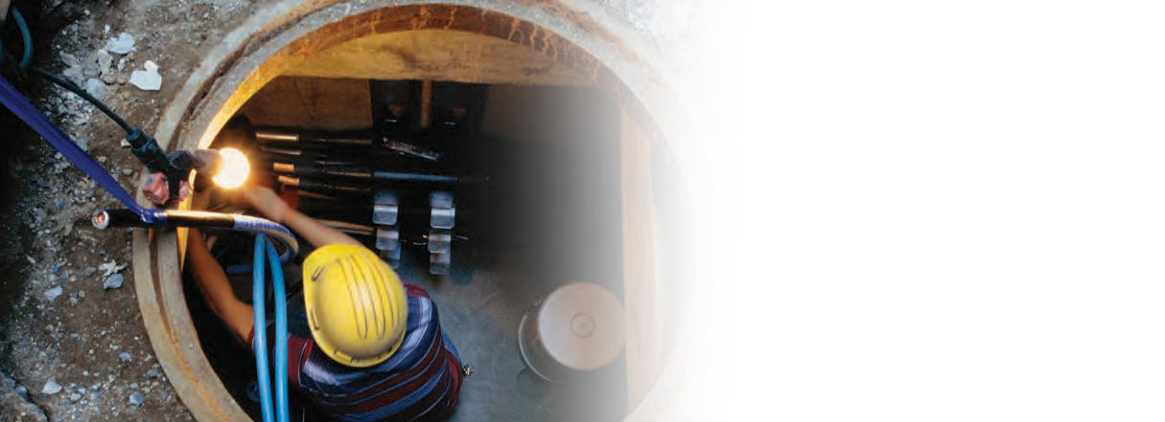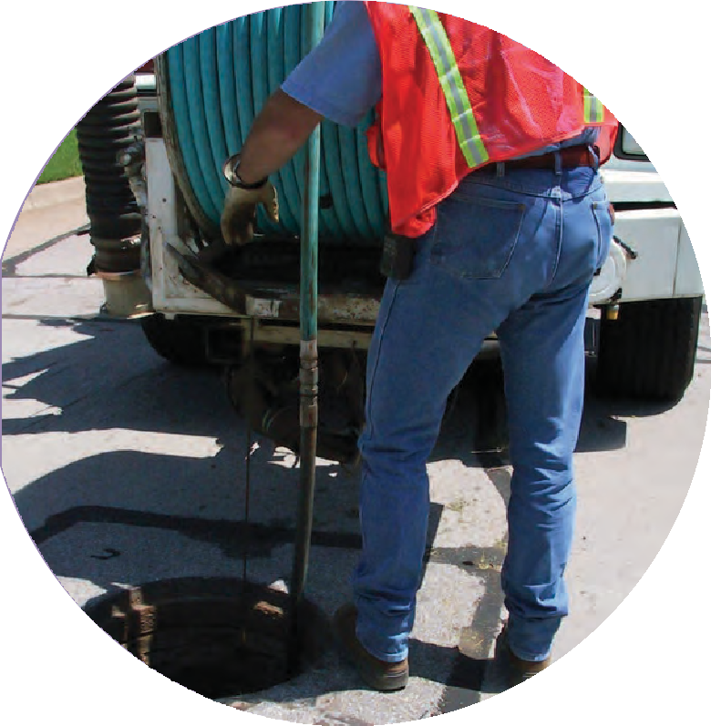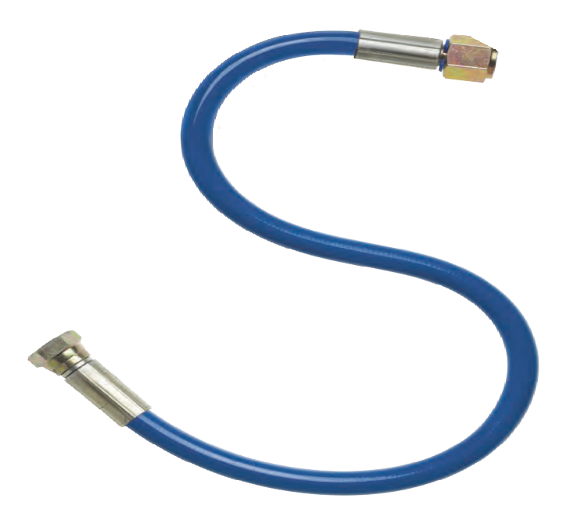

Backed by OE quality, Reinflex’s Sewer Jetting Hoses meet the requirements for all sewer equipment. It is ideal for high pressure applications in even the most harsh sewer environments. Lightweight fabric or steel wire reinforced, our sewer jetting hose is available in many standard stocking assemblies, allowing us to drop ship anywhere quickly. For those requiring hose in long lengths, we are also able to provide speedy turnaround. In addition,
we can design custom fittings and fabrications based on your application needs, and of course, no job is too big or too small.

SEWER JETTING HOSE FEATURES:
  - Working pressures from low to very high (6,170 psi)
  - Fitting options — NPT, NPSM, and JIC in plated or Stainless Steel – male (M) or female (F)
  - Lengths from 4” up to 600’
  - Hose sizes (ID) from 1/8” to 1”
  - Provides excellent abrasion and fungus resistance
  - Meets Waste Equipment Technology Association (WETA) specifications

42

1000SJ SERIES FABRIC BRAID REINFORCED THERMOPLASTIC SEWER JETTING HOSE

Sewer Line Jetting Hose with high tensile fabric braid reinforcement. Provides excellent abrasion, cut, and fungus resistance. Meets Waste Equipment Technology Association specifications.

CONSTRUCTION:
Inner: Yellow Olefin Tube
Outer: Abrasion and Chemical Resistant Polyurethane Cover

COUPLING CAPABILITIES: NPT, NPSM, JIC Plated or Stainless Steel – M or F
CRP PART NUMBER | COLORS | # OF BRAIDS | NOMINAL I.D.  Inches (MM) |  | NOMINAL O.D.  Inches (MM) |  | MINIMUM BEND RADIUS  Inches (MM) |  | DYNAMIC WORKING PRESSURE | MINIMUM BURST PRESSURE | WEIGHT (LBS/FT) | MAXIMUM LENGTH | TEMPERATURE RANGE
1003SJ | n | 2 | 1/8 | (3.2) | 0.32 | (8.1) | 1.3 | (32) | 4,000 psi | 10,000 psi | 0.04 | 4” up to 600’ | -40 to +150ºF
1004SJ | n | 2 | 3/16 | (4.8) | 0.41 | (10.4) | 1.8 | (45) | 4,000 psi | 10,000 psi | 0.05 | 4” up to 600’ | -40 to +150ºF
1006SJ | n | 2 | 1/4 | (6.4) | 0.50 | (12.7) | 2.5 | (64) | 4,000 psi | 10,000 psi | 0.06 | 4” up to 600’ | -40 to +150ºF
1010SJ | n | 2 | 3/8 | (9.5) | 0.65 | (16.5) | 3.0 | (76) | 4,000 psi | 10,000 psi | 0.11 | 4” up to 600’ | -40 to +150ºF
1020SJ | n | 1 | 3/4 | (19.1) | 1.18 | (29.9) | 5.0 | (127) | 2,500 psi | 6,250 psi | 0.28 | 4” up to 600’ | -40 to +150ºF
1025SJ | n | 1 | 1 | (25.4) | 1.46 | (37.1) | 6.0 | (152) | 2,500 psi | 6,250 psi | 0.40 | 4” up to 600’ | -40 to +150ºF

1000AV SERIES FABRIC BRAID REINFORCED THERMOPLASTIC SEWER JETTING HOSE

A high pressure semi-conductive thermoplastic hose that will not swell or degrade when
in contact with most chemicals, oils, and solvents. Extremely durable. Ideal for where electrostatic charge must be dissipated and high temperature applications.

CONSTRUCTION:
Inner: Seamless Nylon Liner
Outer: Abrasion and Chemical Resistant Polyurethane Cover

COUPLING CAPABILITIES: NPT, NPSM, JIC Plated or Stainless Steel – M or F
CRP PART NUMBER | COLORS | # OF BRAIDS | NOMINAL I.D.  Inches (MM) | NOMINAL O.D.  Inches (MM) | MINIMUM BEND RADIUS  Inches (MM) | DYNAMIC WORKING PRESSURE | MINIMUM BURST PRESSURE | WEIGHT (LBS/FT) | MAXIMUM LENGTH | TEMPERATURE RANGE
1003AV | n | 1 | 1/8 (3.2) | 0.32 (8.1) | 1.3 (32) | 3,500 psi | 14,000 psi | 0.03 | 4” up to 500’ | 0 to 180ºF
1004AV | n | 2 | 3/16 (4.8) | 0.43 (10.9) | 1.8 (45) | 3,500 psi | 14,000 psi | 0.05 | 4” up to 500’ | 0 to 180ºF
1006AV | n | 2 | 1/4 (6.4) | 0.49 (12.5) | 2.5 (64) | 3,300 psi | 13,200 psi | 0.05 | 4” up to 500’ | 0 to 180ºF
1010AV | n | 2 | 3/8 (9.5) | 0.72 (18.2) | 3.0 (76) | 3,300 psi | 13,200 psi | 0.11 | 4” up to 500’ | 0 to 180ºF

2000AV SERIES FABRIC BRAID REINFORCED THERMOPLASTIC SEWER JETTING HOSE

Large Bore Sewer Line Jetting Hose with high tensile fabric braid reinforcement. Provides excellent abrasion, cut, and fungus resistance meets Waste Equipment Technology Association specifications.

CONSTRUCTION:
Inner: Olefin Tube
Outer: Abrasion and Chemical Resistant Polyurethane Cover

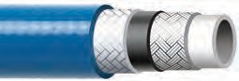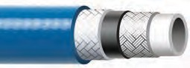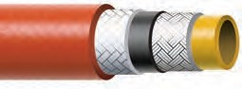
3
SEWER JETTING

COUPLING CAPABILITIES: NPT, NPSM, JIC Plated or Stainless Steel – M or F
CRP PART NUMBER | COLORS | # OF BRAIDS | NOMINAL I.D.  Inches (MM) | NOMINAL O.D.  Inches (MM) | MINIMUM BEND RADIUS  Inches (MM) | DYNAMIC WORKING PRESSURE | MINIMUM BURST PRESSURE | WEIGHT (LBS/FT) | MAXIMUM LENGTH | TEMPERATURE RANGE
2013AV | n | 2 | 1/2 (12.7) | 0.87 (22.1) | 3.0 (76) | 4,000 psi | 12,000 psi | 0.20 | 4” up to 600’ | -40 to +150ºF
2020AV | n | 2 | 3/4 (19.1) | 1.18 (29.9) | 5.0 (127) | 3,000 psi | 7,500 psi | 0.29 | 4” up to 600’ | -40 to +150ºF
2025AV | n | 2 | 1 (25.4) | 1.48 (37.6) | 8.0 (203) | 3,000 psi | 7,500 psi | 0.41 | 4” up to 600’ | -40 to +150ºF

CUSTOM SIZES AND OTHER COUPLING CAPABILITIES AVAILABLE ON ALL HOSES.
TO PLACE AN ORDER OR SPEAK WITH A CRP REPRESENTATIVE, CALL 800-526-4066. 4

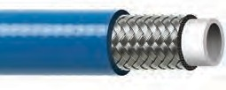1000UK SERIES WIRE REINFORCED THERMOPLASTIC SEWER JETTING HOSE

A high pressure, high performance hose with steel braid reinforcement for strength and guaranteed electrical conductivity. Offers optimum resistance to a wide range of chlorinated solvents, and other chemicals. Extremely durable. Cover is pin-pricked standard.

CONSTRUCTION:
Inner: Seamless Nylon Liner
Outer: Abrasion and Chemical Resistant Polyurethane Cover

COUPLING CAPABILITIES: NPT, NPSM, JIC Plated or Stainless Steel – M or F
CRP PART NUMBER | COLORS | # OF BRAIDS | NOMINAL I.D.  Inches (MM) | NOMINAL O.D.  Inches (MM) | MINIMUM BEND RADIUS  Inches (MM) | DYNAMIC WORKING PRESSURE | MINIMUM BURST PRESSURE | WEIGHT (LBS/FT) | MAXIMUM LENGTH | TEMPERATURE RANGE
1003K | n | 1 | 1/8 (3.2) | 0.27 (7.0) | 1.2 (30) | 5,075 psi | 20,300 psi | 0.04 | 4” up to 500’ | -40 to +212ºF
1004UK | n n | 1 | 3/16 (4.8) | 0.37 (9.4) | 1.0 (25) | 5,250 psi | 21,000 psi | 0.08 | 4” up to 500’ | -40 to +212ºF
1006UK | n n | 1 | 1/4 (6.4) | 0.46 (11.7) | 1.5 (37) | 5,000 psi | 18,000 psi | 0.11 | 4” up to 500’ | -40 to +212ºF
1010UK | n n | 1 | 3/8 (9.5) | 0.60 (15.1) | 2.0 (50) | 3,500 psi | 13,000 psi | 0.15 | 4” up to 500’ | -40 to +212ºF
1013UK | n n | 1 | 1/2 (12.7) | 0.72 (18.3) | 3.0 (75) | 3,000 psi | 12,000 psi | 0.20 | 4” up to 500’ | -40 to +212ºF

2000UK SERIES WIRE REINFORCED THERMOPLASTIC SEWER JETTING HOSE

A high pressure, high performance Sewer Jetting Hose with steel braid reinforcement for strength and guaranteed electrical conductivity. Offers optimum resistance to a wide range of paints, chlorinated solvents, and other chemicals. Extremely durable.
Cover is pin-pricked standard.

CONSTRUCTION:
Inner: Seamless Nylon 6 Liner = 2006/2010/2013 Seamless Nylon 12 Liner = 2020/2025
Outer: Abrasion and Chemical Resistant Polyurethane Cover

COUPLING CAPABILITIES: NPT, NPSM, JIC Plated or Stainless Steel – M or F
CRP PART NUMBER | COLORS | # OF BRAIDS | NOMINAL I.D.  Inches (MM) | NOMINAL O.D.  Inches (MM) | MINIMUM BEND RADIUS  Inches (MM) | DYNAMIC WORKING PRESSURE | MINIMUM BURST PRESSURE | WEIGHT (LBS/FT) | MAXIMUM LENGTH | TEMPERATURE RANGE
2006UK | n | 2 | 1/4 (6.4) | 0.54 (13.7) | 1.0 (25) | 6,170 psi | 28,000 psi | 0.21 | 4” up to 500’ | -40 to +212ºF
2010UK | n n | 2 | 3/8 (9.5) | 0.67 (17.0) | 1.5 (37) | 6,000 psi | 22,000 psi | 0.28 | 4” up to 500’ | -40 to +212ºF
2013UK | n n | 2 | 1/2 (12.7) | 0.80 (20.2) | 2.5 (62) | 5,000 psi | 17,000 psi | 0.34 | 4” up to 300’ | -40 to +212ºF
2020UK | n | 2 | 3/4 (19.1) | 1.07 (27.1) | 6.7 (170) | 3,100 psi | 13,000 psi | 0.50 | 4” up to 300’ | -40 to +212ºF
2025UK | n | 3** | 1 (25.4) | 1.46 (37.1) | 10.0 (254) | 4,750 psi | 19,000 psi | 0.61 | 4” up to 300’ | -40 to +212ºF*
*+158ºF for water based fluids
**Wire and kevlar reinforced

Reinflex also carries all the hose accessories you need. See pages 48-62 for details.
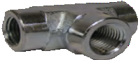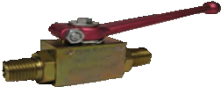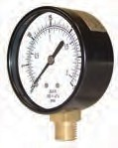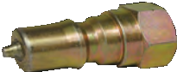

ADAPTERS

BALL VALVES

PRESSURE GAUGES

QUICK COUPLERS

44

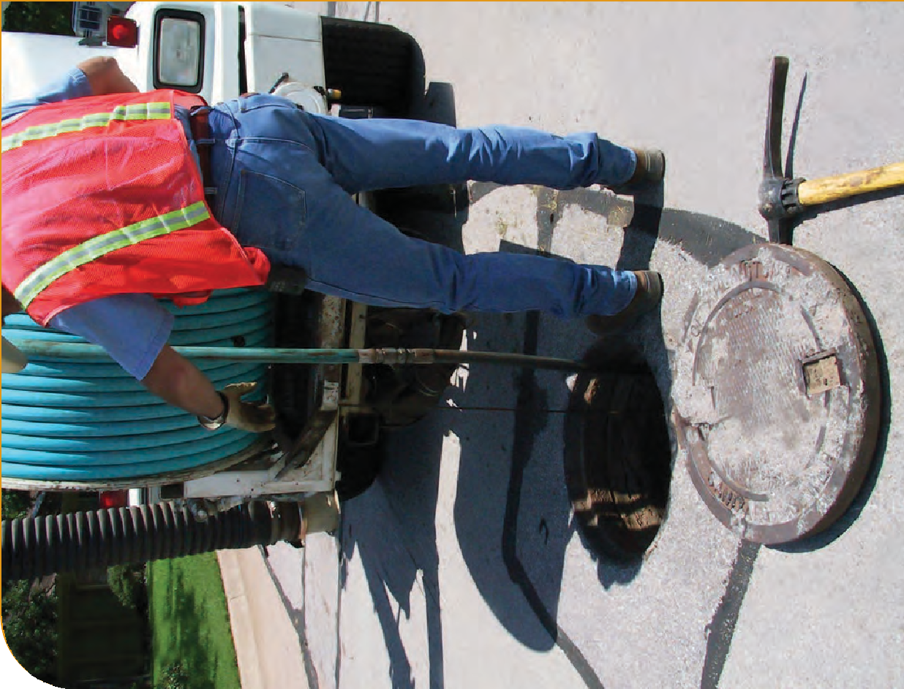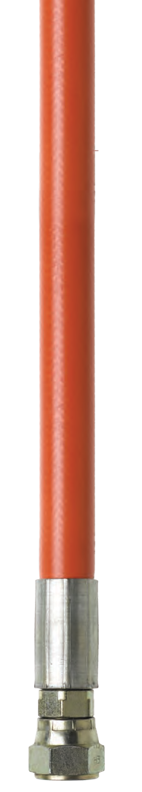SEWER JETTING
45

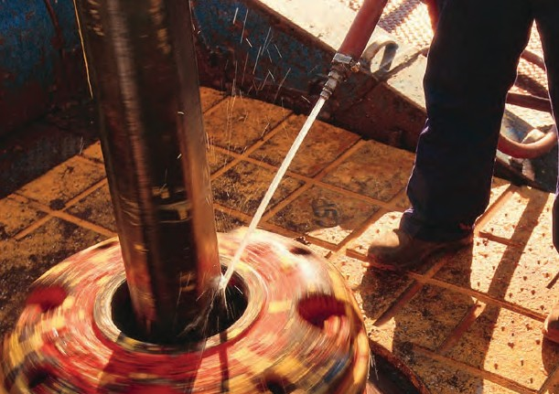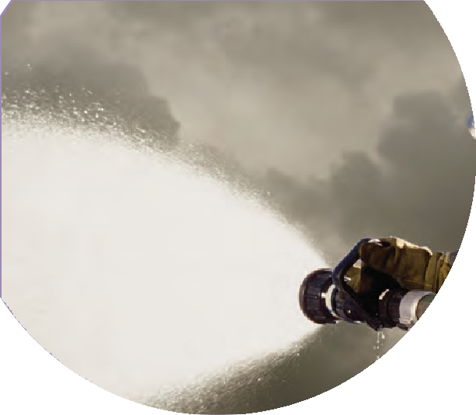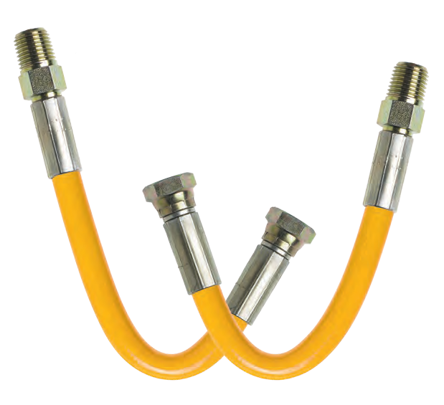

W

Superior OE quality is just one feature that sets Reinflex’s Water Jetting Hose apart from its competitors. This extremely high pressure hose is also competitively priced. What’s more, many of our competitors don’t even carry the wide variety that we do. Many standard stocking assemblies, as well as custom fabrications, are available depending on your application needs in jackets ranging from lightweight to steel wire reinforced. Keep in mind that no order is too big or small for CRP to fill. That’s one of the benefits of dealing with a company that prides itself on being large enough to help, yet small enough to care.

WATER JETTING HOSE FEATURES:
    - Working pressure from low to very high (10,000 psi)
    - Fitting options include NPT, NPSM, and JIC in plated or Stainless Steel — male (M) or female (F)
    - Lengths from 4” up to 500’
    - Hose sizes from 1/4” to 1/2”
    - Suitable for oil and chemical plant applications

46

2100UK SERIES WIRE & FABRIC BRAID REINFORCED THERMOPLASTIC WATER JETTING HOSE

High pressure, high performance hydraulic hose reinforced with a braid of steel and a polyaramid yard. Compatible with hydraulic oils, grease, fuel oils, mineral oils, and most phosphate esters. Superior flexibility and bend radii.

CONSTRUCTION:
Inner: Polyester Elastomer Liner
Outer: Abrasion and Chemical Resistant Polyurethane Cover

COUPLING CAPABILITIES: NPT, NPSM, JIC Plated or Stainless Steel – M or F
CRP PART NUMBER | COLORS | # OF BRAIDS | NOMINAL I.D.  Inches (MM) | NOMINAL O.D.  Inches (MM) | MINIMUM BEND RADIUS  Inches (MM) | DYNAMIC WORKING PRESSURE | MINIMUM BURST PRESSURE | WEIGHT (LBS/FT) | MAXIMUM LENGTH | TEMPERATURE RANGE
2106UK | nnnn | 2 | 1/4 (6.4) | 0.54 (13.7) | 1.5 (38) | 10,000 psi | 40,000 psi | 0.15 | 4” up to 500’ | -40 to +212ºF*
2110UK | n | 2 | 3/8 (9.5) | 0.74 (18.8) | 3.8 (95) | 10,000 psi | 40,000 psi | 0.24 | 4” up to 300’ | -40 to +212ºF*
*+158ºF for water based fluids

3000UK SERIES WIRE & FABRIC REINFORCED THERMOPLASTIC WATER JETTING HOSE

High pressure, high performance hose with steel and Kevlar braid reinforcement to ensure strength and guaranteed electrical conductivity resistance in the order of 1.0 ohms/meter. Superior resistance to most fluids and solvents.

CONSTRUCTION:
Inner: Seamless Nylon 12 Liner
Outer: Abrasion and Chemical Resistant Polyurethane Cover

COUPLING CAPABILITIES: NPT, NPSM, JIC Plated or Stainless Steel – M or F
CRP PART NUMBER | COLORS | # OF BRAIDS | NOMINAL I.D.  Inches (MM) | NOMINAL O.D.  Inches (MM) | MINIMUM BEND RADIUS  Inches (MM) | DYNAMIC WORKING PRESSURE | MINIMUM BURST PRESSURE | WEIGHT (LBS/FT) | MAXIMUM LENGTH | TEMPERATURE RANGE
3013UK | n | 3 | 1/2 (12.7) | 0.90 (22.9) | 5.0 (127) | 8,500 psi | 34,000 psi | 0.33 | 4” up to 300’ | -40 to +212ºF*
3113UK | n | 3 | 1/2 (12.7) | 0.90 (22.9) | 5.0 (127) | 10,000 psi | 34,000 psi | 0.33 | 4” up to 300’ | -40 to +212ºF*
*+158ºF for water based fluids

Reinflex also carries all the hose accessories you need. See pages 48-62 for details.

ADAPTERS

BALL VALVES

QUICK COUPLERS

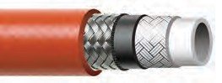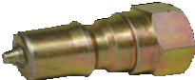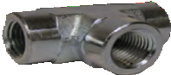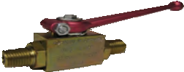
7
WATER JETTING

CUSTOM SIZES AND OTHER COUPLING CAPABILITIES AVAILABLE ON ALL HOSES.
TO PLACE AN ORDER OR SPEAK WITH A CRP REPRESENTATIVE, CALL 800-526-4066. 4

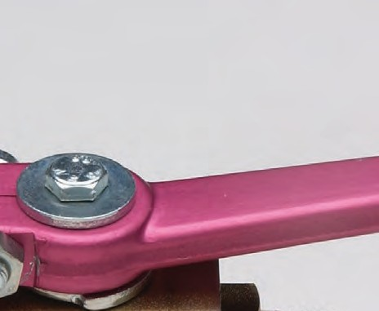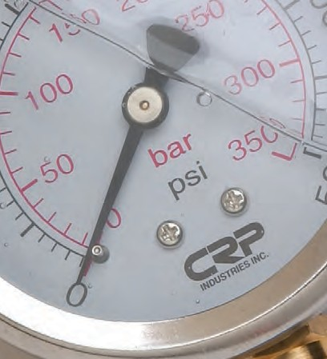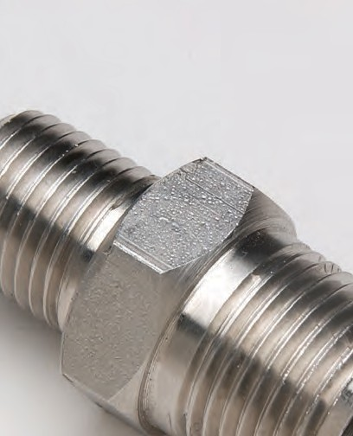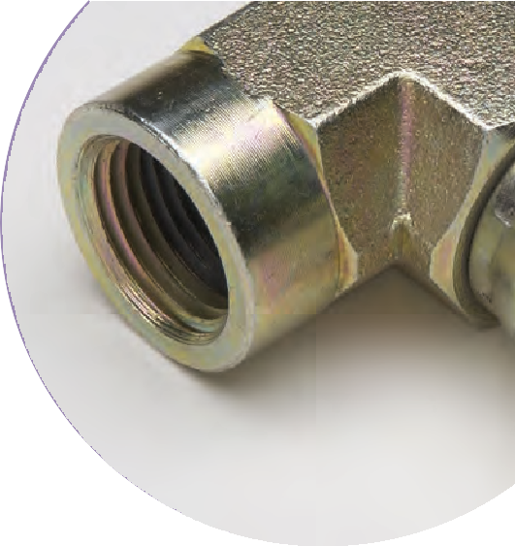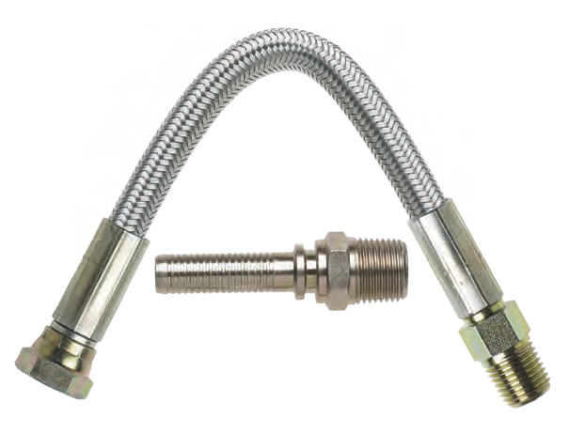

When it comes to accessories, no one can match Reinflex’s extensive stock of OEM grade adapters, ball valves, fittings, pressure gauges, and quick disconnects. Many of our adapters are plated in stainless steel and all of our accessories’ male ends are chamfered. You can also count on our excellent customer service staff to see to it that all of your accessories are delivered quickly each and every time.

OUR COMPLETE ACCESSORIES LINE INCLUDES:
- High Pressure Adapters
- Ball Valves
- Hose Jacketing
- Pressure Gauges
- Quick Disconnects

48

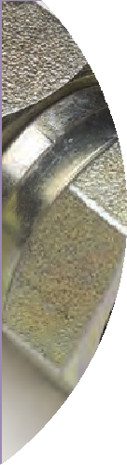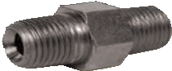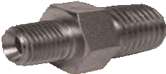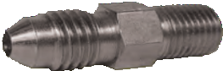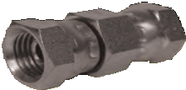
9
ACCESSORIES

Adapters
When you are using a Reinflex high pressure hose, you want to be sure that any connections you make are equally
reliable. That’s where Reinflex high pressure adapters come in. Available in both plated steel and stainless steel, Reinflex adapters come in a variety of fitments and insure leak free connections and optimal flow. For added convenience and value, we even sell a pre-boxed assortment containing 17 of the most popular adapters in the industry.

plated steel
HEX NIPPLE MALE NPT TO MALE NPT, TAPERED ENDS 30° CHAMFER
PART # SIDE A SIDE B
HN 12 | 1/8” | 1/8”
HN 25 | 1/4” | 1/4”
HN 38 | 3/8” | 3/8”
HN 50 | 1/2” | 1/2”
HN 75 | 3/4” | 3/4”
HN 100 | 1” | 1”
HEX REDUCING NIPPLE MALE NPT TO MALE NPT, TAPERED ENDS 30° CHAMFER
PART # SIDE A SIDE B
HRN 1225 1/8” 1/4”
HRN 2538 1/4” 3/8”
HRN 2550 1/4” 1/2”
HRN 3850 3/8” 1/2”
HRN 3875 3/8” 3/4”
HRN 5075 1/2” 3/4”
HRN 5010 1/2” 1”
HRN 7510 3/4” 1”
MALE CONNECTOR JIC MALE TO MALE NPT, 30° CHAMFER END
PART # SIDE A SIDE B
HNJ 0412 JIC#4 1/8”
HNJ 0425 JIC#4 1/4”
HNJ 0438 JIC#4 3/8”
HNJ 0450 JIC#4 1/2”
HNJ 0525 JIC#5 1/4”
HNJ 0625 JIC#6 1/4”
HNJ 0638 JIC#6 3/8”
HNJ 0650 JIC#6 1/2”
HNJ 0825 JIC#8 1/4”
HNJ 0838 JIC#8 3/8”
HNJ 0850 JIC#8 1/2”
HNJ 1275 JIC#12 3/4”
HNJ 1610 JIC#16 1”
PIPE SWIVEL UNION FEMALE NPSM SWIVEL TO FEMALE NPSM SWIVEL
PART # SIDE A SIDE B
PSU 2525 | 1/4” | 1/4”
PSU 3838 | 3/8” | 3/8”
PSU 5050 | 1/2” | 1/2”
PSU 7575 | 3/4” | 3/4”
PSU 1010 | 1” | 1”
CUSTOM SIZES AND OTHER COUPLING CAPABILITIES AVAILABLE ON ALL HOSES.
TO PLACE AN ORDER OR SPEAK WITH A CRP REPRESENTATIVE, CALL 800-526-4066. 4

HEX COUPLING
FEMALE NPT TO FEMALE NPT
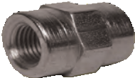
PART # SIDE A SIDE B

HPC 1212 1/8” 1/8”
HPC 1225 1/8” 1/4”
HPC 2525 1/4” 1/4”
HPC 2538 1/4” 3/8”
HPC 2550 1/4” 1/2”
HPC 3838 3/8” 3/8”
HPC 3850 3/8” 1/2”
HPC 5050 1/2” 1/2”
HPC 5075 1/2” 3/4”
HPC 7575 3/4” 3/4”
HPC 7510 3/4” 1”
HPC 1010 1” 1”
ADAPTER
MALE NPT TO FEMALE NPT, 30° CHAMFER MALE END

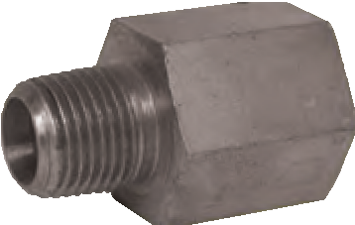
PART # | SIDE A | SIDE B
PA 1212 | 1/8” | 1/8”
PA 1225 | 1/8” | 1/4”
PA 1238 | 1/8” | 3/8”
PA 2525 | 1/4” | 1/4”
PA 2538 | 1/4” | 3/8”
PA 2550 | 1/4” | 1/2”
PA 2575 | 1/4” | 3/4”
PA 3838 | 3/8” | 3/8”
PA 3850 | 3/8” | 1/2”
PA 3875 | 3/8” | 3/4”
PA 5050 | 1/2” | 1/2”
PA 5075 | 1/2” | 3/4”
PA 5010 | 1/2” | 1”
PA 7575 | 3/4” | 3/4”
PA 7510 | 3/4” | 1“
PA 1010 | 1” | 1”

HEX REDUCER BUSHING
MALE TO FEMALE, 30° CHAMFER MALE END

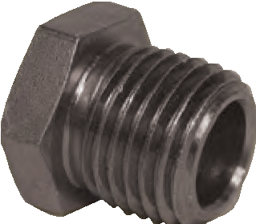
PART # | SIDE A | SIDE B
HRB 1225 | 1/8” | 1/4”
HRB 1238 | 1/8” | 3/8”
HRB 1250 | 1/8” | 1/2”
HRB 2538 | 1/4” | 3/8”
HRB 2550 | 1/4” | 1/2”
HRB 2575 | 1/4” | 3/4”
HRB 2510 | 1/4” | 1”
HRB 3850 | 3/8” | 1/2”
HRB 3875 | 3/8” | 3/4”
HRB 3810 | 3/8” | 1”
HRB 5075 | 1/2” | 3/4”
HRB 5010 | 1/2” | 1”
HRB 7510 | 3/4” | 1”

CUSTOM SIZES AND OTHER COUPLING CAPABILITIES AVAILABLE ON ALL HOSES.

50
TO PLACE AN ORDER OR SPEAK WITH A CRP REPRESENTATIVE, CALL 800-526-4066.

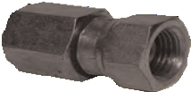
51
FEMALE ADAPTER UNION
FEMALE TO FEMALE SWIVEL, 30° CHAMFER MALE END
ACCESSORIES

PART # | SIDE A | SIDE B
FA 1212 | 1/8” | 1/8”
FA 1225 | 1/8” | 1/4”
FA 2512 | 1/4” | 1/8”
FA 2525 | 1/4” | 1/4”
FA 2538 | 1/4” | 3/8”
FA 3825 | 3/8” | 1/4”
FA 3838 | 3/8” | 3/8”
FA 3850 | 3/8” | 1/2”
FA 5038 | 1/2” | 3/8”
FA 5050 | 1/2” | 1/2”
FA 5075 | 1/2” | 3/4”
FA 7550 | 3/4” | 1/2”
FA 7575 | 3/4” | 3/4”
FA 7510 | 3/4” | 1”
FA 1075 | 1” | 3/4”
FA 1010 | 1” | 1”
MALE ADAPTER UNION
MALE NPT TO FEMALE NPSM SWIVEL, 30° CHAMFER MALE END

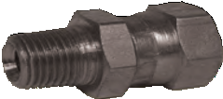
PART # | SIDE A | SIDE B
MFA 1212 | 1/8” | 1/8”
MFA 1225 | 1/8” | 1/4”
MFA 2512 | 1/4” | 1/8”
MFA 2525 | 1/4” | 1/4”
MFA 2538 | 1/4” | 3/8”
MFA 3825 | 3/8” | 1/4”
MFA 3838 | 3/8” | 3/8”
MFA 3850 | 3/8” | 1/2”
MFA 5038 | 1/2” | 3/8”
MFA 5050 | 1/2” | 1/2”
MFA 5075 | 1/2” | 3/4”
MFA 7550 | 3/4” | 1/2”
MFA 7575 | 3/4” | 3/4”
MFA 7510 | 3/4” | 1”

FEMALE JIC ADAPTER
FEMALE JIC SWIVEL TO MALE NPT
PART # SIDE A SIDE B

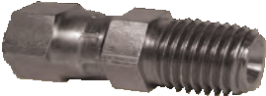
FAMJ 0425 JIC#4 1/4”
FAMJ 0525 JIC#5 1/4”
FAMJ 0625 JIC#6 1/4”
FAMJ 0638 JIC#6 3/8”
FAMJ 0838 JIC#8 3/8”
FAMJ 0850 JIC#8 1/2”
FAMJ 1275 JIC#12 3/4”
FEMALE JIC ADAPTER
FEMALE JIC SWIVEL TO FEMALE
PART # SIDE A SIDE B

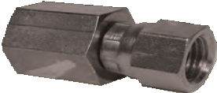
FAFJ 0425 JIC#4 1/4”
FAFJ 0625 JIC#6 1/4”
FAFJ 0638 JIC#6 3/8”
FAFJ 0650 JIC#6 1/2”
FAFJ 0838 JIC#8 3/8”
FAFJ 0850 JIC#8 1/2”
FAFJ 1275 JIC#12 3/4”

MALE SWIVEL ELBOW
MALE NPT TO FEMALE NPSM SWIVEL, 30° CHAMFER MALE END
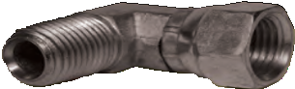
PART # SIDE A SIDE B

MPE 2525 1/4” 1/4”
MPE 2538 1/4” 3/8”
MPE 3825 3/8” 1/4”
MPE 3838 3/8” 3/8”
MPE 3850 3/8” 1/2”
MPE 5038 1/2” 3/8”
MPE 5050 1/2” 1/2”
MPE 5075 1/2” 3/4”
MPE 7550 3/4” 1/2”
MPE 7575 3/4” 3/4”
MPE 1075 1” 3/4”
MPE 1010 1” 1”
FEMALE SWIVEL ELBOW
FEMALE TO 90° FEMALE SWIVEL, 30° CHAMFER MALE END
PART # SIDE A SIDE B

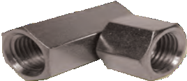
FPE 2525 1/4” 1/4”
FPE 2538 1/4” 3/8”
FPE 3825 3/8” 1/4”
FPE 3838 3/8” 3/8”
FPE 3850 3/8” 1/2”
FPE 5038 1/2” 3/8”
FPE 5050 1/2” 1/2”
FPE 5075 1/2” 3/4”
FPE 7550 3/4” 1/2”
FPE 7575 3/4” 3/4”
FPE 1010 1” 1”
HEX HEAD PLUG
SOLID MALE END TO PLUG
PART # SIDE A

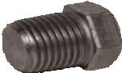
HHP 12 1/8”
HHP 25 1/4”
HHP 38 3/8”
HHP 50 1/2”
HHP 75 3/4”
HHP 100 1”
HEX CAP
FEMALE NPT CAP
PART # SIDE A

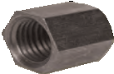
HC 12 1/8”
HC 25 1/4”
HC 38 3/8”
HC 50 1/2”
HC 75 3/4”
HC 100 1”
SQUARE HEAD PLUG
MALE NPT PLUG
PART # SIDE A

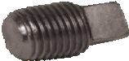
SPP 12 1/8”
SPP 25 1/4”
SPP 38 3/8”
SPP 50 1/2”
SPP 75 3/4”

52
SPP 100 1”

53
ACCESSORIES

JIC CAP PLUG
MALE JIC PLUG
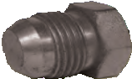
PART # SIDE A

JC 12 JIC#2
JC 25 JIC#4
JC 30 JIC#5
JC 38 JIC#6
JC 50 JIC#8
JC 62 JIC#10
JC 75 JIC#12
JC 100 JIC#16
UNION TEES
MALE NPT BY MALE NPT BY MALE NPT, 30° CHAMFER MALE END
PART # SIDE A SIDE B SIDE C

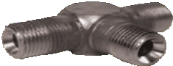
UPT 12 1/8” 1/8” 1/8”
UPT 25 1/4” 1/4” 1/4”
UPT 38 3/8” 3/8” 3/8”
UPT 50 1/2” 1/2” 1/2”
UPT 75 3/4” 3/4” 3/4”
UPT 100 1” 1” 1”
FEMALE TEE
FEMALE NPT BY MALE NPT BY MALE NPT
PART # SIDE A SIDE B SIDE C

FPT 12 1/8” 1/8” 1/8”
FPT 25 1/4” 1/4” 1/4”
FPT 38 3/8” 3/8” 3/8”
FPT 50 1/2” 1/2” 1/2”
FPT 75 3/4” 3/4” 3/4”
FPT 100 1” 1” 1”
UNION TEE
FEMALE NPSM SWIVEL
PART # SIDE A SIDE B SIDE C

UPTF 12 1/8” 1/8” 1/8”
UPTF 25 1/4” 1/4” 1/4”
UPTF 38 3/8” 3/8” 3/8”
UPTF 50 1/2” 1/2” 1/2”
UPTF 75 3/4” 3/4” 3/4”
UPTF 100 1” 1” 1”
FEMALE CROSS
FEMALE NPT ALL ENDS
PART # SIDE A SIDE B SIDE C SIDE D

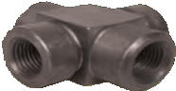
FC 12 1/8” 1/8” 1/8” 1/8”
FC 25 1/4” 1/4” 1/4” 1/4”
FC 38 3/8” 3/8” 3/8” 3/8”
FC 50 1/2” 1/2” 1/2” 1/2”
FC 75 3/4” 3/4” 3/4” 3/4”
FC 100 1” 1” 1” 1”
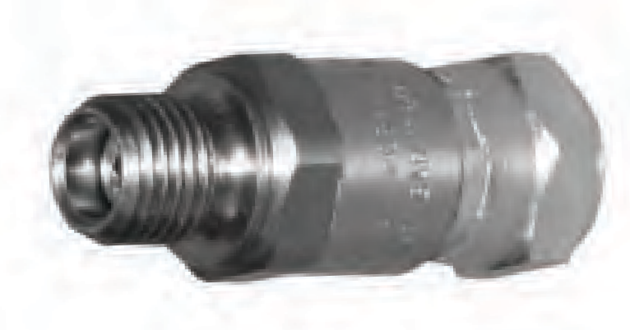
LIVE GUN SWIVEL
MALE NPT TO FEMALE NPSM SWIVEL, 30° CHAMFER MALE END
PART #
FSG2525
SIDE A SIDE B
1/4”
1/4”

FREE WORKING SWIVELS
30° CHAMFER MALE END

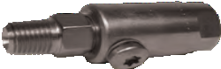
MALE NPT TO FEMALE NPT PART # SIDE A SIDE B
FS 2525 1/4” 1/4” Steel FS 3838 3/8” 3/8” Steel FS 5050 1/2” 1/2” Steel FS 7575 3/4” 3/4” Steel FS 1010 1” 1” Steel
FEMALE NPT BOTH SIDES PART # SIDE A SIDE B
FSF 2525 1/4” 1/4” FSF 3838 3/8” 3/8” FSF 5050 1/2” 1/2” FSF 7575 3/4” 3/4” FSF 1010 1” 1”
MALE ELBOW
MALE NPT END TO 90° MALE NPT END, 30° CHAMFER MALE END
PART # SIDE A SIDE B
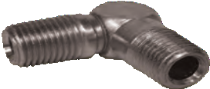
ME 2525 | 1/4” | 1/4”
ME 2538 | 1/4” | 3/8”
ME 3838 | 3/8” | 3/8”
ME 3850 | 3/8” | 1/2”
ME 5050 | 1/2” | 1/2”
ME 5075 | 1/2” | 3/4”
ME 7575 | 3/4” | 3/4”
ME 1010 | 1” | 1”

TEE
ONE FEMALE NPT END, TWO MALE NPT ENDS, 30° CHAMFER MALE END
PART # SIDE A SIDE B SIDE C
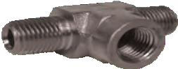
PT 25 | 1/4” | 1/4” | 1/4”
PT 38 | 3/8” | 3/8” | 3/8”
PT 50 | 1/2” | 1/2” | 1/2”
PT 75 | 3/4” | 3/4” | 3/4”

MALE RUN TEE
TWO FEMALE NPT ENDS, ONE MALE NPT ENDS, 30° CHAMFER MALE END
PART # SIDE A SIDE B SIDE C

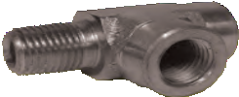
MPST 25 1/4” 1/4” 1/4”
MPST 38 3/8” 3/8” 3/8”
MPST 50 1/2” 1/2” 1/2”
MPST 75 3/4” 3/4” 3/4”
MPST 100 1” 1” 1”

stainless steel – 316 grade
HEX NIPPLE
MALE NPT TO MALE NPT, 30° CHAMFER MALE END
PART # SIDE A SIDE B

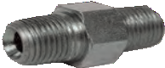
HN 12 SS 1/8” 1/8”
HN 25 SS 1/4” 1/4”
HN 38 SS 3/8” 3/8”
HN 50 SS 1/2” 1/2”
HN 75 SS 3/4” 3/4”
HN 100 SS 1” 1”

54

5
ACCESSORIES

HEX REDUCING NIPPLE
MALE NPT TO MALE NPT, 30° CHAMFER MALE END
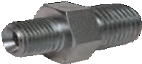
PART # SIDE A SIDE B

HRN 1225 SS 1/8” 1/4”
HRN 2538 SS 1/4” 3/8”
HRN 2550 SS 1/4” 1/2”
HRN 3850 SS 3/8” 1/2”
HRN 3875 SS 3/8” 3/4”
HRN 5075 SS 1/2” 3/4”
HRN 7510 SS 3/4” 1”
HEX REDUCING BUSHING
MALE NPT TO FEMALE NPT, 30° CHAMFER MALE END
PART # SIDE A SIDE B
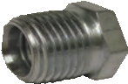
HRB 1225 SS | 1/8” | 1/4”
HRB 2538 SS | 1/4” | 3/8”
HRB 3850 SS | 3/8” | 1/2”
HRB 5075 SS | 1/2” | 3/4”
HRB 7510 SS | 3/4” | 1”

MALE ADAPTER UNION
MALE NPT TO FEMALE NPSM SWIVEL, 30° CHAMFER MALE END
PART # SIDE A SIDE B

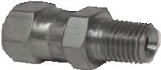
MFA 2525 SS 1/4” 1/4”
MFA 2538 SS 1/4” 3/8”
MFA 3825 SS 3/8” 1/4”
MFA 3838 SS 3/8” 3/8”
MFA 3850 SS 3/8” 1/2”
MFA 5050 SS 1/2” 1/2”
MFA 7575 SS 3/4” 3/4”
FEMALE ADAPTER UNION
FEMALE NPT TO FEMALE NPSM SWIVEL
PART # SIDE A SIDE B
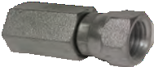
FA 2525 SS | 1/4” | 1/4”
FA 3838 SS | 3/8” | 3/8”

ADAPTER
MALE NPT TO FEMALE NPT RIGID, 30° CHAMFER MALE END
PART # SIDE A SIDE B
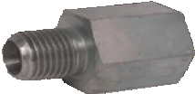
PA 1212 SS | 1/8” | 1/8”
PA 1225 SS | 1/8” | 1/4”
PA 1238 SS | 1/8” | 3/8”
PA 2525 SS | 1/4” | 1/4”
PA 2538 SS | 1/4” | 3/8”
PA 3838 SS | 3/8” | 3/8”
PA 3850 SS | 3/8” | 1/2”
PA 3875 SS | 3/8” | 3/4”
PA 5075 SS | 1/2” | 3/4”
PA 5010 SS | 1/2” | 1”

CUSTOM SIZES AND OTHER COUPLING CAPABILITIES AVAILABLE ON ALL HOSES.
TO PLACE AN ORDER OR SPEAK WITH A CRP REPRESENTATIVE, CALL 800-526-4066. 5

HEX COUPLING
FEMALE NPT TO FEMALE NPT
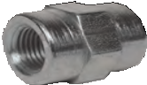
PART # SIDE A SIDE B

HPC 1212 SS 1/8” 1/8”
HPC 1225 SS 1/8” 1/4”
HPC 2525 SS 1/4” 1/4”
HPC 2538 SS 1/4” 3/8”
HPC 3838 SS 3/8” 3/8”
HPC 3850 SS 3/8” 1/2”
HPC 5050 SS 1/2” 1/2”
HPC 7575 SS 3/4” 3/4”
HPC 7510 SS 3/4” 1”
FEMALE TEE
FEMALE BY FEMALE BY FEMALE
PART # SIDE A SIDE B SIDE C

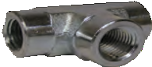
FPT 25 SS 1/4” 1/4” 1/4”
FPT 38 SS 3/8” 3/8” 3/8”
FPT 50 SS 1/2” 1/2” 1/2”
FPT 75 SS 3/4” 3/4” 3/4”

UNION TEE
MALE NPT TO MALE NPT TO MALE NPT, 30° CHAMFER MALE END
PART # SIDE A SIDE B SIDE C
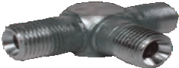
UPT 25 SS | 1/4” | 1/4” | 1/4”
UPT 38 SS | 3/8” | 3/8” | 3/8”

MALE ELBOW
90° MALE NPT TO MALE NPT, 30° CHAMFER MALE END
PART # SIDE A SIDE B
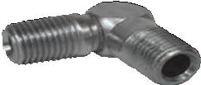
ME 1225 SS | 1/8” | 1/4”
ME 2525 SS | 1/4” | 1/4”
ME 2538 SS | 1/4” | 3/8”
ME 3838 SS | 3/8” | 3/8”
ME 5050 SS | 1/2” | 1/2”
ME 7575 SS | 3/4” | 3/4”
ME 1010 SS | 1” | 1”

FEMALE ELBOW
90° FEMALE NPT TO FEMALE NPT
PART # SIDE A SIDE B

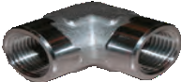
FE 2525 SS 1/4” 1/4”
FE 2538 SS 1/4” 3/8”
FE 5050 SS 1/2” 1/2”
FE 7575 SS 3/4” 3/4”

56

7
ACCESSORIES

MALE SWIVEL ELBOW
90° MALE NPT TO FEMALE NPSM SWIVEL, 30° CHAMFER MALE END
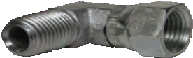
PART # SIDE A SIDE B

MPE 2525 SS 1/4” 1/4”
MPE 3838 SS 3/8” 3/8”
MPE 5050 SS 1/2” 1/2”
MPE 7575 SS 3/4” 3/4”

MALE/FEMALE ELBOW
90° MALE NPT TO FEMALE NPT, 30° CHAMFER MALE END
PART # SIDE A SIDE B

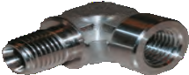
MFE 2525 SS 1/4” 1/4”
MFE 3838 SS 3/8” 3/8”
MFE 5050 SS 1/2” 1/2”
MFE 7575 SS 3/4” 3/4”

HEX HEAD PLUG
MALE NPT PLUG
PART # SIZE

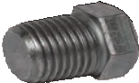
HHP 25 SS 1/4”
HHP 38 SS 3/8”

MALE CONNECTOR
MALE JIC TO MALE, 30° CHAMFER
PART # SIDE A SIDE B

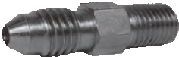
HNJ 0425 SS JIC#4 1/4”
HNJ 0525 SS JIC#5 1/4”

FEMALE SWIVEL ELBOW
90° FEMALE TO FEMALE SWIVEL
PART # SIDE A SIDE B

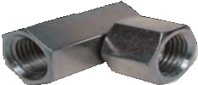
FPE 7575 SS 3/4” 3/4”

MALE RUN TEE
TWO FEMALE ENDS, ONE MALE NPT END, 30° CHAMFER
PART # SIDE A SIDE B SIDE C

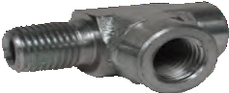
MPST 25 SS 1/4” 1/4” 1/4”

CUSTOM SIZES AND OTHER COUPLING CAPABILITIES AVAILABLE ON ALL HOSES.
TO PLACE AN ORDER OR SPEAK WITH A CRP REPRESENTATIVE, CALL 800-526-4066. 5

ADAPTER KIT
STARTER ASSORTMENT OF ADAPTERS

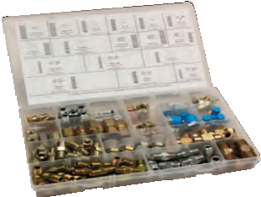
PART # | QTY | SIDE A | SIDE B | SIDE C | SEE PG.
HN 25 | 24 | 1/4” | 1/4” |  | 46
HN 38 | 9 | 3/8” | 3/8” |  | 46
HN 50 | 3 | 1/2” | 1/2” |  | 46
HRN 2538 | 10 | 1/4” | 3/8” |  | 46
HRN 3850 | 4 | 3/8” | 1/2” |  | 46
FPT 25 | 5 | 1/4” | 1/4” | 1/4” | 53
MFA 2525 | 4 | 1/4” | 1/4” |  | 48
MFA 2538 | 4 | 1/4” | 3/8” |  | 48
HC 25 | 6 | 1/4” |  |  | 49
HC 38 | 4 | 3/8” |  |  | 49
HC 50 | 2 | 1/2” |  |  | 49
UPT 25 | 2 | 1/4” | 1/4” | 1/4” | 50
FA 2525 | 4 | 1/4” | 1/4” |  | 52
FA 3838 | 4 | 3/8” | 3/8” |  | 52
HRB 2538 | 4 | 1/4” | 3/8” |  | 47
HRB 3850 | 4 | 3/8” | 1/2” |  | 47
PA 2538 | 2 | 1/4” | 1/4” |  | 52

58

9
ACCESSORIES

Ball Valves
If you need ball valves that offer the same quality as the Reinflex hoses in your applications and installations, look no further. The
male and female ball valve assemblies shown below work with paint, petroleum-based hydraulic fluids, fuel oil, and air.
Reinflex’s male-thread ball valves use carbon steel for the body, hard chrome plated carbon steel for the ball, and zinc plated steel for the stem. Connections are male NPT, full bore, and the valves are rated to a working pressure of 7,500 PSI. Our female-thread ball valves have carbon steel or stainless steel bodies, hard chrome plated carbon steel or stainless steel balls, zinc plated steel or stainless steel stems, and Viton or PTFE seals. Connection is female NPT, full bore. For working pressures, please see chart below.
If you require other ball valve construction types, talk to a CRP service specialist who will be happy to discuss the other options available.

BALL VALVES MALE THREADS
BODY: FORGED CARBON STEEL STEM: FORGED CARBON STEEL BALL: CHROME PLATED STEEL

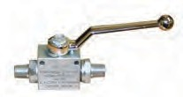
PART # | SIDE A | SIDE B | CONNECTIONS | WORKING PRESSURE | BALL SEALS | STEM SEALS
BV 2525 | 1/4” | 1/4” | Male NPT | 7,250 psi | Delrin | Viton
BV 3838 | 3/8” | 3/8” | Male NPT | 7,250 psi | Delrin | Viton

BALL VALVES FEMALE THREADS
BODY: FORGED CARBON STEEL STEM: FORGED CARBON STEEL BALL: CHROME PLATED STEEL
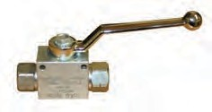
PART # | SIDE A SIDE B | CONNECTIONS | WORKING PRESSURE | BALL SEALS | STEM SEALS
BVF 2525 | 1/4” 1/4” | Female NPT | 7,250 psi | Delrin | Viton
BVF 3838 | 3/8” 3/8” | Female NPT | 7,250 psi | Delrin | Viton
BVF 5050 | 1/2” 1/2” | Female NPT | 7,250 psi | Delrin | Viton
BVF 7575 | 3/4” 3/4” | Female NPT | 5,800 psi | Delrin | Viton
BVF 1010 | 1” 1” | Female NPT | 5,800 psi | Delrin | Viton
BVF 2525 T | 1/4” 1/4” | Female NPT | 4,500 psi | Viton | PTFE
BVF 3838 T | 3/8” 3/8” | Female NPT | 4,500 psi | Viton | PTFE
BVF 5050 T | 1/2” 1/2” | Female NPT | 4,500 psi | Viton | PTFE
BVF 7575 T | 3/4” 3/4” | Female NPT | 3,600 psi | Viton | PTFE
BVF 1010 T | 1” 1” | Female NPT | 3,600 psi | Viton | PTFE

NOTE: Replacement Handles and Seal Kits Available.

CUSTOM SIZES AND OTHER COUPLING CAPABILITIES AVAILABLE ON ALL HOSES.
TO PLACE AN ORDER OR SPEAK WITH A CRP REPRESENTATIVE, CALL 800-526-4066. 5

Hose Jacketing

Reinflex is proud to offer Expando PT hose jacketing. Expando PT is a self-fitting protective oversleeve, with expandable
braid construction, designed to offer maximum resistance to abrasion and impact damage. Its open weave construction allows easy identification of contents. An additional advantage offered by these lightweight oversleeves is that each size fits several diameters.
Expando PT is easy to apply, has an operating temperature range from -40ºF to +125ºF, and is up to 4 times more abrasion resistant than competitive products. Additional features like flexibility, choice of colors, and resistance to most industrial fluids round out Expando PT’s advantages.

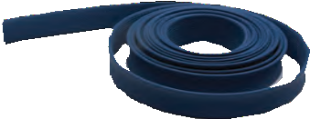
HOSE JACKETING
SELF–FITTING PROTECTIVE OVERSLEEVE
PART # (COLOR) | SLEEVE SIZE | EXPANDED SIZE | FEET PER SPOOL | WEIGHT PER 100 FT. (LBS.)
JACKET 012 (color) | 1/8” | 1/4” | 2,000 | 0.16
JACKET 025 (color) | 1/4” | 7/16” | 1,000 | 0.24
JACKET 050 (color) | 1/2” | 3/4” | 500 | 0.77
JACKET 075 (color) | 3/4” | 1 1/4” | 500 | 1.20
JACKET 125 (color) | 1 1/4” | 1 3/4” | 250 | 1.60
JACKET 175 (color) | 1 3/4” | 2 3/4” | 250 | 2.70
JACKET 200 (color) | 2” | 3 1/2” | 250 | 3.30
JACKET 250 (color) | 2 1/2” | 4 1/2” | 250 | 4.60

*Always specify hose jacket color when ordering.

60

1
ACCESSORIES

Pressure Gauge
Reinflex’s Pressure Gauge line up comes in a variety of pressure ranges, dial and connection sizes, and mounting configurations.
For added durability and accuracy in more extreme environments, glycerine filled gauges are also available.

PRESSURE GAUGE
GLASS-FACED

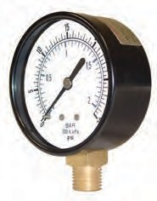
PART # PRESSURE CONNECTION  RANGE (PSI) (MALE) | MOUNT | DIAL DIAMETER | METAL FINISH | LIQUID FILLED
PG15-200B 0 to 15 1/8” | Back | 2” | Black | No
PG30-150 0 to 30 1/8” | Bottom | 1 1/2” | Black | No
PG60-200 0 to 60 1/4” | Bottom | 2” | Black | No
PG60-200B 0 to 60 1/4” | Back | 2” | Black | No
PG100-150 0 to 100 1/8” | Bottom | 1 1/2” | Black | No
PG100-150B 0 to 100 1/8” | Back | 1 1/2” | Black | No
PG100-200 0 to 100 1/4” | Bottom | 2” | Black | No
PG100-200B 0 to 100 1/4” | Back | 2” | Black | No
PG100-200-8 0 to 100 1/8” | Bottom | 2” | Black | No
PG160-200 0 to 160 1/4” | Bottom | 2” | Black | No
PG160-200B 0 to 160 1/4” | Back | 2” | Black | No
PG200-150 0 to 200 1/8” | Bottom | 1 1/2” | Black | No
PG200-150B 0 to 200 1/8” | Back | 1 1/2” | Black | No
PG200-200 0 to 200 1/4” | Bottom | 2” | Black | No
PG100-250 0 to 100 1/4” | Bottom | 2 1/2” | Stainless | Yes
PG300-250 0 to 300 1/4” | Bottom | 2 1/2” | Stainless | Yes
PG1000-250 0 to 1,000 1/4” | Bottom | 2 1/2” | Stainless | Yes
PG1500-250 0 to 1,500 1/4” | Bottom | 2 1/2” | Stainless | Yes
PG2000-250 0 to 2,000 1/4” | Bottom | 2 1/2” | Stainless | Yes
PG3000-250 0 to 3,000 1/4” | Bottom | 2 1/2” | Stainless | Yes
PG5000-250 0 to 5,000 1/4” | Bottom | 2 1/2” | Stainless | Yes
PG6000-250 0 to 6,000 1/4” | Bottom | 2 1/2” | Stainless | Yes
PG10K-250 0 to 10,000 1/4” | Bottom | 2 1/2” | Stainless | Yes

PRESSURE TEST GAUGE KIT
INCLUDES PSI GAUGE, TEE, SWIVEL AND HEX NIPPLE
PART # PRESSURE CONNECTION MOUNT DIAL METAL LIQUID RANGE (PSI) (MALE) DIAMETER FINISH FILLED

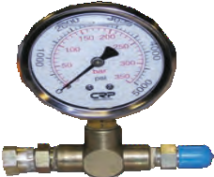
PG5000-KIT 0 to 5,000 1/4” Bottom 2 1/2” Stainless Yes
(Gauge) Plated Steel (Fittings)

CUSTOM SIZES AND OTHER COUPLING CAPABILITIES AVAILABLE ON ALL HOSES.
TO PLACE AN ORDER OR SPEAK WITH A CRP REPRESENTATIVE, CALL 800-526-4066. 6

Quick Disconnects

The fastest and simplest way to connect and disconnect hoses are these quick couplers. For use in spray
applications, the working pressure rating for the 1/4” coupler is 5,000 psi; for the 3/8” option, 4,000 psi; and for the 1/2”, 4,000 psi. Viton O-rings allow use with most paints and solvents. We can also source non-standard couplers, call for details.

QUICK COUPLERS

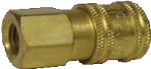

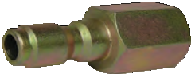

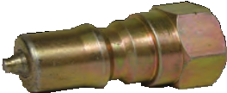

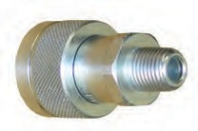
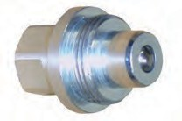

62
FEMALE ENDS MALE ENDS
PART #
QC 25F QC 38F QC 50F
SIZE
1/4”
3/8”
1/2”
PART #
QC 25M QC 38M QC 50M
SIZE
1/4”
3/8”
1/2”

FEMALE ENDS MALE ENDS
NIPPLES

PART # | SIZE | PART # | SIZE
QC 25FN | 1/4” | QC 25MN | 1/4”
QC 38FN | 3/8” | QC 38MN | 3/8”
QC 50FN | 1/2” | QC 50MN | 1/2”

QUICK COUPLERS NIPPLES
DOUBLE SHUT OFF SERIES
ALL FEMALE ENDS

PART # | SIZE | PART # | SIZE
QCDS 25F | 1/4” | QCDS 25FN | 1/4”
QCDS 38F | 3/8” | QCDS 38FN | 3/8”

COUPLERS
10,000 PSI QUICK COUPLERS
PART # SIZE BRAND

QCS18M10KP 1/8” Male NPT Pioneer QCS25M10KP 1/4” Male NPT Pioneer QCS38M10KP 3/8” Male NPT Pioneer

NIPPLES
PART # SIZE BRAND

QCS18MN10KP 1/8” Male NPT Pioneer QCS25MN10KP 1/4” Male NPT Pioneer QCS25FN10KP 1/4” Female NPT Pioneer QCS38FN10KP 3/8” Female NPT Pioneer

3
NOTES

High Pressure Hose Safety
CRP Industrial is very concerned about your safety when working with High Pressure Hose and related equipment. We have compiled this list of best practices for your reference and invite you to suggest any other safety measures that you have found valuable in your experience with high pressure hose and equipment.
Best Practices for High Pressure Hose Safety
- Stay within the stated working pressure of hose or equipment — never exceed this pressure.
- Work within the “minimum bend radius” guidelines suggested. Exceeding this radius could cause a kink that will lead to hose failure.
- Stay within recommended operating temperature limits of both hose and equipment. Higher temperatures increase pressure, which can cause failure.
- Inspect hoses prior to every use for signs of wear such as cuts, abrasions, coupling integrity, etc.
- Do not interline Reinflex hose with that of another manufacturer. Differences in manufacturing tolerances and quality standards could result in the failure of the weaker hose.
- Route hose away from areas of high temperature such as exhaust manifolds, heaters, or burners.
- Never run over hose with a vehicle or equipment, as this can compromise the integrity of the hose in a way that might not be visible.
- To avoid uncontrolled and potentially dangerous static discharges, be sure that all equipment is properly grounded. If you have any comments or questions about these guidelines or hose safety in general, please call your CRP representative.

CUSTOM SIZES AND OTHER COUPLING CAPABILITIES AVAILABLE ON ALL HOSES.
TO PLACE AN ORDER OR SPEAK WITH A CRP REPRESENTATIVE, CALL 800-526-4066. 6

NOTES

64

65
NOTES

NOTES

66

67
NOTES

CRP Industries Inc. 35 Commerce Drive
Cranbury, NJ 08512 USA
Toll Free 800.526.4066
Phone 609.578.4100
Telefax 609.578.4112 industrialcs@crpindustries.com
USA I MEXICO
www.crpreinflex.com

CATIND18

